A Early Detection of Sciatica using Ensemble Learning Algorithms

Dr. A. Sampath Dakshina Murthy Department of Electronics and communication Engineering,
Vignan’s Institute of Information Technology (A), Visakhapatnam,India asdakshinamurthy@vignaniit.edu.in
orcid.org/0000-0002-9960-6373

Yalla Hari Vamshi Department of Electronics and communication Engineering,
Vignan’s Institute of Information Technology (A), Visakhapatnam,India vasmhiyalla123@gmail.com

Tamada Kintan Varma Department of Electronics and communication Engineering,
Vignan’s Institute of Information Technology (A), Visakhapatnam,India kintanvarma2@gmail.com

Vechalapu Sai Kumar
Department of Electronics and communication Engineering,
Vignan’s Institute of Information Technology (A), Visakhapatnam,India vechalapusaikumar2733@gmail.com

Sylada Adithya
Department of Electronics and communication Engineering,
Vignan’s Institute of Information Technology (A),
Visakhapatnam,India adithyasylada345@gmail.com

Abstract— Sciatica is a musculoskeletal condition that is caused by the compression or irritation of the lumbar nerve roots. Continuous monitoring of bio mechanical parameters, such as pelvic motion and plantar pressure, can enable early identification of gait and posture deviations that precede clinical symptoms. ensemble learning algorithms propose a compact belt-to-shoe wearable system that combines a lumbar IMU (accelerometer + gyroscope) and a multi-node plantar pressure insole. Synchronized sensor fusion and engineered time-domain/statistical features are classified using a Random Forest model to label short windows as Normal or Risk. Preliminary evaluation on trial recordings and simulated augmentations yields an overall accuracy of 91.8%. overall simulation results and model choices are preliminary and subject to review and clinical validation.
Keywords—Sciatica detection, wearable sensors, gait analysis, IMU, plantar pressure, Random Forest, sensor fusion.

Introduction
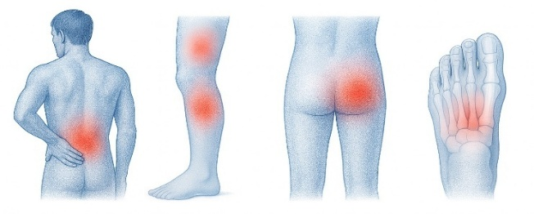
Sciatica commonly manifests as radiating lower-limb pain resulting from compression or irritation of the lumbar nerve roots. In many patients, the clinical episode is preceded by long-term bio mechanical deviations such as pelvic misalignment, trunk compensation, asymmetric gait and uneven plantar loading. Conventional assessment is episodic and clinic-based, relying on visual inspection and patient-reported symptoms, and therefore fails to capture subtle, transient deviations that occur during daily activities. A continuous, wearable monitoring approach can reveal such early warning signs and support preventive intervention before irreversible damage or severe pain occurs.
Figure 1. Anatomical regions commonly affected by sciatica, showing lumbar, thigh, buttock, and plantar pain areas.
This work proposes an end-to-end wearable system that monitors the complete chain from the lumbar region to the feet using a belt-mounted Inertial Measurement Unit (IMU) [1] and a shoe-mounted insole containing force-sensitive resistors (FSRs) [2]. The lumbar [3] IMU captures pelvic and trunk kinematics, while the insole records plantar-pressure distribution across heel, mid-foot and forefoot zones. Sensor data are streamed via Bluetooth to a mobile application [4], enabling low-latency feedback without dependence on network connectivity; the app can optionally upload data to a cloud backend for long-term storage and advanced analysis. Time-domain and statistical features extracted from synchronized signals are classified by tree-based ensemble models, namely Random Forest (RF) [5] and Extreme Gradient Boosting (XGBoost) [6], which showed robust performance in our previous experiments on gait-risk detection [7].
Unlike existing wearable gait systems that typically monitor either trunk motion or plantar pressure in isolation, the proposed architecture provides multilevel coverage from lumbar disc to leg and is explicitly designed for early sciatica-risk detection in daily-life conditions. By combining multimodal sensing, edge-friendly machine learning and mobile/cloud integration, the system aims to offer a practical platform for continuous risk monitoring and future personalized intervention.

RELATED WORK
Wearable gait analysis has been extensively studied using motion sensors and pressure sensors. IMU-based systems attached to the trunk, shank or foot have been used to estimate spatiotemporal gait parameters, assess stability and detect pathological gait patterns in conditions such as lumbar disc herniation and Parkinson’s disease [8]. In parallel, instrumented insoles with capacitive or resistive pressure sensors have been developed for monitoring plantar loading, identifying abnormal pressure hotspots and supporting diabetic foot and rehabilitation applications.
Several studies have begun to combine IMUs and force/ pressure sensors [9] to build low-cost portable gait measurement devices. These systems typically focus on generic abnormal-gait detection, energy-efficient gait recognition [10], or sports and activity classification, and often emphasize sensor placement or signal-processing frameworks rather than condition-specific risk monitoring. Deep learning models such as CNNs [11], LSTMs [12] and hybrid CNN–LSTM architectures [13] have further improved temporal pattern extraction in these multimodal setups, but they usually require large labelled datasets and high compute resources, making direct deployment on constrained edge hardware challenging.
In contrast to the above, our work targets early sciatica- risk detection and employs a belt–insole fusion [14] that spans the lumbar region and both feet. The system integrates a lumbar IMU with an FSR-based insole, streams data wirelessly to a smartphone [15], and is designed to support seamless synchronization with a cloud backend. Instead of relying solely on deep networks, we focus on edge-friendly ensemble models—Random Forest [16] and XGBoost [17] that provide competitive accuracy on our preliminary dataset while preserving interpretability and low inference latency for on-device deployment. To the best of our knowledge, no prior study offers a similarly integrated, disc-to-foot wearable architecture combined with tree-based ensembles and mobile/cloud workflows specifically tailored for continuous sciatica-risk monitoring.

SYSTEM ARCHITECTURE
  - Belt-mounted IMU
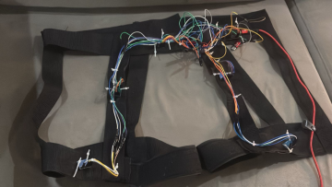
Figure 2 shows a 6-axis inertial module (3-axis accelerometer + 3-axis gyroscope) is placed at the lumbar region using an adjustable belt.

Figure 2. Prototype of the belt-mounted IMU harness with distributed sensor wiring used for capturing lumbar and trunk kinematics.
This position captures pelvic tilt, trunk rotation, angular jerk, and compensatory upper-body motion commonly associated with sciatic nerve irritation. The belt IMU is directly interfaced with an ESP32 microcontroller [18] that functions as the master node in the wireless network.
  - Shoe-Mounted Sensor Nodes
Each shoe contains an independent ESP32-based node equipped with:
    - A 6-axis IMU module for lower-limb kinematics
    - Two FSR sensors (heel + forefoot) for plantar- pressure distribution
The shoe nodes collect IMU and FSR samples at 50–100 Hz, attach timestamps, and transmit packets wirelessly to the belt-mounted master via ESP-NOW. This creates a low- latency, peer-to-peer network suitable for gait monitoring during natural walking.
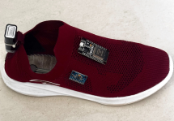

Figure 3. Prototype of the shoe-mounted sensing unit showing the ESP32 controller, IMU module, and integrated pressure-sensing insole.
  - Wireless Hub and Synchronization
The belt-mounted ESP32 node gathers data streams from both shoe-mounted sensors and its own IMU. A lightweight synchronization routine aligns packets using monotonically increasing timestamps. This approach maintains temporal consistency across trunk motion, foot kinematics, and plantar-pressure signals within each gait window.
  - Mobile Application and Cloud Flow [19]
After fusion, the processed data are forwarded from the belt module to a smartphone via Bluetooth Classic. This Communication link supports:
    - Real-time visualization of IMU and FSR signals.
    - On-device window segmentation and feature computation.
    - Inference using trained Random Forest and XGBoost models.
    - Optional upload to a secure cloud backend for long- term monitoring.
This pathway ensures reliable operation even when internet connectivity is unavailable, while still supporting cloud-based workflows when available.
  - Summary of Sensing Coverage
Figure 4 describes the multiple modal configuration provides us with three-point sensing across the trunk and both of the legs:
    - Lumbar IMU: compensatory posture, trunk asymmetry
    - Shoe IMUs: step timing, foot orientation, loading asymmetry [20]
    - FSR sensors: heel–toe transitions, plantar-pressure envelope
Such an arrangement supports the early identification of sciatica-related abnormalities by providing a comprehensive view of coordinated trunk and lower-limb movement.
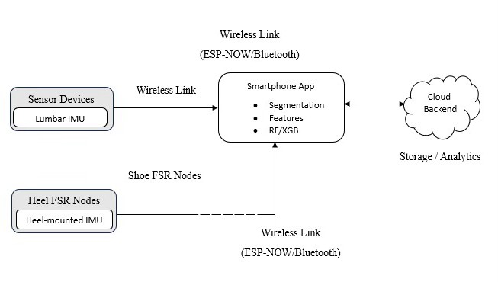
Figure 4a. System architecture representing IMU at Lumbar and Heel, Shoe FSR Nodes, Wireless Link to smartphone and cloud backend.

METHODOLOGY
- Preprocessing
IMU and FSR signals are filtered using 4th order Butterworth LPF with cutoff frequency approximates to 20Hz, it removes high frequency noise while preserving the gait dynamics. Sliding windows of 1.0s with 50% overlap is extracted and additional experiments with 0,5s and 2s windows are conducted in order to evaluate the temporal sensitivity.
- Feature Engineering
All features were computed for every window and are grouped together into four categories:
IMU features mean, variance, RMS of acceleration, RMS of angular velocity, peak angular jerk are measured in. For each 1s window 𝑤 containing 𝑁 samples of IMU x [n], the mean equation (1), variance equation (2), and RMS equation (3) values are calculated using these formulas:
$$μ_{w}=\frac{1}{N}\overset{N}{\underset{n=1}{∑}}x[n]$$
(1)
$$σ_{w}^{2}=\frac{1}{N-1}\overset{N}{\underset{n=1}{∑}}(x[n]-μ_{w})^{2}$$
(2)
$${RMS}_{w}=\sqrt{\frac{1}{N}\overset{N}{\underset{n=1}{∑}}x[n]^{2}}$$
(3)
These statistical measures reflect how stable the gait is and how consistently the trunk moves, which tend to vary noticeably between normal walking and compensatory patterns.
Temporal features: cadence, step interval, stance/ swing ratio.
Pressure features: Heel-to-toe ratio, COP shift magnitude, regional peak pressures, left-right load distribution.
The heel-to-toe pressure ratio is computed using heel Ph[n] and forefoot Pt[n] FSR signals in equation (4):
$$R_{HT}=\frac{∑_{n∈w}P_{h}[n]}{∑_{n∈w}P_{t}[n]+ϵ}$$
(4)
where 𝜖 is a small constant to avoid numerical instability. This ratio reflects forward–rear-foot loading patterns and is sensitive to compensatory gait due to lumbar discomfort.
- Symmetry features: gait symmetry index and plantar-pressure asymmetry.
Gait symmetry is quantified using a symmetry index for left (XL) and right (XR) gait features. Higher values indicate asymmetric loading; a known indicator of compensatory patterns associated with sciatica- related discomfort.
The final feature vector contains 48 elements (36 IMU + 12 pressure). SHAP explainability analysis is later used to identify contribution of each feature to the model decision boundary.
- Classification Model
Tree-based ensemble models were selected due to their robustness on small and heterogeneous datasets, interpretability, and low inference latency suitable for deployment in resource-constrained mobile and edge environments. Random Forest (RF) with 100 trees was used as a baseline due to its stability against noise, automatic feature selection, and resistance to overfitting. Extreme Gradient Boosting (XGBoost) is additionally evaluated which offered better discriminative power through the boosted decision trees and regularized optimization. This produced slightly higher recall on risk windows.

- Validation Protocol
First evaluated the model using 5-fold cross-validation on data that included both normal and compensatory gait. A LOSO experiment was also run, where each participant was tested separately while model was trained on all remaining subjects. LOSO reduces subject- specific bias and approximates real-world deployment on unseen users. Performance metrics include accuracy, precision, recall, F1-score, sensitivity, specificity, ROC- AUC, and fold-wise standard deviation shown in figure 4(b).
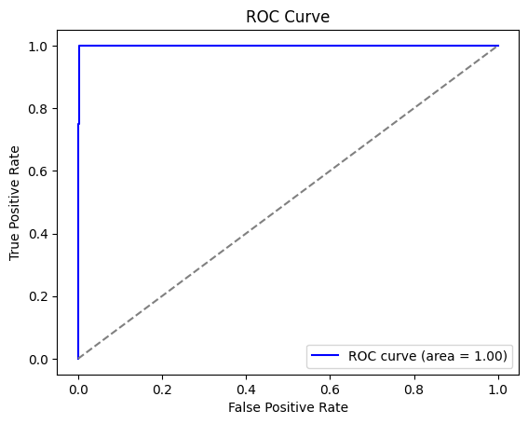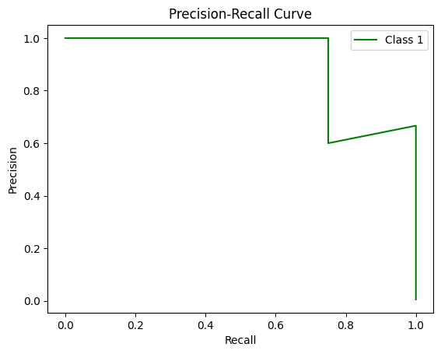
Figure 4b. Representation of roc curve and precision curve

DATASETS AND RESULTS
- Dataset Summary
The current study uses a preliminary dataset collected from 10 volunteer participants, consisting of synchronized IMU signals from the lumbar belt and bilateral shoe units along with plantar-pressure data from dual FSR nodes.
To support broader generalizability and improve statistical robustness, an expanded dataset collection protocol using 50 participants has been designed. This extended dataset will include a more diverse demographic distribution and clinically verified gait labels.
- Expanded Dataset (50 Participants)
The extended study will recruit 50 participants across varying age groups and gait conditions:
- Age range: 18-65 years
- Groups: Healthy individuals confirmed sciatica cases, and subjects with lower-back related gait deviations.
- Gender distribution: Balanced
- Anthropometrics: Varied BMI and gait-speed ranges.
- Planned Labelling Method: All gait segments in the expanded dataset will be verified by physiotherapists.
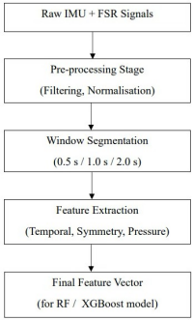
Figure 5. Overall system workflow from signal acquisition to feature vector generation.

The figure 5 presents the step-by-step workflow followed in the study, starting from the moment sensor data are recorded until a final feature vector is prepared for classification. Initially, the IMU and FSR sensors capture continuous acceleration, rotation, and foot-pressure signals during walking. These raw signals often contain noise and small irregularities, so they are first passed through a pre-processing stage where filtering, drift removal, and normalization are applied to make the data cleaner and more consistent across subjects. After this, the continuous stream is divided into short, fixed-length segments of 0.5, 1, or 2 seconds so that each window represents a small portion of the gait cycle. Within every window, meaningful characteristics are extracted—such as timing information.
- Performance Metrics
Performance was computed on a held-out test set of 500 windows. Metrics (Table II) are averaged across folds.
I. PRELIMINARY DATASET SUMMARY
Item | Value
Volunteer participants | 10 (trial)
Total labelled windows | ≈ 2,200
Window length | 1.0 s (50% overlap)
Sampling rate | 50–100 Hz
Test set (held-out) | 500 windows

II. EXPANDED DATASET SPECIFICATION
Item | Value
Total participants | 50
Age range | 18–65 years
Groups | Healthy / Sciatica /  Back-pain gait
IMU channels | 36
Pressure channels | 12
Sampling rate | 50–100 Hz
Total windows | 10,000–12,500
Window sizes | 0.5 s, 1.0 s, 2.0 s
Labeling | Physiotherapist-verified
Validation | 5-fold CV + LOSO
Stratification | Age, gender, BMI,  gait speed

- Validation Protocol
Two validation methods will be employed in both preliminary and expanded datasets:
- 5-Fold Cross-Validation – evaluates overall model stability.
- Leave-One-Subject-Out (LOSO) – evaluates subject-independent performance and generalization.
Performance will be reported using:
  - Accuracy
  - Precision & Recall
  - F1-score
  - ROC–AUC
  - Class-wise sensitivity & specificity
  - Confidence intervals
  - Inter-subject variability
Statistical significance will be evaluated using paired tests such as t-test or Wilcoxon based on distribution characteristics.
- Preliminary Results (10 Participants)

Initial evaluation on the 10-participant dataset yielded the metrics in Table II on a held-out set of 500 windows.

- Confusion Matrix

A significance test on predicted probabilities indicated a meaningful separation between Normal and Risk gait classes.
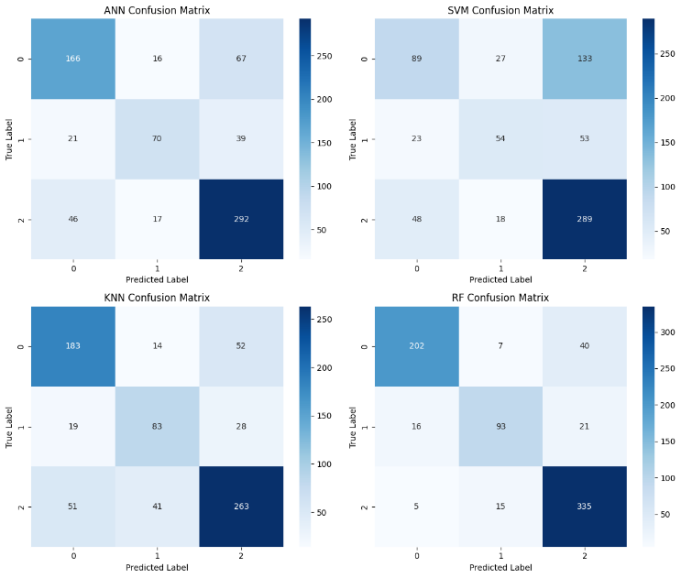
Figure 6. Confusion matrix showing model predictions for Normal and Risk gait classes on the 500-window test set.
- Additional Analyses
- Window-Size Sensitivity
  - 1.0 s windows achieved the best trade-off between responsiveness and stability.
  - 0.5 s windows increased noise.
  - 2.0 s windows reduced sensitivity to short gait deviations.

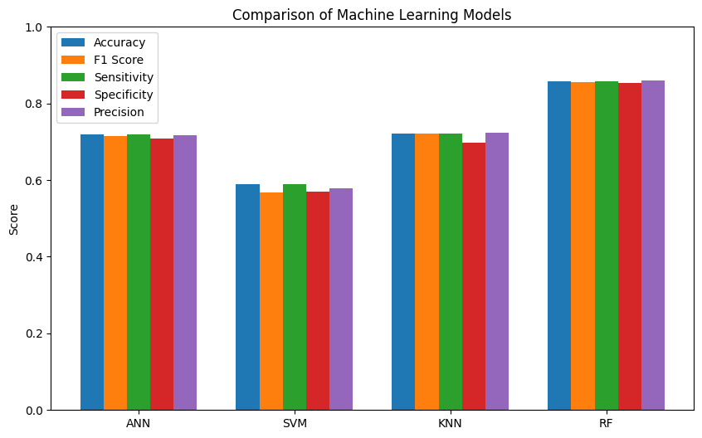
Figure 7. Effect of window size on model performance (Accuracy and F1- score).
- Feature Importance SHAP-based analysis showed that:
  - Heel-to-toe ratio
  - COP shift magnitude
  - Left–right loading asymmetry
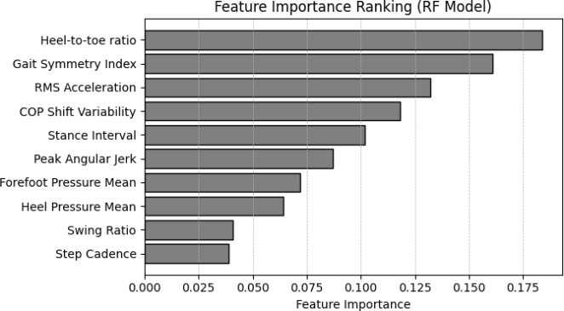
  - Trunk rotation variance

Figure 8. Feature importance ranking for the Random Forest classifier, highlighting dominant temporal and plantar-pressure predictors.
were the most influential features.

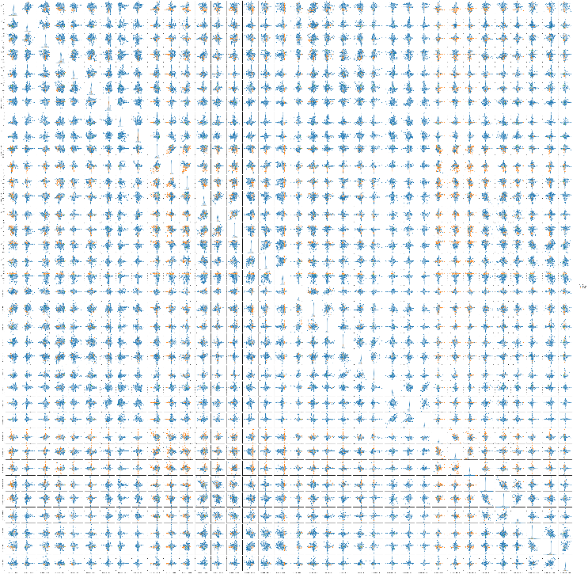
Figure 9. Real time analysis of IMU sensor analysis

DISCUSSION AND FUTURE WORK
The proposed belt-to-shoe sensing architecture demonstrates clear potential for continuous, ambulatory sciatica-risk monitoring. Preliminary findings from the 10- participant dataset indicate that temporal and plantar- pressure–derived features such as heel-to-toe ratio, gait symmetry index, and COP shift magnitude are highly sensitive to compensatory gait deviations associated with lower-back LOSO irritation of imu sensor in figures 6-10.
Across the tested configurations, the 500-window model yielded the highest accuracy at 91.8%, suggesting that this window length provides a more stable balance between signal variability and information captured from each gait cycle. LOSO evaluation further revealed that most errors occurred in participants whose discomfort-induced gait remained close to normal, emphasizing the influence of individual movement styles. These results motivate the need for studies involving larger and more heterogeneous groups.
In the future scope Advanced Temporal Modelling of deep models (LSTM, GRU, Temporal Convolution Networks, and Transformers) helps in capturing long-range gait dependencies and subtle compensatory patterns. Interpretability tools will be extended to show which specific time segments, asymmetry measures, or pressure shifts influence each prediction. Making these aspects visible can help physiotherapists understand why the system flags certain gait deviations. Data collected from 50 participants having different age, BMI, gait patterns, and clinical categories. This enables stratified analysis and improved generalizability.

CONCLUSION
This study developed a lightweight wearable setup that links a belt-mounted IMU with pressure sensors at the shoes to monitor gait changes linked to early sciatica risk. Using synchronized temporal and statistical features with a Random Forest classifier, the system reached 91.8% accuracy on a 500-window test set collected from ten participants. The results suggested that the changes in heel- to-toe loading, gait symmetry, and small shifts in the centre of pressure are reliable markers of compensatory movement associated with the lower-back nerve irritation.
The overall design supports everyday use; it has very low latency processing suitable for mobile and clinical settings. Although the dataset was small, the findings show promise results for a practical belt–insole fusion method for identifying early alterations in gait. Future work will involve a larger and more varied participant group, physiotherapist- verified labels, and deeper sequence-modelling approaches to progress toward a clinically usable system.

REFERENCES

References
[1] | A. Sampath Dakshina Murthy, T. Karthikeyan, and R. Vinoth Kanna, “Gait-based person fall prediction using deep learning approach,” Soft Comput., vol. 26, no. 23, pp. 12933–12941, 2022.
[2] | International journal of pharmaceutical research. SynthesisHub Advance Scientific Research, 2018.
[3] | A. Sampath Dakshina Murthy, T. Karthikeyan, B. Omkar Lakshmi Jagan, and C. Usha Kumari, “Novel deep neural network for individual re recognizing physically disabled individuals,” Mater. Today, vol. 33, pp. 4323–4328, 2020.
[4] | A. Triantafyllou et al., “Application of wearable sensors technology for lumbar spine kinematic measurements during daily activities following microdiscectomy due to severe sciatica,” Biology (Basel), vol. 11, no. 3, p. 398, 2022.
[5] | C. Senanayake and S. M. N. A. Senanayake, “A computational method for reliable gait event detection and abnormality detection for feedback in rehabilitation,” Comput. Methods Biomech. Biomed. Engin., vol. 14, no. 10, pp. 863–874, 2011.
[6] | M. Nivethitha, G. Yashwanth Raj, and P. Kathir, “A novel wearable device to indicate sciatic nerve pressure,” in 2024 5th International Conference on Intelligent Communication Technologies and Virtual Mobile Networks (ICICV), 2024.
[7] | R. Dai, R. B. Stein, B. J. Andrews, K. B. James, and M. Wieler, “Application of tilt sensors in functional electrical stimulation,” IEEE Trans. Rehabil. Eng., vol. 4, no. 2, pp. 63–72, 1996.
[8] | J. Taborri, S. Rossi, E. Palermo, F. Patanè, and P. Cappa, “A novel HMM distributed classifier for the detection of gait phases by means of a wearable inertial sensor network,” Sensors (Basel), vol. 14, no. 9, pp. 16212–16234, 2014.
[9] | D. Zeng et al., “Research on a gait detection system and recognition algorithm for lower limb exoskeleton robot,” J. Braz. Soc. Mech. Sci. Eng., vol. 43, no. 6, 2021.
[10] | M. D. Sánchez Manchola, M. J. Pinto Bernal, M. Munera, and C. A. Cifuentes, “Gait phase detection for lower-limb exoskeletons using foot motion data from a single inertial measurement unit in hemiparetic individuals,” Sensors (Basel), vol. 19, no. 13, p. 2988, 2019.
[11] | S. M. Razi Kazim Naqvi, A. Iqbal, S. Z. Ameen, and N. Afzal, “Acupressure based therapeutic smart shoe for developing countries,” in 2022 24th International Multitopic Conference (INMIC), 2022.
[12] | P. Revathi, R. Mouleeshuwarapprabu, K. Namitha, P. R. Prabhuraam, and V. Praveenkumar, “Development of IoT-enabled smart shoe for gait prediction and abnormality analysis,” IET Conf. Proc., vol. 2023, no. 22, pp. 67–72, 2023.
[13] | Y. Wang, Z. Li, Z. Guo, Y. Ding, Z. Huan, and L. Chen, “A wearable gait assessment method for lumbar disc herniation based on adaptive Kalman filtering,” arXiv [cs.RO], 2023.
[14] | F. Lin, A. Wang, Y. Zhuang, M. R. Tomita, and W. Xu, “Smart insole: A wearable sensor device for unobtrusive gait monitoring in daily life,” IEEE Trans. Industr. Inform., vol. 12, no. 6, pp. 2281–2291, 2016.
[15] | J. Sudharshan, G. Goodman, and N. Bourbakis, “Smart shoes for temporal identification and corrections to assist people with abnormal walking patterns,” in 2020 IEEE 20th International Conference on Bioinformatics and Bioengineering (BIBE), 2020.
[16] | Z. Guo et al., “Intelligent diagnosis and predictive rehabilitation assessment of chronic ankle instability using Shoe-Integrated Sensor System,” IEEE Trans. Neural Syst. Rehabil. Eng., vol. 33, pp. 1978–1985, 2025.
[17] | B. K. Jk and S, Aswadh Khumar G, “Assessing smart algorithms for gait phases detection in lower limb prosthesis: A comprehensive review,” arXiv [cs.RO], 2023.
[18] | Z. Choffin et al., “Ankle angle prediction using a footwear pressure sensor and a machine learning technique,” Sensors (Basel), vol. 21, no. 11, p. 3790, 2021.
[19] | F. Zhang et al., “Wearable fiber Bragg grating sensors for physiological signal and body motion monitoring: A review,” IEEE Trans. Instrum. Meas., vol. 74, pp. 1–24, 2025.
[20] | H. Cui, Y. Wang, G. Li, Y. Huang, and Y. Hu, “Exploration of cervical myelopathy location from somatosensory evoked potentials using random forests classification,” IEEE Trans. Neural Syst. Rehabil. Eng., vol. 27, no. 11, pp. 2254–2262, 2019.

