Android Quiz Game for Computer Fundamentals, A Fun and Interactive Learning Tool

- INTRODUCTION

Advancements in technology have transformed the way people communicate, work, and learn. One of the most significant innovations shaping modern life is the rise of smartphones. The rapid evolution of mobile technology ushered in an era where smartphones became essential in education, business, and daily life. Their increasing accessibility enabled more flexible learning, breaking traditional limitations. Educational technology adoption helps
to support flexible learning environments while enhancing students’ interaction with instructional content when appropriately designed 1.
The shift toward online and mobile supported learning environments has further emphasized the importance of having a interactive and easily accessible learning tools. Furthermore, studies on online, offline, and blended learning approaches indicates that technology-based learning can improve learners’ motivation and accommodate varying learning preferences 2. Gamification has been widely applied in education as a strategy to increase learners’ motivation and participation in class 3. The integration of game elements such as challenges, points, and feedback has shown to positively influence creativity, engagement, and learning outcomes, particularly when the game mechanics are aligned with the educational objectives 4.
With the widespread use of mobile devices and the rapid evolution of technology, Android has emerged as a practical platform for delivering applications for education due to its accessibility and flexibility5. In programming education, gamified quizzes and formative assessments have demonstrated effectiveness in improving student involvement and enhancing learning. Incorporating essential features such as leaderboards and immediate feedback in online quizzes enhances student engagement and performance 6.
At Pangasinan State University – Alaminos City Campus, the BSIT program has always been about finding a good balance. By mixing classic classroom face to face interactions with self- paced learning modules and digital activities, the faculty has built a reliable routine that helps the students to navigate along their studies throughout their college years. While this approach served its purpose well, it is now susceptible to challenges for both the faculty and the students. One of the major difficulties is students’ engagement, as students now have diverse learning styles, which can limit the effectiveness of traditional instructional methods.
To develop a mobile educational game suited for learners, the proponents examined the learning processes of BS Information Technology students at Pangasinan State University – Alaminos City Campus. The Android quiz game, 404 IQ Not Found, is designed as a supplementary educational tool to support students and gaming enthusiasts. By incorporating gamification into the subject Computer Fundamentals—which includes basic concepts such as hardware, software, operating systems, and data representation—the game aims to make

learning more interactive and engaging. Through subjects such as Introduction to Computing (CC 101), Fundamentals of Programming (CO 102), Intermediate Programming (CC 103) and Computer Organization (CO 101), the project turns complex academic concepts into an engaging and enjoyable gaming experience, seeking to bridge the gap between classroom education and digital entertainment.

- METHODOLOGY

The proponents utilized both a descriptive and developmental research approach to develop Android Quiz Game for Computer Fundamentals: A Fun and Interactive learning tool for Bachelor of science in information technology students at the Pangasinan State University – Alaminos City Campus. The descriptive research techniques such as surveys, and interviews were used to identify the learning challenges, and student engagement issues that the students and faculty face related to the teaching of Fundamentals of Programming. This approach enabled the documentation and the assessment of the processes that could be enhanced by developing a system by transforming traditional teaching methods, and paper quizzes into an interactive, engaging, and user-friendly mobile learning tool. Thus, using developmental approach guided the design phase and the development of the proposed system, ensuring that the features, game mechanics, and learning strategies aligned with the identified user requirements and educational objectives. this approach supported an iterative process for design, development, and evaluation, allowing the proponents to continuously refine and produce a fully functional, effective, and reliable learning application.
In developing the system, the proponents utilized the Agile Methodology as the SDLC framework. Agile was chosen for its flexibility, adaptability to changes, and prioritizing on continuous feedback from users and improvement throughout the development. The methodology enables the developers to work in short, structured and manageable cycles also called as sprints, allowing the team to gradually deliver functional elements and apply continuous refinements based on the test and evaluation results. The development process was carried out through six key phases – the Requirements Phase, Design Phase, Development Phase, Deployment, and Review Phase, also illustrated in Fig 1. below. This ensures that the final application met both the educational objectives and user needs.
Fig 1. Agile Model
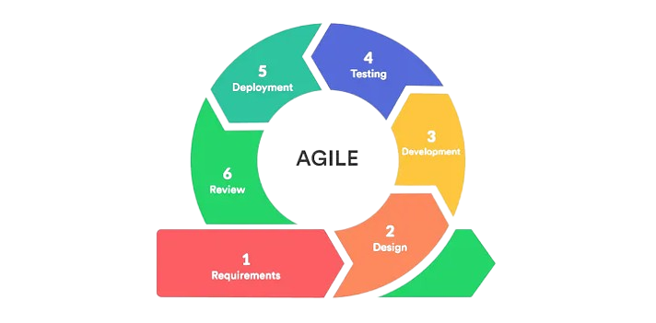
Source: https://medium.com/@chathmini96/agile- methodology-30ec4cdf3fc

Here at the requirements phase, the developers plan and gather the data necessary for the development. The team talks with the client or users to understand what they want from the project. Instead of long documents, the needs are written down as simple task. The developers focused on gathering accurate data to guide the development of the project. The proponents conducted interviews to the users of the game such as the BSIT students, this is to identify and understand their needs, preferences, and challenges when studying Computer Fundamentals. The data collected was analyzed and was used to identify the user requirements.
Design phase is where the team plans how the system will look and work. The team create assets, diagrams, and prototypes to guide development. This way, changes can be made easily if new ideas or feedback come up. The developers converted the gathered into structured plans and visual layout that guide development. Using an Entity Relationship Diagram (ERD) to represent how the data was organized and connected within the system. Also created Use Case Diagram with detailed descriptions show how users interact with the game along with hierarchy charts to illustrate the system logic and a flowchart to identify the existing process. Lastly by designing the user interface ensured the game was user friendly, engaging, and aligned with the learning goals of the students.
The Development phase, here the team brings the blueprint to life by coding and building of the product happens. In this phase we began to write the actual code that brought the quiz game to life based on the data and requirements gathered. We conducted initial testing with our adviser to check if basic functions work as expected and to identify areas for improvement. Debugging was also a crucial part of this phase, allowing us to asses and correct errors or bugs to ensure smooth performance. The preparation of usability and acceptability evaluation papers was also planned during this stage.
The Testing phase, every new feature is checked to make sure it works properly and doesn’t cause problems with the rest of the system. The developer focused on checking and testing the performance and reliability of the quiz game to ensure that it meets the intended requirements. By having a dummy data, we were able to simulate different scenarios and identify possible issues without affecting the real user information. Through this, we gathered information which helps us to debug and fix setbacks immediately.
The finalized system will be introduced to the locale in the deployment phase. Once the new features have been developed and tested, they are ready to be deployed, or released, to the end-users or a production environment. The developers introduced the system to the users, ensuring that it operated effectively in a real-world environment. This involved presenting the game to the locale to demonstrate its functionality and gather their feedback, as well as showing it to IT experts to validate its performance and ensure that it complied to the standards. With these steps followed, we continued to debug errors, refine the system to make it fully functional, as well as optimized for usability, reliability, and efficient system.

Review phase, finally the team and stakeholders look back at the work completed. They discuss what went well, what problems were faced, and how to improve. The developers gathered user feedback using acceptability and usability assessments to ensure that the system met their wants and needs, fix bugs, and implement new features based on the feedback received from testers. Enhancements such as adding more quiz topics and UI improvements will help keep users engaged over time. Additionally, we finalize the manuscript, prepare presentation materials.
The respondents of the study consisted of thirty-one (31) participants, composed of thirty (30) first-year students of Pangasinan State University – Alaminos City Campus and one
(1) IT expert. The BSIT students were selected by using purposive sampling to ensure that the participants had hands-on experience with the Computer Fundamentals subjects, while the IT expert provides the technical insights for the system.
TABLE I
RESPONDENTS OF THE STUDY
Respondents | Number of Respondents
First Year BSIT Students | 30
IT expert | 1
Total | 31

Quantitative statistical approach was used to assess the result from the evaluation of the respondents during the usability and acceptability of the system. The proponents utilized a 5 – point Likert scale, where the highest rating indicated “Excellent” and the lowest indicated “Poor”, as presented on the table below. The responses collected were then analyzed using weighted mean to determine the overall level of system usability, performance, and user acceptance.
TABLE II
SCALE OF MEASUREMENTS
Rating | Scale | Statistical boundaries | Descriptive Interpretation
Poor | 1 | 1.00 – 1.75 | Not Accepted
Fair | 2 | 1.76 – 2.50 | Not Accepted
Good | 3 | 2.51 – 3.50 | Accepted
Very Good | 4 | 3.51 – 4.00 | Accepted
Excellent | 5 | 4.01- 5.00 | Accepted

- RESULTS AND DISCUSION

The Android Quiz Game for Computer Fundamentals system was designed to address the limitations that is linked to traditional learning methods, which often result to reduced motivation and engagement among students studying subjects within Computer Fundamentals. Through conducting interviews with BSIT students of Pangasinan State University - Alaminos City Campus, the proponents identified the need for a more enjoyable, interactive, and self-paced learning method. To meet this need, the system titled Android Quiz Game for Computer Fundamentals a Fun and Interactive Learning Tool aimed to enhance motivation, retention, and participation
without compromising the quality of education, this way the system provides a modern educational tool that promotes active learning. The following discussion highlights the conceptual framework for the Android Quiz Game for Computer Fundamentals a Fun and Interactive Learning Tool. The systems framework is show in the Fig. 2 below.
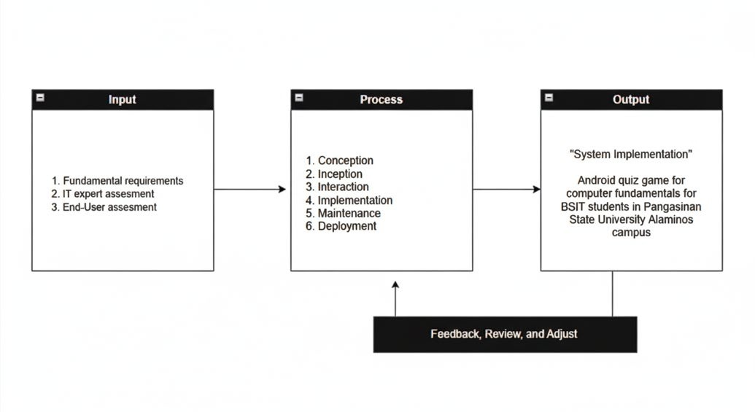
Fig. 2 Input Output Process
The Input-Process-Output (IPO) framework is a model that is used to describe how a system functions whether it is a computer program, a business operation, or a research study. It is a representation of all factors that make up a process on a system 7.
The inputs serve as the foundational elements that initiate the entire development process. These include the knowledge requirements such as background research on the fundamentals of Information Technology and the principles of gamified learning. The team also conducted a review of related literature, established clear project objectives, and held brainstorming sessions and initial consultations with students and faculty. Software requirements consist of the necessary development tools, including Unity Hub and Visual Studio, which were used for both frontend and backend development, along with Photon, and firebase for multiplayer hosting server and real-time database management. Hardware requirements include devices such as laptops or PCs for development, as well as Android smartphones for testing the application in a real-world environment. User requirements were obtained through informal interviews and observation, which helped shape the design of quiz categories, and difficulty.
The process stage outlines the phases of project execution, beginning with the initial interviews and documentation. During this phase, relevant data was gathered to identify existing learning challenges and scope the project requirements, followed by formal acceptance from the target academic department. System design followed, involving the creation of layouts, interface mockups, and quiz structure diagrams that outlined the app’s visual and functional elements. This helped form the blueprint of the system.
The output of the process is a fully functional Android quiz game designed specifically to enhance the learning of Computer Fundamentals. The app includes user-friendly interfaces, categorized quizzes, real-time scoring, and feedback

features that make learning more interactive and effective. Furthermore, the system outputs include both technical documentation, which describes the system architecture, code structure, and development process, and user documentation, which provides step-by-step instructions and troubleshooting information for end users. Ultimately, the application seeks to improve student motivation, engagement, and knowledge retention through a gamified mobile learning experience.
System Architecture and Features The development of "404 IQ Not Found" focused on creating a seamless user experience that balances technical performance with educational value.
The core of the system is built on a responsive UI that adapts to various Android screen sizes. As illustrated in Figure 2, the application features a distinct retro-pixel art style in the Main Menu to appeal to the target demographic's gaming preferences.
Crucially, to address the issue of limited internet access, the application includes a Study Room mode featuring a digital Book Interface (shown in Figure 5). This module allows students to review comprehensive lecture notes and modules offline, ensuring that learning can continue even without a data connection.
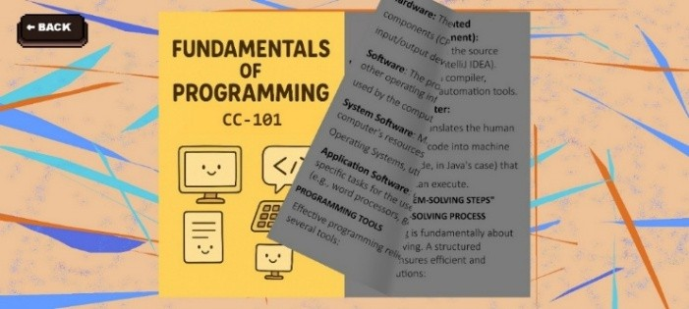
Fig. 5 Book Interface


Fig. 2 Main Menu

Quantitative Evaluation of Acceptability To measure the effectiveness of the system; the proponents conducted a comprehensive survey based on ISO/IEC 29110 standards. The evaluation focused on functionality, reliability, and user satisfaction. The summary of these findings is presented in Table III.

To foster engagement, the Leaderboard System (shown in Figure 3) updates in real-time, pulling data from Firebase to display global rankings. This serves as a primary motivator for student competition.
TABLE III
OVERALL ACCEPTANCE LEVEL


Fig. 3 Leaderboards
Assessment | Mean | Description
1. System Functionality and Relevance | 4.52 | Strongly Agree
2. Performance and Reliability | 4.31 | Strongly Agree
3. User Satisfaction | 4.56 | Strongly Agree
4. Learnability and Understandability | 4.20 | Agree
5. Operability and User Interface | 4.39 | Strongly Agree
6. Efficiency and Satisfaction | 4.46 | Strongly Agree
Weighted Mean: | 4.41 | Strongly Agree

Furthermore, the Quiz Interface, depicted in Figure 4, was designed for clarity. It presents questions with immediate visual feedback—green for correct answers and red for incorrect ones—to reinforce learning instantly.
Fig. 4 Quiz Interface


The Table 3 shows the overall Acceptance level, with a computed weighted mean of 4.41 and have a descriptive equivalent of strongly agree, underscores the Android Quiz Game excellence and suitability for an alternative learning platform and a material for learning Computer Fundamentals. This positive evaluation outcome indicates that not only that the application meets the users’ requirements, but also exceeds the user expectations for the game, positioning it as a valuable tool for learning Computer Fundamentals in a modern educational environment. The comprehensive evaluation, which analyzed six key characteristics-System Functionality and Relevance (4.52), Performance and Reliability (4.31), User Satisfaction (4.56), Learnability and Understandability (4.20), Operability and User Satisfaction (4.39), and Efficiency and Satisfaction (4.46)-resulted in a final overall weighted mean of 4.41.this robust result indicates that students perceive the application as highly beneficial to their overall learning needs, suggesting that interactive digital tools can enhance comprehension and retention when designed thoroughly and valuable for other

subject areas, providing a promising direction for future educational technology advancements.

- CONCLUSION

Advancements in technology have transformed the way people communicate, work, and learn. The rapid evolution of mobile technology gave opportunity to an era where smartphones became essential in education, and daily life. The shift toward online and mobile supported learning environments has further emphasized the importance of having a interactive and easily accessible learning tools. The development and design of the Android Quiz Game crafted to address critical challenges faced by both the faculty and students on varying learning preferences. By aiding traditional methods of teaching, the system integrates gamification to add interaction, motivation, enjoyment and accessibility for different users.
With these outcomes, the study contributes to the growing body of educational technology solutions that leverage mobile platforms and gamification to support academic performance and enhance the student learning experience. Future enhancements may include the addition of more quiz content, broader subject coverage, and expanded multiplayer features to further increase scalability and academic value.
REFERENCES

- Granić, A. (2022). Educational technology adoption: A systematic review. Education and Information Technologies, 27(7), 9725–9744. https://doi.org/10.1007/s10639-022-10951-7
- Sharma, D., Sood, A. K., Darius, P. S. H., Gundabattini, E., Gnanaraj, S. D., & Jeyapaul, A. J. (2022). A study on the online-offline and blended learning methods. Journal of The Institution of Engineers (India): Series B, 103, 1373–1382. https://doi.org/10.1007/s40031-022-00766-y
- Boom-Cárcamo, E., Buelvas-Gutiérrez, L., Acosta- Oñate, L., & Boom-Cárcamo, D. (2024). Gamification and problem-based learning (PBL): Development of creativity in the teaching-learning process of mathematics in university students. Thinking Skills and Creativity, 53, 101614. https://doi.org/10.1016/j.tsc.2024.101614
- Oliveira, W., Hamari, J., Shi, L., Toda, A. M., Rodrigues, L., Palomino, P. T., & Isotani, S. (2023). Tailored gamification in education: A literature review and future agenda. Education and Information Technologies, 28, 373–406. https://doi.org/10.1007/s10639-022-11122-4
- Bong, S. W., Chen, W. K., & Ringgau, D. A. (2022). Design and development of a smart CNF app for DEC30023 Computer Networking Fundamentals course. Malaysian Journal of Innovation in Engineering and Applied Sciences, 1(1), 1–9. Retrieved from
http://myjieas.psa.edu.my/index.php/myjieas
- Cigdem, H., Korkusuz, M. E., & Karaçaltı, C. (2024). Gamified learning: Assessing the influence of leaderboards on online formative quizzes in a computer programming course. Computer Applications in Engineering Education, 32(2), 479–
493. https://doi.org/10.1002/cae.22697
- Isagani, C. C., (2024). Input-Process-Output Model. https://discover.hubpages.com/education/IPO-Model- of-Research

