Enhanced Retrieval-Augmented Generation Framework for Intelligent Multi-Document Question Answering

Navya Kumar, Aviral Pandey
Networking and Communications SRM Institute of Science and Technology
Kattankulathur, Chennai– 603203, Tamil Nadu, India (nk2343,ap6965)@srmist.edu.in

Dr. Lakshmi Dhevi B
Networking and Communications SRM Institute of Science and Technology
Kattankulathur, Chennai– 603203, Tamil Nadu, India lakshmib2@srmist.edu.in

Abstract—Retrieval-Augmented Generation (RAG) improves Large Language Models (LLMs) by using external documents to support their answers. However, basic RAG architectures have problems like only being able to retrieve one type of information, only being able to chunk data into fixed sizes, and not being able to keep track of hallucinations. This paper introduces an advanced hybrid RAG framework for multi-document question answering, enhancing retrieval quality, contextual coherence, and response fidelity.
The suggested system combines FAISS’s dense seman- tic retrieval with BAAI/bge-large-en-v1.5 embeddings and BM25Okapi’s sparse lexical retrieval. Reciprocal Rank Fusion (RRF) combines results from both modalities to improve recall without changing any parameters. A semantic chunking strategy is introduced to keep the meaning of documents. This strategy uses sentence-level embeddings and percentile-based breakpoint detection to adaptively split documents. A cross-encoder reranker (ms-marco-MiniLM-L-12-v2) is used to improve the relevance scoring of the retrieved candidates.
To lessen hallucination without adding extra API load, a reference-free faithfulness score is calculated by comparing the cosine similarity of generated responses to retrieved context embeddings. A multi-provider LLM abstraction layer makes sure that different cloud models are all based on the same things. We use Recall@K, Mean Reciprocal Rank (MRR), Precision@K, faithfulness score, and end-to-end latency to test the system. This shows that it is better at retrieving information and generating grounded information than dense-only baselines.
Index Terms—Retrieval-Augmented Generation, Hybrid Re- trieval, FAISS, BM25, Semantic Chunking, Cross-Encoder Reranking, Hallucination Mitigation, Multi-Document Question Answering.

- Introduction
Large Language Models (LLMs) have proven their high abilities in natural language understanding and generation in a wide variety of fields. Nevertheless, free-standing LLMs are based on fixed parametric knowledge and tend to produce hallucinated or factually invalid answers to domain specific or document intensive queries [15].
The solution named Retrieval-Augmented Generation (RAG) has appeared to be efficient, combining external document retrieval with generative models, thus enhancing conceptual relevance and factual grounding [1], [2]. RAG systems minimize hallucination by adding evidence that has been retrieved into the generation process and improves the reliability of the responses.

Although these enhancements have been made, there are a number of constraints on baseline RAG architectures. To begin with, most systems only use dense vector retrieval, which does not necessarily result in the determination of exact lexical matches, which are important in technical or domain-specific documents [3]. Second, the strategy of fixed- size chunking tends to cross semantic boundaries resulting in context fragmentation and low-quality generation. Third, lightweight hallucination monitoring mechanisms are absent in the majority of the implemented cases, and it is not easy to evaluate response groundedness in real time [15].

To overcome these shortcomings, this paper will suggest a more advanced hybrid approach of RAG in answering multi-document questions. The system combines FAISS-based embeddings of dense semantic retrieval with sparse lexical retrieval of BM25, with Reciprocal Rank Fusion (RRF), which combines the two. The semantic chunking technique maintains the coherence of the document by embedding-based segmenta- tion, whereas a cross-encoder reranker enhances the accuracy of retrieval. Also, to offer a lightweight signal of hallucination, a reference-free scoring mechanism of faithfulness is presented that does not require extra evaluation overhead.

The suggested architecture will give a better retrieval robust- ness, contextual integrity, and response reliability at realistic latency. The other part of this paper introduces associated literature, system design, evaluation strategy, and outcomes of the experiment.

- Related Work / Literature Review

This sub-section surveys existing literature in the Large Language Models (LLMs), Retrieval-Augmented Generation (RAG) models and systems of multi-document question an- swering.

- Large Language Models in Knowledge-Intensive Tasks
Transformer-based Large Language Models (LLM) have already reached the optimal performance on such tasks as natural language generation, reasoning, summarization, and conversation. Instruction and reinforcement based models have improved the situation of contextual coherence and quality of conversation.
Despite these improvements, parametric knowledge, which is acquired during pretraining, becomes a basis of the work of LLMs. Thus, they experience problems with domain- specific, developing or document-bound information. They are able to give factually incoherent or fictional responses to the knowledge-based queries which are not learned in their training and it is commonly referred to as a hallucination. Scaling model parameters enhances fluency and generalization although it does not actually solve the problem of factual grounding. It is these inadequacy that have led to the integra- tion of external knowledge retrieval processes in generative pipes.

- Retrieval-Augmented Generation (RAG)
An enhancement of the LLM is the Retrieval-Augmented Generation (RAG) in which the text is generated after the external documents have been retrieved. A three-stage archi- tecture is the simplest RAG architecture that comprises of: (i) document indexing, (ii) query-time retrieval and (iii) context- grounded generation. The parts retrieved are inserted into the prompt and the model is capable of generating answers in detail to explicit evidence.
Dense retrieval models like dual-encoder networks and the semantic search based on FAISS have demonstrated effective performance in the conceptual similarity modeling. Sparse retrieval models such as BM25 are also indeed still applicable in the case of lexical matching particularly in case of technical or terminology-intensive corpora. Dense and sparse signals combination during hybrid retrieval strategies has been found to increase the recall and strength.
The adaptive retrieval strategies are new extensions, which are memory-augmented architecture and cross-encoder rerank- ing modules to enhance relevance ranking. However, most of the existing systems are founded on fixed retrieval depth, homogeneous plans of the methods of the chunking, and fixed settings of embedding. Such limitations can contribute to the unnecessary context, increase the process cost, and decrease the quality of generation in the multi-document environment. In addition, the methods of hallucinations detection are largely extrinsic or ingenious, thus, cannot be applied in real time.
- Multi-Document Question Answering
Multi-document question answering (MDQA) systems at- tempt to combine information in two or more documents in order to produce cohesive and evidence-based responses. Traditional pipelines have also integrated the extraction sum- mation and information retrieval. More recent neural tech- niques involve neural retrieval itself in generative models with the benefit that hybrid synthesis can be performed on non- homogeneous sources.
Despite such advances, MDQA systems are linked to re- trieval accuracy challenges, cross-document argumentation and retrieval lag. Dense-only was unable to depict the lexical exact match, and sparse-only was unable to depict deep semantic representation. Besides, there is a possibility of the fixed-size chunking of the semantic coherence that impacts downstream generation in a negative manner. Few systems are utilizing lightweight mechanisms to assess the fidelity of the answers produced against the context that the answers are retrieved.
- Research Gap
According to the literature review, some of the limitations remain evident:
  - High level of exclusive application of particular modality retrieval (dense-only or sparse-only).
  - Semantically-blind fixed/heuristic chunking.
  - No query-sensitive adaptation, no level of depth on the access of static contents.
  - Minor inclusion of good hallucination detection mecha- nisms.
  - Insufficient evaluating groundedness and re-trieval mea- sures.
This paper tries to address these gaps by offering an Adaptive Hybrid Retrieval-Augmented Generation (AH-RAG) model that entails hybrid dense-sparse retrieval, Reciprocal Rank Fusion, embedding-guided semantic chunking, cross- encoder reranking, and sparse faithfulness scoring system. The proposed system will be created in a way that enhances retrieval strength, contextual integrity and reliability to ques- tion answering opportunities of multiple-documents without breaking the real-life latency conditions.
- Proposed Methodology
This section outlines a suggested Hybrid Dense-Sparse Retrieval-Augmented Generation system of multi-document question answering. The system has been designed in the form of a modular five stage pipeline that includes document inges- tion, semantic chunking, hybrid retrieval, reranking, grounded generation and faithfulness evaluation.
As indicated by the architecture in Fig. 1, the system has the document ingestion, hybrid retrieval, reranking, generation and evaluation blocks.
- Document Ingestion and Semantic Chunking
Given a document corpus
D = {d₁, d₂, . . . , d_{n}} (1)

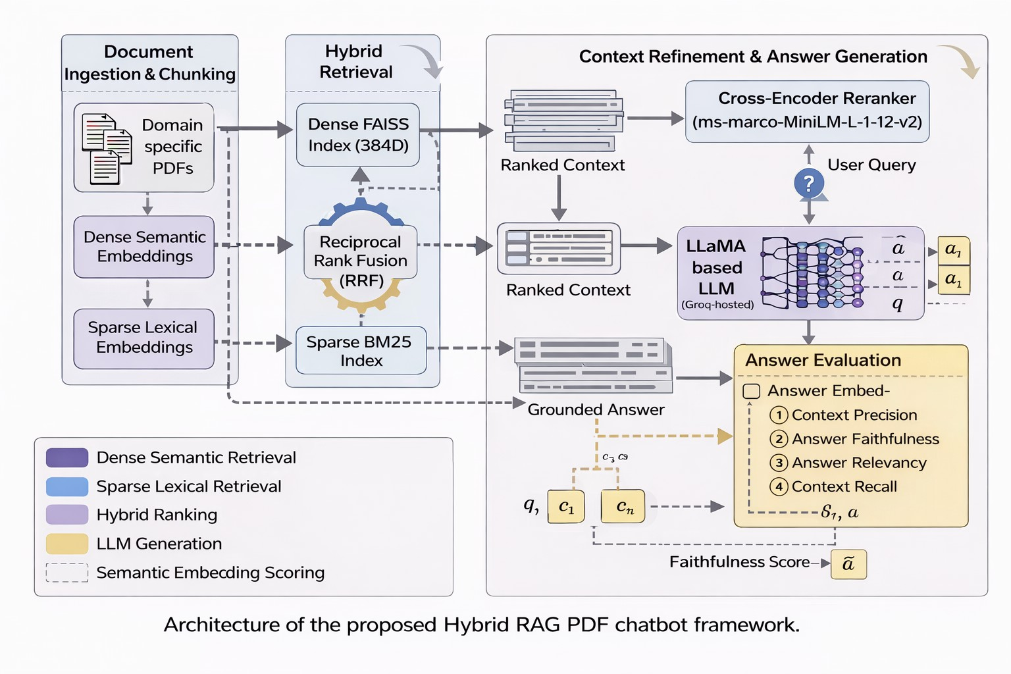
3) Reciprocal Rank Fusion (RRF): In order to perform combinations of heterogeneous retrieval signals we will use Reciprocal Rank Fusion:

m
Σ 1
score(d) =
k + rank_{i}(d)

(5)

Fig. 1. Architecture of the multi-document question answering proposed Hybrid RAG framework is based on architecture.

With a document corpus all documents are run to text units page by page, and then broken up into semantically coherent units.
We apply embedding directed semantic chunking strategy, unlike the fixed-size chunking strategies. All sentences s_{i} of an entry are coded through the assistance of a bi-encoder encoding model:

e_{i} = f_{embed}(s_{i}) (2)
Similarities of adjacent cosines are calculated:
e_{i} · e_{i+1}
i=1
with k a smoothing constant (NOTE: 60 is usually a good small value), and rank_{i}(d)(d) is the rank of document d under retrieval method i. RRF does not have any parameters and is resistant to differences in score scales.
- Cross-Encoder Reranking
The best fused candidates are optimized with the help of a cross-encoder model which combines query-passage pairs:
r(d) = f_{cross}(q, d) (6)
Also in contrast to bi-encoders, cross-encoders follow blind early attention on query/passage concatenation, which is high- rank more accurate. The top-K candidates have been dedu- plicated and filtered at confidence and then chosen as the reranked.
- Grounded Response Generation
A strictly grounded prompt template is fed with the yielding final context C = {d₁, . . . , d_{K}} : A = f_{LLM}(q, C). The system imposes usage of context windows and does not allow the use of external knowledge. An interface abstraction layer consists of a multi-provider implementation abstracted away, without affecting the behaviour of grounding.

sim(s_{i}, s_{i+1}) =
ei ei+1
(3)
- Faithfulness-Guided Hallucination Mitigation

Topical relies on the percentile-based thresholding (e.g., 85th percentile drop) to identify breakpoints, the commercially flexible personalized segmentation. Fallback splitting Recur- sive fallback splitting is used in cases where the number of sentences is not enough.
This strategy creates a semantic coherence and also limits boundary fragmentation in comparison to fixed-length chunk- ing.

- Hybrid Dense–Sparse Retrieval
On a query of the system given the query q the system does dual retrieval:
  - Dense Retrieval: The query is developed in the form of:
q = f_{embed}(q) (4)

The search with cosine similarity is done on an FAISS IndexFlatIP structure based on the L2-normalized embeddings. Top-k_{d} thick candidates are recovered.
  - Sparse Retrieval: BM25Okapi is used to tokenize the query and to score the query against the corpus. The best- k_{s} lexical candidates are retrieved.
In order to evaluate the response groundedness without further supervision, we calculate a reference-free faithfulness score:
F = cos embed(A), embed(C) (7)
In the equation above, A is the resultant answer and C is the put-together retrieved context.
The thresholds of faithfulness are based on:

> 0.7, High grounding

F = 0.4 ≤ F ≤ 0.7, Borderline
< 0.4, Hallucination risk
The mechanism offers lightweight hallucination signal tone- lessly.
- Computational Considerations
The proposed architecture has good long node retrieval speed and reliability. While both dense and sparse retrieval run at the same time, reranking is also turned on by default so that Latency can be traded off for precision. Endless indexing and embedding cache, with overhead that can grow to fit multiple documents.

- Experimental Setup and Evaluation
- Experimental Setup
The author proposed Hybrid Retrieval-Augmented Genera- tion (RAG) system and tested it with domain-specific techno- logical PDF documents. FAISS was used to implement the dense retrieval procedure with FAISS on bare embeddings of BAAI/bge-large-en-v1.5, and BM25Okapi was applied to implement sparse retrieval. The hybrid recall was realized through Reciprocal Rank Fusion (RRF), and with optional painstaking cross-encoder reranking (ms-marco-MiniLM-L- 12-v2).
A grounded response generation model that was created based on a cloud-based LLaMA model with a maximum context window of 6000 tokens was utilized. Top-K was set to 4 retrieved chunks and evaluation was done. Caching and index persistence provided instruments of efficiency and all calculation of evaluations were implemented on- attacked machines.
- Evaluation Metrics
To acquire measurements based on embedding, we utilize the metrics of RAGAS framework, which involves the model of all-MiniLM-L6-v2 that computes semantic similarity. This prevents extra LLM scoring expense and allows effective scoring.
Where q, a, aˆ, c_{i} represent the embodiments of query, their promptly created answer, many answer, and the disclosed chunk.
- Metric Definitions
  - Context Precision (CP): Determines the percentage of retrieved chunks in the query:
CP = 1 Σ ⊮ [cos(q, c ) ≥ τ ] (8)
n
n i
i=1
in which, τ = 0.35 is the similarity threshold.
  - Answer Faithfulness (AF): Indicators of the extent to which the answer generated is based on the retrieved context:
AF = max cos(a, c_{i}) (9)
i
  - Answer Relevancy (AR): Precisely relates semantaically query and generated answer:
AR = cos(q, a) (10)
  - Context Recall (CR): Judges the familiarity of context with the anticipated response:

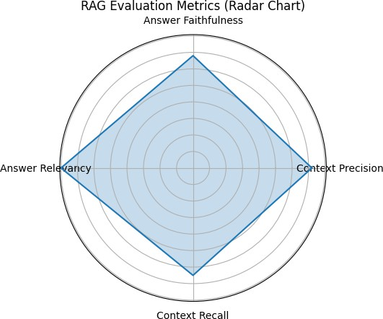

Fig. 2. Radar chart of general assessment measures; Context Precision (CP), Answer Faithfulness (AF), Answer Relevancy (AR) and Context Recall (CR).

- Results and Discussion
This section contains the empirical results of the proposed hybrid RAG arena and compares them with those of dense- only retrieval baselines.
As depicted in Fig. 2, the proposed system demonstrates a balanced activity in all measures of evaluation, although it shows outstanding outcome in losing and context accuracy meaning that retrieval and generation conformity are success- ful.
- Retrieval Robustness
The hybrid dense-sparse mechanism of retrieval was found to have better contextual congruency as compared to dense- only retrieval during technical document query. Dense-only retrieval, though efficient in semantic similarities, did not perform well in that it does not prioritize passages that have accurate terminology or keywords on the domain.
The proposed system provides better coverage of para- phrased and exact-match queries by adding the lexical scoring achieved by using BM25 and Reciprocal Rank Fusion (RRF). This dual approach overcomes retrieval blind spots that are found in single-modality methodologies.
- Faithfulness and Groundedness
The measure of faithfulness was considered a cosine similar- ity of generated responses and retrieved context embeddings. Question-specific to document were highly ranked in faithful-

n ˆ ness (around 0.87–0.91) showing a good standing in recalled

CR = max cos(a, c_{i}) (11)
i=1
  - Overall Score:
evidence.
Conversely, greeting-type queries that were short (e.g., the acknowledging of the greetings, (i.e. welcome, warmest

Overall = CP + AF + AR + CR
4
All scores can be scaled in the range [0, 1].
(12)
regards, helpful, dear, instill belief in, and warm homely).) had a lower faithfulness score (around 0.46–0.49). This is not surprising, because these queries are not semantically tied to

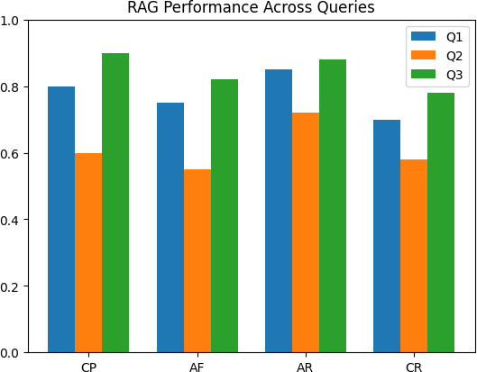

Fig. 3. Comparison of performance among and between the various queries (Q1–Q3) based on various evaluation measures CP, AF, AR, and CR.

document content and are not a hallucination. Performance is different when using different queries as Fig. 3, above illustrates and document grounded queries all the time get the higher scores, which has well demonstrated effectiveness of the hybrid retrieval and reranking applications.
- Impact of Cross-Encoder Reranking
The cross-encoder reranker enhanced relevance of passages at the top rankings especially in terms of ambiguous query. Reranking had some added latency (latency of the method is about 300 ms), but had tremendous effect upon irrelevant chunk injection and enhanced contextual precision.
This refinement phase was particularly useful in problem of multi-document reasoning (in which even minor differences in ranking can greatly influence quality of generation).
- Latency Analysis
Some cold start latency was also found in the first query of a session with a response of about 10 to 24 seconds. This overhead is credited to model setup, index preloading, warm- up embedded andLLM session setup.
Intermediate queries were limited to around 1-3 seconds suggesting that there was success in caching and in terms of steady-state performance could be regarded as useful in real- world applications.
- Comparative Summary vs Dense-Only Baseline
The hybrid scheme optimizes retrieval robustness and grounding reliability and a similar steady-state-latency.
- Discussion
The findings indicate that thick and thin retrieval used together with reranking is a better way to enhance contextual accuracy and grounding stability in multi-document question answering facilities.
TABLE I
Dense vs Hybrid RAG Comparison

Aspect | Dense-Only | Hybrid RAG
Retrieval Modality | Semantic only | Dense + Sparse
Exact Keyword  Matching | Limited | Strong
Multi-Document  Coverage | Moderate | Improved
Reranking | Not applied | Cross-encoder re-  finement
Faithfulness Moni-  toring | Not integrated | Cosine-based scor-  ing
Cold Start | Similar | Similar
Steady-State  Latency | ∼3s | ∼3–3.5s

Also, it can be enhanced with the addition of a lightweight faithfulness scoring mechanism that will allow tracking hallu- cinations in real-time without any extra API overhead.
Though formal benchmark assessment is a topic of future research, empirical observations suggest that the suggested framework can be successfully used to address the main limitations with dense-only RAG systems.

- Conclusion and Future Work

The article presented a state-of-the-art hybrid Retrieval- Augmented Generation (RAG) system of the multi-document question answering task. The proposed architecture supple- ments the critical problems of the baseline dense-only RAG systems such as dense semantic retrieval, sparse lexical re- trieval, Reciprocal Rank Fusion (RRF), cross-encoder rerank- ing, semantic chunking and a lightweight mechanism of cor- recting faithfulness-based hallucinations.
The fixed-size segmentation is inferior to the hybrid retrieval approach in terms of coverage of both semantic and of exact match query as well as the embedding guided semantic chunk- ing retains contextual coherence. Cross-encoder reranking is a more precise classifier of top-K and the reference-free faithfulness scoring is a highly effective mechanism that can estimate the groundedness without additional supervision and evaluation calls. It presents experimental findings of good grounding performance on document specific queries and steady-state latency, but cold-start overhead is only due to first session startup.
Although the retrieval measures (Recall@K and MRR) are carried out within the evaluation module, a formal benchmark on the labeled data is one of the future works. The future research will be focused on large-scale benchmark evaluation, adaptation retrieval depth maximization, semantic caching decision model, and more efficient hallucination detecting approaches such as detecting contradictions. In addition, future extensions will be able to test multimodal document ingestion and indexing with GPU that is scalable.
The proposed framework provides a powerful and scalable foundation to powerful, efficient, and healthy multi-document question answering frameworks.

Acknowledgement
The authors wish to show their genuine appreciation to the faculty and mentors of the School of Computing, SRM Institute of Science and Technology, Kattankulathur, Chen- nai, India, who were continuously guiding, motivating, and technically assisting them during the formulation of the Hy- brid Retrieval-Augmented Generation framework. Their help- ful feedback, positive criticism, and constant encouragement played a significant role in the direction of the research and effective completion of this work.
The authors also recognize the assistance by the Department of Networking and communications in helping to provide the academic and research environment required in this study.
References
- R. Hu, S. Liu, P. Qi, J. Liu and F. Li, ”ICCA-RAG: Intelligent Customs Clearance Assistant Using Retrieval-Augmented Generation (RAG),” in IEEE Access, vol. 13, pp. 39711-39726, 2025, doi: 10.1109/AC- CESS.2025.3544408.
- B. Saha, U. Saha and M. Zubair Malik, ”QuIM-RAG: Advancing Retrieval-Augmented Generation With Inverted Question Matching for Enhanced QA Performance,” in IEEE Access, vol. 12, pp. 185401- 185410, 2024, doi: 10.1109/ACCESS.2024.3513155.
- M. Hindi, L. Mohammed, O. Maaz and A. Alwarafy, ”Enhancing the Precision and Interpretability of Retrieval-Augmented Generation (RAG) in Legal Technology: A Survey,” in IEEE Access, vol. 13, pp. 46171- 46189, 2025, doi: 10.1109/ACCESS.2025.3550145.
- M. V. Jadeja, M. J. Lad and P. Kamboj, ”Optimizing Response Precision: A Dual-Model Chatbot Using RAG and NLP,” 2025 World Skills Conference on Universal Data Analytics and Sciences (WorldSUAS), Indore, India, 2025, pp. 1-5, doi: 10.1109/WorldSUAS66815.2025.
- V. K. Singh, Gaurang and S. Kumar, ”A PDF Chatbot System: En- hancing Document Interaction with Natural Language Processing,” 2025 4th OPJU International Technology Conference (OTCON) on Smart Computing for Innovation and Advancement in Industry 5.0, Raigarh, India, 2025, pp. 1-5, doi: 10.1109/OTCON65728.2025.11070367.
- S. Siddique and F. Alsayoud, ”Multi-Tiered RAG-Based Chatbot for Mental Health Support,” 2025 Eighth International Women in Data Science Conference at Prince Sultan University (WiDS PSU), Riyadh, Saudi Arabia, 2025, pp. 1-6, doi: 10.1109/WiDS-PSU64963.2025.00041.
- H. D. Hua, C. P. Yin, W. P. Voon and H. X. Chun, ”RAG-
Enhanced AI Agent Chatbot Architecture for Optimizing Insurance Operations,” 2025 IEEE 7th Symposium on Computers and In- formatics (ISCI), Kuala Lumpur, Malaysia, 2025, pp. 15-20, doi: 10.1109/ISCI65687.2025.11167672.
- D. Shikha, S. Bansal, A. Raman and S. Sharma, ”QuickAid: A Hy- brid RAG and LLM Framework for Improving Chatbot Accuracy and Relevance in First-Aid Guidance,” 2025 International Conference on Computing and Communication Technologies (ICCCT), Chennai, India, 2025, pp. 1-5, doi: 10.1109/ICCCT63501.2025.11019682.
- M. A. Khadija, A. Aziz and W. Nurharjadmo, ”Automating Information Retrieval from Faculty Guidelines: Designing a PDF-Driven Chatbot powered by OpenAI ChatGPT,” 2023 International Conference on Com- puter, Control, Informatics and its Applications (IC3INA), Bandung, In- donesia, 2023, pp. 394-399, doi: 10.1109/IC3INA60834.2023.10285808.
- T. Prem Jacob, B. L. S. Bizotto and M. Sathiyanarayanan, ”Constructing the ChatGPT for PDF Files with Langchain – AI,” 2024 International Conference on Inventive Computation Technologies (ICICT), Lalitpur, Nepal, 2024, pp. 835-839, doi: 10.1109/ICICT60155.2024.10544643.
- C. J. Silaen, T. Mantoro, M. A. Ayu and R. T. Handayanto, ”Automatic Generation of Presentation Slides from PDF Using Retrieval-Augmented Chatbot,” 2025 IEEE 11th International Conference on Computing, Engineering and Design (ICCED), Cairo, Egypt, 2025, pp. 1-6, doi: 10.1109/ICCED68324.2025.11324852.
- M.P.Geetha, G. Thirukumaran, C.Pradakshana, B.Sudharsana and T. Ashwin, ”Conversational AI Meets Documents Revolutionizing PDF Interaction with GenAI,” 2024 International Conference on Emerging Research in Computational Science (ICERCS), Coimbatore, India, 2024,
pp. 1-6, doi: 10.1109/ICERCS63125.2024.10895303.
- S. Uke, A. Laddha, S. Bambal, A. Bonde and P. Atram, ”Generative AI- Powered Conversational Assistant for Document, Web, and Repository Interaction and Retrieval,” 2025 International Conference on Computing Technologies and Data Communication (ICCTDC), HASSAN, India, 2025, pp. 1-5, doi: 10.1109/ICCTDC64446.2025.11158845.
- K. Anvitha, T. Durjay, K. Sathvika, G. Gnanendra, A. S and S.
K. Natarajan, ”EduBot: A Compact AI-Driven Study Assistant for Contextual Knowledge Retrieval,” 2025 Global Conference in Emerg- ing Technology (GINOTECH), PUNE, India, 2025, pp. 1-7, doi: 10.1109/GINOTECH63460.2025.11077097.
- R. More, ”A Unified Evaluation Framework for Grounded LLM Ar- chitectures: Comparative Analysis of RAG, Self-RAG, and Agentic RAG,” 2025 5th International Conference on Artificial Intelligence and Signal Processing (AISP), Vijayawada, India, 2025, pp. 1-5, doi: 10.1109/AISP68263.2025.11396270.
- S. Vakayil, D. S. Juliet, A. J and S. Vakayil, ”RAG-Based LLM Chatbot Using Llama-2,” 2024 7th International Conference on Devices, Circuits and Systems (ICDCS), Coimbatore, India, 2024, pp. 1-5, doi: 10.1109/ICDCS59278.2024.10561020.
- D. Shikha, S. Bansal, A. Raman and S. Sharma, ”QuickAid: A Hy- brid RAG and LLM Framework for Improving Chatbot Accuracy and Relevance in First-Aid Guidance,” 2025 International Conference on Computing and Communication Technologies (ICCCT), Chennai, India, 2025, pp. 1-5, doi: 10.1109/ICCCT63501.2025.11019682.
- H. -C. Lee, K. Hung, G. M. -T. Man, R. Ho and M. Leung, ”De- velopment of an RAG-Based LLM Chatbot for Enhancing Technical Support Service,” TENCON 2024 - 2024 IEEE Region 10 Confer- ence (TENCON), Singapore, Singapore, 2024, pp. 1080-1083, doi: 10.1109/TENCON61640.2024.10902801.
- A. Ilapaka and R. Ghosh, ”A Comprehensive RAG-Based LLM for AI-Driven Mental Health Chatbot,” 2025 7th International Congress on Human-Computer Interaction, Optimization and Robotic Applications (ICHORA), Ankara, Turkiye, 2025, pp. 1-5, doi: 10.1109/ICHORA65333.2025.11017017.
- A. Sar et al., ”PDF-Based Chatbot Development Using LLAMA2 and LangChain: Training and Deployment for Document Interaction,” 2024 OPJU International Technology Conference (OTCON) on Smart Computing for Innovation and Advancement in Industry 4.0, Raigarh, India, 2024, pp. 1-6, doi: 10.1109/OTCON60325.2024.10688337.
- M. R. Putri, A. Y. Husodo and B. Irmawati, ”Simplification of Embedding Process in Retrieval Augmented Generation for Optimiz- ing Question Answering Chatbot Model,” 2024 IEEE International Conference on Communication, Networks and Satellite (COMNET- SAT), Mataram, Indonesia, 2024, pp. 665-670, doi: 10.1109/COMNET- SAT63286.2024.10862926.
- M. I. S. Watson Benjamin, A. J. V. K, R. Yadav, V. S. Reddy Thippareddy and B. Raju, ”Context-Fusion: An Intelligent Retrieval- Augmented Conversational AI Framework with Multi-Model Support,” 2025 3rd International Conference on Self Sustainable Artificial In- telligence Systems (ICSSAS), Erode, India, 2025, pp. 965-971, doi: 10.1109/ICSSAS66150.2025.11081255.
- O. T. -C. Chen and C. -H. Chang, ”Enhancing Medical Question- Answering Chatbot with RAG-Based Retrieval and Summarization,” 2025 IEEE International Conference on Consumer Electronics - Tai- wan (ICCE-Taiwan), Kaohsiung, Taiwan, 2025, pp. 209-210, doi: 10.1109/ICCE-Taiwan66881.2025.11207819.
- O. T. -C. Chen and C. -H. Chang, ”Enhancing Medical Question- Answering Chatbot with RAG-Based Retrieval and Summarization,” 2025 IEEE International Conference on Consumer Electronics - Tai- wan (ICCE-Taiwan), Kaohsiung, Taiwan, 2025, pp. 209-210, doi: 10.1109/ICCE-Taiwan66881.2025.11207819.
- H. -C. Lee, K. Hung, G. M. -T. Man, R. Ho and M. Leung, ”De- velopment of an RAG-Based LLM Chatbot for Enhancing Technical Support Service,” TENCON 2024 - 2024 IEEE Region 10 Confer- ence (TENCON), Singapore, Singapore, 2024, pp. 1080-1083, doi: 10.1109/TENCON61640.2024.10902801.

