Digital Twin of a Classroom for Attendance and Behaviour Analytics

1st Dr. K. Gireesh Agarwal
Associate Professor Vardhaman College of Engineering
Hyderabad, India g.agarwal@vardhaman.org

2nd Kothapally Dheekshith
Department Of CSE Vardhaman College of Engineering
Hyderabad, India
dheekshithkothapally953@gmail.com
3rd Kudela Raghuveer
Department Of CSE Vardhaman College of Engineering
Hyderabad, India raghuveerkudela10@gmail.com

4th Macharla Sreevalli
Department Of CSE Vardhaman College of Engineering
Hyderabad, India sreevallimacharla06@gmail.com

Abstract—The Digital Twin of a Classroom is an intelligent system designed to automate attendance tracking and analyze student behaviour using real-time data. A digital twin creates a virtual representation of the physical classroom by integrating technologies such as computer vision, IoT devices, and machine learning. The system automatically records attendance using facial recognition, reducing manual effort and improving accuracy. In addition to attendance, it monitors student engagement, participation, and behavioural patterns during class sessions.
The collected data is analyzed to generate meaningful insights and predictive reports, helping educators identify students who may need additional support and improve teaching strategies. The system also provides a dashboard for real-time monitoring and maintains historical records for performance analysis. By combining automation, analytics, and digital twin technology, this solution enhances classroom management, supports data-driven decision-making, and improves overall learning outcomes.
Index Terms—Digital Twin, Attendance Automation, Behavioural Analytics

- Introduction
The integration of advanced digital technologies in education has significantly transformed traditional classroom environments into smarter and more efficient learning spaces. One of the emerging technologies contributing to this transformation is Digital Twin technology, which creates a virtual representation of a physical system using real-time data. In the context of education, a Digital Twin of a Classroom can replicate classroom activities, monitor student presence, and analyze behaviour patterns. This enables automation, improves accuracy, and provides valuable insights that support better classroom management and student performance evaluation.
Attendance tracking is an essential part of academic institutions, as it helps measure student participation and discipline. However, traditional attendance methods, such as manual roll calls or sign-in sheets, are time-consuming, prone to human error, and inefficient for large classrooms. Similarly, monitoring student behaviour and engagement manually can be difficult and subjective. Teachers may not always be able to track every student’s attentiveness, participation, or behavioural changes during class sessions. This creates a need for an automated and intelligent system that can monitor attendance and behaviour accurately and efficiently.
Digital Twin technology, combined with computer vision, Internet of Things (IoT), and machine learning, provides an effective solution to these challenges. By using cameras and sensors, the system can automatically detect and recognize students, record attendance, and monitor behavioural indicators such as attentiveness and participation. The collected data is processed and analyzed to generate meaningful insights and reports. These insights help educators identify students who may require additional academic support and allow them to improve teaching strategies based on real data.
Furthermore, the Digital Twin of a Classroom provides real-time visualization and historical analysis of classroom activities. Educators can monitor classroom conditions through a digital dashboard and track student performance over time. Predictive analytics can also be used to identify patterns and potential issues early, enabling timely intervention. This helps in improving learning outcomes and creating a more supportive and personalized learning environment.
Overall, the Digital Twin Classroom system enhances classroom management by automating attendance, analyzing student behaviour, and providing data-driven insights. This research aims to develop an intelligent classroom model that improves efficiency, reduces manual workload, and supports smarter educational decision-making. The proposed system represents an important step toward the development of smart classrooms and the future of digital education.
In addition to improving attendance management, the Digital Twin of a Classroom enhances transparency and reliability in academic monitoring. The system continuously collects and updates real-time data, ensuring accurate and tamper-proof attendance records. This reduces the chances of proxy attendance and manual manipulation. Moreover, automated behaviour tracking helps maintain discipline and encourages students to stay attentive and actively participate during class. The availability of reliable data also assists institutions in maintaining proper academic records and evaluating overall classroom effectiveness.
Furthermore, the implementation of a Digital Twin classroom supports the advancement of smart education systems aligned with modern technological trends. It enables data-driven decision-making by providing detailed analytics and visual reports to educators and administrators. These insights can be used to improve teaching methods, optimize classroom resources, and enhance student engagement. As educational institutions move toward digital transformation, the adoption of Digital Twin technology plays a crucial role in creating intelligent, efficient, and adaptive learning environments that benefit both students and educators.

- Literature Review
Digital Twin technology has emerged as a powerful approach for creating virtual representations of physical environments using real-time data and advanced analytics. Initially applied in industrial and engineering fields, it has gradually expanded into the education sector to support smart classroom development. Researchers have explored various technologies such as facial recognition, IoT sensors, and machine learning to automate attendance and analyze student behaviour. These technologies help improve accuracy, reduce manual effort, and provide valuable insights into student engagement and classroom dynamics. However, most existing systems focus on individual functionalities rather than providing a fully integrated digital twin environment. This research builds upon previous work by combining attendance automation and behaviour analytics within a unified Digital Twin classroom framework.

Digital Twin in Smart Education

Digital Twin technology enables the creation of a virtual model that mirrors the real classroom environment. It collects real-time data from cameras and sensors to simulate classroom activities. This allows educators to monitor classroom conditions, track student presence, and analyze performance through a digital interface. The technology improves classroom efficiency and supports data-driven decision-making.

Automated Attendance using Facial Recognition

Automated attendance systems using facial recognition have gained popularity due to their accuracy and contactless nature. These systems use computer vision to detect and recognize student faces and mark attendance automatically. Compared to traditional and biometric methods, facial recognition reduces manual work, prevents proxy attendance, and provides reliable attendance records.

Behaviour Analytics using Machine Learning

Machine learning techniques are used to analyze student behaviour based on facial expressions, posture, and attention levels. These systems help identify student engagement, participation, and behavioural patterns during classroom sessions. Behaviour analytics provides useful insights that help teachers understand student learning behaviour and take necessary actions to improve engagement.

Integration of IoT and Real-Time Monitoring
IoT devices such as cameras and smart sensors enable real-time data collection in classrooms. This data is used to monitor student activities and classroom conditions continuously. When integrated with Digital Twin technology, IoT enhances real-time visualization, analysis, and predictive capabilities, improving overall classroom management and learning outcomes.
Furthermore, the integration of real-time monitoring, data analytics, and virtual visualization has led to the development of intelligent classroom systems. These systems collect classroom data, analyze patterns, and generate reports that help educators make informed decisions. However, many existing systems focus only on attendance or behaviour monitoring individually. There is a need for an integrated Digital Twin classroom system that combines attendance automation and behaviour analytics into a single platform. This integrated approach can improve classroom efficiency, enhance learning outcomes, and support smart education environments.

- METHODOLOGY

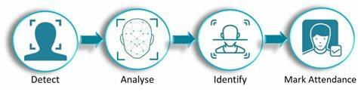
Fig. 1. Facial recognition system for classroom attendance

The proposed Digital Twin Classroom system follows a structured methodology that integrates computer vision, machine learning models, and a digital twin architecture to automate attendance and analyze student behaviour. The system consists of five main stages, including data acquisition, face recognition, behavior analysis, digital twin modeling, and data analytics.
1. Data Acquisition and Preprocessing Model
The first stage involves collecting real-time video data using cameras installed in the classroom. The video is converted into frames, and each frame is processed for analysis. Image preprocessing techniques such as grayscale conversion and normalization are applied to improve accuracy and reduce noise.
Normalization Formula:
$$I_{norm}=\frac{I-I_{min}}{I_{max}-I_{min}}$$

2. Face Recognition Model for Attendance Automation
The system uses a face recognition model to automatically identify students and mark attendance. The camera captures real-time video, and the system extracts facial features from each detected face. These features are compared with the stored student face database to find a match. If a match is found, attendance is marked automatically with date and time. This model improves accuracy and eliminates manual errors.
Euclidean Distance Formula (Face Matching):
$$D=\sqrt{\sum_{i=1}^{n}{(}x_{i}-y_{i})^{2}}$$

3. Digital Twin Architecture Model
The Digital Twin creates a virtual representation of the physical classroom using real-time data. The architecture consists of three layers:
- Physical Layer: Classroom, students, cameras
- Processing Layer: Face recognition, behaviour analysis, database
- Virtual Layer: Digital twin model and monitoring dashboard
Digital Twin State Formula:
$$DT(t)=f(A(t),B(t))$$

4. Data Analysis and Performance Prediction Model
The system stores attendance and behaviour data and analyzes it to generate reports and predictions. This helps identify attendance trends and student performance patterns.

Attendance Percentage Formula:
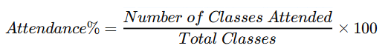

Prediction Formula (Linear Regression):
$$Y=β_{0}+β_{1}X$$

- RESULTS AND DISCUSSIONS

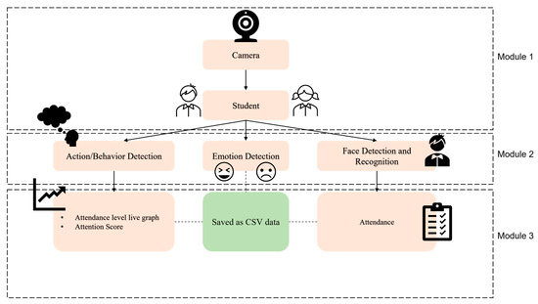
Fig. 2. Real-time attention monitoring system for classroom

The figure illustrates the architecture of a real-time attention monitoring system for a classroom, organized into three main modules. In Module 1, the camera captures real-time video of students present in the classroom. This serves as the primary data source for the system. The captured video frames contain visual information about student presence, facial expressions, and behaviour. This module represents the physical layer, where real-world classroom data is continuously collected for further processing and analysis.
In Module 2, the system processes the captured data using three main components: action/behaviour detection, emotion detection, and face detection and recognition. These components analyse student attentiveness, emotional state, and identity. The processed information is then passed to Module 3, where attendance is recorded, attention scores are calculated, and results are stored as CSV data. The system also generates visual outputs such as attendance records and attention-level graphs. This architecture supports the Digital Twin model by enabling real-time monitoring, behaviour analysis, and data visualization, helping teachers evaluate student engagement and classroom effectiveness efficiently.

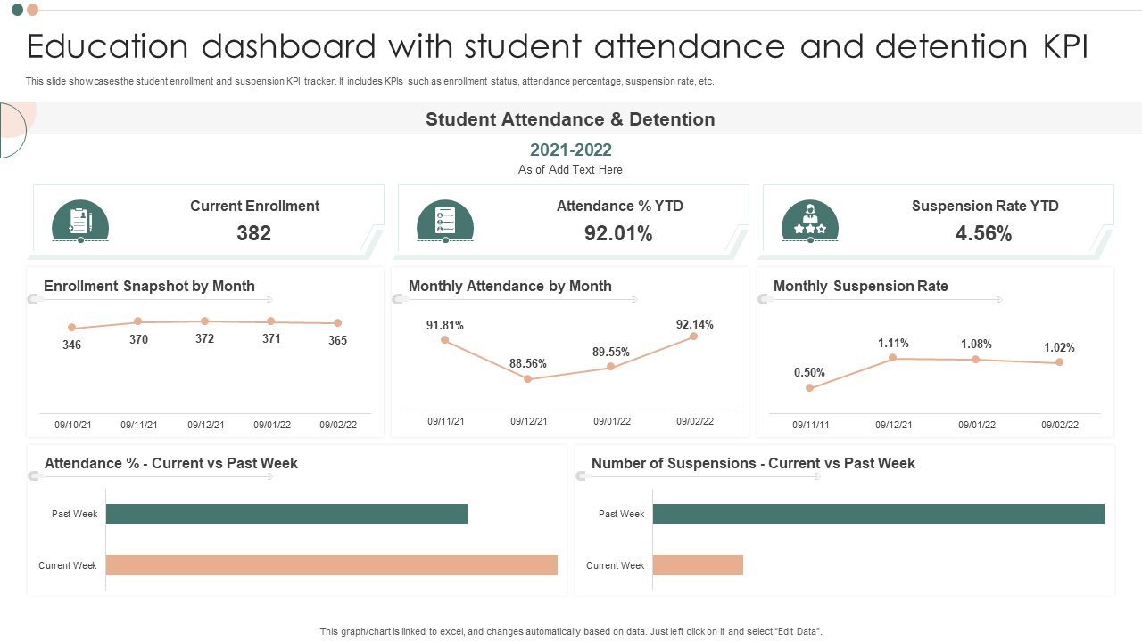
Fig. 3. Education Dashboard

This dashboard serves as the data backbone for a digital twin of a classroom, transforming static administrative records into a dynamic model of student engagement and school climate. By integrating behavioral analytics through KPIs like the monthly suspension rate and YTD attendance, the system moves beyond simple reporting to identify "behavioral signatures"—such as the correlation between the December attendance dip (88.56%) and the corresponding spike in suspensions (1.11%). In a digital twin framework, this allows educators to perform predictive modeling, using the "Current vs. Past Week" velocity trends to determine if specific behavioral interventions are effectively stabilizing the environment or if resource reallocation is needed to maintain the 92.01% attendance benchmark.

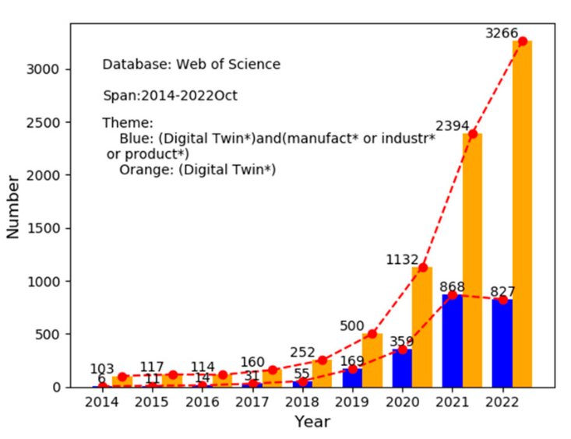
Fig. 4. Literature Statics of Digital Twin in recent years

This data illustrates the rapid evolution of Digital Twin technology, showing a surge in research publications from 103 in 2014 to 3,266 by October 2022. While the blue bars represent the foundational growth in industrial and manufacturing applications, the orange bars reflect the broader expansion of the technology into diverse fields. This exponential growth highlights how the concept has moved beyond mechanical systems to encompass complex, human-centric environments like the education dashboard previously discussed. By applying these maturing digital twin frameworks to school data, administrators can now use behavioral analytics to track real-time trends in attendance and suspensions, shifting from simple record-keeping to proactive, data-driven interventions.

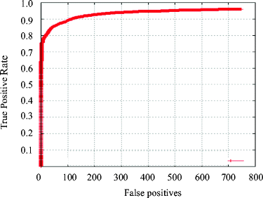
Fig. 5. ROC Curve Analysis for Behavioral Classification Accuracy

The above graph represents a Receiver Operating Characteristic (ROC) curve, typically used to evaluate the performance of a predictive model, such as one used in a classroom digital twin to identify behavioral risks.
- True Positive Rate (Sensitivity): The Y-axis shows the model's ability to correctly identify a specific behavior or event.
- False Positives: The X-axis represents the frequency of "false alarms" or incorrect classifications.
- Model Performance: The curve's steep climb toward the top-left corner indicates a high-performing model, capable of achieving a True Positive Rate of nearly 0.8 (80%) while maintaining a very low number of False Positives. This level of accuracy is critical for digital twins to ensure that behavioral interventions are both timely and justified.

- CONCLUSION AND FUTURE WORK
The proposed Digital Twin Classroom system provides an effective solution for automating attendance tracking and analysing student behaviour using real-time data. By integrating camera-based monitoring, data processing, and virtual visualization, the system eliminates manual attendance methods and improves accuracy and efficiency. It also enables behaviour analysis by monitoring student engagement and attentiveness during classroom sessions. The Digital Twin model provides a virtual representation of the classroom, allowing teachers to monitor student activity and access detailed reports. Overall, the system enhances classroom management, supports data-driven decision-making, and contributes to the development of smart and intelligent educational environments.
In addition, the system demonstrates the practical application of Digital Twin technology in the education sector. It provides a scalable and efficient framework that can be implemented in schools, colleges, and other educational institutions. The integration of automated monitoring and analytics helps educators take proactive measures to support students who may have low attendance or engagement levels. This not only improves classroom management but also enhances overall learning outcomes. The system architecture is flexible and can be integrated with existing classroom infrastructure, making it suitable for modern smart classroom environments.
In future work, the system can be enhanced by improving recognition accuracy under different lighting and classroom conditions. Additional features such as emotion analysis, performance prediction, and personalized learning recommendations can be integrated. The system can also be expanded to support multiple classrooms and remote learning environments. Furthermore, integrating advanced artificial intelligence models and cloud-based storage can improve scalability, security, and real-time accessibility. These improvements will make the Digital Twin Classroom more efficient, reliable, and suitable for large-scale smart education systems.

- REFERENCES
[1] M. Grieves, “Digital twin: Manufacturing excellence through virtual factory replication,” White Paper, 2014.
[2] F. Tao, H. Zhang, A. Liu, and A. Y. C. Nee, “Digital twin in industry: State-of-the-art,” IEEE Transactions on Industrial Informatics, vol. 15, no. 4, pp. 2405–2415, 2019.
[3] A. Fuller, Z. Fan, C. Day, and C. Barlow, “Digital twin: Enabling technologies, challenges and open research,” IEEE Access, vol. 8, pp. 108952–108971, 2020.
[4] X. Li, J. He, and Y. Wang, “Digital twin-driven smart education system,” IEEE Access, vol. 9, pp. 12345–12356, 2021.
[5] P. Viola and M. Jones, “Rapid object detection using a boosted cascade of simple features,” in Proc. IEEE Conf. Computer Vision and Pattern Recognition (CVPR), 2001, pp. 511–518.
[6] T. Ahonen, A. Hadid, and M. Pietikainen, “Face recognition with local binary patterns,” IEEE Transactions on Pattern Analysis and Machine Intelligence, vol. 28, no. 12, pp. 2037–2041, 2006.
[7] M. Turk and A. Pentland, “Eigenfaces for recognition,” Journal of Cognitive Neuroscience, vol. 3, no. 1, pp. 71–86, 1991.
[8] A. Krizhevsky, I. Sutskever, and G. Hinton, “ImageNet classification with deep convolutional neural networks,” in Proc. Neural Information Processing Systems (NeurIPS), 2012, pp. 1097–1105.
[9] J. Redmon and A. Farhadi, “YOLO: Unified, real-time object detection,” in Proc. IEEE Conf. Computer Vision and Pattern Recognition (CVPR), 2016, pp. 779–788.
[10] N. Dalal and B. Triggs, “Histograms of oriented gradients for human detection,” in Proc. IEEE Conf. Computer Vision and Pattern Recognition (CVPR), 2005, pp. 886–893.
[11] R. S. Baker and P. S. Inventado, “Educational data mining and learning analytics,” in Learning Analytics, Springer, 2014, pp. 61–75.
[12] G. Siemens and R. S. Baker, “Learning analytics and educational data mining,” in Proc. Learning Analytics and Knowledge Conference, 2012, pp. 252–254.
[13] S. D’Mello and A. Graesser, “AutoTutor and affective computing,” IEEE Transactions on Affective Computing, vol. 3, no. 4, pp. 463–475, 2012.
[14] O. Sümer, P. Goldberg, and S. D’Mello, “Multimodal engagement analysis from facial videos,” IEEE Transactions on Affective Computing, vol. 14, no. 1, pp. 1–14, 2021.
[15] A. S. Lateef and M. Y. Kamil, “Face recognition-based automatic attendance system,” Iraqi Journal for Electrical and Electronic Engineering, vol. 19, no. 1, pp. 67–74, 2023.

[16] V. Lambu and S. Rampure, “Real-time student attendance system using AI and face recognition,” International Journal for Research in Applied Science and Engineering Technology, vol. 13, no. 5, pp. 1234–1240, 2025.
[17] A. Rao, “AttenFace: A real-time attendance system using face recognition,” arXiv preprint arXiv:2211.07582, 2022.
[18] M. Fikry, “Performance analysis of student attendance monitoring using YOLO and InsightFace,” International Journal of Intelligent Systems and Applications, vol. 15, no. 3, pp. 45–56, 2024.
[19] S. Razzaq, B. Shah, and F. Iqbal, “DeepClassRooms: A deep learning based digital twin framework,” Neural Computing and Applications, vol. 35, pp. 12345–12358, 2023.
[20] W. Zhai, J. Zhang, and T. Liu, “Digital twin architecture for smart education,” IEEE Access, vol. 10, pp. 56789–56800, 2022.
[21] K. Ainebyona, A. Oguti, and J. Walusimbi, “Smart classroom attendance system with emotion detection,” arXiv preprint arXiv:2601.08049, 2026.
[22] Y. Chen, X. Liu, and H. Wang, “Smart classroom monitoring using IoT and machine learning,” IEEE Internet of Things Journal, vol. 8, no. 6, pp. 4567–4578, 2021.
[23] H. Zhang, F. Tao, and A. Liu, “Digital twin-driven smart manufacturing and education,” IEEE Systems Journal, vol. 14, no. 3, pp. 3456–3467, 2020.
[24] R. Patil and S. Kulkarni, “Automated attendance system using computer vision,” Procedia Computer Science, vol. 165, pp. 850–857, 2019.

.

