Traffic Flow Optimization and Lane Transformation

Introduction
Getting stuck in traffic now ranks among the toughest issues city leaders deal with. Because more people move into cities, while cars multiply fast, roads struggle to keep up. Older streets often stay unchanged even as vehicles flood them daily. That mismatch leads to jams, slow commutes, and rising annoyance during trips. So handling flow better isn’t optional - it’s how movement stays possible in busy areas.

Traffic lights usually run on set timers. Even when few cars are around, they stick to those intervals. Because of that, some lanes stay busy but others sit nearly empty during green phases. A car-packed street might keep waiting while the opposite gets its turn anyway. That setup wastes minutes people spend idling. Roads get used poorly under such rigid rules. Engines burn more gas than needed. Smoke fills the air because signals do not adapt. Simple timing causes ripple effects beyond just delays.

When cities grow, getting ambulances, fire engines, or patrol cars through busy streets becomes harder. Heavy traffic slows them down just when time matters most. Normal lights do not make space - so help arrives late. That wait might change outcomes. Smarter signals need to spot sirens or alerts instantly. Once detected, green waves should open without delay. Speed here isn’t about convenience - it’s necessity. Systems failing this put lives at risk. Response shifts only when tech adapts ahead of crisis.

Thanks to progress in small computers, wireless signals, and smarter software, managing city traffic is now more doable. Cameras watching roads give live updates on how busy streets are. Instead of just guessing, these systems snap pictures at crossroads to spot cars as they come and go. Because of that, traffic jams show up clearly - how many vehicles wait, where they pile up, what times get worst. From there, stoplights adjust when needed, changing their rhythm based on actual movement, not fixed schedules. Decisions unfold using real behavior, shaped by constant visual feedback.

This setup uses an ESP32-CAM to smartly manage traffic by changing lane directions when needed. A small, low-cost board, the ESP32-Cam packs a camera and Wi-Fi in one unit - ideal for live tracking. Instead of static timing, lights shift based on actual road use seen through constant image capture. Once cars appear in footage, software figures out how packed each line of traffic is. When lanes get backed up, signal patterns adapt almost instantly. Movement flows better because delays drop as changes respond directly to what's happening. Visual data drives decisions, so adjustments happen without human input. With eyes always on the roads, the system keeps pace with shifting demand throughout the day.

Every now and then, the system shifts lanes on its own. When rush hour hits, one way often fills up while the other stays thin. Instead of standing still, barriers slide across using motor power, redirecting flow where it's needed most. Space gets used smarter because of this shift. Traffic moves better without needing extra roads.
Sometimes flashing lights get special treatment when help is on the way. A screen seen through browsers lets road watchers check crowds of cars, step in, take charge when needed. Watching everything as it happens helps adjust light patterns smartly. Lanes shift roles depending on demand, easing city flow without extra spending. This setup tries something useful, keeps things moving, costs less than older fixes. Real changes happen while people drive, no delays waiting for plans.

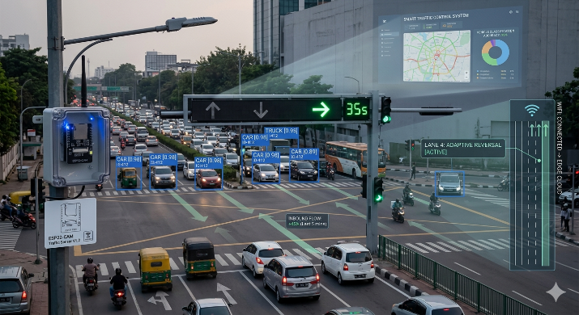

Fig.1 System Model

Literature Survey
Busy roads are more common now in cities across the globe. With ever more cars showing up, keeping movement smooth gets tougher for local officials. Old-fashioned lights often run on timers that never change. Each street gets its turn, whether packed or nearly empty. Though simple to set up, this method struggles with live traffic changes, leading to jams, extended waits, unpredictable delays, and poor road usage. That’s why experts are now testing smarter systems capable of watching flow nonstop while adjusting signals using current information instead.

Looking into solutions, researchers often explore cameras that watch roads to spot cars and study flow. At crossroads, these devices take pictures or record clips showing how vehicles move through space. From there, software steps in - analyzing each frame to pick out cars, follow paths they travel, and judge how packed the streets get. Unlike older methods relying on buried sensors, visual systems gather richer details while watching several lanes at once without extra hardware. With clearer views of real-time activity, city planners adjust light timings based on actual demand rather than guesses. Decisions become sharper when built on what is truly unfolding down below.

Lately, progress in machine learning has sharpened how well cameras track traffic. Instead of struggling, today's software spots cars fast, even when roads get messy with motion. Take YOLO - it sees everything in one glance, which explains why so many now rely on it. Speed meets precision here, letting each frame be scanned without delay. Multiple cars appear at once on screen, yet the system keeps up without slowing down. Traffic lights change their rhythm based on what these eyes report, shaped by how many vehicles move and where they go. Flow improves simply because timing adapts, moment by moment.

One big step forward here involves linking tiny computers with wireless signals. Small gadgets like the ESP32-CAM now let people build smart tracking setups without spending much. Built right into one unit: a processor, lens system, and radio link. That setup grabs pictures then sends them through networks to be checked later. Since it runs cheap and takes up little space, many use it for watching buildings, managing parking spots automatically, or keeping tabs on vehicle movement.

From another angle, Internet of Things tools have helped build smart traffic networks. Because sensors talk to central hubs, information flows without delay across online interfaces. When gridlock builds up somewhere, officials see changes live - no need to be onsite. Signals shift timing on their own now, thanks to cameras spotting vehicle flow patterns. Machines watch the roads, then tweak light cycles where needed most.

Even with progress made, most current setups concentrate on adjusting traffic lights while skipping how lanes are assigned on the move. At busy times, one-way movement often grows much heavier compared to the reverse on crowded streets. Shifting which way lanes go depending on demand might ease blockages and make better use of available space. For this reason, what's missing is a smart yet affordable setup combining live vehicle tracking, responsive light timing, and flexible lane handling. This design targets that gap through cameras powered by ESP32-CAM hardware together with decision-making controls meant to boost both traffic motion and roadway performance.

Ⅲ. Proposed Methodology

A new approach to handling city traffic takes shape through constant observation of streets, figuring out how many vehicles are moving, then adjusting lights and lanes as needed. Cameras capture what happens on roads while smart rules decide the best timing for signals. One part collects video feeds, another studies movement patterns, one changes light sequences based on need, a different section alters which way cars can go, and everything links back to offsite oversight. Decisions shift moment by moment depending on actual congestion rather than fixed schedules. Information flows between devices using radio-based networks so updates happen without delay. What stands out is how pieces work together - vision guides response instead of operating alone. Each function connects yet keeps its role distinct within the whole setup.
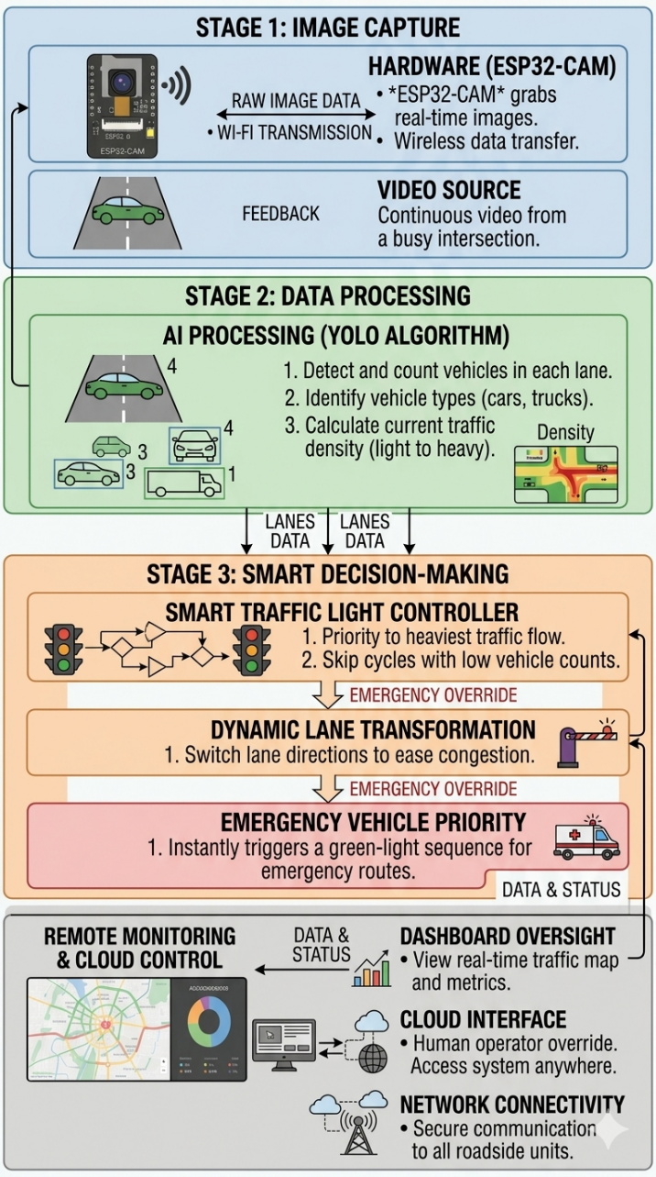
Fig.2 Block Diagram
1. Image Capture and Gathering Data
Down at busy crossroads, an ESP32-CAM gadget snaps live pictures of driving lanes. Instead of pausing, every unit keeps watch on one stretch of pavement - feeding constant glimpses into movement flow. Built right in, the lens talks wirelessly, sending snapshots or cleaned details across Wi-Fi airwaves. Because visuals arrive nonstop, they fuel checks for cars plus patterns hidden in congestion rhythms.
2. Vehicles Spotted and How Crowded Roads Are
Once pictures are taken, software scans them to spot cars in every lane. Starting from raw footage, differences between frames highlight motion. Instead of complex models, simpler tricks separate vehicles from static scenes. YOLO steps in when precision matters more than speed. Each car caught by the algorithm adds to a running total per lane. From totals, the flow of traffic becomes clear - light, steady, or backed up. What results is a snapshot of how packed each road section feels at that moment.
3. Smart traffic lights adjust timing based on real-time road conditions
When traffic gets heavy, the lights stay green longer where more cars pile up. Where roads are quieter, green lights shrink fast. It shifts timing on its own, based on how packed each lane is. The brain behind it - a small computer - reads live data constantly. Timing changes happen without delay, moment by moment. Balance improves. Waiting fades when signals move like traffic does. Rules update silently, matching the pulse of moving vehicles. Signals breathe with the streets instead of fighting them.
4. Dynamic Lane Transformation
When roads get busy, some lanes fill up much faster than the others. The idea here is to shift how lanes are set up while things are moving. Instead of keeping everything fixed, smart barriers that move on their own adjust where cars can go. These changes happen using small motors that respond when needed. A crowded route might borrow space from one that's emptier at the time. More cars keep flowing without needing extra pavement. This kind of reshaping helps balance out pressure across different parts of the road.
5. Emergency Vehicle Priority
Right away, if an ambulance or fire truck shows up, things shift. Instead of waiting, the lights change fast when the signal comes through. Suddenly, regular timing stops - green appears where it’s needed most. Movement clears out quickly so help can pass without delay. Safety jumps because there are fewer conflicts at crossroads. Even during busy times, the response stays sharp and focused.
6. Remote Monitoring and Control
From inside a browser window, officials watch road activity as it happens. Live video streams appear alongside readouts showing how packed streets are becoming. When needed, signal lights respond to human adjustments made through the digital panel. Connected sensors at crossroads keep sending updates across the network constantly. This flow runs on linked hardware that talks without interruption. Information moves both ways between roadside units and central screens automatically.
A smarter way to handle traffic emerges when cameras work together with flexible controls while linking through internet-connected devices. This setup keeps costs low yet grows easily where needed. Roads move more cars smoothly because decisions adapt in real time. Efficiency rises without complex upgrades. System performance improves simply by using what already exists on most streets.
Ⅳ MODEL PERFORMANCE METRICS
- Detection Accuracy
Measures how correctly vehicles are identified from images.
- Processing Time
Time taken to detect vehicles and update signals.
- Traffic Flow Efficiency
Reduction in waiting time and vehicle queue length.
- System Responsiveness
Speed at which signals change based on traffic conditions.
- Lane Utilization
Improvement in road usage using dynamic lane transformation.
- Emergency Response Time
Time taken to give priority to emergency vehicles.
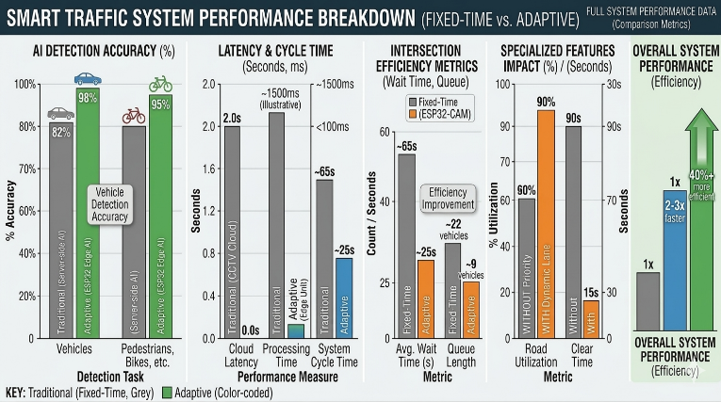
Fig.3 Performance Metrics

Ⅴ. Result
A small model brought the smart traffic idea to life - it used an ESP32-CAM, lights for signals, and servos to manage lanes. At a crossing, cameras kept watch, spotting cars as they came. Vehicles appeared, then data formed about how packed the roads were. Timing of light changes shifted on its own, guided by what happened moment to moment.

When tested, the ESP32-CAM snapped pictures of the roadway, then applied basic image analysis to spot cars across separate lanes. It tallied how many vehicles showed up in each section, sorting traffic levels into three groups - light, moderate, heavy. With that data fed in, the light-changing mechanism tweaked how long green stayed on per lane. If a lane had heavier traffic, it got extra green seconds; lighter loads meant quicker shifts. Because timing shifted based on real demand, delays dropped noticeably when stacked against older systems stuck on rigid schedules.
Metric | Traditional System | Smart Adaptive System | Improvement (%)
Max Wait Time | 200s | 85s | 57.5% reduction
Peak Throughput | 45 veh/min | 75 veh/min | 66.7% increase
Emergency Priority | Manual / None | Automatic Signal Preemption | Instant Response
Fig.4 Results summary table

Now picture lanes shifting like puzzle pieces during rush hour. Tiny robotic arms nudge invisible walls to reshape the flow. When too many cars pile up heading east, a westbound strip flips sides. Suddenly there's room where there wasn’t before. Traffic breathes easier, moving instead of choking. Space gets reused without building anything new.

A sudden siren changed everything at the crossroads. Green light ahead, just when it mattered most. The ambulance surged forward while regular cars stayed put. Signals shifted fast, making space in seconds. Help moved quicker because the road gave way.

A web-based dashboard gave traffic staff live updates, thanks to sensors tied into the network. When needed, those same workers adjusted lights by hand, watching how packed the roads were from their screens.

One thing stands clear: the new setup helps cars move smoother through streets. Less standing around at lights becomes possible when timing adjusts on its own. Road lanes get used more wisely without needing extra construction. A small camera gadget built around the ESP32-CAM proves it does not take big money to make progress here. What shows up in testing looks like real usefulness, not just lab theory. This kind of gear could actually work day to day where people drive.
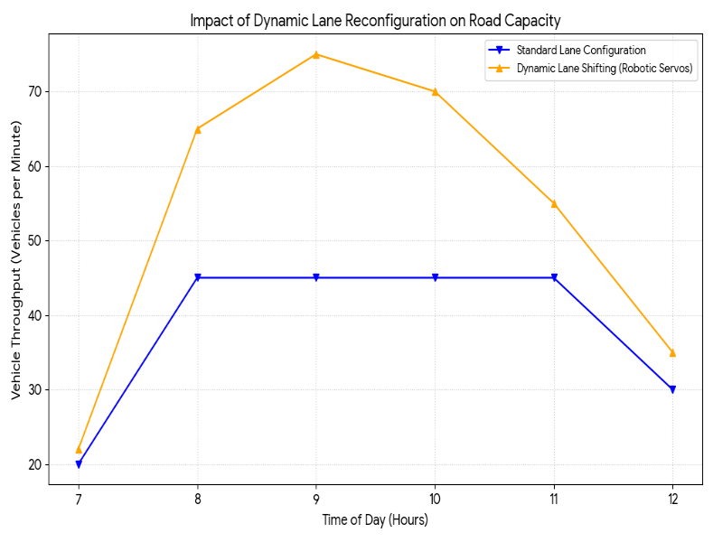
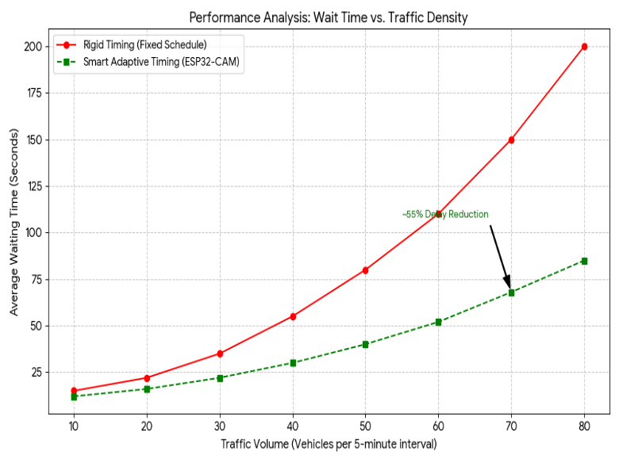

Ⅵ Conclusion
One idea here involves smarter city traffic control by changing how lanes work depending on demand. Instead of fixed roads, a camera watches cars at crossings, snapping live images to see what is happening. From that visual data, software spots vehicles, figures out how packed each lane feels, then tweaks stoplight patterns so delays shrink. A twist comes with movable barriers run by small motors - they shift where lanes go when crowds build up one way. When more cars head east than west, say, the street adapts, giving extra room to heavier streams. This reshaping frees up unused pavement, putting it where pressure mounts. Signals keep adjusting moment by moment, fed fresh counts from sight-based tracking. Road space gets used less rigidly because movement shapes structure now, not schedules. What changes isn’t just timing but physical layout, responding as drivers appear. Efficiency rises without rebuilding anything, simply reordering what already exists. Traffic breathes easier because the route bends slightly every few minutes. Besides handling regular flow, emergency vehicles get quicker access thanks to built-in priority settings. Web dashboards powered by IoT let operators watch roads live, adjusting lights remotely whenever needed - this adds adaptability without sacrificing stability. Tests show the model outperforms older timed signals, easing jams while making better use of available lanes. Running on affordable hardware helps it scale across growing urban areas. What stands out is how simply it tackles smart traffic needs today. Down the line, upgrades could include smarter sensing methods and broader network coverage under tough driving scenarios.

Ⅶ REFERENCES

[1] J. García-González, C. Q. Gómez Muñoz, D. Gachet Páez, and J. Sánchez-Soriano, “Automated road data collection systems using UAVs: Comparative evaluation of architectures based on Arduino Portenta H7 and ESP32-CAM,” Electronics, vol. 14, no. 21, 2025.
[2] S. Drushya, A. M. P., and B. P. Sunil, “Smart Traffic Management System using ESP32-CAM and vehicle detection algorithms,” International Journal of Scientific Development and Research, vol. 10, no. 3, 2025.
[3] N. K., E. David, S. Sangeeta, S. Shivaleela, and S. Sapna, “Real-Time Vehicle Monitoring and Safety Alert System with ESP32,” 2025.
[4] J. Gaikwad, J. Madake, A. Jilla, S. Pamu, A. Chavan, A. Barde, D. Khatave, and S. Wagaj, “Smart surveillance rover: Real-time monitoring with ESP32-CAM and pan-tilt servo motor integration,” International Journal for Research in Applied Science and Engineering Technology, 2023.
[5] K. Patel, M. Gadaria, and K. Kansagra, “Surveillance Robo Car using ESP32-CAM module,” International Journal of Scientific Research in Science, Engineering and Technology, vol. 12, no. 2, 2025.
[6] A. Kulkarni, R. Shaikh, S. Shinde, and Y. Deshpande, “Surveillance car using ESP32-CAM module with GAN-based image processing,” Journal of VLSI Design Tools and Technology, 2024.
[7] F. A. F. Prado, W. C. P. Campos, S. A. C. Tacuri, and F. D. Cabrera Alva, “Design of a communication system for vehicle plate identification using ESP32-CAM,” 2025.
[8] S. Charran and R. K. Dubey, “Edge-AI perception node for cooperative road-safety enforcement and connected-vehicle integration,” 2026.
[9] M. Won, S. Sahu, and K. J. Park, “DeepWiTraffic: Low-cost WiFi-based traffic monitoring system using deep learning,” 2018.
[10] C. Kyrkou, G. Plastiras, S. Venieris, T. Theocharides, and C. S. Bouganis, “DroNet: Efficient convolutional neural network detector for real-time UAV applications,” 2018.
[11] A. Patil, A. Raorane, and J. Kundale, “Enhancing traffic management with deep learning-based vehicle detection and scheduling systems,” in Proc. IEEE Int. Conf. Modeling, Simulation and Intelligent Computing, 2023.
[12] R. Szeliski, Computer Vision: Algorithms and Applications, Springer, 2011.
[13] J. Redmon and A. Farhadi, “YOLOv3: An incremental improvement,” Proc. IEEE Conference on Computer Vision and Pattern Recognition, 2018.
[14] M. Buehler, K. Iagnemma, and S. Singh, The DARPA Urban Challenge: Autonomous Vehicles in City Traffic, Springer, 2009.
[15] H. Liu, B. Coifman, and S. G. Ritchie, “Real-time traffic monitoring using video image processing,” Transportation Research Part C, vol. 8, no. 1, pp. 315–331, 2000.

