Dynamic Capabilities and Digital Transformation Performance: The Role of Organizational Agility in the Public Sector

Ravizah Hanum¹, Mahdani Ibrahim², Syaruddin Chan³
^{1,2,3} Magister Management Study, Economic and Business Faculty, Syiah Kuala University. Indonesia

Abstract:
This study investigates the role of dynamic capabilities, organizational agility, digital literacy, and leadership support in influencing digital transformation performance within the public sector. Drawing on the Dynamic Capability View (DCV), the research proposes an integrated model in which organizational agility mediates the relationship between dynamic capabilities and performance, while digital literacy and leadership support act as moderating variables. Data were collected from 123 civil servants at the Aceh Civil Service Agency (BKA) using a census approach and analyzed using Partial Least Squares Structural Equation Modeling (PLS-SEM). The results reveal that dynamic capabilities—comprising sensing, seizing, and reconfiguring—do not have a significant direct effect on digital transformation performance. However, they significantly enhance organizational agility, which in turn has a strong and significant impact on performance. Mediation analysis confirms that organizational agility fully mediates the relationship between dynamic capabilities and digital transformation performance, highlighting its central role as a translation mechanism. In contrast, the moderating effects of digital literacy and leadership support are found to be statistically insignificant, suggesting that these factors function more as enabling conditions than as direct amplifiers of performance relationships. These findings extend the Dynamic Capability View by emphasizing the importance of organizational-level mechanisms in realizing the value of strategic capabilities. Practically, the study underscores the need for public organizations to prioritize agility—through flexible structures, rapid decision-making, and process integration—over purely technological or skill-based interventions. Ultimately, the study demonstrates that successful digital transformation is fundamentally an organizational challenge rather than a technological one.
Keywords: Dynamic Capabilities, Organizational Agility, Digital Transformation Performance, Digital Literacy, Leadership Support

- Introduction
Digital transformation has become a central agenda in public sector reform, aiming to enhance efficiency, transparency, and accountability in government services. In Indonesia, regional institutions such as the Aceh Civil Service Agency (Badan Kepegawaian Aceh/BKA) have initiated multiple digital platforms, including E-Keurani, Simanja, Siudin, and SIASN, to modernize administrative processes. However, despite these initiatives, the performance of digital transformation remains suboptimal. Empirical evidence shows that only 58% of civil servants in Aceh have participated in formal IT training, while internal surveys indicate that user satisfaction with digital systems reaches only 61%. Furthermore, system disruptions were recorded 14 times in 2023, and the average perception score of digital transformation performance remains at 3.392 (on a 5-point scale), indicating a marginal evaluation . These figures highlight a persistent gap between digital adoption and actual performance outcomes in the public sector.
From a theoretical perspective, digital transformation performance (DTP) can be explained through the Dynamic Capability View (DCV), which emphasizes three core organizational capabilities: sensing, seizing, and reconfiguring (Teece, 2007). Sensing refers to the ability to identify technological opportunities and user needs; seizing involves strategic decision-making to capture these opportunities; while reconfiguring reflects the organization’s capacity to realign resources and processes. Prior studies confirm that these capabilities are critical drivers of digital transformation success (Zhang et al., 2023; Saeedikiya et al., 2024). In addition, organizational agility—defined as the ability to rapidly respond to environmental changes—has been identified as a key mediating mechanism linking dynamic capabilities to performance outcomes (Shakhoor et al., 2024).
However, in the context of public organizations such as BKA, these theoretical constructs are not fully realized in practice. The sensing capability appears weak, as evidenced by the misalignment between system features and user needs. Seizing capability is constrained by bureaucratic rigidity, leading to slow decision-making and limited responsiveness to innovation. Meanwhile, reconfiguring capability is hindered by fragmented systems and lack of integration across units. These issues are compounded by low digital literacy among civil servants and insufficient leadership support, both of which are crucial moderating factors in digital transformation (Ghosh et al., 2022; Coulon et al., 2020).
Despite the growing body of literature on digital transformation, several research gaps remain. First, most studies on dynamic capabilities and digital transformation are concentrated in the private sector, with limited empirical evidence from public sector institutions, particularly in developing regions. Second, while prior research acknowledges the role of organizational agility as a mediator, there is still insufficient understanding of how different dimensions of agility—such as operational adjustment agility and strategic agility—function simultaneously within bureaucratic contexts. Third, the moderating roles of digital literacy and leadership support are often examined independently, rather than as integrated factors influencing the relationship between dynamic capabilities, agility, and performance.
This study addresses these gaps by proposing an integrated model that links dynamic capabilities (sensing, seizing, reconfiguring) to digital transformation performance through organizational agility, while incorporating digital literacy and leadership support as moderating variables. The novelty of this research lies in three key aspects. First, it contextualizes the Dynamic Capability View within the public sector, specifically in a regional government institution. Second, it distinguishes between operational and strategic dimensions of organizational agility, offering a more nuanced understanding of agility in bureaucratic settings. Third, it simultaneously examines the dual moderating effects of digital literacy and leadership support, providing a more comprehensive explanation of digital transformation performance.
By bridging these gaps, this study contributes both theoretically and practically. Theoretically, it extends the application of DCV and organizational agility frameworks into the public sector domain. Practically, it offers actionable insights for policymakers and administrators in improving digital transformation outcomes, particularly in regions with similar structural and capability constraints.

2. Literature Review
2.1 Dynamic Capability View
The Dynamic Capability View (DCV) provides a robust theoretical foundation for understanding how organizations adapt to rapidly changing environments, particularly in the context of digital transformation. According to Teece (2007), dynamic capabilities consist of three core dimensions: sensing, seizing, and reconfiguring. Sensing capability refers to the organization’s ability to identify and interpret emerging technological opportunities and stakeholder needs. Seizing capability involves mobilizing resources and making timely strategic decisions to capture these opportunities. Meanwhile, reconfiguring capability reflects the organization’s capacity to realign internal processes, structures, and resources to sustain competitive advantage.
In the public sector, these capabilities are essential for overcoming bureaucratic rigidity and enabling adaptive governance. However, dynamic capabilities alone are insufficient to guarantee performance outcomes unless they are effectively translated into organizational actions.

2.2 Organizational Agility
Organizational agility refers to the ability of an organization to rapidly sense and respond to environmental changes. It is commonly conceptualized into two dimensions: operational adjustment agility and strategic agility (Al-Hawary & AlTaweel, 2021). Operational adjustment agility reflects the organization’s ability to quickly adapt processes, workflows, and service delivery mechanisms. Strategic agility, on the other hand, refers to the capacity to reorient long-term strategies and policies in response to dynamic external conditions. In this context, agility plays a crucial role in ensuring that digital initiatives are not only adopted but also effectively implemented. Agile organizations are better positioned to handle uncertainty, reduce resistance to change, and improve service performance.

2.3 Dynamic Capabilities and Organizational Agility
Dynamic capabilities are key antecedents of organizational agility. Sensing capability enables organizations to detect changes in the digital environment, which informs both operational and strategic responses. Seizing capability allows organizations to act upon these insights by adjusting policies, investing in technology, and implementing innovations. Reconfiguring capability ensures that internal systems and resources remain aligned with evolving demands.
Empirical studies demonstrate that organizations with strong dynamic capabilities tend to exhibit higher levels of agility in both operational and strategic dimensions . In this regard, dynamic capabilities serve as the foundation upon which agility is built.
H1a: Sensing capability positively influences operational adjustment agility.
H1b: Sensing capability positively influences strategic agility.
H2a: Seizing capability positively influences operational adjustment agility.
H2b: Seizing capability positively influences strategic agility.
H3a: Reconfiguring capability positively influences operational adjustment agility.
H3b: Reconfiguring capability positively influences strategic agility.

2.4 Organizational Agility and Digital Transformation Performance
Digital transformation performance (DTP) refers to the extent to which digital initiatives improve organizational efficiency, service quality, and innovation. Organizational agility is a critical driver of DTP, as it enables organizations to respond quickly to technological changes and implement digital solutions effectively.
Operational adjustment agility contributes to DTP by enhancing process efficiency, reducing delays, and improving service delivery. Strategic agility ensures that digital initiatives are aligned with long-term goals and external demands. Prior research indicates that organizations with higher agility levels achieve superior digital transformation outcomes (Al-Haddad & Kotnour, 2015).
H4a: Operational adjustment agility positively influences digital transformation performance.
H4b: Strategic agility positively influences digital transformation performance.

2.5 The Mediating Role of Organizational Agility
While dynamic capabilities provide the foundation for transformation, their impact on performance is often indirect. Organizational agility acts as a mediating mechanism that translates capabilities into tangible outcomes. Without agility, sensing, seizing, and reconfiguring capabilities may not lead to effective implementation.
Studies suggest that agility bridges the gap between capability and performance by enabling rapid execution and adaptation . Thus, organizational agility plays a crucial role in ensuring that dynamic capabilities result in improved digital transformation performance.
H5a: Operational adjustment agility mediates the relationship between sensing capability and digital transformation performance.
H5b: Strategic agility mediates the relationship between sensing capability and digital transformation performance.
H6a: Operational adjustment agility mediates the relationship between seizing capability and digital transformation performance.
H6b: Strategic agility mediates the relationship between seizing capability and digital transformation performance.
H7a: Operational adjustment agility mediates the relationship between reconfiguring capability and digital transformation performance.
H7b: Strategic agility mediates the relationship between reconfiguring capability and digital transformation performance.

2.6 The Moderating Role of Digital Literacy
Digital literacy refers to the ability of individuals to effectively use and understand digital technologies (Ng, 2012; Redecker, 2017). It plays a critical role in strengthening the relationship between dynamic capabilities and organizational agility. When employees possess high digital literacy, they are better able to interpret digital information, adopt new systems, and support agile processes.
Conversely, low digital literacy can hinder the translation of capabilities into action. Therefore, digital literacy acts as an enabling factor that enhances the effectiveness of dynamic capabilities.
H8: Digital literacy positively moderates the relationship between dynamic capabilities (sensing, seizing, reconfiguring) and organizational agility.

2.7 The Moderating Role of Leadership Support
Leadership support is a critical factor in ensuring the success of digital transformation initiatives. It involves providing strategic direction, allocating resources, and fostering a culture of innovation (Bass & Riggio, 2006). Leadership support strengthens the relationship between organizational agility and digital transformation performance by ensuring that agile practices are effectively implemented.
Without strong leadership support, even agile organizations may struggle to achieve desired outcomes. Thus, leadership acts as a catalyst that amplifies the impact of agility on performance.
H9: Leadership support positively moderates the relationship between organizational agility and digital transformation performance.
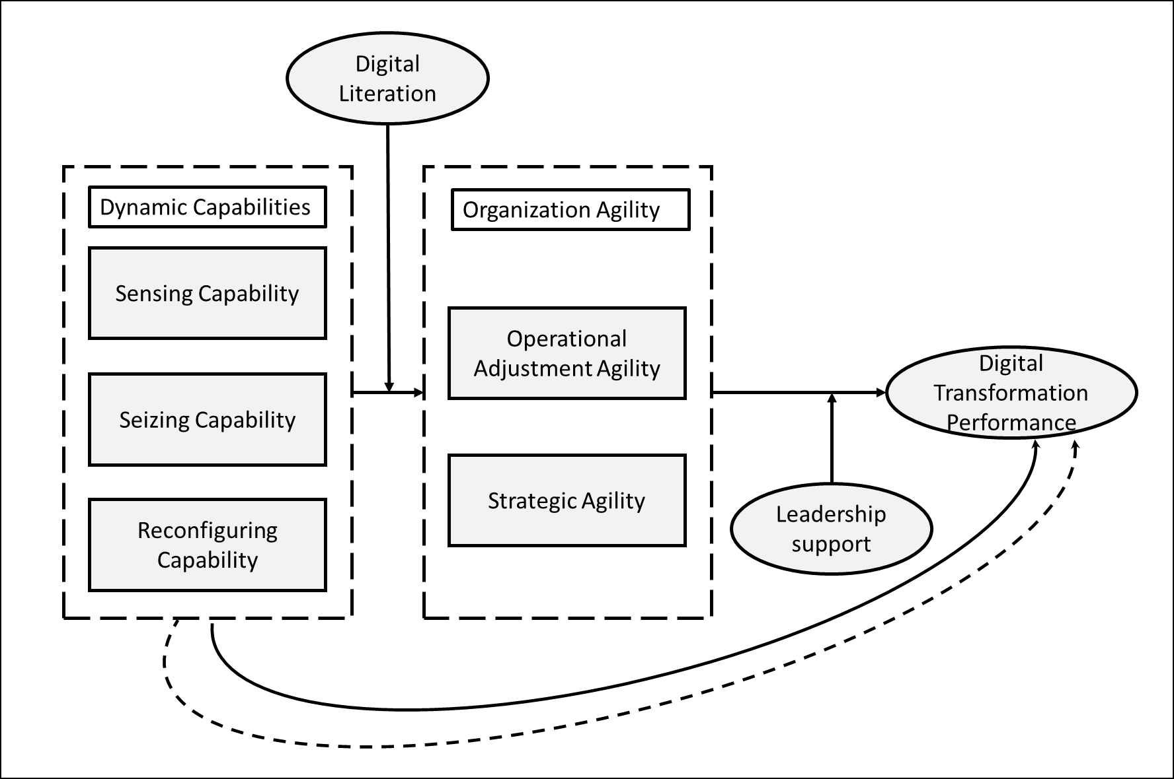
Figure 1. Research Framework
Here is your upgraded Q1 journal–style Methodology section (±600 words) with stronger academic tone, justification, and tighter structure:

3. Research Methodology
3.1 Research Design and Context
This study employs a quantitative, explanatory research design to test a theoretically grounded model linking dynamic capabilities, organizational agility, and digital transformation performance within the public sector. An explanatory approach is appropriate as the study aims to examine causal relationships and underlying mechanisms among constructs derived from the Dynamic Capability View (DCV). The empirical context is the Aceh Civil Service Agency (Badan Kepegawaian Aceh/BKA), a regional public institution actively engaged in digital transformation initiatives. This context provides a relevant setting to investigate how bureaucratic structures interact with capability-driven transformation processes.

3.2 Population and Sampling Strategy
The target population comprises all civil servants employed at BKA, totaling 123 individuals. Given the relatively small and accessible population size, this study adopts a census approach, including all members of the population as respondents. This approach enhances the statistical power and eliminates sampling bias, thereby strengthening the internal validity of the findings. Census-based data collection is particularly suitable in organizational-level research where the objective is to capture a comprehensive representation of perceptions across all functional units .
3.3 Data Collection Procedure
Data were collected using a structured questionnaire administered both online and offline to maximize response rates and accessibility. The instrument was designed based on established theoretical constructs and prior empirical studies to ensure content validity. Respondents were asked to evaluate statements related to dynamic capabilities, organizational agility, digital literacy, leadership support, and digital transformation performance.
All items were measured using a five-point Likert scale ranging from 1 (strongly disagree) to 5 (strongly agree). This scaling method is appropriate for capturing perceptual and attitudinal data and is widely used in organizational and information systems research.

3.4 Measurement of Constructs
The constructs in this study are operationalized as reflective latent variables. Dynamic capabilities are measured through three dimensions: sensing capability, seizing capability, and reconfiguring capability, consistent with Teece (2007). Organizational agility is conceptualized as a multidimensional construct comprising operational adjustment agility and strategic agility (Doz & Kosonen, 2010), capturing both short-term responsiveness and long-term adaptability.
Digital literacy is defined as the individual capability to effectively access, evaluate, and utilize digital technologies, while leadership support reflects managerial commitment and involvement in driving digital initiatives. Digital transformation performance is operationalized through indicators such as technology adoption, system integration, service efficiency, user satisfaction, and innovation outcomes. The use of multidimensional constructs enables a more nuanced representation of complex organizational phenomena.

3.5 Instrument Validation and Reliability
Prior to hypothesis testing, the measurement instrument was assessed for reliability and validity using a pilot sample of 30 respondents. Reliability was evaluated using Cronbach’s Alpha, with all constructs exceeding the recommended threshold of 0.70, indicating strong internal consistency.
Construct validity was assessed through corrected item–total correlation, with all indicators meeting the minimum threshold of 0.30, except one item within the organizational agility construct, which was subsequently removed. These results confirm that the measurement model demonstrates adequate reliability and validity for further analysis .

3.6 Data Analysis Technique
The proposed model is analyzed using Partial Least Squares Structural Equation Modeling (PLS-SEM) with SmartPLS software. PLS-SEM is selected due to its suitability for predictive and exploratory models involving complex relationships, including mediation and moderation effects. Unlike covariance-based SEM, PLS-SEM is less restrictive regarding data distribution assumptions and performs well with relatively small sample sizes.
The analysis follows a two-step approach. First, the measurement model (outer model) is evaluated by assessing indicator reliability (factor loadings > 0.70), convergent validity (Average Variance Extracted > 0.50), and internal consistency reliability (Composite Reliability > 0.70). Discriminant validity is examined using cross-loadings and the Fornell-Larcker criterion.
Second, the structural model (inner model) is evaluated by examining path coefficients, coefficient of determination (R²), effect size (f²), These metrics provide insights into the explanatory power and predictive capability of the model.

3.7 Hypothesis Testing
Hypotheses are tested using a bootstrapping procedure with resampling to estimate the significance of path coefficients. A t-value greater than 1.96 (p < 0.05) is considered statistically significant. Mediation effects are assessed through indirect path analysis, while moderation effects are tested by incorporating interaction terms between constructs.
This analytical approach enables a comprehensive evaluation of both direct and indirect relationships, as well as conditional effects, thereby aligning with the study’s objective to develop an integrated understanding of digital transformation performance in the public sector.

4. Results and Discussion (Theory-Integrated)
4.1 Measurement Model Evaluation
The measurement model demonstrates satisfactory reliability and validity. All constructs exceed the recommended thresholds for Cronbach’s alpha and composite reliability (>0.70), while AVE values are above 0.50, confirming convergent validity. Discriminant validity is also established using the Fornell–Larcker criterion, indicating that each construct captures a distinct conceptual domain.
Table 1. Validity and Reliability
Construct | Cronbach’s Alpha | Composite Reliability | AVE
Digital Transformation Performance | 0.871 | 0.906 | 0.664
Dynamic Capability | 0.933 | 0.942 | 0.521
Organizational Agility | 0.932 | 0.944 | 0.680
Operational Adjustment Agility | 0.918 | 0.939 | 0.755
Strategic Agility | 0.809 | 0.867 | 0.581
Sensing Capability | 0.881 | 0.914 | 0.680
Seizing Capability | 0.878 | 0.911 | 0.674
Reconfiguring Capability | 0.813 | 0.872 | 0.582

These results are consistent with best practices in PLS-SEM, where reflective constructs must demonstrate internal consistency and construct validity before structural interpretation (Hair et al., 2021). The robustness of the measurement model ensures that subsequent findings are not biased by measurement error.

4.2 Structural Model and Explanatory Power
The structural model shows moderate to substantial explanatory power. Digital Transformation Performance (R² = 0.564) indicates that more than half of the variance is explained by the model, while Organization Agility (R² = 0.475) demonstrates moderate explanatory strength. According to Chin (1998), these values indicate acceptable predictive capability in variance-based SEM.
Effect size analysis further reveals that Dynamic Capability has a negligible direct effect on Digital Transformation Performance (f² = 0.019), but a substantial effect on Organization Agility (f² = 0.903). Meanwhile, Organization Agility exerts a strong influence on Digital Transformation Performance (f² = 0.521). These findings suggest that performance outcomes are not directly driven by capabilities, but by how those capabilities are operationalized within the organization.

4.3 Direct Effects and Theoretical Implications
The results show that Dynamic Capability does not significantly affect Digital Transformation Performance (β = 0.155, p > 0.05). This finding is theoretically consistent with the Dynamic Capability View (DCV), which posits that dynamic capabilities are higher-order competences that enable change rather than directly produce performance (Teece, 2007).
Previous studies also support this indirect nature. For instance, Pavlou and El Sawy (2011) argue that dynamic capabilities influence performance through operational capabilities, while Wilden et al. (2013) highlight that their value depends on organizational processes and alignment.
Table 2. Direct Effect Testing
Path | β | t-value | p-value | Result
Dynamic Capability → Digital Transformation Performance | 0.155 | 1.281 | 0.200 | Not supported
Dynamic Capability → Organizational Agility | 0.662 | 3.828 | 0.000 | Supported
Organizational Agility → Digital Transformation Performance | 0.642 | 5.309 | 0.000 | Supported

Conversely, Dynamic Capability significantly influences Organization Agility (β = 0.662, p < 0.001). This aligns with DCV logic, where sensing, seizing, and reconfiguring enhance organizational responsiveness. Organizations with strong dynamic capabilities are better equipped to detect environmental changes and adapt strategically, thereby increasing agility.
Furthermore, Organization Agility significantly affects Digital Transformation Performance (β = 0.642, p < 0.001). This finding supports the perspective that agility acts as a key execution mechanism in digital transformation (Overby et al., 2006; Vial, 2019). In dynamic environments, performance is determined not merely by resources or technology, but by the speed and flexibility of organizational responses.
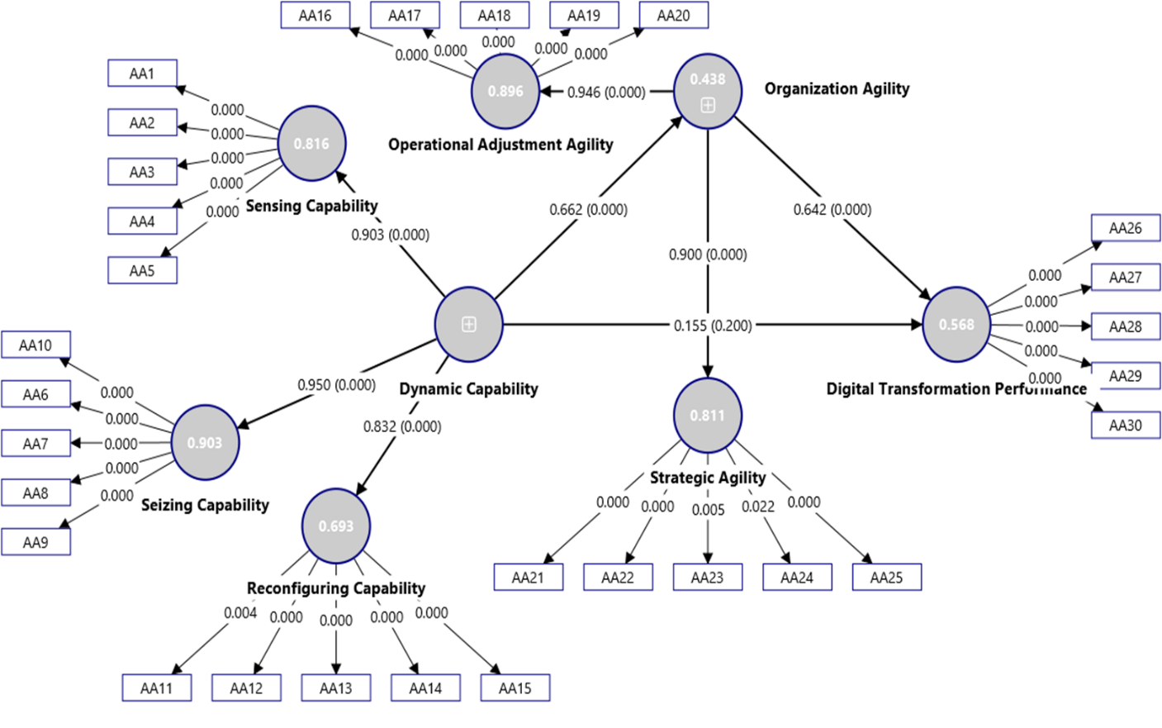
Figure 2. Direct Effect Testing

4.4 Mediation Analysis: The Central Role of Agility
The mediation analysis confirms that Organization Agility fully mediates the relationship between Dynamic Capability and Digital Transformation Performance (β = 0.425, p < 0.001). This finding is theoretically significant, as it empirically validates the “capability–performance gap” often discussed in DCV literature.
Teece (2007) emphasizes that capabilities must be deployed through organizational processes to create value. Similarly, Pavlou and El Sawy (2011) identify agility as a dynamic operational capability that translates strategic potential into performance outcomes.
Thus, the findings reinforce the notion that dynamic capabilities are necessary but not sufficient; they must be activated through agility to generate measurable performance improvements.

4.5 Moderation Effects and Boundary Conditions
The moderating effect of Leadership Support is positive but not significant (β = 0.091, p > 0.05). This suggests that leadership functions more as an enabling condition rather than a strengthening mechanism. This finding aligns with Yukl (2013), who argues that leadership influence may diminish once organizational routines become institutionalized.
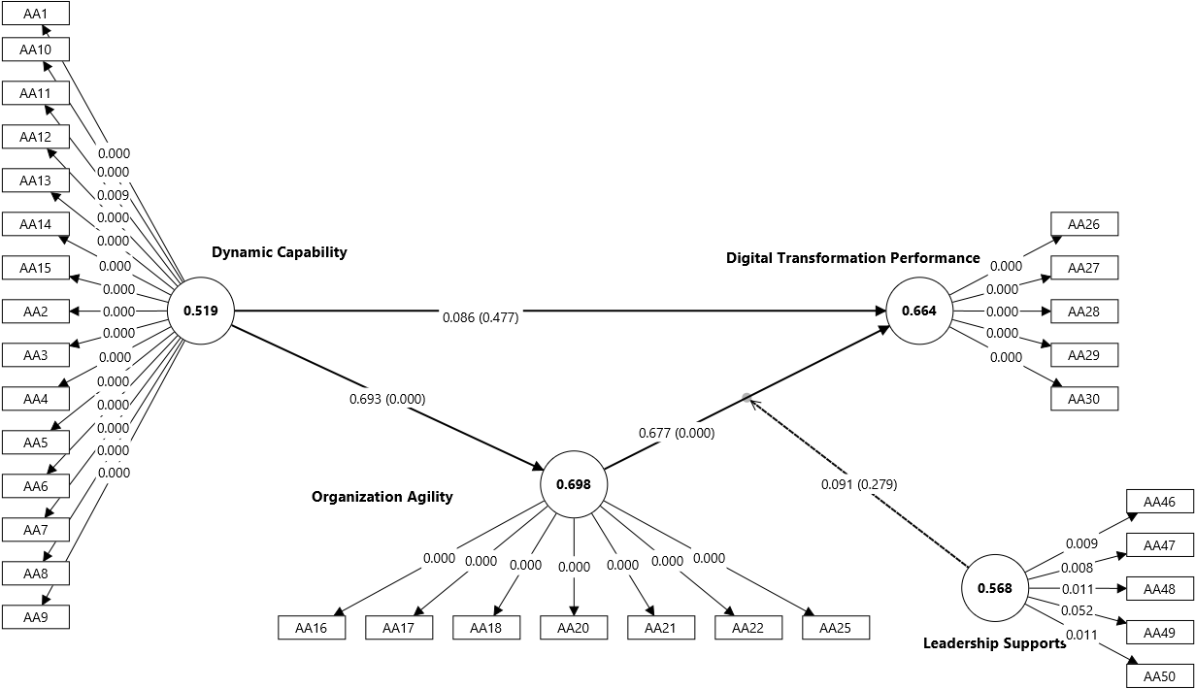
Figure 3. The Moderating Effect of Leadership Support
Similarly, Digital Literacy does not significantly moderate the relationship between Dynamic Capability and performance (β = −0.266, p > 0.05). This result challenges assumptions that digital competence automatically enhances transformation outcomes. Instead, it supports the argument that knowledge alone is insufficient without structural alignment and execution mechanisms (Vial, 2019).
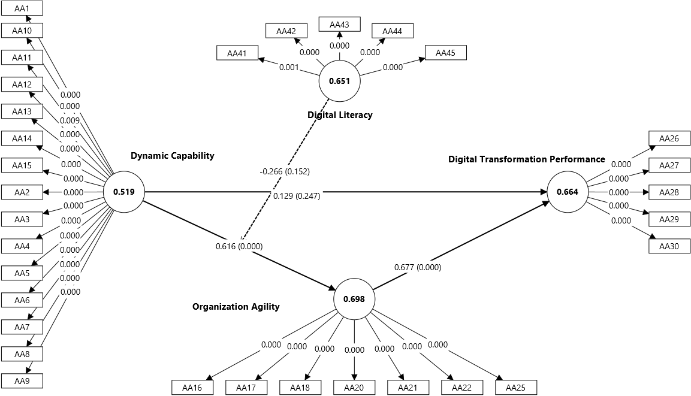

Figure 4. The Moderating Effect of Digital Literacy
4.6 Integrated Discussion
Overall, the findings of this study extend the Dynamic Capability View (DCV) by providing empirical evidence that dynamic capabilities influence performance primarily through indirect mechanisms rather than direct effects. The non-significant direct relationship between dynamic capability and digital transformation performance confirms that sensing, seizing, and reconfiguring capabilities function as enabling capacities rather than immediate performance drivers. This aligns with Dynamic Capability View, where capabilities are conceptualized as higher-order processes that shape how organizations deploy resources, rather than directly generating outcomes (Teece, 2007). Empirical studies have consistently demonstrated that the performance impact of dynamic capabilities is contingent upon intermediate organizational processes, such as operational capabilities or structural alignment (Pavlou & El Sawy, 2011; Wilden et al., 2013). Therefore, the insignificance of the direct path is theoretically expected and reinforces the notion of a “capability–performance gap.”
The results further highlight that organizational agility acts as the primary mechanism translating capability into performance. The strong and significant relationship between dynamic capability and organizational agility, combined with the significant effect of agility on digital transformation performance, confirms a full mediation effect. This finding is consistent with prior literature positioning agility as a dynamic operational capability that enables organizations to respond rapidly and effectively to environmental changes (Overby et al., 2006). In this context, agility serves as the execution layer that converts strategic intent into operational outcomes. Teece (2007) emphasizes that capabilities must be orchestrated and embedded in organizational routines to create value, while Pavlou and El Sawy (2011) argue that agility is essential for transforming sensed opportunities into realized performance. Thus, the empirical evidence supports the theoretical proposition that dynamic capabilities require agile organizational processes to generate tangible results.
Another important insight concerns the role of contextual factors, particularly leadership support and digital literacy. Although both variables are theoretically expected to strengthen relationships within the model, their moderating effects were found to be statistically insignificant. This finding can be explained through the lens of organizational institutionalization. When agility is already embedded in routines and processes, the marginal contribution of leadership may diminish, as decision-making and adaptation become decentralized and system-driven (Yukl, 2013). In such contexts, leadership operates more as an enabling condition rather than an active moderator. Similarly, the non-significant moderating effect of digital literacy suggests that individual-level competencies do not automatically translate into organizational-level performance improvements. As argued by Vial (2019), digital transformation is not merely a function of technological skills but requires alignment between people, processes, and structures. Without such alignment, digital literacy may remain at the level of cognitive readiness (“knowing”) rather than being converted into organizational action (“doing”).
Taken together, these findings reinforce a critical insight: digital transformation success in the public sector is fundamentally an organizational challenge rather than a purely technological one. While investments in technology and human capital are necessary, they are insufficient without mechanisms that enable coordinated, rapid, and adaptive responses. Organizational agility emerges as the central capability that bridges the gap between strategic potential and performance realization. This perspective contributes to the growing body of literature emphasizing that the effectiveness of digital transformation depends less on the availability of resources and more on the organization’s ability to mobilize and reconfigure them in a timely manner (Wilden et al., 2013; Vial, 2019).
Conclusion
This study concludes that digital transformation performance in the public sector is not directly driven by dynamic capabilities or individual-level competencies, but rather by the organization’s ability to translate these capabilities into agile actions. While sensing, seizing, and reconfiguring capabilities provide the strategic foundation, their impact on performance is fully mediated by organizational agility, which serves as the critical execution mechanism. The findings further reveal that leadership support and digital literacy, although important, function primarily as enabling conditions rather than decisive factors in strengthening performance outcomes. Consequently, the success of digital transformation in public organizations depends less on technological investment or skill enhancement alone, and more on the development of adaptive, responsive, and well-coordinated organizational processes.

References
Abdullahi, A., et al. (2024). Digital transformation in public sector organizations: The role of leadership and capability development. Government Information Quarterly, 41(1), 101789.
Chin, W. W. (1998). The partial least squares approach to structural equation modeling. In G. A. Marcoulides (Ed.), Modern methods for business research (pp. 295–336). Lawrence Erlbaum Associates.
Coulon, T., et al. (2020). Leadership alignment and digital transformation success. Journal of Public Administration Research and Theory, 30(4), 567–583.
Doz, Y. L., & Kosonen, M. (2010). Embedding strategic agility: A leadership agenda for accelerating business model renewal. Long Range Planning, 43(2–3), 370–382.
Ghosh, S., Hughes, M., & Hodgkinson, I. (2022). Digital transformation and dynamic capabilities: The role of digital literacy. Technological Forecasting and Social Change, 174, 121233.
Hair, J. F., Hult, G. T. M., Ringle, C. M., & Sarstedt, M. (2021). A primer on partial least squares structural equation modeling (PLS-SEM) (3rd ed.). Sage Publications.
Ndrecaj, V., et al. (2025). Organizational agility and digital performance in public institutions. Public Management Review, 27(2), 345–367.
Overby, E., Bharadwaj, A., & Sambamurthy, V. (2006). Enterprise agility and the enabling role of information technology. European Journal of Information Systems, 15(2), 120–131.
Pavlou, P. A., & El Sawy, O. A. (2011). Understanding the elusive black box of dynamic capabilities. Decision Sciences, 42(1), 239–273.
Redecker, C. (2017). European framework for the digital competence of educators (DigCompEdu). European Commission.
Saeedikiya, M., et al. (2024). Dynamic capabilities and digital transformation performance: A systematic review. Information Systems Frontiers, 26(1), 55–72.
Shakhoor, A., et al. (2024). The mediating role of organizational agility in digital transformation. Journal of Business Research, 168, 114–126.
Spante, M., Hashemi, S. S., Lundin, M., & Algers, A. (2018). Digital competence and digital literacy in higher education research: Systematic review of concept use. Cogent Education, 5(1), 1519143.
Teece, D. J. (2007). Explicating dynamic capabilities: The nature and microfoundations of sustainable enterprise performance. Strategic Management Journal, 28(13), 1319–1350.
Vial, G. (2019). Understanding digital transformation: A review and a research agenda. Journal of Strategic Information Systems, 28(2), 118–144.
Wilden, R., Gudergan, S. P., Nielsen, B. B., & Lings, I. (2013). Dynamic capabilities and performance: Strategy, structure and environment. Long Range Planning, 46(1–2), 72–96.
Yukl, G. (2013). Leadership in organizations (8th ed.). Pearson.
Zhang, Y., et al. (2023). Linking dynamic capabilities to digital transformation: Evidence from emerging economies. Information & Management, 60(2), 103456.

