FOMULATION AND EVALUATON OF IMMEDIATE RELEASE TABLETS OF HIBISCUS ROSA –SINENSIS AND ACMELLA OLERACEA FOR DIURETIC ACTIVITY

ABSTRACT
The present study focuses on the formulation and evaluation of immediate release tablets containing extracts of Hibiscus rosa-sinensis and Acmella oleracea for assessing diuretic activity. Herbal extracts were selected based on their reported pharmacological potential, particularly the diuretic effect of Hibiscus rosa-sinensis, which has been shown to significantly increase urine output and electrolyte excretion in experimental models , and the diverse therapeutic properties of Acmella oleracea, including bioactive phytoconstituents with potential renal and systemic effects.Innovare Academics Journals
The prepared tablets were evaluated for physicochemical parameters including weight variation, hardness, friability, thickness, and disintegration time, ensuring compliance with pharmacopeial standards. In vitro dissolution studies confirmed rapid release of active constituents, indicating suitability of the formulation for immediate therapeutic action.The diuretic activity of the formulated tablets was evaluated using standard experimental models (e.g., Lipschitz test) by measuring urine volume and electrolyte excretion (Na⁺, K⁺, Cl⁻) in treated groups compared to control and standard diuretics. The formulation exhibited significant, dose-dependent enhancement in urine output and electrolyte excretion, demonstrating comparable efficacy to standard drugs.
Keywords: Immediate release tablets, Herbal formulation,Diuretic activity,Polyherbal tablets,Tablet formulation

INTODUCTION
The use of medicinal plants for the treatment of various ailments has been an integral part of traditional healthcare systems worldwide. In recent years, there has been a growing interest in herbal medicines due to their perceived safety, effectiveness, and minimal side effects compared to synthetic drugs. Among these, plant-based diuretics have gained attention for their role in managing conditions such as hypertension, edema, and renal disorders. Diuretics are substances that promote the increased production of urine, thereby facilitating the removal of excess fluids and electrolytes from the body. Although synthetic diuretics are widely used, their prolonged use is often associated with adverse effects such as electrolyte imbalance and dehydration. This has led to a renewed focus on natural alternatives derived from medicinal plants.Hibiscus rosa-sinensis is a widely distributed ornamental plant known for its various pharmacological properties, including anti-inflammatory, antioxidant, and potential diuretic effects.
WHAT ARE DIUETICS?
Diuretics are a class of therapeutic agents that increase the rate of urine formation and promote the excretion of water and electrolytes, particularly sodium and chloride, from the body. They are commonly used in the treatment of conditions associated with fluid retention and elevated blood pressure, such as Hypertension, Heart Failure, edema, and renal disorders.

Figure 1 diuretics in different conditions

WHY SHOULD CHOOSE HERBAL OVER SYNTHETIC?
Synthetic diuretic drugs are widely used for the management of hypertension, edema, and renal disorders, but their prolonged use may produce adverse effects such as electrolyte imbalance, dehydration, and kidney dysfunction. Herbal medicines are gaining importance due to their comparatively safer profile and traditional therapeutic value. Although Hibiscus rosa-sinensis and Acmella oleracea have been traditionally reported to possess medicinal properties, limited scientific work has been carried out on the formulation of these herbal extracts into stable and effective immediate release tablet dosage forms for diuretic activity.
There is a need to develop a standardized herbal immediate release tablet containing extracts of Hibiscus rosa-sinensis and Acmella oleracea and to evaluate its physicochemical characteristics, drug release behavior, and diuretic potential. Therefore, the present research aims to formulate and evaluate immediate release tablets of these herbal extracts to establish their effectiveness and suitability as a natural diuretic formulation.

Pathophysiology Related to Immediate Release Diuretic Tablets
Diuretics are agents that increase the excretion of water and electrolytes such as sodium and chloride through the kidneys. Immediate release diuretic tablets are designed to disintegrate and release the active ingredient rapidly after oral administration, producing a quick onset of action.

Normal Physiology of Urine Formation

The kidneys regulate body fluid balance through filtration, reabsorption, and secretion in the nephron. Sodium and water are normally reabsorbed in different segments of the nephron to maintain electrolyte and fluid homeostasis.

Pathophysiology of Fluid Retention

Fluid retention occurs due to excessive reabsorption of sodium and water or impaired renal excretion. This condition is commonly associated with:
- Hypertension
- Congestive heart failure
- Renal disorders
- Liver cirrhosis
- Edema
In these conditions, increased sodium retention leads to water accumulation in tissues and blood vessels, causing swelling and elevated blood pressure.
Mechanism of Diuretic Action
Diuretics act by inhibiting sodium and water reabsorption in the nephron, resulting in increased urine output. Immediate release formulations rapidly dissolve in gastrointestinal fluids, allowing faster absorption and onset of pharmacological action.
For herbal formulations containing Hibiscus rosa-sinensis and Acmella oleracea, phytoconstituents such as flavonoids, alkaloids, tannins, and phenolic compounds may contribute to:
- Increased renal blood flow
- Inhibition of tubular sodium reabsorption
- Enhanced glomerular filtration
- Increased excretion of sodium and water
Figure 2pathophysiology of immediate release tab

PLANT PROFILE
- HIBISCUS ROSA SINESIS

INTRODUCTION

Hibiscus rosa-sinensis is a flowering medicinal plant belonging to the family Malvaceae. It is commonly known as Chinese hibiscus or shoe flower. The plant is widely distributed in tropical and subtropical regions and is traditionally used in herbal medicine for various therapeutic purposes.
Figure 3 hibiscus rosa sinesis

SR.  NO | CHARACTERISTICS | INFORMATION
 | Common name | Rosella ,Jamaican sorrel,florida cranberry,red sorrel karkde,gongura ,zobo bissap
 | Family | Malvaceae(mallow family)
 | Major active compound | Orgaic acids ,anthocyanins,,flavonoid and polyphenols ,polysaccharides,vitamins ,other component.
 | Growth rate | Fast
 | Medicinal uses | High in vitamin c ,antioxidents ,used to lower blood pressure support liver health  And act as a diuretic.
 | Diuretic mechanism | Act as diuretic primarily by inhibiting the reabsorption of

Table 1 BIOLOGICAL PROFILE OF HIBISCUS ROSA SINESIS

ACMELLA OLEARACEA
INTODUCTION
Acmella oleracea is a medicinal herb belonging to the family Asteraceae. It is commonly known as the toothache plant or paracress because of its traditional use in relieving toothache and oral discomfort. The plant is widely used in traditional medicine due to its diverse pharmacological properties.

Figure 4 acmella oleracea
SR.  NO | CHARACTERISTICS | INFORMATION
 | Common name | Toothache Plant, Spilanthes, Para Cress
 | Family | Asteraceae
 | Part used | Flower heads, Leaves, Aerial parts
 | Major active compound | Spilanthol (an alkylamide)
 | Other constituent | Flavonoids, Tannins, Sterols
 | Diuretic mechanism | Increases excretion of Sodium (Na⁺) and Chloride (Cl⁻)

Table 2 BIOLOGICAL PROFILE OF HIBISCUS ROSA SINESIS

CHEMICAL CONSTITUENT
- HIBISCUS ROSA SINESIS :

Figure 5 QUERCETIN
Figure 5 ANTHOCYANIN
Figure 7 HIBISCETIN

EVIDENCE SUPPORTING DIURETIC ACTIVITY:
Rats were adrenalectomized (ADX) under surgical anesthesia with sodium pentobarbital (55 mg/kg). A 2-cm incision was made at the costoventral angle, and the left and right adrenal glands were removed without exposing the kidney. The complete gland was excised together with the adjacent fat and the mesenteric junction. The rats were placed on a normal diet and 1% saline solution
FORMULATION CONSIDERATION OF HIBISCUS ROSA SINESIS AND ACMELLA OLERACEA IMMEDIATE RELEASE TAB
- Extaction of plant material
- Physiochemical screening of extract
- Fomula fo batches
- Wet granulation process
- The standardized solid powder extracts of Hibiscus rosa-sinensis and Acmella oleracea employed in the formulation study were procured online from Sai Herbs.( KR Impex Enterprises (Sai Herbs) Gulmarg Avenue, Amritsar Punjab India
- PHYSIOCHEMICAL SCREENING OF EXTACT
Requirements
Chemicals | Aparatus
- Ethanol , magnesium turning , concentrated HCL, NAOH,Dil.HCL,Fecl3,lead acetate solution, distilled water conc.H2SO4. | - Test tubes ,test tube stand ,beaker, burner ,spatula , weighing balance

TEST FO ACMELLA OLEACEA EXTACT:
sr.no. | Test | Procedure | Positive result
 | SHINODA TEST | Add small quantity of extact to ethanol and then add mg turning and few dop of conc. Hcl | Pink ,cimson or reddish color appears
 | DRAGONDROFF  TEST | 2ml of extract add few drops of reagent | Orange or reddish brown ppt
 | FECL3TEST | Add 2-3 drops of 5%Fecl3 solution to extract | Deep blue green or black coloration
 | LEAD ACETATE TEST | Add few dop of 10%lead acetate solution | Formation of bulky white ppt
Table 3 PRELIMINAY TEST

Figure 6 SHINODA TEST

Figure 7 DAGONDROFF TEST
Figure 8 FECL3 TEST

Figure 9 LEAD ACETATE TEST

TEST FO HIBISCUS EXTRACT:
sr.no. | Test | Procedure | Positive result
 | SHINODA TEST | Add small quantity of extact to ethanol and then add mg turning and few dop of conc. Hcl | Pink ,cimson or reddish color appears
 | NAOH TEST | Add 2ml NAOH to the extract | Blue green coloration develops
 | FECL3TEST | Add 2-3 drops of 5%Fecl3 solution to extract | Deep blue green or black coloration
 | LEAD ACETATE TEST | Add few dop of 10%lead acetate solution | Formation of bulky white ppt
Table 4 preliminay test of acmella oleracea extract

Figure 10 SHINODA TEST

Figure 11 NAOH TEST

Figure 12 FECL3 TEST

Figure 13 LEAD ACETATE TEST

OBSERVATION:
TEST | CHEMICAL CONSTITUENT IDENTIFIED | HIBISCUS EXTACT | ACMELLA EXTRACT
Dragondroff Test | Alkaloid | Present (+) | Present (+)
NAOH Test | Flavanoid | Present (+) | Present (+)
Fecl3Test | Phenol and Tannin | Present (+) | Present (+)
Lead acetate test | Flavonoid and Tannin | Present (+) | Present (+)

FOMULA FOR BATCHES:
Sr.no | Ingredient | Role of ingredient | Batch 1(in gram) | Batch 2(in gram) | Batch 3(in gram)
 | Hibiscus extract | Active ingredient | 15g | 20g | 25g
 | Acmella oleracea extract | Active ingredient | 15g | 10g | 5g
 | Guar gum | Binder | 16g | 16g | 16g
 | Starch | Diluent ,disintegant | 2.5g | 2.5g | 2.5g
 | Acacia gum | Binder | 1g | 1g | 1g
 | Talc | Glident | 0.3g | 0.3g | 0.3g
 | kaolin | Adsobants | 0.2g | 0.2g | 0.2g
 | Total |  | 50g | 50g | 50g
Table 5 FORMULA TABLE
WET GRANULATION PROCESS:
Requirements
Chemicals | Aparatus
Hibiscus extract | - Beaker ,
Acmella oleracea extract | - Petry plate ,hot air oven,
Guar gum | - Sieve no.60,80,22
Starch | - Mortor pastle
Acacia gum | - Tablet compression machine
Talc | - Stirrer
kaolin | - weighing balance

Figure 16 SOLID EXTRACT
Figure 17 INGREDIENTS

Step 1: Pass all the ingredient form the sieve number #60and talc from #80.

Figure 14 SIEVING

Step 2 :transfer the following ingredient into the mortor or blender.
- Hibiscus extract
- Acmella oleacea extract
- Guar gum
- Starch
- Kaolin
Blend for 10-15 min to obtain unifom mixture .
Figure 15 MIXING ALL INGREDIENT

Step 3:
- preparation of binder – 1gram of acacia gum in approximately 10ml purified water .(granulating fluid)
- Add above binder solution slowly to the mixture .
Step 4:
- Produce wet granules passing through sieve number #16 0r #20.
Figure 16 PEPERATION WET GRANULES

Step5: Drying granules in hot air oven at 40-50 degree celcius for 2-4 hrs or until the moisture content is 3-5%

Figure 17 DRYING GRANULES
Step 6:
- Pass the ganules though the sieve no 20 and 22 and break lumps and obtain uniform granule size .

Figure 18 RECIEVING PROCESS

Step 7: after the sieving mix uniformly in mortor fo 10-15 min and add the talc and blend gently for the 3-5 min

Figure 19MIXING
Step 8: compression of above mixture to make immediate release tab in tablet compression machine

Figure 20 TABLET COMPRESSION
EVALUATION PARAMETE OF IMMEDIATE RELEASE TAB:
Sr.no. | Test | Procedure | Performed test
 | Appearance | Color, shape, odor, surface texture, defects. | 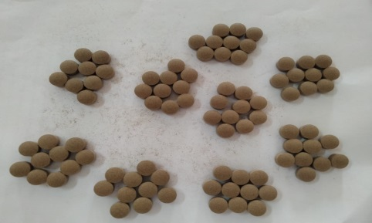
 | Thickness | - Randomly select 3 to 10 tablets from each batch.  - Clean the tablet surface to remove any dust particles.  - Measure the thickness of each tablet using a Vernier caliper or digital thickness gauge.  - Place the tablet between the two jaws of the instrument carefully without applying excessive pressure.  - Record the thickness reading in millimeters (mm).  - Repeat the procedure for all selected tablets.  - Calculate the average thickness and standard deviation. | 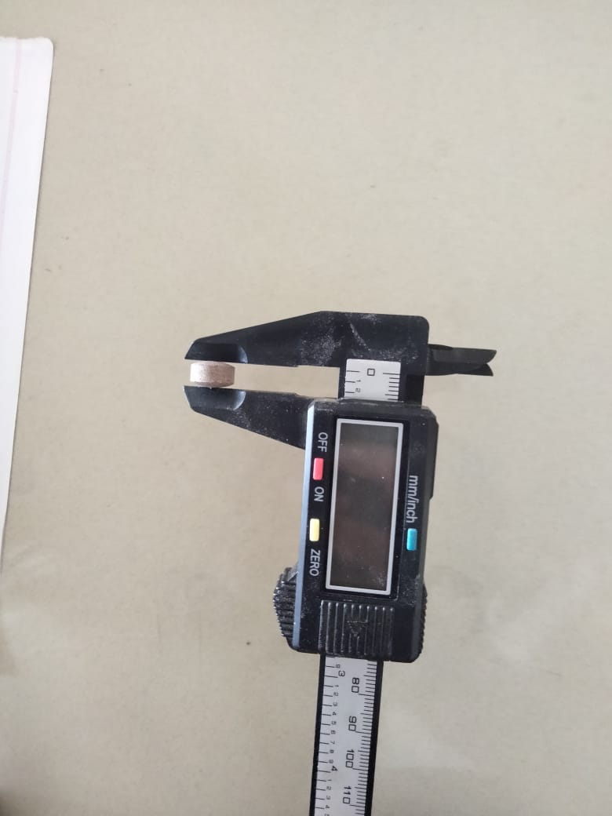
 | Weight Variation Test | - Randomly select 20 tablets from each batch.  - Clean the tablets to remove dust particles.  - Weigh all 20 tablets together using a digital weighing balance and calculate the average weight.  - Weigh each tablet individually and record the weights.  - Compare the individual tablet weights with the average tablet weight.  - Calculate the percentage weight variation for each tablet. | 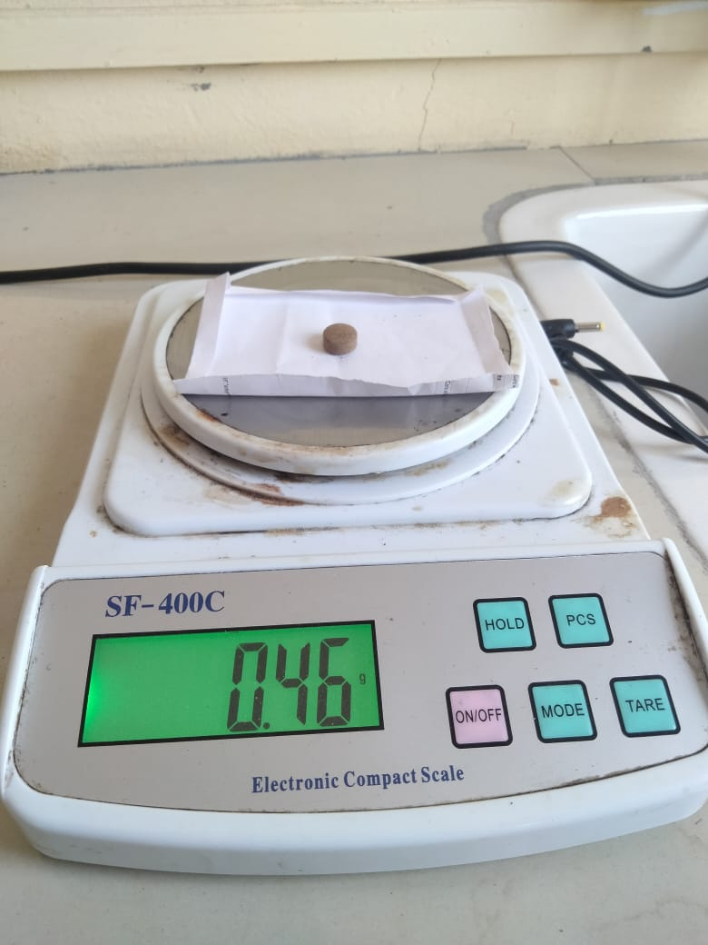
 | Hardness Test | • Select 3–6 tablets randomly.  • Place one tablet in the hardness tester.  • Apply pressure until the tablet breaks.  • Record the hardness value.  • Repeat for all tablets and calculate the average hardness. | 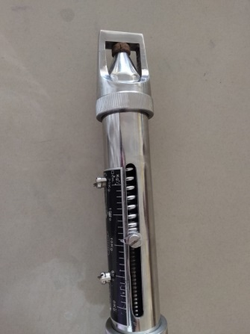
 | Friability Test | • Weigh 10 tablets accurately (Initial weight = W₁).  • Place the tablets in a Roche friabilator.  • Rotate the friabilator at 25 rpm for 4 minutes (100 rotations).  • Remove tablets, dedust, and weigh again (Final weight = W₂).  • Calculate percentage friability. | 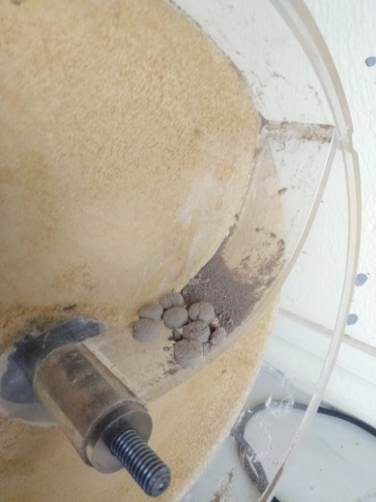
 | Disintegration Test | • Place one tablet in each tube of the disintegration apparatus.  • Fill the vessel with distilled water maintained at 37 ± 0.5°C.  • Start the apparatus and allow the basket to move up and down.  • Observe the time taken for complete disintegration of tablets.  • Record the disintegration time for each tablet. | 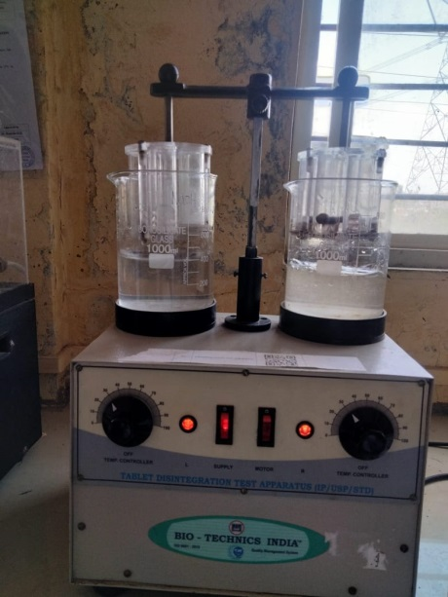
 | Diameter | • Take 3–10 tablets randomly.  • Measure diameter using Vernier caliper.  • Record readings in mm.  • Calculate average. | 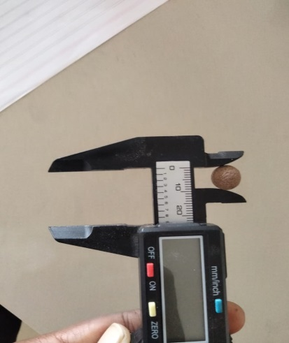
Table 6 EVALUATION PAAMETERS
OBSERVATION:
Sr.no | Test | Standard ranges | Batch 1 | Batch 2 | Batch3
 | Appearence | Uniform and defectfree | Smooth,uniform reddish brown tablet | Smooth and uniform | Minor roughness
 | Thickness | 4.5-5.5mm | 4.5-5.5mm | 4.5-5.5mm | 4.5-5.5mm
 | Diameter | 10mm | 10mm | 10mm | 10mm
 | Hardness | 5-7Kg/cm2 | 5.8+/-0.2 | 5.2+/-0.3 | 4.4+/-0.4
 | Weight variation | 475-525(+/-5%) | 498+/-3 | 501+/-2 | 505+/-4
 | Friability | NMT 1% | 0.42% | 0.58% | 0.86%
 | disintegration | NMT 15 min | 5.2min | 6.8min | 9.5min
Table 7 EVALUATION PAAMETER RESULT
According to above table, All formulations exhibited acceptable post-compression characteristics within pharmacopeial limits. Among the prepared batches, F2 demonstrated optimum tablet properties with satisfactory hardness, low friability, uniform appearance, and rapid disintegration behavior.
RESULT:
The present study was carried out to formulate and evaluate immediate-release polyherbal tablets containing extracts of Hibiscus rosa-sinensis and Acmella oleracea. Different formulations were prepared by varying the concentration of the herbal extracts while maintaining a constant tablet weight of 500 mg.
Preformulation studies confirmed acceptable physicochemical properties of the extracts. Phytochemical screening revealed the presence of flavonoids, alkaloids, tannins, saponins, glycosides, and phenolic compounds, which are reported to possess diuretic potential. Compatibility studies indicated that the extracts were compatible with the selected herbal excipients.
The prepared tablets were evaluated for post-compression parameters including appearance, weight variation, hardness, friability, and disintegration time. All formulations complied with acceptable pharmacopeial limits for immediate-release tablets. The formulations showed satisfactory mechasnical strength, acceptable friability, uniform weight variation, and rapid disintegration characteristics.SSS
Among all formulations, F2 showed optimum tablet characteristics with acceptable hardness, low friability, and satisfactory disintegration time. The formulation also exhibited good immediate-release properties.
CONCLUSION:
The present study successfully formulated immediate-release polyherbal tablets containing Hibiscus rosa-sinensis and Acmella oleracea extracts using herbal excipients. The prepared formulations showed satisfactory physicochemical and post-compression evaluation parameters within acceptable limits for immediate-release tablets.
Phytochemical screening confirmed the presence of bioactive constituents associated with diuretic potential. Among the formulations, F2 demonstrated optimum tablet properties and was considered the optimized formulation.
The study suggests that the formulated polyherbal tablets may possess potential diuretic activity due to the presence of phytoconstituents reported in the selected medicinal plants. However, further pharmacological studies are required to confirm the diuretic activity experimentally.

REFERENCES
- Wright CI, Van-Buren L, Kroner CI, Koning MMG. Herbal medicines as diuretics: a review of the scientific evidence. J Ethnopharmacol. 2007;114(1):1–31.
- Dubey S, Maity S, Singh M, Saraf SA, Saha S. Phytochemistry, pharmacology and toxicology of Acmella oleracea: a review. Adv Pharmacol Sci. 2013;2013:423750.
- Sharma S, Sharma RA. Pharmacological evaluation of Hibiscus rosa-sinensis Linn.: a review. Int J Pharm Sci Rev Res. 2013;22(1):135–138.
- Fakeye TO, Pal A, Bawankule DU, Yadav NP, Khanuja SP. Anti-inflammatory and antioxidant effects of Hibiscus rosa-sinensis. Fitoterapia. 2009;80(4):234–238.
- Aulton ME, Taylor KMG. Aulton’s pharmaceutics: the design and manufacture of medicines. 5th ed. London: Elsevier; 2018.
- Ekor M. The growing use of herbal medicines: issues relating to adverse reactions and challenges in monitoring safety. Front Pharmacol. 2014;4:177.
- Ali BH, Wabel NA, Blunden G. Phytochemical, pharmacological and toxicological aspects of Hibiscus species: a review. Phytother Res. 2005;19(5):369–375
- Qureshi R, Bhatti GR, Memon RA. Ethnomedicinal uses of herbs and shrubs in the treatment of diuretic disorders. Pak J Bot. 2009;41(5):2513–2521.
- Gasparotto A Jr, Gasparotto FM, Boffo MA, Lourenço ELB, Stefanello MÉA, Salvador MJ, et al. Diuretic and potassium-sparing effect of Echinodorus grandiflorus in rats. J Ethnopharmacol. 2009;124(1):85–90.
- Jouad H, Lacaille-Dubois MA, Eddouks M. Chronic diuretic effect of the water extract of Spergularia purpurea in normal rats. J Ethnopharmacol. 2001;75(2–3):219–223.
- Dearing MD, Foley WJ, McLean S. The influence of plant secondary metabolites on the nutritional ecology of herbivorous mammals. Annu Rev Ecol Evol Syst. 2005;36:169–189.
- Rates SMK. Plants as source of drugs. Toxicon. 2001;39(5):603–613.
- Calixto JB. Efficacy, safety, quality control, marketing and regulatory guidelines for herbal medicines (phytotherapeutic agents). Braz J Med Biol Res. 2000;33(2):179–189
- McKay DL, Chen CY, Saltzman E, Blumberg JB. Hibiscus sabdariffa L. tea (roselle) lowers blood pressure in prehypertensive and mildly hypertensive adults. J Nutr. 2010;140(2):298–303.
- Hopkins AL, Lamm MG, Funk JL, Ritenbaugh C. Hibiscus sabdariffa L. in the treatment of hypertension and hyperlipidemia: a comprehensive review of animal and human studies. Fitoterapia. 2013;85:84–94.
- Herrera-Arellano A, Flores-Romero S, Chávez-Soto MA, Tortoriello J. Effectiveness and tolerability of a standardized extract from Hibiscus sabdariffa in patients with mild to moderate hypertension: a controlled trial. Phytomedicine. 2004;11(5):375–382.
- Carvajal-Zarrabal O, Waliszewski SM, Barradas-Dermitz DM, Orta-Flores Z, Hayward-Jones PM, Nolasco-Hipólito C, et al. The consumption of Hibiscus
- Da-Costa-Rocha I, Bonnlaender B, Sievers H, Pischel I, Heinrich M. Hibiscus sabdariffa L.–a phytochemical and pharmacological review. Food Chem. 2014;165:424–443.
- Aguirre-Crespo F, Vergara-Galicia J, Villanueva-Michel MT, Villaseñor-García MM, Estrada-Soto S. Diuretic activity of Hibiscus sabdariffa aqueous extract and its effects on renal function in an experimental model. J Ethnopharmacol. 2011;137(1):620–626.
- Thakur M, Bhargava S, Dixit VK. Immunomodulatory activity of Acmella oleracea (L.) R.K. Jansen. J Ethnopharmacol. 2007;109(3):332–336.
- Dias JE, De Carvalho MG, Da Silva JFM. Alkylamides from Acmella oleracea: isolation and biological activity. Phytochemistry. 2012;77:83–90.
- Prachayasittikul V, Prachayasittikul S, Ruchirawat S, Prachayasittikul V. Spilanthes acmella: a review of pharmacological properties and bioactive compounds. EXCLI J. 2013;12:291–312.
- Dwivedi A, Singh AK. Experimental evaluation of renal protective and diuretic potential of medicinal plant extracts in rats. Phcog Res. 2011;3(2):115–119.
- Santos C, Salvador MJ, dos Santos DP, et al. In vivo pharmacological screening of plant extracts for renal excretory effects. Braz J Pharm Sci. 2010;46(4):701–708.
- Remington JP. Remington: the science and practice of pharmacy. 21st ed. Philadelphia: Lippincott Williams & Wilkins; 2005.
- Banker GS, Rhodes CT. Modern pharmaceutics. 4th ed. New York: Marcel Dekker; 2002.
- Shah RR, Tawakkul MA, Khan MA. Comparative evaluation of flow for pharmaceutical powders and granules. AAPS PharmSciTech. 2008;9(1):250–258.
- Singh S, Singh T, Saini V. Natural superdisintegrants in tablet formulations: a review. Int J Pharm Sci Res. 2012;3(2):245–252.
- Deshmukh PK, Jain CP, et al. Development and evaluation of herbal fast dissolving tablets: a review. J Pharm Res. 2011;4(3):749–752.
- Wadher KJ, Kakde RB, Umekar MJ. Formulation and evaluation of orally disintegrating tablets using natural superdisintegrants. Int J ChemTech Res. 2010;2(1):367–371.
- Martin A, Bustamante P, Chun AHC. Physical pharmacy: physical chemical principles in the pharmaceutical sciences. 5th ed. Philadelphia: Lippincott Williams & Wilkins; 2002.
- Staniforth JN. Powder flow. In: Aulton ME, Taylor KMG, editors. Aulton’s pharmaceutics: the design and manufacture of medicines. 5th ed. London: Elsevier; 2018. p. 183–216.
- Lachman L, Lieberman HA, Kanig JL. The theory and practice of industrial pharmacy. 3rd ed. Mumbai: Varghese Publishing House; 2009.
- Banker GS, Rhodes CT. Modern pharmaceutics. 4th ed. New York: Marcel Dekker; 2002.
- Shangraw RF. Compressed tablets by direct compression. In: Lieberman HA, Lachman L, Schwartz JB, editors. Pharmaceutical dosage forms: tablets. Vol 1. 2nd ed. New York: Marcel Dekker; 1989. p. 195–246.
- Reddy LH, Ghosh B, Rajneesh. Fast dissolving drug delivery systems: a review. Indian J Pharm Sci. 2002;64(4):331–336.
- Lipschitz WL, Haddian Z, Kerpcsar A. Bioassay of diuretics. J Pharmacol Exp Ther. 1943;79:97–110.
- Vogel HG. Drug discovery and evaluation: pharmacological assays. 2nd ed. Berlin: Springer; 2002.
- Turnheim K. Pharmacodynamics of diuretics. Pharmacol Ther. 2004;66(2):113–150.
- Hailu B, Giday M, Erko B. Experimental evaluation of diuretic activity of medicinal plants in rodents: methods and models. J Ethnopharmacol. 2013;147(2):394–399. Patel S, Shah V, Patel R. Evaluation of diuretic activity: preclinical screening methods and interpretation. Int J Pharm Sci Res. 2011;2(5):1200–1206.

