EXPLORING FIRE HAZARD, HOUSEHOLD PRACTICES AND COMMUNITY PREPAREDNESS IN INFORMAL SETTLEMENTS OF UTTAM NAGAR

ABSTRACT
The aim of the study is to examines the fire hazards, Household-level practices and community preparedness in informal settlements of Uttam Nagar. This research is based on the Mixed method approach; the primary data was collected from the 50 respondents through survey and google form and a Field observation collected for JJ cluster in informal settlements of Uttam Nagar. The findings reveal that the fire is influenced by household practices like unsafe cooking method, improper electrical wiring and storage of flammable materials which influence the fire hazards and physical vulnerabilities does also increase the fire incidents. The study Highlights that while the awareness of fire safety remain high but the preparedness among the respondent remain low as there is lack of training and lack of fire equipment’s in the household. The study focuses on the need of improving infrastructure and citizen participation in risk reduction.
Keywords: Fire Hazards, Informal Settlements, Community Preparedness, Vulnerability, Household Practices, Disaster Risk Reduction, Uttam Nagar, Delhi

INTRODUCTION

Background
Fire Hazards are one of the major occurring problems in India, especially in cities like Delhi where the growing population and unplanned urban expansion has led to the development of Informal settlements. These settlements are consists of features like narrow lanes, high population density and poor housing condition, which can increase the risk of the Fire Hazards. These features are one of the major causes for Fire incidents as the fire spread quickly due to the close spacing of houses and the presence of flammable materials like wood and plastics.
Uttam Nagar is a residential area which is located in West Delhi. Due to rapid expansion in this area, it has led to the development of informal settlements. It consists of high population density of 182,171 (2011 census). The congested housing and inadequate infrastructure in these settlements increase the Fire vulnerability. The major causes of fire incidents in these settlements are due to the unsafe electrical connection, unsafe use of cooking fuel and also the lack of awareness among the people which lead to the fire disaster.
Also, the household-level practices and community preparedness are important factor in fire hazards. Household practices like cooking fuel, use of electrical appliances can shape the potential risk of fire incidents. The study of these household practices is very important for studying the Fire hazards in informal settlements. Whereas, community preparedness is also considered to be an important factor in reducing the risk of fire incidents. The preparedness includes the awareness about safety measures, availability of safety equipment and the knowledge about the emergency helpline.

Objectives
The few major objectives of the study are
- To assess the Fire vulnerability in the informal settlements
- To examine the Household practices influencing fire incidents at micro level
- To examine the community preparedness among the residents

Research question
- What are the major factors affecting the fire hazards in Uttam Nagar?
- How does the household-level practice affect the fire risk in the informal settlements?
- What is the level of community preparedness and awareness existing in informal settlements?

LITERATURE REVIEW
Fire hazards have been the most frequent disaster occurring in urban areas. With the increasing expansion and population growth in the urban areas it has led to the development of the informal settlements. These settlements consist of factors like inadequate infrastructure, poor housing condition and high population. The fire incidents can cause the loss of lives and property damage. This literature review synthesis the finding of various studies related to fire hazards.
Several studies have focused on fire risk assessment using the spatial and technological aspect. Authors like Bhatia and Upadhya (2023) has assessed the fire risk and highlighted the role of overcrowding and poor infrastructure in increasing the fire incidents. Similarly, Tomar et al. (2018) and Thakare et al. (2025) has highlighted the use of GIS mapping in identifying the fire hazard zones and vulnerable areas. In addition, Mandal et at. (2023) and, Ferreira et at. (2016) has highlighted the role of effective emergency planning and building material which impact the risk of fire hazards.
While the above studies were focusing on spatial aspect some other studies focus on the High vulnerability. Some other studies conducted by Karmakar et at. (2024) has examined the household response to fire and highlighted the socio-economic conditions in influencing the fire response. Similarly, Nida Ali (2024) has founded the unsafe use of cooking fuel and improper electrical wiring a major cause for fire incidents. The fire incidents are majorly influenced by the daily household practices of residents. Study by Rajagopal Kannan (2025) highlights the lack of safety fire equipment’s at home and unsafe cooking method influence the major outbreak of fire. This indicates that the household-level practices play an important role in fire hazards.
Studies also highlights influence of physical infrastructure on fire vulnerability. Research conducted by Nerina du Toit (2009) has highlighted the frequent occurrence of fire incidents due to building material, poverty and lack of institutional. Other studies by authors like Sanu et al. (2022) had studied the fire disaster through the case study and highlighted the delayed response, poor accessibility and lack of preparedness in its study. These studies reveals that adequate infrastructure can increase the risk of fire incidents and can delay the emergency responses.
The other reports like SEEDS India (Sustainable environment and ecological development society 2016) have found that the unplanned urbanization has failed the emergency system in India and increased the community vulnerability. Apart from this the government initiative and reports like Aapda Mitra program, NDMA (2016) and DDMA (2016-17) has highlighted the importance of community awareness in reducing the fire risk. Reports from DFS highlights the increasing number of fire outbreaks in Delhi.
Several other studies have focused on community preparedness and awareness. Studies like Gautam and Tewari (2020) and Jain et al. (2025) highlights the importance of community preparedness and founded the low preparedness level among the community. Similarly, Sharma et al. (2015) has conducted the gender-based disaster study on fire and highlighted the important role played by women in household level preparedness.
Overall, this existing literature had studied the fire hazards and preparedness but it has mostly focus on the general idea about preparedness and not about the gap between the actual awareness and preparedness among the people. The limited attention has been given to relationship between the household practices and practical preparedness within the informal settlements. Therefore, the aim of this study is to address these gaps by exploring the fire hazards, household-level practices and community preparedness in informal settlements of Uttam Nagar.
STUDY AREA
Uttam Nagar is located in West Delhi, is a densely populated area having a mix of authorised and unauthorised colonies and nearby JJ cluster settlements. This area has seen the rapid urbanization and population growth which led to the development of informal settlements in this area. This study area has been selected because it consists of high population density, narrow lanes, close space housing and increasing vulnerability of fire hazards. The area is characterised by pucca and semi-pucca housing, unsafe electrical connections and limited emergency accessibility. These types of conditions increase the rapid spread of fire and can create the challenges in evacuation during the emergency.
The JJ cluster is selected in Uttam Nagar for field observation as it shows the physical and social vulnerability of the area. The presence of congested housing, unsafe electrical connection and storage of flammable materials makes the area highly vulnerable to fire disasters. Therefore, Uttam Nagar is an appropriate area to study fire hazards, household practices and community preparedness at local level.
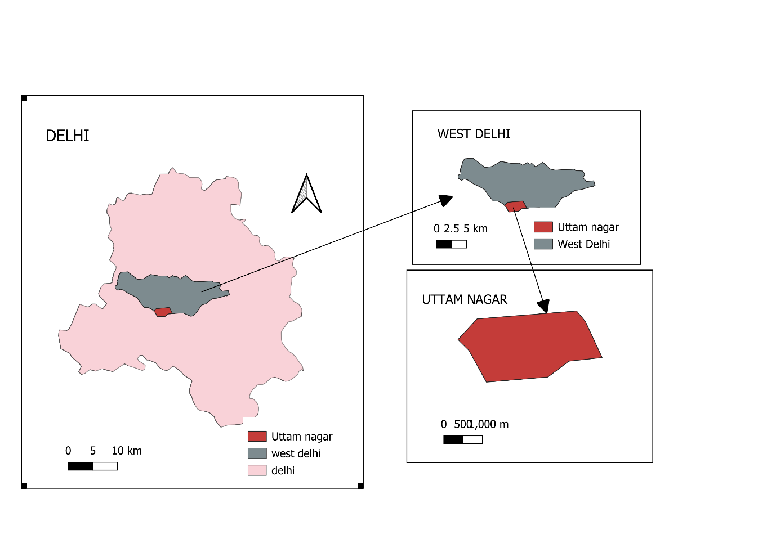
Geographical location of the study area

METHODOLOGY
This study is based on both descriptive and exploratory research design to examine fire hazards, household practices and community preparedness in in formal settlements. The data was collected using structured questionnaire which is consists of the open-ended and close-ended questionnaire about the household practice and community preparedness from the residents. This survey was conducted in the selected informal settlements of Uttam Nagar. This locality has been selected on the basis of the factors of physical and social vulnerability. The random sampling method has been used for selecting the respondent for survey.
A total of 50 household responses was collected for this study through both field visit and google forms. The field observation has also been conducted in the JJ cluster area of Uttam Nagar to examine the physical conditions, storage of flammable materials, unsafe electrical connections and accessibility of emergency services. The statistical tools such as charts and tables have been used for the data interpretation.
SOURCES OF DATA
The two different sources of data have used to in this study.
- Primary Data source
The primary data has been collected through the household survey and field observation in the informal settlements of the Uttam Nagar. The personal observation helps in understanding the physical conditions of the locality.
- Secondary Data source
The secondary data has been collected by the government reports, journals, books and previous research studies related to fire vulnerability and community preparedness.

ANALYSIS
These findings are based on the primary data which has been collected through the household questionnaire survey. This analysis is divided into three sections which are the household-level practices, vulnerability conditions and community preparedness.
- Household-level Practices

VARIABLE | CATEGORY | FREQUENCY(n) | PERCENTAGE
Cooking Fuel | LPG  Gas Pipeline | 30  20 | 60%  40%
Electrical wiring condition | Good  Average  Poor | 34  15  1 | 68%  30%  2%
Exposed wiring | Yes  No | 9  41 | 18%  82%
Overloading of electrical sockets | Always  Sometimes  Never | 8  20  22 | 16%  40%  44%
Switching off electrical appliances | Always  Sometimes  Never | 38  11  1 | 76%  22%  2%
Storage of Flammable materials | Yes  No | 24  26 | 48%  52%
SOURCE: FIELD SURVEY, 2026

The findings from survey reveals that 60% of people use LPG for cooking, while 40% of the residents use the gas pipeline for cooking purpose. Although these fuels are somewhat safe. Most of the people still use LPG which can be unsafe due to the improper handling of this fuel and can cause the fire outbreaks in the locality. Whereas Electrical wiring safety is another concerned. It shows that 68% of residents are having good electrical wiring while 30% of respondent are having average condition of electrical wiring at their home. Additionally, 18% have reported having exposed wiring in their homes which can increase the risk of fire incidents.
Apart from this overloading is another major concern because of potential fire risk. While the 16% responded have reported always doing overloading in sockets, there are another 40% reported of doing overloading sometimes. Whereas, the 76% reported to always switching off appliance, 22% responded only doing it sometimes and remaining 2% never switch off the appliances when its is not in use. While a significant 72% reported not checking the electrical wiring regularly, which highlights the gaps between the awareness and preventive practices.
As the flammable materials can increase the risk of fire incidents. A significant 48% have been reported storing such materials like plastic, paper and wood. The gas safety practices show variations as 66% has kept the gas at safe and ventilated place, while the 34% keep it inside room and unsafe place. Whereas, only 62% check gas leakage regularly and the rest 38% either don’t check it or done it unregularly and This highlight that the significant portion neglects the gas safety measures.
The observation made from the JJ cluster indicates that there is limited space and cooking are done inside the room, while many flammable materials are stored which can cause a major fire outbreak.

- VULNERABILITY ANALYSIS
VARIABLE | CATEGORY | FREQUENCY (n) | PRECENTAGE
Housing spacing | Closely spaced  Moderate spacing  Spacious | 33  16  1 | 66%  32%  2%
Lane Width | Narrow  Moderate  wide | 17  23  10 | 34%  46%  20%
Accessibility of Fire Services | Easy access  Difficult access  Not accessible | 24  22  4 | 48%  44%  8%
Access to water during emergency | Available  Not available | 41  9 | 82%  18%
SOURCE: FIELD SURVEY, 2026

The finding reveals that Physical vulnerability contributes to risk in fire incidents. It is reported that 66% of houses are closely spaced while 32% have moderate spaced and 2% have spaciously spaced. This indicates that the high density in the locality where the closely spaced houses can spread rapid fire outbreaks. Whereas, the narrow lanes in the locality are another major concern. The 34% responded reported having narrow lanes while 46% having moderate lanes and 20% have wide lanes. It highlights the problem of the evacuation during fire outbreak and also delayed the fire emergency services in the locality.
The accessibility of Fire emergency services is the most important aspect during fire hazards. It is reported that 48% residents have easy accessibility of these services where as 44% have reported to have difficult accessibility while 8% has reported that the fire accessibility as not possible. This indicate that more than half of population have problem in accessibility of fire services due to the narrow lanes and closely spaced housing.
Whereas, it is reported that 82% residents have the nearby access to water while only 18% have reported having lack of access to waster in these settlements. It indicates that even though most people do have access to water but it may not be easily accessible or useful at the time of emergency.
The observation from JJ cluster reveals the narrow lanes, congested areas and lack of access to water can increase the further vulnerability as it can spread the fire rapidly in informal settlements.
- COMMUNITY PREPAREDNESS
VARIABLE | CATEGORY | FREQUENCY (n) | PERCENTAGE
Awareness of fire safety measures | Aware  Not aware | 44  6 | 88%  12%
Knowledge of emergency helpline number | Yes  No | 34  16 | 68%  32%
Participation in fire safety training | Attended  Not attended | 20  30 | 40%  60%
Availability of Fire safety equipment | Available  Not Available | 9  41 | 18%  82%
Frequency of Fire Incidents | Very often  Sometimes  Rarely  Never | 8  13  24  5 | 16%  26%  48%  10%
SOURCE: FIELD SURVEY, 2026
Community preparedness is a most important aspect in reducing the fire risk in the informal settlements. The finding from the survey has indicate that 88% of responded in the settlement are aware of the fire safety measures in reducing the risk of fir incidents. Whereas, the only 12% responded have been reported having lack of awareness about the fire safety measures. This indicate that there is a general awareness regarding the safety measures among the residents.
Whereas, the data shows that only 68% of the responded know the fire emergency number and 32% responded are not being aware of the fire emergency number. This shows that there is a significant gap and most people will not be able to call fire safety department during the critical situation. While 60% of the responded had reported of not attendant any kind of training and awareness program and only 40% of the respondent did have attended fire training program. It indicates that most of people in the informal settlements have limited practical knowledge about fire and will not able to respond effectively during the emergency.
The data also reveal that only 18% respondent are having any kind of fire safety equipment present in their homes, whereas majority 82% do not have any equipment. It shows the limited preparedness among the residents and it also make it difficult to control the fire during the fire incidents.
The responded does are having past experience about fire hazards and major causes has been the short circuit in the locality. The frequency of fire in these settlements indicate the risk of fire outbreaks. As the 16% has reported fire incidents very often, 26% reported sometimes, 48% reported rarely and only 10% reported never which indicate that fire incidents do take place in these areas and has a major risk.
Whereas, the field observation from the JJ cluster reveals the physical vulnerability which also impact the preparedness. The lack of formal infrastructure and organize system can reduce community preparedness.

DISCUSSION
The findings from the study reveals that the household-level practices, vulnerability conditions and community preparedness do influence the fire risk in the informal settlements of Uttam Nagar. The household-level practices such as condition of electrical wiring, overloading and cooking fuel and storage of flammable materials at home influence the fire incidents. The majority of people do follow the safety measures but still the irregular behavior can cause fire hazards.
The vulnerability analysis highlights the influence of physical structure in major fire risk in these settlements. The closely space housing and narrow lane increase the risk of rapid spread of fire and can also delayed the emergency response. Even though the majority people have access to water, its reliability is still uncertain. Due to these narrow lanes many people face difficulty in access the emergency services.
Whereas, the study of community preparedness in these settlements shows that there is high awareness regarding fire safety measures among the residents but still the preparedness level remain low as people does not receive any formal training and do not have any fire safety equipment. This highlights the gap between the actual awareness and preparedness in the informal settlements.
While the field observation collected from JJ cluster supports these findings by showing congested areas, kuccha house and unsafe electrical connection which increase the fire risk in these settlements.
LIMITATION
This study has certain limitation which can affect the generalization of the findings. The study is based on small sample size of 50 respondents, which might not represent every informal settlement of Delhi. This study is limited to selected areas of Uttam Nagar; therefore, the findings may vary in other informal settlements of Delhi which has different socio- economic and infrastructural conditions.
The time and resource constraints also limit the field investigation and data collection for the study. The study focuses on the household practices, community preparedness and vulnerability conditions and does not include the detail technical assessments. Furthermore, the study only uses descriptive analysis and does not include the advance statistical techniques because of the exploratory nature of research. Even after certain limitation the study provide the important insights into fire hazards, household practices and community preparedness in informal settlements of Uttam Nagar.
CONCLUSION
The study concludes that the fire hazards in the informal settlements of Uttam Nagar is due to the both household-level practices and the community preparedness. The physical vulnerability includes the closely spaced housing, narrow lanes which impact the emergency response.
The study indicates the basic awareness among the residents but a low level of community preparedness among the residents. The study also highlights the need of localized method approach to fire risk reduction, the need to improve the infrastructure, promoting training programs and the important role of citizen participation in the fire risk reduction.

REFERENCES
- Tomar s., Kaur A., Dangi H.K., Sarma K. (2018) Fire Risk Assessment and Fire Hazard Zonation Mapping using GIS in South-West Division of Delhi. Journal For Advance Research in Applied Sciences, 5(3) https://www.researchgate.net/publication/324223446
- Kanika Bhatia and Aakash Upadhyay (2023) Assessing the Risk of Fire Hazard: A Case Study of Delhi. In proceedings of 5th World Congress on Disaster Management (volume. II) https://www.researchgate.net/publication/369538674
- Mandal. T., Rao, K.R., Tiwari, G. (2023) Fire risk analysis from fire call data- a case study of Delhi. https://ssrn.com/abstract=4666907
- Karmakar, S., Sharma, U., & Lange, D. (2024) Determinants of Response to Fire Incidents in the Informal Settlements: A Case of Jhuggi Jhonpdi Clusters in Delhi, India. Journal of Physics. https://iopscience.iop.org/article/10.1088/1742-6596/2885/1/012093
- Sanu, S. K., Rai, S., & Sharma, V. R. (2022). Description of Fire as a Disaster with a Case Study of Delhi’s Mundka Fire. Disaster & Development, 11(2), https://www.researchgate.net/publication/368916117
- Thakare, K. V., & Tajne, K. M. (2025). A comprehensive review of geographic information systems (GIS)-based methodologies for urban fire risk assessment. Cureus Journal of Engineering, 2, e44388. https://doi.org/10.7759/s44388-024-02916-y
- Kannan, R. (2025). Modern-day fire protection arrangements in Indian urban homes: The role of regulations. International Journal for Multidisciplinary Research, 7(2). https://www.ijfmr.com
- Ali, N. (2024). A review of fire causes in informal settlement. Journal of Research in Infrastructure Designing, 7(1), 1–11.
- du Toit, N. (2009). Informal settlement fires: Addressing the issue in Kayamandi (Master’s thesis, Stellenbosch University).
- Gautam, U., & Tewari, D. B. (2020). Community preparedness for disasters in Delhi: An empirical evaluation. European Journal of Sustainable Development, 9(4), 71–83. https://doi.org/10.14207/ejsd.2020.v9n4p71
- Sharma, R., Kumar, V., & Raja, D. (2015). Disaster preparedness amongst women, the invisible force of resilience: A study from Delhi, India. International Journal of Health System and Disaster Management, 3(3).
- Ferreira, T. M., Vicente, R., Mendes da Silva, J. A. R., Varum, H., Costa, A., & Maio, R. (2016). Urban fire risk: Evaluation and emergency planning. Journal of Cultural Heritage, 20, 1–10. https://doi.org/10.1016/j.culher.2016.01.011
- National Disaster Management Authority. (2016 a). Delhi disaster management plan 2016–17. Government of India.
- SEEDS India. (2016). Urbanization and disaster risk in Delhi: Challenges and community-led solutions.
- National Disaster Management Authority. (2016 b). Aapda Mitra: Community volunteer training scheme. Government of India. https://ndma.gov.in
- Delhi Disaster Management Authority. (2016–2017). Annual disaster management report. Government of NCT of Delhi. https://ddma.delhi.gov.in/
- Delhi Fire Services. (n.d.). Fire incident statistics report. Government of NCT of Delhi. https://dfs.delhi.gov.in
- Jain, S., & Nayak, A. V. (2025). Disaster preparedness and response (Comparison between Delhi, Mussoorie and Kerala). International Journal of Urban Design and Development, 3(2).

