A DEEP LEARNING-BASED APPROACH FOR WEED DETECTION IN MAIZE FARMS USING THE YOLOV11 OBJECT DETECTION MODEL

Abstract
Rapid population growth has pushed up the demand for greater agricultural productivity, especially in crop production. Weed infestation, however, is a major challenge as it significantly reduces the crop yield by competing with the crop for essential resources like nutrients, water and sunlight. Traditional weed control practices such as hand pulling, herbicide spraying are often ineffective, expensive and harm the environment. The study proposes a deep learning-based weed detection method for maize fields that utilises the object detection model YOLOv11 with its high detection accuracy and efficiency. A mixed-methods research approach based on the Design Science Research (DSR) framework was adopted in order to guide the development and evaluation of the proposed system. A dataset containing 57,717 weed images from both the primary and secondary data was collected and prepared for model training, and in order to enhance the performance of the model, data preprocessing techniques such as augmentation, annotation and labelling were employed by the study. Optimised hyperparameters were used to train the YOLOv11 model with C3K2 and C2PSA modules that enhance feature extraction and spatial attention. The YOLOv11 model, which is an enhanced YOLOv8 with C3K2 and C2PSA modules for improved feature extraction and spatial attention, was trained using optimised hyperparameters on a high-performance computing system. The experimental results obtained from model training demonstrated strong performance, with the model achieving a precision of 84.16%, a recall of 80.16%, a mAP@50 of 77.42%, and mAP@50–95 of 74.30%. The low training and validation losses indicate effective learning and minimal overfitting. These findings confirm that the proposed model can reliably detect and classify weeds in maize farms under varying conditions. The study concludes that YOLOv11 provides a robust and scalable solution for precision agriculture, with potential applications in real-time weed monitoring and smart farming systems. Future work will focus on improving model generalisation and integrating the system into automated agricultural platforms.

Keywords: Weed Detection, Deep Learning, YOLOv11, Precision Agriculture, Computer Vision

1. INTRODUCTION
Global population has continued to increase on a yearly basis. The United Nations (UN) has estimated 9.7 billion as the global population of mankind by the year 2050 (World population prospect, UN, 2022). Against this backdrop, facing this challenge of feeding this massively growing population of mankind becomes an imperative task. Increasing the productivity of crops resonates as a solution to address this problem through agricultural practice (Qu et al., 2024). Crops are plants with which, when harvested and processed, provide enough food for man to eat and survive; however, in the processing of cultivating and managing the growth process, factors such as weeds stand out as a major factor hindering success crop growth (Iqbal et al., 2019).
According to Qu et al. (2024), weeds are the biggest threat in crop production as they occur in all parts of the fields and compete with the crop for resources. This competition affects the original plant in terms of growth, as the weeds share vital soil resources such as fertilizer, nutrients, soil moisture, and PH level (Moldvai et al., 2024). Osorio et al. (2020) revealed that over 30% of crops are lost due to the presence of weed, which in turn is a loss of 30% of the potential crop yield, which might have helped issues of food scarcity in different parts of the world, hence necessitating the need for innovative methods and technologies to improve weed detection and management so as to ensure food sustainability for everyone.
According to Hamuda et al. (2018), the traditional method for weed management is the manual approach to herbicide application. However, the manual techniques can be very time-consuming, stressful, and not effective for large-scale farming. The use of chemicals, on the other hand, is harmful to the health of the farmer and also to the plants in certain cases; the high cost of herbicides; and in many cases, it is not specific to a particular weed type and hence not as effective as required (Osorio et al., 2020).
Recently, the application of Artificial Intelligence (AI) has continued to witness massive attention in the scientific community as an approach to managing weeds in crop production. In this AI context, two notable computer vision approaches currently trending to solve this problem, according to Moldvai et al. (2024), are the application feature-based approach and the deep learning methods. In the former, key features that model the problem are extracted considering distinctive attributes within the image, such as texture, color, and shapes, and then used to classify the weed. On the other hand, the deep learning approach utilized deep connected neural network algorithms and a large corpus of plant weed datasets as tools to facilitate the weed detection process. In this approach, the dataset is employed to train the deep learning algorithms designed with Convolutional Neural Network (CNN) (Kekong et al. (2019)) as the foundation to generate a model that can be deployed for the classification of weeds on the farm. While these two computer vision methods have recorded significant success for weed detection, the application of deep learning has consistently provided better solutions in terms of classification speed, efficiency, reliability, low cost, and accuracy (Qu et al., 2024).
Today several studies on the application of deep learning for the detection of weed have been presented. For instance, Osorio proposed three approaches that used histogram-oriented support, Support Vector Machine (SVM), You Can Only Look Once (YOLO) version 3, and Mask Recurrent CNN (MR-CNN) for the classification of weeds, separate after each was complemented with the Normalized Difference Vegetation Index (NDVI). Results reported F1 scores of 88%, 94%, and 94%, respectively, revealing that deep learning was better than machine learning for image classification problems. In Reedha et al. (2022), CNN-based architectures ResNet and EfficientNet were trained to generate models for the classification of weeds. In the same vein, Gallo et al. (2023) trained several YOLOV series, such as 3 and 7, for the classification of weed in real-time, while McKay et al. (2024) trained ResNet18, ResNet34, and VGG-16 for the classification of weed. While these studies have made a significant contribution to the classification of weeds on the farm, several weaknesses remain, such as the variability of weeds and the impact of the environment, domain adaptation, as models trained on data from a particular environment may not be effective in a different domain. These challenges generally undermine the reliability of existing deep learning-based weed detection models, necessitating an innovative approach that accounts for these changes and provides a reliable model that can accurately detect weeds on a farm. Therefore, this study proposes developing a deep learning-based model to accurately classify weeds on a farm.
2. RESEARCH METHOD
The research method is based on the mind-mapping diagram in Figure 1. The context and organisation are process integration. The reason was that each process used in the Design Science Strategy (DSR) is flexible and can be revisited and updated as the study develops. The DSR method began with a literature review and the identification of a research gap. The study problem was identified and then used to develop the study's motivation. Design and development of the solution were presented, and then implemented with software development tools.
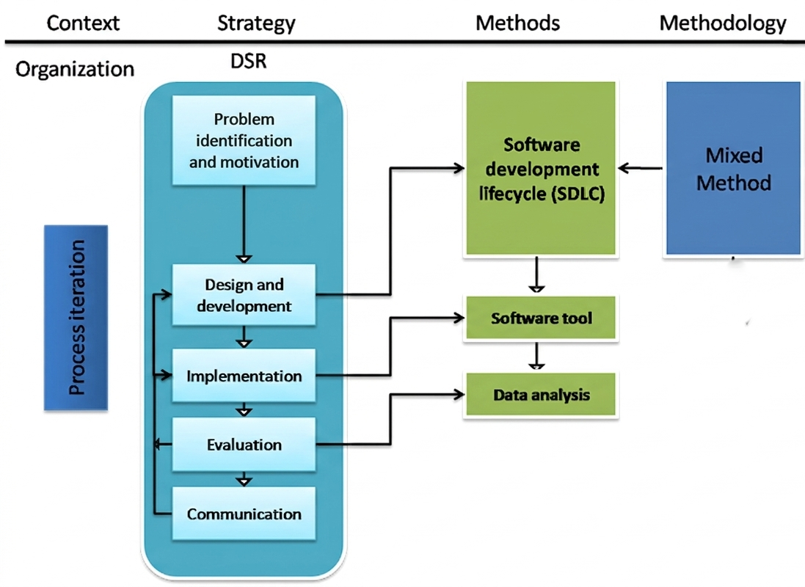
Figure 1: Research method mind map
The methodology for this work is a mixed-methods approach that combines quantitative and qualitative methods. The quantitative method was applied for the analysis of non-statistical data collected from the farm, and also obtained for literature review. In addition, the method was used to analyze the final results obtained for this work. The quantitative methodology was applied for results analysis of the statistical output of the training. The methodology also informed the software development life cycle, which utilises software and data analysis tools to develop and interpret the outcome of the design process. The philosophy for the methodology is pragmatism, and the reason was because of the practical-oriented nature of the work.
2.1 Data Acquisition
The data source used for this is primary and secondary data. The primary data source is ESUT, while the secondary data source is the maize image dataset (Olaniyi et al., 2022). The dataset contains images of maize plants and weed species. The dataset contains 36874 images in total and is stored in four folders, namely Annotated Maize-Weed Images, Data Description and Questionnaire, Dry Season Maize Weed Images, and Wet Season Maize Weed Images. The Dry Season contains 18,187 images captured during the dry season farm survey, the Wet Season contains 18,187 images captured during the wet season farm survey, and the Annotated contains 500 annotated images selected from the Dry Season survey saved in JSON, XML, and txt format. The annotation was achieved using the Labelmg suite. The raw wet and dry season images have been captured using a high-resolution digital camera during the weed survey, while the annotation of the annotated image was done using the Labelmg suite. A total of 18 farm locations were visited in the North Central part of Nigeria for the data acquisition as part of an ongoing research effort on maize-weed identification in farmlands. Total sample size of data is 36874 images, comprises of primary and secondary data. The data was collected using the experimental setup in Figure 2.
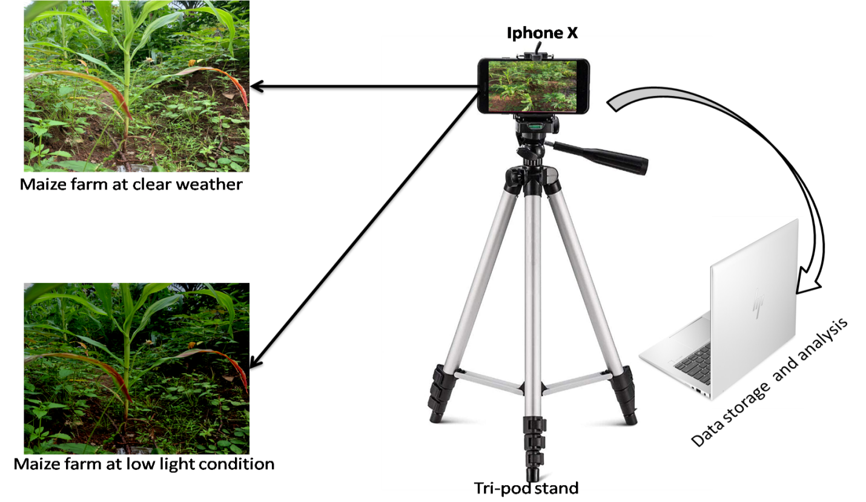
Figure 2: Experimental setup for data collection at the field
2.2 Data preparation
The data preparation was carried out through augmentation, annotation and labelling using the Robowflow toolbox. The augmentation processes are flipping and rotation. The angles considered for the rotations are ${45}^{o}$, ${90}^{o}$ and ${30}^{o}$ respectively. The flipping was done horizontally and vertically. The total sample size of the dataset after augmentation is 57,717 images. The class distributions are Ageratum conyzoides (9643 samples) and Commelina (11200 samples).
2.3 Proposed Model
The proposed model for the classification of weeds in the maize farm is YOLOv-11 (Alkhammash, 2025). It was developed with the YOLOV8 as the building block, while introducing new features such as the C3K2, which replaced the C2 layer in YOLOv-8, and then the Cross-Stage Partial with Self-Attention (C2PSA) module. Collectively, these two features optimised the quality of feature extraction in the model and improved classification performance. The C3K2 block is a customised cross-stage spatial (CSP) bottleneck layer, which is the main transfer learning model, connected with two convolutional layers designed with filters to maintain classification accuracy, speed and efficiency. In the head, the model uses the same detection head output as the YOLOv10 (Wang et al., 2024). The mathematical model of the C3k2 is presented in Equation 1 (Alif, 2014).
$C3k2*\left(X\right)= Conv*\left(Split*(X\right)) +Conv*(Merge*split*\left(X\right)))$ (1)
Where X is the feature maps, which are split into bottlenecks, then merged and combined to produce output. The C2PSA module combined the structural functionalities of CSP with an attention mechanism tailored towards spatial information identification. The PSA devices the feature maps identified into several parallel channels, process separately and then concatenate the output using attention weighted summation as shown in Equation 2;
$y= \sum_{i=1}^{n}{a_{i}f_{i} \left(X\right).} \sum_{i}{a_{i}}=1$ (2)
Where $f_{i} \left(X\right)$ presents the $i-th$ attention branch, $a_{i}$ donates the learned attention weight, which allows better focus on different input data regions, suppresses noise and prioritises quality feature maps. Figure 3 presents the architecture of YOLOv11.
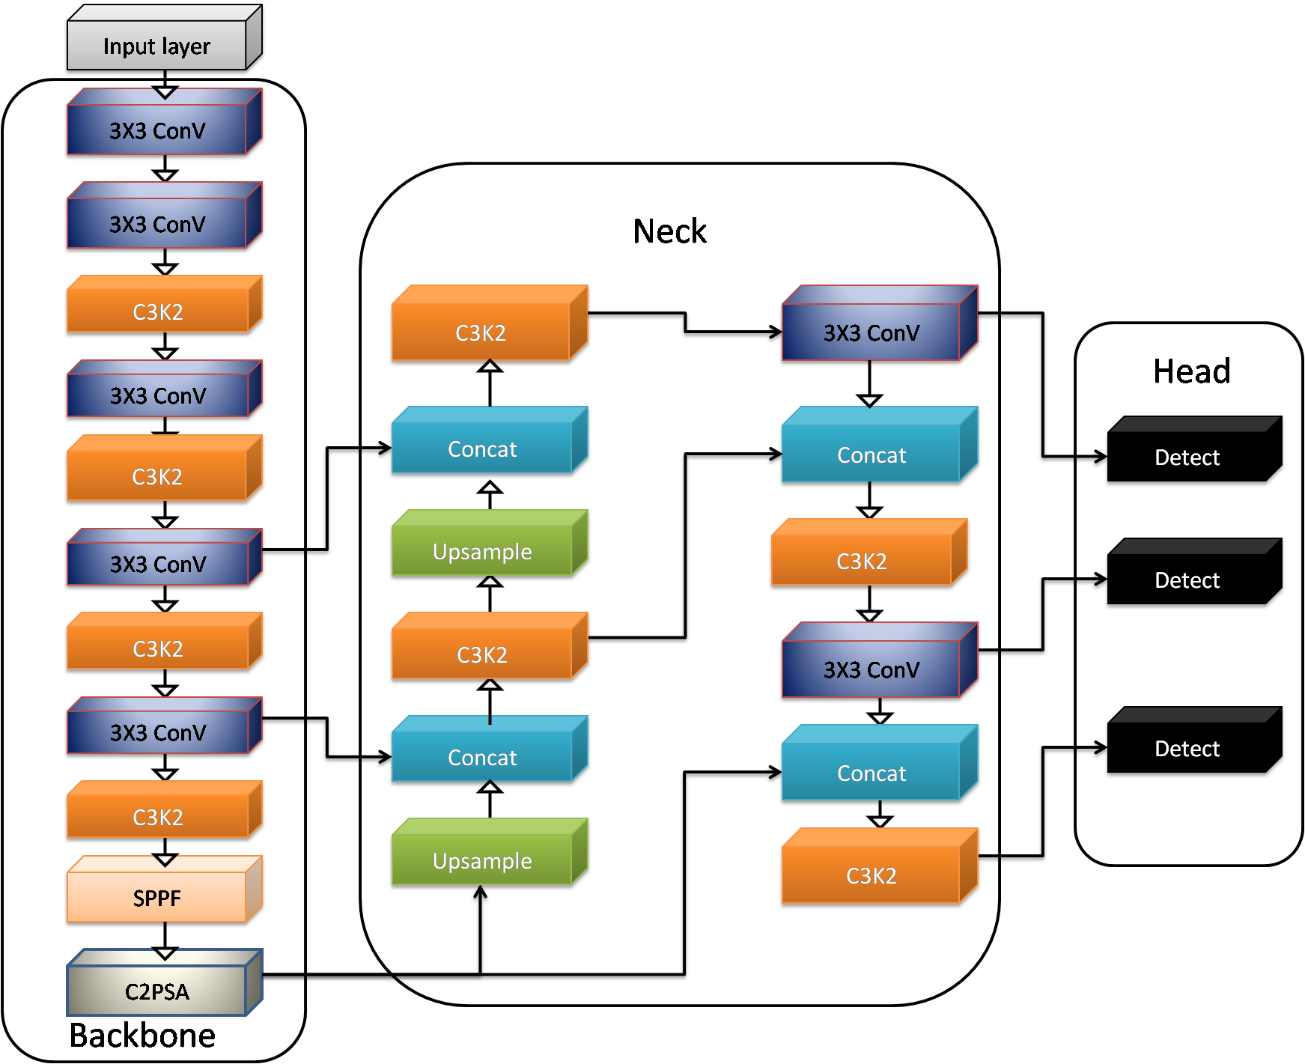
Figure 3: Architecture of the YOLOv11 (Alkhammash, 2025).
2.4 Training of Model
The training of the model was performed on a NVIDIA GeForce RTX 3030Ti computer with a graphical processing unit, running on Windows 10 as the operating system. The processor used is Core i9-12900 with 16GB of graphics memory. The training process was done experimentally, considering different architectures of YOLOv-11. The experimental architecture includes the custom YOLOv11 model. During the training process, the dataset was split into training (80%), test (10%) and validation set (10%). The Adam optimisation algorithm was applied as the training algorithm. The metrics in Equations 3 to 6 were applied to optimise the neurons using the hyperparameters in Table 1. The four different models were generated upon meeting the stopping criteria. The results of the training are reported in chapter four. Figure 4 presents the flow chart of the weed detection system.
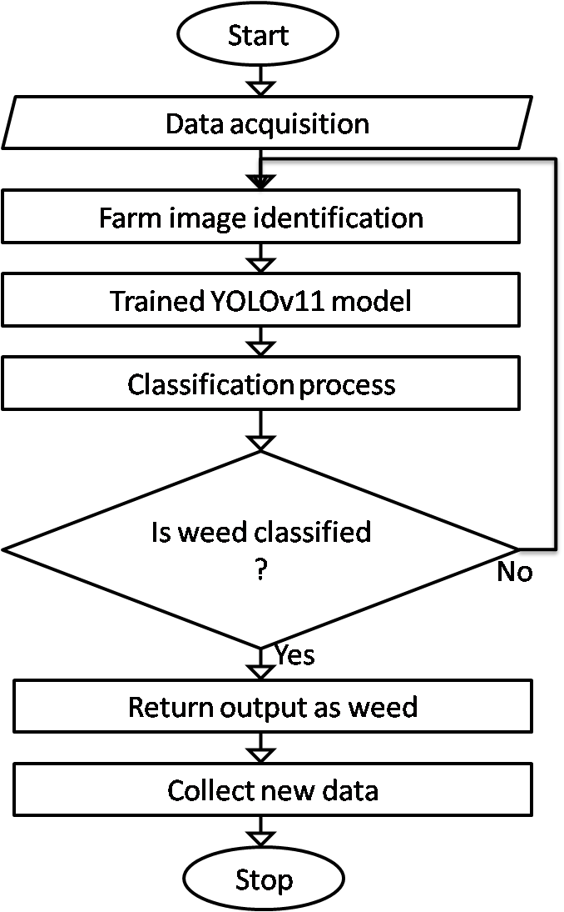
Figure 4: Flowchart of the weed detection system
Figure 4 presents the flow chart of the weed detection system. The information from the farm is collected through the camera. Then feed to the classification model, which processes the data to classify whether it is a weed or not. Upon classification of weed, the system returns the output as weed in the farm, identifying the different classified weed categories, while when weed is not classified, then the system returns to the initial state to capture new data.

Table 1: Model Training Hyperparameters
Parameters | Values
Weed Image size | 640640
Epochs during the training | 400
Learning rate of the neurons | 0.00125
Momentum | 0.935
Weight decay | 0.0005
Size of Batch | 18
Number of Iterations | 400
Kernel size (d) | 2

2.5 Performance Evaluation Metrics
The performance evaluation metrics for the model are Precision (P), Recall (R), average precision (${AP}_{i})$, and mean average precision ($mAP)$, and are computed using Equation (3)-(6), respectively.
(3)
(4)
(5)
(6)
Where TP is true positive maize weed detection, FP is negative samples that are positively detected; FN is positive samples that are not detected. Other metrics used for the evaluation of the model are F1confidence curve, precision-recall curve, recall-confidence curve and precision-confidence curve.

3. RESULTS AND DISCUSSION
This section presents the training results of the transfer learning model used in developing the artifact for weed detection in the maize farm. The results were reported for the four experimental architectures, considering precision, recall, and loss. The results obtained across the 100 training epoch steps were recorded for the custom YOLOv11 in Table 2.

Table 2: Results of the CUSTOM YOLOV-11 Training
Epoch | Train_loss | Val_loss | Precision | Recall | mAP_50 | mAP_50_95
1 | 1.218959 | 1.255252 | 0.55154 | 0.521113 | 0.514762 | 0.479284
2 | 1.182361 | 1.23359 | 0.562649 | 0.505525 | 0.504363 | 0.464532
3 | 1.160863 | 1.191009 | 0.595106 | 0.524142 | 0.546439 | 0.513762
4 | 1.05688 | 1.044103 | 0.561192 | 0.532397 | 0.503281 | 0.478224
5 | 1.066572 | 1.085381 | 0.58284 | 0.537171 | 0.535644 | 0.507991
6 | 1.059832 | 1.096245 | 0.593473 | 0.53556 | 0.549216 | 0.50817
7 | 1.03012 | 1.082943 | 0.616694 | 0.549802 | 0.596562 | 0.559485
8 | 0.998153 | 1.051866 | 0.624976 | 0.560032 | 0.576459 | 0.525628
9 | 0.923568 | 0.982669 | 0.620853 | 0.574148 | 0.597835 | 0.552099
10 | 0.90658 | 0.929272 | 0.64034 | 0.578399 | 0.591591 | 0.555538
11 | 0.868847 | 0.919074 | 0.646852 | 0.580551 | 0.616459 | 0.573039
12 | 0.838595 | 0.835581 | 0.637882 | 0.606544 | 0.569886 | 0.517494
13 | 0.817665 | 0.854403 | 0.651691 | 0.612414 | 0.628367 | 0.573474
14 | 0.809593 | 0.813873 | 0.677788 | 0.616325 | 0.61255 | 0.55887
15 | 0.836867 | 0.863394 | 0.67088 | 0.62811 | 0.646145 | 0.602141
16 | 0.793608 | 0.832215 | 0.675693 | 0.619238 | 0.655171 | 0.633564
17 | 0.769226 | 0.787612 | 0.692791 | 0.65163 | 0.653531 | 0.624101
18 | 0.70495 | 0.720094 | 0.687533 | 0.65331 | 0.626902 | 0.570712
19 | 0.674207 | 0.730356 | 0.688166 | 0.65628 | 0.648609 | 0.62115
20 | 0.677405 | 0.725822 | 0.70086 | 0.658726 | 0.646196 | 0.590126
21 | 0.662882 | 0.682205 | 0.719401 | 0.650557 | 0.666898 | 0.62898
22 | 0.679913 | 0.71282 | 0.71535 | 0.661877 | 0.662013 | 0.629042
23 | 0.632069 | 0.632397 | 0.728989 | 0.652652 | 0.693787 | 0.652595
24 | 0.591936 | 0.631734 | 0.728758 | 0.69008 | 0.683029 | 0.662538
25 | 0.547732 | 0.54815 | 0.718113 | 0.668674 | 0.656612 | 0.607317
26 | 0.584265 | 0.613725 | 0.722783 | 0.693458 | 0.69267 | 0.66982
27 | 0.538757 | 0.572456 | 0.741488 | 0.682172 | 0.694172 | 0.649996
28 | 0.509574 | 0.544151 | 0.729159 | 0.700592 | 0.700443 | 0.656747
29 | 0.49958 | 0.510742 | 0.737104 | 0.682653 | 0.695609 | 0.636659
30 | 0.460086 | 0.527717 | 0.732325 | 0.703413 | 0.681308 | 0.659933
31 | 0.489134 | 0.549738 | 0.740328 | 0.702565 | 0.698676 | 0.654296
32 | 0.445269 | 0.518239 | 0.766323 | 0.72574 | 0.735413 | 0.701309
33 | 0.43907 | 0.498214 | 0.767778 | 0.710254 | 0.736143 | 0.707023
34 | 0.458403 | 0.468358 | 0.754279 | 0.707667 | 0.720409 | 0.695302
35 | 0.43198 | 0.439121 | 0.751273 | 0.732247 | 0.717163 | 0.672568
36 | 0.43365 | 0.484379 | 0.762369 | 0.733305 | 0.731105 | 0.688727
37 | 0.41004 | 0.447578 | 0.776056 | 0.721587 | 0.737795 | 0.689544
38 | 0.387129 | 0.42089 | 0.777462 | 0.731299 | 0.735469 | 0.698218
39 | 0.355261 | 0.370489 | 0.768172 | 0.734526 | 0.722384 | 0.685737
40 | 0.387189 | 0.456748 | 0.771339 | 0.739056 | 0.726175 | 0.679919
41 | 0.355352 | 0.363809 | 0.770763 | 0.746494 | 0.746751 | 0.704616
42 | 0.36656 | 0.379581 | 0.787567 | 0.732234 | 0.727659 | 0.677826
43 | 0.302352 | 0.313396 | 0.783256 | 0.735212 | 0.753454 | 0.733356
44 | 0.3169 | 0.352264 | 0.789023 | 0.759468 | 0.726942 | 0.68854
45 | 0.310997 | 0.339676 | 0.780075 | 0.751272 | 0.745024 | 0.710108
46 | 0.307901 | 0.364444 | 0.781576 | 0.737058 | 0.723638 | 0.699718
47 | 0.278478 | 0.305122 | 0.78531 | 0.750829 | 0.756207 | 0.735143
48 | 0.303712 | 0.341291 | 0.806542 | 0.74862 | 0.756335 | 0.714001
49 | 0.294347 | 0.325025 | 0.805631 | 0.752424 | 0.77349 | 0.740574
50 | 0.239327 | 0.248791 | 0.810829 | 0.773053 | 0.745714 | 0.706893
51 | 0.257379 | 0.267046 | 0.800825 | 0.772568 | 0.750428 | 0.727286
52 | 0.266626 | 0.287113 | 0.805221 | 0.776477 | 0.78119 | 0.757174
53 | 0.209437 | 0.253793 | 0.818213 | 0.775329 | 0.794099 | 0.740426
54 | 0.283461 | 0.305923 | 0.803874 | 0.774954 | 0.765941 | 0.74225
55 | 0.249408 | 0.277546 | 0.803281 | 0.778731 | 0.756468 | 0.733652
56 | 0.223499 | 0.239584 | 0.792416 | 0.777843 | 0.735926 | 0.677559
57 | 0.24002 | 0.293364 | 0.812439 | 0.765615 | 0.781328 | 0.75651
58 | 0.211214 | 0.239076 | 0.810962 | 0.768446 | 0.79039 | 0.758078
59 | 0.225392 | 0.226771 | 0.82078 | 0.76754 | 0.76341 | 0.708282
60 | 0.172896 | 0.247545 | 0.809367 | 0.779422 | 0.771348 | 0.721705
61 | 0.213717 | 0.243249 | 0.807563 | 0.767689 | 0.769773 | 0.720868
62 | 0.226752 | 0.268443 | 0.805776 | 0.793375 | 0.770034 | 0.735487
63 | 0.195911 | 0.210606 | 0.822523 | 0.780065 | 0.779898 | 0.720062
64 | 0.229576 | 0.264204 | 0.814132 | 0.78722 | 0.744806 | 0.707098
65 | 0.173532 | 0.241208 | 0.817119 | 0.794686 | 0.79053 | 0.755375
66 | 0.180311 | 0.194821 | 0.823847 | 0.794539 | 0.767306 | 0.711927
67 | 0.142521 | 0.198622 | 0.825503 | 0.794864 | 0.767393 | 0.746673
68 | 0.170425 | 0.187683 | 0.824488 | 0.777723 | 0.793699 | 0.765359
69 | 0.147085 | 0.187768 | 0.822236 | 0.781787 | 0.796957 | 0.763544
70 | 0.178252 | 0.216307 | 0.824231 | 0.806981 | 0.759852 | 0.716273
71 | 0.136875 | 0.16002 | 0.813866 | 0.80438 | 0.773714 | 0.742925
72 | 0.160991 | 0.191216 | 0.818784 | 0.77606 | 0.756 | 0.697151
73 | 0.19137 | 0.249008 | 0.817076 | 0.800541 | 0.750276 | 0.699014
74 | 0.135703 | 0.206647 | 0.834445 | 0.79835 | 0.807146 | 0.779815
75 | 0.141106 | 0.1595 | 0.83067 | 0.806583 | 0.766977 | 0.727429
76 | 0.153058 | 0.172265 | 0.842193 | 0.802773 | 0.815696 | 0.772223
77 | 0.097377 | 0.114116 | 0.827543 | 0.786712 | 0.793983 | 0.742154
78 | 0.109504 | 0.126969 | 0.844548 | 0.803926 | 0.786397 | 0.740902
79 | 0.136495 | 0.216903 | 0.840278 | 0.803906 | 0.795716 | 0.748327
80 | 0.10709 | 0.164621 | 0.833109 | 0.808292 | 0.778414 | 0.732554
81 | 0.114895 | 0.164009 | 0.831147 | 0.805495 | 0.765344 | 0.730407
82 | 0.102598 | 0.116555 | 0.836212 | 0.787383 | 0.772403 | 0.750162
83 | 0.100064 | 0.096115 | 0.832215 | 0.798009 | 0.77985 | 0.748622
84 | 0.078316 | 0.107762 | 0.828394 | 0.808828 | 0.767815 | 0.729509
85 | 0.079896 | 0.149383 | 0.828357 | 0.804485 | 0.802648 | 0.769655
86 | 0.105404 | 0.113576 | 0.838951 | 0.800967 | 0.801686 | 0.771253
87 | 0.107085 | 0.117577 | 0.848814 | 0.805602 | 0.801628 | 0.754619
88 | 0.094098 | 0.112082 | 0.833077 | 0.800138 | 0.765867 | 0.712981
89 | 0.048497 | 0.086543 | 0.835345 | 0.803987 | 0.770136 | 0.711729
90 | 0.047229 | 0.059369 | 0.839192 | 0.803563 | 0.811437 | 0.775033
91 | 0.135637 | 0.169302 | 0.83771 | 0.802498 | 0.792567 | 0.750213
92 | 0.045548 | 0.073958 | 0.843927 | 0.813146 | 0.791221 | 0.769435
93 | 0.075683 | 0.11382 | 0.827827 | 0.814714 | 0.786211 | 0.758033
94 | 0.082151 | 0.091699 | 0.84193 | 0.812702 | 0.802984 | 0.774348
95 | 0.105832 | 0.150934 | 0.838212 | 0.813983 | 0.804103 | 0.765031
96 | 0.088081 | 0.104044 | 0.831695 | 0.801247 | 0.804216 | 0.775565
97 | 0.078089 | 0.132501 | 0.83672 | 0.782429 | 0.790971 | 0.765694
98 | 0.059402 | 0.090402 | 0.823061 | 0.820724 | 0.799564 | 0.748435
99 | 0.050491 | 0.125156 | 0.844513 | 0.798071 | 0.816094 | 0.766212
100 | 0.071434 | 0.081392 | 0.841635 | 0.801619 | 0.774182 | 0.74298

Table 2 presents the results obtained while training the custom YOLOv11 model for the maize weed classification. The results were generated iteratively across different epochs, and the final training results obtained for training loss are 0.071434, and validation loss reported 0.081392. These results implied that the model learn effectively the features of the maize weed in the dataset and then will generalize better on seen data. The limited difference between the training and validation results implied minimal overfitting which suggests that the model consistently learn the feature maps of the dataset and will also maintain consistency in detecting weed outside the training environment. Precision recorded 0.841635, which is good and implied that the model recorded 84.16% correct precision. This high precision score is very important to facilitate correct classification of weeds in the maize farm. The result also implied that false positive will be minimized and issues of healthy maize mistaken as weed are minimized.
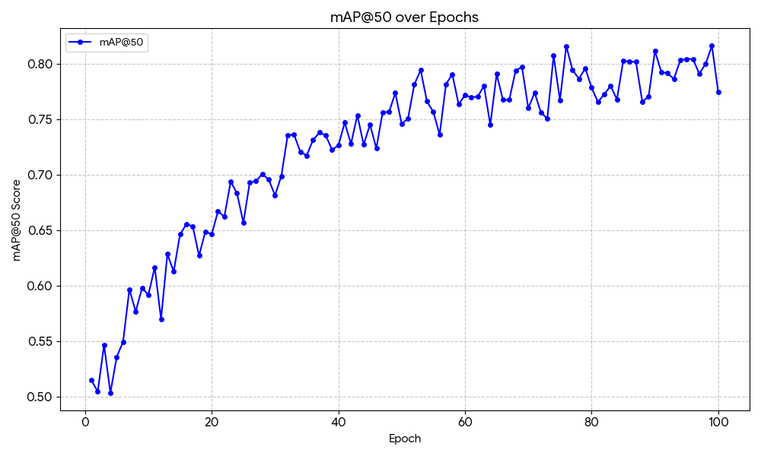
Figure 5: mAP@50 Results of the Model
The recall reported 0.801619, which measure the actual classification of weed instances in the farm. The results showed that the model was able to record actual weed classification success of 80.16%. This high value ensures that weeds in the farm are not overlooked during detection, as in reality weeds looks similar and competes with the maize crop for soil resources. The mAP50 recorded 0.774182 as in Figure 5. This value indicates that the model achieves 77.42% detection accuracy under a moderately strict matching criterion. The mAP50-90 recorded 0.74298 as shown in Figure 6. This is a more stringent and comprehensive evaluation, as it assesses detection precision and localization accuracy under increasingly strict conditions. The recorded score of 74.30% reflects the model’s robustness and its ability to accurately localize weeds even when high spatial precision is required.
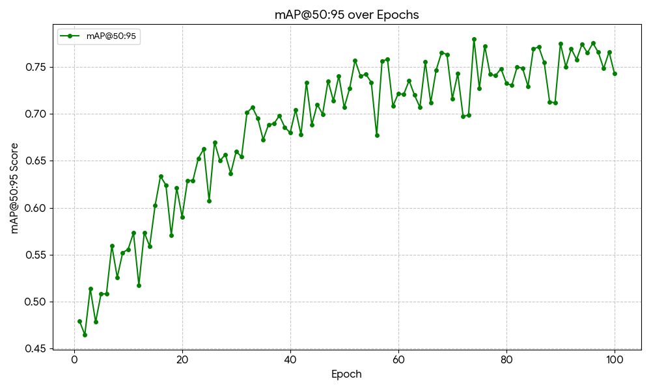
Figure 6: mAP@50-95 Performance Result
Overall, these results have demonstrated that YOLOv11 achieved a strong balance among precision, recall, and mAP. The results suggest that the model correctly classified weeds on the farm with a high success rate and align with the overall performance of YOLOv11 in solving the object detection problem.

4. CONCLUSION
This study addressed the critical challenge of weed infestation in maize farming, which significantly reduces crop yield and contributes to global food insecurity. A deep learning-based approach was proposed using the YOLOv11 architecture in order to improve the accuracy and efficiency of weed detection in agricultural fields. The research adopted a Design Science Research (DSR) methodology integrated with a mixed-methods approach, enabling iterative development, implementation, and evaluation of the model. A comprehensive dataset comprising both primary and secondary sources was collected, preprocessed through augmentation and annotation, and used to train the proposed model under optimized conditions.
The experimental results demonstrated that the proposed YOLOv11 model achieved strong performance across key evaluation metrics, including a precision of 84.16%, a recall of 80.16%, mAP@50 of 77.42%, and mAP@50–95 of 74.30%. The low training and validation losses further confirmed that the model effectively learned relevant features with minimal overfitting. These results indicate that the model can reliably distinguish weeds from maize crops, even under varying environmental conditions. The integration of advanced modules such as C3K2 and C2PSA contributed significantly to improved feature extraction and spatial attention, enhancing the overall detection capability of the system.
In conclusion, this study has demonstrated the effectiveness of deep learning, particularly the YOLOv11 architecture, in addressing the limitations of traditional and earlier machine learning approaches to weed detection. The proposed model offers a practical and scalable solution for precision agriculture, with the potential to support farmers in reducing crop losses and improving productivity. Future work should focus on expanding the dataset to include more diverse crop and weed species, improving model generalisation across different geographical regions, and integrating the system into real-time agricultural tools such as drones or smart farming devices for field deployment.

REFERENCES
Alif, M. A. R. (2014). YOLOv11 for vehicle detection: Advancements, performance, and applications in intelligent transportation systems. arXiv. https://arxiv.org/abs/2410.22898
Alkhammash, E. H. (2025). Multi-classification using YOLOv11 and hybrid YOLO11n-MobileNet models: A fire classes case study. Fire, 8(1), 17. https://doi.org/10.3390/fire8010017
Gallo, I., Rehman, A. U., Dehkord, R. H., Landro, N., La Grassa, R., & Boschetti, M. (2023). Deep object detection of crop weeds: Performance of YOLOv7 on a real case dataset from UAV images. Remote Sensing, 15(2), 539. https://doi.org/10.3390/rs15020539
Iqbal, N., Manalil, S., Chauhan, B. S., & Adkins, S. W. (2019). Investigation of alternate herbicides for effective weed management in glyphosate-tolerant cotton. Archives of Agronomy and Soil Science, 65(13), 1885–1899.
Kekong, P. E., Ajah, A., & Ebere, U. C. (2019). Real-time drowsy driver monitoring and detection system using deep learning-based behavioural approach. International Journal of Computer Sciences and Engineering, 9(1), 11–21.
Mckay, M., Danilevicz, M. F., Ashworth, M. B., Rocha, R. L., Upadhyaya, S. R., Bennamoun, M., & Edwards, D. (2024). Focus on the crop not the weed: Canola identification for precision weed management using deep learning. Remote Sensing, 16(11), 2041. https://doi.org/10.3390/rs16112041
Moldvai, L., Mesterházi, P. Á., Teschner, G., & Nyéki, A. (2024). Weed detection and classification with computer vision using a limited image dataset. Applied Sciences, 14(11), 4839. https://doi.org/10.3390/app14114839
Olaniyi, O., Salaudeen, M., Daniya, E., Abdullahi, I. M., Folorunso, T. A., Bala, J., Bello Kontagora, N., Adedigba, A., Oluwole, B., Macarthy, O., & Bankole, A. (2022). Maize-weed image dataset (Version 2) [Data set]. Mendeley Data. https://doi.org/10.17632/jjbfcckrsp.2
Osorio, K., Puerto, A., Pedraza, C., Jamaica, D., & Rodriguez, L. (2020). A deep learning approach for weed detection in lettuce crops using multispectral images. AgriEngineering, 2(3), 471–488. https://doi.org/10.3390/agriengineering2030032
Qu, H. R., & Su, W. H. (2024). Deep learning-based weed–crop recognition for smart agricultural equipment: A review. Agronomy, 14(2), 363. https://doi.org/10.3390/agronomy14020363
Reedha, R., Dericquebourg, E., Canals, R., & Hafiane, A. (2022). Transformer neural network for weed and crop classification of high-resolution UAV images. Remote Sensing, 14(3), 592. https://doi.org/10.3390/rs14030592
Wang, A., Chen, H., Liu, L., Chen, K., Lin, Z., Han, J., & Ding, G. (2024). YOLOv10: Real-time end-to-end object detection. arXiv. https://arxiv.org/abs/2405.14458
World Population Prospects. (2022). Summary of results. United Nations Department of Economic and Social Affairs, Population Division. https://www.un.org/development/desa/pd/sites/www.un.org.development.desa.pd/files/wpp2022_summary_of_results.pdf

