Cascaded SOA FWM with non-uniform ASE seeding: expanding a low-cost DWDM system from 12 to 20 channels

David I. Forsyth¹

¹ Department of Electronics and Computer Engineering Technology (FTKEK), Universiti Teknikal Malaysia Melaka (UTeM), Jalan Hang Tuah Jaya, 76100 Durian Tunggal, Melaka, Malaysia
Corresponding e-mail: david@utem.edu.my

Abstract
This paper extends a low-cost wavelength-division multiplexing (WDM) source from 12 to 20 dense wavelength-division multiplexed (DWDM) channels using a cascaded semiconductor optical amplifier (SOA) architecture — without requiring any coherent lasers. A second SOA stage, seeded by the 12-channel output of the first stage (derived from three non-uniformly spaced, spectrum-sliced ASE inputs from a single high-power LED), generates eight additional four-wave mixing (FWM) components under theoretical and simulated evaluation. The non-uniform input spacing (0.3 THz and 0.4 THz) deliberately inhibits a fully populated frequency comb, producing instead a finite, structured, and manufacturable channel set. Performance reveals a practical trade-off well-suited to cost-sensitive networks: the three original inputs exceed 195 km, while the eight cascaded channels are limited to 25–100 km due to OSNR degradation — a range fully viable for urban and distribution links. Critically, the entire 20-channel system requires only one high-power LED and two SOAs, with no laser arrays, wavelength locking, or complex stabilization, offering a clear and experimentally realizable pathway to low-cost DWDM expansion.
Keywords: Four-wave mixing, semiconductor optical amplifier, ASE, spectrum slicing, cascaded SOA
- Introduction
The demand for high-capacity, cost-effective optical networks still continues to drive innovations in wavelength division multiplexing (WDM) technologies [1]. Conventional multi-wavelength sources rely on arrays of distributed feedback lasers or optical frequency combs, which increase system cost and complexity, especially in access and metro networks [2].
Semiconductor optical amplifiers (SOAs) are attractive for their nonlinear properties, enabling wavelength conversion and signal regeneration - particularly through four-wave mixing (FWM) [3], [4]. They also possess highly desirable intensity noise reduction capabilities due to their saturation effects [5], a key feature in this work. Traditionally, arrays of expensive coherent laser inputs are required for efficient mixing, but here incoherent sources, like inexpensive broadband amplified spontaneous emission (ASE) from a high-powered LED are considered, whilst mitigating the phase noise and low coherence inherent in these systems [5].
Spectrum slicing of ASE sources partially mitigates these limitations by generating narrowband quasi-coherent carriers suitable for WDM [5]. Recent work has demonstrated significant reach extension in spectrum-sliced systems using SOA enhancements, achieving transmission distances of up to 340 km for a single channel [6]. Previous novel experimental work has also shown that FWM in SOAs is feasible using total spectrum-sliced ASE inputs [7], establishing the practical viability of this approach. More recently, simulation-based studies have shown that such systems can be accurately modeled using commercial software tools such as OptiSystem [8], confirming that the nonlinear interactions required for efficient FWM can be reproduced numerically with appropriate parameter selection.
In our recently demonstrated system [9], we developed a low-cost, multi-wavelength WDM source using a single semiconductor optical amplifier (SOA) with three spectrum-sliced amplified spontaneous emission (ASE) inputs derived from a single high-power LED. The three slices were centered at 193.1 THz, 193.4 THz, and 193.8 THz — a non-uniform spacing of 0.3 THz and 0.4 THz. The SOA generated nine four-wave mixing (FWM) products, yielding a total of 12 usable channels (3 original + 9 FWM). Critically, modulation at 10 Gb/s was applied after FWM generation, decoupling carrier generation from data encoding and eliminating the phase-noise transfer that plagued our earlier pre-modulation architecture. The system achieved an average FWM channel link length of 63.9 km and a maximum of 95 km, with clear eye diagrams (average Q-factor ≈ 24). The natural extension of that work is to consider adding a second cascaded SOA stage after the first. This paper analytically investigates whether the 12 channels mix further to produce a dense frequency comb, how many new channels could be generated, and whether the non-uniform input spacing prevents full comb formation.
In this work, we extend our previous WDM system by considering a second SOA that receives all 12 outputs from the first stage and performs a second round of FWM mixing. The derived frequency set shows that the second stage generates a total of 20 DWDM dominant and usable frequency components under the given system conditions – which is not a fully populated comb, due to the limited combinations achievable with two mixing stages and the non-uniform base spacing. This theoretical prediction provides a clear roadmap for experimentally extending our existing 12-channel system to 20 channels by simply adding a second SOA. Section 2 gives the theoretical background, section 3 the set-up, section 4 the results and section 5 discusses the conclusions.
- Theoretical Background
When multiple optical fields at frequencies $f_{1},f_{2},f_{3}$ propagate through a non-linear medium such as an SOA, nonlinear interactions produce new FWM products, expressed as:
- degenerate FWM: $2f_{i}-f_{j}$
- non-degenerate FWM: $f_{i}+f_{j}-f_{k}$

The total number of generated components increases rapidly with the number of input channels, as the number of possible mixing combinations grows combinatorially. However, in practical SOA-based systems, the observable set of FWM products is constrained by several physical factors, including phase-matching conditions, gain bandwidth, saturation effects, and noise accumulation. In wavelength division multiplexing (WDM) systems, FWM is often considered detrimental due to the generation of intermodulation products that introduce crosstalk. In contrast, this work deliberately exploits FWM as a wavelength generation mechanism. A key design feature is the use of non-uniform input frequency spacing, which suppresses the formation of a fully periodic frequency comb. Instead of generating a dense and potentially redundant comb structure, the system produces a finite and structured set of frequency components determined by the available mixing combinations.

Applying this principle to the previously demonstrated three-tone input system at 193.1 THz, 193.4 THz, and 193.8 THz, the first SOA stage generates a set of twelve dominant frequency components (three original inputs and nine FWM products). These components are not evenly spaced due to the initial non-uniform separation (0.3 THz and 0.4 THz), which limits symmetry in the mixing process. When this 12-channel output is injected into a second cascaded SOA stage, further FWM interactions occur among the existing tones. Although the number of possible combinations increases significantly, only a subset of these products emerges as usable channels. This is due to the combined effects of finite SOA gain bandwidth, reduced conversion efficiency for higher-order mixing terms, and accumulated optical signal-to-noise ratio (OSNR) degradation.

By systematically enumerating the dominant mixing products and excluding components that fall outside the effective gain region or below practical power thresholds, the cascaded system yields a total of 20 usable frequency components. Importantly, the spectrum does not evolve into a fully populated frequency comb, confirming that the initial non-uniform spacing constrains the growth of the frequency set even under cascaded mixing conditions. The twelve frequencies generated by the first SOA stage are listed in Table 1, forming the input set for the second-stage mixing process.

Table 1: output frequencies from the first SOA stage
showing three original input tones (highlighted in red) and dominant four-wave mixing (FWM) products.
channel nos. | Output Frequency (THz) | origin
1 | 192.4 | FWM product
2 | 192.7 | FWM product
3 | 192.8 | FWM product
4 | 193.0 | FWM product
5 | 193.1 | Original input
6 | 193.4 | Original input
7 | 193.5 | FWM product
8 | 193.7 | FWM product (cascaded)
9 | 193.8 | Original input
10 | 194.1 | FWM product
11 | 194.2 | FWM product
12 | 194.5 | FWM product

The modulated frequency outputs from the second stage are shown in Table 2. This table lists all 20 useable frequency components (in THz) obtained after the second SOA stage. Channels 1–12 correspond to the outputs of the first SOA stage, comprising three original spectrum-sliced ASE input tones at 193.1, 193.4, and 193.8 THz, together with dominant first-order and selected cascaded four-wave mixing (FWM) products. Channels 13–20 represent eight additional frequency components generated in the second SOA through cascaded FWM interactions among the existing tones. These components form a denser spectral distribution, with several frequencies appearing at approximately 0.1 THz spacing due to higher-order mixing effects. The highest-frequency candidate at 194.6 THz is excluded due to reduced SOA gain and roll-off at the spectral edge.

Table 2: Twenty usable channels after two-stage four-wave mixing (FWM): 12 channels from the first SOA stage (three original inputs shown in red and dominant FWM products) and 8 additional cascaded FWM components generated in the second SOA.
channel nos. | Output Frequency (THz) | origin
1 | 192.4 | SOA1
2 | 192.7 | SOA1
3 | 192.8 | SOA1
4 | 193.0 | SOA1
5 | 193.1 | Input
6 | 193.4 | Input
7 | 193.5 | SOA1
8 | 193.7 | SOA1 (cascaded)
9 | 193.8 | Input
10 | 194.1 | SOA1
11 | 194.2 | SOA1
12 | 194.5 | SOA1
13 | 192.3 | SOA2
14 | 192.5 | SOA2
15 | 192.6 | SOA2
16 | 193.2 | SOA2
17 | 193.3 | SOA2
18 | 193.9 | SOA2
19 | 194.0 | SOA2
20 | 194.4 | SOA2

3. System Design
The proposed system is modeled using OptiSystem, with its cascaded dual SOA DWDM architecture shown in figure 1.
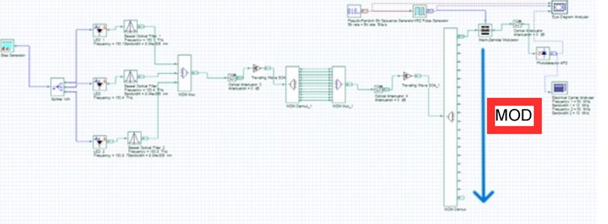
Figure 1: cascaded dual-SOA DWDM system setup
The design extends our previously demonstrated 12-channel single-SOA configuration by incorporating a second semiconductor optical amplifier (SOA) stage to perform additional four-wave mixing (FWM) on the output of the first stage.
As shown in Figure 1, a single high-power light-emitting diode (LED) is used as the primary broadband source, generating amplified spontaneous emission (ASE) over a spectral width of approximately 150 nm. The ASE output is passed through a triple-band optical bandpass filter (OBPF) to extract three spectral slices centered at 193.1 THz, 193.4 THz, and 193.8 THz, corresponding to non-uniform spacings of 0.3 THz and 0.4 THz. These filtered components are combined using a 3 × 1 optical coupler and injected into the first semiconductor optical amplifier (SOA1), which is biased at 1 A to ensure operation in the gain-saturation regime.
The combined optical signal at the input of SOA1 has a high total aggregate optical power of approximately 35.7 dBm across all channels, promoting strong nonlinear interaction within the device. Under these conditions, efficient four-wave mixing (FWM) occurs through both degenerate and non-degenerate processes, generating nine additional frequency components and yielding a total of 12 dominant channels at the output.
The full 12-channel output from SOA1 is subsequently launched into a second semiconductor optical amplifier (SOA2), which is identical in structure and operated under the same biasing conditions. The total aggregate optical power at the input of SOA2 is approximately 36.5 dBm, slightly higher due to the cumulative contribution of the generated FWM components. The use of elevated aggregate input power in both stages enhances nonlinear conversion efficiency while also enabling the inherent gain saturation characteristics of the SOAs to suppress intensity noise, thereby improving overall signal quality [6], [7], [9].
Within SOA2, the 12 input tones undergo a second stage of four-wave mixing (FWM), generating additional frequency components through further nonlinear interactions. A 20-channel demultiplexer with a 50 GHz bandwidth is positioned after SOA2 to isolate the resulting 20 dominant and usable frequency components. These channels are subsequently modulated at 10 Gb/s, while the demultiplexer also serves to suppress residual higher-order mixing products and out-of-band ASE noise. Each channel is then individually transmitted, received, and evaluated, as illustrated for Channel 1 in Figure 1.
All simulation parameters, including SOA injection current, confinement factor, and linewidth enhancement factor, are maintained consistently across both stages to ensure direct comparability of the mixing dynamics. This cascaded architecture enables a systematic expansion from 12 to 20 channels using low-cost, incoherent seeding, without the need for additional external lasers or complex stabilization mechanisms.
4. Results
The system's performance was evaluated through spectrum analysis and eye diagram assessment. Figure 2 shows the three spectrum-sliced ASE inputs to the first SOA, centered at 193.1 THz, 193.4 THz, and 193.8 THz. These non-uniformly spaced carriers (0.3 THz and 0.4 THz separation) serve as the seed signals for the first FWM stage. The spectral width of each slice is approximately 0.2 THz, determined by the bandpass filters used after the LED-based ASE source. While wider than strictly necessary for 10 Gb/s modulation, this width ensures sufficient ASE power injection into the SOA to drive efficient FWM generation.
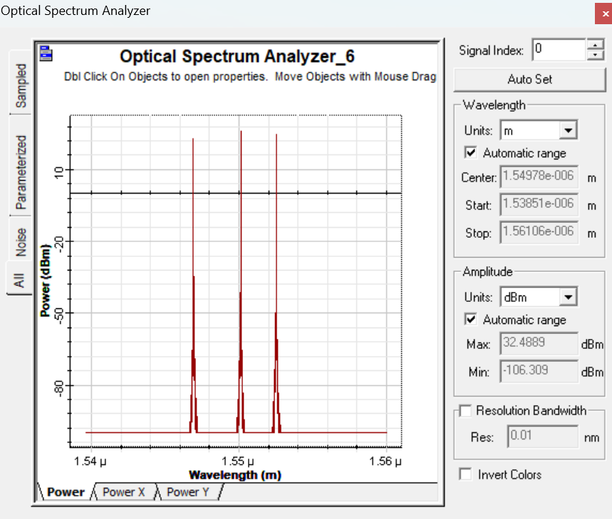
Figure 2: three spectrum sliced ASE inputs to the first SOA
Figure 3 presents the total optical spectrum at the output of the first SOA (SOA1). Twelve distinct frequency components are visible: the three original input tones plus nine first-order FWM products. The relative power distribution among these channels is non-uniform, with the original inputs and strong degenerate mixing products exhibiting higher peak powers than higher-order or off-resonant components. This output forms the input to the second cascaded SOA stage.
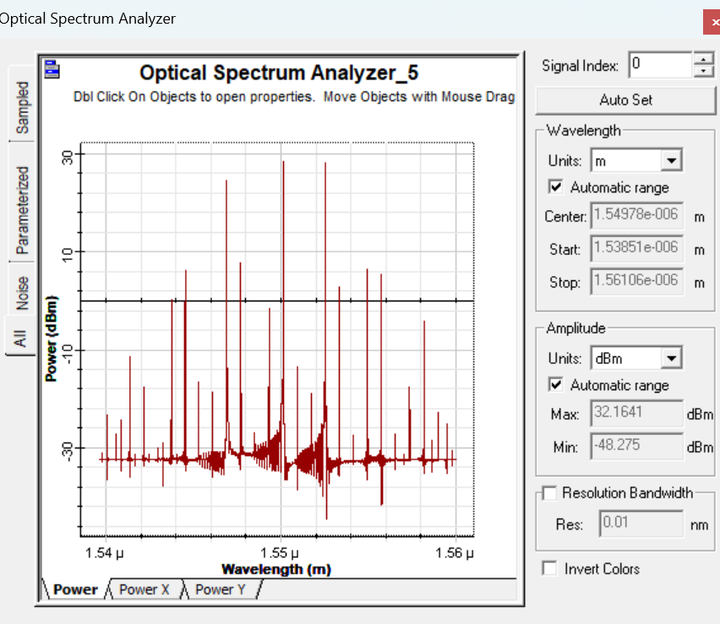
Figure 3: output spectrum from SOA1 showing 12 frequency components: three original inputs (red) plus nine first-order FWM products.
Figure 4 illustrates the output spectrum after the second SOA (SOA2). The number of usable frequency components increases from 12 to 20, confirming successful cascaded FWM. The additional eight channels (labeled 13–20 in Table 2) appear at interleaved frequencies between the original SOA1 outputs, resulting in a denser spectral grid. However, the spectrum does not form a fully populated frequency comb; several frequency slots remain vacant due to the non-uniform base spacing and the limited combinatorial set produced by two-stage mixing, consistent with the theoretical prediction in Section 2.
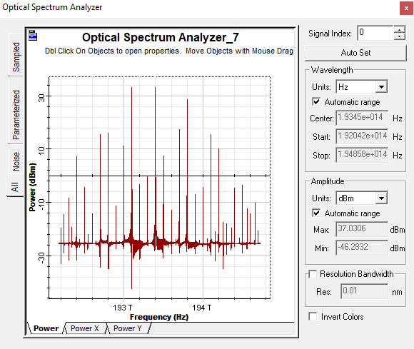
Figure 4: output spectrum from SOA2 showing 20 usable frequency components: twelve from SOA1 plus eight new cascaded FWM products.
Figure 5 lists the key SOA parameters used for both devices. Both SOAs are biased at the maximum injection current of 1 A to maximize gain and FWM efficiency. The linewidth enhancement factor is set to 5, the confinement factor to 0.3, and the differential gain to 2.78 × 10⁻²⁰ m². These values were selected to match typical commercial InGaAsP SOA devices and to ensure reproducibility with previously published models [8,9].
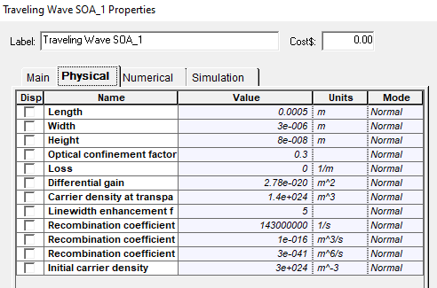
Figure 5: SOA simulation parameters for both stages (bias current = 1 A, linewidth enhancement factor = 5, confinement factor = 0.3).
Figures 6 and 7 respectively show representative eye diagrams for two selected channels: channel 13 (192.3 THz) and channel 20 (194.4 THz) after transmission over their respective maximum distances. The eye diagrams were evaluated at a data rate of 10 Gb/s using a pseudorandom bit sequence (PRBS) of length 2³¹ − 1. It was seen that channel 13 FWM signal was able to travel a simulated link length of 25 km before degradation (Q factor < 6), while channel 20 was able to travel 40 km.
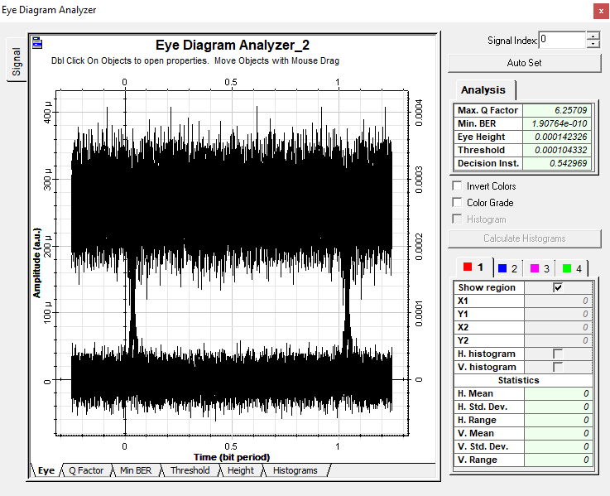
Figure 6: representative eye diagram at 10 Gb/s for channel 13 (192.3 THz) after 25 km
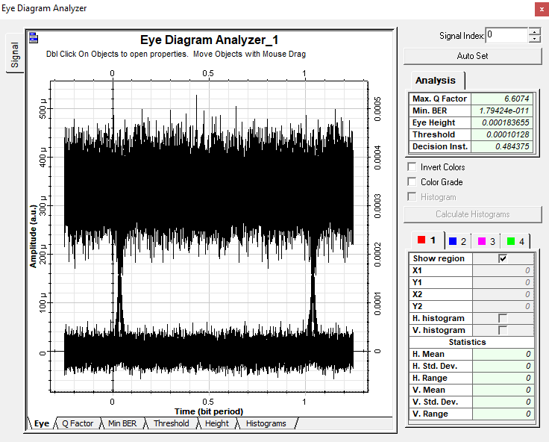
Figure 7: representative eye diagram at 10 Gb/s for channel 20 (194.4 THz) after 40 km.
Table 3 summarizes the maximum achievable transmission distance for each of the 20 channels, defined as the longest achievable link length whilst still maintaining an eye with a Q-factor greater than 6 (corresponding to a bit error rate below 10⁻⁹). This was facilitated by placing an attenuator on each link, and calculation assuming normal fibre loss of 0.2 dB/km for single mode. This table reveals several important performance trends in the cascaded two-stage FWM system. For the 20-channel system, the three original input channels (193.1, 193.4, and 193.8 THz) achieve a mean transmission distance of 210 km, ranging from 195 to 220 km. The nine first-stage FWM products (channels 1–4, 7–12) exhibit a mean reach of 106 km, although channel 12 at 194.5 THz is limited to 40 km due to SOA gain roll-off; excluding this outlier raises the mean to 117.5 km. The eight new channels generated in the second SOA stage (channels 13–20) show substantially poorer performance, with a mean reach of only 55 km (median 47.5 km, range 25–100 km), reflecting the cumulative OSNR penalty and reduced launch power associated with cascaded four-wave mixing. Channel 20 (194.4 THz) achieves only 40 km, versus 100 km for Channel 18 (193.9 THz), due to lower FWM conversion efficiency and reduced SOA gain near the upper edge of the amplifier's bandwidth, which degrades OSNR more severely. Across all 20 channels, the overall mean transmission distance is 101.5 km, with a standard deviation of 63.7 km, highlighting the significant performance disparity between the robust input tones and the progressively weaker higher-order mixing products.
Table 3: maximum achievable transmission distance for each of the 20 channels
channel nos. | Output Frequency (THz) | Max. link length (km)
1 | 192.4 | 100
2 | 192.7 | 130
3 | 192.8 | 125
4 | 193.0 | 105
5 | 193.1 | 215
6 | 193.4 | 220
7 | 193.5 | 115
8 | 193.7 | 130
9 | 193.8 | 195
10 | 194.1 | 130
11 | 194.2 | 105
12 | 194.5 | 40
13 | 192.3 | 25
14 | 192.5 | 50
15 | 192.6 | 50
16 | 193.2 | 40
17 | 193.3 | 55
18 | 193.9 | 100
19 | 194.0 | 80
20 | 194.4 | 40
5. Conclusions
This paper has shown, through theoretical analysis and simulation, that adding a second cascaded semiconductor optical amplifier (SOA) stage extends a previously demonstrated 12-channel single-SOA WDM system to 20 usable frequency components in a DWDM system —without introducing a single coherent laser. While combinatorial mixing could in principle generate many more products, practical constraints such as gain bandwidth, phase mismatch, and cumulative OSNR degradation limit the observable set to a structured, finite comb. Critically, the non-uniform input spacing (0.3 THz and 0.4 THz) deliberately prevents a fully populated—and impractical—frequency comb, yielding instead a predictable, manufacturable channel plan. The second SOA stage contributes eight new channels via cascaded four-wave mixing (FWM), interleaved between the original 12 outputs, thereby increasing spectral density using only low-cost broadband ASE seeding from a single high-powered LED.
Performance evaluation reveals a clear trade-off, but one that is entirely acceptable for cost-sensitive access and metro networks. The three original input channels achieve transmission distances exceeding 195 km, matching or exceeding the reach of many coherent systems in short-haul applications. Even the eight cascaded channels, limited to 25–100 km, remain perfectly viable for urban and distribution networks where link lengths are typically short. With an overall mean transmission distance of 101.5 km across all 20 channels, the proposed architecture comfortably serves the majority of low-cost DWDM deployment scenarios.
Crucially, this work offers a practical, experimentally realizable pathway to 20-channel DWDM using just one high-powered LED and two SOAs—no laser arrays, no wavelength locking, and no complex thermal stabilization. For future low-cost DWDM systems that cannot tolerate the expense of coherent lasers, cascaded FWM from incoherent seeds provides a compelling alternative: scalable, simple, and built from off-the-shelf components. Looking ahead, while a third SOA stage could theoretically add more channels, the gains would be marginal and the resulting channels too weak for meaningful transmission distances (likely <10–25 km) due to accumulated OSNR penalties. A more productive direction lies in optimizing input spacing, using four initial ASE tones, or applying simple gain flattening—all of which can increase channel count or improve uniformity without sacrificing the low-cost, laser-free advantage. Future work should therefore prioritize these alternatives, along with experimental validation and bias optimization.
Acknowledgment
Special thanks to the Photonics Engineering (PERG) Research group at Universiti Teknikal Malaysia Melaka (UteM), Melaka, Malaysia for the use of their simulation software.
Corresponding author: David I. Forsyth, Department of Electronics and Computer Engineering Technology (FTKEK), Universiti Teknikal Malaysia Melaka (UTeM), Jalan Hang Tuah Jaya, 76100 Durian Tunggal, Melaka, Malaysia.
e-mail: david@utem.edu.my
References
[1] G. Keiser, Optical Fiber Communications, 5th ed. New York, NY, USA: McGraw-Hill, 2015.

[2] R. Ramaswami, K. N. Sivarajan, and G. H. Sasaki, Optical Networks: A Practical Perspective, 3rd ed. San Francisco, CA, USA: Morgan Kaufmann, 2010.

[3] H. Li, G. T. Kanellos, and D. Nesset, “Four-wave mixing in SOAs for wavelength conversion,” IEEE Photon. Technol. Lett., vol. 22, no. 15, pp. 1124–1126, 2010.

[4] K. Inoue and T. Mukai, “Signal wavelength conversion using four-wave mixing in semiconductor optical amplifiers,” J. Lightwave Technol., vol. 14, no. 6, pp. 1237–1245, 1996.

[5] J. Zhang, N. Cheng, X. Gao, Y. Li, and F. Zhao, “Performance enhancement of spectrum-sliced DWDM systems using semiconductor optical amplifiers,” IEEE Photonics J., vol. 12, no. 3, pp. 1–9, 2020.

[6] D. I. Forsyth, "210 km long incoherent DWDM spectrum-sliced system running at 10 Gb/s incorporating semiconductor optical amplifier (SOA) enhancements," Int. J. Res. Innov. Appl. Sci., vol. 11, no. 1, pp. 396–400, Jan. 2026, doi: 10.51584/IJRIAS.2026.11010034.

[7] D. I. Forsyth and M. J. Connelly, “Spectrum-sliced wavelength conversion using four-wave mixing from a semiconductor optical amplifier,” in Proc. Optical Amplifiers and Their Applications (OAA), Budapest, Hungary, 2005.

[8] D. I. Forsyth, K. R. Tariq, and A. J. Abdullah Al-Gburi, “Fully spectrum-sliced four-wave mixing wavelength conversion in a semiconductor optical amplifier,” Przegląd Elektrotechniczny, vol. 5, pp. 215–218, 2024, doi: 10.15199/48.2024.05.40.

[9] D. I. Forsyth and A. J. Abdullah Al-Gburi, “A low cost, multi-wavelength optical source enabling independent WDM channels using a single SOA and ASE inputs,” Int. J. Res. Innov. Appl. Sci., vol. 11, no. 3, pp. 1521–1532, 2026, doi: 10.51584/IJRIAS.2026.11030117.

[10] R. Paschotta, “Four-wave mixing,” in RP Photonics Encyclopedia. [Online]. Available: https://www.rp-photonics.com/four_wave_mixing.html, Accessed: Apr. 15, 2026.

