PRACTICAL APPROACH TO MEP EXECUTION AND ELECTRICAL ESTIMATION IN COMMERCIAL INFRASTRUCTURE

ABSTRACT
Modern infrastructure projects require reliable and efficient electrical systems for safe and uninterrupted operation. This project focuses on electrical execution, estimation, planning, and coordination activities involved in large-scale MEP projects. The study includes power distribution systems, lighting systems, earthing, cable routing, panel installation, DG backup systems, and fire alarm systems. It also involved understanding electrical drawings, Single Line Diagrams (SLD), load schedules, and technical specifications used in project execution. Responsibilities during the internship included site supervision, quality checking, safety compliance, contractor coordination, and monitoring project progress. The project further covered estimation activities such as Quantity Take-Off (QTO), BOQ preparation, material estimation, budgeting, tender preparation, and vendor quotation comparison. Testing and commissioning activities were also observed to understand practical project implementation. The internship provided practical exposure to real-time MEP electrical projects and improved technical, estimation, and project coordination skills required in the construction industry.
Keywords: MEP Engineering, Electrical Estimation, BOQ Preparation, Quantity Take-Off (QTO), Power Distribution System, Electrical Project Execution, Cost Estimation, Project Engineering, Tendering & Budgeting, Electrical Systems.

I. INTRODUCTION
MEP systems play a vital role in modern commercial infrastructure projects by ensuring safe, efficient, and reliable operation of buildings and facilities. Proper execution and estimation of MEP works are essential for maintaining project quality, safety, cost control, and operational efficiency. MEP engineering includes mechanical, electrical, and plumbing systems such as HVAC systems, power distribution systems, lighting systems, fire alarm systems, grounding networks, water supply, and drainage systems. This project titled “Practical Approach to MEP Execution and Electrical Estimation in Commercial Infrastructure” was carried out to gain practical knowledge and industry exposure in MEP project execution and estimation activities. The project involved studying MEP drawings, Single Line Diagrams (SLD), HVAC layouts, load schedules, and installation procedures followed in commercial projects. Responsibilities included site supervision, contractor coordination, quality inspections, safety monitoring, and project progress tracking. The internship also covered estimation activities such as Quantity Take-Off (QTO), BOQ preparation, material estimation, budgeting, cost analysis, and tender documentation. Overall, the project helped in developing technical knowledge, practical site experience, and understanding of real-time MEP project management practices used in the construction industry..

II. METHODOLOGY AND FLOW OF WORK
The methodology followed in this study is based on generalized engineering practices adopted in commercial infrastructure. The workflow involved systematic and phased manner following standard practices used in large-scale MEP electrical projects. The work included both execution and estimation activities
II.1 Study of Drawings and Specifications:
Electrical drawings such as layouts, SLDs, riser diagrams, cable routing plans, and technical specifications were studied to understand the project requirements and design intent.
II.2 Understanding SLD and Load Schedules:
Single Line Diagrams (SLD) and load schedules were reviewed to understand the power distribution system, connected loads, and equipment sizing requirements.
II.3 Site Inspection and Planning:
Regular site inspections were conducted to monitor installation progress, identify issues, and plan execution activities, material requirements, and work schedules.
II.4 Quantity Take-Off (QTO):
Quantities of electrical materials such as cables, conduits, panels, cable trays, lighting fixtures, and earthing materials were calculated from approved drawings for estimation purposes.
II.5 BOQ and Cost Estimation:
The Bill of Quantities (BOQ) was prepared using QTO data along with material and labor rates to estimate the overall project cost.
II.6 Material and Vendor Coordination:
Coordination with vendors and procurement teams was carried out for material requisitions, quotation comparisons, delivery tracking, and quality checks.
II.7 Installation Supervision:
Electrical installation activities including conduit work, cable laying, panel installation, earthing, and lighting installation were supervised to ensure compliance with drawings and standards.
II.8 Quality and Safety Inspection:
Quality checks and safety inspections were performed regularly to ensure proper workmanship, PPE compliance, and adherence to safety regulations.
II.9 Testing and Commissioning:
Testing activities such as insulation resistance tests, continuity tests, earthing tests, and functional testing of electrical systems were conducted before commissioning.
II.10 Documentation and Reporting:
Final documentation including as-built drawings, test reports, completion records, and progress reports was prepared and submitted to the project management team and client.
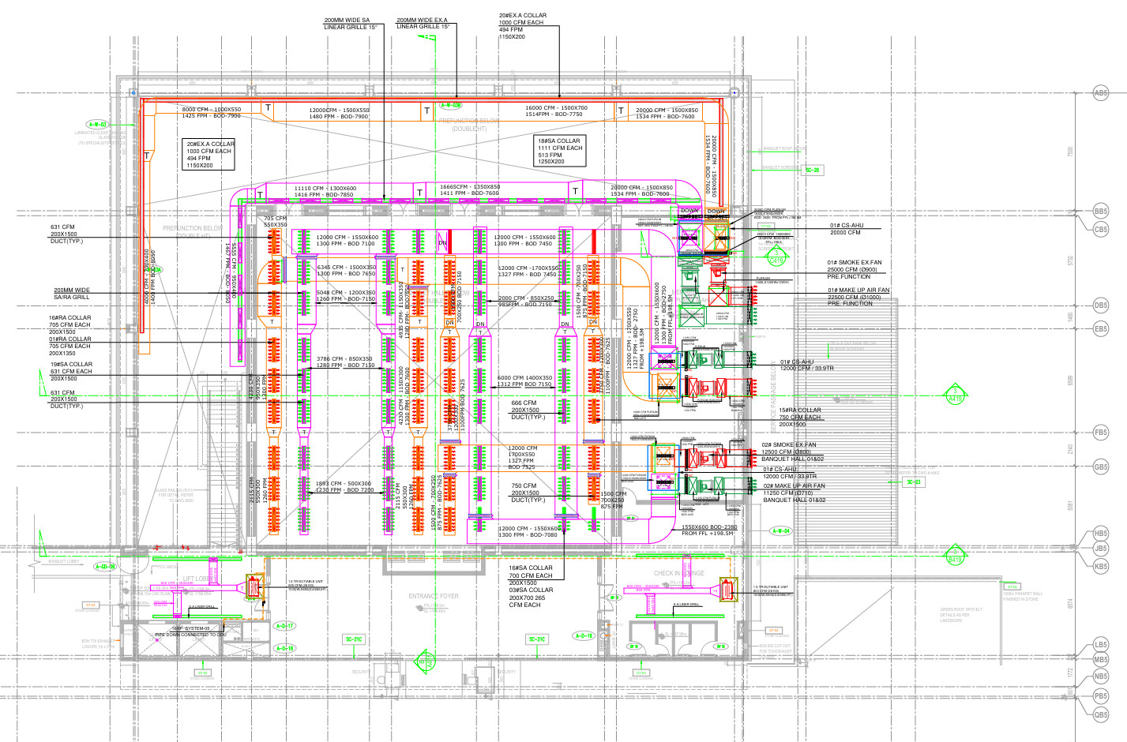
(Fig.II.A.) Lobby HVAC Shop Drawing.

III. ESTIMATION AND EXECUTION ACTIVITIES

III.1 Estimation Activities
The electrical estimation activities performed during the project included:
- Review of tender drawings, specifications, and schedule of rates to understand the scope of work.
- Systematic Quantity Take-Off (QTO) of all electrical items from architectural and electrical drawings.
- Preparation of detailed BOQ spreadsheets with item descriptions, units, quantities, and rates.
- Material cost analysis by obtaining quotations from approved vendors and comparing prices.
- Labor cost calculation based on productivity norms and applicable labor rates.
- Preparation of cost summary sheets covering direct costs, overheads, and profit margins.
- Tender document preparation including covering letter, BOQ, technical submittals, and deviation lists.
- Comparison of received tenders and preparation of tender evaluation reports.
III.2 Site Execution Activities
The site execution activities carried out during the project included:
- Layout marking for conduit routes, cable trays, and panel locations as per approved drawings.
- Installation of GI conduits (surface and concealed) for power and lighting circuits.
- Installation of cable trays and cable ladders for main feeder and distribution cables.
- Pulling of LT cables including armored cables for main distribution and unarmored cables for final circuits.
- Installation of distribution boards, MCBs, MCCBs, ACBs, and associated switchgear.
- Connection of transformer LT side to MDB and verification of phase sequence and voltage levels.
- Installation of earthing electrodes, earth strips, and equipotential bonding conductors.
- Installation of light fixtures, switches, sockets, and accessories.
- Supervision of DG set installation, fuel system connections, and AMF panel commissioning.
- Inspection and supervision of fire alarm detector placement, cabling, and panel connections.

IV. RESULTS AND OBSERVATIONS

IV.1 Technical Learnings
- The project provided extensive technical knowledge and practical experience in the following areas:
- Comprehensive understanding of airport electrical systems from high-voltage incoming supply to final circuit distribution
- Ability to read, interpret, and cross-reference complex electrical drawings, SLDs, and specifications
- Practical experience in supervising electrical installations and identifying common site defects
- Understanding of earthing and bonding requirements for large-scale infrastructure projects
- Knowledge of testing and commissioning procedures for LT distribution systems, earthing systems, and fire alarm systems.

IV.2 Estimation and Cost Management Learnings
On the estimation front, the project developed the following competencies:
- Proficiency in QTO methodology for all categories of electrical work including conduits, cables, trays, panels, and fixtures
- Experience in BOQ preparation using standard formats adopted in the MEP industry
- Understanding of material rate analysis and vendor management in procurement
- Ability to prepare cost summary sheets and project cost budgets
- Familiarity with tender documentation and evaluation processes in the construction industry.

IV.3 Challenges Encountered
Several practical challenges were encountered during the project execution and addressed as follows:
- Design coordination issues: Conflicts between electrical and civil/structural drawings were identified and resolved through regular MEP coordination meetings
- Material procurement delays: Alternative materials were identified and approved from qualified vendors to prevent critical path delays
- Site access constraints: Work sequencing was revised to accommodate civil construction activities ahead of electrical installation in each zone
- QTO discrepancies: Initial quantity discrepancies between design drawings and actual site conditions were resolved through site measurements and design revision requests.

V. CONCLUSION

This internship project on Electrical Project Execution, Estimation, and MEP Coordination for Infrastructure Development provided a comprehensive and enriching experience in real-world electrical engineering practice. The project successfully bridged the gap between academic knowledge and industry requirements by exposing participants to the complete lifecycle of an MEP project, from drawing interpretation and estimation through site execution to testing, commissioning, and documentation.
The dual exposure to project execution and estimation functions provided a well-rounded understanding of how electrical projects are planned, costed, executed, and delivered in the MEP industry. The work environment, with its unique demands for reliability, safety, and operational continuity, offered an ideal setting to appreciate the importance of technical precision, interdisciplinary coordination, and rigorous quality and safety standards.
The skills, knowledge, and practical experience gained through this internship are expected to form a strong foundation for a career in electrical engineering, MEP project management, or related fields. The project demonstrated that successful execution of complex electrical infrastructure requires not only technical competence but also strong coordination, communication, and problem-solving abilities.
Future work in this area could explore the application of digital tools such as BIM and IoT-based monitoring systems for enhancing the efficiency and accuracy of airport electrical project management, estimation, and maintenance operations.

VI. ACKNOWLEDGEMENT
We express our sincere gratitude to Enncon Synergies for providing industrial exposure in MEP execution and electrical estimation. We are thankful to Prof. Dinesh D. Pawar and the Department of Electrical Engineering, Nagesh Karajagi Orchid College of Engineering and Technology, for their continuous guidance and support.

VII. REFERENCES
- National Fire Protection Association. (2022). NFPA 72: National Fire Alarm and Signaling Code. NFPA.
- International Electrotechnical Commission. (2010). IEC 62305: Protection Against Lightning. IEC.
- Bureau of Indian Standards. (2020). IS 732: Code of Practice for Electrical Wiring Installations. BIS.
- National Building Code of India (NBC), Electrical Installations in Buildings, Bureau of Indian Standards, New Delhi, India.

