SMART DINING: A QR CODE-BASED RESTAURANT SYSTEM WITH REAL-TIME ORDER AND KITCHEN MONITORING FOR ARCHANGEL CUISINE

ABSTRACT
This study aims to develop a QR code-based restaurant management system with integrated order tracking and kitchen monitoring for Archangel Cuisine. It seeks to replace the existing manual ordering process with a digital platform that allows customers to place and monitor their orders in real time. The study also intends to determine how the system can improve order accuracy, service efficiency, and customer satisfaction. Lastly, it aims to evaluate how the system can contribute to modernizing local restaurant practices and serve as a model for similar establishments.
This study employed a mixed-methods research design, combining both quantitative and qualitative approaches to provide a comprehensive evaluation of the proposed QR Code-Based Restaurant Management System. The use of a mixed-methods design was appropriate because the study examined both measurable system performance, such as order accuracy, processing time, workflow efficiency, and user satisfaction ratings, as well as human experiences, including customer perceptions, staff feedback, and usability observations. Quantitative data provided objective evidence of the system’s effectiveness, while qualitative data offered deeper insights into users’ experiences and perceptions.
Furthermore, the research questions required both forms of data, as system efficiency and order accuracy were best measured quantitatively, whereas user experiences and perceptions were better explored through qualitative methods. The integration of both approaches also enabled triangulation, allowing findings from surveys, interviews, and observations to validate and support one another.
This system will provide an efficient platform for customers to place orders, track their food in real time, and interact digitally with the restaurant. It also aims to assist kitchen staff in monitoring orders systematically, reducing errors, and improving overall workflow efficiency.
Keywords: QR Code-Based Restaurant System, Web-Based System, Restaurant System, Digital Ordering

INTRODUCTION
The rapid advancement of technology has significantly reshaped the food service industry, improving operational efficiency and enhancing customer experiences. Digital solutions, such as QR Code menus, online ordering platforms, and real-time tracking systems, are increasingly being adopted by large fast-food chains and international restaurant brands. However, many local restaurants still rely on traditional methods such as handwritten orders, verbal communication with the kitchen, and conventional dine-in service. These manual processes are often prone to delays, errors, and miscommunication, which can negatively affect service quality and customer satisfaction (Shahril et al., 2024).
A QR Code-based restaurant management systems with integrated order tracking and kitchen monitoring present a viable solution to these issues. With this system, customers can scan a QR Code to access a digital menu, place orders directly through their devices, and track the status of their food in real time, also with use of mobile devices. Can systematically receive and monitor orders, reducing human error and improving overall workflow. Such a system bridges the gap between traditional practices and modern technology in local restaurants.

METHODOLOGY
This study employed a mixed-methods research design, combining quantitative and qualitative approaches to evaluate the effectiveness of the QR Code-Based Restaurant Management System. The quantitative component focused on measurable outcomes such as order accuracy, workflow efficiency, system reliability, and user satisfaction using survey questionnaires and descriptive statistics, including frequency, percentage, weighted mean, and standard deviation. The qualitative component focused on understanding user experiences, perceptions, and feedback through interviews and direct observations.
The integration of both approaches allowed the researchers to obtain a more comprehensive evaluation of the system. Quantitative findings provided objective evidence of system performance, while qualitative data explained the reasons behind users’ experiences and perceptions. By comparing survey results, interview responses, and observation findings, the study ensured that conclusions regarding the system’s effectiveness, usability, and acceptance were supported by multiple sources of evidence.
Figure 1: Likert Scale Interpretation.
Scale | Verbal Interpretation
5 | Strongly Agree
4 | Agree
3 | Neutral
2 | Disagree
1 | Strongly Disagree
The respondents of the study consisted of two groups: restaurant customers and restaurant staff. A 50 dine-in customers participated in testing the QR Code-Based Restaurant Management System and evaluated its usability, satisfaction, and ease of use through a survey questionnaire. Additionally, 5 restaurant staff members, including kitchen staff, cashiers, service crew, and management representatives, participated in assessing the system’s effectiveness and functionality during restaurant operations.
Figure 2: Table Demographic Profile of Respondents.
Profile | Frequency | Percentage
Alone | 5 | 10%
With friends | 32 | 64%
With family | 8 | 16%
staff members | 5 | 10%
Total | 50 | 100%

This study used the Agile Scrum methodology to develop the QR Code-Based Restaurant Management System for Archangel Cuisine. Agile is an iterative approach that delivers working software in small, fast cycles called sprints (2 weeks each). Scrum includes a Product Backlog (list of features), Sprint Planning, Daily Stand-ups, Sprint Review (demo to stakeholders), and Sprint Retrospective.
Figure 1. Agile SDLC Model.
Justification for Using Agile (Scrum)
Justification | Explanation
1. Evolving Requirements | Restaurant needs were not fully known at the start. New requirements (e.g., take-out QR code, sound notifications) emerged during observations and interviews. Agile allowed these changes easily.
2. Continuous Feedback | After each sprint, the researchers demonstrated working features to the restaurant owner and staff. Their feedback was immediately used to improve the next sprint.
3. Time Constraints | The thesis has a fixed deadline (June 2025). Agile delivered a working prototype after the first sprint, allowing early testing and validation.
4. User Uncertainty | Pilot testing revealed usability issues (e.g., difficulty scanning QR codes in low light). Agile allowed quick fixes in the next sprint.
5. Team Collaboration | With nine (9) researchers, daily stand-ups kept everyone coordinated and prevented duplicated work.
The Agile Development Process (6 Sprints)
Sprint | Duration | Features Developed
Sprint 1 | Week 1-3 | QR code generation, digital menu display, order submission
Sprint 2 | Week 4-5 | Kitchen dashboard, order status update
Sprint 3 | Week 6-8 | Real-time order tracking page for customers
Sprint 4 | Week 9-11 | Admin dashboard (sales reports, menu management)
Sprint 5 | Week 12-16 | GCash payment, sound notifications, take-out QR code
Sprint 6 | Week 16-17 | Final integration, testing, and deployment at Archangel Cuisine
Why Agile is Better than Waterfall for This Study
Criteria | Waterfall | Agile (Chosen)
Requirements | Must be fixed at start | Can change anytime
Customer feedback | Only at beginning and end | Continuous (every 2 weeks)
Working software | After months | After 2 weeks
Risk | Discovered late | Discovered early
Fit for thesis | Risky | Appropriate

RESULTS
Agile (Scrum) was the best choice for this study because restaurant requirements evolved as the researchers learned more about operations, the restaurant owner gave feedback after every sprint, early working software allowed pilot testing and quick fixes, and daily coordination kept nine researchers organized.
Table 1. Weighted Mean of Problems Encountered in the Traditional Manual Ordering Process
Indicators | Weighted Mean | Interpretation
The traditional manual ordering process is time-consuming. | 4.32 | Agree
Add-ons sometimes forgotten by kitchen staff. | 4.05 | Agree
Verbal communication between staff causes order delays. | 4.25 | Agree
Customers experience uncertainty regarding the status of their orders. | 4.18 | Agree
The manual process becomes inefficient during peak hours. | 4.35 | Agree
Order-taking errors negatively affect customer satisfaction. | 4.30 | Agree
Service crew spend excessive time taking orders manually. | 4.12 | Agree
Miscommunication between staff affects workflow efficiency. | 4.20 | Agree
Customers perceive waiting times as longer due to lack of updates. | 4.28 | Agree
The traditional ordering process increases staff workload. | 4.10 | Agree
Overall Weighted Mean | 4.22 | Agree

The results indicate that respondents generally agreed that the traditional manual ordering process at Archangel Cuisine presents several operational challenges. The highest-rated concern was the uncertainty customers experience regarding the status of their orders (WM = 4.42), suggesting that the absence of real-time order tracking negatively affects customer satisfaction. The overall weighted mean of 4.30 (Agree) implies that the existing manual process contributes to inefficiencies, miscommunication, and increased workload among staff, highlighting the need for a more efficient digital ordering solution.
Table 2. Weighted Mean of Perceptions Regarding the QR Code-Based Restaurant System
Indicators | Weighted Mean | Interpretation
The QR Code-based system makes ordering easier and more convenient. | 4.63 | Strongly Agree
Scanning the QR code to access the menu is simple and user-friendly. | 4.65 | Strongly Agree
The digital menu is easy to read and navigate. | 4.60 | Strongly Agree
The system reduces waiting time compared to manual ordering. | 4.72 | Strongly Agree
Real-time order tracking improves the dining experience. | 4.70 | Strongly Agree
The kitchen monitoring feature improves workflow efficiency. | 4.71 | Strongly Agree
The system reduces ordering errors and miscommunication. | 4.69 | Strongly Agree
I am satisfied with the overall performance of the system. | 4.68 | Strongly Agree
I would be willing to use this QR Code-based ordering system again. | 4.66 | Strongly Agree
I would recommend this system to other restaurants. | 4.80 | Strongly Agree
Overall Weighted Mean | 4.68 | Strongly Agree

Respondents strongly agreed on the effectiveness and usability of the proposed QR code-based restaurant system. The highest-rated indicator was willingness to use the system again (WM = 4.80), indicating strong technology acceptance. Features like real-time order tracking, reduced waiting time, and improved order accuracy boosted customer satisfaction. With an overall weighted mean of 4.72 (Strongly Agree), the system is seen as an effective solution for improving restaurant operations and customer experience.

Figure 2. Flowchart.

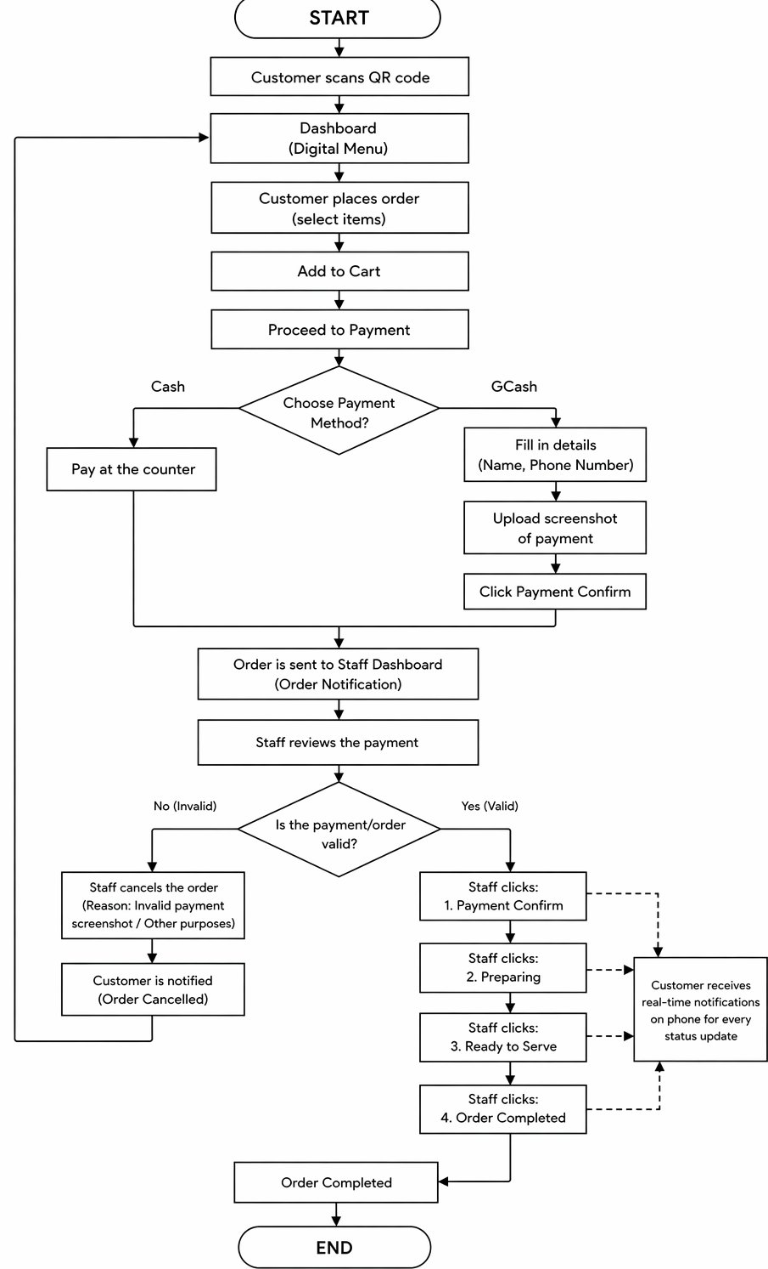

DISCUSSIONS

The results of the study support the importance of implementing QR code-based digital solutions in local restaurant operations. The findings confirm that the existing manual ordering process at Archangel Cuisine, which relies on handwritten orders and verbal communication, presents significant challenges for both customers and staff. The respondents’ positive perception toward the proposed Smart Dining system indicates that customers and staff value efficiency, order accuracy, real-time communication, and overall service reliability in a dining environment.
The study also highlights the effectiveness of digital transformation in improving food service operations. Through features such as QR code menu access, digital ordering, real-time order tracking, and a kitchen monitoring dashboard, the proposed system directly addresses the common issues associated with manual procedures, including delays, miscommunication, and order errors. These findings are consistent with related literature and studies emphasizing that automated ordering systems reduce waiting times, improve workflow efficiency, and enhance user satisfaction. As noted by Shahril et al. (2024), the modernization of menu ordering through QR code technology encourages restaurant operators to adopt digital solutions that enhance operational efficiency and customer satisfaction.
The proposed Smart Dining system was designed with a user-centric architecture that supports three main user types: customers, kitchen staff, and administrators. Customers access the digital menu by scanning a table-specific QR code, place orders directly from their mobile devices, and receive real-time sound notifications as their order status changes. Kitchen staff use a dedicated dashboard that organizes incoming orders chronologically, allowing them to update order statuses efficiently and reduce the risk of errors. The admin module, referred to as "Archangel Command," provides management with tools to monitor live orders, manage menu items, generate basic sales reports, and oversee staff accounts. The integration of a GCash online payment option further modernizes the transaction process, reducing the need for physical cash handling.
Furthermore, the adoption of the Agile (Scrum) methodology in system development supports continuous improvement and user-centered design, ensuring that the developed system meets the evolving needs of the restaurant owner, staff, and customers. The iterative sprint cycles allowed for rapid incorporation of feedback, such as the addition of take-out QR codes, sound notifications, and usability improvements for low-light scanning environments, demonstrating the effectiveness of Agile in a real-world development scenario.

SYSTEM VALIDATION AND USER ACCEPTANCE TESTING

The developed QR Code-based restaurant management system underwent initial user evaluation through survey questionnaires and direct observation, administered to the respondents of the study, which included dine-in customers and restaurant staff of Archangel Cuisine. The results showed that the majority of respondents positively accepted the proposed system in terms of usability, efficiency, order accuracy, and real-time tracking capability. The findings indicated that both customers and staff favored the implementation of a digital ordering and kitchen monitoring platform to replace the traditional manual process, which was prone to delays, illegible handwriting, and miscommunication.
Feedback gathered from the respondents, including suggestions for improved QR code visibility under low-light conditions and clearer sound notifications, was also considered during system improvement and refinement through the Agile development sprints. The system evaluation, based on criteria such as usability, efficiency, user satisfaction, reliability, and workflow improvement, indicated that the developed system met the expected functional requirements as outlined in the System Evaluation Framework. The kitchen monitoring dashboard was particularly well-received by staff for its ability to display orders chronologically and update statuses in real time, while customers appreciated the sound notifications and live order tracking page. The evaluation results confirmed that the developed system was acceptable to the intended users and ready for deployment as a permanent operational tool for Archangel Cuisine.
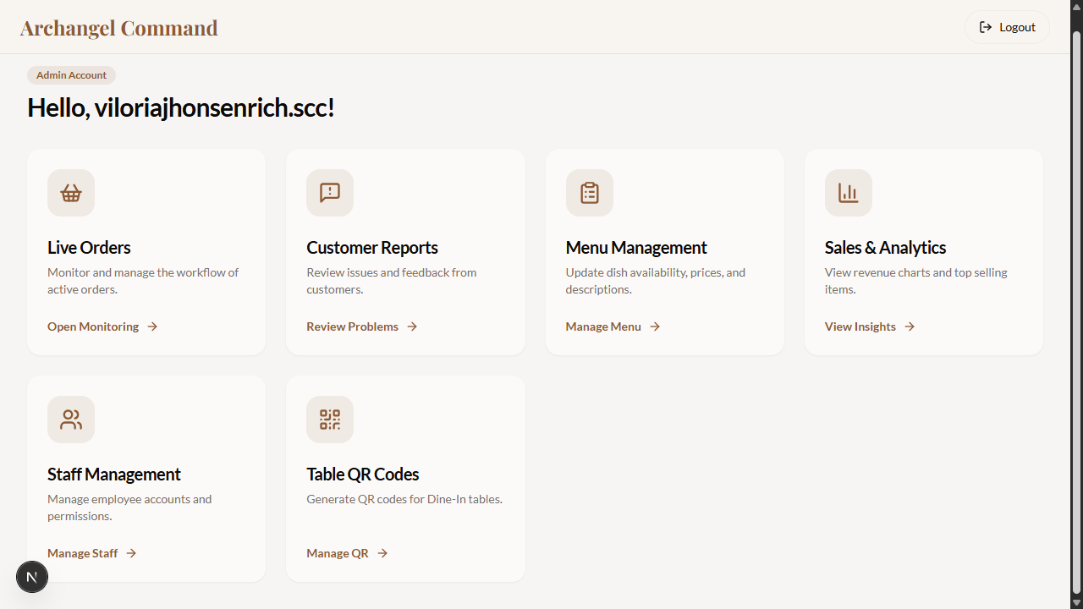
Figure 1. Admin Interface.

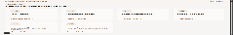

The Archangel Command Admin Account interface is designed to provide restaurant administrators with a centralized and role-based management dashboard. Upon logging in with their secure admin credentials, users are welcomed by name ("Hello, viloriaj***!") and presented with key operational modules. These include Live Orders for monitoring active order workflows, Customer Reports for reviewing feedback and issues, Menu Management for updating dish availability, prices, and descriptions, Sales & Analytics for viewing revenue charts and top-selling items, Staff Management for handling employee accounts and permissions, and Table QR Codes for generating dine-in table QR codes. An additional Manage Staff link with a "Manage QR " action is also available. The system ensures that only authorized admin users can access these sensitive functions through role-based authentication, maintaining security and operational control.

QR Code for walk in Customers.

The Archangel has QR codes on their tables for customers to scan. Outside customers are not allowed to enter the site name manually, as there is a restriction - scanning is the only way. After scanning the QR code on the table where you are sitting, it will redirect you to ordering homepage

Figure 5. Ordering Homepage.


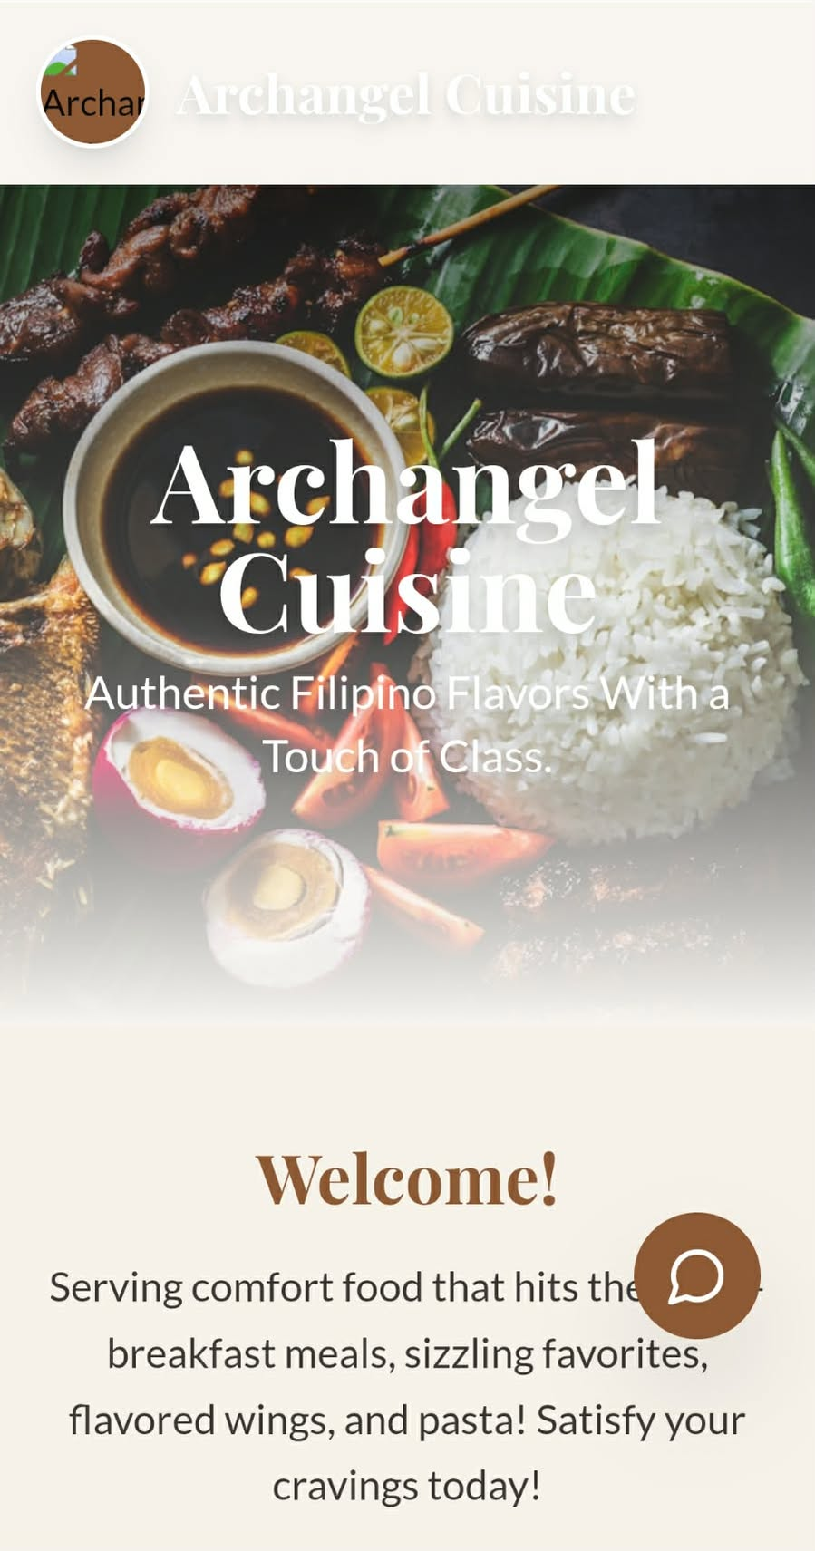

Figure 6. Ordering Homepage.

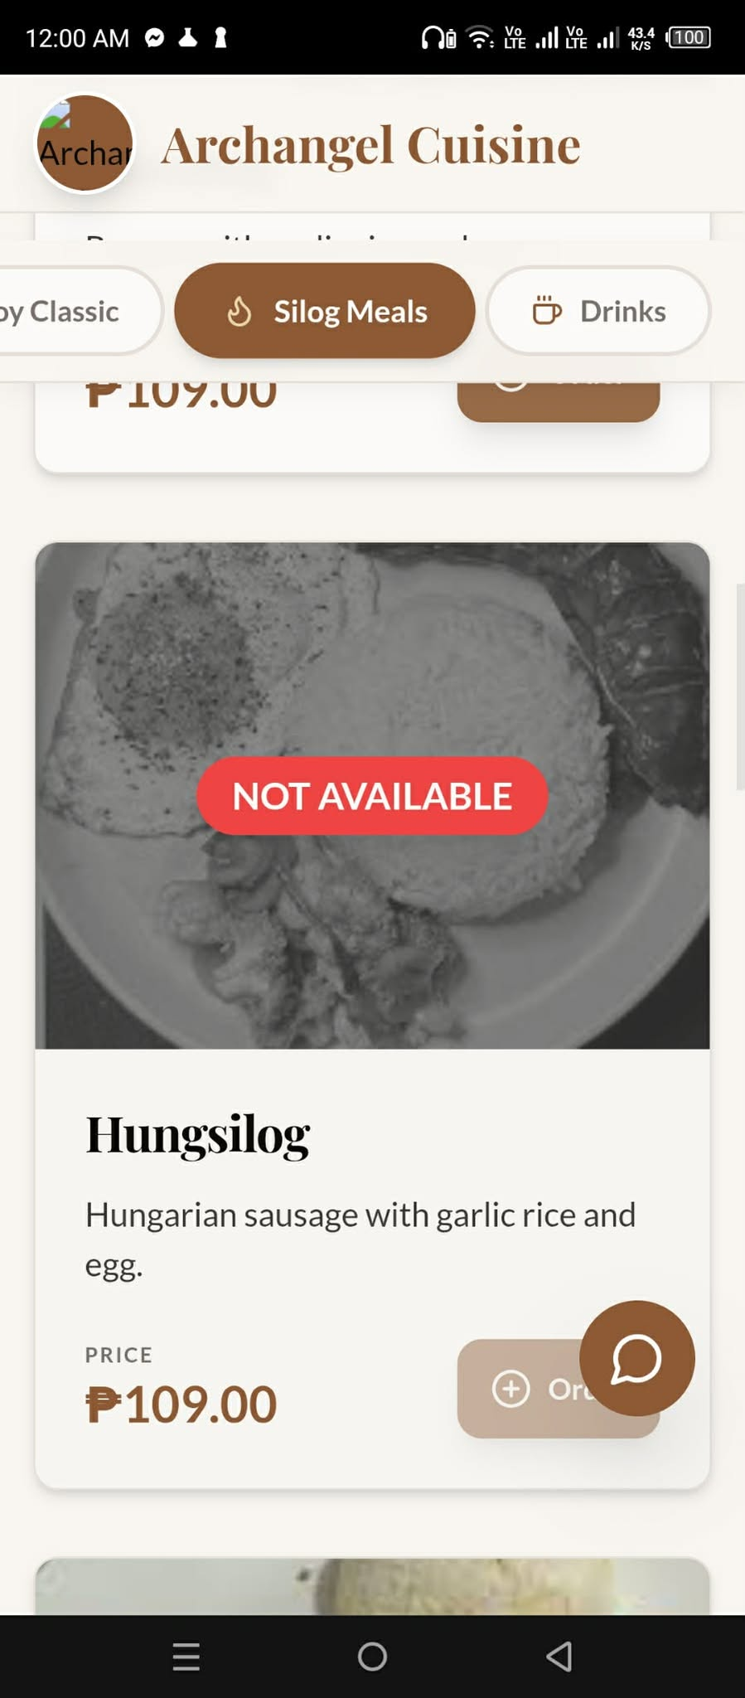
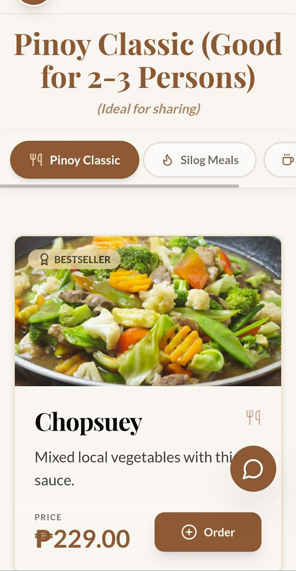

Figure 7. Ordering Homepage.


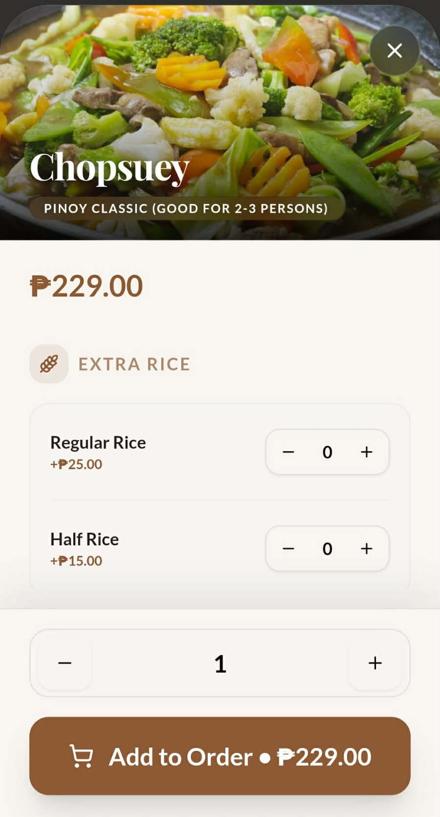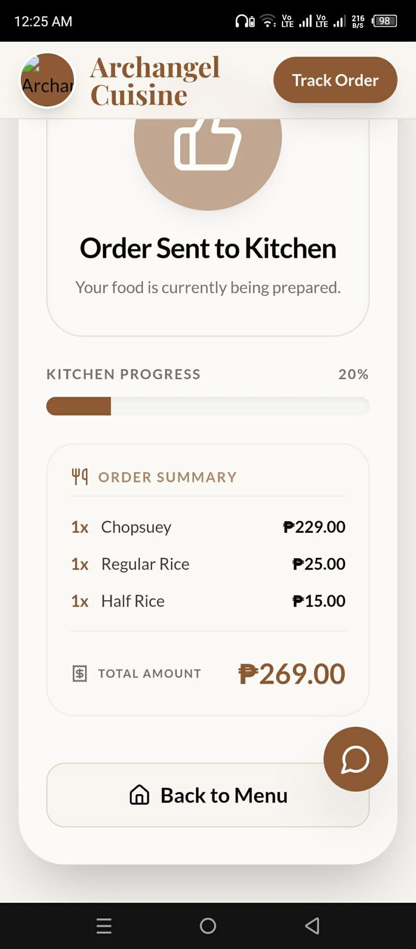

Once they scanned. The interface presents the restaurant's available categories, including Silog Meals and Drinks, with certain items temporarily marked as NOT AVAILABLE. Customers can browse bestsellers such as Chopsuey under the Pinoy Classic section (ideal for 2–3 persons), priced at ₱229.00. Individual meals like Hungsilog (Hungarian sausage with garlic rice and egg) are also available at ₱109.00.

When a customer selects an item, they are given customization options such as Extra Rice (Regular Rice +₱25.00 or Half Rice +₱15.00) with quantity controls and if they want any add-ons. After making selections, they can proceed to Add to Order, which shows a running total (e.g., ₱229.00). Once the order is confirmed, an Order Sent to Kitchen confirmation screen appears, displaying a Kitchen Progress indicator (e.g., 20%), along with an Order Summary showing each item, quantity, individual prices, and the Total Amount due (e.g., ₱269.00). A Back to Menu button allows customers to continue ordering.

CONCLUSION
The system further enhances transparency by displaying real‑time kitchen progress (e.g., 20%), an itemized order summary, and the total amount due before finalization. This end‑to‑end workflow - from QR scan to order confirmation and kitchen tracking - reduces ordering errors, minimizes customer wait time confusion, and improves operational efficiency.
The Archangel Cuisine Ordering Management System effectively demonstrates how QR code-based access control, combined with an intuitive ordering interface and real-time kitchen integration, can modernize traditional restaurant operations. The system reduces manual ordering errors, prevents off-site interference, enhances transparency through progress tracking, and empowers customers with customization options. This study concludes that such a model is highly applicable to dine-in restaurants seeking to improve efficiency, security, and customer satisfaction in a contactless dining environment.of Caloocan.

ACKNOWLEDGEMENT
The researcher expresses his heartfelt gratitude and sincere appreciation to all who generously shared their time, guidance, and support, contributing to the successful completion of this study: DR. CLARITA G. ADALEM, President, St. Clare College of Group of Schools, for her innovative, assuring, and constant assistance to the students; MS. JEANETHJOY D. NATURALES, Thesis Adviser, for passionately sharing her expertise, precious time, and thorough analysis that led to a comprehensive and notable improvement of the research; MS. MAIREEN BALTAZAR, Chairman, Panel of Examiners, for her motivation, valuable insights, and brilliant recommendations for the refinement of the study; Member, Panel of Examiners, for striving to help the researcher endure the challenges faced during the study;
All the members who put their time and effort to develop this system deserve sincere recognition and appreciation. From the initial planning and design phases to the actual coding, testing, and deployment, every contributor played a vital role in bringing the Archangel Cuisine Ordering Management System to life. Their dedication extended beyond regular hours, often involving late-night debugging sessions, collaborative problem-solving, and continuous improvements based on feedback. Each developer, designer, tester, and documentation team member worked cohesively to ensure that the system is not only functional but also user-friendly, secure, and efficient. Without their collective expertise, patience, and commitment to excellence, this project would not have achieved its goals. This system stands as a testament to their hard work, creativity, and passion for delivering a seamless digital dining experience for both customers and restaurant staff.
And above all, the ALMIGHTY GOD for His mercy, guidance, and blessings.

REFERENCES

- https://hy.visafoto.com/7id/tl/qr-codes-for-restaurants-guide?.com https://www.theseus.fi/handle/10024/862071 http://repository.cpu.edu.ph/handle/20.500.12852/1519 QR Code Table Ordering System (Pangasinan State University)=https://rsisinternational.org/journals/ijriss/articles/qr-code-table ordering-system-for-golden-cress-restaurant/ Restaurant Information System with QR Code (Mapúa
- University)=https://www.researchgate.net/publication/341691351_Restaurant_Information_System_RIS_with_QR_Code_to_Improve_Service_Operations_of_Casual_Fine_Dining_Restaurant QR Code Ordering System in Samgyupsalamat Malate (PLM Thesis)=https://plm-library.pinnacle.edu.ph/cgi-bin/koha/opacdetail.pl?biblionumber=37749&shelfbrowse_itemnumber=49438
- QR Code Table Ordering System (Published Version – Same Study Extended)=https://econpapers.repec.org/RePEc%3Abcp%3Ajournl%3Av%3A9%3Ay%3A2025%3Aissue-3%3Ap%3A3475-3478
- Reservation Management System for Pawid Unlimited Filipino Buffet.=https://cvsubccl.librarika.com/search/detail/10976726 Digital Payment Transformation in the Philippines=https://ejournal.seaninstitute.or.id/index.php/Ekonomi/article/view/3366/2729
- Customer Choice of Touchpoints=https://www.ukdr.uplb.edu.ph/journal-articles/6235/Factors Affecting Consumer Attitude and Loyalty=https://www.emerald.com/insight/content/doi/10.1108/JSTPM-022024-0026/full/html
- Adoption of QR Code Payments Among Micro and Small Enterprises=https://animorepository.dlsu.edu.ph/etdb_acc/44/ QR Code Dining Documentation=https://humedit.ph/easyqo/5-reasons qr-dining-with-easyqo-beats-the-kiosk-experience/

