UNUSUAL PRESENTATION OF SUPRAGLOTTIC CARCINOMA WITH INGUINAL NODE METASTASIS
Dr. Poonam Gupta MBBS, MD Clinical Oncology
Senior Consultant
Hanuman Prasad Poddar Cancer Hospital & Research Centre

Abstract- A 60 yr male presented with carcinoma supraglottic larynx. He underwent neoadjuvant chemotherapy followed by radical concurrent chemoradiotherapy. After 9 months he developed distant metastasis to inguinal node.
Introduction-Laryngeal cancer is the second most common head and neck mucosal cancer. Although supraglottic and glottic lesions tend to remain confined to their original compartments, there is no anatomic barrier to growth from one area to the next. Glottic lesions tend to be slow growing, but as they increase in size, they extend to the supraglottic and subglottic areas. Supraglottic lesions do not often start near the vocal cords. Involvement of the cords on their external epithelial surface is a late phenomenon, but submucosal extension by way of the paraglottic space occurs earlier. The fat space is an important avenue of submucosal tumor spread for infrahyoid epiglottis, false cord, and true vocal cord lesions. As the false cord and the true vocal cord lesions penetrate anteriorly and laterally, they quickly encounter the tough perichondrium of the thyroid cartilage and may eventually be shunted by the conus elasticus (lateral cricothyroid membrane) out of the larynx via the cricothyroid space. Thyroid cartilage invasion usually occurs in the ossified section of the cartilage, commonly in the region of the anterior commissure tendon or the junction of the anterior one-fourth and the posterior three-fourths of the thyroid lamina. Fixation of the vocal cord from laryngeal cancer is usually caused by invasion or destruction of the vocal cord muscle, invasion of the cricoarytenoid muscle or joint, or, rarely, invasion of the recurrent laryngeal nerve. Perineural spread is uncommon.
The disease spreads mainly to level II nodes. The level Ib nodes are rarely involved, and there is only a small risk of level V lymph nodes being involved. The incidence of clinically positive nodes is 55% at the time of diagnosis; 16% are bilateral. Elective neck dissection shows pathologically positive nodes in at least 16% of cases; observation of initially node-negative necks eventually identifies the appearance of positive nodes in 33% of cases. The risk of late-appearing contralateral lymph node metastasis is 37% if the ipsilateral neck is pathologically positive, but the risk is unrelated to whether the nodes in the ipsilateral neck were palpable before neck dissection.
The incidence of clinically positive lymph nodes at diagnosis for vocal cord carcinoma approaches zero for T1 lesions and is <2% for T2 lesions, but it increases to 20% to 30% for T3 and T4 lesions.
Case Report-A 60 years old male presented with Difficulty swallowing x 3 months, change in voice x 1 month
Local Examination: - Inspection- Mouth opening-3 fingers
Hygiene- tobacco-stained teeth +
Tongue protrusion +
Uvula and Posterior pharyngeal wall-Clear
Laryngeal Crepitations+
Biopsy -Poorly differentiated squamous cell carcinoma
Fiberoptic laryngoscopy -Bulky proliferative mass + over right aryepiglottic fold, extending into right pyriform sinus- medial, apex and lateral wall mass+ over left aryepiglottic fold with bulky overhang. Glottis not visualized Right pre-epiglottic fold involved
CT scan:
Supraglottic lesion involving right part of vallecula, abutting hyoid, paroglottic space involved, post cricoid extension+ prevertebral fascia uninvolved, right thyroid lamina abutted.
Impression- Ca Supraglottic Larynx T3N1M0

CT image:

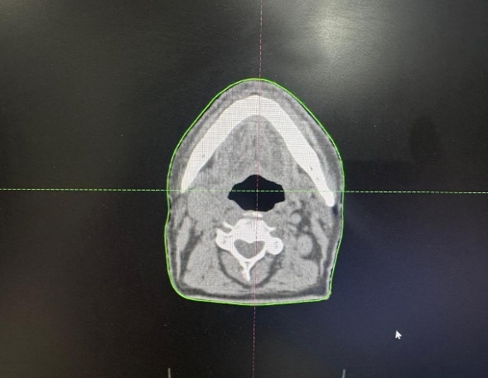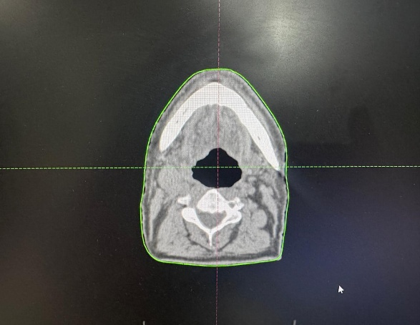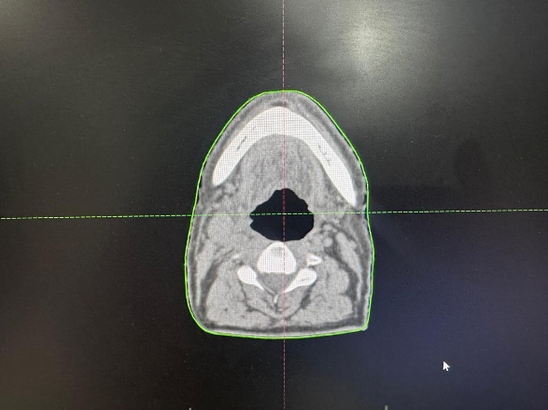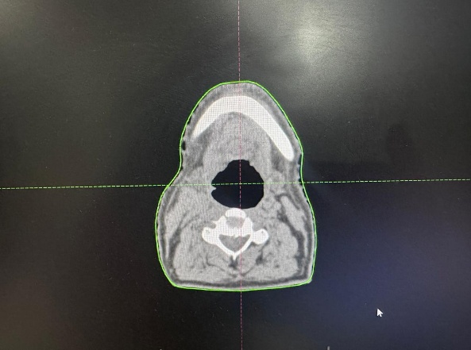
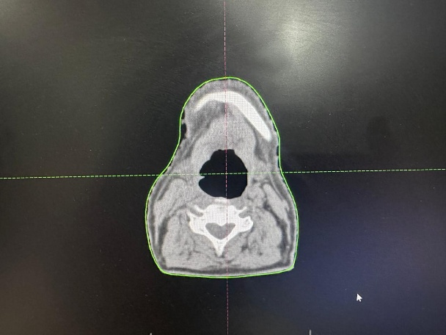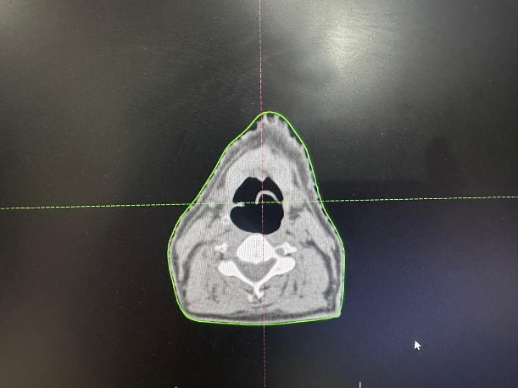
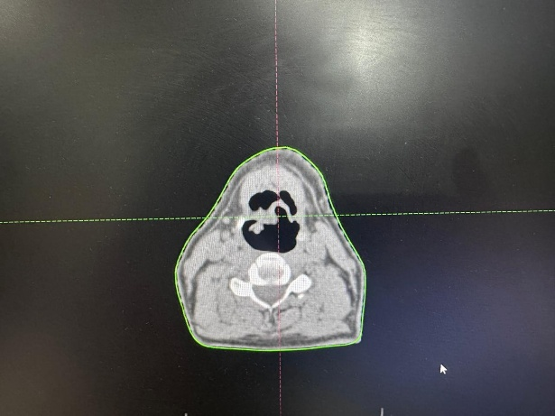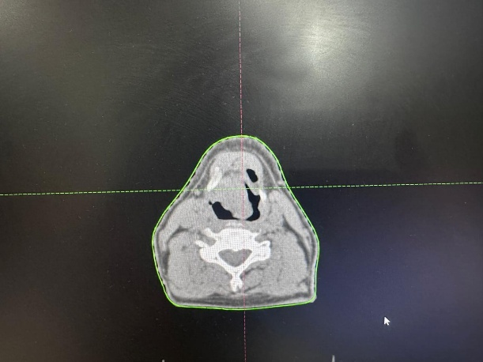
Treatment: Neoadjuvant chemotherapy 3 cycle followed by radical concurrent chemoradiotherapy 70 Gy 35fr given.
Follow -up -After completion of RT He was in follow up. After 9 month presented with palpable inguinal node.
Examination: Right inguinal node palpable size 2.5 cm.
CT pelvis: There is enlarged right inguinal node.
CT Neck: Edema is seen in bilateral vocal cord. Post RT changes
Biopsy from inguinal node: showing poorly differentiated malignant neoplasm with round cell morphology.
IHC study: compatible with metastatic poorly differentiated squamous cell carcinoma

Marker | Results
CK | Positive
GATA3 | Positive
P40 | Positive
P63 | Positive
CD56 | Focal Positive
PAX 8 | Negative
Chromogranin | Negative
CD45 | Negative
Synaptophysin | Negative
TTF1 | Negative
CK7 | Negative
CDX2 | Negative
Ki-67 | 90%

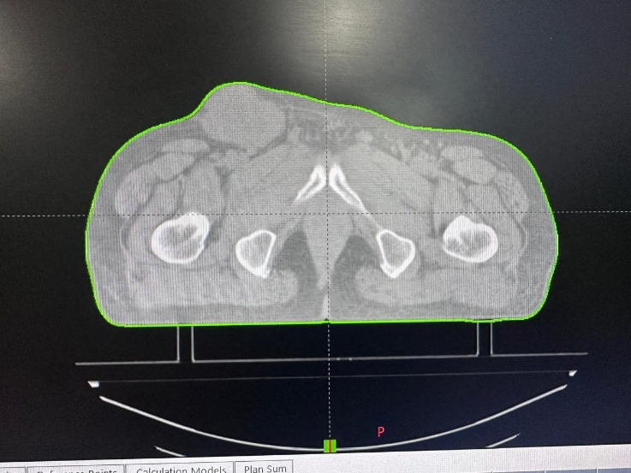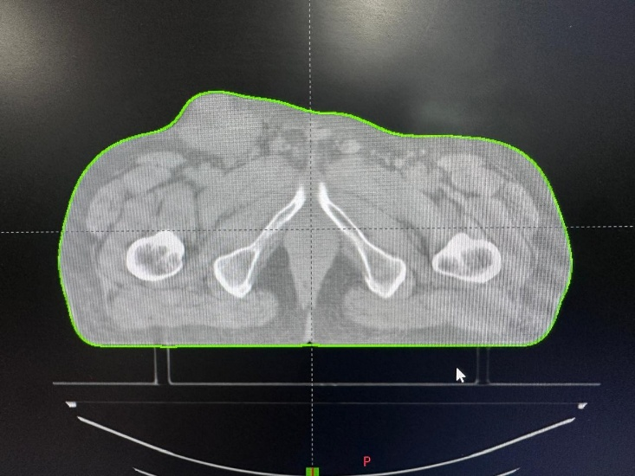
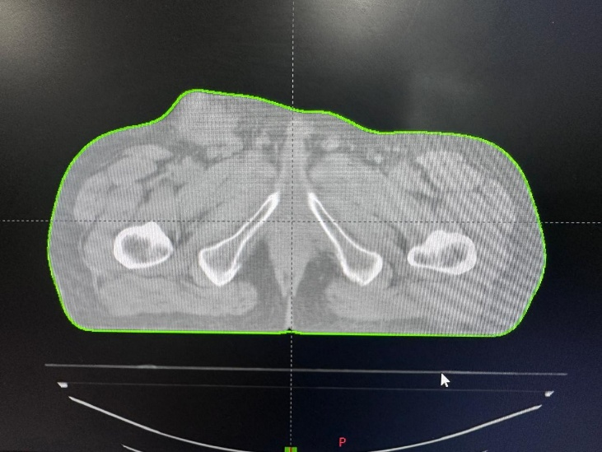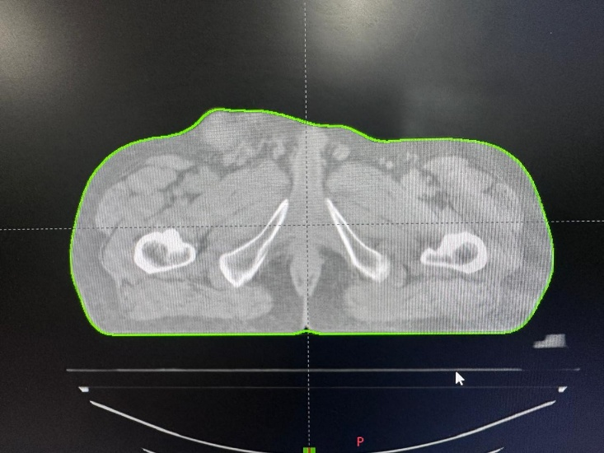
Discussion: With careful follow-up, recurrence is sometimes detected before the patient notices a return of hoarseness. There is often minimal lymphedema for 1 to 2 months after RT, which usually subsides or stabilizes. An increase in edema, particularly if associated with hoarseness or pain, suggests recurrence, even if there is no obvious tumor. It may be difficult to diagnose recurrence if the tumor is submucosal. Generous, deep biopsies are required. If recurrence is strongly suspected, laryngectomy may rarely be advised without biopsy-confirmed evidence of recurrence. Positron emission tomography may be useful to distinguish recurrent tumor from necrosis. The risk of distant metastasis is related more to N stage and the location of involved nodes in the low neck rather than to T stage. The risk is <10% for N0 or N1 disease and rises to approximately 30% for N3 disease as well as N1 or N2 nodes with disease below the level of the thyroid notch. Distant metastases are found most often in the lung.

References- 1. Archer CR, Yeager VL, Herbold DR. Computed tomography vs. histology of laryngeal cancer: their value in predicting laryngeal cartilage invasion. Laryngoscope 1983; 93:140–147.

2. Kirchner JA. Staging as seen in serial sections. Laryngoscope1975; 85:1816–1821.
3.Olofsson J, van Nostrand AW. Growth and spread of laryngeal and hypopharyngeal carcinoma with reflections on the effect of preoperative irradiation. 139 cases studied by whole organ serial sectioning. Acta Otolaryngol Suppl 1973; 308:1–84.

4. Cassidy R, Morris CG, Kirwan JM, et al. Radiation therapy for squamous cell carcinoma of the subglottic larynx. J Radiat Oncol 2012; 1:333–336.
5. Fletcher GH. Elective irradiation of subclinical disease in cancers of the head and neck. Cancer 1972; 29:1450–1454.
6. Ogura JH, Biller HF, Wette R. Elective neck dissection for pharyngeal and laryngeal cancers. An evaluation. Ann Otol Rhinol Laryngol 1971; 80:646–650.
7.Akagi K, Li J, Broutian TR, et al. Genome-wide analysis of HPV integration in human cancers reveals recurrent, focal genomic instability. Genome Res 2014;24(2):185–199.

8. Parfenov M, Pedamallu CS, Gehlenborg N, et al. Characterization of HPV and host genome interactions in primary head and neck cancers. Proc Natl Acad Sci U S A 2014;111(43):15544–15549.

