Impact of Purslane (Portulaca oleracea L.) on rabbit

Introduction
The African Swine Fever Disease (ASFD) outbreak in the nation has resulted in low productivity and a shortage of pork, which is harming the swine business. As a potential solution, rabbit meat could be one of the options. The production and use of rabbit meat have long been supported by the Food and Agricultural Organization (FAO), as it can be a great backyard and commercial venture with little initial investment, even in intensive farming systems (Odunaiya & Akinyemi, 2008 as cited by Odinawa, A. B et al. 2016).

Although its typical wild taste is the main reason for rejection, traditional consumers view rabbit meat as having positive sensory qualities such, as juiciness, aroma, texture, low-fat content, and delicate flavoring. Nevertheless, sensory qualities play a critical role in the consumer's decision-making process. Additionally, to meet the expectations for researching the impacts of rabbit behavior and condition on carcass (Princz et al. 2008 as quoted by Dale Zotte et al. 2008) and meat qualities. To prevent disappointment in the overall acceptability of rabbit meat to customers, it is necessary to monitor the impact of this alteration on the sensory qualities of the flesh.
Pork, however, be an effective substitute for rabbit meat in a regular diet, provided that the general population comes to accept these goods as such. Consumer acceptance of meat is influenced by both person-related and product-specific sensory qualities, hence sensory evaluation plays a dual function in this process. These can serve as either motivators or obstacles to the acceptance of meat substitutes, depending on the ethical considerations, political beliefs, and ecological well-being involved in the production. While a food product's sensory attributes all contribute to creating favorable expectations before and during ingestion, some may be more significant than others. In a 2019 survey of adult US citizens, 86% of respondents said taste to be the major driver of purchase intentions. (Fiorentini, Martina et al. 2020).

II. The objective of the study
The general objective of the study was to determine the response of supplementing different levels of purslane (Portulaca oleracea L.) on the growth and its effect on the organoleptic evaluation of two upgraded breeds of rabbits.
Specifically, the study aimed:
- To determine and compare the effect of breed and levels of Purslane supplementation in terms of the following parameters:
- average daily gain in weight
- final weight
- feed conversion rate
- feed consumption
- mortality rate
- Determine and compare the organoleptic evaluation of rabbits as influenced by breeds and levels of purslane supplementation.
III. Materials and Methods

Experimental Animals
A total of twenty-four (24) heads of apparently healthy weaned kits of upgraded New Zealand White and Californian White Rabbit (with an equal ratio of male and female i.e. twelve females and twelve males) weighing approximately 0.5 kg per head and 6 weeks’ old were used.
Experimental Design, Treatment, and Layout
The two separate experiments (grow-out and reproduction trials) were conducted to determine the interaction of two factors i.e. breed (two upgraded breeds) and level of purslane supplementations (3 levels) which were laid out in a split-plot in Randomized Complete Block Design with 4 replications. The following are the factors:
Factor A –Breed
A1- New Zealand White Upgraded Rabbits
A2- Californian White Upgraded Rabbits
Factor B- Level of inclusion
P1- Common Farmers Practice (60% commercial feeds and 40% grasses)
P2- 25% air-dried purslane and 75% commercial rabbit feeds
P3- 50% air-dried purslane and 50% commercial rabbit feeds
Treatment combinations
For grow out
A1P1
A1P2
A1P3
A2P1
A2P2
A2P3
Experimental Layout

Rep 1 |  | Rep 2 |  | Rep 3 |  | Rep 4
A1P3 |  | A2P2 |  | A2P2 |  | A1P1
A1P1 |  | A2P3 |  | A2P1 |  | A1P2
A1P2 |  | A2P1 |  | A2P3 |  | A1P3
A2P1 |  | A1P3 |  | A1P2 |  | A2P3
A2P3 |  | A1P1 |  | A1P3 |  | A2P1
A2P2 |  | A1P2 |  | A1P1 |  | A2P2

Propagation and Preparation of Purslane
An area of one square meter was harvested with 2.5 kg of purslane which meant that for every 100 square meters, 250 kgs was produced per harvest.
One thousand (1,000) square meters’ area was provided for the propagation of purslane. Matured purslane plants (leaves and stems) were harvested in the morning (9:00 AM) by cutting the base of the plant above the ground leaving around an inch. The harvested purslane was air-dried overnight before use.
Experimental allocation of weaners for grow-out trial
The experimental purslane plants were gradually introduced to the animals following the one-week pre-trial activity. The number of commercial feeds and purslane with the desired amount was given to the animals in equal amounts in the morning and the afternoon on a separate clay pot on 6% dry matter requirements of the animals computed based on their body weight.
The weaners were allocated into individual cages following the experimental design. The initial weights of the animals were determined and subjected to statistical analysis. The grow-out trial commenced when the initial weights revealed non-statistically significant comparisons. The experimental period was terminated on their 60th days.
Experimental feeding based on dry matter requirement for grow-out trial
The amount of feed (either commercial feed or purslane) for the grow-out trial was based on the dry matter requirement and body weight. The dry matter intake of the animals was six percent (6%) of their body weight. Before experimentation, samples of commercial feed and purslane was submitted to the DA-RFU 3 Feed Laboratory for proximate analysis The dry matter content of the samples was the basis for the computation of daily feed allocation to each treatment combination
Proximate Analysis of purslane and concentrate.
Forages | DM (%) | TDN (%) | CP (%) | C (%) | P (%)
Purslane | 90 | 60 | 9.3
Concentrates | 90 | 75 | 15 | 0.5 | 0.3

Sample diet allocation for 500-gram grow-out rabbit based on 6% DM requirement and 90% DM content of concentrate and purslane based on proximate analysis.
Treatments | Computation | Diet allocation (g)
Common Farmer’s Practice  60% Concentrated feeds  40% Napier grasses | 500 x 0.06 x 0.6 / 0.9  500 x 0.06 x 0.4 / 0.9 | 20.00  13.33
75% Concentrate Feeds  25% Air Dried Purslane | 500 x 0.06 x 0.75 / 0.9  500 x 0.06 x 0.25 / 0.9 | 25  8.33
50% Concentrated Feeds  50% Air Dried Purslane | 500 x 0.06 x 0.50 / 0.9  500 x 0.06 x 0.50 / 0.9 | 16.66  16.66

Feeding was done twice a day: P1 is the common farmer’s Practice which is 60% concentrated feeds and 40 % air-dried Napier grass, this was given 50% in the morning (8:00 AM) and 50% in the afternoon (5:00 PM), for P2, is 25% concentrated feeds and 75% air dried purslane was given 50% in the morning (8:00 AM) and (50%) in the afternoon (5:00 PM). For P3 50% concentrated feeds and 50% air-dried purslane were given 50% in the morning (8:00 AM) and 50% in the afternoon (5:00 PM).
Care and management practices
Housing
The housing premises have adequate shade of trees, a peaceful environment, and free from inclement weather, and are protected from predators like dogs, cats, snakes, bats, etc. It had good ventilation and natural light. Each cage was made up of gauge 14 GI wire mesh with a hard plastic rabbit floor mat fitted with an inverted bottle nipple drinker and feeder with bottom mesh. For a grow-out trial, each weaner was placed in an individual cage with a dimension of 2ft x 4 ft x 16” LWH.
Determination of feed allocation and daily feed consumption
Feed was allocated first on all feeders based on the body weight of each animal before they were placed in the cage. Before feeding in the morning from the second day of the experiment and onwards, all feeders were withdrawn at the same time from each cage and placed on top of each cage. Thereafter, the leftover feed was obtained and weighed. After all, leftover feeds have been measured, feed allocation per animal was done to all feeders and then placed back in the cage at the same time.
Deworming
All experimental animals were dewormed before the actual experimentation. Albendazole was given at a rate of 10 mg/kg body weight through drinking water.
Sanitation for disease prevention
The individual cages were cleaned and disinfected before the conduct of the experiment. Daily cleaning of each cage was done. Animals that showed signs of infection were well-examined and treated immediately.
The Importance of the IACUC Protocol
The IACUC protocol is a well-designed and efficient review process in research, training, or testing conducted by the authority or directive of the university. This is to promote the humane care, ethical treatment, and use of animals, regardless of funding sources. These activities are conducted by any faculty, staff, or students of the university in conjunction with their academic or professional responsibilities. It is a detailed description of the proposed use of animals prepared by the researcher for IACUC review and approval. Activities involving animals in research, testing, and teaching can begin only after they have been reviewed and approved by the IACUC. In addition, testing regulations which is the Animal Welfare Act 2006 (AWA) set high standards of care for laboratory animals about their housing, feeding, cleanliness, ventilation, and medical needs. It also requires the use of anesthesia or analgesic drugs for potentially painful procedures and during post-operative care. (https://www.google.com/search?q=why+there+is+a+need+of+IACUC+Protocol.
Organoleptic Examination
Carcass Quality
The rabbits were slaughtered after the grow-out feeding trial. The slaughtering process was executed by a well- trained from TESDA and an employee of the Rabbit Production of the school campus. The carcass was subjected to a sensory evaluation to be performed by trained panelists (sex, age level, respectively). Grading of the carcass was based on a Likert scale of intensity level (1= lesser; 6=greater) of each descriptor (tenderness, juiciness, aroma, palatability, and flavor). Each panelist evaluated the samples corresponding to the treatment combinations.
Preparation and Presentation for Sensory Evaluation
In preparing the sample for sensory evaluation, 100 grams of carcass per treatment was placed in an aluminum tray sealed with a plastic cover. A total of two kilograms and four hundred grams was brought to the College of Home Science and Industry, Department of Food Science and Technology, Central Luzon State University, Science City of Muñoz, Nueva Ecija.
The meat samples from each treatment were cut, cleaned, slightly breaded, and fried before evaluation. All samples were subjected to sensory evaluation by a group of panelists using Quality Scoring for meat on parameters that include; aroma, juiciness, color, aftertaste, and overall acceptability.
The Procedure of Sensory Evaluation
The consumers who served in this study were randomly recruited at Central Luzon State University Philippines. The following criteria for eligibility were used familiar, have tasted rabbit meat and willing to try rabbit meat, do not have any known food allergies or dietary intolerance willing and available to participate in the study. Eligible respondents were oriented about the test procedure. Respondents were seated at the CLSU Sensory Laboratory and were given brief instructions about the procedure for the test. The samples were marked with random three-digit codes before being served to the respondents in randomized monadic order. The respondents received table napkins and were encouraged to drink some still mineral water (CLSU Aqua) in between samples to cleanse their palate. The average time for a respondent to complete the evaluation was ten minutes. The questionnaire was comprised of two parts, First, the respondents were asked to taste the fried rabbit and rate their overall liking for each product, using a nine–point hedonic scale (where 1=dislike extremely and 9 = like extremely) (Lawless & Heimann, 2010). Second, they were required to indicate the Rate –All –That –Apply (RATA score) for each of the sensory attributes.
Data Collection
The data gathered are described below:

- Average daily gain in weight (ADG) - the gain in weight from the start to end date of each actual experiment.
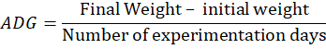
- Final weight- Weight of the animals after experimentation.
- Feed Conversion Ratio- total feed consumed over total gain in weight.
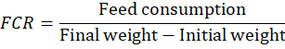
- Daily Feed consumption- the amount of feed consumed per day.
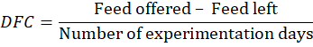
- Mortality rate- the percentage of the dead animal during the experimentation
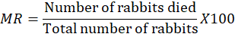
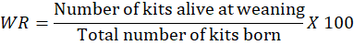
6. Sensory Evaluation rating of rabbit meat based on tenderness, taste, aroma, flavor, mouthfeel, and aftertaste.
7. Dressing Percentage -The standard method of obtaining dressing percent is dividing the carcass weight by the slaughter weight multiplied by 100.
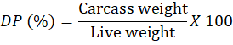

Statistical Analysis
The data gathered were expressed in means and analyzed by using a two-way analysis of variance in the Randomized Complete Block Designed (RCBD) that determined the interaction of breed and level of inclusion within breeds and level of inclusion for the identified data collected. Significant differences between means were compared using the Least Significant Different test.
IV. RESULTS AND DISCUSSIONS
A. Growth performance parameters- (Weaners)
The average initial, weight, average final weight, average daily increase, average feed intake, feed conversion ratio, and mortality rate of the two breeds of rabbit fed with various amounts of purslane are among the growth performance fed with different varying levels of purslane are the metrics.
Grow–out Trial
The average initial weight of the two kinds of rabbits indicated that there are no appreciable differences between means. However, as the table below illustrates, there is no interaction with the effect of the level of supplementation.
Table 1. Mean initial weight (grams) of rabbits in different treatment combinations.
Breed | Level of Supplementation |  |  | Mean^{NS}
Breed | 1 | 2 | 3
New Zealand | 919.25 | 874.50 | 779.50 | 857.75
California White | 820.00 | 889.50 | 859.00 | 856.17
Mean^{NS} | 869.62 | 882.00 | 819.25
Factors | P-value
A | 0.9798
B | 0.6841
A x B | 0.5019
CV=17.58% ns-No statistically significant difference (p>0.05).

Mean Average Final Weight
The mean average final weight was recorded and weighed by using a digital weighing scale, this was done when the herd reached their sixty days of experimentation as shown in the table below:

Table 2. Mean final weight (grams) of rabbits in different treatment combinations.
Breed (A) | Level of Supplementation (B) |  |  | Mean
Breed (A) | 1 | 2 | 3
New Zealand | 1843.75 | 1919.50 | 1554.50 | 1772.58 ^{B}
California White | 2003.00 | 2267.00 | 1774.50 | 2014.83^{A}
Mean | 1923.38^{ab} | 2093.25ª | 1664.50^{b}
Factors | P-value
A | 0.0283
B | 0.0107
A x B | 0.7389
CV=12.91% * Means with different letter superscripts in the same row (small case) and column
(upper case) are statistically significant (p<0.05).

Statistically proven that the Mean Average Final weight of rabbit in Table 2, treatment combinations were found significantly different. The Californian white rabbit breed shows an evident growth rate as compared to New Zealand breeds. Because of their excellent growth qualities and high meat-bone ratio, the Californian white rabbit breed is the most widely used for meat production worldwide, according to Mailu et al. 2013 (as quoted by Mailafia et al. 2010, Oseni, 2008). In addition, supplementation of purslane in their daily food has a substantial influence on their final weight.
Mean Average Daily Gain
The mean average daily gain of the experimental rabbits is presented in Table 3. The average daily gain was obtained by subtracting the initial weight from the final weight of the experimental rabbits divided by the number of experimentation days. It is the measure of the daily increase in the live weight of the animal. This was discussed below:
Table 3. Mean Average Daily in Gain (grams) of rabbits in different treatment combinations.
Breed (A) | Level of Supplementation (B) |  |  | Mean
Breed (A) | 1 | 2 | 3
New Zealand | 15.41 | 17.42 | 12.92 | 15.25^{B}
California White | 19.72 | 22.96 | 15.26 | 19.31^{A}
Mean | 17.56ª | 20.19ª | 14.09^{b}
Factors | P-value
A | 0.0029
B | 0.0021
A x B | 0.5303
CV= 16.23% * Means with different letter superscripts in the same row (small case) and column
(upper case) are statistically significant (p<0.05)

As reflected in Table 3, the mean average daily gain for weaners was significantly different in treatment combination. This means that the Californian white breed was heavier than the New Zealand white rabbit. The results of the findings that purslane supplementation in the diet highly influenced their daily gain. Weight increase is mostly determined by nutrient balance and intake, as described by Gutierrez et al. (2003) and Bacab et al. (2013). Dietary energy density and fiber content directly affect the amount of dry matter an animal consumes, which in turn affects its productivity and performance. Cong Wang et al. (2021) also discovered a significant rise in weight and a decrease in the relative abundance of dangerous bacteria compared to the number of good bacteria. These outcomes are in line with other research that demonstrated purslane improves gut microbiota. The results demonstrated that the ordinary farmer’s practice in supplementation is equivalent to the daily consumption of different treatment combinations of purslane supplementations. However, there was no discernible interaction effect on the breed or amount of purslane supplementation.
Mean Feed Conversion Ratio
The mean feed conversion ratio was determined by the total feed consumption divided by the final weight subtracted from the initial weight of the animals during the 60 days of the experimental period. The results of findings are shown below:
Table 4. Mean Feed Conversion Ratio (grams) of rabbits in different treatment combinations.
Breed (A) | Level of Supplementation (B) |  |  | Mean
Breed (A) | 1 | 2 | 3
New Zealand | 7.98 | 6.90 | 9.30 | 8.07^{A}
California White | 5.71 | 4.89 | 8.49 | 6.37^{B}
Mean | 6.85^{b} | 5.90^{b} | 8.90ª
Factors | P-value
A | 0.0462
B | 0.0203
A x B | 0.7238
CV= 26.54% *Means with different letter superscripts in the same row (small case) and column (upper
case) are statistically significant (p<0.05).

It is statistically revealed that the mean feed conversion ratio was significantly different between New Zealand White rabbits as compared to Californian white rabbit breeds shown in Table 4. It means that the Californian white breed had a better feed conversion efficiency. The efficiency increases with a lower FCR. Animals with a low feed conversion ratio (FCR) are regarded as efficient feed users, according to Wikipedia. Comparing FCR between species, however, might not mean much unless the foods are appropriately comparable and similar in quality.
According to Momoh et al. (2015), breeds and genotypes range in how efficiently they utilize feed, which is reflected in the feed conversion ratio variations. For instance, the comparison of New Zealand white × California crossbred on 17% CP, the Chinchilla × Dutch belted crossbred rabbit had a lower feed conversion ratio (12% CP), indicating a lower kilogram of feed intake per kilogram of body weight gain. This could be an example of the genotype × protein level (environment) interaction.
The weight increase of body weight in chickens according to Kartikasari et al. (2014) trial did not differ between the control group and the group that received 6% purslane meal in their diet. Remarkably, they found that the feed conversion ratio of hens given diets supplemented with 12% purslane meal was almost identical relative to using a basal diet. Despite that accordingly, Sadeghi et al. (2016) found that purslane considerably increased the antioxidant status and feed efficiency of broiler chickens. However, standard farmer practices were equivalent to the purslane supplementation in the treatment combinations.
Another finding from the study of Cong Wang et al. (2021), adding purslane to broiler chicken feed results in a large weight gain while having no discernible impact on feed intake. This improves growth performance and lowers the feed conversion rate.
This demonstrated that the optimum effect of decreasing the FCR was acquired by feeding the birds at least 3 % purslane. Meanwhile, there was no interaction effect on the average feed conversion observed on the breeds and level of supplementation.
Table 5. Mean Average Feed Consumption of rabbits in different treatment combinations.
Breed | Level of Supplementation |  |  | Meanings
Breed | 1 | 2 | 3
New Zealand | 119.17 | 113.98 | 116.48 | 116.54
California White | 112.34 | 112.13 | 127.34 | 117.27
Mean^{ns} | 115.76 | 113.06 | 121.91
Factors | P-value
A | 0.9274
B | 0.6451
A x B | 0.6423
CV= 16.35% ^{ns} No statistically significant differences (p>0.05).

B.Dressing Percentage
The dressing percentage was the weight of a dressed carcass to the weight of the live animal. The standard method was obtained on the percentage by dividing the carcass weight by the live weight of the animal multiplied by 100.
Mean Slaughter Weight

When compared to the mean weight gain of New Zealand white rabbits, the Californian White rabbits' mean slaughter weight increased significantly for each treatment during the trial. The results are displayed in the table below:
Table 6. Mean Slaughter weight (grams) of rabbits in different treatment combinations.
Breed | Level of Supplementation |  |  | Mean
Breed | 1 | 2 | 3
New Zealand | 1843.75 | 1919.50 | 1554.50 | 1772.58^{b}
Californian White | 2002.50 | 2267.00 | 1774.50 | 2014.67ª
Mean | 1923.13^{b} | 2093.25ª | 1664.5^{b}
Factors | P-value
A | 0.0284
B | 0.0107
A x B | 0.7379
CV=12.91% *Means with different letter superscripts in the same row (lower case) and same column (upper case) is statistically significant (p<0.05).

The mean average Slaughter weight was significantly different between the two breeds Californian white breeds gained heavier slaughter weight than the New Zealand white breed as reflected in Table 6. According to Tomasz and Gugolek (2020), breeding strategies related to selection for rapid growth have an impact on the quality of rabbit meat. As a result, rabbits reach their slaughter weight faster, but even when the animals are slaughtered at the same age, the quality of the carcasses and meat can differ greatly. Given that medium-sized and big rabbit breeds differ in terms of development rate and maturity at slaughter, variations in the quality of meat between FG and CAL rabbits killed at 91 days of age should be predicted.
Moreover, Michalik et al. (2008) concluded that increasing the slaughter weight of rabbits causes the proportion of the valuable front and rear sections of the carcass to rise and decrease, respectively, while the proportion of the intermediate section stays constant. When comparing the corpses of lighter and heavier rabbits, it can be observed that the former will have a greater proportion of meat and a lower proportion of fat. Conversely, in treatment combinations, there was no interaction effect on the level of supplementation.
Mean Carcass Weight
In a competitive market where consumers often have preconceived notions about the characteristics that constitute meat quality, such as flavor, tenderness, juiciness, smell, color, and texture, the quality of ruminant carcasses, meat, and meat products is crucial. The flesh of the rabbit made up of muscle, fat, bone, and connective tissue is called carcass weight. The following is an expression of the mean average carcass weight value found in the table:
Table 7. The mean Average Carcass Weight (grams) of rabbits in different treatment combinations.
Breed | Level of Supplementation |  |  | Mean
Breed | 1 | 2 | 3
New Zealand | 919.0 | 991.0 | 747.5 | 885.83^{b}
Californian White | 975.0 | 1136.0 | 880.0 | 997.00ª
Mean | 947.00^{ab} | 1063.58ª | 813.75^{b}
Factors | P-value
A | 0.0732
B | 0.0106
A x B | 0.7954
CV=15.01% *Means with different letter superscripts in the same row (lowercase)
is statistically significant (p<0.05).

Table 7, indicates that the mean average carcass weight of Californian white rabbit breeds was much higher than that of New Zealand rabbit breeds. Breeds of Californian white rabbits demonstrated superiority in terms of paternity. Similar findings were reported by Ortiz Hernández and Rubio Lozano (Cited by Daszkiewicz and Gugolek, 2020), who discovered that while NZW rabbits showed the opposite pattern, the meat of female CAL rabbits had a greater IMF level than that of other breeds. On the other hand, no interaction effect was observed on the breed and level of supplementation as described below:
Table 8. Mean Average of Dressing Percentage (grams) of rabbits in different treatment combinations.
Breed | Level of Supplementation |  |  | Mean^{ns}
Breed | 1 | 2 | 3
New Zealand | 49.37 | 51.62 | 47.28 | 49.42
Californian White | 48.72 | 50.14 | 49.50 | 49.45
Mean^{ns} | 49.05 | 50.88 | 48.39 | 49.44
Factors | P-value
A | 0.9727
B | 0.1114
A x B | 0.2692
CV=4.63% ^{ns} No statistically significant differences (p>0.05).

Sensory evaluation of rabbit meat
Overall Acceptability

Acceptability is the quality of something that is being accepted for a certain reason. Even if something is significantly less useful for this purpose than the perfect example, it is still acceptable if it is adequate to fulfill the goal for which it is offered.
The sensory quality of the product and the consumer's attitude toward it both have a significant role in determining a food's overall acceptance.
Table 9. Overall acceptability⁺ score of rabbit meat (n = 50)
Treatments | Overall Acceptability (mean+ sd)
T1 (A1P1) | 6.3^{b} + 1.0
T2 (A1P2) | 6.5^{ab} + 1.3
T3 (A1P3) | 6.7^{ab} + 1.5
T4 (A2P1) | 6.7^{ab} + 1.5
T5 (A2P2) | 7.0^{ab} + 1.1
T6 (A2P3) | 7.1ª + 1.4
*Means with different letter superscripts are significantly different (p<0.05).
Based on a 9-point hedonic scale with 100 respondents where 1 = dislike extremely; 2 = dislike very much; 3 = dislike moderately; 4 = dislike slightly; 5 = neither like nor dislike; 6 = like slightly; 7 = like moderately; 8 = like very much; 9 = extremely like
T6's overall acceptability was found to be substantially greater than T1's by Analysis of Variance. The panelists gave the T6 a moderate liking and the T1 a slight liking. However, T2, T3, T4, and T5 mean ratings ranged from "slightly like" to "moderately like," all of which were equivalent to T1 and T6.

Individual Attribute Liking
When assessing the quality of food, sensory factors including appearance, flavor, texture, and aroma that are perceptible to the human senses are frequently considered. These qualities could be used as a guide when the panelists are choosing dishes.
A method for deciding whether to include attribute questions that have the potential to change a respondent's overall liking rating is individual attribute liking. The table was expressed below:
Table 10. Mean of liking score for each sensory attribute of rabbit meat (n = 50)
Treatments | Color | Aroma | Texture | Taste | Flavor | Mouthfeel | Aftertaste
T1 | 6.3^{b} | 6.6ª | 6.3ª | 6.3ª | 6.3^{b} | 6.3ª | 6.2ª
T2 | 6.6^{ab} | 6.5ª | 6.5ª | 6.4ª | 6.6^{ab} | 6.3ª | 6.3ª
T3 | 7.0^{ab} | 6.9ª | 6.8ª | 6.8ª | 6.9^{ab} | 6.8ª | 6.7ª
T4 | 7.2ª | 6.8ª | 6.2ª | 6.7ª | 6.6^{ab} | 6.3ª | 6.5ª
T5 | 7.3ª | 6.9ª | 6.7ª | 7.0ª | 6.9^{ab} | 6.8ª | 6.7ª
T6 | 7.3ª | 7.1ª | 6.9ª | 7.1ª | 7.2ª | 6.9ª | 6.7ª
p-value | 0.001 | 0.225 | 0.235 | 0.084 | 0.040 | 0.086 | 0.385
The aggregate mean of the liking scores for each sensory characteristic of rabbit meat is displayed in Table 10. Every therapy has a substantial effect, according to the analysis of variance. The colors of T6, T5, and T4 were determined to be the most comparable to T3, whereas T1, T2, and T3 did not significantly differ from each other. T6 has the greatest mean flavor, which is consistent with T5, T4, T3, and T2. T1, T2, T3, T4, and T5 differ significantly from one another, though. Last but not least, there is a statistical similarity between the means of aroma, texture, taste, mouthfeel, and aftertaste. A variation of check-all-that-apply (CATA) questions called Rate-All-That-Apply (RATA) enables assessors to rate the degree to which particular traits are present. RATA may be more helpful in situations when there are fewer assessors available than CATA since it can be enhanced through sample descriptions and discriminations.

Mean of RATA Score
Table 11, shows the mean RATA score for each sensory quality of rabbit meat. According to statistical analysis, Color is significantly impacted by the treatment. The color T5 mean exhibits a much greater rate compared to T6, T4, and T3, meanwhile, there was similarity between T6, T4, T3, and T2. Moreover, there were no discernible variations between T1, T2, and T4. The table below discussed the mean RATA:
Table 12. Mean of RATA score for each sensory attribute of rabbit meat (n = 50)
Code | Color | Aroma | Texture | Taste | Flavor | Mouthfeel | Aftertaste
T1 | 1.7^{c} | 1.9ª | 1.9ª | 1.9ª | 1.8ª | 1.8ª | 1.8ª
T2 | 1.8^{bc} | 1.8ª | 2.2ª | 2.1ª | 2.1ª | 2.0ª | 2.0ª
T3 | 2.2^{ab} | 2.0ª | 2.2ª | 2.1ª | 2.2ª | 2.1ª | 2.1ª
T4 | 2.1^{abc} | 1.8ª | 1.9ª | 2.0ª | 1.9ª | 1.8ª | 1.7ª
T5 | 2.3ª | 2.0ª | 2.2ª | 2.1ª | 2.0ª | 2.1ª | 1.7ª
T6 | 2.2^{ab} | 1.9ª | 2.2ª | 2.2ª | 2.1ª | 2.2ª | 1.8ª
p-value | 0.001 | 0.621 | 0.082 | 0.267 | 0.124 | 0.050 | 0.114

The six samples were determined to have similar levels of aroma strength, texture, taste, flavor, mouthfeel, and aftertaste, with a mean grade of "mild."
When it comes to color, it was determined that sample T5 had the highest mean score. This indicated that the panelists thought the color was the best choice, with a mean rating of "mild." Furthermore, it was discovered that the T5 and T3, T4, and T6 mean color scores were similar. However, it was shown that T1 had the lowest average score for color intensity. With a mean rating description ranging from "weak to milk," T1 had the least strong hue, according to this information. Nonetheless, T4 and T2 were found to be similar to T1, with statistically insignificant differences in their averages. In their research, Fadare and Arogbo (2015) found out that consumers are particularly drawn to meat's color and flavor, which made them acceptable the meat of any kind (Apata & Akinfemi, 2010). According to Combes et al. (2008), the key factors that determined the attractiveness of rabbit meat for customers was its appearance, which was mostly determined by its color. Many factors can impact the color of meat; environmental factors associated with management conditions that may have an indirect effects on the color of rabbit meat (as noted by Dal Bosco et al.2002).
Furthermore, one of the key elements influenced on well-liked meat by consumers was its flavor. Meat's fundamental flavor was derived from water-soluble substances found in the muscle, including sugars, nucleotides, and amino acids. These substances are shared by several animal species. However, the ratios of the various fatty acids that contribute to the scent of meat determine the distinctive flavor of meat from a certain species. According to Beriain et al. (2000), phospholipids—which are abundant in polyunsaturated fatty acids—also significantly contribute to the flavor of the meat.
In addition, in the studies conducted by Osei et al. (2012), it was found that meat from rabbits fed on concentrated diets containing 30% Brassica oleracea and 20% Musa paradisiaca leaves tended to have an advantage over meat from rabbits fed the other diets because the former had the highest scores for appearance and color, which are the main characteristics that influence consumers' selection of meat by giving it their first impression (Apata et al. 2012).
Mean Total Cost of Production for Grow-out Trial
The table reflected that Californian breeds of rabbit shown an evident that it was significantly higher in the mean total cost of production as compared to New Zealand white rabbit breeds which was expressed below:
Table 12. Mean Average of the Total Cost of rabbit production for grow-out trial in different treatment combinations
Breed | Level of Supplementation |  |  | Mean
Breed | 1 | 2 | 3
New Zealand | 421.7820 | 422.9475 | 389.8510 | 411.52^{b}
Californian White | 417.3790 | 441.2070 | 397.9817 | 418.86ª
Mean | 419.58^{b} | 432.08ª | 393.92
Factors | P Value
A | 0.2320
B | 0.0003
A x B | 0.3172
CV: 3.47 % *Means with different letter superscripts in the same row (lowercase)
is statistically significant (p<0.05).

As indicated in Table 12, Californian white rabbit breeds had a higher value in the total cost of production as compared to the New Zealand white breed, whereas P2 gave the highest total cost among the different levels of supplementation. However, the various treatment combinations did not significantly affect the total cost of production for the New Zealand white rabbit breed.
Mean Total Return of Growth Trial
It was described in the table below that the Californian white breed of rabbits had a higher mean total return for growth trial production as compared to New Zealand white rabbit breeds.
Table 13. Mean Average of the Total Return of rabbit production for grow trial in different treatment combinations
Breed | Level of Supplementation |  |  | Mean
Breed | 1 | 2 | 3
New Zealand | 413.550 | 445.950 | 336.375 | 398.62^{b}
Californian White | 438.750 | 511.200 | 396.00 | 448.65ª
Mean | 426.15^{ab} | 478.58ª | 366.19^{b}
Factors | P-value
A | 0.0732
B | 0.0106
A x B | 0.7954
CV: 15.01 % *Means with different letter superscripts in the same row (lowercase) is statistically
significant (p<0.05).

Table 13, presented statistically has an evidences indicated that the P2 level of supplementation for Californian rabbit breeds had a higher mean average of total return than other treatment combinations. In contrast, the level of supplementation for New Zealand white rabbit breeds was comparable across treatment combinations.
Table 14. Mean Average Net Return of rabbit production for grow-out trial in different treatment combinations.
Breed | Level of Supplementation |  |  | Mean
Breed | 1 | 2 | 3
New Zealand | -8.23200 | 23.00250 | -53.47600 | 28.24^{b}
Californian White | 21.37100 | 69.99300 | -1.98175 | 31.11ª
Mean | 6.57^{ab} | 46.50ª | -27.73^{b}
Factors | P-value
A | 0.0611
B | 0.0370
A x B | 0.9053
CV:611.51 % *Means with different letter superscripts in the same row (lowercase)
is statistically significant (p<0.05).

The mean average of the net return was presented in Table 14, which demonstrated that the Californian White breed, namely the P2 in the degree of supplementation in various treatment combinations, had a significantly greater net return of rabbit production for the grow-out trial. The white rabbit breeds from New Zealand are comparable when it comes to the various treatment combinations.
IV. Conclusions and Recommendations
Conclusions
Based on the result of the study, the following were drawn.
1.Breed and level of supplementation of purslane had a great significant influence on their growth performance.
2. The Californian white rabbit breed's in their slaughter weight was significantly affected by 25% of purslane supplementation.
5. Supplementation of 25% of purslane among Californian white breeds was greater than New Zealand breeds in terms of carcass weight.
6. Organoleptic assessment revealed that rabbits fed with purslane had higher overall acceptability ratings however, color and flavor was significantly had higher levels of liking. Moreover, other criteria for palatability were comparable in the sensory evaluation of the two breeds of rabbits.

Recommendations:
Based on the results obtained, the following suggestions are recommended:
1. Purslane is not only essential for medicinal used but it has a potential source that has a great influence on the growth performance in the supplementation for the diet of the breeds of rabbit.
2. Purslane significantly affects the flavor and color of rabbit meat, which attracts and entices customers for general acceptability.
3. It was suggested that purslane study be conducted to learn more about the nutritional advantages for other animals.

References:

Abou-Kassem, D.E. 2017 “Effect of Feed Restriction System On Performance, Carcass Traits, Meat Quality and Blood Parameters of Growing Rabbits.” Poultry Department, Faculty of Agriculture, Zagazig University, Zagazig, Egypt. Egyptian Journal of Rabbit Science, 27 (2): 359- 375(2017).

Abdul,Shukor Juraimi, et.al. 2014 “Purslane Weed (Portulaca oleracea L): A Prospective Plant Source of Nutrition, Omega-3 Fatty Acid, and Antioxidant Attributes.” Scientific World Journal 2014.

Amata, I.A, E.O. Okorodudu 2016” Comparative Evaluation of the Growth Performance and Feed Intake of Weaned Rabbits Fed Tropical Grasses and Selected Forage Leaves.”International Journal of Research Studies in Agricultural Sciences (IJRSAS) Volume 2, Issue 2, February 2016, PP 14-18 ISSN 2454-6224.

Bacab, E.L., Luis Sarmiento Franco, Carlos Sandoval Castro.2015 “Effect of dietary inclusion of purslane on performance and content of fatty acids in the meat of growing rabbits.” División Académica de Ciencias Agropecuarias, Universidad Juárez Autónoma de Tabasco –E mail: lecb82@gmail.com 2Campus de Ciencias Biológicas y Agropecuarias, Universidad Autónoma de Yucatán

Cong Wang, Qing Liu, Fengchu Ye, Hongbo Tang, Yanpeng Xiong, Yongfei Wu, Luping Wang, Yuanbiao Feng, Shuiying Zhang, Yongmei Wan, and Jianhua Huang 2021. “Dietary purslane (Portulaca oleracea L.) promotes the growth performance of broiler by modulation of gut microbiota “Published online 2021 Feb 23. doi: 10.1186/s13568-021-01190.

Dalle Zotte, A. G. Masoero , A. Brugiapaglia, B. Contiero1 , G. Jekkel4 & M. Gàbor, 2008. “Sensory and rheological evaluation of meat from rabbits reared at different floor type and stocking density.” Department of Animal Science, University of Padova, Viale dell’Università 16, 35020 Legnaro (PD), Italy, E-mail: antonella.dallezotte@unipd.it Faculty of Animal Science, Kaposvàr University, Kaposvàr, H-7400 Guba S. u. 40., Hungary, E-mail: milisits.gabor@ke.hu.

Dalle Zotte, Antonella, 2014. “Rabbit farming for meat purposes “Animal Frontiers,
Volume 4, Issue 4, October 2014, Pages 62–67,

Fadare, Adelodun Opeyemi and Victoria Kehinde Arogbo ,2015. “Influence of Breed on the Organoleptic Properties of Rabbit” Department of Environmental Biology and Fisheries, Adekunle Ajasin University, Akungba-Akoko, Ondo-State, Nigeria, Journal of Agriculture and Sustainability ISSN 2201-4357 Volume 8, Number 1, 2015, 1-13

Fiorentini, Martina, Amanda J. Kinchla and Alissa A. Nolden , 2020. “Role of Sensory Evaluation in Consumer Acceptance of Plant-Based Meat Analogs and Meat Extenders: A Scoping Review, Department of Food Science, University of Massachusetts Amherst, Amherst, MA 01003, USA.

Gripo, Cherlyn 2019. “SENSORY EVALUATION OF RABBIT (Oryctolagus cuniculus) MEAT AS COMPARED WITH BROILER MEAT (Gallus domesticus L.) Unpublished Undergraduate Thesis, Bataan Peninsula State University Abucay, Bataan

Hardy,Diane,Kevin,Drouin-Leger,and Amaury,Berteaud 2010. “Raising New Zealand White Rabbits in Barbados: Analysis of the Environment, Feasibility, and Growth Rate”

Ignacio, O. E., J. M. Santos,S. Eduardo D., J. Santos , C V. Saoza, A.C. S. Barreto, 2020. “Effect of the addition of rabbit meat on the technological and sensory properties of fermented sausage” Original Article • Food Sci. Tech. June 2020 • https://doi.org/10.1590/fst.02019

J.C. Moreki and D. Seabo.”Current Status, Challenges And Opportunities of Rabbit Production In Botswana 2012“ Department of Animal Science and Production, Botswana College of Agriculture Private Bag 0027, Gaborone, Botswana *E-mail: jcmoreki@gmail.com Online Journal of Animal and Feed Research Volume 2, Issue 2: 177-181 (2012) International Journal of Animal and Veterinary Sciences | Year-2018 | Volume 05 | Pages 23-28 © 2018 Jakraya

Kartikasari ,Lilik R., Adi Magna Patriadi Nuhriawangsa, Bayu Setya Hertanto and Winny Swastika 2015” Effect of Supplementation Purslane (Portulaca Oleracea) as A Source of Alpha-Linolenic Acid on Production Performance and Physical Quality of Egg of Laying Hens” Department of Animal Science, Faculty of Agriculture, Sebelas Maret University, Jl. Ir. Sutami no 36A, Kentingan Surakarta 57126, Central Java, Indonesia

Lombardi, L., Fernandez, N. Moreno,S.and Villafuerte ,R. 2003.”Habitat -Related Differences In Rabbit (Oryctolagus cuniculus) Abundance, Distribution, And Activity.” Department of Applied Biology, Universidad de Castilla La Mancha y Junta de Comunidades de Castilla La Mancha, Apartado 535, Ciudad Real 13080, Spain.

Md. Kamal Uddin, Abdul Shukor Juraimi, Md Sabir Hossain, Most. Altaf Un Nahar, Md. Eaqub Ali, and M. M. Rahman 2014.” Purslane Weed (Portulaca oleracea): A Prospective Plant Source of Nutrition, Omega-3 Fatty Acid, and Antioxidant Attributes.” The Scientific World Journal. Review Article | Open Access Volume 2014 |Article ID 951019.

Michalik, D. A., Lewczuk, W. Brzozowski, and K. Wawro 2008 “Effect of body weight on the carcass composition of French Lop rabbits.” Department of Commodity Science and Animal Improvement, University of Warmia and Mazury, Olsztyn, Poland. Received 27 May 2008, accepted 10 October 2008.

Mokoro, Abel, Kepha Osoro, Dr. Dickson, and Prof. A. Getabu 2015.
“Analysis of Factors Influencing Farmers Adoption of Improved Rabbit Production Technologies.” A Case of Nyamira County, Kenya. IOSR Journal of Humanities and Social Science (IOSR-JHSS) Volume 20, Issue 4, Ver. 1 (Apr. 2015), PP 90-104 e-ISSN: 2279-0837, p-ISSN: 2279-0845.

Mohamad, Golshan-Zoroofi, Habib Aghdam Shahryar, Saeid Chekani-Az and Farhan Ahadi. 2013 “Effects of diet supplementation with Purslane (Portulaca Oleracea L.) on Growth Performance of Moghani Lamb.” Journal of Applied Environmental and Biological Sciences www.textroad.com. ISSN: 2090-4274.

Odinawa, A. B., Emah , G. N. Odinawa, A. N 2016 “Challenges of Rabbit Farming” in Ogba/Egbema/Ndoni Local Government Area of Rivers State.

O. M. Momoh, H. U. Unung & S. Attah 2015” Growth Performance of Two Crossbred Rabbit Genotypes Fed Two Levels of Dietary Protein” Pages 51-57 | Published online: 27 Jul 2015

Oseni S.O. and Lukefahr S.D. 2003 “RABBIT PRODUCTION IN LOW-INPUT SYSTEMS IN AFRICA: SITUATION, KNOWLEDGE AND PERSPECTIVES” A REVIEW. Department of Animal Sciences, Obafemi Awolowo University, Ile-Ife, 220005, Osun State, Nigeria. † Department of Animal, Rangeland and Wildlife Sciences, Texas A&M University-Kingsville, TX 78363, Kingsville, USA.

Rui, Jin, Yan Ping, Wang, Ruijje, Liu, Junbo Gou and Zholong Chan 2016.” Physiological and Metabolic Changes of Purslane (Portulaca oleracea L.) in Response to Drought, Heat, and Combined Stresses.” University of Chinese Academy of Sciences, Beijing, China

Safwat, A.M., L, Sarmiento, R.H. Santos, Ricalde D. Nieves 2013.” Determination of Tropical Forage Preferences Using Two Offering Methods of Rabbit.” Asian –Australian Journal of Animal Science.

Shadrack M, Kitavi, Lawrence K. Kibet, Job K. Lagat, Walter Koech 2016 “Evaluation of Technical Efficiency of Rabbit Production in Buuri Sub-County, Meru County, Kenya.” Department of Agricultural Economics and Agribusiness Management, Egerton University, P.O. Box 536- 20115, Egerton, Kenya.

Tomasz Daszkiewics and Andrzej Gugolek 2020. “A Comparison of the Quality of Meat from Female and Male Californian and Flemish Giant Gray Rabbits”. Department of Commodity Science and Processing of Animal Raw Materials, University of Warmia and Mazury in Olsztyn, Oczapowskiego 5, 10-719 Olsztyn,Poland. https://pdfs.semanticscholar.org/e87a/69e9cfa8e324fda62bc076c6dd7cbade1c38.pdf

Tellez, J.A. Maria Jose Sanchez-Guererro, Mercedez Valera, and Pedro-Gonzalez Redondo 2021” Influences of Stress Assessed Through Infrared, Thermography and Environmental Parameters on the Performances of Fattening Rabbits “National Center for Biotechnology Information, Published online June 2021.

Valenzuela-Grijalva NV, Pinelli-Saavedra A, Muhlia-Almazan A, Dominguez-Diaz D, Gonzalez-Rios H.2017.” Dietary inclusion effects of phytochemicals as growth promoters in animal production”. J.Anim Sci Tech. 2017;59:8.

Vantsawa, Philip Anthony and Ibrahim Madu 2015 “Survey of the Current Status and Seasonal Problems Associated with Rabbit Production in Kaduna Metropolis.”Department of Biological Sciences Nigerian Defense Academy Kaduna corresponding author: vantsawa@yahoo.com.

Varga, Molly B. VetMed DZooMed MRCVS Clinical Pathology Published online Oct 10, 2013. doi: 10.1016/B978-0-7020-4979-8.00002-9
Vigya Mishra, Vishal Chugh, SV Dwivedi and KD Sharma,2020. “Food nutraceuticals value of purslane (Portulaca oleracea L.)”: An overview. ISSN (E): 2277- 7695 ISSN (P): 2349-8242 NAAS Rating: 5.03 TPI 2020; 9(7): 419-424 © 2020 TPI

Yalçın, E. S. E. Onbaşılar and İ. Onbaşılar 2006. “Effect of Sex on Carcass and Meat Characteristics of New Zealand White Rabbits Aged 11 Weeks” Selçuk University, Faculty of Veterinary, Food Hygiene and Technology Department, Konya, Turkey. Asian-Aust. J. Anim. Sci. Vol. 19, No. 8: 1212 – 1216

Books

Miyanishi, Kiyoko and Paul B. Cavers 1980.THE BIOLOGY OF CANADIAN WEEDS. (Portulaca oleracea L.) Department of Plant Sciences, University of Western Ontario, London, Ontario N6A 587. Received 10 Oct. 1979, accepted 3 Mar. 1980.
Rabbit Handbook Feeds and Feeding.pdf
Unit 10. Selection and Training of Sensory Panelists And
Methods of Sensory Evaluation Pdf.
Magazine

Veneracion, Angie, 2017 “An Overview of the Rabbit Industry in The Philippines”

Issue: Nov.21,2017

NEWSLETTER

Ancharski-Stutler, Denise 2012.Rabbit Rx,” Rabbit Sanitation”

Issue: May – June 2021.

Rajani Srivastava,Vineet Srivastava,and Ajeet Singh “Multipurpose Benefits of an Underexplored Species Purslane (Portulaca oleracea L.): A Critical Review”. 2021 Environmental Management https://doi.org/10.1007/s00267-021-01456-z

Bauman,Hannah,2021.“Food as Medicine Purslane (Portulaca oleracea, Linn. Portulacaceae)” Herbal EGram ,Issue 8, August 2021

Davidson, Gemma, 2010. An introduction to rabbits, newsletter Seattle Animal Shelter 2061 15th Ave. W., Seattle, WA9

Hess, Laurie, DVM; Rick Axelson, DVM,2021. Feeding Your Rabbit Care & Wellness, Nutrition, Pet Services

Hess, Laurie, DVM, Rick Axelson, DVM 2021.” Health Problems in Rabbits.” Care & Wellness, Nutrition, Pet Services

Hess, Laurie, DVM, Rick Axelson, DVM 2021” Infectious Disease in Rabbits.”Care & Wellness, Nutrition, Pet Services

Mayer, Joerg, DMW, MSc, DABVP, DECZM (Small mammal) 2021” Nutrition of Rabbits.” University of Georgia, Last full review/revision July 2021.

McClure, Diane, 2020 “Disorder and Diseases of Rabbits” DVM, PhD, DACLAM, Animal Resource Center Veterinary Services Last full review/revision Aug 2020 | Content last modified 2020.

Meredith, Anna 2011. RABBIT NUTRITION– AN OVERVIEW, Vet Times The website for the veterinary profession. Nonye, Benadine,2021 Consideration and Requirements for Rabbit Farming. Agri4profit. Issue: April 11, 2021.

Polluck, Christal DVM DABVP (Avian Practice )2014. “Behavior Essentials: The European Rabbit.” Basics, Lafebervet The resource for exotic animal veterinary professionals, Issue: May 3, 2014.

Rajani Srivastava,Vineet Srivastava,and Ajeet Singh “Multipurpose Benefits of an Underexplored Species Purslane (Portulaca oleracea L.): A Critical Review.” 2021 Environmental Management https://doi.org/10.1007/s00267-021-01456-z

RF Staff, 2021 Californian Rabbit Characteristics, Uses May 31, 2021 Issue.

Siddharta, Reddy 2020. Are New Zealand rabbit as good pets? May 6, 2020 Issue.

Thompson, Daniel 2014.” Purslane Plant Care” Home Hacks & Answers 4-H Rabbit Tracks: Meat Quality and Carcass Evaluation © 2017 by the Michigan State University Board of Trustees. MSU Extension 108 Morrill Hall of Agriculture, 446 West Circle Drive, East Lansing, MI 48824.

URL Sources:
Britannica, T. Editors of Encyclopedia (2021, April 29). rabbit summary. Encyclopedia Britannica. https://www.britannica.com/summary/rabbit
https://www.britannica.com/summary/rabbit
https://wiki.bugwood.org/HPIPM:Common_purslane
https://www.google.com/search?q=why+there+is+a+need+of+IACUC+Protocol

Appendices

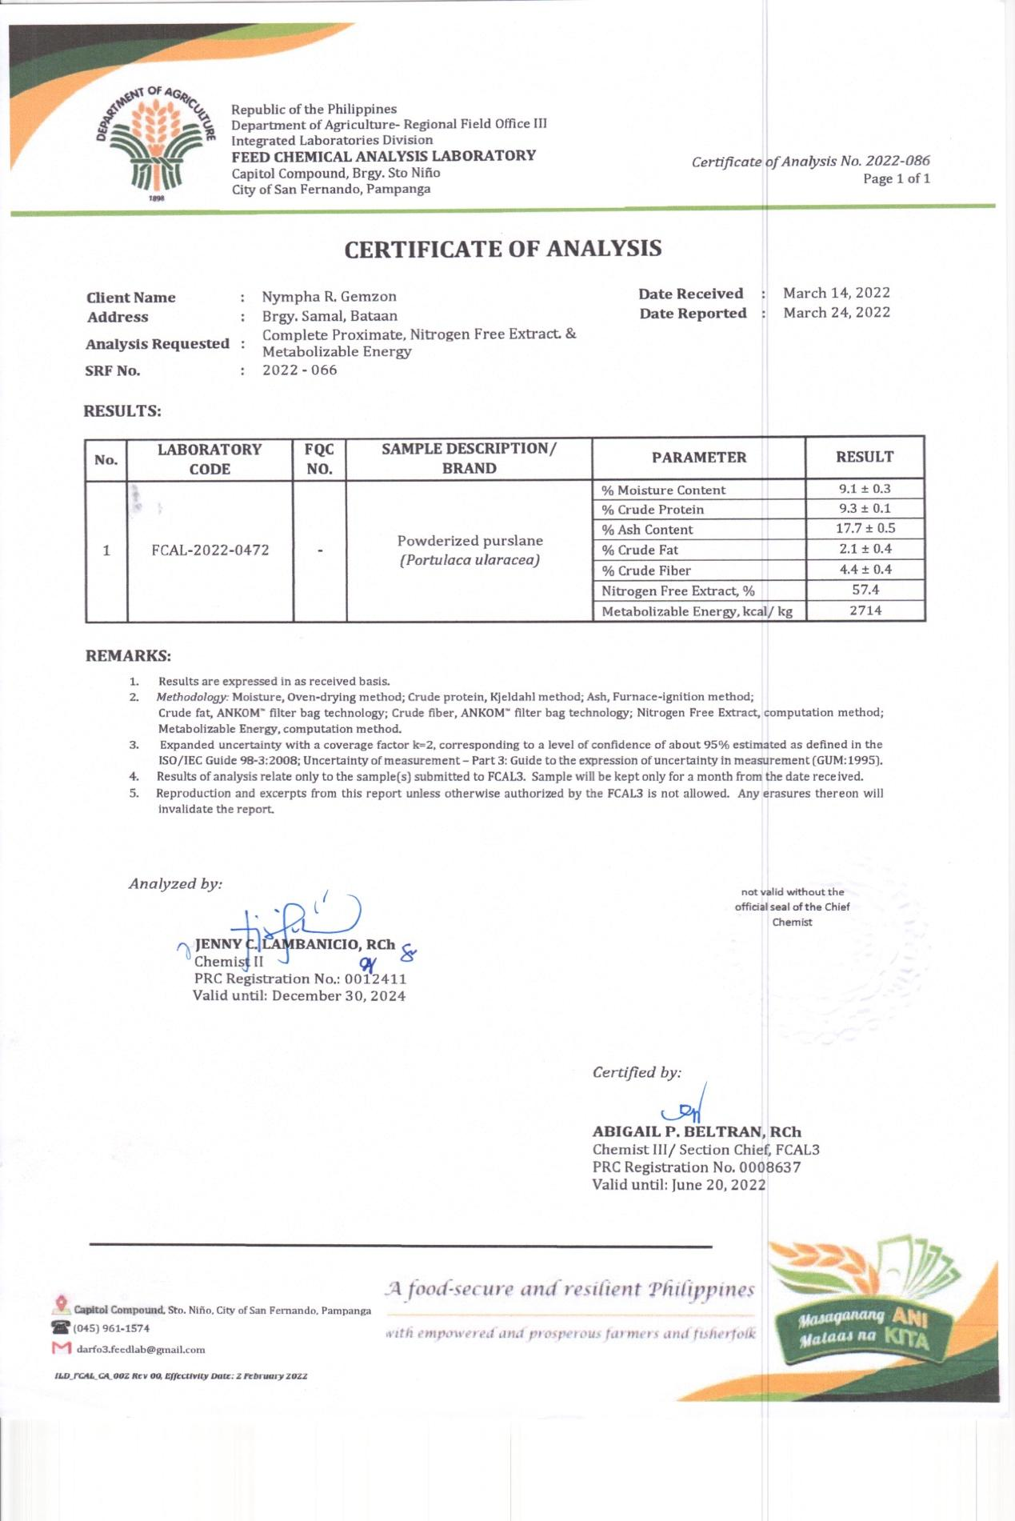



INSTITUTIONAL ANIMAL CARE AND USE COMMITTEE PAMPANGA STATE AGRICULTURAL UNIVERSITY
Magalang, Pampanga

NOTICE OF APPROVAL

Protocol No.: 023
Name of the Primary Investigator: Nympha R. Gemzon
Title of Proposed Study:
“Impact of Purslane (Portulaca oleracea) on rabbit (Oryctolagus cuniculus) performance and its significance for Organoleptic Evaluation”.
Date of Application: June 8, 2022
Date of Protocol Review Assessment: June 9, 2022
The project proposal with Protocol No.: 023 is approved for implementation. The principal investigator is advised to notify the committee once the project has started for the IACUC to schedule visits for monitoring.


Approved:

Cheryl C. Yalung, DVM Michael Angelo C. Nicdao, PhD
Member Member


Neil C. Tanquilut, DVM, PhD
Chairman

Prepared by:

Kimberly M. Peña
IACUC Secretary

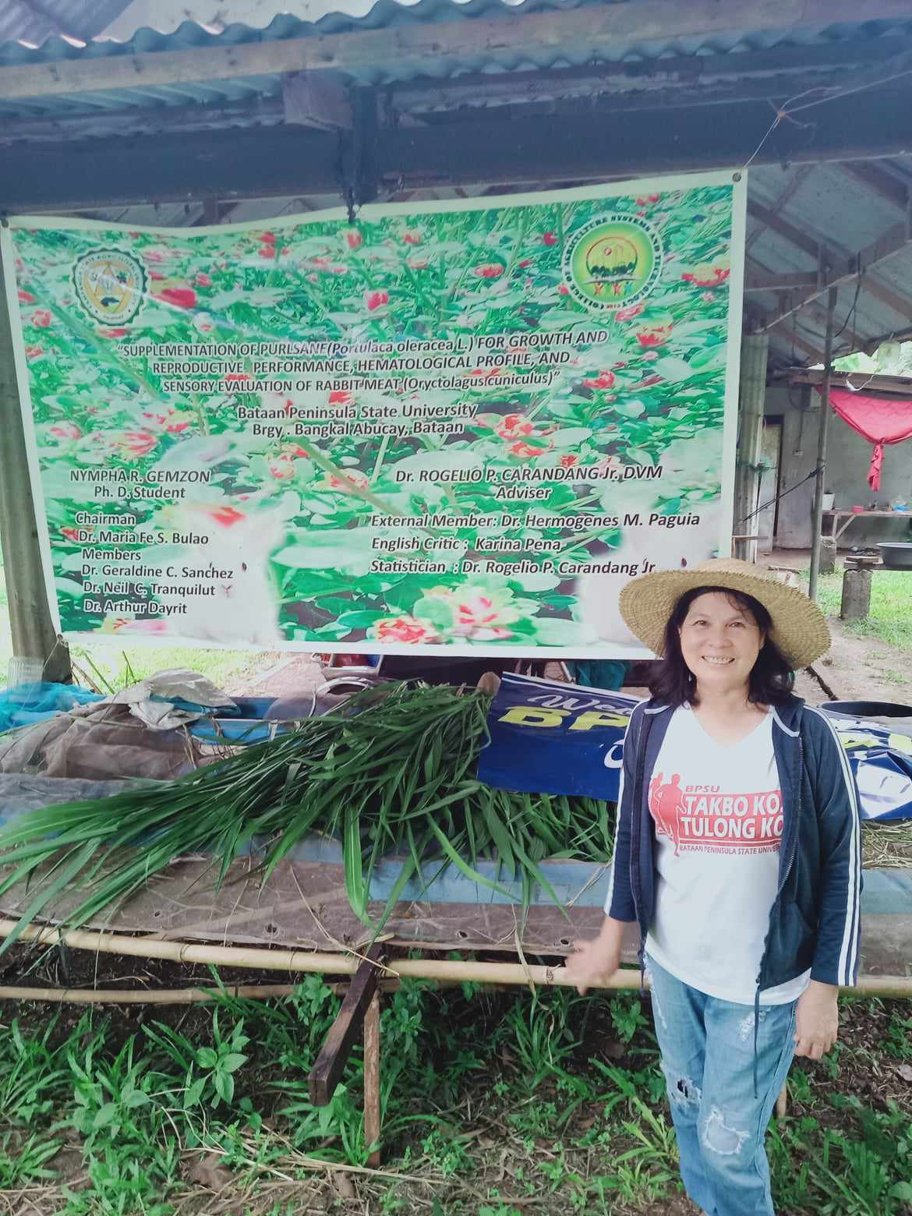
List of figures

The author at the front of her experimental study


The author with her purslane plants
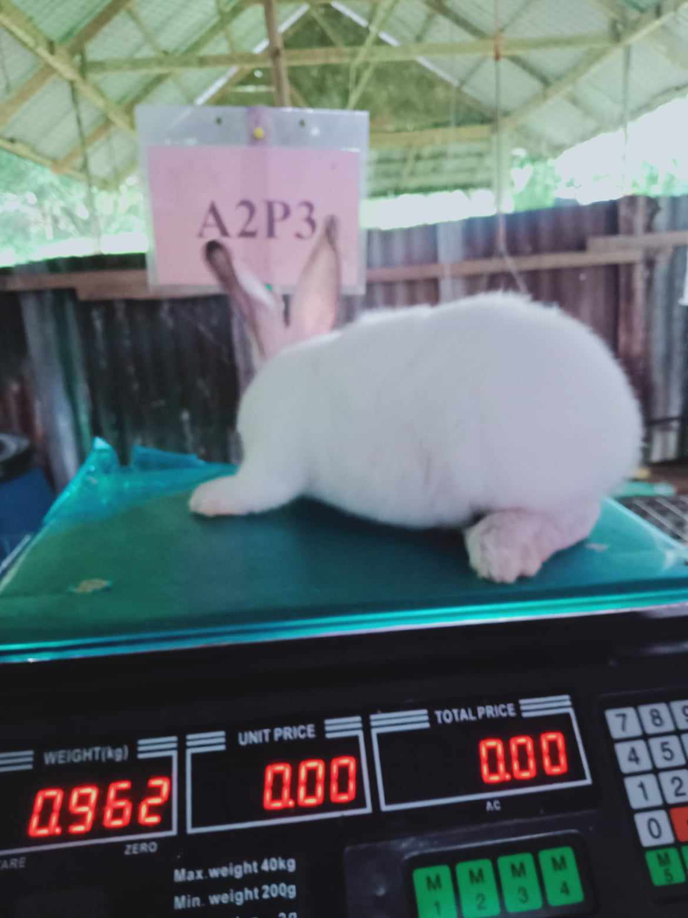 Weighed the final weight of Californian white rabbit

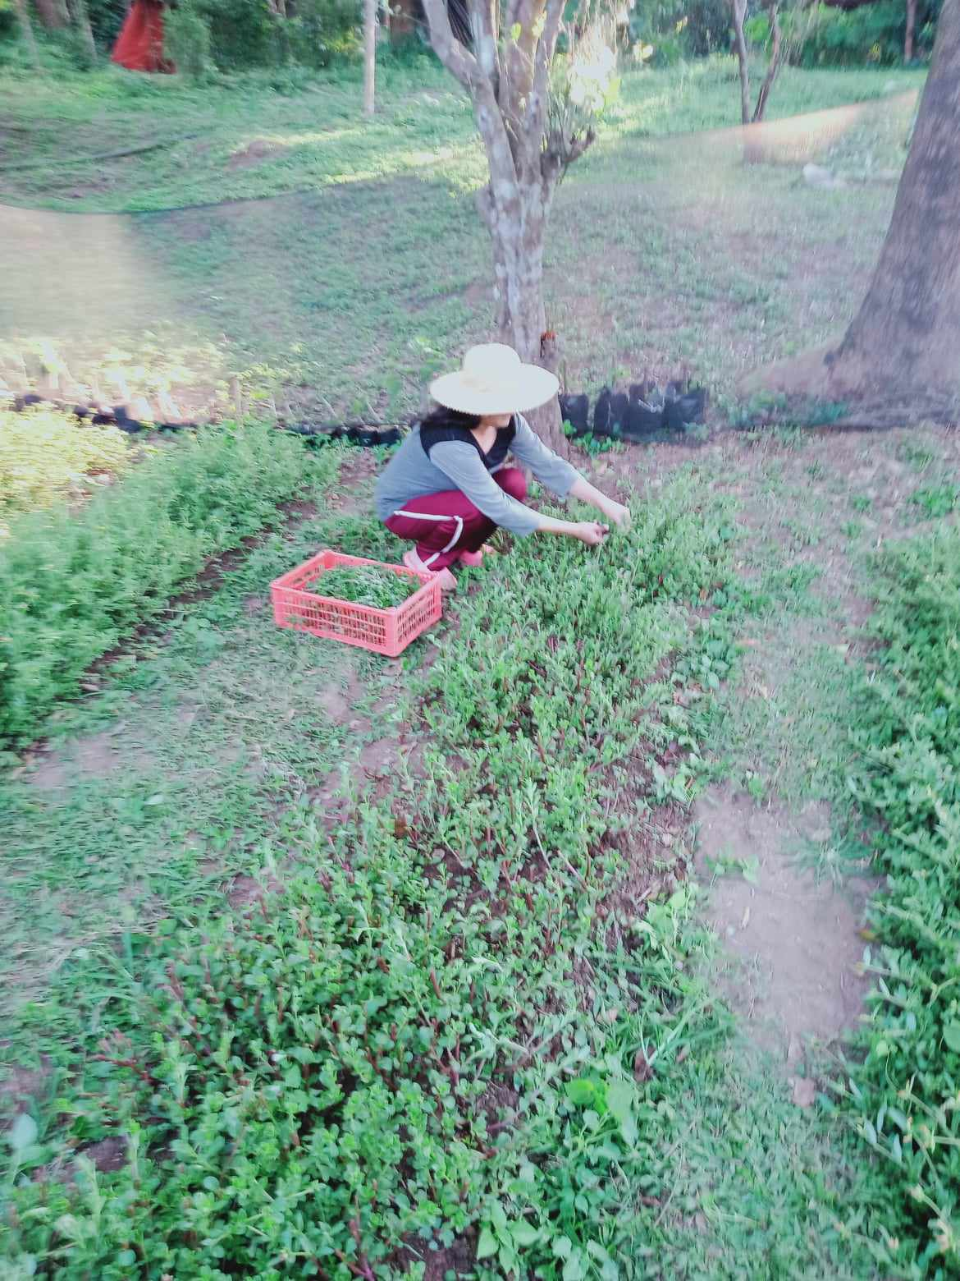
Harvested purslane plant for air drying preparation to be given to the experimental animals.
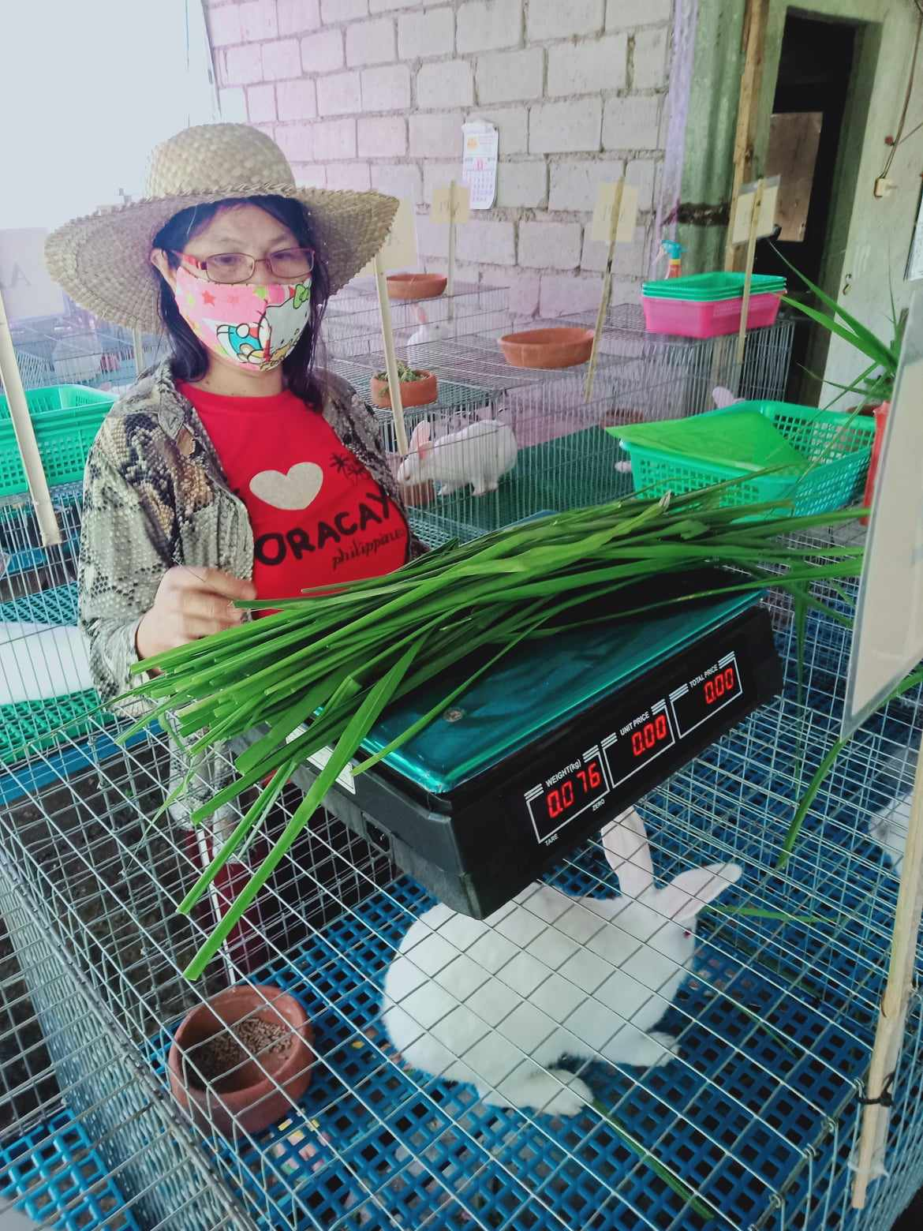
Weighed napier grasses to be given to the animals

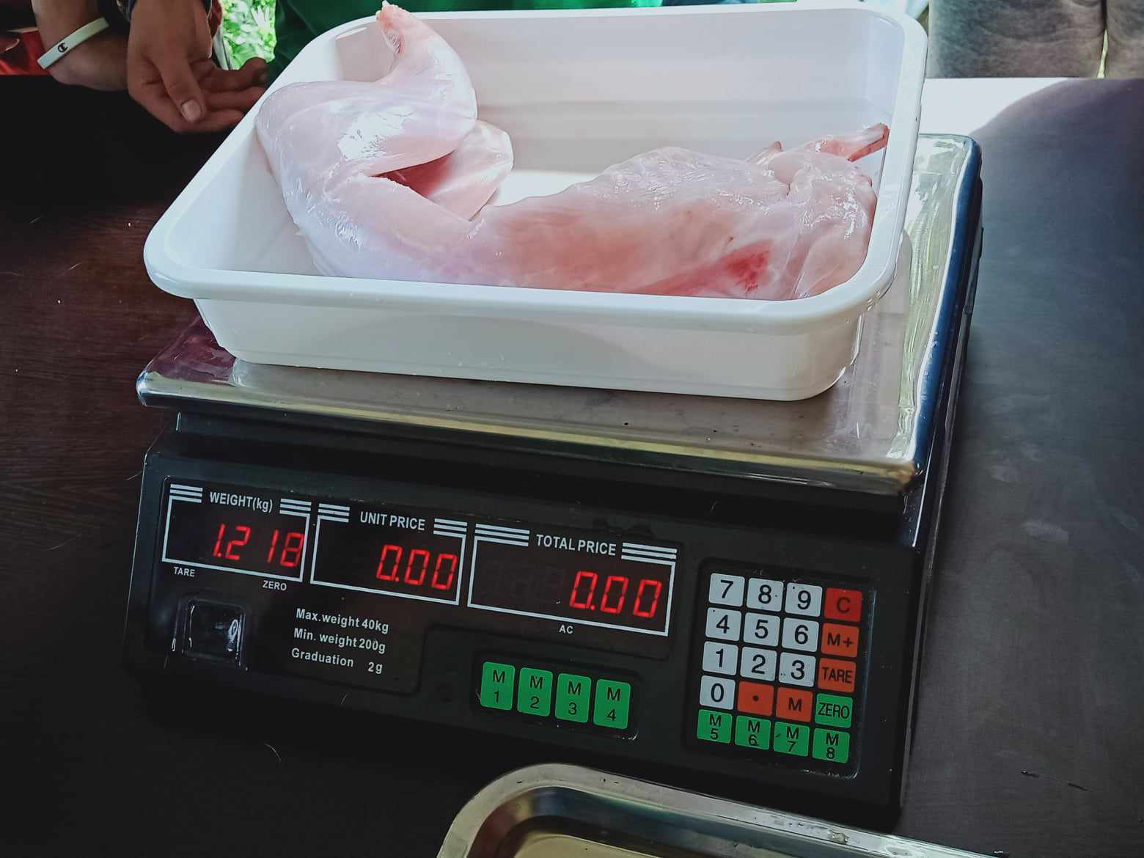
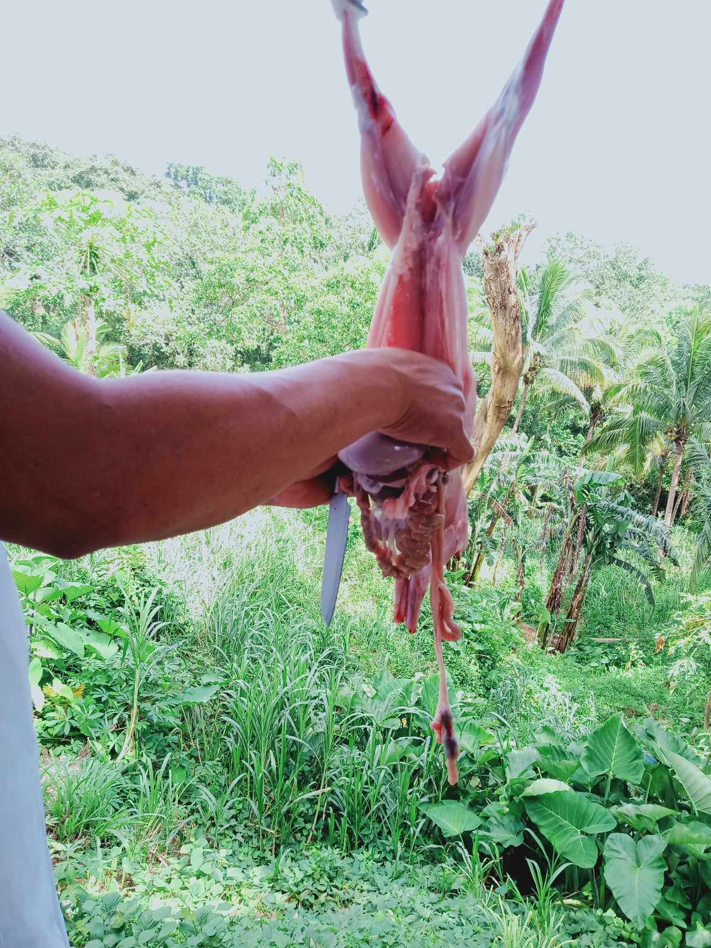

Slaughtered and weighed the dressing percentage of the carcass rabbit meat preparation for organoleptic assessment

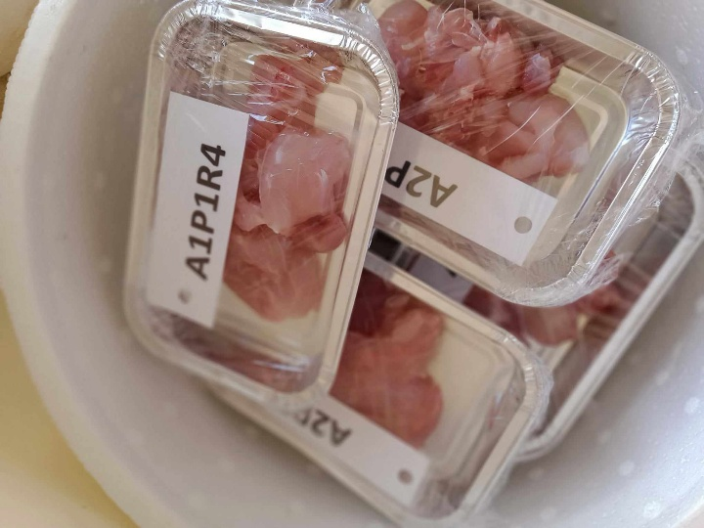

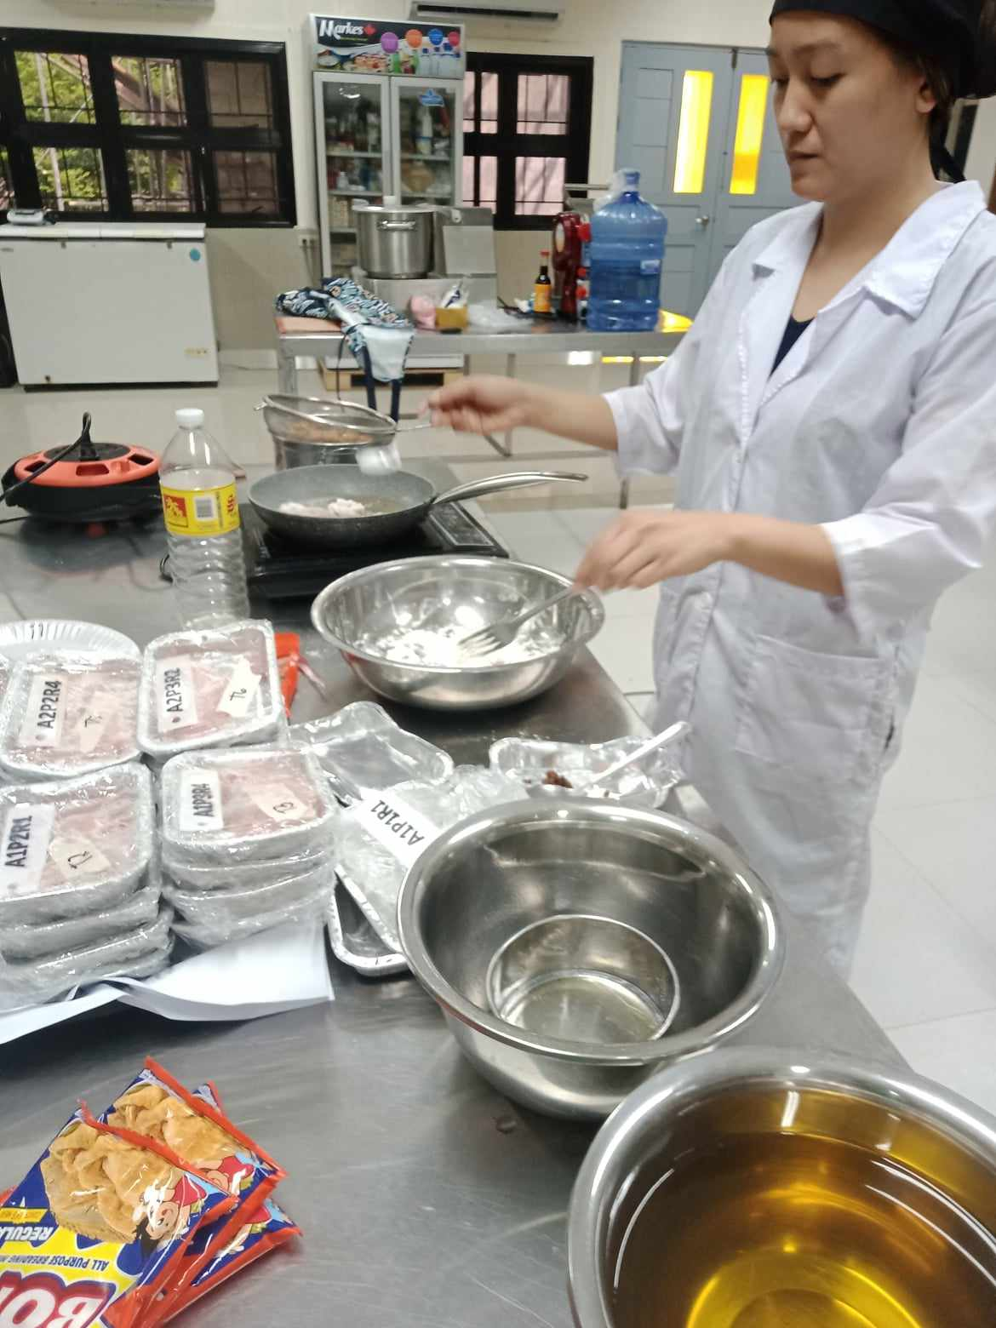 Preparation of lapan for organoleptic test at Central Luzon State University in Muῆos Nueva , Ecja .

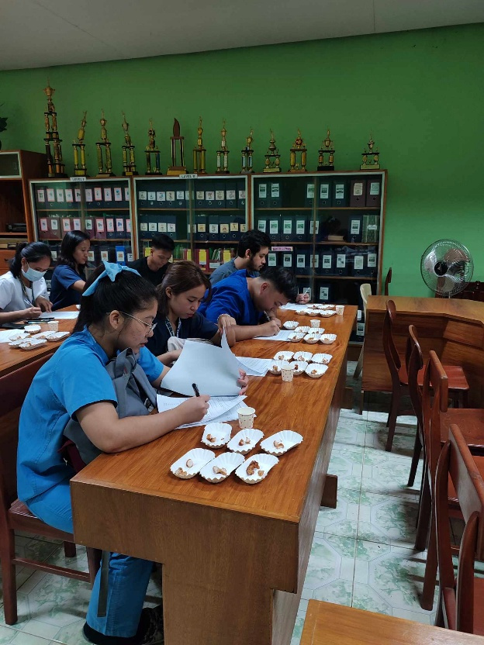
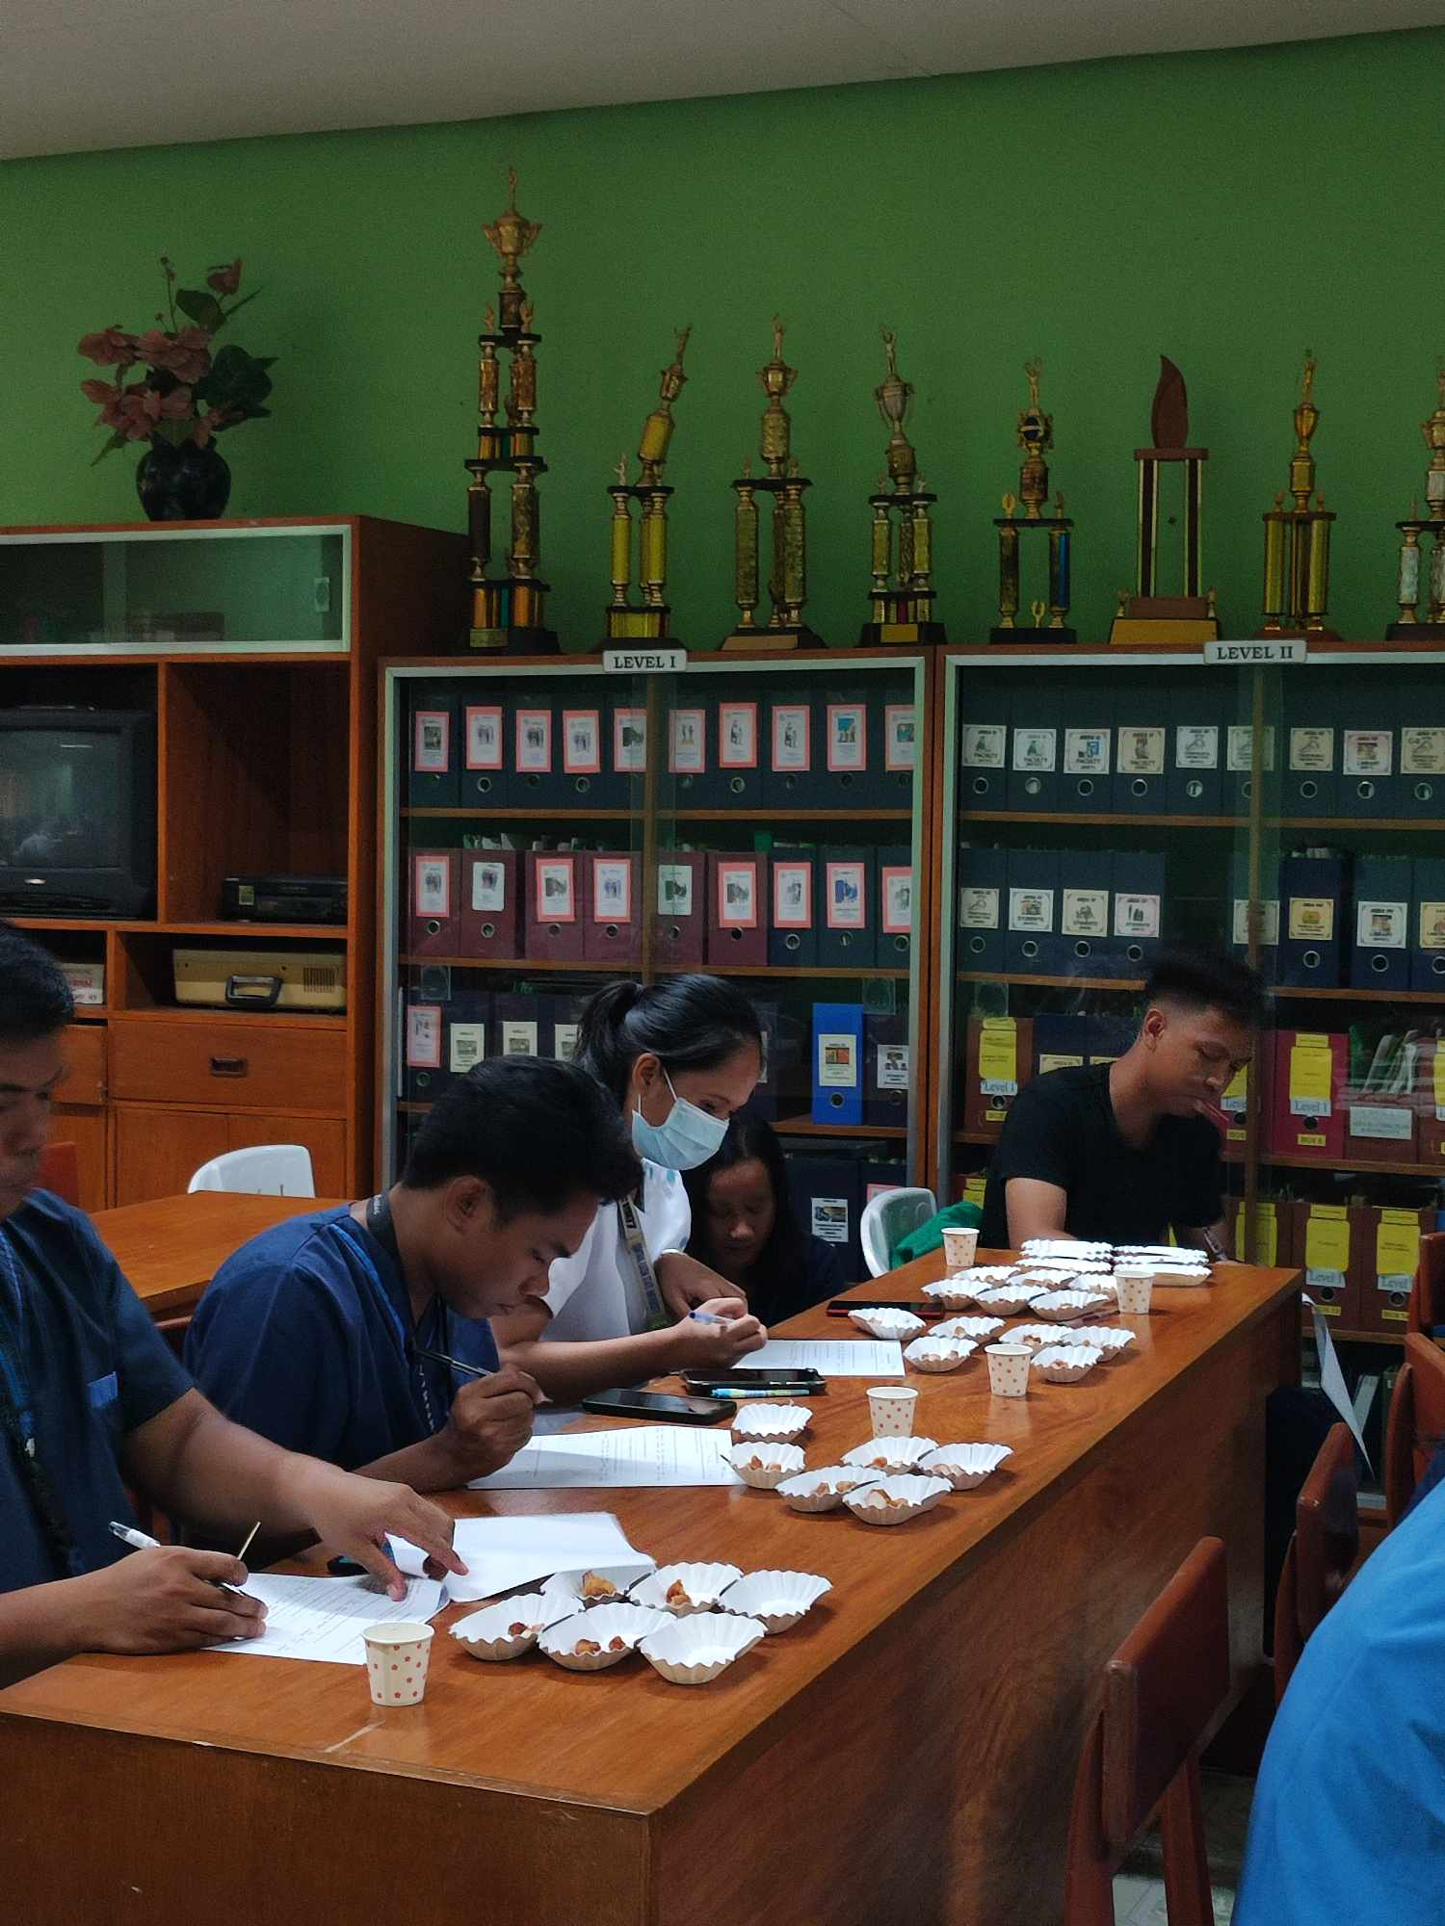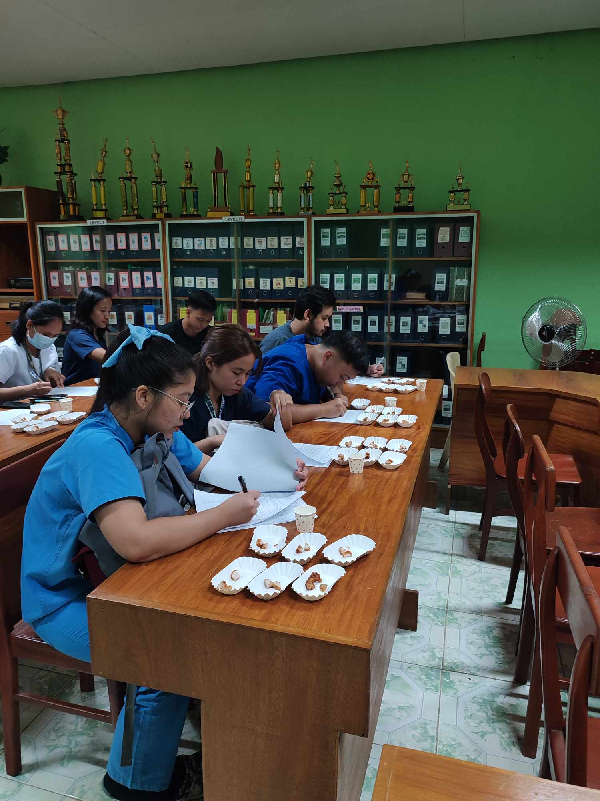

Panelist who evaluated the cooked lapan to determine its taste, texture , aroma , color juiceness, mouthfeel and after taste of the meat.

