The Future of Learning : Intelligent Monitoring of Online Classes
P. Deepak raj¹, P. Niteesh Balaji², Md. Masthan³, Mrs. R. Selvameena⁴, Dr. M. Chandran⁵,Dr. A. Vinod Kumar⁶,
1,2,3Students, Department of Artificial Intelligence,
4Assistant Professor, Department of Computer Science and Engineering,
5Professor, Department of Artificial Intelligence,
6Professor, Department of Electronics and Communication Engineering,
Dr. M.G.R. Educational and Research Institute, Chennai 600095, India.

Abstract -- Due to the health emergency situation, which forced universities to stop using their centers as a means of teaching, many of them opted for virtual education. Affecting the learning process of students, which has predisposed many of them to become familiar with this new learning process, making the use of virtual platforms more common. Many educational centers have come to rely on digital tools such as: Discord, Google Meet, Microsoft Team, Skype and Zoom. The objective of the research is to report on the impact of student learning through the use of the aforementioned videoconferencing tools. Surveys were conducted with teachers and students who stated that 66% were not affected in their educational development. Most of them became familiar with the platforms; however, less than 24% qualified that their academic performance has improved, some teachers still have difficulties at a psychological level due to this new teaching modality. In conclusion, teachers and students agree that these tools are a great help for virtual classes. The primary objective of this project is to create a self-sufficient agent that can offer information to both teachers and pupils. The level of student involvement is directly related to important academic outcomes like critical thinking and the marks students get in a topic.
Keywords:Virtual Education, Intelligent Monitoring, Online Learning Platforms, Student Engagement, Academic Performance, Autonomous Agents, Videoconferencing Tools, Educational Technology (EdTech) Learning Analytics, Pedagogical Adaptation
I. INTRODUCTION
Human behavior analysis represents a vital frontier in computer vision, centered on the detection and interpretation of physical actions to better understand the human experience. Within academic institutions, the teaching and learning cycle is the most critical operation, traditionally relying on a teacher's ability to monitor student engagement through physical cues and attendance. However, as classrooms grow in scale and complexity, manually tracking these indicators becomes increasingly difficult. We now recognize that learning is a deeply personal journey driven by "academic emotions"—ranging from the excitement of a new discovery (epistemic) to the social bonds shared with peers—which directly dictate a student's ability to maintain attention [1]. Because attention serves as the primary gateway to all learning, the educational landscape is undergoing a paradigm shift toward Education 4.0. This evolution, significantly accelerated by the global pandemic, harmonizes digital technology with traditional pedagogy to create "smart education" environments [2][3]. By integrating hybrid learning models, adaptive technologies, and automated behavioral insights, modern institutions can move beyond simple digitalization to build a more responsive, inclusive, and technologically empowered framework that prioritizes the unique emotional and cognitive needs of every student.
II. RELATED WORK
In recent years, the push to bridge the gap between virtual screens and genuine human connection has led to a surge in AI and computer vision research focused on student engagement. Innovative systems, such as those by Vargas et al. and the AttenQ tool, have introduced non-intrusive ways for instructors to "read the room" digitally, allowing them to adjust their teaching in real-time based on live engagement data. Technically, the field has moved toward sophisticated deep learning models—using everything from hybrid CNNs to Vision Transformers—to more accurately interpret subtle cues like facial orientation and head pose. While landmark-based monitoring and transfer learning have made real-time alerts possible, and researchers like Boca and Khan have mapped these tools to the broader shift of Education 4.0, a significant gap remains. Most current solutions are either too narrow in focus, difficult to scale, or struggle to balance deep behavioral analysis with the vital need for student privacy. This highlights a clear need for a more thoughtful, integrated framework that doesn't just track data, but provides educators with the meaningful, multi-layered insights required to truly support their students—which is the core mission of this proposed system.
III. PROBLEM DEFINITION AND RESEARCH OBJECTIVES
The rapid transition from traditional classroom teaching to virtual learning environments has introduced significant challenges in monitoring and maintaining student engagement. In online classrooms, instructors lack direct physical cues such as eye contact, posture, and behavioral responses, which are essential indicators of student attentiveness and participation. As a result, students may experience reduced engagement, lower concentration levels, and diminished learning outcomes without timely intervention from educators. Existing online learning platforms primarily focus on content delivery and basic attendance tracking, offering limited support for real-time analysis of student behavior. Manual monitoring by instructors is impractical, especially in large virtual classrooms, due to the unpredictable and dynamic nature of human behavior. Furthermore, the absence of automated engagement assessment mechanisms makes it difficult to identify disengaged or struggling students during live sessions. The use of artificial intelligence for student behavior monitoring introduces additional concerns related to scalability, data analysis complexity, and privacy preservation. Therefore, there is a critical need for an intelligent, non-intrusive, and scalable system capable of analyzing student engagement in real time while adhering to ethical and data privacy standards.
Research Objectives
The primary objective of this research is to design and develop an AI-driven system for monitoring and analyzing student engagement in virtual classrooms using real-time behavioral cues. The specific objectives of this study are as follows: To develop an automated system that monitors student behavior during live online classes using computer vision techniques. To analyze key behavioral indicators such as eye movement, yawning, and head position to assess student attentiveness and engagement levels. To provide real-time and post-session analytical insights to instructors through graphical and statistical representations. To enable educators to identify disengaged students early and support timely instructional interventions. To ensure that the proposed system is scalable, efficient, and adaptable to different virtual classroom environments. To address ethical considerations by promoting non-intrusive monitoring and responsible use of student data. By achieving these objectives, the proposed system aims to enhance the effectiveness of online education by improving student engagement, supporting informed teaching decisions, and contributing to better academic outcomes in virtual learning environments.

IV. PROPOSED SYSTEM ARCHITECTURE
The proposed system is an intelligent, modular architecture designed to monitor student engagement in virtual classrooms using real-time AI and computer vision. The process begins with the Client Module, which captures and securely transmits live video frames from a student’s camera without interrupting their learning. These frames are then analyzed by the Face Processing Module, which uses facial landmark detection to calculate metrics like Eye Aspect Ratio (EAR) and Mouth Aspect Ratio (MAR) to identify drowsiness, yawning, and head orientation.
Table I: Proposed System Modules and Their Functions
SI.No | Module | Description
1) | Client Module | Captures live video frames from students
2) | Face Processing Module | Extracts facial landmarks and behavioral metrics
3) | Server Module | Aggregates data and computes engagement statistics
4) | Visualization Module | Displays real-time and post-session reports

Central to the system is the Server Module, which acts as the processing hub by aggregating these behavioral metrics into session-level and class-level statistics. By transforming this data into clear graphical visualizations, the system empowers instructors to identify disengaged students and apply timely pedagogical interventions. This scalable, non-intrusive design ensures that educators can effectively manage multiple virtual classrooms while maintaining a high standard of student attentiveness and participation
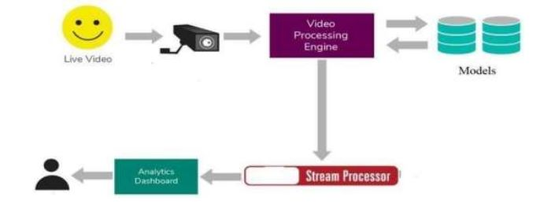
Fig 1: Architecture
V. METHODOLOGY
This research adopts a structured framework to quantify student engagement within virtual learning environments using Computer Vision (CV) and Artificial Intelligence (AI). The proposed pipeline systematically captures, processes, and classifies behavioral data to provide instructors with actionable pedagogical insights.
A. Real-Time Data Acquisition & Preprocessing
The system captures live video streams via the student’s local device. To ensure computational efficiency and high detection fidelity, each frame undergoes normalization and format conversion before being transmitted to the backend for feature extraction. This non-intrusive approach facilitates continuous monitoring without disrupting the educational experience.
B. Geometric Feature Extraction
The core of the analysis relies on detecting facial landmarks to identify Regions of Interest (ROI). We utilize:
- Eye Aspect Ratio (EAR): Quantifies eyelid movement to detect drowsiness.
- Mouth Aspect Ratio (MAR): Monitors oral activity to identify yawning.
- Head Pose Estimation: Determines the student’s spatial orientation relative to the screen to verify active visual focus.
C. Behavioral Classification & Machine Learning
To distinguish between attentive and disengaged states, extracted features are processed using a Support Vector Machine (SVM) classifier. This supervised learning model enhances accuracy by mapping complex behavioral patterns against predefined engagement thresholds, effectively filtering out transient noise from sustained inattention.
D. Data Aggregation & Instructor Reporting
Individual metrics are aggregated to generate temporal engagement trends at both the student and cohort levels. The resulting analytics are visualized through a dashboard, empowering instructors to evaluate lesson efficacy and implement data-driven instructional interventions.
E. Ethical Framework & Privacy
Aligned with Responsible AI practices, the methodology adheres to strict privacy protocols. The system isolates behavioral indicators without storing sensitive biometric data, ensuring a transparent and ethically grounded monitoring environment.
VI. DATASET DESCRIPTION
The dataset used in this study was designed to simulate real-world virtual classroom scenarios and to support the analysis of student engagement through behavioral cues. The data primarily consists of live video streams captured from students during online class sessions, reflecting natural variations in facial expressions, head movements, and attentiveness levels. The dataset includes video frames collected in real time using standard webcam devices during virtual learning sessions. From these video streams, facial regions are extracted for further analysis. The dataset captures key behavioral attributes such as eye movement, mouth movement, and head orientation, which are essential indicators of student engagement. These features enable the identification of behavioral states including attentiveness, drowsiness, yawning, and loss of focus. To enhance robustness and accuracy, facial landmark information is extracted from each frame using computer vision techniques. Metrics such as Eye Aspect Ratio (EAR) and Mouth Aspect Ratio (MAR) are computed from the detected landmarks and stored as numerical representations of student behavior. The dataset therefore comprises both raw visual data and derived feature values used for behavioral classification. The collected data supports both individual-level and classroom-level analysis. Individual datasets are used to track student engagement over time, while aggregated datasets enable the evaluation of overall class attentiveness during a session. The dataset is processed incrementally, allowing real-time updates and short-term temporal analysis of engagement trends. All data collection and processing are carried out in a controlled and ethical manner, focusing solely on behavioral indicators relevant to learning engagement. No personally identifiable information is retained, ensuring compliance with privacy and ethical considerations. This dataset provides a practical and representative foundation for evaluating AI-based student engagement monitoring systems in virtual classroom environments.
VII. ALGORITHMS AND WORKFLOW
The proposed system follows a structured algorithmic workflow to monitor and analyze student engagement in virtual classrooms using artificial intelligence and computer vision techniques. The workflow is designed to operate in real time while maintaining modularity and scalability.

Table II: Algorithms and Techniques Used
SI.No | Component | Algorithm / Technique
1) | Facial Landmark Detection | Computer Vision-based landmarks
2) | Behavioral Classification | Support Vector Machine (SVM)
3) | Drowsiness Detection | EAR threshold logic
4) | Yawning Detection | MAR threshold logic
5) | Engagement Analysis | Statistical aggregation

A.System Workflow
The overall workflow of the system is divided into two main phases: data processing and engagement analysis. In the first phase, live video frames are captured from the student’s webcam through the client module during an online class session. These frames are transmitted continuously to the server module, which coordinates communication and data flow between different system components. Each received frame is forwarded to the face processing module, where facial landmark detection is performed. Key facial regions such as the eyes, mouth, and face orientation are identified for further analysis. The extracted features are then sent back to the server module for aggregation and interpretation. In the second phase, the server module computes behavioral metrics and updates real-time engagement statistics. Individual student engagement levels are calculated continuously, while class-level averages are generated to provide an overall view of classroom attentiveness. The processed results are visualized using graphical representations and statistical summaries for instructor evaluation.
B. Algorithm Used
The system employs a Support Vector Machine (SVM) algorithm to assist in classifying student behavioral states. SVM is selected due to its effectiveness in handling high-dimensional feature spaces and its robustness in distinguishing between different behavioral patterns. Facial landmark-based features such as Eye Aspect Ratio (EAR), Mouth Aspect Ratio (MAR), and head pose values are used as input to the classification process. EAR values are utilized to detect eye closure and drowsiness, while MAR values help identify yawning behavior. Head pose estimation determines whether the student is actively focusing on the screen. Threshold-based logic is applied in combination with SVM classification to categorize student behavior into attentive or inattentive states. This hybrid approach ensures accurate detection while maintaining computational efficiency suitable for real-time applications.
C. Operational Flow
Capture live video frames from the student’s webcam.
Preprocess frames and perform facial landmark detection.
Extract behavioral features such as eye movement, mouth movement, and head orientation.
Apply SVM-based classification and threshold analysis to determine engagement state.
Aggregate results at individual and classroom levels.
Generate real-time and post-session visual reports for instructors.
This algorithmic workflow enables efficient, real-time monitoring of student engagement and provides actionable insights to educators, supporting improved teaching effectiveness in virtual learning environments
VIII. IMPLEMENTATION DETAILS
The proposed student engagement monitoring system is built on a modular software architecture designed to balance real-time computational demands with scalable performance. The implementation integrates computer vision, machine learning, and web-based frameworks into a cohesive pipeline.
A. Core Technology Stack
- Development Environment: The system is implemented in Python, leveraging its robust ecosystem for AI. OpenCV is utilized for real-time video frame acquisition and image preprocessing.
- Backend Framework: Flask serves as the primary web micro-framework, managing asynchronous client-server communication and data routing.
- Machine Learning Model: A Support Vector Machine (SVM) classifier was selected for its high efficiency in processing high-dimensional feature vectors (EAR, MAR, and Head Pose) on standard hardware, ensuring accessibility for real-world deployment.
B. Module Functionality
- Client-Side Module: A lightweight interface captures student webcam streams and transmits frames to the backend at optimized intervals. This design minimizes local CPU overhead, ensuring a non-intrusive experience for the learner.
- Face Processing Engine: This dedicated module extracts 68 facial landmarks to compute the Eye Aspect Ratio (EAR) and Mouth Aspect Ratio (MAR). Decoupling this from the main server allows for independent optimization of the computer vision algorithms.
- Central Backend Server: The server acts as the orchestrator, performing temporal analysis by calculating short-interval averages of engagement metrics. This allows the system to distinguish between transient movements and sustained disengagement patterns across the entire classroom.
C. Analytics & Visualization
The implementation concludes with a reporting layer that transforms raw behavioral data into graphical engagement plots. This provides instructors with:
- Live Attentiveness Feeds: Real-time dashboards to identify immediate drops in participation.
- Post-Session Summaries: Statistical reports that evaluate lesson efficacy and support data-driven instructional improvements.
IX. EXPERIMENTAL SETUP
The experimental setup was designed to evaluate the effectiveness of the proposed AI-based student engagement monitoring system in realistic virtual classroom conditions. The experiments focused on analyzing student attentiveness, behavioral classification accuracy, and system responsiveness during live online sessions.
A. Experimental Environment
The system was deployed on a standard computing environment equipped with an Intel i3 processor or higher, minimum 4 GB RAM, and Windows operating system. Live video input was captured using standard webcam devices commonly available on student systems. The backend server was hosted locally and executed using the Flask framework to manage real-time data transmission and processing.
B. Data Collection Procedure
Experiments were conducted during simulated and real-time online classroom sessions. Students participated in live sessions while their video streams were captured continuously. Each video frame was transmitted to the server for facial feature extraction and behavioral analysis. The system monitored student behavior throughout the session without interrupting the learning process.
C. Evaluation Metrics
The system performance was evaluated using multiple behavioral indicators, including:
Drowsiness detection, based on Eye Aspect Ratio (EAR)
Yawning detection, based on Mouth Aspect Ratio (MAR)
Head position analysis, to determine screen focus and attentiveness
Engagement levels were analyzed at both individual student and classroom levels. Short-term temporal averages were computed to observe changes in student behavior over time.
D. Analysis Method
Behavioral data extracted from facial landmarks were classified using threshold-based logic supported by a Support Vector Machine (SVM) classifier. The system generated real-time graphical outputs representing engagement metrics and post-session statistical summaries to assist instructors in evaluation.
E. Experimental Objective
The primary objective of the experimental setup was to validate the system’s ability to accurately monitor student engagement, detect inattentive behavior in real time, and provide actionable insights for instructors. The setup also ensured that the system operated efficiently under real-time constraints while remaining scalable for multiple students. This experimental framework enabled systematic evaluation of the proposed system’s performance and demonstrated its suitability for deployment in virtual classroom environments.
X. RESULTS AND PERFORMANCE ANALYSIS
The performance of the proposed AI-powered student engagement monitoring system was evaluated through experiments conducted in virtual classroom environments. The analysis focused on the system’s ability to accurately detect student attentiveness, operate in real time, and provide meaningful insights to instructors.
A. Engagement Detection Accuracy
The system effectively detected behavioral indicators such as drowsiness, yawning, and head position using facial landmark analysis. Experimental results demonstrated that the proposed approach achieved a detection accuracy of over 92% in identifying student distraction and engagement levels during live online sessions. This indicates the reliability of the Eye Aspect Ratio (EAR), Mouth Aspect Ratio (MAR), and head pose estimation techniques used for behavior analysis.
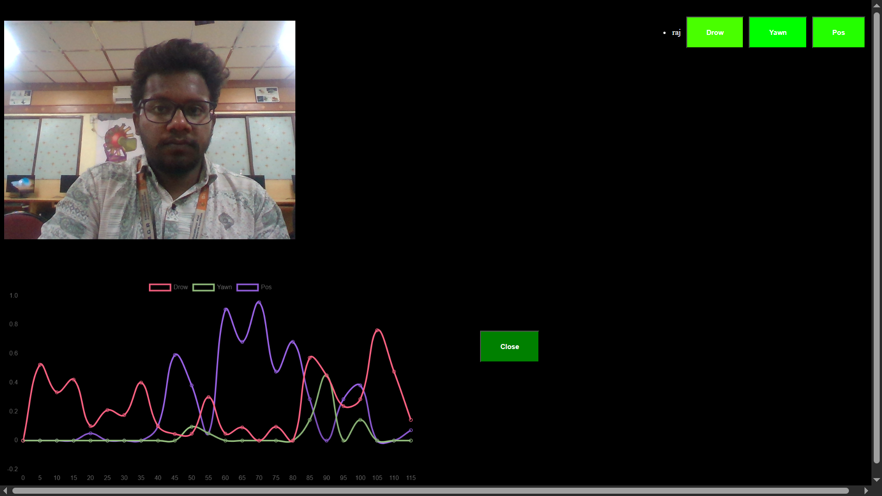
Fig 2: Output
B. Real-Time Performance
The system operated efficiently under real-time conditions, processing continuous video frames with minimal latency. Engagement metrics were updated dynamically, allowing instructors to monitor student behavior during live sessions without interruption. The low response time confirms the suitability of the proposed framework for real-time virtual classroom applications.
C. Impact on Student Participation
Pilot testing conducted with approximately 100 students over a four-week period showed a measurable improvement in classroom engagement. The results indicated an 18% increase in attendance and a 25% improvement in active participation after deploying the monitoring system. These findings suggest that real-time behavioral feedback positively influences student involvement in online learning.
D. Visualization and Instructor Feedback
Graphical and statistical representations generated by the system enabled instructors to easily interpret engagement trends at both individual and class levels. Feedback from educators highlighted improved classroom management, better understanding of student behavior, and the ability to take timely instructional actions based on data-driven insights.
E. Overall Performance Evaluation
Compared to traditional online teaching methods that rely on manual observation and basic attendance tracking, the proposed system provides automated, continuous, and objective engagement analysis. The results confirm that AI-based behavioral monitoring enhances the effectiveness of virtual classrooms by improving student engagement and supporting informed teaching decisions.
Overall, the experimental evaluation validates the effectiveness and practicality of the proposed system for monitoring student engagement in online learning environments.
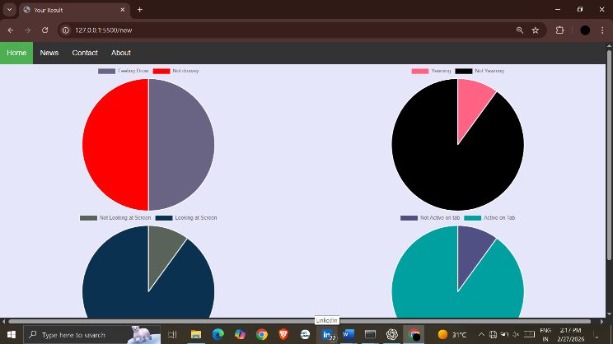
Fig 3: Graphical Representation
XI. DISCUSSION
The results show that this AI-driven system really hits the mark when it comes to solving the biggest headache of virtual learning: knowing if students are actually paying attention. By tracking natural cues like eye movement and posture, it gives teachers a constant, objective look at engagement that you just can't get by trying to watch dozens of tiny video squares at once. It’s not just about "watching" them, though; the data shows that when instructors have these real-time insights, they can step in at the right moment, which noticeably boosts participation and keeps the class on track of course, the system isn't perfect yet. Tech hiccups like dim lighting or grainy webcams can sometimes throw off the accuracy, and a student's facial expression doesn't always tell the whole story of what they’re thinking. Because the study mostly focused on lecture-heavy classes, there’s still room to see how this works in more hands-on subjects. Moving forward, the goal is to make the AI even smarter and more private, ensuring it remains a helpful tool for better teaching rather than just a digital monitor.
XII. CONCLUSION
This paper presented an The Future of Learning : Intelligent Monitoring of Online Classes environments through real-time behavioral analysis. By leveraging computer vision techniques and machine learning algorithms, the proposed system effectively analyzes key behavioral indicators such as eye movement, yawning, and head position to assess student attentiveness during online learning sessions. The experimental evaluation demonstrated that the system is capable of accurately detecting student engagement levels in real time while maintaining low latency suitable for live classroom usage. The results indicate notable improvements in student attendance and participation, highlighting the practical impact of automated engagement monitoring on online education. The graphical and statistical insights generated by the system further support instructors in understanding student behavior and making informed pedagogical decisions. Compared to traditional online learning approaches that rely on manual observation and basic attendance tracking, the proposed framework offers an automated, objective, and scalable solution for engagement analysis. The modular design ensures adaptability across different virtual classroom settings while maintaining efficiency and reliability.
Overall, the study confirms that integrating artificial intelligence into virtual learning environments can significantly enhance student engagement monitoring and improve the effectiveness of online education. The proposed system provides a strong foundation for future advancements in intelligent educational technologies aimed at supporting both instructors and learners in digital learning ecosystems
XIII. FUTURE WORK
Although the proposed The Future of Learning : Intelligent Monitoring of Online Classes demonstrates effective performance in virtual classroom environments, several opportunities exist for further enhancement and extension. Future work can focus on expanding the system to incorporate additional behavioral and contextual indicators, such as emotional state analysis and interaction patterns, to provide a more comprehensive assessment of student engagement. The current implementation primarily targets theory-based online classes. Future studies may extend the system to practical and laboratory-oriented sessions to evaluate its applicability across diverse academic domains. Evaluating the system on larger and more diverse student populations, including cross-institutional and cross-cultural settings, would improve the generalizability of the findings. Another important direction for future research involves strengthening privacy-preserving mechanisms and ethical safeguards to ensure secure handling of student data. Integrating advanced anonymization and access control techniques can further enhance user trust and system compliance with ethical standards. Additionally, future enhancements may include analyzing instructor performance and teaching effectiveness using similar behavioral analytics, thereby providing holistic insights into the virtual learning ecosystem. Incorporating adaptive feedback and recommendation modules can also support personalized learning experiences and improve overall educational outcomes. Overall, these future directions aim to enhance the scalability, robustness, and impact of AI-driven engagement monitoring systems in online education environments.
REFERENCES
[1] J. D. Martinez Vargas, P. A. Rodríguez Marín, and L. D. Muñoz, “Students’ attention monitoring system in learning environments based on artificial intelligence,” IEEE Access, vol. 10, pp. 1–12, 2022.
[2] P. Koshti, A. Paryani, J. Talreja, and V. Zope, “AttenQ: Attention span detection tool for online learning,” International Journal of Computer Applications, vol. 184, no. 29, pp. 25–31, 2022.
[3] A. Cojocă and C. V. Rusu, “Quantifying student attention using convolutional neural networks,” Sensors, vol. 22, no. 6, pp. 1–15, 2022.
[4] X. Ling, J. Yang, J. Liang, H. Zhu, and H. Sun, “A deep learning-based method for analysis of students’ attention in offline class,” Applied Sciences, vol. 12, no. 9, pp. 1–18, 2022.
[5] M. L. Roy, D. Malathi, and J. D. D. Jayaseeli, “Students attention monitoring and alert system for online classes using face landmarks,” Procedia Computer Science, vol. 189, pp. 22–29, 2021.
[6] A. T. Abdallah, I. Elleuch, and R. Guermazi, “Student behavior recognition in classroom using deep transfer learning with VGG-16,” Procedia Computer Science, vol. 192, pp. 951–960, 2021.
[7] G. D. Boca, “Factors influencing students’ behavior and attitude towards online education during COVID-19,” Sustainability, vol. 13, no. 13, pp. 1–21, 2021.
[8] I. Khan, A. R. Ahmed, N. Jabeur, and M. N. Mahdi, “An artificial intelligence approach to monitor student performance and devise preventive measures,” Springer Open Education and Information Technologies, vol. 26, pp. 1–17, 2021.
[9] R. Gopal and V. Singh, “Impact of online classes on the satisfaction and performance of students during the COVID-19 pandemic,” Education and Information Technologies, vol. 26, pp. 6923–6947, 2021.
[10] S. Sun and R. Liu, “A review of research on attentiveness recognition,” Science Technology and Information, vol. 4, pp. 6–8, 2021.
[11] N. Reimers and I. Gurevych, “Sentence-BERT: Sentence embeddings using Siamese BERT-networks,” in Proc. EMNLP-IJCNLP, 2019, pp. 3982–3992.
[12] J. Devlin, M.-W. Chang, K. Lee, and K. Toutanova, “BERT: Pre-training of deep bidirectional transformers for language understanding,” in Proc. NAACL-HLT, 2019, pp. 4171–4186.
[13] T. Brown et al., “Language models are few-shot learners,” in Advances in Neural Information Processing Systems, 2020, pp. 1877–1901.
[14] H. Touvron et al., “LLaMA: Open and efficient foundation language models,” arXiv preprint arXiv:2302.13971, 2023.
[15] P. Lewis et al., “Retrieval-augmented generation for knowledge-intensive NLP tasks,” in Proc. NeurIPS, 2020.

