A Qualitative Study on the Lived Experiences, Hair-Esteem and Motivations of Textured-Hair Women in India Who Follow Natural Hair-Enhancing Routines
Abstract
Textured-hair women are well researched upon in the African American Community. While existing literature focused more on the Natural Hair Movement as a result of racial discrimination faced by these women, very little to no research has been done on textured hair women in other parts of the world. Additionally, with the popularisation of the Curly Girl Method introduced by Lorraine Massey, many women all over the world have started to embrace their natural hair texture. This study aims to find the lived experiences of such women in India who have learned to embrace their hair texture, and find out their various motivations regarding doing so. It also aims to understand the hair-esteem of such women, and the various social aspects surrounding the construction of ideologies related to textured hair. Findings suggest that women have positive feelings after following natural hair-enhancing routines, reporting feelings such as improved confidence.
Keywords: Curly Girl Method, Hair-Esteem, Textured-Hair, Curly Hair
Author's information: Elizabeth Mary Ginzy
elizabethmginzy@gmail.com
Introduction
Provided that head hair is a part of the human body and that it plays an important role in protecting our head from harmful sun rays (Parisi, 2009), it is not a far-fetched concept that it also contributes to a person’s overall physical appearance. The Natural Hair Movement in the United States of America empowered black women and encouraged them to wear their hair in its natural form, without using artificial methods of styling that would damage their hair health in the long run, such as perms and hair relaxing. This movement held deep meanings for the African-American community, as it was not just about embracing their hair texture, but about fighting back for their human rights, set in the backdrop and history of the slavery system, racism and social discrimination that was present in the United States (White, 2005). The decision to wear their hair naturally would thus have a deeper meaning of reclaiming self-identity, that is not tainted and defined by the society around them, as having Eurocentric features (light skin, straight hair) would mean that they would be higher in the social ladder (King et. al., 2013; White, 2005; Henderson, 2015).
In the early 2000s, Lorraine Massey released a book named Curly Girl: The Handbook, where she underlined the various differences between straight hair and curly hair, and gave a clear understanding about how curly hair needs to be taken care of. This was not necessarily for the African American community, but for women in general who have textured hair. Textured hair, as I describe later, is hair that is simply not straight. Many women grew up not knowing how to take care of their textured hair because it was very different and much more complex than taking care of straight hair, due to which, many women with textured hair would resort to straightening their hair, which could be permanent (such as relaxing) or temporary (using store-bought straighteners). As a result, women with textured hair would have issues with their hair-health, and would have a deep seated dissatisfaction with their natural hair texture. In this backdrop, the Curly Girl Method by Lorraine got popularised, especially after the 2010s, during which there was a trend to go natural and embrace one's natural curls. This was also accompanied by women who would come to ‘realise’ that their hair was actually curly all this while. This is an important distinction to note, as the Natural Hair Movement was focused on the African-American women alone, who ethnically have hair type that is ranging from 3a-4c, which is coily and kinky in nature. Their hair type has a more stubborn texture than type 2-3 waves and curls. This suggests that their hair texture would stand out even without much styling as per the rules given in the Curly Girl Method, using water and hair creams, for example. Therefore, one wouldn't have a hard time to figure out that they had curly hair, just by observation.
Figure 1
Hair types
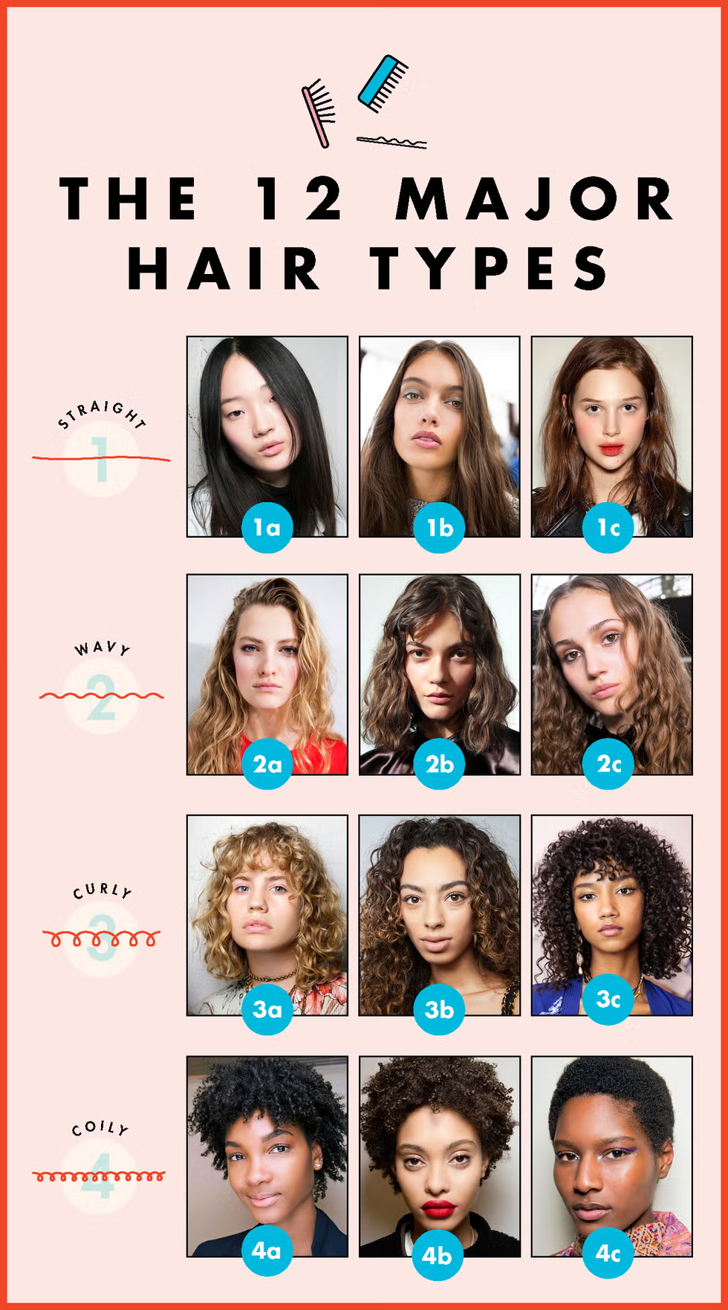
Note. From Sanchi Oberoi on Cosmopolitan, in the article written by Chloe Metzeger, 2021.
Emilie Schwarz (2022), highlights this concept of ‘discovery of curly hair’ in her study, which is especially more common in White women compared to Black Women. She also underlines how the Whites are seen as ‘race-neutral’, an interesting idea put forth, as textured hair is seen as ‘different’ from the mainstream, where methods of taking care of hair have mostly been suited to straight, Caucasian Hair.
The latest trends of embracing curls also came with discovery of their texture, because it was not restricted to the African American community alone, but to all women who have textured hair, due to social media (Tik Tok, Instagram, Youtube, etc). This would therefore include women with wavy and curly hair types as well, ranging from type 2a-3c. This is also because prior to the popularisation of the Curly Girl Method, women would resort to combing their hair dry as an essential component of their hair care, which is one of the ways that one's natural hair texture is hidden, because combing textured hair would cause it to be frizzy. Liliana D. on Instagram (@curlylily, 2024), presents how textured hair looks when it is brushed out vs. when it is styled, as shown in Figure 2.
Figure 2
Brushed-out v.s. Naturally enhanced textured hair 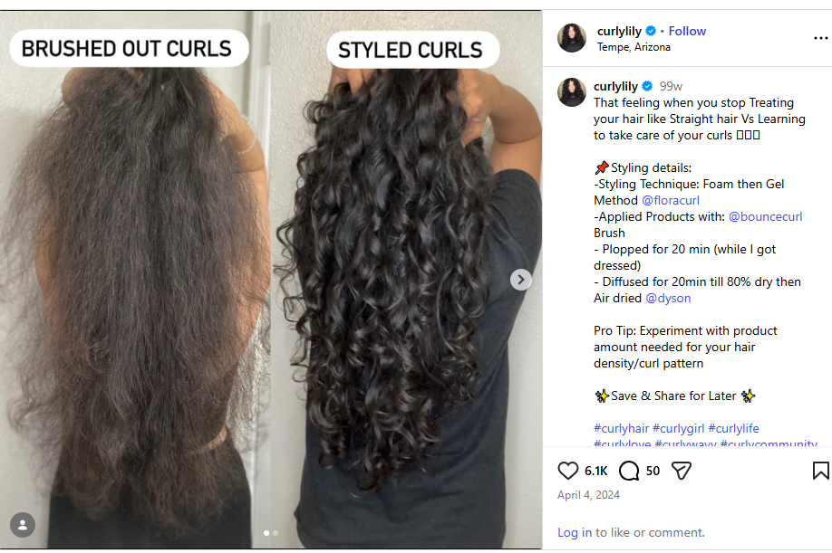
Therefore, the distinction between the Natural Hair Movement and the recent popularisation of the Curly Girl Method is that while the Natural Hair Movement had political underpinnings, that lead to bills like the CROWN act, and was constricted to one community, the latter was a hair care method that was popularised and embraced by women across the world through the internet. This study aims to understand the lived experiences of such women in India who have textured hair, and have learned to take care of it, following steps similar to the ones mentioned in Lorraine Massey’s book (2001). I aim to understand their unique experiences with their hair such as how people perceive it, their motivations behind wearing it in a naturally-enhancing manner, and the course of their hair-esteem, i.e., how their views about their hair have changed over the course of their lifetime.
Where does Hair stand in Psychology?
Just like how different features of the human body affect one’s view of oneself, such as skin color, body type. etc, hair here is no need to explain how hair has always been a part of physical beauty. Long and luscious hair, smooth and silky - these are all the adjectives that have been synonymous with ‘beautiful hair’. With the beauty standards, however, comes the human perception of oneself, where feelings and thoughts are intertwined with beauty and value. How a person feels about their hair can tell how they feel about their appearance, and that can determine how they feel about themselves as a person. For example, a person who views their hair as healthy and beautiful would have those adjectives added to their inner dialogue about themselves. However, a person who would have a slightly negative perspective about their hair might look gloomily in their mirror, and could be slightly behind in accepting their natural hair. Hair, as it has always been a part of our bodies, has the power to affect our daily mood, thoughts, and emotions, which makes it a relevant topic to be discussed in Psychology.
Theoretical Framework
Social Comparison
According to APA, social comparison can happen upward or downward. In this study, I presume the upward social comparison, as Eurocentric features were seen as the standard, as portrayed through media. A study conducted among African American girls points out that girls with lower self esteem had more social comparisons with people who have Eurocentric hair (Hennings et. al., 2022). Children tend to compare themselves with those who are around them, or those who they see through the media.
Social Conformity
Conformity, according to the Cambridge dictionary, refers to behaviour that follows the usual standards that are expected by a group or society. The Japanese population is a great example of conformity, where uniformity is very important, and people do not prefer to stand out. People wear neutral-toned outfits and are dressed similarly. Foreigners who wear brighter clothes would stand out from the crowd. They would also be dressed well, as beauty is given a lot of importance as well. Women are seen in public transportation applying makeup. Interestingly, according to a study conducted by Flament et. al. (2025), the Japanese had the least number of people with naturally curly (textured) hair, which would mean that the majority of the population has naturally straight hair. In a collectivist country like Japan, which values uniformity as well as beauty, it is no surprise that the minority curly-haired women would prefer to conform to the majority who have straight hair. The concept of conformity is very relevant to this topic especially in India, which is also a collectivist nation like Japan. When we look at the market trends for hair straighteners, we can see that there is an increase in its consumption over the years. There is a compound annual growth rate of 5.21% from the financial year 2025 to financial year 2033, according to marketsandata.com. This shows us how women with textured hair in India have been conforming to the beauty standards of straight, silky and smooth hair. A study conducted by Puri et. al. (2025) points out how social conformity leads to psychological distress in adolescent girls. The standardisation of Eurocentric hair features through media has led to greater conformity, leading African American girls to achieve the same looks (Hennings et. al., 2022).
Constructivism
Constructivism is defined by the Cambridge dictionary as ‘a theory that learning is an active process and that people gain knowledge and understanding through the combination of experiences and ideas’. As I explore the lived experiences of women with textured hair, I aim to find the various events and ideas that shaped the women’s perceptions about their hair, such as how they viewed their hair as a child, how the people around them influenced it, and how learning to take care of it and seeing their hair in a naturally enhanced manner has affected their views towards their hair.
Statement of the Problem
Women in India with textured hair have undergone quite a lot of struggle with regard to their hair, in terms of managing it, and simply liking it in its natural state. Instead, many would resort to unnatural methods of managing it, such as straightening it using heat or chemicals. Since the popularisation of the Curly Girl Method, many textured-hair women have ‘discovered’ that their hair is curly, and have been wearing it in a naturally enhanced manner.
Definition of Key Terms
Natural Hair-Enhancing Routines: Inspired by the Curly-Girl Method, I use this term for ease of understanding and to avoid the confusion that could arise, as not everyone follows the exact steps and rules given in this method. However, this is a more inclusive term that would include people who style their hair in a way that their natural hair texture would be defined, rather than brushed out or straightened.
Textured Hair: Hair that is not straight. In a study conducted by Bankhead & Johnson in 2014, they defined natural hairstyle as ‘non-synthetic hair that is grown from one’s scalp and is not chemically or thermally straightened.’ This includes wavy, curly, coily, and kinky hair types. Although the Curly Girl Method includes the term ‘Curly’, the methods that they recommend can be followed by anyone with textured hair. So for this study, I have avoided using the term ‘Curly-Haired Women’ to include all kinds of textured hair.
Lived Experiences: The various experiences that textured-hair women in India went through before and after following natural hair-enhancing techniques.
Hair-Esteem: A term derived from the Bankhead/Johnson Hair-Esteem Scale, adapted from Rosenberg’s Self-Esteem Scale. Hair-esteem refers to the perception of one’s own hair and its impact on self-esteem.
Method
The sample population chosen for this research are 9 young women in India (18-25 years of age) with textured hair, who wear their hair in a naturally-enhanced manner. This could be a tricky definition, as it may seem quite ambiguous to anyone reading. The reason I didn’t add it as ‘women who follow the Curly Girl Method’ is because not everyone who wears their hair curly follows all the steps originally outlined by Lorraine Massey in her book ‘The Curly Handbook’, which includes no heat, using sulphate-free shampoos and silicone-free conditioners, etc.. I chose this age range as this age group would be more exposed to the internet than the older generations. The participants for this study would mostly be chosen through observation or purposive sampling, i.e., as it would be needed to see if they are wearing their hair in a naturally enhanced manner on most days rather than none. This is still a very ambiguous definition, and it is because of a lack of a proper scale that would give us proper clarity about the kind of steps that the woman would be following from the Curly Girl Method, along with aspects like hair texture pattern. The exclusion criteria would involve women with textured hair who do not wear their hair in a naturally enhanced manner. This would involve textured-hair women who brush out their curls when they are dry, or straighten their hair using heat or chemicals, in a way that their natural texture is hidden (Figure 2). At first, the participants were chosen through observation, as mentioned above. Once they gave informed consent, they were asked to fill a google form containing spaces to fill demographic details, along with some basic screening questions. The screening questions included questions like whether they know about CGM, and what they thought their hair type was. After this, an in-depth interview was conducted. The data collected was transcribed and analysed using thematic analysis.
Results
Experiences while growing up
One of the participants mentioned that she didn’t know how to take care of her hair because there wasn’t any proper guidance from her family members, as all of them had ‘straight baby hair’, and hair that wasn’t this curly. One of the participants mentioned that growing up, she would comb out her hair to keep it straight. However, her grandmother used to keep insisting that she had curls and that brushing them would cause her curls to be lost. However, she didn’t heed it because she didn’t like curly hair. This is a rather interesting take, as the older generations, who are not as exposed to naturally-enhanced curly hair, would be more inclined to keep it straight to fit into the societal norms, to keep it ‘tamed’. Another participant reported that her aunt would say that she had ‘bushy’ hair every time she saw her. She recalls it as a reason that she started hating her hair. However, her father and grandmother loved her curls, as her father also had curls. This helps us to understand that not all from the older generation would have a hatred towards textured hair, and some would even encourage keeping it curly. This was a discovery for me, as my own mother dislikes it when I wear my hair in a naturally enhanced manner, and would ask me to brush out the curls. She found it rather absurd that people wouldn’t comb their hair (although I’ve tried multiple times to explain that we do comb our hair, just that we do it when it is wet). This made me keep aside my own biases and practice reflexivity.
One of the participants mentioned that she would see her cousin, who has ‘sleek straight hair’, wearing her hair open along with a bow or clip, and would think that she wanted her hair (Social Comparison). She admitted to being jealous of her as well. Another participant mentioned how she had a period of time where she used to feel that if she had straight hair, it would be less maintenance, and she would look more beautiful.
Straightening of hair is a common experience faced by many of the participants. One of the participants mentioned how she thought she would look more beautiful if she straightened her hair. However, one time when she did straighten her hair, she didn't feel like herself, although she looked nice. One of the participants mentioned that she would want long hair, but she was always made to cut it as a child because of how unmanageable it was.
One of the participants mentioned how she would want to keep her hair long and straight, and wear open hairstyles. However, because it would look ‘poofy' and ‘messy', she would tie it up in a pony, even though she had shoulder-length hair, as it was comfortable. One of them reported that her go-to hairstyle was a French braid and a half-up with brushed-out curls. She felt that it didn’t suit her and would feel bad. The girls in her class are very pretty, so she would start to compare herself to them and feel insecure as a result.
Certain participants mentioned that they didn’t know about their hair texture, and lacked knowledge about how to take care of it. “It was only in my college that I realised that my hair is actually curly.” One of them had to Google ‘crunchy hair’, which is basically the gel-cast curls, which opened up her understanding of textured haircare. All the participants claimed that they came to know about methods to take care of their hair after the COVID era, as it has become more popular since 2020, suggesting the recent popularisation.

Hair esteem/ Perceptions about their hair, before following natural hair-enhancing routines
Some participants mentioned how they hated her hair prior to learning how to take care of it. Some started hating because of comments made by others, which included relatives. Another says that she thought that something was wrong with her hair.
Participants mentioned feeling worried about how their hair used to look daily, before learning about ways to take care of it. One participant mentioned that she would feel annoyed when her grandmother pointed out that she has curly hair, and that brushing it out and straightening it is ruining her natural hair. One of the participants mentioned how she had very thick hair, in a way that it was too unmanageable and ugly. One participant mentioned names such as ‘poofy’, ‘bird’s nest’ to describe their hair prior to styling.
These would give us an idea that the women were generally unsatisfied with their hair.
Hair esteem/ Perceptions about their hair, after following natural hair-enhancing routines
Participants have a generally positive outlook on their hair after following natural hair-enhancing routines. Participants report feeling better about their hair in the initial few days after washing their hair, such as the second and third day, compared to the fourth or fifth day. This is because their hair is freshly styled and contains less frizz than on other days. They report feeling their best and more like themselves on the days when their hair is looking best. One of them mentioned that they would feel fresh and would love the smell of their products, and their entire day would feel good because their hair is freshly styled. On days that it is not freshly styled, she reported that her mood would be comparatively low.
Motivations behind wearing it in a naturally enhanced manner
One participant mentioned how she used to straighten her hair all the time, which caused a lot of damage, like hair fall, and a burning smell from using a straightener. After following natural hair-enhancing methods, her hair has become more nourished. She mentioned that her hair growing and being healthy is the reason that she wears it naturally, and not just for styling it.
Participants mentioned feeling that they are in their ‘natural element’ while wearing their hair curly, ‘naturally pleasant’. One of the participants mentioned how, after seeing people with textured hair managing their hair, she started feeling that she could do something about her hair as well. Seeing her dad outgrow his bobs, which looked nice, inspired her to embrace her curls. Another mentioned that seeing her cousin and friend wearing it naturally is what motivated her to start keeping it curly. One of them mentioned that this hairstyle is trending.
A few participants mentioned that others pointed out that they have curly hair, and encouraged them to maintain it, which motivated them to try out methods to take care of their hair. This suggests that social conformity goes both ways, in keeping one’s hair straight and in keeping it natural. Findings also suggest that many have resorted to natural hair-enhancing methods due to prior damage caused by straightening.
Discussion
Findings suggest that women feel much more confident about their hair after following natural hair-enhancing routines, especially on the first few days. Experiences while growing up suggest that there was a lock of knowledge regarding how to take care of textured hair, which resulted in practices like brushing out their hair when it is dry, causing the hair texture to be hidden. As a result, they mention that they didn’t know they had curly hair. Most of them discovered how to take care of their hair through social media such as instagram and youtube, making statements like ‘I didn’t know my hair could sit like that’. It was also understood that societal influence was mixed while growing up, such as some appreciating the women’s natural hair even before following CGM and encouraging them to enhance it, and some others wanting their children to follow traditional methods like brushing their hair dry. Some instances of negative name callings and bullying was mentioned, and some others reported no such negative experiences. Most of them mentioned that damage caused by straightening was one of the main motivations and reasons that they resorted to embracing their natural texture.
Limitations
One limitation of this study is that because the Curly Girl method is a fairly new phenomenon, due to which, many ambiguities remain in the definitions of the key terms, and selection of participants, especially to a reader who has no background information regarding the concept. Another ambiguity is regarding what exactly the ‘natural hair enhancing routines’ mean. Although I explained that it refers to the Curly Girl Method, it has been understood that people don’t follow all the rules given by Lorraine Massey in her book (Massey, 2001), which is why I had to use the broader term that can include any of the rules.
Conclusion
Based on the findings, it can be concluded that the textured hair women following natural hair-enhancing routines resulted in increased confidence and acceptance for hair texture, compared to earlier life experiences.

References
American Psychological Association. (2018, April 19). Social comparison theory. APA
dictionary of psychology.
https://dictionary.apa.org/social-comparison-theory
Business Research Insights. (2026, February 16). Flat irons market size, share 2035 Robust
CAGR 6.5% growth (Report ID: 115739).
https://www.businessresearchinsights.com/market-reports/flat-irons-market-115739
Flament, F., Maudet, A., Barbarat, P., Jabnoun, M., Bayer-Vanmoen, M., Imbert Legrain, A.,
Leclerc-Mercier, S., Taieb, C., Skayem, C., & Lebarbanchon, L. (2025). Types and Characteristics of Hair Across the Globe: Results of a Multinational Study on 19,461 Individuals. Clinical, cosmetic and investigational dermatology, 18, 393–404. https://doi.org/10.2147/CCID.S377009
Henning, T., Holman, M., Ismael, L., Yu, K. Y., Williams, L., Shelton, S. J., & Perez, M. (2022).
Examination of hair experiences among girls with Black/African American identities.
Body image, 42, 75-83.
King, V., & Niabaly, D. (2013). The Politics of Black Womens' Hair. Journal of Undergraduate
Research at Minnesota State University, Mankato, 13(1), 4.
Liliana D. [curlylily]. (2024, April 4). “ That feeling when you stop Treating your hair like
Straight hair Vs Learning to take care of your curls..”[Photo]. Instagram.
https://www.instagram.com/p/C5WVRiFv_Iw/.
Parisi, A. V., Smith, D., Schouten, P., & Turnbull, D. J. (2009). Solar ultraviolet protection
provided by human head hair. Photochemistry and photobiology, 85(1), 250-254.
Puri, M. R., & Sharma, S. Unfolding the Relationship Between Conformity to Feminine Norms,
Body Image Dissatisfaction and Psychological Distress in Adolescent Girls.
Schwarz, E. D. (2022). “Wait… IS MY HAIR ACTUALLY CURLY?!”: The Curly Girl Method
and the Racial Significance of White Women’s Hair Care. Georgetown University.
Skedung, L., Collier, E. S., Harris, K. L., Rutland, M. W., Applebaum, M., Greaves, A. J., & Luengo, G. S. (2021). A Curly Q: Is Frizz a Matter of Friction?. Perception, 50(8), 728-732. https://doi.org/10.1177/03010066211024442
White, S. B. (2005). Releasing the pursuit of bouncin'and behavin'hair: natural hair as an
Afrocentric feminist aesthetic for beauty. International Journal of Media & Cultural
Politics, 1(3), 295-308.

