MATLAB Algorithms for Computing the Chromatic Number of Fuzzy Cycle

Abstract
In this paper, MATLAB algorithms for computing the chromatic number of fuzzy cycles and their middle graph are formulated and it generates the diagrammatic representation of these fuzzy graphs with the proper fuzzy coloring.
Keywords: Fuzzy Coloring, Chromatic Number, Fuzzy Cycle, Middle Graph, MATLAB.

1. Introduction
Fuzzy graph coloring has become an important area of research in combinatorial optimization [1], as it provides effective methods for addressing problems characterized by vagueness, imprecision, and uncertainty. It plays a crucial role in resource allocation and task scheduling, ensuring conflict-free schedules and optimal resource utilization [2]. To address such situations, Susana Munoz et al. [3] introduced fuzzy graph coloring in 2005 by reformulating the traffic light problem in terms of fuzzy graphs, focusing on crisp vertex sets with fuzzy edge sets (type–1 fuzzy graphs). In 2006, Eslahchi and Onagh [4] extended this framework to type–2 fuzzy graphs, where both vertices and edges are fuzzy and proposed a coloring method based on strong adjacency relations. The idea was then expanded upon by Sovan Samanta et al. [5], who developed a different method of coloring fuzzy graphs by using fuzzy colors based on the strength of an edge incident to a vertex. Building upon these contributions, the present work aims to extend the fuzzy coloring procedure by integrating fuzzy colors and edge strengths into a more generalized framework. In 2024, we derived some features of fuzzy coloring and used fuzzy colors to compute the chromatic number of specific families of fuzzy graphs [6]. Additionally, we determined the chromatic number of a few related graphs of fuzzy path, fuzzy cycle and homogeneous fuzzy caterpillar graphs, (refer [7],[8],[9]). Furthermore, using the proper fuzzy coloring process, we developed a MATLAB code to calculate the chromatic number of fuzzy paths and their middle graph [10].
MATLAB was originally developed as a user-friendly tool for linear algebra and eigenvalue problems, but it has since evolved into a comprehensive platform for scientific computing and research [11]. As a high-performance computing language, MATLAB combines numerical analysis, visualization, and a modern programming environment into a unified system [12]. This integration allows researchers and educators to move seamlessly from theoretical models to computational experiments and graphical interpretation of results. One of its key strengths lies in its interactive nature: arrays form the core data type, which simplifies coding and accelerates problem-solving compared to conventional programming languages. In addition to its computational power, MATLAB incorporates debugging tools, object-oriented programming support, and an extensive library of specialized toolboxes that address applications in engineering, mathematics, optimization, and simulation [13]. These features have established MATLAB not only as a computational tool but also as an effective platform for teaching, learning, and innovation across multiple disciplines. In this study, we are trying to develop a MATLAB coding to determine the chromatic number of fuzzy cycles and its middle graph using the proper fuzzy coloring procedure.

The structure of this paper is as follows. Section 1 introduces fuzzy coloring and provides an overview of MATLAB. Section 2 presents some fundamental concepts in fuzzy graph theory that aid in the research. In Section 3, we develop MATLAB algorithm to compute the chromatic number of fuzzy cycles by using the proper fuzzy coloring procedure. Section 4, focuses on the implementation of MATLAB algorithm to compute the chromatic number of middle graph of a fuzzy cycle by using the proper fuzzy coloring procedure.

2. Preliminaries
The theoretical underpinnings of fuzzy graph theory and fuzzy coloring, which are crucial for determining the chromatic number of fuzzy cycles and their middle graph, are reviewed in this section.

Definition 2.1. [14] A fuzzy graph $G=(V, σ, µ)$ is a pair of functions$(σ, µ)$, where $σ : V →[0, 1]$ is a fuzzy subset of a non-empty set $V$ and $µ : V→ [0, 1]$ is a symmetric fuzzy relation on $σ$, such that the relation $µ(v_{i}, v_{j})≤σ(v_{i})∧σ(v_{j})$ is satisfied for all $v_{i}, v_{j}∈V$and $(v_{i}, v_{j})∈E⊂V×V .$
Definition 2.2. [15] Let $G=(V, σ, µ)$ be a fuzzy graph with underlying crisp graph $G^{*}$. A fuzzy path $P_{n}$in $G$ is a sequence of distinct vertices $v_{0}, v_{1}, . . . , v_{n}$ such that $µ(v_{i-1},v_{i})>0, 1≤i≤n$. Here $n≥1$ is called the length of the path $P_{n}$.
Definition 2.3. [15] A fuzzy path $P_{n}$in which $v_{0}=v_{n}$ and $n≥3$, then $P_{n}$is called a fuzzy cycle $C_{n}$ of length $n$.
Definition 2.4. [5] Let $G = \left(V,σ,μ\right)$ be a fuzzy graph and an edge $e=\left(v_{i},v_{j}\right)∈G$ is called strong if $\frac{1}{2}\{σ\left(v_{i}\right) ⋀ σ(v_{j})\}≤μ(v_{i},v_{j})$ and it is called weak otherwise.
Definition 2.5. [5] Let $G=\left(V, σ, µ\right)$ be a fuzzy graph and the strength of an edge $\left(v_{i}, v_{j}\right)∈G$is denoted by,
$$I\left(v_{i},v_{j}\right)=\frac{μ(v_{i},v_{j})}{σ(v_{i})∧σ(v_{j})}.$$
Definition 2.6. [16] A fuzzy graph $G=\left(V, σ, µ\right)$ is called a strong fuzzy graph if each edge in $G$ is a strong edge.
Definition 2.7. [6] Let $G=(V, σ, µ)$ be a fuzzy graph. Fuzzy coloring is an assignment of basic or fuzzy colors to the vertices of a fuzzy graph $G$ and it is proper,
- if two vertices are connected by a strong edge, then they either have different basic or fuzzy colors(if necessary), or one vertex can have a basic color and the other can have a fuzzy color corresponding to different basic color.
- if two vertices are connected by a weak edge, then they either have same or different fuzzy colors, or one vertex can have a basic color and other can have a fuzzy color corresponding to the same basic color.

Definition 2.8. [6] Let $G=(V, σ, µ)$ be a fuzzy graph. Perfect fuzzy coloring (optimal fuzzy coloring) is an assignment of minimum number of colors (basic or fuzzy) for a proper fuzzy coloring of $G$.
Definition 2.9. [6] Let $G=(V, σ, µ)$ be a fuzzy graph. The minimum number of colors (basic or fuzzy) needed for a proper fuzzy coloring of $G$ is called the chromatic number of $G$ and is denoted by $χ_{f}(G)$.
Definition 2.10. [7] The middle graph $M_{f}(G)(V_{M},σ_{M},μ_{M} )$ of a fuzzy graph $G(V,σ, μ)$ is a fuzzy graph with underlying crisp graph $M(G)(V_{M},E_{M})$, with the vertex set $V_{M}= V∪V_{ij}$ where $V=\{v_{i}∣v_{i}∈V\}$ and $V_{ij}=\{v_{ij} ∀ \left(v_{i},v_{j}\right)∈E\}$ and $ν(M_{f}(G))=n+1+n=2n+1$ and the edge set
$$E_{M}= \left\{\begin{aligned}\left(v_{ij},v_{i}\right), \left(v_{ij},v_{j}\right) ∀ i and j, \\ \left(v_{ij},v_{rs}\right) if the edges \left(v_{i},v_{j}\right) and \left(v_{r},v_{s}\right) are adjacent in G. \end{aligned}\right.$$

Then, $σ_{M}\left(v_{i}\right)=σ\left(v_{i}\right) if v_{i}∈V, 0≤ i≤ n,$
$$σ_{M}\left(v_{ij}\right)=μ\left(v_{i},v_{j}\right) if \left(v_{i},v_{j}\right)∈E ∀ i and j,$$
$μ_{M}\left(v_{ij},v_{rs}\right)=μ\left(v_{i},v_{j}\right) ⋀ μ(v_{r},v_{s})$ if the edges $\left(v_{i},v_{j}\right)$ and $(v_{r},v_{s})$ are adjacent in G,
and $μ_{M}\left(v_{i}, v_{ij}\right)=μ_{M}\left(v_{j}, v_{ij}\right)=μ\left(v_{i},v_{j}\right) ∀ i and j$.

Lemma 2.1. [6] Let $C_{n}$ be a fuzzy cycle of length $n$. If all edges are weak in $C_{n}$, then
$χ_{f}(C_{n})=1$.
Lemma 2.2. [6] Let $C_{n}$ be a fuzzy cycle of length $n$. If all the edges are strong in $C_{n}$, then

$$χ_{f}\left(C_{n}\right)=\left\{\begin{aligned}2 if n is even, \\ 3 if n is odd.\end{aligned}\right.$$
Theorem 2.1.[8] If $M_{f}(C_{n})$ is a strong fuzzy graph, then $χ_{f}(M_{f}(C_{n}))=3.$
Theorem 2.2. [7] $χ_{f}\left(G\right)≥ max \{χ_{f}(G_{i}) : 1≤ i≤ k\}$, where $G=G_{1}∪G_{2}∪…∪G_{k}$ and $G_{i}, 1≤i≤k$ are fuzzy graphs.
Corollary 2.2.1. [7] $χ_{f}\left(G\right)≥max \{χ_{f}(G_{i}) :1≤i≤k\}$, where $G=G_{1}⊕G_{2}⊕…⊕G_{k}$ and $G_{i}, 1≤i≤k$ are edge disjoint fuzzy graphs.

3. MATLAB Implementation for Fuzzy Coloring of Fuzzy Cycle
This study implements the proper fuzzy coloring of fuzzy cycles using MATLAB. Here, we are attempting to create a MATLAB program to determine a fuzzy cycle's chromatic number when all of its edges are either strong or weak. The procedure is divided into five main steps: There are five primary steps in the process: Input of the number of edges and vertices with membership values, Categorization of edges, Proper fuzzy coloring, Calculating the chromatic number of the fuzzy cycle and visualizing it with proper fuzzy coloring.

Step 1: Input of Membership Values

Let $C_{n}$ be a fuzzy cycle with $n$ vertices and$n$ edges. The membership values of the vertices are denoted by $σ(v_{i})$, where $1≤i≤n$, and the membership values of the edges are denoted by $μ(v_{i},v_{i+1})$, where $1≤i≤n$ with $v_{n+1}=v_{1}$. These values are taken as input from the user.

Step 2: Edge Classification
Each edge is classified as strong or weak using the following rule: If
$\frac{1}{2}\{σ\left(v_{i}\right) ⋀ σ(v_{j})\}≤μ(v_{i},v_{j})$,
Then the edge $(v_{i},v_{i+1})$ is strong; otherwise, it is weak. The classification results are displayed for all edges in the fuzzy cycle.

Step 3: Fuzzy Coloring of Vertices
Coloring proceeds sequentially from vertex $v_{1}$ to $v_{n}$ under the following rules:
- Case 1 – All edges are weak:
- The first vertex $v_{1}$ is assigned a basic color with full intensity.
- Remaining vertices receive the same color with diluted intensity:
$$Intensity=1 - \frac{μ\left(v_{i},v_{j}\right)}{σ\left(v_{i}\right)∧σ\left(v_{j}\right)}.$$
- Case 2 – All edges are strong:
- Subcase 2.1 – $n$ is even: Assign two basic colors alternately around the cycle.
- Subcase 2.2 – $n$ is odd: Assign two basic colors alternately to vertices $v_{1}$ to $v_{n-1}$, and assign a third color to $v_{n}$.

Step 4: Computation of the Chromatic Number
The chromatic number $χ_{f}(C_{n})$ is computed. This value denotes the minimum number of colors (basic or fuzzy) required for a proper fuzzy coloring.

Step 5: Visualization
The fuzzy cycle $C_{n}$ is visualized in MATLAB:
- Vertices are represented by circular nodes labeled with their names, membership values and color-intensity pairs.
- Edges are drawn as black lines, and their membership value $μ$ is displayed at the midpoint.
This visualization provides a clear and intuitive representation of proper fuzzy coloring with the chromatic number.
Example 1. Figure 1 presents the MATLAB output for the proper fuzzy coloring of the fuzzy cycle $C_{3}$, in which all edges are weak. The vertices $v_{1}, v_{2}, v_{3}$ have membership values $0.9, 0.8, 0.7$, while the edges $(v_{1},v_{2}), (v_{2},v_{3}), (v_{3},v_{1})$ have membership values $0.39, 0.34, 0.34$.
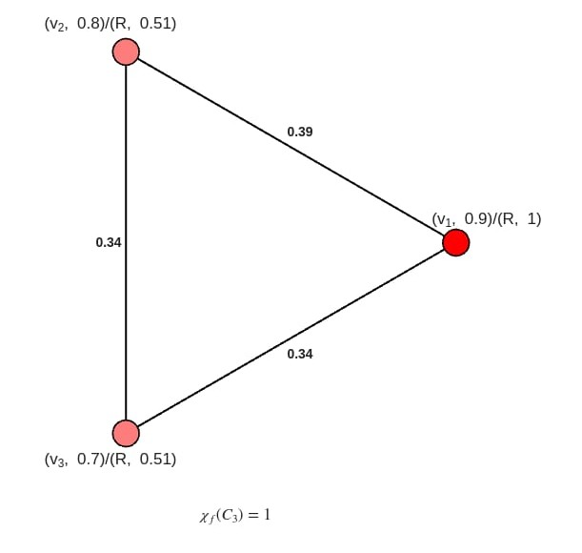

Figure 1. Fuzzy coloring of fuzzy cycle $C_{3}$, when all the edges are weak.

Example 2. Figure 2 presents the MATLAB output for the proper fuzzy coloring of the fuzzy cycle $C_{4}$, in which all edges are weak. The vertices $v_{1}, v_{2}, v_{3},v_{4}$ have membership values $0.9, 0.8, 0.7, 0.6$, while the edges $(v_{1},v_{2}), (v_{2},v_{3}), (v_{3},v_{4}), (v_{4},v_{1})$ have membership values $0.39, 0.34, 0.23, 0.24$.
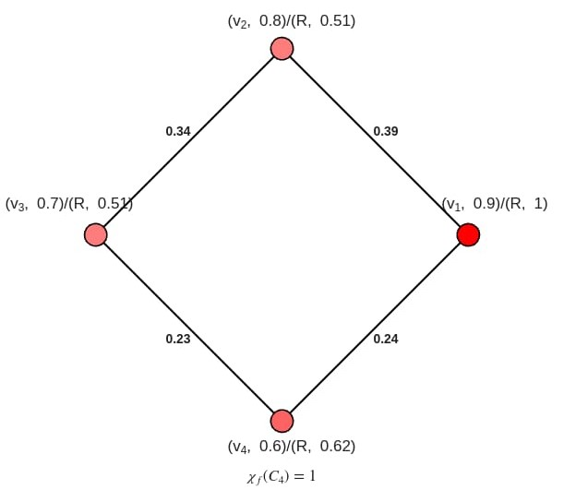
Figure 2. Fuzzy coloring of fuzzy cycle $C_{4}$, when all the edges are weak.
Example 3. Figure 3 presents the MATLAB output for the proper fuzzy coloring of the fuzzy cycle $C_{4}$, in which all edges are strong. The vertices $v_{1}, v_{2}, v_{3},v_{4}$ have membership values $0.9, 0.8, 0.7$, while the edges $(v_{1},v_{2}), (v_{2},v_{3}), (v_{3},v_{4}), (v_{4},v_{1})$ have membership values $0.6, 0.5, 0.6, 0.5$.
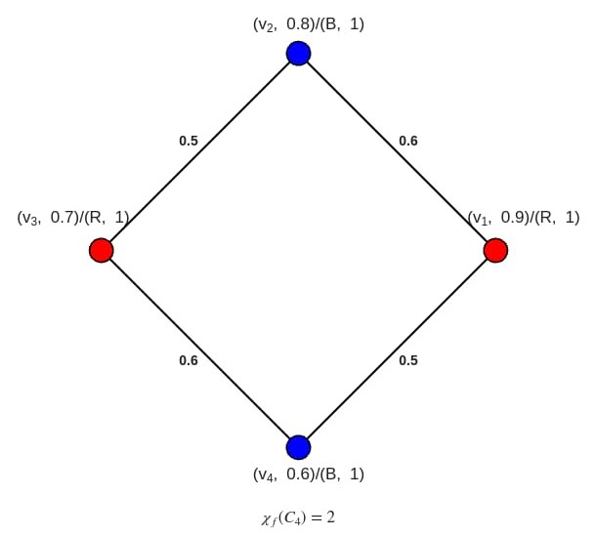
Figure 3. Fuzzy coloring of fuzzy cycle $C_{4}$, when all the edges are strong.
Example 4. Figure 4 presents the MATLAB output for the proper fuzzy coloring of the fuzzy cycle $C_{3}$, in which all edges are strong. The vertices $v_{1}, v_{2}, v_{3}$ have membership values $0.9, 0.8, 0.7$, while the edges $(v_{1},v_{2}), (v_{2},v_{3}), (v_{3},v_{1})$ have membership values $0.6, 0.6, 0.6$.
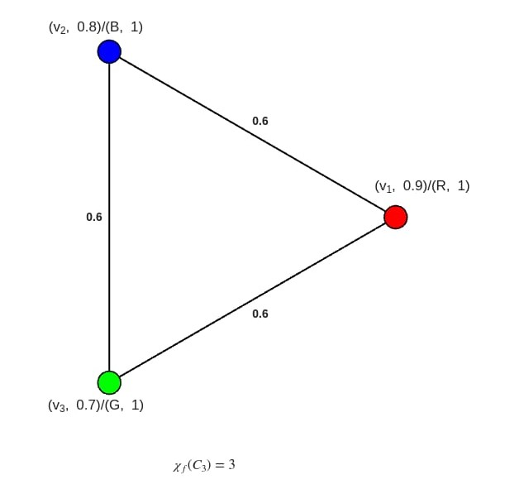
Figure 4. Fuzzy coloring of fuzzy cycle $C_{3}$, when all the edges are strong.

4. Fuzzy Coloring of Middle Graph of Fuzzy Cycle Using MATLAB
This study implements the proper fuzzy coloring of the middle graph of a fuzzy cycle $C_{n}$ using MATLAB. The procedure is divided into six main steps: Input of vertex and edge membership values, Construction of the middle graph of $C_{n}$, Edge classification, Proper fuzzy coloring of the vertices, Computation of the chromatic number, and Visualization of the middle graph with proper fuzzy coloring.

Step 1: Input of Membership Values
Let $C_{n}$ be a fuzzy cycle with $n$ vertices and $n$ edges. The membership values of the vertices are denoted by $σ(v_{i})$, for $i=1,2,…,n$, and the membership values of the edges are denoted by $μ(v_{i},v_{i+1})$, for $i=1,2,…,n$ (with $v_{n+1}=v_{1}$). These values are provided as input by the user.

Step 2: Construction of the Vertex Set
The middle graph $M_{f}(C_{n})$ is constructed by two categories of vertices:
- All vertices of the fuzzy cycle $C_{n}$, namely $v_{1}, v_{2}, …, v_{n}$, each carrying its corresponding membership value $σ(v_{i})$.
- For each edge $\left(v_{i},v_{i+1}\right)∈C_{n}$, a new vertex $v_{ii+1}$ is added. The membership value of this vertex is defined as $σ(v_{ii+1} )=μ(v_{i},v_{i+1}).$
Thus, the vertex set is given by, $V\left(M_{f}\left(C_{n}\right)\right)=\left\{v_{1}, v_{2}, …, v_{n}\right\}∪\{v_{12}, v_{23}, …, v_{n1}\}$.

Step 3: Construction of the Edge Set
There are two types of edges in $M_{f}(C_{n})$:
- For each edge $(v_{i},v_{i+1})$ in $C_{n}$, the vertex $v_{ii+1}$ is connected to both $v_{i}$ and $v_{i+1}$ with membership value $μ\left(v_{i},v_{ii+1}\right)=μ\left(v_{i+1},v_{ii+1}\right)=μ\left(v_{i},v_{i+1}\right).$
- If two consecutive edges $(v_{i},v_{i+1})$ and $(v_{i+1},v_{i+2})$ exist in $C_{n}$, then the vertices $v_{ii+1}$ and $v_{i+1i+2}$ are connected with membership value
$$μ(v_{ii+1}, v_{i+1i+2}) = min\{μ(v_{i},v_{i+1}), μ(v_{i+1},v_{i+2})\}.$$

Step 4: Edge Classification
Each edge $(v_{i},v_{j})$ of $M_{f}(C_{n})$ is classified as either strong or weak based on the following criterion:
$\frac{1}{2}\{σ\left(v_{i}\right) ⋀ σ(v_{j})\}≤μ(v_{i},v_{j})$,
If the condition is satisfied, the edge $(v_{i},v_{j})$ is strong. Otherwise, the edge is weak.

Step 5: The Proper Fuzzy Coloring of Middle Graph and its Chromatic Number
The adjacent vertices must be assigned distinct basic colors with full intensity, as $M_{f}(C_{n})$ is classified as a strong fuzzy graph. Additionally, it calculates the chromatic number $χ_{f}(M_{f}(C_{n}))$, which indicates the number of colors (basic or fuzzy) required for a proper fuzzy coloring.

Step 6: Visualization
Finally, the graph is visualized such that
- Vertices are represented by circular nodes labeled with their names, membership values, and color-intensity pairs.
- Edges are drawn between vertices with their membership values $μ$ displayed at the midpoint.
This visualization provide a clear and intuitive representation of proper fuzzy coloring with the chromatic number.
Example 5. Figure 5 presents the MATLAB output for the proper fuzzy coloring of middle graph of fuzzy cycle $C_{3}$. The vertices $v_{1}, v_{2}, v_{3}$ have membership values $0.9, 0.8, 0.7$, while the edges $(v_{1},v_{2}), (v_{2},v_{3}), (v_{3},v_{1})$ have membership values $0.4, 0.2, 0.4$.
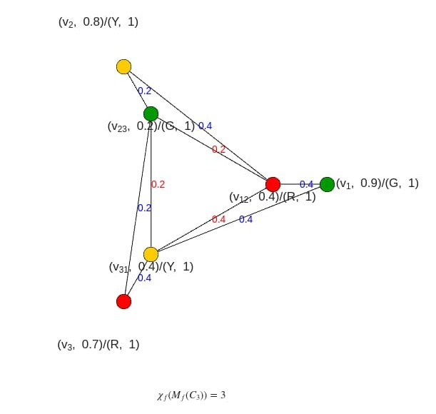
Figure 5. Fuzzy coloring of middle graph $M_{f}\left(C_{3}\right).$
Example 6. Figure 6 presents the MATLAB output for the proper fuzzy coloring of middle graph of fuzzy cycle $C_{4}$. The vertices $v_{1}, v_{2}, v_{3},v_{4}$ have membership values $0.9, 0.8, 0.7,0.6$, while the edges $(v_{1},v_{2}), (v_{2},v_{3}), (v_{3},v_{4}), (v_{4},v_{1})$ have membership values $0.4, 0.2, 0.4, 0.2$.
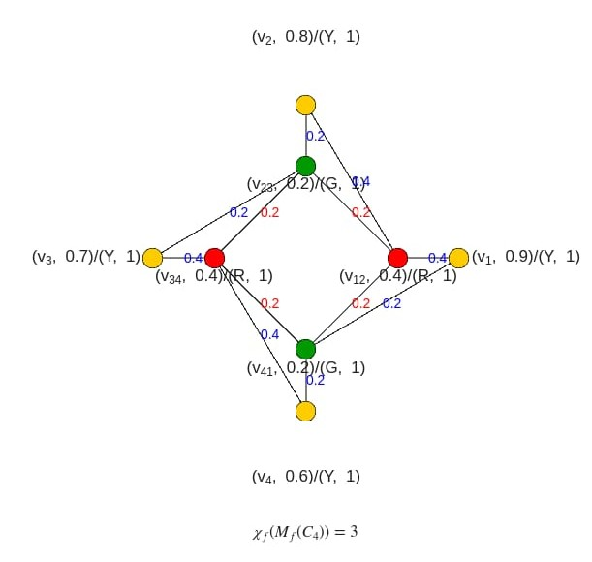
Figure 6. Fuzzy coloring of middle graph $M_{f}\left(C_{4}\right).$

5. References

[1] Kannan, M., Sathiragavan, M., Nivetha, P., Sankar, K., & Gurjar, J. (2024).Graph coloring techniques
in scheduling and resource allocation. Journal of Nonlinear Analysis and Optimization, 15(2).
[2] Anjaly, K., & Sunitha, M. S. (2016). Chromatic number of resultant of fuzzy graphs. Fuzzy
Information and Engineering, 8(2), 219–229.
[3] Munoz, S., Ortuno, M. T., Ramirez, J., & Yanez, J. (2005). Coloring fuzzy graphs. Omega, 33(3),
211–221.
[4] Eslahchi, C., & Onagh, B. N. (2006). Vertex-strength of fuzzy graphs. International Journal of
Mathematics and Mathematical Sciences, 2006(1), 43614.
[5] Samanta, S., Pramanik, T., & Pal, M. (2016). Fuzzy colouring of fuzzy graphs. Afrika Matematika,
27(1–2), 37–50.
[6] Karunambigai, M. G., & Mathew, J. A. (2024). The chromatic number of certain families of fuzzy
graphs. Cuestiones Fisioterapia, 53(3), 5153–5268.
[7] Karunambigai, M. G., & Mathew, J. A. (2025). The chromatic number of fuzzy paths and its related
graphs. International Journal of Environmental Science,11(18s), 1858–1869.
[8] Karunambigai, M. G., & Mathew, J. A. (2025). The chromatic number of fuzzy cycles and its related
graphs. International Journal of Environmental Science,11(20s), 3697–3709.
[9] Karunambigai, M. G., & Mathew, J. A. (2025). The chromatic number of homogeneous fuzzy
caterpillars and its related graphs. International Journal of Applied Mathematics, 38(3s), 928–942.
[10] Karunambigai, M. G., & Mathew, J. A. (2025). Fuzzy coloring of fuzzy paths using
MATLAB. IJRDO – Journal of Mathematics, 11(3), 1-8.
[11] Houcque, D. (2005). Introduction to MATLAB for engineering students (p. 1). Northwestern
University.
[12] Moler, C., & Little, J. (2020). A history of MATLAB. Proceedings of the ACM on Programming
Languages, 4(HOPL), 1–83.
[13] Abdul Majid, M., Huneiti, Z. A., Balachandran, W., & Balarabe, Y. (2013). MATLAB as a teaching
and learning tool for mathematics: A literature review. International Journal of Arts & Sciences, 6(1),
205–221.
[14] Mathew, S., Mordeson, J. N., & Malik, D. S. (2018). Fuzzy graph theory. Springer International
Publishing.
[15] Pal, M., Samanta, S., & Ghorai, G. (2020). Fuzzy cut vertices and fuzzy trees. In Modern trends in
fuzzy graph theory (pp. 115–124). Springer.
[16] Gong, Z., & Zhang, J. (2022). Chromatic number of fuzzy graphs: Operations, fuzzy graph coloring
and applications. Axioms, 11(12), 697.

