"Relationship of Socio-Emotional Skills and Cognitive Development in Kindergarten Pupils: An Assessment Using the Early Childhood Care and Development (ECCD) Checklist"

ABSTRACT

This study aimed to describe the cognitive and socio-emotional skills of early
childhood learners in the Philippines. Data were collected using the Early Childhood Care and Development (ECCD) tool to measure the frequency and percentage of skills exhibited by learners. The cognitive skills of the learners, as measured using the ECCD Tool, demonstrate high proficiency across a variety of tasks. Of the 21 skills assessed, 13 were consistently mastered by all 48 participants, with a 100% success rate. Many parents highlighted the role of play-based activities in their children’s daily routines. These activities typically include reading, storytelling, drawing, coloring, and simple art projects. These practices nurture both cognitive and creative development. Social skills in early childhood are vital, as they serve as the foundation for a child's ability to interact and build relationships with others. During this stage, children learn essential skills such as communication, cooperation, and empathy, which help them navigate social interactions and develop meaningful connections. These early experiences shape their ability to understand and engage with the world around them, fostering confidence and emotional intelligence as they grow.
Keywords: Cognitive Development, Socio-emotional skills, Early Childhood Education

Project Background and Justification

Kindergarten served as the foundation for children's learning, where they acquired fundamental knowledge and skills essential for their educational journey. This critical stage marked the beginning of formal education, introducing children to literacy, numeracy, socialization, and critical thinking concepts. It laid the groundwork upon which subsequent learning experiences were built. Republic Act No. 10157 and the K to 12 law on the "Enhanced Basic Education Act of 2013" (Republic Act No. 10533) ensured equal opportunities for all children through accessible, mandatory, and compulsory kindergarten education. This law promoted the development of physical, social, cognitive, and emotional skills among five-year-old Filipino children, sufficiently preparing them for Grade One. School readiness was a primary goal of the kindergarten program to ensure a smooth transition to formal education.
The Philippine Early Childhood Development (ECD) Checklist served as an assessment tool to determine a child’s growth and development. The ECD assessment did not interpret overall scores as "pass or fail" but rather provided an initial assessment to plan and implement appropriate interventions for kindergarten learners. It helped monitor progress and identify learners at risk of developmental delays who needed further assessment or specialized interventions.
Developmental domains in early childhood education played a crucial role in shaping children's holistic growth. Holistic development was vital in kindergarten as it laid the foundation for future success. By utilizing the Early Childhood Care and Development (ECCD) checklists, children's progress across various developmental domains was monitored effectively. Among these domains, socio-emotional development was particularly significant. By utilizing ECCD checklists to assess socio-emotional development, valuable insights were gained into children's emotional awareness, self-regulation abilities, and social skills.
Socio-emotional development is vital for children, as it equips them with the ability to understand and manage their emotions, which is essential for forming healthy relationships in various social contexts, including family and school environments (Herrera & San Lorenzo, 2024). The conclusion reinforces the idea that early childhood education should focus on the holistic development of children. This includes not only cognitive and motor skills but also socio-emotional competencies, which serve as the foundation for overall well-being and future success.
Brain development is crucial during early childhood, as this is when a child's brain is most flexible and capable of absorbing vast amounts of information. Early childhood is a critical period for brain development, during which children acquire essential cognitive, emotional, and social skills. Numerous studies highlight the importance of Early Childhood Education (ECE) in providing a structured environment for learning and interaction. However, many regions still face challenges such as limited access to quality preschool programs and lack of awareness about their benefits. This research aims to bridge the gap by analyzing how ECE programs influence the overall development of children aged 3-6, focusing on cognitive growth, emotional intelligence, and social behavior (Ghosh, 2024)

LITERATURE REVIEW

According to the study of Ramos, (2021) Pre-school teachers play a vital part in transforming children into responsible people. They instill skills in children during their childhood years that will support them immensely as they reach primary school. As a result, nursery teachers must do everything possible to fulfill the children's needs under their care. There is a need to have a good relationship with parents to properly guide their children's growth, particularly in cognitive skills, since there is a connection between kindergarten learners' planning, cognitive skills, and the highest academic achievement.
The study of Doctor, Macalisang, (2024) The ability, knowledge, and mindset that learners need for both academic performance and future learning and life experiences are known as school readiness. To be prepared for school, learners must have developed their physical, cognitive, social, and emotional skills. This descriptive-correlational study was conducted to assess the level of school readiness of the 227 randomly chosen kindergarten learners from 30 public schools in Tudela District, Division of Misamis Occidental. A total of 227 samples were obtained using the sample size calculator to collect data from the respondents using the Early Childhood Care and Development (ECCD

Checklist Record. Results revealed that the Self-Help Domain had the highest level of preparedness, while the Receptive Language and Expressive Language Domains had the lowest. Assessment results described that kindergarten as having “overall average development” described as ready to start Grade 1. Thus, the study suggests providing additional support for language development; fostering continued independence; monitoring and tracking progress; and using evidence-based interventions.
Children’s social and emotional behaviors (SEBs) are linked with school readiness and healthy development. However, less is known about the ways in which different SEBs simultaneously manifest within children and the implications of such combinations for children’s academic outcomes. In this investigation, we conducted two studies that identify SEB profiles among kindergarten children based on five SEBs: cooperative, socially responsible, helpful, anxious, and aggressive-disruptive behaviors. Results revealed four different profiles that were replicated across two studies. In addition, the profiles were differentially associated with children’s background characteristics and academic achievement in Grades 3 and 5. The findings have implications for efforts to promote adaptive SEBs among students and, in particular, the development of interventions that are appropriately targeted to each child’s unique needs. (Collie, Martin, et al., 2019).

In the study of (Alzahrani, Mona, et al.,2019). They explore the importance of the social-emotional competence on children's growth. To develop children social-emotional competence, an interaction between adults and children is critically needed. Teachers have the responsibility to enhance children's development in many aspects, including social, emotional, cognitive, academic, and behavioral skills. A positive relationship between teachers and young students helps those students to have better school achievement and behavioral skills. We review several studies that show the influence that social and emotional competence has on children's learning outcomes and on their ability to engage in good behaviors. We also provide several strategies that help teachers to build strong and healthy relationships with children. These strategies foster children's academic and behavioral success. We define social and emotional learning in relation to school successes to show that competence in these areas increases students' reading, writing, critical thinking, and vocabulary skills. Emotional regulations can also enhance school achievement, both in the present and in the future. Additionally, we provide strategies that teachers can use to foster positive behavioral skills.

Collaborative learning involves fluctuations in how students participate in social interaction and how they engage in interactions that are cognitive (e.g., sharing knowledge, monitoring learning) and more socio-emotional (e.g., encouragement, positive appraisal) in nature. Few studies have investigated how participation in social interaction fluctuates in relation to these varying types of interaction. The aim of this process-oriented study was to explore how actively students participated in cognitive and socio-emotional interactions and what characterized the moments when participation changed during transitions between the types of interaction. The qualitative analysis focused on video-recorded collaborative learning of six groups of student teachers (N = 24). We found that socio-emotional interaction involved more active participation than cognitive interaction. Changes in participation during transitions between types of interaction were characterized by shifts between domain-focused and metacognitive activities. Implications for supporting and studying productive social interaction in collaborative learning are discussed. (Isohätälä, et al., 2019).

The study of Uttiya Ghosh (2024,) The Role of Play-Based Learning in Enhancing Cognitive and Emotional Development in Early Childhood" provides a concise overview of the research conducted. The research employs a mixed-method approach, which means it combines both qualitative and quantitative research methods. This approach allows for a comprehensive understanding of the impact of play-based learning. Research explores the impact of play-based learning on the cognitive and emotional development of children aged 3-6 years. Through a mixed-method approach, the study examines how various forms of play—free play, guided play, and structured play—contribute to problem-solving, language acquisition, emotional regulation, and social interaction. The findings suggest that play-based learning significantly enhances children's cognitive abilities and emotional well-being, fostering creativity, resilience, and social skills that lay a strong foundation for lifelong learning
The preschool years represent a critical stage in a child's cognitive development, marked by significant progress in various mental processes. This study delves into the cognitive growth of preschool children by examining fundamental domains such as attention, memory, language, problem-solving, and executive functions. It explores the complex interplay between biological, environmental, and experiential factors that influence cognitive development during early childhood. A deeper understanding of these processes is essential for educators, parents, and policymakers to create targeted interventions and educational strategies that support optimal cognitive growth in young learners. Umarova Muqaddasxon (2024) emphasizes the importance of these key cognitive skills in early childhood education, highlighting how they evolve and contribute to a child's overall learning and development.
The research of Doctor, (2024), The least learned competencies among kindergarten students were found in the Receptive Language and Expressive Language Domains, indicating a need for additional support in language development to enhance overall school readiness and preparedness for Grade 1. Recommendations include language support, independence, progress monitoring, and interventions
Selman, (2025), Examines the association between preschool children's routine use and socioemotional adjustment, finding that consistently high routine use is linked to better adjustment, while decreasing routine use is associated with increased attentional and behavioral problems. The present study examined how use of routines across the preschool period is linked to children's socioemotional adjustment. We used Year 3 and Year 5 data from the Future of Families and Child Wellbeing Study (N = 2,353; 48% female). Child routines were measured through maternal reports of routines, including household chores, play, mealtime, and bedtime. Latent profile analysis revealed four groups based on timing and number of routines: stable-high, increasing, decreasing, and stable-low. In Year 5, parents reported on children's attentional, externalizing, and internalizing problems and social skills. Latent transition analysis indicated that most children (n = 1,782; 75%) maintained the same profiles over time. Regression analyses showed that profiles were differentially related to outcomes. After controlling for a set of confounding variables, children in the stable-high group had significantly lower attentional, externalizing, and internalizing problems than the decrease routines group (βs range from .23 to .40, p < .05). These findings contribute to the understanding of how routines are associated with child functioning and highlight the potential importance of the continued use of routines across early childhood. Children who had consistently high routines demonstrated better adjustment compared to those whose routines decreased across the preschool period.
The study of Rodriguez, (2023) explores how physical activity in play influences preschoolers' cognitive, linguistic, and emotional development. Researchers observed 50 Chilean children, tracking their playtime, playmates, and development using standardized questionnaires. Findings showed that children who engaged in more physically active play had better communication skills, emotional expression, social interaction, and adaptability. Additionally, playing with nearby adults further improved adaptive skills. The study highlights the importance of regular, active play in promoting various aspects of early childhood development, especially in social and communication skills.

Intervention Plan
Early Childhood Care and Development (ECCD) Checklist

SOCIO-EMOTIONAL SKILLS
COGNITIVE SKILLS

Figure 1: The Paradigm of the Study
The assessment framework is structured into seven key developmental domains: Gross Motor, Fine Motor, Self-Help, Receptive Language, Expressive Language, Cognitive, and Social-Emotional Skills. Through this evaluation, the researcher examines the socio-emotional competencies of kindergarten pupils. A variety of assessment and evaluation methods may be employed, such as standardized tests, rating scales, checklists, numerical and letter grading, portfolios, and observational assessments. The Philippine Early Childhood Development (Phil. ECD) Checklist is a tool designed for use by teachers, rural health midwives, child development workers, daycare providers, and parents or caregivers. After undergoing brief training, these individuals can effectively administer the checklist to assess whether a child is developing appropriately or is at risk for developmental delays. However, this checklist is not intended to:
- Serve as a basis for medical diagnosis
- Measure a child’s intelligence quotient (IQ)
- Assess academic achievement
Rather, it functions as an initial screening tool within a broader assessment process, enabling early identification of children who may need intervention and support. (DepEd Order 47, s. 2017)
This study examines the implementation of the kindergarten curriculum and its connection to socio-emotional development as a fundamental learning domain. The Early Childhood Care and Development (ECCD) assessment tool aligns with the learning domains established in the Department of Education's kindergarten curriculum. By utilizing this tool, the researcher identifies both the strongest and least developed competencies among kindergarten students.
To gain a comprehensive understanding, the study involves:
- Assessing kindergarten students' cognitive and socio-emotional development scores
- Conducting interviews with parents to gather deeper insights
- Implementing an intervention program based on the research findings

PROJECT OBJECTIVES:
This study aims to determine the socio-emotional and cognitive development of the kindergarten children.
Specifically, the study seeks to answer the following:

    - Describe the result of the social-emotional domain in the ECCD checklist?
2.1 Least learned domain?
2.3 Most learned domain?

    - Describe the result of cognitive domain in the ECCD checklist?
3.1 Least learned domain?
3.2 Most learned domain?

    - Is there a significant difference in socio-emotional and cognitive domain in the ECCD checklist?

    - What activities do parents believe can enhance their child's socio-emotional and cognitive development, and how do these activities contribute to their overall growth?

    - What are parents' perceptions of socio-emotional and cognitive development based on the Early Childhood Care and Development (ECCD) checklist?

    - What is the proposed intervention plan based on the findings?

METHODOLOGY AND MATERIALS
The researchers assessed the level of kindergarten learners' readiness using the ECCD checklist. The study focused on 50 kindergarten students enrolled at Bataan Peninsula State University - Dinalupihan Campus. The profile of the parents of the respondents was collected to address the first research problem, while the findings on the level of preparedness of kindergarten learners were used to answer the second and third research problems.
Permission was sought from the principal and campus director of Bataan Peninsula State University - Dinalupihan Campus before conducting the study. The gathered information was kept confidential to maintain the integrity and objectivity of the research. Various methodological approaches were employed to examine the study's key concerns. Frequency counts and percentages were used to analyze the kindergarten profile, including the number of siblings, family background, birth order, and parents' educational attainment.
The qualitative data analysis followed the six-phase thematic analysis framework developed by Braun and Clarke (2006). This approach was employed to generate rich, detailed themes from the interview transcripts of 48 parents who participated in the study. The goal was to supplement the statistical findings with in-depth qualitative insights that addressed Research Questions 6 to 9.
The process began with Phase 1: Familiarization with the Data, where the researchers immersed themselves in the dataset by reading and re-reading the interview transcripts to gain a thorough understanding of the participants’ responses. Notes were taken to highlight recurring ideas and initial impressions relevant to the study objectives.
In Phase 2: Generating Initial Codes, meaningful features of the data were systematically identified across the entire dataset. Manual coding was applied, resulting in the generation of seventy-two (72) initial codes. These codes captured distinct ideas related to children's regular activities at home, the role of parental involvement in socio-emotional and cognitive development, and parents' perceptions based on the Early Childhood Care and Development (ECCD) checklist.
Phase 3: Searching for Categories and Themes involved sorting the codes into potential categories based on shared characteristics or underlying meanings. A total of eighteen (18) categories were identified, representing clustered ideas that provided deeper insight into the participants' narratives. These categories were further examined and grouped into candidate themes.
In Phase 4: Reviewing Themes, the candidate themes were refined by reviewing their coherence and consistency in relation to the coded extracts and the entire dataset. Themes that were too broad or overlapping were either redefined or separated. This resulted in ten (10) final themes that accurately represented the participants' shared experiences and perceptions.
During Phase 5: Defining and Naming Themes, each theme was clearly defined and labeled to reflect its essence. Descriptions of each theme were developed to capture the scope and depth of the patterns observed in the data. These themes were aligned with the four research questions guiding the qualitative component of the study.
Finally, Phase 6: Producing the Report involved weaving together the analytical narrative with illustrative data extracts from the interviews. Verbatim quotes from parents were included to substantiate each theme, with participants anonymized and coded numerically (e.g., P12). To enhance the presentation of findings, data visualizations such as bar charts, pie charts, thematic maps, and word clouds were created. These visual aids provided additional clarity and facilitated the interpretation of key patterns and insights.
Throughout the analysis process, efforts were made to ensure the trustworthiness of the qualitative findings. Credibility was achieved through iterative coding and cross-validation of themes. Dependability and confirmability were maintained through systematic documentation and consistent application of the Braun and Clarke framework. Rich, thick descriptions and direct participant quotations supported the transferability of the findings to similar early childhood education contexts.
The thematic analysis yielded seventy-two (72) initial codes, grouped into eighteen (18) categories, which were further synthesized into ten (10) themes. These themes offered nuanced explanations of the regular activities that children engage in at home, the types of activities perceived to enhance socio-emotional and cognitive development, parental perspectives informed by the ECCD checklist, and the basis for the proposed intervention plan.

Population and Sample of the Study
The population of this study consists of 48 kindergarten pupils enrolled at Bataan Peninsula State University – Dinalupihan Campus, along with their respective 48 parents. By including both the young learners and their guardians, this study aims to gain a comprehensive understanding of parental perspectives on early childhood education and its impact on children's socio-emotional and cognitive development.

RESULTS AND DISCUSSION
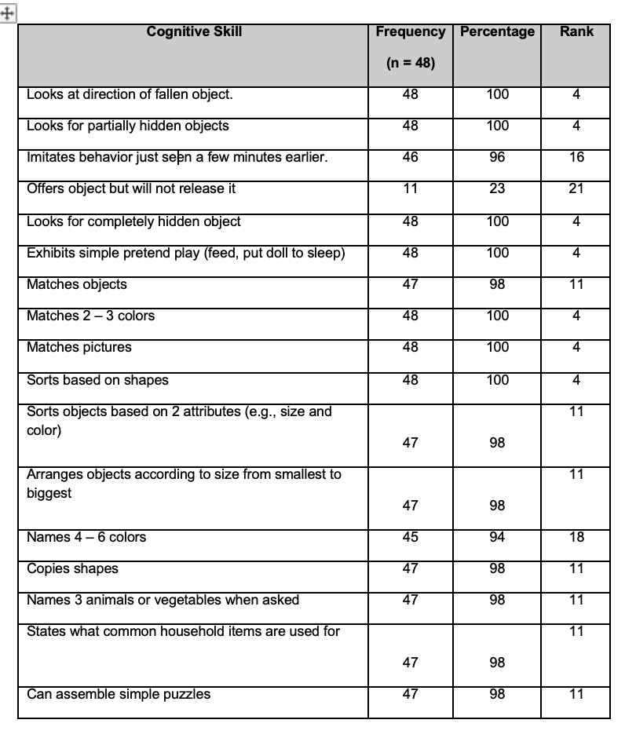
PART I. Description of kindergarten learners’ socio-emotional skills.

Table 1 . Description of kindergarten learners’ socio-emotional skills

The socio-emotional skills of learners, as assessed using the ECCD Tool, reveal a range of developmental achievements and areas for growth. Several skills demonstrated near-universal mastery, with 100% of learners excelling in activities such as laughing or squealing aloud in play, engaging in interactive games like rolling a ball with a caregiver, playing peek-a-boo, and hugging or cuddling toys. These results underscore a strong foundation in joyful, interactive, and nurturing behaviors, which are critical for healthy emotional development.
Other socio-emotional skills were also highly prevalent, including recognizing feelings in others (96%, n = 46) and enjoying watching activities of nearby people or animals (98%, n = 47). These findings reflect the learners' emerging empathy and curiosity about their environment. Additionally, 92% (n = 44) of learners demonstrated culturally appropriate behaviors such as greeting gestures and respect for elders through terms like “po” and “opo,” as well as fair play in organized group games.
Skills such as sharing toys, waiting for turns, and asking permission to use another's toy were performed by 90% (n = 43) of learners. These abilities indicate developing cooperation and social awareness, foundational for forming positive relationships with peers and adults.
Learners also showed interest in adult-like activities, with 90% persisting when faced with a problem or obstacle. However, specific behaviors such as honoring bargains, comforting playmates or siblings, and watching over younger siblings were observed at lower rates, highlighting potential areas for future focus.
Hence, the learners exhibit a strong socio-emotional base with notable strengths in interactive play, emotional expression, and cultural behaviors, providing a solid platform for continued socio-emotional growth.
Study of Walog et al., 2024 highlights that the most learned competencies in socio-emotional skills among early childhood learners include emotional awareness, social skills, and pro-social behaviors. These competencies are crucial as they significantly correlate with improved academic performance and better interpersonal relationships among peers and with adults. The research emphasizes the importance of integrating socio-emotional learning (SEL) into the curriculum to foster these skills effectively, thereby enhancing the overall development of young learners. The study found a correlation between strong social-emotional competencies and improved interpersonal relationships, both among learners and between learners and adults, highlighting the importance of SEL in fostering positive interactions.
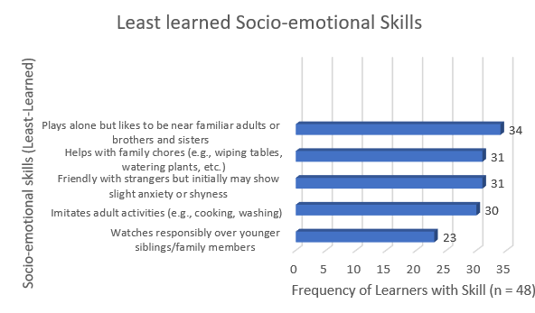

Figure 1. Least-learned Socio-emotional Skills

The graph above highlights the five least-learned socio-emotional skills among early childhood learners, indicating developmental areas that require attention. The least demonstrated skill is "watches responsibly over younger siblings or family members," observed in only 23 learners (48%). This result may reflect limited exposure to caregiving responsibilities or a lack of opportunities for such roles within the family structure.
Imitating adult activities such as cooking and washing was performed by 30 learners (63%), suggesting that while some children engage in role-playing adult tasks, others may benefit from more structured encouragement to participate in such activities. Similarly, being friendly with strangers while showing initial anxiety or shyness was observed in 31 learners (65%), indicating varying comfort levels in unfamiliar social settings.
Helping with family chores, such as wiping tables or watering plants, was also achieved by 31 learners (65%). This finding may highlight differences in household practices or expectations for young children’s participation in daily tasks. Lastly, 34 learners (71%) exhibited the ability to play alone while staying near familiar adults or siblings, suggesting that a portion of children may prefer more interactive or guided play experiences. The graph visually emphasizes these least-learned socio-emotional skills, providing a clear representation of their frequencies and highlighting areas where additional guidance and support could enhance the learners' development.
The importance of social-emotional development in early childhood education, highlighting that delays in this area can hinder a child's ability to socialize effectively with their environment. It emphasizes the necessity for proper social-emotional development to facilitate better interactions and relationships. (Damayanti & Syafril, 2024) The study also highlighted the importance of self-regulation, prosocial behavior, and emotional social behavior, which encompass skills such as managing emotions, helping and entertaining others, and demonstrating empathy and social support, all of which contribute to a child's overall social emotional development.
The relatively lower percentages in these areas may reflect variations in home environments and opportunities for social-emotional learning. This underscores the crucial role of early childhood education in bridging these gaps by intentionally fostering skills like self-regulation, empathy, and cooperative behavior. As emphasized by Damayanti & Syafril (2024), supporting young children in developing these competencies is essential not only for their immediate social interactions but also for their long-term ability to form healthy relationships and adapt to group settings. Providing targeted support in these least-learned areas can significantly enhance children's emotional resilience and social adaptability.

Part II. Description of kindergarten learners’ cognitive skills.
Table 2. Frequency and Percentage of Learners Demonstrating Cognitive Skills

The cognitive skills of the learners, as measured using the ECCD Tool, demonstrate high proficiency across a variety of tasks. Of the 21 skills assessed, 13 were consistently mastered by all 48 participants, with a 100% success rate. These skills include looking at the direction of a fallen object, searching for partially or completely hidden objects, matching 2–3 colors, matching pictures, sorting objects based on shapes, and exhibiting simple pretend play (e.g., feeding or putting a doll to sleep). These results highlight strong foundational abilities in object recognition, matching, sorting, and symbolic play, which are essential developmental milestones in early childhood. Additionally, 98% of learners (n = 47) successfully performed tasks such as matching objects, sorting objects based on two attributes (e.g., size and color), arranging objects by size, copying shapes, naming 3 animals or vegetables, stating the uses of common household items, and assembling simple puzzles. These skills reflect an emerging ability to classify, organize, and utilize cognitive reasoning. Tasks requiring an understanding of opposites and identifying errors or inconsistencies in pictures were successfully completed by 96% of learners. These achievements indicate developing cognitive reasoning and the ability to comprehend relationships and abstract concepts. Taken together, the results reveal that learners have a firm grasp of foundational cognitive skills which indicates their readiness for more complex learning activities. Effective intervention can enhance cognitive growth in children. Cognitive development in preschool children is shaped by a combination of biological, environmental, and experiential factors. Early experiences, such as engaging learning activities, social interactions, and exposure to language-rich environments, play a crucial role in shaping cognitive abilities like attention, memory, problem-solving, and executive functions. Implementing effective interventions—such as structured play-based learning, interactive storytelling, and hands-on activities—can significantly enhance cognitive growth. Educators and parents must create stimulating environments that encourage curiosity, critical thinking, and problem-solving skills. Timely interventions not only strengthen foundational cognitive abilities but also foster a lifelong love for learning, setting children on a path toward academic success and overall intellectual development.

Frequency and Percentage Least Learned Cognitive Skills

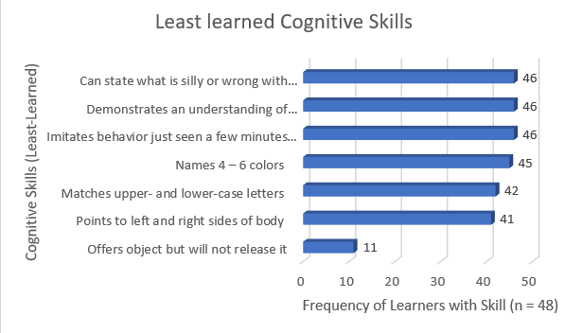

Figure 2. Least-learned Cognitive Skills

The graph above highlights the least-learned cognitive skills among the early childhood learners, reflecting areas where proficiency is relatively lower. These skills include offering an object but not releasing it, which only 11 learners (23%) demonstrated successfully. This finding suggests a potential developmental delay in skills related to sharing or motor coordination. Other least-learned skills, though performed by a majority of learners, show room for improvement. For example, pointing to the left and right sides of the body was correctly identified by 41 learners (85%), and matching upper- and lower-case letters was achieved by 42 learners (88%). These tasks require spatial awareness and early literacy recognition, respectively, indicating areas where additional instructional support may be needed.
Tasks requiring naming 4–6 colors and imitating behavior just seen a few minutes earlier were performed by 45 (94%) and 46 (96%) learners, respectively. Similarly, 96% of learners could demonstrate an understanding of opposites and identify what is silly or wrong with pictures, but these skills still rank lower compared to the consistently mastered tasks. The graph illustrates these least-learned skills with their respective frequencies and ranks, emphasizing the importance of targeted interventions to strengthen these areas of development.
According to the research of Doctor 2024, The ability, knowledge, and mindset that learners need for both academic performance and future learning and life experiences are known as school readiness. To be prepared for school, learners must have developed their physical, cognitive, social, and emotional skills. This descriptive-correlational study was conducted to assess the level of school readiness of the 227 randomly chosen kindergarten learners from 30 public schools in Tudela District, Division of Misamis Occidental. A total of 227 samples were obtained using the sample size calculator to collect data from the respondents using the Early Childhood Care and Development (ECCD) Checklist Record. Results revealed that the Self-Help Domain had the highest level of preparedness, while the Receptive Language and Expressive Language Domains had the lowest. This indicates a need for enhanced language development programs in early childhood education, as communication skills are crucial for learning and social interaction.
Part III. Test of Significant Relationship between Cognitive Skills and Socio-Emotional Skills

Table 3. Relationship between Cognitive Skills and Socio-Emotional Skills

Variables | Spearman’s rho | df | p-value | Interpretation
Cognitive Skills and Socio Emotional Skills | -0.21 | 46 | .155 | Not Significant
Note: at 0.05 level of significance

A Spearman's rho correlation was conducted to determine the relationship between cognitive skills and socio-emotional skills among the early childhood learners. The analysis yielded a correlation coefficient of ρ = -0.21, with df = 46 and a p-value of .155. Since the p-value exceeds the 0.05 level of significance, the result is not statistically significant. This finding indicates that there is no sufficient evidence to suggest a significant relationship between cognitive skills and socio-emotional skills in this sample. The negative correlation, though weak and insignificant, suggests a slight inverse trend, but it does not reliably indicate any substantial interaction between these two domains of development. Further research with a larger sample or different methods might be necessary to explore this relationship more thoroughly. Cognitive and socio-emotional development in children are interconnected, yet distinct domains that can be influenced by various factors. Research indicates that while these areas of development can be related, they are not always directly correlated. For instance, parental attitudes and environmental structuring have been shown to significantly impact cognitive development, but not necessarily socio-emotional development(Rudnova et al., 2024). This suggests that while cognitive and socio-emotional development can be influenced by similar factors, they may not always be directly related. The distinction between cognitive and socio-emotional development highlights the complexity of early childhood growth. Although these domains often develop alongside each other, they are shaped by different influences and do not always progress in tandem. As noted by Rudnova et al. (2024), factors such as parental attitudes and environmental structuring may have a strong effect on cognitive development without necessarily fostering socio-emotional growth. This emphasizes the need for intentional, domain-specific approaches in early childhood education—ensuring that while cognitive skills are nurtured through structured learning and stimulation, socio-emotional development is equally supported through relationship-building, emotional coaching, and social interaction. Recognizing their interconnected yet independent nature allows educators and caregivers to better support holistic child development.

Part IV. Regular Activities Do Children Engage at Home with their Parents

Theme 1: Learning through Play and Creativity

Many parents highlighted the role of play-based activities in their children’s daily routines. These activities typically include reading, storytelling, drawing, coloring, and simple art projects. These practices nurture both cognitive and creative development. Both P12 and P25 describe shared activities, "We spend quality time together by watching shows, engaging in art activities, or playing games. Sometimes, we also enjoy writing and coloring”
Play is not just about entertainment; it is a vital tool for cognitive, social, and emotional development. Through hands-on activities, imaginative scenarios, and interactive experiences, children develop problem-solving skills, creativity, and critical thinking. Whether through structured games or free exploration, play fosters curiosity and a love for learning that lasts a lifetime.
According to the study by Uttiya Ghosh (2024), play-based learning plays a crucial role in shaping the cognitive and emotional development of children aged 3 to 6 years. The research, utilizing a mixed-method approach, explores the effects of different types of play—including free play, guided play, and structured play—on key developmental areas such as problem-solving, language acquisition, emotional regulation, and social interaction. Findings indicate that engaging in play-based activities significantly strengthens cognitive abilities and emotional well-being, while also fostering creativity, resilience, and essential social skills. These developmental benefits create a strong foundation for lifelong learning, reinforcing the critical role of play in early childhood education. Encouraging children to engage their imagination and creativity plays a critical role in healthy cognitive, social, and emotional development. As such, questions about the influence of digital media use (“screen time”) on the development of imagination and creativity are critical. Findings to date regarding the impact of media exposure on creativity are mixed. Some studies suggest that decreases in creative thought and expression are related to the frequency of media exposure and having media in the foreground and background during play.
However, others suggest that media content aiming to engage children’s imagination can promote creativity and abstract thinking, especially when engaging with characters that they love or want to be like. (Richert et al., 2024). Parents and educators should focus on curating media experiences that inspire exploration, storytelling, and creative thinking rather than simply restricting screen time altogether.
Creativity can be enhanced and developed through play, making it essential to incorporate play into early childhood education. Play provides children with opportunities to explore, experiment, and express themselves freely, fostering imagination and problem-solving skills. Through open-ended and unstructured play, children engage in storytelling, role-playing, and abstract thinking, all of which are crucial for cognitive and social development.
Moreover, integrating play with thoughtfully designed media content can further support creativity. When children interact with media that encourages imaginative engagement—such as storytelling games, interactive shows, or role-playing activities—they can expand their creative thinking. However, passive media consumption should be balanced with hands-on play experiences to maximize benefits. Ultimately, play serves as a powerful tool for nurturing creativity, curiosity, and innovation in young minds, reinforcing the importance of active, imaginative experiences in early childhood development.

Theme 2: Daily Routines as Learning Opportunities

Parents shared that they actively involve their children in household chores and daily family routines, fostering responsibility and essential life skills. These activities include cleaning, cooking, and assisting with small tasks in family businesses. For instance, P30 mentioned allowing their child to help in their store by arranging items, handing out change, or simply observing how adults serve customers. Similarly, another parent shared that their child engages in both play and household tasks, such as tidying up the bedroom, folding blankets, and arranging pillows. These experiences not only encourage participation in daily responsibilities but also create meaningful opportunities for learning and bonding within the family. The findings suggest that children who consistently follow structured routines, such as household chores, play, mealtime, and bedtime, exhibit fewer attentional, externalizing, and internalizing problems compared to those whose routines decline over time. stablishing a routine in early childhood is essential, as it helps children become familiar with their daily tasks and responsibilities. A consistent routine provides structure, allowing young learners to develop a sense of security and independence. It also reinforces important life skills by helping them recognize and remember the activities they need to accomplish each day. Through routines, children gain confidence, improve time management, and build a strong foundation for lifelong habits.This highlights the stabilizing effect of routines in fostering self-regulation, emotional security, and social competence. Given that most children maintained their routine patterns over time, the study emphasizes the importance of encouraging and sustaining structured daily activities throughout early childhood to support positive developmental outcomes. Similarly to the study of Selman 2025, examines the association between preschool children's routine use and socioemotional adjustment, finding that consistently high routine use is linked to better adjustment, while decreasing routine use is associated with increased attentional and behavioral problem.
Theme 3: Physical and Social Play

Outdoor games and social interactions with peers and family members were frequently mentioned as valuable experiences for children. Engaging in activities such as riding bicycles, playing badminton, and participating in group games fosters physical development, social skills, and meaningful connections. For instance, P40 highlighted the joy of riding a bicycle, coloring books, and spending quality time playing with cousins and grandparents. These activities not only provide entertainment but also strengthen family bonds and encourage active, creative play.
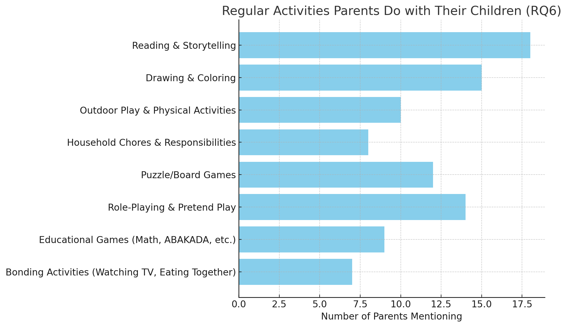

Figure 3: Regular Activities Parents do with their children
Parents most commonly engage in Reading & Storytelling with their children, emphasizing its significance in fostering strong parent-child interactions. Similarly, Drawing & Coloring is a frequently mentioned activity, highlighting its contribution to early childhood creativity and cognitive development. The data suggests that parents tend to prioritize activities that support both education and creativity, such as reading, artistic expression, and outdoor play. Meanwhile, structured recreational activities like board games and role-playing hold moderate importance, whereas unstructured bonding activities, such as watching television or shared mealtimes, appear less frequently mentioned—possibly because they are considered routine rather than intentional engagement. The study of Rodriguez, (2023) agreed how physical activity in play influences preschoolers' cognitive, linguistic, and emotional development. Findings showed that children who engaged in more physically active play had better communication skills, emotional expression, social interaction, and adaptability. Additionally, playing with nearby adults further improved adaptive skills.
Part V. Activities do parents believe can enhance their child's socio-emotional and cognitive development, and how do these activities contribute to their overall growth

Theme 4: Interactive Social Play Enhances Emotional Growth
Parents emphasized that role-playing, collaborative games, and social play enhance their children's empathy, communication, and teamwork.

Social skills in early childhood are vital, as they serve as the foundation for a child's ability to interact and build relationships with others. During this stage, children learn essential skills such as communication, cooperation, and empathy, which help them navigate social interactions and develop meaningful connections. These early experiences shape their ability to understand and engage with the world around them, fostering confidence and emotional intelligence as they grow. Parents highlighted the significance of social interactions and creative activities in their children's development. Engaging in activities such as arts and crafts not only nurtures creativity but also enhances social skills by encouraging communication and collaboration. P22 shared that they encourage their child to socialize with peers through fun activities like art, allowing them to interact and express themselves. Similarly, P29 emphasized the value of collaborative play with siblings and neighbors, which helps children develop essential skills such as teamwork, cooperation, and sharing. These experiences contribute to a child's overall social and emotional growth, preparing them for positive interactions in various settings.
Interactive teaching strategies provide opportunities for engaging children in discussing difficult concepts such as socio-emotional wellbeing and wide range of ideas about their social and personal lives. However, few studies have explored preschool teachers’ efficacy of using coaching through ‘Play and puppetry programs as approaches to developing children’s emotional regulation, socio-emotional learning and wellbeing. This paper reports on a “Labyrinth Project” aimed to gain in-depth understandings of preschool teachers’ experiences and perspectives pertaining to their efficacy of using play and puppetry as tools to promote children’s emotional learning and development. The results showed that despite early challenges with the use of these two teaching strategies, coaching and professional development facilitated a progression from feelings of inadequacy to confidence to teach social emotional skills using play and puppetry. At the end of the second year of this three-year project, children demonstrated improved cognitive skills in managing their emotions. (Tamakloe et al., 2024). When children engage in role-playing, they actively develop essential emotional and social skills. This activity serves as a powerful tool for navigating social situations, allowing children to practice empathy, communication, and emotional regulation in a safe and imaginative environment. Through role-playing, children learn to understand different perspectives, express their emotions effectively, and build meaningful relationships, all of which contribute to their overall socio-emotional growth.

Theme 5: Structured Cognitive Activities Promote Critical Thinking
Puzzle-solving, math games, and educational storytelling were believed to stimulate reasoning and problem-solving abilities.

Parents recognize the importance of activities that support cognitive development, particularly those that enhance problem-solving and critical thinking skills. P28 emphasized that engaging in activities like math helps strengthen these abilities, making them beneficial for a child's intellectual growth. Similarly, P32 highlighted various cognitive-enriching activities such as reading, solving puzzles, coloring, working with wooden puzzles, and sorting objects. These activities not only promote critical thinking and problem-solving but also contribute to a child's overall learning experience, helping them develop essential skills for future academic success. Engaging children in activities such as puzzle-solving, math games, and educational storytelling plays a crucial role in developing their reasoning and problem-solving abilities. These interactive experiences nurture critical thinking, logical reasoning, and cognitive flexibility, equipping children with the skills needed to tackle both academic tasks and real-world situations. The perspectives shared by parents and educators emphasize the significance of hands-on learning experiences, including puzzles, sorting activities, and interactive reading. These methods serve as effective tools for fostering cognitive growth. By incorporating these activities into daily routines, children refine their analytical and strategic thinking skills, laying a strong foundation for future learning and informed decision-making. This aligns with the findings of Tzuriel (2021), who highlights the role of cognitive education in promoting systematic thinking and problem-solving processes. Activities such as puzzle-solving, math games, and educational storytelling support this approach by enhancing critical thinking and metacognitive skills, which are essential for effective learning and reasoning.
Theme 6: Emotional Support and Life Skills through Parental Engagement
Parents highlighted the importance of emotional coaching, praise, and responsibility-giving as foundational for emotional intelligence and independence. One parent shared their approach to fostering emotional expression and responsibility in their child. They emphasized the importance of active listening, ensuring that their child feels heard and understood. "I will always listen to them so they can learn to express their feelings," the parent explained, highlighting how open communication helps children articulate their emotions effectively. Additionally, the parent emphasized the importance of teaching responsibility through small tasks. By assigning manageable duties, such as tidying up toys or assisting with simple household chores, they aimed to cultivate a sense of accountability and independence from an early age. This balanced approach—promoting emotional expression while gradually introducing responsibility—demonstrates a thoughtful parenting strategy that supports both socio-emotional and cognitive development. This perspective aligns with the research of Sharma (2024), which underscores the significant role of parental involvement in a child's educational journey. The study highlights how active engagement from parents contributes to various aspects of student success, including academic performance, attitudes toward learning, and emotional development. It explores different forms of parental participation, such as maintaining open communication with teachers, engaging in school activities, and providing academic support at home. By drawing on empirical evidence and theoretical frameworks, Sharma’s research emphasizes the positive impact of parental involvement across diverse educational settings and socio-economic backgrounds, reinforcing the notion that parental guidance plays a vital role in shaping children's overall development.
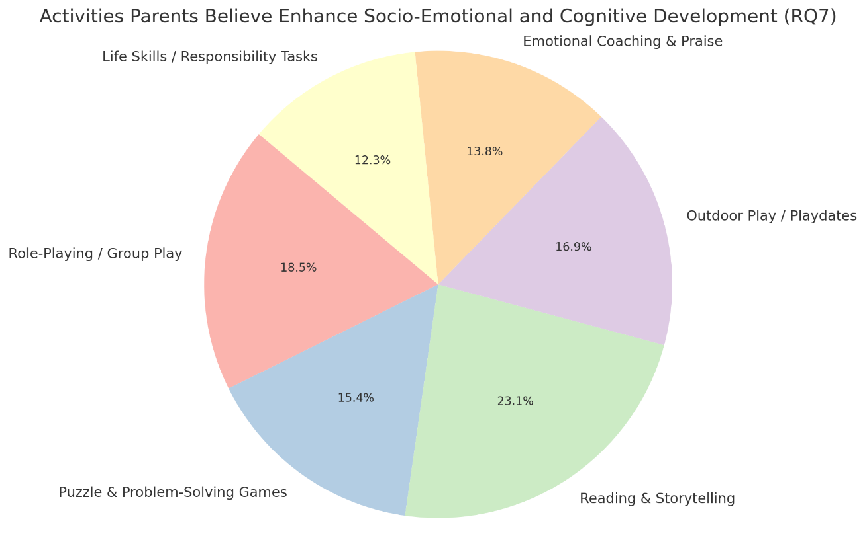

Figure 4: Activities That Parents Believe Enhance Socio-Emotional and Cognitive Development

The largest portion of parents identified reading and storytelling as the most beneficial activity for socio-emotional and cognitive development. This suggests that parents value literacy-based activities for fostering imagination, communication, and emotional intelligence. Second most recognized, emphasizing how social interactions help children build empathy, cooperation, and problem-solving skills. Many parents believe that playing outdoors and engaging with peers contributes to emotional regulation, teamwork, and physical well-being. The shows that parents see a balance of academic, social, and emotional activities as crucial for child development. Reading and storytelling are considered the most impactful, but other interactive and play-based activities also play a significant role. Parents recognize that a combination of structured and unstructured play, problem-solving activities, and emotional guidance is essential for fostering well-rounded growth in children.
Part VI. Parents' Perceptions of Socio-emotional and Cognitive Development Based on the Early Childhood Care and Development (ECCD) Checklist.
Theme 7: Recognition of Progress and Milestones
Parents expressed satisfaction with their children's developmental milestones. Improvements in empathy, communication, and cognitive abilities were commonly noted. Parents observe and appreciate the gradual progress their children make in developing various skills, highlighting both independence and socio-emotional growth. One parent shared how their child has shown continuous improvement over time: "I can say that he develops some skills and he improved a lot. Step by step he can do a lot on his own." (P3). This statement reflects the child’s journey toward self-sufficiency, reinforcing the idea that development is a process that unfolds progressively through experience and learning. Another parent noted their child's social-emotional awareness, acknowledging both challenges and strengths. "She may struggle sitting still or waiting for her turn at times, but we notice how empathetic she is." (P15). This observation highlights that while children may face difficulties in areas like patience and impulse control, their empathy and emotional intelligence continue to flourish. Together, these insights emphasize the individualized nature of child development, where each step—whether in acquiring independence or building emotional awareness—plays a crucial role in shaping a child’s overall growth. Parents express satisfaction as they witness improvements in their children's empathy, communication, and cognitive abilities, reinforcing the importance of nurturing both independence and socio-emotional skills.
According to the research of Kabir et al. (2021), every family operates within its own unique background, cultural beliefs, and expectations, all of which influence parental involvement in a child's early education. Understanding the factors that drive or hinder parental engagement in preschool education is essential for strengthening the link between parental participation and school readiness. The home serves as the first social environment where children begin to comprehend the world, making it a crucial foundation for early learning. Through daily interactions with parents and home experiences, children internalize cultural values, develop foundational skills, and form perceptions that shape their future learning experiences. This study explores the role of parents in their child’s school readiness, examining how parental involvement contributes to a child’s physical, cognitive, and linguistic development before formal education begins. The findings highlight that active parental participation in early childhood learning fosters a more seamless transition to formal schooling, equipping children with essential skills needed for academic and social success.

Theme 8: Continued Need for Guidance and Support
Many parents acknowledged that while progress is evident, their children still need guidance, particularly in areas like patience, social interaction, and task focus. Parents acknowledge that their child's development is an ongoing journey that demands patience, commitment, and a strong support network. One parent emphasized this perspective, stating, "As a parent, there is more to be done for my son’s own progress, but what is important is the assistance and help of school, therapy center, and other family members one step at a time." (P41).This sentiment underscores the collaborative nature of child development, where multiple influences—including parents, educators, therapists, and extended family members—play essential roles in fostering growth. While parents serve as primary caregivers and guides, structured learning environments, professional interventions, and social support systems significantly enhance a child's progress. By recognizing the importance of shared responsibility, this perspective reinforces the idea that a child’s development flourishes when nurtured by a collective effort. A combination of consistent support, expert guidance, and a positive, enriching environment provides children with the necessary foundation to thrive academically, emotionally, and socially.
Parents play a crucial role in monitoring their child's development to ensure they stay on the right track. To effectively support their growth, it is essential for parents to utilize structured assessment tools that provide clear insights into their child’s progress. Among the most valuable resources for this purpose are the Early Childhood Care and Development (ECCD) Checklist and the Progress Report Card. The ECCD Checklist serves as a comprehensive developmental assessment tool, helping parents and educators identify a child’s strengths and areas that may require additional support across various domains, including cognitive, socio-emotional, physical, and language development. Similarly, the Progress Report Card offers a systematic record of a child's academic performance and behavioral development, allowing parents to track improvements and address any learning gaps. By regularly reviewing these documents, parents can make informed decisions, collaborate effectively with teachers, and implement necessary interventions to enhance their child’s learning experience and overall well-being. The progress card of the student typically provides information about their development only once a semester, which can limit parents' ability to track their child's ongoing progress effectivel (Aman et al., 2022)
Theme 9: ECCD as a Tool for Awareness and Reflection
The Early Childhood Care and Development (ECCD) Checklist serves as a valuable tool for parents, enabling them to monitor their child's developmental milestones, assess strengths, and identify areas that require additional support. One parent emphasized its significance, stating that the ECCD checklist helps them recognize their child’s specific developmental needs and determine key areas to focus on for growth. Mhlanga's (2023) study found that the use of developmental checklists primarily focuses on assessing children's growth and development rather than categorizing them as competent or incompetent based on predetermined scores. The research also revealed that many educators tend to prioritize assessment results over the learning process itself. Furthermore, the lack of intervention strategies based on observation can hinder a child's progress. From these findings, it can be concluded that developmental checklists serve as valuable tools for promoting learning and development in young children. The study, therefore, recommends the proper utilization of developmental checklists within a well-structured environment, as this approach accommodates individual differences while fostering meaningful learning experiences.
Theme 10: Proposed Intervention Plan

The intervention plan synthesizes qualitative and quantitative findings and includes:

- Interactive Play-Based Learning Programs
Focus on role-playing, storytelling, and group play to foster socio-emotional skills. Role-playing activities (e.g., community helpers, family scenarios) to encourage empathy and communication
- Parent-Led Structured Cognitive Activities
Encourage home-based math games, puzzles, and sorting tasks to support cognitive development.
- Outdoor and Group Activities for Social Skills
Promote organized playdates and outdoor activities to enhance peer interaction and teamwork.
- Parental Workshops on ECCD Framework Utilization
Provide orientation and strategies to help parents better interpret ECCD assessments and apply insights to guide their children's growth.
- Emotional Literacy and Life Skills Program Incorporate daily emotional check-ins, affirmation practices, and household responsibilities to promote self-regulation and resilience.
Part VII. Convergences Between Quantitative and Qualitative Findings.
The analysis revealed several areas of convergence between the quantitative findings gathered through the ECCD checklist assessments and the qualitative data collected from parent interviews. These convergences reinforce the credibility of the results by demonstrating alignment across different methods of data collection and perspectives. Parents’ descriptions of their children’s day-to-day activities and developmental milestones frequently mirrored the trends identified in the ECCD assessments.
For instance, foundational cognitive skills such as matching, sorting, and problem-solving were consistently mentioned by parents and were reflected in high ECCD scores. Parents actively fostered these skills through activities like puzzle-solving, storytelling, and reading, resulting in 100% mastery in several cognitive tasks, including sorting objects by shape and engaging in pretend play. Similarly, socio-emotional skills (particularly empathy, sharing, and turn-taking) were well-developed according to both data sources. Parents frequently observed these behaviors in role-play and collaborative games, which corresponded with high rates of sharing and recognizing emotions in the ECCD results.
Parents’ active roles in facilitating their children’s learning at home further corroborate ECCD findings of strong cognitive development. Many parents described structured activities like reading and math games, aligning with children’s excellent performance in literacy and numeracy tasks on the ECCD tool. Additionally, both datasets emphasized the importance of outdoor play and social interaction for socio-emotional growth.

Aspect | Explanation | Sample Evidence (Quanti and Quali)
Foundational Cognitive Skills | Both datasets affirm that children have mastered basic cognitive skills such as sorting, matching, and simple problem-solving activities. | Quantitative: 100% mastery in matching pictures, sorting by shape, symbolic play.  Qualitative (P12): "We do ABAKADA in our free time. We also do puzzles and sorting games together."
Socio-Emotional Skills (Empathy & Play) | Parents and ECCD data both show children demonstrate empathy, sharing, and turn-taking in social play. | Quantitative: 96% identify feelings, 90% share toys.  Qualitative (P15): "She may struggle sitting still but she is empathetic and comforts friends when they are sad."
Use of Pretend/Role-Play | Both data sets highlight pretend play as common, supporting socio-emotional learning and cognitive development. | Quantitative: 100% exhibit pretend play.  Qualitative (P33): "We play doctor and patient. She loves being the doctor and explaining things to her dolls."
Focus and Attention (Turn-Taking) | Both data sets identified areas for improvement in patience and focus (e.g., waiting for a turn). | Quantitative: 83% wait for their turn.  Qualitative (P15): "She’s very energetic and has a hard time waiting her turn in group activities, but she’s learning slowly."
Outdoor Play and Peer Engagement | Both findings highlight outdoor and group play as important to socio-emotional development. Parents encourage peer play; ECCD shows strong group cooperation. | Quantitative: 90% play organized group games fairly.  Qualitative (P19): "Playing outside with friends teaches him to share and wait for his turn."
Parental Role in Cognitive Stimulation | Parents actively engage in home learning activities like math and literacy, which align with children's strong performance on cognitive ECCD indicators. | Quantitative: 100% mastery in matching and sorting.  Qualitative (P17): “She loves reading books and counting things around the house. We make learning part of daily life.”

While there are clear areas of alignment between the quantitative and qualitative findings, several divergences were also noted. These divergences offer insights into the complexities of child development and illustrate how parental perceptions and home contexts may influence developmental outcomes differently than standardized assessments. The findings indicate that children have successfully developed fundamental cognitive abilities, including sorting objects, matching items, and engaging in problem-solving tasks. These foundational skills play a vital role in fostering higher-order thinking and preparing children for future academic learning.
Similarly, the results highlight the progression of children's social and emotional skills, such as recognizing emotions, sharing with peers, and taking turns. These competencies are essential for building strong peer relationships and fostering positive social interactions.
One key divergence lies in the opportunities for social interaction. While the ECCD data reported high levels of cooperative behavior and social play, some parents described limited opportunities for their children to interact with peers outside their immediate family, due to household dynamics or lack of community interaction. This suggests that while social skills may be demonstrated in formal assessments, real-life contexts may limit their consistent application.
Another divergence was identified in the perceived link between cognitive and socio-emotional development. Many parents believed that activities fostering cognitive skills, such as math games, also strengthened their child’s socio-emotional abilities, including teamwork and patience. However, the statistical analysis revealed no significant correlation between cognitive and socio-emotional skills within the ECCD results.
Furthermore, although parents frequently reported involving their children in household chores to foster responsibility, ECCD data indicated a lower percentage of children participating in such activities. This highlights potential discrepancies between parental perception and actual behavioral assessments. Additionally, the ECCD checklist was variably perceived; while some parents found it helpful in monitoring development, others were unfamiliar with its content and purpose, pointing to a gap in parental understanding or engagement.

Aspect | Explanation | Sample Evidence (Quanti and Quali)
Social Interaction Opportunities | While ECCD data show most learners demonstrate social interaction skills, parents noted limited opportunities for interaction outside family settings. | Quantitative: 90% cooperate in groups.  Qualitative (P43): "He needs reminders when playing with others to be patient; he doesn’t always have playmates here at home."
Link Between Cognitive and Socio-Emotional Development | Parents often described cognitive and socio-emotional development as closely connected, but the statistical correlation was not significant. | Quantitative: Spearman's rho = -0.21 (not significant).  Qualitative (P28): "Math games help him focus, and he enjoys working in teams to solve puzzles with his cousins."
Household Chores and Life Skills | Parents reported involving children in household chores to teach responsibility, yet the ECCD data showed fewer children help with family chores. | Quantitative: Only 65% help with family chores.  Qualitative (P30): "I let him help sweep the floor and fold laundry. He’s learning responsibility."
Perception and Use of ECCD Checklist | Some parents value ECCD for monitoring development, while others show limited awareness of its purpose or application. | Quantitative: Universal ECCD tool application by assessors.  Qualitative (P41): "I’m not fully familiar with the ECCD checklist, but I think it’s helpful when explained by the teacher."

Recommendation
Based on the findings of this study, the following recommendations are proposed:

Targeted Interventions for Least-Learned Skills – Educators should implement focused strategies to enhance the development of socio-emotional and cognitive skills that were identified as least learned, such as understanding opposites and imitating adult activities. Activities such as role-playing, interactive storytelling, and structured play can help strengthen these areas.

Parental Involvement in Early Learning – Schools should encourage active parental involvement in the development of both cognitive and socio-emotional skills. Conducting parent workshops or training sessions on effective home-based learning strategies can be beneficial. Teacher Training Development- The ECCD Checklist serves as a valuable assessment tool for tracking a child's developmental progress across multiple domains. To maximize its effectiveness, comprehensive training programs for early childhood educators should be implemented. The ECCD checklist can be utilized

Conclusion
This study evaluated the socio-emotional and cognitive development of kindergarten pupils using the Early Childhood Care and Development (ECCD) checklist. The findings revealed that while most children demonstrated proficiency in fundamental cognitive skills, certain areas—such as understanding opposites and imitating adult activities—showed room for improvement. Additionally, the study identified a weak, negative, and statistically insignificant correlation between cognitive and socio-emotional development, suggesting that these domains may progress independently rather than in direct relation to each other. Developmental checklists serve as essential tools for tracking and fostering learning in young children. Therefore, the study emphasizes the proper and consistent utilization of these checklists within a well-structured learning environment, ensuring that individual differences are recognized while promoting meaningful, holistic development.
Parental insights provided valuable perspectives on activities that support children's growth. The majority of parents identified reading and storytelling as the most beneficial activities for enhancing socio-emotional and cognitive development, emphasizing their role in stimulating imagination, strengthening communication skills, and nurturing emotional intelligence. Social interactions ranked as the second most recognized factor, highlighting their importance in developing empathy, cooperation, and problem-solving skills. Additionally, many parents stressed the value of outdoor play and peer engagement, noting their contributions to emotional regulation, teamwork, and overall physical well-being. Interestingly, there was a divergence between parental perceptions and statistical findings regarding the relationship between cognitive and socio-emotional development. Many parents believed that activities fostering cognitive skills, such as math games, also contributed to socio-emotional growth, particularly in areas like teamwork and patience. However, statistical analysis of ECCD results found no significant correlation between cognitive and socio-emotional skills, suggesting that while these areas may influence each other in practical settings, they do not always develop in tandem.
These findings reinforce the importance of a balanced and integrated approach to early childhood education, combining structured cognitive learning with rich social and emotional experiences to support comprehensive child development.

REFERENCES:

Albina, AC.; Balasabas, JY.; Laquinon, B J I.; Pampilo, MH; Caballero & L J. , Factors and Challenges Influencing the Criminologist Licensure Examination Performance through the Non-Passers' Lens, European Journal of Educational Research, v11 n1 p365-380 2022, https://eric.ed.gov/?id=EJ1329072

Aman, A., Utami, L. T., Aras, M. K. A., & Kasmi, M. (2022). Information System for Monitoring the Development of Children With Special Needs. 1(2), 1–7. https://doi.org/10.56134/cje.v1i2.24

Aung, N. W. A Study on the Stakeholders' Perceptions and Community Participation for Community Based Early Childhood Care and Development Centers (Case Study: ECCD Centers at Pwint Phyu Township)(Nan Wai Aung, 2022)(Doctoral dissertation, MERAL Portal).

Binayao, BS, & Dalez ZI (2020), A Phenomenological Study of the Passers and Non-Passers in the Licensure Examination for Teachers, International Journal of Innovative Science and Research Technology Volume 5, Issue 8, August – 2020 ISSN No:-2456-2165 https://ijisrt.com/assets/upload/files/IJISRT20AUG828.pdf

Briones, M. A. (2021), Licensure Examination: Students’ Intrinsic and Extrinsic Factors as Success Predictor, Vol. 2 No. 2 (2021): Journal of English Education and Linguistics, https://jurnal.stain-madina.ac.id/index.php/je2l/article/view/424

Briones, MA & Romero VA (2020), Examining the Personal Factors Affecting Licensure Examination Preparation, Journal of English Education and Linguistics, Issue Vol. 1 No. 2 (2020), https://jurnal.stain-madina.ac.id/index.php/je2l/article/view/52
Cabahug, M.M., Bonghanoy, S.M.A., Tubog Jr. J., Asingua, A.B., Chen, Q. & Tul-id, C.S. (2024). Graduates are Failing in the Examination: An Ethical Investigation on the Experiences of Board Licensure Examination for Teachers (BLEPT) Takers. American Journal of Multidisciplinay Research and Innovation, 3(2),1-6. https://doi.org/10.54536/ajmri.v3i2.2514

Calubayan, MA C. (2020), Performance of Southern Luzon State University – BS Accountancy in the Board Licensure Examination: A Basis of Proposed Intervention Program, Journal of Business and Management Studies, https://al-kindipublisher.com/index.php/jbms/article/view/854

Cortez, M., Alipante, A., & Lajato, D. (2017). Binary logistic model on factors affecting the result of licensure examination for teachers (LET). International Journal of Education and Research, 5 (5), 279, 288.

Collie, R. J., Martin, A. J., Nassar, N., & Roberts, C. L. (2019). Social and emotional behavioral profiles in kindergarten: A population-based latent profile analysis of links to socio-educational characteristics and later achievement. Journal of Educational Psychology, 111(1), 170.

Dayaday, MG, Factors Affecting the Performance in the Board Examination of Electronics Engineering – University of Southern Mindanao Graduates, International Journal for Current Research https://www.journalcra.com/article/factors-affecting-performance-board-examination-electronics-engineering

DOCTOR, F. (2024). SCHOOL READINESS AMONG KINDERGARTEN LEARNERS: BASIS FOR POLICY RECOMMENDATION. Sprin Journal of Arts, Humanities and Social Sciences, 3(2), 26-34.

Doctor, F., & Macalisang, D. S. (2024). School readiness among kindergarten learners: basis for policy recommendation. Sprin Journal of Arts, Humanities and Social Sciences. https://doi.org/10.55559/sjahss.v3i2.219

Delos Angeles, M. (2019), Curriculum and Quality of Instruction Factors for Successful Board Examination Performance, American Journal of Humanities and Social Sciences Research (AJHSSR) e-ISSN :2378-703X Volume-3, Issue-6, pp-250-253, https://www.researchgate.net/profile/Marie-Ann-Gladys-Delos-Angeles/publication/334250868

Espartero, JR E. (2022), Factors that Influenced and Problems Encountered in the Criminologist Licensure Examination, International Journal of Innovative Science and Research Technology ISSN No:-2456-2165, Volume 7, Issue 5, May – 2022, https://ijisrt.com/assets/upload/files/IJISRT22MAY1268_(2)_(1).pdf
Gallardo-Rodríguez, R., Léniz-Maturana, L., Gallardo-Rodríguez, K., & Hidalgo-Pérez, H. (2023). Parent-Perceived Child Development in Preschoolers Engaging in Play that Includes Physical Activity. International Journal of Human Movement and Sports Sciences. https://doi.org/10.13189/saj.2023.110414

Ghosh, U. (2024). The Role of Play-Based Learning in Enhancing Cognitive and Emotional Development in Early Childhood. International Journal For Multidisciplinary Research, 6(6). https://doi.org/10.36948/ijfmr.2024.v06i06.34144

Herrero, C.C. (2015). Influence of Selected Factors on CPA Licensure Examination Results. International Letters of Social and Humanistic Sciences, 64, 87-93. Retrieved March 23, 2024 from https://www.learntechlib.org/p/177153/.

Herrera, L., & San Lorenzo, A. S. de. (2024). Socio-Emotional Development in Early Childhood Education Classrooms (pp. 217–241). IGI Global. https://doi.org/10.4018/979-8-3693-0956-8.ch010

Kuria, ME (2022), Factors Influencing Bachelor of Science in Clinical Medicine Students’ Performance in Clinical Officers Council Licensure Examination in Nairobi, Kenya, Amref International University, https://repository.amref.ac.ke/handle/123456789/814

Maloloy-on M., Igcasama, AM, Layao, J. & Magallano, SM, Factors Affecting the Licensure Examination for Teachers (LET) Performance of Saint Michael College of Caraga from 2017-2019, https://www.researchgate.net/publication/357828184

MHLANGA, S. (2023). USE OF DEVELOPMENTAL CHECKLIST IN TEACHING AND LEARNING AT EARLY CHILDHOOD DEVELOPMENT LEVEL IN MAUN BOTSWANA. GEN-MULTIDISCIPLINARY JOURNAL OF SUSTAINABLE DEVELOPMENT, 1(2), 111-123.

Moore A, Nguyen A, Rivas S, Bany-Mohammed A, Majeika J, Martinez L. A qualitative examination of the impacts of financial stress on college students’ well-being: Insights from a large, private institution. SAGE Open Medicine. 2021;9. doi:10.1177/20503121211018122

Webster, KE (2020), Student Perceptions of Barriers to Professional Exam Success, Internet Journal of Allied Health Sciences and Practice, https://nsuworks.nova.edu/cgi/viewcontent.cgi?article=1853&context=ijahsp

Selman, S. B., Distefano, R., Dilworth‐Bart, J. E., & Brooks‐Gunn, J. (2025). Child routines across preschool and associations with socioemotional adjustment. Journal of Family Psychology. https://doi.org/10.1037/fam0001299

Sharma, R. C. (2024). The Effects of Parental Involvement on Student Academic Success. Global International Research Thoughts, 12(1), 43–48. https://doi.org/10.36676/girt.v12.i1.111

Tamakloe, D., Powers, E., Landis, A., & McCracken, L. (2024). Teachers’ Experiences of Using Play and Al’s Pals to Teach Socio-Emotional Skills Through Coaching Support Models. Excelsior. https://doi.org/10.14305/jn.19440413.2023.16.2.02
Richert, R. A., Choi, K., Gleason, T. R., Goldstein, T. R., & Sibert, S. M. (2024). Imagination, Creativity, and Play. 47–53. https://doi.org/10.1007/978-3-031-69362-5_7

Umarova, M. (2024). Development of cognitive processes of preschool children. International Journal of Pedagogics, 4(12), 97–101. https://doi.org/10.37547/ijp/volume04issue12-19

