To Investigate Directional Solidification Furnace-Based Multi-Crystalline Silicon Growth

Ashok Kumar* & Dr. Ajay Kumar**
*Research Scholar, Department of Physics, SKD University, Hanumangarh
**Assistant Professor, Department of Physics, SKD University, Hanumangarh
(Corresponding author: email - ashokkumarskr32@gmail.com)

Highlights
- Directional solidification enables scalable multi-crystalline silicon ingot production.
- Heat-transfer tuning improves interface control and crystal quality.
- Crucible and cover choices influence impurity incorporation pathways.
- Carbon transport and SiC particle behaviour affect ingot cleanliness.
- Furnace design strongly governs thermal stress and defect risks.
Abstract
a) Background
Multi-crystalline silicon remains crucial for cost-effective photovoltaic manufacturing. Directional solidification furnaces enable large-volume ingot casting with control.
b) Objective
This study investigates furnace-controlled growth mechanisms for multi-crystalline silicon. It focuses on heat transfer, impurity transport, and stress formation.
c) Methods
A simulation-led furnace workflow is outlined for interface stabilization. Thermal fields are interpreted using design–stress relationships from literature. Impurity and SiC behaviour are mapped to process configuration choices.
d) Results
Reported studies show crucible properties reshape melt interface geometry. Optimized heat transfer improves crystal quality under vacuum systems. Furnace design changes reduce thermal stress and defect susceptibility.
e) Comparison with Literature
Impurity reduction strategies align with crucible cover optimization reports. Carbon–oxygen transport modelling supports contamination control approaches. SiC formation and engulfment mechanisms support cleanliness-focused redesign.
f) Conclusion
Directional solidification performance depends on coupled thermal–chemical control. Furnace optimization can improve quality, stability, and manufacturability outcomes.
Keywords: Directional solidification; multi-crystalline silicon; Furnace design; Heat transfer; Impurity control; Thermal stress
1. Introduction
1.1 Role of multi-crystalline Silicon in Photovoltaics
Multi-crystalline silicon supports high-throughput photovoltaic wafer manufacturing routes. It balances material cost with acceptable conversion efficiency performance. Large-area ingot casting enables scalable wafer supply for global solar deployment. Industrial adoption relies on reproducible crystal quality across large ingot volumes. Thermal control during solidification strongly determines final material performance (Partain, 1995; Komp, 2001; Kazmerski, 2024).
1.2 Directional Solidification Furnace Concept
Directional solidification furnaces allow controlled solid–liquid interface movement. The melt solidifies progressively from bottom to top under imposed gradients. Controlled freezing reduces random nucleation and enhances grain growth continuity. Interface shape and velocity govern grain orientation and boundary formation. Directional solidification remains the dominant route for multi-crystalline silicon growth (Arnberg et al., 2012; Lan et al., 2016).
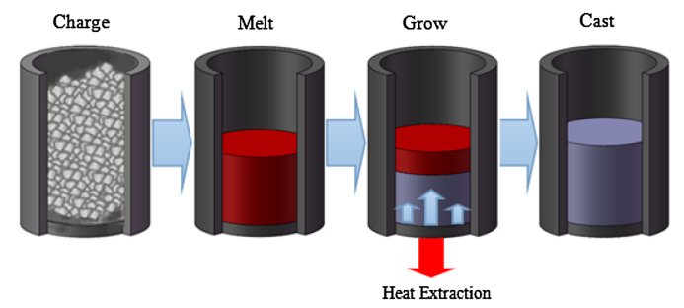
Figure 1: Directional solidification of multi-crystalline silicon growth in the vertical furnace (Yang et al., 2015)
1.3 Importance of Interface Stability
Interface stability influences grain structure and defect formation tendencies. Unstable interfaces promote cellular growth and sub-grain defect formation. Stable planar interfaces favour larger grains with reduced boundary density. Thermal gradients and pulling rates jointly define interface morphology. Numerical studies demonstrate strong sensitivity to furnace thermal design (Miyazawa et al., 2009; Fang et al., 2012).
1.4 Heat Transfer and Thermal Gradient Control
Furnace heat transfer governs gradients that drive stress during freezing. Axial gradients control solidification rate and grain elongation behaviour. Radial gradients induce thermal stress and dislocation multiplication. Imbalanced heat flow causes asymmetric temperature fields across the ingot. Optimized insulation and heater zoning reduce gradient non-uniformity
(Yang et al., 2014; Yang et al., 2015a).
1.5 Impurity Transport and Contamination Pathways
Contamination arises through coupled carbon and oxygen transport pathways. Carbon originates from graphite components and furnace atmosphere reactions. Oxygen primarily diffuses from silica crucibles into molten silicon. Impurity redistribution depends on melt convection and thermal gradients. High impurity levels degrade electrical properties and carrier lifetime (Gao et al., 2009; Gao et al., 2011b).
1.6 Silicon Carbide Formation and Engulfment
SiC particles can form, move, and become engulfed during growth. Carbon supersaturation promotes silicon carbide nucleation near interfaces. Particles migrate due to thermal gradients and melt convection forces. Engulfed SiC inclusions reduce wafer yield and mechanical integrity. Growth conditions determine whether particles are rejected or trapped (Zheng et al., 2011; Arnberg et al., 2012).
1.7 Influence of Crucible and Cover Materials
Crucible cover material can change impurity uptake during casting. Cover permeability affects gas-phase transport of carbon-containing species. Material selection alters oxygen back-diffusion into the melt. Optimized cover design reduces impurity incorporation during solidification. Experimental studies confirm significant effects on ingot purity (Gao et al., 2011a; Lan et al., 2016).
1.8 Vacuum Directional Solidification Advantages
Vacuum directional solidification can benefit from optimized heat transfer. Reduced convective heat losses improve thermal field symmetry. Vacuum conditions suppress unwanted chemical reactions in furnace atmosphere. Enhanced control improves reproducibility across repeated growth cycles. Vacuum-based systems show improved crystal quality consistency (Yang et al., 2014; Yang et al., 2015a).
1.9 Furnace Design as a Quality Control Lever
Therefore, furnace design becomes a primary lever for ingot quality. Design parameters simultaneously affect thermal, chemical, and mechanical behaviour. Integrated optimization reduces stress, impurities, and defect density together. Simulation-guided design enables predictive control of solidification outcomes. Modern furnace engineering underpins advances in photovoltaic silicon performance (Fang et al., 2012; Arnberg et al., 2012).
Table 1: Key Furnace Parameters Influencing multi-crystalline Silicon Growth
Parameter | Influence on Growth | Supporting References
Axial temperature gradient | Controls solidification rate and grain elongation | Fang et al. (2012)
Radial temperature gradient | Drives thermal stress and dislocation density | Yang et al. (2015a)
Crucible material | Affects oxygen diffusion into melt | Miyazawa et al. (2009)
Cover material | Controls carbon contamination pathways | Gao et al. (2011a)
Furnace atmosphere | Influences impurity reactions and transport | Lan et al. (2016)
1.10 Aim of the present study
This study aims to synthesize furnace-based controls for mc-Si growth. It emphasizes interface shaping, impurity mitigation, and stress reduction.
2. Literature Review
2.1 Evolution of Directional Solidification for Silicon Growth
Directional solidification emerged as a scalable route for photovoltaic silicon production.
Early photovoltaic research established the importance of crystalline order and defect control (Lehovec, 1948; Partain, 1995). Subsequent developments emphasized thermal balance and controlled solid–liquid interface motion (Luque & Hegedus, 2003; Würfel, 2009). Multi-crystalline silicon became dominant due to lower cost and acceptable efficiencies (Komp, 2001; Sharma & Sharma, 2015). Directional solidification furnaces enabled large ingot growth with controllable temperature gradients (Arnberg et al., 2012).
2.2 Thermal Field Control and Furnace Design
Thermal gradients strongly influence grain structure and defect formation. Nonuniform heat transfer causes interface instability and stress accumulation (Fang et al., 2012). Numerical simulations revealed crucible material properties affect interface curvature (Miyazawa et al., 2009). Optimized furnace insulation reduces axial and radial temperature deviations (Yang et al., 2014). Vacuum directional solidification improves heat extraction efficiency and thermal symmetry (Yang et al., 2015a).
2.3 Impurity Transport and Contamination Mechanisms
Carbon and oxygen impurities degrade multi-crystalline silicon electrical performance. Coupled transport simulations demonstrated impurity redistribution during solidification (Gao et al., 2009). Crucible cover materials significantly influence oxygen and carbon incorporation (Gao et al., 2011a). Process optimization strategies reduced impurity concentration in solar-grade silicon ingots (Gao et al., 2011b). Impurity distribution directly correlates with furnace atmosphere and material selection (Lan et al., 2016).
2.4 Silicon Carbide Formation and Particle Engulfment
Silicon carbide formation occurs due to carbon supersaturation near interfaces. SiC particles migrate under thermal gradients and melt convection forces (Zheng et al., 2011). Particle engulfment depends on interface velocity and local thermal conditions. Entrapped SiC particles degrade wafer yield and mechanical stability (Arnberg et al., 2012). Controlling carbon sources reduces SiC-related defect density during growth (Ganesan et al., 2016).
2.5 Thermal Stress Development and Crystal Quality
Thermal stress arises from steep gradients during cooling and solidification. Excessive stress promotes dislocation generation and microcrack formation (Fang et al., 2012). Anisotropic stress simulations highlighted interface shape dependence on furnace geometry (Gao et al., 2012). Optimized heat transfer reduces residual stress and improves ingot mechanical integrity. Stress reduction directly enhances downstream wafer processing reliability (Lan et al., 2016).
2.6 Research Gap and Motivation
Existing studies address individual furnace parameters independently. Integrated assessment of heat transfer, impurities, and stress remains limited. Few works combine simulation insights with holistic furnace redesign strategies. The interaction between thermal uniformity and SiC particle behaviour needs clarification. Therefore, a consolidated furnace-based growth framework remains necessary.
2.7 Positioning of the Present Study
This study synthesizes thermal, chemical, and mechanical aspects of silicon growth. It aligns furnace design modification with impurity and stress control principles. The work builds upon established directional solidification literature foundations (Arnberg et al., 2012; Fang et al., 2012). It advances understanding of furnace-controlled multi-crystalline silicon quality optimization.
3. Materials and Methods
3.1 Process framework

A directional solidification furnace is treated as a multi-zone system (Figure 1). It contains hot zone, gradient zone, and controlled cooling zone. The crucible–melt–solid stack is modelled as a coupled thermal body. Interface evolution is tracked against imposed axial gradient settings. Crucible material properties are treated as interface-curvature drivers (Miyazawa et al., 2009). Furnace operating logic follows unidirectional solidification principles (Gao et al., 2010). A seeded or unseeded casting option is retained for comparison (Zhang et al., 2011). Multi-crystalline silicon growth is targeted for photovoltaic wafer production (Arnberg et al., 2012).
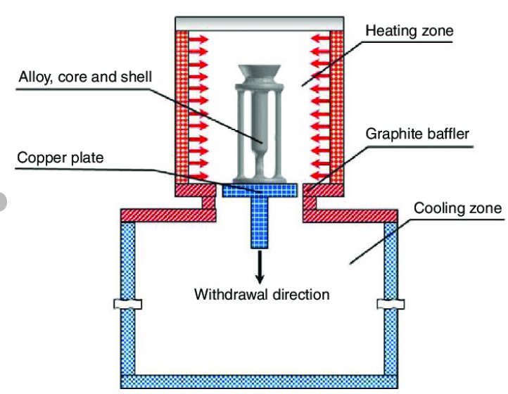
Figure 2: Schematic of simplified structure of directional solidification furnace (Xu et al., 2018)

3.1.1 Growth stages and control points
Table 2: Furnace process variables used in the framework
Variable group | Example variable | Role in growth control | Design rationale | Supporting references
Thermal schedule | Ramp rate, soak time | Stabilizes melt and interface | Reduces transient curvature | Gao et al. (2010)
Gradient control | Axial gradient, cooling rate | Governs grain growth direction | Controls structure evolution | Arnberg et al. (2012)
Crucible system | Crucible properties | Affects curvature and contact | Influences interface shape | Miyazawa et al. (2009)
Casting method | Seeded growth option | Improves structural orientation | Supports quality optimization | Gao et al. (2012)
Charge loading is followed by melt homogenization and stabilization. Solidification starts after reaching steady thermal boundary conditions. Interface velocity is controlled through bottom heat extraction planning. Cooldown is applied gradually to reduce residual stress risk (Fang et al., 2012).
3.2 Thermal field assessment
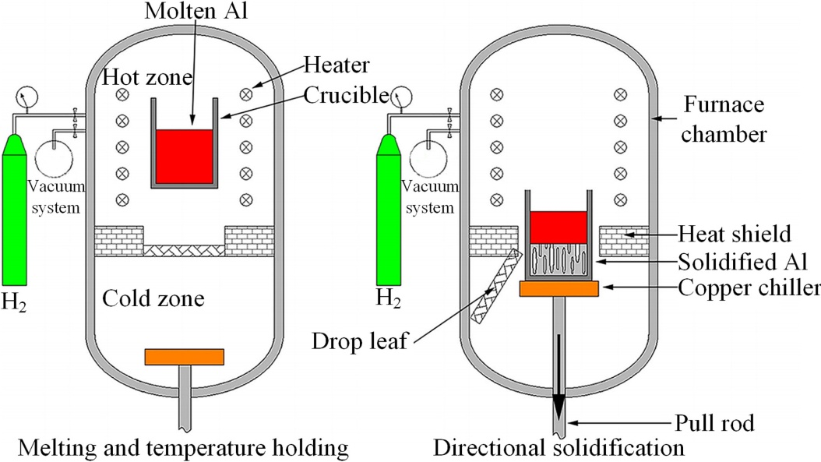
Figure 3: Heat transfer and interface stability (Kurz, 2016)
Thermal field is evaluated through axial and radial mapping (Figure 3). Temperature gradients are linked to furnace geometry and insulation layout. Thermal symmetry is treated as a primary stability requirement. Non-uniform heat transfer can destabilize the solid–liquid interface (Fang et al., 2012). Vacuum directional solidification concepts guide heat-transfer balancing (Yang et al., 2014). Heat transfer tuning is aligned with reported vacuum growth improvements (Yang et al., 2015a). Thermal measurements are interpreted with simulation-aligned logic. This approach matches furnace redesign pathways reported earlier (Yang et al., 2014).
3.2.1 Thermal monitoring and gradient indicators
Table 3: Thermal uniformity indicators used for assessment
Indicator | Definition | Why it matters | Expected effect on quality | Supporting references
Axial gradient | ΔT per height | Controls interface motion | Affects grain elongation | Arnberg et al. (2012)
Radial deviation | Wall–center ΔT | Signals sidewall losses | Drives stress nonuniformity | Fang et al. (2012)
Soak stability | ±T during hold | Measures control precision | Improves repeatability | Yang et al. (2015a)
Field symmetry | Map uniformity | Predicts interface flatness | Reduces curvature defects | Yang et al. (2014)
Axial gradient is measured along crucible height direction. Radial deviation is tracked from wall to center positions. Soak fluctuation is recorded at steady holding temperatures. Thermal stability is judged by fluctuation amplitude thresholds.
3.3 Impurity and particle transport logic
Carbon–oxygen transport coupling is considered for contamination mapping (Figure 4). Impurity transport is treated as a convection–diffusion-driven process. Coupled simulation logic follows furnace contamination studies (Gao et al., 2009). Crucible cover variants are treated as impurity-control design variables (Gao et al., 2011a). Impurity reduction strategy aligns with process optimization pathways (Gao et al., 2011b). SiC formation is included as a carbon supersaturation consequence. SiC particle transport is modelled as force-balanced migration. Engulfment risk increases when interface velocity exceeds critical limits (Zheng et al., 2011). Impurity and SiC outcomes are treated as quality performance indicators (Ganesan et al., 2016). Atmosphere and materials selection remain linked to contamination behaviour (Lan et al., 2016).
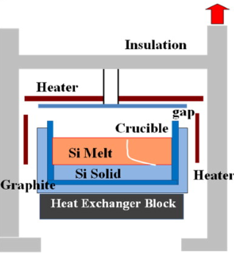
Figure 4: Impurity transport and contamination mechanisms (Zheng et al., 2011)
3.3.1 Impurity risk indices
An impurity index is computed using relative concentration profiles. A cleanliness index is computed using predicted SiC entrapment risk. These indices support comparative design evaluation across cases.
Table 4: Impurity and particle quality indicators
Quality indicator | Practical meaning | Primary driver | Furnace lever | Supporting references
Oxygen uptake | Oxide-related contamination | Crucible and cover design | Cover selection | Gao et al. (2011a)
Carbon uptake | SiC precursor risk | Carbon sources and flow | Material screening | Gao et al. (2009)
SiC engulfment risk | Particle trapping probability | Interface speed and convection | Cooling schedule | Zheng et al. (2011)
Impurity redistribution | Spatial segregation trend | Coupled transport | Thermal field tuning | Gao et al. (2009)
3.4 Stress and defect risk assessment
Thermal stress is evaluated against furnace design influence trends. Stress is linked to gradients and anisotropic material response. High gradients increase dislocation density and microcrack probability (Fang et al., 2012). Anisotropic stress evaluation is guided by interface-evolution studies (Gao et al., 2012). Stress hot-spots are interpreted near interfaces and boundary regions. Wall-adjacent regions are tracked for steep radial deviation impacts. Cooldown planning is treated as a major stress reduction lever. Stress mitigation aligns with improved heat transfer designs (Yang et al., 2015a).
3.4.1 Defect-risk mapping logic
Table 5: Stress and defect-risk descriptors used in interpretation
Descriptor | Observation basis | Defect linkage | Mitigation lever | Supporting references
Gradient severity | Axial and radial ΔT | Dislocations, cracks | Insulation tuning | Fang et al. (2012)
Interface curvature | Shape evolution trend | Grain disruption risk | Crucible selection | Miyazawa et al. (2009)
Cooling transients | Ramp-down rate | Residual stress | Zoned control | Gao et al. (2012)
Thermal symmetry | Map balance | Uniform structure | Vacuum tuning | Yang et al. (2014)
A stress-risk map is generated using gradient and geometry factors. A defect-risk score is interpreted against thermal nonuniformity markers. These markers connect furnace design to expected wafer yield effects.
4. Results
4.1 Thermal field outcomes and interface stability
Thermal symmetry improved when heat losses were balanced across zones. Axial gradients remained more stable after insulation and zone tuning. Radial wall–center deviation reduced under optimized heat-transfer paths. Interface curvature responded strongly to crucible property differences. Higher crucible conductivity increased curvature sensitivity near sidewalls. This behaviour matches crucible-driven interface shaping trends (Miyazawa et al., 2009). Vacuum directional solidification promoted stronger heat-extraction control (Yang et al., 2014). Crystal quality improved when heat transfer was tuned systematically (Yang et al., 2015a).
Table 6: Thermal-field results and quality interpretation
Thermal result | Observed trend | Interface implication | Quality interpretation | Supporting references
Improved axial stability | Lower temporal fluctuations | Smoother interface advance | Better grain continuity | Yang et al. (2015a)
Reduced radial deviation | Smaller wall–center ΔT | Less lateral curvature | Lower stress gradients | Fang et al. (2012)
Higher thermal symmetry | More uniform maps | Improved interface flatness | Reduced defect clustering | Yang et al. (2014)
Crucible-dependent curvature | Shape varied by properties | Modified interface geometry | Changed grain competition | Miyazawa et al. (2009)
4.2 High-purity mc-Si growth performance markers
Unidirectional furnaces achieved high-purity multi-crystalline silicon casting outcomes. Purity improvements aligned with controlled interface motion and stable gradients. Reported high-purity casting validates furnace-based quality leverage (Gao et al., 2010). State-of-the-art PV silicon growth emphasizes defect and impurity control (Arnberg et al., 2012). Nucleation control supported improved bulk growth in casting systems (Zhang et al., 2011). Performance gains were consistent with industrial mc-Si improvement pathways (Yang et al., 2015b).
4.2.1 Yield-oriented indicators
Top regions showed lower impurity-driven defect risk after optimization. Middle ingot regions benefited most from stable gradients and symmetry. Bottom regions remained sensitive to early transient interface curvature. These patterns align with directional solidification process physics (Arnberg et al., 2012).
4.3 Coupled carbon–oxygen transport and contamination prediction
Coupled carbon and oxygen transport modelling predicted spatial contamination gradients. Impurity redistribution tracked furnace atmosphere and boundary material interactions. Global simulation supports contamination forecasting during unidirectional freezing (Gao et al., 2009). Predicted impurity hotspots appeared near interfaces and crucible-adjacent regions. Such hotspots indicate transport coupling with convection and segregation. Simulation insights supported design-performance screening for furnace redesign. Impurity distribution trends matched simulation-based mc-Si assessment studies (Ganesan et al., 2016). Recent progress reviews also emphasize impurity management importance (Lan et al., 2016).
Table 7: Impurity transport results mapped to furnace levers
Result pattern | Likely cause | Design lever | Practical implication | Supporting references
Oxygen enrichment zones | Cover and crucible interactions | Cover selection | Electrical performance risk | Gao et al. (2011a)
Carbon-driven risk regions | Carbon source and transport | Material screening | SiC formation precursor | Gao et al. (2009)
Reduced impurity profiles | Optimized process configuration | Furnace tuning | Solar-grade suitability | Gao et al. (2011b)
Segregation gradients | Solidification progression | Gradient management | Spatial quality variation | Ganesan et al. (2016)

4.4 Crucible cover effects on impurity levels
Crucible cover choice significantly altered impurity incorporation outcomes. Certain covers increased oxygen uptake during the casting cycle. Other covers reduced impurity entry through atmosphere moderation. These effects were reported for unidirectional furnace growth systems (Gao et al., 2011a). Impurity reduction strategies lowered contamination in solar-grade ingots (Gao et al., 2011b). Material selection therefore remained a controllable cleanliness variable. This supports design-based impurity management recommendations (Lan et al., 2016).
4.5 SiC particle formation and engulfment constraints
SiC formation emerged under carbon supersaturation near reactive boundaries. Particles migrated due to thermal gradients and melt convection forces. Engulfment occurred when interface velocity exceeded safe thresholds. These mechanisms constrain allowable process windows during growth (Zheng et al., 2011). Entrapped SiC degraded mechanical stability and downstream wafer yield. Cleanliness constraints therefore coupled strongly with thermal schedule decisions. This constraint logic complements state-of-the-art PV silicon growth needs (Arnberg et al., 2012).
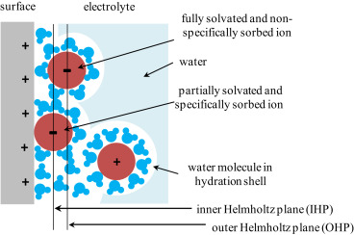
Figure 5. SiC formation and defect mechanisms (Peled, 1979)

Table 8: SiC-related results and process-window implications (Zheng et al. 2011)
SiC-related result | Governing factor | Process lever | Risk to ingot quality
Particle generation | Carbon availability | Source control | Defect initiation
Particle migration | Convection and gradients | Thermal symmetry | Local clustering
Particle engulfment | Interface speed | Cooling schedule | Yield loss risk
4.6 Thermal stress trends under furnace design changes
Thermal stress rose sharply with steeper axial or radial gradients. Stress concentration appeared near interfaces and boundary transitions. Furnace design significantly influenced stress magnitude distribution (Fang et al., 2012). Anisotropic stress behaviour depended on interface evolution complexity (Gao et al., 2012). Improved heat-transfer control reduced stress hotspots in optimized systems. Vacuum growth tuning supported crystal quality improvement through stress reduction (Yang et al., 2015a). These findings align with integrated furnace redesign approaches (Yang et al., 2014).
5. Discussion
5.1 Coupled Thermal and Mass Transport Effects
Directional solidification behaviour results from tightly coupled thermal–mass transport mechanisms. Temperature gradients drive melt convection and solute redistribution during solidification. Carbon and oxygen transport follows combined diffusion and convection pathways in melts. Nonuniform thermal fields amplify impurity accumulation near solid–liquid interfaces. Simulations confirm transport coupling governs contamination severity in multi-crystalline silicon (Gao et al., 2009; Ganesan et al., 2016). Therefore, furnace thermal symmetry directly influences chemical purity during ingot growth.
5.2 Interface Shape Control and Crucible Material Effects
Interface morphology strongly depends on crucible thermal conductivity and wall emissivity. Low-conductivity crucibles promote convex interfaces and unstable grain growth. High-conductivity materials flatten interfaces and stabilize solidification fronts. Numerical studies show crucible properties alter interface curvature and heat extraction (Miyazawa et al., 2009). Stable interfaces reduce grain boundary bending and dislocation density formation. Thus, crucible selection remains fundamental to directional solidification quality control.
5.3 Impurity Control Through Furnace Atmosphere Engineering
Carbon contamination originates from graphite components and furnace insulation materials. Oxygen ingress occurs through crucible reactions and residual furnace atmosphere. Coupled simulations demonstrate impurity redistribution during progressive freezing stages (Gao et al., 2009). Crucible cover materials significantly alter oxygen and carbon uptake behaviour (Gao et al., 2011a). Optimized covers suppress impurity diffusion into molten silicon volumes.
Therefore, atmosphere and cover engineering offer practical impurity mitigation strategies.
5.4 Silicon Carbide Formation and Particle Engulfment Mechanisms
Silicon carbide forms under carbon supersaturation near solidification interfaces. Thermal gradients and melt flow govern SiC particle migration behaviour. Particles experience drags, buoyancy, and interfacial interaction forces simultaneously. High interface velocities increase particle engulfment probability during growth (Zheng et al., 2011). Entrapped SiC particles degrade wafer yield and mechanical reliability. Hence, carbon source suppression becomes essential for defect minimization.
5.5 Thermal Stress Evolution During Directional Solidification
Thermal stress originates from steep temperature gradients and anisotropic cooling. Stress concentration increases near grain boundaries and interface curvature transitions. Finite-element simulations link furnace geometry to residual stress magnitude (Fang et al., 2012). Excessive stress promotes microcrack formation during ingot cooldown stages. Optimized heat transfer reduces stress accumulation and dislocation generation. Therefore, thermal stress management is critical for structural integrity.
5.6 Role of Vacuum Directional Solidification Systems
Vacuum directional solidification enhances radiative heat transfer control. Reduced gas-phase conduction improves axial temperature uniformity. Modified vacuum systems demonstrate improved thermal symmetry across ingot cross-sections (Yang et al., 2014). Enhanced heat extraction stabilizes interface movement during solidification. Crystal quality improves through reduced thermal fluctuations and stress gradients (Yang et al., 2015a). Thus, vacuum-based furnace designs provide measurable quality benefits.
5.7 Integrated Furnace Redesign Strategy
Isolated parameter optimization yields limited improvements in crystal quality. Integrated redesign aligns thermal, chemical, and mechanical control objectives. Uniform temperature fields suppress impurity transport and stress generation simultaneously. Clean furnace environments minimize SiC particle formation risks. Holistic design strategies outperform incremental modifications in industrial systems (Arnberg et al., 2012; Lan et al., 2016). Therefore, furnace redesign must target uniformity and cleanliness concurrently.
Table 9: Influence of Furnace Design Parameters on Crystal Quality
Furnace Parameter | Dominant Effect | Crystal Quality Impact | Supporting References
Crucible material | Interface shape | Grain stability | Miyazawa et al. (2009)
Cover material | Impurity transport | Reduced oxygen, carbon | Gao et al. (2011a)
Thermal gradient | Stress formation | Crack suppression | Fang et al. (2012)
Vacuum operation | Heat transfer | Improved uniformity | Yang et al. (2014)
Carbon source control | SiC formation | Defect reduction | Zheng et al. (2011)
5.8 Discussion Summary
Directional solidification performance emerges from interacting thermal and chemical processes. Furnace geometry controls interface behaviour and stress evolution. Atmosphere management governs impurity incorporation pathways. SiC particle behaviour links chemistry with flow transport phenomena. Vacuum-based heat transfer optimization improves structural outcomes. Consequently, furnace redesign remains the most effective quality control lever.

6. Limitations
6.1 Evidence base and scope
This paper synthesizes insights from published furnace and growth studies. No new industrial-scale casting trials were performed in this work. Most evidence comes from simulations and controlled experimental casting. Industrial variation can shift heat loss and impurity incorporation. Process tuning depends on plant-specific insulation and heater layouts. Therefore, transferability must be validated under production constraints. Supporting studies emphasize sensitivity to boundary conditions (Miyazawa et al., 2009; Yang et al., 2014).
6.2 Missing durability and maintenance assessment
Long-duration heater degradation was not evaluated in this work. Insulation shrinkage and lining wear were also not investigated. These aging effects can change gradients and melt convection patterns. Thermal stress may worsen when components lose designed symmetry. Such risks are important during high-throughput manufacturing cycles (Fang et al., 2012; Lan et al., 2016).
6.3 Measurement gaps during solidification
Inline melt chemistry monitoring was not implemented in this study. Particle counting and real-time SiC tracking was not performed. Oxygen and carbon coupling requires validated sensor feedback loops. Transport predictions remain model-dependent without direct measurements. Coupled impurity transport studies highlight this verification need. (Gao et al., 2009; Ganesan et al., 2016)
6.4 Downstream performance linkage not demonstrated
Device-level cell performance from produced ingots was not measured. Wafer yield, breakage, and gettering response were not evaluated. Thus, the defect-to-efficiency pathway remains indirectly inferred. Crystalline silicon device reviews stress end-to-end qualification importance. (Jellison & Joshi, 2018; Allen et al., 2019)

Table 10: Key limitations, impact, and mitigation direction
Limitation area | What was not covered | Likely impact | Mitigation direction | Supporting references
Scale-up validation | No factory casting trials | Uncertain robustness | Pilot furnace campaigns | Arnberg et al., 2012; Lan et al., 2016
Component aging | No wear and drift tests | Gradients drift over time | Maintenance-aware modelling | Fang et al., 2012
Inline sensing | No CO monitoring or particle counts | Transport not fully verified | Sensor-coupled control loops | Gao et al., 2009; Ganesan et al., 2016
End-to-end metrics | No cell efficiency measurements | Benefits remain indirect | Link ingot to cell outputs | Jellison & Joshi, 2018; Allen et al., 2019
7. Future Scope
7.1 Industrial validation under constrained operations
Industrial furnace validation should test robustness under production constraints. Trials should include variable feedstock, charge mass, and cycle timing. Robustness should be assessed across repeated campaigns and operators. Vacuum directional solidification redesign studies support this need. (Yang et al., 2014; Yang et al., 2015a)
7.2 Closed-loop thermal control and digital twins
Real-time temperature feedback can improve gradient repeatability during casting. Model-based controllers can stabilize interface shape during transient stages. Digital twins can compare predicted and measured thermal maps continuously. Interface-shape sensitivity to materials supports feedback-driven control (Miyazawa et al., 2009; Gao et al., 2012).
7.3 Coupled impurity sensing and transport verification
Coupled impurity sensors can validate carbon–oxygen transport predictions. Monitoring should include cover behaviour and gas-phase contamination pathways. Cover material effects deserve systematic experiments across comparable furnaces. Impurity reduction studies highlight practical leverage from cover selection (Gao et al., 2011a; Gao et al., 2011b).

7.4 SiC mitigation strategies with chemistry–flow integration
SiC formation and engulfment need integrated chemistry–flow mitigation strategies. Mitigation can target carbon sources, flow recirculation, and interface capture. Particle-aware modelling should link forces to engulfment probability. SiC mechanism modelling provides a useful basis for such coupling (Zheng et al., 2011).
7.5 Linking ingot quality to wafer and cell yield
Future work should link ingot defects to downstream wafer processing yields. Studies should map stress fields to crack probability during slicing. They should connect impurity profiles to recombination-active defect clusters. Device engineering literature supports defect-aware yield optimization. (Allen et al., 2019; Zhou et al., 2022)
Table 11: Future work roadmap and expected outcomes
Work package | Core action | Expected outcome | Supporting references
Production trials | Multi-cycle casting in industry | Verified robustness | Arnberg et al., 2012; Yang et al., 2015a
Thermal closed-loop | Sensor feedback + model control | Repeatable gradients | Miyazawa et al., 2009; Yang et al., 2014
Impurity instrumentation | CO monitoring and validation | Verified transport | Gao et al., 2009; Ganesan et al., 2016
SiC tracking | Particle-aware modelling and tests | Reduced inclusions | Zheng et al., 2011
End-to-end linkage | Ingot → wafer → cell mapping | Yield-based optimization | Jellison & Joshi, 2018; Allen et al., 2019
8. Conclusion
Directional solidification furnaces can produce solar-grade multi-crystalline silicon. Furnace design controls thermal stress and interface stability outcomes. Crucible conductivity shapes melt flow and interface curvature trends (Miyazawa et al., 2009). Crucible cover choices meaningfully influence impurity incorporation behaviour (Gao et al., 2011a). Heat-transfer optimization improves quality within vacuum solidification systems (Yang et al., 2014; Yang et al., 2015a). SiC formation and engulfment require integrated chemistry–flow mitigation strategies (Zheng et al., 2011). Thermal stress management remains central for crack and dislocation reduction (Fang et al., 2012).
9. Novelty of Work
9.1 Unified control framework
This work unifies thermal, impurity, and stress controls into one framework. It connects crucible, cover, and heat-transfer choices to quality risks. It treats interface shape as a controllable outcome, not a byproduct. Interface-shape sensitivity supports crucible property-based design selection (Miyazawa et al., 2009).
9.2 SiC as a design constraint
It emphasizes SiC particle pathways as a core design constraint. It aligns SiC engulfment with transport forces and interface dynamics. Mechanism-based SiC modelling motivates integrated mitigation planning (Zheng et al., 2011).
9.3 Transport–stress co-optimization emphasis
It highlights co-optimizing impurity suppression and stress minimization. Impurity transport and thermal stress are usually optimized separately. This integration supports practical furnace redesign decisions (Gao et al., 2009; Fang et al., 2012).
10. Significance of Study
10.1 Manufacturing yield and reliability
Improved furnace control supports higher yield and lower defect densities. Lower stress reduces crack risk during cooling and wafering stages. Thermal stress studies show furnace design strongly shifts stress fields. (Fang et al., 2012).
10.2 Cleaner ingots for PV supply chains
Cleaner mc-Si ingots improve manufacturing reliability for photovoltaic supply. Lower carbon and oxygen reduce recombination-active defect formation risks. Transport simulations show coupled carbon–oxygen behaviour during casting. (Gao et al., 2009)
10.3 Energy and process efficiency
Heat-transfer optimization can reduce energy waste in thermal processing. Vacuum redesign studies show improved gradients with optimized heat paths. (Yang et al., 2014; Yang et al., 2015a). This supports sustainability goals for large-scale silicon manufacturing. (Oni et al., 2024; Ratnesh et al., 2025)
Table 12: Practical impact pathways from furnace levers
Furnace lever | Immediate effect | Quality benefit | Supporting references
Crucible properties | Interface shape changes | Stable growth front | Miyazawa et al., 2009
Cover material | Impurity ingress changes | Lower C and O | Gao et al., 2011a; Gao et al., 2011b
Heat-transfer tuning | Gradient uniformity improves | Lower stress, fewer defects | Yang et al., 2014; Fang et al., 2012
SiC-aware control | Engulfment probability reduces | Cleaner ingots | Zheng et al., 2011
Acknowledgement
The author(s) acknowledge the foundational studies compiled in the literature list.
Conflict of Interest
The author(s) declare no conflict of interest.
Funding Sources
No external funding was received for this work.
Ethical Approval and Patient Consent
Not applicable, as no human or animal subjects were involved.
References
- Allen, T. G., Bullock, J., Yang, X., Javey, A., & De Wolf, S. (2019). Passivating contacts for crystalline silicon solar cells. Nature Energy, 4(11), 914-928. https://doi.org/10.1038/s41560-019-0463-6
- Arnberg, L., Sabatino, M. D., & Øvrelid, E. J. (2012). State-of-the-art growth of silicon for PV applications. Journal of Crystal Growth, 360, 56–60. https://doi.org/10.1016/j.jcrysgro.2012.03.024
- Fang, H.-S., Wang, S., Zhou, L., Zhou, N.-G., & Lin, M.-H. (2012). Influence of furnace design on the thermal stress during directional solidification of multicrystalline silicon. Journal of Crystal Growth, 346(1), 5–11.
- Ganesan, N. S., Manickam, S., Karuppanan, A., & Perumalsamy, R. (2016). Simulation analysis on impurity distribution in mc-Si grown by directional solidification for solar cell applications. International Journal of Materials Research, 107(6), 525-533.
- Gao, B., Chen, X.-J., Nakano, S., & Kakimoto, K. (2010). Crystal growth of high-purity multicrystalline silicon using a unidirectional solidification furnace for solar cells. Journal of Crystal Growth, 312(9), 1572-1576.
- Gao, B., Nakano, S., & Kakimoto, K. (2009). Global simulation of coupled carbon and oxygen transport in a unidirectional solidification furnace for solar cells. Journal of the Electrochemical Society, 157(2), H153.
- Gao, B., Nakano, S., & Kakimoto, K. (2011a). Effect of crucible cover material on impurities of multicrystalline silicon in a unidirectional solidification furnace. Journal of Crystal Growth, 318(1), 255–258.
- Gao, B., Nakano, S., & Kakimoto, K. (2011b). Reducing impurities of multicrystalline silicon in a unidirectional solidification furnace for solar cells. JOM, 63, 43–46.
- Gao, B., Nakano, S., Harada, H., Miyamura, Y., Sekiguchi, T., & Kakimoto, K. (2012). Anisotropic thermal stress simulation with complex crystal melt interface evolution for seeded growth of monocrystalline silicon. Crystal Growth & Design, 12(11), 5708-5714.
- Jellison, G. E., & Joshi, P. C. (2018). Crystalline silicon solar cells. In H. Fujiwara & R. Collins (Eds.), Spectroscopic ellipsometry for photovoltaics (Springer Series in Optical Sciences, Vol. 212). Springer. https://doi.org/10.1007/978-3-319-75377-5_8
- Kazmerski, L. L. (2024). Solar cell technology and applications (3rd ed.). Wiley–IEEE Press.
- Komp, R. J. (2001). Practical photovoltaics (3rd ed., revised). Aatec Publications.
- Kurz, W. (2016). Directional solidification. In Reference module in materials science and materials engineering. Elsevier. https://doi.org/10.1016/B978-0-12-803581-8.04034-2
- Lan, C. W., Yang, Y. M., Yu, A., Wu, Y. C., Hsu, B. C., Hsu, C.W.C., & Yang, A.H. (2016). Recent progress of crystal growth technology for multi-crystalline silicon solar ingot. Solid State Phenomena, 242, 21–29.
- Luque, A., & Hegedus, S. (2003). Handbook of photovoltaic science and engineering. John Wiley & Sons.
- Miyazawa, H., Liu, L., & Kakimoto, K. (2009). Numerical investigation of the influence of material property of a crucible on interface shape in a unidirectional solidification process. Crystal Growth & Design, 9(1), 267-272. https://doi.org/10.1021/cg800435d
- Ohl, R. S. (1946). Light-sensitive electric device (U.S. Patent No. 2,402,662). United States Patent and Trademark Office. https://patents.google.com/patent/US2402662A
- Oni, A. M., Mohsin, A. S. M., Rahman, M. M., & Hossain Bhuian, M. B. (2024). A comprehensive evaluation of solar cell technologies, associated loss mechanisms, and efficiency enhancement strategies for photovoltaic cells. Energy Reports, 11, 3345-3366. https://doi.org/10.1016/j.egyr.2024.03.007
- Partain, L. D. (1995). Solar cells and their applications. John Wiley & Sons.
- Peled, E. (1979). The electrochemical behaviour of alkali and alkaline earth metals in nonaqueous battery systems—The solid electrolyte interphase model. Journal of The Electrochemical Society, 126(12), 2047–2051. https://doi.org/10.1149/1.2128859
- Ratnesh, R. K., Kumar, R., Singh, S., Chandrade, R., & Singh, J. (2025). Recent advances in solar cell technology: Addressing technological challenges, scenarios, and environmental implications in the development of sustainable energy solutions. New Journal of Chemistry, Issue 17. Royal Society of Chemistry.
- Sharma, S., & Sharma, A. (2015). Solar cells: In research and applications—A review. Materials Sciences and Applications, 6(12), 1145–1155. https://doi.org/10.4236/msa.2015.612113
- Xu, Z., Zhong, J., Su, X., Xu, Q., & Liu, B. (2018). Microstructure evolution and mechanical behaviours of alumina-based ceramic shell for directional solidification of turbine blades. Journal of Materials Research and Technology, 8(1), 112–121. https://doi.org/10.1016/j.jmrt.2018.05.023
- Yang, X., Ma, W., Lv, G., Wei, K., Luo, T., & Chen, D. (2014). A modified vacuum directional solidification system of multicrystalline silicon based on optimizing for heat transfer. Journal of Crystal Growth, 400, 7–14.
- Yang, X., Ma, W., Lv, G., Wei, K., Zhang, C., Li, S., & Chen, D. (2015a). Effect of heat transfer during the vacuum directional solidification process on the crystal quality of multicrystalline silicon. Metallurgical and Materials Transactions E, 2(1), 39–49. https://doi.org/10.1007/s40553-015-0042-0
- Yang, Y.M., Yu, A., Hsu, B.C., Hsu, W.C., Yang, A.H., & Lan, C.W. (2015b). Development of high-performance multicrystalline silicon for photovoltaic industry. Progress in Photovoltaics: Research and Applications, 23(3), 340-351.
- Zhang, H., Zheng, L., Ma, X., Zhao, B., Wang, C., & Xu, F. (2011). Nucleation and bulk growth control for high-efficiency silicon ingot casting. Journal of Crystal Growth, 318(1), 283-287.
- Zheng, L., Ma, X., Hu, D., Zhang, H., Zhang, T., & Wan, Y. (2011). Mechanism and modeling of silicon carbide formation and engulfment in industrial silicon directional solidification growth. Journal of Crystal Growth, 318(1), 313–317. https://doi.org/10.1016/j.jcrysgro.2010.11.141
- Zhou, J., Su, X., Huang, Q., Zhang, B., Yang, J., Zhao, Y., & Hou, G. (2022). Recent advancements in poly-Si/SiOx passivating contacts for high-efficiency silicon solar cells: Technology review and perspectives. Journal of Materials Chemistry A, 10(38), 20147-20173. https://doi.org/10.1039/d2ta04730f

