Predictive Resilience: Safeguarding Multi-Cloud Infrastructure with Machine Learning

Abstract
The explosion of enterprises adopting many cloud functionalities has created problems associated with the management of these disparate systems. To meet this challenge, enterprises will begin to move from old ways of executing reactive management to newer, more forward-looking methodologies. This paper will provide an overview of how incorporating predictive analytics and AI can enhance automation in managing multi-cloud environments through an innovative conceptual model that uses machine learning (ML) to improve real-time visibility, anomaly detection and automated remediation to improve operational efficiency and resiliency. Further, this paper will identify measurable performance indicators such as decreased mean-time-to-resolution (MTTR) and fewer service-level agreement (SLA) violations after implementing this model. Challenges in managing multi-cloud environments, including normalizing data between providers, model drift, and issues with integration will also be addressed, as well as potential solutions such as federated learning and autonomous IT operations, to facilitate better governance of multi-cloud environments.
Keywords: Multi-cloud Environment, Predictive Analytics, Machine Learning, AIOps, Mean-Time-to-Resolution (MTTR), Service-Level Agreement (SLA), Anomaly Detection.

1. Introduction

Multi-cloud strategies are a key component of digital transformation because organizations are now taking advantage of different services offered by all cloud service providers (e.g., Amazon Web Services (AWS), Microsoft Azure, Google Cloud Platform, etc.) in an effort to avoid vendor lock-in, maximize cost savings, and provide their customers with the best possible outcome [10].

While multi-cloud strategies address these concerns, they also create a fragmented operating environment. The traditional monitoring tools, which were designed for static and on-premises infrastructures, are not able to keep up with the rapidly changing and transient nature of cloud resources. Additionally, because IT departments are frequently structurally siloed, they often experience tool over-saturation and alert fatigue as they try to work through issues re-actively rather than working strategically to optimize performance [1].

To overcome these challenges, the industry is moving toward using AI operations (AIOps). A significant shift from reactive troubleshooting to proactive management of infrastructure is possible by leveraging AI/ML-driven predictive analytics [9]. By collecting and analyzing vast amounts of telemetry data (i.e., metrics, logs, and events), machine learning models can identify the normal behaviour of complex systems. From this information, operational teams can identify anomalies that occur before failure, estimate when they may reach capacity, and automate remedial actions before users are impacted [5][7].

The advantages of this approach are many including: improving service reliability by providing a mechanism to forecast when services will fail, improving how resources are used and reducing costs by enabling intelligent placement of workloads, and greatly reducing the cognitive load on operations teams [2]. This article will examine the application of predictive analytics within a multi-cloud environment. It will review the current state-of-the-art, propose a general architecture for these systems, and evaluate the real benefits and continued challenges. Overall, this article will provide a thorough overview for researchers and practitioners alike who are trying to navigate this rapidly changing area of technology.

2. Literature Survey

Research and development into artificial intelligence in cloud operations is an active field. Here, we review key contributions to AI-powered multi-cloud management that establish the foundations of the technology. The early AI-related research efforts focused on automating IT service management processes. An example is Costa et al. (2019) [2], who investigated using machine learning to create predictive incident resolution categories related to ticket management processes and provided automated ticket routing to reduce manual triage [1]. This represented a significant initial step into leveraging AI for improved operational efficiency however, the focus was still primarily on reactive solutions.

AIOps, or artificial intelligence for IT operations, began to take shape around the time of the introduction of platforms designed to provide a holistic view of all operations, an example of which is the transformer. As stated by industry partners, transforming raw telemetry data into meaningful intelligence requires a dynamic topology model that captures contextual data from many different sources during the telemetry of operations. The need for unifying these processes is critical to breaking down silos when managing operations across multiple cloud environments.

Another common theme across current literature regarding AI in multi-cloud environments is predictive resilience. Vaidya (2025) introduced a framework to improve multi-cloud resilience through the ability to identify infrastructure failure patterns before they occur by leveraging anomaly detection and time series forecasts using multicast (cross) provider telemetry. These findings reflect a clear trend toward a proactive approach to resilience, as they demonstrate the ability to move away from reactive solutions [5]. The complementary work of Alla (2025) provides examples of how machine learning has improved fault tolerance in hybrid infrastructure implementations, with significant reductions in downtime and improved recovery metrics compared to traditional approaches based solely on redundancy [7].

The literature also includes extensive reviews of how AI has impacted the DevOps process and the optimization of cloud infrastructure. Davenport (2026) provided a complete analysis of AI-driven DevOps frameworks as they relate to multi-cloud orchestration, workload optimization, and cost reductions, as well as the persistent challenges of explainability of models and the need for governance of algorithms. Similarly, Gosai (2025) assessed the impact on the management of both cloud and edge infrastructure and emphasized the importance of adaptive learning systems within AIOps and their value to organizations [2].

The evolution of middleware solutions is also representative of the evolution and incorporation of intelligence. Kadam et al. (2025) proposed an Intelligent Middleware Hub (IMH) based on statistical models and multiple objective optimizations for the real-time adaptive orchestration of middleware. These researchers also showed several metrics from their simulations that support their findings, including an 18.7% increase in predictive accuracy and a 14% reduction in SLA violations due to adaptive integration. The need for predictive analytics to optimize cloud costs is critical for firms’ multi-cloud FinOps processes [3][8]. Polu et al. (2025) presented an example of the use of predictive analytics to manage cloud costs, and industry providers have produced some real-world evidence of the value created by AI-driven observability in cloud environments [12]. For example, HCL HIVE reported evidence produced through the application of AI-driven observability that demonstrated a 50% reduction in cloud expenditure and a 45% reduction in Mean Time to Identify issues [6].

Overall, a common theme demonstrated is the continued significant growth of autonomous, AI-driven management processes in multi-cloud environments based on the body of literature. There continues to be common themes present within the studies that point toward ongoing challenges that organizations have to face in integrating AI intelligence into the management of their operations, including the need for proper data normalization within a heterogeneous cloud provider environment, issues concerning model drift, and the challenges of incorporating AI into existing governance and security models [2][7][10].

3. Methodology

AI-driven predictive analytics for multi-cloud management has a systematic, iterative model that is based on principles of data science and MLOps. This model involves:

Data ingestion and normalization: A predictive system relies on high-quality data. The initial step to build this system is to aggregate telemetry from all disparate sources of data in the multi-cloud environment. The telemetry data includes infrastructure metrics, such as CPU, memory, storage I/O, and network latency log events, such as configuration changes made by the vendor (i.e., AWS, Azure, GCP), on-premise systems, and container-based environments, such as Kubernetes. The major challenge to building the predictive model will be the various formats of the data being integrated into the system. Since data is coming from different vendors, a normalization layer will be built to take all the data coming from different sources and convert it into a standard schema so that the data can be compared and correlated across the different vendors [3][9].

Establishing a baseline and detecting anomalies: After the ingestion of data is complete, unsupervised ML algorithms will establish the baseline of performance for every component of the multi-cloud infrastructure. Time-series decomposition and statistical process control techniques will be used to build the model of the normal behaviour (e.g., typical spike at a specific time of day or resource consumption peaks). By establishing a baseline model of normal behaviour, any deviation from that learned baseline will be flagged as an anomaly to help separate out the non-threatening fluctuations (i.e., noise) from meaningful indicators of possible problems [5][9].

Predicting failures and workloads: To predict failures and workloads, the predictive models used are supervised classification and time series forecasting models.

To predict failures, the predictive model will be built using historical incident data (i.e., the data that will end up in the incident repository) to classify what telemetry patterns were present before previous failures. These predictive models will use the classification model to learn the correlation between the subtle signals when measuring parameters, such as increasing disk latency over time with certain types of error logs before a system fails [5][7].

To predict workloads (i.e., predict what resources will be needed before they are needed), the historical usage data that is stored in the anomaly detection system will be used as the basis for predicting future resource requirements using models such as ARIMA, Prophet, or LSTM (Long Short-Term Memory) networks. This information is critical for both proactively scaling resources and minimizing costs as the predictive models will allow the predictive system to optimally schedule resources [2][3].

Automating remediation and orchestration: The output of a predictive model is of little value unless it becomes actionable. The predictive analytics methodology will integrate the insights from AI predictions with the orchestration tools through API integration. The result will be the closed-loop predictive system, where a predicted event will automatically invoke an associated remediation runbook. For example, if the predictive model predicts that a storage device will run out of space within the next week, the predictive system will automatically invoke the volume-resizing runbook [1][5].

Continuous feedback and retraining: The final step in the predictive analytics methodology is the continuous feedback loop. Any outcomes associated with the predicted events (i.e., were the predictions accurate?, did the remediation action resolve the incident?) will be recorded and used to continuously retrain and refine the predictive models to mitigate model drift and ensure that the accuracy of the AI model remains accurate regardless of the changes to the cloud environment [3][7].

Architecture Diagram
The following Figure 1 illustrates, at a high level, the different components and corresponding data flows within the proposed AI-Powered Predictive Analytics Framework for Multi-Cloud Management.
Figure 1: Proposed AI-Powered Predictive Analytics Framework
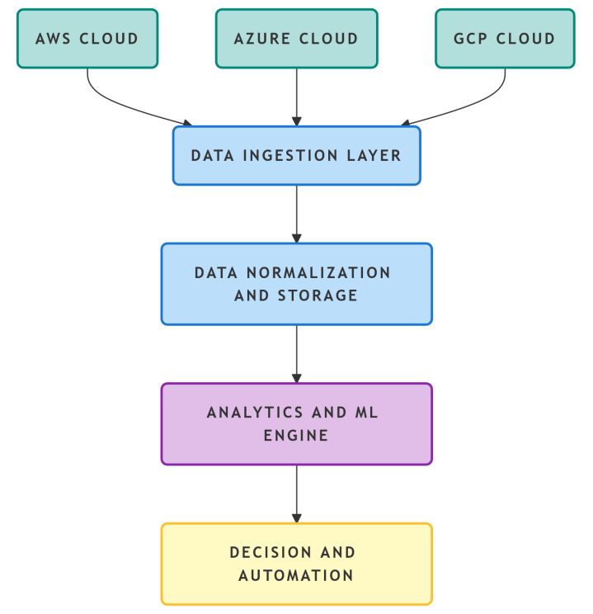

4. Result Chart representation using Metrics
When evaluating the use of predictive analytics from a system based on artificial intelligence concepts, we will focus on using those metrics that show the success or productivity of your organization and how this affects your business; therefore traditional infrastructure metrics should not be utilized when assessing or calculating the performance level of your AI-based system. Numerous valid case studies and research simulations conducted in various industries have shown how using these as evaluation metrics gives you quantifiable benefits when using predictive analytics as the evaluation measurement for your predictive analytical performance.
Table 1: Key Performance Metrics of AI-Driven Multi-Cloud Management
Metric Category | Metric | Reported Improvement
Resilience & Reliability | Mean Time to Resolve (MTTR) | ~40-50% Reduction
Resilience & Reliability | SLA Violations | ~14% Reduction
Resilience & Reliability | Service Outages | Significant Reduction
Operational Efficiency | Mean Time to Identify (MTTI) | ~45% Improvement
Operational Efficiency | False Positive Rate (Alerting) | Significant Reduction
Operational Efficiency | Decision Time | ~23% Decrease
Cost & Resource Optimization | Cloud Spend | ~50% Reduction
Cost & Resource Optimization | Operation Cost | ~19% Decrease
Cost & Resource Optimization | Resource Utilization | Significant Increase
Predictive Accuracy | Predictive Accuracy | ~18.7% Increase
Figure 2 provides a comparison of the different ways to manage your responsibilities, either by taking action ahead of time (proactively) or by waiting until the event occurs (reactive). This figure highlights that, as the time before an event occurs increases, the increased cost to manage it increases, while the increase in cost to manage an event decreases after it occurs.
Figure 2: Performance Improvements with AI-Driven Management
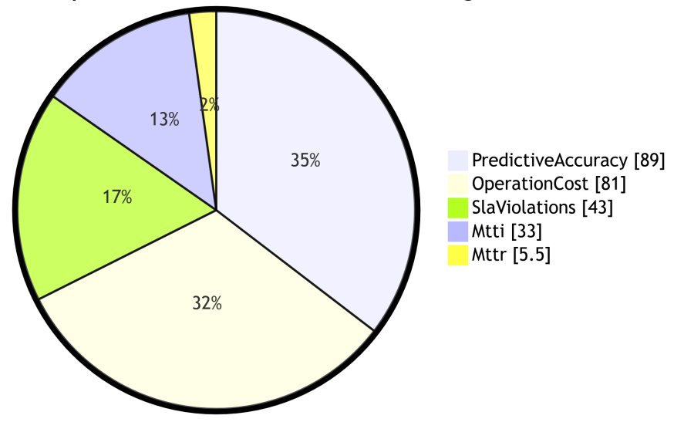
5. Discussion
Studies show that AI-based predictive analysis will be instrumental in helping organizations modernize their multi-cloud management (MCM) capabilities. Academic research and real-world evidence indicate that enterprises will increasingly implement Autonomous Operations models that allow their systems to monitor, self-correct, and respond in near real-time. As a result, AI's predictive analytics tools will reduce mean time to repair (MTTR) and total cost of ownership, while also improving predictive analytics' accuracy; thus, making the shift from a reactive mode of operation (commonly known as “break/fix”) to proactive operations (predictive) will provide greater reliability and agility in today's enterprises.

Unified Observability is fundamental to achieving the aforementioned benefits. As stated in several industry best practice recommendations, ingesting and normalizing data from multiple disparate sources (e.g., storage arrays, virtual machines (VMs), containers, and other Cloud services) into a unified view or panel is critical for success. Without this level of integration, AI will lack the insight to determine interdependencies between different components of the compute infrastructure and, therefore, will not be able to account for the cascading failures that are typical of distributed computing environments.Both Nutanix and NetApp have indicated that Dynamic Topology Mapping platforms allow for the AI to understand the relationships between the components of your computer infrastructure and create links to the different anomalies when compared against this contextual understanding. This understanding of context will help differentiate between an intelligent insight and a simple spike in a metric.

Achieving this ideal state of AI-based management is not without its challenges, and the biggest challenge encountered will be model drift and data quality. For example, if a machine learning model is built upon historical workload patterns for the last year, that model may not produce valid results in the year after due to up-stream changes to the business and/or applications the business uses in connection with that workload. Therefore, continuous feedback is a technical need as well as a necessary method for maintaining the accuracy of the AI Models. Programmers also need to take the Garbage in / Garbage Out rule into consideration. For example, if the organization uses poorly instrumented systems producing erratic and/or incomplete data, then any AI models created will produce predictions based on that garbage data.

A key challenge in implementing the recommended architecture is the confluence of competencies and the difficulty of integrating these competencies. To successfully implement the recommended architecture for cloud-based IT, a data engineer, data scientist, and cloud architect must be combined into one person, something that many organizations do not have available to them [10]. Furthermore, integrating AI-driven recommendations into existing IT Governance and Security policies is going to be very difficult. As mentioned in the literature, the ethical and interpretive boundaries that apply to the changes in model performance must be taken into account during implementation. For example, the recommended course of action for the automated remediation would be technically correct, but could potentially violate a compliance policy without having proper governance. Moving towards the graduated remediation process will require human involvement for actions that are considered to be high risk in order to build trust in the independently operated systems [11].

Additionally, the need for FinOps will provide additional motivation to drive the implementation of AI-driven multi-cloud management methodologies. The melding of the ability to predict failure and the ability to forecast future capital expenses along with the identification of underutilized resources will provide an organization with a continuous ROI on the total investment in AI-driven management systems. Thus, AI-enabled MCM solutions will be considered to not only be operationally relevant, but also to be strategically utilized in future planning for cloud resources.
6. Conclusion
The focus of this article is the use of predictive analytics with AIOps to transition from reactive operations to proactive operations through the use of machine learning and providing a framework that can be implemented across multiple cloud environments. A proposed architecture combines closed loop management systems with the three layers used to support predictive analytics; these include data normalization, advanced analytics, and automated remediation. There are numerous quantitative benefits that resemble the use of predictive analytics through AIOps, such as reducing the time taken to resolve incidents, reducing operational costs, reducing the number of incidents that violate service level agreements (SLA), improving resource efficiency, and improving predictive accuracy; all of these factors are indicative of how AI can help organizations optimize their costs and improve their readiness to respond to changes in the marketplace. While there are numerous advantages associated with adopting predictive analytics, organizations will face numerous challenges when implementing this technology. Organizations also need to invest in their staff and create governance frameworks to comply with applicable regulations and be able to effectively implement actions generated by AI.

Future developments in Federation Learning will help improve predictive models' ability to learn from multiple distributed data sources while respecting individuals' privacy. Additionally, greater sophistication in the orchestration of both AI and edge computing will be necessary for implementing these two technologies together. With ongoing advancements in these two areas, a completely autonomous, self-healing multi-cloud infrastructure will be achievable and will be significantly influenced by AI as a key driver of innovation and resiliency in the digital realm.
7. Acknowledgement
The Author expresses his appreciation for the researchers and practitioners for their foundational contributions towards AIOps, Cloud Computing and Predictive Analytics that laid the basis for this synthesis. In particular, recognition is given to all the practitioners for their ongoing practical knowledge surrounding the use of artificial intelligence in complex, multi-cloud environments and their successes.

8. References
- “Accelerate Intelligent Operations Across Nutanix Environments”, Nutanix, (2025), https://www.nutanix.com/library/solution-briefs/accelerate-intelligent-operations-across-nutanix-environments.
- “Artificial Intelligence-Driven Optimization of DevOps and Cloud Infrastructure: A Comprehensive Review of Intelligent Automation, Predictive Analytics, and IT Service Management”, Davenport, U. M, (2026), Ethiopian International Journal of Multidisciplinary Research, 13(2), 489–494, https://www.eijmr.org/index.php/eijmr.
- Kadam, S., Kollu, B. R., Patel, N., Mittana, R. R., Balakumar, G., & Sharma, A. (2025), “Intelligent Middleware Hub for Adaptive Integration in Multi-Cloud, Hybrid IT and On-Premise-to-Cloud Environments”, https://doi.org/10.36227/techrxiv. 176472774.43902329/v1.
- NetApp. (2025), “NetApp Data Infrastructure Insights Premium Edition”, [AWS Marketplace Listing], https://aws.amazon.com/marketplace/pp/prodview-axhuy7muvzfx2.
- Vaidya, D. P. (2025), “AI-Driven Predictive Resilience in Multi-Cloud Environments”, Journal of Computer Science and Technology Studies, https://doi.org/10.32996/jcsts.2025.7.4.124.
- HCL Software. (2025), “HCL HIVE: AI-driven Full-stack Observability Platform” [Product Overview], https://www.hcl-software.com/hive.
- Alla, S. S. R. (2025), “Demystifying AI-driven cloud resiliency: How machine learning enhances fault tolerance in hybrid cloud infrastructure”, World Journal of Advanced Engineering Technology and Sciences, https://doi.org/10.30574/ wjaets.2025.15.2.0591.
- TechRxiv. (2025), “Browse Preprints on Middleware Architecture”, https://www.techrxiv.org/browse-ll?tags=%5B%22middleware+architecture%22% 5D.
- Wopat, C. (2025, September 23), “Seven best practices for hybrid cloud infrastructure monitoring”, https://www.netapp.com/blog/hybrid-cloud-infrastructure-monitoring-best-practices/.
- Frost & Sullivan. (2025, July 3), ”Future-ready Cloud Strategies: 8 Ways to Thrive Amid the Transformation of Managed Cloud Infrastructure and Application Services”, https://www.frost.com/growth-opportunity-news/information-communications-technology/cloud/future-ready-cloud-strategies-8-ways-to-thrive-amid-the-transformation-of-managed-cloud-infrastructure-and-application-services-ict02_blog-tm_kaaa_jul25_topsis_cim-rg/.
- Ali Zaidi, S. S., Fraz, M. M., Shahzad, M., & Khan, S. (2022). A multi-approach generalized framework for automated solution suggestion of support tickets. International Journal of Intelligent Systems, 37(6), 3654–3681, https://doi.org/10.1002/int.22701.
- Polu, O. R., et al. (2025), “AI-Enhanced Cloud Cost Optimization Using Predictive Analytics”, International Journal of Artificial Intelligence Research and Development, https://doi.org/10.34218/IJAIRD_03_01_00.

