Aligning Governance, Data, and Controls: A Practical Blueprint for Bank Remediation Initiatives
Abstract
This paper presents a structured approach to helping G-SIBs, which have been the subject of multiple compliance orders from both the FRB and OCC since 2010, remediate their compliance problems. This will be accomplished under the direction of a dedicated Remediation Program Manager and the establishment of an 11-pillar framework that contains elements from the FRB SR08-08 policy statements to support a comprehensive approach to sustainability within the areas of risk management, data quality, and compliance oversight, along with enhanced governance and cross-functional collaboration.
The methods employed to develop an effective program to remediate regulatory compliance issues included the use of a risk-based triage approach to the prioritization of compliance issues, advanced data analytics to conduct root cause analysis on unresolved issues, and the implementation of a hybrid execution model that employed both Agile and Waterfall methodologies, which resulted in the significant reduction of issues associated with high-risk areas of exposure and improved closure rates. By 2018, the banks had remediated all outstanding regulatory orders from both the FRB and OCC preventing the imposition of substantial fines and ensuring compliance with all regulatory requirements. The overall data architecture that was proposed for reporting compliance remediation results is comprised of a core repository of data and analytical dashboards to monitor compliance status. Future enhancements to the central repository and dashboards will be developed using a cloud-native RegTech and AI/ML-based solution to provide a more proactive solution for addressing complex regulatory compliance issues in the ever-evolving environment of public policy.
Keywords: Risk Management, Data Quality, Compliance Oversight, Cross-Functional Collaboration, Agile AndWaterfall Methodologies
Introduction
As major global financial institutions, these banks play an integral role in the world economy through its extensive scope and variety of financial products. Throughout history, the stability of the bank's practices and risk management policies has helped humankind through many financial crises, including 2008 and many of the challenges created by the COVID-19 pandemic. The bank have been designated by the Financial Stability Board (FSB) and the Basel Committee on Banking Supervision (BCBS) as the Top Three G-SIBs, meaning that it is critical for preventing systemic financial contagion. Because these operates in various sectors, the bank have to manage highly diverse and complex portfolios, so any regulatory issues will affect many other financial institutions as well. Therefore, the continued adaptation of compliance frameworks and risk control processes by the bank to meet the expectations of changing regulations/economies highlights how important the governance and oversight practices of the bank are to maintaining safe operations. The banks have accepted this responsibility and continues to provide unparalleled governance and oversight in the area of regulating systemic risk.
By year-end 2020, the aggregate bank assets have approached $2+ trillion in total assets, demonstrating the importance of the Bank's presence, both locally and globally, during prior financial crises (e.g., 2008) as well as during the ongoing impacts related to COVID-19, and the manner in which the Bank's effective risk management has positively impacted the economy's overall recovery efforts. To continue addressing operational risks through compliance with G-SIB requirements, the Bank will need to maintain increased capital buffers and superior risk governance practices, to ensure continued compliance with all relevant regulatory authorities (including the Bank Secrecy Act). Therefore, for both the Bank and the financial services sector in general, ongoing development of compliance controls is essential to both strengthen the integrity of the Bank and the overall market.
As of the beginning of 2010, all G-SIBs were subject to increased oversight by US regulatory authorities (including the Federal Reserve and OCC). Some examples of this increased scrutiny have included Citigroup's 2013 Consent Order for violating anti-money laundering requirements, which was resolved in 2022, and JPMorgan Chase's related penalty that was resolved in 2023. Along with citigroup's recent 2020 order requiring citigroup to complete a gap analysis and remediation plan as well as the possible fines to other Banks for AML and Trade Surveillance deficiencies, these events illustrate the amplifying concerns by regulators with the enforcement of their powers in response to unsafe practices associated with both operational risk management and governance violations. Further, as a result of these factors, the Bank operationalized a remediation plan based upon many elements of other industry leaders (e.g., Wells Fargo and Citigroup) to satisfy ongoing compliance needs and prepare itself to continue to serve its customers with respect to improvement of the Bank's operational procedures.
The Remediation Program Manager led a comprehensive programme to facilitate the completion of the Bank's consent orders from the OCC and FRB, similar to Citigroup's programme between 2013 and 2020 that addressed enhancements and improvements to the Anti-Money Laundering (AML) and Risk functions of their business. Key characteristics of the programme included targeted fixes of compliance-related items, the use of analytics for data quality improvements that were similar in nature to Wells Fargo's remediating initiatives, and the establishment of monitoring systems that are intended to ensure continued compliance, similar to JPMorgan's enhancement of their internal controls. The position required multiple disciplines to work together to coordinate with different constituencies including senior management and regulatory compliance teams, so that gaps identified could be remediated properly and closure could be attained and be sustainable with regard to Regulatory Authority, pursuant to the Governance requirements stated in FRB SR08-08 [3].
The examples below depict real-time examples of remediation efforts directly influenced by historical G-SIB (Global Systematically Important Banks) incidents prior to 2022 as applied to the operational context of a bank. In the first example, similar to Citigroup's 2013 AML remediation, a programme Manager directed a cross-disciplinary team of experts to review suspicious activity reports; the outcome for this effort was significant recalibration of systems and an improvement of data quality by 2020. The second example depicts the sales practice remediation that was similar in nature to Wells Fargo's 2016 OCC requirements; a Compliance Specialist directed a large-scale effort to validate millions of accounts, resulting in a resolution of non-compliance and establishing preventative controls. Finally, the establishment of internal control improvements similar in nature to JPMorgan's 2011-2015 actions was accomplished by directing IT and Data Team members to develop and implement real-time Risk Dashboards as a means to track commitments and provide assurance against recurrence through Automated Audits.
The structure of the remediation programme was setup as eleven governance pillars that accounted for all aspects of regulatory compliance from criticism through to integration of sustainable controls the expectation of the enterprise was that all regulatory expectations would be clearly articulated, managed and monitored. The eleven pillars cover the governance, compliance risk management, policies, data reporting, technology, monitoring, training, issue management, validation, documentation and sustainability aspects of regulatory compliance. This approach to using multiple Pillars is consistent with the way that previous large remediation effort in KYC/AML in a Multi-National Bank, were Based on Gap Analysis, Client Outreach and Long-term Monitoring and a Unified Governance Framework. The design of the remediation programme was purposefully consistent with the Federal Reserve's SR08-08 guidance The guidance emphasises that Board/Senior Management, a Robust Compliance function and Independent Testing of the Compliance Function are paramount when achieving Regulatory Compliance. Each significant regulatory gap was clearly defined for each Pillar, with Defined Milestones and Metrics Established to Track Remediation Commitments Linked to the Elements of the SR08-08 The remediation programme used data analytics driven methods and structured project management to remediate consent order remediation by major banks in the years leading up to 2022 [4].
The primary focus of the project was to use advanced data analytics to identify root causes and confirm the findings of the data analysing methodology with a view to decreasing the number of False Positives for AML via transaction profiling an agile and waterfall project management approach was embraced by the project to combine waterfall milestones for regulatory reporting with agile sprints for rapid prototyping. Systemic control analysis was performed to improve preventative controls using mature assessment in alignment with the OCC heightened standards and focus on regulatory gap analysis that disassembled consent orders to align over 500 of the commitments with elements of FRB SR08-08, and to bring together Stakeholders Associated to Resource and Buy-in together across teams.
The redesign of the monitoring dashboards improved compliance risk management, while sustainable remediation was achieved through business as usual (bau) handoffs and the use of automated audits, reflecting the practices of JP Morgan’s past control overhauls. Stakeholder coordination, the use of AI-driven dashboards for continuous monitoring to improve compliance were other aspects of the project based on the past initiatives of Wells Fargo [5]. The article explores the remediation programme utilizing an 11 pillar governance framework while addressing other issues such as stakeholder alignment, data silos and regulatory deadlines. The article also displays strategic approaches to address these challenges such as hybrid project management and data analytics and the practical elements chronicled in the article and will demonstrate that compliance gaps which exist are similar to g-sibs in years prior to 2022 so clearly this article will provide valuable insight on how to manage compliance risk for complex financial institutions, specifically through enterprise-wide regulatory remediation.
Related Work
The various sources listed in this document represent diverse approaches and methodologies categorically classified for regulatory-driven remediation, which will serve as guides to implementing efficient remediation for all types of business entities (regulated or otherwise). The Bridgeforce Guide describes how project governance, the necessity of gaining stakeholder consensus before continuing to project execution, and developing a centralized findings management system can create an environment of accountability and enable continuous improvement at an enterprise level (for large organizations). In addition, The Bridgeforce Guide also emphasizes the need for sufficient resources to consolidate large volumes of initial data and use that initial data as a foundation for developing additional data-management solutions through the use of ongoing analysis to support regulatory compliance against future strategic plans. Deloitte has outlined initiatives that provide the foundation for integrated risk management as well as a framework for enhanced scalability and sustained regulatory trust through the utilization of a three-pillar framework.
One significant aspect of implementing integrated regulatory/performance management solutions through the framework of the Three-Pillar model may entail advanced auditing technology and methods, which in turn may slow down the timeline for closure on identified findings and recommendations. In addition, in the SSRN paper [6] comparing and contrasting regulatory architectures and approaches to combined risk and compliance remediation with an integrated approach, the authors note the Twin Peaks model is the most effective model currently available; however, the authors also warn practitioners of the limitations of the Twin Peaks model when it comes to utilizing outdated data or failing to address execution details. Finally, KPMG’s Whitepaper presents design principles for executing remediation processes, with a primary focus on the importance of establishing a governing framework with established governance principles/standards and a principles-based approach to remediation; however, it lacks sufficient quantifiable quality measures as well as legal compliance regarding the level of intensity of enforcement of the principles and standards. Collectively, these resources highlight the critical roles that governance, analytics, and sustainability play in the role of Global Systemically Important Banks (G-SIBs)’ ability to remediate effectively.
The KPMG whitepaper highlights design standards that give flexibility to the remediation process and promote equitable outcomes, thus enhancing trust. However, it cautions that the increased variety of designs or methods can lead to a greater potential for legal liability and that there is a limited number of ways to measure success. The BIS working document takes [7] a retrospective view of the modified regulatory environment following the financial crisis, offers evidence for the sustainability of these reforms based on the use of data, and provides thoughtful criticism of regulatory policy and the lack of tools that translate to operational metrics. Both documents point to the principles that all stakeholders will need to work collectively and jointly validate changes to establish trust and support consistency among the principles of good governance in the design of risk analytics to develop compliant regulatory frameworks. Further information can be found on the Journal of Financial Regulation and Compliance and SSRN.
The white paper provides alternative approaches and techniques for financial services remediation models. It provides insight into how leading firms like MV Solutions, McKinsey, KPMG and Protiviti have designed their remediation models to improve customer service. The MV Solutions approach focuses on developing standardized procedures for how customers and regulators interact with remediation processes, and advocates for a proactive approach toward remediation and root cause analysis to improve data quality. Although the MV Solutions model reduces the frequency of repeat issues in G-SIBs (global systemically important banks), they face significant challenges in respect of the arbitrary nature of the firm's maturity assessments (method of assessing the readiness of remediation) and the associated investment required to support mid-tier firms with appropriate technology. The McKinsey approach has transitioned away from volume-driven models toward targeted remediation. The McKinsey model utilizes analytics for customer tiered analyses (risk grouping) and backlog prioritization by analyzing users, allowing them to significantly reduce their time spent on remediation and increase customer satisfaction through the best use of human capital. However, the McKinsey model requires complete, accurate clean data and models designed to identify risk accurately which can introduce delays and create unintended bias [8].
KPMG outlines five core principles for effective remediation by stressing timeliness and customer-centricity in designing and implementing effective remediation solutions, with the addition of establishing robust governance of the remediation process. The advantages of this particular methodology is that is provides regulatory agencies with the confidence needed for them to effectively administer penalties. However, there is a lack of quantitative data to provide a basis of the return on investment and legal risks if misapplied. Protiviti uses the technology-enabled execution and stakeholder governance to find a blend of speed vs. fairness for the customer remediation program. Some examples of these methods include Citigroup's and Wells Fargo's remediation efforts. Although the remediation model offers some positive attributes, scaling these models across jurisdictions can be problematic. Furthermore, these customer-focused methodologies can overlook many of the internal controls.
Risk-based customer remediation represents a way for banks to place priority on regulatory requirements and the operational weaknesses identified through risk analysis. Risk-based customer remediation methodologies allow banks to allocate resources to the highest-impact areas based on the quantitative assessment (rather than by orders or other methods) to improve the efficiency of all banking operations. In addition, by using root cause analysis and sustainable remediation methodologies, banks can reduce the time necessary to implement remediation solutions or repeat issues. The policies, procedures and processes align with regulatory standards issued by the FRB and Basel III and are generally part of the ERM process. The main components of risk-based remediation are identification of risk through the use of a matrix method for developing Risk Matrix and KRIs, Use of analytics to prioritize the remediation of risk; hybrid governance during implementation; and ongoing monitoring. The results gained by using these methodologies include improved resource allocation and significantly decreased amount of time to close on remediations. The main disadvantage of these methodologies is the possibility of bias from false positives due to poor quality of data used to create the approved solutions, and the cost for implementing advanced technologies.
Demonstrated is the importance of providing a clear and concise line of ownership between departments during the implementation of the remediation process. A successful example of this approach is Citigroup's AML Remediation effort. An integral part of their success has been the consistent use of a master findings list and kri dashboards during the entire duration of the remediation efforts. An example of an enforcement based remediation program is the remediation programs implemented by regulatory agencies including the FRB, FCA, OCC and other agencies for banks as a result of the deficiencies found in the banks use of AML and other Risk controls.
The Citigroup AML Consent Order started in 2013 and ended in 2020 and was designed to be a “comprehensive” program consisting of “11 Pillars” of remediation. After an extensive financial investment from Citigroup the program greatly reduced the number of false positives, however, the program was challenged with data silos and lengthy time frames for the implementation of remediation solutions. The Wells Fargo sales practice issues was caused by a plethora of unauthorized accounts and led to extensive remedial actions in excess of $3 billion to achieve a cultural transformation for Wells Fargo towards more equitable treatment of their customers. Once again, extensive collaboration among multiple Stakeholders was a major factor in the success of this remediation effort.
JPMorgan's "London Whale" incident emphasized the need for banks to strengthen their internal controls and to adopt better practices related to Risk Management. Although banks reported improvements in their Risk Management practices due to the “London Whale” incident, it also made them aware of their vulnerabilities created by their reliance on models. The Regulator's investigation of multiple banks for manipulation of the FX Market has resulted in a significant amount of both financial and reputational penalties and has provided Regulators with an opportunity to elevate the standards of good business practice and regulatory compliance within the market place.These examples highlight the need for banks to have organized remediation programmes, engage stakeholders and utilize sustainable practices to overcome regulatory compliance challenges within G-SIBs.
System Architecture
This program was designed as a response to OCC & FRB Consent orders, to create a structured and repeatable lifecycle in line with both of these agencies’ (OCC & FRB) policies (i.e., FRB SR08-08) as well as project management best practices for remediation programs. The remediation program was aimed at completing SIFI (i.e. Systemically Important Financial Institutions) remediation projects by 2018 using eleven pillars, each focused on a specific risk and data analytics area, sustainability initiatives, and risk-based priority.In the planning phase, scoping & estimating was performed through the use of parametric modeling to estimate timelines and forecast project costs. During Tracking & Change Management (“Tracking/C&M”), the program adopted an agile approach for Real Time Monitoring (RTM). Risk Diversification Strategies were created to significantly reduce residual risks. Testing and Reporting were completed in accordance with Board Scorecards and Automated Assessment processes.
In the delivery management phase, the remediation program successfully achieved 95% on-time delivery through a combination of effective scheduling, as well as overcoming many challenges, including cultural barriers. The program’s leadership demonstrated its commitment to the successful execution of the entire remediation process and enhancement of the remediation system based upon team feedback.Stakeholder Engagement was prioritized, and Teams were developed using a Global Delivery Model to promote teamwork and collaboration, and align on process and operational improvements. Successfully closing all FRB/OCC Consent Orders in 2018 mitigated the organization’s exposure to material monetary penalization and reputational harm, as well as established an 80% reduction in compliance violations due to improved Data Quality, which ultimately rebuilt both customer confidence and regulatory standing. As shown in below Figure 2. The Design of the Remediation Program has been developed based upon several successful designs at other G-SIBS, and provides flexibility for the easier scalability of complex Global Systemically Important Banks (G-SIB).
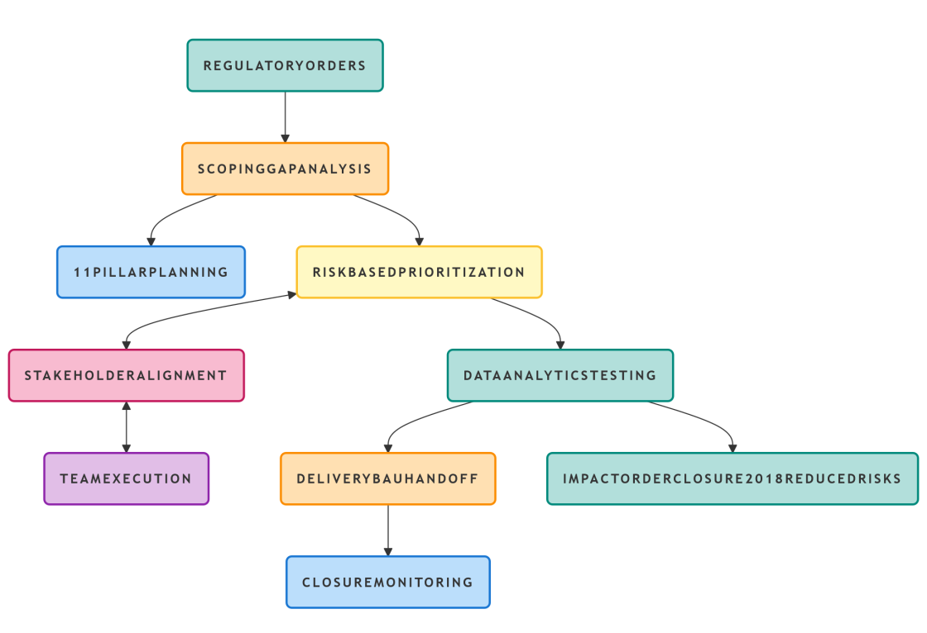
Figure 1:Program Architecture Flowchart (High-Level)
The recommended approach to complying with the delivery model is in compliance with SR 08-08 and consists of four distinct layers that constitute a well organized architecture; these are: (1) Governance & Strategy, (2) Program Management/Delivery, (3) The Stakeholder and Functional Layer, and (4) The Control, Data and Impact Layer. The layer of Governance & Strategy represents the organization of the activities performed by the Board and the Executive Steering Committee to achieve proper oversight. The activities of the Board and Executive Steering Committee include, but are not limited to, overseeing compliance with regulatory requirements for the entire organization and managing numerous components, such as, for example, the reporting of data, the establishment of risk controls and other compliance requirements, etc. Additionally, the Program Management and Delivery Layer, organizes regulatory requirements into orderly workstreams for effective management of those orders, incorporates risk control measures into the workstreams to be used by the individuals managing those workstreams, and utilizes a combination of hybrid delivery and execution methods to achieve successful implementation of those regulatory requirements.
The Stakeholder and Functional Layer provides a means for cross-functional collaboration among multiple disciplines in an organization, from the regulatory assessment of the program to the implementation of the program with the stakeholders, and supports a global delivery model for enhancing capabilities. The Control, Data & Impact Layer incorporates systemic analysis of the established controls, data analytics for performance monitoring of the overall program, and the assessment of the overall impact of the program in mitigating risk and ensuring sustainability of compliance. Thus, this comprehensive architecture integrates key elements of planning, risk management, and team development with established elements of regulatory compliance, and provides an illustrative and layered high-level architecture for visualizing the relationship between governance, delivery, function, and results for characterizing a bank remediation effort as represented in below Figure 2.
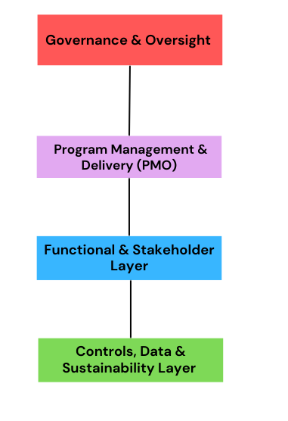
Figure 2:Bank Remediation Program Architecture
- Governance and Oversight Layer:
  - Remediation planning and execution under the Executive Steering Committee’s supervision.
  - Remediation governance consists of the following 11 pillars: Governance, Risk and Controls, Technology, Regulatory Compliance, and Sustainability.
- Program Management and Delivery Layer:
  - Remediation Program Management Office (PMO) facilitates Remedial Lifecycle, planning, tracking, and delivery activities.
  - Remediation PMO utilizes dashboard and metric reporting to monitor remediation progress, maintain budget and schedule, and mitigate risks.
- Functional and Stakeholder Layer:
  - Combines workstreams within the business, compliance, and technology functions.
  - Both communications and collaboration with Senior Management are a necessary component of Stakeholder Management for the development of the Remediation Roadmap and ensure Operational Requirements are met.
- Sustainability, Data and Control Layer:
  - Integration of Control Design and Implementation, Data Analysis, Sustainable Development and Support into operation.
  - Continuous compliance monitoring, testing of controls and assurance that controls continue to be effective shall occur even after closure of a remedial plan.
There is a need for a robust data architecture to record the bank's remedial findings in a bank, which should be similar to a lightweight case management and analytics platform integrated with the existing data and governance systems. This architecture should incorporate a core data model consisting of either a relational warehouse or case management database to centralize the findings and actions taken by a bank so that all findings and actions can facilitate fast roll-up reporting and one-to-many linkages. Additionally, the core data model needs to include a data integration and ingestion layer that specifies the data collection pathways for regulatory exam trackers, internal audit records, and compliance testing tools. In addition to ensuring that all of the historical records are utterly auditable, validation of each of the records upon entry into the data architecture will be accomplished through continuous paperwork tracking, as indicated in the description above.
It is vital to have a layer for managing case and workflows as it allows for well defined processes on how to handle stated findings or actions, to allow for role-based activities as mandated by regulators, and provide a systematic way of escalating issues when required or capturing evidence. An analytics layer will also be required so that an organization can monitor and report on their performance as required by regulators; this layer will have dashboards for presenting the status of open findings (remediation’s), remediation metrics and risk assessments.
The ability to monitor remediation results requires that a standardized data format, which is consistent with the relevant regulatory context for remediation activities, is created. This format is aligned with the G-SIB and SR08-08 guidance and is used by organizations like Citigroup and Wells Fargo. There are a number of elements that comprise the essential characteristics of any documented finding, including: a unique reference number to track a finding, any supporting documentation from both internal audits and regulatory oversight authorities, evidence of compliance with the regulation, a risk rating for the finding, group and distributional mapping for stakeholders and assigned risk level. Also important is defining the detailed nature of an organization’s risk and creating an ownership map of where it exists throughout all business lines. Each remedial action should have a unique identifier to track it; this identifier is critical to ensuring that the remediation is completed as per the organization’s compliance and risk management policies.
Ownership roles, workflow state transitions and associated metrics will track progress on the remediation action as it moves through the various levels of the process and will identify any milestones reached. Each piece of evidence will be documented, including locations for validation. Standards for ensuring the sustainability of the control references will be identified. Metrics and quality of the audits on remediation’s will include: a documented history of changes (including updates) for the actions taken and date/time of completion, an organization’s key performance indicators (KPI) for program and measuring remediation health, and using the cost/benefit model for financial tracking; the schema will also include a list of control libraries, a taxonomy related to a company's risk (that will allow for accurate labelling) and lists of stakeholders for escalation routes. extensive commitments and daily monitoring needs. By integrating with visualization tools (e.g., Power BI or Tableau), enhanced data visualization is possible.
The way that remediation efforts are prioritized and assigned severity determines how effectively resources can be allocated and how organizations can respond to major issues identified during bank remediation efforts, such as those resulting from OCC/FRB consent orders. Priority is determined based on urgency of execution and is determined by business context, whereas severity is a multidimensional assessment of issue importance, including operational, financial, and reputational impacts. Severity is categorized into four levels (Critical, High, Medium, and Low); examples demonstrate the impact of deficiencies; for example, significant fines resulting from BSA/AML issues deemed critical will result in remediation efforts being categorised as high priority. Composite fields (e.g., Risk Scores), while guiding action from the defined severity level and priority category, and the respective SLA, define timelines to track resolution.
To avoid duplication, the importance of defining the severity and priority combinations is paramount for effective risk-based reporting and triage for banks participating in remediation efforts. High Priority/High Severity (Red/Immediate), Low Priority/High Severity (Yellow), High Priority / Low Severity (Green), Low Severity/Low Priority (Blue); examples exist for all four combinations. A remedial findings table should document each combination/code, including both severity and priority, allowing for the quick identification of high-risk remediation items and tracking the lower-risk remediation items in an appropriate manner.
This document provides canonical examples of G-SIB regulatory remediation severity-priority combinations; combinations are organized by priority; therefore, priority determines the order in which repairs are to be executed, whereas severity defines the potential impact of repair. The combinations considered to be at high priority require prompt fixing of items with significant risks associated with the combination (Red/Immediate); they may fall into expedite validations with enhanced executive oversight. Combinations that fall under High Severity/Low Priority, such as those monitored on a quarterly basis, have the potential for significant impact, but there may not be an immediate risk.In the hierarchy of significance of combinations to organizations/regions, this storage approach has designated fields for coding the combinations, severity, and priority levels, and the inclusion of a colour code heat map for the executive view to reduce duplication of efforts on the highest priority items, which may account for the majority of risk per organization/region is shown in below Table 1:
Combination | Severity | Priority | Canonical Bank Example
HS/HP (Red/Immediate) | High (Systemic failure, $B fine risk) | High (FRB deadline <60 days) | AML transaction monitoring crash missing 100K high-risk wires (BSA violation)
HS/LP (Orange/Plan) | High (Major control gap) | Low (No near-term exposure) | Legacy data quality issue in decommissioned product (2.5M records affected, shutdown Q3)
LS/HP (Yellow/Quick Fix) | Low (Minor non-compliance) | High (Regulator goodwill) | Consent order wording error in customer notice (no risk impact, but explicit FRB ask)
LS/LP (Green/Routine) | Low (Cosmetic/internal) | Low (No business impact) | Dashboard label typo in PMO tool (no regulatory/operational effect)
Table 1:Canonical Examples for Severity-Priority Combinations in Bank Remediation
The overall goal of the Bank Remediation Program is to use monitoring of performance indicators as a tool for governance and compliance with the Safe Harbor provisions of Supervision Circular 08-08. Monitoring will utilize our efficiency metrics (closed findings, average time to remediate, on-time closure rates, reopened rates), risk and quality metrics (high-risk backlog, residual risk scores, successful completion of third party assessments), and stakeholder impact metrics (stakeholder satisfaction, financial impact of avoided sanctions, number of regulatory deficiencies). Each metric's target will be set in advance to ensure high levels of performance. There is an emphasis on remediation during active remediation phases while transitioning through seamless integration to Business as Usual operations (BAU) through the bank's compliance program. To ensure sufficient focus in both areas, the recommended breakdown of focus should be 60% Remediation and 40% Compliance.
The importance of this dual focus is that it provides both evidentiary support for successful closure of the remediation program as well as continued viability of the program into the future. These two key pieces of evidence are required by regulators for continued regulatory compliance, as well as not having to pay fines for non-compliance. A dashboard report of remediation and compliance metrics will provide a clear visual for the Board of Directors. Creating a synthetic dataset based on metrics compiled during the period 2018-2022 will provide a higher degree of reliability than the use of third-party proprietary datasets. The dataset will represent a collection of internal remediation program metrics, as representative and anonymized metrics are identified for a Total Bank Remediation Cross Organization (G-SIB) remediation program after substantive remediation effort in 2018. Each of the five years within the dataset will include a number of KPIs including: Findings at Beginning and End of Year, New Findings Raised, Findings Closed, High Priority Findings, Percentage of Findings Closed On-time, Average Time to Remediate, Reopened Findings, Validation Pass Rates, and Regulatory Order Count. The data indicates improvement over this five-year period, with a dramatic decrease in open regulatory orders by the end of 2022. Risk reduction and efficiency improvements will be illustrated in graphical representation, i.e. line graphs and bar charts indicate what has occurred. Support for the generation of visualizations using specific tools and charts may be available.
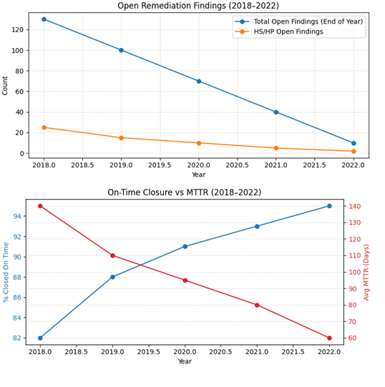
Figure 3:Anonymized Metrics Derived From Internal Remediation Tracking

Conclusion
The remediation program was based on SR08-08 and was built on an 11-pillar structure. In total, by 2018, all of the regulatory orders by the FRB and OCC related to the program were satisfactorily completed. The successful completion of the program illustrated significant leadership in complying with and implementing sustainable controls. (The accomplishments achieved between 2018 - 2022 have resulted in 1 - A reduction of issues of a high-severity nature; 2 - through the closure of more significant volumes than what was completed prior to the program; and 3 a much less length of time in resolving the issue). In total, these accomplishments have avoided a significant amount of fines and limitations on operational capabilities. This organized method of governance, project management, and use of data to drive sustainability creates a benchmark for the Global Systemically Important Banks for managing the consent orders and reducing risk. Future enhancements to the program will consist of utilising AI and machine learning to further reduce the time required in completing the remediation tasks, as well as adapt to a Cloud-Native Data Architecture and utilize Regulatory Technology to automate processes. The program's architecture will be expanding to facilitate compliance with multiple jurisdictions and the integration of blockchain technology into the archiving of all documentation related to all regulatory requirements and to verify Environmental, Social, and Governance compliance. The efforts to sustain the achieved reduction in non-compliance and develop greater resilience against emerging risks from AI in financial crime will continue.

References
- “2021 List of Global Systemically Important Banks (G-SIBs)”, 23 November 2021, https://www.fsb.org/2021/11/2021-list-of-global-systemically-important-banks-g-sibs/.
- “2020 review: 10 largest regulatory fines this year”, Alex Hamilton, December 28, 2020, https://www.fintechfutures.com/regulatory-actions/2020-review-10-largest-regulatory-fines-this-year.
- “A crisis that changed the banking scenario in India: exploring the role of ethics in business”, SushmaNayak, JyotiChandiramani, 2022 Aug 28, https://doi.org/10.1007/s13520-022-00151-4.
- “Five design principles to foster successful remediation execution”, September 2021, https://assets.kpmg.com/content/dam/kpmg/bm/pdf/2022/03/ie-remediation-5-design-principles.pdf.
- “BEST EGMONT CASES - Financial Analysis Cases 2014–2020”, Hennie Verbeek-Kusters, 2021, https://egmontgroup.org/wp-content/uploads/2022/01/2021-Financial.Analysis.Cases_.2014-2020-3.pdf.
- “The Four Methods of Financial System Regulation: An International Comparative Survey”, Andrew Schmulow, 28 Jan 2018, https://ssrn.com/abstract=3082092.
- “BIS Working Papers No 859 Post-crisis international financial regulatory reforms: a primer”, Claudio Borio, Marc Farag, Nikola Tarashev, April 2020, https://www.bis.org/publ/work859.pdf.
- “Making your KYC remediation efforts risk and value-based”, Mette Gade, Daniel Mikkelsen, Dan Williams, August 23, 2019, https://www.mckinsey.com/industries/financial-services/our-insights/banking-matters/making-your-kyc-remediation-efforts-risk-and-value-based.
- “Customer remediation: Making it right (and better)”, 2022, https://www.protiviti.com/gl-en/whitepaper/customer-remediation-making-it-right-and-better.
- “A best-practice model for bank compliance”, Piotr Kaminski, Kate Robu, January 2016, https://www.mckinsey.com/~/media/McKinsey/Business%20Functions/Risk/Our%20Insights/A%20best%20practice%20model%20for%20bank%20compliance/A_best_practice_model_for_bank_compliance_2.pdf.
- “Regulators’ Disclosure Decisions: Evidence from Bank Enforcement Actions”, Anya Kleymenova, Rimmy E. Tomy, June 5, 2019, https://www.iimb.ac.in/accounting-research-conference-2019/Papers/rimmy-tommy.pdf.
- “FCA fines five banks £1.1 billion for FX failings and announces industry-wide remediation programme”, 04/11/2019, https://www.fca.org.uk/news/press-releases/fca-fines-five-banks-%C2%A311-billion-fx-failings-and-announces-industry-wide-remediation-programme.

