Development of an Online School Document Processing for Registrar and Cashier in Pangasinan State University Alaminos City Campus

INTRODUCTION

Organizations that provide higher education services need to handle a large quantity of academic documents together with financial records because document processing efficiency represents a core requirement for their institutional functions. Students request these records through official documents which contain their transcripts of records and certificates of enrollment and certificates of graduation and grades. The institution needs to process these documents both accurately and promptly because it affects student satisfaction and institutional credibility.
At Pangasinan State University – Alaminos City Campus, students regularly submit requests for various academic documents that require coordination between the Registrar and Cashier offices. The Registrar verifies student records to approve document requests while the Cashier manages fee assessment and verification processes. The two offices need to work together because document release requires payment confirmation through their processing system. The process becomes difficult to handle because there is no integrated system available.
The campus executes most document processing work through its manual processes and uncoordinated systems. Students must go to physical offices to complete their requests through document submission and payment verification and document status tracking. The manual system creates processing delays because it needs multiple times to enter data and it results in lost files and the process lacks monitoring of document request progress. The repetitive tasks in administration work lead to more work for staff members while students experience service delays and uncertainty.

The two offices encounter challenges in monitoring both pending requests and finished work because they lack real-time tracking and centralized data management. The situation brings higher risks of human errors and data discrepancies and it delays service distribution. The existing system shows its limitations more clearly as student populations rise and users require faster services. Educational institutions now utilize online systems because information technology has progressed to provide these systems which enhance administrative operations through better performance and precise results and easier access to their services. The web-based document processing systems enable students to submit their requests through electronic means while they track their progress in real time and they can minimize their need to visit campus offices. The system enables administrators to access central databases while it streamlines processes through automated systems and enhances interdepartmental communication.

The study aims to create an Online School Document Processing System which improves the registration processes at Pangasinan State University through its online system between students and administrative staff which includes the Registrar and the Cashier. The proposed system aims to automate document and approval processes, thereby enhancing operational efficiency, reducing processing time, and improving overall service quality. The university will achieve administrative modernization through system implementation which will deliver better services to its stakeholders with enhanced transparency and operational efficiency.
The Online School Document Processing System generates institutional advantages because it helps administrators work more efficiently while creating a campus environment that uses less paper at Pangasinan State University - Alaminos City Campus. The system digitizes all operations which previously required physical documents because it makes operations more efficient and reduces document maintenance expenses through its digital document processing. An efficient administrative system is essential in improving service delivery within higher education institutions, as it enhances accessibility, transparency, and reliability for both students and staff.

The use of online document requests and digital record management systems reduces students and staff needs to visit campus offices, which results in less administrative office congestion and better time management. The research assesses two aspects of the proposed system which include technical development and institutional modernization along with its contribution to sustainable administrative operations. The system implementation at Pangasinan State University - Alaminos City Campus will improve document processing methods through better communication between Registrar and Cashier offices. The study presents an analysis that covers system development and actual system use along with expected benefits which provide essential knowledge about digital transformation and administrative systems in higher education. The findings of this study may serve as a reference for future initiatives aimed at improving efficiency, service quality, and sustainability in university document management systems.

METHODOLOGY

The purposed system development utilizes Agile Software Development. The project team uses Agile methodology to build the system through repeated development cycles which enable them to enhance the system based on user input and changing project needs. The system development process creates a system that can quickly adapt to changing requirements from end users who work primarily as Registrar and Cashier staff members. Agile methodology enables development teams to conduct testing and validation activities throughout the development cycle which allows them to detect problems at an early stage and emphasis on user involvement, consists of six phases: Requirements, Design, Development, Testing, Deployment and Review. During Requirements Planning a combination of interviews and surveys collect data and concepts for system needs identification alongside potential issues discovery. The researchers used a developmental research design which researchers typically use for information technology projects that involve designing and developing systems to assess their performance. The feedback was analyzed to identify any issues or areas for improvement. The evaluation results required system adjustments which made necessary improvements to ensure the final system met user requirements and accomplished the project goals. The development method of the mobile application follows an adapted Agile model as shown in Fig. 1.

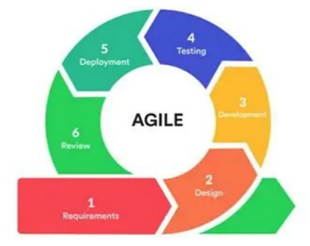
Figure 1: Agile Methodology

An Input–Process–Output (IPO) framework guided the overall conduct of the study. The framework defines the resources and requirements used (input), the system development activities undertaken (process), and the expected system output.

Figure 2: (IPO) Framework of the Study
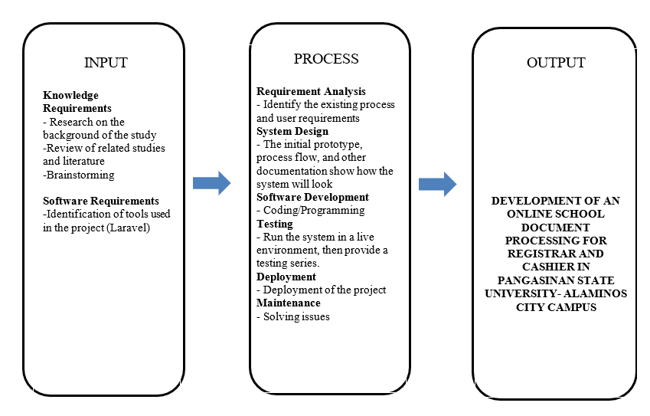

Research activities took place at Pangasinan State University-Alaminos City Campus where researchers studied manual processing documents workflow. The researchers evaluated system usability through user feedback which assessed system performance and accessibility and ease of use. We gathered data through interviews by interviewing Dr. Elmer C. Diocares and Mrs. Marjorie G. Mariado in their roles as Acting Campus Registrar and Cashier II. The system will provide end users especially Registrar and Cashier employees with daily system access through this approach.
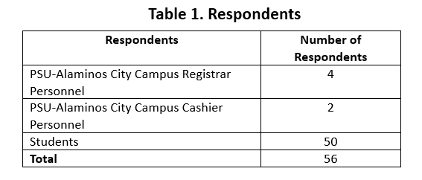
Table 1: List of the Respondents.
Multiple data collection methods were employed to ensure comprehensive system analysis and evaluation:
- Interviews were conducted with Registrar and Cashier personnel to identify existing document processing workflows, challenges, and user requirements.
- Questionnaires were administered to students and administrative staff to evaluate the acceptability of the proposed system in terms of functionality, usability, efficiency, and reliability.
- Observation was utilized to document the actual procedures involved in requesting, processing, and releasing school documents under the existing manual system.
- Document Analysis involved reviewing current Registrar and Cashier forms such as document request slips, official receipts, transaction logs, and reports used in daily operations.
- Internet and Literature Review supported the system design by identifying best practices, standards, and related studies on online document processing and records management systems in educational institutions.

RESULTS AND DISCUSSION

This section presents and discusses the results obtained from the implementation and evaluation of the Online School Document Processing System for the Registrar and Cashier of Pangasinan State University – Alaminos City Campus. The findings were derived from interviews, observations, document analysis, and system acceptability and usability evaluations conducted among students and administrative personnel of the university. The discussion focuses on the existing document processing practices, identified challenges in the manual system, the features of the developed system, and its usability and performance based on the ISO/IEC 25010 software quality model.

Current Process of Requesting and Processing
Results from interviews and observations revealed that Pangasinan State University – Alaminos City Campus primarily relies on a manual, paper-based system for processing and managing school document requests. Students are required to physically visit the Cashier’s Office to file requests and make payments, after which they proceed to the Registrar’s Office for document processing. Transaction details are recorded manually using request forms, receipts, and logbooks, which are later consolidated for record-keeping and reporting purposes.
Table 2: Requesting Document Flowchart
- Start the process.
- Request for documents
- Fill up form
- Submit form
- Pay amount of the document
- Claim receipt
- End of process
The existing process involves manual recording of student information, requested documents, and payment details, resulting in delays, long queues, and difficulties in tracking request status. This traditional method increases the likelihood of errors and misplaced records, highlighting the need for an automated online document processing system to improve efficiency, accuracy, and accessibility for both students and administrative staff.

After requesting the document, present your official receipt to the registrar. After submitting it, wait for the documents to be processed. After receiving your document, you are required to fill out the customer satisfaction survey and log book.

Table 3: Claiming Document Flowchart

- Start the process.
- Submit your official receipt to the registrar staff
- Wait for your form to be processed
- Claim your document
- Fill up log book
- End the process.

The cashier need to submit an audit report for each month’s collection. Gathering all tangible receipts and sort them. The next step is manually typing all the amount to an Excel spreadsheet where they input it accordingly.

Table 4: Generating Report Flowchart

- Start the process.
- Collect all the receipt gather for the month
- Sort by type of service/document
- Soft by day
- Input all data to an Excel spreadsheet
- Print spreadsheet
- End the process.

Challenges in the Existing System
The analysis of the current document processing system identified several challenges affecting the operations of the Registrar and Cashier offices at Pangasinan State University – Alaminos City Campus. Using a Fishbone Diagram, the study categorized these challenges into key areas, including security, personnel, process, technology, environment, and management. This structured analysis helped identify the root causes of inefficiencies in the manual document processing system and served as a basis for designing an improved online document processing solution.

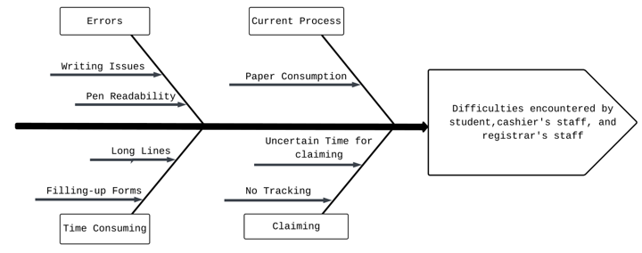
Figure 3: Fishbone Diagram

The Online School Document Processing System developed its complete system for Pangasinan State University at Alaminos City Campus through its implementation of suitable methods together with required tools and technological systems. The system improves document processing workflows for users through its solution to the main challenges which students and administrative staff face when they request documents and verify payments and track their progress. The developed system works for both the Registrar and Cashier offices because its design and development process ensures all their operational requirements will be fulfilled. The system enables better document processing which becomes more efficient and accurate and dependable through its implementation at the university.

Features of the School Document Processing System
The Online School Document Processing System was developed to address the operational and documentation challenges identified in the existing manual document processing practices of the Registrar and Cashier offices at Pangasinan State University – Alaminos City Campus. The system is composed of several interconnected functional modules, each designed to support specific tasks involved in requesting, processing, verifying payments, approving, and releasing school documents. These modules work collaboratively to ensure accurate record management, efficient workflow coordination between offices, and timely issuance of requested documents to students.

Tracking request is one of the main feature of the system, this show the payment status if its paid or not and if the document is processed and ready to claim.

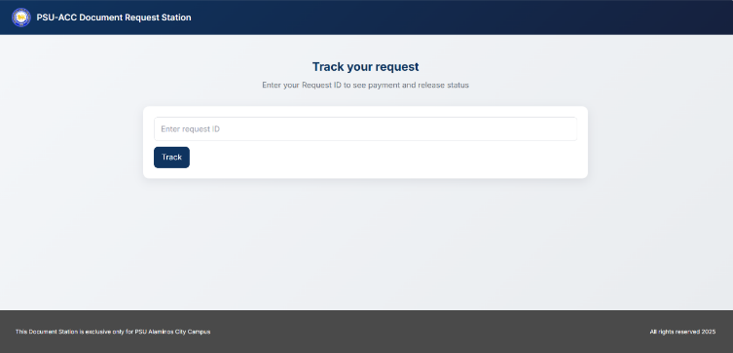
Figure 4: Track Request

The QR Code for student’s request, this feature allows the students to have all of their request’s data in a single screenshot, they only need to show to the cashier the QR provided after submitting the request for the document and the cashier can navigate their request and start processing.

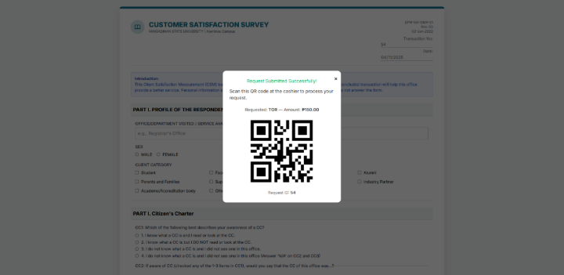
Figure 5: QR Code for student’s request

The cahier’s exportable reports. This system offers the cashier staffs a readymade report for the requests that has been processed/paid in a day, week, or month that can be exported in a PDF format.
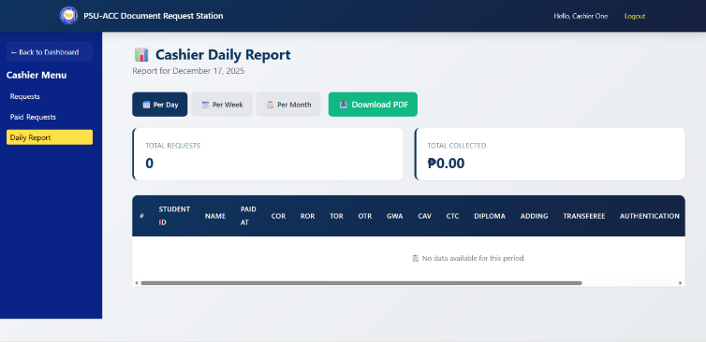
Figure 6 Cashier’s exportable reports

Viewing all css surveys for registrar. The student who want to successfully submit their request they need to fill the CSS survey. All of those answered survey can be viewed by the registrar, so they can what aspect are the students/customer see that is lacking and need to improve.
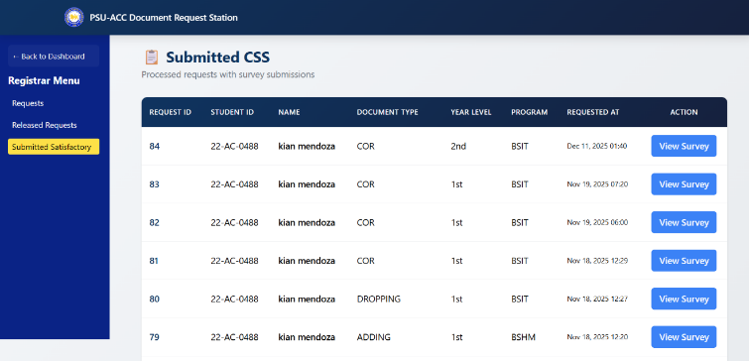
Figure 7 Viewing all css surveys for registrar

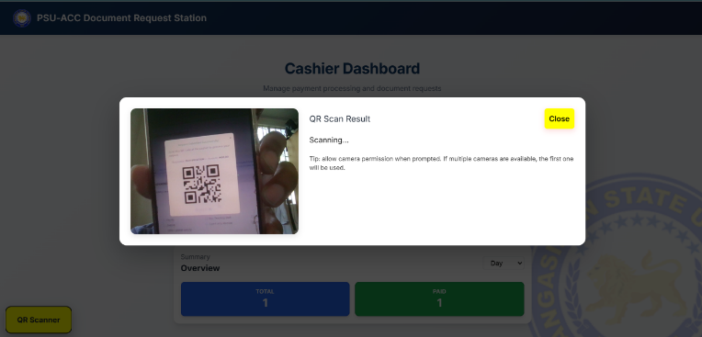
The Cashier’s QR Scanner can scan the students’s request QR and immediately show the request’s data and change its status to paid.

Figure 8. Cashier’s QR Scanner

Usability Evaluation of the System
The usability evaluation of the Online School Document Processing System was conducted using the ISO/IEC 25010 software quality model, covering key quality characteristics such as functionality, reliability, usability, efficiency, maintainability, and portability. The respondents included Registrar personnel, Cashier personnel, and students of Pangasinan State University – Alaminos City Campus.
As presented in Table 4, the system obtained an Average Weighted Mean (AWM) of 4.03, interpreted as More Evident The results indicate that respondents agreed that the system provides essential features, performs its intended functions effectively, and significantly improves the efficiency and quality of document processing services within the university.

Table 4: System Evaluation Functionality

Functionality | Mean | Description
1. The system covers all the specific task and user objectives.  2. The system provides the correct results with the needed degree of precision.  3. The system facilities the accomplishment of specified task and objectives | 4.05  4.09  3.96 | More Evident  More Evident  More Evident
Average Weighted Mean | 4.03 | More Evident

Table 5 indicates an AWM of 3.98 (More Evident), suggesting that the system operates consistently, saves data accurately, and maintains stable performance during peak usage.

Table 5. System Evaluation Reliability

Functionality | Mean | Description
1. The system works without unexpected errors.  2. The system loads properly every time.  3. Data is saved correctly  4. The system performs well even during busy hours. | 4.16  3.98  3.87  8.91 | More Evident  More Evident  Evident  More evident
Average Weighted Mean | 3.98 | More Evident

The usability evaluation presented in Table 6 yielded an Average Weighted Mean (AWM) of 4.12, interpreted as More Evident. The respondents found the Online School Document Processing System easy to learn, intuitive to navigate, and appropriate for the administrative processes of the Registrar and Cashier offices at Pangasinan State University – Alaminos City Campus..

Table 6. System Evaluation Usability

Functionality | Mean | Description
1. The system allows users to recognize if it is appropriate for their needs.  2. The system can be used by specified users to achieved specified goals.  3. The system has attribute to make it easy.  4. The system protects users against errors.  5. The system user interface enables pleasing and satisfaction.  6. The system can be used by people with the widest range. | 4.48  4.21  4.05  3.92  4.03  4.05 | Highly Evident  Highly Evident  More Evident  More Evident  More Evident  More Evident
Average Weighted Mean | 4.12 | More Evident

The efficiency evaluation results presented in Table 7 show an Average Weighted Mean (AWM) of 3.94, interpreted as More Evident. The findings indicate that the Online School Document Processing System effectively reduces paperwork, accelerates document request processing, and improves overall workflow efficiency in the Registrar and Cashier offices of Pangasinan State University – Alaminos City Campus.
Table 7. System Evaluation Efficiency

Functionality | Mean | Description
1. The system helps response and processing times throughout rates when performing.  2. The system responds amounts and types of resources used when performing its function.  3. The system reduces paperwork. | 3.80  4.08  3.94 | More Evident  More Evident  More Evident
Average Weighted Mean | 3.94 | More Evident

Table 8 presents an Average Weighted Mean (AWM) of 4.08, interpreted as More Evident, indicating that the Online School Document Processing System can be easily updated, maintained, and adapted to the evolving requirements of the Registrar and Cashier offices at Pangasinan State University – Alaminos City Campus.

Table 8. System Evaluation Maintainability

Maintainability | Mean | Description
1. The system is easy to update or improve.  2. Issues can be fixed quickly.  3. The system can determine those criteria have been met. | 4.14  3.38  3.92 | More Evident  Evident  More Evident
Average Weighted Mean | 4.08 | More Evident

Portability obtained the highest rating among the evaluation criteria, with an Average Weighted Mean (AWM) of 4.04, interpreted as More Evident, as shown in Table 9. The results indicate that the Online School Document Processing System can be accessed across various devices, web browsers, and locations, making it convenient for students and administrative personnel of Pangasinan State University – Alaminos City Campus, even under conditions of limited internet connectivity.

Table 9. System Evaluation Portability

Portability | Mean | Description
1. The system works any devices or usage environments.  2. The system can be successfully installed and uninstalled.  3. The system can replace another specified software product. | 4.05  4.05  4.03 | More Evident  More Evident  More Evident
Average Weighted Mean | 4.04 | More Evident

The overall evaluation recorded an AWM of 4.04 (More Evident), reflecting high user satisfaction and strong acceptance of the RHU Bani Talaan System. A summary of all criteria is presented in Table 11, confirming the system’s effectiveness across all quality attributes
Criteria | AWM | Interpretation
Functionality  Reliability  Usability  Efficiency  Maintainability  Portability | 4.03  3.98  4.12  3.94  4.08  4.04 | More Evident  More Evident  More Evident  More Evident  More Evident  More Evident
Overall | 4.03713 | More Evident

Discussion and Findings
The findings show that the transition from a manual to an online document processing system has a significant positive impact on the efficiency of operations in the Registrar and Cashier offices of the Pangasinan State University – Alaminos City Campus. The Online School Document Processing System proposed in this study tackles the major issues brought about by the current system, such as long queues, delayed verification, manual errors in records, and lack of tracking of requests. The system improves the accessibility, accuracy, security, and efficiency of the current system by providing online processing of document requests, payments, and verification of records. Students can now request documents and track the status of their requests online, while office personnel can easily access and manage their online records and reports.
The results of the usability evaluation are high, indicating that the system is well-aligned with the needs and requirements of the users. In general, the results of the study show that the Online School Document Processing System is an efficient and effective solution to the current document management and financial transaction processes in the university setting.

CONCLUSION

The Online School Document Processing System for Pangasinan State University Alaminos City Campus Registrar and Cashier functions as an effective solution which addresses administrative difficulties that arise from conventional manual school document processing methods. The system achieves processing efficiency improvements and accuracy enhancements and user satisfaction increases through its implementation of modern web technologies and real-time request tracking and its structured workflow system. The system enables students and administrative staff to experience better services because it decreases waiting times and speeds up document processing and it makes document transactions more transparent. Through a user-friendly interface, students can easily access document request services, which help the Registrar and Cashier offices to work together more efficiently while they check payments and manage their records. The three-tier architecture system protects data, allows systems to grow, and maintains system performance through its strong protective measures.

REFERENCE
[1] Adra, J. B., Sarmiento, J. R., & Bausa, M. E. (2024). Student services digital records management system for the registrar’s office. GSJ: Global Scientific Journal, 12(4). Retrieved from https://www.globalscientificjournal.com/researchpaper/STUDENT_SERVICES_DIGITAL_RECORDS_MANAGEMENT_SYSTEM_FOR_THE_REGISTRAR_S_OFFICE.pdf

[2] Adra, J. B., Sarmiento, J. R., & Bausa, M. E. (2024). Student services digital records management system for the registrar’s office. GSJ: Global Scientific Journal, 12(4). Retrieved from https://www.globalscientificjournal.com/researchpaper/STUDENT_SERVICES_DIGITAL_RECORDS_MANAGEMENT_SYSTEM_FOR_THE_REGISTRAR_S_OFFICE.pdf

[3] Berdin, M. J. A., Agostilo, J. E., Descartin, J. A., Estomo, M. G., & Nodalo, C. N. L. (n.d.). A Centralized Document Processing and Support System (CeDoPSS) for Philippine Registered Vessels. Innovatus: A Journal on Computing Technology Innovations, 5(2) https://innovatus-
pub.github.io/abstractpublications_archive/2022b/paper4_pdf.pdf​

[4] Brohi, K. B., Memon, S., & Shaikh, K. H. (2023). Navigating Barriers to Successful Implementation of Digital Record Management System: A Case Study of Pakistani Public Sector Universities. Journal of Enterprise and Management Innovation (JEMI),5(1),59-73. https://coralpublications.org/index.php/jemi/article/view/346/168

[5] Falolo, V. M., Capillas, K. T., Vergarra, N. A., & Cerbito, A. F. (2022). Student registration and records management services towards digitization. International Journal of Educational Management and Development Studies, 3(1). https://doi.org/10.53378/352867.

[6] Magno-Tan, M. J., Crisostomo, A. V., Villaflor, B., & Faller, J. C. (2020). Cloud-based college management information system for universities. International Journal of Information and Education Technology, 4(6), 476-479. https://www.ijiet.org/papers/460-F017.pdf

[7] Maslang, K. L., Baguilat, I. D., Mania, E. E. N., Damayon, S. B., & Dacles, D. D. M. (2021). Student Services Awareness and Satisfaction in a Private Higher Education Institution amid the Pandemic. American Journal of Educational Research, 9(12), 708-719. https://pubs.sciepub.com/education/9/12/3/

[8] Nagrama, N. D. C., Lingating, M. L. D., Calleno, J. T., Rato, R. K. A., Catungal, M. L. P., & Encarnacion, P. C. (2024). Web-based Document Management System. International Journal of Science and Advanced Information Technology, 13(3), 16-21. https://doi.org/10.30534/ijsait/2024/031332024
[9] Pagayonan, S. M. S. (2022). Development of E-Document Management System for Higher Education Institution. International Journal of Research in Engineering and Science (IJRES), 10(6),366-372. https://www.ijres.org/papers/Volume-10/Issue-6/1006366372.pdf

[10] Taruc, F. S., Martin, T. A. S., Olipas, C. N. P., & Alegado, R. T. (2023). Docu-Go: The Development and Assessment of a Web-Based Barangay Document Requesting System. International Journal of Information Technology and Computer Engineering, 3(4), 40–49. https://doi.org/10.55529/ijitc.34.40.49

