Abstract
The main objective of this study was to assess the treatments of prisoner’s rights in HGWZ correction center. The study was limited to assess prisoner’s right to adequate food, clean water, health care, bedding and clothing condition, way of separation, number of inmates in each room, prisoners living condition including the right to education, the right to religion, the right to contact their family, the right to equality, the right to petition, the right to access sport, freedom from cruel and inhuman treatment, parole condition and way of recognizing trust prisoners. Data was collected from primary source like Prison leaders, social worker and prisoners. Data collection tools such as interviews, questionnaires and observation were used. To achieve the stated objective, analysis was done by using both qualitative and quantitative research approaches and employed SPSS 20 version software. The study used descriptive type of research design to describe the situations that exist in prison centers at the time of study.
The major finding of the study reveals that there were insufficient food, clean water and health care of prisoner’s in HGWZ prison. The prison provides basic services not in accordance with FPAC and international prisoner’s rule. Similarly, service like bed, clothing & toilet are poor and inconsistent with FPAC and international prisoner’s right. The number of inmates in a single hall was highly overcrowded (between 90-120) in HGWZ prison; that is small in size and not enough for inmates and imbalance with the number of inmates. FPAC recommend 40-50 inmates in single hall. There is no separation of prisoner via their degree of crime in the study area; rather, only separating based on their sex. In similar vein, there were poor implementation of constitutional right and living condition of prisoners in the prison. Further, the existing proclamation and regulation regarding to the treatments of prisoners could not properly protect the rights of prisoners in prison, because, the federal proclamation and regional regulation not clearly provide the rights of prisoners as provided in international human right. On the other hand, FPAC and ORSPAC need to be improvement.. Based on the findings, the researcher suggest that the improvement of the existing proclamation and regulations on the protections of prisoners’ rights that govern every prisons institution of the country.
Key Term: prison, prison administration, prisoner’s rights, human rights, Federal Prison Commission

CHAPTER ONE

INTRODUCTION

1.1. Background of the Study
Human rights are a fundamental right to which a person is inherently entitled simply because she/he is a human being. Prisoners’ right is part of a human right which is not violated simply for their criminal status except expressly provided by law because human rights are thus conceived as universal and the same for everyone everywhere. It is a universal legal guarantee protecting individuals and groups against actions that interfere with fundamental freedoms and human dignity. (UN, 2005)
The preamble of the Universal Declaration of Human Right also provides that the recognition of the inherent dignity and of the equal and inalienable rights of all members of the human family is the foundation of freedom, justice and peace in the world. (UDHR, 1948)
The growing trend in international and comparative law shows that human rights are indivisible and inviolable. The economic, social and cultural rights become justifiable under artificial division of constitutional rights between economic, social, cultural, civil and political right that seems to continue until the constitutional reform after world war second. Since then the protection of human rights emerged as the new ideology to ensure the prisoners’ right with regard to its non- absolute and impossible issues due to the isolation from the society and lack of desire of the outside world. ( EHRC, 2013).
As a result, the conflicting goal that correctional law and human rights law seems to become the challenging issues in prison and other places of detention in many states of the world. These challenges encompass communicable diseases, lack of health service, and lack of access to education, inability to some constitutional rights, malnutrition, torture and ill-treatment of inmate’s. (Adisu, Gulilat , 2012).
Due to the above challenging issues, human beings demand the recognition of diverse values to guarantee their individual and collective wellbeing. Human rights to become rooted deep in the condensation of time yet the term itself dates back a barely several decades to international discussion proceeding the founding of united nation.
Since 1945, the scope of human right has been elaborate ted and the concept now consistent that causes the emergence and the foundation of international, regional, national and local society. ( Getahun, 2005).
The African charter on human and peoples’ rights under article 5 stated that the prohibition of inhuman treatment and every individual should have the right to respect the dignity inherent in human beings and to the recognition of his legal status. All forms of exploitation and degradation of human being particularly slavery, torture, cruel, degrading punishment and treatment should be prohibited. (Adisu Gulilat, 2012).
Prisoner’s right associated with the constitutional concept of rule of law that the inherent limitation on the exercise of absolute power by a ruler. It entails the citizens to enjoy the right to speech, the right not to torture, the right to provision of food, health care, the right to contact family, the right to life, the right to privacy, the right to security, the right to equality and fraternity are some rights that they need to enjoy. With regard to this, punishment based approach are not effective in rehabilitating prisoners moderately such approach gave away into increased recommitting of crime. (Ebad Rouhi,I.R, 2016)
However, the reality is that prisoners are often held in the most restricted conditions, i.e., conditions that in a number of cases are disrespect to human dignity. Prisoners who are in prisons are challenged by a number of problems, such as overcrowded, poor medical services, insufficient provision of food and water, poor sanitations, lack of bed, clothing, declassifications of prisoners in terms of their age, sex, seriousness of the crime committed, the rights to contact with families and the way prisoners are handled concerning their human dignity. Therefore, even if different International Human Rights Instruments have recognized the prisoners’ rights, still there are problems concerning the handling and treatments of prisoners particularly in the Prison institution. (Cullen P.G, 2000).
Today, education training has turn into essential element of prison organization in order to rehabilitate prisoners. As such, presenting basic education, vocational education and training, high school diploma and distance education are the main widely used strategies of rehabilitation in prison organization transverse the world. (Hurry etal, 2012).

Similarly, in Africa identical development has been experiential in terms of the move from long years of brutal and nasty condition in the treatment of prisoners into rehabilitative approaches. Therefore, most prison in Africa present vocational education and training as part of prisoner rehabilitation curriculum. (Gatotoh etal , 2011)
In the long history of Ethiopia, there has been no satisfactory inmates’ right protection record. Rather Ethiopia has been disgracefully known for abuses and violation of fundamental prisoners’ rights and freedoms under nearly all successive regimes taking the state power. The natural domestic political culture about human right dignity and worth in the country has remained markedly poor for centuries. (Alene Agegnew and Work Dibu,2015).
With respect to the practice the inquiry carried out shows that the treatment of detained person in Ethiopia failed short of compliance to the minimum expectation as it is found challenges such as highly overcrowded, diseases, malnutrition, unhygienic condition, lack of separate treatment based on sex, age, illness, and nature of criminal; lack of organized and continuing education and training and absence of viable compliant hearing mechanism. (Addisu Gulilat, 2012).
Similarly, the Ethiopian detainees also described terrible conditions of detention, including inadequate food, poor bedding condition and restriction on access to daylight, poor clean water and limited medical treatment. The authorities at Maekelawi to maximize pressure on detainees to extract statements, confessions and other information whether accurate or not to implicate and others in illegal criminal activity use the coercive methods, exacerbated by the poor detention condition. (HRW report, 2013)
Post 1991, prisons are re-start with clearly stated mandate and objectives whereby the treatment of prisoners moved from unkind physical penalty to improve and rehabilitate on the basis of the FDRE constitution and state proclamation.
Accordingly, the 1995 FDRE constitution everyone has the right to equal access to publically funded social service including education, public health, clean water adequate living condition and other social services. These rights extend to include all the Ethiopian citizens held under any custody. (FDRE constitution Art, 41 (3 and 4).

In addition to this, federal FPAC proclamation in its preamble clearly states the objectives as being to undertake the function of the custody, reformation and rehabilitation of prisoners. The proclamation pointed that one among the other power and duties of the commission is to recognize and protector prisoners’ and provide correctional and counseling service to facilitate post release rehabilitation. (FPAC, 365/2003).
Similarly, the Federal detainees’ treatment regulation (FDTR) noted out that inmates should be offered with the opportunity to attend academic and vocational education and training. The federal prisons like Addis Ababa prison provides varieties of vocational education and technical training in metalwork, woodwork, home economics, weaving and the like. (FDTR,No. 138/2003).
As such, in Ethiopia, there is no any uniform standard or guidelines that determine the treatments of prisoners concerning the living space of prisoners in the country. Moreover, the regulation for the treatments of prisoners of Oromia region has no any clear provisions for the protections of prisoners’ rights regarding the adequate living space or accommodation. Hence, where prisoners are highly overcrowded, it affects the prisoners’ human dignity and it cause to increase the risk of physical and mental health problems because of they are incarcerated in overcrowded and cause unsanitary and stressful conditions. (Andrew Coyle, 2009)
Since 1995, Ethiopia comes up with newly developed democratic constitution, which introduces the provision of human rights. As the protection of human right, it is a recent phenomenon in our country and then, the study has been conducted in Oromia regional state at HGWZ in Shambu towns.
The HGWZ prison was one of the prisoners institution found in Oromia regional state. Whereby it is one of the administrative zones found in Oromia national regional state and started to rule under zonal administration in 1998 and its age of zone was 12 years old. Shambu is the capital city of the zonal administration and established in 1911 and it was 101 years old.

1.2. Statement of the problem
Concerning the treatments and handling of the prisoners, Art.21 of the FDRE and the revised Oromia regional Constitutions impose a duty on the prison institutions to respect the human dignity of the prisoners. Even if both the national and international human right instruments are provided the rights of prisoners in line with the international laws or international conventions, various prison institutions are not practically implementing the rights of the person in prison according to the provisions of the law provided for prisoners.
Of course ensuring prisoners’ right is not absolute rather it is relative issue to everyone. Because no state in this world even in developed, states did not successfully address the protection of prisoners’ right. Therefore, it is not exceptional issue for Ethiopia that has no suitable human right protection condition even in modern history since imperial regime to the current regimes.
Moreover, the thesis also come up with to what extent HGWZ prisoner’s human dignity are respected according to the FDRE constitutions and federal prison administration. The prison institutions have a duty to treat prisoners in accordance with the international prisoners’ rights principles that provided under FDRE and regional Constitutions.
Therefore, the thesis attempted to discuss the problems concerning the particular prisoners’ rights such as: prisoner’s right to adequate food, clean water, health care, toilet service, bedding and clothing, separation of prisoners based on sex, age and others, constitutional right, living condition of prisoners and prisoners right to sex with their wife or husband. The 1995 constitution, Article (21) states that all person held in custody and prisoners imprisoned up on conviction and sentencing have the right to treatment respecting their inherent human dignity. From the above discussion different researchers investigated inquiry on human right condition particularly prisoners right in different prison institution. For instance, at special Oromia zone in case of Burayu town and at Addis Ababa city administration in different sub-cities.
However, still now only very few people have been carried out a research on an assessment of prisoner’s right in HGWZ prison. Thus, the researcher is interested to investigate detail research to examine and practically assessing the existing problem on the treatment of prisoners to fill the research gap on current condition of prisoner’s right in HGWZ prison administration.

1. 3. Basic Research Questions.
Based on the general and specific objectives of the study given below, the study answered the following basic research question.
1. To what extent HGWZ prisoners enjoy their service delivery such as food, bed, health care, accommodation and clean water in line with FDRE constitution and international standard?
2. What are the constitutional rights that prisoners enjoy in HGWZ prison administration in line with federal prison commission?
3. How can prisoners handle and provide their living condition in HGWZ correctional center?

1.4. Research Objectives

1.4.1 General objectives
The general objective of the study could be aimed to assess practical implementation and treatments of prisoners’ right in HGWZ Prison administration in line with the federal prison commission proclamation and international prisoner’s rights and rules that adopted under ONRS and FDRE constitution.

1.4.2 Specific Objectives
The specific objectives of this study are:
A. To investigate the extent of access service delivery of prisoners in HGWZ prison administration such as the right to adequate food, bedding condition, clean water, health care and way of accommodation in line with FDRE constitution and international standard.
B. To describes the constitutional rights of prisoners and its practice in HGWZ prison administration.
C. To evaluate the nature of living condition of prisoners in HGWZ prison administration in line with federal prison administration standard.

1.5. Significance of the study
Prisoners’ right is a dynamic phenomenon in this world that needs investigation to be resolved by concerned body, which is changed with the system of the government. The result of this study helps for further discover the condition of prisoners’ right today in Ethiopia, in Oromia national regional states particularly in HGWZ prison administration, which is situated in shambu town. It forwards the necessary strategic solution that helps the correction and rehabilitation center to improve the existing problem. in other way it also help the researchers as the base for further study in other prisons administration either in other region or in other zone.
As respecting human right is participatory in process, the result of this study also helps the government, societies and humanitarian institutions to work jointly to protect human rights in prison. It also aware the community living around the area about the right of prisoners in prison. Moreover, this study also used to enhance the knowledge of the prison officials, judges, public Prosecutors and public polices or police officers in order to realize the rights of the prisoners’ according to federal prison commission and international prisoners’ right instruments.

1.6. Scope of the study
This study has been conducted in Oromia national regional state (ONRS) at HGWZ in Shambu town, which is situated in the western part of Oromia at about 333km far from Addis Ababa. The scope of this study has been only delimited to an assessment of the prisoners’ right in Oromia regional state, the case of HGWZ prison administration.
The study had only focused on prisoners’ right to adequate food, bed, clothing, health care, way of separation, the right to education, way of handling and treatment, the right to be visited by their family, freedom of religion, way of providing pardon and constitutional rights of prisoners. In addition, it extended to cover the roles of the regional prison regulation for the protection of prisoners in HGWZ prison administration.

1.7. Limitation of the study
Definitely gathering information on prisoners’ right is difficult and challenging issue in order to address and achieve the target goal. Therefore, the researcher faced varieties of challenges during investigation such as the problem of prison administration ethical principle that states civilians are not allowed to inter and move here and there in prison without the internal legal experts support and the permission of top officials. However, the researcher overcomes these all challenges by following the ethical principles exist in the prison to collect the necessary information by using questionnaire’s and open full observation.
In addition to these, lack of finance and time, lack of access of internet, personal bias of prisoners in giving accurate information, low interest of respondents to answer the question openly and considering as collecting questionaries’ by researcher as no value for them, earlier experience of the researcher to conduct holistic research on prisoners’ rights and these all are some of the constraints that negatively affected the researcher. To overcome all the above challenges the researcher limit the number of respondents, created awareness to improve inmates’ negative attitudes, written questionnaire was used to help prisoners’ to give their idea freely without any fear.

1.8. Organization of the study
The thesis composed of five chapters. Every chapter has inter-related. The earlier chapter presents the general introduction to the research background, statement of the problem, objectives, and research questions, significance, scope and limitation of the study. The next chapter discussed about literature review including the concept of prison, prisoner’s, prisoners right as constitutive human right, principle of good prison management, prisoner’s right in international and regional context and prisoners right under FDRE constitution. In addition, it contains prisoner right to food, education and health and international standard minimum rule for protecting prisoner’s right. Chapter three contains: Research methodology, description of study area, research design and approaches, methods of data collection, source of data and sampling techniques. Chapter Four discusses the right to basic service delivery of prisoners, practical implementation of constitutional right of prisoners in HGWZ prison and way of treatment of prisoners. Finally, Chapter 5 comes up with the conclusion and recommendation of the study. At the end, reference and appendixes has been provided

1.9. Definition of key concepts
Prison: is correctional institutions where prisoners sentenced by court serve their sentences are reformed and rehabilitated and where remand prisoners are held in custody until verdict. Prison is also a jail facility in which criminals are forcibly confined and denied some of freedoms under authority of the state as a form of punishment.
Prisoner’s: Is a convicted person serving a sentence passed by a court authorized by law and shall refer to a person detained upon judicial remand. It is who deprived of liberty against their will this can be confinement capacity or by forcible restraint or a person for the time of being in a prison as a result of any requirement imposed by a court or otherwise that he or she be detained in legal custody.
Prisoner’s right: Prisoners’ right is part of a human right, which is not violated simply for their criminal status, except expressly provided by law.
Human rights: Human right is a fundamental right to which a person is inherently entitled simply because she or he is a human being. Human rights generally derived from the inherent dignity of the human person. All human beings have these inherent, inalienable, inviolable, eternal, indisputable and universal moral rights simply by virtue of being human.

CHAPTER TWO

REVIEW OF RELATED LITERATURE

2. General overview of prison and prisoner’s

2.1 Conceptual framework of prison
A number of scholars suggest that the modern prison is a product of the eighteenth century Enlightenment. This has led many reference works on prisons and prison systems to give short shrift to the development of prisons and places of confinement prior to the 1700s. Although early prisons were rarely built expressly for the purpose of imprisonment, most cultures resorted to makeshift cages or dungeons to confine prisoners in existing structures. Since incarceration is widely used as punishment in the world today, most readers would be surprised to find that imprisonment played a minor role in the punishment regimes of most countries before the nineteenth century. (Mitchel P. Roth, 1953)
When we talk about crime and criminals, immediately we remember the word prison. Different scholars have defined prison. However, different authors defined the term prison differently. For instance: Imam Amidi M. Zuberi defined the term prison as: A public building used as a house of convicted criminals and accused persons remanded in custody and waiting trial or it is any place of confinement or it is a jail, penitentiary and place of reformatory. (Imam Ahimed M, Zuberi, 2001)
Prison is one part of the correctional sphere and is neither the most important nor the most extensive. However, it is the heart of it because not only it represents the hard kernel in terms of severity of penalty but also because it is an ever-looming presence behind the many structures of surveillance and monitoring outside detention, where failure to respect their rules exposes the offender to the permanent threat of incarceration. In other words, far from countering the centrality of prison, the words of the director of the national prison administration confirm it, at the same time as situating the carceral world within a broader correctional network where incarceration always remains on the horizon. The punitive state must therefore be

understood to extend within and around prison through correctional. (Didier Fassin, 2017)

On the other hand, it has been defined as any correctional institution or any penal or correctional facility, jail, reformatory, detention center, halfway house or residential community program operated by or under contract to a state a territory a political subdivision of a state or territory for the confinement or rehabilitation of persons charged with or convicted of a criminal offense. (Alexander L. Bednar, 2003).
Writers often use the terms jail and prison interchangeably when describing places of incarceration. Prisons are generally federal or state institutions that house convicted criminals serving long sentences whereas cities or counties usually run jails. Authorities place people in jails that are awaiting a trial or a legal disposition. ( Regar Smith, 2017).
In some jurisdictions, different terms are used to denote places of detention, which hold people who are awaiting trial, who have been convicted or who are subject to different conditions of security. In the United States of America, for example, places which hold persons who are awaiting trial at minor courts or who have been sentenced to short sentences are usually described as jails; those holding convicted prisoners are often called correctional institutions. In the Russian Federation, there are only a minority of prisons, since this term denotes places of detention with the highest security. Establishments for other convicted persons are usually described as penal colonies. (Andrew Coyle, 2009)

2.2. Conceptual framework of Prisoner’s
In some jurisdictions, different words are used for various groups of people who are detained. Those awaiting trial may be known as pre-trial, under-trial or remand and are often referred to as detainees. Accordingly, prison has been used for all places of detention and the word prisoner’s has been used to describe all who are held in such places. (Ibid)
Prisoner is also a person who entered in to prison institution because of receiving a sentence in a criminal court, convicted or for civil liability and for such reasons loses his or her personal liberty. Sending the prisoner in to incarceration is not the means to denying his human rights. That means, they hold their rights even when in prison. This is so, because human rights are universal and it is the same for every human being including a prisoner, no matter where she or he lives. (WHO-2007, health in prison).
A man is not evil by nature and can be educated; going further, if man is by nature good, then when good and evil is presented to him, he will naturally choose the former than the latter. (Allyn Rickets and Adele Rickets, 1973)
As such, different authors were defined who the prisoner is. How and when a person become a prisoner also differentiated and defined by a number of scholars. Hence, prisoner is defined as a person incarcerated in or otherwise confined to a correctional institution. Moreover, prisoners are person who is received to serve a period of imprisonment composed of a sentence for a criminal offence and a consecutive period of imprisonment in connection with a non-criminal matter and a person who deprived of his liberty for his criminal status. (Andrew Coyle, 2009).
On the other hand, Prisoners means a convicted person serving a sentence passed by a court authorized by law and refer to a person detained upon judicial remand. (Federal prison proclamation No.365/2003: Art.2 (5)
Thus, accordingly, every person who deprived of his or her liberty either for criminal or civil purpose is considered as prisoners. Principally states are the major be obliged actors to promote and protect basic rights for their citizen’s regardless of gender, ethnicity, religion and race or class. Consequently, the conflicting goal that the correctional law and human rights seems to become the challenging issues in prison and other places of detention in many parts of Ethiopia. However, Ethiopia is not exceptional when it comes to prevalence of human rights abuses against detained prison. (Adisu Gulilat, 2012).
It is the obligation of the states to distinguish basic rights and provide the prior facilities in national and international policy whereby, these prior basic rights encompass the primary material and non-material needs. With non-existence of primary necessities; no human beings can lead dignified existence and the basic right encompasses the right to life, the right to security, the inviolability of persons’ right, freedom from servitudes and freedom from torture, unlawful, deprivation of liberty, discrimination and other acts, which impose on human dignity. This right also extends to include freedom of thought, conscience and religion as well as the right to suitable nutrition, clothing, shelter, medical care and other essential to physical and mental health. (Ibid)
There are rights that are regarded as inalienable and the facts of imprisonment should not affect by the enjoyment of these basic right. Prisoners may also entertain social and economic rights including a right to decent accommodation, food and clothing available to prisoners may be claiming a right to equality, to be treated equally with others who are not in prison and to enjoy his or her fundamental or other rights despite in cancellation.
Everyone is entitled to justice and the right to ensure government accountability and prisoners demand that the laws boundaries do not stop at the prisons gates. (Laughlin and Quinn, 1993).
However, the term prisoners right is sometimes refers to those rights guaranteed to every person under treaties such as the European convention, civil and political right, including the right to life, freedom from torture or other ill treatment, the right to privacy, family life and freedom of thought, conscience, religion and freedom of expression. (Living Stone and Owen, 1992).
The prisoners may be claiming including rights, over and above the rights enjoyed by persons who are not incarcerated. This may be based either on the arguments that the prisoner is particularly vulnerable to the power of prison authority or that the given nature and purpose of imprisonment, they should be provided with extra resources and opportunities. (Foster, 2003).

2.3. The principles of good prison management
The framework liberty of the person is one of the most precious rights of all human beings. In certain circumstances, judicial authorities may decide that it is necessary to deprive some people of that right for a period because of the actions of which they have been convicted or of which they are accused. When this happens, the persons concerned are handed over by the judicial authority to the care of the prison administration. They are then described as prisoners. (Andrew Coyle, 2009)
The principal international human rights documents clearly protect the human rights of prisoners. The international covenant on civil and political rights (ICCPR) and the Convention against torture and other Cruel, inhuman or degrading treatment or punishment (here in after, Convention against torture (CAT) both prohibit torture and cruel, inhuman, or degrading treatment or punishment, without exception or derogation. Article 10 of the ICCPR in addition, mandates that persons deprived of their liberty shall be treated with humanity and with respect for the inherent dignity of the human person. (HRW prison project)
The essence of imprisonment is deprivation of liberty and the task of the prison authorities is to ensure that this is implemented in a manner, which is no more restrictive than is necessary. It is not the function of the prison authority to impose additional deprivations on those in its care. (ibid)

2.4. Standard Minimum Rules for the Treatment of Prisoners.
According to united nation SMR, there shall be no discrimination on grounds of race, color, sex, language, religion, political or other opinion, national or social origin, property and birth or other status. In addition, it is necessary to respect the religious beliefs and moral precepts of the group to which the prisoner belongs. If the institution contains a sufficient number of prisoners of the same religion, a qualified representative of that religion shall be appointed or approved. (UN, 2005)
Regarding to registration and separation of prisoners; in every place where prisoners are imprisoned there shall be kept a bound registration book with numbered pages in which shall be entered in respect of each prisoner received, which include information concerning his identity, the reasons for his commitment and the day and hour of his admission and release. The different categories of prisoners shall be kept in separate institutions or parts of institutions taking account of their sex, age, criminal record, the legal reason for their detention and the necessities of their treatment. (ibid)
Where sleeping accommodation is in individual rooms, each prisoner shall occupy by night room by himself. Where rooms are used, they shall be occupied by prisoners carefully selected as being suitable to associate with one another in those conditions all places where prisoners are required to live or work. The windows shall be large enough to enable the prisoners to read or work by natural light and shall be constructed that they can allow the entrance of fresh air whether or not there is artificial ventilation.
The sanitary installations shall be adequate to enable every prisoner to comply with the needs of nature when necessary and in a clean and decent manner. Adequate bathing and shower installations shall be provided so that every prisoner may be enabled and required to have a bath or shower at a temperature suitable. (ibid)
In relation to personal hygiene, clothing and bedding condition, prisoners shall be required to keep their personals clean and they shall be provided water that are necessary for health and cleanliness. At the same time, every prisoner who is not allow to wear his or her own clothes shall be provided with an outfit of clothing suitable for the climate and adequate to keep in good health. Such clothing shall in no manner be degrading or humiliating. Every prisoner shall in accordance with local or national standards, be provided with a separate and sufficient bedding which shall be clean when issued kept in good order and changed often enough to ensure its cleanliness. (ibid)
Every prisoner shall be provide by the administration at the usual hours with food of nutritional value adequate for health and strength of wholesome quality, well prepared and served. Drinking water shall be available to every prisoner whenever he needs it.
Every prisoner who is not employed in outdoor work shall have at least one hour of suitable exercise in the open air daily if the weather permits. Young prisoners and others of suitable age and physique shall receive physical and recreational training during the period of exercise. To this end space, installations and equipment should be provided. (ibid)
At every institution there shall be available the services of at least one qualified medical officer who should have some knowledge of psychiatry. The medical services should be organized in close relationship to the general administration of the community or nation. They shall include a psychiatric service for the diagnosis and in proper cases, the treatment of states of mental abnormality. Sick prisoners who require specialist treatment shall be transferred to specialized institutions or to civil hospitals.
Where hospital facilities are provided in an institution, their equipment, furnishings and pharmaceutical supplies shall be proper for the medical care and treatment of sick prisoners and there shall be a staff of suitable trained officers. The services of a qualified dental officer shall be available to every prisoner. In women's institutions, there shall be special accommodation for all necessary pre-natal and post-natal care and treatment. Arrangements shall be made wherever practicable for children to be born in a hospital outside the institution. If a child is born in prison, this fact shall not be mentioned in the birth certificate. (ibid)
The medical officer shall see and examine every prisoner as soon as possible after his admission and there after necessary with a view particularly to the discovery of physical and mental illness and the taking of all necessary measures, the segregation of prisoners suspected of infectious or contagious conditions, the noting of physical or mental defects which might hamper rehabilitation and the determination of the physical capacity of every prisoner to work.

Regarding to discipline and punishment of prisoners, the SMR states that discipline and order shall be maintain with firmness but with no more restriction than is necessary for safe custody and well-ordered community life. No prisoner shall be punished except in accordance with the terms of such law or regulation and never twice for the same offence. No prisoner shall be punished unless he has been informed of the offence against him and given a proper opportunity of presenting his defense. The competent authority shall conduct a thorough examination of the case. Corporal or physical punishment is punishment by placing in a dark room and all cruel, inhuman / degrading punishments shall be completely prohibited as punishment for disciplinary offences. Punishment by close confinement or reduction of diet shall never be inflicted unless the medical officer has examined the prisoner and certified in writing that he is fit to sustain it. (ibid)
Instruments of restraint such as handcuffs, chains, irons and repression shall never be applied as punishment. Furthermore, chains or irons shall not be used as restraints. Other instruments of restraint shall not be used except in the following circumstances as a precaution against escape during a transfer on medical grounds by direction of the medical officer. By order of the director, if other methods fail in order to prevent a prisoner from injuring himself or others or from damaging property. (Ibid)
Pertaining to information and complaints by prisoners, every prisoner on admission shall be provided with written information about the regulations governing the treatment of prisoners of his category, the disciplinary requirements of the institution, the authorized methods of seeking information and making complaints and all such other matters as necessary to enable him to understand both his rights and his obligations and to adapt himself to the life of the institution. If a prisoner is illiterate, the previously mentioned information shall be conveyed to him orally.

2.5. Prisoners’ Rights as Constitutive Part of the General Human Rights
In the preceding concept, we have tried to look at a brief description of the conceptual framework of prison, prisoners and principle of good prison management. Here we made to make a discussion regarding the prisoners’ right according to international context, regional context particularly prisoners’ right under European, Inter- American and African system and at the last the prisoners’ right under Ethiopian Context also discussed.

2.6. International legal framework on prisoner’s rights
The principal international human rights documents clearly protect the human rights of prisoners. Such as UDHR, ICCPR, convention against torture and other cruel, inhuman or degrading treatment or punishment and United Nations standard minimum rules for the treatment of Prisoners which is known as the SMR adopted by the UN, economic and social council in 1957. Article 10 (1) of ICCPR states that all persons deprived of their liberty shall be treated with humanity and with respect for the inherent dignity of the human person. (UN,2010)
UDHR is one of the important documents that declared fundamental rights for human and requested all of the states to protect these rights. It is a milestone document in the history of human rights and drafted by representatives with different legal and cultural backgrounds from all regions of the world. The declaration was proclaimed by the UNGA in Paris on 10 December 1948 as a common standard of achievements for all peoples and all nations. It sets out for the first time, fundamental human rights to be universally protected. It provided a set of rights for all people. Some of these rights related to prisoners that have been provided in Articles 4, 9, 18, 19 and 25. ( Ebad Rouhi etal , 2016)
According to international human rights standards for prison officials, international human rights law is binding on all states and their agents, including prison institution. Human rights are a legitimate subject under international law and international conventions. Law enforcement officials are obliged to know and apply international bills of human rights including prisoners’ rights so that all human beings are born free and equal in dignity and rights.
OHCHR states that all persons deprived of their liberty shall be treated at all times with humanity and with respect for the inherent dignity of the human person with the exception of those rights restricted for their criminal status. (ibid)
Moreover, international human rights instruments protect everyone, including prisoners against gross violations of their health and the integrity of their person, because people who are in custody are particularly vulnerable, there are specific international standards, which protect their right to health care. (SMR for the treatment of Prisoners, 1977)

This indicates that, having deprived a person of his or her liberty, there is an obligation on the state to care for that person. This obligation extends to health care from the moment of his admission to his release. Thus, the first point when prisoners’ admission to custody is likely to be a stressful time for prisoners. During this time, the medical staff in the reception area of the prison should care of in re-assuring prisoners that they will be treated in a decent and humane manner and that they will not be abused.
According to international SMR of prisoners, prisoner rights to adequate temperature and heating are extremely important in ensuring acceptable living conditions. In this regard, all room should be adequately heated to provide comfortable room temperatures and well ventilated as to contribute preventing disease and ensuring a healthy environment for prisoners. (UN, 2010)

2.7. Prisoners’ Rights in Regional Context

2.7.1. The prisoners’ right under the European system
Accordingly, regional prisoner’s right instruments and arrangements were recognized in Europe, Americas and Africa. Under the European system, the protection of human rights in general and prisoners’ rights protection in particular recognized in different human right instruments of the region. As such, the main human rights instrument in the European region is the convention for the protection of human rights and fundamental freedoms, generally referred to as the European convention on human rights. (Europe convention on human right, 1953)
The organs of the European system relevant to the European Convention and its Protocols are the European Court of human rights and the committee of ministers of the council of Europe. These organs empowered to inspect and to supervise the proper implementations of the convention and other regional human right bills. (ibid)
The court is a judicial body that receives complaints from contracting states or individual that claim victims of a violation of the convention. After receiving the complaints, decides on cases and issues binding decisions and gives advisory opinions on legal questions concerning the interpretation of the convention or of its protocols. While the committee of ministers is a political body whose members are appointed by member states of the council of Europe.

2.7.2. The Prisoners’ Right under Inter-American System
The organization of American states is the other region that also owned different human rights instruments and conventions for the protection prisoners’ rights in their jurisdiction. Human rights at the regional level for the Americas are governed mainly by the American convention on human rights. (American Convention on Human Rights, 1978).
The convention created the inter-American court of human rights and defines its functions and procedures accordingly. In addition, it defines most of the functions and powers of the Inter-American commission on human rights (IACHR). As such, both IACHR and individual states may bring cases before the Inter-American court where their recognized rights are violated. (ibid).
The Inter-American court of human rights performs three main functions: deciding contentious cases, adopting provisional measures and issuing advisory opinions. As it has been discussed above, both states and IACHR may bring cases before the court on all matters relating to the interpretation and application of the American convention and other regional human rights treaties which formally recognized the competence of the court in that regard. In order for the court's decision to be binding, a state party to the American convention must make a formal declaration accepting the court's jurisdiction unconditionally on the condition of reciprocity either for a specified period or for specific cases. Decisions made by the court are final and not subject to appeal. (ibid)
Moreover, member states and competent organs of the organization of American states may consult with the court in order to interpret the American convention or other treaties formally recognizing the competence of the Court.
In addition, IACHR, among other things receives analyses and investigates individual petitions asserting human rights violations; monitors the general human rights situation in the member states of organization of American state and publishes special reports, when it considers it appropriate on the situation in specific states visits countries to engage in more in-depth analysis of the general situation and to investigate a specific situation; recommends to member states the adoption of measures which would contribute to human rights protection and requests advisory opinions from the Inter-American court regarding questions of interpretation of the American human right convention. (ibid)

2.7. 3.The Prisoners’ Right under the African system
The African charter on human and people's rights (ACHPR) followed the principles of the European and inter-American systems by creating a regional human rights system for Africa. The African charter on human and Peoples' rights was adopted followed by the organization of African unity in 1981 and entered into force in October 1986. Under the charter, the ACHPR was established to promote and protect human rights in Africa. (African Commission, 1987).
The Commission also interprets provisions of the charter and is empowered to receive complaints of human rights violations from States, individuals and groups. Based on such complaints, commission may seek an amicable solution initiate studies in order to make recommendations concerning the violations of human rights including prisoner’s right. Accordingly, in 1997 the ACHPR appointed a special rapporteur on prisons and conditions of detention in Africa to assess the handling of prisoners and prison conditions. Thus, the special rapporteur empowered to visit prisons institutions, different police stations and gendarmerie cells or any other place where people are imprisoned or detained in various African countries in order to obtain information. (ibid)
As it was provided under article 46 of the charter, the commission has the power to use any appropriate method of investigation in order to verify the allegation of human rights abuses. Where the commission finds that violations have occurred, it makes recommendations to the state concerned; to ensure that the occurrences are investigated, comment that the victim should be compensated and that measures are taken to prevent the recurrence of the violations. Finally, the African commission adopted the guidelines and measures for the prohibition and prevention of torture, cruel, inhuman or degrading treatment in Africa. (Robben Island, 2002).
These guidelines state in clear and concrete terms the measures that are recommended to African states and other actors in order to prevent torture and ill-treatment. Moreover, the guidelines encourage states to cooperate with the African commission's special rapporteurs on prisons and conditions of detention in Africa; as well as with the United Nations human rights treaties or conventions. Hence, Article 34 of the guidelines states that, concerning the prisoner’s right, a member states have an obligation to take steps to improve conditions in places of detention that do not consistence with international standards. (ibid)
Even though different human rights and conventions are defining all the rights of prisoners in Africa, still there are many problems on its implementation when it compared with that of the European and organization of American states. Hence, even if the special rapporteurs are established to visit the conditions of prisons and the treatments of prisoners in state parties to the African union visiting is not in a position to bring result for the protections of prisoners’ rights in the region. For this reason, though the recommendations are made concerning the ill-treatments of prisoners’ rights, the African court on human and peoples’ right still not on functioning or not yet in operation. Therefore, there is no a functional organ that inspect, supervise and implement the rights of person deprived their liberty in Africa. (ibid)

2.7.4. Prisoners’ Rights under Ethiopian Context
Ethiopia has no a long history concerning the establishment of prison in the country. Before the country was unified and up to the modern prison institution was established in Ethiopia, different ethnic group of the country used the traditional method of punishment. The modern Ethiopian prison system was created on a proper and country wide by the proclamation No.45/ 1944. (The prison proclamation No.45/ 1944, Negarit Gazetta)
Under this proclamation, the ministry of interior was empowered to declare thorough a legal notice, any building or premise as a prison and appoint officers and wardens of the institution. In addition to the proclamation, Subsequent amendment of prisons administration was done under the sponsorship of the ministry of interior of that time.
Subsequently, in 1956, prison regulation was enacted by then council of ministers pursuant to Art, (13) proclamation 45/1944. The main object of this rule was to be effectively implemented of the proclamation on prisons. Moreover, this rule and regulation were proclaimed particularly to apply and to govern both the prisoners and prison administrators. To this end, Art. 13 of proclamation number 45 of 1944 the ministry of interior was empowered to make rules and regulations regarding the duties of prison officers and other persons employed the health and sanitations of prisons, the safe custody and treatment of prisoners .( ibid )

2.8. National legal framework on prisoner’s right
The FDRE constitution, Article 18 guarantees the right of everyone to be protected from all forms of cruel, in human and degrading treatment and punishment and the observance of human dignity of all persons held in custody and those serving prison terms. The constitution also states that the right to be protected from torture would not be also subjected for derogation under any circumstance, even under extraordinary situations like in state of emergency. (FDRE constitution, Article, 18)
The FDRE constitution also makes the international human rights conventions and other instruments ratified by Ethiopia an integral part of the constitution. Furthermore, the FDRE constitution declares the interpretation of constitutionally accepted human rights in line with the principle of UDHR. Moreover, the 1995 FDRE Constitution recognizes the international bill of human rights as a part of the constitution. (FDRE Constitution, Article (9) 4). Concerning the implementation of fundamental human right that provided under chapter III of the constitution, it should be interpreted in line with the international human right adopted by Ethiopia. ( FDRE constitution, Article (13) 2).
The Federal police commission proclamation No.313/2003 and the Federal police commission administration regulation number 86/2003 clearly stated that among others duties and responsibilities, any police officers should perform any of its activities by fully complying and observing human and democratic rights ensured by the constitution. Any violations of human rights and democratic rights, specifically, any inhuman or degrading treatment or act that have prohibited under the constitution would entail rigorous penalties and disciplinary measures.
There are also different legislations and administrative regulations that govern the rules of detention and imprisonments. These include the criminal procedure code, the Federal warden’s administration and council of ministers regulations No. 137/2007.
Other directives that contain basic standards and the fulfillment of prison conditions include the right to sufficient and adequate facilities, the right to family visit, the right to consult a lawyer and to legal advice, the right to be treated in clinics and hospital in time of sickness, the right to compline before the prison, the right access books, newspapers, magazines and radio, the right to practice their religion, the right to physical integrity and honor and other basic rights of prisoners that have guarantee under the constitution. (Federal prison proclamation and treatment of federal prisoner’s council of minister regulation No.138/ 2007)
As Ethiopia is a Federal country, different legislations were proclaimed for the protection of prisoners’ rights both at states and at Federal level. As such, concerning the rights of prisoners, proclamation No.365/2003 provides that the Federal prison commission has a duty to maintain prisoners’ health care and provide prisoners free medical treatment, food and shelter undertake and encourage tasks, services and activities necessary for the physical and mental well-being of prisoners. (FPC, Proclamation No.365/2003)
The main duties and responsibility of FPC are to maintain prisoners' health care; provide prisoners with free medical treatment, food and shelter in accordance with the regulations to be issued on the basis of this proclamation; undertake and encourage tasks, services and activities necessary for the physical and mental well-being of prisoners, particulars shall be determined by the directives to be issued by the commission provide prisoners with academic education, vocational training, and social work services and counseling services to facilitate their post-release rehabilitation and respect for the law; particulars shall be determined by regulations and directives. (ibid).
As the federal principles, the ONRS also owned its constitution by which exercise different functions within the boundary given by the Federal and Oromia National Regional Constitutions. When we see the Oromia State Constitution concerning to the human rights in general and particularly the prisoners’ right, it is a copy of one another with the federal constitution; i.e. both of them are used similar word and the same principle even without changing the particular articles which talk about the fundamental human rights as well the prisoners’ rights.
No matter how whether they are similar or not, but both of them are expressly provided in a clear manner the fundamental human right in general and prisoners right in particular. Hence, Art.21 of the Oromia Regional State Constitution also provides that, a person in custody or imprisoned upon conviction shall have the right to treatments respecting his human dignity as well as the right to the opportunity to communicate with and to be visited by his spouse, relatives, religious counselor, medical practitioners and lawyers shall be given.

Moreover, a proclamation No.163/2011of the Oromia Prison commission states that, the prisoners’ rights should be protected without any discrimination as to prisoners’ criminal status. Hence, the Oromia Prison Commission has an obligation to provide sufficient food for the prisoners, to care the personal hygiene and sanitation of prisoners, arrange conditions that help the health matter of prisoners and causes prisoners to meet with their family, physicians and legal counselors.

2.9. Basic principle of Ethiopian Federal prison commission
Ethiopian federal prison commission proclamation no.365/2003 states that; Prisoners shall have the right to be treated conditions of respect for human dignity; the treatment of sentenced prisoners shall facilitate their post-release respect for law and their rehabilitation towards self-supporting reintegration into society, no person shall be admitted into custody by the commission without court warrant, no adverse distinction shall be made among prisoners on grounds of gender, religion, political opinion, nation, nationality and of social origin.
The other basic principle of the commission are Female prisoners shall have prison premises entirely separate from male prisoner to the extent that circumstances allow, prisoners shall have separate accommodation on the basis of their age, criminal record and other similar factors. According to the commission, prison premises and compounds shall not be hazardous to health and they shall have fresh air and sufficient lights. Food and health care prisoners shall be free of charge, be provided with sufficient food and the necessary medical care and treatment that as much as possible enable the maintenance of their health. Female prisoners having dependent infant not beyond eighteen months and that needs close maternal care may stay with his mother who is in custody. (Proclamation number, 365/2003).
Where the imprisonment of the mother where found to have an adverse physical or psychological impact on the infant. Accordingly, the commission shall provide what is necessary to the health care of the infant. Access to visitor’s prisoners shall have the right to communicate with their partners, close relatives, friends, medical doctors, legal counselors and religious leaders. Regarding to engagement in work and permission; every prisoner serving his sentence shall be assigned to work that suits his ability and vocation and that does not affect his health and shall receive remuneration for his work in accordance with the directives to be issued by the commission. The conditions of permission to enable prisoners settle various social problems with warden's escort shall be determined by directives. (ibid).

2.10. Prisoners right to adequate provision of food under united nation SMRs
The other important right of prisoners is the provision of food to them. The right to food is a comprehensive right. It is not simply a right to a minimum ration of calories, proteins and other specific nutrients. It is a right to all nutritional elements that a person needs to live a healthy. Appropriate nutrition is required for human beings and administration of every prison must consider this matter. According to rule 20 (1) of the SMR for the treatment of prisoners, every prisoner shall be provided by the administration at the usual hours with food of nutritional value adequate for health and strength of wholesome quality and well prepared and served. (UN, SMR on the right to food of Prisoners, 2013)
Thus, food should be safe for human consumption and free from adverse substances, such as contaminants from industrial. Moreover, the manner in which food is prepared and served is important to ensuring the right to adequate food and clean water because for the health of prisoners; there should be proper sanitary conditions in prison kitchens and good ventilation in order to prevent infestation and to maintain culinary hygiene. (ibid)

2.11. Prisoners’ right to education from international legal document
The right to education is both human rights in itself and an indispensable means from realizing of other human right. Education empowers individuals to raise themselves out of poverty and advance their socio-economic status. Politically and socially, education offers people the necessary skills to identify common goals, assume a full and active place in community life, recognize manipulative media practices and resist oppression. Despite its vital importance, it also securing human rights and advancing socio-economic activity. There is persistent and unacceptable gap between educations needs available resources. Indeed, total global financial support for education has actually fallen in recent years. (Klaus Dieter Beiter, 2005)
Education in prison should be aimed at developing the whole person taking account of prisoners’ social, economic and cultural background. Education shall be compulsory for young and illiterate prisoners. The prison authorities should give this high priority. The outside community should be involved as such as possible in educational and cultural activities in prisons. ( UN, 2005).

The right to education is articulated in article 26 of the UDHR, which emphasizes universality, equal access, and the role of education in promoting respect for human right and tolerance among nation and social groups. The right to education is likely reaffirmed in article 13 of the ICESCR. The major regional human right instrument similarly recognizes a universal right to education, including the ACHPR Article17 (1) and the ECHR article two of the first protocol.
Similarly, the quality of education in prison is difficult to assess in a comparative way due to different educational standards applied by different world states. The allocation of inmates join education programs is also not relevant, because it depends on issue beyond the control of the prison administration such as the education level and the will of individual inmates and the duration of the sentence. ( Dimitar Marky and Maria Doichinova, 2015).

2.11.1. Prisoners’ right to education as basic right
As stated out in the international legal document the so called the United Nation special rapporteur on the right to education, education for people in detention should be guaranteed and entrenched in constitutional and other legislative instruments. The value of education is generally judge by its impact on recidivism, reintegration and employment outcomes. Education is much more than a tool for change. It is very important in its own right. (John Vorhaus, 2014).
Prison education can provide a source of hope and aspiration, whilst making purposeful use of time in detention. It also has the capacity to encourage a prisoner to take some control over their lives and to change their self-perception from seeing oneself as a criminal or a failure to someone who is worth something and can make a success of one’s life. Although these claims refer to the effect of education on prisoners, the emphasis is less on improving prospects of employment and reintegration and more on education as a source of self-belief and agency. (Ibid)

2.11.2. Prisoners’ right to Vocational Education and Training in Ethiopia
Prison-made products could be marketed to outside customers. Firms could send in components for assembly in prison workshops. A prison and a private firm could form a partnership for making particular goods or services. A private company could set up business within a prison, paying rent and employing prisoner. (Frances H. Simon, 1999)
Education training policy has focused on expanding access to educational opportunities. Thus, the educational reforms are intended to achieve universal primary enrolment by 2015, with local language used as the language of instruction in primary grades. In addition to addressing the formal education system, the education sector development program adopted by the government in 1997, including no formal education opportunities for dropouts and out of schoolchildren and young people. ( Genet Galena and Haftu Hindaye , 2014).
The 1995 FDRE constitution under article 21(1) guarantee that all persons held in custody and imprisoned upon conviction and punishment have the right to get treatments respecting their human dignity. Article 41 ( 3, 4) moreover, emphasizes Ethiopian would get equal access to widely funded social services such as education. Therefore, citizens who are incarcerated also have the right to education commonly called as prison education citizens.
Similarly, the regional national states were responsible for VET and skills development. There is considerable difference between the states regarding how far they have come in strategic planning of VET and skill development program. The Oromia national regional state is in the process of developing a strategic on VET plan.

2.12. Prisoners’ Right to health care
The right of all persons deprived of liberty to the highest attainable standard of health is guaranteed in a wide range of international instruments, including human rights treaties at the international and regional levels, United Nations resolutions and agreed model standards and guidelines for the treatment of prisoners adopted by the UNGA. (Rick lines, 2008)
Prisons should recognize that most prisoners’ need considerable health care adequate; resources should be devoted to prison health care to provide prisoners with standards of health care that is at least equivalent to that provided in the community outside.
Many from marginalized and poor communities are in poor prison health care and it should be ultimately reduces the health risks to people in the community. (Daniel Mengistu and Equlinet Misganew, 2006).
All prison system receive people who are marginalized, poor, homeless or out of work, with mental health and dependence problems; those who have health care chaotic life, without access to proper and regular health care with several co-occurring health problems and those who have health care needs requiring specialists from a number of disciplines, including dentistry, psychology, optometry and pharmacy. Providing adequate primary health in prison ideally leads to a narrowing of the health gap and to promoting equality in health by providing prisoners’ with access to care for known condition that may not otherwise be available to them in the community and by offering an opportunity to assess, detect and treat serious illness, especially mental health, infections and dependence problems. (Ibid).
With regard to this, the UN noted out that the enjoyment of health service provision is one of the fundamental prisoners’ rights as the minimum requirement. The enjoyment of the highest attainable standards of physical and mental health is a human right and basic requirement that all prisoners should be given a medical examination as soon they have been admitted to prison or place of a detention and ay necessary medical treatment should then be provided free of charge. (UN, 2005)
The secretary of public safety and corrections shall establish and prescribe standards for health, medical and dental services for each institution, including preventive, diagnostic and therapeutic measures on both an outpatient and a hospital basis for all types of patients. An inmate may be taken to a medical facility outside the institution when deemed necessary by the director. However, in situations, which are not life threatening, the medical facility selected to treat the inmate shall be a part of the state’s charity hospital system. (David L. Hundson, Ji, 2007)
In addition to this, the UN noted out that the enjoyment the highest attainable standard of physical and mental health is a human right. It is the basic requirement that all prisoners should be given a medical examination as soon as they have been admitted to a prison or place of detention. Any necessary medical treatment should then be provided free of charge. Prisoners have free access to the health service available in the country. Decision about a prisoner’s health should be taken only on medical grounds by medically qualified people. (UN, 2005).
The medical officer has an important responsibility to ensure that proper health standard is met. He or she can do this by regularly inspecting and advising the director of the prison on the suitability of water, hygiene, cleanliness, sanitation, heating, lighting, ventilation, clothing, bedding and opportunities for exercise .(Ibid).
A sharp deterioration in a health inevitably gives rises to questions concerning the adequacy of healthcare and state authorities will be under an obligation to account for their treatment of detainees. There is thus a need to ensure that a prisoner’s health is monitored not only at the time of admission but periodically thereafter. Prisons inevitably contain higher percentages of individuals with health problems than is the case in the population. (UN, 2005
In many prison systems, there are high levels of prevalence of communicable diseases, while many prisoners may also be suffering from problems associated with drug abuse. Every prison should have proper health facilities and medical staff to provide for a range of health needs, including dental and psychiatric care. Sick prisoners who cannot be treated in the prison, such as prisoners with mental illness, should be transferred to a civilian hospital or to a specialized prison hospital. (Jim Murdoch and Vaclav Jiricha , 2015).

2.12.1. Prisoners’ Right to health care in Ethiopia
The prisoners’ right to health care also refers to having access to adequate and available provisions of health care service exist in rehabilitation center. With regarding to this, prisoners’ right to medical service provision is ensured under legal document. It is read as; inmates have the right to access health service available in the country without discrimination on the grounds of their legal institution. It is the fundamental necessity that all inmates should be given a medical examination as soon as they have been admitted to a prison. (Rebuma Tefera, 2014).
The above statement illustrate that detention center should have to be monitored and well treated during their admission. The purpose of showing new inmates health care and not for the benefit of the prison establishment because inmates have a right to live in the healthy circumstance due to the fact that, they have the right to medical care without considering their criminal status. This means that, having deprived a person of his or her liberty, there is an obligation on the state to care for that person. (ibid)

In contrast to this idea, the prison institution is exercising contrary to different international and domestic laws. For example, the proclamation and regulation on the treatment of federal prisoners number 138/2007, Art.11 (2) read as -To the extent that circumstances allow every detention center shall have a medical facilities, adequate medical equipment, pharmaceuticals and medical officers. From this we conclude that the government and the prison administration have an obligation to provide the fair health service to inmates and in turn inmates have the right to be protected from any disease without discrimination .( ibid).

2.13. Prisoners’ adequate living condition from viewpoint of human dignity
The adequate living conditions in detention center are an important requirement for achieving the objective of the penalty of incarceration. At the same time, their satisfactoriness remains a major confront for many prison facilities particularly across Europe. The lack of adequate living conditions may have a negative impact on the rehabilitation and social re-integration of offenders. In some extreme cases, the failure to provide appropriate living environment can even qualify as inhuman and degrading treatment and thus constitute violation of international human rights laws. ( Dimitar Marky and Maria Doichinova, 2015)
People in prison have the right to an amount of living space sufficient to safeguard their health. Accordingly, accommodation is one of the basic needs of prisoners’ rights, i.e. lack of adequate living space not only contributes to a violation of the right to dignity and humane treatment, but also to conditions that breach the rights to life and health. This indicates that, there are serious problems of overcrowding and poor health and sanitary conditions in many prisons, which are incompatible with applicable national, international standards and guidelines. For this reason the author recommends that, the prison institutions have an obligation to reduce overcrowding and to upgrade prison facilities as quickly as possible. (Risk lines, 2008)
Prison staff should never lose sight because prisoners are human beings and they should have enjoyed adequate living condition. In addition, Prison staffs do not any right to inflict additional punishment on prisoners by treating them as lesser human beings who have lost the right to be respected because of accused of they have done. (Andrew Coyle, 2009).
Moreover, Prison living condition is related with the issue of the accessibility of adequate facilities such as available light, heating, ventilation, toilets and water.
The availability of central heating system gives an indication of whether inmates are accommodated at appropriate temperature. The availability of both a central ventilation and heating system points to the quality of the air in the room. Both the UN and the council of Europe explicitly mention the heating and ventilation, which must be respected when providing accommodation to prisoners clearly, there are no universal standards in terms of technical specification would depend on the climate of the area where the prison is located. (Dimitar and Maria, 2015).

2.13.1. Prisoners’ living condition in Ethiopia
In fact, the adequate living condition is the basic and fundamental human right whereby inmates have the right to acquire living room, which must be available for his or her personal dignity, health and hygiene. This is due to inadequate living condition such as unhygienic and unsanitary. Overcrowded has an adverse effect on the detainees’ daily lives and often on the way in which they are managed and treated by prison staff. Inadequate living condition the health problem that may go outside the issue of the space available to provides somewhere to stay the inmate.
People in the prison have the right to an amount of living room sufficient to save guarding their health. Accordingly the UN, ICCPR considers that, lack of adequate living space is not only contributes to a violation of the right to dignity and humane treatment but also conditions that breaches the rights to life and health. Moreover, committee has identified overcrowding as a condition, which contributes high level of death in custody. In prison institutions, overcrowded is the major factor that have resulted in a high rate of infectious disease and this in turn alarming morality rate in prison custody. (Rebuma Tefea, 2014).
The living space of prisoners is serious problems in many prisons institutions. This problem also the main problem of the Oromia regional state Prison Administration in general and the problems of prisoners in HGWZ prison administration in particular. This overcrowded not only cause to disturb the prisoners living conditions; such as prisoners’ health, sanitations, concentrations to use to toilet but also disturb the administrations system of the institutions. (ibid).

CHAPTER THREE

RESEARCH METHODOLOGY

3.1 Description of the Study Area.
Horo Guduru Wollega Zone (HGWZ) is one of the administrative zones exist in ONRS and it established as zonal administration in 1998 and its age of zone was 12 years old. Shambu is the capital city of the zonal administration and its particular age was 101 years old. HGWZ prison administration, to which the study dedicated, is one of the prison administrations found in ONRS. This Prison Administration receives criminals from the eleven Weredas in the Zone. In addition, it is a seat for Horo Woreda. Geographically and in terms of absolute location Shambu is located between 10°20'0"N - 9°10'0"N latitude and 37°0'0"E- 37°0'0"E longitude. Relatively HGWZ shares common borders with east wollega in the south-west and Amhara regional state in the north and western Shoa zone in the East. Shambu town is located on 333 km far away from Addis Ababa and 56 km North West of Fincha town.
According to top officials verbalize, in the long history of Ethiopia the establishment of jail dated back to 1916 in which the first prison named as Alambaka institutionally established in our country during imperial regime with the emergence of UN declaration and later since 1950th named different names such as national minister, Fitih minister, Hager Wust Guday minister, lastly, since 2008 named as justice minister with being accountable for ministry of justice. In proceeding they said that there is no any written document on the background of HGWZ prison administration formation.
HGWZ has eleven woreda’s currently and one city administration. And it is the collection of all woreda’s prisoner’s found in the zone and focused as the study site. This is because the selected site is a collection of universal set of prisoners from eleven woreda’s and one city administration. Therefore, the researcher can collect the necessary information about the general overview condition of prisoners’ right in eleven woreda’s of HGWZ. The prison administration is situated between chafe Buluk institution to the west and model primary school to the East in shambu town.

Figure 1: Map of the study area
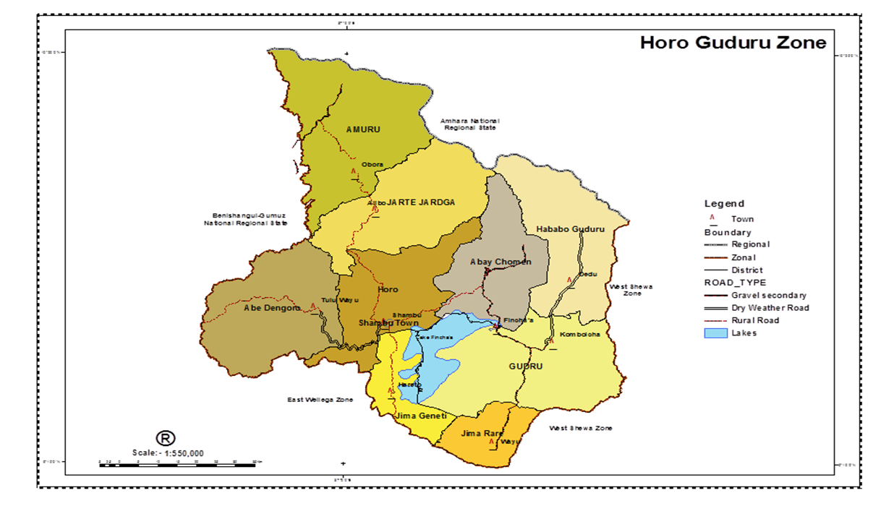Source: - Horo Guduru Wallaga Zone Tourism bureau profile

Picture 1: HGWZ prison administration site and its gate two.
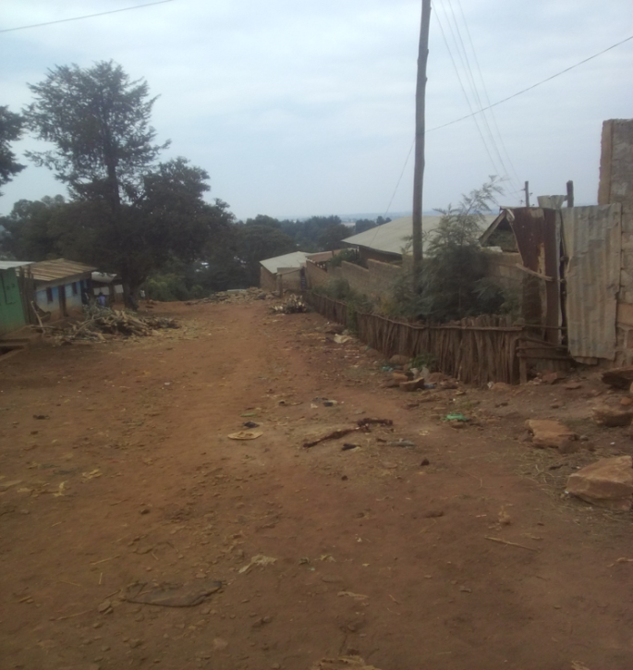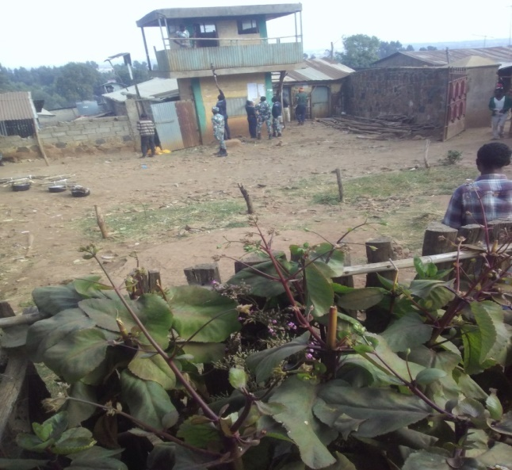
Source: own survey, 2020

3.2. Research Design and Approach
A research design is the understanding of manners for collecting and analyzing data in the situation of aiming at combining the significance of the study (Kothari, 2004). The research design is employed collecting data one time and analysis it or cross sectional survey and descriptive in nature. The major purpose of descriptive research is description of the state of affairs, as it exists to present. Descriptive study is mainly easy as the investigator choose what he tends to investigate, identify the site, population, select sample respondents and contact the concerned body to obtain the necessary information.

3.3. Research approach
The study carried out and employs both quantitative and qualitative research approach. The researcher had analyzed qualitative data through embodied in quantitative data. The researcher used statistical package for social science (SPSS 20 version) as the research is qualitative and related to descriptive in nature and then, data was analyzed in terms of frequency, percentage table, chart, line chart and bar chart.

3.4. The Sources of data and tools for data collection.
To address the targeted objectives, the researcher had used both primary and secondary data. Qualitative and quantitative data have been collected from both primary and secondary data.

3.4.1. Primary data sources
The primary data has been obtained from the largest population of HGWZ inmates. To collect the primary data, first the researchers meets the prison administration head officer and submit letter by creating awareness about the needed information is only for academic purpose and would be kept confidentially. As a result the researcher got consent from the head officer. The primary data has been obtained from the assessment carried on the largest population in HGWZ inmates’ through structured questionnaires prepared for inmates and prison leader, interview with top official, key informants and personal observation carried out by researcher.

3.4.2. Secondary data
The secondary data has been gathered from the existing literature such as reports, books, and different domestic regulations, proclamations, laws and international human rights instruments that have direct relations with the prisoners’ rights, articles and other written materials were discussed.

3.5. Sampling technique and Sample size determination

3.5.1. Population of the study area
The researcher had selected 88 sample respondents from the total population of 754 by using simple random sample technique. This method gives equal chance to be selected for the population. The method is preferably selected by researcher to collect necessary information from individual and reduce the bias level of the researcher while selecting sample. First the researcher went to HGWZ rehabilitation center human resource team leader and identified the information on inmates. Human resource team leader bring me to the place of prisoners for the sake of selecting samples from the total universe.

Table 1 – Table show that nature of crime for which prisoners are imprisoned

No | Nature of crime for which prisoners are imprisoned | Sex |  |  |  | Total quantity
No | Nature of crime for which prisoners are imprisoned | M |  | F
No | Nature of crime for which prisoners are imprisoned | No | % | No | % | No | %
1 | Criminal prisoners | 683 | 94.8 | 31 | 93.9 | 714 | 94.6
2 | Civil prisoners | 21 | 2.9 | - | - | 21 | 2.9
3 | Political prisoners | 17 | 2.3 | 2 | 6.1 | 19 | 2.6
Total |  | 721 | 100% | 33 | 100% | 754 | 100%

As the result, the researcher identified that 714 (94.6%) prisoners are accused because of they are participate and commit in crimes like killing person, hiding materials or stealing property, hate person, contraband, kidnapping and 21 (2.9%) of them are civil prisoner (is prisoners those who are not commit in crime but those who do not take court order to do something and 17 (2.3%) of them are political prisoners or those who are suspicion of terrorist act in HGWZ prison institution. So that the researcher observes that, many inmates are criminal prisoners. Picture 2: Target population size of study area.
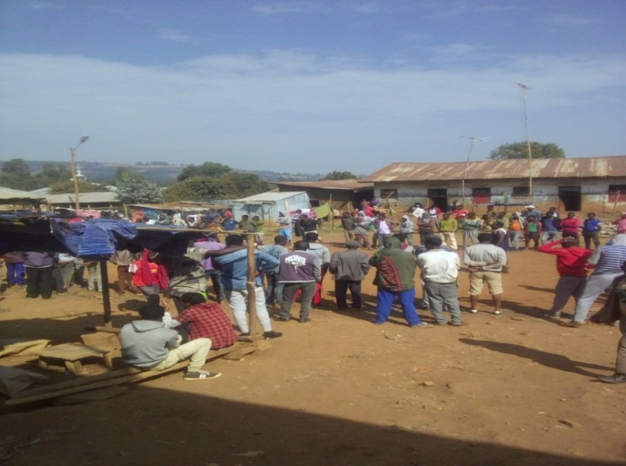
Source, own survey, 2020

Table 2: indicates age duration of prisoners in prison

No | Age duration of prisoners in prison  (year of accusations) | Sex |  |  |  | Total in number and percentage
No | Age duration of prisoners in prison  (year of accusations) | M |  | F
No | Age duration of prisoners in prison  (year of accusations) | No | % | No | % | No | %
1 | 1day to 5 year | 439 | 60.9 | 27 | 81.8 | 466 | 61.8
2 | 6 y - 10y | 121 | 16.7 | 6 | 18.2 | 127 | 16.9
3 | 11y- 15y | 87 | 12 | - | - | 87 | 11.7
4 | 16y- 20y | 55 | 8 | - | - | 55 | 7.3
5 | 21y-25y | 6 | 0.8 | - | - | 6 | 0.7
6 | 26y-30 | 4 | 0.5 | - | - | 4 | 0.5
7 | Lifelong prisoners | 7 | 0.9 | - | - | 7 | 0.9
8 | Death penalty | 2 | 0.2 | - | - | 2 | 0.2
Total |  | 721 | 100% | 33 | 100% | 754 | 100%
Source: - own survey, 2020
As a result, the researcher identified that short age duration with one day to five year are male 439 (60.9%) female 27 (81.8%), from six year to ten year are 121 (16.7%) male inmates, 6 (18.2%) female inmates and from eleven year to fifteen year male inmates 87 (12%) in number. From sixteen year to twenty year 55 (8%) male inmates. From twenty one to twenty five year male 6 (0.8%) and from twenty six to thirty male inmates 4 (0.5%). Accusation of life long imprisonment and death penalty prisoners are 7 (0.9%) and 2 (0.2%) male respectively. Accordingly, the majority prisoners are stay in prison from one day to five year period.
According to response of top officials, death penalty is not applied in HGWZ prison unless it is signed by the head of the state of federal government. it is only in principle form. Accordingly, the prisoner’s sentences of death penalty stay their lifelong in prison instead punishment of death. No one is disappeared physically because of punishment of death penalty in HGWZ prison. In the same manner, unlike in principle, sentences of life long prisoners are released after 25-30 years of accusation in HGWZ prison.
Out of the total of age duration of the population in the prison 33 of them are females and the rests 721 are male accusation. Among 33 female prisoners 9 of them are imprisoned with their child.
Therefore, the sample respondents were selected through simple random sample techniques because of it gives equal chance for the universe to be selected as the representative and the method is minimize biased of the researcher during selecting samples.

3.5.2. Sampling Techniques
To select sample the researcher uses simple random sampling techniques or chance sampling from the total universe or population, because it allows each element in the study population equal and independent chance of being selected as sample (Kothari 2004). This type of sampling is probability sampling where each and every item in the population has an equal chance of inclusion in the sample and each one of the possible samples, in case of finite universe, has the same probability of being selected. Every member of the prisoner has equal chance to be represented as the sample. Therefore, the total population of the study are male 721, female 33 total 754 (N=754) in number and it is finite population. The sample size had been determined based on the following simplified formula proposed by Yemane (1967).
n= $\frac{ N}{1+N\left(e\right)2}$ Where:- n- Represent sample size.
N- Represent population size.
e- Represent the level of accuracy or precision (10%)
n=$\frac{N}{1+N\left(e\right)2}$ n= $\frac{ 754}{ 1+754\left(10\%\right)2}$
n= $\frac{ 754}{ 1+754\left(0.1\right)2 }$= $\frac{ 754}{ 1+754\left(0.01\right)}$
n = $\frac{754}{ 8.54}$= 88.2 = 88
Based on formula stated by Yemane (1967), total of 88 sample size were selected using simple random sampling techniques from the total population of 754. The questionnaire have been translated into Afan Oromo language for easily understanding and responding and analyzed by English language. For conducting interview, the researcher prefers purposive sampling technique to select key informants from 754 total populations based on their duration in prison. So that for the sake of interview; the researcher purposely selected 20 individual prisoners those who are stayed in prison for a long period of time.

3.6. Tools of data Collection.

3.6.1. Questionnaires
The structured questionnaires were prepared for prisoners to obtain reliable information from inmates without any fear. Thus, the researcher had distributed structured open ended and close ended written questionnaire prepared in Afan Oromo for 88 selected sample respondents. This method is used for its merit that a cost of sampling respondents over a wide geographic area is lower and the time required to collect the data is less. Afan Oromo language has been used purposely for the sake of clarity and more understanding for the selected respondents to give available information and finally translated to English which is the instructional language by a researcher.

3.6.2. Interview
Similarly, the researcher had conducted detailed personal interview with officials and prisoners. This method is used to obtain reliable information from officials and correlate response from prisoners through questionnaires from both side respondents. At the same time, the researcher conducted interview with some inmates purposely selected those who stayed long duration in prison, because they may have more information about the existing condition and they can give more information relevant to prisoner’s right.

3.6.3 Personal Observation
Personal observation was also conducted by the researcher in order to gather real information concerning, the overcrowdings of the prisoners, the categorizations of prisoners in their sex, age and types of crime they record and sanitation of the prisoners. This personal observation exposed the existing realties and provided supportive information personal observation was carried out based on the basic prison administration ethical principle with the help of assigned social worker legal experts.

3.7. Ethical consideration
Participants must be treated with respect and the researcher needs to seek their cooperation in the research. While the researcher conduct the research, it is impossible to defames and demoralize prisoners rather valuing and respecting them because they are human being. The participants’ identities should be protected both in writing and verbal reporting so that the information the researcher collect must not embarrass or harm them. The researcher should tell truth when writing up and reporting the findings. Thus, faithfulness, respect, honesty, pursuit for excellence and fairness are very important in this research. Therefore, fabricating data or distorting data is inexcusable in this study.

CHAPTER FOUR

DISCUSSION AND RESULT
This part of the study present the analysis and interpretation of the data obtained from the sample respondents by using data gathering tools to search and give the appropriate answers to the basic research questions listed in chapter one. The data was obtained through questionnaires, personal observation and interviews and then analyzed. The statistical method was employed to present and analyze the structured items of the questionnaires. To supplement and enrich the information that was drawn from using questionnaire, data from closed-ended questionnaires and personal interviews were illustrated and described in words whereas the quantitative data was analyzed by the support of statistical package for social science research (SPSS 20 version).
This chapter is categorized into two major parts. The first part presents the general background of the respondents and the second part presents with the analysis and interpretation of the collected data on the prisoners’ right in the case of HGWZ prison administration.
To answer basic research questions; the researcher prepared written questionnaires and distributed for 88 selected samples. Among the distributed 88 questionnaire the researcher have returned all questionnaires with full information for the study. Thus, the researcher analyzed all the returned questionnaires obtained from respondents using statistical package for social Science ( SPSS 20 version) and interpreted using percentage, line chart, bar chart, chart table and the rest open ended questionnaire, interview and personal observation were analyzed by using word description method thought embodied in quantitative data. In addition, some analyses were supported by picture to indicate the current real life of the prisoner’s rights in HGWZ prison institution.

4.1. Background of the respondents
The following general background of the respondents gives some basic information about the sample population involved in the study. Basically, the key participants of the study were prisoners and officials. The intent was to reflect all the concerned bodies’ view in the research.
Table 3: General background of respondents by sex
No | Sex | Frequency |  | Percentage
1 | Male | 82 |  | 93.2%
2 | Female | 6 |  | 6.8%
Total |  | 88 | 100%
Source: Own survey 2010
As it is indicated in the above table 3, from the selected sample size of 88 (100%) respondents 82 (93.2% respondents were male whereas 6 (6.8%) were female. This implies that male were the dominance population that covers the majority population size in the prison than female prisoner’s size.

Table 4: General backgrounds of respondents by age
No | Age | Frequency | Percent %
1 | 16-25 | 12 | 35.7
2 | 26-35 | 39 | 44.3
3 | 36-45 | 31 | 35.2
4 | 46-65 | 4 | 4.5
5 | 66-80 | 2 | 2.2
6 | Above 80 | - | -
Total |  | 88 | 100.00
Source: Own survey, 2020
As it is illustrated in above table, from the selected sample size of 88 (100%) respondents 39 (44.3%) were 26-35 age group that covers the maximum sample size respondents population and 31(35.2% ) were age group between 36-45 whereas 12 (35.7%) were 16-25 age groups that covers the sample respondents.
They are so called juveniles delinquency ( Dargaggoo ballessitootaa). Similarly, 46-65 age group covers 4 (4.5%) and 66-80 age group covers 2 (2.2%) of the sample respondents. This implies that from the total sample respondents of 88 prisoners’ the maximum sample size is the productive force population imprisoned in HGWZ prison with age group interval of 26-35 that is followed by age group interval of 16-25.

Table 5: General backgrounds of respondents by Education level
No | Education level | Frequency |  | Percent (%)
1 | Grade 1-8 | 29 |  | 32.9
2 | 9-12 | 37 |  | 42.2
3 | Level I-III | 14 |  | 15.9
4 | Diploma | 6 |  | 6.8
5 | Degree | 2 |  | 2.2
Total |  | 88 | 100.00
Source: Own survey, 2020
In the above table five, the educational level indicated as 1-8 Grade level covers 29 (32.9%) of the total respondents whereas 9-12 grade level covers 37 (42.2%) of the represented and grade level of level I-III covers 14 (15.9%) of the respondents total sample size. Similarly, diploma level covers 6 (6.8%) of the total respondents and degree grade level interval covers 2 (2.2%) of the total respondents.
This implies 9-12 grade covers the maximum sample size represented the total population which is followed by 1-8 grade level interval whereas the rest two education level degree and diploma respectively covers the minimum sample size of the total respondents in HGWZ prison. Table 6: General background of respondents by marital status.
Marital status | Frequency Percent | Percent
Married | 52 | 59.1 %
Single | 28 | 31.9 %
Separate | 5 | 5.63 %
Widow | 3 | 3.4 %
Total 88 |  | 100.0 %
Source: Own survey, 2020
As it is shown in the above table six, from the total sample respondents of 88 (100%) about 52 (59.1%) are married 5 (5.6%) are separate and 28 (31.9%) are single whereas 3 (3.4%) are widow. The analysis of general back ground of respondents’ based on marital status indicates that the married marital status covers the maximum sample size of the total respondents’ population which is followed by single marital status that covers the second maximum sample respondent population size while the rest two separated marital status and widow marital status covers the minimum sample respondent size respectively from the total sample respondents selected from the total population size.

4.2. Basic necessities and service delivery in HGWZ prison

4.2.1 Prisoner’s right to adequate food

Figure 2: Shows food provision in HGW zone prison institution

From the sample respondents, about 13 (14.6%) reply that they are strongly agree and 17 (19.3%) agree with the idea that there is adequate food provision in HGWZ prison. About 26 (29.6%) respondents responded that disagree while 32 (36.3%) of sample respondents strongly disagree with the idea that there is adequate food provision in HGWZ prison. On the other hand, the response of the top official indicates the service they offered is sufficient but sometimes insufficiency may emerge due to traditional mechanism of food preparation or lack of comfort and modern kitchen access, lack of resource supply because of mass prisoners, it is difficult to provide adequate and quality food provision for prisoners.
However, prisoners in HGWZ prison administration are challenged by the provisions of food. The food provided for prisoners are poor and undernourishment.
As such, the food they feed is too poor both in quality and in quantity. In addition, the feeding system of prisoners in HGWZ prison institution, prisoners are eating always only shiro throughout the year and there is no change. The Injera also prepared from maize and very few Teff and as soon as it was eaten, they are going to hungry. The tea has no sugar; bread at breakfast is overcooked and not fresh. These all are violating the basic right of prisoners. The budget allocated for each prisoners is too imbalance to feed them. According to ONRS prison commission, 8 birr was allocated for each prisoner per day before. Now a day it is extended to 12.50 cents and by this amount of birr, it is impossible to provide adequate food for prisoners. Prisoners are suffering from hungry due to the insufficiency of budget allocated to feed them, and what provided at breakfast, lunch and dinner has no quantity and quality. Most of the prisoners supported by their relatives but those prisoners, who have no relatives, live under hunger. Moreover, in prison institution, prisoners of breastfeeding and pregnant mothers, children with their imprisoned mother and for sick prisoners, additional food are not provided. Oromia national regional state proc. no.163/2011 states that, the prisons institution should provide sufficient food and special treatment should be given for children imprisoned with their mother. In addition to this, federal prison commission proclamation number 365/2003 states that food shall be provided with sufficient and quality.
Thus, the response from both sides and the open observation carried by a researcher shows that the same results. Similarly, the places where food is prepared and the equipment is not comfort in HGWZ prison institution. From the view point of the analyzed response from both side indicates the provision of food service in HGWZ rehabilitation center is inconsistent and poor. The existing reality is indicated using photography taken during observation. Picture 3 indicates current HGWZ prison kitchen
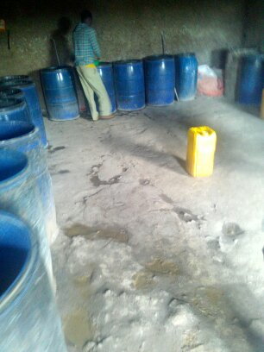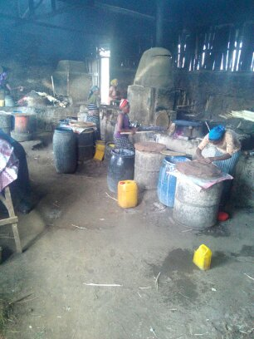Source, own survey, 2020

4.2.2. Prisoners’ right to bedding and clothing provision
Figure 3 shows bedding and clothing provision in HGWZ prison
In the above figure three, from the sample respondents 11 (12.5%) reply that they strongly agree and 19 (21.5%) agree with the idea that the prison provides sufficient clothing and bedding service for inmates. On the other hand 49 (55.6%) of the sample respondents responded that they disagree and 9 (10.2%) of the respondents are strongly disagree with the idea that the prison provides sufficient clothing and bedding service for inmates. According to respondents, there are prisoners overcrowded, especially in sleeping room.

In addition to this, the response from personal interview and observation indicates that the provision of bedding service is very poor. According to response from top officials, many prisoners are sleeping on bare floor because some prisoners are missing from the prison by penetrating the roof and some of them are sleeping on inadequate bed and even there is no provision of clothing service provided by the prison administration. As anyone know, HGWZ, shambu city is too cold and it is simple to guess how it is difficult to those not have a day and a nightwear. Therefore, prisoners who are sleeping on the bare floor suffered from cold. On the other hand, Federal regulation on the treatment of prisoners’ rights regestration.No.138/2007, Art. 7(1) state that, every prisoner shall wear clothes provided by the prison and also Art.8 (1) of the same regulations provides that every prisoner shall be provided with necessary bed even additional clothes and bedding is given when the health officers recommend to this effect.
In the institution, there are few beds, which is not enough for total prisoners in HGWZ prison institution. The number of bed and prisoners are too imbalance. The number of inmates in each hall is about 96-120 prisoners. The researcher also observes that, most of the prisoners are sleeping on bare floor and wearing their own clothes, which is underclothes.
According to key respondents, when the number of accused person is increased; the number of prisoners in each hall also increased. Therefore, the prisoners become overcrowded, especially in bedding room. As the result, the analyzed data from observation, questionnaires and interview show that the prisoners right to bedding and clothing service as underprivileged provision in HGWZ prison. Relatively the finding of the study, show that there is poor provision of bedding and clothing service in HGWZ rehabilitation center. The existing reality is show in the following photography 4 taken during personal observation.

Picture 4: photography taken during personal observation
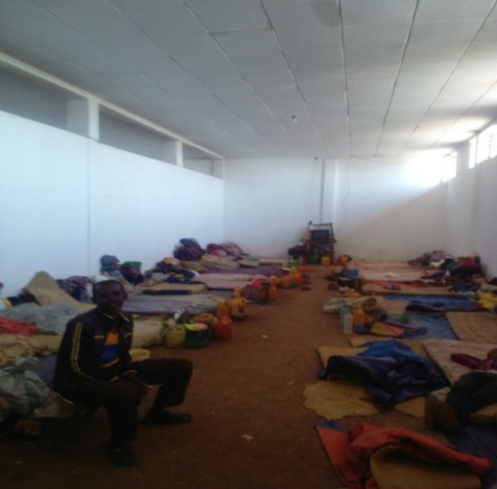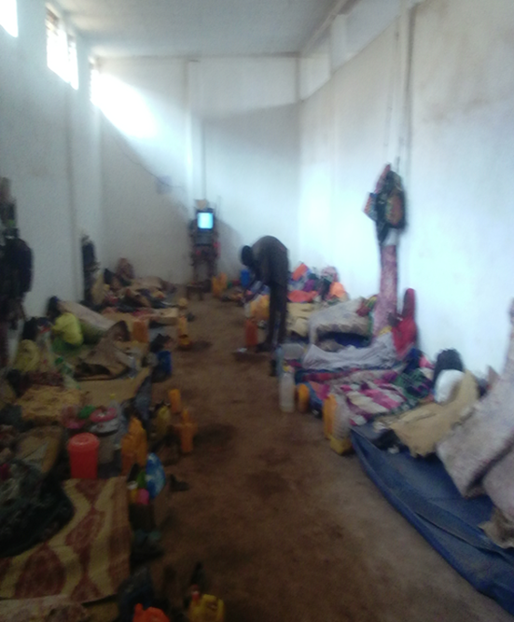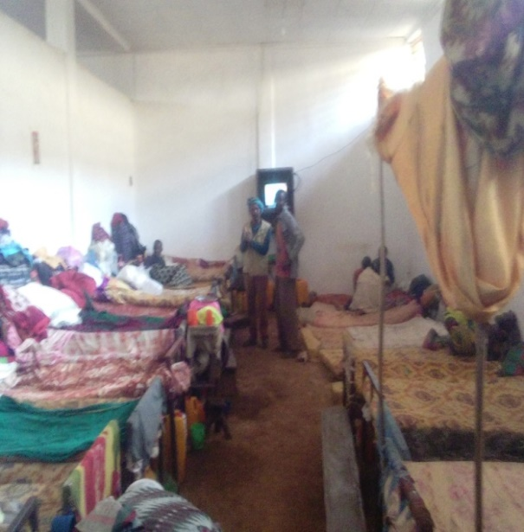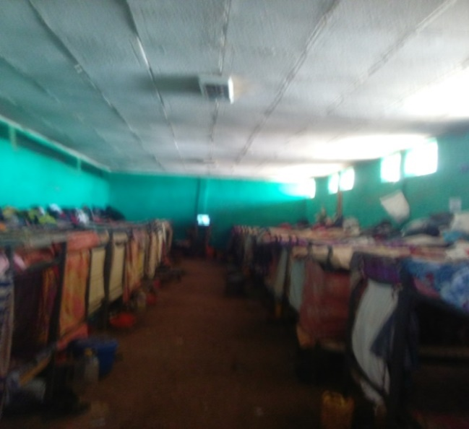
Source, own survey, 2020

4.2.3. Separations of prisoners
It is always advisable to accommodate prisoners according to their sex, age, criminal record health condition, issues such as mental problem, pregnancy and communicable diseases. Women prisoners shall be detained separately from male prisoners. Women prisoners shall be supervised and searched only by female officers and staff. Pregnant women should provide with the special facilities which they need for their condition. (UN, 2005).

Figure 4: Show separation of bedding service provision.

As it can be observed from the above figure four, from the respondents 3 (3.5%) reply that they strongly agree and 7 (8 %) agree with the idea that bedding service is separated in to sub section such as pregnancy class, elders class, mental problem class, communicable disease class, political prisoners class etc. On the other hand 12 (14%) of the sample respondents’ reply that they were disagree and 66 (74.2%) respondents responded that they strongly disagree with the idea that bedding service is separated in to sub section in HGWZ prison.
The analyzed data indicates that lack of separating prisoners based on their age, criminal records, pregnancy class, elders’ class, mental problem class, communicable diseases class, politician class were exist in HGWZ prison administration. The prison only separate prisoners on the bases of their sex.
In the same manner, result of personal observation and top official interviews response indicate that the prison has only the bedding service separate for female and male and there is no as such categorization of class division due to lack of resource, narrow compound and the institution itself is located in the center of the city in turns this resulted in limitation of different construction in the compound.
In the same vein, according to the Ethiopian prison commission there should be sub-section classification of bedding service for pregnancy female, elders, mental problem, communicable diseases, below age and politicians should have to be exist. Not only these but also permanent prisoners’ class, life imprisonment prisoner’s class, tentative prisoners or case ongoing prisoner’s class, serious criminal class and easy criminal class should have to exist separately.
Basically, it is always advisable to accommodate prisoners according to their sex, age, health condition, degree of their crime, special case related issues such as mental problem, pregnancy, communicable diseases. Instead, the prison management should take into account in different inmate’s accommodation process. (Jim and Vaclav,2015).
Article eight of the UN standard minimum rules for the treatment of prisoners states that, the different categories of prisoners shall be kept in separate or part of institutions taking account of their sex, age, criminal records, the legal reason for their detentions and the necessities of their treatment. (UN,2005).
Similarly, Rebuma noted out separation of inmates should be in terms of their sex, age and their serious of crime. The separations of inmates are the obligation of the prison authority and it is the rights of the prisoners to classified in terms of their age, sex, type of crime committed for which imprisoned.
From the view point of this literature HGWZ rehabilitation center is inconsistent. There is room division only used to separate male and female.

4.2.4. Provision of Health service in HGWZ prison administration

Table 7: show that whether the prison provides adequate health service for Inmate’s
No | Response of respondent | Frequency | Percentage
1 | S/agree | 3 | 3.5%
2 | Agree | 11 | 12.5%
3 | Disagree | 31 | 35.3%
4 | S/ disagree | 43 | 48.8%
Total |  | 88 | 100%
Source: own survey, 2020
Table 7 shows that, the respondents’ opinion regarding to whether the prison provides adequate health service for inmates in HGWZ prison. Accordingly, 3 (3.5%) of the respondents strongly agree while 11(12.5%) of the respondents agree with the above statement. On the other hand, 31 (35.3%) of the respondents disagree and 43(48.8%) of the respondents are strongly disagree with the above statement.
In the same manner the response of the top officials interview results indicate similar with that of the inmates. There is only one clinic in prison compound with too less facilities even there is no access of sufficient medication and laboratory in HGWZ prison. According to key informants, in the prison’s clinic, no medical equipment is fulfilled and no enough budgets are allocated. for this reasons, the numbers of prisoners and the budget allocated for prisoners medication is highly imbalance. In addition, the numbers of prisoners and nurse is not balance with the number of inmates imprisoned in HGWZ zone. In the same things, serious illness prisoners referred to Shambu hospital to get credit health service. However, the hospitals have not given an attention to prisoners equal with other patient. Therefore, concerning the health care of prisoners, there are serious problems because both the prison administration and the hospitals have not given more attention to inmates. As the result, this cause poor health service provision in HGWZ prison.
In the same manner, the clinic is not providing enough pharmaceuticals for prisoners rather than the Paracetamols. Prisoners enjoy only first aid service due to there is no available access of medicine and qualified medical professionals in HGWZ prison. According to top official, prisoners who are very ill may be allowed to be released from prison early. According to the federal prison commission, prison compounds shall not be hazardous to health and they shall have fresh air and sufficient lights. Health care of prisoners shall be free of charge and necessary medical care and treatment that as much as possible enable the maintenance of their health.
As a consequence, the prison Institution is exercising contrary to different domestics and international laws. For instance, regulations on the treatment of federal prisoners No.138/2007 Art.11 (2) reads as: To the extent that circumstances allow, every prison shall have a medical facility, adequate medical equipment, pharmaceuticals and medical officer.
As we understand from this particular provision, both the government and the prison institution have an obligation to provide fair and free medical services to prisoners and in turn prisoners have the right to be protected from any diseases without discrimination.
Hence, prisoners’ rights to life are at stake due to lack of adequate health services. Thus, the prisoners right to adequate medication directly contact with the right to life of the prisoners. That means, denying the health services of prisoners is violating their right to life. Article 15 of the FDRE Constitution provides that every person have the right to life.
With regard to this, the UN 2005 noted out that the enjoyment of health service provision is one of the fundamental prisoners’ rights as the minimum requirement. The enjoyment of the highest attainable standards of physical and mental health is human right and basic requirement that all prisoners should be given a medical examination as soon they have been admitted to prison or place of a detention and any necessary medical treatment should then be provided free of charge.
Thus, the finding of the study reveals that there is poor health service provision from the view point of discussed literature and analyzed data. The right to health service in HGWZ zone rehabilitation center is still inadequate and it is not reliable with federal prison commission standards and international standard minimum rule.

4.2.5. The right to provision of water supply for drinking, bath and washing

Figure 5: shows clean water supply for drinking, for bath and washing clothes.

Source, own survey, 2020
In the above figure five from the total sample respondents about 11 (12.4%) strongly agree and about 14 (15.7%) agree on the issue of sufficient water supply for bath and washing clothes in HGWZ prison.
On the other hand, the majority of the respondents about 55 (62%) reply that they disagree and about 8 (9 %) respondents reply that they are strongly disagree with there is sufficient water supply for drinking, bath and washing clothes. In fact, the response of personal interview carried out with inmates and the open observation carried out also show the same result. There is no available water supply for drinking, taking bath and the provision of washing cloth place. Only one hand pumping water for drinking, for bath and washing clothes were found in prison and it is not available with the number of prisoners. The bath room has no water installation rather inmate are forced to fetch water with jar to take bath and wash their clothes.
The water is comes only one time in a week. Therefore, the prisoners are suffered from shortage of water both for drinking and for sanitations. The classes of prisoners are also polluted with bad smell and prisoners’ are urinating in their class at the nighttime. Moreover, women prisoners in the institution were challenged with the absence of water in HGWZ prison.
According to department of correctional service (DCS) rules, every prisoner must keep his/her person, clothing, bedding and cell clean and tidy. The DCS must provide what is needed to ensure a clean prison environment, for instance, providing cleaning tools. DCS must ensure a clean prison environment. With regard to this the provision of available and accessible toilets, running water for bath is the indication of the level of hygiene within the prison and in contrast to this idea unhygienic, unsanitary conditions in combination with overcrowding contribute to an overall judgment of degrading treatment. ( Dimtar Marky and Maria Doichinova, 2015).
Thus, from the view point of the discussed literature the existing situation on the provision of water supply in HGWZ zone prison is the major challenge problem. The result of the study shows poor water supply that contribute to an overall judgment of degrading.

Picture 5 shows hand pump water for bath room and a place to wash clothes without water pipe
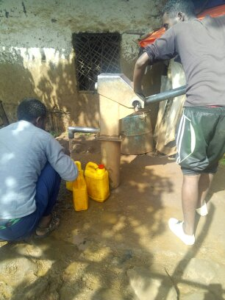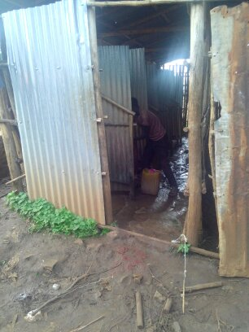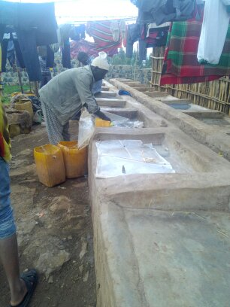
Source, own survey 2020

4.2.6 The right to provision of available latrine

Figure 6: shows access to latrine house for prisoners

From the total sample respondents 15 (16. 9%) of the respondents response show that they strongly agree and 20 (23 %) of the respondents reply that they agree with there is sufficient access of latrine house. In opposite response from the total sample respondents about 12 (14%) of the sample respondents reply that they disagree and 41 (46.1%) strongly disagree with the idea of the access of latrine provision is sufficient. In the same manner the result of observation and personal interview show that the same outcome somewhat less quality and mismatched service with the prisoners’ population living in the prison that it can serve only about 20 peoples at once time, as a result prisoners use the latrine waiting a turn and latrine is most of the time busy and overcrowded.
According to federal prison commission, the sanitary installations in prisons must be adequate to enable every prisoner to comply with the needs of nature when necessary in a clean and decent manner. It includes facilities that are hygienic and respect privacy of the prisoners that ready access to proper toilet facilities and the maintenance of good standards of hygiene are essential components of a humane environment. Prisoners’ right to provision of available and accessible of running water and bath is an indication of the level of hygiene within the prison and unhygienic, unsanitary condition in combination with overcrowding may contribute to an overall judgment of degrading treatment.
However, there is a good hope for the future that the jail is on the ways of constructing a modern and moderate construction to fulfilled all types of facilities.

4.2.7 Prisoners’ provision of living condition
Figure show that whether No. of inmates living in one cell conform to the standard of federal prison commission

In the above figure seven from the total sample respondents about 2 (2.2%) reply that they strongly agree and about 6 (7%) sample of the respondents responded that they agree with the ratio of inmates living in one small room not out of the standard of the Ethiopian prison commission. On the other hand about 23 (26%) of the sample respondents responded that they disagree and about 57 (64.8%) responded that they strongly disagree with the ratio of inmates living in one cell the same with standard of federal prison commission.
From the analysis we can easily conclude that the prisoners’ living condition in HGWZ prison is out of the ratio of inmates to be live in one room. The top officials responded that the number of prisoners in one room must between 40 and 50. But in the case of HGWZ prison, the population ration of prisoners living in one room exceed more than 50 and a single room holds about 96-120 inmates in male section whereas in female section a single room holds about 33 prisoners which are fair according to the Ethiopian prison commission due to less population in female room.
In addition to these top officials responded that, not all facilities are fulfilling in our prison, because of lack of budget and logistic or material supply from the concerned body. There is only TV in some room and the prisoners have no right to watch all channels alternatively as they want.
As the result, in solving these problems they said that they are on the way of constructing new standardized bedding room based on national prison standards with full facilities such as latrine room, bathroom, ventilation and window that can hold between 40 and 50 prisoners in each room.
In the similar vein, overcrowding can cause a serious health problem over prisoners living in single room. Accordingly, one of the prisoners say that “ in our room there are 120 prisoners, at night time breathing is impossible because the class is too blistering and there is no windows, there is no enough space for sleeping and prisoners stand through the night. The class is dangerous for prisoners’ health and we live under a tension because prisoners who suffered from TB living with us and there are no separations of prisoners who have sickness. The suffocation in bedding room affects the health of the prisoners. In HGWZ prison institution; there is bad and unpleasant smell in each sleeping room.
The prisoners’ living condition must be proportional to the standard legally laid down by the Federal prison commission and it shall be manageable and easily controllable. In contrast to this reality, the result of response from inmates’, personal interview and observation carried out indicate that currently there is a serious overcrowded prisoners’ living condition in prison. Thus, relatively the finding of the study shows that HGWZ rehabilitation center living condition is not reliable with federal prison commission.
On the other hand, top officials responded that Ethiopia federal prison commission and Oromia regional state prison regulation did not mentioned the right to sex of prisoner’s with their wife/husband if not one of the two (wife or husband) considers as criminals and sentenced together. However, one of the two families might be free from crime. In fact, the right to sex is not for the matter of leisure rather it is one of the fundamental basic needs and given for human being.
According to response from inmates, because of the prison did not implement prisoners right to sex with their wife or husband, the one who left at home wife or husband may bear a child for other person, which is very unethical. As the result, when the accused wife or husband become freed after long period of imprisonment and go to his or her home, there might be conflict among wife and husband and one of the two may be kill the other and returned back to prison again. It is so called Prison prepares prisoners for coming back to prison again.
In similar vein, Country like India and Switzerland implement the right to sex of prisoners. The accused engages in sexual intercourse two times in a week with their wife/husband.
Therefore, Ethiopia federal prisoner’s proclamation in general and Oromia prison regulation in particular need to be some improvement because it did not consist and protect prisoner is right to sex with their wife or husband.

4.2.8. The impact of overcrowded prisoners
The response from open ended questions result indicates that overcrowded condition causes the problem of communicable diseases such as TB and other transmission disease. And also it causes inadequate ventilation, malnutrition, poor personal hygiene, poor environmental hygiene and idleness. According to respondents, the cellmates were arguing over who got the top or bottom bed. And also they argue over when they would turn the lights on or off, property storage and cell cleaning. Every day they argued over stealing and missing property from each other. As prisons became more crowded, authorities placed prisoners together based on the availability their sex only.
According to federal prison commission proclamation 365/2003 Prison compounds shall not be hazardous to health and they shall have fresh air and sufficient lights.

Thus, from the above open ended response analysis of from the top officials reveals that overcrowded condition have impact on inmates health that it can cause communicable diseases whereby the reality exist in HGW prison not relevant with federal prison commission and united nation prisoners right minimum standard. Picture 6: show that the newly room constructing by the prison administration in HGWZ prison.
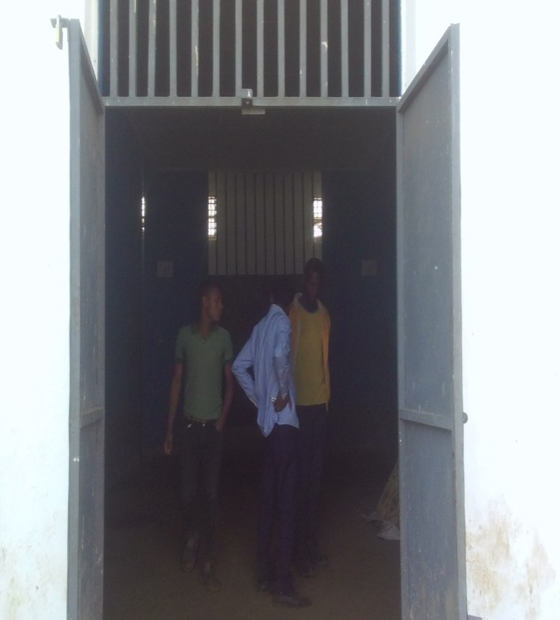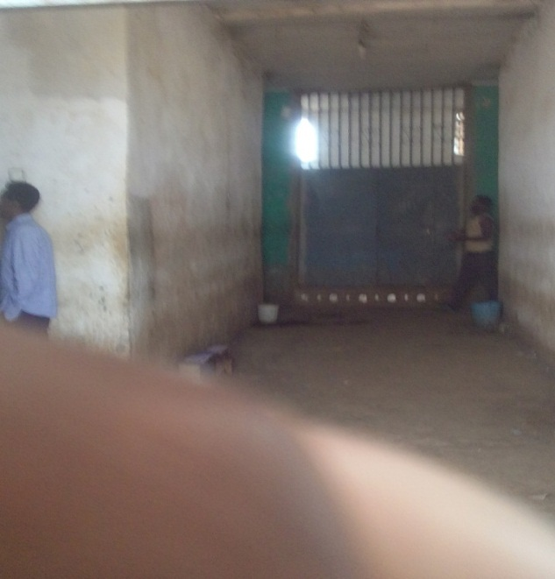Source, own survey, 2020

4.3 Provision of Prisoner’s fundamental constitutional right in HGWZ prison

4.3.1 Prisoners’ right to Education

Figure 8: shows education provision for prisoners in HGWZ detention center

Source, own survey 2020
As it can be observed from the above figure eight from the total sample respondents about 30 (34.1%) reply that they strongly agree and 58 (65.9%) reply that they agree with the existence of prisoner’s education in HGW correctional center.
From the analyzed data the majority of the respondents’ response indicates that there is the provision of education service in HGWZ prison administration. However, the availability of the education service exists in prison but it is poor and there is no available teacher and learning material provision such as book and other learning material.
In addition to this; there is only elementary school 1-8 grade level in the prison as a result the rest secondary school and preparatory school class academic availability is exist only at Nekemte, Ambo and Adama city prison institution. As a result sometimes due to above intake capacity resolution, inmates sent to Ambo and Nekemte prison to provide available the rest classes such as secondary and preparatory level education.
In fact the personal observation under taken and the response of interview from top official of the prison administration indicates the same results that the prison has some problems to supply the access of education for inmates. There is no as such favorable condition in the prison to provide available education and the school has lack of material such as table, bench and class.
Facilities used for teaching-learning process at correction center schools are too much complicated. According to a coordinator of education in HGWZ prison correction school; there was a shortage of input of education. A 42 years old male who has been incarcerated and stayed there for ten years at a center argued that there was shortage of books and any learning guides. Besides, from his experience he elaborated that the prison center did not support the school.
With regard to this the international legal document called UDHR states that everyone has the right to education. In the same manner Article 2 of protocol number 1 of the 1952 the European Convention for the protection of human right and fundamental freedom noted out that no person shall be denied the right to education including inmates in custody. This entails that the right to education should be applied to each and every individual citizens including person held in custody. (UDHR 1948 as cited in John, 2014).

In support to this issue Dimitar Marky and Maria Doichinova, 2015 distinguished that the quality of education in prison is difficult to assess in a comparative way due to different educational standards applied by different world states. The allocation of inmates join education programs is also not relevant, because it depends on issue beyond the control of the prison administration such as the education level, the interest of individual inmates and the duration of the sentence.
Thus, the finding of the study reveals that however, the education provision of prisoners exist in HGWZ correction center, it is not sufficient and need some sorts of improvement by state due to it is the major instrument that promotes behavioral change on human beings particularly on prisoners. As a result, the education provision of inmates existing in HGWZ prison administration is very poor.

4.3.2 Whether educating inmates have an advantage of improving their behavior

Table 8: Educating inmates have an advantage of improving their behavior
No | Response of Respondents | Frequency | Percentage
1. | S/Agree | 76 | 88.3
2. | Agree | 12 | 13.7
3. | Disagree | - | -
4 | S/ disagree | - | -
 | Total | 88 | 100.00
Source: Own survey 2020
Table eight shows that the respondents’ opinion with regard to the advantage of educating inmates in improving the behavior of inmates. Accordingly, 76 (88.3%) of the respondents strongly agreed and 12 (13.7%) of the respondents agreed with the suggested statement. In the same manner the response of the top official interviews results indicate similar with that of the inmate’s opinion. The top officials responded that we have seen several behavioral changes on inmates by educating them that they promote the radical behavioral change and most of them became rehabilitating themselves and disciplined. They became tolerant and open minded in the institution and tolerate challenges sometimes emerge in prison.
The finding of the above results indicates that the educating inmates have the advantages of improving the behavior of inmates to reduce the act of inmates not to participate in criminal activities again. Thus, Learning helps inmates to identify the impact of crime that it can suffer their life and their family by retarding their social life in their communities. Education is not only a way toward life but also education itself is life. (john Dewey)
With regard to this the MOE noted out that Education is the pivotal tools to bring behavioral change of human being. The purposeful and conscious activity operates practice in his life span either through structured and unstructured curriculum.

4.3.3 The Provision of Vocational Education and Training

Figure 9: show that whether the prison provides sufficient VET for prisoners

Source: own survey, 2020
In the above figure nine from the total sample respondents 6 (6.7%) agree with the idea that there is sufficient vocational training provision for prisoners in prison. On the other hand, from the total sample respondents 22 (24.7%) responded that they disagree and 60 (67.4%) of the respondent replies that they are strongly disagree with the idea that prisoners have access to vocational training in the rehabilitation center.
Federal prison commission gives permission for prisoners to engagement in work. Thus every prisoner serving his sentence shall be assigned to work that suits his ability and vocation and that does not affect his health and shall receive payment for his work in accordance with the directives to be issued by the Commission. The conditions of permission to enable prisoners settle various social problems with warden's guide shall be determined by directives.
In the same manner, the observation carried out and the response from top official shows that previously there are varieties of vocational training center such as woodwork, metal work, weaving, construction work, tailor and some other technical works training.
However, now a day the prison is forced to stop the provision of these vocational training due to lack of access of resource supply and some machineries are destroyed and become non- functional. In addition to these, there is no sufficient budget allocation and human resource such as professional trainer, material supply from the area and currently only weaving training is functional in HGWZ prison. And also there is no access of supermarket for prisoners to sell their vocational production output. These all challenges lead the institution to provide poor vocational training service in the prison. This reality is shown by the photographs taken during personal observation below.
In relation to this the UN 2005 noted out that vocational training shall be provided, especial for young prisoners. Juveniles of compulsory school age have the right to vocational training. Both law enforcement agencies and prison authorities shall not discriminate against women in recruitment, hiring, training, assignment, promotion or other career and administrative matters. From the view point of the above discussed literature access of vocational training in HGW prison is not reliable. This reality is indicated below using photograph taken during open observation.
Picture 7 shows dysfunctional metalwork training centers and functional weaving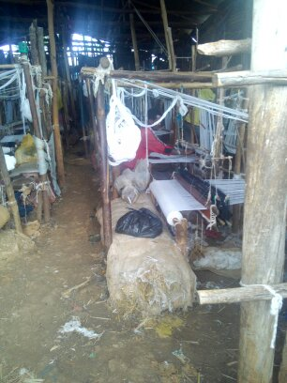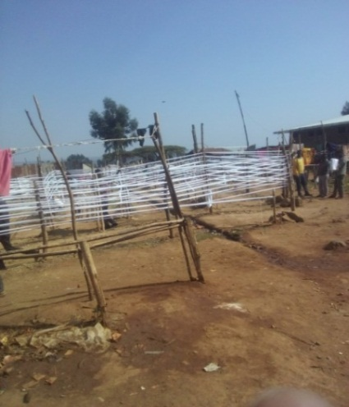 Source: own surveyss, 2020

4.3.4. Whether VET can play a role in enabling inmates to be entrepreneurs and earn income

Figure 10: Show the role of VET in enabling inmates to be entrepreneur and earn income

Source: own survey, 2020
Figure ten depicts that the respondents’ idea with regard to prison ensure VET can play a role in enabling inmates to be entrepreneurs and earn income that improve their living.
Accordingly, 3 (3.4%) of the respondents were agreed with the above statement while 26 (29.6%) of the respondents disagree with the issue. On the other hand the majority of respondents 59 (67.0%) strongly disagree with the statement.
In the same manner; the observation carried out and the response from top official also shows that there is no available machinery that helps to give sufficient training in the detention center. According to respondent from inmates the prison did not facilitate pre condition for prisoners to sell their production. In addition to this there is no favorable condition in the detention center where inmates can sell their products to earn income and there are whole sellers who can take their product. Thus, the result of the finding reveals that VET cannot play a role in enabling inmates to be entrepreneurs and earn income that improve their living in case of HGWZ correctional and rehabilitation center.

4.3.5 The right to religion of prisoners

Figure 11: shows freedom of religion of prisoners in prison.
In figure eleven above indicated that from the total sample respondents about 8 (9%) of them reply that they strongly agree and 52 (59%) agree with the idea that everyone has the right to freedom of religion. On the other hand from the total sample respondents about 24 (27%) reply that they disagree and 4 (5%) of the respondents responded that they strongly disagree with the idea that everyone has the right to freedom of conscience and religion in HGWZ prison.
The above response of the respondents proves in an average prisoners’ right to freedom of conscience and religion respected and not violated which should be continue and it should be appreciated. Therefore, the response of the prisoners, personal observation and the top official interview response is jointly show the same result that prisoners have the right to freedom of conscience and religion in HGWZ prison.
According to FDRE constitution provides under Article 27 that everyone has the right to freedom of conscience and religion. This right shall include the freedom to hold or to adopt a religion or belief of his choice and the freedom, either individually or in community with others.
Regarding to this; Andrew 2009 says that the right to freedom of religious belief and to observe the requirement of that religion is a universal human right and applies to all prisoners as well as to free persons in which the prison regulations should include the right of qualified religious representatives to visit jail regularly to meet prisoners’ facilities and it is reliable in with the finding of this study.

Picture 8. Religious institutions Orthodox Church, Mosque and protestant church
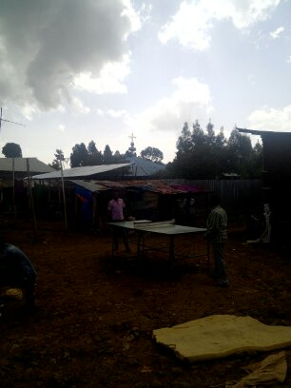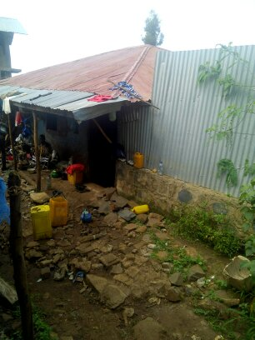
Orthodox Church mosque protestant church
Source, own survey, 2020

4.3.6 The prisoners’ right to communicate their family

Figure 12: shows the condition of registration center and family contact area in HGWZ zone prison

As it is indicated in the above line diagram twelve from the total sample size of the respondents 4 (4.5%) of the respondents reply that they strongly disagree with the existence of favorable facilities provision for prisoners’ family to communicate with inmate and 23 (27%) of the respondents responded that they disagree with the existence of favorable facilities provision for prisoners and their family. On the other hand 11 (12.5%) of the total sample respondents responded that they strongly agree with the existence of favorable reception center for prisoners and their family to communicate each other with their family freely and openly while 50 (56%) of the sample respondents reply that they agree with the existence of reception center for the inmate to be visited by their family.
In the same manner the response from the top officials and the open observation carried by the researcher shows the same result with that of inmates’ response. However, the existing facilities are not sufficient and unsatisfactory in relation to the place where prisoners contact their relatives and family. And also it lacks recreational area, registration center and appropriate family contact center. Even though the prisoners’ are allowed to be visited by their family, unfavorable condition exist in the compound which leads to the cause of the violation of prisoners’ right to be visited. According to the officials’ response these all problems are caused by lack of budget and overcrowded condition of the prisoner in prison compound.
According to FDRE constitution article 21 sub 2 states that all prisoners shall have the opportunity to communicate with and to be visited by their spouses or partner, close relatives, friends, religious counselor, medical doctor and their legal counsel.
In the same manner, Prisoners’ right to favorable facilities to communicate with their family is concerned with all arrested or detained persons shall have access to adequate opportunity to communicate with their family and representative. Untried prisoners shall be allowed immediately to inform their families of their detention and shall be given all reasonable facilities for communicating with their families and friends. (UN, 2005).
From the viewpoint of this literature the study reveals that the finding of this study is somewhat consistent with some shortage. Picture 9 shows that family registration and contact place in HGWZ prison which is not as much comfort to visit families.
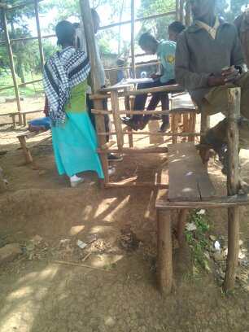
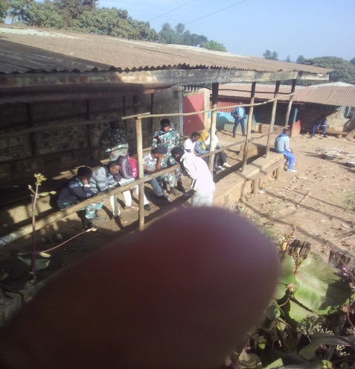
Source: own survey, 2020

4.3.7 Prisoners’ right to access sport fields

Table 9: shows access of sport field for prisoners.
value | Frequency Percent
strongly agree | 4 | 4.5
Agree | 9 | 10.1
disagree | 40 | 44.9
Strongly disagree | 35 | 39.3
Total | 88 | 100

As indicated in the above table nine from the total sample respondents 4 (4.5%) respondents strongly agree and 9 (10.1%) agree on the issue that there is access of sport field in the compound. On the other hand, from the sample respondents 40 (44.9%) reply disagree and 35(39.3%) strongly disagree on the provision of access of sport field for prisoners in prison.

The top officials responded that in one side we are trying to solve the existing problem; on the other hand we are tend to fail another problem because this standardized room is built on sport field due to overcrowded compound area. So that they are giving priority to building new room instead of facilitating sport area. The responses given by top officials are the same with the reality what is observed by a researcher in the compound.
Putting inmate in custody is intended in only as a means of restricting their movement and not to bring any harm at all to their physical and mental well-being. Favorable condition has to be created for developing their physical and mental well-being of prisoners by removing anything that may cause them distress. (Adisu Gulilat, 2012).
Thus, the result of the study is inconsistent with the above literature due to there is no any sport field in HGWZ prison for inmate to do any exercises and enjoy themselves.

4.3.8 Prisoner’s right to informed in language they understand

Table 10: indicates prisoners right to informed in language they heard

Value | Frequency Percent
Strongly agree | 23 | 25.8
Agree | 43 | 48.3
Disagree | 17 | 19.1
Strongly disagree | 5 | 5.6
Total | 88 | 100

Source, own survey, 2020
The above table ten shows that from the total population of sample respondents, 23 (25.8%) responded that they strongly agree and 43 (48.3%) responded that they agree with the idea of prisoners have the rights to be informed in a language they understand of their arrest and of their charge against them. On the other hand 17 (19.1%) of the sample size responded that they disagree and 5 (5.6%) responded that they strongly disagree with the concept that arrested person or prisoners have the right to be informed in a language they understand, of their arrest and of their charge against them.
Similarly, the response of top officials indicates the prisoners have the right to be informed in a language they understand well, of their arrest and of their charge against them. In support of this the UN 2005 states that anyone who is arrested shall be informed, at the time of arrest of the reason for the arrest in a language he/ she understand. Anyone who is arrested shall be promptly informed of any charges. From this, the result of this study reveals that the right to be informed in a language they understand, of their arrest and of their charge against them is consistent in HGWZ zone rehabilitation and correctional center.

4.3.9. The right to petition of prisoners

Table 11: shows that weather the prisoner’s right to petition is respected
Value | Frequency Percent
strongly agree | 26 | 29.2
Agree | 39 | 43.8
Disagree | 19 | 21.3
Strongly disagree | 4 | 4.5
Total | 88 | 100

As it can be observed from the above table eleven from the sample respondents about 26 (29.2%) reply that they strongly agree and 39 (43.8%) agree with prisoners have inalienable right to petition the court to order their physical release where the arresting police officer. On the other hand 19 (21.3%) percent of the total sample respondents reply that they disagree and 4 (4.5%) strongly disagree with the idea that prisoners have inalienable right to petition the court to order their physical release where the arresting police officer.
Similarly, the response of the top officials in relation to prisoners’ inalienable right to petition indicates that their right is respected. They send the prisoners to court to follow up their case and hear their case on the appointment day carefully. The prisoner has full right to take petition to the highest court to recourse the decision given by the lower court. As a result the jail facilitate precondition as much as possible the condition for inmates to organize their evidence on their case. With regard to this, the UN, 2005 noted out that a pre-trial prisoner shall have the right to appeal to a judicial or other independent authority against his or her detention in any case. Similarly, MOE, 2004 states the right to appeal is the legal principle which promotes the access of accused person or prosecutor after a decision has been made by the court is entitled to recourse the case is reviewed to a competent high court.
Accused person has the right to appeal to competent court against an order or a judgment of court which first heard the case. In addition the FDRE constitution article 19 (4) states that all person have an inalienable right to petition the court to order their physical release where the arresting police officer or the law enforcer fails to bring them before the court within the prescribed time and to provide reason for their arrest which is consistent with the finding of this study in HGWZ correction center.

4.3.10 Parole or Pardon condition of prisoner’s

Figure 13: Whether HGWZ prison implement pardon for the prisoner’s

As it is indicated in the above figure13 from the total sample size of the respondents 18 (20.5%) of the respondents reply that they strongly agree with that HGWZ prison apply pardon for the prisoners and 47 (52.8%) of the respondents responded that they are agree with the existence of pardon condition. On the other hand 21 (23.6%) of the total sample respondents responded that they disagree with the existence of pardon provision of the prisoners, while 2 (2.2%) of the sample respondents reply that they strongly disagree with the existence of pardon provision of prisoners in HGWZ zone prison.
In the same manner, the response from the top officials indicates that parole or pardon condition is implement and prisoners be released in accordance with the law and on the basis of their behavioral reform.
According to interview, the pardon condition of prisoners is situational; the prison is implement pardon condition of the prisoners when the country’s head of state allowed for the national prisoners.
Top officials replies that these pardon condition is exclusionary because the inmates who are committing in serious crime like murder, contraband and kidnapping are not include in pardon provide by prison administration.
And also according to informants, pardon condition is provide for those who left short period of time to release from the prison and it is also given for female prisoners who are imprisoned with their child. Therefore, because of the spread of pandemic and communicable disease so called Nobel Covid -19 viruses; HGWZ prison institutions provide parole by following the national prisoners pardon condition. The released inmates are about 300 in HGWZ prison in 2012 E.C. Those who were released from the custody were those who commit in easy and simple crime.

4.3.11 Honesty or trust prisoners.

Figure 14: show that weather the prison gives recognition for honesty prisoners

As it is indicated in the above figure from the total sample size of the respondents 18 (20.5%) of the respondents reply that they strongly agree with that HGW prison gives a recognition with honest prisoners and 37 (41.6%) of the respondents responded that they are agree with the existence of honest prisoners. On the other hand 22 (24.7%) of the total sample respondents responded that they are disagree with the existence of honesty provision of the prisoners, whereas 11 (12.4%) of the sample respondents reply that they strongly disagree with the existence of honest provision of prisoners in HGWZ zone prison.
In the same manner, the response from the top officials and some inmates indicates; giving recognition for honesty prisoner is based on the radical behavioral changes shown by prisoners and it is based on types of crime commit in.
According to response from top officials; the one who engage in murder and serious crime never gate trust from the prison and never stay out of the prison.
In similar vein, honesty and trustful prisoners recognized for prisoners after the prisoners stays six month in the prison and the inmates have the chance to move here and there out of the prison and search job opportunity and then at night he or she come back to prison.

4.4 Handling and Treatment of prisoners in HGWZ rehabilitation center.

4.4.1 Prisoners’ right to be treated equally

Figure 15: shows weather prisoner’s treated equally in HGWZ prison

As it is indicated in the above figure 15 from the total sample respondents about 15 (16.9%) reply that they strongly agree and about 21 (23.6%) responded that they agree with the idea that prisoners have the right to be treated equally whereas about 28 (31.6%) of the sample respondent reply that they disagree and about 25 (27%) strongly disagree to that the prisoners are treated impartially. Thus, the majority responses of the respondents indicate that prisoners are not treated equally in HGWZ prison.
However, the feedback of the top official interview shows that there is a good initial and there is no as such exaggerated discrimination. But a lot of unfair discrimination still takes place in prisons; sometimes the few team group members may show a little bit discrimination based on close relation with inmates because of desire of wealth and in any case we solve the problem on a time.
Similarly, the researcher carried out open observation for two days and during researcher’s observation time different team leaders treat partial inmates fairly and allow them to express their idea freely whatever they like specially in social work team. They can directly contact the officials if any at work time and when necessary to contact their family on phone using the officials’ phone and apply to follow up their cases. Almost there is a good approach relationship among different team leaders and partial inmates. Moreover, a proclamation No.163/2011of the Oromia Prison commission states that, the prisoners’ rights should be protected without any discrimination as to prisoners’ criminal status.
All international human rights instrument establishes that human rights are to be enjoyed irrespective of any form of discrimination whereby the promotion and fulfillment of human rights needs to respect and take in account of the diversity of the population and to advance inclusionary and equality. The fair accommodation of prisoners and equal treatment by considering the principle of equality and non- discrimination primary view point in human right that can make all human right universal to under-pin the enjoyment of human rights. Thus, the result of the study reveals that the response of top official and the result of open observation carried out show the same result. However, in HGWZ prison the response from inmate and top administration is inconsistent with the above literature.

4.4.2 Prisoners’ right to protection against cruel, inhuman or degrading treatment.

Figure 16 :whether prisoners have the right to protection against cruel, inhuman or degrading treatment in HGWZ

As shown in the above diagram16 from the sample respondents 3.4 % strongly agree and 40.4% responded that they agree that every prisoner in HGWZ has the right to protection against cruel, inhuman or degrading treatment or punishment.
On the other hand about 34.8% of the sample respondent’s reply that they disagree with the idea that prisoner’s protection against cruel and inhuman treatment and about 20.2% of the sample respondents’ reply that they strongly disagree with the issue. Similarly, the response of top officials indicates that the prisoners have the right to be treated well and free from torture, inhuman treatment and degrading in HGWZ prison institution. Accordingly, there is no forced disappearance of prisoner’s life in the case of HGWZ prison administration.
At the same time, the interviewed officials responded that the prisoners have the right to apply for any inhuman treatment committed against them with tangible evidence then any police who commit the act, punished by police regulation and other violation committed by police can be resolved through criminal code and police regulation.
In contrast to responses from top officials; the response of some inmates reveals that prisoners’ right to against inhuman or degrading treatment is inconsistent with the provision of the FDRE constitution in HGWZ prison.

They are verbally harassed by the guard and demoralize often take place in prison. According to response from inmates, the security force are physically hate the prisoners at add place to gather detail information; especially political prisoners those who are suspicion of terrorist act in HGWZ prison institution.
As a result this indicates that there is no any problem with constitutional policy rather it is a problem of implication under taken by the concerned body. FDRE constitution, Article (21) states that” all persons held in custody and persons imprisoned upon conviction and sentenced have the right to treatment respecting their human worth and dignity. In relation to the study finding the 1995 FDRE constitution states the prohibition of inhuman treatment which is read as “Everyone has the right to protection against cruel, inhuman or degrading treatment or punishment. FDRE constitution, Article, 18 (1), accordingly, no person may be detained arbitrarily for no reason or without just cause.
The right to security of a person and personal liberty are well recognized under Article 16 and 17 of FDRE Constitution, Article 9 of ICCPR and Article 3 of UDHR. Related to the rights to security of a person and a personal liberty is well recognized in FDRE Constitution under Article 16 and 17. Article 16 of the 1995 FDRE Constitution stated that everyone has the right to protection against bodily harm. Article 17(1) prescribes that no one shall be deprived of his or her liberty except on such grounds and in accordance with such procedures established by law.
But as ICJ reported that the rules mentioned above are not applied in Ethiopian prison administration at satisfactory level. The various security agents, like the common police and special police force take arbitrary measures on detainee without the authorization from the top officials and at any time. Political and security suspects have sometimes been taken away secretly without notice to family, friends or close relatives, without notifying of their destination or reason for their arrest. In contemporary world around 106 countries avoid and did not apply death penalty whereas China, Saud Arabia and south Sudan was punished accusation by death.
The one who committed in murder and contrabands are punished by death in such country which were denied by Amnesty international and HRW. In similar vein, Ethiopia also applies death penalty, which needs to be improvement.

CHAPTER FIVE

CONCLUSION AND RECOMMENDATION

5.1. Conclusion
The protection of prisoners’ right is an essential precondition for human right development and implies that they can have a bearing on relations both between the individual and the states and between individual themselves. It has an advantage of promoting the dignified treatment of human being and respect their fundamental right enjoyed by virtue of being human. Based on the thorough study, the following conclusions were drawn. Prisoners’ right is the constitutional concept of rule of law that should bring about citizens to enjoy their basic and fundamental rights in HGWZ rehabilitation and correctional center. These rights were guaranteed to every person under international legal document or treaties such as international convention on civil and political right, regional organization like European convention and domestic document. This may be based either on the arguments that the prisoner is particularly vulnerable to the power of prison authority.
As such, prisoners retain all their rights except those taken away expressly by the laws or having regard to the nature of imprisonment. The rights which is most obviously lost on incarceration is that of liberty and there are other rights which are certainly restricted, i.e., the right to free medical services, the right to get enough living space, right to provisions of nutritional diet and water for personal hygiene and sanitations, the right to classifications, the rights to provisions of bed and clothing, the right to contact with families and close relatives, the right to education, the right to vocational education and training and the right to adequate living condition.
After analyzing the food provision of the prisoners in HGWZ Prison administration, the writer concluded that, there is the existence of serious problem concerning the provision of adequate food in the HGWZ prison institution. Thus, the food provided for prisoners in the prison institution has no quality and quantity. Special attention is not given to those children live with their mother and pregnant women in HGWZ prison. Bearing in mind this fact, prisoners in the prison are frequently living under starvation. The prisoners also have serious problems of water both for drinking and for sanitations.
The classes of prisoners are also polluted with bad smell because of prisoners’ are urinate in their class at the night time. Especially women prisoners in the prison are challenged with the total absence of water.
In the same manner, the writer concluded that, there are no adequate health facilities and services for prisoners in HGWZ Prison administration. There is lack of sufficient medication and the prisoners only provide first aid service in HGWZ prison. In fact, the enjoyment of health service provision is one of the primary prisoners’ rights as the minimum prerequisite.
On the other hand, after examining the accommodations of prisoners of HGWZ prison administration, the researcher concluded that there are highly overcrowded of prisoners in the prison institution. Thus, prisoners are suffering from communicable diseases like TB and other diseases because it is transmitted simply from one prisoner to the others. And also many prisoners are sleeping on the bare floor without having any bed. And also, the prison institution is not provided clothes for them in HGWZ prison. Similarly, there is no separation of prisoners in terms of their age, types of crime, politicians and other in prison.
However, the right to education of prisoners is somewhat implemented in HGWZ prison, it lacks teaching learning materials like enough book and bench. Education empowers individuals to raise themselves out of poverty and advance their socio economic status. UN standard minimum rule emphasize that the detained person has the right to access to enjoy adequate learning environment to educating themselves with values,morals and with a particular purposes to serve the needs of the society and oneself.
Vocational Education and Training is a part of skill from which an entity is trained successfully for any useful occupation. It prepares prisoners for occupation fields for effective participation in the world of work when released from the prison. Thus, vocational education training is poor in HGWZ prison, because there is inadequate material that provide for training inmates. Only hand craft like weaving profession is implementing in HGWZ prison.
Accordingly, the federal prison commission proclamation 365/2003 under Art3 (3) noted out that the prison should ensure the execution of sentences through education and rehabilitation means.

In addition to this inmates should have enjoy adequate living condition which is related with the issue of the adequate facilities of prisoners’ residence, available heating and ventilation, toilets, running water and bath. Even though the inmates commit any type of crime, prison staff should never lose sight because of the fact that prisoners are human beings and they should have enjoyed adequate living condition and also prison staffs have no any right to impose additional punishment on prisoners by treating them as lesser human beings who have lost the right to be respected because of what they have done or accused of they have done.
According to conducted interview with key informants the prisoners cause for the poor handling and ill-treatment in HGWZ prison. And also both federal prison commission regulation and Oromia regional state rule did not mention and protect the right to sex of prisoners which is also the fundamental basic right of human being including detained person.
On the other hand, the proclamation and regulations for the treatment of prisoners in the country is not in a position to protect the prisoners’ rights in line with that provided under both the international rule of protecting prisoners and FDRE constitutions. Therefore, after examining the implementation of prisoners right in HGWZ prison administration, the researcher comes up to conclude that, the existing laws and proclamation concerning the protections of prisoners’ should be amended.

5.2. Recommendation
Regarding to handling of prisoners by the prison administration in Oromia national regional state particularly in HGWZ prison is highly backward when we compare in line with both the FDRE constitution and the international prisoner’s rights. Thus, With regard to the above inquiry the following are the general recommendations forwarded by the researcher.
Provision of health service in HGWZ rehabilitation center is poor and there is only one clinic with inadequate facilities. Even there is no access of sufficient medication and laboratory. So that there should be health professionals recruit in prison. The prison administration should have work jointly with public health officer to provide available service. Hence, people who are in prison have the same right to health care as everyone else and both the government and prison administrations have a responsibility to ensure that prisoners receive proper health care and that prison conditions should promote the wellbeing of prisoners because the main objectives of the prison institution are changing the bad behavior of prisoners and reintegrate them to the society.
Therefore, in order to address the health problems in the prison institutions, the health policy should be integrated into national health policy and the administration of public health should be closely linked to the health services administered in prisons. The study also reveals that there are inadequate basic needs like food and water provision. Therefore the prison administration should work with different voluntary organization and NGOs to provide service delivery for inmates.
Clothing and bedding should be adequately provided to prisoners. Since prisoners are a vulnerable group of the society and the prisons institutions have an obligation to provide free of charge clothes and bedding as it is expressly provided under the federal prison regulations and international prisoners minimum standard rules.
Prisoner should separate on the basis of their age, types of criminal they record, pregnant women and also mentally abnormal and sick prisoners should be given special attention. These groups of prisoners seek especial treatments because of their conditions of life regarding the accommodation, classification, provisions of food and water and their personal hygiene.

And also the discrimination conducted between the prisoners regarding to the provision of treatment should be avoided. These inequalities among prisoners in HGWZ prison require due attention and urgent solution since it contradict with underlying principles of human rights provided in FDRE and Oromia constitution. In addition, education provision in HGWZ correction center is not sufficient and need some sorts of improvement by prison administration. Poor education service is due to lack of material such as books, table, bench and other learning teaching materials. Inmates were transferred to Ambo and Nekemte prison due to lack of teachers, secondary and preparatory school level. Thus, HGWZ prison administration should have to work jointly with Oromia educational bureaus to provide access education for inmates.
The study also shows that except weaving and tailor the other VET were dysfunctional and the prison is forced to stop the provision of vocational training due to lack of access of resource supply and some machineries are destroyed. Thus, HGWZ prison officials and coordinators of VET should work jointly with shambu town trade and market development office for the provision of resources and raw material for creating skilled man power and entrepreneurs inmates.
The result of the study also indicates that the prisoners’ living condition in HGWZ prison administration is out of standard of the FPAC, which are 90-120 and highly overcrowded. Hence, the prison administration should have to work jointly with civil society in solving inadequate living condition. On the other hand, FPAC regulation needs to some improvement because, it did not mentioned the right to sex of prisoners with their wife or husband. So that both federal and regional prison regulation should states the right to sex of prisoners with their wife/ husband and facilitate a precondition where the accused wife or husband join each other.
Lastly, in addition to human right commission, other independent supervising institute affairs of prisoners at regional as well as at zonal administration level should be established; like interested volunteers and group of intellectuals those who have full of awareness on the concept of human right. This body should be empowered to supervise concerning protection and proper implementations of prisoners’ human dignity, implementation of constitutional right of prisoners, separate and standard of accommodations, the nutritional values of food and clean drinking water, health care of prisoners, bed and clothing condition, the sanitations and personal hygiene of the prisoners discipline and punishment of prisoners.

Reference
Alexanderl.Bednar. (2003). Prisoners right to health care.
Bieter, K. D. (2005). International studty in human right: The protection of the right to education by international law. Martinus Nijhoff.
Coyle, A. (2009). Human right approuch to prison management:International center for prison sdudies : UK, london.
Cullen, P. G. (2000). Assessing correctional rehabilitation: Policy Practice and prospect. US Washington DC: Department of justice office program.
David L.Hundson, J. (2007). Prisoners right. USA: Chelsea House.
Dibu, A. A. (2015). Ethiopian human right system. Journal of Society and development,www.Iiste.Org ISSN2422-8400. An international peer- revied journal.
Doichinova, D. M. (2015). Prison condition monitaring index methodology and pilot result. human right with university of Barcelona, Spain Nicola Giovannin, Driot Belgium. University Of Barcelona,Spain Nicola Giovannin.
Ebad Rouhi, L. R. (2016). Protection of prisoners human right in prison throught the guide line of rule of law. Journals of politics and law, p 74-76.
EHRC. (2013). Ethiopian human right commission . The Ethiopian journal of human right.
Fassin, D. (2017). Prison Worlds:An Ethnography of the Carceral Condition. Cambridge , UK: Polity.
Foster, S. (2003). Human right and civil liberties. Printed in UK by Henry Ptd ,At the Dorset Press.
Gatotoh M.A Omuleman E.B And Nassiuma, O. (2011). Corrctional Attitude: An impetus for Paradigm shift in inmates rehabilitation. International journal of humanities and social science, p 263-270.
Getahun. (2005). Teaching material for the study of human rights law Vol.1 Mekelle University. UnPublished.
Gulilat, A. (2012). The Human right of detained person in Ethiopia, case study n Addis Ababa. Addis Ababa.
H.Simon, F. (1999). Prisoners Works and Vocational training . London and Neywork.
Hindaye, G. G. (2014). Correctional education teachers competence and use of adult learning: inmates and teacher view in selected correctional institution Ethiopian journal of Education and sciince, P 83-97.
HRW. (2013). They want confession: Tortue and ill- treatment in Ethiopia maikelawi police station. USA.
Hurry, J. R. (2012). Inside Education: The Aspiration and realities of prion education for Less than 25 Sin. London,UK: Sir Johncass's Foundation.
Imam Ahimed M, Z. (2001). Being in prison, right or wrong: Dedication to prisoners, world wide. India.
Jiricka, J. M. (2015). Report on combating ill- treatment in prison. Action against crime, Department of Criminal law co-operation unit.
Kothari, C. (2004). Research methodology: Method and techniques. New Delhi,Willey, Eastern LTD.
Lines, R. (2008). The right to health of prisoners in international human right law. International journals of prisoners health.
Manville, J. B. (1995). Know your rights and freedom of religion.
Misganew, D. M. (2006). In Collaboration with the Ethiopia public health training initiatives,the carter center. The Ethiopian minister of health and Ehiopian minister of education lecture notes for nursing students.
Munoz, V. (2009). The Right to education of person in detention: Report of special rappotreur on the right to education, human right council,UN.
Own, L. S. (1992). Prisoners Law: Second Edition .
Quin, L. A. (1993). Prisoners ill- treatment.
Rickett, A. R. (1973). Prisoners of liberation:Four year in Chinese communist prison. Anchor
Roth, M. P. (1953). Prisons and prison systems:A Global Encyclopedia. London: Green Wood
Smith, R. (2017). The Prison System: The treatment of prisoners and prison condtion. Mason Crest.
Stone, L. (1995). Princes’ rights in Harries and Joseph, the international covenant, on civil and political rights and United Kingdom Law.
Tefera, R. (2014). A Critical assessment of prisoners right in Oromia National Regional state: The case of Burayu prison administration.Addis Ababa University. Addis Ababa .
UN. (2005). Human right and prison: A Pocket Book of international human right standard for prison officials. Newyork and Geneva .
UN. (2010). Hand Book for prison leader: Abasic training tool and curriculum for prison managers based on international standard and norm,criminal justice hand book series. Newyork.
UNHRC. (2012). Detention guide line on the applicable criteria and standard relation to the detaintion of Asylum-Seeker and alternatives to detention.
Varhauls, J. (2014). Prisoners right to education: Aphilosophy survey ,Volume 12,No2. London ,review education.
WHO. (2007). Health in prison, guides to the essential in prison. India .

International legal instrument
HRW, international human right standard on protecting prisoners
UN, International convention on civil and political right. (ICCPR)
UN, standard minimum rule on the right to food of prisoners, 2013
International convention on economic, social and cultural right. (ICESCR)
United nation standard minimum rule on the treatment of prisoners, 1977 Article 22
The First UN congress on the prevention of crime and the treatment of offenders, Geneva, 1955 and approved by the economic and social council by its resolutions 663
United nation convention on human right. (UNCHR), 2012
UN, convention against torture, ill treatment or degrading treatment. (CAT)
Office of united nation high commissioners for human right. (OHCHR)
Universal declaration of human right adopted in 1948 by united nation general assembly (UDHR)

Regional legal instrument
European convention on human right. (ECHR) come to in effect in 1953
Inter -American convention on human and people right. (IACHPR), 1978
African convention on human and people right. (ACHPR), 1987
Robben Island guide line on prohibition of torture and in human treatment, 2002

National legal instrument
The 1995 FDRE constitution, First year number 1 Addis Ababa, Ethiopia
Ethiopian federal prison commission proclamation no, 138/2007
Federal prison commission proclamation no, 365/2003, Negarit Gazeta
Ethiopian prison proclamation no, 313/2003
Website : Http://Www.Unhcr.Org/Refworld/Docid/503489533b8.Html

APPENDIX -1
WOLLEGA UNIVERSITY
COLLEGE OF SOCIAL SCIENCE AND HUMANITY
DEPARTMENT OF CIVICS AND ETHICS
Questionnaires to be fulfilled by prisoners in English version
Questionnaire to be filled by prisoner’s
Dear prisoners! The purpose of this questionnaire is to collect data for the study that intended to find out “prisoners right the case of Ho/Gu/wollega zone prison” since the information you give is valuable for the success and accuracy of the study. You are kindly requested to give the genuine response for the raised question and the information which is obtained from the response of this questionnaire will be used only for research purpose.
NB:- You do not need to write your name on the questionnaire
Instruction: Fill the necessary information below
Part I. Identification of area and personal background
1.1. Region_____________ 1.4. kebele__________________ 1.7. Sex__________
1.2. Zone_______________ 1.5. Occupation_________________1.8.Age__________
1.3. Wereda_____________ 1.6. City_______________ 1.9. Education level___________
1.10 Marital status: married=1 single= 2 separate =3 Widow =4 (Choose one of a given items).
1.11.Types of crime committed in_______________________________________________
1.12 sentences of: _______________________year

Part II: Questionnaire on prisoners’ rights.
Read the following statement carefully and decide your responses to each of them by using thick mark under one of the four scales given below in table in front of the statement.
Strongly agree=1 Agree=2 Disagree =3 strongly disagree =4
Direction I: Basic necessities & service delivery related question. .
No | Questions |  |  | Measurement
No |  |  |  | 1 |  | 2 |  | 3 |  | 4
1.1 | There is sufficient food provision in Ho/Gu/Wollega prison.
1.2 | The prison provides adequate health service for inmates.
1.3 | There is available medication and laboratory service with sufficient treatment
1.4 | The prison provides clothing and bedding service for prisoners.
1.5 | Bedding service is sub-divided in separate to pregnancy class, elder’s prisoner’s class, mental problem class, communicable diseases class and below age children class.
1.6 | The prison provides sufficient water supply for bath & washing clothes.
1.7 | The prison has standardized latrine house
Direction II: Questions raised on prisoners’ fundamental rights
2.1 |  |  | Prisoners have the right to be visited by their family, medical doctors and their legal counsel
2.2 |  |  | There is favorable reception center for prisoners’ family to communicate with inmates
2.3 |  |  | HGWZ prison provides the right to educations of inmates
2.4 |  |  | The prison has sufficient teachers to provide adequate education
2.5 |  |  | Educating inmates has an advantage in improving the behaviors of inmates
2.6 |  |  | The provision of VET for inmates is sufficient
2.7 |  |  | The provision of TEV enables inmates to be entrepreneurs & make conducive environment to acquire the necessary skills
2.8 |  |  | Pardon condition of prisoners is respected
2.9 |  |  | There is vocational training center in prison of prisoners
2.10 |  |  | Everyone has the right to freedom of thought and religion.
2.6 |  |  | There is sufficient sport fields and recreational
2.7 |  |  | The prison gives recognition to honesty prisoners
2.8 |  |  | Person arrested have the right to informed in a Language they understand, of their arrest and of any charge against them.
Direction III. Questions raised on prisoners’ handle treatment.
3.1 |  | The prison has adequate living condition.
3.2 |  | The number of prisoners living in one room is not out of the standard federal prisoners’ commission
3.3 |  | Prisoners have the right to be treated equally in prison.
3.4 |  | No person may be subjected to arbitrary arrest and may be detained without a charge against him.
3.5 |  | prisoners has the right to protection against cruel, inhuman or degrading treatment or punishment

Direction IV. Open ended question on prisoners’ rights.
4.1. Does the prison provide the rehabilitation training on prisoners’ behavioral change?
___________________________________________________________________________
4.2. If it does on what issues and what the outcomes of training and how frequently it under taken per year?_______________________________________________________________
4.3. Does the prisoners’ take vocational training? If any list them.______________________
4.4. What are the types of vocational training exist in Ho/Gu/Wollega zone prison?
4.5.Do the prisons face the problem of communicable diseases? If any please list the name of the disease__________________________________________________
4.6. What is the pre measurement taken by you to tackle pandemic disease called covid-19 virus?
__________________________________________________________________________

Appendix - 2
HGWZ zone Prisoners’ observation check list
Name of the observer_________________ Position_______________
Date of observation ____________Name of institution to be observed__________________
Quality measurement standard 1= poor, 2= satisfactory, 3= good, 4=very good 5= Excellent
 | No | list of observations | Alternatives |  | Quality standards
 | No | list of observations | Yes | No | 1 | 2 | 3 | 4 |  | 5
 | 1 | Does the prisoners security is protected?
 | 2 | Is there prisoners’ family reception center?
 | 3 | Do Prisoners’ have the right to be visited by their family?
 | 4 | Are there vocational training centers?
 | 5 | Are there sport fields in the compound?
 | 6 | Are there buzz room to contact their family on phone when necessary?
 | 7 | Is there standardized latrine
 | 8 | Is there good supply water for washing clothes?
 | 9 | Is there clean water supply for drinking?
 | 10 | Is there sufficient water for taking bath?
 | 12 | Is there standardized bed room for pregnancy female?
 | 13 | Is there bedroom for breast feeding?
 | 14 | Is there bedroom for elders prisoners?
 | 15 | Is there bedroom for mental problem people?
 | 16 | Is there bedroom for politicians? Is there academic institution in the compound?
 | 17 | Is there VET center in the compound?
 | 18 | Is there available material provision for VET?
 | 19 | Is there adequate living condition in the compound
 | 20 | Is the number of inmates’ in one cell are with the ratio of prison standard
21 |  | Is there access of laboratory, medication & professional treatment?
22 |  | Is there bedroom for below age children?
23 |  | is detention provide vocational training center?
24 |  | Is there special room for communicable diseases?
25 |  | Is there good quality kitchen for prisoners?
26 |  | Is there good quality of food supply for prisoners’?
27 |  | Is there sport field in prison?
28 |  | Is there access of health service in the compound?
29 |  | Does the prison provide standardized room for living?

Appendix- 3
Interview Guide lines Questions for Ho/ Gu/ Wollega zone prisoner’s
- What are the constitutional rights that the prison provides for you? And what are not? ____________________________________________________________________________________________________________________________________________________________________________________________________________
2. Is prisons provide adequate food for prisoners? ____________________________
3 . How can prison implement the right to education of prisoners?
4 .is there academic materials exist in prison? If yes list them, if no why?
_____________________________________________________________________________________________________________________________________________
5 .Does the provision of class and teachers sufficient to ensure education quality in prison?
______________________________________________________________________________________________________________________________________________________
4. How do you evaluate the provision of VET?
_____________________________________________________________________________________________________________________________________________________
5. What are available living condition facilities in the room?
___________________________________________________________________________
6.Is there available health facilities exist in HGWZ prison administration such as laboratory, medication, treatment and other service to combat against covid -19 pandemic virus?_____________________________________________________

APPENDIX - 4
Questionnaires prepared in Afan Oromo to be fulfilled by prisoners
Yuuniversiitii wallaggaatti
Kollejjii saaayinsii hawaasaa fi namummaa
Muummee barnoota lammummaa fi amala gaarii
Gaafannoo sirreeffamtoota amalaan guutamu.
Jaalatamtoota sirreeffamtootaa! Gaafannoon kun kan qophaa’e odeeffannoo waa’ee mirga sirreeffamtootaa mana sirreessaa godina horro guduru wallaggaa qorachuuf; funaanama kanaaf odeeffannoon isin laattan dhugoominaa fi qabatamummaa qorannoo kanaaf gatii qaba waan ta’eef gaaffii gaafatameef deebii ykn odeeffannoo barbaachisuu laachuun deeggarsa lammummaa akka baatan isin gaafadha.
Hub: Gaafannicharratti maqaa keessan hin barreessinaa.
Odeeffannoo (Mallattoo sororsaa fi lakkoofsa fayyadamaa odeeffannoo gaafatame guutaa).
Kutaa I .Qoodinsa Naannawaa.
1.1. Naannoo _____________ 1.4. Magaalaa_____________
1.2.Godina_______________ 1.5. Ganda_______________
1.3.Aanaa________________ 1.6 hojii_____________________
Kutaa II odeeffannoo dhuunfaa.
2.1.Koorniyaa:__________2.2. Umurii ___________ 2.3. Sadarkaa barnootaa___________
2.4. Haala gaa’elaa 1= kan fuudhe 2=kan hiike 3=qeerroo 4= kan duute/du’e
2.5.Gosa yakka dalagee:__________________________________________
2.6.Waggaa itti murtaa’e 1=waggaa 1-5 2= waggaa 6-10 3=waggaa11-15
4=waggaa 16-20 5= waggaa 21-25 6=waggaa 26-30 7=umurii guutuu, 6= murtoo du’aa

Kutaa III : Gaaffannoo Mirga sirreeffamtootaa irratti
Gaaffilee armaan gadii dubbisii hubadhuu filannoo kennaman keessaa tokkotti marsi.
Sirriitti irratti walii nan gala = 1 Irratti walii nan gala= 2
Walii hin galu = 3 Gonkuma irratti walii hin galu = 4
Qajeelfama 1ffaa: Gaaffilee dhiheessii tajaajila wantoota bu’uura jireenyaan walqabatan.
1.1 Manni amala sirreessichaa tajaajila nyaataa gahaa sirreeffamtootaf ni dhiheessa. (1, 2,3,4)
1.2. Sirreefamtoonni tajaajila yaalaa gahaa ni argatu. (1, 2,3,4)
1.3.Sirreeffamtoonni mana amala sirreessaa Go/ho/gu/wallaggaa tajaajila siree fi uffataa mijaawaa ta;e ni argatu. (1, 2,3,4)
1.4.Tajaajilli siree kutaalee dubartoota ulfaa, jaaarsolii, rakkoo sammuu warra qabaniif, haadholii ijoollee qabaniif fi daa’imman umriin gadii jedhamuun qoodamaadha. (1, 2,3,4)
1.5.Manni sirreessichaa mana Fincaanii sadarkaa isaa eegate ni qaba.(1, 2,3,4)
1.6 Tajaajila bishaanii gahaa qulqullina qaamaa fi uffataaf ooluu gahaa ni qaba. (1,2,3,4)
1.8. Sirrefamtoonni mirga wal qunnamtii saalaa abbaa manna ykn haadh manaa isaanii waliin nii eegamaa? Yoo eegama ta’e torbetti moo ji’attii , yoo hin jiru ta’ e maaliif?
Qajeelfama 2ffaa:Gaaffilee mirgoota bu’uraa heeraa sirreeffamtootaan walqabatan irraatti gaafataman.
2.1. Mirgi barachuu sireeffamtoota hojirra oolaa jira. (1, 2, 3, 4)
2.2. Giddu gallii wiirtuu leenjii ogummaa sirreeffamtootaa ni jira. (1, 2,3,4)
2.3. Sirreeffamtoonni mirga amantaa isaanii gaaggeeffachuu ni qabu. (1, 2,3,4)
2.4. Sirreeffamtoonni dhimma to’atamaniif afaan isaan beekanii fi hubachuu danda’aniin ni ibsamaaf (1, 2,3 ,4)
2.5. Sireeffamtoonni maatii, gorsaa seeraa, fira, abbootii amantaa fi ogeessota fayyaa isaanii waliin yeroo isaaniif eeyyamameen fayyaadamanii dubbisuu ni danda’u. (1, 2, 3, 4)
2.6. Manni sirreessaa dirree ispoortii mijataa ni qaba. (1, 2,3, 4)
2.7.Sirreeffamtoonnii yaada isaanii ifaa fi bilisaan ni ibsatu. (1, 2,3,4)
2.8. Sirreeffamtoonnii mirga ol iyyannoo isaanii mana amala sirreessaa keessa taa’anii hordofuu qabu.(1,2,3
2.9. Dhiifaamni yeroo yeroon sirreffamtotaaf ni ta;a (1,2,3,4)
2.10. Haalli ittiin sireeffamaa amanamaa ittiin adda baasan nii jira (1,2,3,4)
2.11 .Namni kamiiyyuu loogii tokko malee murtii seeraa argachuuf mirga qaba. (1, 2, 3, 4 )
Qajeelfama 3ffaa Gaaffilee haala qabiinsaa fi kunuunsa sirreeffamtootan walqabatan.
3.1. Sirreeffamtoonni hundi seera fuulduratti mirga walqixxxummaa ni qabu. (1, 2,3,4)
3.2. Baayinni sirreeffamtoota mana ciisichaa tokko keessa jiraatan istaandardii kennameen ala miti. (1,2,3,4)
3.3. Namni to’atamee tokko qoodiinsi osoo irratti hin taasifamin mirga dhaaabbaticha keessatti qabu ni argata. (1,2,3,4)
3.4. Namni kamiiyyuu qabiinsa ykn adaba hammeenyaa kan farra namummaa fi kan ulfina isaa salphisu irraa walabadha. (1, 2,3,4)
3.5. Namni kamiiyyuu sirna seeeran tumameen ala too’atamuu, osoo hin himatamin ykn itti hin murtaa’in hidhamuu hin danda’u. (1, 2,3,4)

Qajeelfama 4ffaa: Gaafannoowwan banaa mirga sirreeffamtootaan wal qabatan.
4.1. Manni sirreessichaa leenjii jijjiirraa amalaa yeroo yeroon sirreeffamtootaaf ni kenna.
___________________________________________________________________________
4.2. Yoo jiraatee mata duree maal maal irratti laattu? Waggaatti si’a meeqa laattu? Bu’aan argamee hoo qabatamaan jiraaa?__________________________________________
4.3. Sirreeffamtoonni fooyya’iinsa amalaa maddiitti leenjii ogummaa garagaraa akka argatan ni taasifamuu? Yoo jiraate akaakuu isaani tarreessaa. __________________________________
4.4.Rakkoo dhibee daddarbaa isaan muudate jiraa? yoo jiraate tarreessaa. ___________________________________________________________________________
4.5. dhukkuba new or Nobel covid -19 virus ykn pandemic disease jedhamu kana ittisuuf hubanno isin fudhattan maali__________________________________________
4.6. Mirgi amantaa siirreeffamtootaa maal fokkaata ?

Appendix- 5
List of interview top official from Ho/Gu/Wollega prison
Name of the interviewed _____________________________________
Position___________________________________________________________
Date of interview conducted___________________________________________
Name of the institution ______________________________ ________________
No. Name of respondents Position Educational background
1. Commander Daniel Tamiru Chief commander of the prison Diploma in law
2. Inspector Garamu Tolasa Human resource leader Degree in management
3. Ato Wagari Kena Social work team leader Degree Sociology
Interview guide lines prepared for top officials in Afan Oromo version
Maqaa nama gaafatamuu________________ Itti gaafatamummaa_________________
Maqaa dhaabaticha ____________________ sadarkaa barnootaa____________________
Gaaffilee gaafataman
1. Mirgoonni bu’uuraa sirreeffamtootaf heera mootumaan laatame maal fa’i?
2. Sirreeffamtoonni mirga seeran isaaniif kenname hammam fayyadamaa jiru jettanii yaaddu?
3. Mirgoonni bu’uura sirreeffamtootaa kanneen akka mirga maatii fi firoottanii akkasumas gorsaa seeraa fi ogeessa fayyaa daawwatamuu hammam eegamaniiruu?
4. Sirreeffamtoonni mirga daawwatamummaa isaanii akka fayyadaman haal-dureewwan akka bakka galmee fi bakka simannaa maatii sirreeffamtootaa hammam mijatoodha?
5. Sirreeffamtoonni mana siirressaa keessatti mirga yeroo seeran murtaa’e keessatti mirga yoo dhiifmni ta,eef gad lakkifamuu, mirga afaan beekaniin dhimma itti too’ataman hubachuu, mirga ol-iyyannoo seeran eegame, mirga amantaa isaanii gaggeessuu fi mirga carraa barnootaa argachuu sadarkaa maal irra jira?
5. Haalli dhiheessi bu’uraalee jireenya dhala namaa kanneen akka nyaataa, uffataa fi bishaan qulqulluu mana sirreessichaa keessatti maal fakkaata?
6. Haalli dhiheessi bu’uraalee jireenya dhala namaa istaandardii komishinii mana amala sirreessan yoo madaalamu akkamitti ilaaltu; fooyya’aadha moo gad aanaa ykn gidduu galeessatti ramaddu?
7. Manni sirreessichaa dhiheessi uffataa ni qabaa? qaba yoo ta’e maal maal dhiheessitu?
8. Manni ciisichaa sirreffamtootaa qoodinsa kutaalee gara garaa ni qabaa? Yoo qabaate kutaalee maal fa’atu jira? Hin jiru yoo ta’e maalif?
10. Sirreeffamtooonni carraa leenjii ogummaa garagaraa ni argatuu? Jira yoo ta’e maal fa’atu laatama? Hin jiru yoo ta’e maalif?
11 .Manni sirreessichaa dirreewwan spoortii adda addaa ni qaba? Yoo jiraate dirreewaan maal maal qaba? Yoo hin jiru ta’e maaliif?
12.Sirreeffamtoonni yeroo barbaachisetti maatii isaanii gorsitoota fi ogeessota isaanii qunnamuu kan isaan dandeessisu giddu gala bilbilaa ni qabuu? Yoo jiraate hammam fayyadamu? Yoo hin jiru ta’e maalif?
13.Haalli dhiheessi man fincaanii, bishaan dhugaatii ykn lafa dhiqannaa qaamaa maal fakkaata? Keessawuu qulqulluu, madaalawaa fi gahaadhaa? Miti yoo ta’e maaliif?
14.Kutaa ciisichaa sirreeffamtootaa tokko keessa namoota hammamtu jiraachuu qaba ? Haammamtu jiraachaa jira?standardiin komoshiniin mana sirressaa federaalan wal fokkaataa?
15. Sirreeffamtoonni mirga wal-qixa ilaalamuu fi fayyadamuu ni qabuu? Yoo qabaata maalin?
16. Haalli qabiinsa sirreeffamtootaan mirga qabiinsa namooman yoo madaalamu maal fakkaata?
19. Hundeeffama isaa irraa eegalee rakkoon dhibee daddarbaa mana sirreesicha muudate ni jiraa? Yoo jiraate akaakuu isaan waggaatti al-meeqa akka muudate tarreessaa.
20. dhukkuba haaraa yeroo ammaa addunyaa weerare maqaan isaa covid -19 virus jedhamu ittisuuf tarkaanfiin isin fudhattan maali?

WOLLEGA UNIVERSIYT
SCHOOL OF GRADUATE STUDIES
AN ASSESSMENT OF PRISONER’S RIGHTS IN OROMIA REGIONAL STATE: THE CASE OF HORO GUDURU WOLLEGA ZONE PRISON ADMINISTRATION
BY: WAKJIRA KEBEDE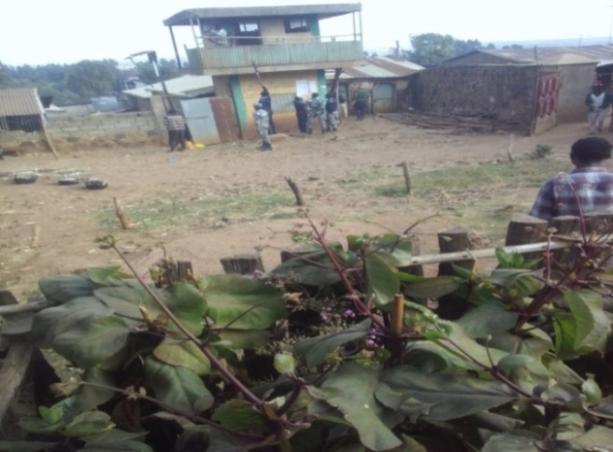 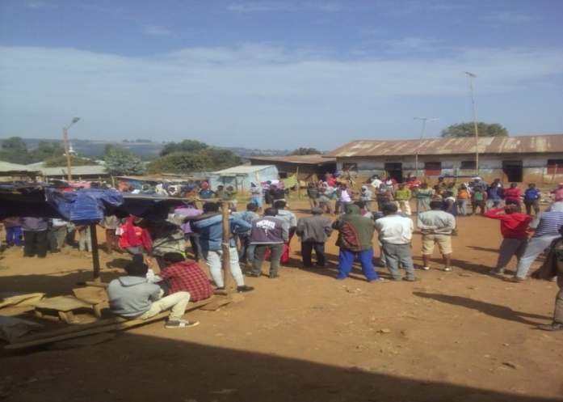 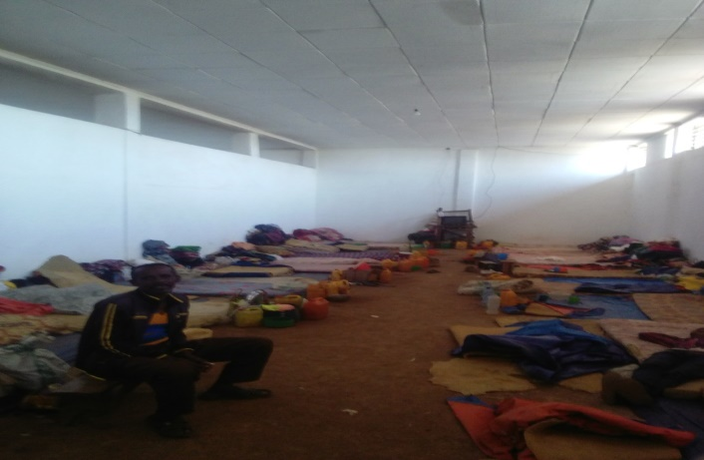

August, 2020 Gimbi, Ethiopia

