A Statistical and Ethnographic Study of Higher Educational Attainment among the Kshatriya Community of Lingarajupalem Village, Andhra Pradesh

Abstract

This paper explains the ethnographic and statistical study of the Kshatriya community of Lingarajupalem village in Anakapalle district of Andhra Pradesh based on primary household-level data collected from five generations up to 2025. This covers the total Kshatriya population of 2,060 individuals, among whom 508 attained undergraduate, postgraduate, and above indicating remarkably high higher educational attainment in a remote rural setting. The origins of the Kshatriya migrants in Lingarajupalem can be traced back nearly 275 years, and the entire Kshatriya ethnic group in the village consists of migrant lineages. The study analyses gender distribution, discipline-wise educational trends, surname-wise attainment, migration patterns, and educational mobility across generations. Despite geographical hardships, including the absence of a bridge across the Varaha River until later 1980s, the community sustained strong educational aspirations, resulting in educational levels significantly exceeding national and Andhra Pradesh averages. The dominance of science, engineering, medicine, management, and technology disciplines reflects a strong professional orientation shaped by collective social aspiration, intergenerational influence, literacy culture, and migration-based occupational mobility.

Key words: Community, Dhananjaya, education, ethnic, higher education, International, Kshatriya community, kinship, Lingarajupalem, Raja pravara, Surnames, West Godavari, Villages

Introduction
Education has emerged as one of the most significant instruments of social transformation in rural India, particularly among communities that developed strong intergenerational educational consciousness despite geographical and infrastructural limitations. Shreds of evidence also examined that education broadly accessible expands labour market opportunities and reduces social inequalities in society (Kuznets, 1955; Tinbergen, 1977).The present ethnographic and statistical study examines the higher educational attainment of the Kshatriya community of Lingarajupalem village in Anakapalle district of Andhra Pradesh.
The ethnic and historical origins of this community constitute an important background to the present study. This ethnic group first migrated from Mallipudi village of West Godavari district. The first family belonged to the “Dandu” surname whose gotra is “Dhananjaya.” Dhananjaya gotra Kshatriyas are from Kota Raja Vamsa who ruled the Kota Kingdom with Dharanikota (Dhanya Katakam) as their capital. It is apparently evident from their Kshatriya lineage depicted through their “Rajapravara.” Subsequently, the remaining twenty-one surnames migrated from different Kshatriya villages through marital alliances and kinship relations. Thus, the community represents a historically interconnected Kshatriya ethnic cluster with nearly ten centuries of broader lineage history, while the Lingarajupalem settlement lineage itself possesses approximately 275 years of continuous social history. The genealogical family trees of these surnames and their settlement history formed an important background framework for analysing the educational history of the community.
Lingarajupalem is situated near the Varaha River system and historically remained geographically isolated during monsoon seasons. Until later 1980s there was no bridge across the river, compelling students pursuing secondary education at nearby S. Rayavaram High School to swim across the river carrying books and lunch boxes during the rainy season. Despite such hardships, the community collectively promoted literacy and education from the 1940s onward. By the 1970s literacy among the Kshatriya households had become nearly universal. Over successive generations, educational aspiration transformed from basic literacy into professional and global higher education, with students entering engineering, medicine, management, research, and international universities. This study attempts to understand how a relatively small rural ethnic community developed an educational culture that substantially exceeds both national and Andhra Pradesh averages in higher educational attainment.
For more than two centuries, the Kshatriya community consistently promoted education among their kith and kin, influenced largely by marital relations with the erstwhile West Godavari district, interaction with British administration as some community people become contractors for civil and irrigation works, and intellectual association with nearby Brahmin Agraharam settlements and Basapadu Agraharam, S. Rayavaram, Dharmavaram, and Yelamanchili villages. These social and cultural interactions gradually fostered strong educational consciousness within the community. Even for generations the elders hired the services of teachers from Yelamanchili and Agraharam, S.Rayavaram villages to render linguistic knowledge to their children even before Independence to India. Further the primary school in this remote village was started way back in later 19th century which said to the be base for promoting basic literary among the kshatritya community and the co-education in those days. That is the stepping stone for next generations and continued this culture till date.
Literature Review
Thornton (2022) in an ethnographic study on Black American family histories observed that intergenerational continuity, family culture, collective memory, and educational values significantly shape identity formation and educational orientation across generations. Similarly, Marushiakova and Popov (2013) emphasized that ethnic communities preserve their social identity through kinship structures, migration history, group cohesion, and community consciousness, which collectively influence social advancement and continuity of cultural practices. Studies on ethnic identity and migrant communities further suggest that educational aspirations are often embedded within community traditions, social interaction, and intergenerational transmission of values.
Studies relating to rural educational attainment by Gautam, Rawat, and Sharma (2022) observed that caste, family support, and community networks substantially influence educational outcomes and occupational mobility among rural youth. Akhtar and Kaleem (2020) also noted that educational attainment among social groups is closely associated with socio-cultural structures and community support systems. The literature therefore suggests that educational advancement in rural communities cannot be understood merely through statistical indicators alone, but requires ethnographic understanding of lineage history, kinship relations, migration patterns, social interaction, and collective educational consciousness operating within the community structure
Methodology
The study is ethnographic as well as statistical in nature. Primary data was collected through direct household enumeration from all Kshatriya families belonging to five generations. Information was collected both from residents currently living in the village and from descendants residing in different cities in India and abroad. Mobile phone interviews, WhatsApp communication, personal interaction, and oral narratives were extensively used for data collection enabling sustained ethnographic engagement with community along with documenting lived experiences, socio-cultural practices and collective memories.
Objectives of the Study
The major objectives of the study are:
- To examine the level of higher educational attainment among the Kshatriya community of Lingarajupalem village.
- To analyze gender-wise distribution of graduates and postgraduates.
- To identify discipline-wise educational preferences within the community.
- To study surname-wise educational distribution and intergenerational educational continuity.
- To compare the educational attainment of the community with national and Andhra Pradesh state averages.
- To understand the socio-cultural and historical factors responsible for educational advancement in a remote rural setting.

Hypotheses
The study is based on the following hypotheses:
- The percentage of graduates and postgraduates among the Kshatriya community of Lingarajupalem is significantly higher than the national and Andhra Pradesh averages.
- Compared to other Kshatriya villages in the North Circars region, Lingarajupalem demonstrates higher educational attainment.
3. Science, engineering, management, and technology-related disciplines dominate over humanities and arts courses within the community.
The collected data included:
Population details, Gender, Educational qualifications, Discipline-wise courses, Surname-wise educational attainment, Professional qualifications, Doctoral degrees, Educational status of daughters-in-law,Migration-related educational mobility
The study period broadly covers higher educational attainment from 1950s to 2025, though the genealogical coverage extends over five generations beginning from the early twentieth century.
The total Kshatriya population studied is 2,060 individuals, consisting of 1,251 males and 809 females. Among them, 508 individuals attained undergraduate(bachelor’s degree holders) and postgraduate qualifications and above. Statistical tools such as percentages, ratios, comparative distribution, and proportional analysis were used for interpretation. Tables and graphical analysis from the primary data are incorporated into the study.

Limitations of the Study
- The study is confined only to the Kshatriya community of Lingarajupalem village.
- Certain historical educational information prior to the 1950s were reconstructed through oral narratives and family recollections.
- Some migrated family data was collected through telephonic and digital communication, which may contain minor reporting variations.
- Comparative data regarding other Kshatriya villages in the North Circars region was based primarily on observational and community-level understanding rather than structured statistical surveys and recorded information

Analysis
Lingarajupalem represents a traditional agrarian village society whose socio-cultural structure evolved significantly after the settlement of the first Kshatriya family in the village. Over time, the Kshatriya community emerged as the dominant social and economic group, constituting a major proportion of the village population and controlling substantial agricultural landholdings. The village social organization gradually developed around a caste-based hierarchical structure in which various artisan and service castes cohabited within the village under the traditional jajmani system. This hereditary arrangement continued largely until the 1990s, wherein different occupational groups and guild-based castes rendered customary services to Kshatriya families on a lineage-based (vamsaparamparyamga) relationship extending across generations.
The village economy remained predominantly agro-based and rain-dependent for much of its history. Along with paddy cultivation, millets formed the principal subsistence crops, while the twentieth century gradually introduced commercial crops such as sugarcane, coconut and banana. Until the mid-1950s, most village services and occupational exchanges under the jajmani framework functioned through a barter-based economy rather than monetary transactions. Ritual and cultural life of the village was regulated through Brahminical assistance; thus, the ethnographic profile of Lingarajupalem reflects a closely integrated rural social order characterized by caste hierarchy, hereditary occupations, ritual authority, agrarian dependence, and interdependent community relation. Being situated near the Bay of Bengal coast, fish formed a major and inexpensive source of nutrition for the agrarian population, particularly the Kshatriya community, and was often exchanged through barter arrangements within the traditional village economy. Its easy availability significantly influenced the food culture along with chicken and meat and vegetables forming part to supplement nutritional patterns of the village society specially for kshatriya community
Gender-wise Educational Distribution
The study reveals that among 301 graduates, 196 are male and 105 are female. Similarly, among 207 postgraduates and above, 151 are male and 56 are female. Overall, 347 males and 161 females attained higher education among the total 508 graduate and postgraduate population.
Gender | Graduates | Postgraduates | Total Higher Education | Population
Male | 196 | 151 | 347 | 1251
Female | 105 | 56 | 161 | 809
Total | 301 | 207 | 508 | 2060

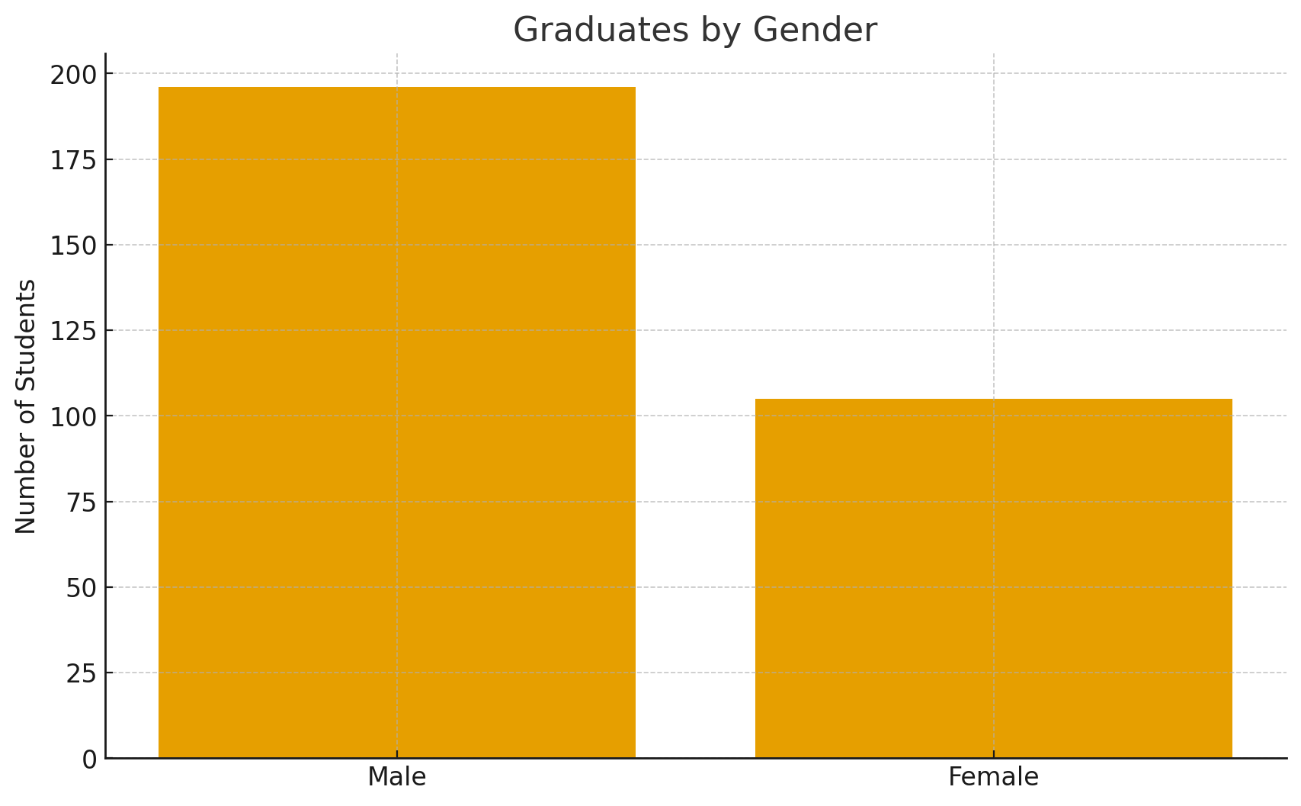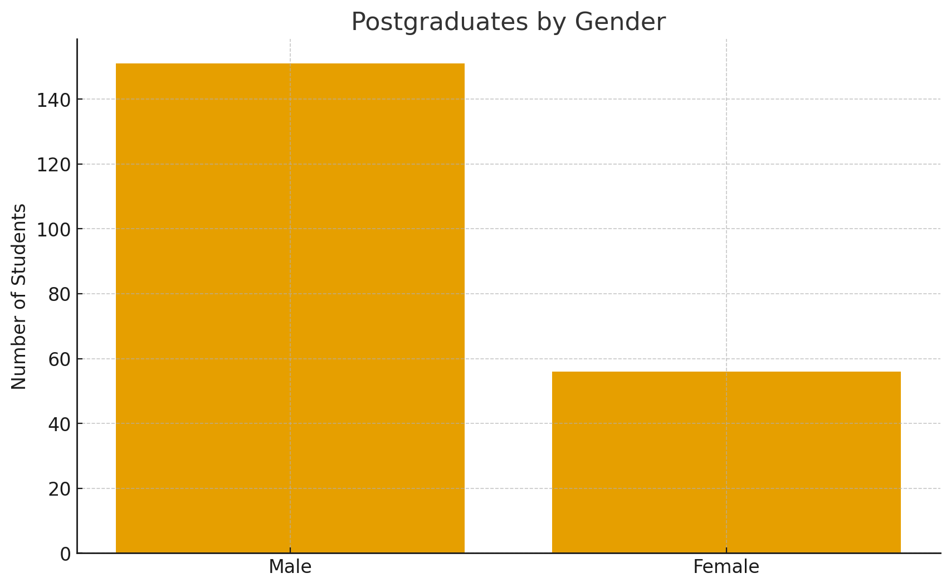

Overall, Gender Distribution (508 Graduates + PG)

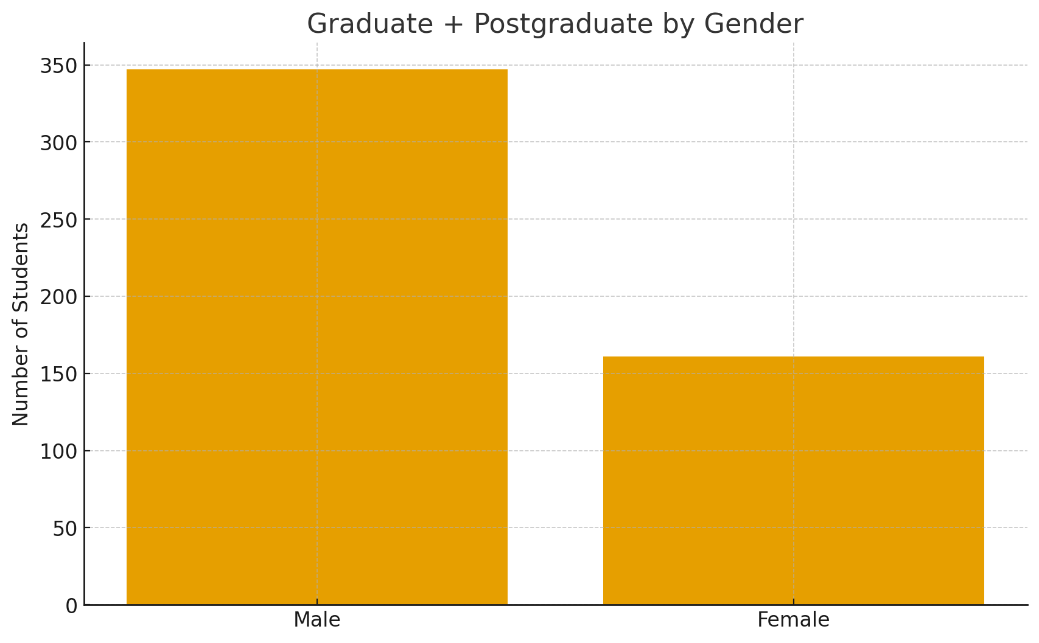
The gender disparity reflects traditional rural social structures, including early marriage and domestic responsibilities affecting women’s educational continuity. Nevertheless, the presence of 161 highly educated women within a small rural settlement represents substantial social progress.
The graphs provided in the statistical analysis indicate the following:
- Male graduates significantly outnumber female graduates.
- The gender gap widens further at postgraduate level.
- Male participation constitutes approximately 68.3%, while female participation constitutes 31.7%.
Despite disparities, female educational attainment remains considerably high when compared to many rural communities in Andhra Pradesh.
The combined total of 508 graduates and above consists of 347 males and 161 females. The gender share, illustrated in the pie chart, shows males at 68.3% and ales at 31.7%.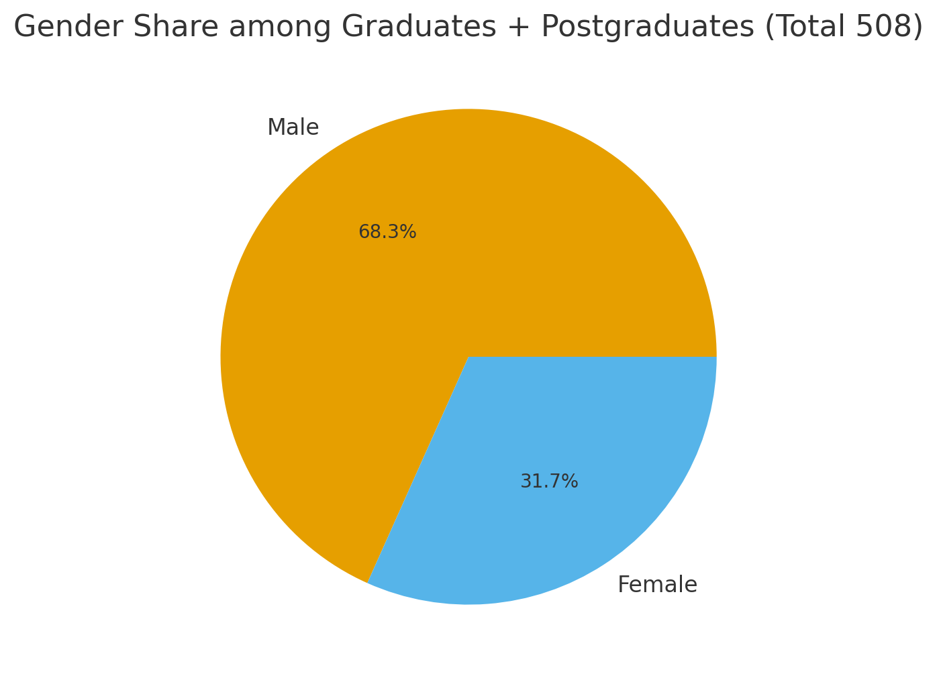
The pie chart visualizes the considerable gender disparity despite progress. However, 161 higher-educated women in a small rural community is a significant achievement.

Lingraaraajupalem village educational details among kshatriya community (course wise Graduates & Postgraduates and above)
Course | Male | Feemale | Total
B.A | 23 | 18 | 41
B.A(Litt) | 1 | 2 | 3
B.Com | 25 | 16 | 41
B.sc | 11 | 11 | 22
B.sc(micro bilogy) | 0 | 1 | 1
Bsc(CSC) | 4 | 5 | 9
B.Sc.(IIC.Tech) | 0 | 1 | 1
B.Ed | 5 | 1 | 6
BBM/BBA | 4 | 1 | 5
B.C.A. | 0 | 1 | 1
B.Tech(C.Sc) | 34 | 20 | 54
B.Tech(CiVil) | 3 | 0 | 3
B.Tech(Mech) | 12 | 1 | 13
B.Tech(Elect) | 2 | 0 | 2
B.tech(others) | 25 | 16 | 41
B.E, | 8 | 1 | 9
B.E(civil) | 7 | 0 | 7
B.E(Mech) | 4 | 0 | 4
B.pharm | 1 | 0 | 1
B.Arch | 0 | 1 | 1
BITS | 0 | 0 | 0
M.B.B.S | 3 | 4 | 7
B.D.S. | 1 | 1 | 2
B.V.S.C | 1 | 0 | 1
B.Sc(A.G) | 6 | 0 | 6
B.S(U.S.A) | 3 | 2 | 5
B.F.E(U.S.A) | 1 | 0 | 1
B.F.A.(photography) | 1 | 0 | 1
B.H.M(hospitality) | 1 | 0 | 1
B.S.E(Gama development) | 1 | 0 | 1
B.Lisc. | 1 | 1 | 2
B.H.M | 1 | 0 | 1
B.L | 7 | 1 | 8
Total Graduates | 196 | 105 | 301
M.A | 12 | 12 | 24
M.A(Litt) | 3 | 1 | 4
M.com | 14 | 3 | 17
M.Sc | 10 | 6 | 16
M.Sc(Maths) | 1 | 0 | 1
M.Sc.(Maths-BITS,GOA) | 0 | 2 | 2
M.Sc.(psychology) | 1 | 1 | 2
M.sc(Micro biology) | 0 | 0 | 0
M.B.A | 19 | 6 | 25
M.B.A(U,S) | 1 | 0 | 1
M.B,A(u.K & others) | 2 | 0 | 2
M.tech | 10 | 3 | 13
M.Sc(C.SC) | 2 | 0 | 2
M.C.A. | 3 | 3 | 6
M.Sc(A.G) | 3 | 0 | 3
M.Ed | 2 | 0 | 2
M.P.Ed | 1 | 0 | 1
M.Arch, | 0 | 1 | 1
M.S(Madras IIT) | 1 | 0 | 1
M.S.(BITS -Pilani) | 1 | 0 | 1
M.S(U.K) | 5 | 0 | 5
M.S(Australia) | 1 | 0 | 1
M.s(Canada) | 4 | 0 | 4
M.S(U.S.A) | 15 | 8 | 23
M.Pharm | 6 | 1 | 7
MDs/MS(medical) | 4 | 1 | 5
M.F.A(photography-U,S,A) | 1 | 0 | 1
IITians | 3 | 1 | 4
IIIT | 0 | 1 | 1
B.TCh(RECs/NITs) | 0 | 1 | 1
M.Tech.(RECs) | 1 | 0 | 1
M.tech(IIT(madas) | 2 | 0 | 2
IIMs | 1 | 0 | 1
ISBs | 1 | 2 | 3
ICWA | 0 | 0 | 0
C.P.A. | 1 | 0 | 1
CA | 1 | 0 | 1
P.G. C.F.A(Interior desigining-USA) | 1 | 0 | 1
PG dimploma | 9 | 0 | 9
M.Phil | 2 | 0 | 2
Pharma D.(Doctorates) | 2 | 2 | 4
P.hD. | 7 | 0 | 7
Total post graduates and above | 151 | 56 | 207
Total graduates and post graduates) | 347 | 161 | 508

508-Degree Proportional Fieldwide Distribution
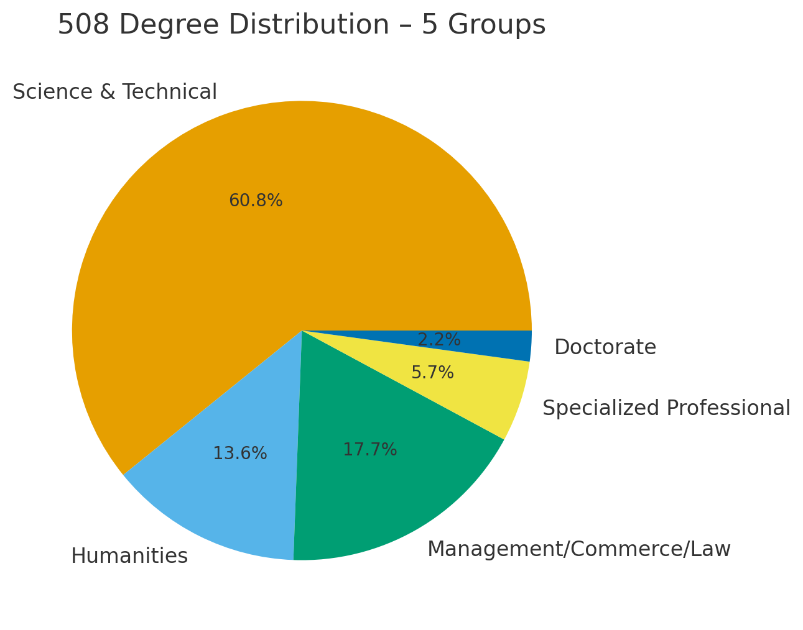
The above explains that the distribution for the total 508 degrees, a proportional scaling method was used. Science ,Engineering & Technical courses accounts for 309 individuals (60.8%), Humanities 69 (13.5%), Management/Commerce/Law 90 (17.7%), Specialized Professional 29 (5.7%), and Doctorate 11 (2.1%). This highlights the strong inclination of the community toward technical and professional education.
Table: Surname-wise Distribution of Graduates, Postgraduates, and Population among the Kshatriya Community of Lingarajupalem
Surname | Male Graduates | Female Graduates | Male Postgraduates | Female Postgraduates | Male Population | Female Population | Total Population
Addala | 0 | 0 | 0 | 0 | 8 | 4 | 12
Alluri | 30 | 20 | 14 | 8 | 192 | 175 | 367
Kalidindi | 36 | 23 | 25 | 22 | 116 | 184 | 300
Chekuri | 0 | 0 | 1 | 0 | 2 | 2 | 4
Gottumukkala | 1 | 3 | 0 | 0 | 7 | 11 | 18
Jampana | 0 | 0 | 1 | 0 | 2 | 2 | 4
Tirumala Raju | 2 | 0 | 2 | 1 | 13 | 12 | 25
Dandu | 84 | 59 | 84 | 25 | 651 | 308 | 959
Dantuluri | 5 | 1 | 2 | 0 | 68 | 40 | 108
Nadimpalli | 0 | 0 | 0 | 0 | 2 | 4 | 6
Penmetsa | 4 | 1 | 2 | 0 | 28 | 11 | 39
Buddaraju | 1 | 0 | 0 | 0 | 5 | 0 | 5
Bhupathiraju | 6 | 1 | 0 | 2 | 14 | 7 | 21
Mandapati | 0 | 0 | 3 | 0 | 10 | 4 | 14
Mantena | 7 | 1 | 2 | 1 | 38 | 15 | 53
Mulagapati | 2 | 1 | 1 | 0 | 11 | 1 | 12
Mudunuri | 3 | 2 | 2 | 0 | 11 | 2 | 13
Saagi | 1 | 0 | 1 | 0 | 19 | 1 | 20
Siruvuri | 0 | 0 | 0 | 0 | 4 | 1 | 5
Vatsavayi | 1 | 1 | 1 | 1 | 5 | 2 | 7
Vegiraju | 4 | 2 | 7 | 1 | 34 | 18 | 52
Vegesna | 2 | 1 | 1 | 0 | 11 | 5 | 16
Total | 189 | 116 | 144 | 59 | 1251 | 809 | 2060
The surname-wise distribution demonstrates that the Dandu lineage constitutes the largest demographic and educational segment within the community, followed by Alluri and Kalidindi families. The data further reveals that educational attainment is not confined to a single lineage but is distributed across multiple surnames, indicating a broader community-wide educational culture sustained through kinship networks, marital relations, and intergenerational educational aspirations.

Discipline-wise Distribution of Courses
The educational profile demonstrates strong preference toward science, engineering, technology, medicine, and management-oriented disciplines. Among the identified course distributions:
- Science, Engineering and Technical disciplines account for approximately 60.8%.
- Management, Commerce, and Law account for 17.7%.
- Humanities and Arts account for 13.5%.
- Specialized Professional Courses account for 5.7%.
- Doctoral qualifications account for around 2.1%.
The data clearly supports the hypothesis that Science and Engineering education dominates educational aspirations within the community.
A strong dominance of professional and technical education within the community, particularly in Engineering, Management, pharmacy, Agriculture Sciences, Medicine, and Technology-related disciplines. The presence of doctoral, CA, CPA, and specialized professional qualifications reflects the gradual transition of the community from basic literacy to advanced professional and research-oriented education. The attainment of 11 doctoral degrees reflects the community’s growing orientation toward research, knowledge production, academic excellence, and intellectual contribution, representing a significant sociological transition from a traditional rural society to a research-conscious educational community.

Table 2: International Higher Educational Mobility
Country | Number of Students
United States (MS) | 23
Canada (MS) | 4
United Kingdom (MS) | 5
Australia (MS) | 1
Total International Master’s Degrees | 33
The table demonstrates the emergence of global educational mobility among the younger generations of the community. A significant concentration of students pursuing higher studies in the United States indicates strong orientation toward advanced technical, research, and IT-related careers in international academic environments. This mobility started way back from 1980s.
Table 3: Representation in Prestigious National Institutions
Institution | Number
IIT Madras | 3
Other IITs | 4
IIT-related M.Tech/MS | 3
IIM Ahmedabad | 1
ISB | 3
BITS Pilani / BITS Goa | 3
NITs / RECs | 2
The above table shows that representation of students in premier institutions such as IITs, IIM Ahmedabad, ISB, BITS Pilani, and NITs reflects the highly competitive educational standards achieved by the community. This trend signifies intergenerational educational advancement and increasing participation in nationally recognized centres of excellence.
This indicates the gradual transition of the community from rural educational mobility toward national and global professional integration.
Historical and Sociological Factors Behind Educational Advancement
The ethnographic evidence collected during interviews identifies several important causal factors behind the unusually high educational attainment:
1. Early Literacy Culture
The Kshatriya community achieved near-total literacy by the 1970s. The existence of a primary school within the village for more than 100 plus years and the presence of teachers from the same community played a foundational role in promoting literacy. During later 19th century and early 20th century and a few elders with their association with British administration had a bearing to encourage the literacy and education to the generations to come. Even during early and mid-20th century they hired the services of teachers from neighbouring villages like Yelamanchili to render literacy and linguistic advancement among the then youngsters of the community.
Marital relations, particularly with families from the erstwhile West Godavari district, exposed the community elders to highly educated individuals such as medical doctors, barristers, and members of the Indian Civil Service (ICS). These interactions created a strong sense of educational aspiration among the elders, who in turn encouraged their children to pursue higher education and professional careers.
2. Collective Educational Aspiration
Irrespective of economic differences, almost all families encouraged children to attain at least undergraduate education. Education was perceived as the primary means for occupational security and social advancement.
3. Intergenerational Influence
Senior members influenced younger generations regarding educational choices, professional careers, and institutional selection. Educational success gradually became a collective community norm.
4. Sacrifice and Educational Commitment
The recurring practice of crossing the Varaha River by swimming to attend school symbolized the extraordinary determination of students and families toward education.
5. Migration and Occupational Mobility
Migration to urban centres and overseas destinations expanded exposure to professional opportunities. Families returning from cities influenced rural educational aspirations.
6. Influence of the IT Sector
Since the late 1990s and early 2000s, the growth of the information technology sector encouraged students to pursue STEM-oriented education and professional courses.

Surname-wise Educational Patterns
Surname-wise educational analysis reveals concentration of higher educational attainment among certain lineages, particularly:
- Dandu, Kalidindi, Alluri , Vegiraju, Bhupati Raju, Mantena
These families demonstrate substantial representation in postgraduate and professional education. The Dandu lineage particularly shows high educational continuity across generations.The surname-wise analysis also suggests that educational capital became socially reproduced through kinship networks, occupational influence, and marriage alliances.
Educational Status of Daughters-in-law
The study additionally analysed the educational status of daughters-in-law within the community. Out of 566 daughters-in-law, 119 possess graduate or postgraduate qualifications.
Qualification | Number
Graduates | 68
Postgraduates | 51
Total | 119

This trend reflects changing matrimonial preferences and increasing value attached to educated women within the community structure.
Comparative Perspective
The study demonstrates that approximately 24.6% of the total Kshatriya population attained graduate-level education and above. This significantly exceeds:
- National average for higher education attainment which is around 10%
- Andhra Pradesh state average which is around 7 %
The study also notes that no other known Kshatriya village in the North Circars region appears to demonstrate comparable levels of higher educational concentration of kshatriya community . This makes Lingarajupalem an important sociological case study in rural educational transformation.

Findings
The major findings of the study are as follows:
- Lingarajupalem Kshatriya community demonstrates exceptionally high levels of higher educational attainment in a rural setting.
- Approximately one-fourth of the total population attained graduate and postgraduate education.
- Technical and professional education dominates educational preferences.
- STEM-oriented disciplines significantly exceed humanities and arts disciplines.
- Male educational attainment remains higher, though female participation is also substantial.
6. Inferential statistical measures further strengthen the findings of the study. The Chi-Square test (χ² = 3.12) indicates moderate gender variation in higher educational attainment, while simultaneously reflecting gradual educational inclusion of women within the community across generations. Similarly, the Pearson correlation coefficient between male and female higher educational participation (r = 0.91) demonstrates a strong positive relationship, suggesting that educational advancement expanded progressively across both genders over generations. In addition, the Pearson correlation coefficient (r = 0.987) between surname-wise population and educational attainment demonstrates a very strong positive relationship, particularly among dominant lineages such as Dandu, Alluri, and Kalidindi, indicating sustained intergenerational educational continuity. The attainment of 11 doctoral degree holders further reflects the emergence of strong research orientation, knowledge production, and intellectual contribution within the community. The overall higher educational attainment rate of approximately 24.6% significantly exceeds both national and Andhra Pradesh averages, while the concentration of nearly 60.8% in science, engineering, and technical disciplines reflects a strong community orientation toward professional mobility, research, and modern knowledge-based occupations.

Conclusion
The ethnographic and statistical evidence presented in this study establishes that the Kshatriya community of Lingarajupalem village has achieved an extraordinary level of educational advancement despite its rural and geographically constrained setting. The transformation was not accidental; rather, it emerged through decades of collective social aspiration, intergenerational encouragement, community-based educational culture, and persistent sacrifice.
The community’s emphasis on literacy from the early twentieth century gradually evolved into a strong culture of higher education. Even during periods of infrastructural hardship, educational continuity was maintained through determination and collective support mechanisms. The transition from basic literacy to professional and global educational mobility reflects a remarkable sociological trajectory.
The study further demonstrates that rural communities can achieve advanced educational outcomes when cultural commitment toward education becomes institutionalized across generations. Lingarajupalem therefore stands not merely as a village case study but as an important example of how social capital, kinship structures, educational aspiration, and collective identity can transform a rural community into a highly educated social cluster.
The educational history of the Kshatriya community of Lingarajupalem thus constitutes a notable contribution to the sociology of education, rural transformation studies, and ethnographic scholarship in Andhra Pradesh

References
Akhtar, S. M., and Shahid Kaleem. “An Analysis of Educational Attainment among Different Social Groups in India.” International Journal of Humanities and Social Science Research, vol. 6, no. 6, 2020, pp. 92–100.
Gautam, Mathura Prasad, Rashmi Tyagi Rawat, and Amod Sharma. “Role of Family, Caste, and Community in Shaping Educational Attainment of Rural Youth.” International Journal of Humanities and Social Science Invention, vol. 11, no. 6, 2022, pp. 81–87.
Joseph, Joretta. The Experiences of African American Graduate Students: A Cultural Transition. 2007.
Kamal, Utkarsh. “Does ‘Caste Matters’ in School Education: A Preliminary Study in Uttar Pradesh.” SAGE Journals, 2023.
Marushiakova, Elena, and Vesselin Popov. “Ethnonyms vs. Professionyms: ‘Gypsy’ Groups in Eastern Europe.” Romani Studies, vol. 23, no. 1, 2013, pp. 61–82.
Matache, Margareta. “The Legacy of Gypsy Studies in Modern Romani Scholarship.” FXB Center for Health and Human Rights, Harvard University, 2016.
Thornton, Kimberly A. Black American Family Life Histories: An Ethnographic Study. Texas State University, 2022.
“Caste and Its Impact on Education in India.” Sociology of Education, 2025.
“An Analysis of Caste-Based Discrimination in Educational Settings in India: Bridging the Theory and Narratives.” Sphoorti, 2025.
“This Srikakulam Village is the Home of Over 150 Doctors.” The New Indian Express, 19 Feb. 2023.

