Fake News Detection Using Machine Learning: A Comparative Study of Naive Bayes, Logistic Regression, and Linear Support Vector Machine with TF-IDF Features

Abstract—The rapid growth of digital misinformation has created an urgent need for computational tools that can identify misleading news content at scale. This paper presents an IEEE-style comparative study of three supervised machine learning classifiers, Multinomial Naive Bayes, Logistic Regression, and Linear Support Vector Machine (Linear SVC), for binary fake news classification using TF-IDF text features. A reproducible Natural Language Processing pipeline is implemented using lowercasing, punctuation removal, stopword filtering, lemmatization, train-test splitting, vectorization, model training, and evaluation. Experiments are conducted on a publicly available fake-and-real news dataset, using 44,898 cleaned English-language articles after preprocessing. The results show that LinearSVC achieves the strongest performance, with 99.3% accuracy and approximately 0.99 precision, recall, and F1-score, followed by Logistic Regression at 98.7% and Multinomial Naive Bayes at 88.5%. The study demonstrates that a lightweight classical machine learning pipeline remains a strong baseline for fake news detection, especially where GPU resources are unavailable. Limitations relating to semantic context, multilingual generalization, dataset leakage risk, and adversarial misinformation are discussed, and future extensions using transformer-based models, explainability, and web deployment are proposed.
Keywords—Fake news detection, machine learning, natural language processing, TF-IDF, Naive Bayes, Logistic Regression, LinearSVC, text classification, misinformation, scikit-learn.

I. INTRODUCTION
The contemporary information ecosystem allows news stories, social commentary, and political claims to circulate at very high speed. Empirical work has shown that false information can diffuse more rapidly and reach more users than truthful information on social platforms [1]. The wider societal concern is not only technical; misinformation can undermine public trust, weaken democratic debate, and produce measurable social harms [2], [3]. During the COVID-19 period, the World Health Organization identified the information disorder surrounding public-health claims as an “infodemic,” emphasizing that credible information management is now part of crisis response [4].
Manual fact-checking remains essential, but it cannot keep pace with the volume and velocity of online content. Automated fact-checking and computational credibility assessment can support human reviewers by filtering high-risk content, prioritizing suspicious stories, and identifying linguistic patterns that require verification [5]. In this context, machine learning and Natural Language Processing (NLP) provide practical methods for classifying news articles as fake or real based on the statistical properties of text.
This study evaluates three classical supervised classifiers, Multinomial Naive Bayes, Logistic Regression, and Linear SVC, using TFIDF features. The aim is not to claim that classical models replace transformer-based systems, but to show that a computationally inexpensive and interpretable baseline can still achieve strong results on a benchmark text dataset. The main contributions are:
- A reproducible preprocessing and classification pipeline.
- A comparative evaluation using accuracy, precision, recall, and F1score
- Visual and tabular performance analysis
- A discussion of limitations and future research directions relevant to IEEE-level publication quality.
II. RELATED WORK
A. Classical credibility and machine learning approaches
Early studies of fake news and credibility focused on linguistic cues, source credibility, and social propagation characteristics. Conroy et al. reviewed automated deception detection and grouped approaches into linguistic, network, and hybrid strategies [6]. Castillo et al. examined credibility on Twitter using message, user, topic, and propagation features, establishing the importance of metadata in social media credibility tasks [7]. For content-based article classification, Ahmed et al. demonstrated that n-gram and TF-IDF representations, combined with SVM and Logistic Regression, could perform well in fake news detection [8].
B. Textual and stylometric indicators
Linguistic studies show that fake news can differ from real news in writing style, headline structure, sentiment, and lexical diversity. Horne and Adali found that fake news often relies on shorter, simpler, and more repetitive textual structures than mainstream reporting [9]. Potthast et al. further demonstrated that stylometric features can reveal hyperpartisan and misleading news writing patterns [10]. These studies justify the present paper’s text-focused approach and show that content-only models may miss source and propagation signals.
C. Feature extraction and implementation tools
TFIDF remains one of the most widely used text representations because it rewards terms that are frequent within a document but relatively rare across the corpus [11]. The present implementation uses standard NLP utilities such as tokenization, stopword removal, and lemmatization, which are commonly implemented through NLTK [12]. Model training and evaluation are implemented through scikit-learn, a widely adopted Python library for machine learning experimentation [13].
D. Deep learning and hybrid approaches
Deep learning introduced sequence-aware and context-aware alternatives to bag-of-words representations. LSTM networks were originally proposed to capture long-range dependencies in sequence data [14], and the LIAR benchmark encouraged further research on short political statement classification [15]. BERT introduced bidirectional transformer pretraining for language understanding [16], building on the transformer architecture proposed by Vaswani et al. [17]. FakeBERT and related models show that transformer-based systems can perform well in misinformation classification, but they require more computational resources and careful fine-tuning [18]–[20].
Hybrid fake news systems integrate text, user engagement, source credibility, and temporal propagation. The CSI model combines content, social response, and source characteristics [21]. FakeNewsNet provides news content along with social and spatiotemporal context for research [22]. Survey studies also show that robust fake news detection should consider writing style, false knowledge, propagation, and source credibility together [23], [24]. Rumor detection research similarly emphasizes temporal dynamics and stance evolution in social platforms [25]. Additional work on rhetorical cues, satirical signals, supervised artificial intelligence models, and broad characterizations of fake news supports the need for stronger generalization beyond a single dataset [26]–[29]. The dataset used in the present study is the publicly available Fake and Real News Dataset distributed via Kaggle [30].
III. DATASET DESCRIPTION
The experiment uses a publicly available fake- and real-news dataset distributed as two CSV files: one containing fake news articles and one containing true news articles [30]. The raw dataset is commonly listed as 23,502 fake articles and 21,417 true articles. In this study, 44,898 records are used after cleaning and removing unusable rows, comprising 23,481 fake articles and 21,417 real articles. This distinction should be retained in the manuscript to prevent a mismatch between the source dataset count and the final experimental count.
TABLE I. DATASET SUMMARY AFTER CLEANING
Class | Label | Records | Share
Fake | 0 | 23,481 | 52.30%
Real | 1 | 21,417 | 47.70%
Total | — | 44,898 | 100%
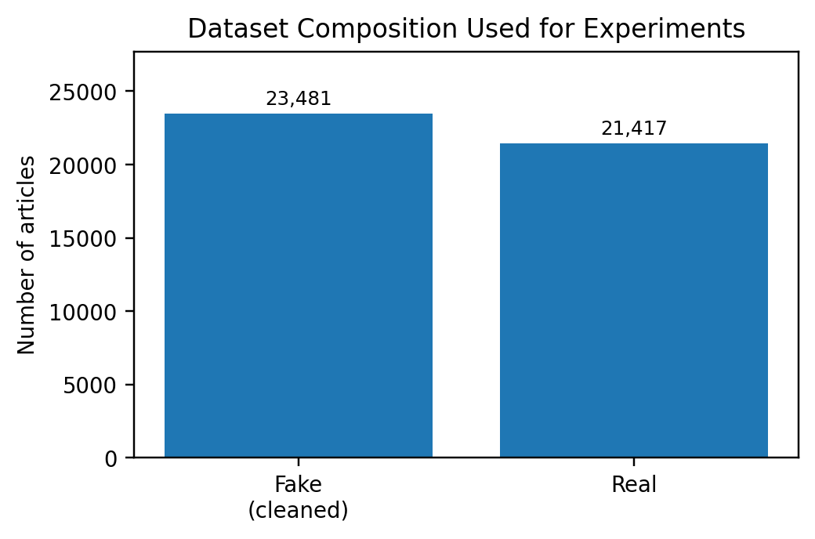
Fig. 1. Dataset composition used for the experimental evaluation.

Each record contains the article title, article text, subject category, and date. The article text field is selected as the primary feature input because it contains richer linguistic evidence than the title alone. The combined corpus is shuffled with a fixed random seed before being split into training and testing sets to improve reproducibility.
IV. PROPOSED METHODOLOGY
The proposed system follows a standard text classification pipeline. Raw article text is normalized, transformed into TFIDF vectors, divided into training and testing partitions, and then passed to three supervised classifiers. The same training split and vectorized feature matrix are used across all models to ensure a fair comparison.
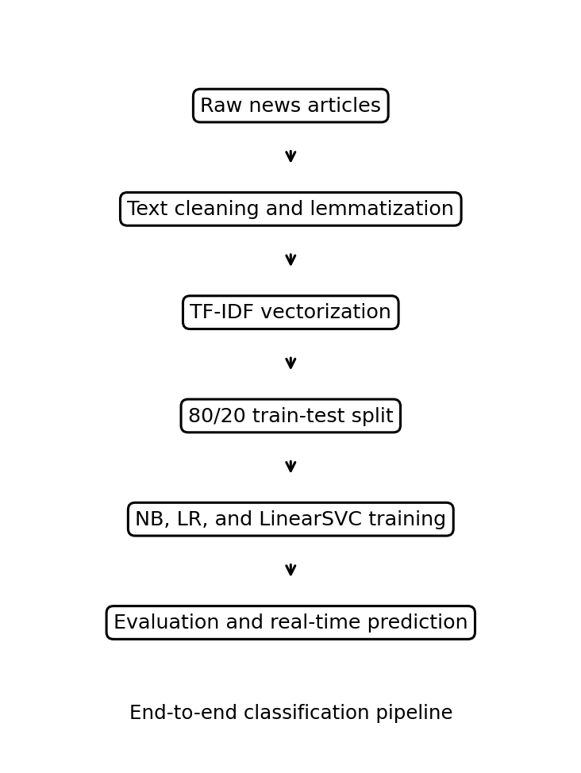
Fig. 2. Proposed fake news detection workflow.
A. Text preprocessing
Raw text contains punctuation, case variation, common function words, and inflectional word forms. The preprocessing module applies lowercasing, punctuation removal, tokenization, stopword removal, and lemmatization. Lowercasing reduces vocabulary fragmentation; punctuation removal decreases no semantic noise; stop word filtering reduces common words with low discriminative value; and lemmatization converts words to their dictionary form so that related variants are treated consistently.
TABLE II. PREPROCESSING OPERATIONS
Step | Purpose | Example
Lowercase | Normalize case | News → news
Remove punct. | Reduce noise | vote! → vote
Stopwords | Remove lowvalue words | the, is, of
Lemma | Reduce variants | studies → study
B. TFIDF vectorization
After preprocessing, the text is converted into numerical vectors using TFIDF. Term Frequency measures how often a word occurs in a document, while Inverse Document Frequency reduces the weight of words that occur in many documents. The final score is the product of these two components. The vectorizer is fitted only on the training data and then applied to the test data. This is important because fitting the vectorizer on the complete dataset would create data leakage and inflate evaluation scores.
C. Classifiers
Multinomial Naive Bayes is used as a fast probabilistic baseline. Logistic Regression is a strong linear discriminative classifier that is interpretable through its learned feature weights. LinearSVC is used because high-dimensional sparse TFIDF vectors often separate well under a maximum-margin objective. All models are trained on the same feature representation and evaluated using the same test set.
V. EXPERIMENTAL SETUP
The combined dataset is split into 80% training data and 20% testing data. For 44,898 articles, this corresponds to approximately 35,918 training samples and 8,980 testing samples. The evaluation uses accuracy, precision, recall, and F1score. Accuracy measures overall correctness, precision measures the reliability of positive predictions, recall measures the model’s ability to identify positive cases, and F1score balances precision and recall. In a misinformation setting, relying solely on accuracy can be misleading; therefore, class-wise metrics and weighted averages are also reported.
TABLE III. CLASSIFIERS USED IN THE STUDY
Classifier | Type | Advantage
MNB | Probabilistic | Fast sparse baseline
LR | Linear | Interpretable weights
LinearSVC | MA margin | Strong with TFIDF
VI. RESULTS AND ANALYSIS
Table IV summarizes the comparative performance of all three classifiers. LinearSVC achieves the highest accuracy of 99.3%, followed by Logistic Regression at 98.7% and Multinomial Naive Bayes at 88.5%. The large difference between Naive Bayes and the two linear discriminative models indicates that independent word probabilities are less expressive than learned linear decision boundaries in this dataset.
TABLE IV. PERFORMANCE COMPARISON OF CLASSIFIERS
Algorithm | Acc. | Prec. | Recall | F1
MNB | 88.50% | 0.89 | 0.88 | 0.88
LR | 98.70% | 0.99 | 0.99 | 0.99
LinearSVC | 99.30% | 0.99 | 0.99 | 0.99
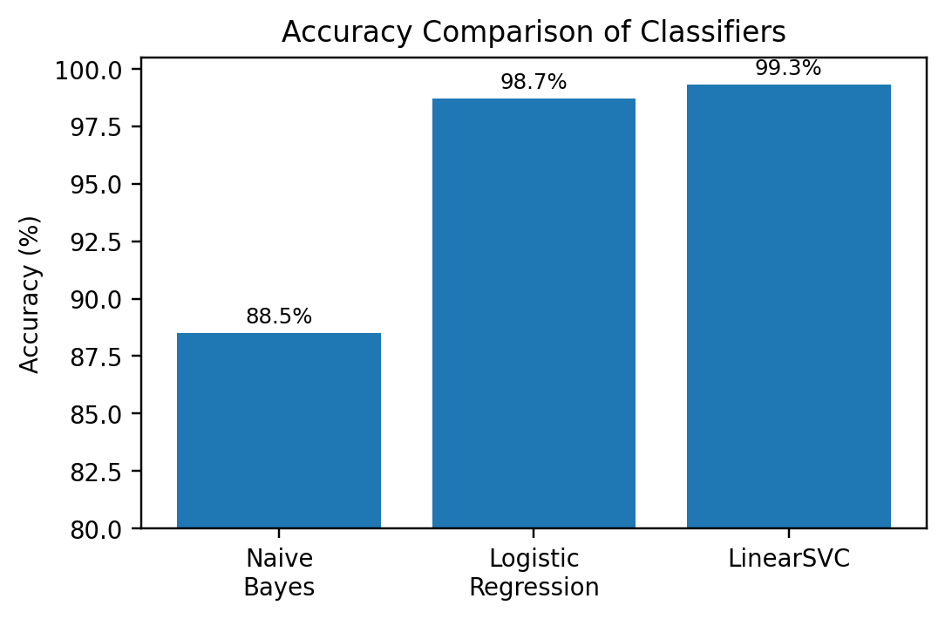
Fig. 3. Accuracy comparison of the three classifiers.
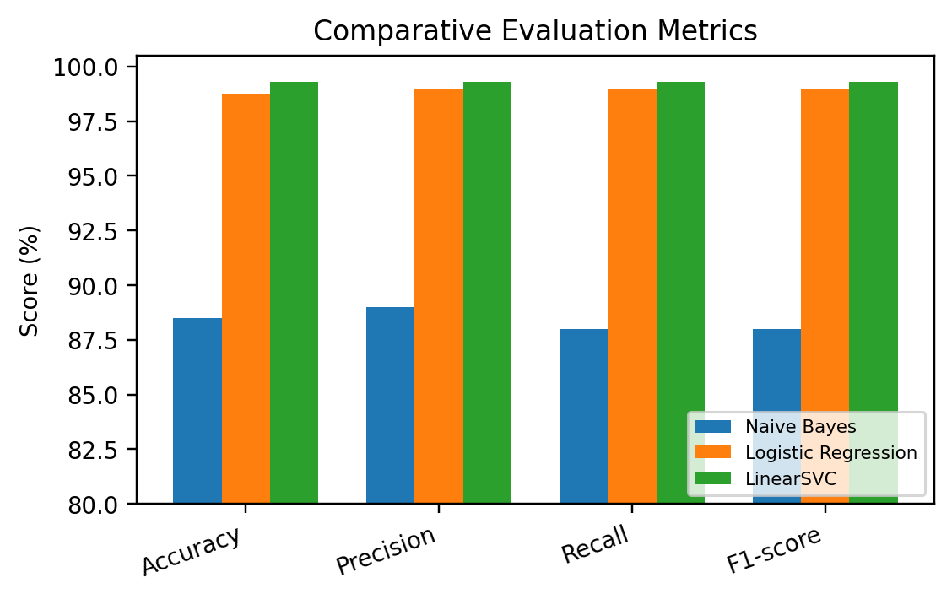
Fig. 4. Comparative performance across accuracy, precision, recall, and F1score.
The per-class report for Linear SVC shows balanced performance on both fake and real classes. Fake news has support of 4,683 records, and real news has support of 4,297 records in the test split. The weighted-average F1 score is 0.993, indicating that the model is not merely benefiting from class imbalance.
TABLE V. LINEARSVC PERCLASS CLASSIFICATION REPORT
Class | Prec. | Recall | F1 | Support
Fake | 0.99 | 0.99 | 0.99 | 4,683
Real | 0.99 | 0.99 | 0.99 | 4,297
Weighted | 0.993 | 0.993 | 0.993 | 8,980
VII. DISCUSSION
The results support the suitability of linear classifiers for TFIDF-based fake news detection. Logistic Regression and LinearSVC both operate well in sparse, high-dimensional vector spaces, where lexical differences between fake and real articles can become approximately linearly separable. LinearSVC slightly outperforms Logistic Regression because the maximum-margin objective seeks the separating boundary with the largest margin, which can improve generalization to unseen sparse vectors.
Although the reported performance is high, it should be interpreted carefully. Very high accuracy on a single benchmark dataset may reflect dataset-specific vocabulary, source-specific terms, or temporal patterns. A strong IEEE-level version of this paper should therefore include additional validation, such as k-fold cross-validation, duplicate detection, ngram ablation, confusion matrices, and testing on a different dataset. Without these checks, the result should be presented as strong benchmark performance rather than a universal solution to fake news.
TABLE VI. ADDITIONAL IEEE LEVEL FIGURES AND TABLES RECOMMENDED
Addition | Purpose | Method
Confusion matrix | FP/FN errors | sklearn matrix
ROC/AUC | Threshold view | decision scores
Top TFIDF | Interpret terms | highest weights
Ablation | Pipeline effect | remove steps
CV table | Reliability | mean ± SD
VIII. LIMITATIONS
The first limitation is semantic blindness: TFIDF ignores word order, negation, sarcasm, and deeper contextual meaning. The second limitation is language restriction: the present pipeline is English-focused and cannot be directly deployed for Hindi, Punjabi, or other Indian languages without multilingual preprocessing and data. Third, the model is static; misinformation tactics evolve, so periodic retraining is necessary. Fourth, the experiment uses default or basic model settings, and additional hyperparameter tuning may change the ranking of classifiers. Finally, the system is content-only and does not use source credibility, network propagation, author behavior, or multimodal evidence.
IX. CONCLUSION AND FUTURE WORK
This paper presented an IEEE-formatted comparative study of fake news detection using Multinomial Naive Bayes, Logistic Regression, and Linear SVC with TFIDF features. On the cleaned benchmark dataset of 44,898 articles, LinearSVC achieved the best performance with 99.3% accuracy and approximately 0.99 precision, recall, and F1score. Logistic Regression also produced strong results at 98.7%, while Naive Bayes provided a useful but weaker baseline at 88.5%.
Future work should extend the study in five directions: (i) compare TFIDF with word embeddings and transformer embeddings; (ii) include BERT, RoBERTa, DistilBERT, and multilingual transformer models; (iii) evaluate cross-dataset generalization; (iv) add explainability methods such as LIME or SHAP; and (v) deploy the trained model through a web interface with real-time prediction, source logging, and human review feedback. These additions would make the system more robust, transparent, and better suited to real-world misinformation screening.
REFERENCES
[1] S. Vosoughi, D. Roy, and S. Aral, “The spread of true and false news online,” Science, vol. 359, no. 6380, pp. 1146–1151, 2018, doi: https://doi.org/10.1126/science.aap9559
[2] D. M. J. Lazer et al., “The science of fake news,” Science, vol. 359, no. 6380, pp. 1094–1096, 2018, doi: https://doi.org/10.1126/science.aao2998
[3] H. Allcott and M. Gentzkow, “Social media and fake news in the 2016 election,” J. Econ. Perspect., vol. 31, no. 2, pp. 211–236, 2017, doi: https://doi.org/10.1257/jep.31.2.211
[4] World Health Organization, “Managing the COVID19 infodemic: Promoting healthy behaviours and mitigating the harm from misinformation and disinformation,” 2020. Available: https://www.who.int/news/item/23092020managingthecovid19infodemicpromotinghealthybehavioursandmitigatingtheharmfrommisinformationanddisinformation
[5] L. Graves, “Understanding the promise and limits of automated factchecking,” Reuters Institute for the Study of Journalism, 2018. Available: https://reutersinstitute.politics.ox.ac.uk/ourresearch/understandingpromiseandlimitsautomatedfactchecking
[6] N. J. Conroy, V. L. Rubin, and Y. Chen, “Automatic deception detection: Methods for finding fake news,” Proc. Assoc. Inf. Sci. Technol., vol. 52, no. 1, pp. 1–4, 2015, doi: https://doi.org/10.1002/pra2.2015.145052010082
[7] C. Castillo, M. Mendoza, and B. Poblete, “Information credibility on Twitter,” in Proc. 20th Int. Conf. World Wide Web, 2011, pp. 675–684, doi: https://doi.org/10.1145/1963405.1963500
[8] H. Ahmed, I. Traore, and S. Saad, “Detection of online fake news using ngram analysis and machine learning techniques,” in Proc. Int. Conf. Intelligent, Secure, and Dependable Systems in Distributed and Cloud Environments, 2017, pp. 127–138, doi: https://doi.org/10.1007/9783319691558_9
[9] B. D. Horne and S. Adali, “This just in: Fake news packs a lot in title, uses simpler, repetitive content in text body, more similar to satire than real news,” in Proc. ICWSM Workshop, 2017. Available: https://ojs.aaai.org/index.php/ICWSM/article/view/14976
[10] M. Potthast, J. Kiesel, K. Reinartz, J. Bevendorff, and B. Stein, “A stylometric inquiry into hyperpartisan and fake news,” in Proc. 56th Annu. Meeting ACL, 2018, pp. 231–240, doi: https://doi.org/10.18653/v1/P181022
[11] G. Salton and C. Buckley, “Termweighting approaches in automatic text retrieval,” Inf. Process. Manage., vol. 24, no. 5, pp. 513–523, 1988, doi: https://doi.org/10.1016/03064573(88)900210
[12] S. Bird, E. Klein, and E. Loper, Natural Language Processing with Python. Sebastopol, CA, USA: O’Reilly Media, 2009. Available: https://www.nltk.org/book/
[13] F. Pedregosa et al., “Scikitlearn: Machine learning in Python,” J. Mach. Learn. Res., vol. 12, pp. 2825–2830, 2011. Available: https://jmlr.org/papers/v12/pedregosa11a.html
[14] S. Hochreiter and J. Schmidhuber, “Long shortterm memory,” Neural Comput., vol. 9, no. 8, pp. 1735–1780, 1997, doi: https://doi.org/10.1162/neco.1997.9.8.1735
[15] W. Y. Wang, “‘Liar, liar pants on fire’: A new benchmark dataset for fake news detection,” in Proc. 55th Annu. Meeting ACL, 2017, pp. 422–426, doi: https://doi.org/10.18653/v1/P172067
[16] J. Devlin, M.W. Chang, K. Lee, and K. Toutanova, “BERT: Pretraining of deep bidirectional transformers for language understanding,” in Proc. NAACLHLT, 2019, pp. 4171–4186, doi: https://doi.org/10.18653/v1/N191423
[17] A. Vaswani et al., “Attention is all you need,” in Proc. NeurIPS, 2017, pp. 5998–6008. Available: https://papers.nips.cc/paper/7181attentionisallyouneed
[18] R. K. Kaliyar, A. Goswami, P. Narang, and S. Sinha, “FakeBERT: Fake news detection in social media with a BERTbased deep learning approach,” Multimedia Tools Appl., vol. 80, no. 8, pp. 11765–11788, 2021, doi: https://doi.org/10.1007/s11042020101832
[19] Y. Liu et al., “RoBERTa: A robustly optimized BERT pretraining approach,” arXiv:1907.11692, 2019. Available: https://arxiv.org/abs/1907.11692
[20] V. Sanh, L. Debut, J. Chaumond, and T. Wolf, “DistilBERT, a distilled version of BERT: Smaller, faster, cheaper and lighter,” arXiv:1910.01108, 2019. Available: https://arxiv.org/abs/1910.01108
[21] N. Ruchansky, S. Seo, and Y. Liu, “CSI: A hybrid deep model for fake news detection,” in Proc. ACM CIKM, 2017, pp. 797–806, doi: https://doi.org/10.1145/3132847.3132877
[22] K. Shu, D. Mahudeswaran, S. Wang, D. Lee, and H. Liu, “FakeNewsNet: A data repository with news content, social context, and spatiotemporal information for studying fake news on social media,” Big Data, vol. 8, no. 3, pp. 171–188, 2020, doi: https://doi.org/10.1089/big.2020.0062
[23] K. Shu, A. Sliva, S. Wang, J. Tang, and H. Liu, “Fake news detection on social media: A data mining perspective,” SIGKDD Explor. Newsl., vol. 19, no. 1, pp. 22–36, 2017, doi: https://doi.org/10.1145/3137597.3137600
[24] X. Zhou and R. Zafarani, “A survey of fake news: Fundamental theories, detection methods, and opportunities,” ACM Comput. Surv., vol. 53, no. 5, pp. 1–40, 2020, doi: https://doi.org/10.1145/3395046
[25] A. Zubiaga, A. Aker, K. Bontcheva, M. Liakata, and R. Procter, “Detection and resolution of rumours in social media: A survey,” ACM Comput. Surv., vol. 51, no. 2, pp. 1–36, 2018, doi: https://doi.org/10.1145/3161603
[26] H. Rashkin, E. Choi, J. Y. Jang, S. Volkova, and Y. Choi, “Truth of varying shades: Analyzing language in fake news and political factchecking,” in Proc. EMNLP, 2017, pp. 2931–2937, doi: https://doi.org/10.18653/v1/D171317
[27] V. L. Rubin, N. J. Conroy, Y. Chen, and S. Cornwell, “Fake news or truth? Using satirical cues to detect potentially misleading news,” in Proc. Workshop Comput. Approaches to Deception Detection, 2016, pp. 7–17, doi: https://doi.org/10.18653/v1/W160802
[28] F. Monti, F. Frasca, D. Eynard, D. Mannion, and M. M. Bronstein, “Fake news detection on social media using geometric deep learning,” arXiv:1902.06673, 2019. Available: https://arxiv.org/abs/1902.06673
[29] X. Zhang and A. A. Ghorbani, “An overview of online fake news: Characterization, detection, and discussion,” Inf. Process. Manage., vol. 57, no. 2, 102025, 2020, doi: https://doi.org/10.1016/j.ipm.2019.03.004
[30] C. Bisaillon, “Fake and real news dataset,” Kaggle, 2020. Available: https://www.kaggle.com/datasets/clmentbisaillon/fakeandrealnewsdataset

