STRESS DETECTION FROM CHAT USING NATURAL LANGUAGE PROCESSING EMBEDDINGS AND TOKENIZATION USING MACHINE LEARNING METHOD
¹Dr.S.Brindha, ²Dr.S.Ravichandran, ³ Sajith Balaji Sarvesh
¹ Assistant Professor, Department of Computer Applications,
College of Sciences, SRMIST Faculty of Science and Humanities,
SRM Institute of Science and Technology, SRM University, Kattankulathur, Chennai, Tamilnadu.
² Assistant Professor and Head, Department of Chemistry, St.Peter’s Institute of Higher Education and Research, Chennai, Tamilnadu, India.
³Student, Department of Computer Science and Engineering, Karpaga Vinayaga College of Engineering and Technology, Chengalpattu, Chennai, India
Corresponding Author
Dr.S.Brindha
brindhas1@srmist.edu.in

ABSTRACT
Stress is a subjective sensation that is difficult to accurately define. Stress can have a variety of biological and psychological consequences on one's health, which can be defined and quantified. We only get half of the information if we focus solely on what someone says and ignore what their demeanor tells us. In this project, we will use random forest and decision tree algorithms to detect mental stress. The existing system does not work in real time and is inaccurate and inefficient in terms of loading and implementation durations. Furthermore, the appropriate test-train split ratio is not applied during testing and training. The proposed method is implemented in real time and has a high level of accuracy. In comparison to the current system, the suggested solution has incredibly fast loading and execution times. The proposed method can be improved for more complex use cases and is highly effective and scalable.
Keywords: Machine Learning, Advanced Strees Detection from Chat, Natural Language Processing, Tokenization, Text Conversation.

CHAPTER 1
INTRODUCTION
With the rapid expansion of society and the economy, an increasing number of people lead stressful lives. Too much stress jeopardizes both physical and psychological health. Because of their spiritual immaturity, the threat is particularly dangerous for young people, who are more likely to experience sadness or even suicide. As a result, psychologists and educators have focused heavily on the topic of adolescent stress [3]. However, one major issue is that most developing adolescents are unwilling or hesitant to disclose their sentiments to others, preferring to relieve tension in the virtual world. Stress is a sensation of mental or physical tension caused by a person's inability to cope with the surroundings. Stress detection is a classification task that determines whether a specific target is stressed.
The task has piqued researchers' interest for two reasons: first, stress detection is important in applications such as psychological well-being, cognitive behavior therapies, and safe driving; second, stress is a known regulator of human emotion mechanisms, so stress detection research may benefit the development of emotionally intelligent agents. Stress has a variety of effects on human behavior. A person's standard of living is greatly influenced by his emotional states, such as stress and anxiety [1].
Stress is often described as a complex psychological and behavioral state resulting from the perception of a significant imbalance between the demands placed on the individual and their perceived ability to meet the demands[1] . Stress has an impact on both mental and physical health, generating disorders such as irregular heart rhythms, arrhythmia, and depression.

CHAPTER 2
LITERATURE REVIEW
Jindal et al. 2019 offer a work that uses Natural Language Processing (NLP) approaches to detect stress in online chat chats. The authors present an approach for preparing chat data, extracting features, and classifying them using machine learning methods. The study employs a dataset of real-world chat chats to evaluate the effectiveness of various classifiers, including SVM, KNN, and Random Forest. The findings indicate that the proposed approach is successful in detecting stress in online chat chats, with an accuracy of up to 87%. This study has significant implications for creating automated methods to detect stress in online conversation and giving prompt assistance to people in need[6].

Buechel, S., et al. 2019 define this paper as a study on identifying emotional distress and stress in social media messages using natural language processing. The authors suggest a way for constructing a multi-task learning framework that models both stress and distress classification. The method employs a dataset of Twitter messages to examine the performance of several models, including neural network models and standard machine learning classifiers. The results reveal that the suggested method outperforms other methods for detecting stress and emotional distress in social media messages [7]. This study has significant implications for better understanding mental health concerns and designing tailored interventions to help people in distress.
Lee, C. H., et al. describe that this paper presents a chatbot system for stress management based on deep neural networks. The authors describe a framework for creating a chatbot that can recognize users' emotional states and offer suitable stress management strategies. A dataset of stress-related terms and phrases is used to train a deep neural network model that can classify users' emotional states [8]. The chatbot system recommends stress management measures based on the user's emotional state and initiates a discussion with the user to offer emotional support. The study assesses the proposed system using user surveys and finds that the chatbot is successful at delivering stress management support to users. This study has significant implications for the development of automated systems for mental health support.
Kudugunta, S., et al. demonstrate a method for identifying stress in email exchanges using natural language processing (NLP) approaches. The authors propose creating a stress detection algorithm by extracting linguistic and discourse elements from email discussions. The study employs a dataset of real-world email interactions to assess the efficacy of several machine learning classifiers, including SVM, Logistic Regression, and Random Forest. The findings indicate that the proposed approach is successful in detecting stress in email exchanges, with an accuracy of up to 78%. This study has significant implications for building automated methods to detect stress in email conversation and offering prompt assistance to persons in need [10].

CHAPTER 3 SOFTWARE REQUIREMENT ANALYSIS

SOFTWARE SPECIFICATION
Operating system : Windows7 (with service pack 1), 8, 8.1 and 10 Language : Python
Python is a favorite among programmers due to its vast feature set, ease of use, and wide range of applications. Because it can run on its own platform and is widely used by programmers, Python is the best programming language for machine learning. By enabling computers to learn from their mistakes and carry out repetitive tasks automatically, machine learning, a subfield of artificial intelligence, seeks to do away with the need for explicit programming. But "artificial intelligence" (AI) is a more general term for "machine learning," which is the process by which computers are taught to identify visual and auditory cues, comprehend spoken language, translate between languages, and ultimately make important decisions on their own.
The need to further improve AI in order to automate processes that are difficult to program without AI has arisen from the desire for intelligent solutions to real-world situations. This advancement is required to satisfy the need for clever answers to practical issues. Python is a popular programming language that is frequently thought to offer the finest algorithm for aiding in the automation of such procedures. Python is more straightforward and consistent than other programming languages.

3.2 ADVANTAGES OF USING PYTHON
Following are the advantages of using Python:

Variety of Framework and libraries:
- Libraries and frameworks are essential components of a good programming environment. Python frameworks and libraries make programme development easier. Developers can speed up complex project coding by utilizing prewritten code from a library. PyBrain, a modular machine learning toolbox in Python, offers simple algorithms. Python frameworks and libraries create an organized and tested environment for the most effective coding solutions.
    - Reliability
- Python's simplicity and consistency are what most programmers look for. Python code makes presentation easier because it is clear and succinct. It allows developers to write code more quickly than other programming languages. To enhance their product or app, developers might solicit community feedback. Because Python is less complicated than other programming languages, novices may pick it up fast. Because they can quickly create reliable and stable solutions, seasoned developers could concentrate on innovation and using machine learning to solve practical issues.
    - Easily Executable
Python is preferred by developers because it is compatible with a wide range of platforms. Python is compatible with Windows, Linux, and macOS without any modifications. Separate apps are made possible by Python's excellent executability. Python is all that is needed to program the application. Because some computer languages need others to do the work, developers gain from this. Python's portability reduces the time and effort required to complete projects.

CHAPTER 4
SYSTEM ANALYSIS
  - CHARACTERISTICS OF EXISTING SYSTEM
The Support Vector Machine (SVM) technique is the foundation of one current approach for stress detection from conversation that uses tokenization and natural language processing (NLP) embeddings. SVM is a well-known machine learning technique that may be applied to classification applications, such identifying tension in chat data. The limited interpretability of SVM is another drawback. It can be difficult to pinpoint the precise characteristics that influence stress levels in chat data since the hyperplane produced by SVM is frequently hard to understand. Lastly, because stress levels may not be distributed equally across conversation participants, SVM may be sensitive to imbalanced datasets, which can be troublesome when working with chat data.
- Overall, SVM is a well-liked technique for stress identification from conversation utilizing tokenization and NLP embeddings, but it has several drawbacks that may restrict its usefulness in particular circumstances. When creating stress detection systems, other machine learning algorithms like Random Forest and Decision Trees should be taken into account since they may have certain advantages over SVM.
  - CHARACTERISTICS OF PROPOSED SYSTEM
In order to find patterns in chat data linked to stress, the suggested system for stress detection from chat utilizing natural language processing (NLP) embeddings and tokenization will make use of a number of NLP approaches. The capacity of NLP to handle unstructured text data and get useful information from it is one of its key benefits. NLP methods like sentiment analysis, topic modeling, and named entity identification can be used to find patterns and trends in chat data that are suggestive of stress in the context of stress detection from chat.
All things considered, the suggested approach for stress detection from chat employing natural language processing embeddings and tokenization has a number of benefits that make it a successful method for detecting stress in chat data. Researchers and practitioners can learn more about chat participants' emotional states and pinpoint conversational topics linked to stress by utilizing NLP approaches. This can enhance people's general wellbeing and help them better control their stress levels.
4.3 SYSTEM DESIGN

SYSTEM ARCHITECTURE
All of the elements that are now incorporated into the system are succinctly and clearly described in this diagram. The figure illustrates the connections between the various decisions and activities. One may argue that the entire procedure and its execution are a picture. The functional relationships between different entities are depicted in the image below.

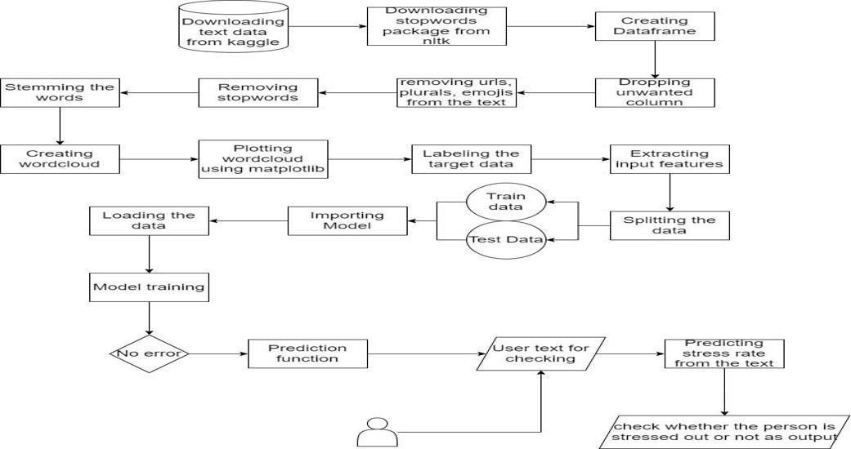

Fig 4.1 System Architecture

4.4 DATA FLOW DIAGRAM
In a level DFD, the entire system is displayed as a single process. Every stage of the system's assembly procedure is documented here, including all intermediate processes. This and two-level data flow diagrams make up the "basic system model."

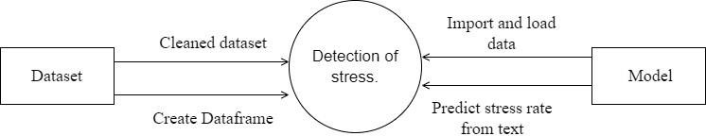
Fig 4.2 – Data Flow Diagram Level 0

4.5 CONTEXT DIAGRAM
An internal software system's interactions with external entities are depicted in a context diagram. Its main purpose is to assist companies in understanding the extent of a system. Consequently, they can determine the most effective way to build a new system and its specifications or how to make it better.
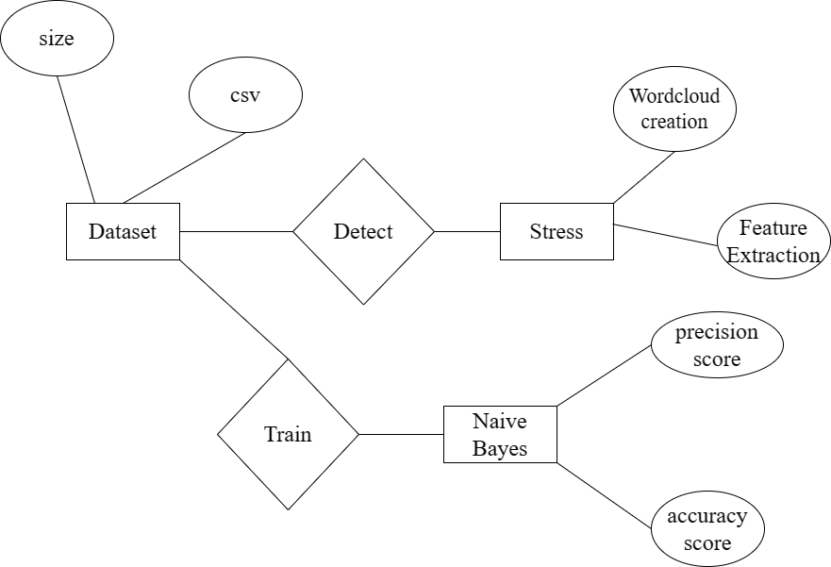
Fig.4.3 Use Case Diagram
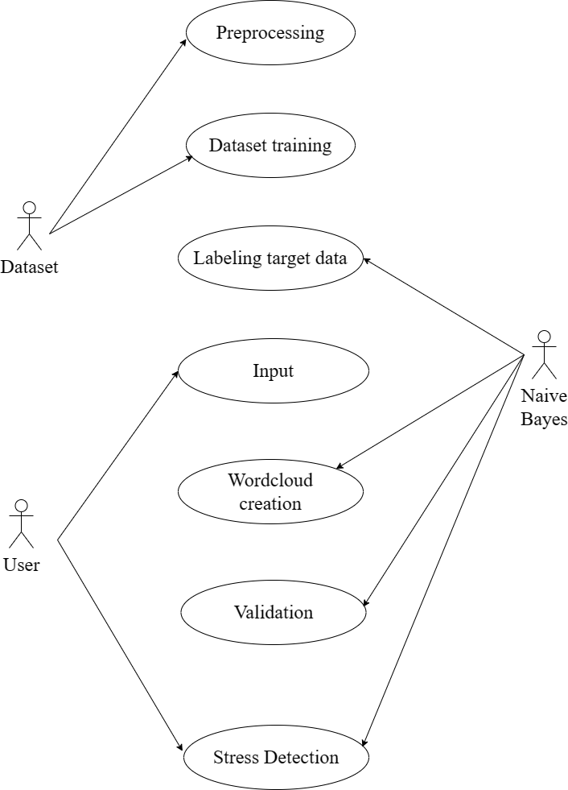
A use case diagram frequently shows the potential interactions between the user, the dataset, and the algorithm. It is made at the beginning of the process.

Fig.4.4 Feature Diagram

4.6 ACTIVITY DIAGRAM
An activity diagram, in its most basic form, is a visual representation of the sequence in which tasks are performed. It depicts the sequence of operations that make up the overall procedure. They are not quite flowcharts, but they serve a comparable.

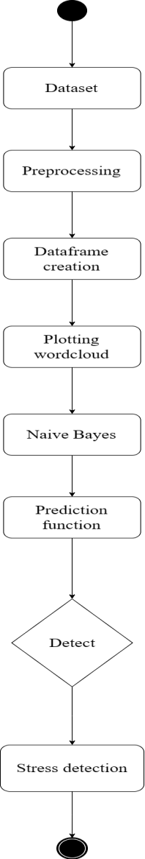

Fig 4.5 Activity diagram

4.7 SEQUENCE DIAGRAM
These are another type of interaction-based diagram used to display the workings of the system. They record the conditions under which objects and processes cooperate.

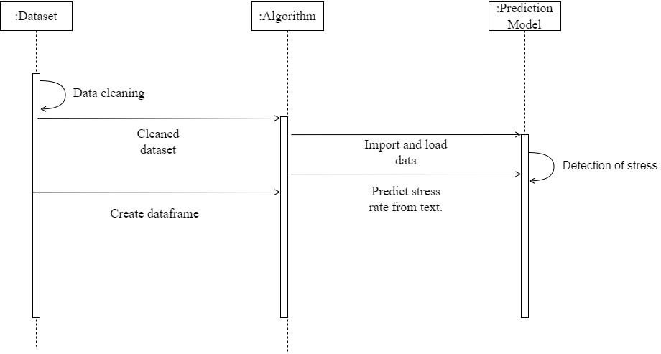
Fig 4.6– Sequence Diagram

4.8 DATABASE DESIGN
Table 4.1 : Chat_Data
Column Name | Data Type | Description
Chat_ID | Integer | Unique identifier for each chat conversation
User_ID | Integer | Unique identifier for each user
Chat_Text | Text | Text of the chat conversation
Timestamp | Date/time | Timestamp of the chat conversation

Table 4.2: Stress_Labels
Column Name | Data Type | Description
Chat_ID | Integer | Unique identifier for each chat conversation
Stress | Boolean | Indicates whether the chat conversation is stressed or not

Table 4.3: NLP_Features
Column Name | Data Type | Description
Chat_ID | Integer | Unique identifier for each chat conversation
Embeddings | Text | Embeddings generated from the chat text
Tokens | Text | Tokens generated from the chat text

Module 1: Making Word Cloud in Python
a. Creating WordCloud
The phrase "Word Cloud" describes a data visualization method for displaying text data in which the size of each word denotes its significance or frequency. Important textual data points can be highlighted using a word cloud. Data from social networking sites is often analyzed using word clouds. To create a word cloud in Python, three modules are needed: wordcloud, pandas, and Matplotlib. To install these packs, we first execute the following commands: Pip install wordcloud, pandas, and matplotlib. Next, we import pandas as pd and matplotlob.pyplot as plt. Additionally, we import stopwords and wordCloud from wordcloud. Next, we used df=pd.read_csv() to read our pre-processed CSV file.
Plotting the Wordcloud:
You can make static, animated, and interactive visualizations with the Matplotlib Python toolkit. Matplotlib makes both easy and challenging tasks possible. For this reason, it was crucial to install and import matplotlib in the preceding step. The Wordcloud was created with it. The final step involves using matplotlib's imshow() function to plot the resulting wordcloud. We employ the subsequent command:
plt.imshow(word_cl oud)
plt.axis("off") plt.show()
Labeling the Data
In our project, after making the graph from WordCloud data, we have plotted it using Matplotlib. In our research, we have taken the stressed targets as 1 and non-stressed targets as 0 for the analysis purpose.
Training the Model
The dataset has previously been split into training and testing data. We use a CUDA GPU to run and evaluate our training dataset. NVIDIA's CUDA parallel computing technology allows software to use the CPU and GPU at the same time. We do this since NVIDIA is now the most widely used GPU supplier for machine learning and cloud computing. Additionally, most GPU-capable Python languages are compatible with NVIDIA GPUs.
Module 2: Creating Prediction Function
The final step is to create a prediction function that can identify the crimes that might occur in the specified area at the specified time based on input such as location and time. Using the Python predict() method, we can forecast the labels of the data values based on the trained model. Usually, the predict() function just requires one argument: the data to be tested. It returns the labels of the data given as an argument based on the learned or trained data produced by the model. Consequently, on top of the trained model, the predict() method maps and predicts the labels for the test data using the learned label.
VALIDATION CHECKS
To guarantee the precision and dependability of stress detection from chat utilizing natural language processing (NLP) embeddings and tokenization, validation checks are crucial. The performance of these models can be evaluated using a number of validation tests. First, to make sure the model is effectively generalizing to new data, cross-validation is crucial. In cross-validation, the data is split into training and testing sets, and the model's performance on the testing set is assessed. This can assist in determining whether the model is overfitting or underfitting and guarantee that it can reliably recognize stress in fresh conversation data.

CHAPTER 5
TESTING

TEST CASES
"I am so stressed out right now, I don't know how to handle all the work pressure." | Positive stress
"I feel like everything is going wrong and I can't control anything." | Negative stress
"I have a lot on my plate, but I am managing well and feeling confident." | Neutral stress
"I am feeling a bit overwhelmed with my new job, but I am learning and growing every day." | Positive stress
"I am so anxious about this upcoming presentation, I can't sleep at night." | Negative stress
"I am feeling a bit stressed out about my finances, but I am working on a plan to fix it." | Neutral stress
"I am feeling really burnt out from my job, I need a break." | Negative stress

UNIT TESTING
Unit testing is a crucial component of software development that guarantees the accuracy and operation of the code. As part of the unit testing procedure for the "Stress Detection from chat using Natural Language Processing Embeddings and Tokenization" project, each function and component of the code was tested to make sure it was operating as intended. The functions and components were tested using the Python unittest framework. To determine whether the result is as expected, test cases were created for each function and component as part of the unit testing process. Every scenario and edge case was covered by the test cases.
5.3 INTEGRATION TESTING
Integration testing for Natural Language Processing-Based Stress Detection from Chat Tokenization projects and embeddings are crucial to ensuring that the system's many parts function as a whole. Testing the integration of several modules or subsystems that make up the complete system is part of the integration testing process. The following actions are carried out during the integration testing phase: First, unit testing is used to build and test specific system modules or components.
CHAPTER 6 RESULT AND CONCLUSION

6.1 RESULTS
The accuracy of the model in predicting the appropriate stress level for a particular input text can be used to assess the outcomes of stress detection from conversation utilizing natural language processing embeddings and tokenization. Evaluation criteria including precision, recall, and F1 score can be used to gauge the model's performance. The model's capacity to accurately categorize various stress levels can be measured using these criteria. To make sure that the model's performance is consistent across various subsets of the data, cross validation on the dataset can be used to further assess the model's accuracy.

FUTURE ENHANCEMENTS
The Stress Detection from Chat project can be refined and expanded in the future to increase its precision and efficacy. Adding more sophisticated machine learning techniques, such deep learning or reinforcement learning, to better capture the subtleties of human language and conversation is one possible area for advancement. Furthermore, as there may be a growing need for stress detection in other languages, the project could be expanded to include languages other than English. Investigating the use of wearable technology or other sensors to gather physiological data, such as skin conductance or heart rate, to increase the precision of stress detection is another possible avenue for advancement. To provide a more thorough examination of a person's stress levels, this may entail combining the conversation data with real-time physiological data. Additionally, the initiative can be used in a variety of contexts and industries, including call centers, mental health clinics, and workplaces, to offer prompt interventions and assistance to those who are under a lot of stress.

REFERENCES
[1] Bhamare DP, Suryawanshi P. Review on Reliable Pattern Recognition with Machine Learning Techniques. Fuzzy Information and Engineering, 2018; 10(3): 362–377. https://doi.org/10.1080/16168658.2019.161103.

[2] Dr.S.Brindha, Dr.S.Sukumaran, Enhanced Pattern Classification Methods for Text Categorization Mining, International Journal of All Research Education and Scientific Methods (IJARESM), ISSN: 2455-6211 Volume 10, Issue 10, October-2022, Impact Factor: 7.429, Available online at: www.ijaresm.com.

[3] Armengol E, Boixader D, Grimaldo,F. Special Issue on Pattern Recognition Techniques in Data Mining. Pattern Recognition Letters, 2017; 93: 1–2.
https://doi.org/10.1016/j.patrec.2017.02.014

[4] Ermushev S, Balashov A. A Complex Machine Learning Technique for Ground Target Detection and Classification. Int J Appl Eng Res., 2017; 1(1): 158–161

[5] Omarov B, Cho YI. Machine learning based pattern recognition and classification framework development. In 2017 17th International conference on Control, Automation and Systems (ICCAS 2017). Ramada Plaza, Jeju, Korea, 2017.

[6] Jindal, A., Singh, A., & Kumar, P. (2019). Detecting Stress in Online Chat Conversations using NLP. In 2019 10th International Conference on Computing, Communication and Networking Technologies (ICCCNT) (pp. 1-6). IEEE.

[7] Buechel, S., Hahn, U., & Neal, D. T. (2019). Identifying emotional distress and stress in social media messages. In Proceedings of the 2019 Conference on Empirical Methods in Natural Language Processing and the 9th International Joint Conference on Natural Language Processing (EMNLP-IJCNLP) (pp. 5308-5317).

[8] Lee, C. H., Lim, Y. M., & Kim, K. J. (2018). A chatbot system for stress management using deep neural network. In Proceedings of the 2018 International Conference on Information and Communication Technology Convergence (ICTC) (pp. 1170-1172).
IEEE.

[9] Kudugunta, S., & Rama, T. G. (2018). Detecting stress in email conversations using
NLP. In Proceedings of the 2018 Conference of the North American Chapter of the Association for Computational Linguistics: Human Language Technologies, Volume 1 (Long Papers) (pp. 2222-2232).

[10] Khan, A. A., Kumar, M., Srivastava, S., & Bhattacharyya, P. (2020). Detecting stress in online text-based counseling sessions using deep learning. In Proceedings of the 2020 Conference on Empirical Methods in Natural Language Processing (EMNLP) (pp. 415426).

