CORROSION BEHAVIOR OF MILD STEEL COATED WITH GRAPHENE ADDED EPOXY FILM

ABSTRACT
A series of graphene-epoxy films were developed and coated onto mild steel substrates using the manual lay-up technique. In this work, the effects of graphene composition on the corrosion behavior of the coated mild steel were systematically investigated. Thermogravimetric (TG) analysis revealed that the incorporation of graphene increased the decomposition temperature of the epoxy film, indicating an improvement in its thermal stability. This enhancement can be attributed to the excellent thermal properties of graphene, which help sustain the epoxy matrix and delay its thermal decomposition. The presence of graphene acts as a barrier that restricts the mobility of polymer chains and slows down the degradation process at elevated temperatures. Among the different graphene loadings studied, the addition of 0.1 wt.% graphene showed the most significant improvement in the corrosion resistance of the epoxy-coated mild steel. The enhanced corrosion protection is associated with the formation of a passive film on the mild steel surface, owing to the excellent electrical conductivity of graphene. This finding was supported by electrical conductivity measurements, open circuit voltage (OCV) analysis, Tafel polarization curves, and scanning electron microscopy (SEM) observations. The results consistently demonstrated a lower corrosion rate and improved surface integrity for the coating containing 0.1 wt.% graphene. However, further increases in graphene content adversely affected the coating performance. Excessive graphene loading promoted the agglomeration of graphene particles within the epoxy matrix, resulting in the formation of pores and structural defects. These defects facilitated the penetration of corrosive species into the coating, thereby increasing the corrosion rate of the coated mild steel and reducing the overall protective effectiveness of the graphene–epoxy film.
Keywords: Graphene added epoxy; corrosion inhibitor; passive coating film

INTRODUCTION
The epoxy paint coating is one of the most commonly used protective coatings for steel due to its high thermal resistance, excellent chemical stability, and good adhesion properties. These characteristics make epoxy coatings an effective barrier layer that isolates the steel substrate from the surrounding environment and reduces corrosion risk. However, epoxy coatings are still permeable to aggressive industrial environments, and prolonged exposure to moisture, oxygen, chloride ions, and other corrosive species can lead to gradual degradation of the coating. This degradation results in decomposition of the epoxy matrix and eventual exposure of the steel surface to corrosion attack, thereby limiting long-term durability in harsh service conditions [1–3]. To overcome these limitations, various fillers have been incorporated into epoxy coatings to enhance their physical, mechanical, and corrosion protection properties. Commonly studied fillers include Al₂O₃, ZnO, and conductive nanoparticles, which have been reported to improve barrier performance, reduce coating permeability, and increase resistance against corrosive media [1,4].
In particular, conductive fillers have attracted significant attention due to their ability to influence electrochemical processes at the coating–metal interface and promote the formation of protective passive films. Nazeri et al. reported that the incorporation of battery cathode waste materials as electrically conducting fillers in an epoxy paint coating system improved the corrosion protection performance of the coating [2]. The enhancement was attributed to the development of a passive film on the steel surface, which acted as a protective barrier against corrosion. However, the proposed corrosion protection mechanism remained unclear due to several influencing factors, including the presence of non-conducting particles, impurities within the waste materials, and non-uniform particle size distribution. These factors complicated the interpretation of the results and limited a clear understanding of the role of electrical conductivity in passive film formation and corrosion inhibition.
Therefore, in the present study, graphene was selected as the filler in the epoxy coating system due to its excellent electrical conductivity, superior mechanical properties, high thermal stability, and strong interfacial compatibility with epoxy matrices [3,5]. In addition, graphene can be effectively dispersed within the epoxy coating to form a more uniform microstructure, thereby enhancing both barrier properties and corrosion resistance. The incorporation of graphene is expected to improve coating performance while providing clearer insight into the role of conductive fillers in passive film formation and corrosion protection mechanisms in epoxy-coated steel systems.

METHODOLOGY
Graphene powder with a purity of 99.9% was incorporated into an epoxy resin system to produce a series of graphene–epoxy composite films containing graphene compositions ranging from 0.1 to 1.0 wt.%. The calculated amount of graphene was first dispersed in the hardener and sonicated in a water bath for 30 min prior to mixing with the epoxy resin. Subsequently, the resulting mixture was sonicated for an additional 15 min to further improve the dispersion of graphene within the epoxy matrix. Sonication is a crucial processing step as it assists in breaking down graphene agglomerates and promotes a more uniform distribution of graphene throughout the epoxy resin system. Improved dispersion is essential to maximize the beneficial effects of graphene on the physical, thermal, and corrosion protection properties of the coating. The prepared graphene–epoxy mixture was carefully applied onto pre-treated mild steel substrates using a manual lay-up technique to obtain a coating film thickness of approximately 0.1 mm. The coated samples were allowed to self-cure under ambient conditions at room temperature for 48 h to ensure complete curing of the epoxy matrix and adequate adhesion between the coating and the steel substrate.
The thermal stability of the graphene–epoxy films was evaluated using thermogravimetric (TG) analysis under an argon atmosphere. The measurements were conducted from room temperature to 900 °C at a heating rate of 5 °C min⁻¹ using a NETZSCH 409C thermal analyzer. The electrical conductivity of the cured films was measured at room temperature using a four-point probe technique. Corrosion performance was assessed through open-circuit voltage (OCV) measurements in a 3.5 wt.% NaCl solution for a duration of 720 h. An Autolab PGSTAT-30 potentiostat was employed to accelerate the corrosion process and evaluate the electrochemical behavior of the coated mild steel samples. Following a 60-day immersion test, the surface morphology and cross-sectional characteristics of the coated samples were examined using optical microscopy and scanning electron microscopy (SEM) to assess coating integrity and corrosion-induced degradation.

RESULTS AND DISCUSSIONS
The thermogravimetric (TG) results in Figure 1 showed that all films exhibited a similar weight-loss pattern throughout the heating process. An initial minor mass loss was observed in the temperature range of 50–300 °C, which can be attributed to the evaporation of absorbed moisture, residual solvents, and low-molecular-weight species trapped within the epoxy matrix [6,7]. This was followed by a significant decrease in mass between 300 and 400 °C, corresponding to the main decomposition stage of the epoxy network through the breakdown of polymer chains and cross-linked structures [8]. Beyond 400 °C, the films exhibited a relatively constant mass and formed a stable plateau up to 900 °C, indicating the presence of thermally stable residual material and char formation resulting from the degradation process.
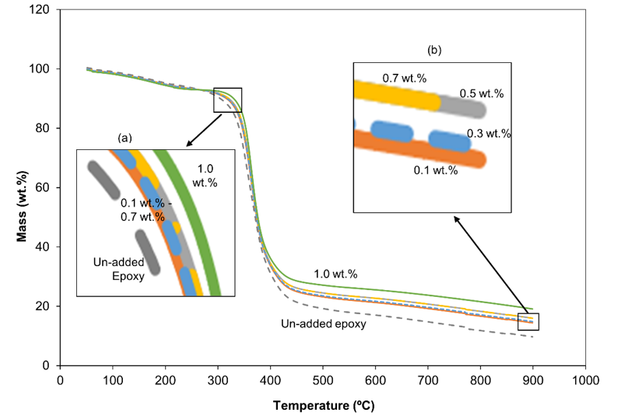
Figure 1: TG analysis of the plane epoxy and graphene added epoxy films. (Insert figure: (a) Decomposition curve, and (b) Final mass)
The addition of graphene was found to enhance the thermal stability of the epoxy films, as evidenced by the increase in both the decomposition temperature and the final residual mass. These effects can be clearly observed in the inserts (a) and (b) of Figure 1. The shift of the decomposition temperature towards higher temperatures indicates that graphene delayed the thermal degradation of the epoxy matrix and improved its resistance to heat-induced decomposition. Similar observations have been reported for graphene-reinforced epoxy composites, where graphene effectively restricts the mobility of polymer chains and suppresses the diffusion of volatile decomposition products during thermal degradation [9-10]. Furthermore, the higher residual mass observed at elevated temperatures suggests that graphene contributed to the formation of a more thermally stable composite structure and promoted char retention during decomposition [11].
This improvement in thermal stability provides evidence of the strong interfacial interaction between graphene and the epoxy matrix. The presence of graphene is believed to inhibit the premature decomposition of epoxy through its excellent thermal properties and heat absorption capability. In addition, the high aspect ratio and large surface area of graphene create an effective barrier against heat transfer and mass transport, thereby slowing the degradation process. As a result, graphene acts as an effective thermal barrier, reducing heat transfer within the composite and enhancing the overall thermal resistance of the graphene–epoxy film. The observed enhancement in thermal stability is consistent with previous studies that reported improved decomposition resistance and increased thermal durability in graphene-filled polymer composites [12].

Figure 2 presents the electrical conductivity of the graphene–epoxy films as a function of graphene content. It can be clearly observed that the electrical conductivity of the epoxy film increased significantly with the addition of 0.1 wt.% graphene. This enhancement can be attributed to the excellent electrical conductivity of graphene, which facilitates the formation of conductive pathways within the epoxy matrix and promotes electron transport throughout the composite film. Similar improvements in the electrical conductivity of graphene-reinforced epoxy composites have been widely reported in the literature, where graphene acts as an effective conductive filler even at relatively low loading levels [14, 15].
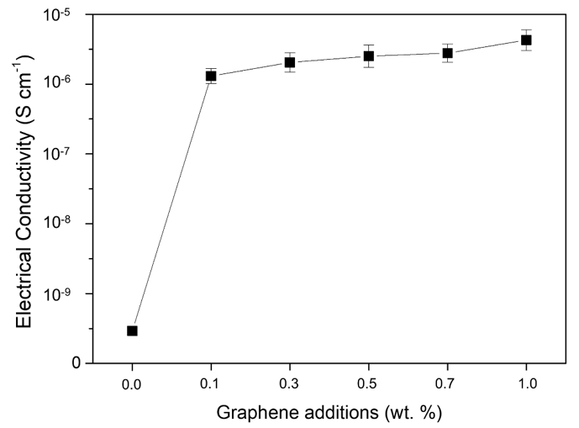
Figure 2: Electrical conductivity of the plane epoxy and graphene added epoxy films.
Further additions of graphene resulted in a continuous increase in the electrical conductivity of the films; however, the magnitude of improvement became relatively smaller compared to that observed at 0.1 wt.% graphene. This behavior may be associated with the gradual formation of a conductive network approaching the percolation threshold, where additional graphene contributes less significantly to the overall conductivity enhancement [16,17]. The reduced rate of increase may also indicate the onset of particle interactions and localized agglomeration at higher graphene contents, which can limit the efficiency of electron transport within the composite structure. Moreover, the relatively small error bars obtained for the graphene-containing epoxy samples indicate good reproducibility of the electrical conductivity measurements and suggest a uniform distribution of graphene throughout the epoxy film. The effective dispersion of graphene can be attributed to the sonication process employed during sample preparation, which helped break down graphene agglomerates and promote homogeneous distribution within the epoxy matrix. Uniform graphene dispersion is essential for establishing stable conductive pathways and maximizing the electrical performance of graphene–epoxy composite films.
Figure 3 shows the physical appearance of the coated mild steel samples before and after 60 days of immersion in a 3.5 wt.% NaCl electrolyte. It can be clearly observed that the samples containing graphene compositions ≥ 0.3 wt.% exhibited visible signs of corrosion after the immersion period. The presence of corrosion products on the coating surface suggests that the higher graphene loadings were unable to provide effective long-term corrosion protection under the testing conditions. This behavior may be associated with graphene agglomeration at higher filler contents, which can create defects, pores, and preferential pathways for electrolyte penetration through the coating, thereby facilitating corrosion of the underlying steel substrate [18]. In contrast, the sample containing 0.1 wt.% graphene exhibited a different behavior. Compared with the pure epoxy-coated sample, the 0.1 wt.% graphene-coated sample showed a noticeable color change rather than visible corrosion attack. This observation is highly attributed to the passive film-forming activity promoted by graphene. The formation of a passive layer on the steel surface can alter the surface appearance while simultaneously protecting the substrate from further corrosion. Similar phenomena have been reported for conductive filler-containing coatings, where electrically conductive particles facilitate electrochemical interactions that promote the development of stable and protective oxide films on metallic surfaces [19]. The superior corrosion resistance observed for the 0.1 wt.% graphene sample suggests that this graphene concentration was sufficient to enhance the electrical conductivity of the coating and stimulate passive film formation without causing significant agglomeration. At this loading, graphene was likely well dispersed within the epoxy matrix, allowing the coating to maintain its barrier properties while promoting the formation of a protective passive layer. Consequently, the color change observed on the 0.1 wt.% graphene-coated sample may be considered indirect evidence of passive film formation, which contributed to the improved corrosion protection performance of the coating system. These findings are consistent with the electrical conductivity, open-circuit potential, and electrochemical results, which indicated enhanced corrosion resistance at low graphene loading levels [20, 21].
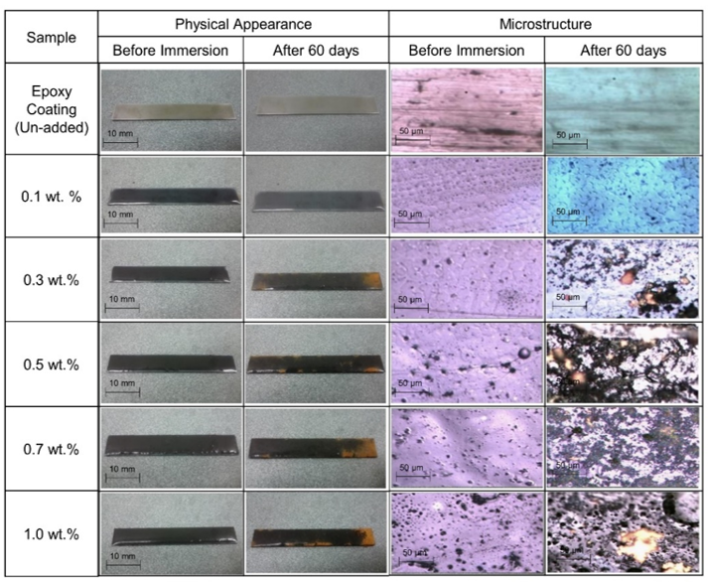
Figure 3: Physical appearance and microstructure of the samples before and after immersion in the 3.5 wt.% NaCl electrolyte for 60 days.

The surface microstructure evolution of the coated samples after 60 days of immersion in a 3.5 wt.% NaCl solution is presented in Figure 3. It is evident that the films containing 0.3 wt.% graphene and above were unable to provide adequate protection to the mild steel substrate. Significant surface degradation and corrosion features can be observed, indicating the deterioration of the coating during prolonged exposure to the electrolyte. This behavior is likely associated with the agglomeration of graphene particles at higher graphene loadings. Excessive graphene content can lead to the formation of agglomerates and micro-pores within the epoxy matrix, creating weak spots and defect sites in the coating structure. These defects facilitate the penetration of water, oxygen, and chloride ions through the coating, thereby promoting electrochemical reactions between the electrolyte and the mild steel substrate and accelerating the corrosion process [22]. Recent studies have reported that although graphene can improve the barrier properties of epoxy coatings, excessive graphene loading often results in poor dispersion and particle agglomeration, which adversely affect coating integrity and corrosion resistance. The formation of conductive clusters and interfacial defects may create preferential pathways for electrolyte diffusion, reducing the effectiveness of the coating as a protective barrier [23].
On the other hand, the addition of 0.1 wt.% graphene gave rise to an intriguing phenomenon. Instead of exhibiting localized corrosion attack, the epoxy grains appeared to evolve into larger grain-like surface features after the immersion test. This observation may be attributed to ion movement from the electrolyte towards the mild steel through the conductive graphene network. The presence of well-dispersed graphene within the epoxy matrix may facilitate a more uniform distribution of electrochemical activity across the coating–substrate interface, preventing ions from accumulating at specific locations and thereby reducing localized corrosion initiation [24]. Furthermore, the enhanced electrical conductivity provided by the uniformly dispersed graphene may promote the formation of a stable passive film on the mild steel surface. Such a passive layer can suppress localized anodic dissolution and encourage a more homogeneous electrochemical response throughout the coated surface [25]. Consequently, the larger grain-like morphology observed for the 0.1 wt.% graphene sample may be associated with passive film development and surface restructuring rather than corrosion damage. These observations are in good agreement with the physical appearance, electrical conductivity, and electrochemical results, which demonstrated superior corrosion protection performance for the coating containing 0.1 wt.% graphene.

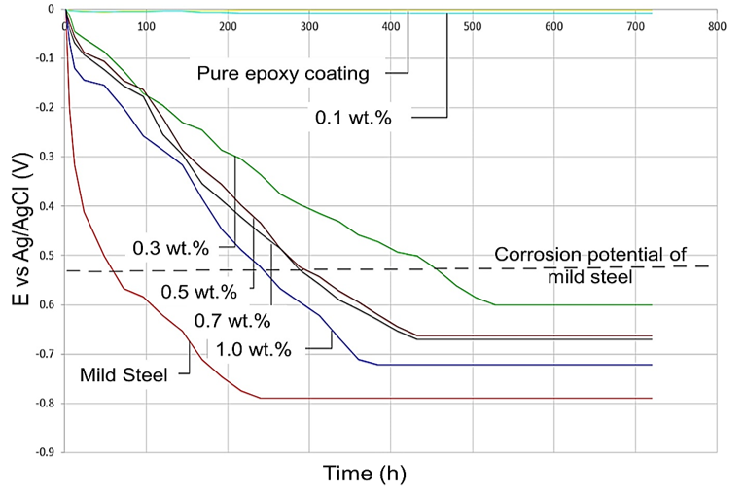
Figure 4: Time dependance OCV of the plane and coated mild steel.

Figure 4 shows the time-dependent open-circuit voltage (OCV) behavior of the bare and coated mild steel samples. The OCV test confirms the corrosion tendency of each sample when the potential approaches and exceeds the corrosion potential of mild steel, which is approximately −0.55 V. In general, a shift of OCV towards more negative values indicates an active corrosion process, where the metal is thermodynamically more prone to dissolution in the electrolyte environment. It can be observed that most of the samples exhibited OCV values that gradually approached the corrosion potential region during immersion, confirming the occurrence of corrosion reactions at the coating–substrate interface. This behavior suggests that the electrolyte progressively penetrated through coating defects, allowing electrochemical reactions to take place on the mild steel surface. Such time-dependent potential drift is commonly associated with coating degradation and loss of barrier properties in polymer-coated steel systems exposed to chloride-containing environments [4]. An exception is observed for the samples coated with pure epoxy film and the film containing 0.1 wt.% graphene. For these samples, the OCV values were relatively stable throughout the immersion period. The pure epoxy-coated sample sustained a potential close to 0 V, indicating effective isolation of the steel substrate from the corrosive medium. Similarly, the 0.1 wt.% graphene-containing sample maintained a slightly lower but still stable potential, suggesting that the steel surface remained in a relatively protected state during exposure.
The stable OCV response of the 0.1 wt.% graphene coating may be attributed to the formation of a passive layer at the metal–coating interface, which limits electrochemical activity and delays corrosion initiation. Recent studies have shown that well-dispersed graphene at low loading levels can enhance coating compactness, promote uniform electrochemical behavior, and support the formation of protective oxide films on steel surfaces [21]. As a result, the observed OCV stability reflects improved barrier performance and reduced corrosion kinetics compared to higher graphene loadings, where coating defects dominate the electrochemical response.

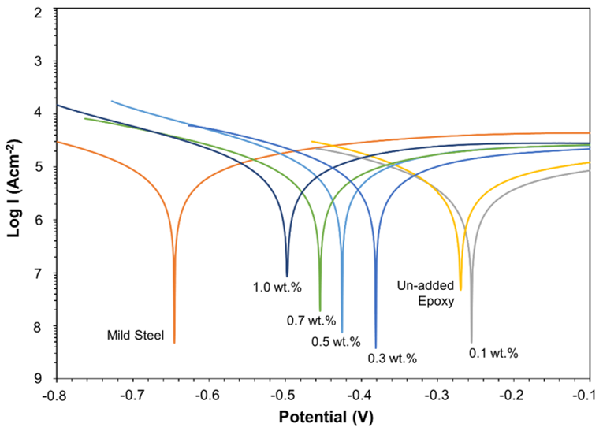
Figure 5: Polarization curve of the plane and coated mild steel.
The corrosion potential (Ecorr) and corrosion current density (Icorr) of the bare and coated mild steel samples are shown in Figure 5. It can be observed that the corrosion behavior of the epoxy-coated mild steel (without graphene) is predominantly controlled by the cathodic reaction, as the Tafel intersection point is shifted towards a more positive potential compared to the bare mild steel (−0.64 V). This indicates that the epoxy coating acts as a physical barrier that restricts the diffusion of oxidizing species, such as oxygen and other corrosion-active agents, from reaching the mild steel surface. As a result, the cathodic reaction is slowed due to limited availability of oxidizing species at the metal–electrolyte interface, which is consistent with reported barrier-controlled corrosion behavior in polymer-coated steels [26]. The addition of 0.1 wt.% graphene in the epoxy coating resulted in a further positive shift of Ecorr to approximately −0.25 V, indicating a significant improvement in corrosion resistance. This suggests that active corrosion on the mild steel surface is greatly suppressed under this condition. The observed behavior is highly attributed to the development of a passive film on the steel surface. Passivity refers to the loss of electrochemical reactivity due to the formation of a thin, adherent oxide layer that reduces metal dissolution and acts as a protective barrier against aggressive ions [27]. In this case, the corrosion potential remains relatively stable in a near-linear region, indicating the presence of a temporarily stable passive layer before localized breakdown or dissolution occurs.

Once partial dissolution of the oxide layer takes place, the corrosion potential begins to shift towards the cathodic side, reflecting renewed electrochemical activity at exposed sites. However, further additions of graphene caused the Ecorr values to shift back towards that of bare mild steel, indicating a deterioration in corrosion protection performance. This reduction in performance can be attributed to the formation of defects such as voids, micro-bubbles, and graphene agglomeration within the epoxy matrix. These defects act as weak points in the coating structure, allowing electrolyte ions to penetrate more easily and reach the steel substrate, thereby accelerating localized corrosion processes. Recent studies have shown that excessive graphene loading can disrupt coating homogeneity and create conductive agglomerates that facilitate electrolyte transport pathways, ultimately reducing the barrier efficiency of the coating system [28, 29]. Consequently, the protective effect observed at low graphene content is diminished at higher loadings due to compromised coating integrity
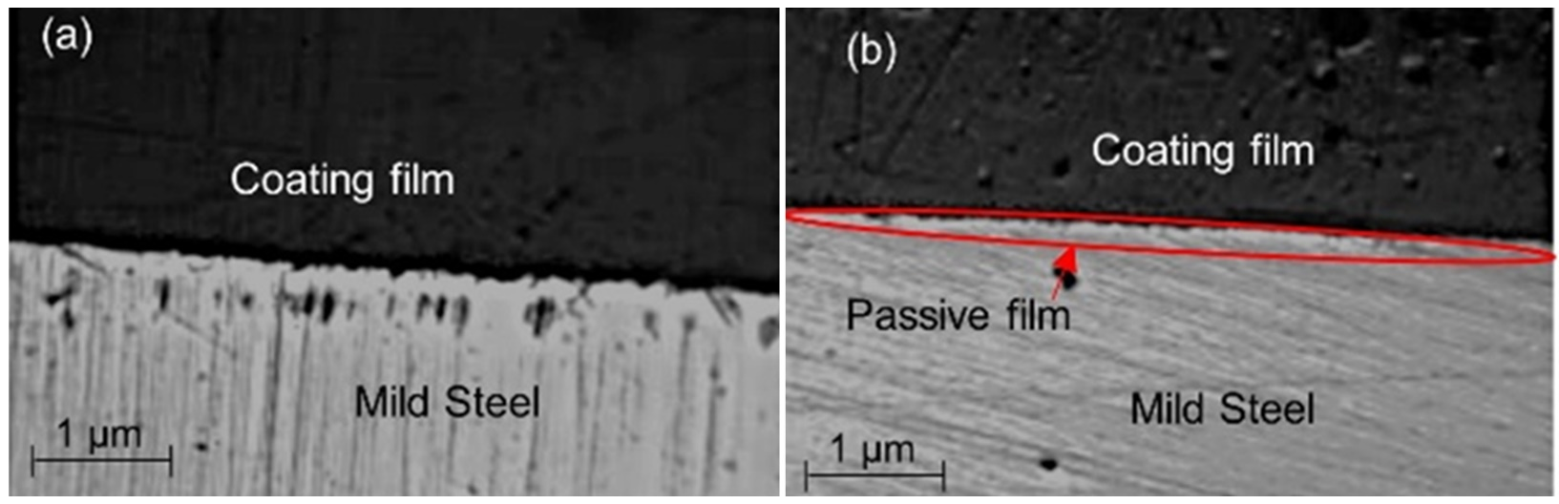
Figure 6: Figure 6: Cross section of the 0.1 wt.% sample: (a) before immersion, and (b) after 60 days of immersion.
The SEM images in Figure 6 show the cross section of the 0.1 wt.% graphene sample after immersion in 3.5 wt.% NaCl solution. From the images, it was revealed that a distinct interfacial passive layer developed between the mild steel substrate and the coating after immersion. The formation of this layer indicates that initial electrochemical interaction between the electrolyte and the steel surface led to the growth of a stable oxide-based film at the interface, which is commonly associated with passivation behavior in metallic systems exposed to chloride environments [30]. This passive layer prohibited further electrochemical reactions between the electrolyte and the mild steel, thereby effectively preventing corrosion from progressing. The layer acts as a protective barrier that limits the diffusion of aggressive ions such as chloride and oxygen toward the steel surface, while also suppressing both anodic dissolution and cathodic reduction reactions [31]. Similar interfacial protective films have been reported in graphene-reinforced epoxy coating systems, where well-dispersed graphene improves coating integrity and supports the formation of stable passive layers at the metal–coating interface [32]. Therefore, the observed SEM cross-sectional morphology confirms that the 0.1 wt.% graphene coating provides effective corrosion protection through the development of a passive interfacial layer, which enhances the overall barrier performance and prevents further degradation of the mild steel substrate.

CONCLUSIONS
The graphene-added epoxy film with 0.1 wt.% composition was successfully developed and demonstrated effective corrosion protection for coated mild steel. The improved performance is attributed to the formation of a passive film at the coating–substrate interface, which acts as an additional protective barrier between the electrolyte and the steel surface. This passive layer, promoted by the well-dispersed graphene within the epoxy matrix, enhances the overall stability of the coating system and reduces the rate of electrochemical reactions responsible for corrosion. Consequently, the incorporation of 0.1 wt.% graphene provides an optimum balance between electrical conductivity, dispersion quality, and barrier properties, resulting in significantly improved corrosion resistance of the epoxy-coated mild steel

REFERENCES
- Zhang, D., Li, X., & Wu, Y. (2022). Journal of Coatings Technology and Research, 19, 1551–1564.
- Nazeri, M. F. M., Suan, M. S. M., Masri, M. N., Alias, N., & Mohamad, A. A. (2012). Corrosion behaviour of mild steel in different environments. International Journal of Electrochemical Science, 7, 6976–6987.
- Ye, Y., Chen, H., & Zou, Y. (2023). Corrosion Science, 214, 110985.
- Kumar, A., Singh, B. P., & Dhawan, S. K. (2024). Surface and Coatings Technology, 485, 130968.
- Gao, F., Huang, H., & Sun, W. (2023). Progress in Organic Coatings, 181, 107627.
- Kim, H., Abdala, A. A., & Macosko, C. W. (2010). Macromolecules, 43, 6515–6530.
- Guo, Z., Pereira, T., Choi, O., Wang, Y., & Hahn, H. T. (2006). Journal of Materials Chemistry, 16, 2800–2808.
- Liu, Y., & Kumar, S. (2014). ACS Applied Materials & Interfaces, 6, 6069–6087.
- Morgan, A. B., & Gilman, J. W. (2013). Fire and Materials, 37, 259–279.
- Zhang, H., Zhang, Z., Friedrich, K., & Eger, C. (2006). Acta Materialia, 54, 1833–1842.
- Yu, A., Ramesh, P., Sun, X., Bekyarova, E., Itkis, M. E., & Haddon, R. C. (2008). Advanced Materials, 20, 4740–4744.
- Kim, H., Miura, Y., & Macosko, C. W. (2010). Chemistry of Materials, 22, 3441–3450.
- Stankovich, S., et al. (2006). Nature, 442, 282–286.
- Kuilla, T., et al. (2010). Progress in Polymer Science, 35, 1350–1375.
- Li, J., & Kim, J. K. (2007). Composites Science and Technology, 67, 2114–2120.
- Bauhofer, W., & Kovacs, J. Z. (2009). Composites Science and Technology, 69, 1486–1498.
- Rafiee, M. A., et al. (2009). ACS Nano, 3, 3884–3890.
- Tallman, D. E., Spinks, G., Dominis, A., & Wallace, G. G. (2002). Journal of Solid State Electrochemistry, 6, 73–84.
- Dhoke, S. K., Khanna, A. S., & Sinha, T. J. M. (2009). Progress in Organic Coatings, 64, 371–382.
- Shi, X., Nguyen, T. A., Suo, Z., Liu, Y., & Avci, R. (2009). Surface and Coatings Technology, 204, 237–245.
- Pourhashem, S., Vaezi, M. R., Rashidi, A., & Bagherzadeh, M. R. (2021). Journal of Materials Science, 56, 10844–10867.
- Wang, J., Liu, Y., & Zhang, X. (2023). Materials Today Communications, 35, 106145.
- Li, Y., Zhao, X., & Chen, J. (2024). Corrosion Science, 231, 111905.
- Lakshmi, R. S., & Rajendran, S. (2022). Corrosion protection of mild steel by polymer coatings: A review. Progress in Organic Coatings, 173, 107195.
- Song, G. L., & Atrens, A. (2023). Understanding corrosion passivation in steels. Corrosion Science, 218, 111199.
- Wang, Y., et al. (2023). Graphene-based epoxy coatings for corrosion protection: Recent advances and challenges. Journal of Materials Science & Technology, 150, 1–15.
- Liu, H., et al. (2024). Effect of graphene agglomeration on the barrier performance of epoxy coatings. Surface & Coatings Technology, 467, 130650.
- Song, G. L., & Atrens, A. (1999). Corrosion mechanisms of magnesium alloys. Advanced Engineering Materials, 1(1), 11–33.
- Liu, Y., et al. (2023). Recent advances in corrosion protection of metals: A review. Corrosion Science, 218, 111199.
- Zhang, X., et al. (2024). Protective passive films and corrosion resistance improvement of coated steels. Journal of Materials Science & Technology, 162, 45–58.

