A Hybrid Ranking-Driven Matrix Factorization and Collaborative Filtering Framework for Customer Behaviour Analysis

Mrs.S.Sathya1 Dr.E.Ramaraj2 Dr.A.Padmapriya3
¹Reasearch Scholar, Department of Computer Science Alagappa University, Karaikudi – 630 003.
²Formaly Head and Professor, Department of Computer Science Alagappa University, Karaikudi – 630 003.
³ Professor and Head, Department of Computer Science Alagappa University, Karaikudi – 630 003.
tncsathya@gmail.com 9566277634 ¹, eramaraj@gmail.com 8778868093 ²,
padmapriyaa@alagappauniversity.ac.in 9443747211 ³,

Abstract
E-commerce systems are now more widely used and present in practically every industry. Customer behavior is a crucial element that aids retailers in predicting product sales and maintaining cost effectiveness, particularly in e-commerce. On e-commerce platforms, numerous algorithms have been implemented to analyze the customer behavior. In this research, we have analyzed the customer behavior using machine learning approaches such as Turicreate Factorization, Collaborative filtering, K-Means clustering and Temporal Cluster Migration Matrix (TCMM) algorithm. The proposed study is compared with the previous works and this work provides more precise product recommendations on e-commerce platforms.

Keywords: Customer behavior, Turicreate Factorization, Colloborative filtering, K-menans clustering, TCMM algorithm.
- Introduction
Earlier than the advent of the internet, entrepreneurs would take a look at a client’s behaviour to decide what merchandise they could be interested for buying. Customer surveys were used for prediction which was expensive and time-consuming. The study of people, groups, or organizations is known as customer behaviour research, and it aims to shed light on how people choose things in future [1]. Durmaz et al., [2] identified that marketers place a high priority on the need to anticipate customer behaviour. Advanced showcasing applications are multiplying and developing more compelling as computerized stages are increasingly more coordinated into promoting systems and day to day existence, as well as people progressively use advanced contraptions instead of going to actual stores. Digital analytics are being used more frequently by marketers to gain a more thorough insight of consumer behaviour.

In particular, consumer behaviour analytics can aid marketers in developing more precise ads and a deeper comprehension of the customer experience. According to [3], the definition of target marketing is the segmentation of markets into manageable groups that include consumers who have particular demands, traits, or behaviours. The secret to behavioural analysis marketing success is being able to recognize what your clients want and then giving it to them. This give more insight of client behaviors, however the development technologies helps to learn more about the client interaction with their goods and services.Then, marketing campaigns can be informed by this knowledge.

Any business can benefit from knowing how to predict client behaviour. While some firms have the resources to use their own data analytics technologies to provide certain projected insights, other businesses do not. Predicting customer behaviour is achievable if you have access to a customer behaviour analytics platform that can offer insights into how customers interact with your business. Customer Relationship Management (CRM) data base gives historical data to study their customer’s behaviors to understand the capacity of purchasing how much prompt supply they made.

- Literature Review

With the help of internet, the social media became the platform for sharing the reviews and those reviews are taken as the input for e-commerce. Customer behaviour analysis received significant study attention because of the implications for both businesses looking to increase sales and consumers looking to have more influence over their purchases. The characteristics, including the quantity of "interactions," the length of "playtime," and the location, to mention a few, giving us more precise insight into what influences a consumer's purchase choice. Gupta et al. [5] used data mining techniques to analyse consumer behaviour.
An overview of the business and technological aspects of data mining is presented in this paper, as well as ways to maximize the profitability of customers through data mining. Data mining may improve and alter the relationship with the consumer when used in conjunction with business practices and complementing technologies.
When used in conjunction with sound business procedures and complementary technologies, data mining can strengthen and reshape the relationship with the customer.

By using the Customer Relationship Management (CRM) and data mining approaches, it is possible to increase productivity and increase the response in effective for clients request. A study was conducted on digital marketing and social media by Tiago et al. [7]. There is currently a significant amount of research on digital marketing that is more customer-centric and firm-centric. Data mining and Customer Behaviour Analytics were presented by Haastrup et al. [8]. By monitoring consumer behaviour through the web logs can create precise profiles of consumer requirements and interests for customer satisfaction and to encourage business.

Armando Vieira [9] provided a reliable classifier to forecast buyers' intentions based on user activity on a large e-commerce website. In this paper, the authors analysed and compared the deep learning methodologies with conventional machine learning techniques. In anticipation of online buying habits during the COVID-19 pandemic, a prediction model was proposed. Examination of five classification models yielded the best result of 94.6% accuracy for Decision tree. Then, Bagging and Boosting ensemble meta-algorithms are applied to increase the classifiers' accuracy. The best results were once again obtained by decision trees, and DT ensembles with bagging outperformed other basic classifiers with 95.3% accuracy.

- Materials and Methods

For this proposed work, data that explains consumer purchasing behaviour from an online retailer web log was gathered. Invoice number, date of invoice, customer ID, item description, stock code, quantity, unit price, and country of purchase, customer registration date, and customer last purchased date are just a few examples of the information that was collected from the UCI repository and reviewed. Twenty two attributes and around 3,10,000 rows are included in the dataset. These attributes of consumer behaviour serve as the proposed model's input variables. In order to predict the customer purchasing behaviour, Factorization Turicreate Ranking Algorithm is employed as the methodology for recommendation. K-Means clustering algorithm is used for clustering.

3.1 Dataset Description

For processing the data set used is a structured transactional data set made between January 3, 2019, and January 10, 2020 which includes every online consumer transaction, for an internationally based and registered e-store. The company mainly sells garments for both male and female. There are 22 attributes of continuous, nominal and string in online retailing dataset to analyse customer behaviour. The Store location in string datatype is the first attribute, and the product purchased with unique item code is the second attribute.The third attribute, Unique Group ID, contains a unique number that is associated with each product type. Fourth field is Sku's Unique group Id Definition, it holds definition each product type.A six-digit integer number allocated to each customer is the client ID as the fifth attribute.
Sixth attribute is brand name, string datatype and it holds brand name. Seventh attribute is product type, it holds uniquely assigned to each distinct product type. Eight attribute is art style and its holds grouping of works into related product categories. Ninth attribute is Product Style and it holds the style with visuals or outer look of a product. Tenth attribute is added to Cart Date, it holds date of visit or customer adds the product(s) in the shopping bag. Eleventh attribute is added to Cart Time, it holds time of visit or the time when customer add the product(s) in the shopping bag. Twelfth attribute is Purchased Date, it holds of customer first purchased date. RFM value is nothing but it denotes thirteenth attribute. RFM value measures customers recent, frequent and monetary of purchase. It gives analysis of customers purchase by marketing technique and to determine the quantitative and behavior of customer best and recent purchase and how much they spent and their frequency.

A 5-digit number for holding the height of the customer is the fourteenth attribute. Fifteenth attribute holds the measurement details of both the kids and adult customers. Sixteenth attribute is Customer Last Purchased Date, it holds of customer last purchased date in respective domain. Seventeenth attribute is Customer Last website Visited date, it holds of Customer Last Visited date. Eighteenth attribute is Customer Registered Date, it holds of Customer Registered Date. Nineteenth attribute is Customer name, varchar data type of 25 characters. Twentieth attribute holds the city name of the customer. The state and country name of the customer is holds in twenty first and the last attribute.
The sample dataset is shown in Figure 1.

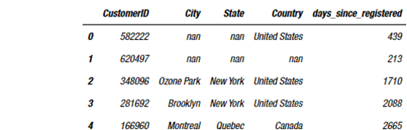

Fig. 1: Sample dataset

Table 1 shows the features and the description for the online retail store purchase.

Table 1. Features of the online retail store purchase dataset

S.No. | Features | Description
1 | Domain | String which mentions the name of the store’s location
2 | StockCode | 5-digit inter number describes the item code
3 | Unique Group ID | String assigns a Unique Code to each and every product
4 | SKU’s unique ID | String which describes the unique code
5 | Customer ID | 6-digit integer number assigned to each customer
6 | Brand Name | String datatype describes the name of the brand
7 | Type | String datatype describes the product type
8 | Art style | String datatype describes the type of art like zari work, embroidery, printed, beads, etc.
9 | Product style | String which describes the style of the product like palazzo, frock, anarkali, etc.
10 | Cart date | Date field which gives the date on which the customer added the items to the cart
11 | Cart time | Time field which gives the exact time at which the customer added the items to the cart
12 | Purchased date | Date attribute describes the purchased date of a specific customer
13 | RFM value | Holds RFM (recent, frequency, monetary) analysis used to determine best customers.
14 | Height | Floating point attribute describes the height of a customer
15 | Readymade size | String describes the measurement of the customerslike small, medium, large etc.
16 | Last purchased date | Describes the last date on which a customer purchased
17 | Last website visit date | Describes the last date on which a customer visited the site
18 | Registered date | Customer’s registered date in the website
19 | Customer name | Describes the name of the customer
20 | City | Describes the city in which the customer resides
21 | State | Describes the state in which the customer resides
22 | Country | Describes the country in which the customer resides

3.2 Data Pre-Processing

Prior to develop a recommendation model, the data should be explored and cleaned. During this stage, relevant and meaningful data is separated from the data collected in previous step. From the above dataset, it has been found that some of the fields are having lot of null and missing values. So, those rows and columns are dropped out and only the rows and columns having full details are taken as the final dataset. In addition, web logs of a particular website contain information about all the web pages visited by all the users. These visits could have been successful or not i.e. the user may have been able to view the web page successful or it may have resulted in some error. For the next stage of analyzing the collected information, only those pages successfully displayed to the user are considered. A pie chart is created to better understand the data after removing the unwanted rows and columns and it is shown in the Figure 2.

Fig. 2: Trends of frequency in E-retail online store

3.3 Proposed Methodology

Understanding consumer behavior and segmenting clients based on their demographics and purchasing patterns is essential in today's competitive market. This crucial component of client segmentation enables marketers to more effectively tailor their marketing initiatives to different audience subgroups. Clustering analysis in customer segmentation is the application of a mathematical model to identify groups of similar consumers based on identifying the smallest variations among customers. Using accurate consumer segmentation through personalization, cluster analysis aims to increase the effectiveness of customer marketing.

In this research, a Ranking Factorization Recommender acquires the factors of each and every user and item employs them to rank suggested things in future. For this study, we have used the Turicreate Ranking Factorization algorithm for personalization of customers. And then the customers are grouped based on the purchase behavior by using k-means clustering algorithm and also the customers are grouped based on loyalty using TCMM algorithm. In the following sections, the ranking factorization algorithm and clustering techniques are explained in details. The overview of the proposed methodology is shown in Figure 3.
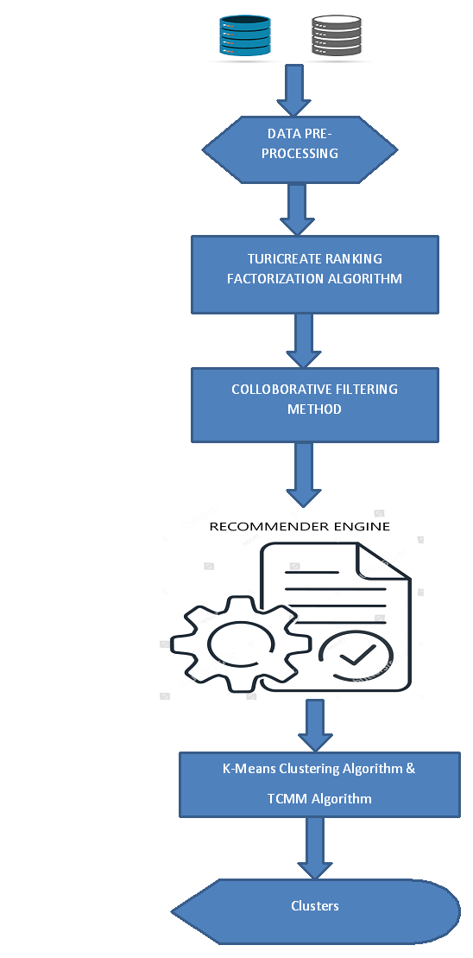

Fig. 3: Proposed Methodology

Turicreate Ranking Factorization Algorithm

Every user and item has latent variables that the recommender learns, and it utilizes these factors to rank recommended items based on how likely the pairings will be seen. When executing collaborative filtering on datasets with explicit ratings or datasets with implicit feedback, ranking prediction is identified. In Ranking Factorization algorithm, the recommender develops a model that can predict a score for any potential user-item combination. From previously recorded user and item scores, the internal model coefficients are learned. These scores are then used to determine recommendations. Weights and factors are used to represent both users and items. Weight is used to give the item or user lower or higher ratings whereas the factors stimulate the interests between users and items. For instance, a product that consistently receives positive reviews would be given more weight, or the criteria might take into account a user's preference for cotton fabric over silk fabric.

Formally, user i's expected score on item j is provided by

$$score\left(i, j\right)= μ+ω_{i}+ ω_{j}+ ax_{i }+by_{j}+ u_{i}v_{j} \left(1\right)$$

Where µ is a global bias term, ω_{i} is the weight for user i and ω_{j} is the weight for user j. x_{i} and y_{j} are the user and item side feature vectors, and a and b are the weight vectors for those side features. The latent factors are u_{i} and v_{j}.

Collaborative Filtering

In 1992, Goldberg et al. introduced the concept of "collaborative filtering" (CF), arguing that "information filtering can be more successful when humans are involved in the filtering process” [11]. Two years later, Resnick et al. [12] proposed the notion of collaborative filtering in its current form. They believed that consumers liked things that other users shared their interests in, and that two users were regarded to be similar in their rating preferences. Items that were highly rated by one user were recommended to another user when similar users were found, and vice versa. CF provides three benefits. The first benefit of CF is that it is content independent, therefore no laborious item processing is needed [13-15]. Second, because CF uses human ratings, it considers actual quality evaluations [16]. Last but not least, because CF bases recommendations on user similarity rather than item similarity, it is expected to offer coincidental recommendations [17-18].

By grouping users according to their preferences, we create a collaborative filter for the website logs Items were then suggested based on the common preferences of users within each group. The more frequently consumers engage with and assess the items on display, the more accurately the algorithm can suggest acceptable items. The main idea behind collaborative filtering algorithms is to find user commonalities based on how users have previously ranked or rated objects. The weighted total of user "u" input that users have provided for item i is predicted. Then the prediction of user rating on the item “i” is calculated as follows:

$$P_{u,i}= \frac{∑_{v}(i_{v,i}* s_{u,v})}{∑_{v }s_{u,v}} (2)$$

Here, i_{v,i} is the interest of user v on the item “i”, s_{u,v} is the common interest of the two users “u” and “v”. If any of the users are having common interests among the products, then the customers are grouped together using K-means clustering algorithm for future predictions. The concept of collaborative filtering is illustrated in the Figure 4.

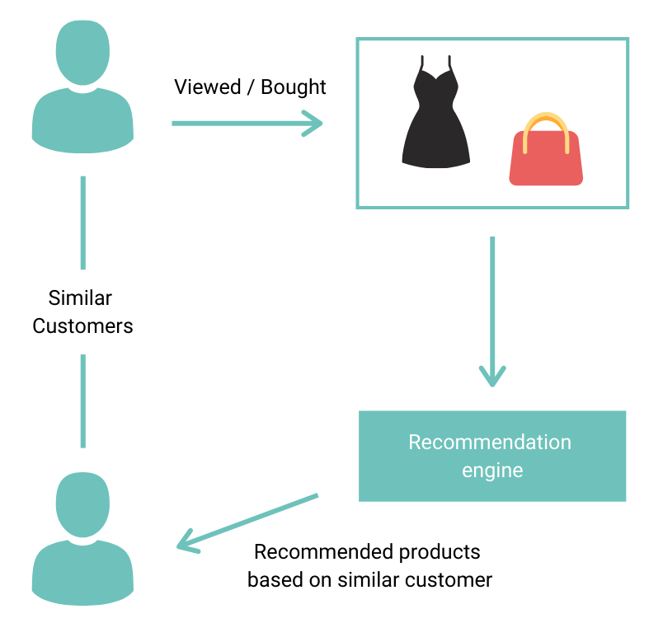

Fig. 4: Illustration of Collaborative Filtering

K-Means Clustering Algorithm

The mathematical model in cluster analysis is used in grouping the related customers by comparing the smallest difference. Using accurate consumer segmentation through personalization, cluster analysis aims to increase the effectiveness of customer marketing. K-means cluster analysis, a mathematical algorithm, is a popular cluster analysis technique. The resulting clusters help to improve consumer modelling and predictive analytics. Additionally, they are utilized to target customers with incentives and offers according to their needs, wants, and preferences. Unsupervised learning, or K-Means clustering, is used to address clustering-related issues [19].

The dataset is split into a predetermined number of clusters using the K-Means clustering algorithm, each of which will have k centres. The approach is centroid-based, and each cluster has a distinct centroid. The main objective is to reduce the distance between each data point and the associated cluster centroid.The algorithm separates the dataset into clusters using the raw, unlabeled data as its input before repeating the procedure until the best clusters are identified. K-Means is fairly simple to use and implement. It is extremely scalable and has a wide range of uses. K-Means is an all-around straightforward and reliable technique that makes clustering relatively simple.

Working of K-Means Clustering Algorithm

The K Means Clustering technique groups observations in a dataset into sets based on how similar they are to one another. The initial assignment of each data point to a group is random, and the centroid for each group is computed. A centroid is the term for the group's centre. After that, the algorithm goes as follows:

- Every observation is evaluated before being assigned to the closest cluster. The "closest" group is one in which the Euclidean distance between a data point and the centroid of the group is smaller than the distances to the other centroids.
- The K-means clustering algorithm updates a cluster's centroid whenever it adds or loses a data point.
- The process iterates until no closer group of data points can be assigned.

The K-means clustering algorithm makes all groups as compact as possible by ensuring that they all have the lowest within-cluster variance after it is finished. Through behavioral pattern, it is possible to group the customers who share the same qualities or purchase intentions, such as high spending, a desire for special offers, or a desire for new arrivals. Behavioral segmentation variables are examined differently by each web shop, but the RFM is the most reliable model. Advanced behavioral segmentation depends on RFM, which stands for Recency, Frequency, and Monetary. It is a method for understanding a customer’s behavior based on: (i) the most recent purchases, (ii) the total number of purchases made, and (iii) amount they spent at a specific online shop. The "high value" customers will actually be the repeat customers who frequently visit, make a sufficient purchase, and return. This can be represented in the Figure 5 as follows:

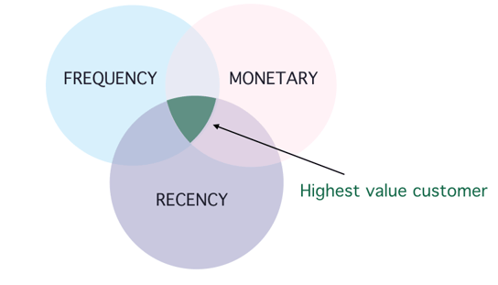
Fig. 5: Highest value customer in RFM model [20]

In the following sections, the result are discussed by K-Means clustering algorithm in clustering the customers into three groups.

Temporal Cluster Migration Matrices (TCMM) Algorithm

When analyzing web usage, time might be a very important factor. Finding natural groups of web resources or web users is a common task in web mining operations called clustering. Modifications in clusters can offer crucial hints regarding the evolving nature of website usage as well as shifting user loyalty. This algorithm can be used to analyze how a website's nature changes over time as well as how specific web users' purchasing patterns change. TCMM can be used as a visualization approach to explore these results.

TCMM is defined as a set of U, C, n, and Ω, where U is a collection of users, C is a collection of clusters, the quantity n denotes the number of time intervals and each user's progression through the clusters across n time periods is represented by the mapping Ω. In this study, based on how often they visit within a month, the customers are divided into three clusters such as (i) Loyal visitors, (ii) Semi-Loyal visitors, and (iii) Infrequent visitors. Here, n = 6 means the cluster behavior was examined for six months.

Working of TCMM Algorithm

Step 1: Get a website's web log data for a period of six months from reliable sources.

Step 2: Preprocess the web logs such as clean up the web log information, identify the users, sessions, URL, and Timestamp.

Step 3: Determine the number of pages that each user viewed each month.

Step 4: Each user is divided into one of the above clusters according on the number of pages they have viewed.

Step 5: Every month, this clustering is performed.

Step 6: The TCMM matrix is built in accordance with the format shown in Table 2 using the clustering results.

Step 7: Use SQL or MySQL to analyze the data in the TCMM table to obtain the required results.

Table 2: Sample TCMM Matrix

CustomerID | I Month | II Month | III Month | IV Month | V Month | VI Month
645652 | 4 | 6 | 3 | 2 | 4 | 6
357576 | 1 | 5 | 2 | 2 | 5 | 4
338693 | 3 | 4 | 2 | 3 | 2 | 1
200231 | 2 | 4 | 3 | 5 | 6 | 1
428997 | 4 | 3 | 5 | 2 | 1 | 2

4. Results and Discussion

The goal of this research work is to create a recommendation engine that would present customers with similar products depending on how they have previously rated other products. For this, we will first do Exploratory Data Analysis (EDA) and then develop recommendation algorithms, using collaborative filtering and ranking factorization methods. After developing the recommendation model, clustering is done to group the customers with the help of K-Means clustering algorithm. This recommendation model is evaluated using offline method to measure the accuracy of the developed recommender system.
Python software is used to develop the recommendation model and for K-Means clustering. After the data pre-processing (explained in section 3.2) step, EDA is done with the help of info() and describe() functions in Python. The summary of data with number of records can be produced one by info() methods. It provides a general overview of the data. The describe() function generates descriptive statistics, such as summaries of a dataset's distributions' central tendency, dispersion, and form.From the results, some of the columns have been dropped which are all no use for the development of recommendation model. For instance, the columns like Sleeve length, Blouse length, Blouse Neck style, etc.. have been dropped. A screenshot of the results of both the info() and describe() functions are shown in the Figure 6 and Figure 7.

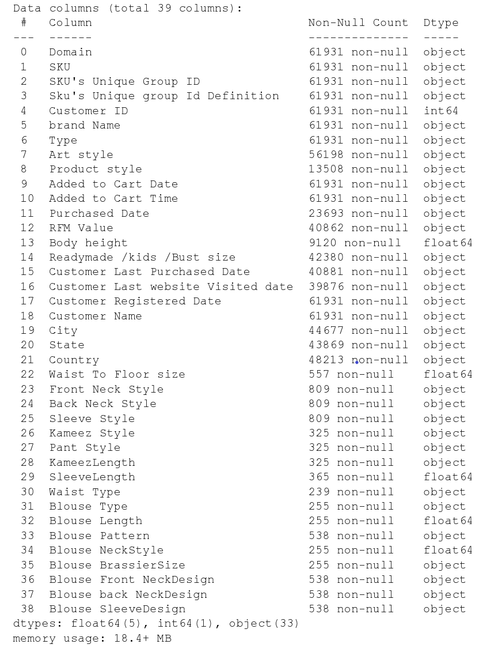

Fig. 6: Results of info() function
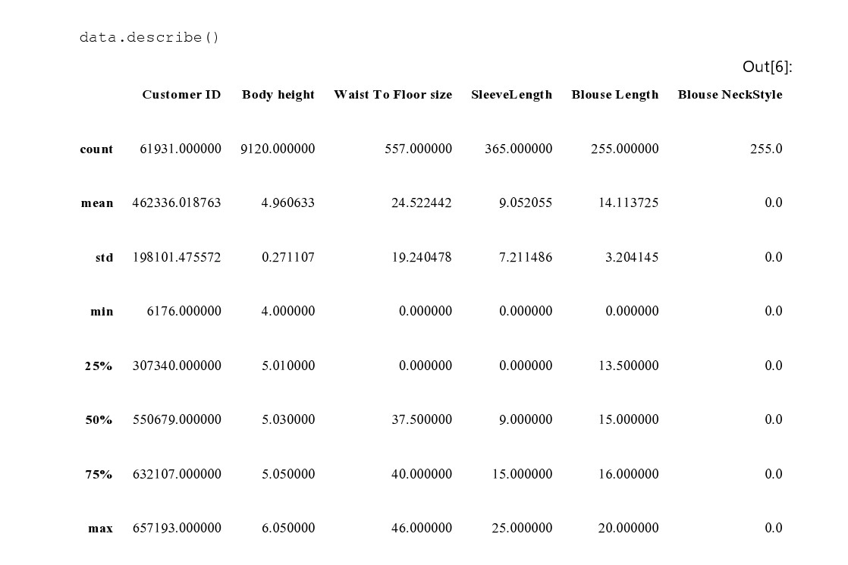
Fig. 7: Results of describe() function

A Python scikit called Surprise library is used as recommender systems to create and analyze that deal in rating data. Here, we apply the Singular Value Decomposition (SVD) technique from the Surprise library to reduce the Root Mean Square Error (RMSE), which is determined by K fold Cross Validation, and provide excellent recommendations. A matrix is created using SVD with a row of users, columns of items, and elements determined by user ratings. The whole data set is divided in the ratio of 70:30 as training data testing data. For our objective, we want to employ product similarity metrics like cosine, Pearson, etc. to recommend new items.

A part of collaborative filtering is matrix factorization. The matrix factorization procedure involves joining two rectangular matrices with smaller dimensions to create the user-item interaction matrix. The benefit of using this method is that we will now have a smaller matrix in a lower-dimensional space rather than a multidimensional matrix with a large number of missing values [21]. Observe the MSE [Mean Squared Error] and RMSE [Root Mean Squared Error] values obtained by K Fold Cross Validation. The average Root Mean Squared Error that we obtain is approximately 1.23, which is acceptable. The results are shown in the Table 3.
Table 3. Results of K-Fold Cross Validation

Metrics | Fold 1 | Fold 2 | Fold 3 | Fold 4 | Fold 5 | Mean | Std
RMSE | 1.37 | 1.40 | 1.42 | 1.37 | 1.39 | 1.40 | 0.02
MAE | 1.13 | 1.15 | 1.13 | 1.16 | 1.16 | 1.15 | 0.01
Fit Time | 0.63 | 0.62 | 0.65 | 0.63 | 0.63 | 0.62 | 0.01
Test Time | 0.14 | 0.11 | 0.13 | 0.14 | 0.11 | 0.13 | 0.02

In order to predict the test data, we fit the train data. Cross validation was done to obtain correct values, and the result was an RMSE [Root Mean Squared Error] of 1.24, which is not significantly different from the average RMSE. After developing the recommendation engine, the model is tested with five users giving their Customer IDs and the number of recommendations to be printed, recommendation which generates a list of all the items and their actual items bought by that specific user. The results of our developed recommender model are shown in the Table 4.

After this step, the customers are grouped with the help of K-Means clustering technique using RFM attribute in the dataset. As a result, we have obtained three clusters such as High spenders, Medium spenders and Low spenders and the results are represented in the following Table 5 and the pictorial representation of clustering results are shown in the Figure 8. Figure 9 shows the top 10 active IP addresses, the number of active IP addresses per day is shown in Figure 10 and Figure 11 shows the top 10 frequently used websites.

Table 5. Clustering Results based on RFM Value

Type of Customers | Days since last purchase (R) | Number of Purchases (F) | Net Revenue (M)
High Spenders | 16 | 6 | $180
Medium Spenders | 55 | 4 | $130
Low Spenders | 187 | 2 | $20
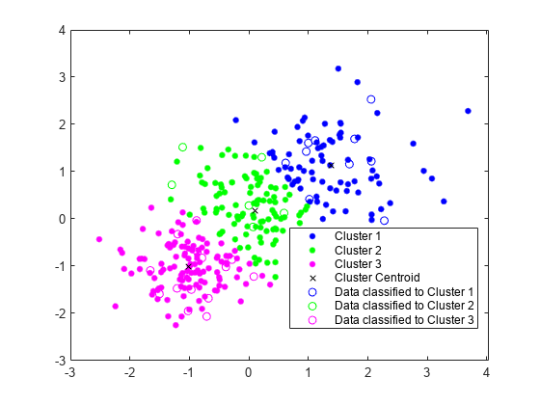
Fig. 8: K-Means Clustering Results

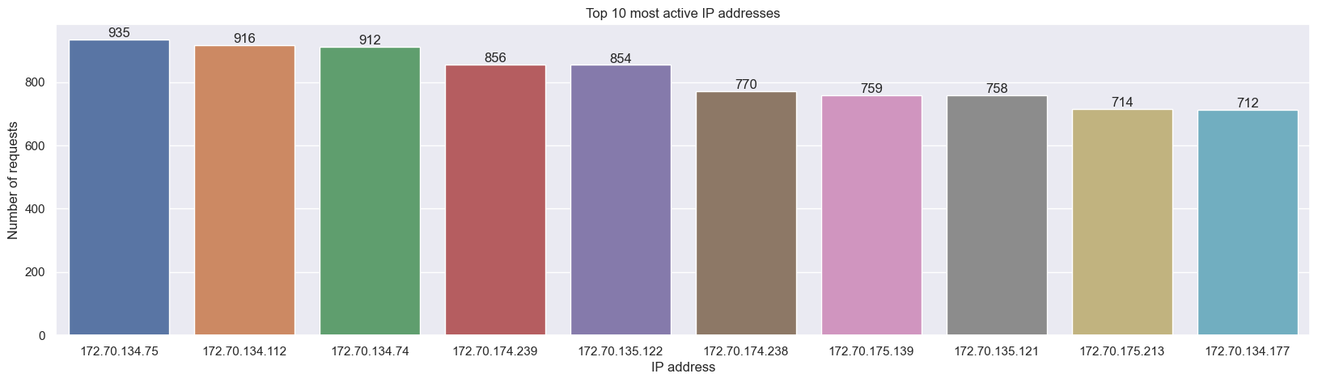
Fig. 9: Top-10 active IP addresses

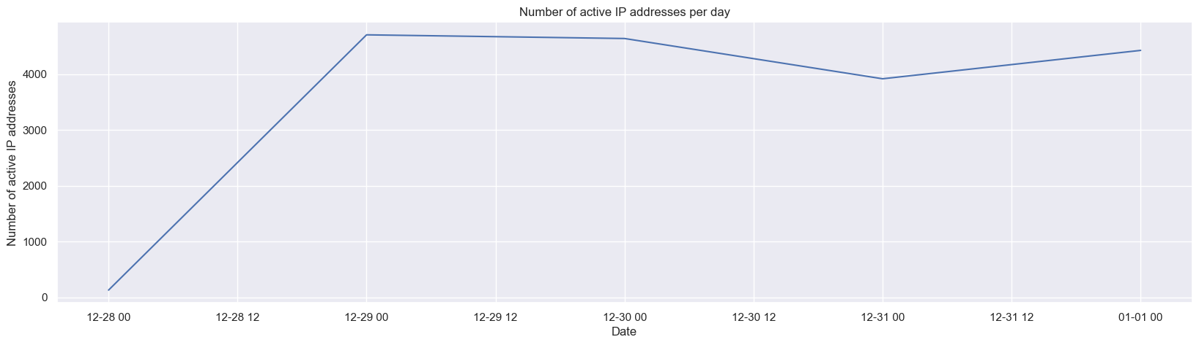

Fig. 10: Number active IP addresses per day

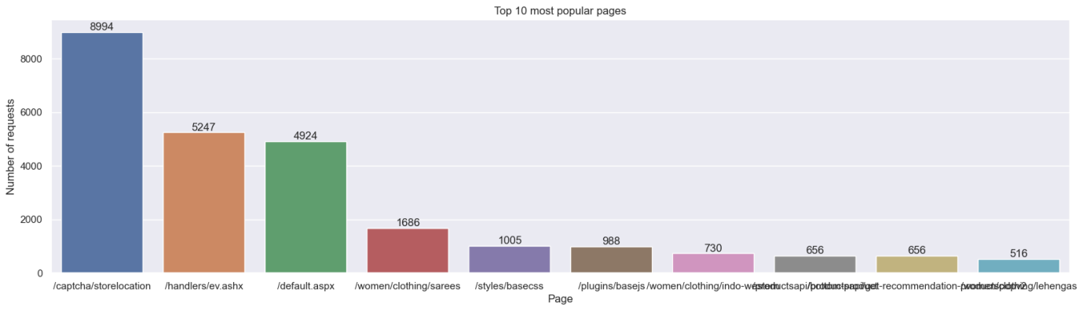

Fig. 11: Top-10 frequently used Websites

5. Comparison with existing works

In [22], Zhiyuan Fang et al., suggested a new behavior-based hybrid recommender system. In their study, they create sequences of user activity and extract those that involve frequent purchases in order to further predict the probability of user’s interest in purchasing activities. Also, they make use of the matrix factorization-based collaborative filtering technique, which has been shown to deliver the best results when analyzing customer’s purchasing preferences. In order to improve the hybrid model's accuracy, it predicts the payment behavior of the consumer. Lianhuan Li et al., [23] examines and studies user-collaborative filtering and content filtering-based recommendation systems, and then suggests a hybrid recommendation algorithm. This method can filter out and promote products to consumers and performing similarity matching filtering on all items, particularly when those items have not been assessed by any users. On the basis of K-means clustering, suggestions were given for the user set.

Compared to previous two hybrid algorithms, in this study, two types of clustering have been done. The purchase behavior is analyzed using K-means clustering technique and the customer’s loyalty is analyzed using TCMM algorithm. We have used Turicreate Factorization algorithm and collaborative filtering for recommendations.

6. Conclusion

As the prediction of customer behavior has grown as an important topic in e-commerce, numerous researchers have offered various methods to improve the prediction accuracy. On online retail sites like Flipkart, Myntra, and Amazon, it can help to offer better suggestions for customers. This study proposes a customer behavior analysis in e-retail weblogs using Turicreate Matrix Factorization algorithm, Collaborative filtering techniques and developed a recommendation model. Further, the customers are grouped into three types by applying K-Means clustering algorithm. The proposed method offered higher accuracy.

6. References

[1] Raorane A. & Kulkarni R.V, (2011) "Data Mining Techniques: A Source for Consumer Behaviour Analysis," Shahu Institute of business Education and Research, 1-15.

[2] Durmaz Y. and Diyarbakırlıoğlu I., (2011). “A Theoritical Approach to the Strength of Motivation in Customer Behavior” in Global Journal of Human Social Science 11(10) 1.0

[3] Sulekha G. (2011) “The basis of market segmentation: a critical review of Literature,” European Journal of Business and Management ISSN 2222-1905 (Paper) ISSN 2222-2839 (Online) 3(9), 2011 45- 55

[4] Sifa, R.; Hadiji, F.; Runge, J.; Drachen, A.; Kersting, K.; and Bauckhage, C. 2015. Predicting purchase decisions in mobile free-to-play games. In Proc. Conference on Artificial Intelligence and Interactive Digital Entertainment.

[5] Gupta G. & Aggarwal, H. (2012). Improving Customer Relationship Management Using Data Mining. International Journal of Machine Learning and Computing, Vol. 2, No. 6, December 2012. Pp 874-878.

[6] Nejad, M. B., Nejad, E. B. &Karami, A. (2012). Using Data Mining Techniques to Increase Efficiency of Customer Relationship Management Process. Research, In Journal of Applied Sciences, Engineering and Technology 4(23): 5010-5015, 2012 ISSN: 2040-7467.

[7] Tiago, B. & Manuel, J. (2014). Digital marketing and social media: Why bother? Business Horizons 57(6):703-708. DOI: 10.1016/j.bushor.2014.07.002

[8] Haastrup, A. V., Oladosu, O. A., Okikiola, F. M., Oladiboye, O. E., &Ishola, P. E. (2014). Customer behaviour analytics and data mining. American Journal of Computation, Communication and Control 2014; 1(4): 66-74.

[9] A. Vieira, “Predicting online user behaviour using deep learning algorithms,” arXiv preprint arXiv:1511.06247, 2015.

[10] Safara, F. A Computational Model to Predict Consumer Behaviour During COVID-19 Pandemic. Comput Econ 59, 1525–1538 (2022). https://doi.org/10.1007/s10614-020-10069-3.

[11] Goldberg, D., Nichols, D., Oki, B.M. and Terry, D. 1992. Using collaborative filtering to weave an information Tapestry. Communications of the ACM. 35, 12 (1992), 61–70.

[12] Resnick, P., Iacovou, N., Suchak, M., Bergstrom, P. and Riedl, J. 1994. GroupLens: an open architecture for collaborative filtering of netnews. Proceedings of the 1994 ACM conference on Computer supported cooperative work (1994), 175–186.

[13] Herlocker, J.L., Konstan, J.A., Borchers, A. and Riedl, J. 1999. An algorithmic framework for performing collaborative filtering. Proceedings 153 Joeran Beel. Towards Effective Research-Paper Recommender Systems and User Modeling based on Mind Maps. PhD Thesis. 2014/2015 of the 22nd annual international ACM SIGIR conference on Research and development in information retrieval (1999), 230–237.

[14] Schafer, J.B., Frankowski, D., Herlocker, J. and Sen, S. 2007. Collaborative filtering recommender systems. Lecture Notes In Computer Science. 4321, (2007), 291.

[15] Torres, R., McNee, S.M., Abel, M., Konstan, J.A. and Riedl, J. 2004. Enhancing digital libraries with TechLens+. Proceedings of the 4th ACM/IEEE-CS joint conference on Digital libraries (2004), 228–236.

[16] Dong, R., Tokarchuk, L. and Ma, A. Digging Friendship: Paper Recommendation in Social Network.

[17] Herlocker, J.L., Konstan, J.A., Borchers, A. and Riedl, J. 1999. An algorithmic framework for performing collaborative filtering. Proceedings of the 22nd annual international ACM SIGIR conference on Research and development in information retrieval (1999), 230–237.

[18] McNee, S.M., Kapoor, N. and Konstan, J.A. 2006. Don’t look stupid: avoiding pitfalls when recommending research papers. Proceedings of the 2006 20th anniversary conference on Computer supported cooperative work (2006), 171–180.

[19] Sinaga, K.P.; Yang, M.S. Unsupervised K-means clustering algorithm. IEEE Access 2020, 8, 80716–80727.

