Assessment and Visualisation of Active Cooling Performance in Energy-Efficient Building Design Supported by Augmented Reality

  - SN Khalil¹, NI Izham
  - ¹Faculty of Mechanical Technology and Engineering, Universiti Teknikal Malaysia Melaka

*Corresponding author: SN Khalil

Abstract

This study focuses on the assessment and visualisation of active cooling performance in energy-efficient building design, with augmented reality (AR) used as a supporting tool. As energy costs and environmental concerns continue to increase, improving the efficiency of cooling systems has become essential in modern building design. A small-scale house model equipped with an active cooling system was developed to evaluate indoor thermal behaviour. Temperature data were collected to compare conditions with and without active cooling, allowing the cooling performance to be assessed based on temperature differences. In addition, an AR application was developed using Reality Composer to support the visualisation of airflow direction and temperature distribution within the model. User feedback was obtained through live demonstrations and video-based survey sessions to evaluate the usefulness of AR in improving understanding of cooling effects. The findings indicate that AR can support clearer interpretation of airflow behaviour and cooling performance, although improvements such as more realistic airflow animation and real-time sensor integration are recommended. Overall, the study demonstrates that active cooling assessment, supported by AR-based visualisation, can enhance understanding and decision-making in energy-efficient building design. The proposed approach also offers potential for future development in smart building applications, engineering education and sustainable building management.
Keywords: Energy-efficient building design, active cooling, passive cooling, indoor temperature, thermal comfort, cooling performance, residential building, temperature measurement, sustainable building design, mechanical engineering.

Introduction

The building sector is one of the major contributors to global energy consumption and environmental emissions. Buildings contributed approximately 38% of global carbon dioxide emissions in 2020[1]. Similarly [2], the building sector accounts for about 40% of global energy consumption and contributes approximately 30% to 40% of global greenhouse gas emissions. These figures indicate that buildings have a significant impact on global energy demand and environmental sustainability. Therefore, effective strategies are required to reduce energy consumption, improve building performance and support sustainable development.

Energy-efficient building design has emerged as an important approach to address these challenges. It refers to the planning, construction and operation of buildings with reduced energy consumption while maintaining occupant comfort and meeting sustainability goals. Energy-efficient buildings aim to minimise energy demand through the integration of passive and active systems. These include natural ventilation, insulation, shading, efficient lighting and mechanical cooling systems. The main objectives are to conserve energy, reduce operational costs and minimise environmental impact.

In addition, the integration of renewable energy sources such as solar, wind and geothermal energy with energy-efficient technologies can further enhance the sustainability of building design. The life cycle of a building, from construction to operation, should also be considered to reduce waste and lower carbon emissions. Energy-efficient systems [3] play an important role in reducing environmental impact and improving the overall sustainability of buildings. Furthermore, green building standards such as Leadership in Energy and Environmental Design (LEED) and Building Research Establishment Environmental Assessment Method (BREEAM) provide useful frameworks to guide the design, construction and certification of sustainable buildings.

Active cooling systems are also important in achieving energy-efficient building performance, particularly in hot and humid climates. These systems help regulate indoor temperature and humidity to improve thermal comfort while reducing unnecessary energy use. Active cooling systems are essential for enhancing indoor comfort, especially in regions where cooling demand is high [4]. However, cooling systems can consume a large amount of energy if they are not properly designed, placed or managed. Therefore, the performance of active cooling systems must be assessed carefully to ensure that they contribute effectively to energy-efficient building design.

Due to the complexity of airflow behaviour, temperature distribution and cooling system performance, conventional evaluation methods may not be sufficient to clearly demonstrate how active cooling systems influence indoor conditions. In this context, augmented reality (AR) can be used as a supporting tool to improve visualisation and understanding. AR enables digital information, such as airflow direction and temperature zones, to be displayed in an interactive format. This can help users, designers and stakeholders better understand cooling performance and support decision-making in energy-efficient building design. Therefore, this study focuses on the assessment and visualisation of active cooling performance in energy-efficient building design, supported by augmented reality.

Based on the reviewed literature, two literature review tables were developed to organise and synthesise the key findings related to this study. The first table, Table 1 focuses on research on active cooling, which summarises previous studies related to cooling technologies, thermal comfort, energy efficiency, humidity control, and building energy performance. This table highlights how active cooling systems, such as air conditioning, Variable Refrigerant Flow (VRF), chilled beam systems, district cooling, and Building Energy Management Systems (BEMS), contribute to reducing energy consumption while maintaining indoor comfort. The analysis also identifies important parameters commonly studied in active cooling research, including indoor temperature, humidity, cooling load, energy consumption, occupancy level, airflow behaviour, and thermal comfort.

The second table, Table 2, focuses on the application of augmented reality (AR) in cooling, particularly in relation to visualisation, monitoring, design optimisation, maintenance, and energy management. This table summarises studies that applied AR to support HVAC layout visualisation, airflow pattern interpretation, real-time system monitoring, energy simulation, fault detection, and stakeholder understanding. The analysis shows that AR is not used as the main cooling technology, but rather as a supporting tool to enhance the assessment and visualisation of cooling system performance. Through these two tables, the literature review provides a clearer comparison between the technical performance of active cooling systems and the potential role of AR in improving understanding, decision-making, and optimisation in energy-efficient building design.

Table 1: Research on Active Cooling
Authors | Summary | Analysis | Parameters Studied
Saidur et al. (2011) [4] | Active cooling systems such as air conditioning, chilled beam systems and district cooling are important for achieving energy efficiency in modern buildings. These systems remove heat from indoor spaces through refrigeration cycles or water-based cooling methods. | The study supports the need to improve active cooling performance because conventional air-conditioning systems can be energy intensive. It highlights the importance of selecting efficient cooling technologies to reduce energy use and operational cost. | Energy consumption, energy savings, air conditioning, chilled beam system, district cooling, building energy performance
Yang et al. (2021) [5] | Variable Refrigerant Flow (VRF) systems can reduce energy usage by providing precise control over cooling output. The system adjusts cooling according to real-time occupancy and load conditions. | VRF systems are relevant because they show how active cooling can be optimised through better control. This supports the importance of evaluating cooling system placement and performance in energy-efficient building design. | VRF system, cooling output, occupancy load, energy reduction, thermal control
Kim et al. (2019) [2] | Chilled beam systems cool indoor air through convection and radiation. They have high energy-saving potential because they reduce dependence on mechanical ventilation. | This study shows that active cooling can be made more sustainable when combined with passive cooling strategies. It also supports the use of alternative cooling systems for reducing energy demand. | Chilled beam system, convection, radiation, mechanical ventilation, energy savings, thermal comfort
Breeze and Owen (2015) [6] | Building Energy Management Systems (BEMS) and demand-response systems can optimise the operation of active cooling systems by responding to occupancy levels, ambient temperature and system demand. | This study highlights the role of smart control in improving cooling efficiency. It shows that cooling systems should not only be mechanically efficient but also intelligently managed. | BEMS, demand response, occupancy level, ambient temperature, system optimisation, cooling demand
Cai and Gou (2024) [7] | Active cooling systems are mechanical systems used to control indoor temperature and humidity, especially when passive cooling methods are insufficient. Common examples include air conditioning, refrigeration, water pumps and evaporative cooling systems. | This provides the basic foundation for understanding active cooling. It is directly related to the project because the experimental setup uses fan and mist-based cooling to represent active cooling behaviour. | Indoor temperature, humidity, refrigeration, evaporative cooling, mechanical cooling, thermal comfort
Buffa et al. (2019) [8] | District Cooling Systems provide cooling to multiple buildings from a centralised cooling plant. These systems optimise energy distribution and reduce overall energy demand. | This study expands the discussion from individual cooling units to larger-scale cooling systems. It shows that energy efficiency can be improved through centralised cooling management. | District cooling, centralised cooling plant, energy distribution, cooling demand, energy efficiency
Watanabe et al. (2024) [9] | In hot and humid climates, high humidity affects human comfort because it reduces the body’s ability to cool itself through sweat evaporation. | This study supports the importance of active cooling in climates such as Malaysia. It shows that cooling performance should consider both temperature and humidity. | Humidity, thermal comfort, sweat evaporation, perceived temperature, hot and humid climate
Santamouris (2016) [10] | Air conditioning systems in hot and humid regions must cool the air and remove moisture to maintain thermal comfort. This requires efficient cooling and dehumidification. | The study highlights that active cooling systems in humid climates require higher energy input due to dehumidification needs. Therefore, system efficiency is critical to avoid excessive energy consumption. | Air conditioning, dehumidification, indoor air quality, thermal comfort, energy consumption

Table 1: Research on Active Cooling
Authors | Summary | Analysis | Parameters Studied
Xu et al. (2024) [11] | AR can project 3D models of HVAC layouts, including ducts, air handling units and cooling coils, onto physical building sites. This helps identify airflow blockages and poor equipment placement before installation. | This study strongly supports the use of AR as a supporting tool for visualising active cooling systems. It shows that AR can help reduce design errors, improve system layout and support better cooling performance. | HVAC layout, ducts, air handling units, cooling coils, airflow blockage, equipment placement, design optimisation
Zhou and Tani (2021)[12] | AR allows engineers to simulate different cooling system configurations and evaluate their impact on energy consumption and thermal comfort. | This study shows that AR can support data-driven decision-making. It is relevant because AR helps stakeholders understand how different cooling arrangements affect energy performance. | Cooling configuration, energy consumption, thermal comfort, AR simulation, design decision-making
Bae et al. (2020) [13] | AR supports risk management by visualising operational scenarios and highlighting high-risk areas such as stress points or possible failure zones. | This study shows that AR can support safety and reliability in mechanical systems. For cooling systems, it may help identify operational risks before failures occur. | Risk management, operational scenario, stress point, failure zone, system safety
Becerik-Gerber et al. (2020) [14] | AR can overlay 3D models of mechanical systems onto physical spaces to support project planning and identify issues early during design and construction. | This study links AR with engineering management. It shows that AR can improve communication, reduce delays and avoid costly mistakes in cooling system installation. | 3D model overlay, project planning, construction progress, issue detection, stakeholder communication
Andarini (2014) [15] | AR can support energy simulation and virtual prototyping by allowing designers to visualise how insulation, ventilation and window orientation affect energy efficiency before construction. | This study supports early-stage design evaluation. It shows that AR can help designers compare design alternatives and select more energy-efficient solutions before physical implementation. | Energy simulation, virtual prototyping, insulation, ventilation, window orientation, airflow simulation

2 Design Modelling and Methods

2.1 Design Modelling and Prototype Assembly

A three-dimensional residential house model was developed as part of the methodological framework to support the assessment and visualisation of active cooling performance. The 3D model served as a digital representation of the selected building type and provided a basis for design evaluation, experimental preparation and augmented reality (AR) visualisation. In this study, a residential house was selected because it represents a common building typology where indoor thermal comfort and cooling efficiency are important considerations.

The modelling process was carried out using SolidWorks computer-aided design (CAD) software. SolidWorks was selected due to its capability to produce detailed and accurate three-dimensional drawings, including non-mechanical structures such as building layouts. The use of CAD modelling enabled the house structure, room arrangement and spatial configuration to be visualised prior to physical fabrication. This step was important to ensure that the prototype design could support the investigation of cooling methods and airflow patterns within the indoor space.

Before the model was developed, several architectural and structural features were considered. These included room layout, wall thickness, door and window openings, roof design and overall building dimensions. These parameters were incorporated to ensure that the model represented realistic building conditions and provided a suitable platform for evaluating indoor air movement and cooling performance. Since openings, partitions and room arrangements can influence airflow distribution, their inclusion was essential for both the experimental assessment and AR-based visualisation.

Following the completion of the digital model, the physical prototype was assembled based on the SolidWorks design. The main components of the house model, including walls, internal partitions, base platform and roof, were fabricated using lightweight materials such as acrylic and foamboard. Selected parts of the prototype were also constructed using recycled materials to support sustainability and reduce fabrication cost. For example, the initial base of the model was made from recycled board. However, due to insufficient structural strength, the base was reinforced with a layer of plasterboard to improve rigidity, flatness and stability.

During the assembly process, the layout plan of the house model was used as a reference to ensure accurate positioning of each component. The room names, dimensions and structural arrangement shown in the layout plan guided the fabrication and assembly stages. This ensured that the final prototype corresponded closely to the digital design and could be used consistently for subsequent cooling performance experiments and AR integration.

Experimental Procedure and Calculation

2.2.1 Experimental Description

The experimental investigation was conducted using a three-dimensional residential house model (Figure 1) consisting of three bedrooms, one living room, one kitchen and one toilet. The overall dimensions of the model were 370 mm in length, 356 mm in width and 94 mm in height. The model was assembled to represent a simplified residential house layout and was used as the experimental platform for evaluating the performance of different active cooling conditions.
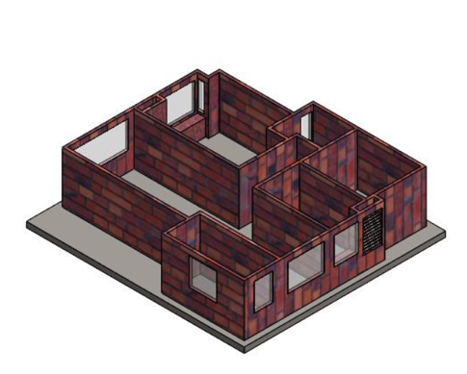
Figure 1 : An isometric view of 3D model for the experimental setup.

The experiment was carried out outdoors under direct sunlight, with the main door of the model oriented towards the west. This orientation was selected to simulate a realistic condition in which a residential building is exposed to hot and windy outdoor weather. The experiment was conducted between 12:30 p.m. and 1:15 p.m., during which the ambient temperature was observed to increase significantly. This period was selected to represent a high-temperature condition suitable for assessing the effectiveness of the cooling system. The main purpose of the experiment was to evaluate the cooling performance of the system based on its placement and the type of cooling medium used.

2.2.2 Apparatus and Instruments

The apparatus and instruments used in the experiment included a thermocouple data logger, a miniature fan, a mini mist producer, normal water, ice water, green food colouring, 1.5 V dry-cell batteries, a battery holder and the house model. The thermocouple data logger was used to record temperature readings at selected locations inside the model. The miniature fan functioned as a blower, while the mini mist producer was used to generate visible mist to support airflow and coolant flow visualisation. Normal water and ice water were used as cooling media, and both were coloured green using food colouring to improve the visibility of airflow movement during the experiment.

2.2.3 Experimental Setup

The house model was positioned according to the layout plan and tested without its roof. A transparent acrylic sheet was placed horizontally on top of the walls to represent the ceiling of a real house while allowing visual observation of airflow movement inside the model. This arrangement enabled the movement of mist and air to be observed clearly during the cooling process.

The active cooling system consisted of a miniature fan and a mini mist producer powered by a 4.5 V dry-cell battery supply. The system was tested at two different positions, identified as Location A and Location B. Temperature readings were recorded separately for each cooling system location to evaluate the effect of placement on indoor temperature distribution. The mist producer converted the coolant into mist, which was then blown into the house model by the fan. The green-coloured coolant allowed the airflow direction and cooling path to be visually observed.

Three cooling conditions were investigated in this experiment. The first condition used air only, representing the operation of a fan without coolant. The second condition used air combined with normal water mist, representing a cooler fan. The third condition used air combined with ice water mist, representing a simplified air-conditioning effect. The use of ice water was expected to provide greater cooling performance compared with normal water due to its lower temperature. Prior to testing the normal water and ice water cooling conditions, two preliminary sets of data were recorded using air only. These readings were obtained using the miniature fan without any coolant to establish baseline data and improve the reliability of the experimental results. The subsequent tests using normal water and ice water were then compared against this baseline condition.
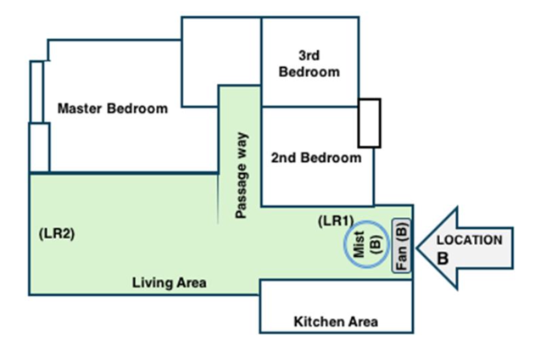

Figure 2: House model setup showing the fan and mist placed at Location 'B' in the living

area (LR1).

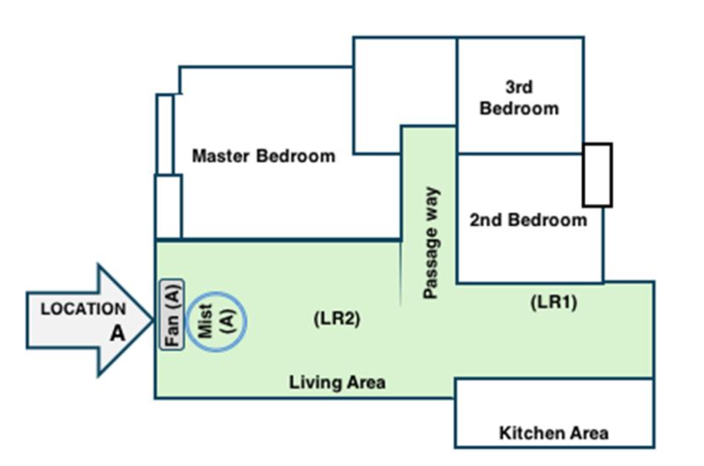

Figure 3: House model setup showing the fan and mist placed at Location 'A' in the living

area (LR2).

Temperature measurements were taken at two locations within the living room area, labelled as Living Room 1 (LR1) Figure 2 and Living Room 2 (LR2) Figure 3. The living room was divided into two sections because the temperature sensors had a limited detection range. The use of two measurement points enabled a more representative comparison of temperature distribution within the living room and allowed the cooling effect at different indoor positions to be analysed.
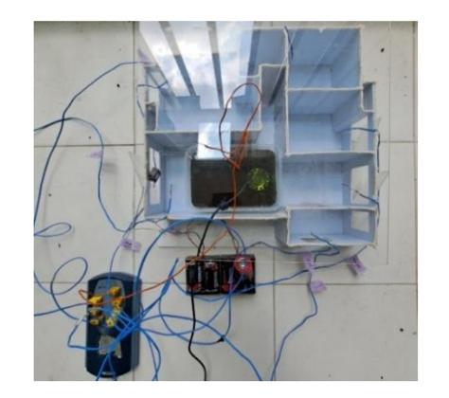

Figure 4: Final look on the experimental setup with a fan and mist producer at location

3 Data collection and Averaging Procedure

Temperature data were collected under three experimental cooling conditions: air only, normal water mist and ice water mist. For each cooling condition, measurements were taken at two cooling system positions, identified as Location A and Location B. Two repeated sets of data were recorded for each condition and location to improve the reliability of the measurements and to allow average values to be calculated.

For the air-only condition, the miniature fan was operated without any coolant to represent baseline airflow. Two sets of temperature readings were recorded at Location A and Location B, and the average values were then calculated. The same procedure was repeated for the normal water mist condition, where water was used as the coolant, and for the ice water mist condition, where ice water was used as the coolant. In each case, two repeated data sets were obtained before the average temperature was determined.

All temperature readings were recorded at two-minute intervals throughout the experiment. At each interval, the average temperature was calculated based on the recorded readings. The result for each condition was obtained by calculating the overall average from the two repeated data sets. In total, 12 data sets were generated, consisting of three cooling conditions, two cooling system locations and two repeated trials for each condition. The breakdown of the experimental data sets is summarised in Table 3 and Table 4.

Table 3: Experimental Data Identification for Passive Cooling Condition

No. | Experiment Data Identification | Fan | Mist | Cooling Agent | Fan & Mist Location
1 | Control (A) Data Set – Day 1 | ✗ | ✗ | ✗ | A
2 | Control (A) Data Set – Day 2 | ✗ | ✗ | ✗ | A
3 | Control (B) Data Set – Day 1 | ✗ | ✗ | ✗ | B
4 | Control (B) Data Set – Day 2 | ✗ | ✗ | ✗ | B

Table 4: Experimental Data Identification for Active Cooling Condition

No. | Experiment Data Identification | Fan | Mist | Cooling Agent | Fan & Mist Location
1 | Simulation (A) Data Set – Day1 | ✓ | ✓ | Water | A
2 | Simulation (A) Data Set – Day 2 | ✓ | ✓ | Water | A
3 | Simulation (A) Data Set – Day 1 | ✓ | ✓ | Ice water | A
4 | Simulation (A) Data Set – Day 2 | ✓ | ✓ | Ice water | A
5 | Simulation (B) Data Set – Day 1 | ✓ | ✓ | Water | B
6 | Simulation (B) Data Set – Day 2 | ✓ | ✓ | Water | B
7 | Simulation (B) Data Set – Day 1 | ✓ | ✓ | Ice water | B
8 | Simulation (B) Data Set – Day 2 | ✓ | ✓ | Ice water | B

3.1 Calculation of Cooling Performance

The active cooling system was evaluated by comparing indoor and outdoor temperature differences. Indoor temperature was measured in the living room, selected as the main observation area. This comparison determined how effectively the cooling system reduced indoor temperature relative to ambient conditions, indicating its overall cooling performance.The temperature difference, ΔT, was calculated using Equation (1):

$∆Τ=Τcooled- Τambient.$ (Equation 1)

where $Τcooled$ represents the measured temperature inside the living room of the house model, while $Τambient$ refers to the outdoor ambient temperature recorded at the same time. A lower or more negative value of ΔT indicates that the indoor temperature was lower than the ambient temperature, suggesting a more effective cooling performance.

This calculation approach was adopted because outdoor environmental conditions could not be maintained consistently across different experimental days. Variations in solar intensity, wind movement and ambient temperature may affect direct comparisons between separate tests conducted with and without cooling. Therefore, comparing the indoor temperature with the corresponding ambient temperature at the same measurement time provided a more reliable basis for evaluating cooling performance. This method ensured that the analysis was conducted under real-time conditions and reduced the influence of day-to-day environmental variation on the experimental results.

4 Results and Discussion

LR1 and LR2 refer to two temperature measurement points in the living room area. The values represent the calculated temperature difference between the indoor living room temperature and the outdoor ambient temperature for air-only cooling conditions at Locations A and B.

Table 5: Temperature differences over time at LR1 and LR2 using air as coolant (control setup) at Location A and B.
No. | Time | Air as Coolant at Location A LR1 | Air as Coolant at Location A LR2 | Air as Coolant at Location B LR1 | Air as Coolant at Location B LR2
1 | 12:30 PM | -0.03 | 0.04 | 0.00 | -0.06
2 | 12:34 PM | -0.06 | 0.05 | 0.00 | -0.05
3 | 12:40 PM | -0.04 | 0.06 | 0.00 | -0.06
4 | 12:42 PM | -0.06 | 0.06 | 0.01 | -0.04
5 | 12:44 PM | -0.05 | 0.04 | -0.01 | -0.06
6 | 12:46 PM | -0.05 | 0.07 | -0.01 | -0.06
7 | 12:48 PM | -0.07 | 0.05 | 0.01 | -0.05
8 | 12:50 PM | -0.06 | 0.04 | -0.01 | -0.07
9 | 12:52 PM | -0.06 | 0.05 | 0.00 | -0.05
10 | 12:54 PM | -0.06 | 0.05 | -0.01 | -0.06
11 | 12:56 PM | -0.08 | 0.05 | -0.02 | -0.07
12 | 12:58 PM | -0.05 | 0.05 | -0.01 | -0.06
13 | 1:00 PM | -0.06 | 0.06 | 0.00 | -0.05
14 | 1:02 PM | -0.05 | 0.05 | 0.01 | -0.05
15 | 1:04 PM | -0.06 | 0.05 | 0.00 | -0.05
16 | 1:06 PM | -0.04 | 0.05 | 0.00 | -0.06
17 | 1:08 PM | -0.06 | 0.05 | 0.00 | -0.06
18 | 1:10 PM | -0.05 | 0.05 | -0.01 | -0.06
19 | 1:12 PM | -0.07 | 0.05 | 0.00 | -0.04
20 | 1:14 PM | -0.08 | 0.04 | -0.01 | -0.05

Table 6: Temperature differences over time at LR1 and LR2 using water as coolant at

Location A and B.
No. | Time | Air as Coolant at Location A LR1 | Air as Coolant at Location A LR2 | Air as Coolant at Location B LR1 | Air as Coolant at Location B LR2
1 | 12:30 PM | -0.18 | 0.30 | -0.60 | -0.66
2 | 12:34 PM | -0.53 | -0.60 | -0.65 | -0.66
3 | 12:40 PM | -0.55 | -0.66 | -0.65 | -0.68
4 | 12:42 PM | -0.53 | -0.67 | -0.68 | -0.70
5 | 12:44 PM | -0.51 | -0.64 | -0.66 | -0.70
6 | 12:46 PM | -0.46 | -0.61 | -0.67 | -0.71
7 | 12:48 PM | -0.46 | -0.64 | -0.64 | -0.67
8 | 12:50 PM | -0.49 | -0.63 | -0.65 | -0.69
9 | 12:52 PM | -0.51 | -0.67 | -0.67 | -0.68
10 | 12:54 PM | -0.57 | -0.73 | -0.65 | -0.64
11 | 12:56 PM | -0.54 | -0.64 | -0.61 | -0.64
12 | 12:58 PM | -0.53 | -0.71 | -0.65 | -0.67
13 | 1:00 PM | -0.50 | -0.75 | -0.63 | -0.66
14 | 1:02 PM | -0.56 | -0.76 | -0.64 | -0.69
15 | 1:04 PM | -0.55 | -0.77 | -0.66 | -0.70
16 | 1:06 PM | -0.55 | -0.73 | -0.66 | -0.68
17 | 1:08 PM | -0.55 | -0.82 | -0.65 | -0.68
18 | 1:10 PM | -0.54 | -0.81 | -0.61 | -0.67
19 | 1:12 PM | -0.54 | -0.77 | -0.66 | -0.69
20 | 1:14 PM | -0.52 | -0.74 | -0.66 | -0.69

Table 7: Temperature differences over time at LR1 and LR2 using ice water as coolant at

Location A and B.

No. | Time | Air as Coolant at Location A LR1 | Air as Coolant at Location A LR2 | Air as Coolant at Location B LR1 | Air as Coolant at Location B LR2
1 | 12:30 PM | -0.04 | 0.00 | -0.02 | -0.05
2 | 12:34 PM | -1.36 | -1.78 | -0.47 | -0.48
3 | 12:40 PM | -1.46 | -1.86 | -0.41 | -0.57
4 | 12:42 PM | -1.45 | -1.86 | -0.45 | -0.61
5 | 12:44 PM | -1.45 | -1.86 | -0.48 | -0.57
6 | 12:46 PM | -1.43 | -1.79 | -0.53 | -0.59
7 | 12:48 PM | -1.46 | -1.84 | -0.44 | -0.58
8 | 12:50 PM | -1.51 | -1.88 | -0.41 | -0.57
9 | 12:52 PM | -1.56 | -1.84 | -0.46 | -0.58
10 | 12:54 PM | -1.56 | -1.83 | -0.49 | -0.63
11 | 12:56 PM | -1.54 | -1.84 | -0.45 | -0.64
12 | 12:58 PM | -1.59 | -1.88 | -0.40 | -0.65
13 | 1:00 PM | -1.59 | -1.84 | -0.45 | -0.72
14 | 1:02 PM | -1.55 | -1.85 | -0.44 | -0.72
15 | 1:04 PM | -1.63 | -1.83 | -0.44 | -0.73
16 | 1:06 PM | -1.69 | -1.88 | -0.48 | -0.81
17 | 1:08 PM | -1.71 | -1.87 | -0.44 | -0.85
18 | 1:10 PM | -1.71 | -1.87 | -0.47 | -0.88
19 | 1:12 PM | -1.70 | -1.78 | -0.44 | -0.87
20 | 1:14 PM | -1.67 | -1.83 | -0.39 | -0.88

Figure 5. Temperature difference, ΔT, between indoor living room temperature and outdoor ambient temperature over time for air, water and ice water cooling conditions at Locations A and B. LR1 and LR2 represent two measurement points in the living room area. Negative ΔT values indicate that the indoor temperature was lower than the ambient temperature, representing better cooling performance.

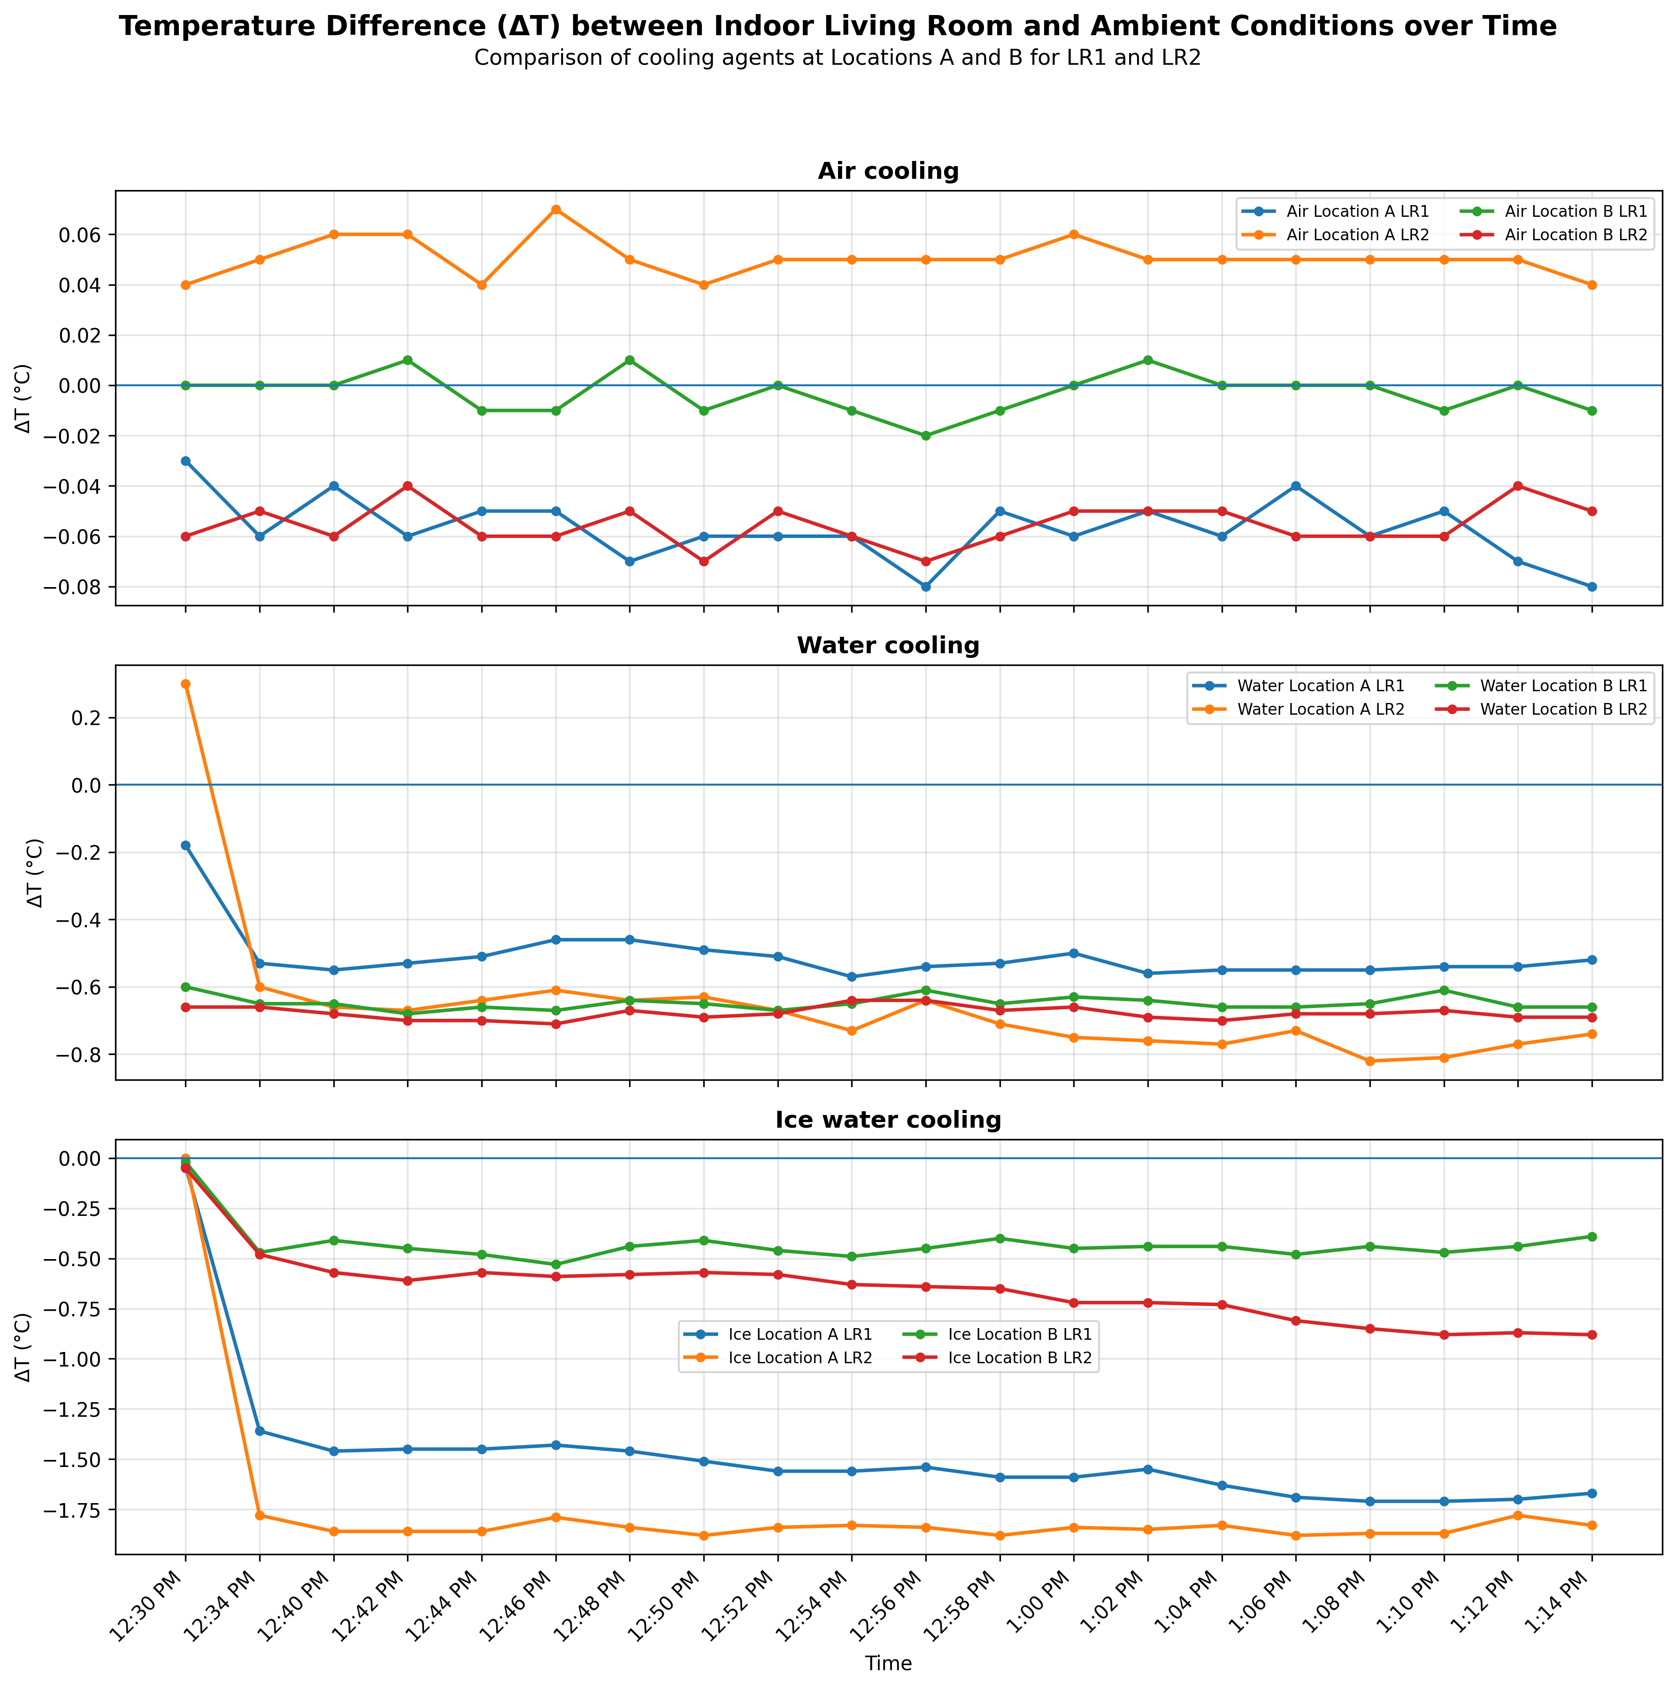

Figure 5: Temperature Difference ($ΔΤ$) between Indoor Living Room and Ambient Conditions over Time

The placement of the cooling system significantly affects room temperature distribution and depends on the cooling method used. For a regular fan using air as coolant, location B is more suitable because it provides better cooling to LR2 and allows air to spread more effectively, even to areas farther from the fan. For a cooler fan using water as coolant, location B also gives a more balanced and consistent cooling effect between LR1 and LR2 compared to location A. However, for a stronger cooling system such as an air-conditioner or ice-water cooling system, location A is more effective because it produces lower temperatures in both LR1 and LR2. Overall, fan-based systems perform better at location B, while air-conditioning systems perform better at location A.

4.1 AR Integration Workflow

The house model, which served as the base model for visualisation, was imported into the augmented reality (AR) platform. Additional components, such as fans and airflow indicators, were then integrated into the model, as illustrated in Figure 6. The AR scene was developed using the behaviour function in Reality Composer (Apple application for Augmented Reality Simulation), which enabled object visibility, movement and animation to respond to user interactions. The sequence of scene behaviours is presented figure below.

For example, users were able to activate airflow animations by tapping on the cooling system component. The interactive scenes were designed to allow users to move around the physical model and observe changes in airflow patterns from different viewing angles. This approach supported a clearer understanding of airflow distribution and assisted users in identifying the most suitable cooling system location.

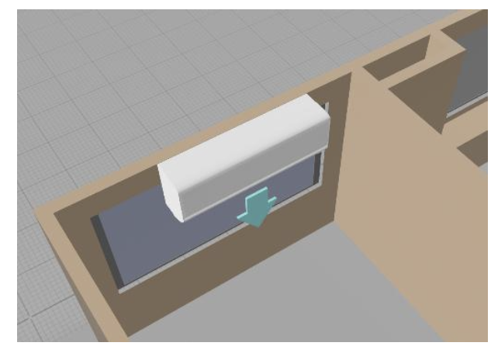

Figure 6: 3D view of air conditioner on house model in Reality Composer.
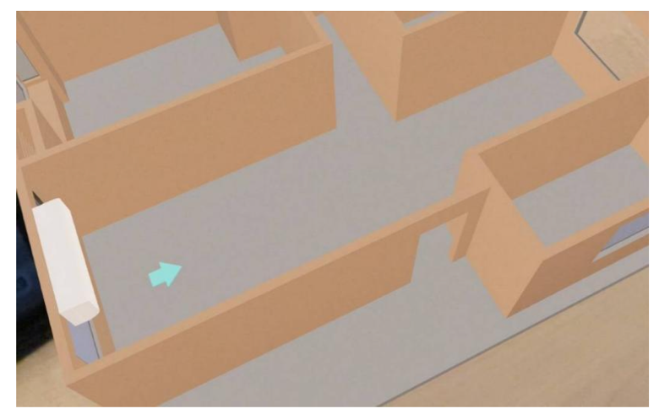

Figure 7: 3D model showing the airflow direction indicated by the blue arrow.
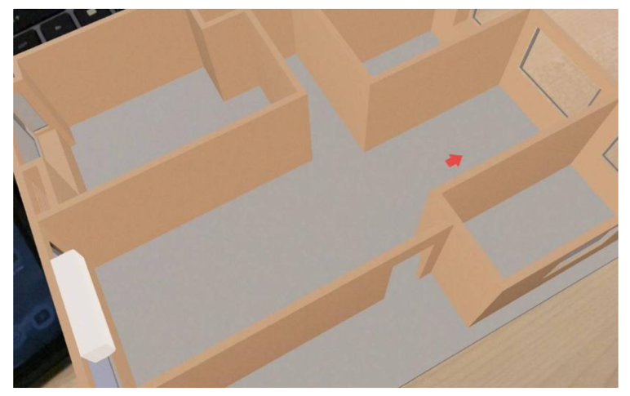

Figure 8: 3D model showing the airflow direction indicated by the red arrow.

4.2 AR User Feedback and survey results

A user feedback survey was conducted to evaluate the effectiveness of the augmented reality (AR) application in supporting the visualisation of heat distribution, airflow direction and cooling system placement. The survey was distributed together with a video demonstration of the AR model. In some cases, the survey was also conducted during live demonstrations, where participants interacted directly with the AR model using an iPad. A total of 32 respondents participated in the survey, consisting of engineers, technicians, managers and students. The distribution of respondents is shown in Figure 9. The survey consisted of Likert-scale, multiple-choice and open-ended questions to assess user experience, understanding, interactivity and potential improvements of the AR application.
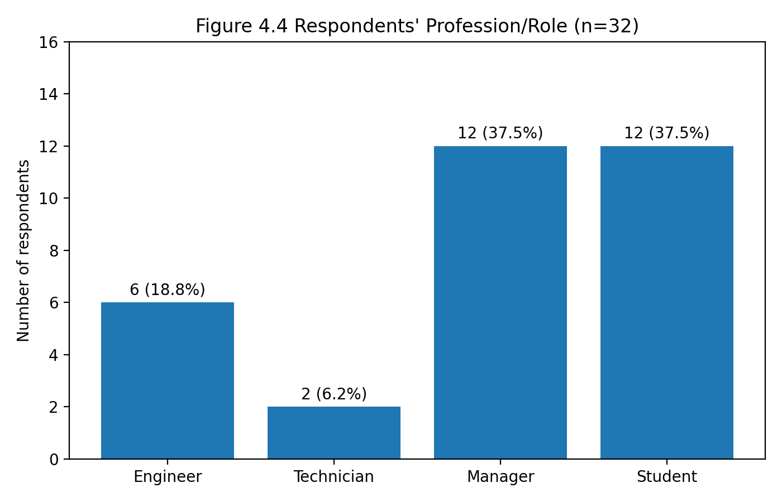

Figure 9: Respondents’ profession/role.
The respondents represented a mixed background of technical and non-technical users. Managers and students formed the largest respondent groups, each representing 37.5% of the total participants. Engineers represented 18.8%, while technicians formed the smallest group at 6.3%. This distribution indicates that the AR application was evaluated by users with different levels of technical knowledge and practical experience. Therefore, the feedback obtained provides a useful indication of how the AR visualisation may be perceived by both engineering-related users and general users (Figure 10).
Based on the survey results, 50.0% of the respondents stated that the AR simulation did not help them understand the cooling system more clearly, while 31.3% agreed that the AR application helped them visualise airflow direction and cooling effects. Another 18.8% were unsure about its impact. This shows that although the AR application had potential as a visualisation tool, its current design was not fully effective for all users. The negative and uncertain responses may be related to limitations in the clarity of the airflow animation, level of detail in the simulation and absence of real-time temperature data. Therefore, the AR model requires further refinement to improve its ability to communicate cooling behaviour more clearly.
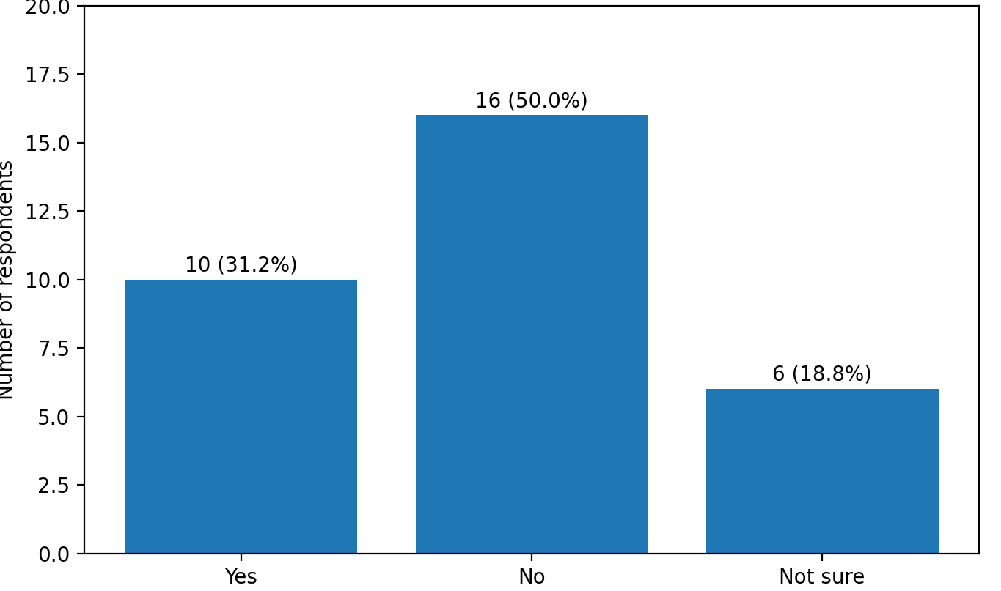

Figure 10: Participants’ views on whether AR helped them understand cooling systems.

In terms of user experience, the AR application received more positive feedback. Most respondents found the AR experience enjoyable and interactive. The interactivity rating showed that 46.9% of respondents rated the AR experience as 4 out of 5, while 12.5% gave the highest rating of 5 (Figure 11). This indicates that the AR application was successful in attracting user interest and encouraging engagement with the cooling system model. Although the AR visualisation did not fully improve technical understanding for all users, it was still perceived as an interactive and engaging learning medium.
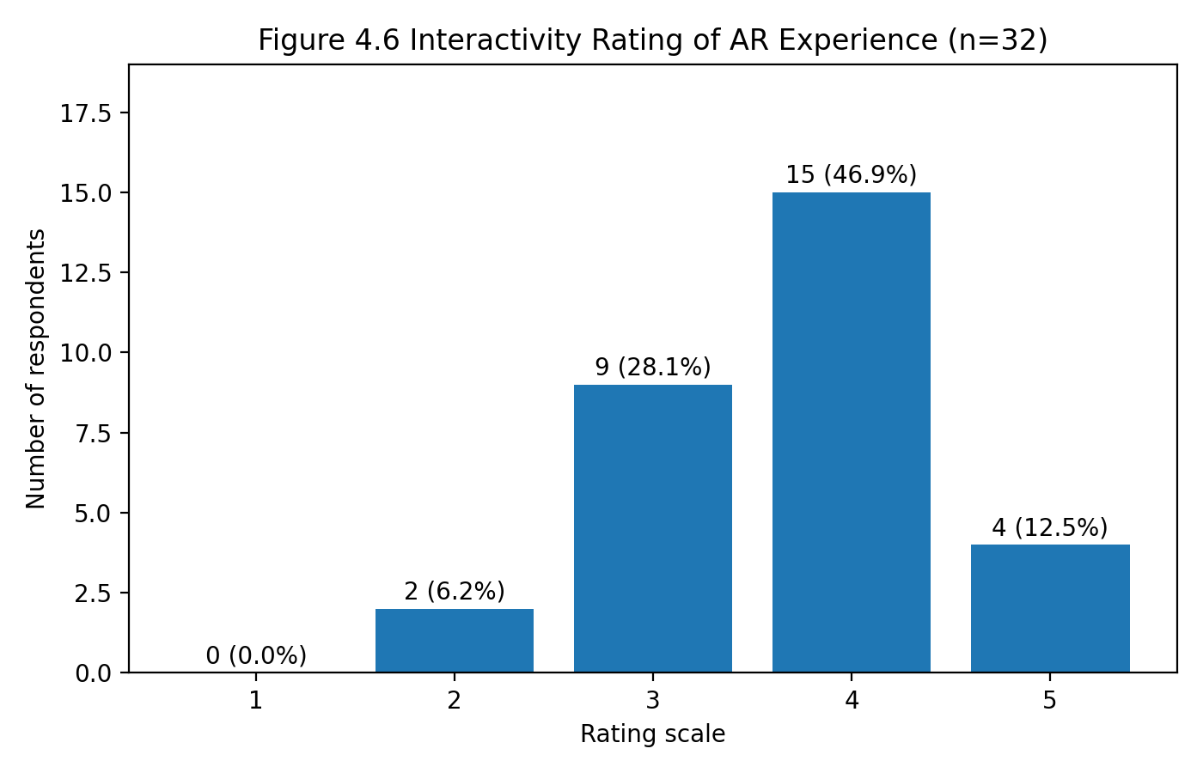

Figure 11: Respondents’ rating of AR interactivity.

The most preferred feature of the AR application was its fun and interactive nature, selected by 87.5% of respondents. This was followed by clear 3D visuals and better understanding, both selected by 62.5% of respondents. These results suggest that the main strength of the AR application lies in its ability to provide an engaging and visually appealing representation of the cooling system (Figure 12). The use of 3D models, animated arrows and colour-based indicators helped users observe airflow direction and thermal changes in a more interactive manner compared to conventional static drawings.

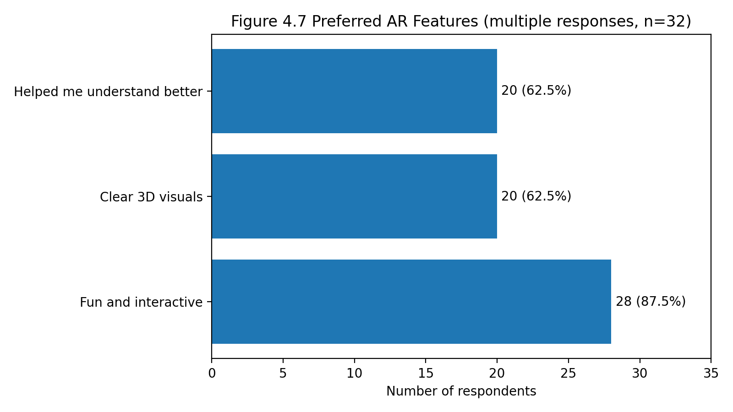

Figure 12: Preferred AR features selected by respondents.

However, the responses on whether respondents would recommend AR for other projects were more varied. Only 18.8% stated that they would recommend AR, while 46.9% answered “No” and 34.4% were unsure. This finding suggests that although users enjoyed the AR experience, many were not fully convinced of its wider practicality or readiness for broader project applications Figure 13. This may be due to the current limitations of the prototype, particularly in terms of simulation realism, technical accuracy and user control. Therefore, further development is required before the AR application can be confidently recommended for wider use in engineering design, education or building management applications.

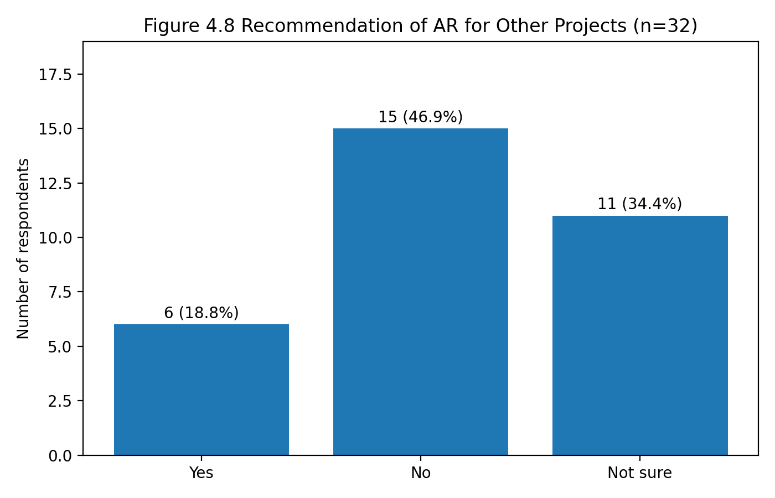
Figure 13: Respondents’ recommendation of AR for other projects.

The open-ended feedback further indicated several areas for improvement. The most important suggested improvement was the ability to adjust settings within the AR application, followed by the integration of real-time information such as temperature readings. Respondents also suggested adding more animations, visual effects and step-by-step instructions. These improvements are important because they would allow users to interact more meaningfully with the AR model and better understand the relationship between cooling system placement, airflow movement and temperature distribution.

Overall, the survey results show that the AR application has potential as a supporting visualisation tool for active cooling systems in energy-efficient building design. The application was effective in creating user engagement and presenting the cooling system in an interactive 3D environment. However, the results also show that the current AR model requires further improvement to enhance technical understanding and user confidence. Future development should focus on improving airflow animation realism, integrating real-time sensor data, allowing user-controlled settings and providing clearer instructional guidance. These enhancements would strengthen the role of AR as a practical tool for cooling system visualisation, design evaluation and decision-making in energy-efficient building applications.

5 Conclusion

The findings of this study show that the effectiveness of an active cooling system is strongly influenced by both the type of cooling method and its placement within the space. For fan-based cooling systems, including air-only and water-based cooling, Location B was found to be more effective because it provided better air distribution and a more balanced cooling effect between LR1 and LR2. In contrast, for a stronger cooling system represented by ice water cooling, Location A produced lower temperatures at both measurement points, indicating better cooling performance. This suggests that cooling system placement should not be generalised, as different cooling methods require different positioning strategies to achieve optimum indoor temperature reduction.

The augmented reality component of the study further demonstrated that AR can support the visualisation of cooling system placement, airflow direction and temperature distribution. Although the survey results showed that AR did not fully improve users’ technical understanding of the cooling system, it provided a more interactive and engaging method of presenting cooling behaviour compared with conventional static models. The limited effectiveness may be due to users’ unfamiliarity with AR technology, limited access to AR devices and the early stage of AR adoption in Malaysia.

Overall, the integration of active cooling assessment with AR-based visualisation offers a practical and low-cost approach for improving early-stage building design evaluation. The small-scale model allowed different cooling arrangements to be tested before actual installation, while AR provided additional visual support for understanding airflow behaviour. However, further improvement is required, particularly in terms of realistic airflow animation, real-time sensor integration and user training. Future studies should apply the approach to full-scale buildings and involve users with different technical backgrounds. This would provide deeper insights into the effectiveness of AR in supporting decision-making, installation accuracy and energy-efficient building management.

Acknowledgement

The authors would like to express their sincere appreciation to the Faculty of Mechanical Technology and Engineering, Universiti Teknikal Malaysia Melaka (UTeM), for providing the facilities, technical support and academic environment required to conduct this study. Special appreciation is also extended to the researchers, laboratory staff and respondents who contributed their guidance, assistance and feedback throughout the development, experimental evaluation and augmented reality visualisation process. Their support has greatly contributed to the successful completion of this research entitled Assessment and Visualisation of Active Cooling Performance in Energy-Efficient Building Design Supported by Augmented Reality.

REFERENCES

- Alhazzaa, K., & Yan, W. (2023). Integrating parametric modeling, BIM, and building performance analysis into augmented reality for architectural design and education. In Proceedings of the 2023 7th International Conference on Virtual and Augmented Reality Simulations (ICVARS ’23) (pp. 68–76).
- Kim, I., An, H., & Kim, W. (2024). Development and validation of intelligent load control for VRF air-conditioning system with deep learning-based load forecasting. Journal of Building Engineering, 98.
- Song, M., et al. (2020). Green building standards and their impact on energy performance. Building and Environment.
- Saidur, R., et al. (2011). Energy consumption, energy savings, and emission reduction in buildings: A comprehensive review. Renewable and Sustainable Energy Reviews.
- Yang, K., Hao, X., Lin, Y., Xing, Q., Tan, H., Hu, J., & Liu, X. (2021). An integrated system of water-cooled VRF and indirect evaporative chiller and its energy saving potential. Applied Thermal Engineering, 194, 117063.
- Breeze, P., & Owen, R. 2015. Smart cooling systems and energy management. Energy Efficiency Journal.
- Cai, S., & Gou, Z. (2024). Towards energy-efficient data centers: A comprehensive review of passive and active cooling strategies. Energy and Built Environment.
- Buffa, S., Cozzini, M., D’Antoni, M., Baratieri, M., & Fedrizzi, R. (2019). 5th generation district heating and cooling systems: A review of existing cases in Europe. Renewable and Sustainable Energy Reviews, 104, 504–522.
- Watanabe, H., Sugi, T., Saito, K., & Nagashima, K. (2024). Mechanism underlying the influence of humidity on thermal comfort and stress under mimicked working conditions. Physiology & Behavior, 285, 114653.
- Santamouris, M. (2016). Innovations in cooling technologies for energy efficiency in hot climates. Energy and Buildings.
- Xu, Z., Feng, Z., Jelodar, M. B., & Guo, B. H. W. (2024). Augmented reality applications in construction productivity: A systematic literature review. Advanced Engineering Informatics, 62, 102798.
- Zhou, D., & Tani, S. (2021). AR applications in building energy management. Energy Management Journal.
- Bae, J., Lee, J., & Cho, J. (2022). Analysis of AI ethical competence to computational thinking. International Journal on Informatics Visualization, 6(2-2). https://doi.org/10.30630/joiv.6.2-2.1126
- Becerik-Gerber, B., et al. (2020). The impact of augmented reality on construction project delivery. Journal of Information Technology in Construction.
- Andarini, R. (2014). The role of building thermal simulation for energy efficient building design. Energy Procedia, 47, 217–226.

