Category – Rare case report
Title - Elephantiasis Nostras Verrucosa: A Great Mimicker of True Elephantiasis – A Rare Case Report

Name of Authors: Dr. Manika Alexander ¹, Dr. Shwetha Patil², Dr. Jeenu J Jayan ³, Dr Nikitha⁴, Dr. Basavaraj P Bommanahalli ⁵.
¹Associate Professor, ² Assistant Professor, ^{3,4} Postgraduate Residents, ⁴Professor & Head of the Department
Department of Pathology, K H Patil Institute of Medical Sciences (Formerly called as Gadag Institute of Medical Sciences), Gadag, Karnataka

Corresponding author -
Dr. Manika Alexander
Associate Professor
Department of Pathology,
K H Patil institute of medical sciences (Formerly called as Gadag Institute of medical sciences), Mallasamudhra, Gadag, Karnataka, India
Email – manikaalex@yahoo.com
Ph - 9482361893

Abstract:
Elephantiasis nostras verrucosa (ENV) is an uncommon, progressive complication of chronic non-filarial lymphedema characterized by dermal fibrosis, papillomatosis, and hyperkeratotic verrucous plaques. We report a 50-year-old woman with diabetes and chronic lower limb ulcer who developed cobblestone-like plaques over the right leg. Laboratory findings showed inflammatory markers elevation, while filarial, fungal, and tubercular aetiologies were excluded. Histopathology revealed marked hyperkeratosis, pseudoepitheliomatous hyperplasia, dilated lymphatics, dermal fibrosis, and inflammatory infiltrate. D2-40 immunostaining confirmed lymphatic endothelial proliferation. Clinicopathological correlation established the diagnosis of ENV. Early recognition is essential to differentiate ENV from filarial elephantiasis and other mimickers to ensure appropriate multidisciplinary management.

Keywords:
Elephantiasis nostras verrucosa; Chronic lymphedema; Pseudoepitheliomatous hyperplasia, Dermal fibrosis, Lymphatic proliferation

Introduction:
Elephantiasis nostras verrucosa (ENV) is a rare, progressive sequela of chronic non-filarial lymphedema, characterized by dermal fibrosis, papillomatosis, marked hyperkeratosis, and indurated “woody” skin changes that impart a cobblestone or mossy appearance.¹ It typically develops secondary to long-standing lymphatic stasis resulting from recurrent bacterial infections, chronic venous insufficiency, trauma, malignancy, obesity, or congestive cardiac failure, all of which contribute to persistent lymphatic obstruction.²
Clinically, ENV may closely resemble classical filarial elephantiasis, and in the absence of careful clinical evaluation, appropriate imaging, and histopathological examination, misdiagnosis can occur.³ The characteristic cutaneous findings—including non-pitting edema, verrucous papules and plaques, ulceration, and secondary infection—favor a diagnosis of ENV over filarial elephantiasis.¹,⁴
We report a rare case of ENV with striking clinical similarity to classical elephantiasis, highlighting the importance of thorough clinicopathological correlation for accurate diagnosis and appropriate management.⁵
Case report:
A 56-year-old woman with a known history of type 2 diabetes mellitus and a long-standing diabetic ulcer presented with progressively enlarging skin lesions over the right lower limb for a duration of four months. She developed multiple hyperpigmented, markedly hyperkeratotic to verrucous plaques, which gradually coalesced to form thickened, cobblestone-like plaques involving the ankle and mid-lower leg region (Fig 1a, Fig 1b). The lesions were associated with induration and non-pitting edema of the surrounding skin.
Laboratory investigations included a complete blood count (CBC), which revealed neutrophilic leukocytosis. Inflammatory markers were elevated including increased erythrocyte sedimentation rate (ESR) and raised C-reactive protein (CRP) levels, suggestive of ongoing inflammation. Her random blood glucose and HbA1c levels indicated markedly uncontrolled glycemic status at presentation.
Diethylcarbamazine (DEC) provocation test for microfilariae was negative, excluding filarial etiology. Wound culture yielded growth of Staphylococcus aureus, while fungal culture did not demonstrate any pathogenic organisms. Tuberculosis was ruled out based on negative acid-fast bacilli smear, negative mycobacterial culture, and negative cartridge-based nucleic acid amplification test (CBNAAT).
Ultrasound Doppler study of the lower limb showed no evidence of deep venous thrombosis. A punch biopsy was obtained from the verrucous plaque and submitted for histopathological examination to establish a definitive diagnosis.
Gross findings:
Received a single skin punch biopsy measuring 0.5 × 0.5 cm. External surface, verrucous plaques noted.

Histopathological findings:
Histopathology revealed epidermis with marked hyperkeratosis, parakeratosis hypergranulosis. Intraepidermal abscess containing numerous neutrophil and eosinophils. There are areas of ballooning degeneration. There are elongated, branching and thickened rete ridges. Dermis shows fibrosis, clefting of the dermal collagen, dilated lymphatics and moderate to dense perivascular infiltration of lymphocytes and plasma cells. Also seen pigment incontinance in the superficial dermis. (Fig 2a, 2b, 2c). No evidence of granuloma/ malignancy/ fungal organism seen in multiple sections studied.
Immunohistochemistry for D2-40 (podoplanin) showed positive staining of lymphatic endothelial cells, confirming lymphatic involvement in the lesion. (Fig 2d)

Discussion:
In this 56-year-old woman, the development of Elephantiasis Nostras Verrucosa (ENV) can be attributed to chronic secondary lymphedema, wherein prolonged lymphatic obstruction results in the accumulation of protein-rich interstitial fluid, persistent inflammation, fibroblast activation, and progressive dermal fibrosis.⁴ The chronic stagnation of lymph further predisposes to recurrent bacterial infections, which perpetuate a cycle of inflammation and lymphatic damage. Recurrent episodes of cellulitis, a well-recognized precipitating factor, likely contributed to additional lymphatic injury and further exacerbation of the cutaneous changes observed in our patient.⁶
Over time, sustained inflammation leads to epidermal hyperplasia, hyperkeratosis, papillomatosis, and dermal fibrosis, culminating in the characteristic verrucous and cobblestone-like surface morphology. Histopathologically, ENV typically demonstrates pseudoepitheliomatous hyperplasia, marked hyperkeratosis, dilated lymphatic channels, dermal edema, and varying degrees of chronic inflammatory infiltrate, findings that support the diagnosis and help exclude mimickers.³
Clinically, ENV manifests as non-pitting, woody edema with progressive thickening of the skin and subcutaneous tissue, features that were evident in our patient and are consistent with previously published reports.² If left untreated, the condition may lead to functional impairment, recurrent ulceration, secondary infections, and significant cosmetic and psychosocial morbidity.
The principal differential diagnoses, including filarial elephantiasis, chromoblastomycosis, pretibial myxedema, and Stewart–Treves syndrome, were carefully excluded through detailed clinical evaluation, microbiological testing, and histopathological confirmation.³ Early recognition is crucial, as timely intervention may halt progression and improve outcomes.
Management of ENV remains challenging and requires a multidisciplinary approach, encompassing strict glycemic control, treatment of the underlying cause, compression therapy, infection control, meticulous local wound care, physiotherapy, and, in selected cases, surgical debulking or keratolytic therapy.¹ Long-term follow-up is essential to prevent recurrence and monitor for complications.

Conclusion:
Elephantiasis nostras verrucosa is a rare but debilitating sequela of chronic lymphedema that can closely mimic filarial elephantiasis, often resulting in diagnostic delay. Early recognition through careful clinical evaluation and histopathological confirmation is essential to prevent progressive fibrosis, recurrent infections, and functional impairment. Identification and management of underlying risk factors such as chronic infection and diabetes mellitus are crucial in halting disease progression.
A multidisciplinary approach involving optimal medical management, compression therapy, meticulous wound care, infection control, and, when required, surgical intervention remains the mainstay of treatment. Long-term follow-up is necessary to prevent recurrence and improve overall outcomes.
Acknowledgement:
Nil
Conflict of Interest:
Nil

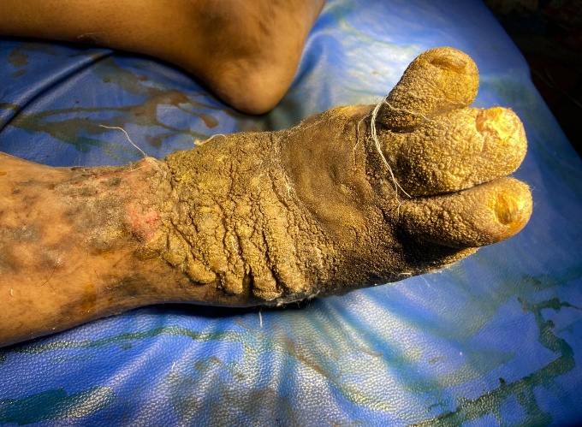 Figure 1a - Thickened, rough and mossy appearance of the skin

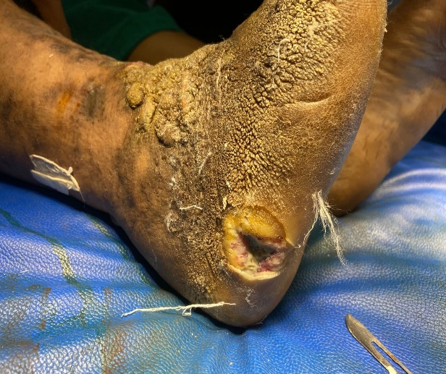 Figure. 1b – Cobble stone appearance with long standing Diabetic ulcer

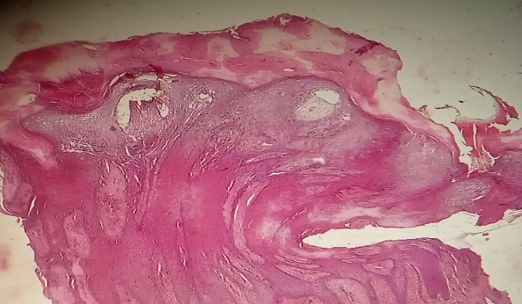 Figure 2a – H & E – 10x - Acanthosis, hyperkeratosis, parakeratosis and hypergranulosis

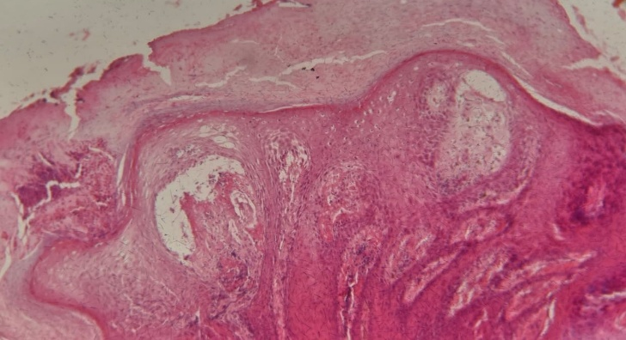 Figure. 2b – Epidermal changes with intraepidermal abscess
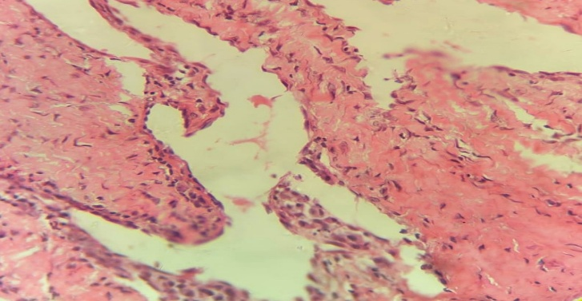 Figure. 2c – Proliferated and dilated Lymphatics lined by endothelial cells

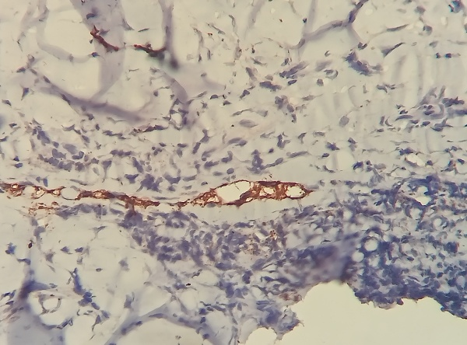 Figure 2d - D2-40 (Podoplanin) – 40x - Highlighting dilated Lymphatics.

References
- Sisto K, Khachemoune A. Elephantiasis nostras verrucosa: a review. Am J Clin Dermatol. 2008;9(3):141-146.
- Damstra RJ, Dickinson-Blok JL, Voesten HG. Shaving technique and compression therapy for Elephantiasis Nostras Verrucosa (Lymphostatic Verrucosis) of forefeet and toes in end-stage primary lymphedema: a 5 year follow-up study in 28 patients and a review of the literature. Journal of Clinical Medicine. 2020 Sep 28;9(10):3139.
- Yang YS, Ahn JJ, Haw S, Shin MK, Haw CR. A case of elephantiasis nostras verrucosa. Annals of Dermatology. 2009 Aug 31;21(3):326.
- Fredman R, Tenenhaus M. Elephantiasis nostras verrucosa. Eplasty. 2012 Oct 12;12:ic14.
- Keong NK, Ngi AT, Muniandy P, Fei WV. Elephantiasis nostras verrucosa: a rare complication of lower limb lymphoedema. Case Reports. 2017 Aug 26;2017:bcr-2017.
- Dean SM, Zirwas MJ, Vander Horst A. Elephantiasis nostras verrucosa: an institutional analysis of 21 cases. Journal of the American Academy of Dermatology. 2011 Jun 1;64(6):1104-10.

