A Study on Impact of Automation on Jobs

………………………………………………………………………………………………

Abstract:

The rapid advancement of automation and digital technologies has significantly transformed the nature of employment across industries. Automation, driven by artificial intelligence, robotics, and advanced information systems, has improved productivity, efficiency, and cost- effectiveness in organizations. However, it has also raised serious concerns regarding job displacement, skill obsolescence, and employment insecurity, particularly among low- and middle-skilled workers.
This study examines the dual impact of automation on employment by analyzing both job creation and job displacement effects. While routine and repetitive tasks are increasingly being automated, new employment opportunities are emerging in technology-intensive sectors requiring advanced skills, creativity, and problem-solving abilities.
The research highlights the growing importance of reskilling and upskilling initiatives to enable workforce adaptation to technological change. It also emphasizes the role of government policies, educational institutions, and organizations in mitigating the adverse effects of automation on employment.
The study concludes that automation does not eliminate employment entirely but reshapes the labor market, making skill development and adaptability crucial for sustainable employment growth in the modern economy.

- INTRODUCTION
Automation has become one of the most significant drivers of economic and industrial transformation in the modern world. Rapid developments in artificial intelligence, robotics, machine learning, and digital technologies have fundamentally changed how businesses
operate and how work is performed. Industries such as manufacturing, banking, retail, transportation, and information technology increasingly rely on automated systems to improve productivity, reduce operational costs, and enhance efficiency. As a result, automation has emerged as a key factor influencing employment patterns across both developed and developing economies.
The growing adoption of automation has generated widespread debate regarding its impact on employment. On one hand, automation reduces the need for human labor in routine and
repetitive tasks, leading to concerns about job displacement and unemployment, particularly among low-skilled workers. On the other hand, technological advancement also creates new job opportunities, encourages innovation, and increases demand for skilled labor in emerging sectors. This dual impact makes automation both a challenge and an opportunity for the
modern workforce.
In countries like India, where a large portion of the workforce is engaged in labor-intensive sectors, the effects of automation are particularly significant. The transition towards automated systems requires workers to adapt by acquiring new skills and improving their technological competencies. Educational institutions, organizations, and government policies therefore play an essential role in facilitating workforce transition and ensuring inclusive economic growth.
This research aims to examine the impact of automation on employment by analyzing changes in job structure, skill requirements, and labor market dynamics. It also seeks to understand how automation reshapes employment opportunities and highlights the
importance of reskilling and upskilling in sustaining long-term employment in an increasingly technology- driven economy.

- Review of Literature

Existing literature on automation and employment presents mixed perspectives regarding its overall impact on the labor market. Several researchers argue that automation leads to the displacement of workers, particularly in jobs involving routine and repetitive tasks. Studies highlight that sectors such as manufacturing and administrative services are more vulnerable to technological replacement, resulting in changes in job structure and growing concerns about unemployment and income inequality.
However, other studies emphasize that automation also creates new employment opportunities by increasing productivity and generating demand for skilled labor in emerging sectors such as information technology, data analysis, and
digital services. The literature generally suggests that automation transforms the nature of work rather than eliminating jobs entirely, and that reskilling,
upskilling, and supportive government policies play a crucial role in helping workers adapt to technological change.

- Research Methodology

  - Statement of Problem
The increasing use of automation has significantly changed employment
patterns across industries. While it improves efficiency and productivity, it also raises concerns about job displacement and changing skill requirements.
Therefore, it is important to examine how automation affects employment opportunities and workforce adaptation.
  - Scope of Study
The study focuses on examining the impact of automation on employment and changes in job structure and skill requirements. It covers general employment trends across various sectors without limiting the study to a specific industry or region. The study aims to understand both the positive and negative effects of automation on employment opportunities and workforce adaptation.

  - Objectives of the Study
    - To examine the impact of automation on employment opportunities.
    - To analyze the effect of automation on job structure and skill requirements.
    - To understand the challenges and opportunities created by automation in the labor market.
    - To study the importance of reskilling and upskilling in adapting to technological changes.
  - Research Design
The study follows a descriptive research design to examine the impact of automation on employment. It focuses on analyzing existing information and trends related to automation and changes in employment patterns. The research is based on secondary data collected from books, research articles, reports, and reliable online sources.
  - Data Collection

    - Primary Data

Primary data was collected through a Structured Questionnaire (Google Form) circulated among working individuals aged 19 to 35 years in the Navi Mumbai region. Informal interviews were conducted with working youths.
    - Secondary Data

Secondary data was collected through newspapers, magazine, journals, internet search, academic papers etc.
3.6 Limitations of the Study
The study is based mainly on secondary data, which may limit the accuracy of findings. It does not focus on any specific industry or geographical area, which may restrict detailed analysis. The study also considers general employment trends and may not reflect rapidly changing technological developments.

- FINDINGS & DATA ANALYSIS

  - Age-wise distribution of the respondents

Sr.no. | Age group | Responses | %
1 | 18 - 25 | 36 | 26.5%
2 | 26 - 30 | 49 | 36%
3 | 31 – 35 | 51 | 37.5%
Total |  | 136 | 100%

Source: Primary Data
Age Group
60
50
40
30
20
10
0
18 - 25
26 - 30
31 - 35
Age Group

Interpretation: The table shows that 26.5% of the respondents are between 18–25 years of
age, 36% are between 26–30 years, and 37.5% are in the 31-35 years age group, out of a total of 136 respondents. This indicates that the majority of participants belong to the younger age group (31-35 years).

  - Identify the category with the highest impact of automation.

Category | %
Jobs at high risk of automation | 30%
Jobs partially automated | 35%
New jobs created by automation | 20%
Jobs unaffected | 15%

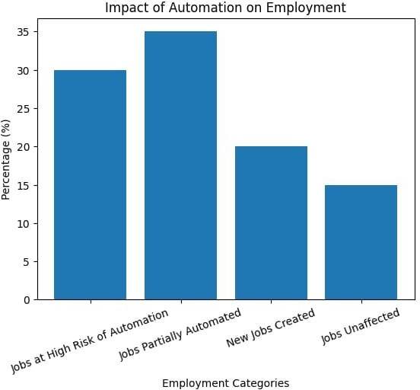
The data shows that 35% of jobs are partially automated, indicating that technology is mainly being used to support human workers rather than
completely replace them. However, 30% of jobs are at high risk of automation, especially routine and repetitive roles, highlighting employment challenges for low-skilled workers.
At the same time, automation has contributed to 20% new job creation, mainly in technology-driven and skill-intensive areas, which reflects the positive side of technological advancement. About 15% of jobs remain unaffected,
particularly those requiring creativity, decision-making, and human interaction.

  - Sector-wise Impact of Automation on Employment.

Sector | Impact(%)
Manufacturing | 40
Banking & Finance | 30
IT | 20
Healthcare | 10

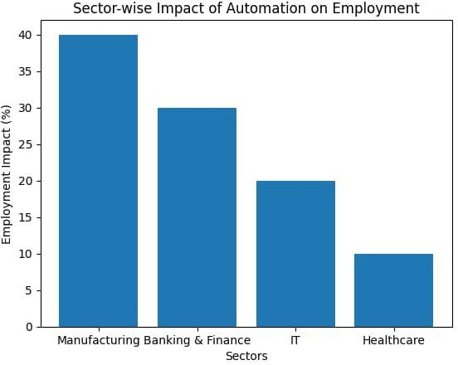
The sector-wise bar graph further reveals that manufacturing is the most affected sector (40%), followed by banking and finance (30%), due to heavy reliance on automated systems. In contrast, healthcare shows the least impact (10%), as it depends largely on human expertise and personal care.

  - Impact of Automation on employment by skill level.

skill | %
Low-Skilled | 45
Semi-Skilled Level | 30
High- Skilled | 25

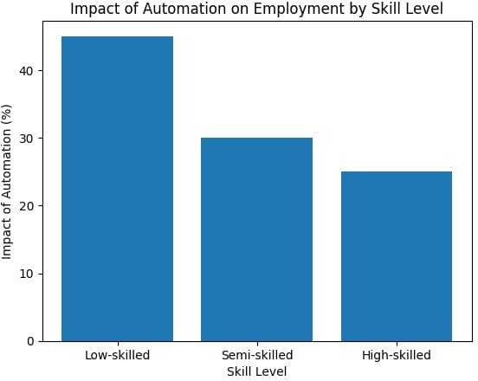
The bar graph indicates that low-skilled workers are most affected by automation (45%) due to routine and repetitive tasks. Semi-skilled workers (30%) face a moderate impact as technology supports their work. In contrast, high-skilled workers are least affected (25%) because their jobs require
creativity and decision-making. The graph highlights the need for skill upgradation to reduce employment inequality.

4.5 Growth of automation impact on Employment over time.

Year | Automation Influence on jobs (%)
2015 | 15
2020 | 25
2025 | 40

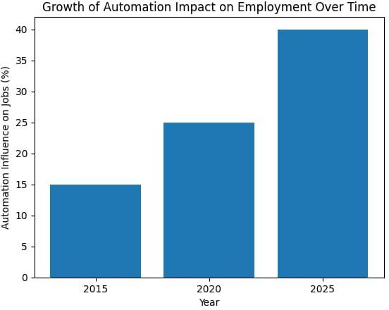
The bar graph shows a steady rise in the impact of automation on employment over time. Automation affected 15% of jobs in 2015, increased to 25% in 2020, and reached 40% by 2025. This trend highlights the growing importance of skill development and adaptability for future employment.

- HYPOTHESIS
Main Hypothesis Null Hypothesis (H₀)
Automation has no significant impact on employment levels.
Alternative Hypothesis (H₁)
Automation has a significant impact on employment levels. Hypothesis 1: Skill Level
H₀₁: Automation does not significantly affect employment across different skill
levels.
H₁₁: Automation significantly affects employment across different skill levels.
Hypothesis 2: Sector-wise Impact
H₀₂: Automation has no significant impact on employment across different sectors.
H₁₂: Automation has a significant impact on employment across different sectors.

Hypothesis 3: Job Displacement
H₀₃: Automation does not lead to job displacement.
H₁₃: Automation leads to job displacement, especially in routine-based jobs.

- FINDINGS
  - The study finds that automation has a significant impact on employment, leading to noticeable changes in job structure rather than complete job elimination.
  - It is observed that partially automated jobs form the largest share, indicating that technology mainly supports human labor instead of fully replacing it.
  - Low-skilled workers are the most affected by automation, as their jobs involve routine and repetitive tasks that can be easily automated.
  - High-skilled workers are comparatively less affected, as automation increases demand for analytical, technical, and decision-making skills.
  - Sector-wise analysis shows that manufacturing and banking sectors are highly impacted, while healthcare is least affected due to its dependence on human expertise.
  - The study reveals that automation has also created new employment opportunities, especially in technology-driven and skill-intensive sectors.
  - The findings highlight a growing skill gap in the labor market, making reskilling and upskilling essential for employment sustainability.
  - The time-trend analysis indicates that the impact of automation on employment is increasing over the years, showing rapid adoption of advanced technologies.
  - Overall, automation leads to a transformation of employment patterns, emphasizing adaptability and continuous learning for the workforce.

Recommendations

  - Skill development and reskilling programs should be promoted by governments and organizations to help workers adapt to automation- driven changes in employment.
  - Educational institutions should update curricula to include digital,
technical, and analytical skills aligned with the needs of an automated economy.
  - Policymakers should design supportive employment and labor policies to reduce job displacement risks and encourage job creation in technology- intensive sectors.

Conclusions

Automation has emerged as a powerful force transforming employment patterns across industries. While it has increased efficiency and
productivity, it has also created challenges for routine-based and low-skilled jobs due to higher automation risk. At the same time, automation has generated new employment opportunities in technology-driven and skill-
intensive sectors. The study shows that the impact of automation on employment is steadily increasing over time, indicating rapid technological adoption. This shift has widened the skill gap in the labor market, making reskilling and upskilling essential. Educational institutions, employers, and governments must work together to prepare the workforce for future job requirements. Overall, automation leads to structural changes in
employment rather than complete job loss, emphasizing adaptability and continuous learning for sustainable economic growth.

- References

  - International Labour Organization. (2019). Work for a Brighter Future. Geneva: ILO.
  - World Economic Forum. (2020). The Future of Jobs Report. Geneva: World Economic Forum.
  - Organisation for Economic Co-operation and Development. (2019). The Future of Work. Paris: OECD Publishing.
  - Frey, C. B., & Osborne, M. A. (2017). The future of employment: How susceptible are jobs to computerisation? Technological Forecasting and Social Change, 114, 254–280.
  - Acemoglu, D., & Restrepo, P. (2020). Artificial intelligence and jobs. Journal of Economic Perspectives, 34(3), 30–50.

