Blood Donation Tracking System Android Application

INTRODUCTION

Blood is really important for our body.
It is used for lots of things like surgeries emergency treatments organ transplants. To treat diseases like cancer and anemia. Blood is always needed. We never know when we will need blood so we have to have a system to manage the blood supply. We need blood for blood donations and blood donations are very important, for saving lives. That is why blood is so important.
In some places in countries that are not very developed people have a hard time finding blood donors when they need them. Usually, they try to find donors by asking family and friends or by going to lots of hospitals and blood banks. This takes a lot of time. Does not always work, especially when someone needs blood right away. One big problem with healthcare today is that there is no way to know if there are blood donors at any given time. This causes delays. Makes things worse for patients. Now that lots of people have The Blood Point app is an Android app that tries to connect blood donors with people who need blood. The Blood Point app has features like signing up to be a donor searching for blood types and talking to people directly. Users can easily find donors who have the blood type they need and who are close to them. The Blood Point app uses Firebase so the information is always up, to date which makes the system work well and be reliable.
The main goal of the Blood Point app is to make it easy for people to find blood donors by using the internet to keep everything updated. The Blood Point app is here to help people find blood donors quickly so patients can get the blood they need when they need it. The Blood Point app is trying to solve the problem of finding blood donors. It is doing this by making a system that connects Blood Point users with the Blood Point app.

LITERATURE SURVEY

Digital solutions have made a difference in the way blood donation systems work. For example, Sharma and Singh created an app that uses GPS to find donors near you when there is an emergency (Sharma & Singh 2019).

Another system made by Gupta helps hospitals keep track of their blood stock in time (Gupta, 2021). The Government of India also made a platform called e-Rakkah that lets people see all the blood bank data in one place. Makes it easier to find out if blood is available (Ministry of Health & Family Welfare 2022).

Even with all these new digital solutions for blood donation systems there are still some problems.
Many digital solutions for blood donation systems do not have updates in time not many people use them and they do not work well with the hospitals systems [1]
The earliest applications for blood donation systems helped in data handling. They, however, failed to provide for any real-time communication among the users.

Later on, SMS application systems became more advanced to communicate with donors for blood donation when needed. such application systems have been slow, and they do not include many features, such as geolocation and real-time updates.
With the current technological advancements in mobile phones, most people prefer to use applications in which donors are linked with recipients. Many blood donation system applications provide functions for donor registration, searching for blood type and also connecting with other users around them. Despite this, they often face issues of low engagement levels from users.

Firebase is a tool that helps people who make apps make sure they work well and can handle a lot of users. It gives them features like updating data in time secure login and storage.

The new system we are talking about uses technology and real-time databases. The new system for blood donation always has the information about donors and makes it easy for people to talk to each other. This makes it faster and more efficient, for blood donation systems.

METHODOLOGY

The system's made up of two main parts: the client and the server. The client is app user user and the server is firebase. When people use the Android application it handles everything they do. Stores their information in a database on the internet.
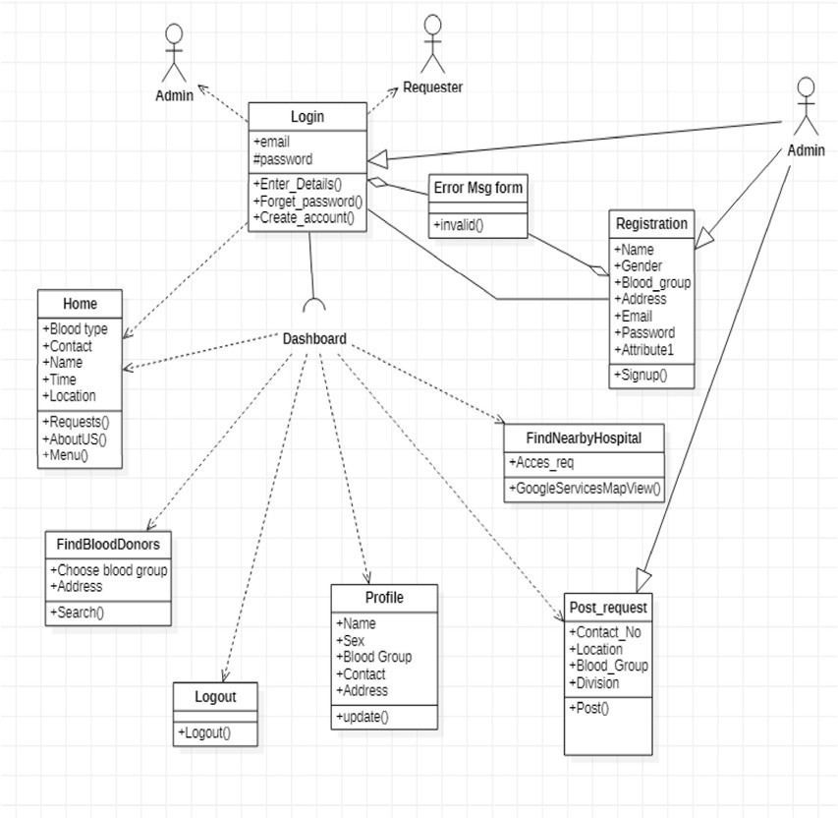

Fig 3.1• Class diagram

B. Working Process
- The Android application is really easy to use. It helps people find blood donors quickly. When someone opens the Android application they can log in to the system. They can also sign up by entering some information about themselves like their name and contact details.
- After they log in to the system they can search for blood by choosing the blood group they need. Where they are located. The system then looks for matching donor information in the Firebase database. Shows them a list of available blood donors.
- People can look at the details of the blood donors like their name and contact information. They can contact the blood donors directly which saves time when it is an emergency
- The Android application and Firebase system is very useful in situations when people need blood quickly.
- People get the information they need about the blood donors.
- The user gets in touch with the blood donor, which is the main goal of the system.

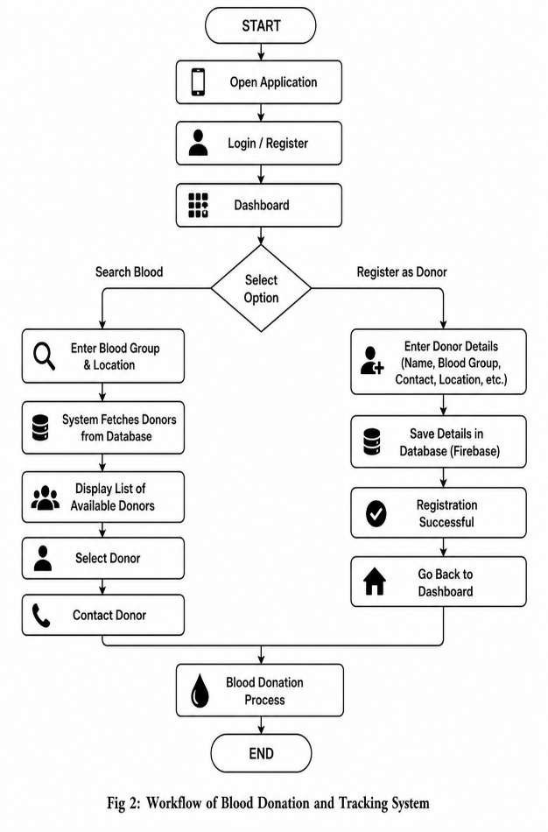

C. User Roles
The system has three types of users:
- Donor: This is someone who signs up to the system and donates blood to help others.
- Recipient: This is someone who searches for blood donors in the system.
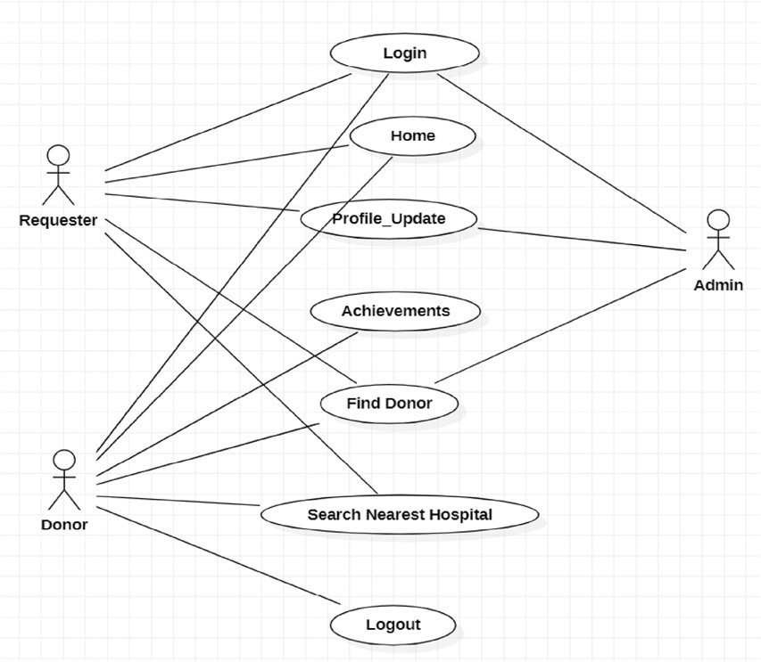
- Admin: This is the person who manages all the information, in the system including the blood donor information and recipient information.

D. Sequence Flow
The sequence diagram shows how the user and the system work together when someone requests blood from the system. It shows the steps involved in finding a blood donor and getting in touch with them.
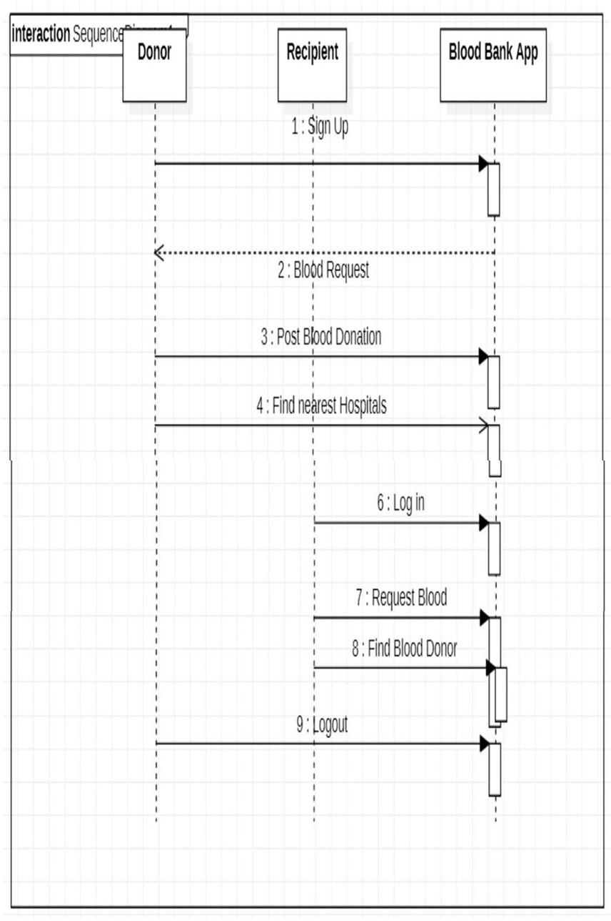

SYSTEM IMPLEMENTATION

Android studios is where we do all the coding and designing and testing for the application. We use Java to write the code for the Android application and XML to make the user interface for the Android application.
We use Firebase for the backend of the application. Firebase is what helps us with things like making sure users of the application are who they say they are storing data for the application in a manner and keeping all the data for the application synchronized. The system for the application stores lots of kinds of data for the application. This includes information about donors for the application and users of the application and requests for blood for the application.

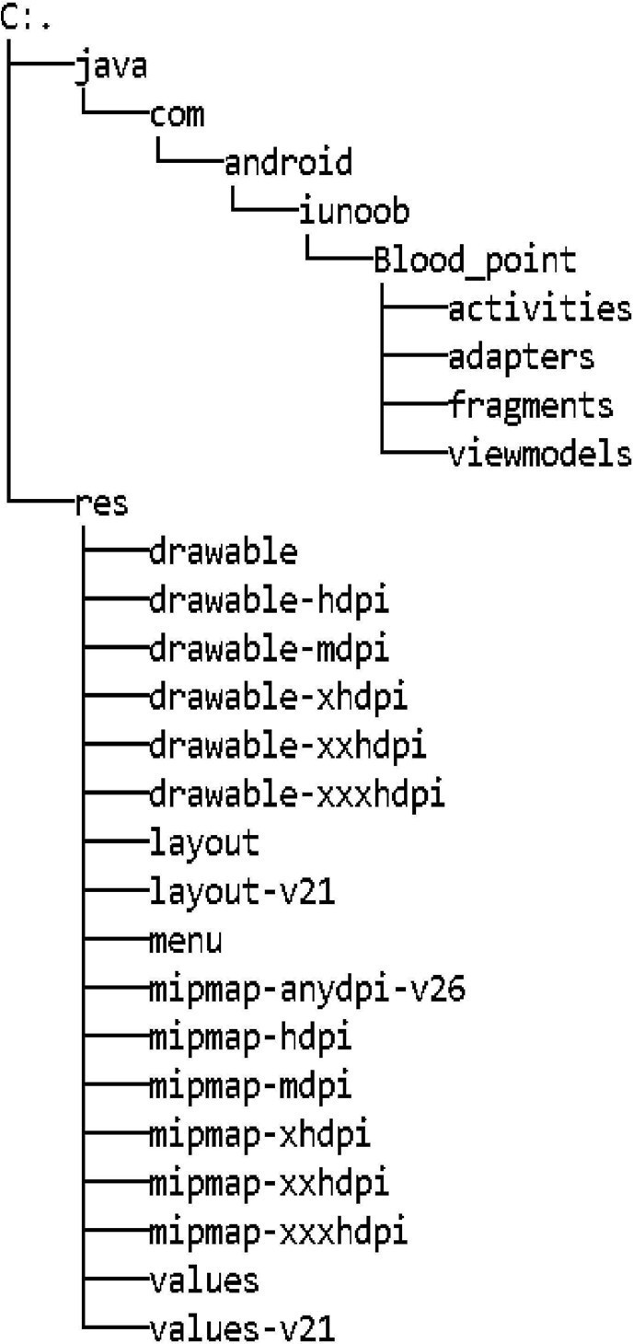

Each user of the application gets an ID that's just for them. This helps us keep all the data for the application safe. The Android application is really easy to use. It is simple. This way users can find what they need quickly.
The Android application is helpful because it assists people in getting without getting confused. Users can use all the features of the Android application. They will not have any trouble.
The main goal of the Android application is to make things easy and clear for everyone who uses the Android application.
The Android application is made to be easy and clear, for people who use the Android application.

RESULTS

To see how well this application works we tried it out in life situations especially when people need to find blood donors. The main thing we checked during the test was how fast the blood donor application responds how correct the information from the blood donor application is and whether people can use the blood donor application easily without getting confused.
The blood donor application gives results away when someone looks for a blood group. This is an improvement compared to the way of doing things, where people usually waste a lot of time calling around or going to hospitals to find blood donors.

The blood donor application also shows updates because it uses Firebase. Whenever a new donor signs up or updates their information it shows up away in the blood donor application. This means people are always seeing the up-to-date information from the blood donor application, which's really important in emergencies when people need to find blood donors quickly.

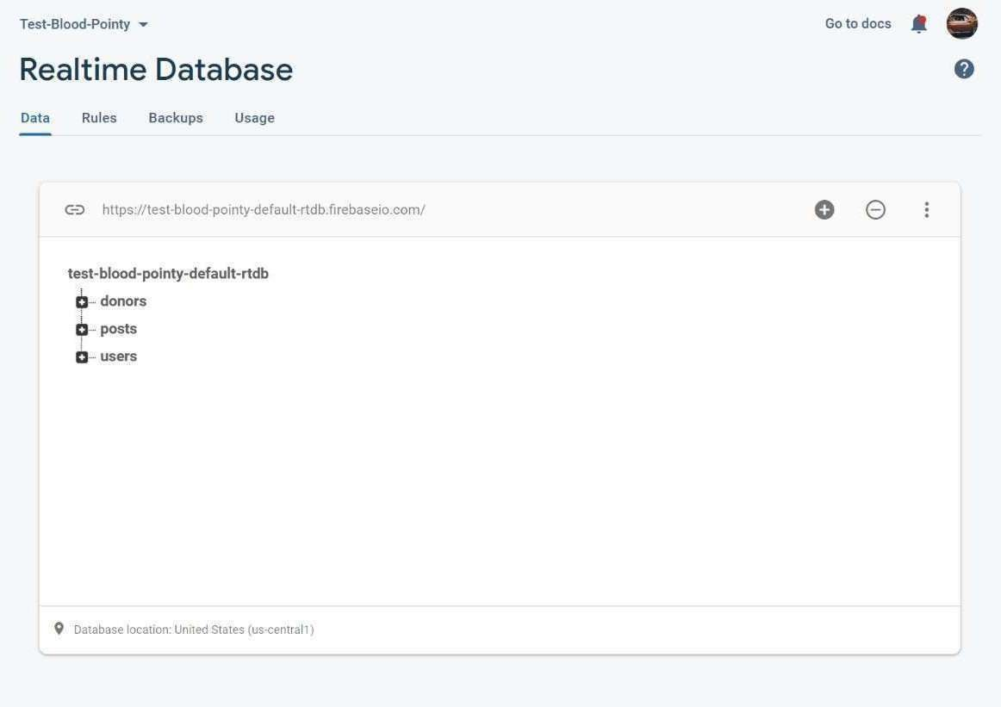

The blood donor application is made to be easy to use for everyone. Even someone who is not good with technology can use the blood donor application without any trouble. The steps are simple: you just need to authenticate with the blood donor application search for blood donors using the blood donor application then get in touch with the blood donors

One good thing about the blood donor application is that people can contact blood donors directly using the blood donor application. Of taking a lot of steps people can quickly get in touch with blood donors using the contact information that is given by the blood donor application. This saves time. Makes the whole process of finding blood donors more efficient using the blood donor application.
Overall, the results show that the blood donor application is not fast but also very useful for finding blood donors. The blood donor application makes it easier to find blood donors and makes the whole process easier and more accessible, for people who need to find blood donors.

DISCUSSION
This project is about solving a problem. Finding blood when its urgently needed. From what we've tested and seen using an app makes it much easier and quicker to find blood.

One of the things about this system is that it gets rid of the need to search manually.
which was stressful and took a lot of time.
The employment of Firebase makes a huge impact on the efficiency of the system. The timely updates ensure that no one has to deal with obsolete data, thus improving the reliability and trust among all stakeholders involved. However, just like any other technological system, there are certain limitations.
First of all, it should be noted that the app operates with the help of the Internet. Hence, it cannot operate without it, which limits its usefulness in areas where there is a lack of network availability. Moreover, the efficiency depends greatly on the number of users since it helps in finding donors. Nonetheless, the system is an enhancement compared to previous methods.

CONCLUSION
The application Blood Point is a practical conversion from theory into reality, thus gaining practical benefits. In this regard, the primary purpose of this software is to allow for fast recognition of blood donors in situations that demand quick action.

A user can use this application to find suitable donors, get in touch with them, and even send them SMSs if required, which is very important during emergencies.
Another great thing about this project is that it shows how good mobile apps can be for health care. they give us information away and we can take them with us wherever we go.
Overall, the Blood Point app does what it is supposed to do. If more people use it and it gets better it could be an important tool, for emergency services and the Blood Point app could be very valuable. The Blood Point app has a lot of potential.

FUTURE WORK

The current application is excellent, but can be made better. This can be done by adding more features to the app.

The first feature can be the automatic detection of the location via GPS. This will allow the app to automatically search for donors in the area without the user typing in the location. This will save time and effort in locating the donors.

The app can also be connected with hospitals and blood banks. This will create a network where hospitals can enter blood availability and contact donors.
It can also be integrated with AI features. For example, it can suggest the appropriate donors according to location, time and activity.
This can make the process quicker and the system can handle more users.

References

  - https://developer.android.com/guide
  - https://en.wikipedia.org/wiki/Android
_Studio
  - https://firebase.google.com/docs/buil d
  - https://www.youtube.com/channel/U C59K-uG2A5ogwlrHw4bmlEg
  - https://en.wikipedia.org/wiki/Blood_d onation_in_India
  - https://science.thewire.in/health/india
-must-change-its-approach-to-blood- donation/

