Understanding The Behavioural Impact Of Snack Content Consumption: A Study Of Delhi University Undergraduate Students

Agranee, Khushi Sharma, Nandini Singh
Under the supervision of Dr. Girish Shastri
Indraprastha College For Women, University Of Delhi

Abstract

The term “Snack Content” has origins in the Wired Magazine 2007 edition. It refers to the Snackable content, or bite-sized content, which encompasses diverse content created in short forms. The driving element of snack content is its high accessibility and immediate information delivery. It provides motivation and encourages positive emotion with its joyful content. On the other hand, it has influenced productivity, procrastination levels, social relationships, and other aspects.
The research aims to understand the behavioural impact of Snack Content Consumption among students with special reference to Delhi University. Its emphasis on investigating the influence of short-form content on productivity, social communication, and the daily lives of students.

METHOD: Using a purposive sampling method, the data of 153 undergraduate college students of the University of Delhi were used in the study. All variables were measured by empirical instruments, and the instruments were highly reliable. Data synthesized, powered by SPSS line graphs and percentage frequency distributions.

RESULTS AND CONCLUSION: Results showed that students consistently engage with snack content consumption due to its concise, relatable, and entertaining features; however, its excess consumption has a tendency to affect daily routine and lifestyle.
The findings broaden our understanding of the behavioural impact of snack content consumption, affecting students’ productivity, everyday routine, and social relationships.

Keywords: Behavioural impact, Compulsion, College students, Productivity, Snack content consumption, Social relationships
INTRODUCTION

Living in the digital world, we’re connected to applications at every moment. Reels have become our reality indeed. According to a report by Datareportal, India recorded over 491 million social media user identities in early 2025. Platforms such as YouTube and Instagram are highly utilized, with snack content becoming the most popular digital format. As the name suggests, it is just like a snack; crisp, quick to consume, and stimulates engagement. (Jinyoung Nam, 2021) Synonyms for short-form content or microcontent, it is created for rapid consumption on social media.

The term “snack content” can be traced back to the 2007 edition of WIRED magazine, where it was reported that the younger generation exhibited a convenient culture of ‘media snacking’, a broader part of the trend of “snack-o-tainment”, a pattern of media consumption in small, bite-sized and interactive format which provides instant gratification.
Almost a decade since the term was introduced, short-form content consumption has only increased in this fast-paced lifestyle. Building on the concept, Carlos A. Scolari, a scholar in Applied Linguistics and Language of Communication, has authored “Cultura Snack” (2020), which emphasizes the short-form communication formats of the present, such as tweets, memes, and short videos.

Snack content provides users with information, a sense of accomplishment, and entertainment. Furthermore, it also offers motivation and encourages positive emotion with joyful content. The sharing feature and content relatability provide a medium of social connection. However, the other side of the perspective is its effect on attention span, memory, and brain rot.

From scrolling through the boredom phase to dedicating a fixed fifteen minutes in our routines, which unknowingly stretches to an hour. It has become part of our everyday lives. As per the Economic Survey 2026, young adults spend over three to over seven hours daily on screens. Thus, understanding how this consumption is impacting various aspects of life becomes necessary.

Researchers have worked on different dimensions of impact, including academic, cognitive, behavioural, and emotional. This study focuses on exploring the behavioural impact of snack content consumption among students through the lens of productivity, compulsive behavior, and communication.

According to the American Psychological Association, Behaviour can be defined as activities in response to external or internal stimuli, including objectively observable activities, introspectively observable activities, and nonconscious processes.

This study explores the behavioural impact of snack content consumption with special reference to Delhi University undergraduate students. The focus is to understand consumption patterns and the behavioural impact of such content on students. Employing a mixed-method research design, the research utilizes a survey and semi-structured interviews of psychology professionals for in-depth insights. The study seeks to create valuable understandings for developing future academic and health interventions.

REVIEW OF LITERATURE
Increasing consumption of snack content has raised questions about its impact on behaviour and mental health of individuals, especially students. This section outlines the key theoretical framework that provides the conceptual foundation for understanding these effects.
Cultivation Theory , proposed by George Gerbner in 1969 , suggests that long-term exposure to media (especially television) gradually shapes how an individual perceives the world and conducts themselves. The theory emphasizes that the more media one consumes, the more likely one is to hold a perception of reality closer to the media’s depiction (Perera,2023).
With the onset of social media and snack content , cultivation theory remains highly relevant even in today’s time and age. People can curate their profiles to showcase exactly what they want to and hide the rest away. Snack Content does not always portray the reality of life and as a result one’s perception of reality can be skewed by what they consume on social media (Vinney,2024).
Researchers highlight how snack content has become an integral part of youth culture. An individual spends 2 to 4 hours daily engaging with snack content , mostly to avoid boredom. This overconsumption can lead to detachment from real life responsibilities (Rahul Chauhan,2021). It has surpassed television to become the primary mode of daily media consumption nowadays (Tandon and Jha , 2025). Snack Content has even surpassed long-form content in terms of views and likes. However, while it captures more attention, long-form content remains more effective in fostering deeper audience connection (Rajendran,Creusy and Garnes, 2024). Features like relatability , fast paced storytelling and algorithm driven personalised feeds are what make snack content so appealing to the young population (Malik, 2025).
Growth of snack content has challenged traditional notions of media consumption and its impact and has led scholars to take a fresh look. Existing research showcases mixed findings, highlighting both positive as well as negative effects of snack content consumption.

Studies highlight several behavioural impacts associated with snack content consumption. Scrolling may provide temporary escape from life stressors but it often results in fatigue and reduced creativity (Aileen, 2024). Hummel (2023), refers to snack content as “digital junk food” that promotes “zombie scrolling”, which means mindlessly scrolling without retaining information. Snack Content provides instant gratification and can become so addictive that it can lead to continued consumption ,even when one experiences negative emotions(Cheng et al., 2023).
Snack Content has also given rise to “binge scrolling”, which means continuous consumption of short form content, where an individual loses the track of time as well as experience perceived loss of self control (Park and Jung, 2024). Binge scrolling often leads to regret, fatigue and reduced productivity. Snack content can also lead to ‘brain rot’ and ‘bed rot’. Brain rot is when constant exposure to fast paced content reduces attention span and memory retention. Bed Rot encompasses behavioural consequences like increased procrastination, social isolation and neglect of responsibilities (Aysi et al., 2025).
Research also highlights the dual nature of impact of snack content consumption. Snack Content can help individuals explore new interests, stay updated with trends, understand complex concepts in a simplified manner. Its impact is not always negative ,but majorly depends upon an individual’s own consumption habits (Jack Martin, 2024). Wang (2024), notes that even though snack content is associated with poor sleep patterns and social comparison , it also serves as a great stress buster and can be educational in nature. Jerremy Adcock (2010), emphasizes that by simplifying complex topics , short form content makes information more accessible. It can act as a starting point for learning new concepts and also help in staying updated with ongoing trends.
While studies suggest snack content can provide access to new information and simplified learning material , some researches also highlight its negative academic impacts. While snack content can deliver information efficiently, it may lead to mindless scrolling and procrastination (Garrison, 2024). Students having a daily average of reel consumption of 3.5hours, experienced difficulty to maintain focus and retain attention (Haliti and Sadiku, 2024).They had higher error rates and slower reaction times. Similarly, John E. (2024) highlights how more than 50% of students consume snack content before sleeping, which leads to poor sleep quality and mood swings. High consumption of snack content leads to shortened attention spans , difficulty in concentration and lower information retention , eventually leading to a poor academic performance.

Research Gap

While the existing literature provides a comprehensive overview of snack content consumption and its impact, the majority of it is based on global populations. There is very limited work focusing on the Indian Context , especially how the youth of the country is impacted by snack content consumption. Almost no study focuses on Delhi University Students , who represent a diverse and digitally active youth population, who consumes snack content frequently. For them, snack content is not just entertainment but a primary source of news, information and validation.

This study aims to address this gap by examining the consumption patterns and behavioural impact of snack content on the students of Delhi University. Hence, it provides insights that are currently missing in both Indian and Delhi-specific research.

METHODOLOGY
Short form content has incorporated itself as an addictive format. Lately, free moments are spent via scrolling through the screens. Such high consumption patterns raise concerns about their potential impact on student’s behaviour and daily routines.
The primary objectives of our study revolve around:
1) To examine the snack content consumption patterns among DU students
2) To examine the behavioral impact of snack content consumption on students.
Thus, the questions our study aims to answer by the end of research process are as follows:
A) What are patterns of snack content consumption among DU students?
B) What is the impact of snack content consumption on behavioral well being of students?
The study follows a mixed method research design to analyze the correlation between snack content consumption and mental well-being of the students of Delhi University. Purposive sampling technique is applied as the study particularly analyzes the data of undergraduate students excluding students from other academic courses. Undergraduates serve as the focal point of the research study. A structured survey collected around 150 responses followed by in-depth interviews of 3 subject matter experts, including practicing psychologists and mental health professionals who serve as the primary tools for data collection while taking care of the ethical guidelines. The varied data gathered from the surveys is processed through line graphs generated through SPSS.
The study is geographically restricted to Delhi and colleges affiliated to Delhi University which makes it challenging to generalize the findings for a larger group of academic population beyond it. The short form content which the research reviews includes Instagram reels and YouTube shorts, excluding other platforms like TikTok and Moj due to limited accessibility. Moreover, the study focuses on the time period from 2020 to present when the term "snack content" earned high popularity reflecting only the recent patterns and trends among the students, ignoring the previous ones.
DATA ANALYSIS AND INTERPRETATION

Data was collected through a survey and interviews. A total of 153 students participated in the survey. Since purposive sampling was employed, the sample consisted entirely of undergraduate students only. Alongside , 3 psychologists were interviewed to gain deeper qualitative insights.

Following analysis presents the demographic profile , consumption patterns and the behavioural impact of snack content consumption of the respondents.

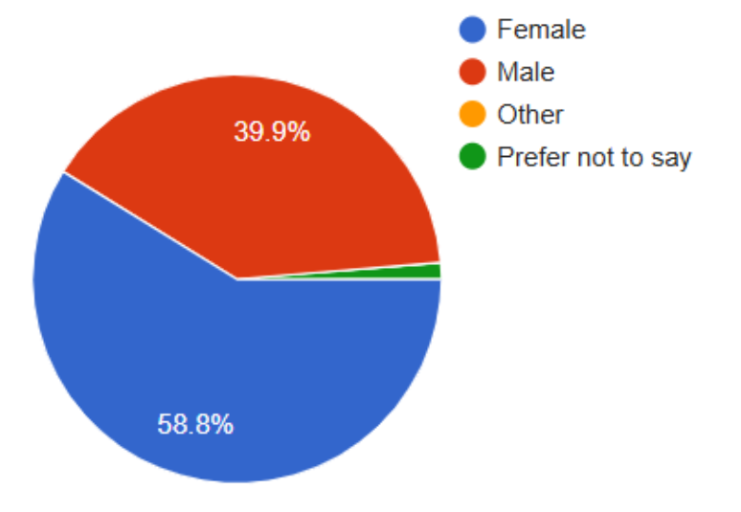
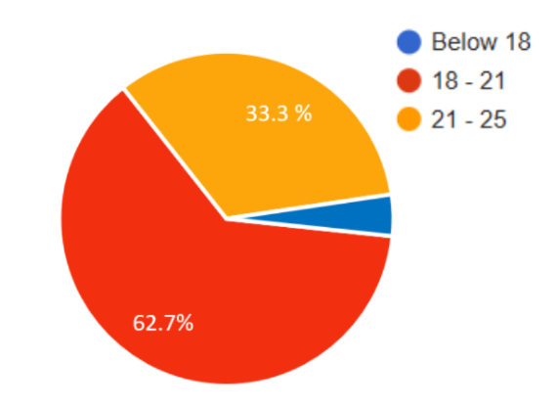
Demographic
Fig. 1.1 - Gender Fig. 1.2 - Age

Out of total respondents 59% were female (90 students) and 40% were male (61 students).This showcases how the gender distribution among respondents was relatively balanced (refer to fig. 1.1).
With reference to age , 63% of the respondents (96 students) were aged 18-21 years , while 33% of the respondents (50 students) were aged 21-25 years. Overall, the majority 95% of respondents (145 students) lie in the age bracket of 18-25 years, representing young adults, a generation which is highly engaged with digital content (refer to fig. 1.2).

Consumption Patterns

Respondents were asked about the devices as well as the platforms they use frequently, with multiple selections allowed.
95% of the respondents (146 students) reported using a smartphone , while 68% of the respondents (105 students) reported using a laptop/PC. This indicates that smartphones dominate daily digital engagement, while laptops come in second. High phone usage makes snack content consumption more likely, as it is mobile-friendly (refer to fig. 1.3).
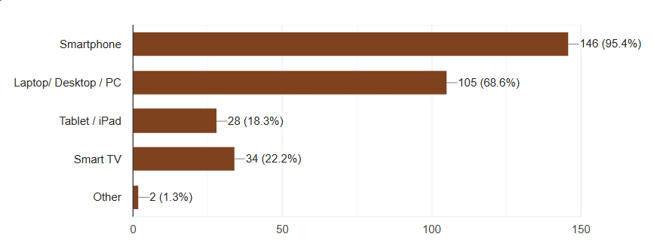
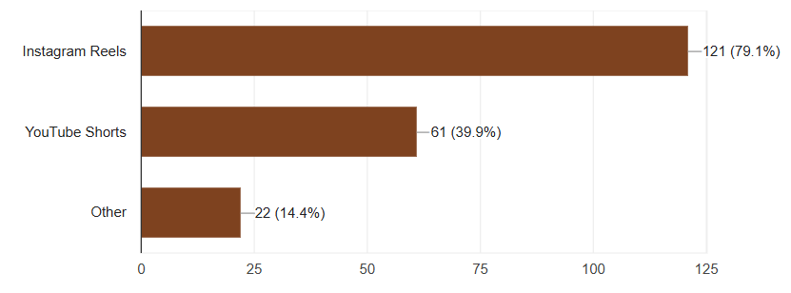
Fig. 1.3 - Device Fig. 1.4 -Platform

Coming to Platforms, 79% of the respondents (121 students) reported consuming Instagram reels, while 40 % of the respondents (61 students) reported consuming Youtube shorts. This indicates that Instagram and YouTube together dominate as major outlets, with Instagram holding a slight lead as the primary ecosystem. Other platforms account for a much smaller share (refer to fig. 1.4).

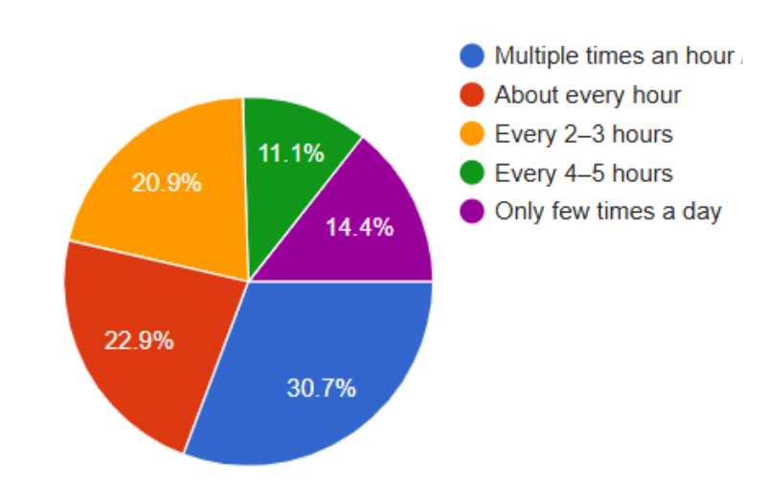
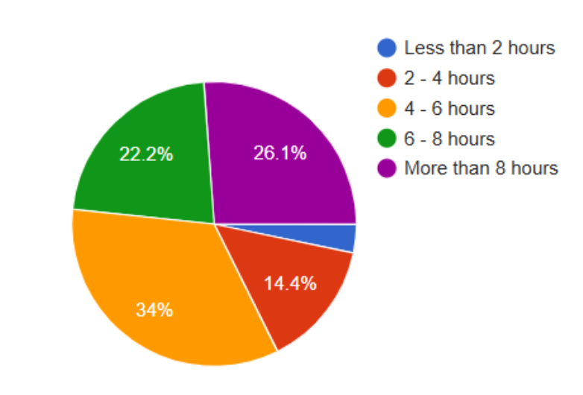

Fig. 1.5 - ScreenTime Fig. 1.6 - Frequency

Respondents were asked about their daily screentime across all devices. 34% of the students (52 students) reported using screens for 4-6 hours ; 26% of the respondents (40 students) reported using screens for more than 8 hours ; 22% of the respondents (34 students) reported using their screens for 6-8 hours ; and 14% of the respondents (21 students) reported using screens for 2-4 hours daily.
Overall, Above 80% of respondents (more than 122 students) spend more than 4 hours on screens daily. This indicates strong exposure to digital content, including snack media (refer to fig. 1.5).
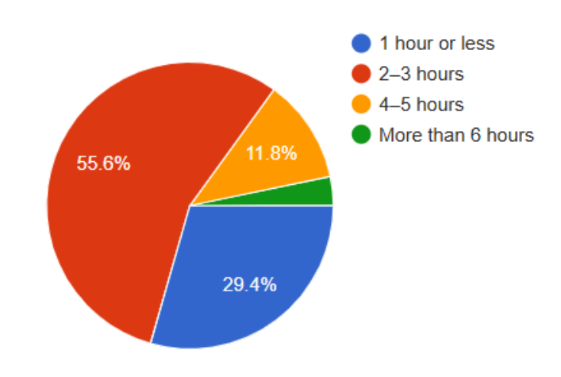
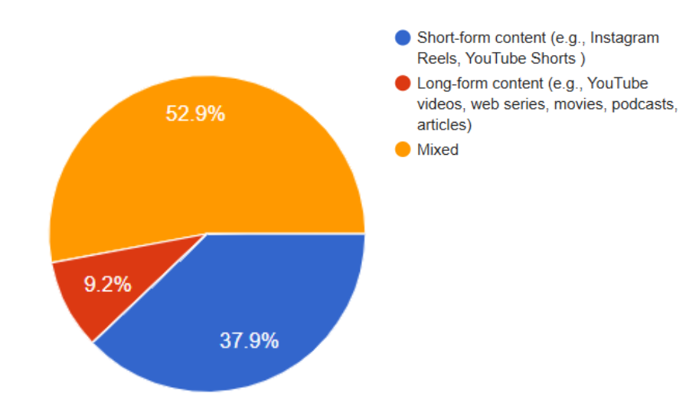
Respondents were also asked about how frequently they check social media. 30% of the respondents (46 students) reported checking it multiple times an hour ; 23% of the respondents (35 students) reported checking it about every hour ; 21% of the respondents (32 students) reported checking in every 2-3 hours ; while 14% of the respondents (21 students) reported checking in only a few times a day.
This indicates more than 50% of respondents (more than 76 students) check social media not just once but multiple times an hour. This high-frequency usage suggests users are stuck in a constant engagement loop (refer to fig. 1.6).

Fig. 1.7 - Format Fig. 1.8 - Exposure

Respondents were asked about the format of content they usually consume. 53% of the respondents (81students) reported preferring mixed format ; 38% of the respondents (58 students) reported preferring Short form or Snack content ; while only 9% of the respondents (14 students) reported preferring long form content only.
This indicates that while long-form content persists, short-form content now plays a dominant role. Short-form content is no longer supplementary, it has become central (refer to fig. 1.7).

Respondents were asked about the time they spend consuming Snack content on a daily basis. 56% of the respondents (86 students) reported spending 2-3 hours ; 29% of the respondents (44 students) reported spending 1 hour or less ; 12% of the respondents (18) reported spending 4-5 hours daily.
Overall, more than two-third of the respondents (109 students) spend more than 2 hours daily on snack content alone. This highlights how snack content takes up a significant part of one’s daily screen time (refer to fig. 1.8).
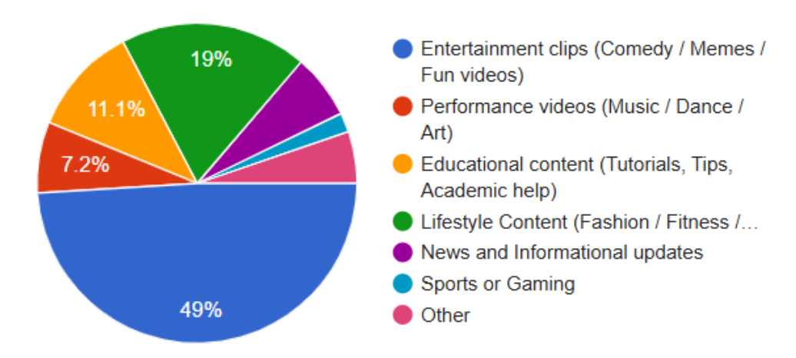
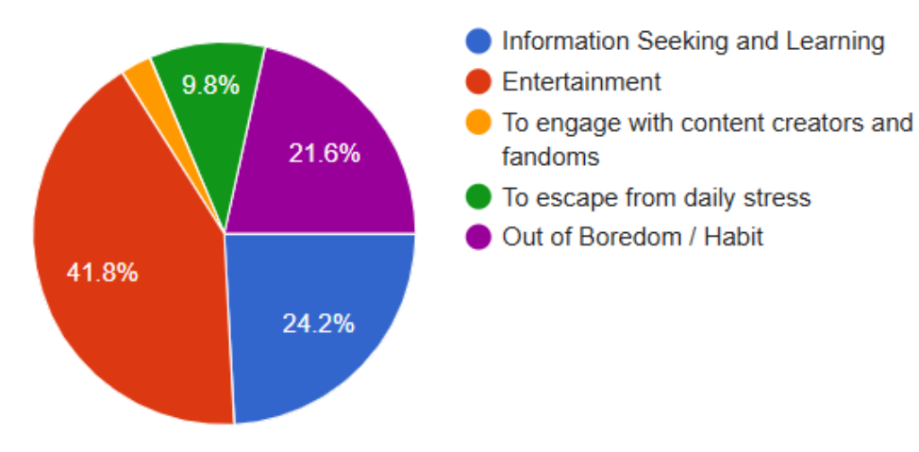
Fig. 1.9 - Genre Fig. 1.10 - Incentive

Respondents were asked about the genre of Snack content they consume the most. 49% of the respondents (75 students) reported preferring entertainment ; 19 % of the respondents (29 students) reported they preferred lifestyle content; while 11% of the respondents (17 students) reported they preferred educational content.
Overall,above 65% of snack content consumption is driven by entertainment and lifestyle genres, while educational content plays a secondary role. This highlights that snack content is primarily consumed for instant gratification and superficial engagement rather than a rich one (refer to fig. 1.9).

Respondents were asked about their primary motives to consume snack content. 42% of the respondents (64 students) reported watching for entertainment; 24% of the respondents (37 students) reported watching for information and learning purposes ; while 22% of the respondents (34 students) reported watching out of boredom or habit; while 10% of the respondents (15 students) reported watching snack content to cope up with daily stressors.
Overall, Entertainment emerging as the most dominant driver of snack content consumption, indicates snack content is consumed for mood enhancement. Gaining information comes in second, and indicates that snack content provides learning opportunities. Habitual use and boredom together emerged as a significant factor, emphasizing how the consumption is often not intentional but passive and automatic in nature (refer to fig. 1.10).

Statement Based

Table 1.0 Survey Statements for Analysis
Statement
Statement 1 | Memes, songs, and challenges have become a part of our offline conversations.
Statement 2 | I prefer sending a reel to a friend rather than writing a long text message to check in on them.
Statement 3 | While commuting to college, I decided to utilize my time for productive work, but ended up scrolling instead.
Statement 4 | Before beginning with my academic work, I spend 5-10 minutes scrolling first.
Statement 5 | I delay sleep by endlessly scrolling short videos.
Statement 6 | I keep swiping videos out of habit, even when I don’t enjoy them.
Statement 7 | I often feel more drained after a long session of scrolling than I did before I started.
Statement 8 | Even when I try to limit my time on social media platforms, I find myself reflexively opening another one to continue scrolling.

Communication

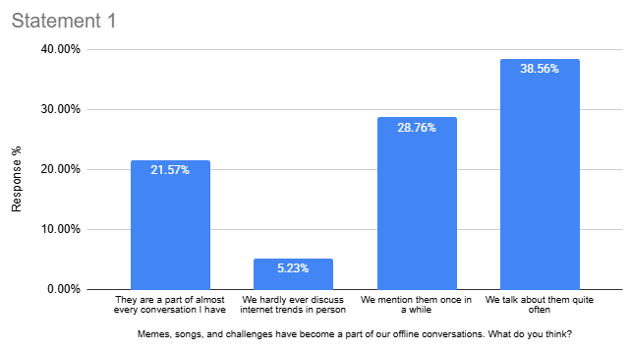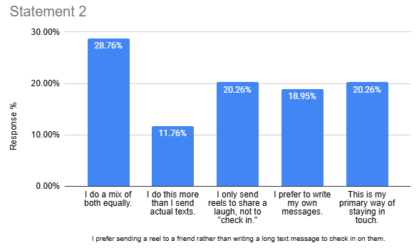
Figure 2.1 Figure 2.2

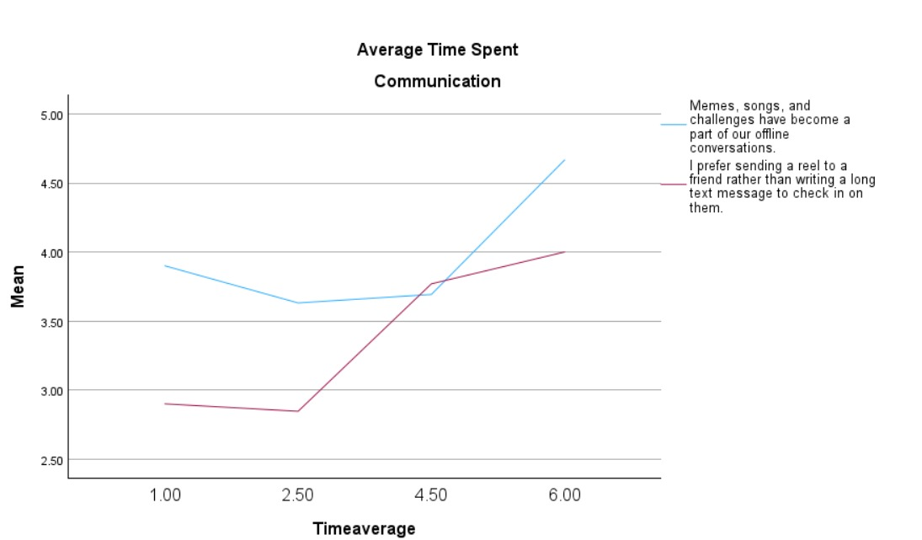
Figure 3.1: Pattern of Snack Content Consumption and Communication

This section explores the influence of snack consumption on the communication aspect. Firstly, statement 1, where a majority of respondents(38.56% and 28.76%) have reported including the content in their conversation, while very few (5.23%) have shown no mention of the internet world offline. (Fig. 2.1)
Followed by statement 2 which focuses on how reels are preferred over a long text to check on a friend. The most preferred response (28.76%) balances between reels and texts equally, inferring that people blend both modes of communication. There is a strong inclination towards(11.76% and 20.26%) using reels as a frequent way of staying connected. (Fig. 2.2)
Moreover, understanding fig 3.1 in the context of time spent, the mean provides a standardized numerical baseline to the individual Likert-scale responses. The blue line (statement 1) at a low consumption of (1.00- 2.50 hours) begins with a high (3.90), however, shows a slight dip ,symbolizing even low-frequency users occasionally use memes, but it is not a dominant part of their communication. The inflection point arises at 4.50 hours mark, when the blue line takes an upward trajectory, crossing a mean of 4.50. Indicating that for high consumption users, it is not just a media but has become a part of communication too. As the responses also show, 38.56% talk about it “quite often” and 21.57% have made it “part of almost everyday conversation”, overall, around 60% users have normalised the reel-lingustics in physical spaces.

Focusing on the red line(Statement 2); however, it is more gradual and slower, but the shift exists. This line remains significantly lower than blue line at the average consumption on 1.00-2.50 hours, with mean at (2.80). Here, the students prefer traditional text or verbal checking in. A convergence can be seen at 4.50 consumption hour marks, where the preference for sending reels has risen rapidly. By the time the consumption is more than 6 hours, the mean for this behaviour rises toward 4.00
This shows traditional form of writing personalized text is getting replaced by the ease of sharing a reel, which is evident with 20.26% students using it as a primary way of staying in touch.
Both lines indicate that snack content is impacting the way the students communicate. Digital culture is taking over offline conversation, while communication has become more visuals based( sharing snack content) and less text-based, however, this shift is slower. Snack content is influencing what and how students talk. Even though using snack content provides greater relatability, it might lack depth of emotion.

Productivity
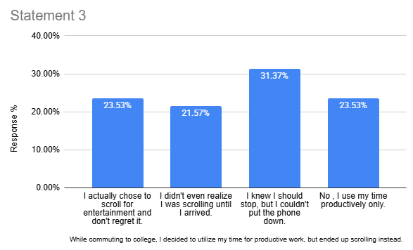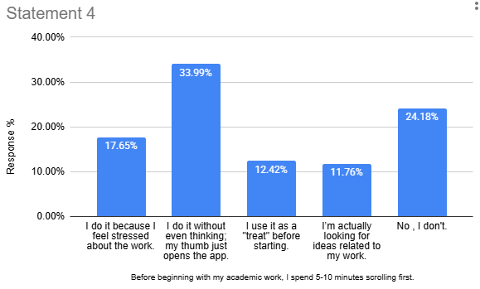
Figure 2.3 Figure 2.4
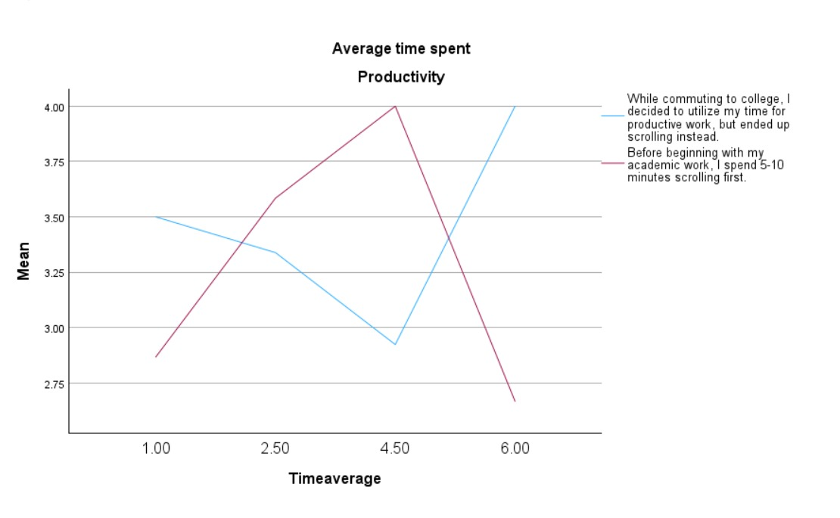

Figure 3.2: Pattern of Snack Content Consumption and Productivity

Focusing on the another behavioural aspect, productivity was assessed based on the following statements, beginning with Statement 3 a majority of respondents (33.37% and 23.53%) reported that irrespective of knowing they were not able to keep the phones down, showing a lack of control in their behaviour, while 23.53% of the population deliberately chose scrolling.The time that students initially decided to some other task was devoted to consuming snack content affecting their routine and daily tasks. (Fig.2.3)
Another statement 4, here the majority of students answered 33.99% of the respondents reported scrolling before beginning with the work without even realizing it, while 17.65% of the population stated that they do it because they feel stressed at work. And the remaining (12.42% and 11.76%) reported to scroll it out of habit and as a treat. (Fig.2.4)
When understood in the time spent context, the results show;for statement 3, the mean behaviour decreases as consumption moves from 1.00 to 4.50 hours. Suggesting moderate users have some control, or the don’t feel the need to scroll as they commute. The inflection point arises from 4.50 hours towards 6.00 hours, where the line takes an upward path, surging the mean from 2.90 to 4.00. This shows a collapse of intentionality; once the student enters the “heavy user” category (6+ hours), it becomes a space dominated by scrolling.
Focusing on statement 4, the red line shows a consistent upward turn from 1.00 to 4.50 hours, with a mean of 4.00. At the 4.50 mark, it represents the procrastination peak, where scrolling before work becomes a ritual. Ironically, during the 6+ hours group, there is a sharp dip.
Emphasizing the cross-over effect, the lines intersect near the 5.00 hours mark, below 5 hours, the productivity leave in intentional, while after it becomes involuntary displacement.

The graph (refer to fig.3.2) shows a dual-phase impact of snack content on workflow. While for moderate users, the obstacle is pre-academic work procrastination for a 4.5 hour threshold, but for 6+ hours consumption users, it shows a behavioural shift, where consuming snack content has become an environment filler.
It could be interpreted that snack content consumption hijacks time which is meant for productive tasks, it delays academic work, students now invest a committed amount of time to scrolling choosing it over other priorities, for it requires less brain interaction, students assume it to be cognitive off loading, translating, they’ll be able to reduce their mental load and easier to consume. eTherefore choosing scrolling over other activity.

Compulsive Behavior

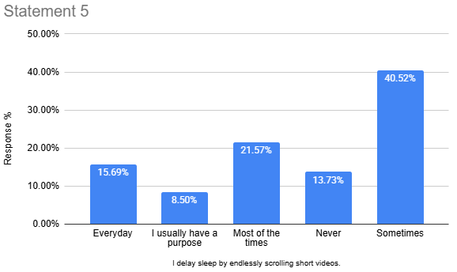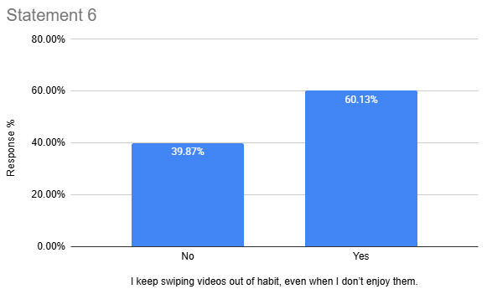
Figure 2.5 Figure 2.6

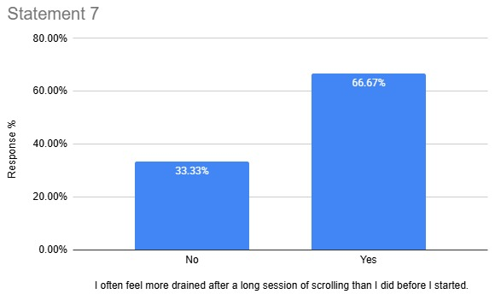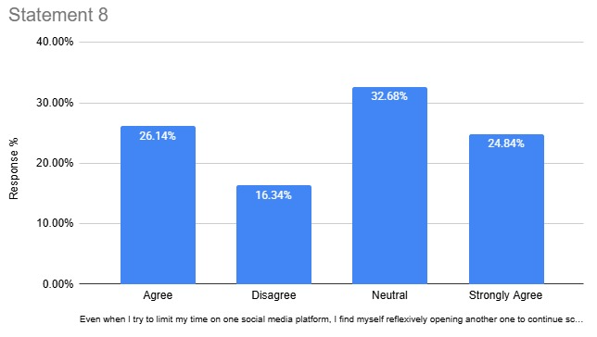
Figure 2.7 Figure 2.8
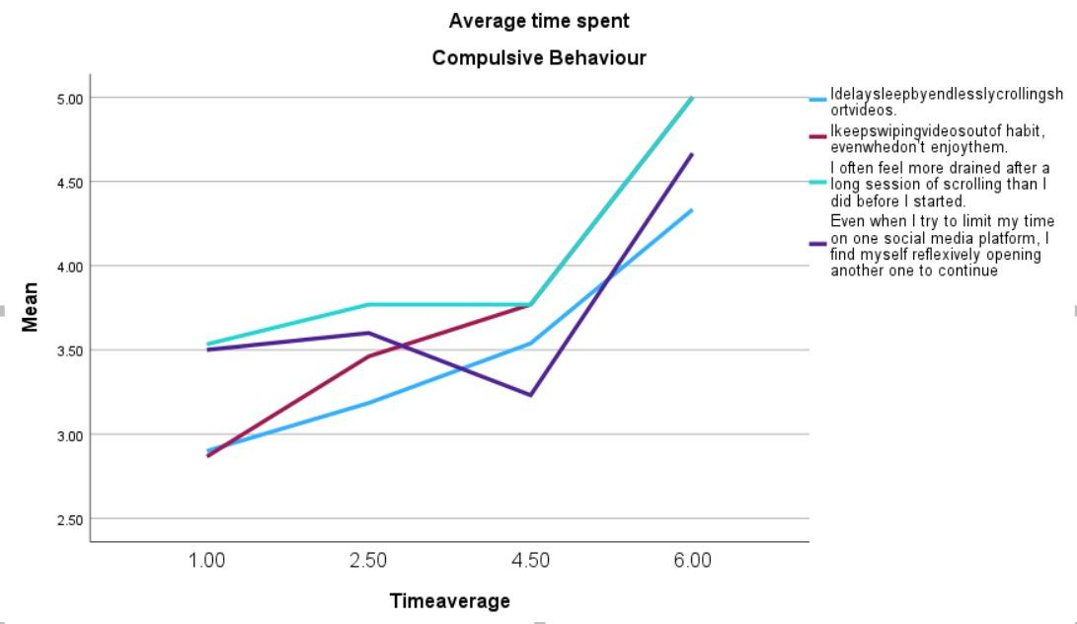
Figure 1.3: Pattern of Compulsive Behavior and Snack Content Consumption
This section analyses the correlation between the time exposure and compulsive behavioural patterns related to snack content consumption. Starting off with fig.2.5, Only 13.7% reported that they refrain from scrolling during their sleep time and 8.5% stated that they scroll purposefully. 40.6% of them delay their sleep sometimes due to scrolling, 21.6% experience this most of the times and the remaining 15.7% experience the same on a daily basis. This distribution highlights that a large proportion (>60%) of students delay their sleep due to unreasonable scrolling.
Understanding fig. 2.6, 60.1% of students reported that they keep scrolling out of habit even when the content is not enjoyable, meanwhile the remaining 39.9% stated that they do not engage in this habitual scrolling behavior. This distribution puts light upon the habitual scrolling pattern which is too prevalent among a larger percentage of students.
Coming to fig 2.7, 66.7% of the students indicated that they experience mental exhaustion after prolonged scrolling, 33.3% do not feel the same. This distribution reveals that the majority connects long hours of scrolling with mental exhaustion.
Lastly, fig 2.8 suggests that 24.8% of the population strongly agreed to the statement indicating high occurrence, 26.1% simply agreed, 32.7% stayed neutral while 16.3% disagreed with the same. This distribution demonstrates that a substantial proportion of students (>50%) switch platforms and find them trapped in the continuous loop of scrolling.
Comprehending fig. 1.3 in context to time spent, the mean value steadily rises from around 2.9 to 4.3 as the time average increases which highlights that the more time people spend consuming snack content, the more they are likely to delay sleep. For statement 6, the mean increases from 2.9 to 3.7 between low to moderate time averages and then levels off slightly before rising again toward 4.7 at the highest time average. This reflects a habitual loop that once formed resurfaces strongly with high usage and automatic behavior. Coming to statement 7, the line starts at 3.5 and shows a sharp increase, especially at higher time averages reaching 5.0 which indicates that mental fatigue is highly sensitive to prolonged scrolling and escalates quickly too. Understanding statement 8, the mean starts at 3.5, slightly increases and then drops around 3.2 and finally sparks sharply to 4.6 which indicates a loss of control and an addictive platform switching behavior. Users might try to self regulate but end up switching platforms.
The results indicate a positive relationship. It highlights that the time spent in consuming snack content is directly proportional to delay in sleep, mental fatigue, and compulsive usage among the students. Despite being aware of this mindless scrolling, they don’t tend to stop which further reflects a lack of self-regulation and control. This prolonged engagement triggers the release of ‘dopamine’- the feel good hormone that leads to digital addiction.
To attain deeper insights into the impact of snack content consumption on student's behaviour , an open ended question was included in the survey , which inquired about the changes in their daily routines due to snack content consumption. Thematic analysis of the same was carried out to identify recurring patterns and are listed below.

Theme | Description | Phrases
Academic Disruption | This theme highlights how snack content consumption poses a negative impact on student productivity, concentration and overall academic performance. | “It has affected my academics a lot”  “Decreased productivity and concentration. In exams I feel like scrolling only”  “Less productivity”  “Procrastination”  “My concentration has decreased and I procrastinate more”
Reduced Engagement in Hobbies | Depicts how spending excessive time on snack content leads to reduced participation in hobbies and offline social interactions. | “Get less time for hobbies”  “Hobbies or socialising changes most probably”  “Energy level drops and less offline interactions”
Altered Sleep Patterns | Captures modifications in student's daily routines , especially sleep schedules due to habitual content consumption. | “Watching reels before going to sleep”  “Disturbed sleep cycle”  “I have gotten habitual to it”
Distraction and Reduced Focus | Reflects concerns around student's attention span and ability to concentration due to snack content consumption | “Increased laziness, procrastination and heavy eyes with less attention span”  “Little bit distracted”  “Motivation for doing better”  “I have lost the ability to sit still and completely delve into academics without thinking about how I can treat myself to a few minutes of social media once I am done”
Positive Outcomes | Identifies various benefits of snack content consumption | “Academics: helps relieve stress, sometimes I get a lot of study tips and hacks from them”  “Hobbies: I have discovered a lot of new things to try because of this”  “Trying to learn new communication skills”

Interviews with psychologists highlight the significant impact of snack content on one’s thinking, behavior, and social life. One becomes dependent on snack content, almost “breathing” through it, and can get so engrossed that they are less aware of their surroundings. This often makes it difficult for them to sit by themselves, and leads to restlessness and compulsive engagement. One rarely spends just a minute on snack content. Excessive consumption can lead to “brain hijacking,” where the brain craves the content compulsively, even when the student is no longer enjoying it. They emphasized that while snack content helps students access new information and stay updated, it has also deteriorated their reading habits, language skills, critical thinking, and other cognitive abilities. In this era of information overload, students often perceive whatever goes viral as the truth.

They also pointed out that students nowadays have more digital friends than offline friends and even with offline friends, they tend to connect through screens. While this shift has helped in relieving stress , providing quick access, at the same time, it has also led to weakened social bonds , interim friendships and increased emotional isolation. Students consume snack content as an escape from life stressors or to seek validation, but these effects provide temporary relief only. Students may develop a compulsive habit , finding it challenging to stop and disconnecting only when they are too exhausted. Over time, this can lead to procrastination , reduced sleep , time distortion and negligence of responsibilities.
CONCLUSION

The study found that among students, smartphones dominate digital engagement, which increases snack content consumption. Instagram is the leading application, followed by YouTube. Moreover, there has been a shift from long-form content to short-form content, where the greater part of users spend more than two hours daily on snack content alone, which is largely driven by the entertainment genre.
While another aspect of the research explored the behavioural impact, the increased usage of snack content is likely to increase compulsive behaviour towards it. Students have made it a significant part of their lives and treat it as a necessity. In addition, the consumption also influences the communication styles; not only has the snack content become a part of the offline world, but it is also becoming a medium to maintain social relationships. And lastly, it is altering daily routines and productivity. Students are choosing it over other priorities, as snack content consumption offers a perceived sense of cognitive offloading. It is assumed that such content requires less brain interaction; all they have to do is scroll, which does not impact mental load.
Snack content consumption is a low-effort activity that students consistently engage with, due to its concise, relatable, and entertaining features; however, its increased usage has a tendency to interfere with their daily routines. Hence, it is advised to consume it with awareness and regulation.
References
Adcock, J. (2023, January 6). In defense of short-form articles. Medium. https://medium.com/@thejabides/in-defense-of-short-form-content-87568bc31ed
Aileen, V. (2024, December 3). The short-form trap: The pitfalls of short-form content and how it can affect our mental well-being. Medium. https://medium.com/@nessaaileen/the-short-form-trap-142f7d99c916
APA Dictionary of Psychology. (n.d.). https://dictionary.apa.org/behavior

Aysi, A. M. T. N., Firdaus, A. R., Pangestu, S. M., & Utomo, H. B. (2025). Short-Form Content, Brain Rot, and Bed Rot: A Literature Review of the Impact on University Students. In ICOSSH (Vol. 2, No. 3, pp. 767–776). ANTiS Publisher. https://doi.org/10.61796/icossh.v2i3.167

Chauhan, R. (2021). Impact of social media on everyday life of the youth [Doctoral dissertation, Banasthali Vidyapith]. Shodhganga. http://hdl.handle.net/10603/370014

Cheng, X., Su, X., Yang, B., Zarifis, A., & Mou, J. (2023). Understanding users’ negative emotions and continuous usage intention in short video platforms. Electronic Commerce Research and Applications, 58, 101244

Chopra, R. (2026). Never logged out: How the internet created India's Gen Z. Bloomsbury Publishing.
“Cultura Snack” (Snack Culture) | UPF-BSM. (n.d.). UPF-BSM. https://www.bsm.upf.edu/en/events/cultura-snack
DataReportal. (2025). Digital 2025: India. https://datareportal.com/reports/digital-2025-india
Garrison, L. (2024, November 17). Is short-form content ruining our attention spans or enhancing our efficiency? Medium. https://medium.com/@lillyg16/is-short-form-content-ruining-our-attention-spans-or-enhancing-our-efficiency-4b636650807c
Haliti-Sylaj, T., & Sadiku, A. (2024). Impact of Short Reels on Attention Span and Academic Performance of Undergraduate Students. Eurasian Journal of Applied Linguistics, 10(3), 60–68. https://doi.org/10.32601/ejal.10306
Hummel, N. (2024, October 10). Why I stay away from short-form content. Medium. https://medium.com/@niclas_hummel/why-i-stay-away-from-short-form-content-a3f023cad70e
John, E. (2024). The impact of short-form video content (Instagram Reels, YouTube Shorts) on students’ concentration, memory, and study habits: A pilot study
Malik, N. I., Ramzan, M. M., Malik, Z., Tariq, I., & Shafiq, S. (2025). The Rise of Reels: Analyzing the Communicative Power of Short-Form Videos on Social Media. Qlantic Journal of Social Sciences, 6(2), 138–145. https://doi.org/10.55737/qjss.vi-ii.25350
Martin, J. (2024, August 15). Short form content is not making you dumb!! Medium. https://medium.com/%40aman280522/short-form-content-is-not-making-you-dumb-64383e01ea7c (medium.com)
Miller, N. (2007, March 1). Minifesto for a new age. WIRED. https://www.wired.com/2007/03/snackminifesto/
sn, J., & Jung, Y. (2021). Digital native’s snack content consumption and their goals: A means-end chain approach. Telematics and Informatics, 63, 101664.

Park, J., & Jung, Y. (2024). Unveiling the dynamics of binge-scrolling: A comprehensive analysis of short-form video consumption using a Stimulus–Organism–Response model.
Perera, A. (2023). Cultivation theory. Simply Psychology. https://www.simplypsychology.org/cultivation-theory.html
Rajendran, P. T., Creusy, K., & Garnes, V. (2024). Shorts on the rise: Assessing the effects of YouTube Shorts on long-form video content. arXiv. https://doi.org/10.48550/arXiv.2402.18208
Snack culture and virality. (n.d.). CCCB. https://www.cccb.org/en/w/articles/snack-culture-and-virality
Tandon, S., & Jha, L. (2025, September 12). Short-form videos overtake TV viewing in India, says Meta report. LiveMint. https://www.livemint.com/companies/shortform-video-consumption-india-meta-reels-india-report-reels-vs-tv-11757586387667.html
Verma, A. M. (2025). The great Indian brain rot: Love, lies and algorithms in digital India. Bloomsbury Publishing India.
Vinney, C. (2024). What is cultivation theory? Verywell Mind. https://www.verywellmind.com/cultivation-theory-5214376
Wang, W. (2024). Exploring the impact of social media short-form videos on adolescent’s psychological and psychosocial well-being. SHS Web of Conferences, 199, 02016. https://doi.org/10.1051/shsconf/202419902016

