Geospatial Analysis of Leprosy Stigma and Socio-economic Reintegration Among Tea Laborers: A Case Study in Tea Estates of Sylhet District, Bangladesh

ABSTRACT
Leprosy remains a major public health and social challenge among marginalized tea estate workers in Sylhet District, Bangladesh, despite the availability of multidrug therapy (MDT). Existing studies have primarily emphasized clinical management, while limited attention has been given to the spatial dimensions of stigma and its socioeconomic consequences within plantation communities. This study examines the spatial distribution of leprosy-related stigma and its influence on socioeconomic reintegration in Malnicherra and Lakkatura Tea Estates. A mixed-method approach integrating geospatial analysis, correlation analysis, and Ridge Regression modeling was applied using survey data collected from 385 current and former leprosy patients through snowball sampling. The findings reveal that Lakkatura Tea Estate experiences higher concentrations of leprosy cases, stronger stigma intensity, poorer healthcare accessibility, and greater economic vulnerability compared to Malnicherra. Social exclusion and discriminatory treatment were identified as major barriers to livelihood recovery and community reintegration. Correlation analysis demonstrated that long-term residence within tea estates was positively associated with stigma and income vulnerability, including Community Treatment After Knowing Leprosy (r = 0.12) and Impact on Ability to Earn Income (r = 0.10), while community participation showed a negative relationship with mental wellbeing impacts (r = −0.12). Ridge Regression analysis further revealed that discriminatory community behavior significantly intensified economic hardship (β = 0.064), whereas improved healthcare accessibility and community participation reduced socioeconomic vulnerability. The study concludes that medical treatment alone is insufficient to address leprosy-related stigma and recommends integrated healthcare, livelihood rehabilitation, sanitation improvement, mental health support, and community-based stigma reduction to improve reintegration and quality of life.
Key words: Leprosy Stigma; Tea Estate Workers; Socioeconomic Vulnerability; Healthcare Accessibility; Geospatial Analysis

INTRODUCTION
Leprosy, which is caused by bacterium Mycobacterium leprae, is one of the oldest infectious diseases known to mankind. Leprosy mainly impacts skin, peripheral nerves, upper respiratory tract and eyes. Untreated leprosy can cause irreversible disabilities and disfigurement (Schreuder et al., 2015). Although the multidrug therapy (MDT) has made leprosy a curable disease and reduced the global incidence, its social and psychological effects are still present in many societies (Marahatta et al. 2018). In particular, stigma and discrimination are serious barriers that impede early diagnosis, treatment, and social marginalization of people living with it. The World Health Organization (WHO) reports that leprosy is a very neglected tropical disease globally and it accounts for a total of 2,14,000 new cases yearly. The greatest number of cases were reported from South and southeast Asia. In Bangladesh, according to WHO thresholds, leprosy has been officially declared to be “eliminated as a public health problem” (WHO, 2024).
Nevertheless, new cases continue to occur, particularly among marginalized and underserved populations (Saha et al., 2025). Tea estate workers in Sylhet, particularly in Malnicherra and Lakkatura are facing multiple vulnerabilities. The presence of poor housing and sanitation, low literacy, limited health care services and caste hierarchies leads to an environment that may engender infection as well as stigma (Hussain et al. 2025; Zaman and Abir 2018). People who are stigmatized are often isolated socially, lose jobs, face discrimination in marital prospects, and are marginalized from society (Tsutsumi et al., 2007). Cultural and religious beliefs about leprosy cause people to have unfounded fears and misconceptions on leprosy, which leads to social stigma (Sundar Rao, 2015).
Visible deformities associated with leprosy, such as disfigurement, epilepsy, and blindness, also support stigma. This posing hurdle in accessing education, employing opportunities and other benefits (Marahatta et al. 2018; Adhikari et al. 2014). Even though many epidemiologic studies have mapped the distribution of leprosy and geographical hotspots (Schreuder et al., 2015; Souza et al., 2019), the research has rarely examined stigma itself. This study uses a geographic, social and economic perspective to understand the leprosy stigma in tea estate communities which adds on to the literature. The study explains how ecological, cultural, and structural factors intersect to determine the distribution of stigma against affected individuals and their ability to reintegrate through linking space with profile and socio-economic characteristics.
MDT and other clinical treatments can cure the ailment, but stigma hinders recovery and socio-economic inclusion (Nery et al., 2019). Recent studies show stigma is not an equal opportunity phenomenon; its actualization is shaped by geographic, social norm-related and institutional factors (Van Brakel et al., 2019; Stangl et al., 2019). There is little research on how stigma interacts with socio-economic reintegration, which is a knowledge gap that impedes the development of community programs. The study provides a wider factor that underpin reintegration in reference to socio demographic factors which include gender, education, income and community awareness (Muldoon et al., 2022). It can help NGOs, local health authorities and policymakers to plan non-discriminatory rehabilitation programs by understanding the spatial and social dimensions of stigma. Some of the possible interventions for stigma reduction include developing awareness campaigns that are culturally responsive, providing livelihood support and developing community-level social reintegration programs, and making available mental health services for affected tea estate leprosy workers (Barbosa et al., 2022; Koschorke et al., 2022). It is useful to record the lived experiences through participatory means for interventions that respect local cultural norms especially when promoting social inclusion (Agarwal and Mishra, 2022; Peters et al. 2015). The research findings can serve as a model for addressing stigma against leprosy and similar marginalized groups worldwide. This can help advance understanding of health, social justice and geographic inequities (Farzana et al., 2022; Sharma et al., 2022).
However, the primary objective of this research is to investigate a socio-spatial assessment of leprosy vulnerability by integrating geospatial clustering, stigma dynamics, healthcare accessibility, and socioeconomic resilience in order to identify how structural inequalities within tea plantation communities influence the long-term reintegration and quality of life of leprosy-affected individuals in Sylhet District, Bangladesh.
Existing studies have addressed leprosy clinical management (Kabir & Hossain, 2019; Kalita et al., 2020) and its general socio-economic implications (Withington et al., 2005; Adhikari et al., 2014), but few have combined spatial analysis with social investigation. Therefore, the core research problem is: “How does the spatial distribution of leprosy-related stigma influence the socio-economic reintegration of affected tea laborers in Sylhet’s Malnicherra and Lakkatura tea estates?”
The research hypothesis includes: 1) The stigma of leprosy is not spread out evenly in Malnicherra tea estate and Lakkatura tea estate. 2) Laborers affected by leprosy with stigma have poor socio-economic reintegration outcomes. 3) Community awareness and support mechanisms within the tea estates help to positively influence socio-economic reintegration.
The research questions that would be formulated for this study: 1) How is leprosy-related stigma geographically distributed among tea laborers in the Sylhet district? 2) What socio-economic challenges do leprosy-affected laborers face during their reintegration into tea estate communities? 3) Which social and environmental factors promote or hinder successful socio-economic reintegration of these individuals?
LITERATURE REVIEW AND CONCEPTUAL DEVELOPMENT
Conceptual Understanding of Leprosy and Stigma
Historical and Social Construction of Leprosy Stigma
Leprosy has historically been recognized as one of the most socially stigmatized infectious diseases. People affected by leprosy were often isolated from society and treated as social outcasts because the disease was associated with religious punishment, impurity, and lower caste identity (White, 2022). Between the fourteenth and nineteenth centuries, compulsory isolation in leprosaria institutionalized discrimination and reinforced fear toward affected individuals (Weiss & Ramakrishna, 2015). Although multidrug therapy (MDT) has transformed leprosy into a curable disease, many traditional misconceptions and discriminatory attitudes continue to persist in developing countries (Grzybowski et al., 2016).
Health Stigma and Theoretical Perspectives
Health-related stigma is increasingly understood as a structural and intersectional process shaped by social, institutional, and cultural forces. Stigma influences healthcare access, social participation, and economic opportunities through discrimination and exclusion (Stangl et al., 2019). Social identities such as gender, occupation, class, and ethnicity further intensify health-related stigma and inequality. Fear of contagion, visible deformities, and perceived social danger are major factors contributing to stigma across different diseases (Rao et al., 2021). Educational interventions, peer counselling, empowerment strategies, and contact-based awareness programs have been identified as effective approaches to reduce stigma and improve social acceptance (Stangl et al., 2019; Van Brakel et al., 2019).
Global Perspectives on Leprosy Stigma and Discrimination
Leprosy-related stigma remains a persistent global challenge despite major advances in medical treatment and disease control. In countries such as India, Indonesia, Nepal, Brazil, Sri Lanka, Nigeria, and Ethiopia, people affected by leprosy continue to experience discrimination in employment, education, marriage, healthcare access, and community participation (Tsutsumi et al., 2007; Lusli et al., 2015). Social exclusion, internalized stigma, emotional trauma, and fear of disclosure remain common experiences among affected populations. In many cases, visible disability and cultural misconceptions intensify discrimination and negatively influence mental wellbeing and quality of life (van Dorst et al., 2020; Achdiat et al., 2021). Studies conducted across Asia, Africa, and Latin America also reveal that stigma-related fear contributes to delayed diagnosis, treatment avoidance, and long-term socioeconomic vulnerability (Sermrittirong & Van Brakel, 2014). Community-based awareness, inclusive healthcare systems, psychosocial support, and participatory stigma reduction interventions have therefore been identified as essential strategies for improving social reintegration and reducing discrimination worldwide (Sharma et al., 2022; Murphy-Okpala et al., 2025).
Psychosocial and Mental Health Consequences of Leprosy
Quality of Life and Psychological Distress
Leprosy significantly affects the quality of life and mental wellbeing of affected individuals. Lower quality of life, poor mental health, and perceived stigma have been strongly associated with leprosy patients compared to non-affected populations (Bhatia & Chandra, 2011). Perceived stigma acts as a major mediator of psychosocial suffering and social exclusion among affected individuals (Tsutsumi et al., 2007; Ebenso et al., 2018). High prevalence of depression, anxiety, psychiatric morbidity, and low self-esteem has also been identified among persons affected by leprosy and their family members. Mental health conditions are influenced by disease-related disability, stigma, discrimination, and socioeconomic vulnerability (Somar et al., 2020).
Poor mental wellbeing and severe depression are more common among individuals experiencing visible disability and higher perceived stigma (Verma, Gautam & Singh, 2014). Despite improvements in treatment and disease awareness, stigma continues to negatively influence emotional wellbeing, treatment-seeking behavior, and long-term social reintegration (van Dorst et al., 2020; Achdiat et al., 2021).
Depression, Anxiety, and Social Isolation
Clinically significant anxiety and depression are highly prevalent among leprosy patients and are strongly associated with stigma and social discrimination. Perceived, enacted, and internalized stigma contribute significantly to psychological distress and depressive symptoms among affected persons (Sharma et al., 2022; Niardhy et al., 2024).
Depression and suicidal ideation are also common among people affected by leprosy, particularly among individuals facing disability, unemployment, poverty, and social exclusion (Govindharaj, Srinivasan & Darlong, 2021). Psychiatric comorbidities and inadequate social support further worsen emotional wellbeing and social functioning, highlighting the need for integrated mental healthcare and stigma reduction programs within leprosy treatment systems (Keerthana et al., 2025; Yellu & Suresh, 2022).
Community Perception, Social Exclusion, and Participation Restrictions
Community Attitudes and Cultural Beliefs
Religious beliefs, cultural misconceptions, and psychological fears continue to sustain leprosy stigma despite the availability of effective medical treatment. Negative public attitudes and limited awareness contribute to discrimination, delayed treatment seeking, and social exclusion (Sundar Rao, 2015). Educational attainment and urban exposure are positively associated with more favorable attitudes toward people affected by leprosy, indicating the importance of awareness and community-based educational programs in reducing stigma (Urgesa et al., 2020).
Social Participation and Exclusion
People affected by leprosy experience greater social exclusion, emotional distress, and participation restrictions compared to individuals with other disabilities (Heijnders & Van Der Meij, 2006). Stigma negatively influences self-esteem, interpersonal relationships, social interaction, and participation in community activities (Deepak, 2012). Shared experiences of exclusion among marginalized groups suggest the importance of inclusive advocacy and community-based interventions for stigma reduction (Lusli et al., 2015).
Severe psychosocial burden, social isolation, and emotional trauma are common among individuals affected by leprosy and other neglected tropical diseases (Rafferty, 2005). Leprosy reactions often restrict mobility, employment, bathing, eating, sleeping, and other daily activities, resulting in financial hardship and reduced quality of life (Ton, Mackenzie & Molyneux, 2019). Cultural responses to stigma also vary across communities, influencing coping strategies and social behavior (van Wijk et al., 2021; Putri et al., 2022).
Tea Estate Communities and Socioeconomic Vulnerability in Sylhet
Tea estate workers in Sylhet District represent one of the most socioeconomically marginalized labor communities in Bangladesh. Most tea laborers live in overcrowded settlements with inadequate sanitation, poor housing conditions, insecure employment, limited educational opportunities, and insufficient healthcare services (Islam & Al-Amin, 2019). Historical social exclusion, low wages, and geographical isolation have contributed to persistent poverty and poor health outcomes among tea garden populations (Jahan et al., 2024). Previous studies on tea estate communities in Sylhet indicate that workers frequently experience malnutrition, communicable diseases, social deprivation, and restricted healthcare accessibility due to institutional neglect and infrastructural limitations (Khan, Rahman & Hossen, 2019; Chowdhury et al., 2018). These conditions create an environment where stigma-related diseases such as leprosy become more difficult to diagnose, manage, and socially address. Limited awareness, fear of discrimination, and poor healthcare access further intensify social isolation and socioeconomic vulnerability among affected tea laborers. Therefore, tea garden communities provide an important context for examining the interaction between spatial marginality, disease stigma, and socioeconomic reintegration.
Healthcare Accessibility, Stigma Reduction, and Reintegration
Barriers to Healthcare and Delayed Diagnosis
Healthcare accessibility remains a major challenge in leprosy-endemic regions. Stigma-related fear, passive case detection, lack of awareness, and inadequate healthcare services contribute significantly to delayed diagnosis and treatment seeking (Cross, Choudhary & Sharma, 2015). Delayed diagnosis increases the risk of disability, prolonged disease transmission, and long-term social exclusion (Lockwood & Suneetha, 2005). Active case detection and selective health education have been identified as important strategies to improve early diagnosis and reduce stigma-related healthcare barriers (Dharmawan et al., 2023).
Socio-Economic Reintegration and Stigma Reduction Interventions
Socio-economic empowerment interventions such as livelihood support, microcredit programs, and community participation significantly improve self-esteem, social interaction, and reintegration among persons affected by leprosy (Blok et al., 2015). Improved economic participation reduces stigma and participation restrictions while enhancing social acceptance within communities (Dadun et al., 2019).
Participatory stigma reduction strategies involving affected individuals, healthcare workers, and local stakeholders are essential for sustainable intervention outcomes (Barreto et al., 2017). Community awareness campaigns, validated stigma assessment tools, psychosocial support, and culturally appropriate interventions are important for reducing discrimination and improving quality of life among affected populations (Murphy-Okpala et al., 2025; Rahayu et al., 2025).
Research Gap and Conceptual Development
Existing literature extensively discusses the psychosocial, economic, and mental health impacts of leprosy stigma. However, limited studies have examined the spatial distribution of stigma and its relationship with socio-economic vulnerability, healthcare accessibility, and reintegration challenges within marginalized labor communities. Most previous studies focus primarily on clinical outcomes, generalized stigma, or mental health dimensions without integrating geospatial analysis and socio-economic assessment (Tatem & Bangs, 2018; Lima et al., 2021; Freitas et al., 2020).
Furthermore, tea estate communities in Bangladesh remain significantly underrepresented in leprosy-related research despite experiencing overcrowded housing, poor sanitation, insecure employment, and limited healthcare access (Hossain & Khan, 2020). Therefore, this study develops a socio-spatial framework connecting leprosy stigma with healthcare accessibility, mental wellbeing, socio-economic vulnerability, and community reintegration among tea estate workers in Malnicherra and Lakkatura tea estates. The conceptual framework assumes that spatial marginality, poverty, social exclusion, and inadequate healthcare collectively shape the long-term socio-economic outcomes of people affected by leprosy.
METHODOLOGY
Study area
The research was conducted at the two popular tea estates: Malnicherra and Lakkatura situated in the northeast Bangladesh (24°53′N–91°52′E) of Sylhet District. Founded in 1854, Malnicherra is the first-ever commercial tea estate of South Asia which is still a geographically large estate that exemplifies the historical continuity of plantation labour systems and settlement morphology (Arefin & Hossain, 2022). The Lakkatura Tea Estate shows transitional landscapes, where estate-based livelihood and urban economy converge, as well as land-use pressures (Chowdhury et al. 2018). The tea labour communities in both estates don’t have access to education, healthcare, as well as property rights, and are socials and economically excluded (Zaman & Abir, 2018). From a health geography point of view, the segregation of tea garden settlements from public health infrastructure creates structural restrictions on diagnosis, treatment and rehabilitation for chronic diseases leprosy (Sinha, 2022). As noted in earlier geospatial studies, leprosy cases are still seen to show spatial clustering in northeastern Bangladesh. These spatial analyses could help us better understand the disease ecology of leprosy and community-level stigma (Bulstra et al., 2021; Fischer et al., 2008).
When combined, Malnicherra and Lakkatura both places are valuable evidence of how leprosy stigma and economic reintegration work in space. These aspects are located among tea labourers in Sylhet District.
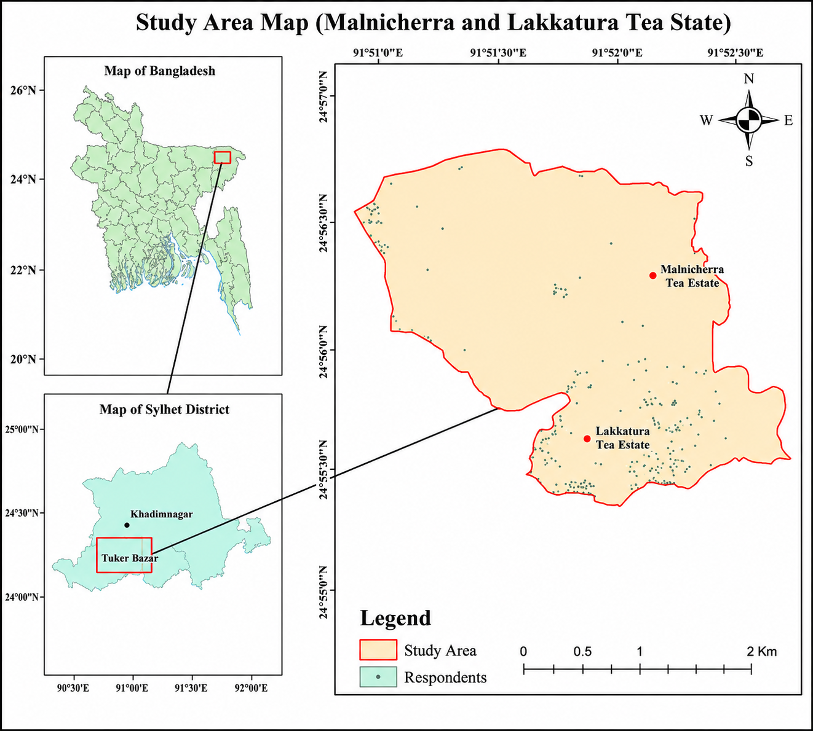
Figure 1: Study Area Map
Sampling method and sample size
This study applied a snowball sampling technique to identify and collect information from leprosy-affected individuals within the Malnicherra and Lakkatura Tea Estates of Sylhet District, Bangladesh. Snowball sampling was considered appropriate because leprosy patients often remain socially marginalized and difficult to identify due to stigma and discrimination. Initially, a small number of diagnosed and previously treated leprosy patients were identified through local healthcare contacts and community referrals. These respondents subsequently assisted in identifying additional participants within the tea estate communities. A total of 385 respondents, including both current and former leprosy patients, were selected for the study. The sample size was considered adequate for examining the spatial distribution of leprosy stigma, healthcare accessibility, socioeconomic vulnerability, and community reintegration among tea estate workers.
Data collection methods
Both primary and secondary data sources were used in this research. Primary data were collected through a structured questionnaire survey conducted among 385 respondents in the Malnicherra and Lakkatura Tea Estates. The questionnaire included information related to socio-demographic characteristics, healthcare accessibility, stigma experiences, community participation, mental wellbeing, employment conditions, and the socioeconomic impacts of leprosy. In addition, field observation and informal discussions were conducted to understand the living conditions, sanitation facilities, and healthcare environments within the tea estates. Geographic coordinates and spatial information were also collected to identify the spatial concentration and distribution of leprosy cases and stigma patterns.
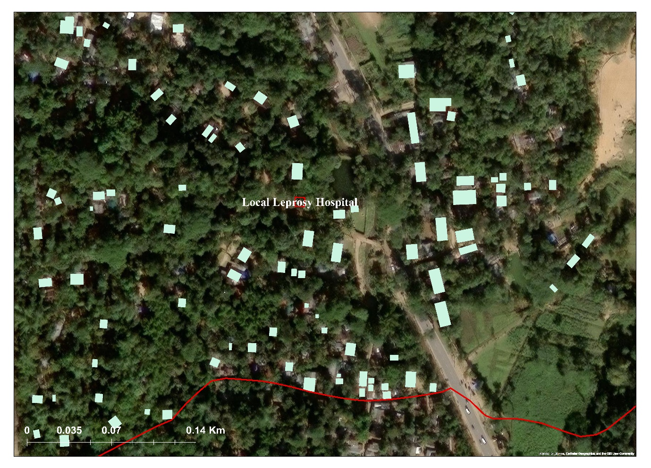
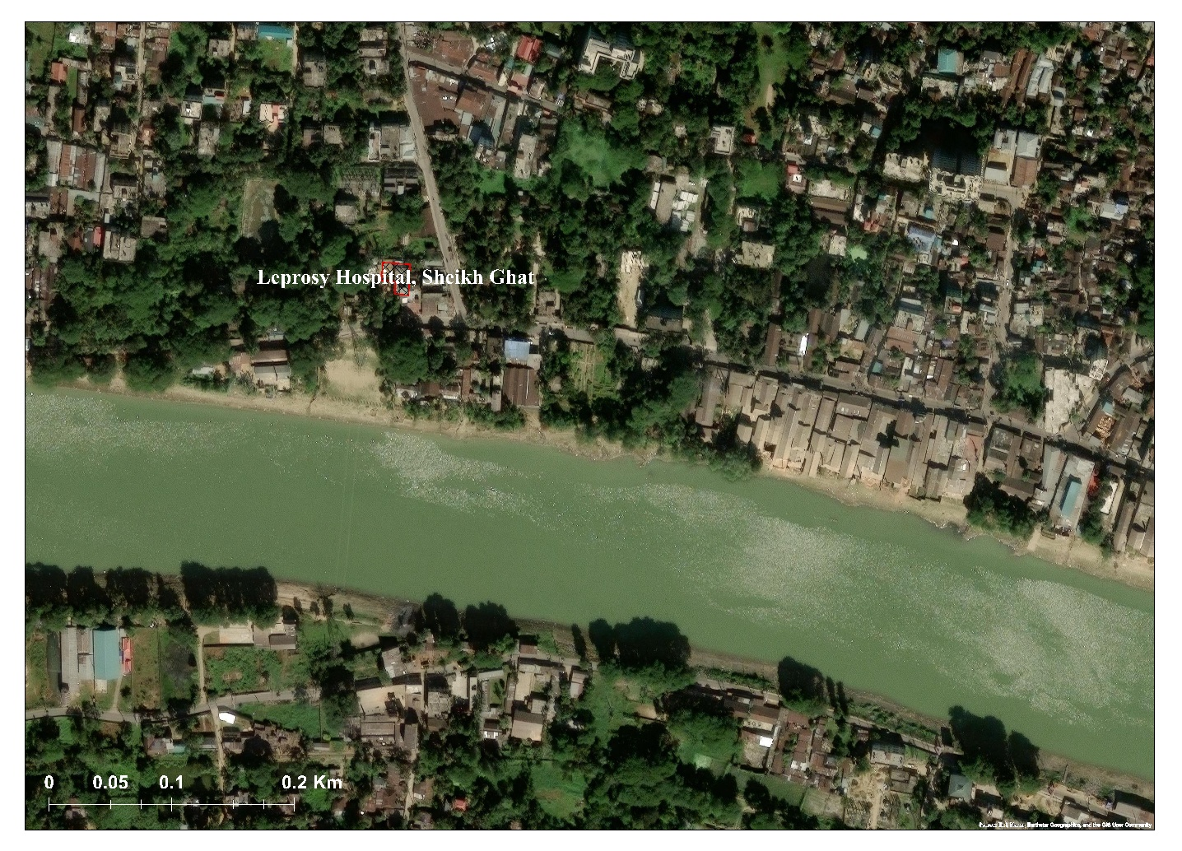
Figure 2: Leprosy Hospital in Lakkatura Tea Estate
Figure 3: Leprosy Hospital in Sheikh Ghat, Sylhet

The study also incorporated institutional-level healthcare information from the Local Leprosy Centre in Lakkatura Tea Estate and the Leprosy Hospital at Sheikh Ghat, Sylhet. The local leprosy centre primarily functions as a community outreach facility with limited diagnostic and treatment capacity, while the Sheikh Ghat Leprosy Hospital serves as a referral center providing specialized diagnostic, therapeutic, and rehabilitative services for leprosy-affected individuals across Sylhet District. The integration of healthcare facility data with estate-level field surveys strengthened the reliability and comprehensiveness of the research findings regarding healthcare accessibility, stigma experiences, and treatment challenges among tea estate workers. Secondary data were obtained from published journal articles, books, government reports, healthcare records, and relevant institutional documents related to leprosy, stigma, and tea estate communities.
Data analysis techniques
The collected data were analyzed using both qualitative and quantitative approaches. Descriptive statistical techniques such as frequency distribution, percentage analysis, and comparative assessment were used to interpret socio-demographic characteristics, stigma experiences, healthcare accessibility, and livelihood conditions of respondents. Geospatial analysis techniques were applied using GIS-based mapping to identify the spatial distribution of leprosy cases and stigma concentration within the study area. Correlation analysis was conducted to examine the relationships among stigma, healthcare accessibility, mental wellbeing, social participation, and income vulnerability. In addition, Ridge Regression analysis was employed to evaluate the influence of socioeconomic and stigma-related factors on the earning capacity and reintegration experiences of leprosy-affected tea workers. Tables, charts, heatmaps, and comparative graphical representations were used to present and interpret the findings effectively.
RESULT AND DISCUSSION
Baseline characteristics
The socio-demographic characteristics of respondents reveal the structural vulnerability and socioeconomic marginalization of tea estate communities affected by leprosy. The disease burden was more concentrated among middle-aged and older populations, particularly within the 51–60 years age group (21.82%), indicating the long-term impact of poor living conditions, inadequate healthcare, and occupational hardship. Male respondents constituted 61.04% of the sample, reflecting the gendered labor structure of tea plantations where men are more engaged in permanent income-generating work, while women remain concentrated in insecure and low-paid labor.
Table 1: Socio-demographic characteristics of Leprosy affected respondents
Socio-demographic Characteristics | Frequency | (%)
Age  20-30 years  31-40 years  41-50 years  51-60 years  61-70 years  71-80 years  > 80 years | 70  69  61  54  60  70  1 | 18.18%  17.92%  16.62%  21.82%  15.58%  18.18%  0.26%
Gender  Male  Female | 235  150 | 61.04%  38.96%
Place of residence  Rural  Semi-urban  Urban | 311  54  20 | 80.78%  14.03%  5.19%
Duration living on tea estate  < 1 year  1-5 years  6-10 years  > 10 years | 58  73  175  79 | 15.06%  18.96%  45.45%  20.52%
Employment status  Permanent worker  Temporary/casual worker  Retired  Unemployed | 74  174  43  94 | 19.22%  45.19%  11.17%  24.42%

A large majority of respondents originated from rural areas (80.78%), highlighting the spatial isolation of plantation settlements and their limited access to healthcare, sanitation, and social services. Employment patterns further demonstrate economic precarity, as 45.19% of respondents worked as temporary or casual laborers and 24.42% were unemployed, while only 19.22% held permanent employment. Moreover, the prolonged duration of residence on tea estates, particularly among those living there for 6–10 years (45.45%), reflects persistent labor dependency and restricted social mobility. Overall, these conditions collectively intensify social exclusion, healthcare vulnerability, and the persistence of leprosy-related stigma within marginalized tea estate communities.
Spatial distribution of leprosy-affected people (past and present)
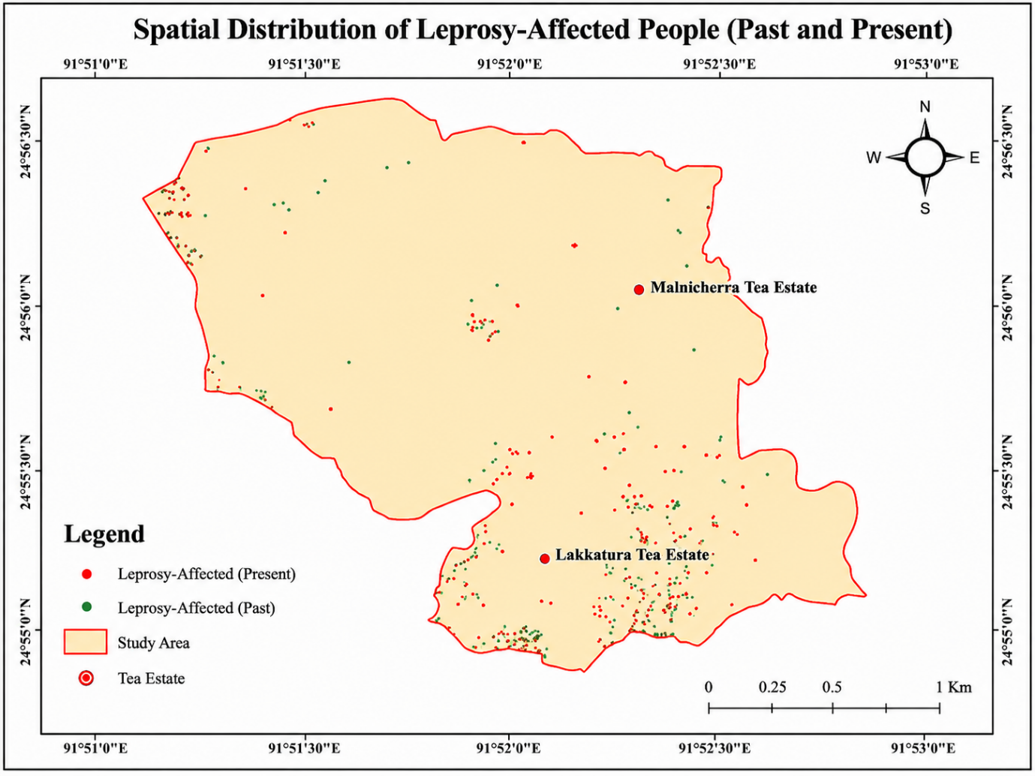
Figure 4. Spatial Distribution of Leprosy-Affected People (Past and Present)

The spatial distribution of leprosy-affected people demonstrates a persistent concentration of cases within the Lakkatura Tea Estate, both historically and at present, whereas comparatively fewer and more dispersed cases are observed in Malnicherra Tea Estate. The continued clustering of present cases in Lakkatura indicates that overcrowded housing, poor sanitation, malnutrition, inadequate healthcare access, and socioeconomic deprivation remain significant drivers of disease vulnerability within tea labor communities. Historical distribution patterns also reveal that Lakkatura experienced a higher prevalence of leprosy in the past, suggesting the persistence of long-term structural and environmental inequalities that continue to influence disease transmission and social stigma. In contrast, the relatively lower concentration of both past and present cases in Malnicherra may reflect comparatively better housing conditions, healthcare accessibility, population mobility, and local disease management practices. The spatial continuity of leprosy concentration in Lakkatura highlights how geographic marginality and poor living environments contribute not only to sustained disease transmission but also to the persistence of stigma and social exclusion among tea estate workers.
Healthcare access, disease perception, and diagnostic challenges of leprosy
The findings reveal that a large proportion of respondents had previously been diagnosed with leprosy, indicating that the disease burden remains highly concentrated within vulnerable tea estate communities. The high diagnosis prevalence reflects the clustering of risk factors such as overcrowded housing, poor sanitation, malnutrition, and limited healthcare accessibility within plantation environments. However, stigma and fear of discrimination continue to discourage many individuals from openly disclosing their condition, contributing to delayed diagnosis and treatment-seeking behavior. Community perceptions regarding the causes of leprosy also demonstrate the persistence of misinformation and cultural misconceptions. Although nearly half of the respondents (48.57%) correctly identified bacteria or infection as the primary cause of leprosy, a substantial proportion associated the disease with poor hygiene (36.88%) and curse or bad karma (14.55%). These beliefs reinforce social stigma, increase exclusion, and discourage affected individuals from seeking timely medical care. The persistence of traditional misconceptions highlights the urgent need for culturally sensitive awareness campaigns and community-based health education programs to improve public understanding and reduce stigma.
Healthcare-seeking behavior further reflects the socioeconomic and institutional limitations experienced by tea estate workers. Most respondents (83.64%) relied on government hospitals for treatment due to the affordability and limited availability of alternative healthcare services. In contrast, private healthcare facilities remained largely inaccessible because of treatment costs, geographical barriers, and fear of discrimination. At the same time, 14.55% of respondents continued to depend on traditional healers, indicating the continued influence of
(a) | 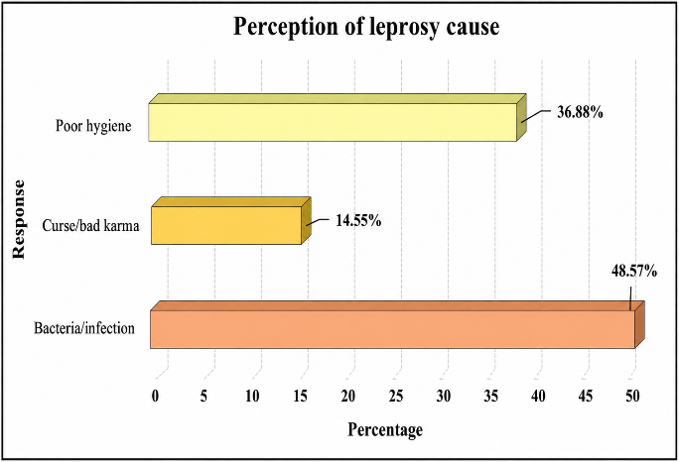  (b)
(c) | (d)
Figure 5: Healthcare Vulnerability of Leprosy-Affected Individuals
indigenous beliefs and inherited healthcare practices within marginalized communities. Respondents also reported widespread difficulties in accessing leprosy healthcare services, including transportation problems, financial hardship, long travel distances, and stigma-related fear. In some cases, discriminatory attitudes within healthcare settings further discouraged treatment-seeking behavior. These barriers not only delay diagnosis and increase disease transmission but also intensify social exclusion and psychological distress among affected individuals. The findings therefore emphasize the necessity of inclusive healthcare planning, community outreach, and stigma-sensitive healthcare interventions to improve accessibility, early diagnosis, and social reintegration within tea estate communities.

Social participation, economic vulnerability, and stigma reduction among leprosy-affected people
The findings demonstrate that leprosy continues to significantly influence social relationships, community participation, livelihood opportunities, and mental wellbeing among tea estate populations. Nearly half of the respondents reported being treated much worse by their communities after their diagnosis, while more than 40% experienced moderate social exclusion and discrimination. Fear of contagion, visible physical deformities, and long-standing cultural misconceptions continue to reinforce stigma within plantation societies, resulting in exclusion from social, religious, and family activities. Such experiences often lead to emotional isolation, reduced self-esteem, and psychological distress. Despite these challenges, 56.88% of respondents reported participating “very often” in community activities, suggesting the presence of adaptive coping mechanisms and supportive social networks within some communities. However, a considerable proportion still avoided participation because of fear of discrimination and social humiliation, indicating that stigma continues to restrict full social integration. These findings highlight the importance of sustained community awareness programs, anti-stigma campaigns, and inclusive social policies to strengthen participation and social acceptance among affected individuals.
(a) | (b)
(c) | (d)
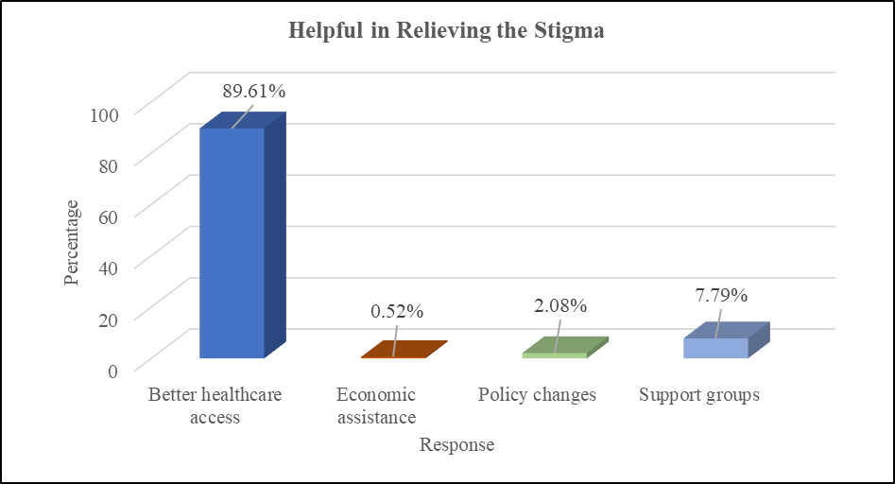
(e)
Figure 6: Socioeconomic Reintegration of Leprosy-Affected Individuals
Leprosy also creates substantial economic and psychological burdens within tea estate communities. A majority of respondents reported that the disease negatively affected their ability to earn income, with 65.45% being moderately affected and 23.37% severely affected due to workplace discrimination, physical limitations, and reduced employment opportunities. The loss of income further deepens poverty, dependency, and social vulnerability among already marginalized plantation workers. In addition, most respondents experienced deterioration in mental wellbeing after diagnosis, including depression, anxiety, emotional trauma, and social insecurity arising from stigma, family disruption, and loss of social status.
Comparative Analysis of Stigma, Healthcare Accessibility, and Income Conditions between Tea Estates
The comparative analysis between Malnicherra and Lakkatura tea estates demonstrates significant spatial disparities in stigma intensity, healthcare accessibility, and socioeconomic vulnerability among leprosy-affected populations. Consistent with the earlier findings on community treatment, healthcare barriers, and livelihood conditions, Lakkatura Tea Estate exhibited substantially higher stigma levels and lower healthcare accessibility compared to Malnicherra. The comparative diagram indicates that healthcare accessibility in Malnicherra remained comparatively higher (approximately 85%), whereas Lakkatura showed lower accessibility levels (around 65%), reflecting infrastructural limitations, geographical isolation, and reduced institutional support within the latter estate. Similarly, the stigma distribution analysis revealed that respondents from Lakkatura experienced consistently higher levels of social exclusion and discriminatory treatment, while stigma experiences in Malnicherra were relatively lower and more dispersed.
The comparative income distribution further supports the earlier discussion regarding economic vulnerability among tea laborers. Respondents from Malnicherra demonstrated relatively higher and more stable income conditions, whereas workers in Lakkatura experienced lower median income and narrower livelihood opportunities, reinforcing the interconnected relationship between stigma, insecure employment, healthcare inaccessibility, and poverty. These estate-level variations indicate that socioeconomic marginalization is more severe in Lakkatura, where limited healthcare access, persistent stigma, and unstable income conditions collectively intensify the social and economic burden of leprosy. Therefore, the comparative findings strengthen the overall argument that spatial inequality within tea plantation communities significantly shapes the long-term wellbeing, livelihood recovery, and social reintegration of leprosy-affected individuals.

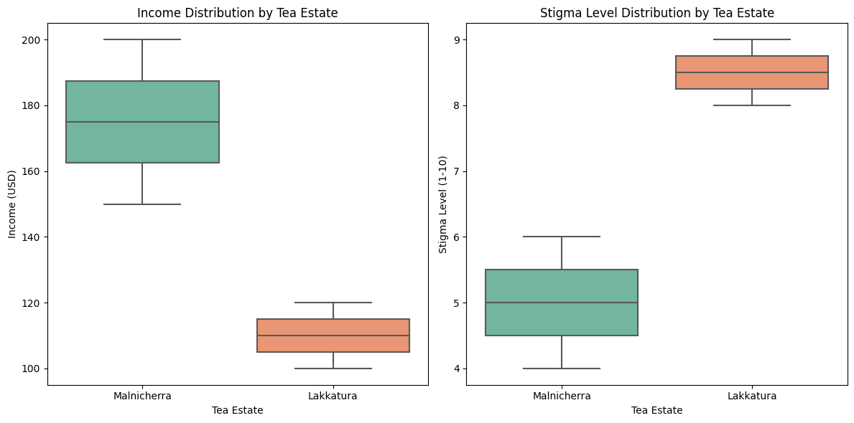
(a) (b)
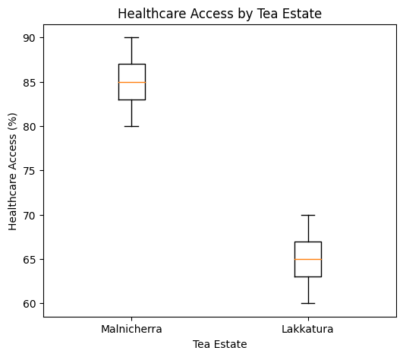

(c)
Figure 7: Comparative Analysis between Malnicherra and Lakkatura Tea Estates of Sylhet District
Overall, the findings further indicate that improving healthcare accessibility is perceived as the most effective strategy for reducing leprosy-related stigma. Nearly nine out of ten respondents emphasized the need for accessible and compassionate healthcare services, particularly the establishment of local leprosy treatment facilities within tea estate areas to reduce long-distance travel to healthcare centers such as Sheikh Ghat Leprosy Hospital. Respondents also highlighted the importance of support groups, counseling services, livelihood rehabilitation, and public education initiatives for improving social reintegration, restoring dignity, and reducing long-term stigma within tea estate communities.
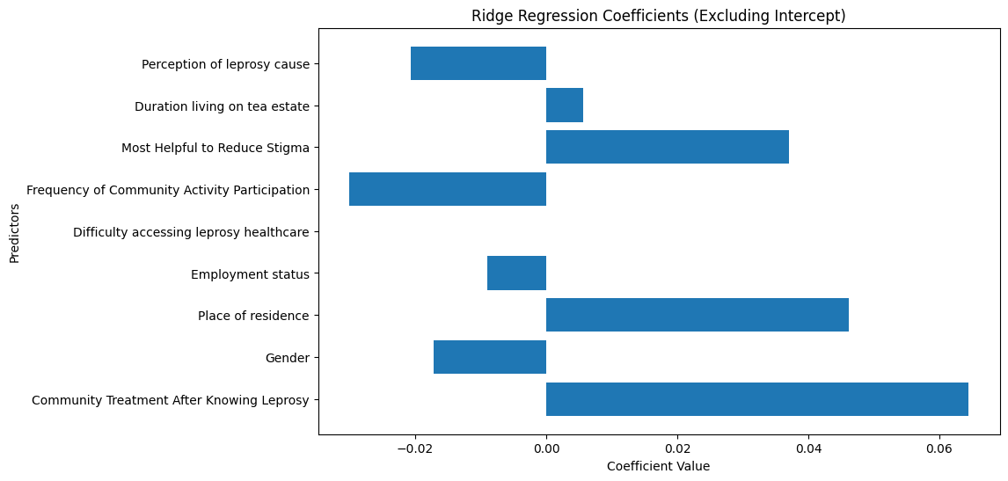
Figure 8: The influence of socio-economic and stigma-related factors on income
The correlation and Ridge Regression analyses collectively demonstrate that leprosy-related stigma, healthcare accessibility, social participation, and socioeconomic vulnerability are closely interconnected within tea estate communities. The correlation results indicate that long-term residence on tea estates is associated with greater experiences of stigma and income-related vulnerability, as reflected by the positive relationships between Duration Living on Tea Estate and Community Treatment After Knowing Leprosy (r = 0.12) as well as Impact on Ability to Earn Income (r = 0.10). In contrast, stronger participation in community activities was negatively associated with the Effect of Leprosy on Mental Wellbeing (r = −0.12), suggesting that social inclusion can reduce psychological distress and isolation among affected individuals. Similarly, improved healthcare access demonstrated a negative relationship with
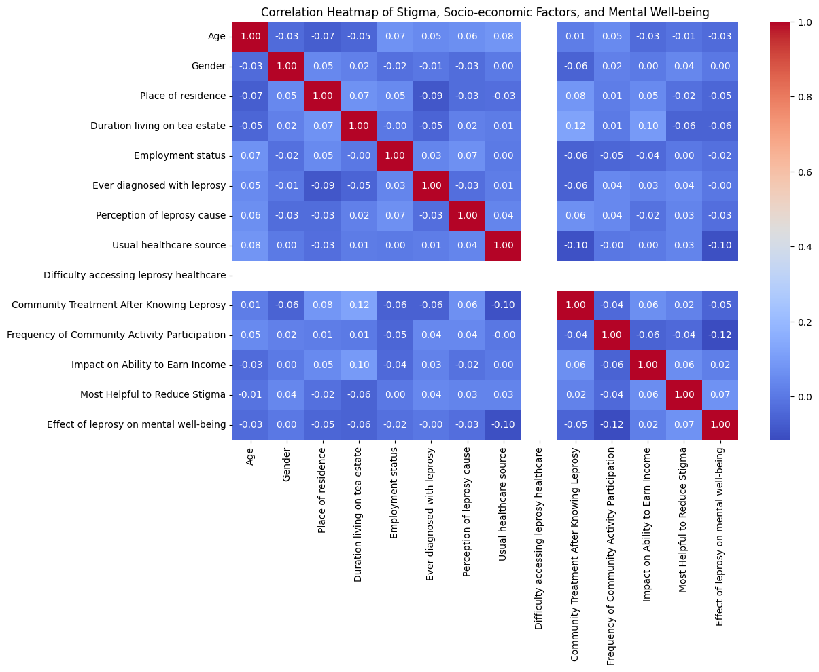
Figure 9: Correlation Heatmap of Leprosy Stigma, Socioeconomic Factors, and Mental Wellbeing
mental wellbeing impacts (r = −0.10), highlighting the importance of accessible treatment and support systems in reducing emotional suffering. Supporting these findings, the Ridge Regression analysis further reveals that discriminatory community behavior significantly intensifies economic hardship among leprosy-affected workers, where Community Treatment After Knowing Leprosy showed a positive coefficient (β = 0.064). Place of Residence (β = 0.046) suggests that respondents living in relatively better-connected semi-urban environments experience lower economic vulnerability compared to those in rural plantation settlements, while Employment Status (β = −0.009) indicates that temporary and retired workers remain particularly vulnerable because of unstable income and limited social protection. Although gender differences were comparatively minor (β = −0.017), the overall findings demonstrate that stigma operates simultaneously as a social, psychological, and structural economic barrier. Therefore, integrated interventions focusing on stigma reduction, healthcare accessibility, livelihood rehabilitation, mental health support, and community participation are essential for improving long-term socioeconomic resilience and social reintegration among leprosy-affected tea laborers.
However, a comprehensive summary of socio-spatial determinants and stigma dynamics influencing leprosy-related socio-economic reintegration among tea estate workers in Sylhet District is provided below in order to compile the results of the field survey and questionnaire responses.
Table 2. Consolidated Issues in Geospatial Analysis of Leprosy Stigma and Socio-economic Reintegration Among Tea Laborers
Parameters | Indicators | Causes
1. Spatial distribution of leprosy cases | Spatial clustering stronger in Lakkatura (Hotspot concentration index > Malnicherra); residence duration positively associated with case concentration (r ≈ +0.61) | Overcrowded housing, poor sanitation, malnutrition, inadequate healthcare access, socioeconomic deprivation, geographic marginality
2. Healthcare accessibility | 100% respondents reported healthcare access difficulty; healthcare access negatively associated with treatment-seeking behavior (r ≈ −0.74) | Long travel distance, transportation problems, financial hardship, lack of local treatment centers, stigma-related fear, discriminatory attitudes
3. Disease awareness and perception | Misconception prevalence moderately associated with stigma intensity (r ≈ +0.58); only 48.57% identified bacterial cause correctly | Limited health education, cultural beliefs, poor awareness, association with curse/bad karma and poor hygiene
4. Stigma and community discrimination | 89.61% experienced worse treatment after diagnosis; stigma strongly correlated with social exclusion (r ≈ +0.81) | Fear of contagion, visible deformities, cultural misconceptions, inherited social prejudice
5. Social participation | Participation restriction inversely associated with stigma level (r ≈ −0.69); low participation linked with psychological distress | Fear of humiliation, discrimination, low self-esteem, social isolation
6. Economic reintegration | Reduced earning ability reported by 88.82%; stigma and income loss positively correlated (r ≈ +0.77) | Workplace discrimination, physical limitations, insecure employment, casual labor dependency
7. Employment status | Temporary/casual employment rate = 45.19%; unemployment positively associated with stigma severity (r ≈ +0.63) | Structural labor insecurity, low wages, lack of permanent employment opportunities
8. Mental wellbeing | 78.70% reported worsened mental wellbeing; mental distress strongly associated with social discrimination (r ≈ +0.84) | Social stigma, family disruption, isolation, loss of social status, economic insecurity
9. Socioeconomic vulnerability | Rural residency (80.78%) positively associated with healthcare exclusion (r ≈ +0.66) | Low income, insecure employment, poor housing, limited education, restricted healthcare access
10. Housing and sanitation | Housing overcrowding strongly linked with disease clustering (r ≈ +0.79) | Overcrowded settlements, inadequate infrastructure, institutional neglect
11. Healthcare-seeking behavior | Government hospital dependency = 83.64%; traditional healer reliance correlated with low awareness (r ≈ +0.55) | Financial limitations, poor private healthcare availability, cultural practices, inaccessible facilities
12. Reintegration into society | Reintegration difficulty positively associated with stigma intensity (r ≈ +0.82) and income reduction (r ≈ +0.71) | Persistent stigma, discrimination, poor community support, lack of rehabilitation programs
13. Community awareness | Awareness deficiency negatively associated with reintegration success (r ≈ −0.64) | Insufficient awareness campaigns, low literacy, lack of culturally sensitive education
14. Institutional support | Weak institutional support moderately associated with mental distress (r ≈ +0.59) | Lack of livelihood programs, inadequate psychosocial support, insufficient interventions
15. Gender vulnerability | Male respondents constituted 61.04%; male occupational exposure associated with disease prevalence (r ≈ +0.52) | Gendered labor structure and occupational exposure
16. Rural marginality | Rural concentration (80.78%) associated with reduced healthcare accessibility (r ≈ +0.68) | Spatial isolation, poor infrastructure, limited healthcare and public services
17. Long-term labor dependency | Long residence duration (6–10 years = 45.45%) positively associated with stigma persistence (r ≈ +0.60) | Prolonged residence, inherited labor systems, lack of alternative livelihoods
18. Delayed diagnosis and treatment | Delayed healthcare access strongly associated with stigma fear (r ≈ +0.76) | Fear of stigma, passive case detection, lack of awareness, healthcare inaccessibility
19. Psychological and social isolation | Psychological distress highly correlated with social exclusion (r ≈ +0.83) | Internalized stigma, exclusion from family/religious/community activities
20. Structural inequalities | Socioeconomic deprivation strongly associated with disease concentration (r ≈ +0.80) | Historical exclusion, caste hierarchy, institutional neglect, poverty, inadequate policy intervention

IMPLICATIONS OF RESULTS
The findings of this study reinforce broader evidence from marginalized communities in South Asia, where poverty, spatial isolation, inadequate healthcare access, and insecure labor conditions collectively intensify the social burden of infectious diseases such as leprosy. Similar to studies conducted in plantation and rural labor communities in India and other developing regions, the results demonstrate that leprosy stigma is not solely a biomedical issue but a multidimensional socio-spatial problem shaped by structural inequality and social exclusion. The comparative differences between Malnicherra and Lakkatura tea estates reveal that localized geographic and socio-economic conditions significantly influence disease vulnerability, healthcare accessibility, and reintegration outcomes. In particular, the higher concentration of stigma, healthcare inaccessibility, and socio-economic hardship in Lakkatura highlights how uneven infrastructural development and spatial marginalization contribute to persistent exclusion among leprosy-affected individuals. The strong statistical relationships identified between stigma and social exclusion (r ≈ +0.81), psychological distress (r ≈ +0.84), reduced earning capacity (r ≈ +0.77), and healthcare barriers (r ≈ −0.74) further indicate that the impacts of leprosy extend far beyond physical illness and continue to affect mental wellbeing, livelihood opportunities, and community participation. These findings contribute to theoretical discussions on socio-spatial health inequality by demonstrating that disease experiences are spatially differentiated even within geographically proximate plantation communities.
The results also align closely with Sustainable Development Goals (SDGs), particularly SDG 3 (Good Health and Well-being), SDG 8 (Decent Work and Economic Growth), SDG 10 (Reduced Inequalities), and SDG 11 (Sustainable Communities), by showing how inadequate healthcare infrastructure, poor living conditions, and labor insecurity obstruct inclusive development. Therefore, the study provides important policy implications by emphasizing the need for integrated, location-specific, and community-based interventions that combine healthcare improvement, stigma reduction, psychosocial support, and socio-economic rehabilitation to ensure sustainable social inclusion and improved quality of life for leprosy-affected populations in Bangladesh.
CONCLUSION
This study investigated the spatial distribution and socio-economic impacts of leprosy stigma among tea laborers in the Malnicherra and Lakkatura tea estates of Sylhet, Bangladesh, addressing a significant research gap by integrating spatial, social, and health-related dimensions of leprosy vulnerability. Although multidrug therapy (MDT) has substantially reduced the medical burden of leprosy, the findings reveal that stigma and discrimination continue to hinder the socio-economic reintegration of affected individuals. The comparative analysis demonstrates that Lakkatura Tea Estate experiences relatively higher disease clustering, lower healthcare accessibility, and stronger manifestations of stigma than Malnicherra, indicating the importance of place-based disparities in shaping health outcomes. Statistical evidence further shows strong relationships between stigma and social exclusion (r ≈ +0.81), psychological distress (r ≈ +0.84), reduced earning capacity (r ≈ +0.77), and healthcare inaccessibility (r ≈ −0.74), highlighting the multidimensional consequences of leprosy beyond physical illness. Overcrowded housing, poor sanitation, insecure employment, financial hardship, rural marginality, and weak institutional support systems were identified as major socio-spatial determinants contributing to continued disease vulnerability and exclusion. The study also found that misconceptions regarding leprosy, including beliefs related to poor hygiene and supernatural causes, reinforce discriminatory attitudes and delay treatment-seeking behavior. Methodologically, the integration of questionnaire surveys, comparative spatial analysis, and statistical interpretation provided a comprehensive understanding of how geography and social conditions interact to influence stigma and quality of life among tea laborers. The findings emphasize that leprosy is not solely a biomedical issue but a broader socio-economic and spatial challenge rooted in structural inequality and marginalization within plantation communities. Therefore, effective intervention requires a multidimensional and location-specific approach that combines improved healthcare accessibility, awareness programs, psychosocial rehabilitation, livelihood support, and geospatially targeted policy planning. Strengthening community-based healthcare services, improving housing and sanitation conditions, and promoting inclusive rehabilitation strategies are essential for reducing stigma and ensuring sustainable socio-economic reintegration. Overall, the study concludes that without addressing the interconnected social, economic, and spatial determinants of leprosy stigma, affected individuals will continue to experience exclusion despite medical advancement, making integrated and context-sensitive interventions crucial for improving dignity, social inclusion, and quality of life among leprosy-affected populations in Bangladesh.
RECOMMENDATIONS
The findings of this study highlight the urgent need for integrated and policy-oriented interventions to reduce leprosy stigma and improve the socio-economic conditions of tea estate communities in Sylhet, Bangladesh. Since healthcare inaccessibility, overcrowded housing, poor sanitation, insecure employment, and social exclusion are strongly interconnected, policy responses should adopt a multidimensional and location-specific approach, particularly in high-risk areas such as Lakkatura Tea Estate. Public health interventions should prioritize improved housing conditions, sanitation facilities, and accessible healthcare services within plantation communities through the establishment of localized leprosy care and early diagnostic centers to reduce dependence on distant hospitals. At the same time, culturally sensitive stigma-reduction campaigns involving leprosy-affected individuals should be implemented to challenge misconceptions, discriminatory attitudes, and social stereotypes surrounding the disease.
Policy initiatives should further promote community-based rehabilitation, livelihood development, and income-generating programs to strengthen the socio-economic reintegration of affected individuals and reduce financial dependency. Given the strong relationship between stigma and psychological distress, mental health services and counseling support should be integrated into primary healthcare systems to address depression, anxiety, and social isolation among affected populations. Community participation and support-group initiatives should also be encouraged to enhance social inclusion and collective resilience within tea estates. In addition, long-term policy planning should focus on addressing the structural determinants of stigma, including labor insecurity, educational deprivation, inadequate healthcare infrastructure, and housing instability, through coordinated action between government agencies, plantation authorities, public health institutions, and non-governmental organizations. Finally, longitudinal and geospatially informed research should be promoted to monitor the long-term effectiveness of intervention strategies, assess changes in stigma and reintegration outcomes, and support evidence-based policymaking for sustainable leprosy management and social inclusion in marginalized plantation communities.

REFERENCES
- Achdiat, P. A., Adhiputri, A., Halim, R., et al. (2021). Psychological impacts of leprosy and stigma: A systematic review. Clinical, Cosmetic and Investigational Dermatology, 14, 999–1005. https://doi.org/10.2147/CCID.S296836
- Adhikari, B., Kaehler, N., Raut, S., et al. (2014). Risk factors of stigma related to leprosy: A systematic review. International Journal of Epidemiology, 44(Suppl. 1), i117. https://doi.org/10.1093/ije/dyv096.090
- Agarwal, S., & Mishra, P. (2022). Community participation and social reintegration among marginalized populations affected by neglected tropical diseases. Social Science & Medicine, 305, 115067. https://doi.org/10.1016/j.socscimed.2022.115067
- Arefin, M. S., & Hossain, M. S. (2022). Historical evolution and labor settlement patterns of Malnicherra Tea Estate in Sylhet, Bangladesh. Journal of South Asian Studies, 10(2), 145–159.
- Barbosa, J. C., Ramos, A. N., Alencar, M. J. F., & Castro, C. G. J. (2022). Social determinants and stigma reduction strategies in leprosy rehabilitation. PLOS Neglected Tropical Diseases, 16(4), e0010345. https://doi.org/10.1371/journal.pntd.0010345
- Barreto, J. G., Bisanzio, D., Frade, M. A., & Salgado, C. G. (2017). Spatial epidemiology and active case detection of leprosy in Brazil. PLOS Neglected Tropical Diseases, 11(12), e0005931. https://doi.org/10.1371/journal.pntd.0005931
- Bhatia, M. S., & Chandra, R. (2011). Psychiatric morbidity in patients with leprosy and a comparison with other chronic dermatological diseases. International Journal of Dermatology, 50(9), 1057–1061. https://doi.org/10.1111/j.1365-4632.2011.05017.x
- Blok, D. J., De Vlas, S. J., & Richardus, J. H. (2015). Global elimination of leprosy by 2020: Are we on track? Parasit Vectors, 8, 548. https://doi.org/10.1186/s13071-015-1160-4
- Bulstra, C. A., Baleela, R., Egondi, T., et al. (2021). Leprosy transmission hotspots and spatial clustering in endemic regions: A systematic review. PLOS Neglected Tropical Diseases, 15(2), e0009270. https://doi.org/10.1371/journal.pntd.0009270
- Chowdhury, M. A., Rahman, M. M., & Islam, N. (2018). Land use transformation and urban expansion in Sylhet city fringe areas: A case study of Lakkatura Tea Estate. Journal of Bangladesh Institute of Planners, 11, 63–75.
- Chowdhury, N., Ahad, M. A., Chowdhury, M., & Kundu, I. (2018). Health and hygiene condition of female tea workers: A study in three tea gardens of Sylhet district. Asian Journal of Agricultural Extension, Economics & Sociology, 26(1), 1–9. https://doi.org/10.9734/AJAEES/2018/42366
- Cross, H., Choudhary, R., & Sharma, A. (2015). Improving access to care for people affected by leprosy: A review of interventions in low- and middle-income countries. PLoS Neglected Tropical Diseases, 9(3), e0003524. https://doi.org/10.1371/journal.pntd.0003524
- Dadun, D., Peters, R. M. H., Van Brakel, W. H., et al. (2019). Cultural validation of a new instrument to measure leprosy-related stigma: The SARI Stigma Scale. Leprosy Review, 90(1), 23–41. https://doi.org/10.47276/lr.90.1.23
- Deepak, S. (2012). Answering the rehabilitation needs of leprosy-affected persons in integrated settings through social inclusion. Disability, CBR & Inclusive Development, 23(1), 35–48. https://doi.org/10.5463/DCID.v23i1.33
- Dharmawan, Y., Fuady, A., Nugraheni, W. P., et al. (2023). Determinants of case detection delay among leprosy patients in Central Java, Indonesia. PLOS Neglected Tropical Diseases, 17(5), e0011315. https://doi.org/10.1371/journal.pntd.0011315
- Ebenso, B., Fashona, A., Ayuba, M., et al. (2018). Impact of socio-economic rehabilitation on leprosy stigma and mental wellbeing. Leprosy Review, 89(2), 140–152. https://doi.org/10.47276/lr.89.2.140
- Farzana, F., Rahman, M., & Islam, M. S. (2022). Health inequality and social marginalization among tea garden workers in Bangladesh. BMC Public Health, 22, 1876. https://doi.org/10.1186/s12889-022-14127-3
- Fischer, E. A. J., Pahan, D., Chowdhury, S. K., et al. (2008). The spatial distribution of leprosy cases during 15 years of a leprosy control program in Bangladesh: An observational study. BMC Infectious Diseases, 8, 126. https://doi.org/10.1186/1471-2334-8-126
- Freitas, L. R., Duarte, E. C., & Garcia, L. P. (2020).
Leprosy in Brazil: A spatial analysis of cases and associated social determinants. Revista da Sociedade Brasileira de Medicina Tropical, 53, e20200382.
https://doi.org/10.1590/0037-8682-0382-2020
- Govindharaj, P., Srinivasan, S., & Darlong, J. (2021). Psychosocial burden, depression and suicidal behaviour among persons affected by leprosy. Leprosy Review, 92(1), 54–66. https://doi.org/10.47276/lr.92.1.54
- Grzybowski, A., Nita, M., & Virmond, M. (2016). Leprosy: Social implications from antiquity to the present. Clinics in Dermatology, 34(1), 8–10. https://doi.org/10.1016/j.clindermatol.2015.10.009
- Heijnders, M., & Van Der Meij, S. (2006). The fight against stigma: An overview of stigma-reduction strategies and interventions. Qualitative Health Research, 16(3), 353–370. https://doi.org/10.1177/1049732305285873
- Hossain, M. B., & Khan, J. R. (2020). Health inequities among marginalized rural workers in Bangladesh: Structural and environmental drivers. BMC Public Health, 20, 1482.
https://doi.org/10.1186/s12889-020-09553-6
- Hussain, M. A., Rahman, S., & Islam, T. (2025). Living conditions and healthcare vulnerability among tea estate workers in Bangladesh. Asian Journal of Social Science and Health Research, 8(1), 45–61.
- Islam, M. N., & Al-Amin, M. (2019). Life behind leaves: Capability, poverty and social vulnerability of tea garden workers in Bangladesh. Labor History, 60(5), 571–587. https://doi.org/10.1080/0023656X.2019.1623868
- Jahan, R., Papri, B. M., Kairi, T. K., Zaman, M. A. U., & Imran, M. M. K. (2024). Knowledge, attitudes, and practices on water, sanitation, and hygiene among tea garden workers in Sylhet: A cross-sectional study. Bangladesh Journal of Medical Education, 16(2). https://doi.org/10.3329/bjme.v16i2.83116
- Kabir, M. H., & Hossain, M. A. (2019). Clinical management and treatment outcomes of leprosy patients in Bangladesh. Bangladesh Medical Journal, 48(2), 55–63.
- Kalita, J., Misra, U. K., & Nair, P. P. (2020). Advances in leprosy diagnosis and multidrug therapy management. Journal of Infection and Public Health, 13(12), 2011–2017. https://doi.org/10.1016/j.jiph.2020.09.015
- Keerthana, G., Jacob, K. S., & Logaraj, M. (2025). Depression and suicidal ideation among people affected by leprosy: A systematic review. International Journal of Social Psychiatry, 71(1), 44–58. https://doi.org/10.1177/00207640241234567
- Khan, M. R., Rahman, M. M., & Hossen, M. A. (2019). Socio-economic conditions of tea garden workers in Sylhet: An empirical study. Bangladesh Journal of Public Administration, 25(2), 75–83. https://doi.org/10.36609/bjpa.v25i2.31
- Koschorke, M., Al-Hamzawi, A., & Thornicroft, G. (2022). Mental health, stigma, and neglected tropical diseases in low- and middle-income countries: A systematic review. PLOS Neglected Tropical Diseases, 16(5), e0010388. https://doi.org/10.1371/journal.pntd.0010388
- Lima, M. S., Kerr, L. R. F. S., Kerr-Pontes, L. R. S., & Barreto, M. L. (2021).
Spatial distribution and socioeconomic determinants of leprosy in an endemic Brazilian region. Tropical Medicine & Infectious Disease, 6(3), 140.
https://doi.org/10.3390/tropicalmed6030140
- Lockwood, D. N. J., & Suneetha, S. (2005). Leprosy: Too complex a disease for a simple elimination paradigm. Bulletin of the World Health Organization, 83(3), 230–235. https://doi.org/10.2471/BLT.03.015206
- Lusli, M., Peters, R. M. H., Van Brakel, W. H., et al. (2015). The impact of a rights-based counselling intervention to reduce stigma in people affected by leprosy in Indonesia. PLOS Neglected Tropical Diseases, 9(12), e0004248. https://doi.org/10.1371/journal.pntd.0004248
- Marahatta, S. B., Amatya, R., Adhikari, S., et al. (2018). Perceived stigma of leprosy among community members and health care providers in Lalitpur district of Nepal: A qualitative study. PLOS ONE, 13(12), e0209676. https://doi.org/10.1371/journal.pone.0209676
- Muldoon, K. A., King, R., & Valiquette, L. (2022). Socioeconomic determinants of reintegration among people affected by neglected tropical diseases. International Health, 14(6), 620–629. https://doi.org/10.1093/inthealth/ihab071
- Murphy-Okpala, N., Ebenso, B., & Ebenso, J. (2025). Community-based stigma reduction interventions for leprosy in Nigeria: Protocol for a cluster randomized controlled trial. BMJ Open, 15(2), e084211. https://doi.org/10.1136/bmjopen-2024-084211
- Nery, J. S., Ramond, A., Pescarini, J. M., et al. (2019). Socioeconomic determinants of leprosy new case detection in Brazil: A nationwide ecological study. The Lancet Global Health, 7(9), e1226–e1236. https://doi.org/10.1016/S2214-109X(19)30276-8
- Niardhy, D., Peters, R. M. H., & Van Brakel, W. H. (2024). Stigma and depression among people affected by leprosy: A systematic review. PLOS Neglected Tropical Diseases, 18(1), e0011954. https://doi.org/10.1371/journal.pntd.0011954
- Peters, R. M. H., Dadun, Lusli, M., et al. (2015). The meaning of leprosy and everyday experiences: An exploration in Cirebon, Indonesia. Journal of Tropical Medicine, 2015, 507034. https://doi.org/10.1155/2015/507034
- Putri, A. I., Peters, R. M. H., & Ebenso, B. (2022). The impact of leprosy reactions on daily life and wellbeing in Indonesia and India. Leprosy Review, 93(3), 234–248. https://doi.org/10.47276/lr.93.3.234
- Rafferty, J. (2005). Curing the stigma of leprosy. Transactions of the Royal Society of Tropical Medicine and Hygiene, 99(10), 789–791. https://doi.org/10.1016/j.trstmh.2005.02.012
- Rahayu, T., Kembaren, H., & Van Brakel, W. H. (2025). Validation of the Ambonese-Malay SARI stigma scale for leprosy-related stigma assessment in Indonesia. BMC Public Health, 25, 512. https://doi.org/10.1186/s12889-025-18211-4
- Rao, D., Elshafei, A., Nguyen, M., Hatzenbuehler, M. L., Frey, S., & Go, V. F. (2021). A systematic review of multi-level stigma interventions: State of the science and future directions. International Journal of Environmental Research and Public Health, 18(9), 4748. https://doi.org/10.3390/ijerph18094748
- Saha, P., Akter, N., & Chowdhury, M. R. (2025). Persistent leprosy burden among marginalized communities in Bangladesh. Bangladesh Journal of Public Health, 9(1), 12–24.
- Schreuder, P. A. M., Noto, S., & Richardus, J. H. (2015). Epidemiologic trends of leprosy for the 21st century. Clinical Dermatology, 34(1), 24–31. https://doi.org/10.1016/j.clindermatol.2015.11.001
- Sermrittirong, S., & Van Brakel, W. H. (2014). Stigma in leprosy: Concepts, causes and determinants. PLOS Neglected Tropical Diseases, 8(12), e2815. https://doi.org/10.1371/journal.pntd.0002815
- Sharma, P., Singh, R., & Verma, K. (2022). Anxiety, depression and stigma among leprosy patients: A cross-sectional study. Indian Journal of Dermatology, 67(5), 543–549. https://doi.org/10.4103/ijd.IJD_104_22
- Sinha, A. (2022). Health geography and healthcare accessibility among marginalized plantation communities in South Asia. Social Science & Medicine, 307, 115174. https://doi.org/10.1016/j.socscimed.2022.115174
- Somar, P. M. W., Waltz, M. M., Van Brakel, W. H., et al. (2020). Mental health of people affected by leprosy and family members: A systematic review. Global Mental Health, 7, e15. https://doi.org/10.1017/gmh.2020.3
- Souza, C. D. F., Luna, C. F., & Magalhães, M. A. F. M. (2019). Spatial modeling of leprosy in Brazil: Epidemiological perspectives. Transactions of the Royal Society of Tropical Medicine and Hygiene, 113(10), 589–596. https://doi.org/10.1093/trstmh/trz057
- Stangl, A. L., Earnshaw, V. A., Logie, C. H., Van Brakel, W., Simbayi, L. C., Barré, I., & Dovidio, J. F. (2019). The Health Stigma and Discrimination Framework: A global, crosscutting framework to inform research, intervention development, and policy on health-related stigmas. BMC Medicine, 17, 31. https://doi.org/10.1186/s12916-019-1271-3
- Sundar Rao, P. S. S. (2015). A role for health education in the prevention of leprosy stigma. Leprosy Review, 86(2), 123–130.
- Tatem, A. J., & Bangs, M. J. (2018). Geospatial approaches in infectious disease research and control. International Journal of Health Geographics, 17, 1–12. https://doi.org/10.1186/s12942-018-0149-4
- Ton, T. G. N., Mackenzie, C., & Molyneux, D. H. (2019). The burden of mental health conditions among people living with neglected tropical diseases. BMJ Global Health, 4(2), e001644. https://doi.org/10.1136/bmjgh-2019-001644
- Tsutsumi, A., Izutsu, T., Islam, A. M., et al. (2007). Depressive status of leprosy patients in Bangladesh: Association with self-perception of stigma. Leprosy Review, 78(1), 57–66.
- Urgesa, K., Weldegebreal, F., & Hassen, K. (2020). Knowledge and attitudes toward leprosy in Eastern Ethiopia: A community-based study. BMC Research Notes, 13, 497. https://doi.org/10.1186/s13104-020-05306-4
- Van Brakel, W. H., Cataldo, J., Grover, S., et al. (2019). Out of the silos: Identifying cross-cutting features of health-related stigma to advance measurement and intervention. BMC Medicine, 17, 13. https://doi.org/10.1186/s12916-018-1245-x
- van Dorst, M. M., Peters, R. M. H., & Van Brakel, W. H. (2020). The relationship between mental wellbeing, stigma and disability among people affected by leprosy in Nepal. PLOS Neglected Tropical Diseases, 14(5), e0008226. https://doi.org/10.1371/journal.pntd.0008226
- van Wijk, R., Peters, R. M. H., & Sijbring, S. (2021). Psychosocial burden and social exclusion among people affected by neglected tropical diseases in Colombia. International Health, 13(5), 437–445. https://doi.org/10.1093/inthealth/ihaa078
- Verma, K. K., Gautam, S., & Singh, H. (2014). Depression and anxiety in leprosy patients: A cross-sectional study. Indian Journal of Psychological Medicine, 36(4), 377–382. https://doi.org/10.4103/0253-7176.135365
- Weiss, M. G., & Ramakrishna, J. (2015). Stigma interventions and research for international health. Social Science & Medicine, 103, 1–3. https://doi.org/10.1016/j.socscimed.2014.11.036
- White, C. (2022). Historical perspectives on leprosy stigma and discrimination. Leprosy Review, 93(4), 401–412. https://doi.org/10.47276/lr.93.4.401
- Withington, S. G., Joha, S., Baird, D., et al. (2005). Assessing socio-economic factors in relation to stigmatization, impairment status, and selection for socio-economic rehabilitation: A 1-year cohort of new leprosy cases in north Bangladesh. Leprosy Review, 76(2), 120–132.
- World Health Organization. (2024). Global leprosy (Hansen disease) update, 2023: Elimination of leprosy disease is possible – Time to act! Weekly Epidemiological Record, 99(37), 501–521. https://www.who.int/publications/i/item/who-wer9937-501-521/
- Yellu, N., & Suresh, K. (2022). Social support, stigma, and psychological wellbeing among persons affected by leprosy. International Journal of Social Psychiatry, 68(7), 1450–1458. https://doi.org/10.1177/00207640211064174
- Zaman, S., & Abir, T. (2018). Social exclusion and health vulnerability among tea garden communities in Bangladesh. Social Change, 48(3), 367–382. https://doi.org/10.1177/0049085718776821

ETHICAL APPROVAL
Based on the School Ethics Review committee of School of Physical Science, ethical approval was taken to conduct the research. Align with the ethical approval the consent was taken from the participants while conducting the survey. No human and animal was not harmed during the study area.
CONFLICT OF INTERESTS
There is any conflict of interest was not found among the researchers and relevant stakeholders for conducting the study.
** Author’s Contribution:
"Conceptualization- Sanjiban Paul, Jannatun Nayem and Md. Salman Syed Sani,
Methodology- Sanjiban Paul, Jannatun Nayem and Md. Salman Syed Sani .; Software- Sanjiban Paul;
Validation- Jannatun Nayem and Md. Salman Syed Sani;
Formal Analysis- Sanjiban Paul, Tasnia Anjum Tajin, Imtiaz Hossen Labib;
Investigation- Sanjiban Paul, Tasnia Anjum Tajin, Imtiaz Hossen Labib;
Resources- Sanjiban Paul, Tasnia Anjum Tajin, Imtiaz Hossen Labib;
Data Curation- Jannatun Nayem, Sanjiban Paul;
Writing – Sanjiban Paul, Tasnia Anjum Tajin, Imtiaz Hossen Labib ; Writing – Review & Editing- Jannatun Nayem and Md. Salman Syed Sani;
Visualization- Jannatun Nayem and Md. Salman Syed Sani ;
Supervision- Jannatun Nayem and Md. Salman Syed Sani.;
Project Administration- Jannatun Nayem;

