AN IOT-BASED SMART CANE FOR BLIND INDIVIDUALS

ABSTRACT
Blindness continues to limit the safety and mobility of many individuals. Traditional White canes can help people navigate space; however‚ they do not provide real-time monitoring‚ emergency alert‚ or environmental detection․ This study carried out the design‚ development‚ and testing of an IoT-based Smart Cane with obstacle and water detection‚ GPS-based location monitoring‚ SOS emergency alert‚ and Multilingual Voice Assistance for Blind Individuals․ The Spiral model was used for this study as a research design․ The prototype was implemented with an ESP32 microcontroller‚ sensors‚ GPS module‚ Firebase Realtime Database‚ and Apache Cordova framework for the Guardian Monitoring Application․ Purposive and snowball sampling methods were used for the sampling of blind respondents‚ guardians‚ and non-blind respondents from the province of Lanao del Norte in Mindanao region․ The IoT-Based Smart Cane was evaluated using USE Questionnaires and the ISO/IEC 25010 system quality using the Five-Point Likert Scale‚ the Smart Cane was found to have the ability to detect obstacles and wet surfaces‚ send SOS emergency alert notification‚ provide real time GPS location‚ and deliver multilingual voice assistance and vibration feedbacks․ Overall‚ results showed high satisfaction ratings for usability‚ functionality‚ accuracy and effectiveness of the system‚ and showed that merging IoT and assistive material into a single assistive device improved safety‚ navigation and mobility of blind individuals․
Keywords: IoT-Based Smart Cane, Blindness, Obstacle Detection, Water Detection, GPS Monitoring, SOS Emergency Alert, Multilingual Voice Assistance
INTRODUCTION
Blindness remains one of the most challenging disabilities worldwide, affecting millions of individuals who struggle with safety and mobility in their daily lives. Vision is considered one of the most essential human senses because it plays a critical role in environmental perception, spatial awareness, and daily human interaction (Chung & Son, 2020). According to the World Health Organization (WHO), at least 2.2 billion people globally have vision impairment or blindness (World Health Organization, 2019). Many of these individuals rely on traditional walking canes that provide only limited support in detecting obstacles and navigating complex environments In the Philippines, approximately 2.17 million Filipinos experience visual impairment, while more than 500,000 are classified as blind according to the Philippine Eye Research Institute and the Department of Health. Blind individuals often face challenges such as uneven sidewalks, limited accessibility infrastructure, and the lack of affordable assistive technologies, which restrict their mobility, independence, and overall quality of life.
Traditional white canes help people who are blind move around. They do not give much information about the environment and cannot detect obstacles that are far away. When crossing streets, avoiding puddles or dealing with emergencies regular canes are not enough. As a result blind people are still at risk of accidents and injuries. Their guardians worry more about their safety. New technologies like the Internet of Things (IoT) are making devices better. IoT can help improve safety, navigation, monitoring and communication for people with disabilities. With these advancements we still need better solutions that can provide additional safety support and help with navigation and mobility, and offer real-time monitoring for blind individuals.
Recognizing these gaps, this study designed and developed an IoT-Based Smart Cane for Blind Individuals with Emergency Alert System. The developed system integrates obstacle detection and water detection with vibration feedback. It also has GPS to track and monitor the blind user’s location. It also has an SOS emergency alert. It also provides voice assistance in four languages including English, Filipino, Bisaya and Maranao. These languages were selected because they want to help people who speak these languages especially in places in the province of Sultan Naga Dimaporo Lanao del Norte in Mindanao Region. The IoT-Based Smart Cane also has a feature that lets guardians track and monitor the blind user’s location in real time through a Guardian Monitoring Application. The goal of this study was to help blind individuals and provide additional safety and assist navigation and mobility and communicate better with their guardians.

This study also contributes to the promotion of inclusivity and accessible innovation through assistive technology. The developed Smart Cane supports Sustainable Development Goals (SDGs). Especially SDG 3 (Good Health and Well-being), SDG 9 (Industry, Innovation, and Infrastructure), SDG 10 (Reduced Inequalities), and SDG 11 (Sustainable Cities and Communities). The Smart Cane can detect obstacles and wet surfaces ahead of the blind user and provide voice assistance and vibration feedback for additional safety and assist navigation. The developed system also integrates GPS-based location that allows the guardian to track and monitor the current location and previous locations of the blind user. Furthermore, the developed system also has a SOS emergency alert button that allows blind users to notify guardian during emergency situation for faster communication. All of these things help blind people get around safely. They help people feel more included and they help the people who take care of the blind individuals feel better because they can check on them and make sure they are safe. The Smart Cane is a helpful tool, for blind individuals and the people who care about them.
Statement of the Problem
Blind individuals continue to face challenges in safe navigation and mobility due to the limitations of traditional walking sticks and existing assistive technologies. Conventional mobility aids are limited to detecting obstacles only through physical contact, which increases the risk of accidents, collisions, and unsafe navigation. In addition, existing assistive devices lack multilingual voice assistance features, reducing accessibility and inclusivity for blind individuals in multilingual communities. Current mobility aids also do not provide guardian GPS-based location monitoring, providing guardians difficulty in ensuring the safety and whereabouts of blind individuals during navigation and emergency situations. These challenges highlighted the need for a comprehensive assistive system that can provide additional safety support, assist navigation and mobility, and improve communication and real-time monitoring for blind individuals and their guardians.
Objectives of the Study
The primary objective of this study was to develop an IoT-Based Smart Cane that provided additional safety support, accessibility, and navigation assistance for blind individuals through the integration of obstacle and water detection, multilingual voice assistance, GPS-based location monitoring, and an SOS emergency alert system. Specifically, the study aimed to develop an obstacle detection feature capable of identifying obstacles and wet surfaces beyond the physical reach of traditional walking sticks to improve safe navigation for blind individuals. It also aimed to integrate four language options for voice assistance to enhance accessibility, usability, and language inclusivity during navigation, particularly in unfamiliar environments. In addition, the study aimed to design and implement a GPS-based location monitoring system that enabled guardians to monitor the real-time location and movement of blind users. Lastly, the study sought to evaluate the ease of use, functionally and overall satisfaction of the user to the proposed assistive system in assisting daily mobility and navigation experiences of blind individuals.
Conceptual Framework
The Input–Process–Output (IPO) model of the study illustrates how the IoT-Based Smart Cane system operates by transforming raw environmental and user data into meaningful assistive outputs that enhance the safety and mobility of blind individuals.
In the input stage, the system receives essential data such as sensor readings from the environment for obstacle and water detection, GPS coordinates for real-time navigation and tracking, and user language selection for multilingual voice assistance. These inputs serve as the foundation of the system’s functionality, enabling it to respond to the user’s surroundings and preferences.
In the process stage, the system analyzes and processes the collected inputs through its integrated hardware and software components. The obstacle and water detection module processes sensor data to identify potential hazards, while the IoT integration and data logging module manages the transmission and storage of GPS data for real-time monitoring. The SOS emergency alert system processes emergency triggers from the user and sends immediate notifications to guardians, including the user’s location. Additionally, the multi-language processing module converts system outputs into the selected language to ensure effective voice communication and guidance for the user.
In the output stage, the system generates real-time responses based on the processed data. These outputs include vibration feedback and voice alerts when obstacles or hazards are detected, allowing users to navigate safely. It also produces real-time movement and safety logs that guardians can access through the monitoring application. In emergency situations, the system sends SOS alerts directly to guardians along with the user’s GPS location. Furthermore, the system provides multilingual voice assistance to guide users effectively in different environments. Overall, the IPO model demonstrates how the system enhances independence, safety, and mobility by converting environmental inputs into intelligent assistive outputs.
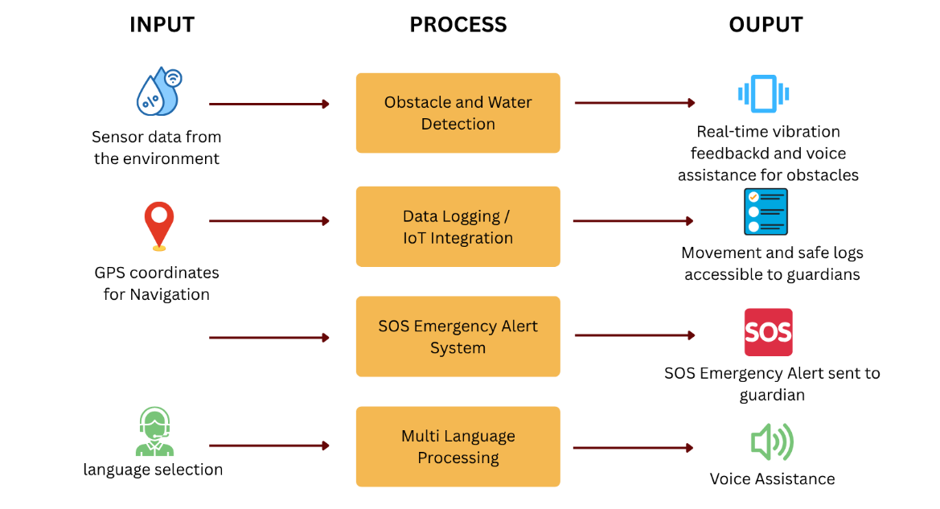

Figure 1. Conceptual Framework of the Study
METHODOLOGY
This study utilized the Spiral Model as its research and development design in developing the IoT-Based Smart Cane for Blind Individuals with Emergency Alert System. The Spiral Model provided an iterative and systematic approach consisting of planning, risk analysis, development and design, and evaluation phases to ensure the proper integration and functionality of both the hardware and software components of the system.
The developed system utilized several hardware components, including the ESP32 DevKit V1 microcontroller, JSN-SR04T ultrasonic sensor, YL-83 water sensor, GY-NEO6MV2 GPS module, SIM800L GSM module, DFPlayer Mini MP3 module, vibration motor, rechargeable 18650 Li-ion battery, TP4056 charging module, boost converter module, push buttons, slide switch, audio jack socket, Micro SD card, wired headset, and power bank. The ESP32 served as the main processing unit responsible for obstacle detection, water detection, GPS-based location monitoring, SOS emergency alert transmission, multilingual voice assistance processing, and IoT communication. The ultrasonic sensor detected obstacles, while the water sensor identified wet surfaces during navigation. The GPS module monitored the blind user’s location, and the SIM800L module handled cellular communication and data transmission for real-time monitoring and emergency alerts. While, the DFPlayer Mini, wired headset, and vibration motor provided multilingual voice assistance and vibration feedback for the blind user.
For software development, the study utilized the Arduino IDE using the C++ programming language to program the ESP32 microcontroller. Firebase Realtime Database was used for cloud-based data storage and IoT communication, while the Guardian Monitoring Application was developed using the Apache Cordova framework with HTML, CSS, and JavaScript. OpenStreetMap was also integrated for map visualization and location monitoring functionalities. In addition, the system design was represented using the Use Case Diagram, Data Flow Diagram, Flowchart Diagram, and Circuit Diagram to illustrate the system structure, data flow, user interaction, and overall operation of the proposed Smart Cane System.
Use Case Diagram
Figure 2 presents the Use Case Diagram of the IoT-Based Smart Cane System, illustrating the interactions between the two primary actors: the Guardian and the Blind User. The Guardian performed monitoring and account management functions, including login authentication, receiving SOS emergency alerts, and monitoring the blind user’s real-time location and location history through the Guardian Monitoring Application. Meanwhile, the Blind User interacted directly with the smart cane by turning the device on or off, detecting obstacles, receiving vibration feedback and voice assistance, switching language modes, and activating the SOS emergency alert feature. Overall, the Use Case Diagram illustrated the interaction flow and functional relationships between the actors and the Smart Cane System to support safety, navigation, mobility, and real-time monitoring.

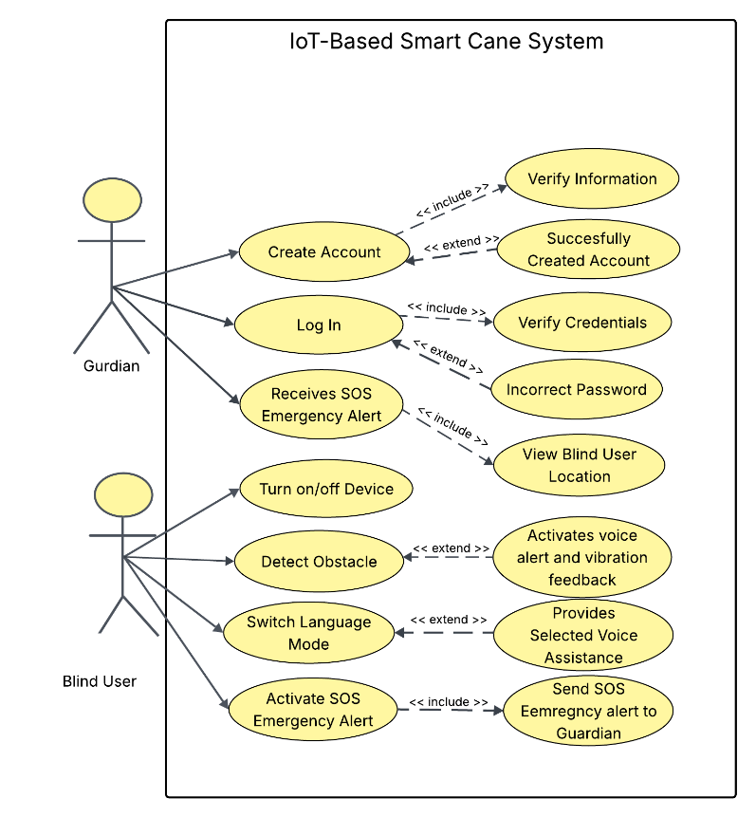

Figure 2. Use Case Diagram of An IoT-Based Smart Cane for Blind Individuals with Emergency Alert System
Data Flow Diagram
Figure 3 illustrates the overall and detailed data flow of the IoT-Based Smart Cane System, designed to assist visually impaired individuals through real-time sensing and communication. At the context level, the system acts as a central hub that receives inputs from the blind user, including environment obstacles, location, SOS emergency alerts, and language preferences, and responds by providing vibration feedback and voice assistance while simultaneously sharing critical information such as location and emergency alerts with the guardian. At the detailed level, the system is decomposed into interconnected processes: it detects obstacles and converts them into immediate feedback, captures and stores the user’s location in a data store, processes language preferences for usability, and manages guardian information for communication. The stored location data is then processed and transmitted to the guardian, particularly during emergencies, ensuring timely response and monitoring. Overall, the system demonstrates an integrated and efficient flow of data that enhances user safety, supports real-time decision-making, and maintains continuous coordination between the blind user and the guardian.
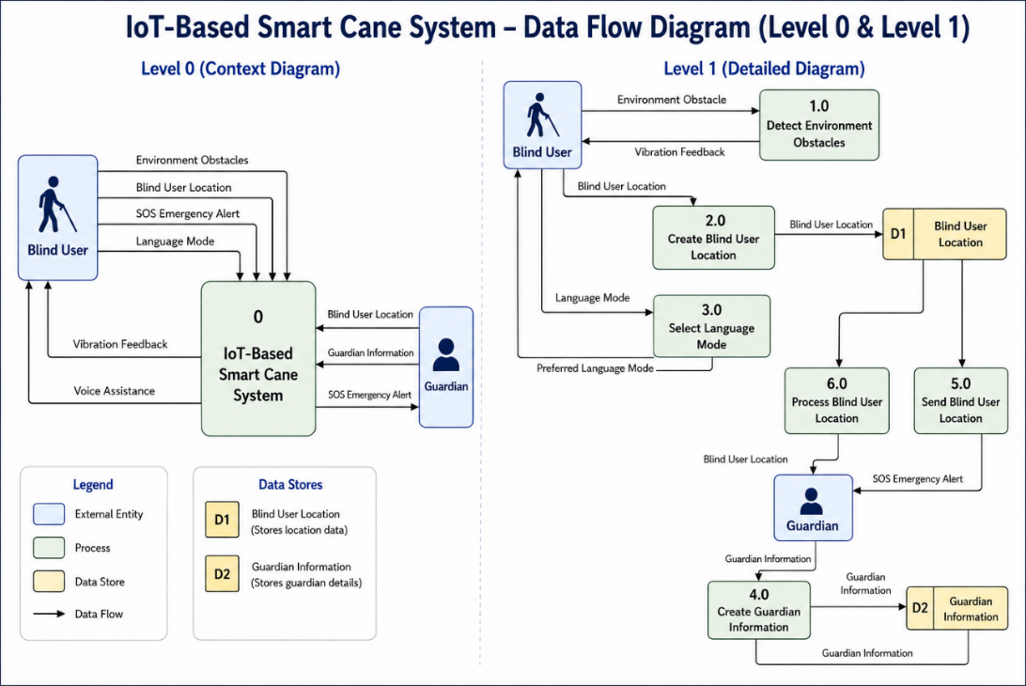

Figure 3. Data Flow Diagram (DFD) Context & Level 1 of An IoT-Based Smart Cane for Blind Individuals with Emergency Alert System
Flow Chart Diagram
Figure 4 presents the flowchart diagram of the IoT-Based Smart Cane for Blind Individuals with Emergency Alert System. The diagram illustrates the step-by-step process of how the smart cane and guardian mobile application interact to provide obstacle detection, voice guidance, location tracking, and emergency assistance for blind individuals.
On the smart cane side, the process begins when the system is initialized. The cane continuously reads the surrounding environment through sensors to detect nearby objects or obstacles. Once an object is detected, the system activates vibration feedback to immediately alert the user. The user may also press the language button to change the language mode, allowing the system to provide voice guidance in the user’s preferred language. If no language selection is made, the system delivers the default voice guidance to assist navigation safely.
In emergency situations, the blind individual can press the SOS button integrated into the cane. Once activated, the system automatically sends an SOS alert together with the user’s location to the guardian through the mobile application. This feature ensures immediate communication and rapid response during critical situations.
On the guardian’s side, the process starts by opening the mobile application and entering the correct password for secure access. After successful authentication, the guardian can access the main dashboard and monitor the real-time location of the blind individual. If an SOS alert is received, the application displays an emergency notification containing the user’s name and opens a map widget showing the GPS coordinates of the user’s location. If no emergency alert is triggered, the guardian can continue monitoring the user’s movement through the tracking feature.
Overall, the flowchart demonstrates the integration of IoT technology, sensor-based obstacle detection, GPS tracking, and emergency communication to improve the safety, mobility, and independence of blind individuals while ensuring that guardians can respond quickly during emergencies.
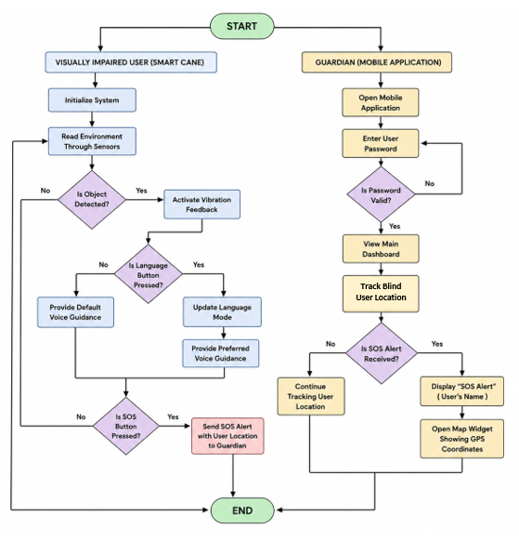

Figure 4. Flowchart Diagram of An IoT-Based Smart Cane for Blind Individuals with Emergency Alert System
Arduino Wiring Diagram
Figure 5 illustrates the actual Arduino wiring diagram of the IoT-Based Smart Cane presents the interconnection of the hardware components used to implement the system’s assistive functionalities. The ESP32 microcontroller serves as the central processing unit that manages communication between the sensors, output devices, and communication modules. The system is primarily powered by a rechargeable power bank, while a separate 18650 lithium-ion battery powers the SIM800L GSM module to provide stable current during GSM communication. The 18650 battery is connected to a TP4056 charging module for safe charging and battery protection, while an XL6009 voltage booster regulates the voltage supply required by the SIM800L module. The breadboard functions as the central connection platform where the 5V and GND lines of the modules are interconnected for organized power distribution and circuit integration. It also accommodates the voltage divider circuits and supporting electrical connections. The voltage divider is specifically applied to the ECHO pin of the JSN-SR04T ultrasonic sensor to reduce the signal voltage into a safe level for the ESP32 input pins. Additional circuit connections include the transistor base used to drive the vibration motor and the SPK1 and SPK2 speaker output connections of the DFPlayer Mini module. The JSN-SR04T ultrasonic sensor is used for obstacle detection, while the YL-83 sensor detects wet surfaces. Once obstacle or wet surfaces are detected, the ESP32 processes the sensor data and activates the DFPlayer Mini module for voice alerts and the vibration motor for tactile feedback. The NEO-6M GPS module provides real-time location monitoring by transmitting geographical coordinates to the ESP32, which forwards the information to the guardian monitoring application through IoT connectivity. The system also includes two push buttons connected to the ESP32: one button functions as the SOS emergency trigger that sends alerts and GPS coordinates to registered guardians through the SIM800L module, while the second button is used for language selection to support multilingual voice assistance. The wiring diagram demonstrates the integration of sensing, communication and emergency response technologies into a unified assistive Smart Cane system for blind individuals.
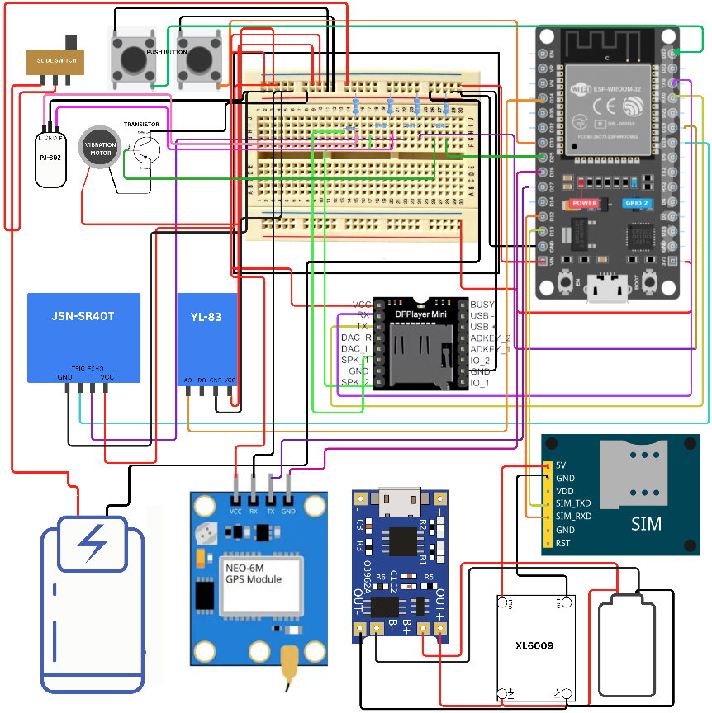

Figure 5. Arduino Wiring Diagram of An IoT-Based Smart Cane for Blind Individuals with Emergency Alert System
Testing Method
The Smart Cane system was evaluated using white-box and black-box testing. White-box testing examined the internal code logic and processes such as sensor handling and system communication, while black-box testing assessed the system’s external performance based on user interaction, including obstacle and water detection, vibration feedback, GPS monitoring, and SOS emergency alerts. Both methods ensured the system’s correctness, reliability, and functionality.
Population and Sample of the Study
A non-probability sampling method was used in the study, specifically purposive and snowball sampling techniques. Purposive sampling was used to select participants who met the study’s criteria, while snowball sampling was applied to identify additional qualified respondents through referrals. The study involved five blind individuals, five non-blind individuals, and five guardians who were selected as respondents. The blind users served as the primary users of the Smart Cane, the non-blind respondents provided comparative usability evaluation, and the guardians assessed the performance of the Guardian Monitoring Application, particularly its GPS monitoring and SOS alert features. All respondents were residents of Lanao del Norte.
Instrumentation
The primary instrument used in the study was a structured questionnaire adapted from the USE (Usefulness, Satisfaction, and Ease of Use) Questionnaire and the ISO/IEC 25010 software quality model. The questionnaire was modified to evaluate the Smart Cane system in terms of ease of use, functionality, accuracy, and user satisfaction.
Both blind and non-blind respondents answered the same set of questions to allow direct comparison of their evaluations of the Smart Cane system. A separate questionnaire was used for guardians to assess the Guardian Monitoring Application. All questionnaires used a five-point Likert scale ranging from 1 (Very Dissatisfied) to 5 (Very Satisfied) to collect quantitative data for analysis. For data analysis, the weighted mean was used as the statistical tool to determine the average responses of the participants for each indicator. This allowed the researchers to interpret the overall level of user evaluation and satisfaction based on the collected Likert-scale data.
RESULTS AND DISCUSSION
Figure 6 presents the actual developed IoT-Based Smart Cane for blind individuals. The prototype integrated both hardware and software components designed to support obstacle and water detection, emergency response, and guardian monitoring functionalities. The developed Smart Cane consisted of a compact control housing mounted at the upper part of the stick, which contained the main electronic components, including the ESP32 DevKit V1 microcontroller, SIM800L GSM module, GY-NEO6MV2 GPS module, DFPlayer Mini MP3 module, power supply unit, JSN-SR04T board and YL-83 board. The tactile push buttons for SOS emergency alert activation and language selection was installed on the top part of the handle, allowing the user to easily press them. In addition, a slide switch was installed near the SOS emergency button and language button as the main power control of the system. The GY-NEO6MV2 GPS module antenna was positioned externally from the housing to ensure stronger satellite signal reception and improved accuracy of real-time location monitoring. This placement reduced signal interference caused by the enclosure and enhanced the reliability of the system’s location monitoring and emergency alert functions. The JSN-SR04T ultrasonic transducer was installed at the lower front section of the cane to detect obstacles along the user’s path. Meanwhile, YL-83 integrated circuit was installed near the lower portion of the cane enabled detection of wet surfaces and provided corresponding warning alerts. The system delivered voice feedback through a wired headset connected via a 3.5 mm audio jack, while vibration feedback was provided through an integrated vibration motor inside the handle. Overall, the physical design of the prototype was developed to ensure portability, durability, and user comfort while securely housing all electronic components. The strategic arrangement of modules and sensors supported stable system performance and maintained the Smart Cane as a lightweight, compact, and practical assistive device for daily use by blind individuals.
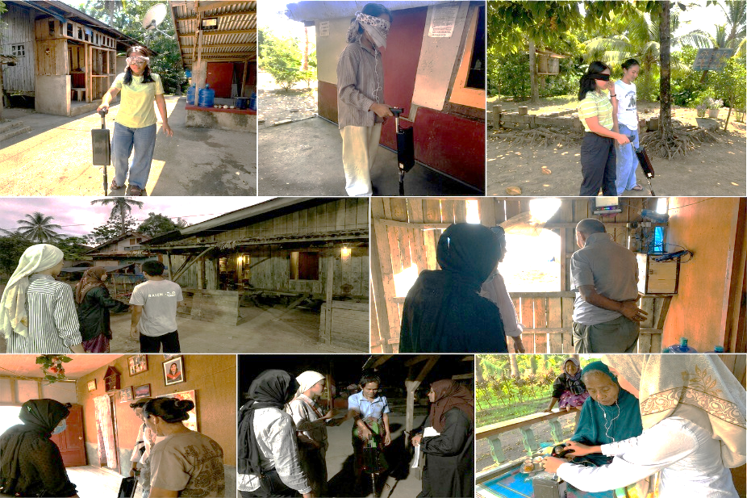

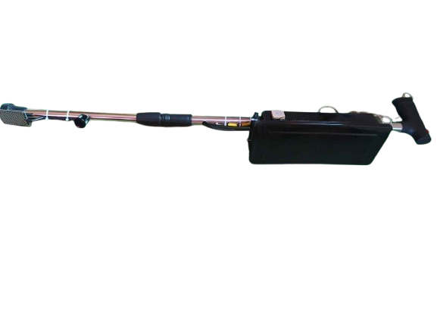

Figure 6. Actual-use of the IoT-Based Smart Cane
Figure 7 presents the compiled interfaces of the Guardian Monitoring Application integrated into the developed Smart Cane. The application was designed to provide guardians with real-time location monitoring, system status updates, and emergency notifications through a user-friendly mobile interface. Each interface performs a specific function to support accessibility, effective monitoring, real-time synchronization, and system security. The Login Interface serves as the secure entry point of the application where registered guardians can access the system using their email and password credentials. The interface includes account authentication, password recovery, and account registration functions to ensure that only authorized users can access the monitoring system. The Create Account Interface allows new guardians to register an account in the application. Users are required to provide valid credentials and create a strong password consisting of letters, numbers, and symbols to improve account security. After successful registration, the user is redirected to the login interface for authentication and system access. The Main Dashboard Interface functions as the central monitoring panel of the application. It displays important real-time information including the current system status, online or offline device connection status, exact location of the blind user, and the latest update timestamp. The dashboard supports synchronized real-time updates to provide guardians with more responsive and accurate monitoring information. In addition, larger text labels and dynamic status indicators were implemented to improve readability, visibility, and usability during monitoring. The Live Map Interface provides guardians with real-time location tracking of the blind user through an interactive map integrated with OpenStreetMap. A live location marker continuously updates based on the current GPS coordinates transmitted by the Smart Cane. The system also processes geofencing and reverse geocoding functions to display more specific and user-friendly location names instead of generalized municipal addresses. This enhancement allows guardians to identify the exact location or nearby landmark of the blind user more accurately for safety and monitoring purposes. The Location History Interface records and displays the previously visited locations of the blind user in chronological order. The system synchronizes location updates in real time and stores movement data periodically to allow guardians to review travel routes, monitor movement patterns, and verify the user’s recent activities. The implementation of real-time location synchronization also improved consistency between the dashboard, live map, and historical records. The SOS Emergency Alert Interface handles emergency situations initiated by the blind user through the emergency button integrated into the Smart Cane. Once activated, the application immediately displays the emergency status, exact location, and timestamp of the alert in real time. The system status automatically changes from SAFE STATUS to SOS ACTIVE STATUS to immediately notify the guardian regarding the emergency situation. An acknowledge button is also provided to confirm that the emergency notification has been received, after which the system returns to its normal monitoring condition. The Guardian Monitoring Application successfully provided a synchronized real-time monitoring system that improved guardian awareness, location accessibility, emergency responsiveness, and user safety for blind individuals using the developed Smart Cane.
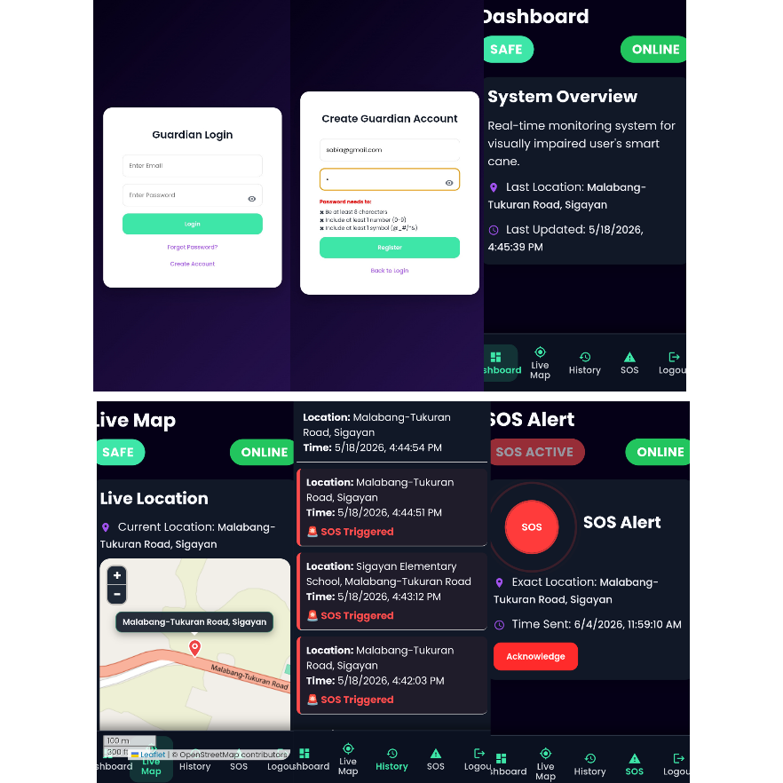

Figure 7. Guardian Monitoring Application Interfaces
Figure 8 presents the evaluation results, which revealed that both blind and non-blind respondents were Very Satisfied with the system in terms of ease of use, functionality, and overall satisfaction based on the five-point Likert scale ranging from 1 (Very Dissatisfied) to 5 (Very Satisfied). Blind respondents consistently provided a perfect weighted mean of 5.00 across all categories, while non-blind respondents rated the system 4.60 for ease of use, 4.76 for functionality, and 4.60 for satisfaction. These findings indicate that the Smart Cane was highly effective, user-friendly, and capable of meeting the mobility and safety needs of blind individuals. The results further imply that the integration of obstacle detection, navigation assistance, and safety features contributed significantly to the reliability and acceptability of the device, demonstrating its strong potential as an assistive technology that can enhance independence, accessibility, and confidence among blind users. The findings are consistent with the studies of Farooq et al. (2022) and Raghu (2024), which emphasized that smart assistive technologies improve mobility, safety, and navigation experiences for blind individuals.

Figure 8. Overall Evaluation Results of the Smart Cane
Figure 9 presents the evaluation results of the Guardian Monitoring Application, which revealed that the respondents were Very Satisfied in terms of ease of use, functionality and accuracy, and overall satisfaction based on the five-point Likert scale ranging from 1 (Very Dissatisfied) to 5 (Very Satisfied). All categories obtained a perfect weighted mean of 5.00, indicating that the application was highly effective, reliable, user-friendly, and accurate in monitoring and assisting guardians of blind individuals. The findings further imply that the system has strong potential as a dependable assistive and safety-support application that enhances accessibility, monitoring efficiency, and user confidence.

Figure 9. Overall Evaluation Result of Guardian Monitoring Application
Comparative Analysis
The comparative analysis presented in Table 1 is the comparative analysis between the developed IoT-Based Smart Cane System and the existing assistive technologies discussed in the related literature. The comparison focused on major system components and functionalities including obstacle detection, water detection, feedback systems, GPS monitoring, IoT integration, emergency support, communication methods, language support, and guardian monitoring capabilities. The reviewed studies consistently utilized ultrasonic sensors for obstacle detection to support blind individuals during navigation. Ali (2023), Farooq et al. (2022), Raghu et al. (2024), and P. Vennila et al. (2025) implemented ultrasonic sensing technologies to detect nearby obstacles and provide environmental awareness. Similar to these studies, the developed Smart Cane utilized the JSN-SR04T ultrasonic sensor to detect obstacles and assist the blind user through vibration feedback and voice assistance. In terms of environmental hazard detection, Farooq et al. (2022), Raghu et al. (2024), and P. Vennila et al. (2025) integrated water detection mechanisms to identify wet surfaces and hazardous areas.
Likewise, the developed system incorporated the YL-83 water sensor to improve user safety by detecting water hazards during navigation. Unlike Ali (2023), which focused primarily on obstacle detection, the developed system combined both obstacle and water detection within a single assistive device. The comparison further showed differences in feedback systems and audio assistance. Existing systems mainly relied on audio alerts, earphones, speakers, or vibration mechanisms to notify users about surrounding obstacles. The developed Smart Cane enhanced this functionality by integrating both vibration feedback and multilingual voice assistance through a wired headset. The use of a wired headset provided more stable and uninterrupted audio guidance compared to wireless communication devices. Furthermore, the developed system supported four languages—English, Filipino, Bisaya, and Maranao—while previous studies primarily supported only a single language.With regard to IoT integration and GPS monitoring, Farooq et al. (2022) and Raghu et al. (2024) implemented IoT and GPS functionalities using GSM communication, while P. Vennila et al. (2025) utilized a mobile application for navigation guidance. In comparison, the developed Smart Cane integrated Firebase-based IoT monitoring, GSM communication, GPS tracking, and a Guardian Monitoring Application to provide real-time location monitoring and emergency communication.
The comparative analysis also revealed that guardian monitoring and location history functionalities were generally absent in most previous studies. The developed system addressed this limitation by integrating a Guardian Monitoring Application capable of displaying the blind user’s real-time location and movement history. This feature improved guardian awareness and strengthened emergency response capabilities during critical situations. In terms of emergency support, Farooq et al. (2022) and Raghu et al. (2024) implemented panic button mechanisms, while some systems lacked emergency alert functionalities entirely. The developed Smart Cane expanded this capability by integrating an SOS emergency alert system with real-time GPS location transmission, enabling guardians to immediately receive emergency notifications together with the blind user’s exact location.
Overall, the comparative analysis demonstrated that the developed IoT-Based Smart Cane System provided a more integrated assistive solution compared to existing studies. By combining obstacle detection, water detection, multilingual voice assistance, GPS monitoring, IoT connectivity, guardian monitoring, location history tracking, and SOS emergency alert transmission into a single platform, the developed system addressed several limitations identified in previous assistive technologies for blind individuals.
Table 1. Comparative Analysis
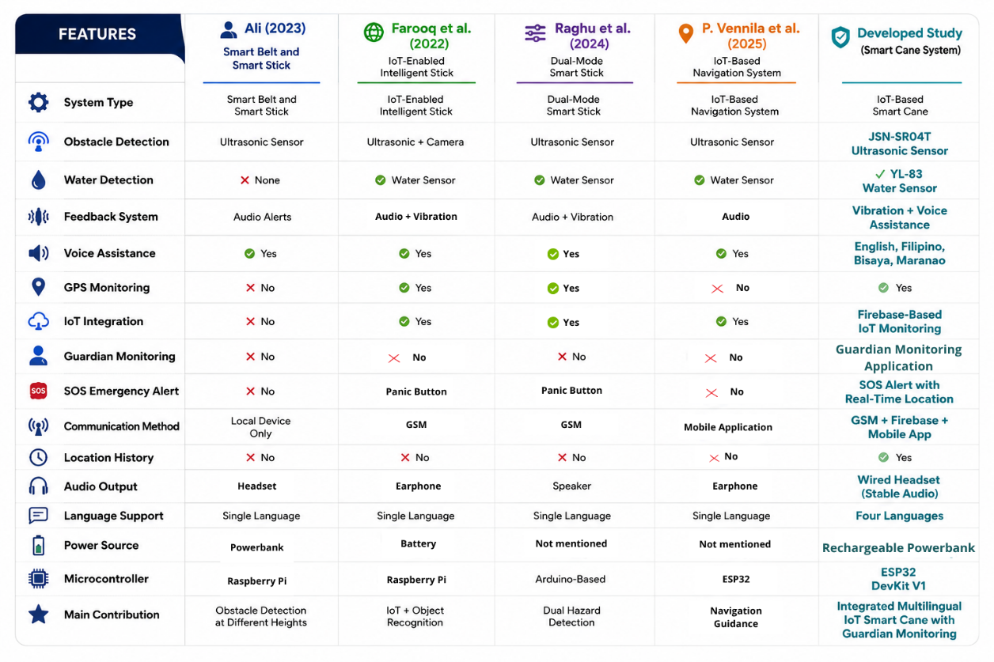

CONCLUSIONS AND RECOMMENDATIONS
This study successfully designed, developed, and evaluated “An IoT-Based Smart Cane for Blind Individuals with Emergency Alert System.” The developed system effectively integrated obstacle and water detection, multilingual voice and vibration feedback, GPS-assisted intersection awareness, real-time location tracking, and SOS emergency alerts into a single assistive device. Findings revealed that the Smart Cane reliably transmitted real-time data to guardians through the Firebase-based monitoring application, improving user safety, mobility, and communication. Evaluation results further confirmed that the system was functional, accurate, user-friendly, and acceptable in controlled testing environments. The study contributes to the advancement of affordable and inclusive IoT-based assistive technology that provides additional safety, assist navigation and mobility for blind individuals. Furthermore, the study may serve as a reference for future researchers and developers in improving assistive technologies and promoting accessible solutions for individuals with blindness.
Future researchers are encouraged to further enhance the system by integrating emergency calling, push notifications, route history, and movement analytics within the Guardian Monitoring Application. The incorporation of artificial intelligence and computer vision is also recommended to support advanced object recognition, traffic signal detection, and autonomous navigation. In addition, GPS capabilities may be improved for real-time route guidance, while wireless audio technology may provide more stable and flexible voice feedback. Lastly, improving automatic SOS detection, battery life, hardware durability, and weather resistance would further strengthen the reliability and long-term usability of the Smart Cane system.

REFERENCES
- Ali, Z. A. (2023). Design and evaluation of two obstacle detection devices for visually impaired people. Journal of Engineering Research, 11(3), 100–105. https://doi.org/10.1016/j.jer.2023.100132
- Bharadwaj, A. S. (n.d.). Smart Blind Stick For Detection And Avoidance Of Obstacle. 8(9).
- Bheemireddi, V. R. C., Pasupuleti, S. T., Gannamani, K. S., Bandaru, G., & Mula, V. S. S. N. (2024). Obstacle Detection and Fire Detection for Visually Imapired using Smart Blind Stick. 2024 3rd International Conference on Applied Artificial Intelligence and Computing (ICAAIC), 1075–1078. https://doi.org/10.1109/ICAAIC60222.2024.10575684
- Chung, S., & Son, J.-W. (2020). Visual perception in autism spectrum disorder: A review of neuroimaging studies. Journal of the Korean Academy of Child & Adolescent Psychiatry, 31(3), 105–120.
- Cleveland Clinic. (2022). Blindness. Cleveland Clinic. Blindness Articl
- Farooq, M. S., Shafi, I., Khan, H., Díez, I. D. L. T., Breñosa, J., Espinosa, J. C. M., & Ashraf, I. (2022). IoT Enabled Intelligent Stick for Visually Impaired People for Obstacle Recognition. Sensors, 22(22), 8914. https://doi.org/10.3390/s22228914
- Lund, A.M. (2001) Measuring Usability with the USE Questionnaire. STC Usability SIG Newsletter, 8:2
- Malla, S., Sahu, P. K., Patnaik, S., & Biswal, A. K. (2023). Obstacle Detection and Assistance for Visually Impaired Individuals Using an IoT-Enabled Smart Blind Stick. Revue d’Intelligence Artificielle, 37(3), 783–794. https://doi.org/10.18280/ria.370327
- N, R. (2024). Design and Implementation of Smart Blind Stick for Obstacle Detection and Navigation System. Journal of Electrical Systems, 20(2s), 1277–1289. https://doi.org/10.52783/jes.1770
- Natarajan, V., M, Y., & Canessane, A. (2022). IoT based Smart Stick with Automated Obstacle Detector for Blind People. 2022 6th International Conference on Trends in Electronics and Informatics (ICOEI), 536–540. https://doi.org/10.1109/ICOEI53556.2022.9777174
- Pathak, A., Singh, A. P., Sharma, H., Kumar, S., & Saini, Y. (2021). Rapid Response Smart Blind Stick With Obstacle Detection Using Arduino. International Journal of Technical Research & Science, 14–17. https://doi.org/10.30780/IJTRS.V06.I08.003
- Pal, S. K. (2025, July 11). What is Spiral Model in Software Engineering? GeeksforGeeks. https://www.geeksforgeeks.org/software-engineering/software-engineering-spiral-model/
- Palachi, E. (2025, July 28). System architecture diagram basics & best practices. vFunction. https://vfunction.com/blog/architecture-diagram-guide/
- Pranata, S. (2025). IoT-based smart cane with sensors and GPS as a modern medical solution to help safe and independent mobility for the visually impaired in daily life. Create the Future Design Contest. https://contest.techbriefs.com/2025/entries/medical/13417
- Raghu, N., Kumaran, S. Y., Rajeshwari, D., Shetty, G. S., Kumar, B. M. H., Kumar, D. A., & Kannanugo, N. (2024, March 31). Design and implementation of smart blind stick for obstacle detection and navigation system. Journal of Electrical Systems, 20(2 S), Article 1770.
- Sandman, A. (2025, June 2). Use cases: Diagram & examples (Updated 2024). Inflectra. https://www.inflectra.com/Ideas/Topic/Use-Cases.aspx
- Shinagawa Lasik & Aesthetics. (2025, May 29). Perfect vision and eye health in the Philippines. Shinagawa.
- Simran, S. (2025, April 14). Spiral model for software development: A risky-driven model. BDTASK. https://www.bdtask.com/blog/spiral-model-for-software-development
- Vennila, P., Alamelu Mangayarkarasi, V., Vinayakan, K., & Gnana Raja, G. R. (2025). Smart IoT navigation system for visually impaired individuals: Improving safety and independence with advanced obstacle detection. International Journal of Computational Research and Development, 10(1), 17–23.
- World Health Organization. (2019). World report on vision. World Health Organization. https://iris.who.int/handle/10665/328717

