Remote Sensing Base Modeling Aboveground Biomass Of Pinus Kesiya Forest Of Licuan-Baay Abra, Philippines

ABSTRACT
This study analyzed available data from the field and remote sensing sources that produced develop model equation in determining the AGB and Carbon Sequestered of Pinus kesiya forest in Licuan-Baay Abra, Philippines. The developed models were as followed: NDVI, SAVI, and SRI, respectively. The AGB of the Pinus kesiya forest stand will be calculated using the developed models.
The estimated Aboveground Biomass using Regression models developed is 1M+ tons for NDVI, SAVI, and SRI respectively. The three models developed have a significant correlation in Aboveground Biomass and the Vegetation Index at the 0.01 level 2-tailed.
The three model equations' Pearson's correlation coefficients (R) vary from 90% to 94%, whereas the coefficient of determination (R2) is between 81% and 89%. The three-model equation's root squared mean error ranges from 5.60 to 7.14 tons/ha. The average Above Ground Biomass tons per plot is 29,948.47 and the carbon average is 13,476.94, and carbon dioxide average is 49,460.37. Therefore, the three model develops have the capability to estimate aboveground biomass of Pinus kesiya forest.
INTRODUCTION
Climate change, which is brought on by global warming, is the most urgent environmental issue facing the globe today. One of the leading gases causing the climatic anomaly is Carbon dioxide which is abundance in the atmosphere. Due to that problem, there are many studies conducted to address climate change such as to reduce the amount of CO₂ in the atmosphere through limiting emissions.
Ecosystems in forests offer a lot of potential in this regard. In forest ecosystems, Biomass, soil, litter, and puddles of coarse woody debris can all serve as carbon storage sites. The CO2 content in the atmosphere has grown throughout time since the start of the industrial revolution and is continuing to grow at an unmatched pace of an average 0.4% per year (Lasco & Pulhin, 2003), as noted by Adrian M. Tulod et al. in 2010. Sequestration is one method for controlling atmospheric carbon. According to Jose Hermis P. Patricio et al. (2014), the process of taking carbon dioxide from the atmosphere and storing it in a long-term carbon sink, such a plant, is known as carbon sequestration.
The Philippines has lost around 12 million acres of its tropical forests since the 1930s, according to Leni Diamante Camacho et al. (2009), which is equivalent to a loss of 2.1 billion tons of carbon. Since the turn of the 19th century, the Philippines' tropical forests have decreased by 15.7 hectares, causing a loss of 2.7 billion tons of carbon (Lasco 1997). Approximately 120 million tons of carbon dioxide are emitted annually from forest areas, which is nearly 93 percent of the nation's overall carbon dioxide output. (Lasco and Pulhin 1998; Murdiyarso 1996). About 109 million tons of CO2, or 84% of the nation's total carbon dioxide emissions, may be stored in the Philippines' forests. According to statistics from 1997, the Philippines may need to restore at least 62 percent of its destroyed forests if it wants to reduce carbon dioxide emissions to 1990 levels. This would suggest that it would be necessary to expand the forest cover by rehabilitating areas of grassland and sagebrush.
As of right now, not enough is known about the carbon reserves of pine, mossy, and mangrove forests. Only a few studies have been done so far to identify and evaluate the above-ground biomass of Pinus kesiya, and further studies are required to evaluate the carbon stock of Pinus kesiya in order to address concerns about carbon sequestration and climate change adaptation. The outcome of this study will serve as a substance for collecting information on above-ground biomass Pinus spp. The equation based on breast height diameter (DBH) is used to calculate the biomass of Benguet pine trees. A calibrated tape measure will be used to estimate the tree's DBH. In the research by M.F. Justine et al., 2015, the biomass of the plantations Pinus massoniana grew as the age of the stand increased, from 0.84 tons per hectare (t•ha1) in the three-year stand to 252.35 t•ha1 in the 42-year stand. The above-ground biomass made up 86.51% of the total; the greatest value is 300 times lower than the minimum.
The practice of identifying and monitoring a location's physical characteristics by calculating the radiation it reflects and emits in a distance is known as remote sensing, and it is now one of the most widely used methods for acquiring information on the ground. Remote sensors that are both active and passive are available. Passive sensors react to external inputs. The natural energy that the earth's surface reflects or emits is captured by them. The most prevalent radiation source that passive sensors can pick up is reflected sunlight. Additionally, it provides an international perspective and a wealth of data on earth systems, enabling data-informed decision-making based on the current and projected future situations of our planet. Remote sensing photos may stand for a multiple of purposes on earth, including following a cloud to anticipate the weather, monitoring erupting volcanoes, keeping an eye out for dust storms, and enabling rangers to observe massive forest fires that have been mapped from space from the ground. It is used to monitor changes in agriculture, forests, and city growth over the course of several years or decades. Additionally, it may be used to map and identify the sea's irregular terrain, including its enormous mountain ranges, unfathomable valleys, and magnetic striations.
For acquiring data on the ground, a variety of sensors are at our disposal, including the multispectral Landsat 1–5 scanner. The newest satellite, called Landsat 8, takes a different tack. The Operational Land Imager (OLI) and the Thermal Infrared Sensor (TIRS) are two independent sensors that it carries and uses to collect data in 11 bands. Bands 1 through 7 and 9 of the nine spectral bands in the OLI and TIRS images have a spatial resolution of 30 meters. Studies of coastal and aerosol topics benefit from the use of the ultra-blue band 1. The new band 9 makes it easier to spot cirrus clouds. The resolution of Band 8 is 15 meters and is sometimes referred to as the panchromatic band. Thermal bands 10 and 11 at 100 meters are beneficial for obtaining more precise surface temperature data.
Thematic Mapper (TM) from Landsat 4-5, Enhanced Thematic Mapper Plus (ETM+) from Landsat 7, and Operational Land Imager (OLI)/Thermal Infrared Sensor (TIRS) from Landsat 8 are used to create the Normalized Difference Vegetation Index (NDVI), which is generated from Landsat Surface Reflectance. The amount of greenness in vegetation is measured using the NDVI, this can be used to comprehend vegetation density and evaluate changes in plant health. NDVI is calculated as a ratio of the red (R) and near-infrared (NIR) data. It is commonly recognized as a predictor of green foliage and was computed using the reflectance values of the red and near-infrared bands of optical vision (Fraser et al. 2011).
In connection with that, Landsat 8 is used to monitor the NDVI, SAVI, and SRI of the Pinus kesiya forest at Licuan Bay, Abra. With a slope that may reach 50%, the terrain is steep and hilly. 11 barangays made up Licuan-Baay: Bonglo, Bulbulala, Caoayan, Domenglay, Lenneng, Mapisla, Nalbuan, Licuan, Tumalip, Mogao, and Subagan. Licuan-Baay has 52.10 kilometers from beyond Bangued's city limits.
To track the global carbon cycle and mitigate the effects of climate change, forest AGB is crucial (Sujit Madhab Ghosh et al., 2018). In this study, Pinus kesiya species in Licuan-Baay, Abra, was estimated using above-ground biomass. The study employed a site-specific model created by Napaldet and Gomez (2015) to calculate the AGB of Pinus kesiya spp. In the study of Fabrico L. Macedo et al. (2018), the application of allometric functions tailored to tree-level species and site circumstances is the most frequently used technique for calculating biomass. These formulas frequently use the explanatory variables total height and diameter at breast height. (Foroughbakhch, Reyes, Alvarado-Vázquez, HernándezPiñero, & Rocha-Estrada, 2005; Flombaum & Sala, 2007; Segura &Kanninen, 2005; Nelson et al., 1999; Parresol, 1999; Peichl & Arain, 2006;). Data from a forest inventory and vegetation indicators was used in the study (such as NDVI, SAVI, and SRI) collected from satellite photos with a high degree of spatial resolution. The statistical analysis included correlation, variance analysis, and linear regression (Fabrcio L. Macedo et al., 2018).

THEORETICAL FRAMEWORK
In order to compare the computed aboveground biomass from the generated model NDVI, SAVI, and SRI with the aboveground biomass of the study area from the field, the aboveground biomass of the study area was then determined using the local Non-destructive model of Napaldet et al.. The workflow of the study is presented in figure 1.
Landsat 8 OLI/TIRS Images
Image Preprocessing
Vegetation Index Calculation
Field Aboveground Biomass
Linear Regression and modeling
Model validation
Aboveground Biomass Prediction Map
Figure 1. Workflow of the Study
OBJECTIVES
The general objective of this study is to evaluate the capability of VI derived from Landsat 8 images to estimate Aboveground Biomass of Pinus kesiya forest. Specifically, it aims to:
1. Determine the relationship between vegetation indices acquired from satellite image and aboveground biomass of Pinus kesiya forests obtained from field data.
2. Develop a model to estimate above-ground biomass of Pine forests at local scale by using high spatial resolution satellite images.
3. Determine the Aboveground Biomass (AGB) values of Pinus kesiya forests in Licuan-Baay.
SIGNIFICANCE OF THE STUDY
This study estimate Above-ground biomass of Pinus kesiya Species. Determine the best resolution used in estimating Above-ground Biomass of Pinus kesiya tree. The tools that was used in estimating the Above-ground Biomass is NDVI, SRI, and SAVI. The results of the study may also recognize by the people in Licuan-Baay, Abra the estimated Above-ground Biomass of the Pinus kesiya species on site. In addition, this study may give an opportunity to the researcher to have a deeper understanding on using satellite images to determine the AGB of Pinus kesiya species. It will also guide other researchers in conducting related studies on the topic. Finally, the study may contribute to the body of knowledge and deepening empirical literature on estimating Above-ground Biomass using satellite images.

METHODOLOGY
Study Area
The study location is at the municipality of Licuan-Baay, Abra (Figure 2). It is located at the Northern part of the Philippines with geographic coordinates of 17°35'08.60" N and 120°32'33.50" E. The area is 25,642 hectares with a population of 4, 864 during the 2015 census. According to the Modified Coronas Classification, the research region has a climate of type II, which has two distinct seasons: dry from November to April and wet from July to November. The average annual temperature is 24.0°C, and there are 3,012 mm of rain on average per year. The research area's land cover based on the 2010 land cover classification by the DENR is presented in the following table 1. Recently, it is observed that there is an increase in forest cover of the area as a result of various reforestation projects of the government such as the National greening program. In addition, the forest cover is maintained because of the implementation of traditional forest management in the municipality. The main possible threats to forest cover loss in the area are small scale illegal logging and forest fires.

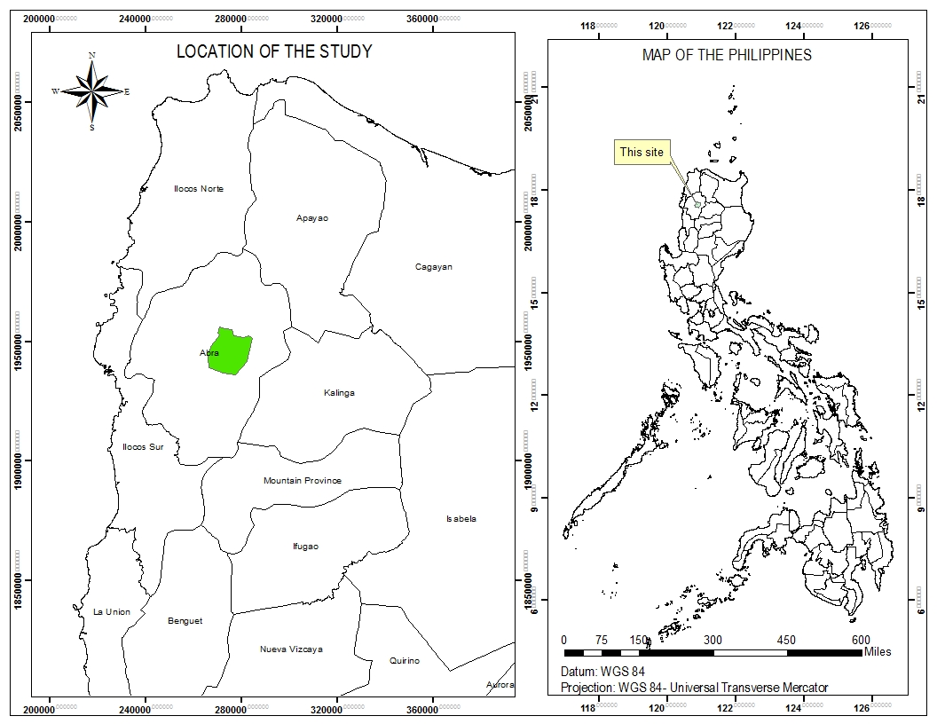
Figure 2. Location of the Study
Table 1. Baay-Licuan Landcover (2015)
LANDCOVER | Area (Has)
Closed forest, broadleaved | 214.94
Closed forest, coniferous | 13.34
Closed forest, mixed | 3.28
Forest plantation, broadleaved | 205.02
Inland water | 256.23
Open forest, broadleaved | 6,428.44
Open forest, coniferous | 1,788.52
mixed open forest | 530.67
built-up area | 24.17
Other forested areas , cultivated, annual crop | 384.04
Other forested areas , natural, barren land | 17.14
Other forested areas, natural, grassland | 2,461.84
Other forested areas, fallow | 5.01
Other forested areas, bushes | 2,576.13
Other forested areas, wooded grassland | 10,339.22

Field Data Collection
Materials
The materials used in the gathering of field data are: diameter tape to measure the DBH of trees; tape measures were used in determining the size and for lay-outing of the sample plots, Global positioning System (GPS) receiver to determine the coordinates of the sample plots and camera to photo document the activities. Other materials such as cutting tools were used in clearing paths in the lay-out of plots and a Biltmore stick to easily determine the breast height of the trees.
Plot Establishment
Biomass and carbon stock estimation was determined following the carbon stocks assessment protocol formulated by Hairiah et al. (2001) which was also used by other researchers in the Philippines with modifications. 35 plots measuring 30 x 30 meters were established. Trees within this plot with DBH (1.3 meters above the ground) of more than 5 cm were recorded.
The coordinates of the established plots were taken at the center of the plot using a GPS receiver. Since GPS receivers have positional errors, it is nearly impossible to accurately locate every sample plot on the center of the 30 m by 30 m grid of Landsat OLI pixels. To remedy this, a moving window technique (Gunlu et al, 2014) such as 3 by 3 pixels was used in the study. This technique to calculate the average index values of the various vegetation indices of each of the sample plots.

Aboveground Biomass Computation
In this study, aboveground biomass of the Pinus kesiya forest was determined by using the site-specific model developed by Napaldet and Gomez (2015). Based on the study of Napaldet and Gomez (2015), their model showed a very high R values, meaning, the model developed had a strong correlation to the actual biomass of the sample trees. Tree biomass will be computed using the following allometric models used for Pinus kesiya species:
Y= 0.067*DBH^{2.474}, Napaldet and Gomez, (2015)
Where: Y = tree biomass (kg tree⁻¹)
DBH = diameter at breast height (cm) at 1.3 m

Landsat Data Acquisition and Preprocessing
Data Acquisition
For this investigation, Landsat 8 satellite pictures were downloaded from the website of the United States Geological Survey (USGS). A satellite picture taken during a period when field data collection was taking place was chosen since it had less cloud cover. The Thermal Infrared Sensor (TIRS) and Operational Land Imager (OLI) equipment are aboard Landsat 8 that debuted. With exception of 15-meter Pan Band, the OLI sensor gathers information from 9 distinct shortwave spectral bands over a 190 km2 region with a spatial precision of 30 meters. On the other hand, the TIRS sensor gathers picture data from two thermal bands across the same 190 km region with 100-meter-high spatial resolution. The 2 thermal infrared bands are an improvement over the single-band thermal data since they cover the same wavelength range as the wider TM and ETM+ thermal band. The spectral bands of the Landsat 9 OLI/TIRS sensor are shown in the following table.
Table 2. Features of Landsat 8 OLI/TIRS Spectral Bands
Bands | Wavelength  (micrometers) | Resolution  (meters)
Coastal aerosol (band 1) | 0.43-0.45 | 30
Blue (band 2) | 0.45-0.51 | 30
Green (band 3) | 0.53-0.59 | 30
Red (band 4) | 0.64-0.67 | 30
Near Infrared (NIR) (band 5) | 0.85-0.88 | 30
SWIR 1 (band 6) | 1.57-1.65 | 30
SWIR 2 (band 7) | 2.11-2.29 | 30
Panchromatic (band 8) | 0.50-0.68 | 15
Cirrus (band 9) | 1.36-1.38 | 30
Thermal Infrared (TIRS) 1 (band 10) | 10.6-11.19 | 100
Thermal Infrared (TIRS) 2 (band 11) | 11.50-12.51 | 100

Image Preprocessing
The satellite image used in this study was undergoing preprocessing in order to increase the precision of the quantitative values of the various vegetation indices. Image preprocessing involves geometric, radiometric and atmospheric corrections. For geometric correction, the satellite image was geo-referenced to WGS 84/ UTM 51 N projection system. Atmospheric correction was done to remove atmospheric effects from satellite images. This was done by converting the DN values of the spectral bands to Using the formula in the Landsat 8 data from Data Users Handbook (2019), calculate Top of Atmosphere (TOA) Reflectance.
Vegetation Indices
After preprocessing the images, the images were processed and analyzed to determine the quantitative values of the various vegetation indices. Arcmap 10.4.1 software was utilized in the data processing. The three formulas were showed in table 3.

Table 3. Vegetation Indices equations.
Vegetation Indices | Equation | References
NDVI | NIR - RED/NIR + RED | Gunlu et al (2014); Estoque et al (2017); Wahlang and
SRI | NIR/RED | Jordan (1969); Vicharnakorn et al (2014); Torabzadeh (2019); Macedo et al (2018)
SAVI | (1 + L) (NIR - Red)  (NIR + Red + L) | Huete, A.R. (1988)

Modeling Relationship between Field AGB and Vegetation Indices
The estimated AGB and VI were correlated in this research using linear regression. This study employed three VI that were estimated using the Pearson correlation coefficient (r) and coefficient of determination (R2). High r and R2 indices suggested that they fit into AGB. To model the relationship between aboveground biomass and vegetation indices, AGB was plotted as a dependent variable and vegetation indices were displayed as independent variables in IBM SPSS 20. To verify the model's dependability, R2 and the RMSE will be determined.
RESULTS AND DISCUSSION
The Model equation develop in this study are NDVI, SRI, and SAVI by using the linear regression analysis. Since linear regression is a commonly used method to estimate Above Ground Biomass in most studies, the three develop vegetation indices model equations used to predict the entire Above Ground Biomass of the study area. The study located at the Municipality of Licuan-Baay, Abra. The three vegetation index which is the NDVI, SRI, and SAVI derived from Landsat 8 image served as the independent variables and field data gathered served as the dependent variables data in developing the model equations to estimate or predict the Above Ground Biomass of the Pinus kesiya forest. The following are the results and discussion based on the objectives of the study.
Objective 1. Determine the relationship of vegetation indices (NDVI, SAVI, SRI) acquired from satellite image and Above Ground Biomass (ABG) of Pinus kesiya forest obtained from field data
The correlation between AGB and VIs was calculated finding the relationship between the two variables. If a change in one variable has an impact on the other, there is correlation. When one variable boosts the other, this is referred to as a positive correlation between the two variables and vice-versa. There are various statistical measures to determine the degree of correlation. In this study, the Pearson’s correlation was used. The degree of connection is represented by correlation coefficient (r). Figure 3, 4, 5 shows the scatterplot between the measured ABG and VI values derived from Landsat 8. It also shows the relationship between vegetation indices acquired from Landsat8 images and Above Ground Biomass of Pinus kesiya forest obtained from field data. The values of vegetation indices were obtained from the generated VI maps shown in Table 4. The VI values are the independent variable while the AGB values are the dependent variables.
Table 4. Vegetation indices and AGB values
Plot | Biomass | NDVI | SAVI | SR
1 | 17857.44083 | 0.16 | 0.19 | 1.11
2 | 27060.76153 | 0.38 | 0.31 | 1.33
3 | 28282.72581 | 0.33 | 0.35 | 1.48
4 | 16770.05495 | 0.17 | 0.19 | 1.17
5 | 21471.25656 | 0.34 | 0.26 | 1.25
6 | 26540.52324 | 0.29 | 0.31 | 1.39
7 | 21769.24685 | 0.22 | 0.21 | 1.36
8 | 29340.66911 | 0.45 | 0.18 | 1.37
9 | 28758.51219 | 0.40 | 0.33 | 1.37
10 | 47182.922 | 0.60 | 0.52 | 2.56
11 | 37299.79868 | 0.43 | 0.44 | 1.86
12 | 28408.90405 | 0.32 | 0.34 | 1.34
13 | 32230.41109 | 0.41 | 0.33 | 1.79
14 | 33354.53463 | 0.39 | 0.41 | 1.83
15 | 30279.31043 | 0.39 | 0.31 | 1.52
16 | 23251.66419 | 0.26 | 0.29 | 1.30
17 | 28738.31581 | 0.34 | 0.28 | 1.42
18 | 25286.56172 | 0.21 | 0.23 | 1.30
19 | 27942.31762 | 0.31 | 0.33 | 1.69
20 | 31306.95128 | 0.41 | 0.34 | 1.81
21 | 48147.0457 | 0.66 | 0.50 | 2.52
22 | 33923.99666 | 0.48 | 0.40 | 1.74
23 | 38389.42908 | 0.44 | 0.47 | 1.92
24 | 29706.35178 | 0.37 | 0.30 | 1.45
25 | 49769.38096 | 0.65 | 0.57 | 2.55
26 | 35793.93971 | 0.45 | 0.48 | 1.76
27 | 27198.88456 | 0.35 | 0.38 | 1.35
28 | 22893.15643 | 0.35 | 0.28 | 1.37
29 | 29760.84607 | 0.34 | 0.36 | 1.46
30 | 30386.34061 | 0.38 | 0.31 | 1.40
31 | 23610.30797 | 0.33 | 0.24 | 1.34
32 | 37538.55191 | 0.46 | 0.48 | 1.71
33 | 28642.73726 | 0.23 | 0.26 | 1.59
34 | 25632.10835 | 0.27 | 0.29 | 1.34
35 | 23680.51884 | 0.30 | 0.22 | 1.34

Table 5 presents the correlation analysis's finding. The coefficient of correlation ranges from 90 % to 94 %. The result shows a positive correlation between the VI values and AG similar to the studies of Das and Singh, 2012; Gizachew et al.,2016; Macedo et al.,2018; Baloloy et al.,2018; Askar et al.,2018 showed a positive correlation between Above Ground Biomass and Vegetation Indices. However, other studies also showed a negative correlation.

Table 5. Correlation analysis results
Vegetation Indices |  | R
1 | NDVI |  | 0.92**
2 | SAVI |  | 0.90**
3 | SRI |  | 0.94**
**. Correlation is significant at the 0.01 level (2-tailed).

Figure 3. Normalized Difference Vegetation Index Biomass Scattered Plots

Figure 4. Soil Adjusted Vegetation Index Biomass Scattered plots

Figure 5. Simple Ratio Index Biomass Scattered Plots

Objective 2. Develop a model to estimate above-ground biomass of Pinus kesiya forests at local scale by using high spatial resolution satellite images.
The developed model used to estimate Above Ground Biomass of Pinus kesiya forest at local scale by using high spatial resolution satellite images shown in table 6. The result shows that the three vegetation indices are significant in correlation at the 0.01 level (2-tailed) which indicates a good correlation of the Vegetation Indices and the Above Ground Biomass of the Pine Forests. It shows that the models are reliable in predicting the Above Ground Biomass of a Pine Forest in Licuan Baay Abra. The NDVI R squared value is 0.842 and its RSME (ton/ha) value is 6.66; the SAVI R squared has a valued of 0.815 and the RMSE value is 7.14 and the SRI R squared value is 0.890 and the RSME value is 5.60, respectively. In the study of Hamdan et al. (2014) as mentioned by M.H. Ismail et al. (2018) using NDVI and SAVI in mangrove forest they obtained RMSE = 43.77 Mg ha-1 (r2 = 0.59) and 68.21 Mg ha-1 (r2 = 0.01). The correlation coefficients found in the study, however, were higher than those LIMA JNIOR et al. (2014) reported with Pearson’s correlation coefficient of R = 0.84 as mentioned in the study of L.R. Luz (2022). This study also implies that the Rs range to 0.818 to 0.888 which higher than the Rs in the study of L.R. Luz (2022) ranging from 0.64 to 0.58 for the correlation coefficients (Rs). Nevertheless, it was shown in figure 3, 4, 5 that the biomass obtained from the field data gathered and vegetation indices have a relationship. Therefore, the study's findings indicated three vegetation model equations have a significant correlation of Above Ground Biomass and Vegetation Index in 0.01 level 2-tailed which shows that the three vegetation index model equations can be used to determined and analyzed the biomass of a Pinus kesiya forest. With that, SRI vegetation index model is the most accurate model develop to use in estimating the Pinus kesiya Forest Biomass, carbon and carbon dioxide based on its R squared which has the highest total value computed among the three Vegetation Index and has the lowest total value computed in the RSME (ton/ha).
Table 6. Model Summary
Model | Equation | R | R Squared | Adjusted R Squared | RSME  (tons/ha)
NDVI | 60.335*NDVI+7.7629 | 0.92 | 0.8421 | 0.837 | 6.66
SAVI | 68.937*SAVI+6.9238 | 0.90 | 0.8149 | 0.813 | 7.14
SRI | 19.74*SRI-1.1216 | 0.94 | 0.8909 | 0.885 | 5.60
The thirty five (35) sample plots used in the study has a total actual biomass from the field data of 1,048,206.48 tons and a total of 471,692.92 tons of carbon and a total of 1,731,113.00 tons carbon dioxide. The average biomass tons per plot is 29,948.47 and the carbon average is 13,476.94, and carbon dioxide average is 49,460.37.

Objective 3. Determine the Aboveground Biomass, carbon, and carbon dioxide values of Pine forest from the developed equation model.
The Table 7 showed the model equations developed based on the data gathered in the field and the vegetation indices which was derived from the Landsat8 images. This computed ABG and sequestered carbon of Pinus kesiya forests stand from the product of developed equation model compared to estimate the Above Ground Biomass Pinus kesiya Forests of Licuan-Baay, Abra from the actual filed data gathered. The predicted Above Ground Biomass for NDVI model equation (60.335*NDVI + 7.7629) estimated a total value of 1,048,212.95 tons of AGB and 471,695.83 ton of C, the SAVI model equations (68.937*SAVI + 6.9238) also estimated a total value of 1,048,206.53 tons of AGB and 3471,692.94 of C, and SRI model equations (19.74*SRI -1.1216) estimated a total value of 1,048,220.60 tons of AGB and 471,699.27 of C of the Pinus kesiya forest of Licuan-Baay. The estimated Above Ground Biomass using the actual data gathered in the field has a total value of 1,048,206.48 tons and 471,692.92, showing that the estimated Above Ground Biomass from the three vegetation indices model equations developed shown in Table 7 was not over projected compared to the actual biomass from the field data. It also showed that the estimated value of Licuan-Baay, Abra Pinus kesiya forest biomass using the three models is reliable to estimate the Above-Ground Biomass of the Pinus kesiya Forest. The results also showed that they are not far from each other. In the study of A. Patriya et al. (2018) using the NDVI, SAVI, and SRI showed the total biomass estimated was approximately 243.85 million kg in a forest stand mixed with Pterocarpus indicus, Roystonea regia, Albizia saman, and Swietenia macrophylla with an area of 50,149 km² which implies that the larger vegetation covers the biomass value increases.
Table 7. Estimated AGB, Carbon and Carbon Dioxide of Licuan-Baay Abra
VI | Estimated AGB | Carbon | Carbon dioxide
NDVI | 1,048,212.95 | 471,695.83 | 1,731,123.69
SAVI | 1,048,206.53 | 471,692.94 | 1,731,113.08
SRI | 1,048,220.60 | 471,699.27 | 1,731,136.32
Field Data | 1,048,206.48 | 471,692.92 | 1,731,113.00
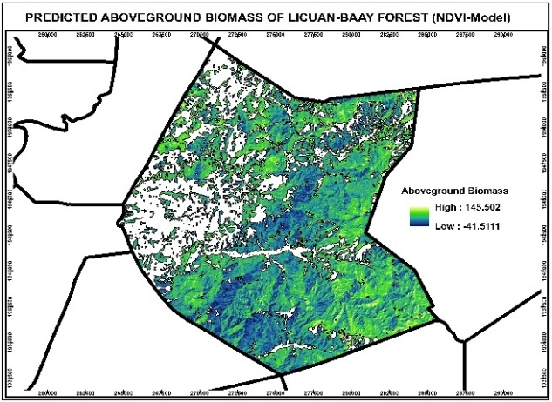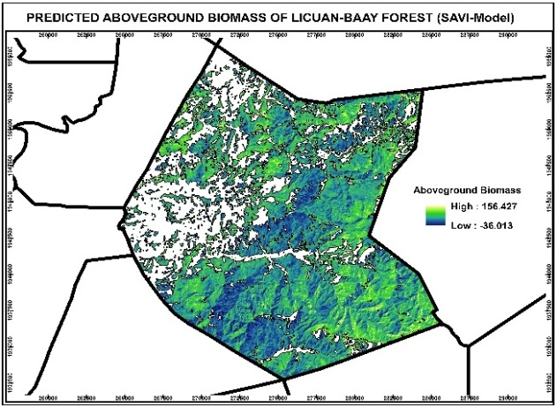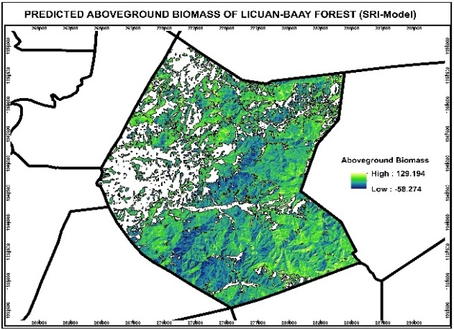
Figure 8. Above Ground Biomass maps using vegetation indices
FINDINGS
The study was conducted to develop a model in determining the aboveground biomass of Pinus kesiya forest through remote sensing using regression analysis. It specifically aimed to Evaluate the capability of vegetation indices derived from Landsat 8 images to estimate Aboveground Biomass of Pinus kesiya Forest, Determine the relationship between vegetation indices acquired from satellite image and aboveground biomass of Pinus kesiya forest obtained from field data, Determine the Aboveground Biomass (AGB) values of Pinus kesiya forests, Quantify the carbon absorbed by the forest stand, and Develop a model to estimate above-ground biomass of Pinus kesiya Forest stands at local scale by using high spatial resolution satellite images. The significance of the study was to seek cost-effective method of estimating carbon stock and estimate the aboveground biomass of Pinus kesiya.
The study area is located at licuan-Baay Abra with a total area of 25,642 hectares. A modified plot design was established measuring of 30 m by 30 m where trees with a diameter at breast height 15 cm were recorded. The coordinates of the established plots were taken at the center of the plot using a GPS receiver. A moving window technique (Gunlu et al., 2014) such as 3 by 3 pixels was used in the study. This technique used to determine the average index values of the various vegetation indices of each of the sample plots. To compute the above ground biomass gathered in the field, Napaldet and Gomez was used as general model for Above Ground Biomass. Furthermore, Landsat 8 satellite images was downloaded from the United States Geological Survey (USGS) website and used in this study. The satellite image was used in this study undergo preprocessing in order to improve the accuracy of the quantitative values of the various vegetation indices. Image preprocessing involves geometric and atmospheric corrections. After preprocessing the images, the images were processed and analyzed to determine the quantitative values of the various vegetation indices, and ArcMap 10.4.1 software utilized the data processing. Correlation analysis was used to determine the relationship of the estimated aboveground biomass and vegetation indices. The three VI used in this study were evaluated based on Pearson correlation coefficient (r) and coefficient of determination (R²). High r and R2 indices suggested that they fit into AGB. To model the relationship of aboveground biomass and vegetation indices, linear regression method was applied using IBM SPSS 20/ excel by plotting AGB as a dependent variable and VI as independent variables. R² and RMSE were calculated to verify the model's accuracy. 35 sample plots were used in generating the model. The aboveground biomass of the study area was then calculated by using the generated model. The three model develop can be used to determine the above ground biomass of Pinus kesiya forest.
CONCLUSIONS
Based on the results of the study, the following conclusions were drawn:
- The vegetation indices derived from Landsat8 images have the capability to estimate Above Ground Biomass of a Pinus kesiya Forest since the vegetation indices values and the above ground biomass obtained from the field are correlated to each other.
- The vegetation indices acquired from the satellite image and above ground biomass of Pinus kesiya forest obtained from the field data have a relationship using linear regression.
- The carbon stock absorbs by the Pinus kesiya forest stand using the three model equation develop are higher than the computed value of carbon stock obtained from the field.
- The three model equations develop have the capability to estimate above ground biomass of Pinus kesiya forests stand.
RECOMMENDATIONS
In view of the study, the following are recommended:
- To improve the results of the study, gathering of the data in the field needs more plots to establish. This is to improve the correlation of the above ground biomass from the field and the vegetation index.
- Furthermore, it is highly recommended to use other non-destructive equations to compute the Above Ground Biomass of the Pinus kesiya Forest.
REFERENCES
- Lasco et al. (2003). Philippine Forest Ecosystem and Climate Change: Carbon Stocks, Rate of Sequestration and the Kyoto Protocol. Annals of Tropical Research 25(2): 37-51 (2003). https://researchgate.net/publication/37619310
- A.M. Tulod et al. (2010). Carbon Sequestration Potential on Benguet Pine (Pinus kesiya) Plantations in Bukidnon, Philippines. Journal of Nature Studies 9(1), ISSN: 1655-3179. https://www.researchgate.net/publication/266896815
- Patricio et al. (2014). Comparing Above-ground Sequestration of Three Economically Important Bamboo Species Grown in Bukidnon, Philippines. J Multidisciplinary Studies Vol. 3, No. 1, Aug 2014, ISSN 2350-7020 (Print), ISSN 2362-9436 http://dx.doi.org/10.7828/jmds.v3i1.622
- Leni diamante Camacho and Youn Yeo-Chang (2009). Carbon sequestration benefits of the makiling forest reserve, Philippines. https://www.researchgate.net/publication/233140518
- M.F. Justine et al. (2015). Biomass Stock and Carbon Sequestration in a Chrono sequence of Pinus massoniana Plantations in the Upper Reaches of the Yangtze River. Forests 2015, 6, 3665-3682; doi:10.3390/f6103665. www.mdpi.com/journal/forests
- R.H. Fraser et al. (2011). Detecting long-term changes to vegetation in northern Canada using the Landsat satellite image archive. Environmental Research Letters, doi:10.1088/1748-9326/045502. https://iopscience.iop.org/article/10.1088/1748-9326/6/4/045502/pdf

- Sujit Madhab Ghosh et al, (2018). Aboveground biomass estimation using multi-sensor data synergy and machine learning algorithms in a dense tropical forest. Centre for Oceans, Rivers, Atmosphere and Land Sciences, Indian Institute of Technology Kharagpur, Kharagpur, West Bengal, 721302, India. www.elsevier.com/locate/apgeo
T
- F.L. Macedo et al. (2018). Above-ground Biomass Estimation for Quercus rotundifolia Using Vegetation Indices Derived from High Resolution Satellite Images. European Journal of Remote Sensing, ISNN: 2279-7254. https://www.tandfonline.com/loi/tejr20
- K. Hairiah et al. (2001). Methods for sampling carbon stocks above and below ground. International Centre for Research in Agroforestry, Southeast Asian Regional Research Programme PO Box 161, Bogor, Indonesia. http://www.icraf.cgiar.org/sea
- A. Gunlu et al. (2014). Estimation Aboveround Biomass Using Landat TM Imagery: A Case Study of Anatolian Crimen Pine Forests in Turkey. Article in Annals of Forest Research December 2014, Doi 10.15287/afr.2104.278. https://www.researchgate.net/publication/273075351
- Handbook (2019). Landsat 8 (L8) Data Users Handbook, (2019). Department of the Interior U.S Geological Survey, LSDS1574, version5.0.
- Sandipan Das, and T.P. Singh, (2012). Correlation analysis between biomass and spectral vegetation indices of forest ecosystem. www.ijert.0rg
- B. Gizachew et al. (2016). Mapping and Estimating the Total Living Biomass and Carbon In-low Biomass Woodlands Using Landsat 8 CDR Data. Balance Management 11:13, Doi 10.1186/s13021-016-0055-8. http://creativecommons.org/licences/by/4.0/
- Askar, et al. (2018). Estimating Above Ground Biomass in Private forest using sentinel-2 imagery. https://doi.org/10.1155/2018/6745629.
- A.B. Baloloy et al. (2018). Estimation of mangrove forest Above Ground Biomass using multispectral bands, vegetation indices and biophysical variables derived from optical satellite imageries: Rapideye, Planetscope, and Sentinel-2. https://doi.org/10.5194/isprs-annals-IV-3-29-2018
- F. L. Macedo et al. (2018). Above-ground Biomass Estimation for Quercus rotundifolia Using Vegetation Indices Derived from High Resolution Satellite Images. European Journal of Remote Sensing, ISNN: 2279-7254. https://www.tandfonline.com/loi/tejr20
- Mohd Hasmadi, Ismail, Hamdan Omar, and Noor Shaila Sarmin (2018). Estimation aboveground biomass in mangrove forests using vegetation indices from SPOT-5 image. https://www.researchgate.net/publication/324758402
- A. Gunlu, I. Ercanli, E.Z. Baskent, and G. Kakir (2014). Estimation Aboveground Biomass Using Landat TM Imagery: A Case Study of Anatolian Crimen Pine Forests in Turkey. Article in Annals of Forest Research December 2014, Doi 10.15287/afr.2104.278. https://www.researchgate.net/publication/273075351
- A. Patriya, R. Rokhmatuloh, and A. Wibowo, (2018). Biomass estimation by combining field sampling measurement and vegetation indices derived from SPOT-7 imagery in urban area: case study in South Tangerang, Indonesia. https://doi.org/10.1063/1.5064185

