APPLICATION OF SPACE-DERIVED DATA FOR POPULATION MONITORING AND ESTIMATION IN NIGERIA: A CASE STUDY OF KWARA STATE
Gwamzhi Ponsah Emmanuel, Dr. Emmanuel Omomoh, Dr. Sunday Nannim, Dr. Rogers Rengje Danlami Gujahar, Boyi Mairiga, Gyang Davou Yusuf, Moses Omitunde Omirinde.

Abstract
Accurate and temporally relevant population data are fundamental prerequisites for evidence-based policy formulation, strategic planning, and sustainable socioeconomic development. In Nigeria, conventional census methodologies are characterized by substantial financial outlays, protracted implementation timelines, and pervasive controversies, culminating in extended inter-censal intervals devoid of reliable demographic intelligence. The most recent comprehensive census conducted in Nigeria was conducted nearly two decades prior to the present study. This research investigates the efficacy and applicability of integrating remote sensing technologies with Geographic Information System (GIS) analytical frameworks for continuous population monitoring and estimation, utilizing Ilorin East Local Government Area within Kwara State as the empirical case study. High-resolution Quick Bird satellite imagery, coupled with advanced GIS-based building footprint extraction methodologies and systematic field enumeration protocols, was strategically employed to delineate and classify residential zones into three distinct density categories: high, medium, and low-density areas. This multi-tiered classification schema was implemented to accommodate and quantify the inherent spatial heterogeneity in population distribution patterns. A rigorous stratified sampling technique facilitated the determination of average household sizes across density strata, while population estimates were subsequently derived through the application of empirically validated mathematical formulas. The analytical results revealed estimated populations of 4,008, 1,540, and 822 inhabitants for high-density, medium-density, and low-density residential areas respectively, demonstrating a robust positive correlation between building concentration metrics and population density indices. These findings substantiate the effectiveness of remote sensing and GIS technologies as cost-efficient, scientifically robust, and methodologically reliable instruments for post-census population estimation and inter-censal demographic monitoring. The research framework provides a replicable methodological foundation for informed decision-making processes, comprehensive spatial planning initiatives, and sustainable urban development strategies in Nigeria's rapidly evolving urban landscapes. Furthermore, this study contributes to the growing body of literature advocating for the integration of geospatial technologies in addressing critical data gaps that impede effective governance and developmental planning in sub-Saharan African contexts.
Keywords: Remote Sensing, Geographic Information Systems, Population Estimation, Spatial Analysis, Building Footprints, Urban Planning

1.0 INTRODUCTION
Population variables play a crucial role in the development of any country. This is because most programmes and policies implemented by governments are directly or indirectly linked to population dynamics and characteristics. Demographic factors increasingly influence the development of modern societies; consequently, demographic research has become one of the major areas of study in the social sciences.
A widely held assumption suggests that population growth exerts pressure on finite natural resources, potentially leading to environmental degradation and localized resource depletion (Debnath et al., 2018). However, empirical evidence from various African contexts indicates that environmental challenges are not solely associated with high population density. In fact, some sparsely populated communities also experience severe environmental problems, suggesting that demographic challenges go beyond numerical population size and involve human behavioural patterns and other anthropogenic activities (Dang et al., 2020).
Nigeria's development challenges are further complicated by the paradox of rapid population growth occurring alongside numerous environmental crises. These include desertification, deforestation, flooding, soil erosion, gully formation, environmental pollution, natural resource depletion, food insecurity, widespread poverty, and the spread of diseases. In addition, critical infrastructure such as educational institutions, healthcare facilities, transportation networks, and housing systems are increasingly under pressure due to rising population demands (Sarki, 2023).
Modern Nigerian urban centres depend heavily on their surrounding hinterlands for food supply and other essential resources. Historically, urban populations have relied on extensive agricultural production from rural and peri-urban areas. However, these supporting regions are now experiencing increasing demographic and environmental pressures. Furthermore, Nigeria has not consistently adhered to the internationally recommended decennial census schedule. The most recent national population census was conducted in 2006, nearly two decades ago.
The long interval between census exercises has resulted in the absence of reliable mechanisms for tracking population changes. As census data age, their usefulness for planning and policy development diminishes. Consequently, the use of space technology for population monitoring, particularly during intercensal periods, has become increasingly important for effective demographic management (Langford, 2013; Wu et al., 2005).
It is against this background that this research seeks to demonstrate the capability of Remote Sensing and Geographic Information Systems (GIS) technologies for monitoring and estimating population distribution and dynamics.
  - Characteristics of the Nigerian Population
Nigeria is one of the most populous countries in the world. As of mid-2020, the population was estimated at approximately 206 million people. The country has an annual population growth rate of about 2.6%, while life expectancy at birth is estimated at 55.75 years. The population density is approximately 226 persons per square kilometre, and about 52% of the population resides in urban areas.
Nigeria’s urban population has been growing at an average annual rate of more than 6.2%, often without a corresponding increase in social amenities and infrastructure. Nigeria accounts for about 2.64% of the world’s total population and currently ranks seventh among the most populous countries globally.
Several factors contribute to the rapid increase in Nigeria’s population. These include high fertility rates, declining mortality rates, limited access to family planning services, and the prevalence of early marriages. The population structure is predominantly youthful, with a high dependency ratio. Other characteristics include rising unemployment and underemployment, increasing rural-urban migration, and growing levels of international migration.
1.2 Traditional Techniques for Population Monitoring
Population growth is a dynamic phenomenon with far-reaching impacts on both the human and natural environment. Sustainable development therefore requires adequate knowledge of population dynamics.
Traditional population estimation techniques, such as those used by the U.S. Census Bureau, are often labour-intensive and time-consuming. Although a national census is conducted every ten years, the bureau produces annual population estimates using the component method, which accounts for population changes through births, deaths, and net migration since the last census (U.S. Bureau of Census, 1999; 2005).
Another commonly used technique is the housing unit method, which is widely applied for estimating populations at smaller geographic scales such as census tracts or block groups. This method relies on current inventories of housing units derived from field counts, building permits, and demolition records (U.S. Bureau of Census, 1990). These approaches assume that population changes can be approximated by combining administrative data with information on occupied housing units.
However, compiling and integrating administrative records can be costly and time-consuming, sometimes nearly as demanding as conducting the census itself (Liu et al., 2006). Additionally, identifying non-residential structures accurately at fine spatial scales can be challenging (Harris & Longley, 2000).
In Nigeria, census exercises are not always conducted regularly every ten years. The most recent census was carried out in 2006, and census results have historically been associated with significant controversies. Consequently, there is a growing need for continuous monitoring of population growth before subsequent census exercises.
The Nigerian Demographic and Health Surveys (NDHS) are designed to collect, analyse, and disseminate demographic and health data to support policy formulation and planning. However, these surveys have not consistently provided sufficient data for comprehensive planning purposes. Accurate monitoring of population growth requires reliable information on births, deaths, and net migration. In Nigeria, data on these variables—particularly migration—are often incomplete or unavailable.
1.3 Relevance of Remote Sensing Data
In recent decades, remote sensing technology has been widely applied in natural sciences for resource assessment, environmental monitoring, and regional planning. More recently, it has also been introduced into the social sciences, particularly in demographic research.
Remote sensing data have proven valuable in several applications including:
Population census enumeration area delineation
Polling unit mapping
Population distribution and monitoring
Cadastral mapping
Land use and land cover mapping
Tenement rate generation
Currently, population data collection largely depends on census exercises. However, conducting a census requires substantial financial resources, manpower, and time. Furthermore, population changes between census periods are difficult to monitor accurately. As census data become outdated over time, their relevance for planning decreases.
Remote sensing therefore offers an alternative approach to population estimation and monitoring (Harvey, 2002). By providing spatial information about settlement patterns, built-up areas, and residential structures, remote sensing enables more efficient estimation of residential populations over large areas.
The use of remote sensing for population estimation dates back to the 1950s, when aerial photographs were used to count dwelling units (Lo, 1986; Wu & Murray, 2007). Early researchers relied heavily on aerial photographs because of their high spatial resolution, which allowed accurate identification of buildings. However, aerial photography data are often restricted from export in some countries, whereas satellite imagery is generally more accessible.
One of the earliest applications of satellite imagery for population estimation was conducted by Tobler (1969), who measured urban radii from satellite images and found strong statistical correlations between city size and population (Wu et al., 2005).
Although population itself is not directly visible in remote sensing images, it can be estimated indirectly through observable indicators such as the number of residential buildings and the extent of built-up areas.
1.4 Remote Sensing Methods for Population Estimation
Three major remote sensing approaches are commonly used for population estimation:
1. Residence Count Method
This method involves identifying and classifying residential buildings from satellite images. The total population is estimated by multiplying the number of housing units by the average household size.
Formula: $P=\sum_{i=1}^{n}{\left(Hi Di\right)}$
Where:
P = Estimated population
Hᵢ = Number of residential units
Dᵢ = Average household size
n = Number of residential unit types
2. Density Method
This method estimates population based on the area of residential land and the population density coefficient for each land use category.
Formula: $P=\sum_{i=1}^{n}{(Ai Di)}$
Where:
P = Estimated population
Aᵢ = Area of residential land
Dᵢ = Population density for that land type
n = Number of residential land categories
3. Model Method
In this approach, regression models are developed to estimate population using variables derived from remote sensing indicators.
Formula: Y= (x1, x2,………..xn)
Where:
Y = Estimated population
x₁, x₂, … xₙ = Remote sensing variables extracted from satellite imagery
Additional techniques involve land use classification (Langford et al., 1991; Yuan et al., 1997; Dobson et al., 2000; Lo, 2003; Mennis, 2003) and automated image analysis based on pixel characteristics or spectral signatures (Lisaka & Hegedus, 1992; Lo, 1995; Harvey, 2000; Li & Weng, 2005; Liu et al., 2006). These methods are often combined with statistical models to establish relationships between population and spatial indicators (Wu et al., 2005).
Wu and Murray (2007) compared three population estimation indicators—impervious surface fraction, spectral radiance, and land use. Their findings showed that the impervious surface fraction model produced the best results, achieving less than 7% relative error across the validation area and approximately 31–33% mean absolute percentage error at the census block group level.
Most studies, however, focus on static population estimation at a single point in time. Relatively few studies have examined dynamic population estimation using multi-temporal remote sensing data.
Thomas et al. (2008) analysed residential population dynamics between 1991 and 2006 using multi-temporal satellite imagery. Impervious surface fraction maps derived from Landsat Thematic Mapper images for 1991, 1999, and 2006 showed strong correlations with aerial photography measurements, with R² values ranging from 0.86 to 0.91 and standard errors between 8.78 and 11.14.
Compared with conventional population estimation methods, remote sensing provides a more efficient and visually informative approach to analysing population distribution. It enables effective spatial analysis of both rural and urban landscapes.
1.5 The Nigerian Example
In Nigeria, the application of remote sensing technology is still developing. However, government interest in space technology as a driver of socio-economic development has significantly increased remote sensing activities.
High-resolution satellite imagery was used to delineate enumeration areas during the 2006 national population census. With adequate financial resources, such data can also be used to extract residential buildings as key indicators for monitoring population growth.
Once generated, these datasets can serve as baseline information for population monitoring as well as for analysing urban and rural spatial changes over time. Recent studies by Nigerian researchers have also demonstrated the growing capacity of local scientists to apply remote sensing and GIS technologies to address issues of national importance.

2.0 STUDY AREA
Ilorin East Local Government Area (LGA) constitutes one of the most strategically significant administrative divisions within Kwara State, Nigeria, functioning simultaneously as a pivotal urban Centre and an integral component of the broader Ilorin metropolitan complex. The geographical jurisdiction encompasses the eastern sector of the historic Ilorin city and extends into surrounding communities that are fundamental to the region's socioeconomic fabric and developmental trajectory (Figure 1).
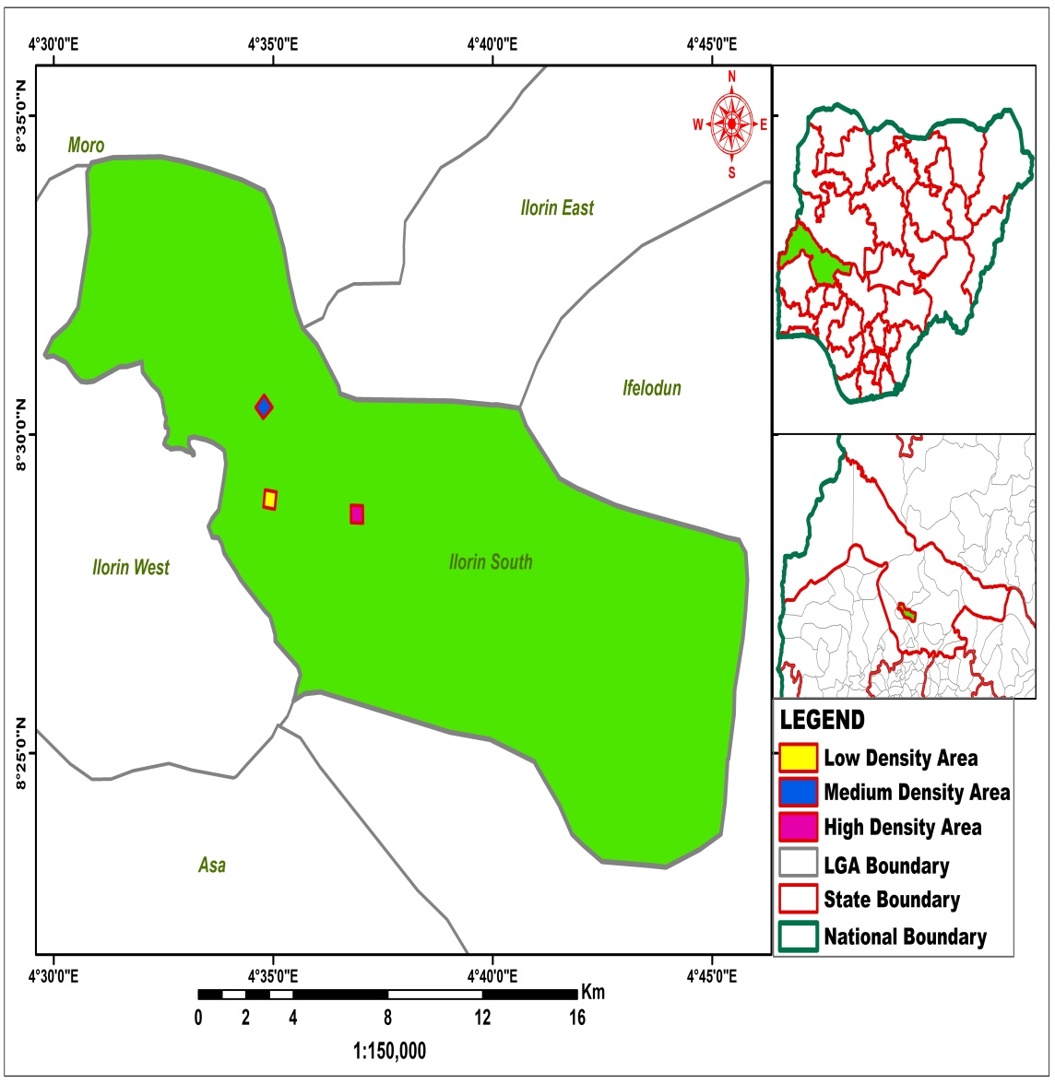
Figure 1: Study Area

2.1 Geological Setting
Ilorin East LGA occupies a strategic position within the Guinea Savanna ecological zone, geographically positioned between longitude 4°35'E and 4°45'E and latitude 8°25'N and 8°35'N, at an approximate elevation of 300 meters above mean sea level. The geological substrate consists predominantly of crystalline rocks derived from the Precambrian Basement Complex, including granites, gneisses, and schists that have undergone extensive weathering processes over millennia. These geological formations have generated the area's characteristic undulating terrain, punctuated by gentle slopes and scattered inselbergs. The weathered basement rocks have produced ferruginous tropical soils that provide adequate support for both agricultural activities and urban development, while the relatively subdued topography has facilitated infrastructural expansion and organized settlement patterns (Duru, 2019). The study encompasses distinct neighborhoods including high-density zones (Oke-Odo, University Road, Oke-Erin, and Elasumi), medium-density zones (NTA Village, Fate Estate, and Federal Secretariat area), and low-density zones (Bishop Court, Kwara Hotel area, Offa Road, Judge Quarters, Amude Bello Way, and GRA).

2.2 Climatic Conditions
The study area experiences a tropical continental climate regime with mean annual temperatures ranging between 22°C and 35°C, manifesting conditions characteristic of the Guinea Savanna ecological zone. Annual precipitation averages 1,000 to 1,200 millimetres during the wet season (May through September), while the dry season (October through April) is characterized by reduced moisture availability and the influence of harmattan winds originating from the Sahara Desert. This climatic pattern provides adequate support for both rain-fed agricultural systems and dry-season farming activities.

3.0 MATERIALS AND METHODS

3.1 Data Sources and Analytical Tools
The population estimation methodology employed high-resolution QuickBird satellite imagery (0.2m spatial resolution) covering 25,000 m² aerial survey areas for each density zone, utilizing sophisticated remote sensing software including ArcGIS and QGIS with the Map Flow extension for automated geospatial analysis and building footprint extraction and Microsoft Excel for statistical computations. Essential datasets incorporated extracted building footprint data, comprehensive land use/land cover classifications, and census data for validation purposes (Chen et al., 2023). The integration of very high-resolution (VHR) satellite imagery with building detection algorithms has been demonstrated to significantly enhance population estimation accuracy in diverse geographical contexts (Khan et al., 2023).

3.2 Reconnaissance and Pre-Field Planning
The population estimation process for Ilorin East LGA commenced with comprehensive reconnaissance and strategic pre-field planning activities. During this preparatory phase, existing administrative boundaries, settlement patterns, and demographic records were systematically reviewed to establish a foundational understanding of the study area's spatial and demographic characteristics. Historical population data and census records from the 2006 enumeration were critically analyzed to provide baseline demographic statistics essential for the estimation methodology (Verstraeten et al., 2018).

3.3 Satellite Image Acquisition and Processing
High-resolution QuickBird satellite imagery with sub-meter spatial resolution was acquired for the study area. The imagery underwent rigorous pre-processing procedures including radiometric correction, atmospheric correction, and geometric rectification to ensure spatial accuracy and spectral consistency. Recent advancements in satellite image processing have demonstrated that preprocessing significantly enhances the accuracy of subsequent feature extraction and classification procedures (Al-Ahmadi et al., 2023).

3.4 Building Footprint Extraction
Building footprints were extracted from the processed satellite imagery utilizing object-based image analysis (OBIA) techniques implemented within the ArcGIS environment. The extraction process involved multi-scale segmentation, feature classification based on spectral, spatial, and textural characteristics, and post-classification refinement to eliminate spurious detections. Contemporary research has demonstrated that automated building footprint extraction using advanced machine learning and deep learning frameworks substantially improves efficiency and accuracy compared to manual digitization approaches (Nurkarim & Wijayanto, 2023; Prakash et al., 2023).

3.5 Density Classification and Stratification
The study area was systematically classified into three distinct residential density categories—high, medium, and low density—based on building concentration metrics, spatial distribution patterns, and morphological characteristics observed in the satellite imagery. This stratification approach was designed to accommodate the inherent spatial heterogeneity in settlement patterns and population distribution characteristics, a methodology supported by contemporary urban remote sensing literature (Li et al., 2024).

3.6 Field Enumeration and Ground Truthing
A stratified random sampling strategy was implemented to select representative buildings across each density category for field enumeration, with specific sample sizes of 35 households in high-density areas, 25 households in medium-density areas, and 15 households in low-density areas. Each zone was carefully demarcated using GPS coordinates and documented with detailed field notes and photographic evidence. Trained enumerators conducted systematic household surveys to determine the number of occupants per dwelling unit within each sampled building. This ground-truthing component provided empirical validation of satellite-derived building counts and facilitated the calculation of average household sizes specific to each density stratum, consistent with established methodological protocols in population estimation research (Verstraeten et al., 2018).
3.7 Population Estimation Formula
Population estimates for each density category were calculated using an empirically validated formula that integrates building counts derived from satellite imagery analysis with average household sizes obtained through field enumeration. In this case, the method used is a variation of the population count method. The Formula for Estimated Population (EP) is expressed as:

EP = [(N_{H}) – (N_{NR})x A_{H}] (1)
Where:
N_{H} = Number of houses generated (residential units identified in each zone)
N_{NR} = Number of non-residential houses
A_{H} = Average household size (derived from field enumeration data)
This formula provides a direct relationship between the physical housing stock and the demographic characteristics of the population, enabling accurate population estimates for each density zone. (Wu et al., 2005; Langford, 2013).

3.8 Validation and Accuracy Assessment
The accuracy of population estimates was assessed through rigorous quality assurance procedures, including comparison with available census data and cross-validation with independent field surveys conducted in selected enumeration areas. Field supervisors conducted regular checks of enumeration activities, and data verification exercises were performed to identify and correct any inconsistencies. Statistical measures including mean absolute error, root mean square error, and correlation coefficients were computed to quantify the reliability of the estimation methodology. Sensitivity analysis was performed to assess the impact of various assumptions and parameters on the overall results, testing the robustness of the population estimation formula under different scenarios.

4.0 RESULTS

4.1 Building Footprint Extraction Results
The automated building footprint extraction process successfully identified and delineated individual building structures across the study area. The high-density residential area yielded 582 building footprints (Figures 2 and 3), of which 501 were classified as residential and 20 as non-residential structures, with detailed classifications provided in Tables 1 and 2. The medium-density area contained 238 buildings (Figures 4 and 5, Tables 3 and 4), comprising 220 residential and 18 non-residential structures. The low-density area comprised 152 buildings (Figures 7 and 8, Tables 5 and 6), with 137 residential and 15 non-residential structures. The extraction accuracy, validated through visual inspection and field verification, demonstrated high fidelity in building detection and boundary delineation.
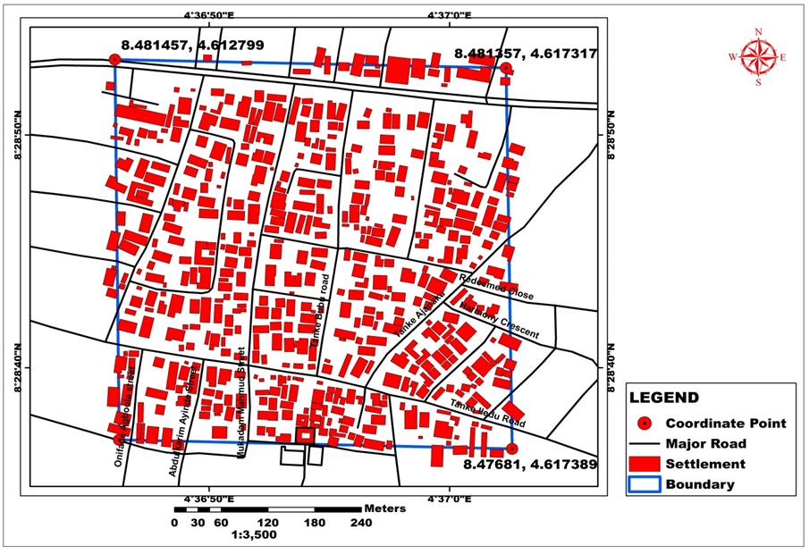
Figure 2: The Building Footprints for the High-Density Area of Part of Ilorin South.
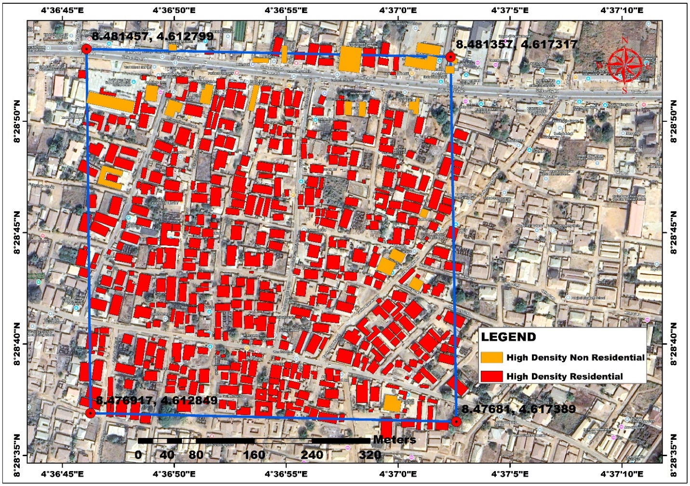
Figure 3: Residential and Non-Residential Building footprints For High Density
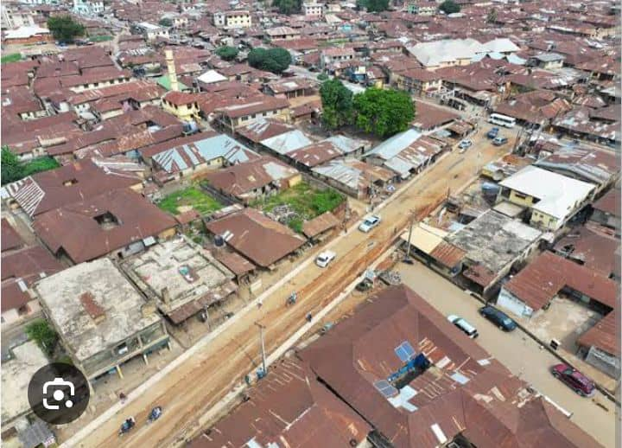
Figure 3: A Portion of the High-Density Settlement
Table 1: Average Household Size in High Density Enumeration Area
S/N | Longitude (X) | Longitude (Y) | Size
1 | 4.61694 | 8.4807 | 12
2 | 4.61694 | 8.47998 | 8
3 | 4.61709 | 8.47934 | 10
4 | 4.61715 | 8.47871 | 12
5 | 4.61726 | 8.47852 | 6
6 | 4.61713 | 8.4778 | 4
7 | 4.61697 | 8.4776 | 7
8 | 4.61639 | 8.47775 | 8
9 | 4.61633 | 8.48123 | 8
10 | 4.61606 | 8.48055 | 12
11 | 4.61541 | 8.48078 | 5
12 | 4.61515 | 8.48033 | 12
13 | 4.61503 | 8.47981 | 9
14 | 4.61471 | 8.4795 | 8
15 | 4.61519 | 8.47902 | 6
16 | 4.61428 | 8.47893 | 5
17 | 4.61419 | 8.47823 | 9
18 | 4.61496 | 8.47801 | 8
19 | 4.61413 | 8.776 | 6
20 | 4.61413 | 8.47728 | 6
21 | 4.61693 | 8.47665 | 8
22 | 4.61415 | 8.48049 | 10
23 | 4.61462 | 8.48169 | 10
24 | 4.61678 | 8.48141 | 9
25 | 4.6146 | 8.48159 | 7
26 | 4.61435 | 8.48143 | 8
27 | 4.61413 | 8.48151 | 6
28 | 4.61358 | 8.48157 | 12
29 | 4.61313 | 8.4771 | 9
30 | 4.61425 | 8.47735 | 8
31 | 4.61499 | 8.47803 | 7
32 | 4.61404 | 8.48094 | 6
33 | 4.61294 | 8.48159 | 8
34 | 4.61351 | 8.48152 | 8
35 | 4.61293 | 8.47861 | 4
Average |  |  | 8.028571

Table 2: Non-Residential Locations in High Density Enumeration Area
S/N | Longitude (X) | Latitude (Y)
1 | 4.61718 | 8.48131
2 | 4.61718 | 8.48104
3 | 4.61673 | 8.48083
4 | 4.61613 | 8.48067
5 | 4.61358 | 8.48141
6 | 4.61389 | 8.4814
7 | 4.61502 | 8.48129
8 | 4.61473 | 8.48134
9 | 4.61526 | 8.48127
10 | 4.61492 | 8.48091
11 | 4.61684 | 8.48127
12 | 4.61714 | 8.48106
13 | 4.61366 | 8.48096
14 | 4.61387 | 8.48077
15 | 4.61428 | 8.48079
16 | 4.61678 | 8.47705
17 | 4.61659 | 8.47873
18 | 4.61682 | 8.47891
19 | 4.61689 | 8.47849
20 | 4.61701 | 8.47933

4.2 Household Size Determination
Field enumeration activities revealed systematic variation in average household sizes across density categories (Tables 1, 3, and 6). The high-density residential area exhibited an average household size of 6.89 persons per dwelling unit, reflecting characteristic patterns of urban densification and multi-family occupancy. The medium-density area demonstrated an average household size of 6.47 persons, indicating a transitional demographic pattern, while the low-density area recorded an average of 5.41 persons per household, consistent with suburban or peri-urban settlement characteristics.
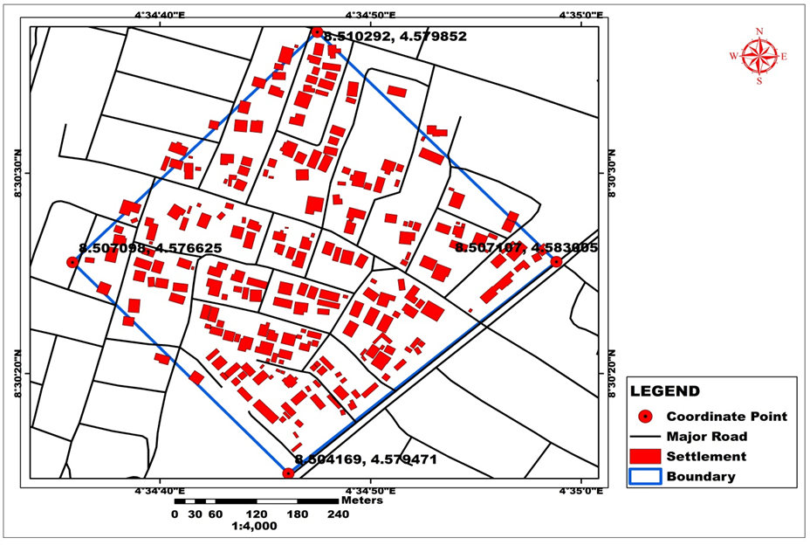
Figure 4: The Building footprints for the medium density area of part of Ilorin South.
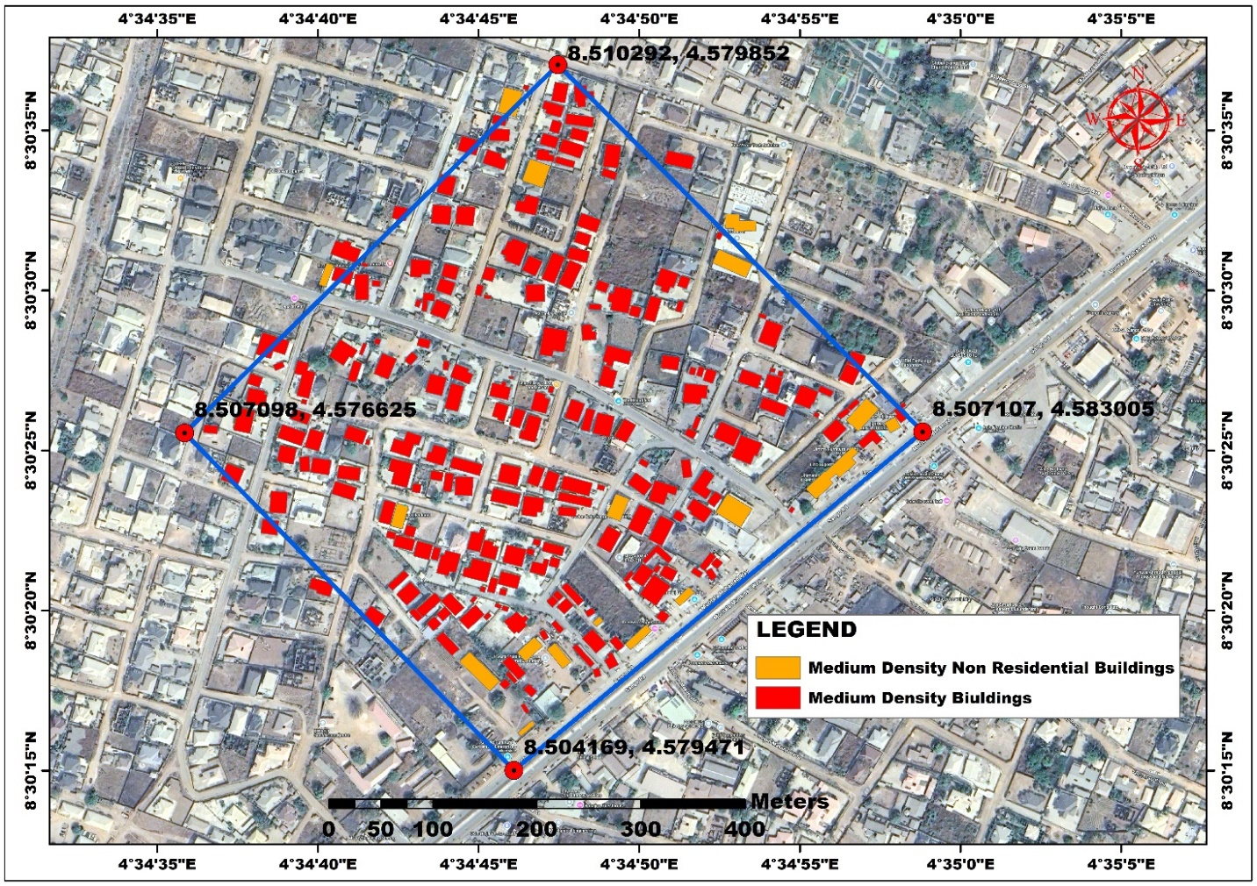
Figure 5: Residential and Non-Residential Building footprints For Medium Density
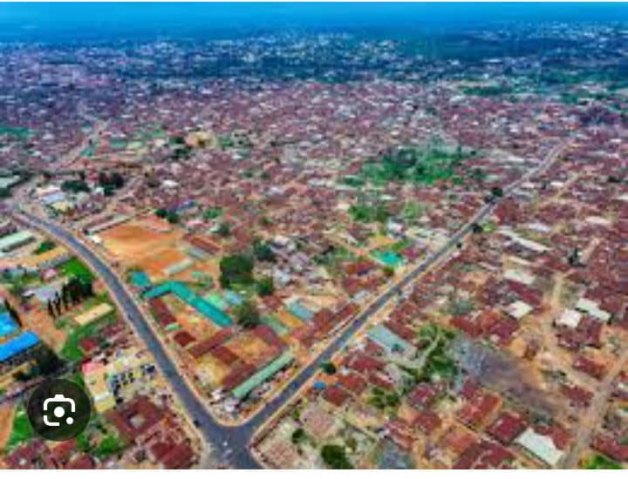
Figure 6: A Portion of Medium Density Settlement
Table 3: Average Household Size in Medium Density Enumeration Area
S/N | Longitude (X) | Latitude (Y) | Size
1 | 4.59244 | 8.49504 | 8
2 | 4.57793 | 8.48651 | 6
3 | 4.5821 | 8.4866 | 4
4 | 4.5793 | 8.4864 | 10
5 | 4.58013 | 8.48637 | 8
6 | 4.58213 | 8.48653 | 7
7 | 4.58212 | 8.48639 | 9
8 | 4.5835 | 8.48609 | 6
9 | 4.58657 | 8.48569 | 8
10 | 4.58754 | 8.48574 | 6
11 | 4.58758 | 8.48597 | 5
12 | 4.58761 | 8.48616 | 10
13 | 4.58749 | 8.48621 | 12
14 | 4.58705 | 8.4411 | 8
15 | 4.5877 | 8.48551 | 6
16 | 4.59389 | 8.49065 | 8
17 | 4.59445 | 8.49193 | 6
18 | 4.58799 | 8.49679 | 6
19 | 4.59385 | 8.49486 | 8
20 | 4.59638 | 8.50269 | 8
21 | 4.59548 | 8.49869 | 10
22 | 4.59717 | 8.50559 | 6
23 | 4.59636 | 8.50285 | 4
24 | 4.59639 | 8.50295 | 6
25 | 4.59121 | 8.50509 | 8
Average |  |  | 7.32

Table 4: Non-Residential Locations in Medium Density Enumeration Area
S/N | Longitude (X) | Latitude (Y)
1 | 4.59381 | 8.49468
2 | 4.58566 | 8.49802
3 | 4.58627 | 8.49919
4 | 4.58656 | 8.49708
5 | 4.59512 | 8.49701
6 | 4.59508 | 8.4974
7 | 4.59586 | 8.4954
8 | 4.59591 | 8.49472
9 | 4.59631 | 8.50266
10 | 4.59543 | 8.49867
11 | 4.59599 | 8.50026
12 | 4.59616 | 8.50153
13 | 4.59712 | 8.50558
14 | 4.59657 | 8.50508
15 | 4.59638 | 8.50294
16 | 4.59637 | 8.50282
17 | 4.59589 | 8.49403
18 | 4.59655 | 8.4935

4.3 Population Estimates by Density Category
Application of the population estimation formula yielded the following results: the high-density residential area recorded an estimated population of 4,008 inhabitants (582 buildings × 6.89 persons/building), the medium-density area yielded approximately 1,540 inhabitants (238 buildings × 6.47 persons/building), and the low-density area produced an estimated population of 822 persons (152 buildings × 5.41 persons/building). These estimates demonstrate a robust positive correlation between building concentration and population density, validating the methodological approach.
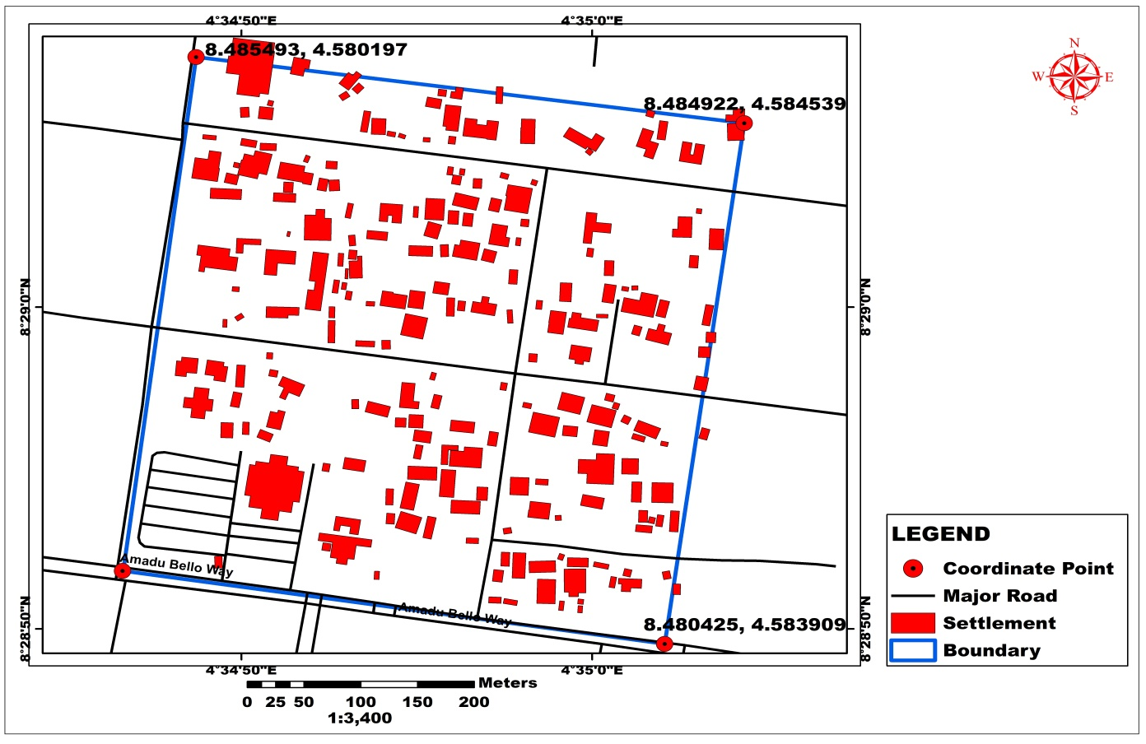
Figure 7: The Building Footprints for the Low-Density Area of Part of Ilorin South.
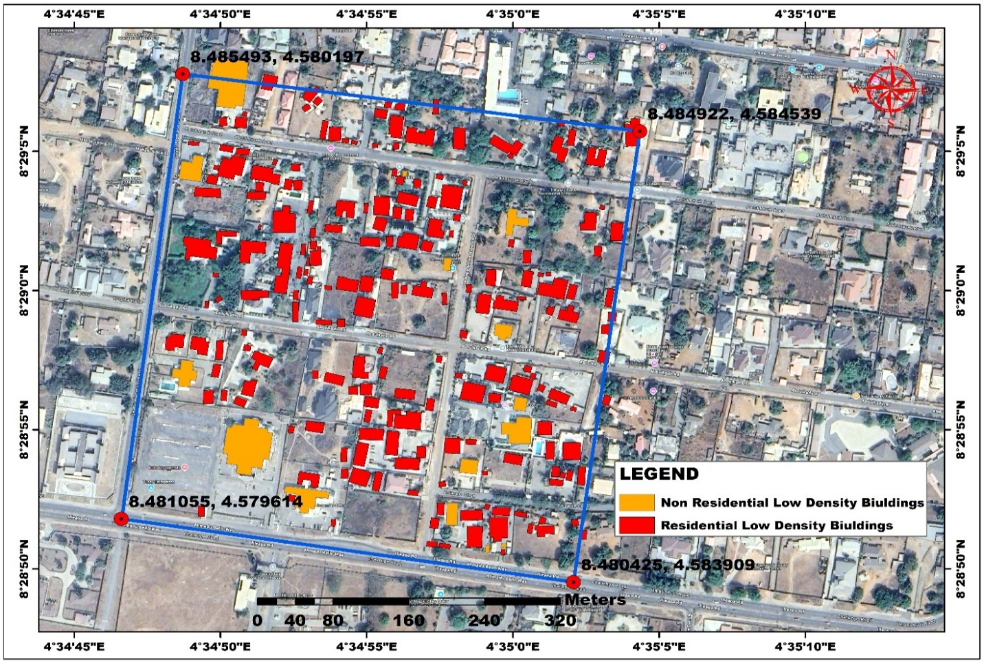
Figure 8: Residential and Non-Residential Building footprints For Low Density
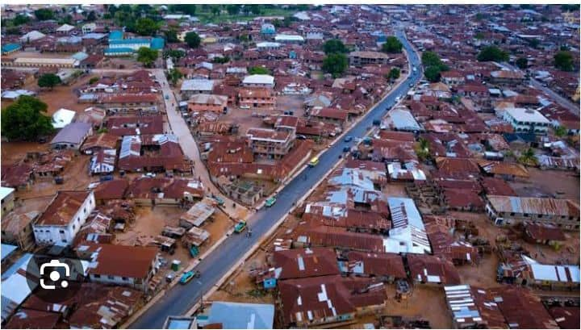
Figure 9: A Portion of Low-Density Settlement
Table 5: Non-Residential Locations in Low Density Enumeration Area
S/N | Longitude (X) | Latitude (Y)
1 | 4.58336 | 8.48431
2 | 4.58272 | 8.48361
3 | 4.58328 | 8.48275
4 | 4.58338 | 8.48219
5 | 4.57993 | 8.48142
6 | 4.58006 | 8.48153
7 | 4.58085 | 8.48175
8 | 4.58039 | 8.48112
9 | 4.58026 | 8.48443
10 | 4.58083 | 8.48467
11 | 4.58224 | 8.48452
12 | 4.58268 | 8.48139
13 | 4.58314 | 8.48076
14 | 4.58328 | 8.48074
15 | 4.58279 | 8.48112

Table 6: Average Household Size in Low Density Enumeration Area
S/N | Longitude (X) | Latitude (Y) | Size
1 | 4.58423 | 8.4848 | 6
2 | 4.5838 | 8.48466 | 8
3 | 4.58254 | 8.48379 | 8
4 | 4.58003 | 8.48137 | 6
5 | 4.58212 | 8.48418 | 5
6 | 4.58167 | 8.48397 | 4
7 | 4.58135 | 8.48309 | 6
8 | 4.58171 | 8.48615 | 6
9 | 4.58168 | 8.48591 | 6
10 | 4.5799 | 8.48138 | 8
11 | 4.58489 | 8.48492 | 8
12 | 4.58167 | 8.4831 | 4
13 | 4.5819 | 8.48167 | 10
14 | 4.58323 | 8.48104 | 6
15 | 4.58279 | 8.48178 | 8
Average |  |  | 6.6

Table 7 Summary of Estimated Population
Density | Buildings | Residential | Non-Residential | Avg. Household Size | Estimated Pop.
High | 521 | 501 | 20 | 8.03 | 4,008
Medium | 238 | 220 | 18 | 7.32 | 1,540
Low | 152 | 137 | 15 | 6.6 | 822

4.4 Spatial Distribution Patterns
Spatial analysis revealed distinct clustering patterns within each density category, as illustrated in Figures 2-9. High-density areas exhibited compact, contiguous building arrangements with minimal inter-building spacing, indicative of intensive land utilization and high population concentration. Medium-density areas demonstrated more dispersed settlement patterns with moderate open spaces, while low-density areas were characterized by widely spaced buildings and substantial undeveloped land parcels.

5.0 DISCUSSION

5.1 High-Density Residential Areas
The high-density residential zone, encompassing neighborhoods such as Oke-Odo, University Road, Oke-Erin, and Elasumi, is characterized by 582 buildings (501 residential, 20 non-residential) and an estimated population of 4,008 with an average household size of 6.89 persons (Tables 1 and 2, Figures 2 and 3), exemplifies the intensive urbanization patterns prevalent in core urban areas. This elevated building concentration and population density creates significant challenges for urban infrastructure provision and service delivery. Recent research has demonstrated that high-density areas require prioritized investment in utilities, transportation networks, and public services to maintain adequate quality of life standards (Wang et al., 2023). The findings align with contemporary urban planning literature emphasizing the necessity for density-responsive infrastructure planning in rapidly urbanizing contexts (Li et al., 2024).

5.2 Medium-Density Residential Areas
The medium-density area, covering NTA Village, Fate Estate, and the Federal Secretariat area, exhibits a more balanced spatial configuration, with moderate building clustering (238 structures: 220 residential, 18 non-residential) and notable open spaces, yielding a population estimate of 1,540 persons with an average household size of 6.47 (Tables 3 and 4, Figures 4, 5, and 6). This pattern indicates a transitional zone between the urban core and suburban periphery, often designated as peri-urban areas in urban geography literature. The moderate density facilitates more flexible land use patterns, including the integration of green spaces and community facilities. Contemporary urban planning frameworks emphasize the importance of maintaining this balance between development intensity and environmental preservation in medium-density zones (Zhu et al., 2020).

5.3 Low-Density Residential Areas
The low-density area, encompassing Bishop Court, Kwara Hotel area, Offa Road, Judge Quarters, Amude Bello Way, and GRA, is distinguished by widely dispersed buildings (152 structures: 137 residential, 15 non-residential) and substantial open land, presenting an estimated population of 822 persons with an average household size of 5.41 (Tables 5 and 6, Figures 7, 8, and 9). This configuration is characteristic of suburban or newly developing regions where land is more readily available and less intensively utilized. While this settlement pattern offers opportunities for future growth and development, it simultaneously presents challenges for efficient service delivery due to dispersed settlement patterns (Verstraeten et al., 2018). The abundance of open space supports future expansion and infrastructure introduction, though lower density can increase the per capita cost and complexity of utility provision.

5.4 Implications for Urban Planning and Policy
The progressive decrease in population density from high to low-density areas, accompanied by corresponding reductions in average household size and building concentration, presents distinct challenges and opportunities for each zone. High-density areas confront challenges related to overcrowding and infrastructure strain, while low-density areas offer expansion capacity but may experience inefficient service delivery. Medium-density areas represent an equilibrium, supporting both development and quality of life maintenance (Bao et al., 2023).
The integration of spatial and demographic data provides a robust analytical framework for understanding urban dynamics in Ilorin East LGA and has broader applicability for wider geographic contexts. This methodological approach facilitates rapid analysis of demographic trends within their spatial contexts and temporal dimensions, information that is essential for informed decision-making and ensuring that urban development aligns with population needs while supporting sustainable city growth (Liu et al., 2024).

5.5 Comparative Analysis with Traditional Census Methods
Satellite remote sensing provides a more cost-effective methodology and superior visual representation capabilities for population estimation compared to conventional census approaches. The synoptic overview afforded by remote sensing technology, coupled with multi-temporal and multi-dimensional perspectives, enables continuous acquisition of spatial and attribute data from physical, demographic, social, economic, and environmental dimensions (Kpegouni et al., 2023). Recent advances in deep learning techniques for building footprint extraction from very high-resolution satellite imagery have further enhanced the efficiency and accuracy of population estimation methodologies (Chen et al., 2023; Khan et al., 2023).

6.0 CONCLUSION
This research successfully demonstrated the efficacy of integrating remote sensing and Geographic Information System technologies for population monitoring and estimation in the Nigerian context. The methodology employed, utilizing high-resolution QuickBird satellite imagery combined with GIS-based building footprint extraction and field enumeration, proved to be a viable and cost-effective alternative to traditional census approaches. The study revealed the population variation across the high, medium, and low-density areas, establishing a robust correlation between building concentration and population density. The research outcomes substantiate the effectiveness of remote sensing and GIS as scientifically robust and methodologically reliable instruments for post-census population estimation and inter-censal demographic monitoring, reflecting the inherent advantages of remote sensing and GIS synoptic overview, multi-temporal capabilities, and multi-dimensional perspectives (Al-Ahmadi et al., 2023).
The findings provide a scientific foundation for informed decision-making, comprehensive spatial planning, and sustainable urban development in Nigeria. The methodology offers a replicable framework applicable to other regions facing similar challenges in demographic data acquisition and urban planning. In the context of Nigeria’s protracted inter-censal periods and the controversies surrounding traditional census methodologies, remote sensing-based population estimation offers a complementary approach that can provide timely and reliable demographic intelligence for evidence-based policy formulation and developmental planning. Future research should explore the integration of emerging technologies, including machine learning algorithms and artificial intelligence-based building detection systems, to further enhance the accuracy and efficiency of population estimation methodologies (Prakash et al., 2023; Li et al., 2024), as well as incorporate temporal analysis using multi-date satellite imagery to facilitate monitoring of population growth dynamics and urbanization trends over time.

Conflict of Interest Statement
The authors declare that they have no financial interests, personal relationships, or institutional affiliations that could be perceived as influencing the work reported in this paper. No commercial funding, departmental sponsorship, or external organizational support was received that might raise questions of bias in the research process, conclusions, or recommendations. The study was conducted independently, and all opinions expressed are solely those of the authors.

REFERENCES
Al-Ahmadi, K., Alahmadi, M., & Al-Zahrani, A. (2023). Estimating population density using open-access satellite images and geographic information system: Case of Al Ain City, UAE. Results in Engineering, 20, Article 101573. https://doi.org/10.1016/j.rineng.2023.101573
Bao, X., Zhang, T., Dewancker, B. J., He, J., & Liu, S. (2023). Exploring the unit spatial layout preference for urban multi-unit residential buildings: A survey in Beijing, China. Sustainability, 15(16), Article 12013. https://doi.org/10.3390/su151612013
Chen, S., Ogawa, Y., Zhao, C., & Sekimoto, Y. (2023). Large-scale individual building extraction from open-source satellite imagery via super-resolution-based instance segmentation approach. ISPRS Journal of Photogrammetry and Remote Sensing, 195, 129-152. https://doi.org/10.1016/j.isprsjprs.2022.11.006
Dang, A. N., Kawasaki, A., Nguyen, T. T. H., & Luu, M. P. (2020). A methodology for integrating disaster risk reduction and climate change adaptation in flood risk assessment. International Journal of Disaster Risk Reduction, 51, Article 101913. https://doi.org/10.1016/j.ijdrr.2020.101913
Debnath, R., Darby, S., Bardhan, R., Mohaddes, K., & Sunikka-Blank, M. (2018). Grounding social practice theory in quantitative data: Energy consumption patterns in India. Energy Research & Social Science, 41, 108-119. https://doi.org/10.1016/j.erss.2018.04.011
Duru, P. N. (2019). Geotechnical assessment of Ilorin metropolis for urban planning and development. Journal of Environmental Science and Technology, 12(2), 115-126.
Khan, S. D., Alarabi, L., & Basalamah, S. (2023). An encoder-decoder deep learning framework for building footprints extraction from aerial imagery. Arabian Journal for Science and Engineering, 48, 1273-1284. https://doi.org/10.1007/s13369-022-07154-8
Kpegouni, G., Bouroubi, Y., Coulombe, H., Echevin, D., Lauzier-Hudon, E., & Germain, M. (2023). Application of deep-learning techniques to very-high-resolution satellite images supporting population censuses in developing countries. Journal of Applied Remote Sensing, 17(2), Article 024506. https://doi.org/10.1117/1.JRS.17.024506
Langford, M. (2013). An evaluation of small area population estimation techniques using open access ancillary data. Geographical Analysis, 45(3), 324-344. https://doi.org/10.1111/gean.12012
Li, J., He, W., Cao, W., Zhang, L., & Zhang, H. (2024). UANet: An uncertainty-aware network for building extraction from remote sensing images. IEEE Transactions on Geoscience and Remote Sensing, 62, Article 5401713. https://doi.org/10.1109/TGRS.2024.3351234
Liu, S., Jia, L., Zhang, F., Wang, R., Liu, X., Zou, L., & Tang, X. (2024). Do new urbanization policies promote sustainable urbanization? Evidence from China's urban agglomerations. Land, 13(4), Article 412. https://doi.org/10.3390/land13040412
National Population Commission. (2024). 2023 Census methodology and implementation framework. National Population Commission of Nigeria. https://nationalpopulation.gov.ng/2023-census
Nurkarim, W., & Wijayanto, A. W. (2023). Building footprint extraction and counting on very high-resolution satellite imagery using object detection deep learning framework. Earth Science Informatics, 16, 515-532. https://doi.org/10.1007/s12145-022-00895-4
Prakash, P., & Aithal, B. H. (2023). Building footprint extraction from very high-resolution satellite images using deep learning. Journal of Spatial Science, 68(3), 487-503. https://doi.org/10.1080/14498596.2022.2037473
Sarki, U. (2023, November 29). Prospects, challenges of conducting a national population and housing census in Nigeria. Vanguard News. https://www.vanguardngr.com/2023/11/prospects-challenges-of-conducting-a-national-population-and-housing-census-in-nigeria-by-usman-sarki/
Utazi, C. E., Aheto, J. M. K., Wigley, A., Tejedor-Garavito, N., Bonnie, A., Nnanatu, A. C., Wagai, J., Williams, C., Setayesh, H., & Tatem, A. J. (2023). Mapping the distribution of zero-dose children to assess the performance of vaccine delivery strategies and their relationships with measles incidence in Nigeria. Vaccine, 41(1), 170-181. https://doi.org/10.1016/j.vaccine.2022.11.031
Verstraeten, G., Poesen, J., Demarée, G., & Salles, C. (2018). Mapping population distribution from high resolution remote sensing imagery in a data poor setting. Remote Sensing, 10(9), Article 1409. https://doi.org/10.3390/rs10091409
Wang, Y., Zhao, Q., Wu, Y., Tian, W., & Zhang, G. (2023). SCA-Net: Multiscale contextual information network for building extraction based on high-resolution remote sensing images. Remote Sensing, 15(18), Article 4466. https://doi.org/10.3390/rs15184466
Wu, S., Qiu, X., & Wang, L. (2005). Population estimation methods in GIS and remote sensing: A review. GIScience & Remote Sensing, 42(1), 80-96. https://doi.org/10.2747/1548-1603.42.1.80
Zhu, L., Guo, Y., Zhang, C., Meng, J., Ju, L., Zhang, Y., & Tang, W. (2020). Assessing community-level livability using combined remote sensing and internet-based big geospatial data. Remote Sensing, 12(23), Article 4026. https://doi.org/10.3390/rs12234026

