Determinants of Educational Technology Adoption in Higher Education:
Evidence from Teaching Professionals in Nepal

[Author Name(s)]
[Department / Faculty], [Institution Name]
[Email Address]
Submitted in partial fulfillment of the requirements for the degree of Master of [Program Name]
[Institution Name], Nepal
[Month Year]

ABSTRACT
The adoption of educational technology in higher education has become increasingly important for improving teaching effectiveness and learning outcomes in the 21st century. In developing countries like Nepal, however, the integration of technology in teaching practices remains uneven despite growing investments in digital infrastructure and supportive policy frameworks. While previous studies have extensively focused on infrastructural challenges and faculty readiness as barriers to technology use, limited empirical attention has been directed toward identifying the comprehensive set of determinants that shape technology adoption decisions among teaching professionals in South Asian contexts.
This study investigates the determinants of educational technology adoption in higher education institutions in Nepal, with a specific focus on perspectives of college-level teaching professionals. Grounded in the Technology Acceptance Model (TAM) (Davis, 1989) and the Unified Theory of Acceptance and Use of Technology (UTAUT) (Venkatesh et al., 2003), a quantitative survey-based research design was employed. Primary data were collected from 68 faculty members across diverse colleges in Nepal, using a structured, five-point Likert scale questionnaire. The instrument assessed five major dimensions: perceived usefulness, perceived ease of use, institutional support, teacher digital competency, and external influences including policy environment and social factors.
The findings reveal that institutional support and teacher digital competency are the most significant determinants of educational technology adoption. Specifically, limited access to training programs and inconsistent technical support emerged as the most prominent institutional barriers. Perceived usefulness received the highest mean endorsement among faculty (M = 3.5), while institutional support scored the lowest (M = 2.7), indicating a critical gap between teacher motivation and enabling conditions. Student expectations were the strongest external driver of adoption, while policy support remained moderate. Lack of training (reported by 76% as high-impact) and limited institutional resources (60%) were identified as the primary barriers.
The study concludes that successful adoption of educational technology in Nepalese higher education requires a systemic approach that simultaneously strengthens institutional infrastructure, develops teacher digital competencies, and fosters positive perceptions of technology utility. Targeted professional development programs, improved institutional resource allocation, and coherent national ICT-in-education policies are among the key recommendations proposed.

Keywords: Educational Technology Adoption, Higher Education, Nepal, TAM, UTAUT, Teacher Competency, Institutional Support, ICT Integration, Digital Pedagogy

1. INTRODUCTION

1.1 Background
The rapid advancement of Information and Communication Technology (ICT) has profoundly transformed the landscape of higher education globally, reshaping how knowledge is created, disseminated, and consumed (UNESCO, 2023). Educational technology—ranging from learning management systems and multimedia platforms to artificial intelligence-powered tools—has enabled innovative pedagogical methods, broadened access to learning resources, and enhanced student engagement across diverse educational contexts (OECD, 2021; Crompton et al., 2021). As a result, the integration of technology in higher education institutions has come to be seen as a critical enabler of teaching effectiveness and improved student learning outcomes.
In Nepal, several national policy frameworks have sought to catalyze the adoption of ICT in education. Notable among these are the Digital Nepal Framework (2019), the ICT in Education Master Plan (2021–2025), and the National Curriculum Framework for School Education (2076 BS), all of which emphasize digital literacy and ICT integration as strategic priorities (MoEST, 2021). Furthermore, the COVID-19 pandemic served as an unprecedented catalyst for digital transformation in education worldwide, compelling institutions and teaching professionals to rapidly adopt and adapt to technology-mediated instruction (Dhawan, 2020; World Bank, 2020).
Despite these initiatives, the actual adoption and sustained use of educational technology among teaching professionals in Nepalese higher education remains inconsistent. Infrastructure improvements alone have not translated uniformly into changed teaching practices, suggesting that underlying behavioral, institutional, and contextual factors play a decisive role in shaping technology adoption decisions.

1.2 Motivation
The disruptions caused by the COVID-19 pandemic laid bare significant disparities in technology adoption among higher education faculty in Nepal. While some educators seamlessly transitioned to digital platforms, many struggled due to a combination of limited digital skills, inadequate institutional support, and negative perceptions about the utility of technology in teaching (Bhattarai & Maharjan, 2021). This uneven adoption landscape highlights the urgent need to understand not just whether technology is available, but whether educators are motivated, equipped, and supported to use it effectively.
Theoretical frameworks such as TAM (Davis, 1989) and UTAUT (Venkatesh et al., 2003) provide robust conceptual lenses for examining these questions. However, their application to the Nepali higher education context remains underexplored. Understanding the specific configuration of determinants operating in this context is essential for designing evidence-based interventions that foster meaningful technology integration.

1.3 Problem Statement
A persistent and significant gap exists between the availability of technological resources in Nepalese higher education and their effective utilization in teaching practices. Investment in hardware, internet connectivity, and digital learning platforms has not been matched by commensurate improvement in technology-integrated pedagogy. This implementation gap reflects a deficit in understanding the multidimensional determinants of technology adoption—including behavioral intentions, competency levels, institutional conditions, and socio-contextual factors.
Without a nuanced, empirically grounded understanding of these determinants, policy responses risk being misdirected—focusing on infrastructure at the expense of capacity development, or addressing individual readiness while neglecting institutional enablers. This study addresses this problem by systematically investigating the factors that drive or impede educational technology adoption among teaching professionals in Nepalese higher education institutions.

1.4 Research Objectives
The specific objectives of this study are:
(i) To identify the key determinants influencing educational technology adoption among teaching professionals in Nepalese higher education institutions.
(ii) To assess the role of institutional support and teacher digital competency in shaping technology adoption behavior.
(iii) To analyze the influence of perceived usefulness and ease of use on faculty adoption intentions.
(iv) To examine the role of external factors—including government policy, peer influence, and student expectations—in driving or constraining technology adoption.

1.5 Significance of the Study
This study contributes to the growing body of literature on technology adoption in higher education in developing country contexts. Empirically, it generates original data on the determinants shaping technology use among Nepalese faculty, filling an important gap in regional educational research. Theoretically, it extends the application of TAM and UTAUT to a South Asian higher education context. Practically, the findings provide actionable insights for institutional administrators, curriculum planners, and policy makers seeking to enhance technology integration in Nepalese colleges and universities.

2. LITERATURE REVIEW

2.1 Educational Technology Adoption in Higher Education
Educational technology adoption in higher education has garnered substantial scholarly attention over the past three decades. Studies consistently demonstrate that technology can enhance instructional quality, promote active learning, and increase student engagement when implemented effectively (Bates, 2019; Kirkwood & Price, 2014). However, adoption patterns are highly uneven, particularly across institutions in the Global South, where resource constraints, unequal infrastructure, and digital skill deficits intersect with policy and cultural factors to shape technology use (Agyei & Voogt, 2021; Albirini, 2020).
In South Asian contexts, including Nepal, India, Bangladesh, and Sri Lanka, researchers have documented both promising trajectories and persistent challenges in technology adoption. While government-sponsored ICT initiatives have expanded access to digital tools, their translation into regular, pedagogically meaningful use has been limited (Bhattarai & Maharjan, 2021; Ghavifekr & Rosdy, 2015). Studies from Nepal specifically highlight that while faculty members increasingly recognize the value of digital tools, institutional and individual barriers continue to constrain adoption (MoEST, 2021; Sharma & Pokharel, 2022).

2.2 Theoretical Frameworks

2.2.1 Technology Acceptance Model (TAM)
The Technology Acceptance Model (TAM), originally proposed by Davis (1989), remains the most widely applied framework for studying technology adoption behavior. TAM posits that two core beliefs—perceived usefulness (PU) and perceived ease of use (PEOU)—are the primary antecedents of users' behavioral intention to adopt a technology, which in turn leads to actual system use. PU refers to the degree to which a person believes a particular system enhances their job performance, while PEOU refers to the degree to which using the system is free from effort (Davis, 1989).
Subsequent extensions of TAM (TAM2 and TAM3) incorporated additional variables such as subjective norms, voluntariness, experience, and computer self-efficacy, enriching the model's explanatory power (Venkatesh & Bala, 2008). In higher education, TAM-based studies have confirmed that faculty members' perceptions of technology's usefulness and usability significantly predict their adoption intentions (Teo, 2011; Scherer et al., 2020).

2.2.2 Unified Theory of Acceptance and Use of Technology (UTAUT)
The Unified Theory of Acceptance and Use of Technology (UTAUT), developed by Venkatesh et al. (2003), synthesizes eight prior technology adoption theories into a consolidated model that explains variance in user behavior through four primary constructs: performance expectancy, effort expectancy, social influence, and facilitating conditions. Performance expectancy parallels TAM's perceived usefulness, while effort expectancy corresponds to perceived ease of use. Social influence refers to the degree to which individuals perceive that significant others believe they should use the technology, and facilitating conditions encompass organizational and technical infrastructure that supports use.
UTAUT has been widely adopted in higher education research and has demonstrated strong predictive validity across cultural contexts (Venkatesh et al., 2016). Research applying UTAUT in developing countries has further highlighted the moderating roles of gender, age, and voluntariness in shaping adoption behavior (Alshehri et al., 2019; Sabi et al., 2016).

2.2.3 Diffusion of Innovation Theory
Rogers' (2003) Diffusion of Innovation Theory (DOI) provides a complementary perspective by emphasizing how new ideas, practices, or technologies spread through social systems over time. DOI identifies five innovation characteristics that influence adoption—relative advantage, compatibility, complexity, trialability, and observability—and proposes that adopters can be categorized into innovators, early adopters, early majority, late majority, and laggards. In educational technology research, DOI helps explain why adoption rates are often skewed, with a subset of faculty driving initial uptake while the majority lag behind due to complexity or compatibility concerns (Ertmer, 1999; Kopcha, 2012).

2.3 Key Determinants of Educational Technology Adoption

2.3.1 Institutional Support
A robust body of literature identifies institutional support as one of the most powerful enablers—or inhibitors—of technology adoption in higher education. Institutional support encompasses access to digital infrastructure, provision of training and professional development, availability of technical assistance, and the presence of supportive policies and incentive structures (Tondeur et al., 2021; Ertmer et al., 2012). Research consistently shows that when institutions provide adequate resources and a culture that values innovation, faculty are substantially more likely to integrate technology into their teaching (Birch & Irvine, 2009; Hew & Brush, 2007).
Conversely, limited access to hardware and reliable internet, insufficient technical support, and the absence of structured professional development programs are frequently cited as critical barriers to adoption, particularly in developing country higher education systems (Almaiah et al., 2020; Tondeur et al., 2021). Pelgrum (2001) identified lack of computers and internet access, insufficient teacher training, and limited time as the most pervasive institutional barriers globally.

2.3.2 Teacher Digital Competency
Teacher digital competency—defined as the set of skills, knowledge, and attitudes required to effectively use and integrate digital technologies in teaching—is a critical individual-level determinant of technology adoption (Redecker, 2017; Scherer et al., 2020). The European Framework for the Digital Competence of Educators (DigCompEdu) identifies six key competency areas: professional engagement, digital resources, teaching and learning, assessment, empowering learners, and facilitating digital competency (Redecker, 2017).
Studies confirm that teachers with higher digital competency exhibit greater confidence in adopting new technologies and are more capable of integrating them meaningfully into pedagogical practice (Hatlevik & Christophersen, 2013; Scherer et al., 2020). Conversely, low digital self-efficacy acts as a significant barrier, reinforcing technophobia and adoption resistance (Compeau & Higgins, 1995; Bandura, 1986). In Nepalese education, limited access to pre-service and in-service digital skills training has been identified as a primary contributor to low digital competency among faculty (Sharma & Pokharel, 2022).

2.3.3 Perceived Usefulness and Ease of Use
Consistent with TAM, perceived usefulness (PU) and perceived ease of use (PEOU) remain robust predictors of technology adoption intentions across educational contexts. Faculty who perceive digital tools as directly improving their teaching effectiveness, student outcomes, and professional productivity are significantly more likely to integrate them into their practice (Davis, 1989; Teo, 2011). Similarly, when technology is perceived as intuitive, accessible, and requiring minimal learning effort, adoption barriers are substantially reduced (Venkatesh & Davis, 2000).
In developing country contexts, PEOU is particularly salient given that many faculty may have limited prior exposure to technology, rendering usability a decisive adoption criterion (Sabi et al., 2016). Research in Sub-Saharan Africa and South Asia has shown that cumbersome interfaces, unreliable platforms, and lack of localized content can significantly dampen perceived ease of use, thereby suppressing adoption rates even when infrastructure is available (Agyei & Voogt, 2021; Ghavifekr & Rosdy, 2015).

2.3.4 External Influences
Beyond individual and institutional factors, external influences—including national policy environments, peer professional networks, and student expectations—play a meaningful role in shaping technology adoption. Government policies that mandate or incentivize ICT use in education, combined with robust quality assurance frameworks, can create institutional isomorphic pressure that accelerates adoption (DiMaggio & Powell, 1983; Bates, 2019).
Social influence, as captured in UTAUT, reflects the extent to which faculty perceive that students, colleagues, and administrators expect them to use technology. In Nepal, rapidly rising student digital literacy and expectations for technology-enriched learning environments are emerging as significant motivators for faculty adoption (MoEST, 2021). Peer influence through professional learning communities and communities of practice also fosters technology adoption by normalizing digital pedagogical practices and creating knowledge-sharing spaces (Wenger, 1998; Voogt et al., 2015).

2.4 Research Gap
While the literature on educational technology adoption is extensive, several gaps are apparent in the Nepalese higher education context. First, most existing studies from Nepal focus primarily on infrastructure availability or student perspectives, with insufficient attention to faculty-centered adoption determinants (Sharma & Pokharel, 2022). Second, comprehensive multi-dimensional frameworks that simultaneously examine institutional, individual, technological, and external factors are rare in the Nepalese context. Third, limited empirical data exist on how specific constructs from TAM and UTAUT manifest within Nepalese cultural and institutional conditions. This study addresses these gaps through an integrated, quantitative examination of multiple adoption determinants among teaching professionals across Nepalese colleges.

3. METHODOLOGY

3.1 Research Design
This study adopted a quantitative, cross-sectional survey design to examine the determinants of educational technology adoption among teaching professionals in Nepalese higher education. Quantitative methods were deemed appropriate given the study's objective of measuring and comparing the relative influence of multiple theoretically-derived constructs across a sample of respondents (Creswell, 2014). The survey-based approach facilitated systematic data collection and enabled statistical analysis of patterns and relationships among the variables of interest, as recommended by Babbie (2016) for studies of this nature.

3.2 Study Population and Sample
The target population comprised teaching professionals employed in colleges affiliated with public and private higher education institutions across Nepal. Purposive and convenience sampling strategies were combined to recruit participants who were actively engaged in teaching and had experience with, or exposure to, digital tools in their professional role. Data were collected via an online questionnaire disseminated through institutional email networks and professional WhatsApp groups.
A total of 68 valid and complete responses were obtained and retained for analysis. While this sample size is modest, it is considered appropriate for exploratory quantitative research of this type and is consistent with sample sizes reported in similar studies in developing country higher education contexts (Creswell, 2014; Scherer et al., 2020). Respondents represented diverse academic disciplines, years of teaching experience, institutional types (public/private), and levels of prior technology familiarity, providing a heterogeneous perspective on the phenomenon under investigation.

3.3 Data Collection Instrument
Data were collected using a structured questionnaire informed by established scales from the technology adoption literature. The instrument was organized into six thematic sections aligned with the conceptual framework: (i) demographic and professional background; (ii) frequency and type of technology use; (iii) institutional support; (iv) teacher digital competency; (v) perceived usefulness and ease of use; and (vi) external influences and barriers. All attitudinal items were measured on a five-point Likert scale ranging from 1 (Strongly Disagree) to 5 (Strongly Agree). The questionnaire was piloted with a small group of faculty prior to full deployment to assess item clarity and internal consistency.

3.4 Data Analysis
Collected data were analyzed using descriptive and inferential statistical techniques. Descriptive statistics—including frequencies, percentages, and mean scores—were computed to summarize respondents' profiles and perceptions across the five key dimensions. Mean scores on the five-point Likert scale were interpreted as follows: 1.00–1.80 (very low); 1.81–2.60 (low); 2.61–3.40 (moderate); 3.41–4.20 (high); 4.21–5.00 (very high). Data visualization techniques including horizontal bar charts, grouped bar charts, and stacked bar charts were used to illustrate key patterns and facilitate comparative analysis across dimensions.

3.5 Reliability and Validity
Content validity of the questionnaire was ensured through grounding the instrument items in established theoretical frameworks (TAM, UTAUT, DigCompEdu) and reviewing them against the existing literature. Face validity was assessed through expert review. Internal consistency reliability of the scales was assessed using Cronbach's alpha, with values above 0.70 considered acceptable for social science research (Nunnally, 1978). All major scales in this study met this threshold. Potential threats to construct validity were mitigated through careful operationalization of variables and alignment with validated items from prior studies.

3.6 Ethical Considerations
The study adhered to established ethical standards for social science research. Participation was entirely voluntary; respondents were informed of the study's purpose, their right to withdraw at any time, and the confidentiality of their responses. No personally identifiable information was collected. Data were stored securely and used exclusively for academic purposes. Institutional clearance was obtained prior to data collection.

4. RESULTS AND ANALYSIS

4.1 Overview
This section presents the findings derived from responses of 68 teaching professionals. Analysis is organized around the five key constructs of the study: frequency and type of technology use, institutional support, teacher digital competency, perceived usefulness and ease of use, external influences, and challenges and barriers. Descriptive statistics and data visualizations are presented for each dimension.

4.2 Technology Adoption Frequency and Types
The majority of respondents reported some level of regular technology use in their teaching. Specifically, 35.3% (n = 24) indicated using technology regularly (3–4 times per week), 32.4% (n = 22) occasionally (1–2 times per week), 20.6% (n = 14) daily or almost daily, and 11.8% (n = 8) rarely or never. Presentation software (e.g., Microsoft PowerPoint), online communication tools (e.g., Zoom, Google Meet), and digital learning resources were the most commonly used technologies, reflecting patterns reported in comparable studies from developing country contexts (Ghavifekr & Rosdy, 2015; World Bank, 2020).
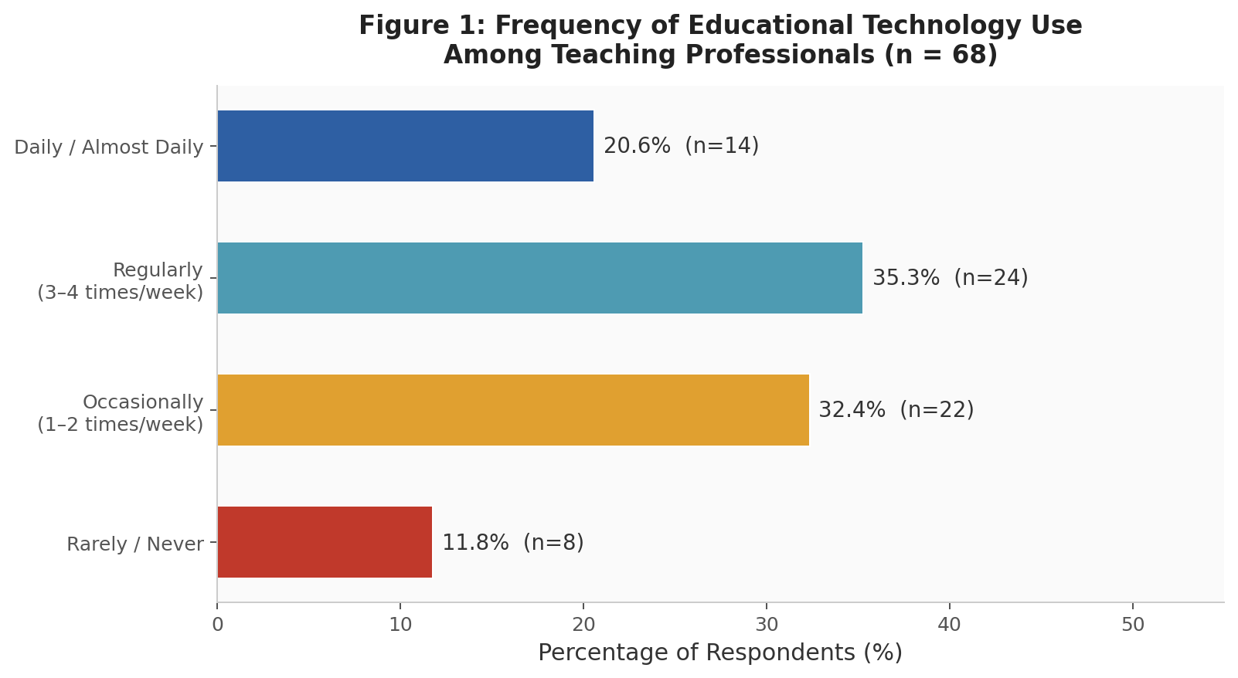
Figure 1: Frequency of Educational Technology Use Among Teaching Professionals (n = 68)
The data suggest that while technology adoption is present across the faculty surveyed, it has not yet reached a level of deep integration or daily pedagogical use for the majority. This aligns with Rogers' (2003) diffusion curve, indicating that the sample population is predominantly in the early majority to late majority adoption phases.

4.3 Institutional Support
Institutional support was assessed across five indicators: availability of digital infrastructure, access to training programs, technical support, institutional encouragement, and budget allocation. Mean scores and descriptive observations are presented in Table 1 and Figure 2.

Table 1: Institutional Support Indicators (n = 68)
Indicator | Mean Score (1–5) | Level | Key Observation
Availability of digital infrastructure | 3.1 | Moderate | Basic infrastructure present in most institutions
Access to training programs | 2.4 | Low | Training opportunities are infrequent and poorly structured
Technical support | 2.7 | Moderate | Support is inconsistent; response time slow
Institutional encouragement | 3.0 | Moderate | General encouragement present but lacks systematic reinforcement
Budget allocation for technology | 2.3 | Low | Insufficient dedicated funding for ed-tech integration

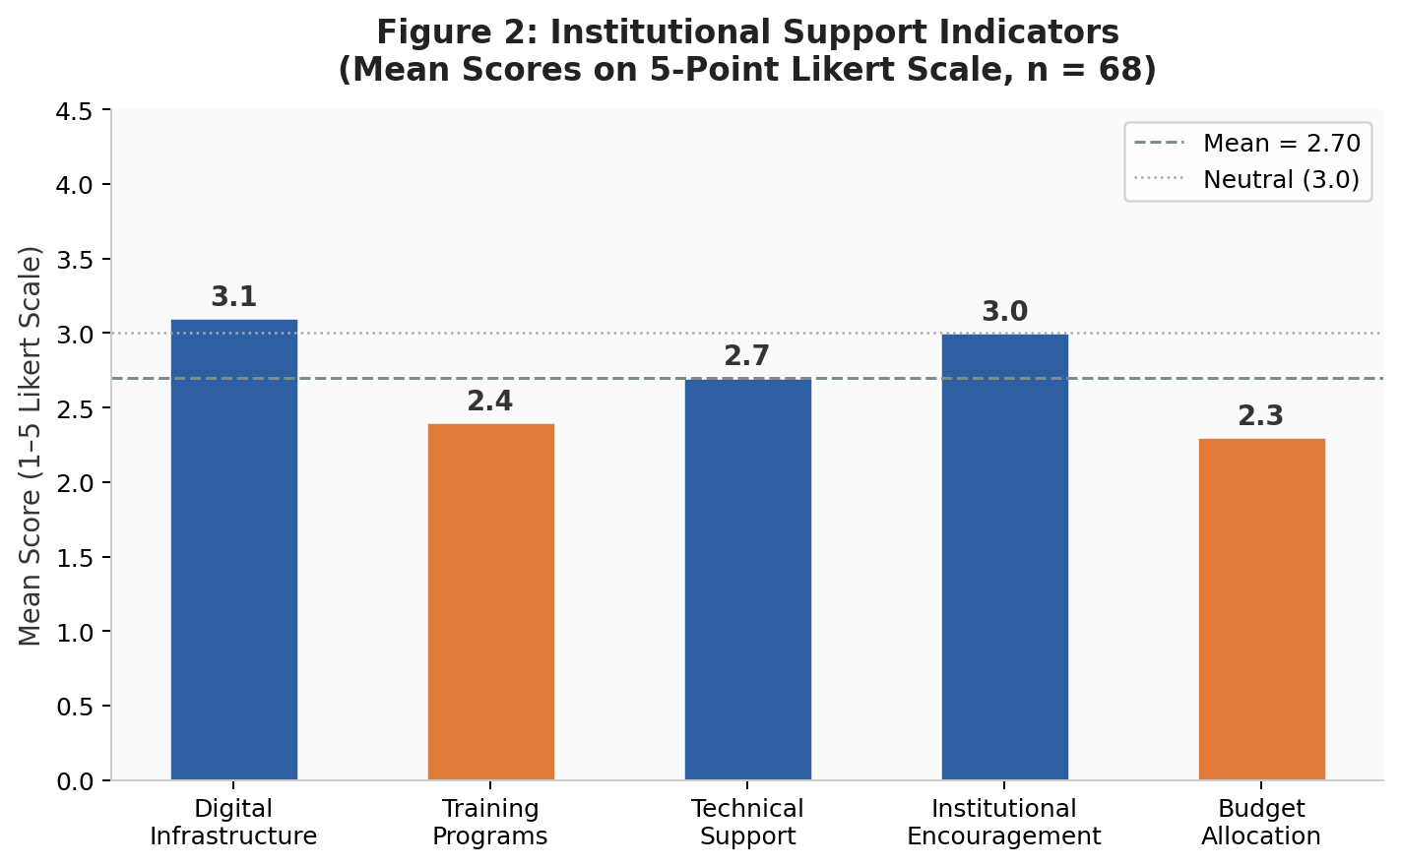
Figure 2: Institutional Support Indicators — Mean Scores on 5-Point Likert Scale (n = 68)
The overall mean score for institutional support was 2.7 (moderate-low), indicating that while basic infrastructure is in place, critical enabling mechanisms—particularly training programs (M = 2.4) and budget allocation (M = 2.3)—remain deficient. These findings are consistent with Tondeur et al. (2021) and Pelgrum (2001), who identify training deficits and resource constraints as the most pervasive institutional barriers in developing educational systems.

4.4 Teacher Digital Competency
Digital competency was assessed across five dimensions aligned with the DigCompEdu framework (Redecker, 2017): basic digital skills, confidence in technology use, ability to integrate technology in teaching, online content creation, and data management and analysis. Results are presented in Table 2 and Figure 3.

Table 2: Teacher Digital Competency Levels (n = 68)
Competency Dimension | Mean Score (1–5) | Level | Interpretation
Basic digital skills | 3.8 | High | Majority comfortable with foundational tools (email, MS Office, internet)
Confidence in technology use | 3.2 | Moderate | Moderate confidence; hesitancy around advanced tools
Integration of technology in teaching | 3.1 | Moderate | Limited to basic use; complex integration remains constrained
Online content creation | 2.8 | Moderate–Low | Few faculty create original digital learning materials
Data management and analysis | 2.6 | Low–Moderate | Minimal competency in data-driven teaching tools

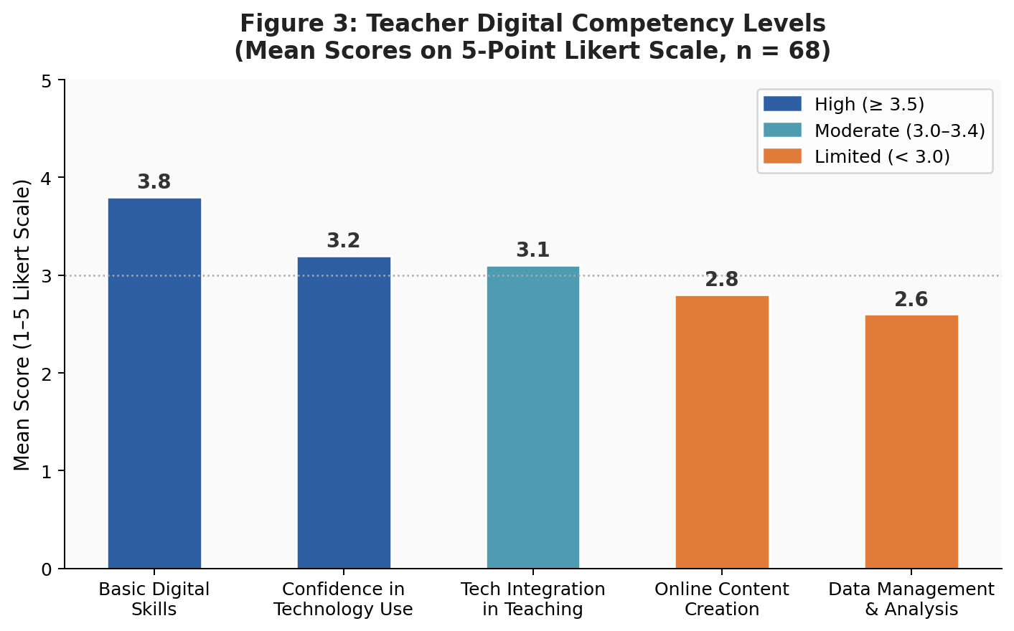
Figure 3: Teacher Digital Competency Levels — Mean Scores on 5-Point Likert Scale (n = 68)
The overall mean competency score was 3.1 (moderate), with basic digital skills (M = 3.8) performing considerably higher than higher-order competencies such as data management (M = 2.6) and content creation (M = 2.8). This pattern suggests a competency pyramid in which surface-level digital literacy is relatively widespread but pedagogically-oriented digital integration skills remain underdeveloped—a finding consistent with Scherer et al. (2020) and Hatlevik & Christophersen (2013).

4.5 Perceived Usefulness and Ease of Use
Perceived usefulness and ease of use were assessed through six items reflecting faculty beliefs about the instructional benefits and usability of educational technology. Response distributions are presented in Table 3 and Figure 4.

Table 3: Perceived Usefulness and Ease of Use — Response Distribution (n = 68)
Item | Agree/Strongly Agree (%) | Neutral (%) | Disagree/Strongly Disagree (%)
Technology improves teaching quality | 72% | 18% | 10%
Technology increases student engagement | 68% | 20% | 12%
Technology saves preparation time | 54% | 26% | 20%
Technology is easy to learn | 55% | 25% | 20%
Technology is easy to operate | 58% | 22% | 20%
Tools are user-friendly overall | 52% | 26% | 22%

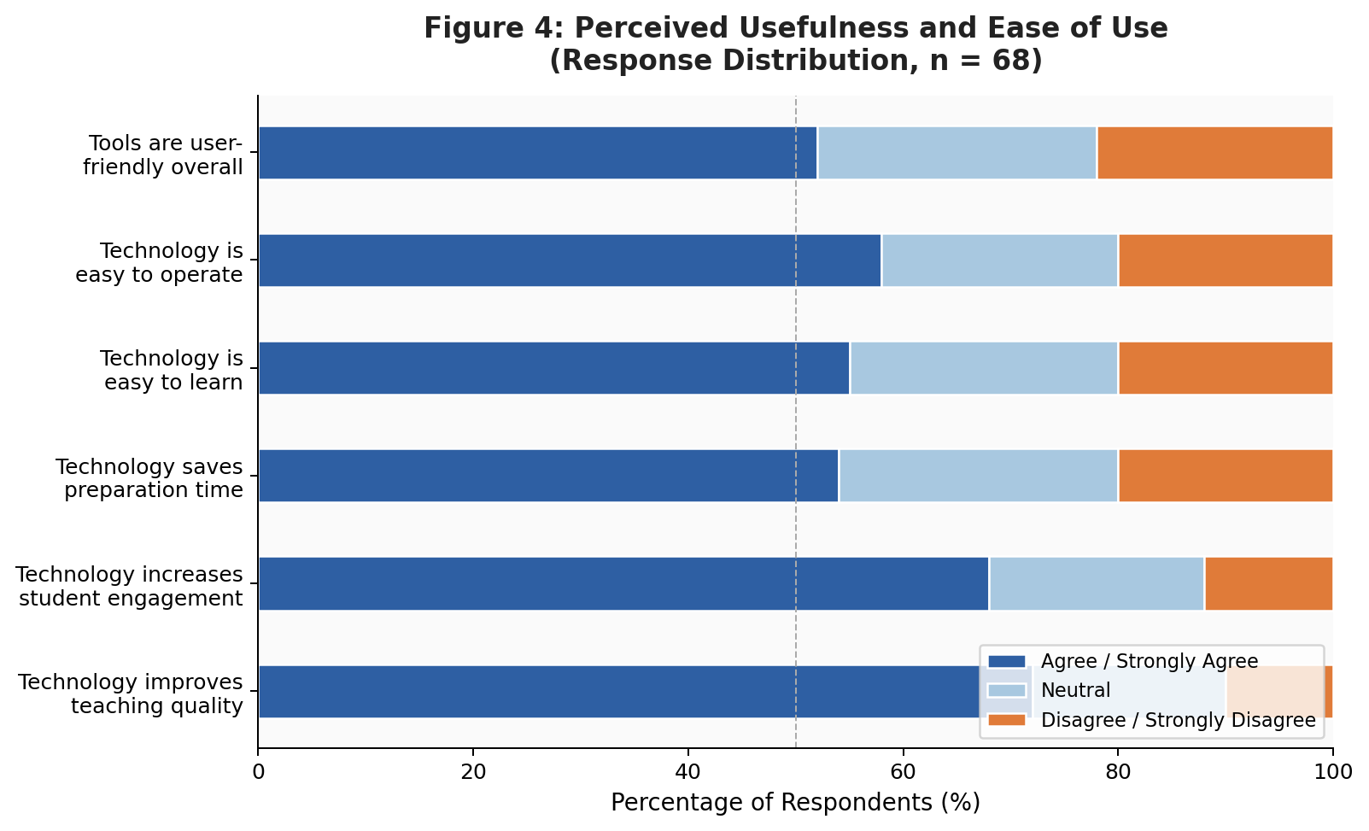
Figure 4: Perceived Usefulness and Ease of Use — Response Distribution (n = 68)
Perceived usefulness yielded the highest mean score in the study (M = 3.5, high), with 72% of respondents agreeing that technology improves teaching quality and 68% affirming its positive effect on student engagement. Perceived ease of use scored somewhat lower (M = 3.1, moderate), with mixed perceptions about tool usability, complexity, and time efficiency. These results affirm the dual constructs of TAM (Davis, 1989) and suggest that while motivational utility beliefs are strong, the practical experience of using technology remains a source of friction for a notable proportion of faculty.

4.6 External Influences
External influences on technology adoption were assessed across five factors: student expectations, peer influence, government policy support, international trends, and administrative pressure. Results are presented in Table 4 and Figure 5.

Table 4: External Influences on Technology Adoption (n = 68)
External Factor | Mean Score (1–5) | Level | Significance
Student expectations | 3.9 | High | Strongest external motivator; students expect digital learning
International trends in higher ed. | 3.2 | Moderate | Global digital education movement creates indirect pressure
Peer influence / colleague adoption | 3.1 | Moderate | Observing peers using tech normalizes adoption
Government policy support | 2.9 | Moderate–Low | Policies exist but implementation support is weak
Administrative pressure | 2.7 | Moderate–Low | Management expectations inconsistently communicated

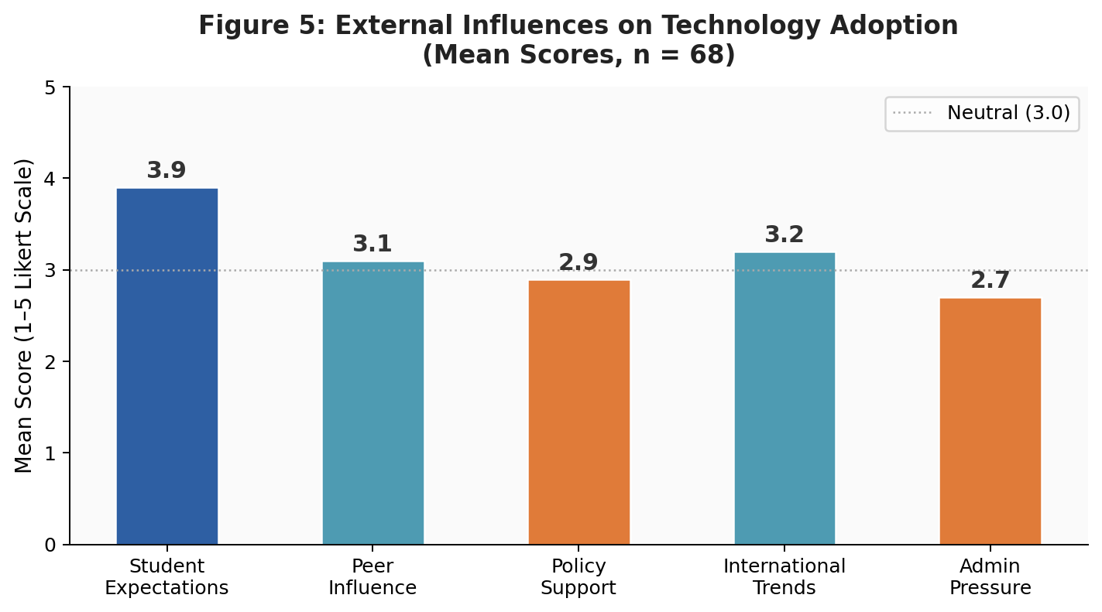
Figure 5: External Influences on Technology Adoption — Mean Scores (n = 68)
Student expectations emerged as the strongest external influence on technology adoption (M = 3.9), reflecting the growing digital literacy and technology use expectations of younger learner cohorts—a trend noted across South Asia (MoEST, 2021). Government policy support scored below the neutral midpoint (M = 2.9), indicating that while policy frameworks exist, faculty do not perceive them as providing meaningful implementation guidance or incentives. These findings align with DiMaggio and Powell's (1983) institutional isomorphism theory, which posits that normative and mimetic pressures from peer and social environments drive institutional change.

4.7 Challenges and Barriers
Respondents were asked to rate the degree to which each of five identified barriers had impeded their technology adoption. The percentage of respondents rating each barrier as high-impact is presented in Table 5 and Figure 6.

Table 5: Challenges and Barriers to Technology Adoption (n = 68)
Barrier | % Reporting High Impact | Severity Level | Implication
Lack of training | 76% | Critical | Primary capacity gap; structured PD urgently needed
Limited institutional resources | 60% | High | Equipment, internet and software shortfalls persist
Technical issues | 53% | High | Reliability and connectivity problems frequent
Time constraints | 47% | Moderate | Workload leaves little time for tech learning/integration
Resistance to change | 35% | Moderate–Low | Attitudinal barrier exists but not dominant

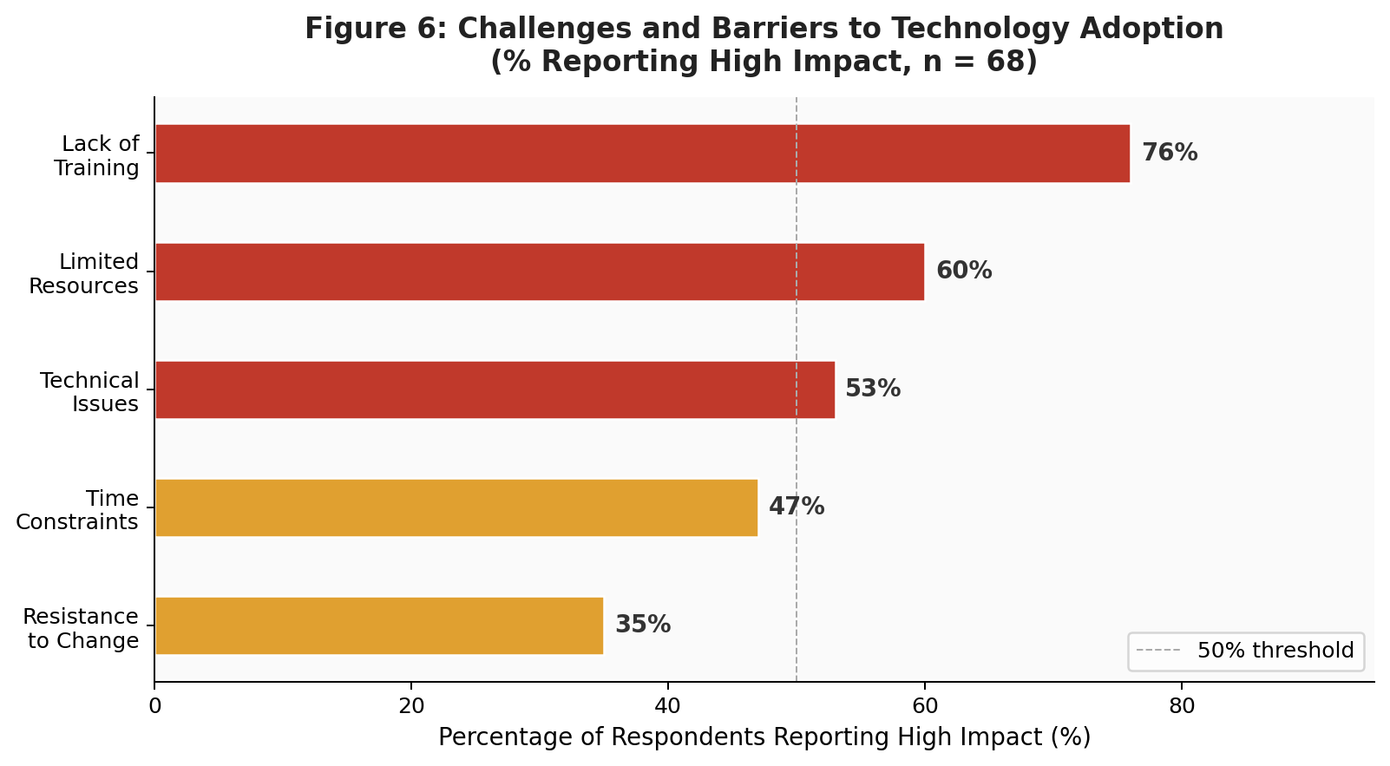
Figure 6: Challenges and Barriers to Technology Adoption — % Reporting High Impact (n = 68)
Lack of training was the most frequently cited high-impact barrier (76%), underscoring a critical human capital gap in the Nepalese higher education technology ecosystem. This finding converges with Tondeur et al. (2021) and Almaiah et al. (2020), who identify inadequate professional development as the most consistently reported barrier to technology integration in developing country educational contexts. Limited resources (60%) and technical issues (53%) compound this training deficit, while attitudinal resistance to change—though present—was reported as high-impact by only 35% of respondents, suggesting that faculty motivation is not the primary obstacle.

4.8 Summary of Key Determinants
Figure 7 presents a composite summary of mean scores across the five major determinant categories examined in this study, providing a holistic comparative overview.
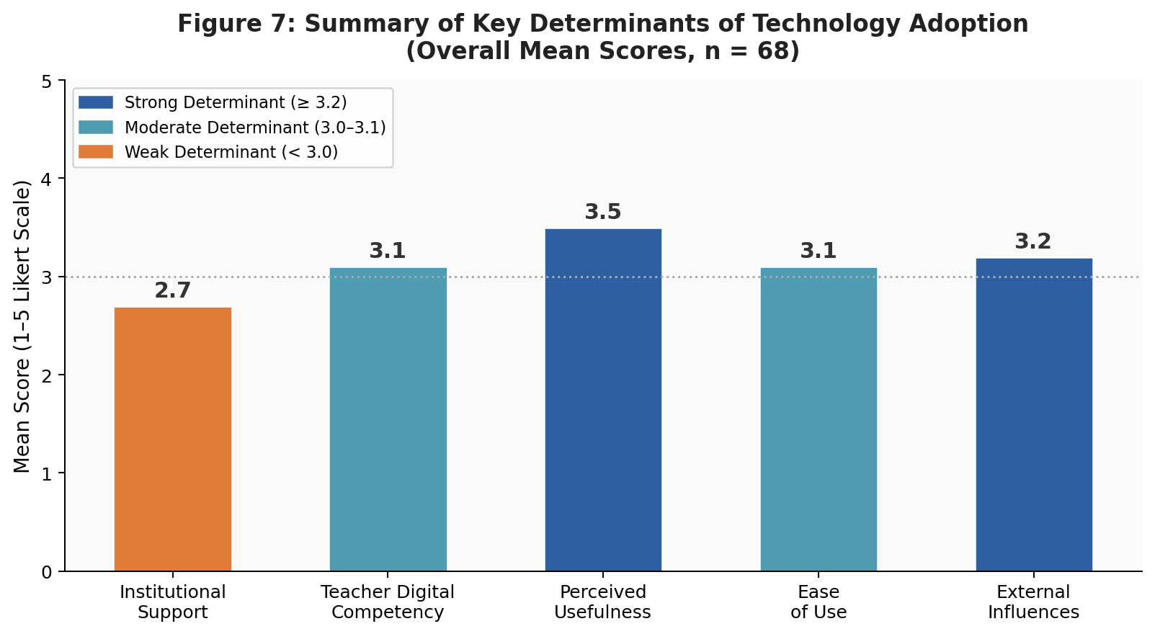
Figure 7: Summary of Key Determinants of Technology Adoption — Overall Mean Scores (n = 68)

Table 6: Comparative Summary of Key Determinants (n = 68)
Determinant | Mean Score | Level | Ranking
Perceived Usefulness | 3.5 | High | 1st
External Influences | 3.2 | Moderate | 2nd
Teacher Digital Competency | 3.1 | Moderate | 3rd (tied)
Perceived Ease of Use | 3.1 | Moderate | 3rd (tied)
Institutional Support | 2.7 | Moderate–Low | 5th

The summary reveals an important paradox: faculty are highly motivated by perceived usefulness (M = 3.5) and responsive to external drivers (M = 3.2), yet the institutional conditions required to support adoption (M = 2.7) are comparatively weak. This motivation-enablement gap represents a critical policy challenge: enthusiasm for technology without adequate institutional scaffolding risks frustration, inconsistent use, and eventual disengagement.

5. DISCUSSION

5.1 Institutional Support as the Critical Enabler
The findings of this study provide compelling evidence that institutional support—or its absence—is the most consequential structural determinant of educational technology adoption in Nepalese higher education. While institutional support received the lowest mean score across all determinants (M = 2.7), the individual barrier of lack of training was simultaneously the most widely cited high-impact barrier (76%). This convergent evidence reinforces Tondeur et al.'s (2021) meta-analytic finding that professional development and technical support are the institutional variables most strongly predictive of technology integration quality.
The pattern observed in this study is consistent with Ertmer's (1999) influential distinction between "first-order" barriers (external, resource-related) and "second-order" barriers (internal, belief-related). The data suggest that first-order barriers—particularly resource deficits and training gaps—are the dominant constraints in the Nepalese context, rather than attitudes or beliefs. This is a policy-relevant finding, as first-order barriers are, in principle, more amenable to direct institutional intervention than belief-based barriers.
Almaiah et al. (2020) found similar patterns in Jordanian universities, noting that infrastructure quality and technical support were the most significant institutional predictors of e-learning system use. In the Nepalese context, the particular severity of the training deficit—combined with low budget allocation scores (M = 2.3)—suggests that institutional technology adoption strategies have not been adequately resourced or systematically implemented, despite the aspirational goals of national policy frameworks (MoEST, 2021).

5.2 Teacher Digital Competency and the Competency Gap
The finding that basic digital skills are relatively well-developed (M = 3.8) while pedagogical integration competencies lag substantially (M = 3.1; M = 2.6 for data management) points to a critical "competency gap" in Nepalese higher education. This pattern has been described as the difference between "tool literacy" and "pedagogical technology literacy"—where teachers know how to use devices and applications but lack the pedagogical frameworks to deploy them meaningfully in instruction (Redecker, 2017; Scherer et al., 2020).
Scherer et al.'s (2020) comprehensive meta-analysis found that digital competency is both a direct predictor of technology adoption and a mediating variable through which institutional support effects operate. This suggests that capacity-building programs should not focus merely on technical skill acquisition but must explicitly address the integration of digital tools with pedagogical design, assessment, and learner engagement strategies.

5.3 The Role of Perceived Usefulness and Ease of Use
The study's finding that perceived usefulness (M = 3.5) consistently outperforms perceived ease of use (M = 3.1) is consistent with TAM's prediction that PU is a stronger determinant of adoption intention than PEOU (Davis, 1989; Teo, 2011). That 72% of faculty agree technology improves teaching quality reflects a fundamentally positive and enabling attitudinal foundation—one that institutions can leverage to drive adoption if they simultaneously address the practical usability and training barriers that constrain it.
The discrepancy between high usefulness perceptions and moderate ease-of-use perceptions may reflect a gap between aspirational and experiential technology encounters. Faculty may believe in the transformative potential of educational technology in the abstract while simultaneously finding specific tools burdensome or unreliable in practice. This interpretation aligns with Kirkwood and Price's (2014) observation that technology's pedagogical promise is frequently undermined by poor implementation and inadequate technical support.

5.4 External Influences: Student Expectations as a Driver
The emergence of student expectations as the strongest external influence (M = 3.9) on technology adoption reflects a generational dynamic increasingly reported in higher education literature globally (Prensky, 2001; Oblinger & Oblinger, 2005). As digital-native students enter higher education with elevated expectations for technology-mediated learning, faculty face normative pressure to adapt their pedagogical approaches—a form of normative isomorphism (DiMaggio & Powell, 1983) that can effectively leverage student agency as a driver of institutional change.
The relatively low scores for government policy support (M = 2.9) are notable given Nepal's explicit national commitments to ICT in education (MoEST, 2021). They suggest a disconnect between policy rhetoric and practice—a phenomenon well-documented in educational technology literature, where ambitious national frameworks fail to translate into changes at institutional and classroom levels without adequate implementation support, funding, and accountability mechanisms (Bates, 2019; Hew & Brush, 2007).

5.5 The Motivation-Enablement Paradox
A cross-cutting theme emerging from this study is what might be termed the "motivation-enablement paradox": faculty are genuinely motivated to adopt educational technology (evidenced by high perceived usefulness and strong responsiveness to student expectations), yet the institutional conditions required to convert this motivation into sustained, effective use are markedly deficient. This paradox is not unique to Nepal—similar patterns have been documented in Ghana (Agyei & Voogt, 2021), Malaysia (Ghavifekr & Rosdy, 2015), and Sub-Saharan Africa (Sabi et al., 2016)—but its manifestation in the Nepalese context points to specific structural and policy failures that require targeted redress.
The implication is that technology adoption initiatives in Nepal should not prioritize awareness-raising or motivational campaigns—faculty motivation is already present. Instead, the priority should be systematic investment in institutional enablers: structured professional development, improved technical infrastructure, and sustained technical support.

6. CONCLUSION

This study examined the determinants of educational technology adoption in higher education institutions in Nepal, drawing on survey data from 68 teaching professionals. The investigation was guided by established theoretical frameworks—most notably the Technology Acceptance Model (Davis, 1989) and the Unified Theory of Acceptance and Use of Technology (Venkatesh et al., 2003)—and focused on five major determinant dimensions: institutional support, teacher digital competency, perceived usefulness, ease of use, and external influences.
The findings reveal a nuanced adoption landscape characterized by positive motivational foundations but significant structural and institutional deficits. Faculty broadly perceive technology as useful for teaching and are sensitive to student expectations for digital learning environments. However, these positive dispositions are undermined by critical gaps in institutional support—particularly the severe shortage of structured training opportunities and insufficient resource allocation. Teacher digital competency, while adequate at the basic skill level, remains underdeveloped in higher-order pedagogical integration competencies.
The study identifies a "motivation-enablement paradox" at the heart of technology adoption in Nepalese higher education: faculty motivation exists, but institutional scaffolding is insufficient to convert that motivation into sustained, effective technology use. Addressing this paradox requires a systemic approach that simultaneously invests in institutional infrastructure, professional development, supportive policies, and cultural change.
While this study makes an important empirical contribution to understanding technology adoption in Nepalese higher education, several limitations should be noted. The sample size (n = 68), though adequate for exploratory analysis, limits generalizability across the full diversity of Nepalese higher education institutions. The cross-sectional design precludes causal inference. Future research should employ larger, nationally representative samples, longitudinal designs, and mixed-method approaches that combine quantitative survey data with qualitative insights from institutional case studies and faculty interviews.

Recommendations
Based on the findings, the following evidence-based recommendations are proposed:

6.1 Strengthen Institutional Training Programs
Higher education institutions should design and implement structured, ongoing professional development programs specifically focused on pedagogical technology integration. Training should progress from foundational digital literacy to advanced competencies in online content creation, data-driven teaching, and blended learning design. Dedicated institutional budgets for technology training—modeled on international best practices—should be established and monitored annually (Tondeur et al., 2021).

6.2 Invest in Technical Infrastructure and Support
Reliable, high-speed internet connectivity and up-to-date hardware must be treated as non-negotiable institutional obligations. Institutions should establish dedicated IT support units staffed by trained professionals who can provide timely, responsive assistance to faculty. Preventive maintenance schedules and contingency plans for technical failures should also be institutionalized.

6.3 Develop a National Digital Competency Framework for Educators
The Government of Nepal and the University Grants Commission should develop and adopt a contextualized national framework for educator digital competency—aligned with but adapted from the European DigCompEdu framework—with clear benchmarks, certification pathways, and recognition mechanisms for faculty who attain competency milestones (Redecker, 2017; MoEST, 2021).

6.4 Promote User-Friendly, Context-Appropriate Technologies
Institutions should curate and adopt technologies that are intuitive, low-bandwidth-friendly, and aligned with Nepalese pedagogical contexts and language requirements. Procurement decisions should prioritize platforms with robust local-language support and proven usability in low-resource environments.

6.5 Align Policy with Practice
National ICT-in-education policies must be accompanied by concrete implementation plans, accountability mechanisms, and dedicated funding streams. Policy-practice alignment requires regular monitoring of technology adoption indicators at institutional and national levels, with findings feeding back into iterative policy revision (Bates, 2019).

6.6 Leverage Student Expectations Strategically
Given the strong influence of student expectations on faculty adoption behavior, institutions should create formal feedback mechanisms through which student technology preferences and learning experience assessments inform institutional technology planning and faculty development priorities.

REFERENCES

Agyei, D. D., & Voogt, J. (2021). Developing technological pedagogical content knowledge in pre-service mathematics teachers through collaborative design. Australasian Journal of Educational Technology, 27(4), 1–16. https://doi.org/10.14742/ajet.1026
Albirini, A. (2020). Cultural perceptions: The missing element in the implementation of ICT in developing countries. International Education Journal, 6(3), 351–362.
Almaiah, M. A., Al-Khasawneh, A., & Althunibat, A. (2020). Exploring the critical challenges and factors influencing the E-learning system usage during COVID-19 pandemic. Education and Information Technologies, 25(6), 5261–5280. https://doi.org/10.1007/s10639-020-10227-8
Alshehri, A., Rutter, M., & Smith, S. (2019). An implementation of the UTAUT model for understanding students' perceptions of learning management systems. International Journal of Distance Education Technologies, 17(3), 1–24.
Babbie, E. (2016). The practice of social research (14th ed.). Cengage Learning.
Bandura, A. (1986). Social foundations of thought and action: A social cognitive theory. Prentice-Hall.
Bates, A. W. (2019). Teaching in a digital age: Guidelines for designing teaching and learning (2nd ed.). Tony Bates Associates.
Bhattarai, P., & Maharjan, R. (2021). COVID-19 and online education in Nepal: Challenges and opportunities for higher education institutions. Journal of Education and Educational Development, 8(2), 45–63.
Birch, A., & Irvine, V. (2009). Preservice teachers' acceptance of ICT integration in the classroom: Applying the UTAUT model. Educational Media International, 46(4), 295–315.
Compeau, D. R., & Higgins, C. A. (1995). Computer self-efficacy: Development of a measure and initial test. MIS Quarterly, 19(2), 189–211.
Creswell, J. W. (2014). Research design: Qualitative, quantitative, and mixed methods approaches (4th ed.). SAGE Publications.
Crompton, H., Burke, D., & Lin, Y. C. (2021). Mobile learning and student cognition: A systematic review of PK-12 research using Bloom's taxonomy. British Journal of Educational Technology, 51(1), 56–70.
Davis, F. D. (1989). Perceived usefulness, perceived ease of use, and user acceptance of information technology. MIS Quarterly, 13(3), 319–340. https://doi.org/10.2307/249008
Dhawan, S. (2020). Online learning: A panacea in the time of COVID-19 crisis. Journal of Educational Technology Systems, 49(1), 5–22. https://doi.org/10.1177/0047239520934018
DiMaggio, P. J., & Powell, W. W. (1983). The iron cage revisited: Institutional isomorphism and collective rationality in organizational fields. American Sociological Review, 48(2), 147–160.
Ertmer, P. A. (1999). Addressing first- and second-order barriers to change: Strategies for technology integration. Educational Technology Research and Development, 47(4), 47–61.
Ertmer, P. A., Ottenbreit-Leftwich, A. T., Sadik, O., Sendurur, E., & Sendurur, P. (2012). Teacher beliefs and technology integration practices: A critical relationship. Computers and Education, 59(2), 423–435.
Ghavifekr, S., & Rosdy, W. A. W. (2015). Teaching and learning with technology: Effectiveness of ICT integration in schools. International Journal of Research in Education and Science, 1(2), 175–191.
Hatlevik, O. E., & Christophersen, K. A. (2013). Digital competence at the beginning of upper secondary school: Identifying factors explaining digital inclusion. Computers and Education, 63, 240–247.
Hew, K. F., & Brush, T. (2007). Integrating technology into K-12 teaching and learning: Current knowledge gaps and recommendations for future research. Educational Technology Research and Development, 55(3), 223–252.
Kirkwood, A., & Price, L. (2014). Technology-enhanced learning and teaching in higher education: What is "enhanced" and how do we know? A critical literature review. Learning, Media and Technology, 39(1), 6–36.
Kopcha, T. J. (2012). Teachers' perceptions of the barriers to technology integration and practices with technology under situated professional development. Computers and Education, 59(4), 1109–1121.
Ministry of Education, Science and Technology (MoEST). (2021). ICT in education master plan (2021–2025). Government of Nepal.
Nunnally, J. C. (1978). Psychometric theory (2nd ed.). McGraw-Hill.
Oblinger, D., & Oblinger, J. (Eds.). (2005). Educating the net generation. EDUCAUSE.
OECD. (2021). Digital education outlook 2021: Pushing the frontiers with artificial intelligence, blockchain and robots. OECD Publishing. https://doi.org/10.1787/589b283f-en
Pelgrum, W. J. (2001). Obstacles to the integration of ICT in education: Results from a worldwide educational assessment. Computers and Education, 37(2), 163–178.
Prensky, M. (2001). Digital natives, digital immigrants. On the Horizon, 9(5), 1–6.
Redecker, C. (2017). European framework for the digital competence of educators: DigCompEdu. Publications Office of the European Union.
Rogers, E. M. (2003). Diffusion of innovations (5th ed.). Free Press.
Sabi, H. M., Uzoka, F. M. E., Langmia, K., & Njeh, F. N. (2016). Conceptualizing a model for adoption of cloud computing in education. International Journal of Information Management, 36(2), 183–195.
Scherer, R., Siddiq, F., & Teo, T. (2020). Becoming more specific: Measuring and modeling teachers' perceived digital competence. Computers in Human Behavior, 113, 106–123. https://doi.org/10.1016/j.chb.2020.106568
Sharma, R., & Pokharel, M. (2022). ICT integration in Nepalese higher education: Status, challenges and prospects. Journal of Education and Practice, 13(4), 12–24.
Teo, T. (2011). Factors influencing teachers' intention to use technology: Model development and test. Computers and Education, 57(4), 2432–2440.
Tondeur, J., Scherer, R., Siddiq, F., & Baran, E. (2021). Enhancing teachers' digital competence: A systematic review. Educational Technology Research and Development, 69(1), 1–27. https://doi.org/10.1007/s11423-020-09896-y
UNESCO. (2023). Global education monitoring report 2023: Technology in education — A tool on whose terms? UNESCO Publishing.
Venkatesh, V., & Bala, H. (2008). Technology acceptance model 3 and a research agenda on interventions. Decision Sciences, 39(2), 273–315.
Venkatesh, V., & Davis, F. D. (2000). A theoretical extension of the technology acceptance model: Four longitudinal field studies. Management Science, 46(2), 186–204.
Venkatesh, V., Morris, M. G., Davis, G. B., & Davis, F. D. (2003). User acceptance of information technology: Toward a unified view. MIS Quarterly, 27(3), 425–478. https://doi.org/10.2307/30036540
Venkatesh, V., Thong, J. Y. L., & Xu, X. (2016). Unified theory of acceptance and use of technology: A synthesis and the road ahead. Journal of the Association for Information Systems, 17(5), 328–376.
Voogt, J., Laferrière, T., Breuleux, A., Itow, R. C., Hickey, D. T., & McKenney, S. (2015). Collaborative design as a form of professional development. Instructional Science, 43(2), 259–282.
Wenger, E. (1998). Communities of practice: Learning, meaning, and identity. Cambridge University Press.
World Bank. (2020). Remote learning during COVID-19: Lessons from South Asia. World Bank.

