Unveiling the AI–SCM Nexus: A Bibliometric and PRISMA-Based Review of Trends, Technologies, and Future Directions (2021–2025)

Thafseela Thasni U ^{1*}, Dr Saleena T A ²
- Research Scholar, Department of Commerce, PSMO College (Autonomous) Tirurangadi, Affiliated to Calicut university, kerala, India
thafseelathasniu@gmail.com
- Research Supervisor & Assistant Professor, Department of Commerce, PSMO College (Autonomous) Tirurangadi, Affiliated to Calicut university, kerala, India
tasaleena@gmail.com
Corresponding Author* Thafseela Thasni U
ABSTRACT
The integration of Artificial Intelligence (AI) into Supply Chain Management (SCM) has become a key driver of digital transformation, transforming industry practices and academic discourse. As global supply chains grow more complex and data-driven, AI’s role in improving efficiency, responsiveness, and sustainability has gained significant attention. This study conducts a bibliometric review of 499 peer-reviewed articles published between 2021 and 2025, sourced from Scopus and Web of Science, to trace the changing intellectual and thematic dimensions of AI–SCM research. Quantitative analysis using R Studio and network visualization via VOSviewer indicate key trends, prolific contributors, and dominant research clusters. The result indicates a significant rise in scholarly output over the past five years, with China, India, and the United States leading in publications. Institutions such as the Indian Institutes of Management and Penn State University emerge as major knowledge centers. The research identifies thematic focal points such as AI-assisted decision-making, supply chain resilience, risk management, and sustainability, closely associated to technologies such as machine learning, big data analytics, and Industry 4.0 frameworks. Network analysis reveals strong keyword co-occurrence around automation, optimization, digital supply chains, and predictive analytics, reflecting the convergence of AI capabilities with the fundamental SCM functions. Despite substantial progress, challenges remain—high implementation costs, shortages in skilled talent, data privacy issues, and ethical implications of AI application. These gaps underscore the need for more inclusive and responsible adoption strategies. This bibliometric paper provides a structured overview of the current research landscape, aiding scholars and practitioners in understanding key developments, influential authors, and emerging opportunities. The paper ends with a recommendation to organize future research on the topic of human-AI collaboration, governance systems, and socio-economic effects of AI on global supply-chains

Keywords: Artificial Intelligence, Supply Chain Management, Bibliometric Analysis, Industry 4.0, Digital Transformation.

INTRODUCTION
Background of the study
The convergence of artificial intelligence (AI) and supply chain management (SCM) has become one of the pivots in the world of business process operations and its direction is represented by the search methods to overcome the challenges of modern supply chains. In the face of supply chains being more challenged than ever before due to phenomena like globalization, uncertainties related to geopolitics, natural catastrophes, and the residual consequences of the COVID-19 pandemic, the utilization of AI algorithms, i.e., machine and deep learning, and generative AI have become the solutions enabling to enhance efficiency, resilience and sustainability (Belu & Marinoiu, 2025; Joshi & Sharma, 2022; Naz et al., 2022). Such technologies provide improved capabilities in demand forecasting, inventory optimization, logistics scheduling and risk management, and completely change the SCM practices as they were (Hezam et al., 2024; Hwang et al., 2025; Rolf et al., 2025). The catalyst behind the fast penetration of AI into SCM is that it can help save money, make better decisions and implement sustainable practices, especially in manufacturing, healthcare, and retail (Chee et al., 2023; Ghouati et al., 2025; Helo & Hao, 2022). Nevertheless, the different uses and functions of AI throughout the subfields of SCM, in addition to the different diversities of the research focus, have led to an absence of overall comprehension which will require a systematic analysis to homogenize the existing values and outline future examination.
Bibliometric analysis has become an effective tool to identify the intellectual map of a specific research subject, identifying the main points, active researchers, and new tendencies by quantitative estimation of scholarly literature (Belu & Marinoiu, 2025). With the help of the VOSviewer and Bibliometrix, bibliometric research can also trace how research has developed, evidence interdisciplinary associations, and identify any literature deficiencies(R. Sharma et al., 2022a). Such an analysis is especially important in the context of AI and SCM because the publication on the second context grows at a rapid pace: research on the role of AI in improving supply chain operations now ranges as diverse as the function of green supply chain management to the use of real-time fashion systems to the interest of SCM in it (Yao et al., 2024). Examples of AI affecting the supply chain include the diversification of the supply chain, reduction of carbon footprints, and predictive definition of drugs to deliver drugs in a predictable manner in terms of healthcare (Chee et al., 2023; Hezam et al., 2024; Lin et al., 2025). Moreover, the incorporation of AI in SCM has been proven to deal with the issue of what is after COVID-19 by ensuring resilience via lean coordination and digitalization (NAYAL et al., n.d.).
Although these improvements have been made, there are still issues that need to be addressed regarding the use of AI, like the high implementation cost, and a lack of AI governance systems, as well as tough resistance to organizational change, specifically in the developing economies(Shrivastav, 2021). Moreover, the replacement of conventional business analytics with AI-driven SCM implementation presupposes special attention to the availability of data, design of algorithms, and human sensemaking, which are discussed in the studies dedicated to the disruptive nature of AI (Hendriksen, 2023). The current bibliometric research will fill these gaps in the current literature because it examines a large and significant amount of scholarly articles to identify the research landscape of AI in SCM. This paper analyzes publication trends and classifies important research clusters of the last decade such as supply chain network design, supplier selection, and green SCM to give an overview of where the field currently is and how this can be applied to theory or practice (R. Sharma et al., 2022b; Sohrabpour et al., 2021). The study aims at informing researchers and professionals in utilizing AI to design resilient, transparent, and sustainable supply chains, and to make recommendations on the potential areas of future research that can be pursued in an attempt to fill gaps and meet new challenges.

Review of literature
The convergence of Artificial Intelligence (AI) and Supply Chain Management (SCM) represents a global move toward digital, data-driven operations. This shift is prompting considerable academic interest, as AI fundamentally alters supply chain planning, logistics, risk management, and sustainability through increased automation and improved decision-making.
Supply chain management (scm)
SCM covers the planning, coordination, and control of sourcing, procurement, production, inventory, logistics, and distribution. Modern SCM is dynamic and agile, adapting to fluctuating markets and stringent environmental policies (M. Sharma et al., 2022). The traditional, labor-intensive supply chains are increasingly replaced by technology-driven systems, prompted by global complexity and higher demands for transparency and sustainability (Daios et al., 2025). AI enables faster, real-time decisions across inventory, logistics, and supplier relationships, particularly for disruption management—making it easier to meet cost, service, and sustainability goals (Belu & Marinoiu, 2025).
Artificial intelligence (AI)
AI systems simulate human intelligence using data to generate actionable insights and automate processes for improved prediction and risk management (R. Sharma et al., 2022a). In supply chain contexts, AI powers demand forecasting, network optimization, and effective risk management. Techniques like machine learning (ML) and genetic algorithms result in accurate demand prediction and network design, cutting costs and emissions (Wei et al., 2025; Yao et al., 2024). However, high costs, data challenges, and skills shortages constrain AI adoption, especially in developing nations(Godinho Filho et al., 2025).
AI algorithms across diverse sectors
AI algorithms—ML, DL, and generative AI—are now widely utilized in critical areas outside SCM, including healthcare (for disease diagnosis and drug discovery), banking (fraud detection and risk management), government (public services optimization), and entertainment (personalized recommendations). Generative AI, for instance, is revolutionizing R&D in pharmaceuticals, accelerating new drug discovery and drastically reducing time-to-market, with sector analysis estimating up to $110 billion in annual value creation in pharma alone. These AI technologies are transforming data-heavy, repetitive tasks across finance, manufacturing, customer service, and logistics, enabling near real-time decision-making and process automation ​(Gupta et al., 2022).
AI and blockchain in supply chain management
The integration of blockchain with AI in SCM underpins traceability, transparency, and stakeholder collaboration. Blockchain adoption is motivated by demands for product traceability, validation of origin and safety, and secure, multi-stakeholder data sharing—essential for food, pharmaceutical, and automotive supply chains. Real-time inventory and lead-time improvements are observed most in upstream supply networks, but require collaborations and partnerships for effective implementation and benefit diffusion. AI and blockchain together ensure faster, safer procurement, minimize fraud, and improve regulatory compliance, as seen in recent traceability projects in the food sector and automotive industry (Ressi et al., 2024).
key terms that are essential to this landscape are:
- Machine Learning (ML):
Machine learning algorithms are foundational in optimizing demand forecasting, risk assessment, and supplier selection across global supply chains(VLACHOS & REDDY, n.d.). ML models leverage historical and real-time data to predict fluctuations in demand, minimize inventory costs, and proactively manage supply risks. In supply chain finance, ML is central to credit risk assessment, cash flow prediction, and dynamic discounting, with major platforms now deploying ML to automate invoice verification, prevent fraud, and optimize working capital. For example, companies like C.H. Robinson and IBM have used ML-driven analytics to automate freight demand forecasting and real-time inventory management, significantly reducing human error and misallocation. Further, in the public sector, ML supports resource allocation and fraud detection in public spending, while in finance, it underpins advanced credit scoring and anti-fraud mechanisms across payment networks (Mitrović et al., 2025)​

- Deep Learning (DL):
Deep learning, as a specialized subset of ML, enables the analysis of highly complex and unstructured datasets such as images, video, and text. In healthcare, DL has revolutionized medical image analysis for diagnostics and treatment planning(B. Liu, 2023). Within supply chains, DL models automate demand prediction, optimize logistics (e.g., route planning, predictive maintenance), and enable intelligent surveillance of goods and facilities. Manufacturing leverages DL for quality control, defect detection, and smart robotics, yielding agile automation in production lines. In media, DL models automate content classification and detect misinformation , while public safety agencies use DL-powered video analytics for enhanced situational awareness(Hosseinnia Shavaki & Ebrahimi Ghahnavieh, 2023).​

- Generative AI (GenAI):
Generative AI goes a step beyond traditional analytics by autonomously creating plans, simulations, and optimizations.(S. Wang et al., 2024) In supply chain management, GenAI is used for scenario planning, automated demand forecasting, and generative product design—making it possible to respond to disruptions and market shifts rapidly and with high precision. Microsoft and Amazon utilize GenAI to predict supplier disruptions, optimize inbound logistics, and automatically generate responses to supply chain events. Beyond SCM, GenAI produces new drug formulas in pharmaceuticals, designs marketing content in media and retail, and develops financial models for fraud detection and investment simulation in banking and insurance. In manufacturing, GenAI improves parts redesign and adaptive workflows in response to detected equipment failures. It is also transforming customer service with AI-powered chatbots and content creation platforms(Richey et al., 2023).

• Predictive Analytics: This technique uses statistical models and AI to forecast future outcomes based on historical and real-time data. In SCM, predictive analytics drives demand planning, inventory optimization, and risk management by anticipating customer needs and disruptions. (Dosdogru et al., 2021) apply predictive analytics to predict lead times, improving inventory routing efficiency. The dataset highlights its role in enabling proactive strategies, such as mitigating supplier delays.
• Industry 4.0: Industry 4.0 integrates smart technologies—AI, IoT, blockchain, and robotics—into industrial and supply chain processes, creating interconnected, data-driven systems.(Jahani et al., 2021) link Industry 4.0 to procurement, where AI automates supplier evaluations and enhances traceability. The dataset underscores its role in enabling smart factories and logistics networks, aligning SCM with digital transformation goals(Luković et al., 2025).
• Blockchain: A decentralized ledger technology, blockchain ensures transparency, traceability, and security in supply chain transactions. It complements AI by providing reliable data for models, such as verifying supplier credentials or tracking product origins(Luković et al., 2025). (NAZ et al., n.d.) emphasize blockchain’s synergy with AI in building resilient supply chains, particularly post-COVID-19, by enhancing data integrity for risk assessments.
• Sustainability: Sustainability in SCM focuses on reducing environmental impact and promoting social responsibility through practices like emissions reduction and ethical sourcing. AI optimizes processes to minimize waste and energy use. (S. Wang et al., 2024) demonstrate how AI-driven analytics optimize delivery routes to lower carbon footprints, aligning with regulatory and consumer demands.
• Resilience: Resilience refers to a supply chain’s ability to absorb, adapt to, and recover from disruptions. AI enhances resilience through predictive risk modeling and real-time monitoring. (Daios et al., 2025)highlight AI’s role in post-COVID-19 resilience, using predictive models to anticipate disruptions and blockchain for visibility.
• Digital Transformation: Digital transformation adopts digital technologies to reengineer business processes. In SCM, it integrates AI, IoT, and cloud computing to create smart supply chains. (Chilicaus et al., 2025) explore its potential in developing economies, noting AI’s role despite skill shortages. The dataset positions digital transformation as a catalyst for AI-SCM integration.
These terms form an ecosystem where AI leverages big data analytics, learns through ML and DL, predicts outcomes via predictive analytics, and integrates with Industry 4.0 and blockchain to enhance SCM’s efficiency, sustainability, and resilience.
AI-driven optimization
Demand forecasting, inventory, logistics, and network design are all optimized by AI-based algorithms (M. Sharma & Firoz, 2022). Notably, ML models like Cat Boosting ensure accurate, timely deliveries in sectors such as healthcare (Hezam et al., 2024). Combining AI with logistics optimization further reduces costs and response times in manufacturing (Y. Wang et al., 2025). Hybrid models enhance inventory routing, and generative AI is being applied to a growing range of supply chain functions for greater accuracy and efficiency (Braganza et al., 2022; Dosdogru et al., 2021).
Sustainability and green scm
AI fosters sustainable SCM by shrinking environmental footprints and implementing green practices. Solutions like deep learning-driven water-saving systems cut emissions for SMEs (Feng et al., 2022). Big data and AI drive balanced supply chains and support circular economy principles (Li et al., 2023). The adoption of Industry 4.0, including AI, boosts sustainable sourcing and operational efficiency (JAHANI et al., n.d.). AI also helps measure the scale of sustainability performance in supply chains (K.-S. Liu & Lin, 2021).
Risk management and resilience
AI improves resilience by forecasting and mitigating risks, replacing subjective assessment with objective, data-driven frameworks (Gupta et al., 2024). AI’s predictive models aid post-COVID-19 supply chain recovery and support diversification and transparency, especially in manufacturing and high-tech industries (Naz et al., 2022; Wu et al., 2025).

Barriers to AI adoption
Significant barriers remain, including organizational and data management challenges, high costs, and lack of AI expertise (Shrivastav M, 2022; Khalifa N et al., 2021). In developing regions, low wages and skills gaps further inhibit integration. There is also a need to view AI implementation as both a technical and sociotechnical challenge, emphasizing human understanding and system preparedness (Hendriksen, 2023).
Despite recognition of these challenges, detailed strategies are essential to facilitate successful AI adoption:

- High Costs and IT Infrastructure: Organizations are often limited by the substantial initial investments required for AI solutions and the challenges of modernizing legacy IT systems. Recommended approaches include phased modernization with cloud-based, API-driven SCM planning, conducting thorough cost-benefit analyses before adoption, and beginning with focused, scalable pilot projects to prove value and spread costs over time(Mahroof, 2019)​

- Data Quality and Management: Fragmented, inconsistent data sources and poor governance limit AI effectiveness. Implementing unified data management frameworks, investing in high-quality real-time data collection, and prioritizing AI-powered data harmonization unlock more accurate forecasting and process optimization (D et al., 2025)

- Workforce Skills and Cultural Resistance: Lack of expertise and cultural resistance persist as key barriers. Organizations should invest in targeted upskilling initiatives and ongoing training, support workforce AI literacy, and foster an environment of participatory design, encouraging buy-in and reducing resistance to change(Shrivastav, 2022).​

- Change Management and Stakeholder Engagement: Successful adoption depends on a clear, customer-centric transformation strategy, alignment with broader organizational goals, and securing stakeholder commitment at every stage. Transparent communication about the benefits, limitations, and roles of AI, as well as collaborative decision-making, are vital to addressing fear and mistrust among employees (Salimimoghadam et al., 2025).

- Regulatory and Compliance Complexities: Navigating data privacy laws and sustainability mandates, especially in regions with stringent compliance requirements (such as GDPR), requires partnering with vendors that prioritize regulatory alignment and sustainability reporting in their AI models (HANGL et al., n.d.).

By applying these best practices—cloud solutions to reduce costs, unified data management, continuous workforce training, and strategic change management—organizations can overcome the technical and sociotechnical challenges of AI adoption, enabling resilience, agility, and long-term supply chain competitiveness.​
METHODOLOGY
The current study is based on a bibliometric study with a literature review which is directed at the determination and synthesis of all the available studies on the topic of supply chain management and artificial intelligence (AI) published within the period 2021 until 2025 with literature search conducted in early April 2025. Within the framework of a systematic review of literature, the eligibility criteria (scoping document selection) are vital and include the possibility of ensuring that these criteria reflect the purpose of the entire research. Second, one must ensure that the document search processes are made explicit to ensure that there is clear and dependable result, which is relevant towards making correct conclusions and making effective decisions. To simplify this type of a systematic review, an international group of experienced authors and methodologists came up with PRISMA (Preferred Reporting Items for Systematic Reviews and Meta-Analyses) which is aimed at scoping reviews(Serrano-Torres et al., 2025). These guidelines organize review process into four base phases: identification, screening, eligibility and inclusion. Because the PRISMA statement suggests that authors must provide the searching strategy used on each and every database, registry or web platform, this systematic literature review accepts such standards which are outlined below.

Figure 1: PRISMA four-phase flow diagram

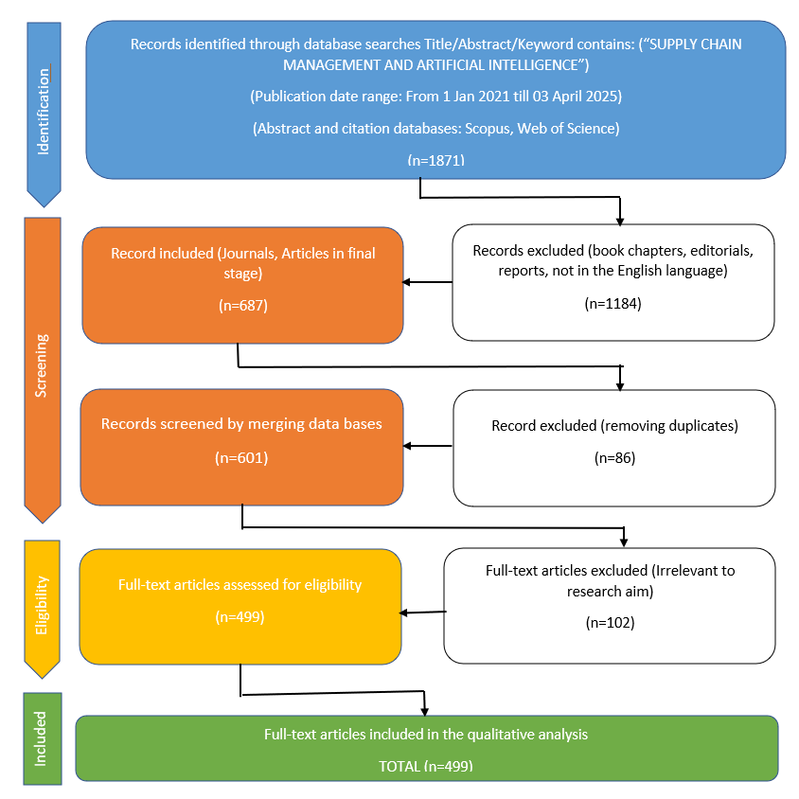

In Figure 1, the identification phase outlines the number of records retrieved through database searches and additional sources. The search for documents was conducted in the Scopus and Web of Science databases, focusing on titles, abstracts, or keywords containing concepts related to logistics, e-commerce, and sustainability (or similar terms). The primary objective was to capture the existing literature on this topic published over the past five years, including all types of documents such as articles, among others, written in English and originating from any country. Specifically, a document search was carried out in the Scopus database using the following search equation: TITLE-ABS-KEY (SUPPLY CHAIN MANAGEMENT*), which initially yielded 1982 documents. Subsequently, the search was refined to include only publications from the years 2021 to 2025, in order to concentrate the analysis on recent studies pertaining to supply chain management and artificial intelligence. This refinement resulted in a total of 1871 documents, accounting for 94.4% of the original search results, as depicted in Figure 2. These findings indicate that the retrieved documents make a substantial contribution to the scientific literature on the research topic and accurately reflect the predominant research trends in supply chain management and artificial intelligence.
Figure 2: Documents published in Scopus on supply chain management and artificial intelligence.

Similarly, the search equation (supply chain management AND artificial intelligence (Topic)) was applied in the Web of Science (WOS) database, resulting in the identification of 714 papers from the Web of Science Core Collection. To further refine the search, additional parameters were set to include only documents published between 2021 and 2022 (Timespan: 1 January 2021 to 3 April 2023), yielding a total of 581 records. This final set of 581 documents represented 81.4% of the initial search results, as illustrated in Figure 3, and reflects the core research activity in the area of supply chain management and artificial intelligence. During the screening phase, records were filtered based on specific criteria, including subject areas (business, management and accounting, social sciences), document type (article), language (English), source type (journal), and publication stage (final). When comparing the 219 Scopus documents with the 468 documents retrieved from WOS, 86 duplicate documents were identified. After accounting for these, WOS contributed an additional 382 unique documents to the Scopus collection, resulting in a combined database of 601 documents. In the eligibility phase, full-text articles were assessed, and documents that did not align with the study’s focus—such as those related to social exchange theory, food informatics, and digitalization in investment—were excluded. A total of 102 articles were removed for falling outside the intended research scope.
Finally, in the inclusion phase of the PRISMA framework, 499 documents were selected for qualitative and quantitative synthesis. These documents were subsequently analyzed in terms of leading authors, institutional affiliations, countries/territories of origin, subject areas, leading journals, most-cited articles, major research themes, and the co-occurrence of keywords.
Figure 3: Documents published in Web of Science on supply chain management and artificial intelligence.

The analysis of authors, institutional affiliations, and countries/territories highlights the geographic distribution and the institutions most actively contributing to scientific research on the topic. The subject areas help define the perspectives through which sustainable e-commerce logistics are addressed in the literature, clarifying the thematic focus of the publications. Identifying the journals and authors with the highest number of published documents allows for the recognition of key publication outlets and the most influential contributions. Additionally, the main research themes and concepts are determined by analyzing the keywords from the collected documents. The co-occurrence of these concepts is mapped into clusters using R Studio software, where research nodes within each cluster are represented by the size of the corresponding spheres.
RESULTS AND DISCUSSION
Most relevant authors
The results of the bibliometric analysis (Figure.1) indicate that the authors with the greatest contributions to the AI in Supply chain management are two authors—Gupta S and Kumar A—demonstrate notably higher publication counts compared to others, indicating their substantial engagement and influence in this research domain. Among these, Gupta S emerges as the leading author with a total of 24 publications, indicating a strong and consistent presence in the research area. Closely following is Kumar A, with 20 publications, also reflecting a notable level of scholarly engagement. Following them, Bag S has authored 9 documents, while Joshi S and Queiroz M have each contributed 8 documents. Other notable contributors include Gunasekaran A, Luthra S, Raut R, and Sharma M, each with 7 documents, and Chen Y, with 6 documents. The distribution suggests that while a few authors are highly prolific, there is also a broader base of consistent contributors, reflecting a diverse and active research community.

Figure 4: Most relevant authors

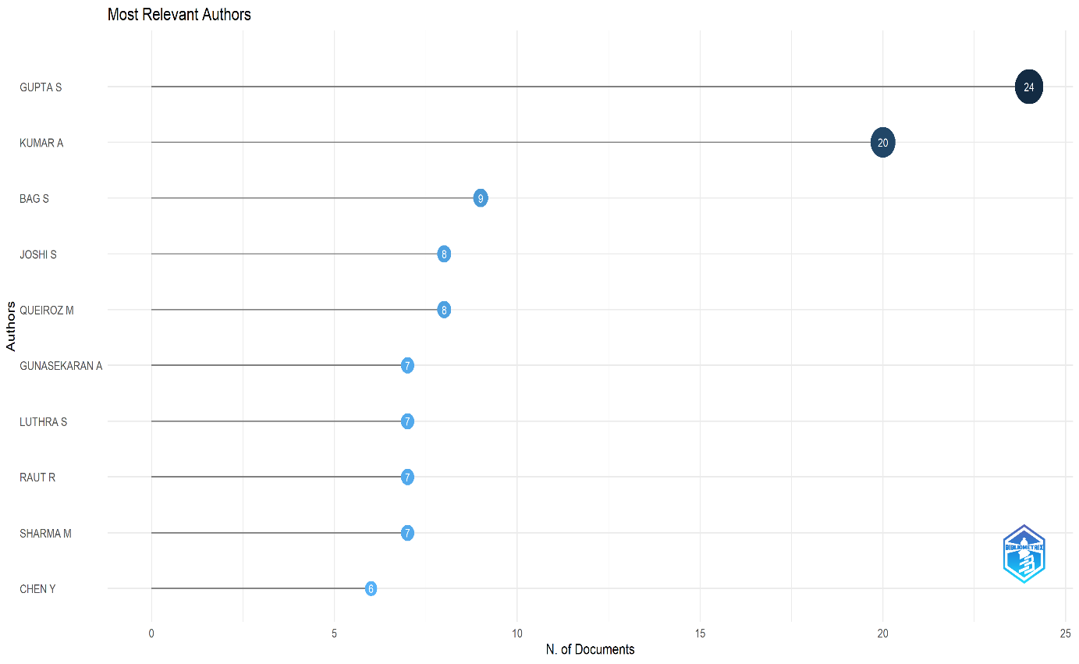
Country level scientific production
The data (Table 1.) presents a detailed breakdown of research article contributions by country, both in absolute numbers and as percentages of the total. China is the most prominent contributor, accounting for 320 articles, which is 64.42% of the total, followed by India with 213 articles (42.69%). The USA ranks third with 112 articles (22.44%), while the UK and France contribute 104 (20.84) and 103 (20.64%) articles respectively. These five countries together constitute a significant portion of the global research output. Saudi Arabia also has a notable presence with 57 articles (11.42%), while other countries like Australia (7.21%), Germany (6.01%), Canada (5.21%), and Italy (5.01%) make moderate contributions. Contributions from emerging and developing nations, such as Brazil, Pakistan, South Africa, Iran, Morocco, and Bangladesh, reflect the growing global interest in the research domain, although their individual shares remain below 5%.
Overall, the distribution highlights a strong dominance by Asian countries, particularly China and India, while also showcasing meaningful involvement from North America, Europe, and selected countries in Africa and South America, indicating a diverse and expanding global research landscape.
Table 1 : Scientific output per country

Country | Articles | % of Articles
China | 320 | 64.13
India | 213 | 42.69
USA | 112 | 22.44
UK | 104 | 20.84
France | 103 | 20.64
Saudi Arabia | 57 | 11.42
Australia | 36 | 7.21
Germany | 30 | 6.01
Canada | 26 | 5.21
Italy | 25 | 5.01
Brazil | 22 | 4.41
Pakistan | 20 | 4.01
South Africa | 20 | 4.01
Iran | 19 | 3.81
Morocco | 16 | 3.21
South Korea | 16 | 3.21
Bangladesh | 15 | 3.01
Malaysia | 14 | 2.81
Thailand | 14 | 2.81
Egypt | 13 | 2.61

Leading institutional affiliation
The Table 2. Provides an overview of institutional contributions to academic research, based on the number of published articles. Among the listed affiliations, the Indian Institute of Management (IIM System) leads with 21 articles, followed by the National Institute of Technology (NIT System) with 15 articles. Several institutions show a strong presence with 14 articles each, including the Hong Kong Polytechnic University and the National Taiwan University of Science and Technology. A number of other institutions, such as EMLYON Business School, Indian Institute of Management Mumbai, and the University of Jeddah, have each contributed 12 articles, demonstrating consistent academic output. The Indian Institute of Technology System (IIT System), along with universities from Taiwan, South Africa, and Australia, each contributed 11 articles, indicating a diverse international participation.
Notably, multiple Indian institutions are among the top contributors, highlighting the country’s growing prominence in academic research. The presence of universities from Asia, the Middle East, Europe, and Africa underscore a globally distributed network of research activity, reflecting cross-regional engagement in scholarly development
Table 2: Leading Affiliation

Affiliation | Articles | % of Articles
Indian Institute of Management (IIM System) | 21 | 4.21
National Institute of Technology (NIT System) | 15 | 3.01
Hong Kong Polytechnic University | 14 | 2.81
National Taiwan University of Science and Technology | 14 | 2.81
Emlyon Business School | 12 | 2.40
Indian Institute of Management Mumbai | 12 | 2.40
University of Jeddah | 12 | 2.40
Indian Institute of Technology System (IIT System) | 11 | 2.20
National Kaohsiung University of Science and Technology | 11 | 2.20
University of Johannesburg | 11 | 2.20
University of Technology Sydney | 11 | 2.20
Jiangnan University | 9 | 1.80
King Abdulaziz University | 9 | 1.80
London Metropolitan University | 9 | 1.80
Middle East University | 9 | 1.80
Egyptian Knowledge Bank (EKB) | 8 | 1.60
Graphic Era University | 8 | 1.60
Shenzhen University | 8 | 1.60
Doon University | 7 | 1.40
Indian Institute of Technology (IIT) – Delhi | 7 | 1.40
*Documents in which one or several authors with corresponding institutional affiliation participate

Leading publication sources
The data presented in the Table 3. Highlights the top journals contributing to the scholarly discourse in the field, measured by the number of articles published. The International Journal of Production Research leads with 24 articles, accounting for 5.35% of the total documents, and holds an h-index of 201, placing it in the Q1 quartile. Close behind is the Engineering Applications of Artificial Intelligence with 21 articles (4.68%), also in Q1, with an h-index of 149. The Technological Forecasting and Social Change journal follows with 18 articles (4.01%) and a strong h-index of 209. Both the International Journal of Production Economics and Sustainability (Switzerland) contribute 17 articles (3.79%), with high h-indices of 248 and 207, respectively. The standard Sustainability journal has 13 articles (2.90%) with an h-index of 146. Other notable sources include Annals of Operations Research and IEEE Access, each with 11 articles (2.45%), with IEEE Access showing a notably high h-index of 290. Computers & Industrial Engineering contributes 10 articles (2.23%), and the Journal of Business Research rounds out the list with 9 articles (2.00%) and the highest h-index among all, at 292. All listed journals are classified in Q1, indicating their high impact and relevance in their respective research domains.

Table 3: Publication sources with the greatest number of published documents
Sources | Articles | % of Articles | Type of Sources | H-index | Quartile
International Journal of Production Research | 24 | 5.35 | Journal | 201 | Q1
Engineering Applications of Artificial Intelligence | 21 | 4.68 | Journal | 149 | Q1
Technological Forecasting and Social Change | 18 | 4.01 | Journal | 209 | Q1
International Journal of Production Economics | 17 | 3.79 | Journal | 248 | Q1
Sustainability (Switzerland) | 17 | 3.79 | Journal | 207 | Q1
Sustainability | 13 | 2.90 | Journal | 146 | Q1
Annals of Operations Research | 11 | 2.45 | Journal | 132 | Q1
IEEE Access | 11 | 2.45 | Journal | 290 | Q1
Computers & Industrial Engineering | 10 | 2.23 | Journal | 176 | Q1
Journal of Business Research | 9 | 2.00 | Journal | 292 | Q1
*Based on the results of the SCI mago ranking in 2021

Main topics
The figure.5 illustrates the frequency of key terms used in the analyzed literature, highlighting dominant research themes. Supply chain management emerges as the most frequently mentioned term, appearing over 100 times, indicating its central role in the research domain. Management and Performance also feature prominently, with frequencies close to 80 and 60, respectively. Terms such as Artificial intelligence and its variant Artificial-intelligence appear with similar frequencies (around 50–55), underlining the growing integration of AI in supply chain and performance-related studies. The term Model is moderately frequent, with around 35 mentions, suggesting its relevance in methodological approaches. Less frequently used terms include Industry, Machine learning, Neural network, Energy, and Chain management, each with fewer than 20 occurrences, indicating either emerging interests or more specialized subtopics within the broader research landscape.

Figure 4: Main topics addressed in the literature

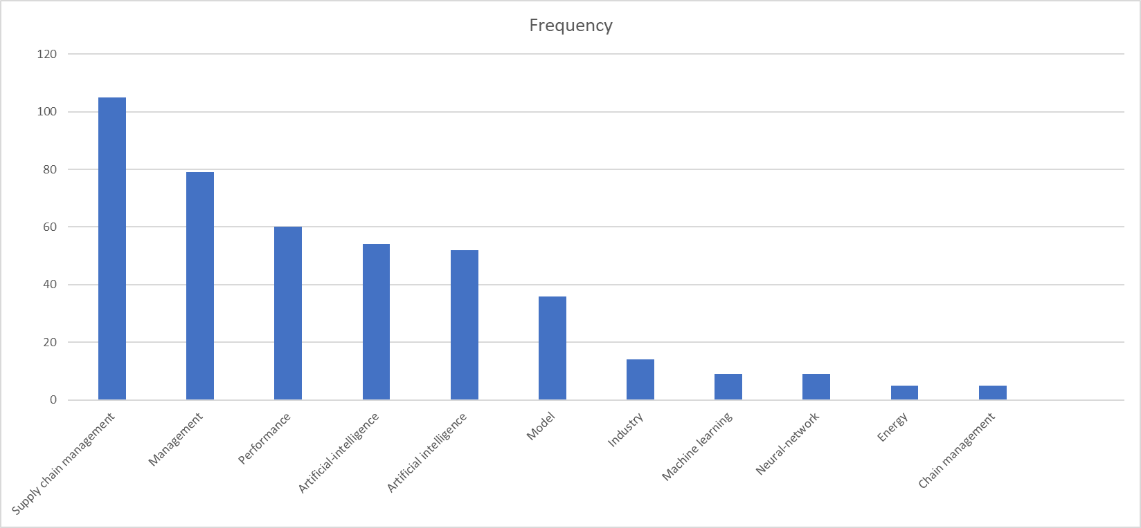

Analysis of key conceptual themes
The thematic map (figure. 6)presents a strategic visualization of research themes based on two key metrics: development degree (density) and relevance degree (centrality). It categorizes themes into four quadrants: Motor Themes, Niche Themes, Emerging or Declining Themes, and Basic Themes. In the top-right quadrant, Motor Themes such as supply chain management, artificial intelligence, and supply chains are both highly developed and central, indicating their critical role and robust scholarly focus. Niche Themes, like barium compounds, Bayesian networks, and cyber physical systems, appear in the top-left quadrant, showing strong internal development but limited external connectivity. The bottom-left quadrant houses Emerging or Declining Themes such as group decision-making, sets, and algorithms, reflecting either emerging interest or diminishing relevance. Meanwhile, the Basic Themes in the bottom-right—optimization, sustainability, innovation, and performance—are central but less developed, suggesting foundational areas that require further research to enhance maturity. This map gives a comprehensive overview of thematic evolution and interconnectivity in the academic world..

Fig. 6. Thematic map
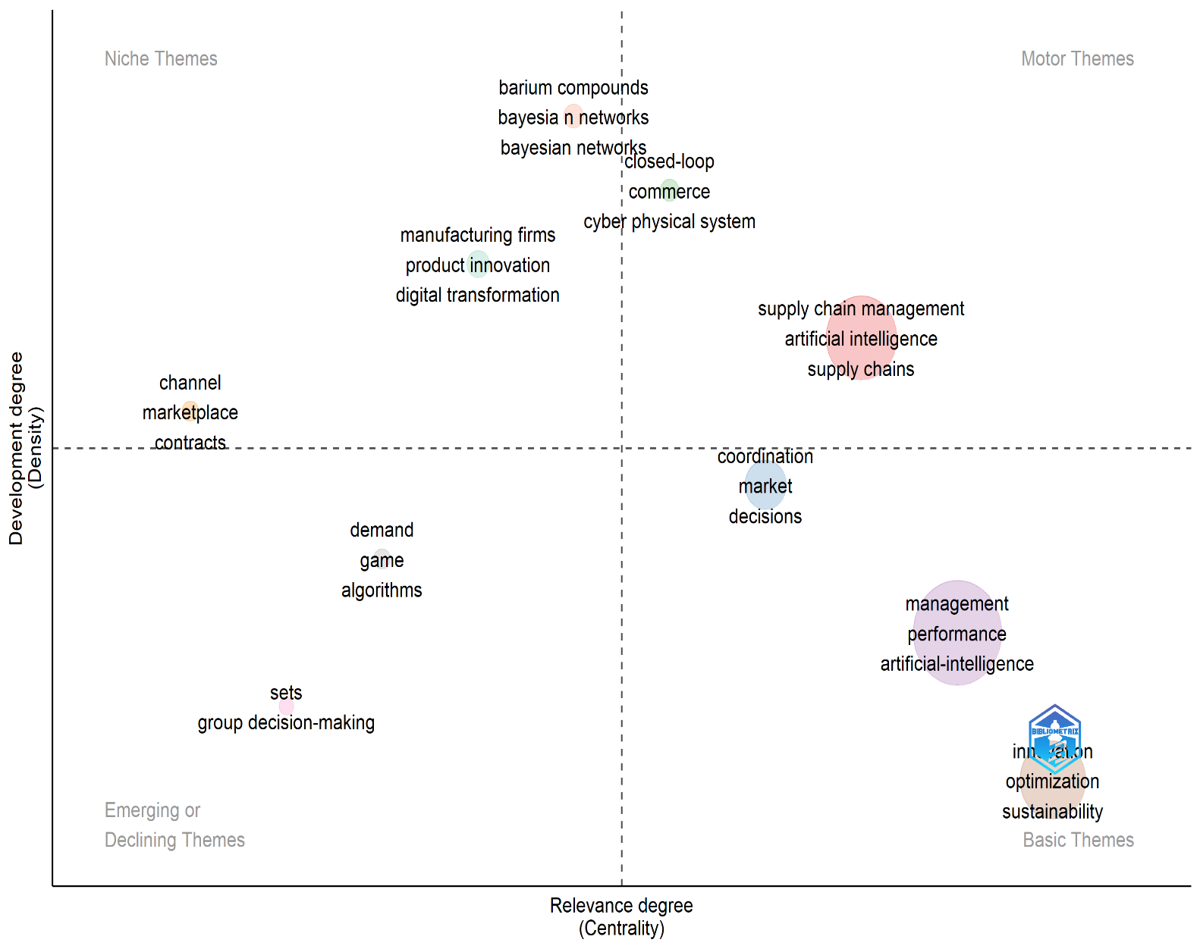

Keyword co-occurrence network visualization
This Figure 7. is a keyword co-occurrence network map generated using VOSviewer, a tool widely used in bibliometric analysis to visualize patterns within academic literature. The map shows how frequently keywords appear in academic documents and how often they co-occur with one another, helping to identify major themes and emerging trends in a specific research domain. In this case, the central focus is on topics related to artificial intelligence (AI), supply chain management, and related technologies.
At the center of the map, large nodes such as “artificial intelligence,” “supply chain management,” and “blockchain” indicate that these terms are the most frequently occurring keywords in the analyzed publications. The size of each node reflects its frequency, with larger nodes appearing more often. Lines connecting the nodes represent co-occurrence relationships; that is, if two keywords appear together in the same document frequently, they are connected with a line. The strength of these relationships is shown by the thickness and number of the lines, forming a web of interconnected terms.
The colored clusters represent thematic groupings of keywords. For example, the red cluster focuses on supply chain challenges and disruptions, including terms like “COVID-19,” “resilience,” “logistics,” and “healthcare supply chain.” These keywords suggest a strong focus on how the pandemic impacted supply chain systems and the need for resilience. The orange cluster contains terms like “machine learning,” “automation,” and “inventory management,” highlighting the growing role of data-driven and automated decision-making in supply chain optimization.
The blue cluster includes keywords such as “sustainable supply chain,” “green supply chain,” and “sustainable development,” indicating a separate but interconnected research stream on environmental sustainability and ethical practices. The green cluster, with terms like “big data analytics,” “internet of things,” “circular economy,” and “blockchain technology,” illustrates how digital technologies are being leveraged to create more transparent, efficient, and sustainable supply chains. The purple cluster, on the other hand, has terms that are specific to particular fields and strategies, such as "knowledge management," "food supply chain," and "digital supply chain." This shows that it is focused on certain applications and industries.
Finally, the yellow cluster focuses on new technologies and developments like "generative AI," "ChatGPT," and "dynamic capabilities." These show how advanced AI tools are being used in supply chain strategies. Overall, The figure emphasizes the interdisciplinary and dynamic nature of
research at the intersection of AI, digital innovation, and supply chain management, providing insights into how scholars are conceptualizing and interlinking these intricate subjects.
. Figure 7: Co-occurrence analysis of keywords and concepts

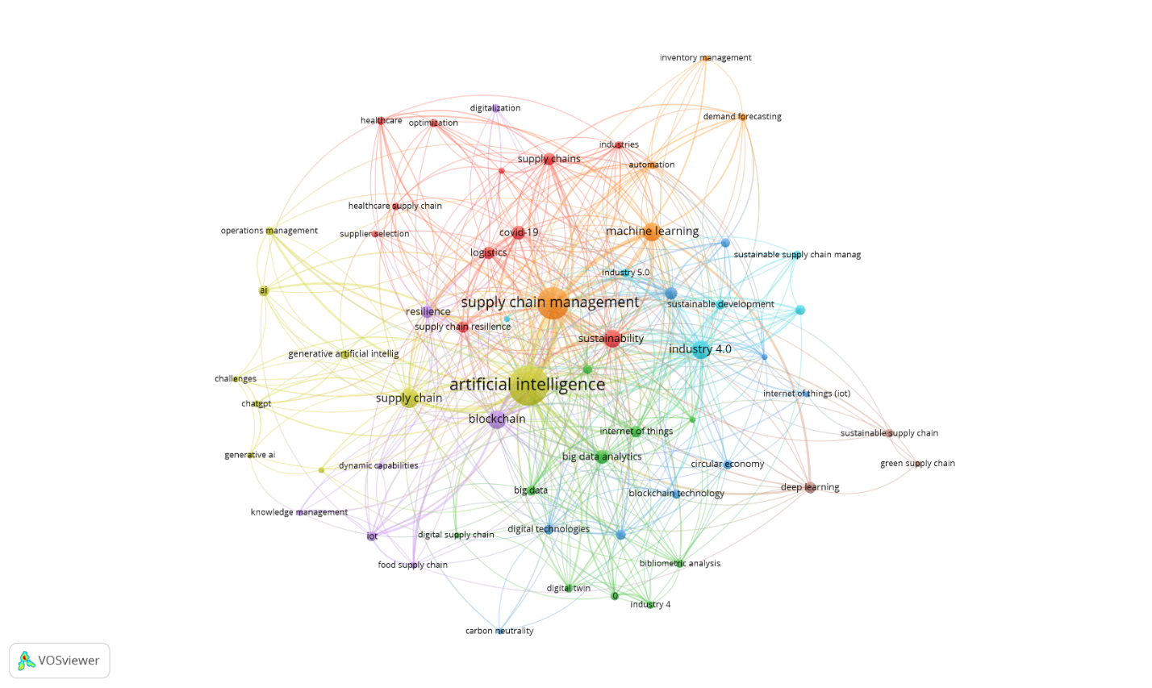
CONCLUSION

The research landscape pertaining to the incorporation of artificial intelligence (AI) in supply chain management (SCM) is systematically explored in this bibliometric study. By analyzing 499 selected documents from 2021 to 2025 using Scopus and Web of Science databases, the study identifies the volume, direction, and focus of scholarly work in this emerging area. The findings indicate a notable surge in research activity, indicating artificial intelligence's expanding contribution to supply chain transformation via automation, predictive analytics, and intelligent decision-making tools. This transformation is largely driven by the need for agility, sustainability, and resilience in global supply networks.
The analysis reveals that key research themes include AI-assisted decision-making, optimization, digital transformation, and sustainability. AI technologies such as machine learning, neural networks, and digital twins are being applied to improve logistics, demand forecasting, and supply chain visibility. Scholars have also examined AI’s contribution to sustainability, particularly in reducing carbon footprints and promoting circular supply chain models. Additionally, the post-COVID era has intensified interest in AI for risk management, with many studies exploring how AI can help anticipate disruptions and enhance resilience through scenario analysis and real-time responses.
Geographically, countries like China, India, and the United States have emerged as dominant contributors to this field, supported by institutions such as the Indian Institutes of Management (IIM), Penn State University, and the Hong Kong Polytechnic University. Journals like International Journal of Production Research, Engineering Applications of Artificial Intelligence, and Sustainability have been identified as key publication venues. The clustering of keywords and co-occurrence analysis further reveals the interdisciplinary nature of the field, bridging operations research, business analytics, and information systems. This global and multidisciplinary engagement underscores the universal relevance and impact of AI on modern supply chains.
Despite the progress, a number of difficulties still exist. The study highlights barriers to AI adoption, including organizational resistance to digital change, a lack of qualified professionals, a lack of technical infrastructure, and high implementation costs — issues particularly acute for small and medium-sized enterprises (SMEs). There is still a dearth of research on ethical issues like algorithmic bias, data privacy, and lack of transparency. To address these obstacles, the paper calls for a more detailed analysis of context-specific strategies, such as targeted government subsidies to lessen financial burdens, public-private partnerships to build technical capacity, and tailored training initiatives to bridge the skills gap. Overcoming organizational resistance needs change management frameworks, leadership engagement, and pilot projects to demonstrate tangible benefits. Furthermore, the development of robust regulatory frameworks, workforce development initiatives, and ethical guidelines is essential to ensure AI is deployed in a transparent, equitable, and responsible manner. Together, these actions encourage broader adoption of AI and long-term digital transformation in a variety of organizational contexts.
In conclusion, this bibliometric analysis not only maps the academic progress in AI and supply chain management (SCM) but also recognizes critical areas for future exploration. Scholars are encouraged to pursue longitudinal and empirical studies, cross-sectoral comparisons, and SME-specific investigations to widen understanding and impact. As the global economy becomes increasingly dependent on intelligent, interconnected supply chains, ongoing research and collaboration will be important for developing adaptable, sustainable, and ethically sound AI solutions that meet the demands of a dynamic business environment. Alongside these general recommendations for future research, the study also highlights the need for specific, practitioner-oriented guidelines for implementing AI in supply chains. In practical terms, organizations should start by developing an AI adoption roadmap that includes readiness assessment, technology selection aligned with strategic priorities, and pilot implementation to evaluate feasibility and scalability. Workforce development through continuous training and cross-functional collaboration is crucial to bridge the skill gap and foster digital transformation readiness. Additionally, firms should establish robust data governance mechanisms to ensure privacy, transparency, and algorithmic fairness, while leveraging predictive analytics and automation to enhance demand forecasting, inventory management, and logistics optimization. Integrating ethical and sustainability considerations into AI design can also support organizations align technological innovation with social responsibility. These practical implications provide a basis for translating academic insights into actionable strategies that enable firms to realize the full potential of AI-driven supply chains in an increasingly competitive and uncertain marketplace.

ACKNOWLEDGEMENTS
This research was not funded by any grant

REFERENCES

- Belu, M. G., & Marinoiu, A. M. (2025). AI-Enabled Supply Chain Management: A Bibliometric Analysis UsingVOSviewer and RStudio Bibliometrix Software Tools. SUSTAINABILITY, 17(5). https://doi.org/10.3390/su17052092
- Braganza, A., Chen, W., Canhoto, A., & Sap, S. (2022). Gigification, job engagement and satisfaction: the moderating role of AIenabled system automation in operations management. PRODUCTION PLANNING & CONTROL, 33(16, SI), 1534–1547. https://doi.org/10.1080/09537287.2021.1882692
- Chee, M. L., Chee, M. L., Huang, H., Mazzochi, K., Taylor, K., Wang, H., Feng, M., Ho, A. F. W., Siddiqui, F. J., Ong, M. E. H., & Liu, N. (2023). Artificial intelligence and machine learning in prehospital emergency care: A scoping review. ISCIENCE, 26(8). https://doi.org/10.1016/j.isci.2023.107407
- Chilicaus, G. C. F., Licapa-Redolfo, G. S., Ballesteros, M. A. A., Otazu, C. D. C., Miranda, S. J. A., Castillo, M. M. F., Ijiri, G. L. C., Valle, M. D. L. A. G., & Castillo, J. C. A. (2025). Digital Transformation and Sustainability in Post-Pandemic Supply Chains: A Global Bibliometric Analysis of Technological Evolution and Research Patterns (2020-2024). SUSTAINABILITY, 17(7). https://doi.org/10.3390/su17073009
- D, A., M, K., A, K., & H, G. (2025). AJMERA D, 2025, INT J LOGIST MANAG. INTERNATIONAL JOURNAL OF LOGISTICS MANAGEMENT. https://doi.org/10.1108/IJLM-09-2023-0408
- Daios, A., Kladovasilakis, N., Kelemis, A., & Kostavelis, I. (2025). AI Applications in Supply Chain Management: A Survey. APPLIED SCIENCES-BASEL, 15(5). https://doi.org/10.3390/app15052775
- Dosdogru, A. T., Boru Ipek, A., & Gocken, M. (2021). A novel hybrid artificial intelligence-based decision support frameworkto predict lead time. INTERNATIONAL JOURNAL OF LOGISTICS-RESEARCH AND APPLICATIONS, 24(3), 261–279. https://doi.org/10.1080/13675567.2020.1749249
- Feng, Y., Lai, K., & Zhu, Q. (2022). Green supply chain innovation: Emergence, adoption, and challenges. INTERNATIONAL JOURNAL OF PRODUCTION ECONOMICS, 248. https://doi.org/10.1016/j.ijpe.2022.108497
- Ghouati, S., Oulfarsi, S., & El Amri, A. (2025). Evolution and Impact of Artificial Intelligence in Sustainable Supply Chain Management: Systematic Review and Bibliometric Analysis. Corporate Governance and Sustainability Review, 9(3 (special issue)), 217–230. https://doi.org/10.22495/cgsrv9i3sip3
- Godinho Filho, M., de Almeida, S. V. Q., Lage Junior, M., Osiro, L., Lima, B., & Callefi, M. H. (2025). A path to follow to overcome foundational barriers to the adoption of artificial intelligence within the manufacturing industry: a conceptual framework. ENTERPRISE INFORMATION SYSTEMS, 19(1–2). https://doi.org/10.1080/17517575.2025.2458685
- Gupta, S., Modgil, S., Kumar, A., Sivarajah, U., & Irani, Z. (2022). Artificial intelligence and cloud-based Collaborative Platforms for Managing Disaster, extreme weather and emergency operations. INTERNATIONAL JOURNAL OF PRODUCTION ECONOMICS, 254. https://doi.org/10.1016/j.ijpe.2022.108642
- Gupta, S., Modgil, S., Meissonier, R., & Dwivedi, Y. K. (2024). Artificial Intelligence and Information System Resilience to Cope WithSupply Chain Disruption. IEEE TRANSACTIONS ON ENGINEERING MANAGEMENT, 71, 10496–10506. https://doi.org/10.1109/TEM.2021.3116770
- HANGL, J., KRAUSE, S., & BEHRENS, V. (n.d.). DRIVERS, BARRIERS AND SOCIAL CONSIDERATIONS FOR AI ADOPTION IN SCM.
- Helo, P., & Hao, Y. (2022). Artificial intelligence in operations management and supply chainmanagement: an exploratory case study. PRODUCTION PLANNING & CONTROL, 33(16, SI), 1573–1590. https://doi.org/10.1080/09537287.2021.1882690
- Hendriksen, C. (2023). Artificial intelligence for supply chain management: Disruptiveinnovation or innovative disruption? JOURNAL OF SUPPLY CHAIN MANAGEMENT, 59(3), 65–76. https://doi.org/10.1111/jscm.12304
- Hezam, I. M., Ali, A. M., Alshamrani, A. M., Gao, X., & Abdel-Basset, M. (2024). Artificial intelligence’s impact on drug delivery in healthcare supplychain management: data, techniques, analysis, and managerialimplications. JOURNAL OF BIG DATA, 11(1). https://doi.org/10.1186/s40537-024-01049-7
- Hosseinnia Shavaki, F., & Ebrahimi Ghahnavieh, A. (2023). Applications of deep learning into supply chain management: a systematicliterature review and a framework for future research. ARTIFICIAL INTELLIGENCE REVIEW, 56(5), 4447–4489. https://doi.org/10.1007/s10462-022-10289-z
- Hwang, R.-H., Chou, T.-Y., Lin, J.-Y., Sudyana, D., Lai, Y.-C., & Lin, Y.-D. (2025). Optimal Resource Allocation for AIoT as a Service Under Various Service Scenarios and Architectures. IEEE TRANSACTIONS ON NETWORK AND SERVICE MANAGEMENT, 22(2), 1420–1436. https://doi.org/10.1109/TNSM.2024.3503575
- Jahani, N., Sepehri, A., Vandchali, H. R., & Tirkolaee, E. B. (2021). Application of Industry 4.0 in the Procurement Processes of SupplyChains: A Systematic Literature Review. SUSTAINABILITY, 13(14). https://doi.org/10.3390/su13147520
- JAHANI, N., SEPEHRI, A., VANDCHALI, H., & TIRKOLAEE, E. (n.d.). APPLICATION OF INDUSTRY 4.0 IN THE PROCUREMENT PROCESSES OF SUPPLY CHAINS: A SYSTEMATIC LITERATURE REVIEW.
- Joshi, S., & Sharma, M. (2022). Sustainable Performance through Digital Supply Chains in Industry 4.0Era: Amidst the Pandemic Experience. SUSTAINABILITY, 14(24). https://doi.org/10.3390/su142416726
- Li, Y., Hu, Y., Min, K., Park, H., Yang, H., Wang, T., Sung, J., Seol, J.-Y., & Zhang, C. J. (2023). Artificial Intelligence Augmentation for Channel State Information in 5Gand 6G. IEEE WIRELESS COMMUNICATIONS, 30(1), 104–110. https://doi.org/10.1109/MWC.005.2200245
- Lin, Y., Tang, J., Guo, J., Wu, S., & Li, Z. (2025). Advancing AI-Enabled Techniques in Energy System Modeling: A Review ofData-Driven, Mechanism-Driven, and Hybrid Modeling Approaches. ENERGIES, 18(4). https://doi.org/10.3390/en18040845
- Liu, B. (2023). Integration of novel uncertainty model construction of green supplychain management for small and medium-sized enterprises using artificialintelligence. OPTIK, 273. https://doi.org/10.1016/j.ijleo.2022.170411
- Liu, K.-S., & Lin, M.-H. (2021). Performance Assessment on the Application of Artificial Intelligence toSustainable Supply Chain Management in the Construction MaterialIndustry. SUSTAINABILITY, 13(22). https://doi.org/10.3390/su132212767
- Luković, M., Cvetić, B., Vasiljević, D., & Danilović, M. (2025). Exploring blockchain adoption for supply chain transformation in industry 4.0. Journal of Decision Analytics and Intelligent Computing, 5(1), 111–121. https://doi.org/10.31181/jdaic10005072025l
- Mahroof, K. (2019). A human-centric perspective exploring the readiness towards smart warehousing: The case of a large retail distribution warehouse. INTERNATIONAL JOURNAL OF INFORMATION MANAGEMENT, 45, 176–190. https://doi.org/10.1016/j.ijinfomgt.2018.11.008
- Mitrović, D., Demir, G., Badi, I., & Bouraima, M. B. (2025). Balancing Efficiency and Risk in Public Sector Artificial Intelligence with Data Envelopment Analysis and Portfolio Approaches. 1(1), 15–35.
- NAYAL, K., RAUT, R., QUEIROZ, M., YADAV, V., & NARKHEDE, B. (n.d.). ARE ARTIFICIAL INTELLIGENCE AND MACHINE LEARNING SUITABLE TO TACKLE THE COVID-19 IMPACTS? AN AGRICULTURE SUPPLY CHAIN PERSPECTIVE.
- Naz, F., Kumar, A., Majumdar, A., & Agrawal, R. (2022). Is artificial intelligence an enabler of supply chain resiliency postCOVID-19? An exploratory state-of-the-art review for future research. OPERATIONS MANAGEMENT RESEARCH, 15(1–2), 378–398. https://doi.org/10.1007/s12063-021-00208-w
- Ressi, D., Romanello, R., Piazza, C., & Rossi, S. (2024). AI-enhanced blockchain technology: A review of advancements and opportunities. JOURNAL OF NETWORK AND COMPUTER APPLICATIONS, 225. https://doi.org/10.1016/j.jnca.2024.103858
- Richey, R. G., Chowdhury, S., Davis-Sramek, B., Giannakis, M., & Dwivedi, Y. K. (2023). Artificial intelligence in logistics and supply chain management: A primer and roadmap for research. Journal of Business Logistics, 44(4), 532–549. https://doi.org/10.1111/jbl.12364
- Rolf, B., Beier, A., Jackson, I., Mueller, M., Reggelin, T., Stuckenschmidt, H., & Lang, S. (2025). A review on unsupervised learning algorithms and applications in supplychain management. INTERNATIONAL JOURNAL OF PRODUCTION RESEARCH, 63(5), 1933–1983. https://doi.org/10.1080/00207543.2024.2390968
- Salimimoghadam, S., Ghanbaripour, A. N., Tumpa, R. J., Rahimi, A. K., Golmoradi, M., Rashidian, S., & Skitmore, M. (2025). The Rise of Artificial Intelligence in Project Management: A Systematic Literature Review of Current Opportunities, Enablers, and Barriers. BUILDINGS, 15(7). https://doi.org/10.3390/buildings15071130
- Serrano-Torres, G. J., Lopez-Naranjo, A. L., Larrea-Cuadrado, P. L., & Mazon-Fierro, G. (2025). Transformation of the Dairy Supply Chain Through ArtificialIntelligence: A Systematic Review. SUSTAINABILITY, 17(3). https://doi.org/10.3390/su17030982
- Sharma, M., Antony, R., Sehrawat, R., Cruz, A. C., & Daim, T. U. (2022). Exploring post-adoption behaviors of e-service users: Evidence from the hospitality sector /online travel services. Technology in Society, 68. https://doi.org/10.1016/j.techsoc.2021.101781
- Sharma, M., & Firoz, M. (2022). Delineating investors’ rationality and behavioural biases - evidence from the Indian stock market. International Journal of Management Practice, 15(1), 59 – 86. https://doi.org/10.1504/IJMP.2022.119925
- Sharma, R., Shishodia, A., Gunasekaran, A., Min, H., & Munim, Z. H. (2022a). The role of artificial intelligence in supply chain management: mappingthe territory. INTERNATIONAL JOURNAL OF PRODUCTION RESEARCH, 60(24, SI), 7527–7550. https://doi.org/10.1080/00207543.2022.2029611
- Sharma, R., Shishodia, A., Gunasekaran, A., Min, H., & Munim, Z. H. (2022b). The role of artificial intelligence in supply chain management: mapping the territory. International Journal of Production Research, 60(24), 7527–7550. https://doi.org/10.1080/00207543.2022.2029611
- Shrivastav, M. (2021). Barriers Related to AI Implementation in Supply Chain Management. Journal of Global Information Management, 30(8), 1–19. https://doi.org/10.4018/JGIM.296725
- Shrivastav, M. (2022). Barriers Related to AI Implementation in Supply Chain Management. JOURNAL OF GLOBAL INFORMATION MANAGEMENT, 30(8). https://doi.org/10.4018/JGIM.296725
- Sohrabpour, V., Oghazi, P., Toorajipour, R., & Nazarpour, A. (2021). Export sales forecasting using artificial intelligence. TECHNOLOGICAL FORECASTING AND SOCIAL CHANGE, 163. https://doi.org/10.1016/j.techfore.2020.120480
- VLACHOS, I., & REDDY, P. (n.d.). MACHINE LEARNING IN SUPPLY CHAIN MANAGEMENT: SYSTEMATIC LITERATURE REVIEW AND FUTURE RESEARCH AGENDA.
- Wang, S., Jia, C., Khan, A., Khan, N. H., Hsieh, C.-H., Hung, C.-W., & Chen, S.-C. (2024). BIG DATAANALYTICS-ARTIFICIAL INTELLIGENCE, AMBIDEXTERITY, AND GREENSUPPLY CHAIN MANAGEMENT: IMPLICATIONS ON RESPONSIBLE ECONOMY. RAE-REVISTA DE ADMINISTRACAO DE EMPRESAS, 65(1). https://doi.org/10.1590/S0034-759020250101
- Wang, Y., Gao, J., Cheng, T. C. E., Jin, M., Yue, X., & Wang, H. (2025). Is it necessary for the supply chain to implement artificialintelligence-driven sales services at both the front-end and back-endstages? TRANSPORTATION RESEARCH PART E-LOGISTICS AND TRANSPORTATION REVIEW, 194. https://doi.org/10.1016/j.tre.2024.103923
- Wei, C., Shan, Y., & Zhen, M. (2025). Deep learning-based anomaly detection for precision field crop protection. FRONTIERS IN PLANT SCIENCE, 16. https://doi.org/10.3389/fpls.2025.1576756
- Wu, B., Chen, H., & Shi, Y. (2025). Influence of artificial intelligence development on supply chaindiversification. FINANCE RESEARCH LETTERS, 78. https://doi.org/10.1016/j.frl.2025.107210
- Yao, Y., Li, S., Shi, P., Huang, Y., Jiang, X., Zheng, Y., & Wang, Z. (2024). Leveraging hybrid machine learning for sustainable development through recycled waste in landscape design. ADVANCES IN CONCRETE CONSTRUCTION, 18(2), 105–113. https://doi.org/10.12989/acc.2024.18.2.105

