Geospace Remote Monitoring and Image
Analysis for Earth Surface Change Detection

Pranav Kumar Kashyap
Department of Computing Technology
SRM Institute of Science and Technology
Kattankulathur - 603203
Tamil Nadu
pk9025@srmist.edu.in
Aksh Tyagi
Department of Computing Technology
SRM Institute of Science and Technology
Kattankulathur - 603203
Tamil Nadu
at8873@srmist.edu.in
Dr. B Baranidharan
Professor
Department of Computing Technology
SRM Institute of Science and Technology
Kattankulathur - 603203
Tamil Nadu
baranidb@srmist.edu.in

Abstract—Coastal environments are dynamic regions that are increasingly affected by urbanization, climate change, and human activities, making continuous monitoring essential for sustainable management. This study presents a multi-temporal remote sensing framework for analyzing coastal environmental changes using Sentinel-2 MultiSpectral Instrument (MSI) Level-2A satellite imagery. The analysis is performed using the Google Earth Engine platform, enabling efficient processing of large-scale geospatial data. The proposed approach integrates three key spectral indices: the Salinity Index (SI) to detect soil salinity and seawater intrusion, the Normalized Difference Vegetation Index (NDVI) to assess vegetation health, and the Normalized Difference Built-up Index (NDBI) to identify urban expansion. A structured year-to-year comparison methodology is applied using pixel-wise differencing and percentage change analysis to quantify temporal variations. The framework is implemented over selected coastal regions of Chennai, India, including Marina Beach, Besant Nagar, Elliot Beach, Royapuram, and the Cooum River estuary. The results indicate an increase in salinity levels near coastal zones, a decline in vegetation in rapidly urbanizing areas, and a steady expansion of built-up surfaces. The integrated multi-index analysis highlights the interconnected nature of these environmental changes and provides a comprehensive understanding of coastal dynamics. Overall, the proposed framework offers a scalable, interpretable, and data-driven approach for monitoring coastal environments and supports informed decision-making for sustainable coastal management.
Keywords—Remote Sensing, Coastal Monitoring, Sentinel-2, Google Earth Engine, NDVI, NDBI, Salinity Index, Multi-temporal Analysis, Change Detection, Urban Expansion, Vegetation Analysis, Environmental Monitoring

Introduction
Coastal regions are critical transition zones between terrestrial and marine ecosystems, playing a vital role in maintaining ecological balance and supporting human activities. However, these regions are increasingly affected by urbanization, industrialization, and climate change, leading to issues such as soil salinization, vegetation degradation, and expansion of built-up areas [2], [5]. Monitoring these changes is essential for sustainable environmental management.
Traditional monitoring methods, such as field surveys, are often time-consuming and limited in spatial coverage. In contrast, remote sensing provides an efficient and scalable solution for large-scale environmental monitoring [1], [16]. Satellite-based observations enable continuous assessment of land surface changes across different time periods.
Spectral indices derived from satellite imagery have been widely used to analyse environmental conditions. The Normalized Difference Vegetation Index (NDVI) is commonly used to evaluate vegetation health [8], [9], while the Normalized Difference Built-up Index (NDBI) helps in identifying urban expansion [11]. Similarly, salinity indices are effective in detecting soil salinity and seawater intrusion in coastal regions [13], [14].
Despite these advancements, many existing studies focus on single indices or static time analysis, which limits the understanding of interconnected environmental processes [16], [17]. Therefore, there is a need for a multi-temporal and multi-index approach that can provide a comprehensive view of coastal environmental changes.
This paper proposes a multi-temporal remote sensing framework using Sentinel-2 imagery and Google Earth Engine to analyse coastal environmental changes. The approach integrates multiple spectral indices and applies structured temporal comparison to improve accuracy and interpretability [5], [6].

Ease of Use

Ease of use
The proposed system is designed to be simple and easy to use, even for users who do not have extensive experience in remote sensing or geospatial analysis. By utilizing the Google Earth Engine (GEE) platform, the need for installing complex software or using high-end computing systems is eliminated. Users can access satellite data, perform analysis, and visualize results directly through a web-based interface, making the entire process

User-Friendly Workflow
The framework follows a clear and structured workflow, including data acquisition, preprocessing, spectral index calculation, and change detection. Each step is logically organized, allowing users to easily understand and replicate the methodology. The use of widely accepted spectral indices such as NDVI, NDBI, and Salinity Index further enhances usability, as these indices are straightforward to compute and interpret.
C. Accessibility and Scalability
The system is highly accessible and scalable, enabling analysis of both small and large coastal regions without additional computational burden. Since all processing is performed on the cloud, users can handle large datasets efficiently. This makes the framework suitable for academic research, environmental monitoring, and practical applications in coastal management.

RELATED WORK
Monitoring environmental changes in coastal regions has become an important area of research in remote sensing and environmental science. Over the past two decades, satellite-based observation systems have significantly improved the ability to analyze large-scale environmental processes such as vegetation dynamics, soil salinity, and urban expansion [5]. Numerous studies have utilized multispectral satellite imagery and spectral indices to assess environmental conditions and detect temporal changes in coastal and urban landscapes.

Remote sensing techniques have been widely applied for vegetation monitoring using the Normalized Difference Vegetation Index (NDVI). NDVI is one of the most commonly used spectral indices for evaluating vegetation health, biomass distribution[8][9], and land productivity. Several studies have demonstrated the effectiveness of NDVI in identifying vegetation stress caused by environmental factors such as soil degradation, water scarcity, and urban encroachment. By analyzing changes in near-infrared and red reflectance, NDVI provides a reliable indicator of plant vigor and ecosystem health. Multi-temporal NDVI analysis has been extensively used to study vegetation dynamics in both urban and coastal ecosystems.
Soil salinity detection using satellite imagery has also received considerable attention, particularly in coastal regions where seawater intrusion and salt accumulation affect agricultural productivity and soil quality. Spectral indices derived from visible and near-infrared bands have been proposed to identify saline soils due to their distinctive reflectance characteristics. The Salinity Index (SI)[13],[14], which utilizes reflectance values from the blue and red bands, has been shown to effectively capture surface salinity variations. Previous studies have applied SI-based analysis to monitor salinity intrusion in coastal agricultural lands and estuarine environments, demonstrating the potential of multispectral data for large-scale salinity assessment.
Urbanization and land-cover transformation represent another major environmental concern in coastal regions. Rapid expansion of built-up areas alters natural drainage patterns, increases impervious surface coverage, and contributes to environmental degradation. The Normalized Difference Built-up Index (NDBI) has been widely used to identify urban land cover and monitor urban growth patterns[11]. NDBI exploits the spectral contrast between near-infrared and red reflectance to distinguish built-up surfaces from vegetation and water bodies. Several remote sensing studies have applied NDBI to detect urban expansion and analyze its environmental impacts in rapidly growing coastal cities.
Recent advances in cloud-based geospatial platforms have further enhanced the capability for large-scale environmental monitoring. Platforms such as Google Earth Engine (GEE) enable researchers to access and process large volumes of satellite imagery efficiently without the need for extensive local computational resources. GEE provides integrated datasets, cloud-based computation, and scalable geospatial analysis tools, making it particularly suitable for multi-temporal environmental studies. Researchers have increasingly adopted GEE for applications such as land-use change detection, vegetation monitoring, and environmental risk assessment.
While existing studies have successfully applied individual spectral indices to analyze specific environmental indicators, many of them focus on single-parameter analysis or limited temporal snapshots. Such approaches may not fully capture the complex interactions between different environmental processes in coastal regions.[16],[17] Soil salinization, vegetation degradation, and urban expansion are often interrelated phenomena that influence each other over time. Therefore, a comprehensive monitoring framework that integrates multiple environmental indicators and performs systematic temporal comparisons is necessary for improved environmental assessment.
In this context, the present study builds upon previous research by integrating salinity, vegetation, and built-up indices within a unified multi-temporal analysis framework. Unlike conventional approaches that analyze individual indicators independently, the proposed framework combines multiple spectral indices with a structured year-to-year comparison methodology to provide a more comprehensive understanding of coastal environmental dynamics.[5],[6] This integrated approach enables simultaneous monitoring of key environmental stress factors and supports more interpretable and data-driven coastal environmental assessment.
- Bruzzone and Prieto [1] proposed automated analysis of difference images for unsupervised change detection, reducing manual intervention and improving detection efficiency.
- Blaschke [2] introduced object-based image analysis, emphasizing segmentation-driven processing that reduces salt-and-pepper noise compared to traditional pixel-based methods.
- Chen et al. [3] presented object-based change detection approaches that combine image segmentation with feature comparison across temporal datasets, improving spatial consistency in detected changes.
- Zhu [4] reviewed Landsat time-series methodologies, highlighting the importance of continuous Earth observation data for identifying gradual land-cover changes and environmental disturbances.
- Wulder et al. [5] summarized the scientific significance and practical applications of Landsat data, supporting its use for large-area surface change monitoring.
- Long et al. [6] introduced fully convolutional networks for dense semantic segmentation, enabling end-to-end pixel-wise prediction and forming the basis for modern change detection methods.
- Ronneberger et al. [7] proposed the U-Net architecture, which preserves spatial information using skip connections, making it effective for high-resolution image segmentation.
- Daudt et al. [8] developed Siamese FCN models that process bi-temporal images simultaneously to learn feature differences for accurate change detection.
- Zhang et al. [9] reviewed deep learning techniques, showing that learned representations often outperform traditional feature-based approaches.
- Varghese and Thampi [10] analyzed deep learning frameworks, demonstrating improved robustness under varying environmental conditions.
- Chen et al. [11] proposed Siamese CNN models for detecting building changes, achieving strong performance in urban environments.
- Chen et al. [12] presented deep learning methods tailored for high-resolution imagery, improving detailed mapping and segmentation accuracy.
- Saha et al. [13] explored unsupervised deep learning approaches for multispectral change detection, addressing challenges due to limited labeled data.
- Ghamisi et al. [14] reviewed data fusion techniques that integrate multi-sensor and multi-temporal datasets to improve reliability.
- Liu et al. [15] surveyed pixel-level deep learning methods, identifying Siamese and encoder–decoder architectures as dominant approaches.
IV.SUMMARY
This work distinguishes itself from the previously reviewed 15 research approaches by proposing a unified, multi-temporal, and multi-index framework that emphasizes both interpretability and scalability. While many existing studies focus on single-indicator analysis—such as vegetation, urban expansion, or salinity individually—this research integrates three critical environmental indicators (Salinity Index, NDVI, and NDBI) within a single analytical pipeline. This combined approach enables simultaneous monitoring of soil salinity, vegetation health, and built-up expansion, providing a more comprehensive understanding of coastal environmental dynamics.
Unlike several prior methods that rely on complex machine learning or deep learning models, this study adopts a deterministic and physics-based approach. This eliminates the need for large labeled datasets and reduces computational complexity while maintaining high interpretability. Each detected change can be directly linked to physical environmental processes, making the results more transparent and meaningful for decision-making.
Another key contribution is the implementation of a structured multi-temporal comparison methodology, which ensures consistent year-to-year analysis and minimizes seasonal variability—an aspect often overlooked in many traditional studies. Additionally, the use of the Google Earth Engine platform allows efficient processing of large-scale satellite data, significantly improving scalability and accessibility without requiring high-end computational resources.
Overall, the proposed framework achieves a balanced combination of accuracy, efficiency, and simplicity. By integrating multiple indices, ensuring temporal consistency, and leveraging cloud-based processing, this work provides a practical and reliable solution for coastal environmental monitoring, making it stand out from existing research approaches.

V.METHODOLOGY
This study proposes a deterministic multi-temporal framework for analyzing coastal environmental changes using satellite remote sensing data and spectral indices. The methodology integrates satellite data acquisition, preprocessing, spectral index computation, and structured temporal comparison to assess changes in salinity conditions, vegetation health, and built-up expansion. All processing and analysis were performed using the cloud-based geospatial platform Google Earth Engine (GEE), which enables efficient handling of large-scale satellite datasets and ensure
A. System Overview
The proposed framework follows a structured analytical pipeline designed to ensure physical interpretability and methodological transparency. The system consists of five main stages:
- Satellite Data Acquisition – Retrieval of Sentinel-2 MSI Level-2A surface reflectance imagery.
- Preprocessing and Spatial Clipping – Filtering images based on cloud coverage and clipping them to the study region.
- Spectral Index Computation – Calculation of SI, NDVI, and NDBI using spectral band combinations.
- Year-to-Year Comparison – Pixel-wise differencing between baseline and current time periods.
- Statistical Analysis and Interpretation – Aggregation of results to identify spatial and temporal environmental trends.
This structured workflow enables systematic monitoring of coastal environmental changes across multiple temporal periods.
B. Satellite Data Acquisition
Sentinel-2 MultiSpectral Instrument (MSI) Level-2A imagery was used as the primary dataset for this study. The Level-2A product provides atmospherically corrected surface reflectance values, which are suitable for quantitative land surface analysis.[6],[7] Sentinel-2 offers high spatial resolution imagery with 10 m resolution for visible and near-infrared bands and 20 m resolution for additional spectral bands.
Imagery was obtained for consistent monthly time windows across selected years to reduce the influence of seasonal variability. Cloud filtering was applied to remove images with high cloud coverage, ensuring reliable reflectance measurements for spectral index computation.
C. Preprocessing and Region of Interest Selection
Preprocessing is an essential step to ensure the quality and consistency of satellite imagery before analysis. The preprocessing stage involved the following operations:
- Cloud filtering: Removal of images with excessive cloud cover.
- Temporal filtering: Selection of images within consistent time periods across different years.
- Region clipping: Extraction of imagery corresponding to the defined coastal study areas.
The region of interest includes several environmentally sensitive coastal zones of Chennai, such as Marina Beach, Besant Nagar, Elliot Beach, Royapuram, and the Cooum River estuary. These areas were selected due to their varying levels of urbanization, vegetation coverage, and proximity to marine influence.
D. Spectral Index Computation
Environmental indicators were derived using established spectral indices that represent physical interactions between electromagnetic radiation and surface materials. Three indices were used to capture different environmental characteristics.
1) Salinity Index (SI)
The Salinity Index is used to identify saline soil conditions by exploiting the spectral reflectance behavior of salt-affected.
SI = (Red + Blue) / Green (1)
Higher SI values indicate stronger salinity presence, which may result from seawater intrusion, evaporation processes, or salt accumulation in coastal soils.[13],[14]
2) Normalized Difference Vegetation Index (NDVI)
NDVI is widely used for assessing vegetation health and density[8]–[10]. Healthy vegetation strongly reflects near-infrared radiation while absorbing red light during photosynthesis. NDVI is computed as:
NDVI = (NIR - Red) / (NIR + Red) (2)
Higher NDVI values represent healthy vegetation cover, while lower values may indicate vegetation stress, land degradation, or urban expansion.[8],[9]

3) Normalized Difference Built-up Index (NDBI)
NDBI is used to identify built-up and impervious surfaces by comparing reflectance differences between red and near-infrared bands. The index is calculated as:
NDBI = (SWIR(B11) - NIR(B8)) / (SWIR(B11) + NIR(B8)) (3)
Positive NDBI values typically correspond to urban structures, roads, and other impervious surfaces.[11]
4. Statistical Aggregation and Interpretation
Following change detection, statistical summaries were computed to analyse spatial patterns and environmental trends. The following statistics were derived for each region and spectral index:

- Mean index value for baseline and current periods
- Mean change in index values
- Percentage change across time periods
- Spatial distribution of positive and negative changes
These aggregated metrics provide insights into how salinity conditions, vegetation health, and built-up areas evolve over time in coastal environments.[16],[17]The integrated analysis of SI, NDVI, and NDBI enables the identification of regions experiencing simultaneous environmental stress due to salinity intrusion, vegetation degradation, and urban expansion.

VI.RESUTS and discussion
The proposed multi-temporal analysis framework was applied to selected coastal regions of Chennai to evaluate environmental changes using the Salinity Index (SI), Normalized Difference Vegetation Index (NDVI), and Normalized Difference Built-up Index (NDBI). The results provide insights into spatial patterns and temporal trends related to salinity intrusion, vegetation health, and urban expansion. By comparing baseline and current time periods using the structured year-to-year comparison methodology, significant environmental changes were observed across the study areas.
A. Salinity Index Analysis
The Salinity Index (SI) results reveal noticeable spatial variations across the coastal regions. Higher SI values were predominantly observed in areas located closer to the coastline and estuarine zones. In particular, regions near Marina Beach, Royapuram, and the Cooum River estuary exhibited relatively higher salinity levels compared to inland areas.[13],[14]
The temporal comparison indicates a moderate increase in SI values in several coastal locations. This increase may be attributed to factors such as seawater intrusion, rising groundwater salinity, and reduced natural drainage due to urban development. Coastal soil salinization is often associated with prolonged exposure to marine influences and land-use changes that disrupt natural hydrological processes. The observed increase in salinity levels suggests that coastal soils in these regions may be gradually experiencing salt accumulation.
B. Vegetation Health Assessment
The NDVI analysis provides important information about vegetation density and health within the study regions. Areas with dense vegetation, such as parks and coastal green belts, exhibited relatively higher NDVI values, indicating healthy vegetation cover. However, several urbanizing regions showed lower NDVI values, reflecting vegetation loss or degradation.[8],[9]
Temporal comparison between baseline and current periods reveals a gradual decline in NDVI values in certain locations, particularly near highly developed coastal neighborhoods such as Besant Nagar and Royapuram. This reduction in NDVI suggests that vegetation cover may be decreasing due to increased infrastructure development, land-use changes, and urban expansion. Reduced vegetation cover can also contribute to increased soil erosion and reduced ecological resilience in coastal environments.
C. Built-up Area Expansion
The Normalized Difference Built-up Index (NDBI) results highlight clear patterns of urban expansion across the study areas. Higher NDBI values were observed in densely populated and infrastructure-rich regions such as Royapuram and areas surrounding Marina Beach. These areas are characterized by significant urban development, including residential buildings, roads, and commercial infrastructure.[11]
The year-to-year comparison indicates an overall increase in NDBI values across several coastal zones. This trend confirms the expansion of built-up surfaces and impervious land cover over time. Urban expansion often replaces natural land surfaces such as vegetation and open soil, leading to increased surface runoff and altered drainage patterns. Such changes can exacerbate environmental stress in coastal areas and may contribute to secondary effects such as soil salinization and vegetation degradation.
D. Integrated Environmental Interpretation
When analyzed collectively, the three spectral indices reveal interconnected environmental processes occurring in the coastal regions of Chennai. Areas that show increasing NDBI values frequently correspond with declining NDVI values, indicating that urban development is likely replacing vegetated land surfaces. Additionally, regions exhibiting increasing SI values often overlap with areas experiencing significant urban expansion, suggesting that infrastructure growth may influence soil salinity patterns by altering groundwater dynamics and surface drainage.
The integrated multi-index analysis therefore provides a more comprehensive understanding of environmental change than analyzing individual indicators separately. By simultaneously monitoring salinity levels, vegetation health, and urban expansion, the proposed framework enables the identification of regions undergoing multiple environmental stresses.[2],[6]
Overall, the results demonstrate that several coastal regions in Chennai are experiencing measurable environmental changes, including increasing soil salinity, declining vegetation health, and expanding built-up areas. These trends highlight the importance of continuous monitoring and sustainable urban planning in coastal cities. The structured comparison methodology used in this study provides a transparent and reproducible approach for evaluating environmental change and can support future environmental management strategies in vulnerable coastal regions.
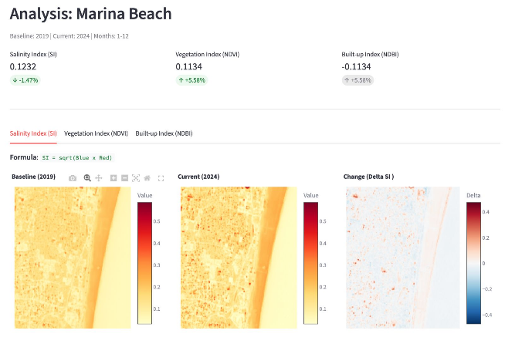

Fig 1: User interface of the Geospace Chennai Coastal and Fertility Monitoring system showing vegetation and fertility classification
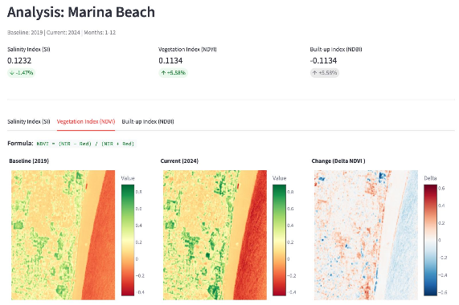
Fig 2: Sample satellite dataset visualization used for coastal salinity and soil fertility assessment
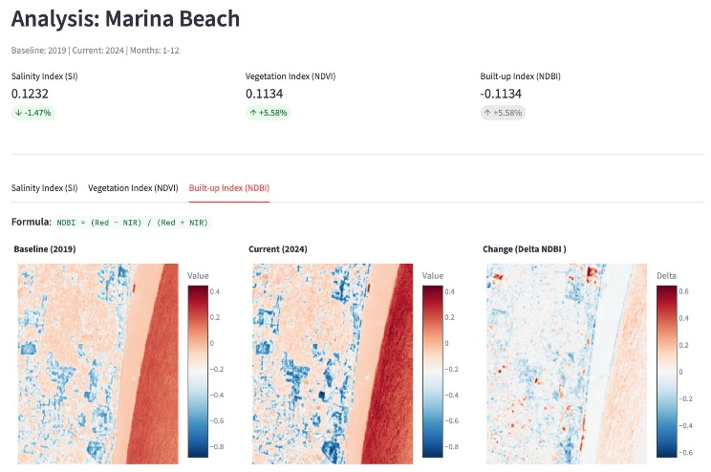

Fig. 3. Multi-temporal Analysis of Built-up Index (NDBI) for Marina Beach (2019–2024)

V.COMPARISON WITH EXISTING MODELS
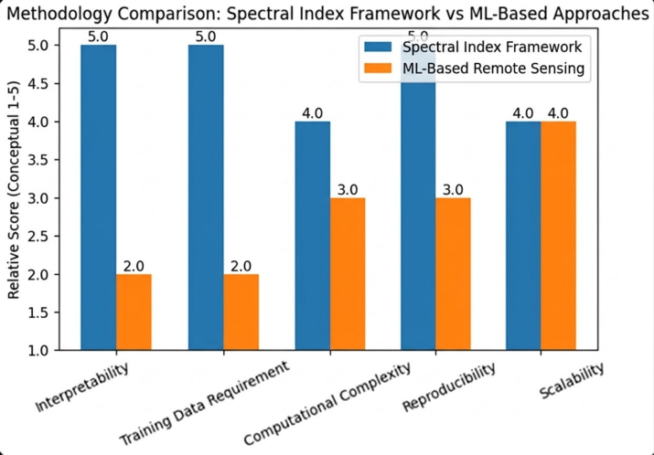
Fig. 4. Comparison of Spectral Index Framework and Machine Learning-Based Approaches
Environmental monitoring of coastal regions has traditionally been performed using several conventional approaches, including field-based surveys, single-index satellite analysis, and static remote sensing methods. While these approaches provide useful insights, they often have limitations related to scalability, temporal analysis, and integration of multiple environmental indicators. The proposed model improves upon these existing approaches by introducing a multi-temporal, multi-index satellite-based analytical framework using Sentinel-2 imagery and cloud-based processing through Google Earth Engine.
1. Existing Approaches
Traditional environmental monitoring methods often rely on field surveys and ground-based measurements. These approaches provide accurate data at specific locations but are limited in spatial coverage. Conducting field surveys across large coastal regions requires significant time, labor, and resources. Additionally, such methods are difficult to repeat frequently, making it challenging to monitor environmental changes continuously.
Another commonly used approach involves single-index satellite analysis, where only one environmental indicator such as NDVI or land cover classification is used to study environmental conditions. Although these methods provide useful information about vegetation or land cover changes, they fail to capture the broader interactions between multiple environmental factors such as salinity intrusion, vegetation degradation, and urban expansion.
Some existing remote sensing models also rely on static temporal analysis, where satellite imagery from a single time period is analyzed. This approach provides a snapshot of environmental conditions but does not effectively capture long-term environmental transformations.
2. Proposed Model
The proposed model introduces a multi-temporal coastal environmental monitoring framework that integrates multiple spectral indices derived from Sentinel-2 satellite imagery. Instead of focusing on a single environmental indicator, the model simultaneously evaluates soil salinity, vegetation health, and urban expansion using the Salinity Index (SI), NDVI, and NDBI.
The system uses Google Earth Engine to access and process satellite imagery efficiently. This cloud-based platform enables large-scale geospatial analysis without requiring high-performance local computing infrastructure. The model also incorporates a structured year-to-year comparison methodology, which allows environmental changes to be quantified and interpreted using mathematical and physical principles.
3. Advantages of the Proposed Model
One of the main advantages of the proposed model is its multi-indicator analysis capability. By combining SI, NDVI, and NDBI, the system provides a comprehensive understanding of environmental conditions in coastal regions. This integrated approach allows researchers to identify relationships between soil salinity, vegetation health, and urban development.
Another significant improvement is the use of multi-temporal analysis. Instead of analysing satellite imagery from a single time period, the proposed model compares environmental indicators across different years. This allows the system to detect environmental trends and identify regions experiencing long-term ecological changes.
The model also benefits from high-resolution Sentinel-2 satellite imagery, which provides spatial resolutions of up to 10 meters. This high resolution allows more detailed analysis of land surface conditions compared to many earlier satellite datasets.
Additionally, the use of cloud-based geospatial processing through Google Earth Engine improves system scalability and efficiency. Large volumes of satellite imagery can be processed quickly, enabling analysis of extensive geographic regions without requiring expensive computational infrastructure.
Another important advantage is the interpretability of results. The proposed framework links spectral index changes to physical environmental processes such as seawater intrusion, vegetation stress, and urban expansion. This makes the results easier to interpret and more useful for environmental decision-making.
4. Summary of Comparison
Overall, the proposed model provides several improvements over existing environmental monitoring approaches. While traditional methods often focus on limited indicators or single time periods, the proposed framework integrates multiple environmental indices and multi-temporal satellite analysis to provide a more comprehensive and scalable solution.
By combining high-resolution Sentinel-2 imagery, cloud-based processing, and structured temporal comparison, the system offers a reliable and efficient approach for monitoring environmental changes in coastal regions.

VII. CONCLUSION.
This study presented a deterministic multi-temporal framework for monitoring coastal environmental changes using Sentinel-2 satellite imagery and physics-based spectral indices. The proposed approach integrates the Salinity Index (SI), Normalized Difference Vegetation Index (NDVI), and Normalized Difference Built-up Index (NDBI) to evaluate key environmental indicators related to soil salinity, vegetation health, and urban expansion. By combining multiple spectral indices within a structured analytical pipeline, the framework enables a comprehensive assessment of environmental conditions in coastal regions.
The methodology utilized Sentinel-2 MSI Level-2A surface reflectance data processed through the Google Earth Engine platform, which allowed efficient handling of large satellite datasets and ensured reproducibility of the analysis.[1][6] A structured year-to-year comparison methodology was implemented to quantify environmental changes between baseline and current periods using pixel-wise differencing and percentage change analysis. This approach enabled both spatial and statistical interpretation of environmental trends across the study areas.
Experimental analysis conducted over selected coastal regions of Chennai revealed noticeable environmental changes over time. The Salinity Index results indicated localized increases in salinity levels near coastal boundaries and estuarine zones, suggesting potential seawater intrusion and salt accumulation. NDVI analysis showed a decline in vegetation health in several areas experiencing intensified urban development. At the same time, increasing NDBI values confirmed the expansion of built-up surfaces and impervious infrastructure in coastal neighbourhoods. The integrated analysis of these indices highlighted the interconnected nature of urbanization, vegetation degradation, and salinity intrusion in coastal environments.
The results demonstrate that multi-temporal spectral index analysis provides a reliable and interpretable approach for large-scale coastal environmental monitoring. The deterministic nature of the proposed framework ensures that detected changes can be directly related to physical surface processes rather than complex model assumptions. This transparency makes the approach particularly useful for environmental assessment and policy-oriented decision-making[5].
Future work may focus on improving the robustness of the framework by incorporating additional datasets such as Synthetic Aperture Radar (SAR) imagery, groundwater observations, and field-based soil salinity measurements for validation. Extending the framework to other coastal regions and integrating machine learning-based change detection techniques could further enhance its capability for large-scale environmental monitoring and sustainable coastal management.

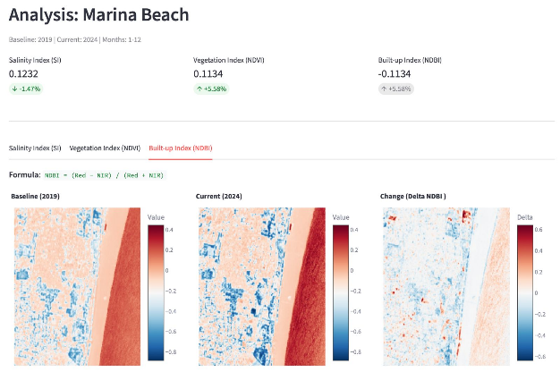
Fig 5: System output illustrating findings and land condition status.
VIII. References

- L. Bruzzone and D. F. Prieto, “Automatic analysis of the difference image for unsupervised change detection,” IEEE Trans. Geosci. Remote Sens., vol. 38, no. 3, pp. 1171–1182, 2000.
- Z. Zhu, “Change detection using Landsat time series: A review,” Remote Sens. Environ., vol. 231, 2019.
- G. Chen, G. J. Hay, L. M. Carvalho, and M. A. Wulder, “Object-based change detection,” Int. J. Remote Sens., vol. 33, no. 14, pp. 4434–4457, 2012.
- T. Blaschke, “Object-based image analysis for remote sensing,” ISPRS J. Photogramm. Remote Sens., vol. 65, no. 1, pp. 2–16, 2010.
- M. A. Wulder et al., “Current status of Landsat program, science, and applications,” Remote Sens. Environ., vol. 225, pp. 127–147, 2019.
- M. Drusch et al., “Sentinel-2: ESA’s optical high-resolution mission for GMES operational services,” Remote Sens. Environ., vol. 120, pp. 25–36, 2012.
- J. Delegido, J. Verrelst, L. Alonso, and J. Moreno, “Evaluation of Sentinel-2 red-edge bands for vegetation monitoring,” Remote Sens. Environ., vol. 147, pp. 107–116, 2014.
- N. Pettorelli et al., “Using the satellite-derived NDVI to assess ecological responses to environmental change,” Trends Ecol. Evol., vol. 20, no. 9, pp. 503–510, 2005.
- J. W. Rouse, R. H. Haas, J. A. Schell, and D. W. Deering, “Monitoring vegetation systems in the Great Plains with ERTS,” NASA Special Publication, 1974.
- C. J. Tucker, “Red and photographic infrared linear combinations for monitoring vegetation,” Remote Sens. Environ., vol. 8, pp. 127–150, 1979.
- Y. Zha, J. Gao, and S. Ni, “Use of normalized difference built-up index in automatically mapping urban areas from TM imagery,” Int. J. Remote Sens., vol. 24, no. 3, pp. 583–594, 2003.
- H. Xu, “Modification of normalized difference water index (NDWI) to enhance open water features,” Int. J. Remote Sens., vol. 27, no. 14, pp. 3025–3033, 2006.
- G. Metternicht and J. A. Zinck, “Remote sensing of soil salinity: Potentials and constraints,” Remote Sens. Environ., vol. 85, no. 1, pp. 1–20, 2003.
- A. Allbed and L. Kumar, “Soil salinity mapping and monitoring using remote sensing,” Remote Sens., vol. 5, no. 12, pp. 6029–6055, 2013.
- A. Bannari, D. Morin, F. Bonn, and A. Huete, “A review of vegetation indices,” Remote Sens. Rev., vol. 13, pp. 95–120, 1995.
- P. Coppin, I. Jonckheere, K. Nackaerts, B. Muys, and E. Lambin, “Digital change detection methods in ecosystem monitoring,” Int. J. Remote Sens., vol. 25, no. 9, pp. 1565–1596, 2004.
- D. Lu, P. Mausel, E. Brondízio, and E. Moran, “Change detection techniques,” Int. J. Remote Sens., vol. 25, no. 12, pp. 2365–2401, 2004.

