Multicultural Teaching Experiences of Filipino Teachers in North America
Zydnee L. Avelino
Bataan Peninsula State University, Balanga City, Bataam, Philippines
DOI: https://doi.org/10.47772/IJRISS.2026.10100589
Received: 09 February 2026; Accepted: 14 February 2026; Published: 19 February 2026
ABSTRACT
Teaching is considered one of the most honorable and in-demand professions today. Filipino educators are in high demand worldwide for their teaching competence and work ethics. However, as multicultural Filipino teachers begin the journey of living and teaching abroad, they are confronted with challenges as they navigate the North American classrooms. This study explored the multicultural teaching experiences of Filipino teachers in North America, specifically their descriptions of classroom culture, the cultural barriers they encountered, and how they addressed those barriers. A qualitative research method, specifically the phenomenological research, was employed. Six participants were selected using the snowball sampling technique. The data were gathered using the semi-structured interview guide, wherein the results were treated using descriptive phenomenological analysis. The findings revealed the descriptions of classroom culture in North America based on these seven themes: (1) culturally-responsive teaching and learning approaches, (2) culturally-inclusive instructional methods and strategies, (3) culturally-adaptive classroom management and discipline, (4) empirically-grounded assessment and evaluation, (5) culturally-sensitive curriculum frameworks and educational standards, (6) advanced classroom technologies, and (7) needs-based teacher professional development. The cultural barriers encountered by the participants encompassed four themes: (1) cultural barriers in teaching, (2) variations in learning styles, (3) biases and stereotypes in the classrooms, and (4) lack of parent engagement. More so, the participants do have ways of coping with difficulties reflected on the following themes: (1) utilizing culturally responsive pedagogy, (2) formation of collaborative learning communities, (3) enhancing intercultural communication, (4) strict implementation of school policies and systems, and (4) instituting an inclusive and empowering environment for the students.
Keywords: Multicultural Filipino teachers, teaching experiences, classroom culture, cultural barriers, North America

INTRODUCTION
Teaching is one of the most honorable professions today, especially in the Philippines. Filipino teachers are highly recognized overseas due to their academic proficiency, including their English language teaching. Filipino educators are in high demand worldwide as more non-English-speaking nations extend their curricula to include the English language as one of the subjects or courses. In the EF English Language Proficiency Index 2017, the Philippines ranked 15 out of 80 countries. The country's competitive advantage over its neighbors is the pool of qualified workers that is readily available (Mariñas, 2021). Three main factors contributing to Filipino teachers' phenomenon include growth, pride, and a matching sense of satisfaction (Modesto, 2020). However, the great expectations of Filipino teachers abroad result in some negative experiences. When multicultural Filipino teachers begin the journey of living and teaching abroad, they are confronted with teaching challenges in terms of attitudes, culture, and discrimination in North American society (Arcillo, 2023). Filipino teachers abroad suffer from emotional distress, cultural differences, and psychological struggles (Sumalinog, 2022). Likewise, some Filipino teachers had trouble adjusting to their host country with their new environment, challenges with their accents and language, and issues with discrimination and cultural differences (Chua, 2021). They also experience challenges involving the language they are using and their accent when speaking, as well as concerns related to prejudice and cultural differences (Lee et al., 2021) and culture shock caused by changes in places and environments (Roskell, 2018). Hence, it is essential for Filipino teachers to adapt to an unfamiliar environment characterized by diverse cultures (Carpio et al., 2018) and to socialize to understand the norms and traditions of a foreign country and to be able to adapt to it (Rajendran et al., 2017). Therefore, multicultural teachers must possess multicultural teaching knowledge and skills to address these issues and ensure that all children have a positive school experience. Multicultural teaching requires teachers to acquire various personal and interpersonal awareness and sensibilities (Moore, 2021). It also involves understanding how cultural variations affect teaching and learning outcomes within and outside the classroom (Deady, 2017). Moreover, Casinader (2018) pointed out that teachers should possess multicultural capability, which means they are open, prepared, and can cater to different types of students in a classroom. There are numerous academic traditions from various countries and cultures; each instructor has a unique teaching style and cultural norms frequently influence pedagogy differently. Multicultural teaching involves learners from other cultures and knowledge traditions to guide the students through ideas and methods of working together to respect differences, acknowledge common ground, and attempt to co-create new pieces of information (Zohar & Newhouse, 2019). The Bachelor of Secondary Education (BSEd) was developed by the Commission on Higher Education (CHED) to prepare aspiring teachers who dreamed of becoming teachers in junior and senior high schools. By CHED Memorandum Order No. 75, S. 2017, BSEd is an undergraduate teacher education program that seeks to provide students with the abilities they require for teaching at the secondary level in their chosen field of specialization or major. Its goal is to create highly qualified, highly motivated teachers focusing on secondary education's methodology and content. In ensuring that graduates have a multidisciplinary preparation in content and pedagogy, the BSEd degree program draws from various related disciplines, including social sciences, science, math, technology, languages, and the humanities. Some of the subjects in the BSEd program give brief information about multiculturalism, including geography and the teaching profession, wherein these subjects are dedicated to teaching the concept of multiculturalism and the cultures and traditions of other countries (Cristy, 2022). However, the curriculum of the CHED still needs to include course subjects intended to help students build their multicultural teaching practices, including the practices teachers should follow once they decide to teach abroad. Only a few studies were conducted on the plight of Filipino teachers handling foreign classes, but a need for more study of North American classrooms is observed. In 2020, Sumalinog researched the drawbacks, and English teachers from the Philippines who have traveled abroad have shared their experiences in several areas of the Indochina peninsula, such as Thailand, Cambodia, Laos, Vietnam, East Asia, Western countries, and lastly, Mozambique. In addition, Nolase et al. (2023) conducted a similar study to Sumalinog, which focused on the lived experiences of multicultural teachers of English in Thailand. On the other hand, Lariosa et al. (2022) conducted their study about Filipino teachers' lived experiences in far-flung schools in the Philippines. The phenomenological research of Chua (2021) focused on the five years of teaching experiences of multicultural Filipino teachers in one of the public schools in Texas, United States. With that remark, the previous studies have yet to address, explore, or answer the multicultural teaching experiences of Filipino teachers in North America. One compelling reason the researchers were prompt to conduct the study was the experience of one of their relatives, who teaches abroad and has encountered a language barrier in her multicultural teaching experience. She emphasizes several vital strategies to effectively accommodate the demands of the kids and comprehend the local culture and teaching methods. Firstly, she recognizes her teaching philosophy. Secondly, she seeks to understand the pedagogy of the school she is attending. Finally, she incorporates her teaching approaches to enhance the learning experience and make it enjoyable for her students. Ultimately, her teaching effectiveness hinges on her passion for the subject matter and the students she teaches. The presented dilemmas, perspectives, inspiration, and lack of a study on multicultural teaching experiences drove the researchers to carry out a study that focused on describing multicultural Filipino teachers in the cultures of North America, the barriers encountered, and addressing them. The study may provide information on how multicultural teachers adapt to changes. Furthermore, for teachers who had the desire to go abroad to work as teachers, this research study may also help address their needs to prepare themselves physically and emotionally, leading to a positive adjustment and gaining information from the people who experienced their lives abroad..

Statement of the Purpose
The study aimed to explore the multicultural teaching experiences of Filipino teachers in North America. How may the socio-demographic profile of solo parents be described in terms of:
Specifically, it sought to answer the following questions:
- How do the participants describe the classroom culture in North America?
- What are the cultural barriers encountered by the participants in teaching in North America?
- How do the participants address these cultural barriers in teaching?

Scope and Delimitations
This descriptive phenomenological research focused on how the participants described North American classroom culture, the cultural barriers they encountered while teaching in North America, how they overcame those barriers, and the lessons that can be learned from the experiences of multicultural Filipino teachers teaching in a foreign country. Using the snowball sampling technique, six (6) multicultural Filipino teachers were chosen as samples for the in depth interview. This study limited its coverage to multicultural teachers teaching in North America only. Due to the depth of the research, the participants can provide the researcher with rich and valuable information. The study utilized a semi-structured interview guide as the data-gathering instrument to learn more about the multicultural teaching experiences of Filipino teachers in North America. To provide participants the opportunity to respond in their own words based on their knowledge, feelings, and comprehension, the researchers used researcher-made interview questions that were open-ended. The data were treated using phenomenological analysis. The study's primary goal was to contribute to the existing literature on the multicultural experiences of overseas Filipino teachers in North America. Thereby, the study excluded the socio-economic aspects of the participants.

Research Assumptions
The researchers assumed the following:
- Participants positively describe the culture of North American classrooms.
- Participants encounter cultural barriers in teaching related to language, values, colonial mentality, and cultural backgrounds or places of origin.
- Participants overcome cultural barriers in teaching by having solid personalities and through acculturation and sociability.

Methods and Techniques
This study utilized a qualitative research method; this method can note in scientific writing that its evaluations are based on a substance's quality rather than quantity or size. It also produced data that could be more numerical and is interested in understanding how participants make sense of the experiences they have in the world. It used techniques like case studies that produce a narrative, descriptive outline of a situation or event (Pathak et al., 2013). Furthermore, the researchers employed descriptive phenomenological research as a method. This research design seeks to uncover the essential aspects and structures of the teaching experience. By conducting in-depth interviews or engaging in reflective discussions, researchers can uncover the underlying meanings and patterns in the experiences of multicultural teachers. The research involved acquiring information about the multicultural teaching experiences of Filipino teachers in North America– perhaps about their perceptions, attitudes, or previous experiences–by providing an interview guide, conducting an interview, and tabulating and succinctly presenting their answers. That process determined the multicultural teaching experiences of Filipino teachers in North America..

Participants of the Study
The participants of the study were selected using the following inclusion criteria: (1) multicultural Filipino teachers currently teaching in North America; (2) having been teaching in a foreign classroom for at least two years; and (3) being assigned to teach high school classes. The study excluded multicultural Filipino teachers with only a year of teaching experience.
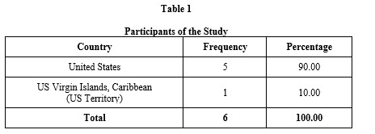
This table provides information about the study participants, wherein multicultural Filipino teachers from North America are the target participants. Furthermore, the participants in the study were chosen using the non-probability sampling technique, namely the snowball sampling technique. As cited by Nikolopoulou (2022), the snowball sampling technique entailed a method of recruitment where participants were requested to help find more possible subjects for the study. Therefore, following that, it proceeded based on recommendations from those participants. The researchers observed the data saturation principle to ensure all relevant data for the investigation was exhausted or mined from the participants. The process was repeated until the desired sample was obtained and a saturation point was reached. With this information, the multicultural Filipino teachers' first-hand experiences likely contributed to this study to collect evidence on the experiences of Filipino teachers teaching in North America.
RESULTS AND DISCUSSION

Part I. Description of Classroom Culture in North America Description of the Phenomenon
Multicultural teaching has allowed Filipino educators to share their knowledge and expertise in North American classrooms. As participants in this phenomenon, Filipino multicultural teachers have experienced various aspects of the North American classroom culture, instructional methods and strategies, classroom management, discipline, and assessment and evaluation. Here is a narrative of their experiences based on the data provided: In terms of classroom culture, Filipino multicultural teachers have observed a culturally diverse environment in North American classrooms, particularly in the Caribbean. The demographics of the students highlight the richness of different backgrounds and experiences. However, they also noticed privileges and limitations on disciplinary actions, which may differ from what they were accustomed to in the Philippines. Despite these differences, some teachers mentioned that the school district near the Mexican border fostered a cultural connection with their Filipino background, creating a sense of home and familiarity. Filipino multicultural teachers highlighted notable differences between the Philippines and North America regarding classroom set-up and student-teacher ratio.
In the Philippines, classrooms are often overcrowded, with a high student-to-teacher ratio of 50-70 students per class. This made it challenging for teachers to manage and provide individual student attention. In contrast, the North American classroom had a smaller student-teacher ratio, allowing for more focused attention and better behavior control. This difference has positively impacted their ability to provide personalized instruction and address the specific needs of their students. When it comes to instructional strategies and support, Filipino multicultural teachers have embraced various approaches in North American classrooms. They have observed using guided reading, writing, and math to enhance student’s learning experiences. Small group instruction is also employed to address students' weaknesses while others work independently. The collaborative approach, such as the KAGAN strategy, stands out as it encourages active student participation and fosters critical thinking and communication skills.
Moreover, providing intervention and individualized support for struggling students has been highlighted, with one-on-one sessions and specialized testing available. Filipino multicultural teachers have also benefited from the availability of teaching materials and technology in North American classrooms. They can access teaching resources, such as iPads or Chromebooks provided by the school or government, which facilitate digital learning, notetaking, and writing. Technology integration enhances students' engagement and gives them broader access to educational resources. Filipino multicultural teachers can consider implementing strategies such as differentiated instruction, collaborative learning, technology integration, and effective classroom management to enhance teaching and learning approaches in North American classrooms.
By tailoring instruction to meet the diverse needs of students, considering their strengths, weaknesses, and learning styles, educators can create a compelling and engaging learning environment. Encouraging collaborative learning approaches, where students actively participate, share ideas, and learn from one another, promotes teamwork, critical thinking, and communication skills. Utilizing technology effectively in the classroom enhances learning experiences and provides access to educational resources. Finally, establishing a positive and inclusive classroom culture with clear expectations, behavior management strategies, and a supportive learning environment fosters mutual respect and a sense of belonging among students. As Filipino multicultural teachers navigate the North American classroom, they also experience unique aspects related to multicultural teaching. They bring their cultural background and experiences, which may enrich the classroom environment and provide diverse perspectives to students. The exchange of ideas and teaching strategies between Filipino and North American educators contributes to a cohesive and effective learning experience. Filipino multicultural teachers must also adapt to new curriculum frameworks and educational standards in their host country.
The effectiveness and organization of these frameworks may vary, influencing instructional practices and student learning outcomes. Filipino multicultural teachers must also align their instruction with state testing requirements to ensure students are adequately prepared for assessments. Multicultural teaching has given Filipino educators opportunities to contribute to North American classrooms, particularly in the Caribbean. Filipino multicultural teachers have experienced a culturally diverse classroom environment while adapting to different disciplinary approaches. They have observed the benefits of smaller student-teacher ratios, enabling personalized instruction and better behavior management. The use of various instructional strategies, collaborative learning, and the availability of teaching materials and technology have enhanced students' learning experiences. Filipino multicultural teachers can continue contributing to the North American classroom by incorporating strategies such as differentiated instruction, collaborative learning, technology integration, and effective classroom management while embracing their cultural background and experiences. The following is a detailed presentation of the Descriptive Phenomenological Analysis of the experiences of Filipino multicultural teachers in North America.
Classroom Culture is the shared values, norms, and expectations that shape the learning environment when students from diverse cultural backgrounds come together inside the classroom. The current study illustrates the description of Filipino teachers in the culture of North American classrooms. Since teaching in a foreign classroom is challenging, Filipino teachers can convey what instructional methods, strategies, or curricula they've used and experienced teaching in North America.
Table 2 discloses the responses in the interview, particularly on the question : "Describe the classroom culture in the North American country where you are teaching right now. It revealed the first theme, which is the culturally responsive teaching and learning approaches that are created to provide teachers the flexibility to select different methods that best suit their students' needs (IB Education, n.d.).
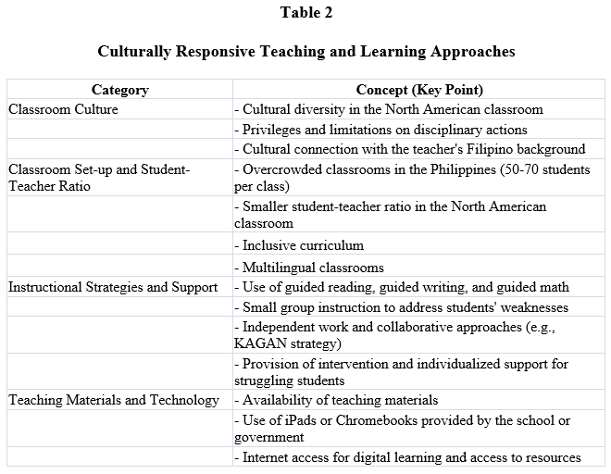
As disclosed from the interviews, the following were identified regarding teaching and learning approaches: the classroom culture, the classroom set-up, the student-teacher ratio, instructional strategies and support, and the teaching materials and technology. The teachers revealed that the classroom culture in North American classrooms is culturally diverse, having students with various cultural backgrounds, and it was also mentioned that the school district near the Mexican border has a cultural connection with the teacher's Filipino background, fostering a sense of home and familiarity.
Table 3 shows the second theme, which is the culturally inclusive instructional methods and strategies, defined as the techniques used by teachers to aid in their students' knowledge and/or skill development (Gray & Stephens, 2023).
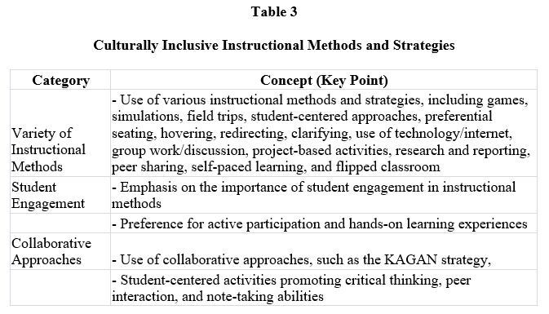
Based on the responses provided, there are a variety of instructional methods and strategies employed by teachers in their classrooms, such as the use of games, simulations, field trips, student-centered strategies, preferential seating, hovering, redirecting, clarifying, use of technology/internet, group work/discussion, project-based activities, research and report, peer sharing, self-paced learning, and flipped classroom which allow for a diverse and engaging learning experience. The use of different methods allows for a diverse and engaging learning experience for the students.
Table 4 discloses the responses to the interview, particularly on the question, "What approaches and techniques do you use to maintain discipline and create a positive learning environment? How? This table shows the third theme, culturally adaptive classroom management, and discipline, or the practice in which a teacher arranges and controls the curriculum's variables, time, space, and student interactions and behaviors (Barnes-Cummins, n.d.).
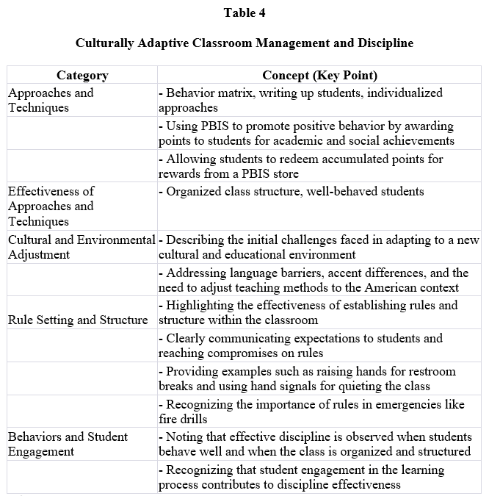
As disclosed from the interviews, the following categories were identified. First, in the category of approaches and techniques, participants shared their specific strategies for maintaining discipline and creating a positive learning environment. It was recognized that every child is different, requiring teachers to employ multiple management techniques based on individual needs. Participants mentioned having difficulty disciplining students but opted to go with the flow, sometimes implementing a reward system or ignoring disruptive behavior. The use of PBIS points (positive behavioral interventions and supports) was mentioned by another participant, where students were rewarded for their positive behavior and could exchange accumulated points for items from a PBIS store.
Table 5 shows the fourth theme, which is empirically grounded assessment and evaluation, which serve as essential tools for teachers to find out the most effective way to modify curricula and instructional strategies to meet the needs of each student as well as assess the overall success of initiatives and teaching methods (Torah High, 2023). The categories revealed based on the responses were the variety of assessments, different assessment levels, considerations in assessment selection, intervention and support, authenticity, and real-world relevance.
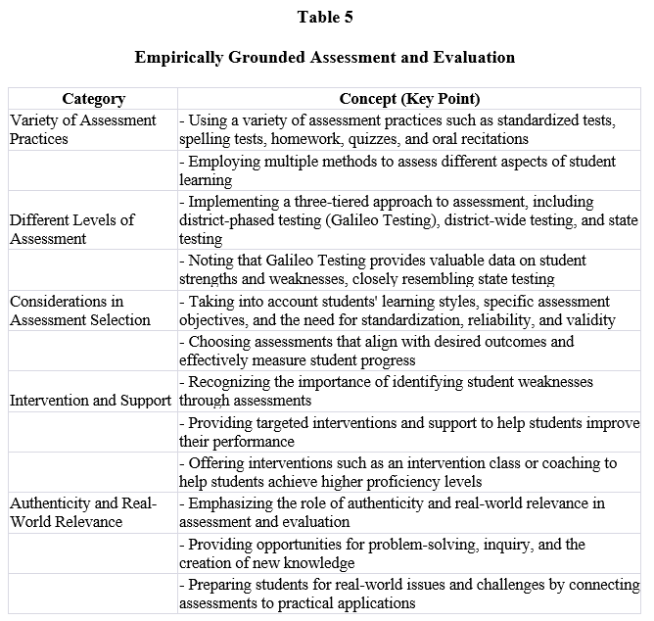
Teachers mentioned using various assessment practices to measure students' learning and progress, such as standardized tests like Iready and SBAC, regular spelling tests, homework assignments, quizzes, and oral recitations. Teachers were also implementing a three-tiered approach to assessment, including district-phased testing (Galileo Testing), which provides valuable data on student strengths and weaknesses resembling state testing, district-wide testing, and state testing.
Table 6 presents culturally sensitive curriculum frameworks and educational standards; this theme is a crucial resource that "indicates assistance, comments, and perspectives" from academics, curriculum professionals, and instructors to guarantee that all learners receive outstanding instruction (Educational Services, n.d.). This table depicts the organizational structure and integration in North America based on the teaching experiences of Filipino teachers.
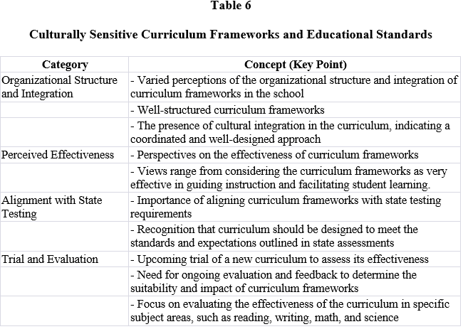
Organizational structure and organization are among the categories that emerge from the participants' responses; this category revealed responses suggesting that the school's curriculum frameworks and standards could be more well organized. This implies a lack of coherence or clarity in the curriculum, which may hinder effective instruction. In contrast, another response highlights that the curriculum is structured and culturally integrated, indicating a well-designed and coordinated approach to instruction.
Table 7 indicates advanced classroom technologies. This theme is the application of electronic equipment in classes, auditoriums, laboratories, and workshops to assist other educational endeavors (ClearTouch, 2021). The table represents four categories based on the participant's responses: enhanced interaction and engagement, contribution to learning, student engagement and independence, and reduced teacher workload.
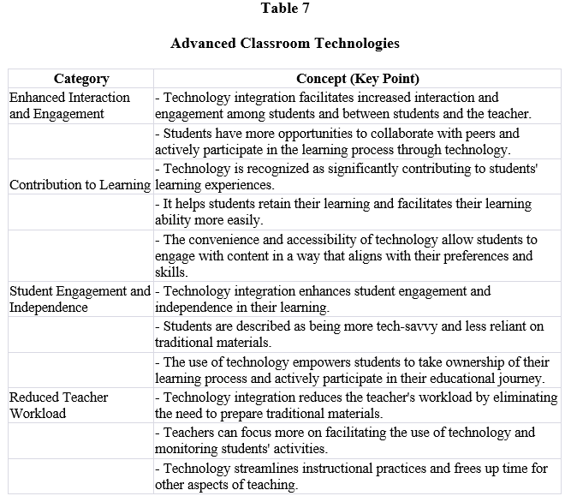
Firstly, enhanced interaction and engagement highlighted technology integration in the classroom, providing students with increased opportunities to interact with the teacher, collaborate with peers, and actively engage in the learning process. This suggests that technology facilitates a more interactive and participatory learning environment.
Table 8 presents a needs-based teacher professional development program. This theme is any endeavor to keep teachers' education relevant. It is a method by which teachers can further develop their abilities and hence improve student outcomes (Prieur, 2023). The table highlights four categories based on the participants' responses: an abundance of opportunities, continuous learning and growth, application in the classroom, and benefits and rewards. For the first category, which is the abundance of opportunities, it was emphasized that there are numerous professional development opportunities in North America.
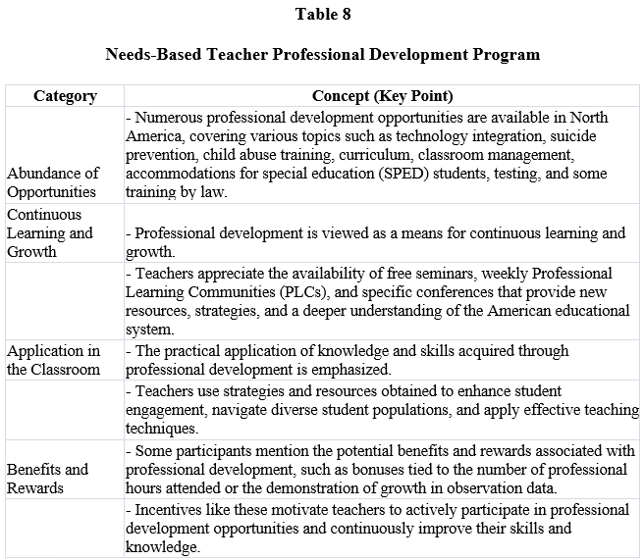
These opportunities encompass a wide range of topics, including technology integration, suicide prevention, child abuse training, curriculum, classroom management, accommodations for special education (SPED) students, testing, and some training by law. The variety of offerings reflects the diverse needs and interests of educators.

Part II. Encountered Cultural Barriers in Teaching by the Participants in the Classroom
Description of the Phenomenon Multicultural teaching opened up new horizons for Filipino educators, allowing them to share their knowledge and expertise in North American classrooms. However, their journey was not without its challenges. As they embarked on this cross-cultural adventure, Filipino teachers confronted many obstacles that tested their resilience and adaptability. One of the first barriers they encountered was the language and accent differences. The Filipino accent, with its distinct nuances, proved to be a stumbling block to effective communication. Students needed help comprehending their Filipino teachers in schools where exposure to diverse accents and cultures was limited.
Pronunciation disparities further compounded the language barrier, necessitating the ability to switch between accents when interacting with Filipinos and Americans effortlessly. Another hurdle lay in the differences in teaching approaches. In the Philippines, direct and assertive methods were often employed to motivate students. However, a more encouraging and inclusive approach was preferred in the North American context. Filipino teachers had to navigate this shift in pedagogy, adjusting their instructional methods to align with the preferred teaching style in their new classrooms. It required immense effort and adaptability to balance their teaching philosophy and the expectations of their American students. Cultural shock hit Filipino teachers hard, as they witnessed stark differences in student behaviors and attitudes.
The lack of responsibility displayed by students towards their belongings, such as carelessly discarding pencils, left the teachers aback. Moreover, the provision of school supplies, the absence of uniforms, and the varying degree of government support for students' needs were in stark contrast to their previous experiences. Understanding and adapting to these new cultural contexts proved to be a formidable challenge, requiring the teachers to unravel unfamiliar expectations and behaviors. While some teachers experienced smooth transitions, others encountered significant obstacles. Limited instances or resolutions were also noted in the data. Some teachers could not recall specific incidents suggesting that their adaptation process ely smoother. Nonetheless, there were instances where proactive Filipino teachers took action to address challenges head-on. They involved guidance counselors to address student rudeness and contacted parents directly to resolve accusations of racism.
These examples showcased their determination to find resolutions and create an inclusive and supportive environment for their students. In the end, the journey of multicultural teaching for Filipino educators was a rollercoaster ride filled with both triumphs and tribulations. They had to develop cultural competence, continually learn and adapt their instructional practices, and navigate the complex interplay of language, teaching styles, and cultural differences. Despite the challenges, these Filipino teachers persevered, leaving an indelible mark on their students and enriching the educational landscape through their dedication and resilience. The following is a detailed presentation of the Descriptive Phenomenological Analysis of the encountered cultural barriers by Filipino multicultural teachers in teaching in the classroom in North America.
Cultural Barriers are the challenges that teachers encounter due to the diversity of cultures between themselves and their students. These barriers can create difficulties in communication, classroom behavior, educational background, values, and biases.
Table 9 discloses the responses in the interviews on the cultural barriers in the teaching of Filipino teachers teaching in North America, specifically on the question: "What are the cultural barriers in teaching encountered by the participants in the classroom?" Situations rooted in cultural elements that hamper educational programs' operation are called cultural barriers. The attitudes and ideas of particular groups of people serve as the foundation for these barriers, which are frequently very complicated (Caffarell, 2010). The table highlights three categories based on the participants' responses: language and accent, race bias, cultural shock, and differences in student behaviors.
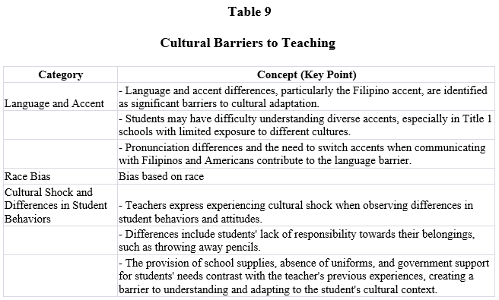
The first category, regarding language and barriers, highlighted pronunciation, understanding of diverse accents, and language switching. The language barrier is intensified by variations in pronunciation and the necessity to switch between Filipino and American accents while communicating with Filipinos and Americans.
Table 10 shows culturally diversified learning style as a theme, focusing on the question, "What are the cultural barriers in teaching encountered by the participants in the classroom?" The study by Guild (2020) emphasized the significance of acknowledging and addressing culturally diversified learning styles to support academic achievement and promote fairness in education.
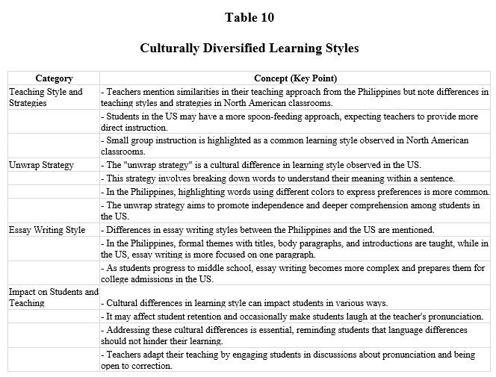
For the first category, teacher style and strategies, educators need to embrace culturally responsive teaching approaches, which involve integrating diverse teaching methods and assessment strategies that cater to various learning styles.
Table 11 presents bias and stereotypes in North American classrooms; this theme refers to unfair prejudice or unjustified judgments made in favor of or against one person or group in comparison to another (Nova Scotia Health Authority, 2023). This table discloses the responses in the interviews on the bias and the stereotypes in North American classrooms, representing one category, including the importance of honesty and communication. The importance of honesty and communication, where participants initially could not think of any biases or stereotypes but later shared an insightful example related to accents and expectations about writing in Filipino. Participants also mention the importance of honesty and finding the right words. While not directly addressing biases and stereotypes, these responses imply that open and honest communication can contribute to minimizing their impact.
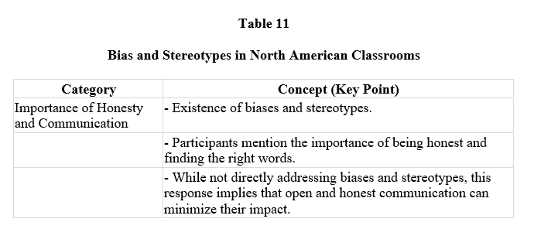
Overall, the category supports the fundamental theme of bias and stereotypes in North American classrooms by revealing that it is essential for educators to actively engage in self-reflection, continuous learning, and ongoing efforts to identify and challenge biases and stereotypes within the classroom. By doing so, educators can create a more inclusive and equitable learning environment for all students.
Table 12 highlights the lack of parent engagement; this theme refers to the partnership between parents and schools that influences and supports children's learning in a variety of contexts, including at home, at school, in after-school activities, and in the community (Centers for Disease Control and Prevention, n.d.). The particular theme discloses the responses in the interviews on parent and community engagement, and the fourth theme represents four categories: complaints and preferences, managing student and parent expectations, and parental involvement.
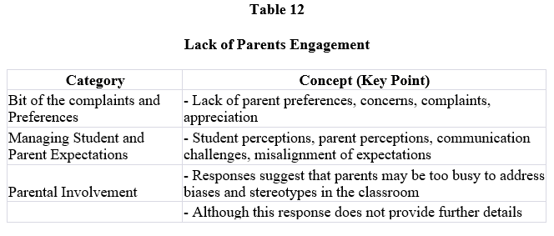
The first is complaints and preferences, where one respondent mentions two types of parents: those who complain and those who express appreciation. This suggests that some parents may have specific preferences for teachers or may raise concerns about their child's educational experience.

Part III. Addressing Cultural Barriers to Teaching Description of the Phenomenon
As Filipino multicultural teachers embark on their journey of multicultural teaching, they are aware of the cultural barriers they may encounter and are determined to navigate them effectively. One of the primary strategies they employ is language enhancement. Recognizing the significance of effective communication, they dedicate themselves to improving their language skills, especially when teaching in non-English-speaking countries. They enroll in language courses, practice local accents and expressions, and actively seek opportunities for language immersion. By enhancing their linguistic abilities, they ensure clearer and more efficient communication with their students, facilitating better comprehension in the classroom. However, Filipino multicultural teachers understand that more than language proficiency is needed to overcome cultural barriers. They also engage in cultural immersion to better understand the host country's customs, traditions, and values.
They actively participate in cultural activities, festivals, and events, immersing themselves in the local culture. This experience allows them to develop a genuine appreciation for diverse perspectives and fosters their ability to incorporate culturally relevant content into their teaching. By infusing elements of the host country's culture into their lessons, they create a more inclusive and engaging learning environment for their students. Cultural sensitivity and awareness are vital tools employed by Filipino multicultural teachers. They understand that every country has its educational practices and norms. They invest time and effort in learning about the host country's educational system, values, and entry to address these cultural barriers. By familiarizing themselves with these aspects, they can tailor their teaching approaches and adapt their instructional methods to align with the local educational context. This cultural sensitivity ensures they can effectively engage with their students and create meaningful learning experiences.
Flexibility and open-mindedness are also critical attributes demonstrated by Filipino multicultural teachers. They understand that cultural differences may lead to contrasting teaching methodologies and approaches. To overcome this challenge, they remain open to new ideas and are willing to embrace different teaching strategies prevalent in the host country. By adapting their teaching methods to suit the local context, they build stronger connections with their students and create a more inclusive and collaborative learning environment. Moreover, Filipino multicultural teachers actively seek opportunities to build cross cultural bridges between their host cultures. They incorporate elements of their own culture, such as Filipino literature, history, or traditions, into their teaching. By doing so, they share their cultural heritage and enhance their students' cultural awareness and appreciation. This approach encourages a diverse and inclusive classroom where students can celebrate their cultural identities while learning about other cultures. Filipino multicultural teachers generally employ various strategies to address the cultural barriers they encounter in multicultural teaching.
They create a dynamic and inclusive learning environment through language enhancement, cultural immersion, cultural sensitivity, adaptability, and the integration of their culture. By embracing and celebrating cultural diversity, they foster an enriching educational experience that prepares students to thrive in a globalized world. The following is a detailed presentation of the Descriptive Phenomenological Analysis of how Filipino multicultural teachers in North America addressed the cultural barriers they encountered. Coping Strategies are the coping mechanism that teachers use to get across cultural barriers. The use of these strategies helps in teachers' comprehension of practical ways to overcome the various barriers in culture. As a means to build understanding among students and to bridge cultural gaps.
Table 13 stresses utilizing culturally responsive pedagogy as one of the themes. According to Paccaud et al. (2021), effective communication between schools and families can help create a setting that supports students' intellectual and emotional development. Moreover, the beneficial effects of this collaboration will also help create inclusive, healthy classrooms.
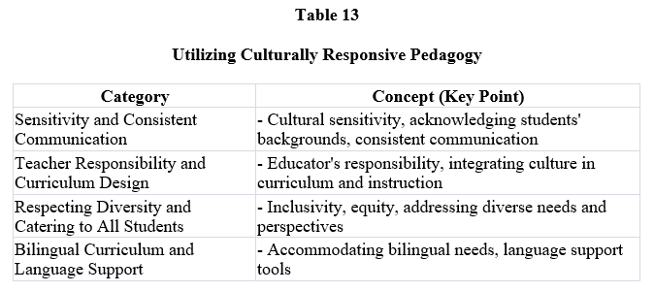
The participants' responses disclose four categories, and the first one is sensitivity and consistent communication, emphasizing the importance of being sensitive to students' cultural backgrounds and maintaining consistent communication with students. This suggests that creating an inclusive classroom environment involves actively acknowledging and respecting students' cultural identities.
Table 14 presents the formation of collaborative learning communities as the thirteenth theme. As stated by Daly (2022), successful schools know the significance of building positive, cooperative connections with nearby communities. Moreover, involving the community in schools may improve access to educational opportunities, foster student retention, inspire teachers' optimism, and raise student attendance rates.
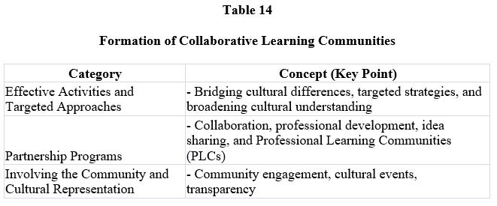
Participants' answers reveal three categories, including practical activities and targeted approaches, and partnership programs. The first category, practical activities and targeted approaches and broadening cultural understanding, emphasizes the need for practical activities and targeted approaches to address transcultural barriers. This suggests that specific initiatives or strategies are implemented to bridge cultural differences and promote student understanding.
Table 15 shows the interview on enhancing intercultural communication employed by the participants. According to Panda (2022), the essence of intercultural communication is to promote understanding of one's culture and identify how similar or different it is from another culture. Since cultures embody distinctive patterns of behavior and perception, intercultural communication approaches consider cultural differences. The table shows categories; the first category is language instruction and support because the educators mentioned implementing specific language instruction and support programs to cater to students with diverse language backgrounds.
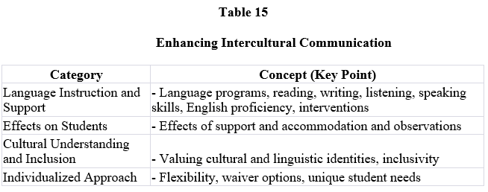
These programs focused on developing reading, writing, listening, and speaking skills in English. Specialized classes and interventions were designed to help students improve their English proficiency and enable effective communication. Moreover, this category includes language programs, reading, writing, listening, speaking skills, English proficiency, and interventions.
Table 16 provides the interview on the strict implementation of school policies and systems employed by the participants. According to Figlio (2018), firm policies and practices that might be successful overall could help one group of students while harming another, so care should be taken to see whether they are benefiting all, some, or no students— and whom they are benefiting.
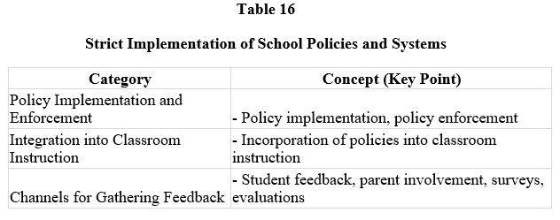
The table presents categories; the first category is policy implementation and enforcement because educators mentioned strictly implementing and staying firm with existing policies that promote inclusivity and address transcultural barriers. This indicates a commitment to upholding the policies and ensuring their practical implementation in the classroom.
Table 17 presents instituting inclusive and empowering student support as the sixteenth theme, highlighting four categories based on participant responses: communication and dialogue, professional development, confidence and engagement, classroom observations, student-led initiatives, collaborative learning, individualized support, and positive reinforcement.
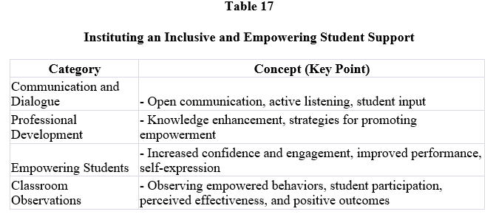
According to Bostwick (2015), empowering a student's voice transforms a learner from an observer to an initiator. This is the foundation of students' voices in the classroom as they progress through stages of growth. The first category is communication and dialogue; it mentioned the importance of talking to students and engaging in open communication. This indicates that fostering a supportive and inclusive classroom environment involves actively listening to students' thoughts, ideas, and concerns.

CONCLUSIONS AND RECOMMENDATIONS

Conclusion
Based on the indicated findings, the following conclusions were drawn.
- The description of classroom culture in North America drew upon the seven themes such as culturally responsive teaching and learning approaches, culturally inclusive instructional methods and strategies, culturally adaptive classroom management and discipline, empirical grounded assessment and evaluation, culturally sensitive curriculum frameworks and educational standards, advanced classroom technologies, and needs-based teacher professional development.
- The cultural barriers encountered in North American classrooms revealed four themes: cultural barriers in teaching, culturally diversified learning style, bias and stereotypes in North American classrooms, and lack of parent engagement.
- Multicultural Filipino teachers in North America do have ways of coping with difficulties. The response of the participant has anticipated the following themes: utilizing culturally responsive pedagogy, formation of collaborative learning communities, enhancing intercultural communication, strict implementation of school policies and systems, and instituting an inclusive and empowering student.

RECOMMENDATIONS
The study's findings revealed the teaching experiences of multicultural Filipino teachers in North America. Thus, the following recommendations were here by presented.
- Recruitment agencies may provide PreDeparture Orientation Seminars (PDOS) and training on multicultural education practices to prepare teachers for culturally responsive teaching, inclusive instruction, adaptive classroom management, and other practical approaches in North America.
- Schools in the Philippines may offer professional development opportunities, including cultural sensitivity and awareness training for teachers and students, to create an inclusive environment, promote cultural understanding, and prepare them for a globalized world.
- The Commission of Higher Education (CHEd) may utilize the study's insights to update the curriculum and integrate multicultural education courses into the professional education cluster, fostering culturally responsive pedagogy, collaborative learning communities, intercultural communication, and inclusive learning environments.
- Future researchers may explore the experiences of Filipino teachers in South America and other key regions to provide a broader understanding of the teaching dynamics and challenges multicultural Filipino educators face.

REFERENCES
- Arcillo, M. T. (2023). Experiences of the Filipino teachers in the Virgin Islands: A phenomenological theory development. International Journal of Science and Research, 12(2), 1560–1566. https://doi.org/10.21275/SR23226022624
- Busetto, L., Wick, W., & Gumbinger, C. (2020). How to use and assess qualitative research methods. Neurological Research and Practice, 2, Article 14. https://doi.org/10.1186/s42466-020-00059-z
- Carpio, G. J., De Torres, A. L., Samiran, R., Villera, K., & Manguerra-Mahusay, S. (2018). Work and travel experiences of Filipino tourism students in selected universities. Asian Journal for Public Opinion Research, 5(2), 143–174. https://doi.org/10.15206/ajpor.2018.5.2.143
- Casinader, N. (2018). Why growing teacher expertise in cultural education reaps big rewards in the classroom. TeachSpace, Monash University. https://www.monash.edu/education/teachspace/article s/why-growing-teacher-expertise-in-culturaleducation-reaps-big-rewards-in-the-classroom
- Chua, J. (2021). The lived experiences of Filipino teachers teaching in Texas: A transcendental phenomenological study (Publication No. 415) [Doctoral dissertation, Stephen F. Austin State University]. Electronic Theses and Dissertations. https://scholarworks.sfasu.edu/etds/415
- Deady, K. (2017). Why teachers abroad need to make cultural competence a priority. Teach Away. https://www.teachaway.com/blog/why-teachersabroad-need-make-cultural-competence-priority
- Lariosa, E., Diendo, M., & Espinosa, F. (2022). Lived experiences of teachers in far-flung schools. International Journal of Novel Research in Education and Learning, 9(5), 27–41. https://doi.org/10.5281/zenodo.7083128
- Lee, M. W., & Kim, S. Y. (2021). I may sound like a native speaker…but I’m not: Identities of Korean English teachers with border-crossing experience. Asia-Pacific Journal of Teacher Education, 49(2), 216–229. https://eric.ed.gov/?id=EJ1296111
- Mariñas, J. (2021). 3 reasons why the Philippines is one of the top English-proficient countries for business. Cloud Employee. https://cloudemployee.co.uk/blog/itoutsourcing/whyp hilippine-forbusiness
- Moore, S. (2021). Cultural competence in education. Teach Hub.
https://www.teachhub.com/professionaldevelopment/2021/06/cultural-competence-ineducation/
- Pathak, V., Jena, B., & Kalra, S. (2013). Qualitative research. Perspectives in Clinical Research, 4(3), 192–195. https://doi.org/10.4103/2229-3485.115389
- Rajendran, D., Farquharson, K., & Hewege, C. R. (2017). Workplace integration: The lived experiences of highly skilled migrants in Australia. Equality, Diversity and Inclusion: An International Journal, 36(5), 437–456. https://doi.org/10.1108/EDI-11-2016-0094
- Roskell, D. (2013). Cross-cultural transition: International teachers’ experience of culture shock. Journal of Research in International Education, 12(2), 155–172.
https://doi.org/10.1177/1475240913497297
- Sumalinog, G. (2022). Lived experiences of the Filipino English teachers abroad: The drawbacks in focus. International Journal of Science and Research, 11(2), 41–47. https://doi.org/10.21275/SR211113010609
- Zohar, A., & Newhouse, D. (2019). What is transcultural education? In Intellectual, scientific, and educational influences on sustainability research (pp. 112–130). IGI Global.
https://doi.org/10.4018/978-15225-7302-9.ch006

