ANALYZING CONSUMER BUYING BEHAVIOR ON MYNTRA
DR. KRITIKA MALHOTRA
ASSISTANT PROFESSOR
NATIONAL P.G. COLLEGE

DIVYA SINGH
STUDENT, M.COM
NATIONAL P.G COLLEGE
ABSTRACT
Looking closer at how consumer buy things on Myntra, an Indian online hub for clothes and lifestyle goods, reveals what really influences their choices. Price often tops the list, though quality holds strong weight, too. Discounts grab attention fast, yet brand reputation significantly shapes long-term loyalty. Customer feedback and reviews can build trust or spark doubt. A smooth application interface keeps users around longer than clumsy ones tend to. Ads seen on social platforms encourage some toward checkout without them even planning to. Young buyers act differently from older groups; young consumers are influenced by what is trending in the market whereas older consumers look for quality and durability. Seasonal sale events bring waves of activity that few other triggers match. Suggestions tailored to past clicks sometimes feel oddly spot-on. Returning items with little hassle removes one big worry mid-purchase.

A fresh look at data came from surveys, online tools, printed material, web pages, and academic papers. Results are meant to help store owners, promotion teams, and companies improve shoppers' experience and build trust. Work adds depth to online selling strategies while clarifying how buyers act using sites such as Myntra.
Keywords- Consumer buying behavior, Myntra, Website features

INTRODUCTION
These days, buying things online plays a big role in how consumer spend their time - thanks largely to the fast rise of digital stores across India. Myntra has come out as one of the leading online marketplaces for fashion, clothing, beauty, footwear and lifestyle products among these online stores. It offers customers a wide variety of national and international brands, attractive discounts, smooth delivery services, and easy exchange and return policies. It is vital to understand consumer buying behavior when they are shopping online because consumers today have many choices and they expect a hassle-free, fast, and reliable shopping experience. When consumers shop online they keep in mind various factors before making a purchase. These may include price, product quality, brand reputation, customer reviews, return policies, delivery time and the overall look of the application interface. Also, Myntra frequently uses advertisements, influencer marketing, and festive sale campaigns like “End of Reason Sale” to affect customer decisions.
Another important aspect is digital advancement, which shapes consumer behavior. Features like personalized suggestions, a user-friendly interface and secure payment options help customers make faster and more confident decisions. Social media platforms like Instagram, YouTube, and Facebook also influence buyers as they often check reviews, try-on videos, and influencer recommendations before purchase decision. Consumer choices on Myntra don't follow a single pattern — they vary considerably depending on who the shopper is. Age plays a big role: younger buyers are attracted toward trendy styles and are influenced by what they see from creators and influencers on social media. Older shoppers often go for durability and consistent product quality over trend. Income and lifestyle shape expectations too — what someone considers value for money, how often they shop, and what they're even browsing for in the first place. Understanding these differences is important to this research. Without accounting for them, any broader picture of consumer behavior on Myntra remains incomplete. This research aims to explore and understand all these factors to get a clear picture of how consumers behave while shopping on Myntra

LITERATURE REVIEW
Chaturvedi & Gupta (2014)-The study by Chaturvedi and Gupta (2014) examined the impact of social media on online shopping behavior among apparel shoppers in the Jaipur city. The analysis was conducted using secondary data sources. According to the study, most consumers shy away from shopping for apparel online because of various issues such as security problems, inability to view or feel products before purchasing, delayed deliveries, as well as doubts about product prices and quality. Apart from these, consumers also fear the adoption of new technologies, hence they feel uncomfortable using online shopping sites. On the other hand, those who use online shopping services have numerous benefits since they can access a wide variety of products, ranging from clothes to other goods that suit their tastes.

Tyagi (2021)- According to Tyagi, his investigation was on customer satisfaction on Myntra. He investigated the effect of different marketing aspects on consumer behavior. Different sources were used in the research, including questionnaires, online materials, literature, books, company reports, journals, among others. He concluded that the purchase behavior of consumers is dependent on various factors, including pricing strategy, newspaper ads, magazine ads, television ads, free samples, quality of the products, and the good name of the organization. In general, most of the consumers are satisfied with the quality of goods and services provided by Myntra.

Thakur (2021)- The experiment involved consumer behavior in online shopping trends in India by using a questionnaire comprising ten questions about gender, age, income, shopping behavior, and reasons for buying products online. The result indicated that consumers were highly involved in purchasing high-value products or special products. Consumers tend to make quick decisions when purchasing cheap products. There is a significant trend towards buying products online, primarily because of ease of access and convenience. Myntra emerged as the preferred online store for buying clothes, followed by Amazon and Flipkart. This was attributed to various factors, including easy refunds and guaranteed delivery. The issue of payment failure, poor quality, and cyber security still needs ratification.

Kumari & Singh (2022)- Kumari and Singh in their year 2022 research carried out an extensive investigation into consumer buying behavior towards Myntra, employing questionnaires, Google Forms, graphs, descriptive statistics, among others. The results from their investigation indicate that with the rising advancement of technologies, more and more consumers have been opting for online shopping sites. In terms of consumer satisfaction regarding the online shopping site, Myntra, the results indicated that factors such as demographics, including age and gender of the customer, as well as factors associated with the site, such as accessibility of the app, diversity of products, availability, reasonable prices, good offers, and quick delivery play a critical role. Most of the consumers, however, showed satisfaction with the site.

Chodisetty & Sreekanth (2022)- In their study, Chodisetty and Sreekanth conducted an investigation into the buying behavior of consumers toward online retailing platforms including Amazon, Flipkart, eBay, and Myntra using questionnaire surveys and online responses. From their research, there was a disparity in the shopping habits of male and female buyers; women are known to take more time browsing for the products online compared to men who eventually go on to buy more frequently since women have a lot of concerns with the security involved, coupled with the fact that they cannot inspect the products physically. In the above study, the influence of demographic factors such as age, level of education, salary income and gender was determined in consumer online buying behavior in the Uppal area.

Ota, Ray & Kumari (2022)- The research examines the customer buying behavior towards online shopping specifically focusing on Myntra. Based on a descriptive research approach, using a self-administrative questionnaire and random sampling technique. The results indicate that online shopping is increasingly becoming a popular choice in today's world. Myntra emerged as one of the most popular sites for the purchase of women's clothing. This study reveals that Myntra has established a firm presence within the fashion industry and has become increasingly popular, especially among women, because of the variety of clothing available through the site.

Saxena (2022)- The research conducted by Saxena (2022) analyzed the online shopping behavior of Indian women for clothing. Using structured surveys and secondary data, the research found that online shopping for clothing is becoming increasingly popular owing to the availability of smartphones and the Internet. The largest demographic of online customers comprises young women in the age group of 18 to 34 years who spend around ₹2,000 on their purchases. The research highlighted the need for online platforms to offer free shipping services for expensive products, quick refunds, and prompt solutions to problems with the products. The success of the online clothing business is contingent upon parameters such as quality of the product, competitive pricing, delivery time, and a strong return policy.

Patra, Mitra & Das (2023)- Patra, Mitra, and Das did a comparative analysis on the consumers' perception about Myntra, Flipkart, and Amazon in 2023. The information for this research work was gathered using interviews, observations, personal meetings, and several secondary sources of information. It was found that Amazon scored the most from customers in terms of preference compared to Flipkart and Myntra, which scored high but were still behind its competitors. Each of the sites was acknowledged for its fast growth and strong relationship with the consumers. Nevertheless, there are many areas where improvements should be made such as Flipkart having low-quality services and Myntra not being able to compete.

Udupa & Nagoji (2023)- Udupa & Nagoji’s (2023) research investigated consumer behavior with respect to online apparels shopping through the use of surveys, books, web sources, and business reports. From their findings, consumers tend to favor those platforms where they have easy access to their products. A single mouse-click results in the delivery of their products right at their doorstep, increasing the ease of access. Companies can develop digital devices such as internet kiosks and good website designs to assist customers in making good decisions. The importance of turning occasional consumers into loyal clients through website improvement, user training, and tackling issues related to reliability and product availability is emphasized in this study.

Gaur & Singh (2025)- According to the Gaur and Singh 2025 study, the buying habits of the consumers on the platform Myntra were investigated through the quantitative methodology using the structured questionnaire. The result indicates that features of the website such as its structure, the recommendations, as well as emotional factors influence impulsive buying behavior. After the coronavirus pandemic, the consumer trust in the online platforms including Myntra grew, as consumers learned to buy things via online mediums. Additionally, the consumer prefers to purchase the branded and easily available items.

RESEARCH METHODOLOGY

Research methodology is a structured plan or approach that guides how a study is designed, carried out and analyzed. Simply it describes what researchers do, how they collect data and interpret it all to ensure the results are accurate and understandable. However data collection methods are mainly of two types

PRIMARY DATA- Which is original first-hand information collected through surveys, interviews, observations, experiments etc.

SECONDARY DATA- Which is sourced from existing materials like published reports, databases, historical records etc.

This research is done from primary data collected in the form of online questionnaire which comprises questions such of five ranking likert scale, yes/no questions and responsive questions .A total of 59 responses is collected through the questionnaire. Also some overview is taken from secondary sources like research papers, journals etc.

This research has targeted buyer who shop on Myntra of different ages i.e. under 18, 18-21, 22-25, 26- 29, 30 and above. The respondents come from different background which are students, working professionals, self-employed, private sector employees, government employees, professionals and homemakers.

OBJECTIVES OF THE STUDY

- To understand the factors that influence consumers to shop on Myntra.
This includes studying elements such as product variety, pricing, discounts, app/website features, delivery speed, and brand options
- To analyze consumer satisfaction with Myntra’s services.
This includes return policies, product quality, customer service, delivery experience, and payment options

DATA ANALYSIS
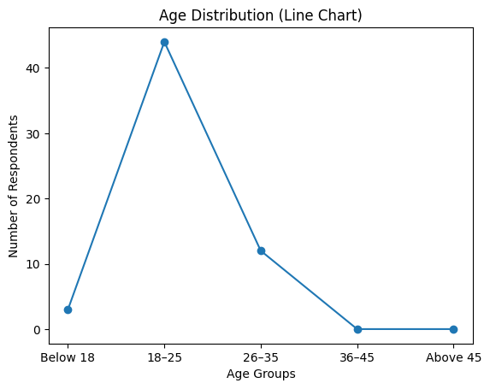
Figure 1: Age of the respondents
From Figure1 we can conclude that the majority of the responses (74.6%) belong to the 18 to25 age group, followed by 26 to 35 years (20.3%) and only 5.1% are below 18. There were no respondents between the age of 36 to 45 or above 45 years old. Hence it can be concluded that youth are the active buyers on Myntra.

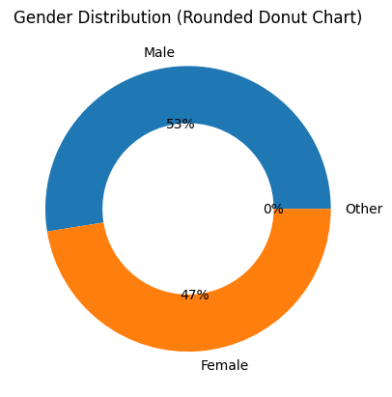
Figure 2: Gender of respondent
From Figure 2, we can see that 52.5% of the respondents were male, whereas 47.5% identified as female. No responses were made under the ‘Other’ category. The gender distribution shows a fair and balanced distribution with a slight majority of male respondents.

Figure 3: Income Distribution
From Figure 3, we can conclude that 57.6% respondents earn less than ₹20,000 per month, followed by the income group of 20,001 to 40,000 with a percentage of 20.30%, whereas 10.2% of respondents are from the income group of above 80,000, 6.8% people from 40,001 to 60,000, and 5.10% respondents who earn 60,000 to 80,000. It can be concluded that majority of the respondents are from lower income group.
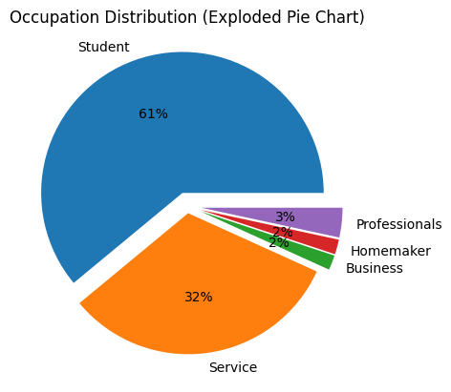
Figure 4: Occupation Distribution
From Figure 4 we can note that maximum number of respondents (61%) are students. Followed by service sector including Government and private job holders (32.2%) , while very few are businesspersons, homemakers etc. Therefore, it can be concluded that students form the largest group then followed by employed individuals.

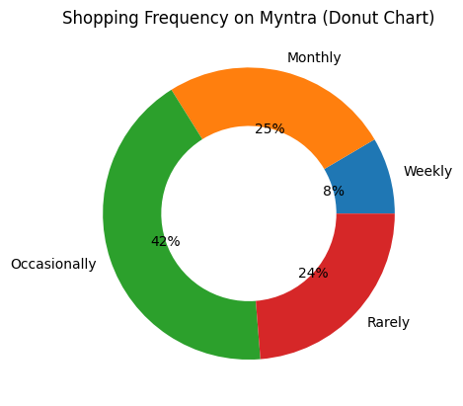
Figure 5: Shopping Frequency
From figure 5 we can conclude that 42.4%of the respondents shop on Myntra occasionally, making it the most common shopping pattern. Approximately the same number of people shop monthly (25.4%) or rarely (23.7%), while a small percentage shop every week. This shows that although many people use Myntra, they generally shop on the platform infrequently or once in a while.

Figure 6: Product Category Preferences of Myntra Consumers
In figure 6 see that 84.7% of the respondents mainly buy clothing on Myntra, thereby making it one of the most popular categories. 42.4% of them purchase footwear and some (33.3%) buy accessories, while a few (21.1%) people shop for beauty products and a very small number buy other items. It can be concluded that clothing is the top choice, followed by footwear and accessories.

Figure 7 : Sales vs Regular Day Purchase
In figure 7 we see that out of 57 respondents, around 64.4% prefer shopping during sales such as End of Reason Sale, Big Billion Days, etc. and 35.6% shop on normal days. So we can say that majority of Myntra users make their purchases during promotional or discount events and relatively less on regular days.

Figure 8: Key Motivations for Shopping

Figure 8 shows’37.3% of the respondents are motivated to shop on Myntra because they are satisfied by good product quality that Myntra offers. Also, 23.7% of them are also influenced by discounts and offers, while some prefer easy returns, brand variety, and convenience. Hence, it can be concluded the buyer are mainly influenced by quality and price-related benefits.

Figure 9: Influence of Reviews on Buying Behavior
In figure 9 we see that the majority (47.5%) of respondents believe that product ratings and reviews are very important when making a purchase decision. 10.2% number of respondents gave neutral importance to product rating and review while only a few respondents rated them as less important. Hence we can say that ratings and reviews strongly influence customers’ buying decisions.

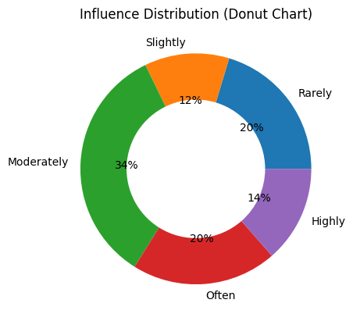
Figure 10: Influence Distribution
In figure 10, the data collected shows that 33.9% of the reported respondents are moderately influenced by Myntra’s advertisements and social media promotions. Meanwhile, 20.3% each indicated often and rare influence, and 13.6% selected the option of highly, and 20.3% selected rarely influence. Overall, this suggests that there is a moderate influence of Myntra’s advertisement on buyers.

Figure 11: Payment Mode
Figure 11 shows that 54.2% of the respondent prefer using UPI/Wallets, 35.6% opt for Cash on Delivery (COD), 8.5% use Debit/Credit Cards and only 1.7% opt for EMI. This shows that digital payments are the most preferred mode among Myntra users, followed by cash-based options, card and EMI options are used by a few.

Figure 12: Return and Exchange Satisfaction
Figure 12 shows that around 32.2% were very satisfied with the return and exchange policy and another 32.2% were satisfied, while 25.4% gave a neutral. A smaller share, 8.5% and 1.7%, rated their experience as very dissatisfied and dissatisfied, respectively. A majority of respondents showed a high level of satisfaction with Myntra’s return and exchange policy, while only a few expressed dissatisfaction.

Figure 13: Effect of Delivery and Packaging on Buying Behavior
From Figure 13, we can conclude that about 30.5% of the respondent agree that delivery and packaging influence their buying behavior and 28.8% strongly agree that delivery speed and packaging factor influence their buying behavior, while 25.4% gave a neutral rating. A smaller proportion, 10.2% and 5.1%, rated that they are not much influenced by the delivery factor. This indicates that most of the respondents are highly influenced by the speed of delivery and the packaging factor.

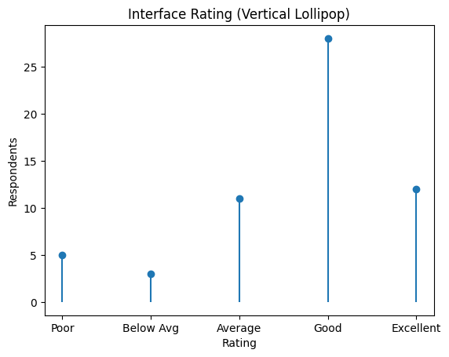
Figure 14: Interface Rating
From Figure 14, we conclude that 47.5% of the respondents rated Myntra’s app/website interface as good and 20.3% as excellent, while 18.6% gave an average rating. And a smaller share, 8.5% and 5.1%, rated it poor and below average respectively. Hence, we can say that the majority of respondents (68%) note that the interface is good or excellent, showing a generally positive user experience.

Figure 15: Customer Retention Likelihood
From Figure 15, we can conclude that out of 59 respondents, 37.3% rated that they are likely to continue shopping on Myntra and 30.5% rated that they are very likely to continue with Myntra while 20.3% remained neutral. A smaller share of 8.5% and 3.4%, rated them as not likely and slightly likely respectively, to continue with Myntra. Overall, around 68% of respondents showed a positive intention to continue shopping on Myntra.

Figure 16: Myntra vs Competitors-Value Comparison
From Figure 16, we can conclude that 32.2% believe that Myntra offers better value over other platform, 23.7% feel that Myntra does not provide better value when compared with others and 44.1% remained uncertain. This indicates mixed opinions, pointing out that the largest group remains undecided, while a smaller share clearly views that Myntra is offering better value.
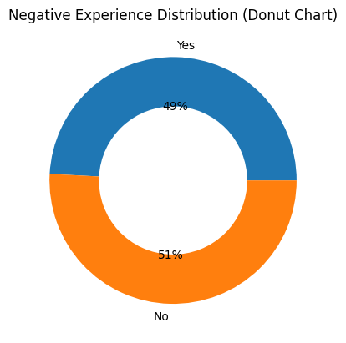
Figure 17: Negative Distribution
Figure 17 shows that 49.2% of the respondents reported that they had negative experiences such as wrong product delivery, delays, or refund issues, while 50.8% did not face any problems. This suggests that although a slight majority had a smooth shopping experience, a significant portion still faced issues.
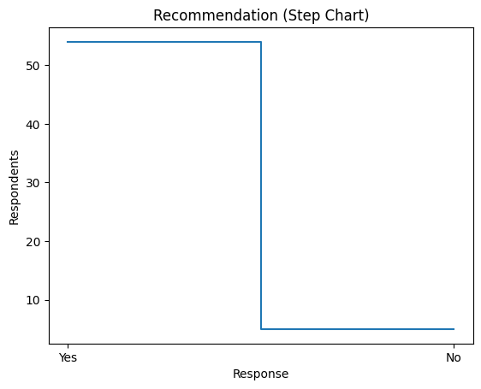
Figure 18: Recommendation to other

From figure 18, we can conclude that 91.5% of the respondents said that they would recommend Myntra to others, while only a small number of respondents (8.5%) said they would not. So we can conclude that most of the users are willing to promote Myntra through word-of-mouth publicity.
RECOMMENDATIONS FOR PLATFORMS
Based on the outcome from this study on consumer buying behavior, Myntra should primarily focus on improving the key factors that influence buying decisions. Quantity and authenticity of the product must be prioritized by strict seller control, as this is one of the critical factors that affect buying decisions. Improving the review and ratings by promoting verified feedback and filtering misleading content can help in building trust among customers. Additionally, efficiently using artificial intelligence for personal recommendations and improving pricing strategies by providing discounts can boost engagement on the application. Myntra should also enhance delivery service by reducing delays and errors, simplifying the return and refund process, and improving package quantity to ensure a hassle-free consumer experience.
Moreover, continuous upgrading of apps and website interface is done to enhance user experience. To address the issue of infrequent shopping, Myntra should come up with loyalty program, reward system, and timely notifications to promote repeated purchases. At the same time, improving its value proposition in comparison to Amazon and Flipkart and addressing negative customer experience through fast grievance handling.
LIMITATIONS OF THE STUDY
Sample size: The results reflect only a localized perspective as opposed to a general perspective for the whole nation with 59 participants.
Age bias: There is a very high proportion of participants in the age range of 18–24, making it difficult to determine the interaction between middle-aged and older people who control the budget within households.
Self-reporting bias: Participants might believe that they are rational individuals; hence, there could be some tendency towards underreporting any impulsive behavior.
CONCLUSION
We can conclude from study that Myntra is popular among young consumer, especially students and individuals from the lower-income group, who mostly shop occasionally. Clothing is one of the most purchased categories, followed by footwear and accessories, which points out that Myntra has strong positioning in a fashion-focused platform. The findings also highlight that product quality, discount, price and customer reviews are the most influential factors. Shopping spikes during sales, while features like hassle-free delivery, user-friendly interface, and secure digital payment options contribute positively to the overall shopping experience. Although advertisements and social media have a significant impact, ratings and reviews play a crucial role in trust-building of customers
REFERENCES
Chaturvedi, D. S., & Gupta, D. S. (2014). Effect of social media on online shopping behaviour of apparels in Jaipur city-an Analytical Review. Available at SSRN 3204970.
Tyagi, A. A study on customer satisfaction with reference to myntra.
Thakur, A. (2021). A STUDY ON CONSUMER BEHAVIOURAL ANALYSIS OF ONLINE SHOPPING TRENDS IN INDIA. International Journal on Customer Relations, 9(1), 28-38.
Kumari, S., & Singh, V. A study of consumer buying behaviour towards myntra online shopping. agamya 2022, 346.
Chodisetty, D. R. C. M., & Sreekanth, M. S. (2022). The Role of Consumer Behaviour Towards Online Shopping--An Empirical Evidence of Amazon, Flipkart., E-Bay, Myntra. The International journal of analytical and experimental modal analysis, 0886-936.
Ota, R., Ray, S. S., & Kumari, M. K. A Study of the Buying Behaviour of the Customers towards Online Shopping: A Special Reference to Myntra. Journal homepage: www. ijrpr. com ISSN, 2582, 7421.
Saxena, M. S. (2022). ONLINE SHOPPING BEHAVIOR OF FEMALES FOR APPARELS IN INDIA. Digitalization, Innovation Transformation and Sustainability in Business Management and Social Sciences, 102, 102-111.
Patra, M. N., Mitra, L., & Das, S. K. A COMPARATIVE STUDY OF ONLINE SHOPPING CONSUMER PERCEPTION ON MYNTRA, FLIPKART, AND AMAZON. DIGITAL TRANSFORMATION IN EMERGING BUSINESS ENVIRONMENT, 224.
Udupa, A. R., & Nagoji, S. (2023). A Study on Consumer Behaviour towards Online Apparel Shopping. Modern Research in Consumer Behaviour and Marketing Research, 68.
Gaur, M. H., & Singh, P. Analyzing Consumer Buying Behavior on Myntra: A Study of Online Shopping Trends.

