DESIGN, AND MANUFACTURING OF MULTI-CEREAL CROP THRESHER
Abdurehman Sultan and Abebe Fenta (PhD)
Bako Agricultural Engineering Research Center, Oromia Agricultural Research Institute, Addis Ababa, Ethiopia
P.O.Box 07, Bako, West Shoa, Ethiopia, E-mail: abdysultan4@gmail.com

ABSTRACT
Ethiopia has a diversified agro-ecology, which makes the production of a wide range of cereal crops possible. The major cereal crops are produced almost in all regions of the country though there are variations in volume. Threshing is a key part of cereals processing that involves removing the grains from crop plants, and from crop parts such as chaff, straw and stalk. In Ethiopia, cereal crops are threshed by beating with sticks manually that require large amount of hard labor accompanied with drudgery or by trampling under animal hooves. In this study, a mechanical multi-cereal crops thresher was designed, manufactured to solve the above problem..
Key words: cereal crops, multi-crop thresher, threshing efficiency, cylinder speed, feed rate, fuel consumption.

1. INTRODUCTION

1.1. Background
Ethiopia has a diversified agro-ecology , which makes the production of a wide range of cereal crops possible (Wondmagn, 2020). The major cereal crops are produced almost in all regions of the country though there are variations in volume (CSA, 2020).
The major cereal grains processing operations are threshing, cleaning, drying, storing, and milling. For the farmers to maximize profit from their cereal crops, appropriate technologies that suites their needs must be made available. Proper processing of agricultural products not only prolongs the useful life of these products, but increases the net profit to farmers, and one of the most important processing operations done to improve quality of cereal crops is shelling or threshing (Oriaku et al., 2014).
Threshing is physicomechanically detaching the grain from the head or ear of a plant. Threshing can be performed using different methods. In the case of smallholder farms, threshing is done manually or using farm animals. Manual threshing that involves the use of hands and simple tools. Manual method of threshing requires a large amount of hard physical labor. The easiest way in manual threshing is beating the crop with sticks or a hinged flail while it is spread on the ground. Animals are also used to trample cereal crops spread on ground to release grains (FAO, 2012).
Threshing can be accomplished by impact from fast moving element too (Samuel et al., 2015). It is important to avoid damage of grains during threshing, which is a challenging task under certain crop conditions. Whatever the case be, grain losses, contamination with dirt and dust, excessive time requirement, and loss on produce quality are the phenomena with traditional methods of threshing, as a result, different research centers, regional and federal, have designed, manufactured, tested and evaluated the performance of a number of stationary multi-cereal crops threshers. The multi-cereal crop threshers were highly successful in threshing cereal crops with similar/identical physicomechanical properties such as size, shape and strength.
The advantage of multi-cereal crop threshers is that with minor adjustments they can be used to thresh different cereal crops like wheat, oat and barley. Whereas, other types of threshers can thresh a single cereal crop only, though farmers want all in one. An improved mechanical thresher for multi-cereal crops would improve timelines of operation and reduce threshing related losses.
Even though, efforts were made to design, manufacture, test and evaluate performances, and release multi-cereal crop threshers, most of them cannot thresh efficiently and effectively more than two types of cereal crops with different physicomechanical properties such as maize and wheat. This was due to lack of provisions to make all the necessary alterations and adjustments to suit different crops with different physicomechanical properties (Samuel et,al., 2015).
Hence, this MSc thesis research is meant to design, manufacture, test and evaluate the performance of diesel engine driven multi-cereal crop thresher with minimum adjustment requirements.

2. MATERIALS AND METHODS

2.1. Description of Study Area
The manufacturing of the thresher was done at Bako Agricultural Engineering Research Center (BAERC), which is located in West Shewa Zone at about 245 km from the capital, Addis Ababa. The Center lies between 9⁰ 04ꞌ 45ꞌꞌ and 9⁰ 07ꞌ 15ꞌꞌ N latitudes and 37⁰ 02ꞌ and 37⁰ 07ꞌ E longitude in sub-humid agro-ecological zone. The mean minimum and maximum air temperatures are 13.20⁰C and 27.90⁰C, respectively.

Figure 1. Map of study area

2.2. Materials and Instruments
Sheet metal, deformed bar, bolts and nuts, bearings, diesel engine, belts, pulleys, flat iron, angle iron, and steel shaft were used to manufacture the component parts of the prototype thresher.
Wheat, barley and maize crops were used for performance evaluation of the prototype thresher. The following measuring instruments and raw materials were used for determination of physicomechanical properties of the crop grains and performance evaluation of the prototype thresher depending on their application, which are described in Table 1.
Table 1. Instruments depending their application
No | Instruments | Model | Precision | Application
1 | Stop watch | - | - | Used to measure duration of test run.
2 | Measuring caliper | Starrett | 0.02 mm | Used to measure the diameters of grains.
3 | Digital balance and suspended balance | Kerroo | 0.05 gm | Used to measure mass of samples.
4 | Tachometer | G-Tech 2236C | 0.50 with 1.00 Accuracy | Used to measuring the revolution per minute of the engine and power transmitting shaft.
5 | Moisture meter | Faithful | 0.05 | Used to measure the moisture content grains.
6 | Measuring cylinder | - | 10.00 ml | Used to measure fuel consumption of engine.
7 | Digital anemometer (GM) | 435 (testo B.V) | 0.50 m/s | To measure the air speed from the fan.

3.3. Determination of Physicomechanical Properties of the Crops
The physicomechanical properties of experimental grains and/or plants such as moisture content, size, geometric mean diameter, shape/sphericity, bulk density, angle of repose, coefficients of friction, and mean ratio of grain-straw and grain-cob were determined using appropriate devices and adopting established procedures.

2.3.1. Determination of grains moisture content
Moisture contents of grains were determined using digital grain moisture meter with accuracy of 0.05, which is made in Poland.

2.3.2. Grain-straw ratio
Grain-straw/cob ratio was determined using randomly taken three samples for wheat and barley crop, weighing approximately 1.00 kg each. The samples were separately placed in a container, threshed, grain and straw separated and weighed. Unshelled maize was randomly selected, shelled manually and weighed separately the kernel and cob to calculate the ratio. The ratio was calculated using Eqn. (1)
$$G_{sr}=\frac{\text{ weight of grain from the sample" }(\text{kg }) }{\text{weight of straw from the sample }(\text{kg }) } (\text{1})$$

2.3.3. Size and shape of the grains
To determine the grains sizes, three perpendicular diameters, i.e. major, intermediate and minor diameters of each grain, were measured using a digital caliper. From the major diameter (L), intermediate diameter (W) and minor diameter (T) the geometric mean diameter was calculated using Eqn. (2) (Garnayak, 2008).
$$G_{d}=\sqrt[3]{L xWxT} (2)$$
where:
G_{d} = geometric mean diameter (cm);
L = major diameter a of grain (cm);
W = intermediate diameter of a grain (cm); and
T = minor diameter of a grain (cm).
The sphericity was determined from Eqn. (3).
$$φ=\frac{G_{d}}{L} (3)$$
where:
φ = Sphericity;
G_{d} = geometric mean diameter (cm) and
L = seeds major diameter (cm).

2.3.4. Bulk Density of crops grain
The bulk density of the grains was determined using the mass/volume relationship. This was achieved by filling an empty plastic container of a predetermined volume (500 cm³), The bulk density was determined from Eqn. (4) given by Ghasemi et al., (2008).

$$ρ=\frac{M}{V} (4)$$
where:
ρ = density (kg/m³);
M = mass of the sample (kg;) and
V = volume of the sample (m³).

2.3.6. Angle of repose of the seed
The angle of repose (θ) was determined using an open-ended cylinder made of sheet metal with diameter of 15.00 cm and height of 25.00 cm The cylinder was placed on a wooden leveled table, filled with grains. Then the cylinder was raised gently until grains formed a conical heap. The diameter and height of the cone were measured and recorded. The angle of repose (θ) was calculated using Eqn. (5), (Ozturk et al., 2016).
$θ=\tan^{−1}{2H}/D] (5)$
where:
θ = angle of repose (degree);
H = the vertical height of conical heap of grains (cm); and
D = the diameter of the cone base (cm).
2.3.7. Coefficient of friction of the grains
The coefficients of friction on material surfaces were determined by placing a box with rectangular cross-section and filled with grains on mild steel metal. Then, one end mild steel gently lofted until the box began to slide. The angle (α) at which the grains start to slip on the metal sheet surface was measured, and tangent of the same angle was taken as coefficient of friction between the mild steel metal and grains
The measured and calculated values of the physicomechanical properties were used in the design and analysis of threshing mechanisms, clearances, separation and cleaning units, grain outlet chutes and power requirement.

2.4. Component parts of the Thresher
The prototype multi-cereal crops thresher has threshing cylinder, concave, feeding hopper, chaff/cob outlet, top and bottom covers, blower, blower housing, shafts, bearings, sieve, engine, engine seat, frame and power transmission system (pulleys and belts). The threshing cylinder is placed above the concave where it rotates and threshes the crops by impact action. Figure 2 and Figure 3.
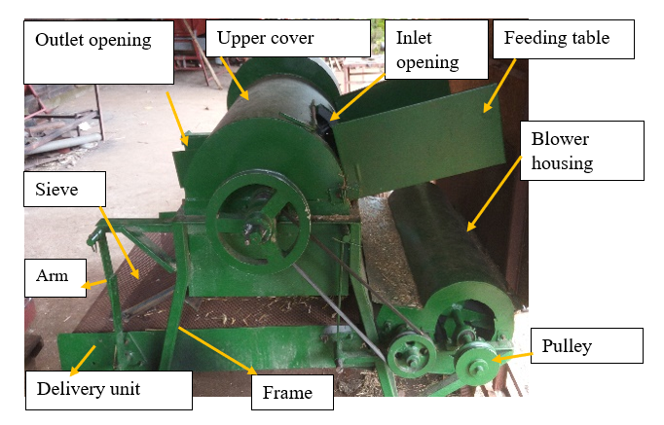
Figure 2. Prototype multi-crop threshing machine

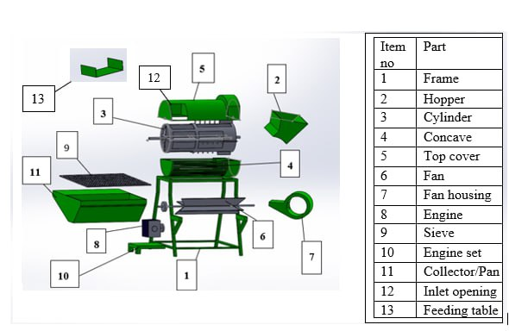
Figure 3. Exploded view of the proposed thresher

2.4.1. Design of the thresher
To fulfill functional requirements of the thresher, such as threshing, high throughput, separating, cleaning, reduced grain damage, maintain grain quality (grains being free of contamination) high recovery of grain with minimum threshing and cleaning loss. The design analysis and selection of appropriate manufacturing materials for fabrication of the component parts were conducted.

2.4.2. Frame
To ease operation and provide comfort to an operator, the height of the thresher was decided on basis of anthropometric measurements of the potential operators. The standard minimum ratio of top and bottom lengths of a trapezoidal frame is given in Eqn. (6), (Shigley , 1980).
$$L_{1}\text{/}{\text{L}}_{2}\text{ = 0.5 }(6)$$
where:
L₁ = bottom length of the frame (cm); and
L₂ = top length of the frame (cm).

The frame has a trapezium shape wide at the bottom, 45.00 by 85.00 by 90.00 cm, made out of 3.00 cm by 3.00 cm x 0.30 cm square hollow section (SHS) (Figure 4). Angle iron, 4.00 by 4.00 cm and 0.40 cm thick was welded across all the members to make frame rigid. The frame has a provision to accommodate the blower assembly.
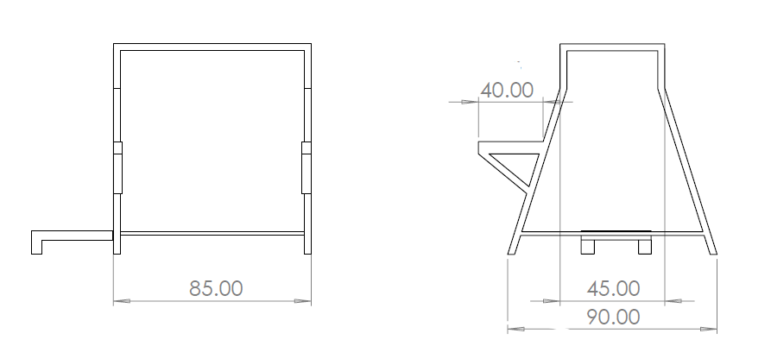
- (b)
Figure 4. Orthographic views of the thresher frame (a) front and (b) side view (all dimensions are in cm)

2.4.3. Hopper design
The hopper is fastened temporarily at the inlet opening on the side of the top cover. The hopper was made of mild steel sheet metal with 0.15 cm in thickness. The size of the hopper is determined using maximum volume desired and average bulk density of the maize. The inclination of the hopper was designed based on the average angle of repose and coefficient of friction between the crop and hopper material as shown in Figure 5. The volume of the trapezoidal shaped feeding hopper is determined using Eqn. (7).
$V_{AT}=\frac{1}{2} (\text{a+b})\text{ x h x L }(\text{ 7})$
where:
V_{AT} = volume of trapezoidal hopper (m³);
h = height of the hopper (0.30 m);
a = base width (0.20 m);
b = top width of hopper (0.40 m) and
L= length of the hopper (0.40 m).
V_{AT} =0.04 m³
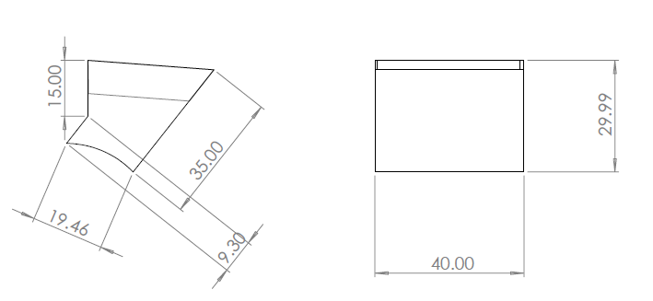
- (b)
Figure 5. Orthographic views of the Hopper (a) side view and (b) front view (all dimensions are in cm)

2.4.4. Feeding table
Feeding table was fastened temporary at the inlet opening of the threshing unit. It was used during threshing wheat and barley in order to facilitate continuous feeding of the harvested wheat and barley crops. The feeding table was made of mild steel sheet metal 0.15 cm thick, and has 65.00 cm width, 40.00 cm length and 20.00 cm side height as shown in Figure 6.
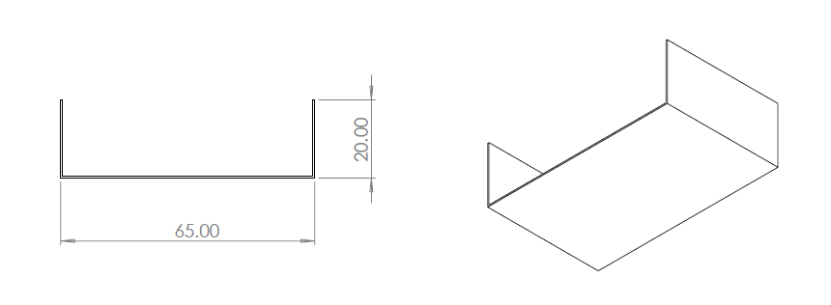
- (b)
Figure 6. Orthographic views of the feeding table (a) front view and (b) isometric view (all dimensions are in cm)

2.4.5. Cylinder design

3.4.5.1. Diameter of threshing cylinder
The diameter of the threshing cylinder was estimated using Eqn. (8)
$$Dc=\frac{Vc x 60.00}{π x Nc} (8)$$
where:
D_{c} = diameter of the threshing cylinder;
V_{c} = peripheral speed of threshing cylinder for spike tooth (16.00 – 25.00 m/s); and
N_{c} = rotational speed of threshing cylinder for spike tooth (675.00 – 1000.00 rpm) (Shekhar, 2020).
$$Dc=\frac{17.70 x 60.00}{3.14 x 1000.00}$$
= 33.80 cm

3.4.5.2. Length of threshing cylinder
The length of threshing cylinder was estimated using Eqn. (9) given by (Steponavicius et al ., 2017).
$$\text{Lc= }\frac{q}{Δ x μ x ρ x u } (\text{9})$$
where:
L_{c} = length of threshing cylinder (m);
q = material feed rate (7.00 kg/m);
Δ = thickness of plant material layer at the entrance in cm, and taken as 0.045 which is equals to the concave clearance at the entrance) (m);
$μ$ = coefficient of cylinder length utilization (0.70 - 0.80) (Shekhar, 2020);
ρ = bulk density of plant mass entering (20.00 – 40.00 kg/m³). ( Ref.Data book).(Kargbo , 2010); and
u = velocity of plant mass entering (3.00 – 6.00 m/s Databook).
The values of $μ,ρ$ and u were taken from (Varshney et al., 2004).
Based on Eqns. (8) and (9), an open cylinder with a length of 82.00 cm and diameter of 33.80 cm was selected to thresh the cereal crops. Concave and semi-cylindrical top cover house the cylinder. The cylinder has peg type beater along its 36.00 cm length, bars beater along its 32.00 cm length while the remaining 14.00 cm length is equipped with blades as shown in Figure 7.
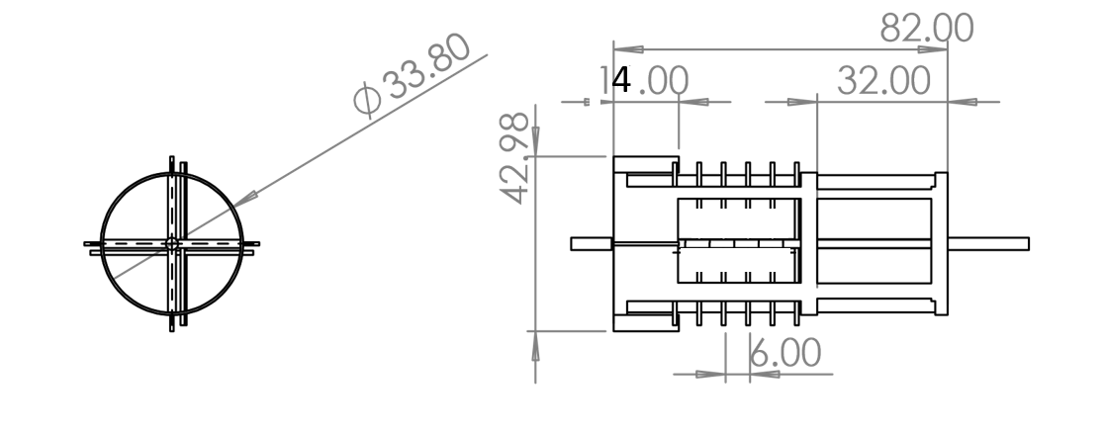
- (b)
Figure 7. Orthographic views of the cylinder (a) side view and (b) front view (all dimensions are in cm)
The pegs were made from round bars with the diameter of 1.00 cm and length of 5.00 cm. of the total length of each peg 3.00 cm directed to the housing and concave while the remaining 2.00 cm was extended to inside of the cylinder, and serve as chaff scupper at the outlet side to throw and blow chaff.

2.4.5.3. Weight of the cylinder
Was calculated by eqn.(36) as given by (Thet et al., 2019)
$Wc=W_{d+}W_{b+}W_{p }(36)$ .
where:
W_{d} = 14.7 N weight of blades and open discs on which bars are maintained (N);
W_{b} = 58.86 N weight of threshing bars (N); and
2W_{p} = 8.74 N weight of threshing pegs (N).

3.4.6. Determination of power requirement

3.4.6.1. Power required to turn unloaded cylinder
The power required to drive empty threshing cylinder shaft was obtained from Eqn. (11), (Abich , 2018).
$$Pc=\frac{2πNrM_{c}}{60 }\left[ g+\frac{V^{2}}{D}\right] (11)$$
where:
P_{C} = power required to drive unloaded cylinder;
N = cylinder speed (rpm);
D = diameter of the cylinder:
M_{c} = total mass of cylinder (kg);
r = effective radius of the pulley on cylinder shaft (m);
V = maximum peripheral velocity of the cylinder (m s⁻¹);
g = acceleration due to gravity (9.81 m s⁻²)
The mass of the threshing cylinder (M_{c}) was 8.39 kg with radius 17.00 cm. The power required to drive the shaft of unloaded cylinder was therefore determined as 3157.21 W.

2.4.6.2. The power required to overcome air resistance
$$P_{a}=K_{f}F_{r}V_{t}^{2} (12)$$
where:
Pa = power required to overcome air resistance;
K_{f} = constant which is equal to 0.06;
F_{r} = feed rates in Kg/hr.; and
V_{t} = peripheral velocity of the threshing cylinder (m/s).
Which gave 2.68 W.

2.4.6.3. Determination of power required to generate air current for cleaning
Equations (13) and (14) were used to estimate power required to generate air current within blower chamber.

$${ P}_{b}=P_{d}Q (13)$$
$$P_{d}=\frac{1}{2}ρV^{2} (14)$$
where:
P_{b} = power required generate air current;
P_{d}= dynamic pressure;
Q = volumetric air flow rate (0.30 m³/s);
ρ = air density at 23.00 degree Celsius (1.16 - 1.19 kg/m³); and
V = the velocity of the air in (m/s).
P_{b} = 35.14 W

2.4.6.4. Power required to operate the blower assembly only
$$P_{u}=\frac{2πN{rM}_{b}}{60}\left[g+\frac{v_{t}^{2}}{D}\right] (15)$$
where:
P_{u} = power required to drive blower assembly only
M_{b} = total mass of blower (kg);
r = effective radius of the pulley on blower shaft (mm);
D = diameter of the blower
V = maximum peripheral velocity of the fan (m s⁻¹); and
g = acceleration due to gravity (9.81 m s⁻²).
The mass of the blower (M_{b}) was 1.70 kg with radius 14.00 cm. The maximum blower shaft peripheral speed was 14.44 m s⁻¹. The power required to drive the shaft was therefore determined as 490.23 W.

2.4.6.5. Power required for shaking mechanism
The power was calculated using the Eqn. (16) as given by Joshi (1981).
$$Ps=\frac{W_{s}xNx2y}{60}+\frac{2u x N x W_{s} x 2x}{60} (16)$$
where:
W_{s} = weight of sieve component along with threshed material,0.4 kN (Sale et al., 2016).;
u = coefficient of friction of the moving component (0.25); and
x and y are horizontal and vertical displacement of the sieve, 6.00 mm
Gave 784.00 W for shaking mechanism.
3.4.6.6. Power to detach the grains:
$$Pg=1.5Ke\left[\frac{v_{g}^{\frac{3}{2}}f_{r}^{\frac{3}{2}}}{ρw l_{c}^{2}}\right] (17)$$
where:
Pg = power required to detach grains;
K_{e} = a constant (grain size characteristics 0.29) (Ndirika, 1997);
L_{c} = concave length (m);
V_{g} = speed of grain crop which is equal to peripheral cylinder velocity (recommended 28.00m/s);
f_{r} = feed rate (7.00 kg/min.); and
ρ_{w} = bulk density (20.00 – 40.00 kg/m³). ( Ref.Data book).(Kargbo , 2010).
P_{g} = 121.80 W

3.4.6.7. The total power Pt:
$$P_{t}=P_{c}+P_{u}+P_{b}+P_{d}+P_{g} (18)$$
= 4.59 kW
Divided the total power required by the transmission efficiency of 0.85 gave 5.40 kW.

2.4.7. Design of pulleys
For engine angular speed of 2300.00 rpm, the required maximum cylinder angular speed of 1100.00 rpm to thresh the crops, and the recommended diameter of a pulley, 120.00 mm, on the crank shaft of the prime mover, the diameters of pulleys on threshing cylinder, sieve crank and blower shafts were calculated using Eqn. (10).
$$N_{1}D_{1}=N_{2}D_{2} (10)$$
No. | Speed(rpm) | Diameter(cm) | Speed(rpm) | Diameter (cm)
1 | N₁ = 2300.00 | D₁ = 12.00 | N₂ = 1100.00 | D₂ = 25.00
2 | N₃ = 1100.00 | D₃ = 6.00 | N₄ = 325.00 | D₄ = 20.00
3 | N₅ = 2300.00 | D₅ = 6.00 | N₆ = 985.00 | D₆ = 14.00
where:
N₁ and N₅ = speed of prime mover (rpm);
N₂ and N₃ = speed of threshing cylinder shaft (rpm);
N₄ = speed of pulley on sieve crank shaft (rpm);
N₆ = speed of threshing blower shaft (rpm);
D₁ and D₅ = diameter of pulley on prime mover (cm);
D₂ and D₃ = diameter of pulley on threshing cylinder Shaft (cm);
D₄ = diameter of the pulley on the sieve crank shaft (cm) and
D₆ = diameter of pulley on blower shaft (cm).

2.4.8. Design of belt

3.4.8.1. Estimation of center distance
The center distance (C) between two pulleys must not be less than or equals twice the diameter of the larger pulley (D) (Merga et al., 2020) and give by the Eqn. (19).
$$\frac{(D+d)}{2}+d≤c≤2\left(D+d\right) (19)$$
Where:
C = center distance (cm);
D = diameters of larger pulley (cm); and
d = diameter of smaller pulley;

3.4.8.2. Estimation of belt length
Length of belt required to transmit power shall be calculated using Eqn. (20) as given by Khurmi and Gupta (2007).
$$L=2C+\frac{π}{2}\left(D_{1}+D_{2}\right)+\frac{{\left(D_{2}−D_{1}\right)}^{2}}{4C} (20)$$
where:
L = belt length (cm);
D₁ and D₂ = diameters of driving and driven pulleys (cm); and
C = center distance (cm);
The length of belts used between prime mover and cylinder shaft, cylinder shaft and sieve crank shaft and prime mover and blower shaft are 162.5, 122.05 and 87.97 cm respectively.

3.4.8.3. Determination of angle of the lap of the belts on pulley
To determine the angle of the lap (θ) of the belt on pulleys the Equations below were given by Khurmi and Gupta (2007).
$$ϴ=\left(180−2α\right) (21)$$
$$α=\sin^{−1}(\frac{D−d}{2C} ) (22)$$
where:
ϴ = angle of lap in (rad)
D = diameter of pulley on cylinder shaft (cm);
d = diameter of pulley on prime mover (cm) and
C = the distance between the Centre of the two pulleys (cm).
The angles of lap of the belts on smaller pulleys were 2.87, 2.78 and 2.86rad for belts, which connect prime mover pulley to cylinder shaft pulley, cylinder shaft pulley to sieve crankshaft pulley and prime mover pulley to blower shaft pulley respectively.

3.4.8.4. Power transmission design and selection of belts
The total power requires to run the prototype multi-crop thresher estimated earlier 4.59 kW excluding the power required to overcome transmission losses and power required to run the engine. Hence, power from engine to the cylinder is 4.59 kW. This power could be written as Eqn. (23)
$$P_{c}= \left(T_{1} – T_{2}\right)v_{c} ⥤ 4.59 = \left(T_{1} – T_{2}\right)v_{c} (23)$$
where:
P_{c} = power to cylinder (4.59kW);
T₁ = tension on the tight side (N);
T₂ = tension on the slack side (N) and
V_{c} = linear velocity of pulley on the cylinder shaft (14.39m/s).
Using the relationship between T₁ and T₂ the value of T₁ = 401.98 and T₂ = 83.01 likewise using power required to drive blower assembly and Power required for shaking mechanism the belt tensions were calculated.
$$p_{u}= \left(T_{3} – T_{4}\right)v_{u} (24)$$
where:
P_{u} = power required to drive blower assembly (490.00W);
T₃ = tension on the tight side (257.90N);
T₄ = tension on the slack side (189.94N) and
V_{u} = linear velocity of pulley on the blower shaft (7.21m/s).
$$p_{s}= \left(T_{5} – T_{6}\right)v_{s} (25)$$
where:
P_{s} = power required for shaking mechanism (784.00W);
T₅ = tension on the tight side (351.02N);
T₆ = tension on the slack side (116.97N) and
V_{s} = linear velocity of pulley on the blower shaft (3.35m/s).
To check whether the belt can withstand the tension we use Eqn. (26)
$${ T}_{max}=σ x A (26)$$
The cross-sectional area of the belt was calculated using Eqn. by Eqn. (27)
$$A= \left( \frac{b−x}{2} \right)t+tx (27)$$

where:
A = the cross-sectional area of the belt (cm²);
b = top width of the belt 1.70 in (cm);
x = bottom width of the belt = 1.40cm;
$σ$ = 2.8x10⁶ in (N/m²⁾
t = thickness of the belt (1.10 cm) and
Values of b, x, and are taken from IS: 2494-1974 standard for B type V- belt.
Gave T_{max} = 490.00 N

2.4.9. Design of the shaft

3.4.9.1. Shaft diameter size determination
The size of shaft was calculated using the Eqn. (28) American Society of Mechanical Engineering (Anon, 1985) as shown below.
$$d^{3}=\frac{16}{πS_{a}}\sqrt{(k_{b}M_{b})^{2}+(k_{t}M_{t})^{2} } (28)$$
where:
T = torsional moment of the shaft (Nm);
d = diameter of the shaft (m);
M_{b} = bending moment (Nm);
S_{a} = allowable stress (N/m²); and
K_{b} and K_{t} are the combined shock and fatigue factors for bending and torsional moments. Khurmi and Gupta, (2007).
Uniformly distributed load on shaft from weight of the cylinder, tension of the belt and concentrated load from pulley weights was considered as the forces acting on the shaft. It is to be noted that 𝑅o and 𝑅p are reactions at the bearings that are supporting shaft.
Total vertical force on cylinder pulley was determined as:
W_{c} = weight of pulley and belt + vertical tensions in belt
The v-belt was inclined 112° from horizontal to connect the pulleys on the engine and cylinder pulley 137° from horizontal to connect pulley on sieve crank shaft and cylinder pulleys as shown in Figure 8.
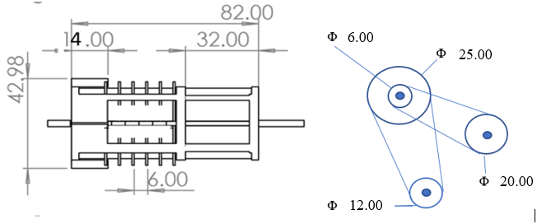
Figure 8. Layout of threshing cylinder pulley and belt integration (all dimensions are in cm)
All forces were resolved into horizontal and vertical direction; the vertical component forces were shown in Figure 9 below.
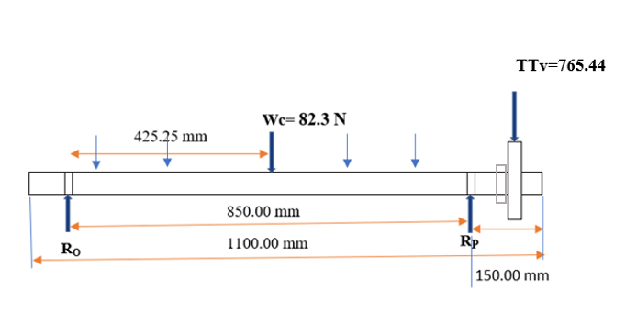
Figure 9. Free body diagram of the vertical force on the shaft of threshing cylinder

The determination of the values of reaction forces were done by taking the summation of moment at point O. gives Rpv =814.82 N and Rov = 32.92 N
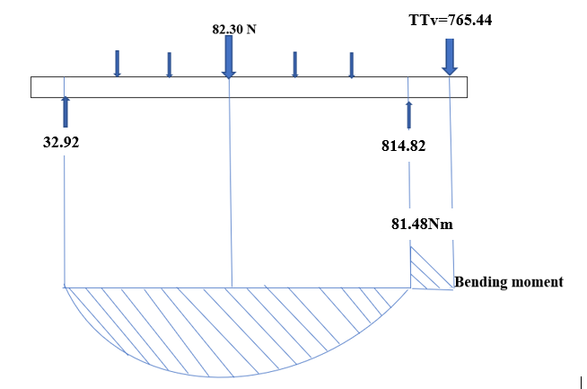
Figure 10. Bending moment diagram of vertical plane
Similarly, the forces were resolved in the horizontal direction to calculate the reaction forces at bearing. The free body diagram of the shaft is shown below in Figure 11.
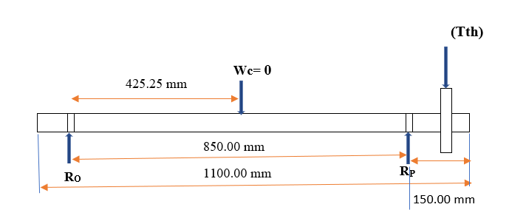
Figure 11. Free body diagram of the horizontal force on the shaft of threshing cylinder
where:
Tth = (T₁+T₂) cos 112⁰ + (T₃+T₄) cos 137⁰
The determination of the values of reaction forces were done by taking the summation of moment at point O and Rp = 565.94 N, Ro = 59.57 N
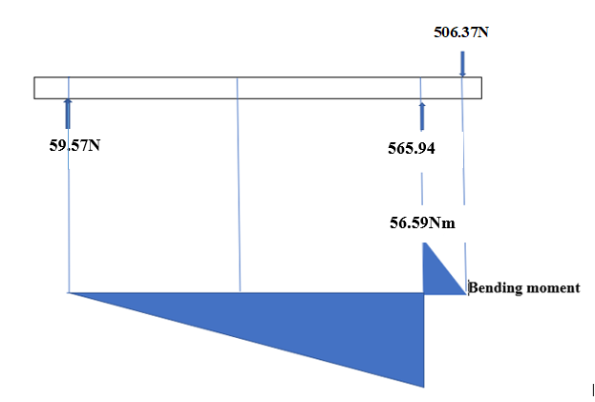

Figure 12. Bending moment diagram of horizontal plane

The torsional moment acting up on cylinder shaft can be calculated or is:
$$M_{t}=\left(T1−T2\right)x r (29)$$
M_{t} = 39.87 Nm
where:
T₁ = tension in tight side (401.98N);
T₂ = tension in slack side (83.01N); and
r = radius of the driven pulley (0.125 m).
The resultant maximum bending moments on the shaft can be determined using Eqn. (30)
$$M_{b}=\sqrt{{{(M_{h})}^{2}+(M_{v})}^{2}} (30)$$
$$M_{b}=\sqrt{{{\left(56.59\right)}^{2}+(81.48)}^{2}}$$
$$Mb=99.20 Nm$$
M_{t} = 39.87 Nm from Eqn. (29)
where:
M_{b} = resultant bending moments (Nm);
M_{v} = maximum bending moments on a vertical plane (Nm); and
M_{h} = maximum bending moments on the horizontal plane (Nm).
Then diameter of the shaft:
$$d^{3}=\frac{16}{πS_{a}}\sqrt{(k_{b}M_{b})^{2}+(k_{t}M_{t})^{2} } (34)$$
$$d^{3}=\frac{16}{{π x 40x10}^{6}}\sqrt{(1.5 x99.20+(1.5x39.87)^{2} }$$
d = 0.027 m, ⁓ 3.00 cm
where:
d = diameter of shaft (mm);
K_{b} and K_{t} are the combined shock and fatigue factors for bending and torsional moments and was taken as1.50 and 1.50 respectively as given by (Khurmi and Gupta, 2007)
Mb and Mt are the maximum bending and torsional moments in Nm. respectively; and
Sf = 40.00 MPa with key is the allowable stress in the shaft material.

2.4.9.2. Determination of shaft diameter for blower
Uniformly distributed load on shaft from weight of the blade, tension of the belt and concentrated load from pulley weights was considered as the forces acting on the shaft. It is to be noted that 𝑅o and 𝑅p are reactions at the bearings that are supporting shaft.
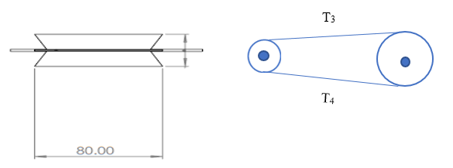
Figure 13. Layout of blower pulley and belt integration
All forces were resolved into horizontal and vertical direction; the vertical component forces were shown in Figure 14 below.
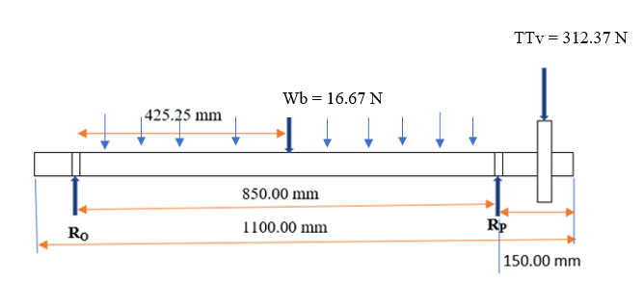
Figure 14. Free body diagram of the vertical force on the shaft of blower
The determination of the values of reaction forces were done by taking the summation of moment at point O. gives Rpv = 401.42 N and Rov = 18.13 N
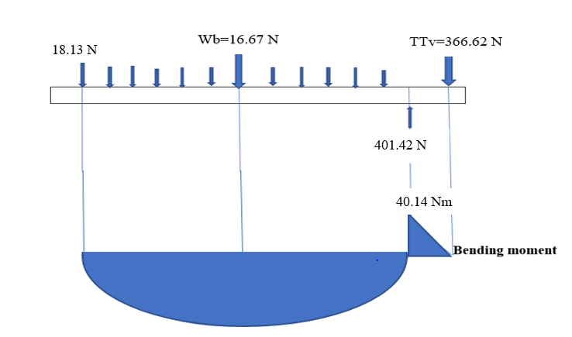
Figure 15. Bending moment diagram of vertical plane
Similarly, the forces were resolved in the horizontal direction to calculate the reaction forces at bearing. The free body diagram of the shaft is shown below in Figure 16.
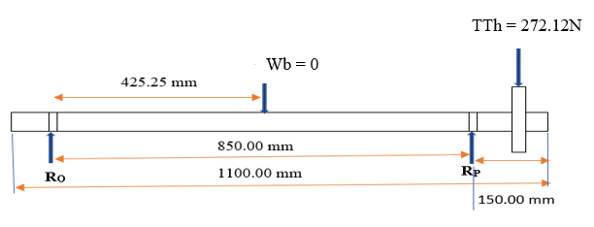
Figure 16. Free body diagram of the horizontal force on the shaft of blower
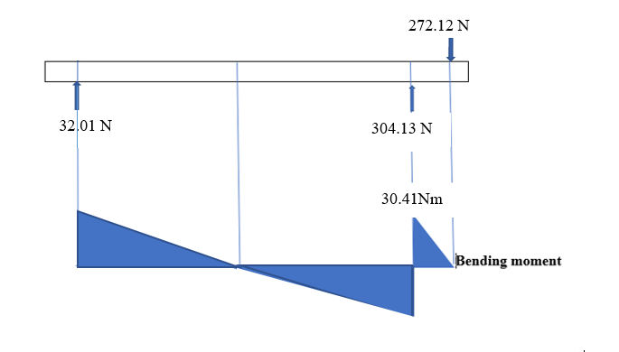
Figure 17. Bending moment diagram of horizontal plane
The resultant maximum bending moments on the shaft was
$$Mb=\sqrt{{{(Mh)}^{2}+(Mv)}^{2}}$$
Mb = 50.35 Nm
Mt = (T3-T4) x 0.07m
Mt = 4.75 Nm
Then diameter of the shaft:
$$d^{3}=\frac{16}{πS_{a}}\sqrt{(k_{b}M_{b})^{2}+(k_{t}M_{t})^{2} }$$
d = 0.021⁓2.5 cm

2.4.9.3. Determination of shaft diameter for sieve
Uniformly distributed load on shaft from weight of the grain delivery unit, tension of the belt and concentrated load from pulley weights was considered as the forces acting on the shaft. It is to be noted that 𝑅o and 𝑅p are reactions at the bearings that are supporting shaft.
All forces were resolved into horizontal and vertical direction; the vertical component forces were shown in Figure 19 below.
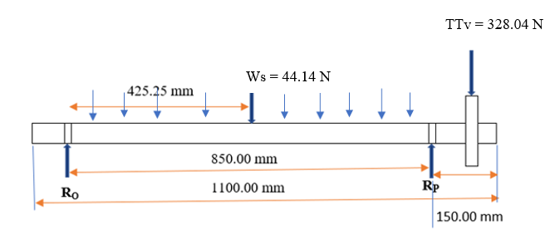
Figure 18. Free body diagram of the vertical force on the shaft of sieve
The determination of the values of reaction forces were done by taking the summation of moment at point O. gives Rpv = 344.56 N and Rov = 27.62 N
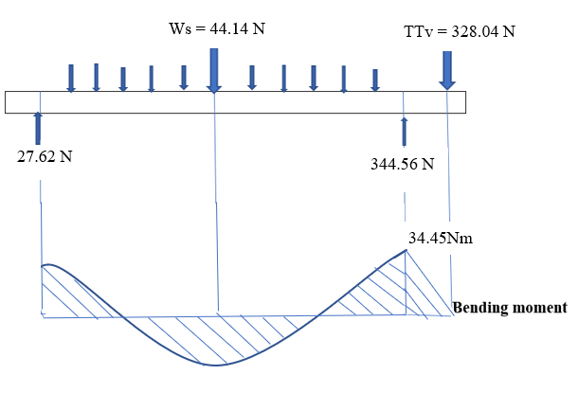
Figure 19. Bending moment diagram of vertical plane

Similarly, the forces were resolved in the horizontal direction to calculate the reaction forces at bearing. The free body diagram of the shaft is shown below in Figure 20.
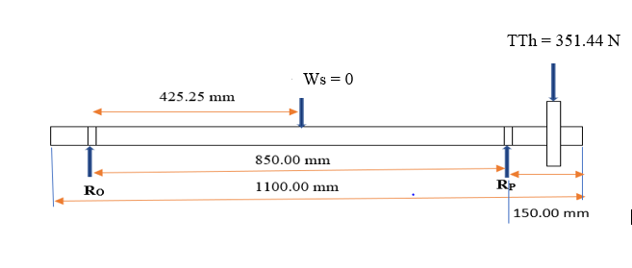
Figure 20. Free body diagram of the horizontal force on the shaft sieve
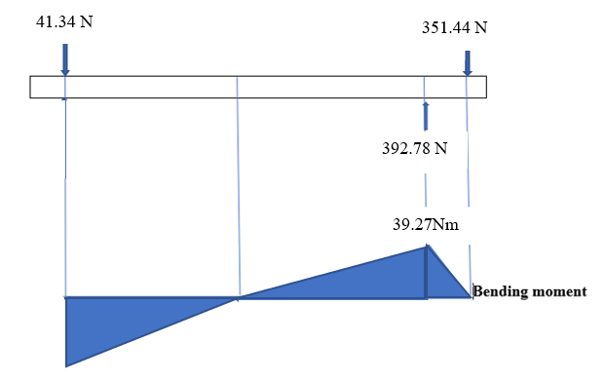
Figure 21. Bending moment diagram of horizontal plane
The resultant maximum bending moments on the shaft was
$$Mb=\sqrt{{{(Mh)}^{2}+(Mv)}^{2}}$$
Mb = 52.23 Nm
Mt= (T₅-T₆) x 0.10
Mt = 23.40 Nm
Then diameter of the shaft:
$$d^{3}=\frac{16}{πS_{a}}\sqrt{(k_{b}M_{b})^{2}+(k_{t}M_{t})^{2} }$$
d = 0.022⁓2.5 cm
2.4.9.4. Shaft rigidity
The diameter of the shaft is determined based on the prescribed value of the limiting angle of twist, θ. According to (Hall et al., 1980), the amount of permissible twist depends on the type of load applied and varies between 0.3 degree per meter for a machine tool shaft to about 3 degree per meter for line shafting.
The permissible angle of twist, θ, caused by torque on the shaft for the solid shaft was given by:
$$θ=\frac{T L}{Gd^{4}} (35)$$
where:
θ = Angle of twist (degree);
T = torsional moment (39.87 Nm);
L = length of the shaft (1.1 m);
G = modulus of rigidity (84GPa); and
d = diameter of shaft (0.03 m).
θ = 0.64 degree/m, this value is within the recommended range of angular distortion.

2.4.10. Selection of the bearing
The selection of the bearing takes into the considerations the load capacity and the geometry of the bearing ensuring that it was installed conveniently in the machine. Ball bearing type was selected for all shafts. Bearing number 206.00 with 3.00 cm diameter, 6.20 cm outer diameter and 1.60 cm breadth and bearing number 205 with 2.50 cm diameter, 5.2 cm outer diameter and 1.5 c m breadth was selected. Since the minimum shaft diameter has been determined to be 3.00 cm for cylinder shaft and 2.50 cm for the blower and the sieve shaft respectively.

2.3.11. Concave
The concave was made of round bar of 0.10 cm diameter and angle iron for its frame, which was 0.30 cm * 3.00 cm * 3.00 cm angle iron, based on the size and shape of the grains A 1.60 cm by 1.80 aperture sieve between the round bar was provided to easily flow grains as shown in Figure 23.

3.4.5.1. The radius of curvature of the concave
The radius of curvature r_{c}, was determined using the following expression given by (Dangora, et al., 2006).
$$r_{c}\text{ = }r_{tc}\text{+} h_{p} \text{+} c_{c} (36)$$
$$r_{c}\text{ =}\text{17.00 cm} \text{+} \text{3}\text{.}\text{0}\text{0 }\text{cm} \text{+}\text{ 3.00 cm }$$
$$r_{c}\text{ =}\text{23}\text{.}\text{0}\text{0}\text{ cm}$$
where:
r_{c} = radius of curvature (cm);
r_{tc} = radius of threshing cylinder (cm);
h_{p} =peg height above the cylinder (cm) and
C_{c} = average concave clearance (cm).

3.4.5.2. The length of concave arc
$Length of concave arc=rc x wrap angle of the concave (37$)
= 23.00 x (115⁰ x (π/180))
= 46.05 cm
where:
r_{c} = radius of the concave (cm);
wrap angle 30⁰ to 120⁰ recommended as (Kanofojski, 1976)
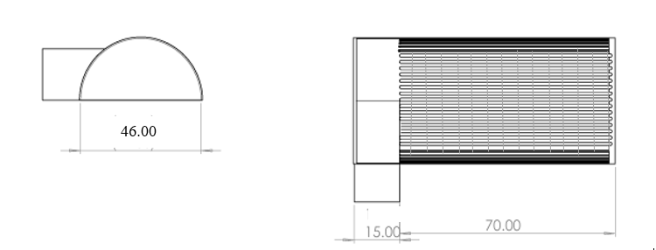
- (b)
Figure 22. Orthographic views of the concave (a) side view and (b) rear view (all dimension in cm)

2.4.12. Design of blower
The blower was manufactured from a sheet metal of 1.50 mm thickness as shown in Figure 25. Bosoi et al., (1991) indicated that the initial data required for the design of a fan are the mean velocity of air stream flow at its exit (C _{mean}), the volume flow rate (V). The volume flow rate of air required to make separation between grains and MoG was estimated using Eqn. (38).

$$V=\frac{G_{a}}{ρ} (38)$$
where:
V = volume flow rate (0.30 m³/s);
Ga = the mass flow rate of air (kg/s);
G_{m} = the quantity of material removed by the air stream per unit of time (kg/s);
$μ$ = coefficient of concentration 0.30 (Bosoi et al., 1991) and
ρ = density of air (1.17 kg/m³).
Grain to straw ration 1:0.82 for wheat taken, because wheat straw has highest bulk density as compared to barley according to (Koh et al., 2023)
GoG = 0.45 % of whole feed rate from grain straw ratio 1:0.82 so, 0.45 of 0.12 kg/s
$$v=\frac{G_{a}}{ρ } (39)$$
$$G_{a}=0.34 kg/s$$
$$G_{t}=G_{a}+GoG (40)$$

where:
G_{t} = total mass flow rate in kg/s;
G_{a} = mass of air in kg/s; and
G_{oG} = mass other than grain in (0.054 kg/s).
Total mass flow rate=0.38 kg/s+0.054 kg/s
Total mass flow rate = 0.40 kg/s

$$F=G_{t} xV_{t} x V_{ec} (41)$$
F = 0.40 kg/s x 14.15 m/s x 1.7
F = 9.62 N

where:
F = force required to lift the mass (N);
G_{t} = mass flow rate (kg/s);
V_{t} = terminal velocity of air =14.15 m/s
V_{ec} = excess velocity coefficient (1.1 to 1.7 Bosoi et al., 1991)
$$P_{t}=P_{s}+P_{d} (42)$$
where:
P_{t} = total pressure required in N/m²;
P_{s} = static pressure in N/m² and
P_{d} = dynamic pressure in N/m².
$$P_{s}=ρ x g x h (43)$$
P_{s} =1.225 x 0.31 x 9.81
P_{s} = 3.72 N/m²
$$P_{d}=0.5 x ρ x {Vt}^{2} (44)$$
$$P_{d}=0.5 x 1.16 x {14.15}^{2}$$
$$P_{d}= 116.13 N/ m^{2}$$
P_{t} = 3.72 +116.13
= 119.85 N/m²
Then, Area of the duct was calculated as follows:
$$A= \frac{F}{Pt} (45)$$
A = 0.08 m²
$$V_{s}= V_{f} x\frac{60}{A x W_{b}} (46)$$
W_{b} = 22.84 cm
where:
V_{s} = speed of the fan (rpm);
V_{f} = volume of the flow rate;
A = cross sectional area of duct; and
w = width of the of the duct.
Maximum fan speed is 1000 rpm Adane, (2004)
The length of the duct cross section:
$$L=\frac{A}{W} (47)$$
L = 0.36 the minimum length of the duct.
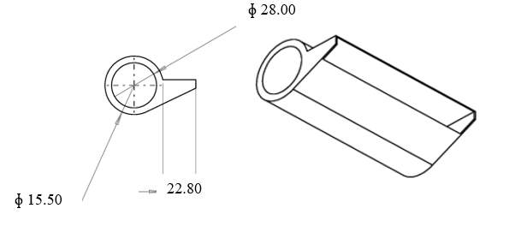
- (b)
Figure 23. Orthographic view of the fan housing (a) side view and (b) front view (all dimension in cm)

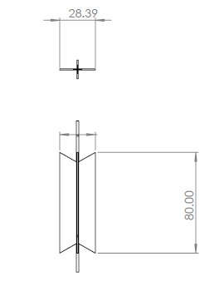
Figure 24. Orthographic view of the blower (a) side view and (b) front view (all dimension in cm)

3.4.13. Sieve and grain delivery
Sieves were made of perforated mild steel sheet metal with thickness of 2.00 mm which are easily available in the market with different openings diameters. which was 16.00 mm diameter opening for maize and 8.00 mm diameter for wheat and barley as shown in Figure 25 based on their major mean diameters. It was simply replacing while threshing its respective crop the maximum sieve oscillation was 5.40 cycle/sec depending on the shaft for the sieve motion. Hence, sieves can be selected depending on the physicomechanical properties of the crops. The grain delivery unit was made from mild steal sheet metal to collect threshed grain passed through the respective sieves.
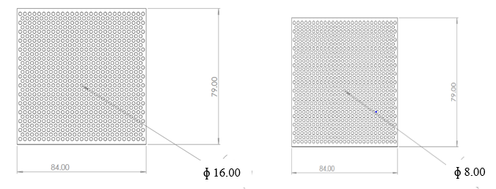
- (b)
Figure 25. Orthographic views of the sieves (a) maize sieve top view and (b) wheat/barley sieve top view (all dimensions are in cm)
The cleaning unit has one discharge chute and is oscillated by eccentricity mechanism using multiple linkage system. The grain delivery unit has a link mechanism with the frame, which performs a horizontal oscillating motion. It was done by eccentric mechanism and those sieves were adjusted to grain delivery unit while threshing respective crops as shown in Figure 26.

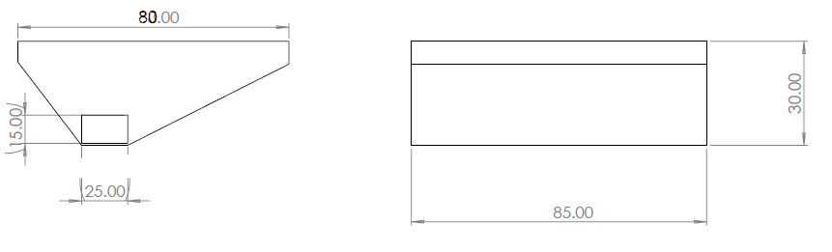
Figure 26. Orthographic view of grain delivery unit, (a) front view and (b) side view (all dimensions are in cm)

Physicomechanical Property of the Grains
The physicomechanical properties of the selected cereal were investigated, and the results are given in Table 3.
Table 3. Mean value of the physicomechanical properties of the grains and crops
Crop | NO | parameter | Mean value
Maize | 1 | Grain-Cob ratio | 1:0.90
 | 2 | Moisture content of grain (%) | 13.20
 | 3 | Mean major, intermediate and minor diameters respectively in mm | 10.50, 8.30 and 3.80
 | 4 | Geometric mean diameter (mm) | 6.92
 | 5 | Angle of repose (degree) | 35.00
 | 6 | Coefficient friction | 0.44
 | 7 | Sphericity | 0.56
Wheat | 1 | Grain-straw ratio | 1:0.82
 | 2 | Moisture content of grain (%) | 11.00
 | 3 | Mean major, intermediate and minor diameters respectively in (mm) | 6.80, 3.20 and 2.00
 | 4 | Geometric mean diameter (mm) | 3.50
 | 5 | Angle of repose(degree) | 26.00
 | 6 | Sphericity | 0.52
 | 8 | Coefficient friction | 0.45
Barley | 1 | Grain-straw ratio | 1:0.70
 | 2 | Moisture content of grain (%) | 10.00
 | 3 | Mean major, intermediate and minor diameters respectively in (mm) | 7.10,3.00 and 2.00
 | 4 | Geometric mean diameter (mm) | 3.47
 | 5 | Angle of repose(degree) | 29.00
 | 6 | Coefficient friction | 0.46
 | 7 | Sphericity | 0.49

Recommendations
Having designed, constructed and evaluated the multi-cereal crop thresher, the following recommendations are hereby given:
- Provide the thresher with properly designed and fabricated sucker to improve cleaning efficiency
- To maintain the uniformity of feeding the crop introduction of a feeding mechanism appears a must.
- Provide pneumatic wheels to ease transportation.

6. REFERENCES
Abaecherli, A. et al. (2004) ‘Industrial Crops and Products: Preface’, Industrial Crops and Products, 20(2), p. 119. Available at: https://doi.org/10.1016/j.indcrop.2004.04.014.
Abdeen, M.A. et al. (2022) ‘Longitudinal axial flow rice thresher feeding rate monitoring based on force sensing resistors’, Scientific Reports, 12(1), pp. 1–15. Available at: https://doi.org/10.1038/s41598-021-04675-w.
Abich Samuel Otieno (2018) ‘Optimization of Threshing Performance of a Spike Tooth’, Thesis Submitted to the Graduate School in Partial Fulfillment for the Requirements of Master of Science Degree in Agricultural Engineering of Egerton University, pp. 1–67.
Adane Kebede., 2004. Investigation into mechanics of grain cleaning and improvement of asella thresher. Unpublished MSc.Thesis, Haramaya University, Dire Dawa, Ethiopia.
Anon (1985) ‘Design of Transmission Shafting.’, American National Standards Institute, Standards [Preprint].
Aremu.D, adwemi . . and ijadunola . . (2015) ‘Design , Fabrication and Performance Evaluation of a Motorized Maize Design , Fabrication and Performance Evaluation of a Motorized Maize Shelling Machine’, (August).
ASME, 1995. Design of transmission shafting. American Society of Mechanical Engineering, New York,USA
Bedada, T. (2018) ‘Improvement of IITA Multi-crop Thresher for Sorghum Threshing’, International Journal of Pure and Applied Researches, 2(1), pp. 15–26.
Begum, F., 2018. Development and Testing of a Gherkin Grader. Master of Technology in Agricultural Engineering (Processing And Food Engineering), Acharya NG Ranga Agricultural University), 79.
Belay, D. and Fetene, M. (2021) ‘The Effect of Moisture Content on the Performance of Melkassa Multicrop Thresher in Some Cereal Crops’, Bioprocess Engineering, 5(1), p. 1. Available at: https://doi.org/10.11648/j.be.20210501.11.
Bosoi, E.S., O.V.Verniaev, I.I.Smirnov and E.G.Sultan-Shakh, 1991. Theory, Construction and Calculations of Agricultural Machines,Vol 2. Balkema, Rotterdam, Netherland
Central Statistical Agency ( CSA) (2020) ‘The Federa Democratic Republic of Ethiopia Report on Area and Production of Majr Crops’, I.
Dangora, N.D., Sulaiman, M.L. and Yusuf, D.D., 2006. Modification of IAR maize dehusker sheller for sorghum threshing. Proceeding of the Seven International Conference of Institute For Agricultural Engineers Vol. 28, No. 1, pp. 106-109..
FAO (2012) ‘Harvesting & Post-harvest processing’, 03/04/2012, p. 3. Available at: http://www.icco.org/about-cocoa/harvesting-and-post-harvest.html.
Hall, A. S., Hollwen, K. O. and Laughum, H, (1980). Schaum’s Outline of Theory and Problem of Machine Design. Metric Selection. Mcgraw-Hill Books Company. New York, USA.
Hannah, J. and Stephen R.C., 1984. Mechanic of Machine, 2nd Edition.Edward Arnold Publisher Ltd,London. p. 10-26
Ifeanyichukwu, V. and Ndirika, O. (2015) ‘Determination of selected physical properties and their relationships with moisture content for millet (Pennisetum glaucum L.)’, (March 2006). Available at: https://doi.org/10.13031/2013.20275.
Kanofojski (1976) ‘Newton’s law of cooling by Emad-Falih transform’, International Journal of Advances in Engineering and Management, 4(6), pp. 1515–1519.
Jorge Pinto , Daniel Cruz , Anabela Paiva , Sandra Pereira a , Pedro Tavares , Lisete Fernandes, H.V. (no date) Characterization of corn cob as a possible raw building material. Available at: https://doi.org/https://doi.org/10.1016/j.conbuildmat.2012.02.014.
Khan, M.R. et al. (2017) ‘MODIFICATION AND PERFORMANCE EVALUATION OF A WHEAT THRESHER, 5(65), May 2017’, 5(May), pp. 261–270.
Khurmi and Gupta (2007) ‘Climate-smart agriculture on small-scale farms: A systematic literature review’, Agronomy, 11(6). Available at: https://doi.org/10.3390/agronomy11061096.
Koh, C.H. et al. (2023) ‘Upcycling wheat and barley straws into sustainable thermal insulation: Assessment and treatment for durability’, Resources, Conservation and Recycling, 198(June), p. 107161. Available at: https://doi.org/10.1016/j.resconrec.2023.107161.
Kumar, A. (2017) ‘Performance Evaluation of Harvesting and Threshing Methods for Wheat Crop’, International Journal of Pure & Applied Bioscience, 5(2), pp. 604–611. Available at: https://doi.org/10.18782/2320-7051.2497.
Merga Workesa Dula (2016) ‘Development and Evaluation of Teff Threshing Machine’, International Journal of Engineering Research and, V5(11), pp. 420–429. Available at: https://doi.org/10.17577/ijertv5is110250.
Muna N.H. Muhammed, U.S., El-Okene, A.M. and Isiaka, M. (2016) ‘Perfomance Evaluation of a Modified I.A.R. Multicrop Thresher’, 7(11).
Ndirika, V.I.O. (1997) ‘MODELLING THE PERFORMANCE OF SELECTED STATIONARY GRAIN THRESHERS BY’, pp. 1–17.
Olaye, A. et al. (2016) ‘Effect of threshing drum speed and crop weight on paddy grain quality in axial-flow thresher (ASI)’, J. Multidisciplin. Eng. Sci. Technol, 3(January 2016), pp. 3716–3721.
Oriaku E C et al. (2014) ‘Design and Performance Evaluation of a Corn De-Cobbing and Separating Machine’, American Journal of Engineering Research (AJER), 03(06), pp. 127–136. Available at: www.ajer.org.
Ozturk, I., Kara, M., Yildiz, C. and Ercisli, S., 2009. Physico‐mechanical seed properties of the common Turkish bean (Phaseolus vulgaris) cultivars ‗Hinis‘ and ‗Ispir‘. New Zealand Journal of Crop and Horticultural Science, 37 (1), pp.41-50
S.K., T.R.K. and C. (2020) ‘Investigations on effect of cylinder configuration of rectangular spiked tooth thresher on threshing performance of wheat crop’.
Sale, N.A. et al. (2016) ‘An improved IAR sorghum thresher’, Agricultural Engineering International: CIGR Journal, 18(3), pp. 119–126.
Samuel Admassu, Bedaso T., Wondwossen T., Oumer T., Aberash T., M.K. and F.C.S. (2015) ‘Dissemination, Adoption and Impacts of Multi-Crop Threshers in Ethiopia: Experiences of Sasakawa Global 2000’, SASAKAWA AFRICA ASSOCIATION/SASAKAWA GLOBAL 2000-ETHIOPIA Research [Preprint], (04).
SEDARA, A., ODEDIRAN, E. and MANUWA, S. (2021) ‘Design and Fabrication of an Improved Motorized Maize Sheller/Threshing Machine’, Journal of Engineering Studies and Research, 26(4), pp. 120–131. Available at: https://doi.org/10.29081/jesr.v26i4.244.
Shekhar, K.S. (2020) ‘Design of the Components of A Stationary Power Thresher for Paddy Crop’, p. 27.
Shoaib, M. and Et, A. (2011) ‘QUANTITATIVE LOSSES AND PHYSICAL DAMAGE CAUSED TO WHEAT KERNEL ( TRITICUM AESTIVUM L .) BY KHAPRA BEETLE INFESTATION’, 43(1), pp. 659–668.
Simonyan, K. J. and Yiljep, Y.D. (2014) ‘Investigating Grain Separation and Cleaning Efficiency Distribution of a Conventional Stationary Rasp-bar Sorghum Thresher’, Agricultural Engineering International: the CIGR Ejournal, X(X), pp. 2–14.
Singh. S. and Pathak.B (1973) ‘Singh. S. and B. Pathak, 1973, Impact phenomena in threshing affected by different parameters, J. Agril. Engg.,10(2): 54-64’, 2(10), pp. 54–64.
Tekalign B .Araso et al. (2017) ‘Performance Evaluation of Jima Drum Replaceable Multi-Crop Thresher for Wheat and Barley Threshing Tekalign’, Proceedings of Review Workshop on Completed Research Activities of Agricultural Engineering Research Directorate, (December), pp. 61–69.
Tesfaye, T. and Befikadu, D. (2016) ‘Modification and Testing of Replaceable Drum Multi-Crop Thresher International Journal of Sciences : Modification and Testing of Replaceable Drum Multi-Crop Thresher’, (March).
Thet, W.W., Kyaw, S. and Sein, M.M. (2019) ‘Design of Threshing Cylinder for a Combine Paddy Harvester (KUBOTA)’, 3(4), pp. 178–184.
Timilsina, U.R., Roorkee, I.I.T. and Engineering, A. (2014) ‘Threshing Machines ( TM ) Threshing Machines ( TM )’.
Varshney A.C., Tiwari P.S., N. Suresh., Mehta C.R., 2004. DataBook For Agricultural Machinery Design. Central Institute of Agricultural Engineering, New Delhi, India.
Waree.k, dula. . and vas. T. (2016) ‘The effect of selected mechanical threshing parameters on kernel damage and threshability of Wheat. Canadian Agril. Engg., 11(2): 83-87’, 8(05), pp. 472–481.
Wondmagn, W. (2020) ‘Adaptation , Design and Fabrication of Multipurpose Threshing Machine’, DSpace Institution DSpace, Manufacturing Engineering http://dspace.org [Preprint]. Available at: http://hdl.handle.net/123456789/10857.
Zeleke, Z., Engida, D. and Bogale, D. (2023) ‘Design , Fabrication , and Performance Evaluation of Teff Cleaning Machine’, Journal of Research in Engineering and Applied Sciences, 08(03), pp. 558–565. Available at: https://doi.org/10.46565/jreas.202383558-565.

