“Translating Palace Architecture into Apparel: A Study of Visual Storytelling through Fashion Illustration and Textile Design”

Abstract
This research aims to explore the process of translating stories from historic buildings to the modern fashion, and how fashion can be utilized as an effective tool of visual narrative, particularly in regard to the rich, yet often ignored tales hidden in historic architecture. The focus will be laid on Indian palaces, including City Palace, Udaipur and Hawa Mahal as sources of inspiration for translating architecture into fashion through visual analysis of the elements present in such architecture, including jharokhas, arches, jaalis and other ornamentation features, as well as designing apparel. Through practice-based research, which involves visual analysis of the case study locations such as Mehrangarh Fort and Amer Fort, and developing clothing lines inspired by them, the connection between historic architecture and modern apparel will be established, and fashion identified as a way of communicating the historic heritage through a different form of art.
Keywords:
Historic Architecture, Fashion Design, Visual Narrative, Indian Palaces, Architectural Elements, Cultural Heritage, Textile Inspiration, Practice-Based Research, Apparel Design, Ornamentation (Jharokha, Jaalis, Arches)

Introduction

The Indian architectural style is known across the world due to its beautiful and unique architecture that reflects its culture and history in terms of its exquisite craftsmanship. In addition, the palaces are considered significant buildings because they have their own histories and tell stories about the culture, society, and art of their times. Some of the most famous examples of architectural buildings include the City Palace in Udaipur and the Hawa Mahal, characterized by such typical features of the architectural style as jharokhas, jaali patterns, arches, and frescoes, each having its own meaning and importance. Nevertheless, despite all their uniqueness and beauty, the stories told through those features are not always analyzed by modern architects and designers in their practices.
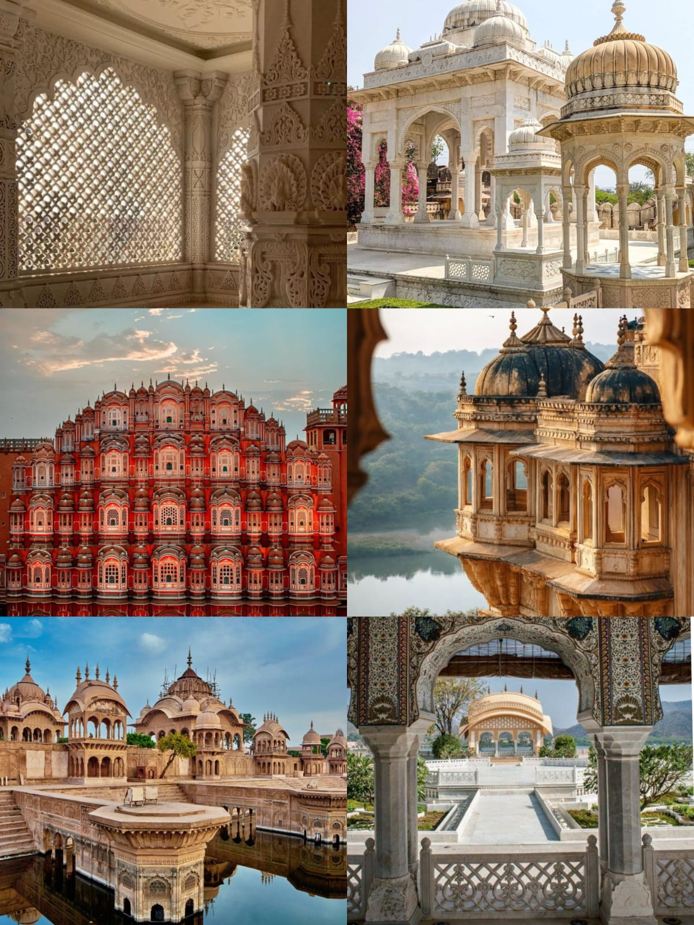

Talking about fashion design specifically, traditional sources are usually considered only aesthetically. That is, when creating a new piece, designers usually use only architectural patterns and images without any deep analysis of what the building tells them, ignoring its history, culture, and stories. The goal of the current study is to address this issue by offering a new way of thinking about the architectural style, its stories, and ways of implementing them using fashion illustration and textile designs.

The idea of “unheard palace narratives” will be at the center of this study. This includes the hidden meanings, symbolic value, and lived experiences that are embedded within various architectural details, which are not considered in mainstream research. Through a re-evaluation and interpretation of various architectural details, including jaali work, motifs, and structural designs, this study will aim to incorporate these elements into clothing.

This will be achieved through practice-based research, where methods of visual analysis, case studies, and design process will be used to investigate specific sites like Mehrangarh Fort and the Amer Fort. Elements from the architecture will be incorporated into fashion design, which will result in fashion illustrations and textile surface designs leading to an overall design.

In conclusion, through this study, an innovative way of linking architectural heritage with contemporary fashion through the role of apparel as visual narrative is sought. In addition, there will be an incorporation of culture in fashion and textile design practices for sustainability purposes.
Uyriue

1.Connection Between Architecture and Fashion

This study establishes a strong link between architectural heritage and contemporary fashion design. It helps in transforming traditional palace elements into modern apparel through a structured and meaningful approach.

2.Exploration of Unheard Narratives
The research highlights the hidden stories of palaces like City Palace Udaipur and Hawa Mahal. It adds cultural and symbolic depth to fashion by focusing on storytelling aspects.

3.Transformation of Architectural Elements
Architectural features such as jharokhas, jaali patterns, and arches are analyzed and converted into fashion illustration and textile design. This encourages innovative and concept-driven design development.

4.Promotion of Cultural Sustainability
The study supports the preservation of traditional motifs by adapting them into contemporary fashion. It ensures that cultural heritage remains relevant and continues to evolve with time.

5.Fashion as a Storytelling Medium
This research positions fashion as an effective tool for visual storytelling. It also provides a practical, design-based framework for students and designers to create meaningful collections.
Aim
The aim of this study is to translate Indian palace architecture into contemporary fashion design by using fashion illustration and textile design as tools for visual storytelling.
Research objective

1. To study and analyze key architectural elements of Indian palaces such as jharokhas, jaali patterns, and arches.

2. To identify the “unheard narratives” and cultural symbolism embedded within palace architecture.

3. To translate architectural elements into visual forms through fashion illustration.

4. To develop textile surface designs inspired by architectural motifs.

5. To establish a creative link between traditional heritage and contemporary fashion design.

Review of Literature
1. Structural Influence of Architecture
- Architecture offers a strong structure by means of concepts like form, proportion, balance, and space management.
- Such structural concepts help fashion designers in constructing garments that incorporate these architectural forms as structural aspects of the clothing.
- This illustrates how fashion designers can get inspiration from the rigid architectural forms for creating wearable structural forms.
2. Cultural References of Indian Palaces
- Structures like the City Palace of Udaipur and Hawa Mahal are rich cultural structures with many stories associated with their designs.
- Concepts like jharokha, jaali work, and frescoes are all indicators of some social practices, climate adaptation, and royal style.
- All these design features are culturally significant and may be used in contemporary fashion design.
3. Converting Architectural Motifs to Textiles
- Many times, architectural motifs are converted into textiles using methods like motif extraction, abstraction, and patterning.
- Fashion designers extract features from such architectural details in terms of motifs and patterns and use these in printed, embroidered, and other surface designs.
- This way, architectural forms are made wearable by converting them into textile patterns.
4. Visual Communication through Fashion Illustration
- Fashion illustration is essential in visually conveying design inspiration, theme, and concept.
- It provides an intermediary for translating abstract inspiration into tangible garment designs by allowing experimentation with form, proportion, and styling.
- The inspiration from architecture can be effectively converted into concept-led fashion visuals via illustration.
5. Gaps in Narrative-Informed Design
- Sites like Mehrangarh Fort and Amer Fort have rich symbolic and cultural values represented through their architectural designs.
- Current literature concentrates mostly on the visual or structural dimensions of fashion without incorporating narrative-informed design in the context of heritage architecture.
- The present study attempts to bridge this knowledge gap.

Research Methodology
The research is based on a qualitative methodology and design-based research approach to examine the metamorphosis of Indian palaces from architecture to fashion design. The methodology combines theoretical research and application of design concepts to allow for the translation of architectural components into fashion illustration and textile design
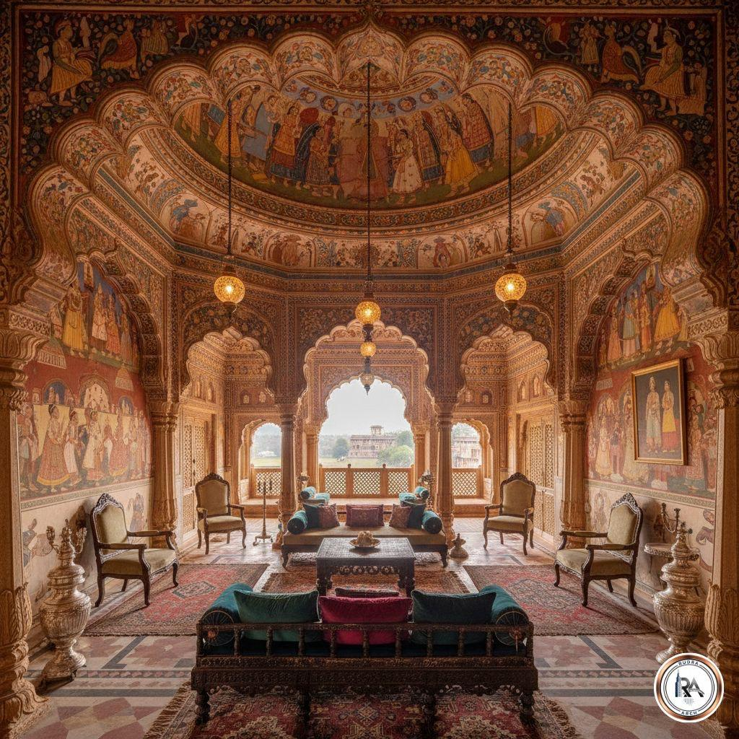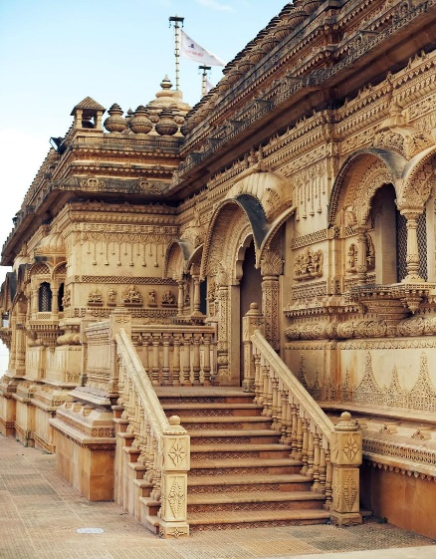
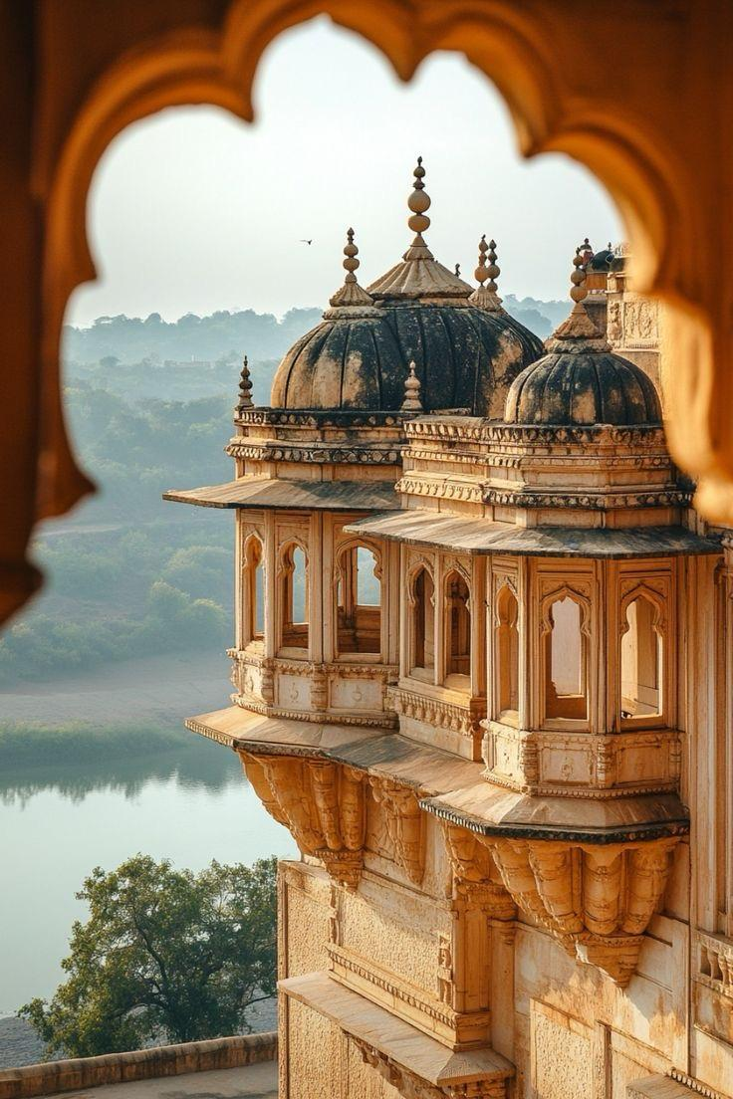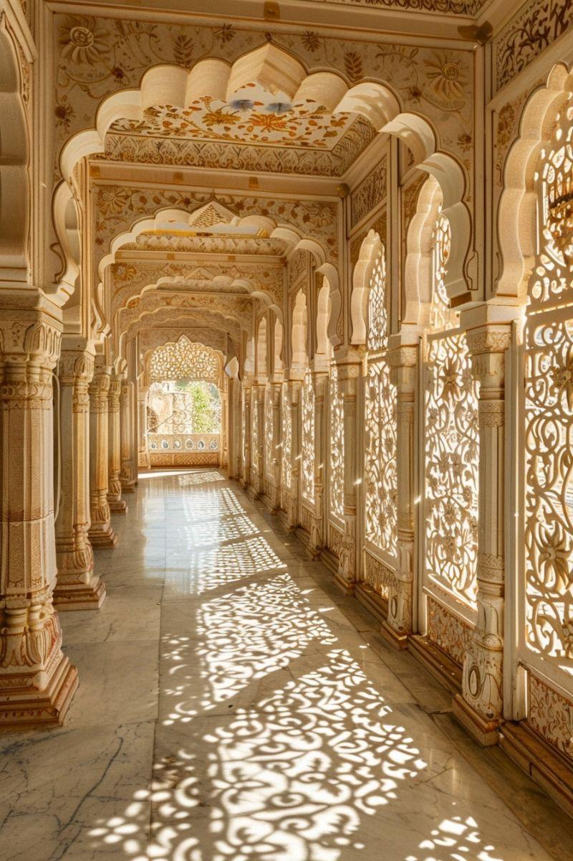
1. Research Approach
A qualitative research strategy will be adopted for this study, which involves the investigation of cultural and symbolic significance of palaces as architecture. The strategy is based on practice, whereby the researcher will study the architecture while applying his findings in practice at the same time.
2. Research Design
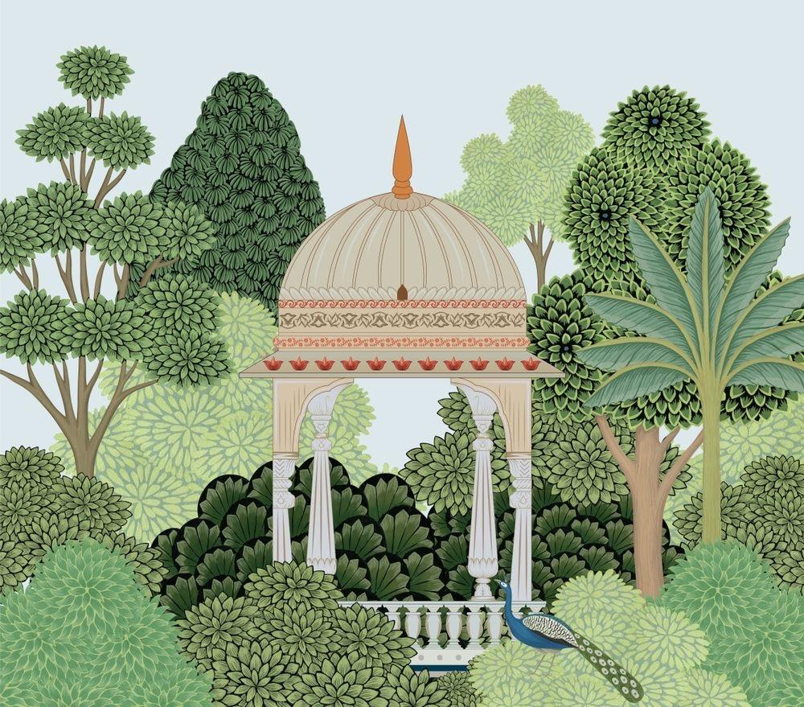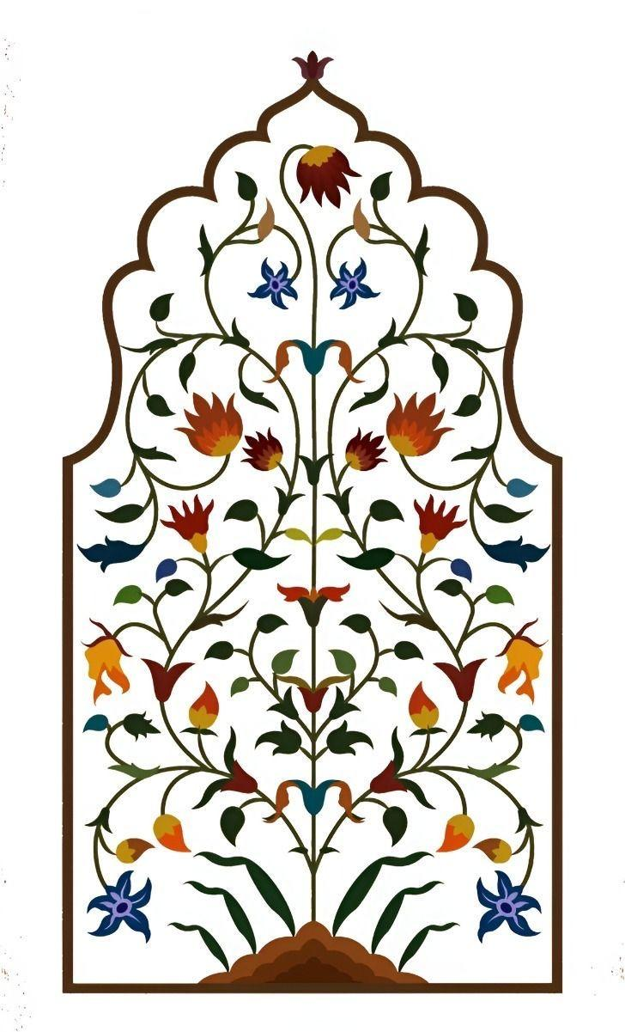
The study is exploratory and descriptive in its nature. Architectural features are explored and then transformed into products of fashion. The design process takes the form of a number of stages starting with research and analysis and ending up with creating garments.
3. Case Study Approach
Indian palaces, including such palaces as City Palace Udaipur, Hawa Mahal, Mehrangarh Fort, and Amer Fort, are chosen for the case studies. Case studies are needed in order to analyze architectural elements, such as jharokhas, jaali patterns, arches, surface decoration, etc., as well as understand their culture and history.
4. Techniques of Data Collection
Several techniques are used to collect data:
● Voice documentation: Pictures and photographs on the Internet depicting palaces
● Pencil documentation: Observing palaces and sketching them in order to understand proportions and forms
● References: Books, magazines, journals, scientific papers about architecture and fashion
● Mood boards: Compilation of images that inspire
5. Tools for Data Collection
Several tools were used in the research process to facilitate systematic acquisition, recording, and analysis of visuals pertaining to the Indian palace architecture and its transition into fashion design.

1. Camera / Digital Images
- Visuals of architectural features including jharokhas, jaali designs, arches, and ornamentation of walls were obtained using digital media sources.
- Using high-quality digital images made it possible to study intricate textures and motifs in detail.
- Such images acted as the main source of visual references.
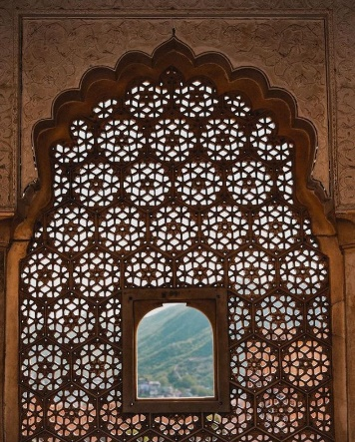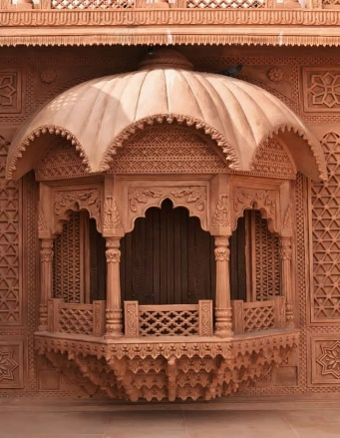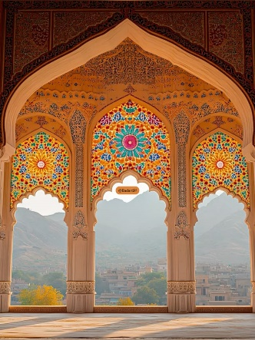
2.
- Drawings were made to observe and analyze details about structural forms of architectural features.
- Sketching made it easier to reduce complicated architectural designs into basic geometric forms, which was vital in motif design.
- The tool facilitated creativity and ideation in the design process.
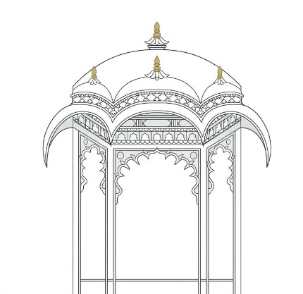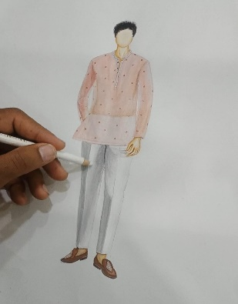
3. Online Platforms and Design Archive
- Digital media and online design archive such as Pinterest were used to obtain design inspirations, visual references, and ideas.
- This platform made it easy to organize visual references regarding moods, color themes, and textures.
- This helped obtain global and regional visual references.
6. Data Analysis Techniques
The collected data is analyzed through the following methods:
- Visual analysis: Studying form, symmetry, pattern, and detailing
- Motif extraction: Converting complex architectural elements into simplified design motifs
- Comparative analysis: Comparing different palaces to identify similarities and uniqueness

- 7. Design Development Process
The design process is carried out in stages:
- Selection of architectural inspiration
- Extraction and simplification of motifs
- Development of theme, concept, and color palette
- Creation of fashion illustrations
- Development of textile surface designs (prints, embroidery, etc.)
- Final garment collection
- Design software for illustration and pattern creation
- Concept development: Interpreting cultural narratives into design ideas

8. Product Development Process
The developed designs are translated into final products through:
- Concept finalization
- Material and color selection
- Design refinement
- Application of motifs on garments
- Final presentation of collection

9. Limitations of the Study
- The study is limited to selected palaces only
- Dependence on secondary data and visual references
- Interpretation of narratives may vary (subjective)
- Lack of quantitative measurement

Scope of the Study

1.Focus on Indian Palace Architecture
This study is limited to selected Indian palaces, focusing on their architectural elements such as jharokhas, jaali patterns, arches, and surface ornamentation. It explores these features as primary sources of design inspiration.

2.Application in Fashion and Textile Design
The scope includes the translation of architectural elements into fashion illustration and textile surface design, leading to the development of a conceptual apparel collection.

3.Practice-Based Design Approach
The study emphasizes a practice-based methodology, where research findings are directly applied to creative design processes, including motif development and garment visualization.

4.Visual Storytelling Aspect
It focuses on interpreting “unheard narratives” of palace architecture and presenting them through fashion as a medium of visual storytelling.

5.Academic and Design Relevance
The study is useful for fashion designers, students, and researchers, providing a framework for integrating cultural heritage into contemporary design practices while encouraging innovation.

Limitations of the Study

1.Limited Case Studies
The study is restricted to a few selected Indian palaces, which may not represent the full diversity of architectural styles across India. This limits the generalization of findings.

2.Dependence on Secondary Data
Much of the research relies on photographs, online archives, and published literature rather than extensive field visits, which may affect the depth and accuracy of observations.

3.Subjective Interpretation
The concept of “unheard narratives” and design translation is based on the researcher’s personal interpretation, which may vary from one designer to another.

4.Lack of Quantitative Analysis
The research follows a qualitative and design-based approach, without
statistical or numerical validation, which may limit empirical evaluation.

5.Limited Practical Execution
The study focuses mainly on conceptual design, illustration, and textile development, and may not include full-scale garment production or market testing.

Results / Findings
The study demonstrates that architectural elements can be effectively transformed into fashion and textile design, creating innovative and culturally rich apparel through a structured design process.

Table 1: Architectural Analysis to Design Transformation

Aspect | Architectural Observation | Design Application | Outcome
Jharokha | Curved, projected balcony forms | Neckline & silhouette design | Structured garment shapes
Jaali Pattern | Geometric perforated patterns | Textile prints & layering | Surface texture & depth
Arches | Symmetrical curved structures | Panel cuts & garment flow | Balanced design composition
Ornamentation | Detailed carvings & frescoes | Embroidery & embellishment | Rich visual detailing

Table 2: Overall Findings & Design Outcome

Stage | Process | Key Finding | Final Result
Research | Collection of architectural references | Strong cultural inspiration identified | Clear design direction
Analysis | Study of forms & patterns | Motifs extracted successfully | Usable design elements
Development | Illustration & textile design | Concept translated into visuals | Design coherence achieved
Application | Garment & surface design | Architecture adapted into fashion | Innovative apparel designs
Outcome | Final collection | Visual storytelling achieved | Cohesive fashion collection

Data Interpretation / Analysis

Table 1: Data Interpretation of Architectural Elements

Element | Observation | Interpretation | Design Meaning
Jharokha | Projected balcony with curves | Symbol of royal viewing & aesthetics | Used in neckline, layering & silhouette
Jaali Pattern | Geometric perforated structure | Represents light, ventilation & privacy | Applied as textile pattern & transparency effect
Arches | Curved symmetrical forms | Structural balance & elegance | Used in panel cuts & garment flow
Ornamentation | Detailed carvings & frescoes | Rich cultural & artistic expression | Used in embroidery & surface detailing

Table 2: Overall Data Analysis & Design Outcome

Stage | Analysis | Interpretation | Outcome
Data Collection | Visual references & sketches | Identification of key elements | Strong inspiration base
Visual Analysis | Study of patterns & forms | Motifs extracted & simplified | Design-ready elements
Concept Development | Story & theme creation | Cultural narratives defined | Clear design direction
Design Application | Illustration & textile design | Architecture translated into fashion | Innovative garments
Final Outcome | Collection development | Visual storytelling achieved | Cohesive fashion collection

Final Conclusion

In summary, this study presents the transformation of palace architecture from India into contemporary fashion design with the help of fashion illustration and textile designs. The design aspects of palace architecture including jharokha, jaali, arch, and ornamentation have been carefully identified and transformed into design language and used as garment and textile designs while retaining their authenticity.
It is evident from the research conducted above that fashion has emerged to be an ideal way to visually communicate a narrative that relates to architecture in its traditional sense. Through a practice-based methodological approach, the study provides structure to the entire research process.
As a whole, the study creates links between heritage and contemporary fashion and promotes sustainable practices within the field. In addition, it paves way for future research on similar concepts within the realm of fashion.

Suggestions / Recommendations

1.Include Various Architectural Elements

Further research could be done based on various other architectural designs of India besides palaces. For instance, there are various temple, fort and regional architectures that could serve as great inspiration.

2.Field Visits

On-field visits to places such as City Palace Udaipur or Amer Fort would be highly beneficial in conducting effective research. In this case, direct observation is vital.

3.Advanced Textile Manufacturing Technologies

Development of future designs may take advantage of various new technologies, such as digital printing, laser cutting, and 3D surface design.

4.Product Development for Market

Further development of designs into commercial products by taking into account consumer needs and preferences.

5.Interdisciplinary Research

Combination of research with architecture, history and culture disciplines would help gain deeper knowledge and insights into the process.

6.Green Products

In order to ensure eco-friendliness of future products, future designs should take into consideration green production practices.

Future Scope

1.Expansion to Diverse Architectural Sources

Future studies can include temples, forts, and regional architecture to explore a wider range of cultural inspirations and design possibilities.

2.Use of Advanced Technologies

Incorporating digital printing, laser cutting, and 3D surface techniques can enhance the translation of architectural elements into innovative fashion designs.

3.Commercial Application

The research can be extended to develop market-ready collections by considering consumer preferences, trends, and pricing strategies.

4.Interdisciplinary Collaboration

Working with architects, historians, and cultural experts can provide deeper insights and improve the authenticity of design interpretation.

5.Sustainable Design Approach

Future work can focus on eco-friendly materials and sustainable production methods to align heritage-based fashion with modern environmental

References / Bibliography

1. Giglio, A., Paoletti, I., & Conti, G. (2022).
Three-Dimensional (3D) Textiles in Architecture and Fashion Design
🔗 https://doi.org/ 10.1007/s10443-021-09932-9

⸻

2. Kumari, A. (2019).
Relationship between Clothing Silhouette and Indian Mughal Architecture
🔗 https://fashionandtextiles.springeropen.com/articles/ 10.1186/s40691-019-0174-4

3. Jankoska, M. (2023).
Influence of Architecture in Clothing Design
🔗 https://www.researchgate.net/publication/ 373099369

4. Muñoz, M., & Cordero, Á. (2024).
https://www.researchgate.net/publication/384262626 _The_Fold_as_a_Design_Strategy_Analogy_between_Architecture_and_Issey_Miyake's_Work

5. Crewe, L. (2010).
https://www.researchgate.net/publication/227472485 _WearWhere_The_Convergent_Geographies_of_Architecture_and_Fashion

⸻

6. Clarke, S. E. B. (2017).
https://www.re-thinkingthefuture.com/architectural-community/a12743 -the-interplay-of-fashion-and-textile-design-innovation-via-collaboration/
⸻

7. Leutner, P. (2021).
https://www.researchgate.net/publication/354877561 _Fashionable_Bauhaus_Translating_the_Bauhaus_Esthetics_into_Textile_and_Fashion_Design

⸻

8. Fahmi, M. et al. (2024).
Exploration of Architectural Forms in Fashion Design
🔗 https://doi.org/10.34148/artika.v 9i2.1423

⸻

9. Quinn, B. (2006).
Textiles in Architecture
https://www.slideshare.net/slideshow/textiles-in-architecture/ 51769353

⸻

10. Georgen, T. (2005).
Art, Fashion and Architecture Interdisciplinary Study
https://medium.com/@sanchita27roy/evaluation-of-fashion-design-integrating-with-art-and-architecture-ffa 0197ce388

Underwood, J. & Zilka, L. (2021).
https://www.researchgate.net/publication/354965391 _Fibre_Architecture_A_Soft_Simultaneity_Design_Practice
(Placeholder1)
⸻

12.

Baruah, S. & Patil, N. (2020).
Assimilation of Architecture in Fashion Wear
https://www.scitechnol.com /abstract/assimilation-of-architecture-in-fashion-wear-11424.htmlrnPT.php?article_id=11424

⸻

13.

Reinhardt, D. (2007).
Elastic Space: Latent Formations in Fashion and Architecture
https://www.researchgate.net/publication/ 233460512_Elastic_Space_Latent_Formations_in_Fashion_and_Architecture
⸻

14.

Souza, P. (2014).
Fashion and Architecture: Relations that Shape Habitable Spaces
🔗 https://dobras.emnuvens.com.br/dobras/article/view/ 36

