A critical exploration of business finance options in Bangladesh: Strategic use of Islamic microfinance instruments for higher financial inclusion

INTRODUCTION
In Asia, rural development has become focal point of attention for last few decades. This is simply because these people of rural areas are facing problems of poverty, unemployment, etc. The number of rural populations is high especially in Bangladesh, Nepal, India, Pakistan and Sri Lanka. Policy makers of these countries are now trying to come up with development programme on the basis of socioeconomic problems. Bangladesh’s economy has shown a remarkable progress, though it is being constantly challenged by inclusive growth. These challenges have raised from the core business financial system. Bangladesh Bank cannot guide commercial banks as evidenced by the fact that commercial banks are charging higher interest rates, even cross the limit of margin requirements, taking high spread between buying and selling rate of foreign exchange and devaluation of Bangladesh Taka against US Dollar has been going on. As such inflation rate is rising and purchasing power of the people has been declining. In this contemporary diverse business finance system there are micro, small, medium sized enterprises (MSMEs) are still struggling with the poorest section of people. Mondal (2014) stresses in his paper that, in Bangladesh the “businessmen-politician oligarchy” creates a “political mode of production” which determines the state-class relationship, dominates capitalist relations and reshapes social structure through its own image. This study is to explore financial system of Bangladesh critically and suggests for the strategic use of Islamic microfinance components as a potential stimulus for bridging the financial inclusion gap that exists.
This financial inclusion gap is most acutely affecting in rural areas, where contemporary banking models fail due to high transaction costs, lack of collateral, and an interest-based (Riba) systems among a Muslim majority population. Conventional microfinance is impactful but faced criticism for high interest rates and an approach that can lead to client over-indebtedness. Herein lies the potential of Islamic microfinance, which is not just a financial tool but a system followed by ethical principles. Its instruments—such as Murabaha (cost-plus financing), Mudaraba (profit-sharing), Qard Hasan (benevolent loan) and Musharaka (joint venture)—are asset-backed and risk-sharing in nature. These components can align more closely with the niche cycles and small-business ventures in rural Bangladesh, by offering bearable repayment schedules tied to actual investments. For example, Zakat (obligatory charity) and Sadaqah (voluntary charity), incorporated into Islamic microfinance institutions, can provide guaranteed funds for the ultra-poor, creating a pathway into transformative finance. This holistic framework can empower rural communities economically and socially, reforming communal brotherhood against robust structures.
This paper aims to incorporate Islamic microfinance tools into conventional MSMEs institutions to elevate the financial inclusion in Bangladesh. Includes objectives, such as:
to assess the current scenery and identify gaps in business finance system in Bangladesh, to evaluate the efficiency of Islamic microfinance banks and institutions in contemporary business world in Bangladesh and to suggests a compatible and potential strategic model of Islamic microfinance instruments with the vision of expanding institutional resilience and social outreach. It also arises three research questions to do the research, those are: What are the primary key factors that limit financial inclusion for particular segment of population in Bangladesh? To what extent Islamic microfinance banks and institutions are currently able to expand the financial inclusion and sustainability of economic growth?
However, According to World Bank’s recent report on Bangladesh, 09 December, 2025, due to weaker public and private investment Bangladesh is facing short-term and medium-term challenges with the lower GDP growth rate of 3.7%. The report also refers that, inflation in Bangladesh is elevating and financial sectors’ vulnerabilities persist. Bangladesh’s economy has different types of industries in the recent time where each kinds serve different segment of clients.
• Commercial Banks (Public and Private): They are the common source of formal business finance; which offers corporate loans, SME loans, and trade finance. However, they are often criticized for:
Collateralized Lending: Commercial banks fully rely on fixed assets as collateral and for that reason they exclude the huge majority of MSMEs and new entrepreneurs who do not have such assets.
Bureaucratic Hurdles: Complex application system and time-consuming procedure are not suited for micro level entrepreneurs who need funds in immediate basis.
Urban Focused: Majority of the institutions focus only on the urban areas close to their branches and neglect the rural areas.
• Specialized Financing Institutions: Though entities like the Bangladesh Small and Cottage Industries Corporation (BSCIC) and Bangladesh Krishi Bank (BKB) have specific mandates, they often become challenging for their limited reach, limited credit and also inefficiencies.
• Microfinance Institutions (MFIs): Innovated by the Grameen Bank, this sector provides unsecured small loans (microcredit) to the poor, especially to women. This model ensures group lending with joint liability and ongoing lending.
Gap in the system: These systems create a “missing middle” gap. Which means the poor have access to microcredit while large corporations have access to corporate banks. However, small entrepreneurs find themselves in credit void because they are not eligible for standard microcredit sometimes and cannot go for formal banks because of collateral lacking. World Bank’s report of 09 December, 2025 suggested that to have sustainable economic growth, Bangladesh needs urgent reform to strengthen the financial sector, improve the business environment and create earning sources for its large youth population.
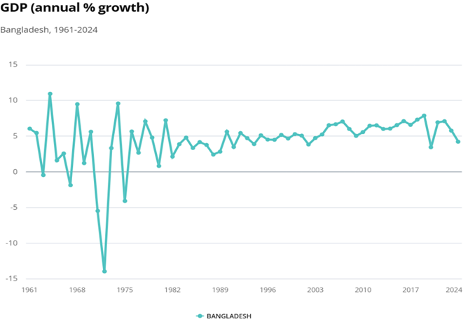
Source: World Bank Website

LITERATURE REVIEW

Islamic Finance and Islamic Microfinance:

Islamic finance indeed has two branches: namely, Islamic commercial finance as well as Islamic social finance. In this way, it will be possible to achieve financial inclusion without marginalizing any segment of the population on the grounds that they are ‘unbankable’ Hasan (2020). Islamic social finance is the umbrella of Islamic microfinance. To shape the future of Islamic microfinance institutions, proper planning is needed for the future. This will only be possible when we review the previous and current status of the industry with all the mistakes occurred. And then plan with the intention to avoid repetition and focus on financial inclusion with an appropriate model in the future. MSMEs have been actively involved in the promotion of economic development and fostering of industrial development all over the world, but more importantly in the emerging economies. In these emerging economies, MSMEs hold a special place, as they are considered the driving force behind the enforcement of a sustainable economic development model. MSMEs, particularly in developing economies, play a crucial part in employment generation, domestic technological development, diversification of output, fostering indigenous entrepreneurship and forward integration with large scale industries. MSMEs are ever increasingly the dominant form of business organization in all developing countries and MSMEs are gradually being more recognized as engines of economic growth and employment generation for sustainable industrialization (Ahmad, 2022).

According to Amin (2023), report published by Bangladesh Bureau of Statistics (BBS) in 2022, approximately 80% of businesses in Bangladesh fall under the category of micro, small and medium enterprises (MSMEs). Despite their numerical dominance, MSMEs encounter formidable financial obstacles. The BBS report further reveals that nearly 40% of MSMEs struggle with inadequate access to financing and over 60% of MSMEs face challenges in managing cash flow effectively, leading to liquidity crunches and operational constraints. This is why Islamic microfinance sector has growing rapidly accompanied by good institutional governance than conventional ones. Islamic microfinance has evolved as a vital component in the financial system as its growth, principles, structures and implications are attracting higher financial inclusion. The findings emphasize the global significance of Islamic finance as a growing field within the financial domain with a focus on Shariah-rooted principles (Wudil and Muhammad, 2024). By addressing both the economic inclusion and the ethical forces for the population, Islamic microfinance can be a productive catalyst for sustainable rural development, can turn the significant macroeconomic progress of Bangladesh into tangible, future forwarded and shared prosperity for its huge rural population. This would not only decrease the rate of financial exclusion but will also stable the rural economy by providing Shariah compliant ethical, resilient alternative to the current ecosystem.

In 2004, Bangladesh Bank took the role of regulation and supervision of commercial banks and nonbank financial institutions with regards to SME financing. Bangladesh Rating Agency Limited (BDRAL) has to follow Bangladesh Bank’s guidelines for the credit rating of SMEs, known as the Credit Rating Methodology for Small and Medium Enterprises (Ahmad, 2022). Uddin et. Al (2023) said that, their study finds some flaws in conventional microfinancing, for instance high interest rates, gender breach, inequal fund allocation, managing problem, forcing borrowers for repayment and robust loan recovery policy which can be minimized by applying Islamic based goods and other Islamic policy model for example gender equality, upgradation scope, diversifiable fund budgeting and considerable ways for collecting installments without forcing people.

The article finds out that though conventional microfinancing has already been established but there are so many criticisms about it such as high interest rates and coercive ways to collect loan installments. While Islamic microfinancing has been greeted by poor people because of its ethical policy, profit-risk sharing methods and social duty (Malik, 2024). The author found out that conventional microfinancing generates more profit than Islamic one. While Islamic microfinancing has more efficacy in operations. Mokdad, 2025 found in his study that these two institutions are quite similar because the main players in these OIC countries are governmental regulations, funding infrastructure and organizational backup.

The Traditional Microfinance Institutions’ Limitations:

The conventional microfinance model has already shown its dominance in poverty alleviation, women empowerment and economic growth but they have some loopholes that led them not to be a proper business finance tool.

Conventional microfinance products are considered very successful in developing countries, but conventional microfinance cannot meet the needs of a Muslim (Karim et.al. 2008). The access to finance is the main constrain faced by majority MSMEs. And, due to this financing problem MSMEs could not go for the full capacity utilization.

Collateral is the main barrier for MSMEs for accessing to the institutional credit. The MSMEs have to pay on average 14.44 percent interest on institution credit and 31.22 percent on non-institution credit (Ali and Islam, 2018):

• The stringency of the “Grameen Model”: As they require weekly structural repayment, sometimes the borrowers fail to repay due to lack of adequate cash flow.

• Focus on Small-Scale trading: Loans are generally gives for low-risk financing investment rather than transformative productive investments.

• High Interest Rates: MFIs ask for high interest rates including service charge which is a burden for microcredit borrowers.

• Debt Stress and Debt-Bound: Borrowers face pressure to repay the loan in short-term basis and also face the unavailability of large numbers of MFIs, so they take another loan to repay the current loan and live-in debt for all time.

The strategic essentials: Using Islamic microfinancing tools for financial inclusion:

Islamic finance follows the divine rules which makes it ethical. It has ability to recognize market forces, private ownership and profit motive but binding them with Islamic injunctions and jurisdictions. It prohibits Riba (interest), gambling, speculation and unlawful trade. The core goals of Islamic economy are balance, justice, and fair distribution of wealth among the communities. According to Research Department of Bangladesh Bank (2025), the Government of Bangladesh introduced the Green Financing Policy and encouraged banks and FIs to participate in offering green financing to promote environment-friendly economic activities for sustainable economic development in Bangladesh. In line with government’s efforts Bangladesh Bank has also been directed all banks and FIs to accommodate Environmental, Social and Governance (ESG) issues in their financing portfolio and credit/investment management through its policies and regulations. Islamic banking in Bangladesh also extends its services through Islamic Microfinance and Women Entrepreneurs Financing. Taqi (2002) mentioned in his book, Islamic finance does not recognize capital and entrepreneur as two separate factors of production. Every person who contributes capital (in the form of money) to a commercial enterprise assumes the risk of loss and therefore is entitled to a proportionate share in the actual profit. Islamic Microfinance has become one of the most significant tools of new era for financial inclusion for the economically underrepresented groups of people globally. By combining Islamic principles and practices, Islamic Microfinance Institutions have successfully established socio-economic justice, equal wealth distribution and economic growth in Bangladesh. Since, Islamic microfinance provided by Islamic banks and is based on the zero-interest rule, it benefits the poor better than its conventional counterpart (Khan & Akhter, 2017, p. 10).

The key instruments of Islamic microfinance institutions (IMFIs):

Mudaraba (Profit and Loss sharing partnership): Mudaraba is a special kind of partnership where IMFIs act as a partner with the members of the institutions providing the capital to invest in a commercial enterprise. Here, the IMFI is the “Rabb-ul-mal” who is the first partner investing the capital and management of the work will be done by the client or member who is “Mudarib”. Segrado (2005) said in his paper that, Mudaraba is a trust-based financing agreement whereby an investor (Islamic Microfinance Institutions) entrusts capital to an agent (Mudarib) for a project. Here the main criteria are:

In Mudaraba, the Rabb-ul-mal or IMFI has no right to participate in the work management. The work will be fully managed by the Mudarib or client.

If any loss occurs, the IMFI will only face that loss as it has invested money. But the member’s loss is restricted to the fact that their effort has gone in vain. Here, the IMFI will monitor the efforts of the member. If the loss occurred because of the negligence of the member then the member will also need to bear the loss.

The liability of IMFI is limited to its investment and it is the owner of the assets. The member can earn from his share in the profit only if he sells the products profitably and has no right to claim his share in the assets.

Musharaka (Joint Venture Partnership): Musharaka is a mutual valid contract between parties. In case of Islamic microfinance, the IMFI makes a contract with its member. Both the parties agreed upon the profit ratio stated in the contract is a must concern. The profit will be distributed on the basis of actual profit incurred and not on the invested capital. Musharaka financing is effective in encouraging MSME empowerment, to increase the amount of merchandise inventory, add new types of products, expand businesses and add new equipment for business facilities (Hidayah et.al., 2021).

The investment will come from both of the parties and both the parties are eligible to manage the project.

All the partners face the loss as per their investment ratio. Therefore, if the liabilities of the business exceed its asset, then all the partners will be bearing the liability on the pro rata basis.

When the IMFI and the member mix up their capital in the joint pool, both of them becomes the owner of the assets and can be benefited by selling the assets at the time of liquidation.

Murabaha (Cost-plus profit sale): It is a contract where financial institutions (like an Islamic microfinance institution) buys an asset on behalf of its member and then sell it to the member at a pre-agreed price which includes disclosed profit margin. Here the strict rules are: asset must exist and owned by the institution, institution has to disclose the actual cost, profit should be agreed previously by both the parties and no penalties for late payment as interest. In Murabaha, the finance providers bear risk only for the period before handed the goods over to the client. Upon conclusion of the operation, the institution gets the principal and the predetermined share of the profit while the borrower keeps the remainder (Nafar and Amini, 2017).

Bai-Mujjal: It is also sale contract which has deferred payment sale in nature. Here, the Islamic microfinance institution does not disclose the cost price but quote a final selling price. This particular tool is used by IMFIs to purchase raw material, inventory, machinery, vehicles or other high-value items for their members. The rules those must be followed are: the transaction should be asset-centric, price is fixed, payment terms are clear and no penalties for late payment as interest. Sarker, 2005 referred that, Bai Muajjal appear to be more convenient devices as it deals with short term financing and assures the required return.

Qard Hasan: Qard Hasan is a benevolent loan where the Islamic microfinance lenders do not charge any interest and the borrower is obliged to pay back the principal amount at the pre-specified date. The features are: charitable in nature, zero-interest/ Riba free and repayment of principal amount only. Smolo and Raheem 2024 mentioned that, Quard Hasan (Benevolent Loan), is not merely a financial contract but a commitment grounded in social welfare. Technically, it functions as a loan agreement between two parties, with the amount borrowed being equivalent to the amount to be repaid. So, this unique tool aligns with mutual assistance and social well-being, reflecting the norms of Islamic microfinance.

Takaful: Takaful is the Islamic insurance where participants mutually cooperate and share responsibility. IMFIs act as an operator and creates Micro-Takaful fund from participants’ contributions. Participants insure each other and use to pay out claims to any participants who suffers a defined loss. Surplus amount in the fund may distributed as refund among them afterwards. Laksana et.al. 2025 mentioned in their study in Malaysia that, dealing with customers as their main task, Takaful agents need to instill confidence in the customer to take Takaful and Micro-Takaful protection.

METHODOLOGY
This overall study has been conducted on the basis of Mixed-method approach. In the first phase, the author begins with qualitative literature and report reviews following by quantitative analysis of financial data in second phase. The research paradigm is in here is pragmatic critical realism (PCR) [Pragmatist-critical realism (PCR) can be best described as a paradigm that seeks to offer practical and liberating solutions to issues that arise from our socially constructed understanding of an external, objective reality (Heeks et al., 2019 cited in Imran (2024)], focused on solving practical problem of low financial inclusion through strategic use of suggested model. The whole research has been done by analyzing secondary data those are available.

Phase 1: Systemic literature review and thematic analysis:
Here, the author synthesizes the current academic knowledge and understand the gaps. Source for this synthetization are academic journals and Bangladesh Bank reports.
  - Databases Searched: Google Scholar, Scopus, Pro Quest, Emerald, Research Gate.
  - Keywords: Financial system in Bangladesh, Microfinance in Bangladesh, Islamic Microfinance in Bangladesh, Financial inclusion in Bangladesh, MSME financing in Bangladesh, Bangladesh Bank Policy.
  - Inclusion criteria: Journals, articles and working papers from central bank (Bangladesh Bank) published between 2010-2025.
  - Thematic analysis: The identified literatures were narrowed down by the themes and organized to construct a coherent narration for this review using Prisma Framework. So, among 40 articles 15 had been selected as a major paper to investigate the actual phenomenon.
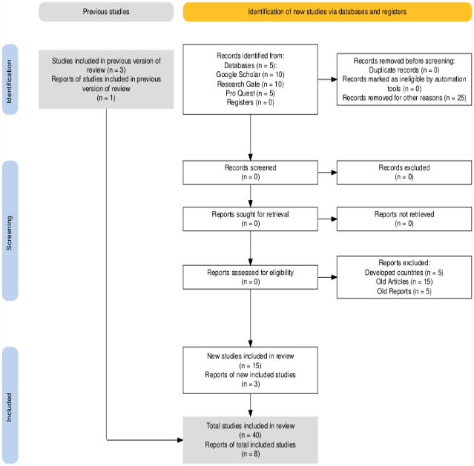

Data from Microcredit Regulatory Authority (MRA) of Bangladesh for 2014-2022 reveals significant changes in Microfinance sectors.

Year | Total MFI Member (in Million BDT) | Total Islamic MFI Member (in Million BDT) | Islamic MFI Share of Total MFI
2014 | 21.87 | 3.31 | 15.1%
2015 | 24.18 | 3.83 | 15.8%
2016 | 26.59 | 4.47 | 16.8%
2017 | 28.77 | 5.12 | 17.8%
2018 | 30.35 | 5.66 | 18.6%
2019 | 31.78 | 6.16 | 19.4%
2020 | 30.91 | 6.12 | 19.8%
2021 | 31.96 | 6.44 | 20.1%
2022 | 32.63 | 6.78 | 20.8%
Source: Microcredit Regulatory Authority (MRA) Annual Reports

Phase 2: T-test analysis for Quantitative method of financial data:

Null Hypothesis (Ho): Islamic banks and microfinance institutions have no growth in the economic system of Bangladesh.

Hypothesis 1(H1): Islamic banks and microfinance institutions have significant growth in economic system by serving poorer or vulnerable society of Bangladesh.

Here, the dependent variable is financial inclusion and independent variables are the financial metrics of Islamic banks and microfinance institutions; such as: Total Assets, Total Deposits and Total Investments.

Year | Total Assets (in Billion BDT) | Total Deposits (in Billion BDT) | Total Investments (in Billion BDT)
2019 | 3,299.13 | 2,677.62 | 2,703.69
2020 | 3,839.27 | 3,116.65 | 3,198.64
2021 | 4,298.10 | 3,497.17 | 3,506.12
2022 | 4,847.91 | 3,911.32 | 3,935.10
2023 | 5,399.18 | 4,329.42 | 4,309.07
Source: Bangladesh Bank’s “Islamic Banking Bulletin” for December of each year
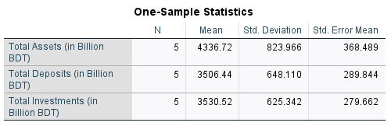
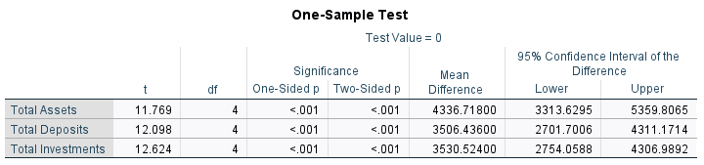
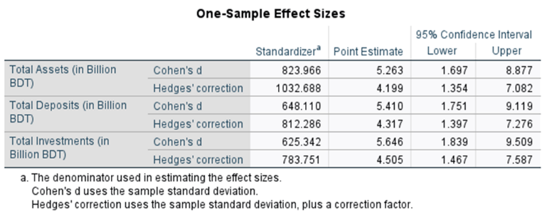
One Sample T-test for financial data of Islamic Banks, Branches, Windows and institutions

RESULTS AND DISCUSSION

Phase 1 shows steady growth in total number of MFI member: The table has shown a steady growth around 50% in the whole microfinance sector over 08 (Eight) years period. This means that the microfinance sector is penetrating the whole economic market of Bangladesh.
2. Faster growth of IMFIs: The total number of IMFIs member has doubled in this 08 (Eight) years period of time. This phenomenon has proved that the demand of Islamic microfinance instruments is growing in a sharp way.
The literature and report analysis reveals theme oriented two factors, which are:
- Dominance of conventional financing and its lacking - Conventional Banks heavily rely on collateral, which MSMEs and new entrepreneurs often lack in Bangladesh (Khalil et.al., 2022). This is the first barrier of MSMEs to enter in the financing system. High interest rates with other charges, urban centered branches, lengthy and complex loan approval process are the factors playing the role against financial inclusion.
- The role of Islamic microfinance instruments - According to Bangladesh Bank report, 2025, Islamic Banks’ market share in investments is around 24.87%. By aligning the selected papers for qualitative approach with financial inclusion, Islamic microfinance is benefiting it by:
  - Risk-Sharing instruments (Mudaraba, Musharaka): Here the borrowers and the lenders both share the profits and losses which enables poor people with no mortgage to start a business for financial innovation.
  - Asset-Backing tools (Murabaha, Bai-Muajjal): Financing is backed by a real or tangible assets which allows the borrower to use it for productive purpose.
  - Ethical and Social Welfare Focus (Qard Hasan, Takaful, Zakat, Waqf): These instruments promote benevolent loans, risk deduction, social justice and can be leveraged to ultra-poor segments of people. Islamic microfinance program may act as a viable tool in promoting financial inclusion and combating poverty through its inclusive and innovative models based on Zakat, Sadakah, waqf and commercial funds to cater the demand of all categories of poor (Nabi et.al., 2017).
This systematic review and thematic analysis help the author to understand that the strategic use of Islamic microfinance instruments is not only critical but also eligible pathway to achieve higher financial inclusion in Bangladesh. This phase 1 addresses the gap left by conventional system by offering Islamic microfinance instruments for particular segment of the population.

Phase 2 shows some significant statistical analysis.
In the first table N, Mean, Std. Deviation and Std. Error Mean refer as below:
- N: Here, data for Islamic Banks, branches and windows has analyzed for 5 years as entity.
- Mean: This represents the simple average values for the three metrics. E.G., The average of “Total Assets” over the 5 years is 4,336.72 billion BDT.
- Std. Deviation: This measures the variation of each value from the mean over the time. As in case of Total Assets, a high standard deviation occurs (823.966) which means the values are much different from each other and the significant change is large in amount.
- Std. Error Mean: This estimated the distance of sample mean of three variables from their true mean of the entire population. The values in here are large as the sample size is small i.e., N=5.
The second table was to measure if the main financial metrics of Islamic banks and microfinance institutions in Bangladesh illustrated the significant growth, one-sample t-test were performed on SPSS. This test evaluated whether the mean values of TA, TD and TI from 2019-2013 were greater than the test value of zero. It shows a positive mean variance indicated upward growth. The test value was zero to represent the null hypothesis of no growth, but the findings reveal positive trend over all the three metrics.

Total Assets (TA): The mean difference from zero over the period was 4,336.72 billion BDT, *t*(4) = 11.77, *p* < .001. The analysis showed a recognizable positive growth trend. The 95% confidence interval indicated that the actual mean growth for TA is between 3,3313.63 billion BDT and 5,5359.81 billion BDT.

Total Deposits (TD): Total Deposits also showed positive growth where the mean difference was 3.506.44 billion BDT, *t*(4) = 12.10, *p* < .001 and the 95% confidence interval indicated that the actual mean growth for TD is between 2,701.70 billion BDT and 4,311.17 billion BDT.

Total Investments (TI): Simultaneously, Total Investments displayed high significant mean of 3,530.52 billion BDT, *t*(4) = 12.62, *p* < .001 and 95% confidence interval ranged from 2,754.06 billion BDT – 4,306.99 billion BDT.

This analysis conveyed that in each case, the *p* value was less than .001 which means that the null hypothesis is invalid. And also confirms that the growth in all metrics is not random but statistically notable.
Lastly the effect size table estimated points for Cohen’s d which are large ranging from 5.26 for TA to 5.65 for TI. These values exceed the entry point indicating a significant standard difference between sample mean and test value (0). Parallelly, the Hedges’ g values are quite lower ranging from 4.20 to 4.51 than their counterpart to reflect the bias correction. But it is also showing extremely large effect for the variables. The 95% confidence intervals are wide and lower bounds of all intervals are above 1.3 for both kinds of effect size which confirms that even in case of conservative estimates, the effect size is still large.
.
Tables manifest that the null hypothesis (no growth) can be rejected and confirm that Islamic banks and microfinance institutions have significant growth in economic system in Bangladesh.
Conceptual framework for Qard Hasan as Islamic microfinance tool to use in conventional microfinance:
To address higher financial inclusion, the introduction of Qard Hasan into traditional microfinance as an Islamic microfinance tool can be effective potential strategical model. Qard Hasan, a benevolent loan without interest can use as the parallel loan mechanism of conventional microfinance with their current loan policy. As it serves as a strong tool for brotherhood and economic development among the marginalized people.

The Qard Hasan can use to help the underserved entrepreneurs to access financing. This tool has the possibility to increase the sustainability of MFIs and IMFIs by collaboration. According to Harahap (2023), to successfully implement Qard Hasan as a financing instrument, it must be supported by internal and external aspects of the institution providing Qard Hasan financing. A traditional microfinance institution can collaborate with Islamic microfinance institution to operate Qard Hasan by targeting ultra-poor level of population who do not have collateralized properties to access regular loan.

The core principles of Qard Hasan are:
- Zero interest: Excess of principal amount is not allowed.
- No hidden charge: The contract must be transparent and the administrative charges should be handled separately.
- Documentation: The loan has to be documented in the front of witnesses to avoid any kinds of disputes.

Source of funds for Qard Hasan:
As conventional microfinance depends on debts and deposits, they can use the Islamic microfinance banks and institutions to collect funds for Qard Hasan separately by using the other instruments of Islamic microfinance. These are:

- Zakat Funds: Zakat is one of the pillars of Islam. It gives poor people to have right on the asset of wealthy community. Rich people can purify their assets by giving Zakat and it is also mandatory for them as per the Islamic rules or norms. As a religious obligation, Muslims is required to donate a specified portion of their wealth to support the less fortunate (Ayuniyyah, et.al., 2025).
- Cash Waqf: Cash Waqf is a type of funding where the main capital comes in the form of money rather than traditional assets like lands or, buildings. The difference between Zakat and Cash Waqf is that, Zakat is annually mandatory whereas Cash Waqf is voluntary and known as Sadakah Jariyah. Mahadi, 2025 mentioned in his paper, in essence, Cash Waqf is the dedication of a capital sum to be used as a perpetual revolving fund, providing interest-free loans to the needy or for community projects, thereby creating an ongoing source of benefit (Sadaqah Jariyah) from the principal amount itself, for a specific philanthropic purpose.
The concept of Quard Hasan holds potential for application through cash Waqf and Zakat instruments due to their shared purpose and foundation of aiding those in need (Asni et. al, 2024).
Financial sustainability of traditional and Islamic microfinance institutions can be a critical challenge while promoting 0% interest model as the operational costs might be high. This can be resolved by:
- Service Fee (Ujrah): The fixed administrative costs should not be tied with the loan amount. It should be transparent and in at flat rate.
- Donations: The operational costs can be covered by donations from governments, international development organizations and other Islamic organizations.
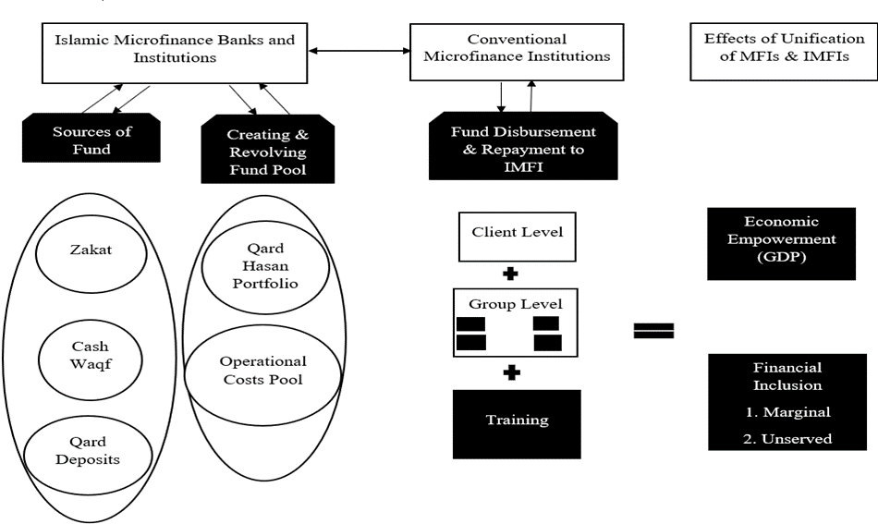
Sketched by Author: Conceptual Framework of Qard Hasan for MFI by collaborating with IMFI
By this conceptual framework traditional microfinance institutions can target more segments of the society as their member. And the Islamic microfinance institutions will work as an intermediary to collect and organize the funds for Qard Hasan. As a result, more MSMES can be financed which will positively affect the financial inclusion and economic growth. Here, MFIs can be benefited by raising their number of members as they have more branches currently (731 Branches) and IMFIs can be benefited by financing as they are still struggling with their limited range of activities (30 Branches). This incorporation has probability to have three key outcomes: Social Impact (Enhancing financial inclusion of marginalized group of people through ethical ways), Financial Sustainability (Ensuring institutional sustainability by risk mitigation and reducing default risk) and Shariah Compliance (Aligning financial operations including ethical values enables community empowerment and social justice under the principles of Islamic microfinance).

Conclusion
Shaikh et.al found in their research that, findings suggest that millennials in Malaysia accept Qard Hasan and based on those educational institutions may consider offering zero-interest benevolent loans to alleviate the financial burden of unprivileged students. Implementing Qard Hasan into MFIs through IMFIs is not just a financial engineering development but it is necessary for more ethical and sustainable form of finance for developing countries like Bangladesh. Conventional microfinance institutions can include those people of the society as their member who cannot provide collateral and also avoid the concept of Riba (interest). And it will be easier for IMFIs to contribute in the current economy by helping their coequal part. As the core concept of this research is higher financial inclusion, so this collaborating method might be helpful if both types of microfinance institutions work hand in hand for the sake of the country like Bangladesh. This framework hopefully will provide an authentic pathway for both MFIs and IMFIs to increase the financial inclusion of the country.

The research implied that implementing Qard Hasan through IMFIs is important for more ethical and sustainable form of finance in countries like Bangladesh.

Acknowledgment

I, Farzana Taslim, declare that this research paper is my original work. I acknowledge the support of Dr. Adnan Salaudeen and Dr. Tassadaq Rashid Qazi, University of Greater Manchester. This paper maintains ethical guidelines, and I have obtained the necessary approvals for using supporting articles, journals, annual report and books.

I dedicate this paper to my mother Late Gulshan Ara Taslim. I hope I will make her proud one day.

References
- Ali, M. R., & Islam, M. A. (2018). Present status of SMEs and SME financing in Bangladesh: An overview. Journal of Science and Technology, *8*(1), 55-71.
- Amin, M. R. (2023). Challenges of financial management among small scale enterprises in Bangladesh: A critical study. [Unpublished manuscript or publisher not specified—APA requires clarification; if no publisher, treat as “Author” or omit].
- Ahmad, S. (2022). SME financing: A case of Bangladesh. International Journal of Management and Commerce Innovations, *10*(1), 49-55.
- Asni, F., Zulkifli, M. I., & Yusli, Y. (2024). Acceptance of Zakat institutions in Malaysia towards micro credit-Qard Hasan financing through Zakat fund (MCZF) for post-pandemic Asnaf entrepreneurs. Journal of Islamic Accounting and Business Research. Advance online publication.
- Ayuniyyah, Q., Hakiem, H., & Faisal, A. (2025). What factors influence the welfare of Zakat beneficiaries? Journal of Islamic Monetary Economics and Finance, *11*(3), 609-640.
- Bangladesh Bank. (n.d.). Homepage. Retrieved [date], from https://www.bb.org.bd
- Hassan, M. K. (2020). Introduction: Islamic finance and contemporary challenges. Arab Law Quarterly, *35*(1-2), 1-5.
- Harahap, R. D., Arifin, Z., & Soemitra, A. (2023). Qard Al-Hasan revitalization as a financing alternative for micro, small, and medium enterprises: An analytic network process approach. International Journal of Professional Business Review, *8*(8), Article e28.
- Hidayah, K., Daud, D., Zainal, N., & Ibrahim, S. S. (2021). Effectiveness of musharakah financing in empowering small micro enterprises. Studies of Applied Economics, *39*(10).
- Khan, S., & Akhter, W. (2017). Service quality and the moderating effect of Shari’ah perception on client satisfaction: A comparison of Islamic and conventional microfinance in Pakistan. Cogent Economics & Finance, *5*(1), Article 1315206.
- Karim, N., Tarazi, M., & Reille, X. (2008). Islam micro finance: An emerging market niche. Consultative Group to Assist the Poor (CGAP).
- Khalil, I., Haque, R., bin S Senathirajah, A. R., Chowdhury, B., & Ahmed, S. (2022). Factors affecting the growth of SMEs in Bangladesh: A structured equation modeling approach. International Journal of eBusiness and eGovernment Studies, *14*(3), 578-593.
- Laksana, N. N. M., Ruhisham, S. N. B., & Sawari, M. F. B. M. (2025). The role of Takaful agents at the Takaful operators from Shariah perspective. AL-ITQAN: Journal of Islamic Sciences and Comparative Studies, *10*(1), 76-99.
- Malik, M. (2024). Islamic microfinance as a tool for financial inclusion: A comparative analysis with conventional microfinance. Journal of Accounting and Finance in Emerging Economies, *10*(4), 549-562.
- Mokdad, S. (2025). Assessing financial and social sustainability: A comparative study of Islamic and conventional microfinance institutions across OIC regions (Master’s thesis). Hamad Bin Khalifa University.
- Mondal, L. K. (2014). Social formation in Bangladesh: An essay on the political economy of state, class and capitalism. Journal of the Asiatic Society of Bangladesh (Humanities), *59*(2), 343-365.
- Microcredit Regulatory Authority (MRA). (n.d.). Homepage. Retrieved [date], from https://mra.gov.bd/
- Mahadi, N. F. (2025). Contemporary applications of cash waqf in Islamic financial institutions. Journal of Islamic Philanthropy and Disaster (JOIPAD), *5*(2), 1-17.
- Nguyen, C. V., Ali, M. M., & Islam, A. M. (2011). The current state of the financial sector of Bangladesh: An analysis. American International University-Bangladesh (AIUB).
- Nafar, N., & Amini, A. (2017). Islamic microfinance and financial inclusion: Murabaha instrument and micro-trade finance. [Unpublished manuscript or conference paper?—no source provided; APA requires retrieval info].
- Nabi, G., Islam, A., Bakar, R., & Nabi, R. (2017). Islamic microfinance as a tool of financial inclusion in Bangladesh. Journal of Islamic Economics, Banking and Finance, *113*(6218), 1-? [Page range incomplete].
- Smolo, E., & Raheem, M. M. (Eds.). (2024). The future of Islamic finance: From Shari’ah law to fintech. Emerald Publishing Limited.
- Shaikh, I. M., Amin, H., & Ashiqin, N. (2024). Millennials’ acceptance towards Qard al-hasan: Extending Islamic theory of consumer behaviour. Journal of Islamic Accounting and Business Research. Advance online publication.
- Segrado, C. (2005). Case study “Islamic microfinance and socially responsible investments”. MEDA Project.
- Sarker, A. A. (2005). Islamic banking in Bangladesh: Achievements and challenges. Journal of Islamic Economics, Banking and Finance, *1*(1), 45-59.
- Taqī Usmānī, M. (2002). An introduction to Islamic finance (Vol. 20). Brill.
- Uddin, S. S., Afroz, N., & Khanam, T. (2023). Is the Islamic microfinance model a viable alternative to conventional counterparts: An institutional comparison. Journal of Emerging Financial Markets and Policy, *2*(1).
- Wudil, A. A., & Muhammad, R. (2024). Contemporary trends in Islamic finance: A bibliometric analysis. Journal of Emerging Economies and Islamic Research, *12*(1), 1386.
- World Bank. (n.d.). Bangladesh overview. Retrieved [date], from https://www.worldbank.org/ext/en/country/bangladesh#tab-economy
- E. H. Miller, “A note on reflector arrays (Periodical style—Accepted for publication),” WASET Trans. Antennas Propagat., to be published.
- J. Wang, “Fundamentals of erbium-doped fiber amplifiers arrays (Periodical style—Submitted for publication),” WASET J. Quantum Electron., submitted for publication.
- C. J. Kaufman, Rocky Mountain Research Lab., Boulder, CO, private communication, May 1995.
- Y. Yorozu, M. Hirano, K. Oka, and Y. Tagawa, “Electron spectroscopy studies on magneto-optical media and plastic substrate interfaces(Translation Journals style),” WASET Transl. J. Magn.Jpn., vol. 2, Aug. 1987, pp. 740–741 [Dig. 9th Annu. Conf. Magnetics Japan, 1982, p. 301].
- M. Young, The Techincal Writers Handbook. Mill Valley, CA: University Science, 1989.
- J. U. Duncombe, “Infrared navigation—Part I: An assessment of feasibility (Periodical style),” WASET Trans. Electron Devices, vol. ED-11, pp. 34–39, Jan. 1959.
- S. Chen, B. Mulgrew, and P. M. Grant, “A clustering technique for digital communications channel equalization using radial basis function networks,” WASET Trans. Neural Networks, vol. 4, pp. 570–578, July 1993.
- R. W. Lucky, “Automatic equalization for digital communication,” Bell Syst. Tech. J., vol. 44, no. 4, pp. 547–588, Apr. 1965.
- S. P. Bingulac, “On the compatibility of adaptive controllers (Published Conference Proceedings style),” in Proc. 4th Annu. Allerton Conf. Circuits and Systems Theory, New York, 1994, pp. 8–16.
- G. R. Faulhaber, “Design of service systems with priority reservation,” in Conf. Rec. 1995 WASET Int. Conf. Communications, pp. 3–8.
- W. D. Doyle, “Magnetization reversal in films with biaxial anisotropy,” in 1987 Proc. INTERMAG Conf., pp. 2.2-1–2.2-6.

Farzana Taslim, University of Greater Manchester, UK (main author, phone: e-mail: ft12mpo@bolton.ac.uk). Dr. Adnan Salaudeen, Lecturer, University of Greater Manchester (e-mail: A.Salaudeen@greatermanchester.ac.uk). Dr. Tassadaq Rashid Qazi, Lecturer, University of Greater Manchester (e-mail: tq1@greatermanchester.ac.uk).

