The Urban Nomad: Reimagining Khadi for Global contemporary Masculinity

Abstract
This research paper explores the concept of the Urban Nomad as a contemporary framework for reinterpreting khadi craftsmanship within modern menswear and sustainable fashion systems. In an era characterized by globalization, transcultural mobility, and increasing environmental awareness, clothing has evolved beyond aesthetic functionality into a medium of identity, adaptability, and ethical consciousness. The study investigates how khadi, historically associated with Indian heritage and Gandhian philosophy, can be transformed into a versatile and globally relevant textile suitable for contemporary urban lifestyles. The research examines the intersection of traditional handloom craftsmanship and modern minimalist fashion aesthetics through theoretical, material, and design-based perspectives. It analyzes the symbolic role of khadi in constructing contemporary masculine identity while emphasizing mobility, comfort, sustainability, and cultural hybridity. Particular attention is given to the thermoregulatory and breathable properties of khadi, which make it suitable for summer-oriented urban environments and multifunctional travel wear.
The paper further discusses innovations in textile engineering, fabric finishing, and garment construction that enhance khadi’s durability, utility, and commercial adaptability. Sustainable production systems associated with khadi are examined in relation to ethical fashion practices, rural employment generation, and low carbon manufacturing processes. Statistical data regarding global sustainable fashion growth, consumer behavior, and handloom industry contribution are incorporated to demonstrate the increasing relevance of sustainable textiles in contemporary fashion markets. The findings suggest that khadi possesses significant potential to emerge as a globally competitive textile for modern menswear by integrating heritage craftsmanship with contemporary design thinking and sustainable innovation. The Urban Nomad framework ultimately positions khadi as a symbol of transcultural identity, responsible consumption, and future oriented fashion practices.
Key Words: Ethical Fashion, low carbon manufacturing, transcultural mobility & Urban Nomad framework.
1. Introduction
The contemporary fashion landscape is increasingly influenced by globalization, sustainability, and the fluidity of cultural identity. Within this evolving framework, the concept of the “Urban Nomad” has emerged as a representation of individuals who navigate multiple cities, climates, and cultural environments while maintaining a dynamic yet grounded identity. Contemporary menswear is no longer confined to rigid formal structures; rather, it seeks adaptability, comfort, and sustainability without compromising aesthetic sophistication.
Khadi, historically associated with Indian nationalism and Gandhian self-reliance, has undergone a significant transformation in recent decades. Once perceived primarily as a symbol of rural craftsmanship and political resistance, khadi has evolved into a sustainable textile material with immense relevance for modern fashion systems. Its breathable structure, natural texture, and environmentally responsible production process position it as an ideal fabric for contemporary urban lifestyles, particularly within tropical and summer climates.
This research paper investigates how khadi craftsmanship can be reimagined for contemporary masculine mobility through the framework of the Urban Nomad. It explores the intersection of traditional Indian handloom heritage and global minimalist fashion aesthetics while emphasizing sustainability, functionality, and transcultural identity formation.
1.1 Indian Handloom and Khadi Sector Statistics
1.1.1 Employment and Economic Contribution
The Indian handloom and khadi sectors remain among the largest rural employment generators after agriculture.
Key Statistics
- The Indian handloom sector provides employment to over 3.5 million people directly and indirectly.
- According to KVIC reports, khadi sales crossed ₹5,000 crore in recent years.
- Khadi and Village Industries Commission (KVIC) reported a growth of more than 248% in khadi sales during the last decade.
- India accounts for nearly 95% of the world’s handwoven fabric production.

1.2. Theoretical Framework of the Urban Nomad and Transcultural Mobility
1.2.1 Defining the Urban Nomad through Fluidity of Movement and Cultural Hybridity
The Urban Nomad represents a modern individual whose identity is shaped through continuous movement across physical, cultural, and digital landscapes. Unlike traditional notions of rooted identity, the urban nomad embraces fluidity, adaptability, and hybridity. Contemporary urban professionals increasingly seek clothing that can transition seamlessly between professional, casual, and travel oriented environments. Fashion theorists argue that globalization has blurred cultural boundaries, enabling garments to function as mediums of transcultural communication. The urban nomad aesthetic reflects this hybridity through silhouettes that combine Eastern drapery, Western tailoring, utilitarian functionality, and minimalist styling. Khadi’s handcrafted irregularities and natural texture embody authenticity in an age dominated by mass industrial production. Consequently, khadi becomes more than a textile; it transforms into a cultural narrative representing sustainability, slow living, and ethical modernity.
1.2.2 The Evolution of Traditional Craftsmanship in Contemporary Global Fashion
Traditional craftsmanship has witnessed renewed relevance due to increasing consumer awareness regarding environmental sustainability and ethical production systems. Luxury fashion houses and contemporary designers now incorporate artisanal techniques to create exclusivity and emotional value. Khadi’s evolution demonstrates how heritage textiles can adapt to global markets without losing cultural integrity. Innovations in yarn blending, fabric finishing, and dyeing techniques have enhanced khadi’s softness, durability, and drape, making it suitable for modern menswear silhouettes such as relaxed tailoring, utility jackets, resort shirts, and modular layering systems. The integration of traditional weaving with modern garment construction reflects a dialogue between heritage preservation and technological adaptation.
1.2.3 Symbolic Representation and Identity Construction in Modern Masculine Attire
Masculine fashion has gradually shifted from rigid power dressing toward more expressive and comfort oriented forms. Modern masculinity emphasizes emotional intelligence, sustainability, mobility, and individuality.
Within this context, khadi based menswear symbolizes:
- ecological consciousness,
- cultural awareness,
- understated luxury,
- and intellectual sophistication.

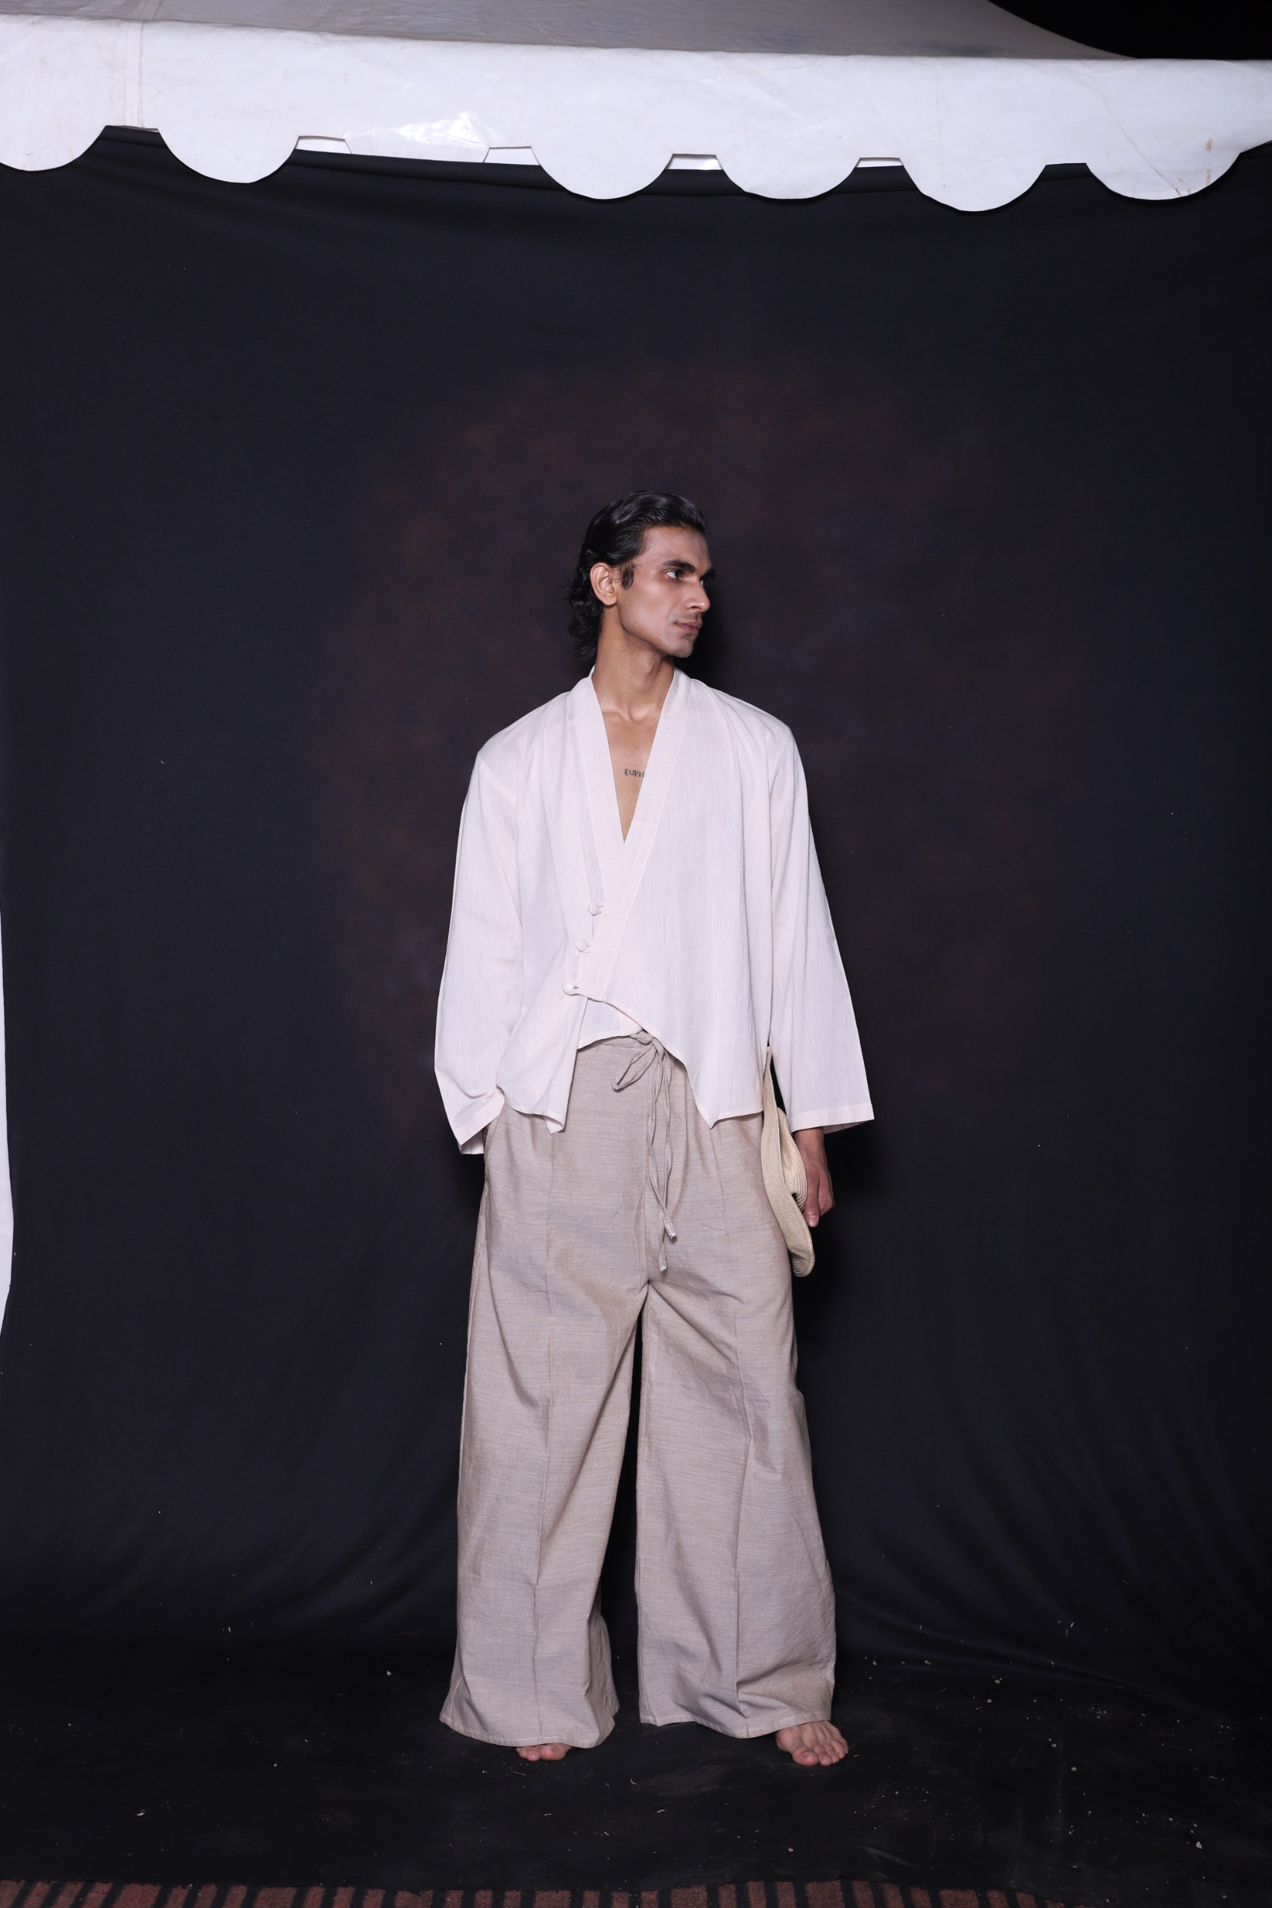
Image no 1: Urban Nomad Aesthetic Appel
The Urban Nomad aesthetic encourages garments that are versatile, breathable, and adaptable across multiple social contexts. Neutral earthy tones, oversized silhouettes, layered forms, and multifunctional garments contribute to this evolving masculine identity.
3. Materiality and Functional Performance of Khadi in Modern Urban Climates
3.1 Thermoregulation and Breathability Attributes for Summer Mobility
Khadi possesses exceptional thermoregulatory properties due to its handspun and handwoven structure. The micro air pockets within the yarn improve ventilation and moisture absorption, making khadi particularly suitable for hot and humid climates.
Key performance characteristics include:
- breathability,
- moisture management,
- lightweight comfort,
- natural insulation,
- and skin-friendly texture.
These qualities align with the requirements of urban mobility where individuals frequently transition between indoor and outdoor environments.
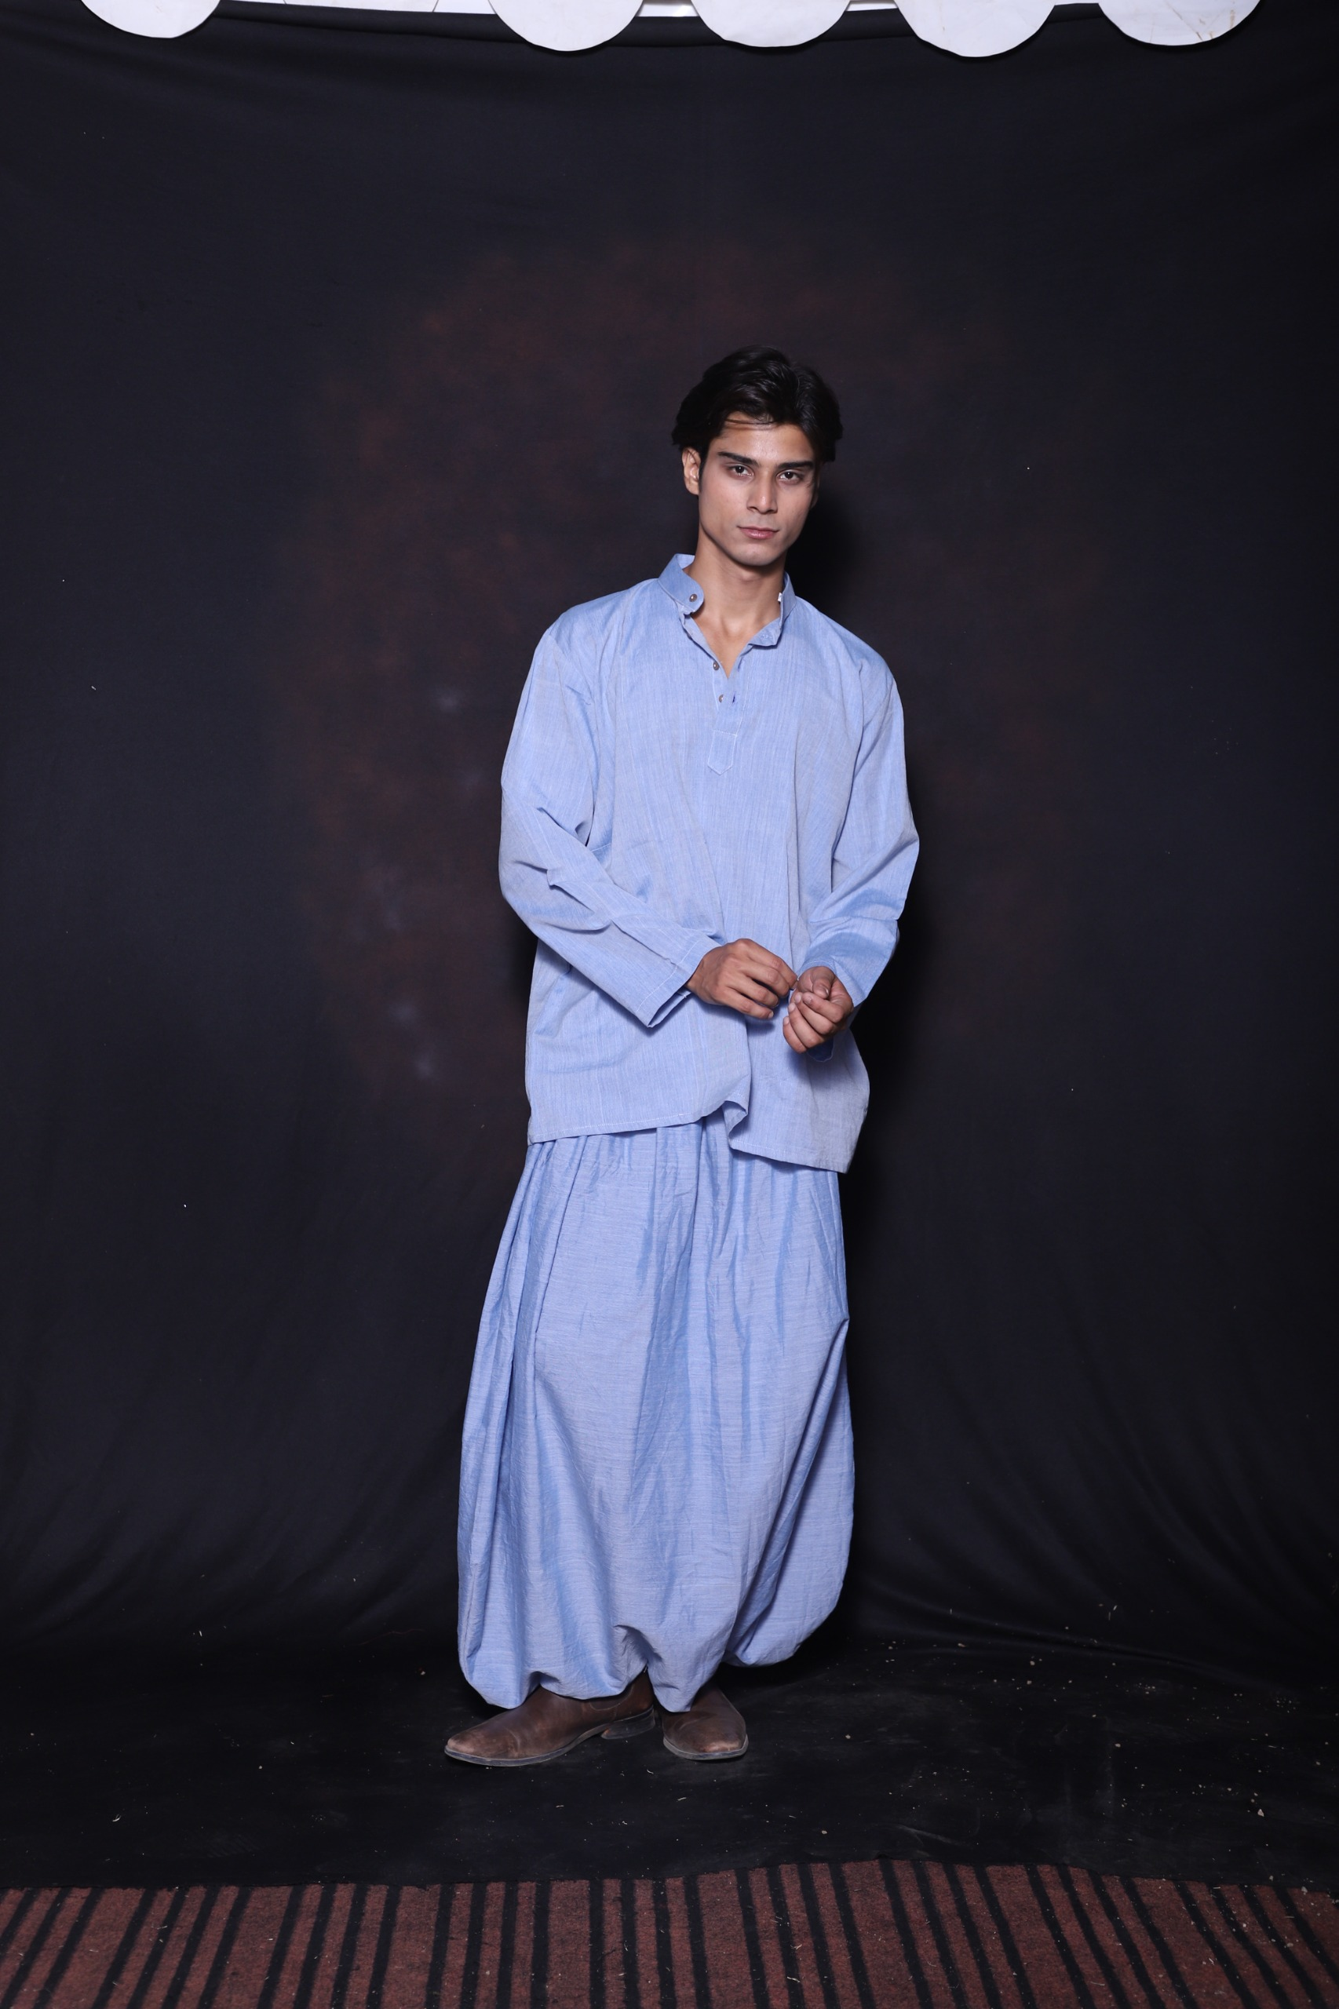
Image no 2: Functional Performance of Khadi
3.2 Technical Reimagining of Khadi for Durability and Versatile Utility
Recent textile innovations have significantly expanded khadi’s functional applications. Blending khadi with silk, linen, modal, or recycled fibers improves:
- tensile strength,
- wrinkle recovery,
- abrasion resistance,
- and fabric drape.
Contemporary finishing techniques such as enzyme washing, softening, and digital printing further enhance khadi’s commercial adaptability. Functional garment details including concealed pockets, adjustable silhouettes, detachable components, and modular layering increase usability for travel-oriented consumers.
3.3 Sustainable Value Chains and the Ethics of Conscious Clothing Production
Khadi production operates through decentralized craft-based systems involving local artisans, hand spinning, and low-energy manufacturing processes. Compared to industrial textile production, khadi significantly reduces:
- carbon emissions,
- water consumption,
- and energy usage.
The ethical dimension of khadi extends beyond sustainability into social empowerment by supporting rural livelihoods and preserving indigenous craft traditions. Therefore, khadi embodies the principles of slow fashion and circular design systems.
4. Design Synthesis: Integrating Traditional Heritage with Contemporary Aesthetics
4.1 Synchronizing Local Ethnic Motifs with Western Minimalist Silhouettes
The Urban Nomad collection integrates Indian textile heritage with contemporary global aesthetics. Traditional motifs inspired by tribal geometry, block printing, and regional weaving patterns are translated into subtle minimalistic applications suitable for modern menswear. Design elements are include as mentioned.
- relaxed tailoring,
- asymmetrical layering,
- utility inspired garments,
- monochromatic palettes,
- and breathable oversized forms.
This synthesis creates garments that resonate with global consumers while preserving local cultural identity.
4.2 Adapting Traditional Weaving Technologies for Modern Functional Requirements
Traditional weaving technologies are increasingly adapted through:
- ergonomic loom modifications,
- yarn engineering,
- eco-friendly dyeing,
- and hybrid fiber development.
Such interventions improve production efficiency while maintaining handcrafted authenticity. Digital technologies also enable artisans to connect with global markets through sustainable fashion platforms.
4.3 Consumer Perception and Acceptance of Sustainable Handloom Fabrics in Professional Environments
Consumer perception toward handloom fabrics has shifted considerably over the past decade. Younger demographics increasingly associate sustainable clothing with prestige, individuality, and ethical awareness.
However, challenges remain regarding:
- perceptions of formality,
- fabric maintenance & scalability.
Design innovation and branding strategies play a crucial role in repositioning khadi as a premium urban lifestyle textile suitable for corporate, travel, and luxury casual wear.
4.4 Global Sustainable Fashion Market Growth
The statistical findings indicate a strong and accelerating shift toward sustainability within the global fashion industry, driven by increasing environmental awareness, ethical consumerism, and policy level attention toward climate responsive production systems. The global sustainable fashion market, valued at approximately USD 7.8 billion in 2023 and projected to exceed USD 33 billion by 2030, reflects a substantial compound annual growth trajectory, demonstrating that sustainability has transitioned from a niche market trend to a mainstream economic driver within the apparel sector. This remarkable growth suggests expanding investment opportunities in eco-friendly textiles, circular fashion systems, and ethically produced garments.
Consumer awareness has emerged as a major catalyst in this transformation, with nearly 67% of global consumers reporting that sustainability influences their apparel purchasing decisions. This indicates that environmental responsibility is increasingly becoming a decisive factor alongside traditional determinants such as price, quality, and aesthetics. The data further reveals a significant generational shift, as approximately 73% of Generation Z consumers express willingness to pay premium prices for sustainable clothing. This finding is particularly important because Gen Z represents the future dominant consumer segment, suggesting long-term market stability for sustainable fashion brands and ethical textile innovations. At the same time, the fashion industry’s contribution of nearly 10% of global carbon emissions highlights the urgent need for sustainable alternatives in textile production and consumption. This environmental burden has intensified demand for low carbon materials such as organic cotton, recycled fibers, and traditional eco-friendly textiles like Khadi, which align with global decarbonization goals. The findings collectively suggest that sustainable textiles are no longer merely cultural or ethical choices; they are becoming strategic economic assets that will define the competitiveness and future resilience of the global apparel industry.

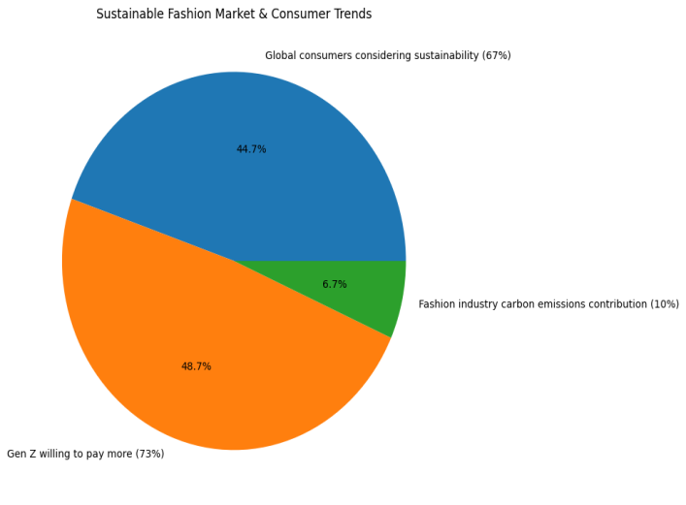
Graph no: Global Sustainable Fashion Market Growth

4.5 Consumer Behaviour and Sustainable Fashion Preferences: The survey findings indicate a significant shift in contemporary consumer behavior toward more conscious and sustainable fashion choices, particularly among urban populations. Approximately 62% of urban consumers expressed a preference for breathable natural fabrics during summer seasons, highlighting the growing importance of comfort, climate responsiveness, and material functionality in apparel purchasing decisions. This trend suggests that consumers increasingly value textiles that offer physical comfort alongside environmental benefits, making natural fabrics such as Khadi highly relevant in modern fashion markets. Additionally, around 58% of millennials reported a preference for ethically sourced apparel brands, reflecting heightened awareness regarding sustainable production practices, labor ethics, and environmental responsibility. This demographic appears particularly influenced by transparency and brand values, indicating that ethical positioning has become a critical factor in purchasing decisions rather than merely a secondary consideration.
Nearly 45% of respondents associated handcrafted textiles with premium quality, demonstrating a growing appreciation for artisanal craftsmanship and authentic cultural products. This finding suggests that consumers increasingly perceive handmade and heritage based textiles as symbols of exclusivity, individuality, and superior value, thereby strengthening the market potential for traditional craft-based industries such as the Indian handloom sector. Most notably, more than 70% of urban professionals preferred multifunctional garments suitable for both work and travel, indicating a strong demand for adaptable and versatile clothing solutions in contemporary urban lifestyles. This reflects the emergence of the “Urban Nomad” consumer individuals seeking garments that combine mobility, functionality, and aesthetic sophistication. Collectively, these findings confirm that modern consumers are progressively aligning their fashion choices with sustainability, functionality, and cultural authenticity, creating favorable conditions for the growth of innovative, ethically produced textiles in the global apparel industry. A result is shown in below mention graph.

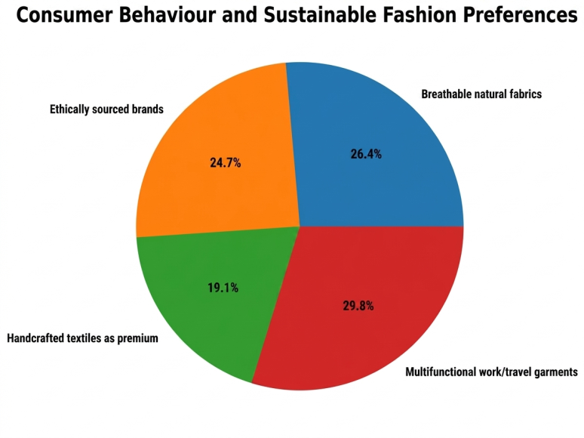
Graph No: Consumer Behaviour and Sustainable Fashion Preferences
5. Conclusion and Future Work
The Urban Nomad framework offers a compelling and innovative direction for contemporary menswear by integrating mobility, sustainability, and transcultural identity through the reinterpretation of Khadi craftsmanship. This study demonstrates that khadi is not merely a traditional textile associated with Indian heritage, but a dynamic and adaptive material capable of responding to the functional, aesthetic, and ethical demands of global contemporary fashion systems. Its significance extends beyond symbolism; khadi possesses measurable functional advantages such as breathability, thermoregulation, comfort, and environmental compatibility, making it highly relevant for modern urban consumers who prioritize versatility and conscious consumption. The research further establishes that the fusion of traditional handloom techniques with contemporary garment construction, minimalist aesthetics, and performance oriented design can reposition khadi from a culturally specific textile to a globally competitive fashion material. By aligning heritage craftsmanship with modern design thinking, khadi can address the growing demand for sustainable luxury, multifunctional clothing, and culturally meaningful fashion products. This transformation is especially important in a global context where consumers increasingly seek authenticity, ethical transparency, and emotional value in their clothing choices. From a socio-economic perspective, the revitalization of khadi also contributes to broader sustainability goals by supporting rural artisan livelihoods, preserving indigenous craft knowledge, and promoting decentralized low-carbon manufacturing systems. Thus, khadi offers a model of fashion innovation that balances technological advancement with cultural preservation and social responsibility. The Urban Nomad concept also contributes theoretically to discussions surrounding contemporary masculinity by positioning menswear as a site of identity negotiation where mobility, comfort, sustainability, and cultural awareness intersect. In this context, khadi based apparel symbolizes a new form of masculine expression one that values understated luxury, ecological responsibility, and transcultural adaptability.
Future research may further expand this framework through interdisciplinary investigations into:
- Integration of Smart Textiles and wearable technology with khadi fabrics,
- Performance enhancement through advanced textile engineering and innovative finishing techniques,
- Consumer behavior analytics related to sustainable menswear adoption across global markets,
- Digital preservation and documentation of traditional craft knowledge using AI and virtual platforms,
- Comparative studies of heritage textiles within international sustainable fashion systems.
In conclusion, the future of Sustainable Fashion lies not solely in technological innovation, but in the meaningful integration of heritage, ethics, material intelligence, and contemporary design strategy. The Urban Nomad framework positions khadi as more than a fabric it emerges as a cultural and sustainable design philosophy capable of redefining the future of global menswear through responsible innovation, transcultural relevance, and enduring craftsmanship.

References

[1] Bhardwaj, V., & Fairhurst, A. (2010). Fast fashion: Response to changes in the fashion industry. The International Review of Retail, Distribution and Consumer Research, 20(1), 165–173. https://doi.org/10.1080/09593960903498300
[2] Fashion Revolution. (2023). Fashion transparency index 2023. Fashion Revolution
[3]Fletcher, K. (2014). Sustainable fashion and textiles: Design journeys (2nd ed.). Routledge.
[4]Fletcher, K., & Grose, L. (2012). Fashion and sustainability: Design for change. Laurence King Publishing.
[5]Mahatma Gandhi. (1955). Khadi: Why and how. Navajivan Publishing House.
[6]Grand View Research. (2024). Sustainable fashion market size, share & trends analysis report. Grand View Research
[7]Khadi and Village Industries Commission. (2023). Annual report 2022–2023. Government of India. KVIC Official Website
[8]Kawamura, Y. (2005). Fashion-ology: An introduction to fashion studies. Berg.
[9]Ministry of Textiles. (2023). Annual report 2022–23. Government of India. Ministry of Textiles
[10]Niessen, S. (2019). Handmade textiles and sustainable fashion. Bloomsbury Academic.
[11]Statista. (2024). Consumer attitudes toward sustainable fashion worldwide. Statista
[12]Sennett, R. (2008). The craftsman. Yale University Press.
[13]United Nations Environment Programme. (2023). Sustainability and circularity in the textile value chain: Global roadmap. UNEP
[14]World Bank. (2023). Textiles and clothing sector: Pathways to sustainable growth. World Bank

