Sustainable Wastewater Treatment Using MnCo₂O₄ / Orange Peel–Derived Cellulose Composite

Abstract
Water pollution is one of the major crises in the modern era caused by industries such hazardous dyes and organic pollutants lead to serious risks for both human health and aquatic ecosystems. Hence, it is essential to remove these contaminants from wastewater before releasing it into the environment. This study focuses the sunlight-assisted adsorption of organic dye MB, MO from wastewater using a MnCo₂O₄ / Cellulose composite. This Citrus reticulata (Kinnow) is synthesized through a hydrothermal method using Cellulose / MnCo₂O₄ composite. The dye degradation was analyzed by UV–Vis spectroscopy. It has showed an absorption peak at 290.06 nm for the composite, with characteristic dye peaks at 660 nm (MB) and 460–505 nm (MO) significantly diminishing after sunlight exposure, indicating efficient dye removal. BET analysis confirmed a high surface area of 56.689 m²/g, a pore volume of 0.219 cc/g, and an average pore diameter of 2.141 nm, indicative of a mesoporous structure ideal for adsorption applications. The composite reached adsorption within 15 minutes and the total adsorption was achieved in 1.5 hours under sunlight without requiring UV assistance. Its high efficiency, reusability, and use of renewable citrus waste have positioned the MnCo₂O₄/Cellulose as a next-generation green adsorbent for industrial and municipal wastewater treatment. The high efficiency, reusability and use of renewable citrus waste of the MnCo₂O₄/Cellulose have become important for the next-generation of green adsorbent for industrial and municipal wastewater treatment.
Keywords: Water pollution, Organic pollutants, Sunlight-assisted adsorption, Cellulose, Orange peels, green adsorbent.
Introduction
Improvement in global health and sanitation, along with a reduction in disease transmission, relies heavily on effective hygiene practices, access to healthcare facilities, and reliable wastewater collection and treatment systems. According to WHO and UNICEF (2000), around 2.4 billion people lack access to basic sanitation facilities, posing a significant public health risk. Water is at the heart of sustainable development, yet it remains a limited resource. population growth and climate change have caused a drastic decline in freshwater availability, emerging as a global concern [1]. Over the past 35 years, drought frequency and severity have increased considerably due to global warming. For instance, in the summer of 2017, Europe experienced a 20% rise in water-scarce areas, a trend likely to continue with major environmental and economic consequences [2].
Advanced oxidation processes (AOPs) have emerged as sustainable solutions for wastewater treatment. These processes utilize eco-friendly methods such as renewable energy, biological degradation, and smart monitoring to ensure high treatment efficiency with minimal carbon emissions [3]. Although water covers most of the Earth's surface, only about 0.7% is accessible for human use, with 97% being saltwater and 2.3% trapped in glaciers. Alarmingly, over 663 million people still lack access to clean water, and contaminated water is responsible for 2.2 million deaths annually, mostly due to diarrheal diseases [4]. Every eight seconds, a child dies from water-related illness, while 2 million tons of untreated sewage enter our water bodies daily. The global freshwater consumption exceeded 2002 trillion m³ in 2022, and demand is expected to rise by 20–30% by 2050 [5].
Industrial wastewater, particularly from the textile industry, presents a severe challenge due to the presence of persistent organic dyes like Methylene Blue (MB) and Methyl Orange (MO) [6]. These dyes are chemically stable, non-biodegradable, and harmful to aquatic ecosystems and human health. The textile industry alone consumes around 300 liters of water per kilogram of product and releases significant quantities of colored effluent into the environment [7]. In response, eco-friendly wastewater treatment technologies are being conceptualized, focusing on sustainable systems for both industrial and municipal applications [8] [9]. Among many materials, MnCo₂O₄/Cellulose’s performance has become exceptional for its toxic absorbance in the pollutants of wastewater treatment [10].
Cellulose, a renewable material derived from cellulose through enzyme hydrolysis, mechanical, or chemical methods, has favorable properties like high surface area, porosity, and tunable properties [11]. It is typically categorized into nanocrystalline cellulose (NCCs), nano fibrillated cellulose (NFCs), and bacterial nanocellulose (BNCs), each with distinct structural and functional characteristics [12] [13].
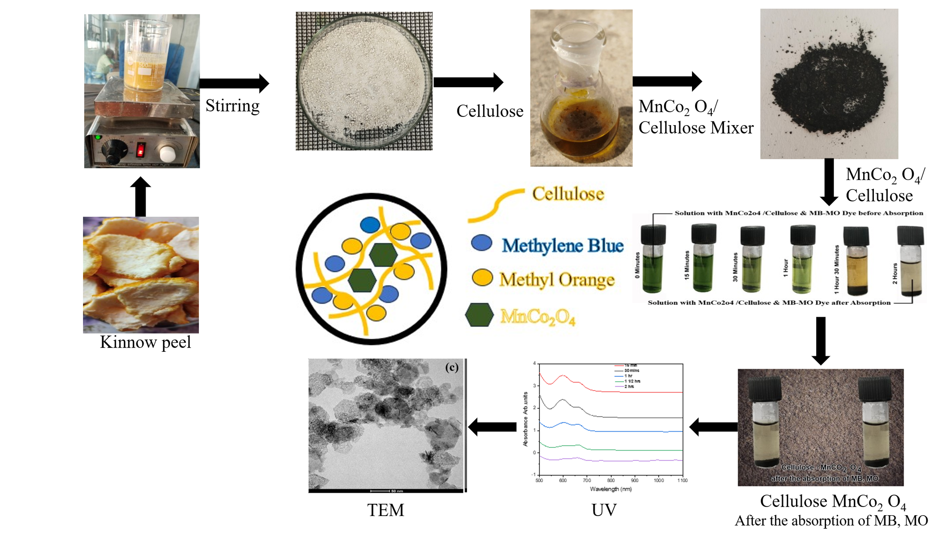
Figure. 1 Illustrates the roadmap, starting from the extraction of materials from Kinnow Peel to the final product
When combined with manganese cobalt oxide (MnCo₂O₄)/Cellulose becomes a powerful adsorbent. MnCo₂O₄ is a spinel-type transition metal oxide with a mixed-valence state (Mn²⁺/Mn³⁺ and Co²⁺/Co³⁺), which imparts high redox activity and surface reactivity. Although MnCo₂O₄ demonstrates remarkable efficiency, improvements in selectivity and regeneration are needed. Doping and composite formation enhance specific adsorption capabilities, and scalable production methods will be important for industrial application [14]. The main research focus is the selection of dye adsorption. Some studies have revealed that materials such as barium phosphate nanoflakes and MOF-polyoxometalate composites can selectively adsorb MB and MO from mixed dye solutions. However, most conventional materials fall short in both performance and reusability [15].
In this study, MnCo₂O₄/Cellulose is synthesized through hydrothermal methods and evaluated for its ability to adsorb MB (319.85 g/mol) and MO (327.33 g/mol). MB is a water-soluble cationic dye widely used in textiles, wood, and paper industries. MO is an anionic azo dye commonly applied in printing [16]. Both, MB and MO, are persistent environmental pollutants. The nanocellulose matrix offers abundant functional groups and large surface area, which, along with MnCo₂O₄ nanoparticles, provides improved active sites for pollutant binding. Adsorption experiments showed rapid absorption of MB and MO, achieving high removal efficiency in a short period [17]. Compared to traditional adsorbents, MnCo₂O₄/Cellulose showed superior adsorption capacity and could be reused effectively after several cycles.
Additionally, unlike many adsorbents that need UV assistance, this composite functions efficiently under ambient conditions. This makes it a more sustainable and cost-effective option for wastewater treatment, particularly in dye-laden effluents [18]. Several adsorbents were studied previously, highlighting the comparative advantage of MnCo₂O₄/Cellulose. The integration of MnCo₂O₄ within the Cellulose matrix enhances its structure, functionality, and pollutant-binding capacity, making it a strong candidate for large-scale wastewater purification. Hence, this study explores a novel, eco-friendly material for wastewater remediation. The MnCo₂O₄/Cellulose composite shows significant promise in removing toxic dyes such as MB and MO. Its high effectiveness, stability, and reusability declare it as a next-generation adsorbent for wastewater treatment applications. Further research can focus on real-world deployment and optimization strategies to maximize its environmental and economic benefits [19]. The synthesis of MnCo₂O₄/Cellulose for dye adsorption from wastewater involves integrating manganese cobalt oxide (MnCo₂O₄) nanoparticles with Cellulose to enhance adsorption properties [20]. While specific studies on MnCo₂O₄/Cellulose composites are limited, related research on similar Cellulose-based adsorbents provides valuable insights.
2. Materials and Methods of Synthesis
2.1 Collection of Kinnow Mandarin peels and its Extraction methodology
Fresh Kinnow (Citrus reticulata) fruits were purchased from Trichy local market. They were thoroughly washed under running water to remove any surface dirt and other impurities. After cleaning, the fruits were peeled, and the peels were dried at a room temperature. Once completely dried, the peels were ground into a fine powder using a household grinder and passed through a 60-mesh sieve to ensure uniform particle size. This fine peel powder was then used for cellulose extraction [21].

2.2 Isolation of Cellulose from Kinnow Mandarin Peels
Cellulose was extracted from the kinnow Mandarin peel powder [22]. To begin with, 30 grams of the ground peel were soaked overnight in ethanol mixture (2:1 ratio). The next day, the mixture was filtered, and the remaining solid residue was left to air-dry at room temperature. This dried material was then treated with hydrogen peroxide (H₂O₂) and heated in a water bath at 80°C. The process was repeated until the material turned into a clear white cellulose product [23].
The obtained cellulose was filtered and soaked overnight in a 6% sodium hydroxide (NaOH) solution at room temperature. Further, it was filtered again and subjected to a second NaOH treatment, this time in a water bath for one hour. The material was then neutralized with distilled water. Following this, it was sonicated in ice-cold water for 45 to 50 minutes and then filtered. Finally, the purified cellulose was dried in a vacuum oven at 80°C for 3 hours and stored at room temperature for future use.
2.3 Cellulose Purification and Treatment
To produce cellulose from the extracted cellulose, 50 mg of the purified cellulose was added to a falcon tube containing 10 ml of distilled water and sonicated at 80°C for about 15 to 20 minutes. After this initial treatment, 5 ml of an acid mixture made of hydrochloric acid (HCl) and sulfuric acid (H₂SO₄) was added to the solution. The mixture was then further sonicated at 60°C for 30 to 32 hours. Two different acid ratios were tested HCl to H₂SO₄ at 0.1:1 and 0.25:1. Once the acid hydrolyzed, the samples were centrifuged at 8000 rpm for 15 minutes. The resultant solid residue was washed by re-suspending it in distilled water, sonicated 5 minutes, and then centrifuged to isolate the cellulose.
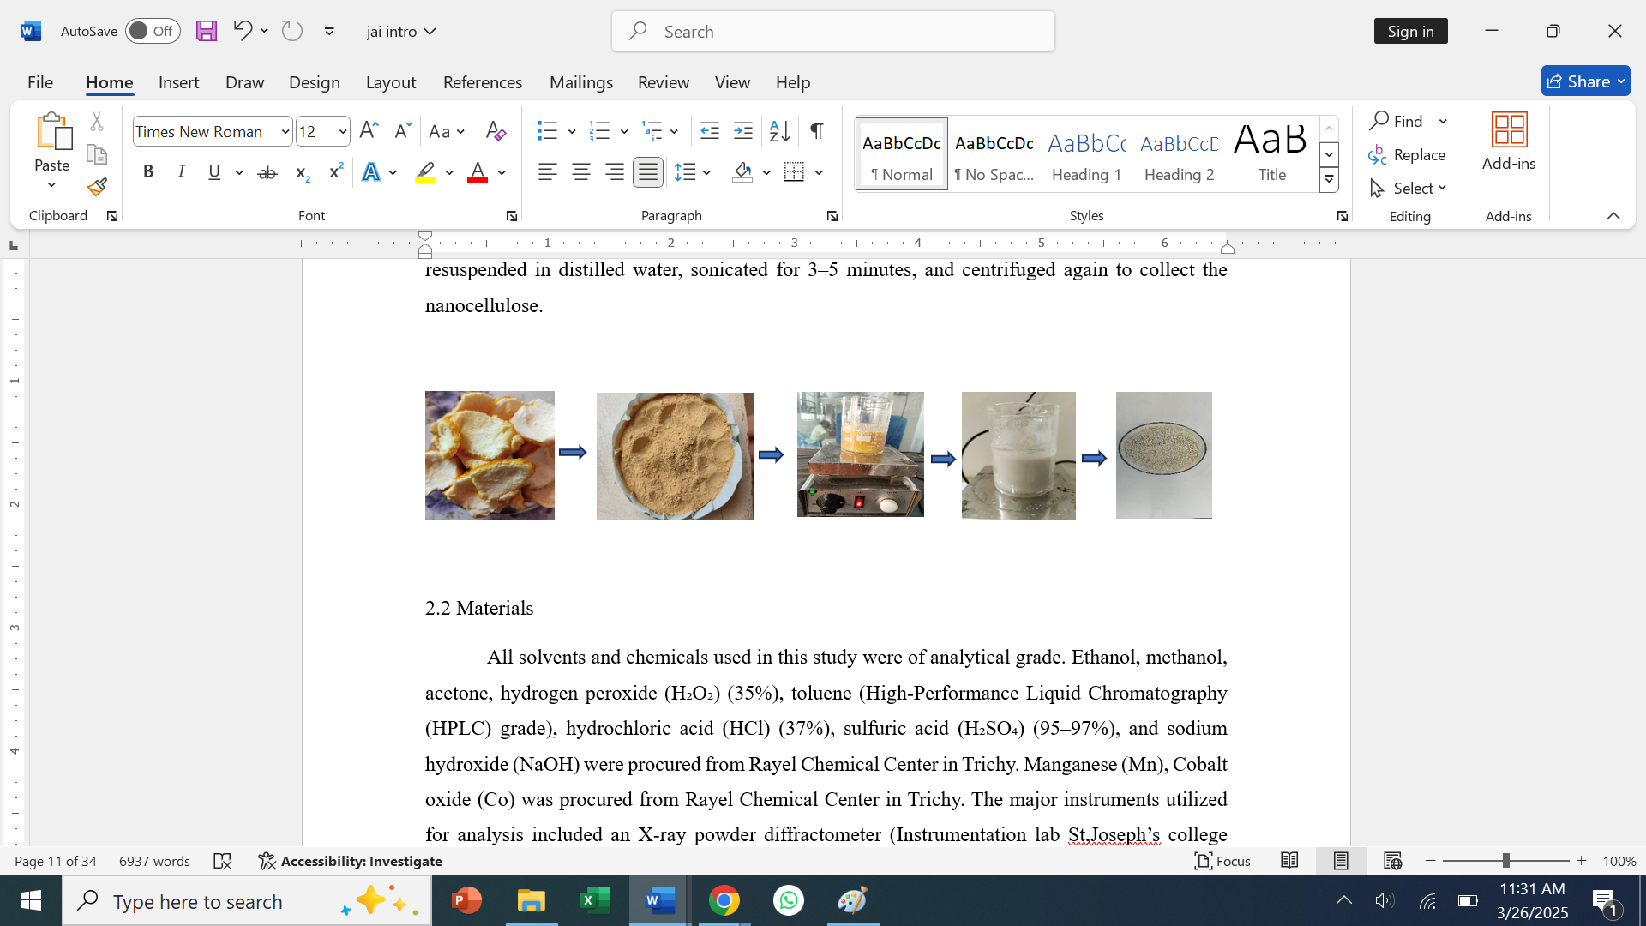
Figure 2: Cellulose Purification and Treatment
2.2 Materials and Methods
Cellulose, Co (NO₃)₂·6H₂O, Mn (NO₃)₂, conc. H₂SO₄, NaOH, and HCl aqueous methylene blue/methyl orange (MB/MO) were obtained from Merck Sigma-Aldrich and utilized without further purification. Double-distilled water had been employed as the solvent.

Synthesis of MnCo₂O₄ / Cellulose

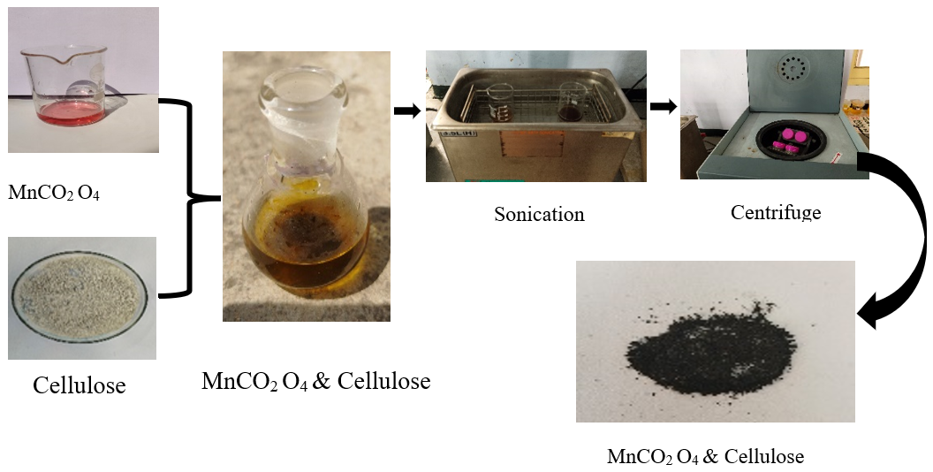
Figure 3: Synthesis of MnCo₂O₄ / Cellulose
0.2 M of Co (NO₃)₂·6H₂O, 0.001 M of Mn (NO₃)₂.6H₂O, and 25 mg of cellulose were mixed with 37.5 ml of ethanol and stirred at room temperature for 8 hours. After the reaction, the product was washed several times with double-distilled water, centrifuged, and dried in a hot air oven at 90 °C for 5 hours. The dried sample was then calcined at 500 °C for 2 hours as shown in figure 3.

3. Results and Discussion
3.1. UV–Vis Analysis of MnCo₂O₄ / Cellulose for Adsorption of Methylene Blue (MB) and Methyl Orange (MO) Dyes

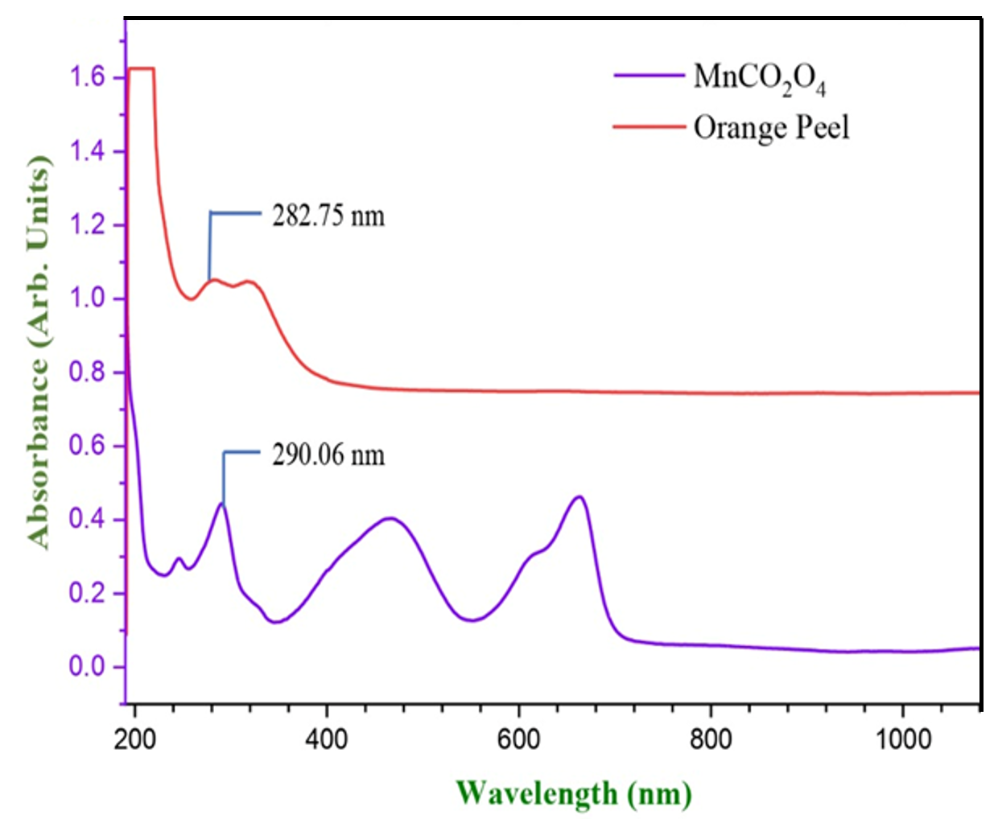
(a)
(b)
(b)
(a)

Figure:4 UV – Vis Plot of (a) Cellulose and (b) MnCo₂O₄
The UV absorption peak of MnCo₂O₄/Cellulose was previously found to be in the 200–1000 nm range. The extract of MnCo₂O₄/Cellulose shows a peak at 282.75 nm, highlighting its optical activity, while the absorption peak is around 290.06 nm [24].
The synthesis of MnCo₂O₄/Cellulose offers a cost-effective and scalable solution for environmental remediation. Materials such as manganese, cobalt, and kinnow peel are readily available and comparatively inexpensive, making the process suitable for large-scale wastewater treatment [25]. Furthermore, the composite material shows excellent thermal and mechanical stability, allowing it to be reused multiple times, which reduces operational costs. In addition, the fabrication methods used, such as hydrothermal or co-precipitation techniques, are simple and easily adaptable for mass production as shown in figure 4. With its high adsorption efficiency, durability, and reusability, MnCo₂O₄/Cellulose stands out as a sustainable and efficient adsorbent for dye removal in wastewater treatment applications.
The spectrum, recorded in the UV–Vis range of 200–1000 nm, displays absorbance patterns for both MnCo₂O₄/Orange peel Cellulose powder. The MnCo₂O₄/Cellulose sample shows a prominent absorption peak around 290.06 nm, while the Cellulose extract exhibits a peak at 282.75 nm, highlighting its optical activity. MB and MO dye is known to absorb strongly between 660–680 nm, and MO shows absorption at around 460 nm in its acidic form and 505 nm in its basic form.
3.2 FTIR: (Fourier Transform Infrared Spectroscopy)
Vibrational Spectroscopic Characterization
To determine the infrared absorption and emission spectrum for solids, liquids, or gases, Fourier Transform Infrared Spectroscopy, or FTIR, has been used. Broad peak at ~3300 cm⁻¹ strong O–H stretching, likely indicates alcohol or phenol [25] [26]. Peak observed at ~1700 cm⁻¹- strong C=O stretching, suggesting the presence of carbonyl groups like esters or acids. Strong peaks around 1000–1200 cm⁻¹ indicates C–O stretching vibrations (esters, ethers). Multiple peaks at 600–900 cm⁻¹ could be fingerprinting region for aromatic C–H bending or other skeletal vibrations [27] [28]. Also shows broad O–H stretch ~3300 cm⁻¹, but slightly less intense. C=O stretch ~1700 cm⁻¹ is prominent. More resolved sharp peaks in the fingerprint region (600–1200 cm⁻¹) than the MnCo₂O₄ / Cellulose spectrum. Additional smaller features in the 1500–1600 cm⁻¹ range may correspond to aromatic ring vibrations. O–H, C–H, C=O, and C–O vibrations [29]. The cellulose spectrum shows more defined peaks in the fingerprint region, which might suggest better structural ordering or more complex vibrational modes as shown in figure 5.

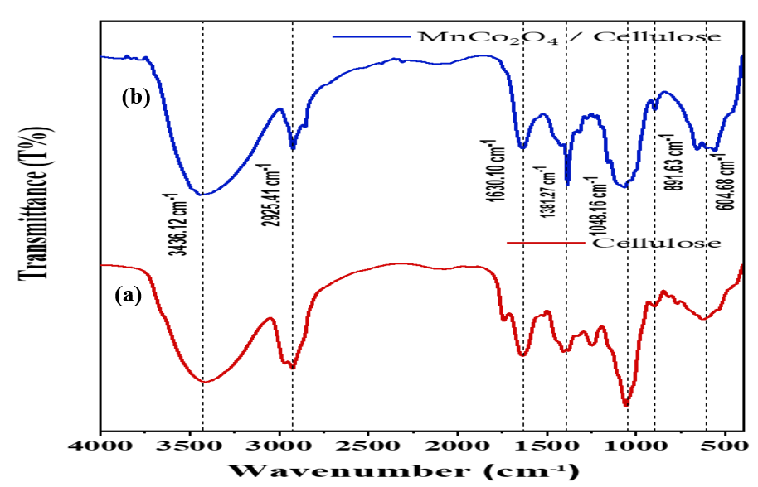
Fig: 5 FTIR spectra of (a) cellulose and (b) MnCo₂O₄/ Cellulose

Table:1 Functional Group
Wavenumber (cm⁻¹) | Functional Group / Vibration Type | Observed in Spectrum
3300–3400 | O–H stretch (alcohols, phenols) | Broad peak, both samples
2900 | C–H stretch (alkanes) | Slight shoulder/peak
1700–1750 | C=O stretch (carbonyl groups – ketones, aldehydes, esters, acids) | Strong peak
1600–1650 | C=C stretch (alkenes or aromatic C=C) | Clear peak
1400–1450 | C–H bending (alkanes) | Small peaks
1000–1200 | C–O stretch (ethers, esters, alcohols) | Strong broad region
600–900 | Aromatic C–H bending, fingerprint region | Multiple sharp bands
Table:1 Examination of the functional group for each FTIR spectra wavenumber
3.3 Morphological Analysis
The structural and morphological analysis of MnCo₂O₄/Cellulose was carried out using Scanning Electron Microscopy (SEM) and Transmission Electron Microscopy (TEM). These techniques provide complementary insights into surface structure, particle distribution, and internal morphology, crucial for evaluating the composite's potential in adsorption, catalysis, and energy storage applications [30].
Scanning Electron Microscopy (SEM)
The SEM images provide detailed surface morphology of the MnCo₂O₄/Cellulose composite. At 5.00 KX magnification, fibrous Cellulose structures derived from kinnow peels are visible, forming a continuous porous matrix that facilitates enhanced surface area and adsorption efficiency [31]. At lower magnifications (2.00 KX), the surface appears rough and irregular, indicating the successful deposition of MnCo₂O₄ nanoparticles. At higher magnification (40.00 KX), the images reveal aggregated MnCo₂O₄ particles with sizes ranging from approximately 50 nm to 167 nm. Darker regions correspond to denser aggregations, while lighter areas indicate dispersed particles. The SEM images reveal a hierarchical nanocomposite architecture composed of fibrous cellulose scaffolds and dispersed MnCo₂O₄ nanoparticles as shown in figure 6. The cellulose provides a high surface area matrix, while MnCo₂O₄ contributes crystalline, porous domains. The composite exhibits mesoporous morphology, strong particle-matrix integration, and rough surface topography, which are ideal for dye adsorption, catalysis, and environmental remediation [32].
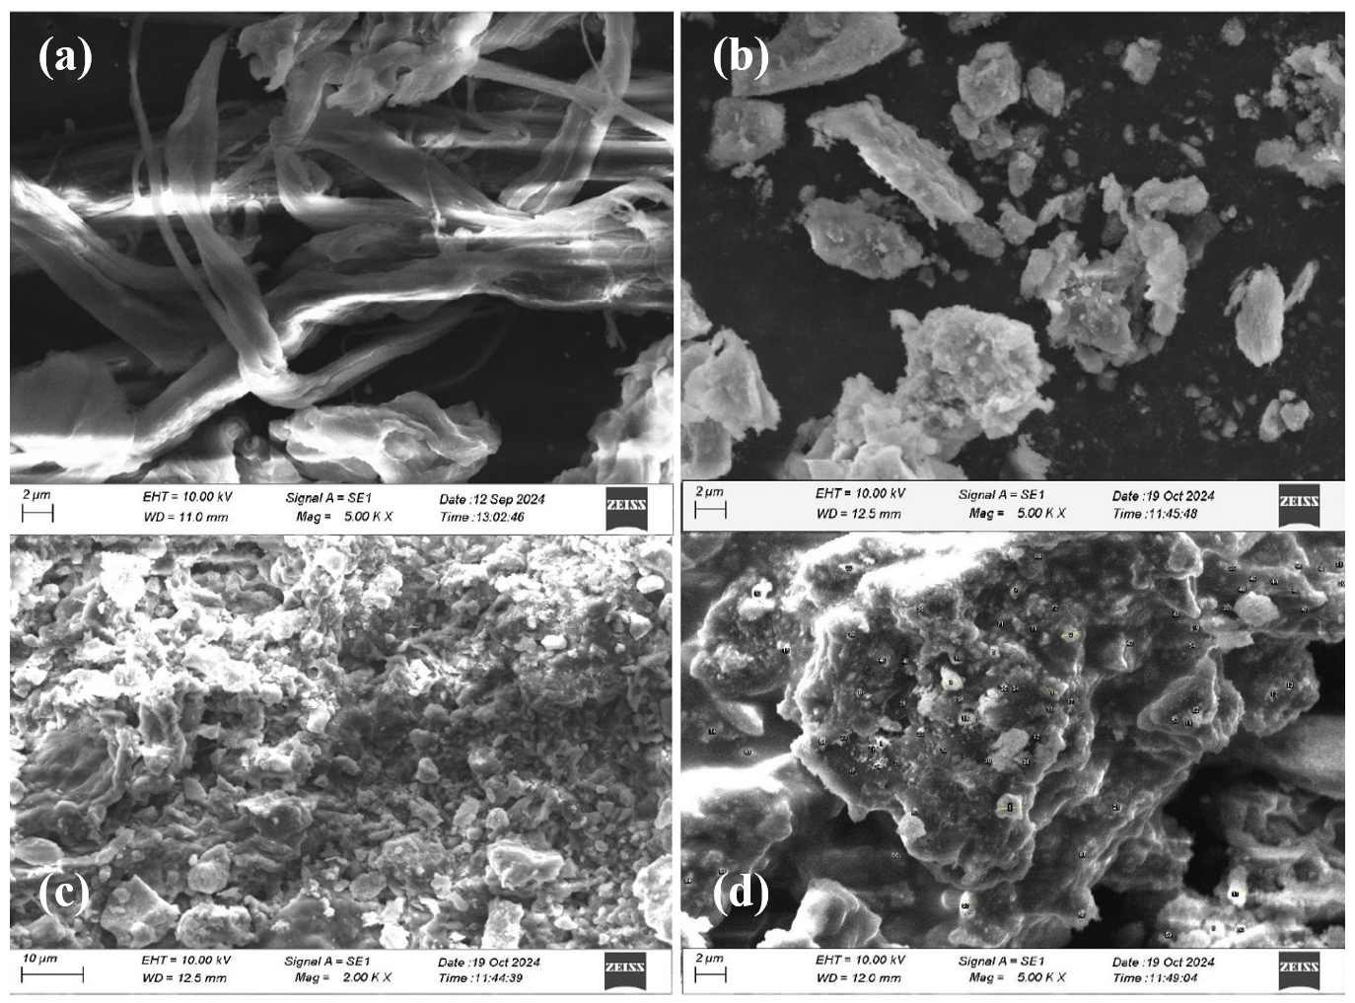
Figure: 6 (a &b) SEM images of Raw material – Kinnow peel (c & d) SEM images of the composite material - MnCo₂O₄ / Cellulose
Transmission Electron Microscopy (TEM)
TEM offers an in-depth look at the internal structure of the composite. At nanoscale resolution, the images show crystalline MnCo₂O₄ nanoparticles uniformly distributed within the cellulose matrix as shown in figure 7. The particle sizes range between 55 nm and 105 nm, with visible porous spaces that support efficient ion diffusion [33] [34]. The cellulose acts as a stabilizing and dispersing medium, preventing excessive particle aggregation and maintaining structural integrity. In the 1 μm scale image, the particles appear well-dispersed, while the 200 nm scale image shows denser, crystalline clusters.
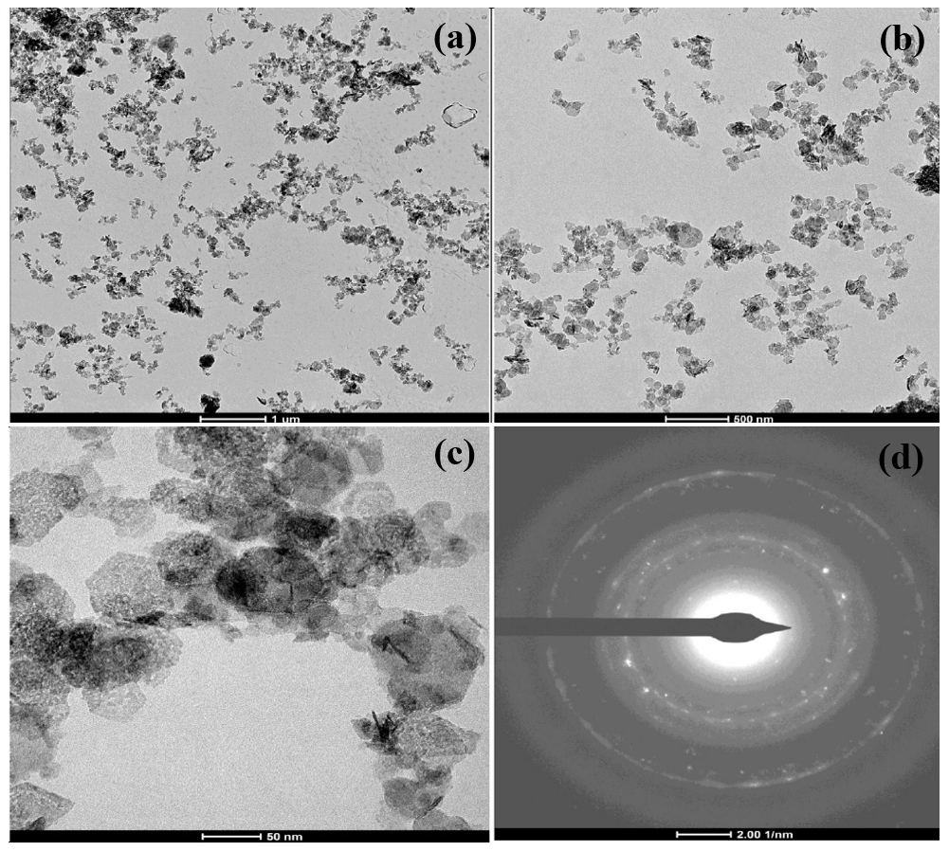
Figure:7 (a, b & c) TEM images of the composite material - MnCo₂O₄ / Cellulose
(d) Selected Area Electron diffraction (SAED) pattern

3.4. Structural Characterization
(XRD) Analysis of X-ray Diffraction

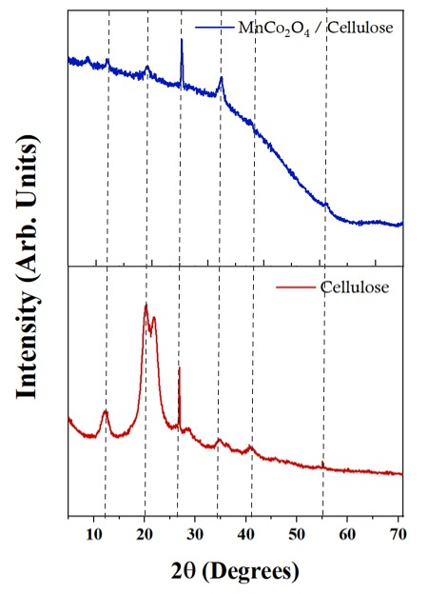
Figure:8 X-ray diffraction patterns of (a) cellulose and (b) MnCo₂O₄/Cellulose

It measures the diffraction of X-rays by the periodic atomic planes in crystalline materials to determine their structural properties. The 2θ (theta) values correspond to the interplanar spacing (d-spacing) in the material [35],
Scherrer’s Equation:
D = K λ​ ------ (Eqn. 1)
βCOS θ
• K = shape factor (typically 0.9),
• λ = X-ray wavelengths (e.g., 1.5406 Å for Cu Kα),
• β = full width at half of the maximum (FWHM in radians),
• Bragg angle (in radians, or is equal to θ.
Dislocation Density (δ):
δ= 1 ------ (Eqn. 2)
D²
Indicates the number of dislocations in the crystal structure.
Lattice Strain (ε):
ε= β ------ (Eqn. 3)
4tanθ
Represents strain in the crystal lattice due to imperfections or dopant-induced distortions.
Important information regarding the crystalline makeup in both the natural cellulose and the MnCo₂O₄/Cellulose composites can be found in the intensity vs. 2θ XRD figure. The brightness and clarity of the peaks reveal the material's crystallinity, while the peak placements reveal the kind of crystalline phase that is present. In the case of pure cellulose, broad peaks are observed around 2θ =22°, corresponding to the (200) crystallographic plane of native cellulose I, and at 2θ = 16°, which is attributed to the (110) plane. These broad peaks confirm the semi-crystalline nature typical of natural cellulose, with regions of both order and disorder.
In contrast, the MnCo₂O₄/Cellulose composite exhibits new sharp peaks at 2θ = 18°, 30°, 36°, 45°, 59°, and 65°, which are characteristic of the spinel crystalline phase of MnCo₂O₄. The sharpness of these peaks indicates the high crystallinity of MnCo₂O₄ and suggests proper embedding of these nanoparticles within the cellulose matrix as shown in figure 8. Importantly, the broad background seen in the composite pattern still retains the signature hump around 22°, implying that the cellulose structure is not destroyed but rather overlapped or masked by the crystalline MnCo₂O₄ peaks. This coincidence of peak positions confirms the continued presence of the cellulose backbone, even after nanoparticle incorporation. The sharp peaks unique to MnCo₂O₄, appearing alongside the original cellulose peaks, confirm the successful incorporation of MnCo₂O₄ into the matrix. The overlapping regions point to possible interactions between cellulose and MnCo₂O₄, but not total substitution. The broadening of cellulose peaks in the composite could be influenced by the nano-scale integration of MnCo₂O₄ particles and the partial disruption of the cellulose’s ordered structure. Nevertheless, the preserved cellulose peaks indicate that its structural integrity is partially retained after doping.
From the structural analysis, the crystallite size of pure cellulose is estimated to be 0.184 nm, while that of the MnCo₂O₄/Cellulose composite is significantly larger at 9.60 nm, confirming the presence of MnCo₂O₄ nanocrystals. The dislocation density also increases from 4.41 × 10¹¹ lines/m² in cellulose to 2.81 × 10¹² lines/m² in the composite, indicating a higher density of crystal imperfections due to doping. Additionally, the lattice strain decreases from 15.9679% in cellulose to 1.0169% in the composite, suggesting relaxation of the structure as a result of MnCo₂O₄ integration. XRD analysis confirms the formation of a dual-phase material a combination of amorphous/semi-crystalline cellulose and highly crystalline MnCo₂O₄ nanoparticles. The results provide strong evidence for the successful synthesis of a MnCo₂O₄/Cellulose composite with retained cellulose structure and enhanced crystalline features contributed by the embedded metal oxide phase.

Elemental Characterization (EDAX)

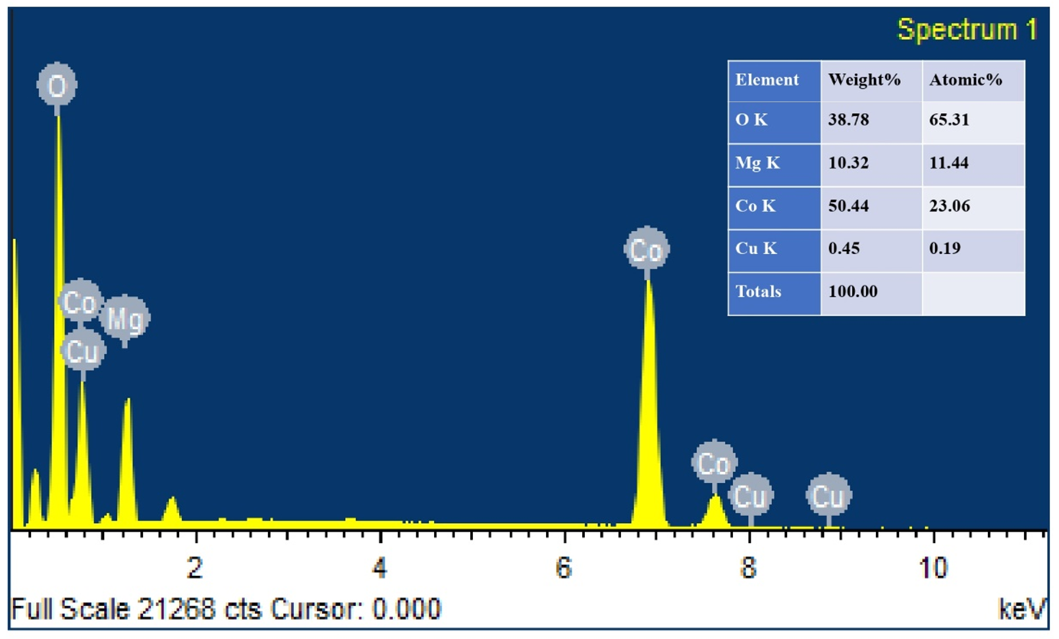
Figure:9 EDAX analysis of MnCo₂O₄ and cellulose
EDAX, or energy-dispersive X-ray analysis was conducted to determine the elemental composition and purity of the synthesized MnCo₂O₄/Cellulose, intended for dye adsorption in wastewater treatment. The EDAX spectrum confirmed the presence of key elements including cobalt (Co), oxygen (O) and magnesium (Mg) [36]. The elemental composition by weight was as follows Cobalt (Co) – 50.44 wt%. confirms MnCo₂O₄ as the dominant component. Oxygen (O) – 38.78 wt%. indicates a strong oxide structure vital for adsorption. Magnesium (Mg) – 10.32 wt% may enhance material porosity and thermal stability as shown in figure 8.
Several minor peaks (at 0.265, 1.742, 2.630, and 3.701 keV) were excluded from the final analysis, possibly due to structural impurities or undetected trace elements. The high concentrations of cobalt and oxygen highlight the composite’s oxide-based nature, which is favorable for adsorption processes [37]. The presence of magnesium may further improve surface interaction and durability, while cellulose provides a large surface area, enhancing overall dye adsorption performance through both physical entrapment and chemical bonding [38].


6/25/2006 2:52:14 AM
3.5. Surface Analysis
Brunauer–Emmett–Teller (BET) analysis
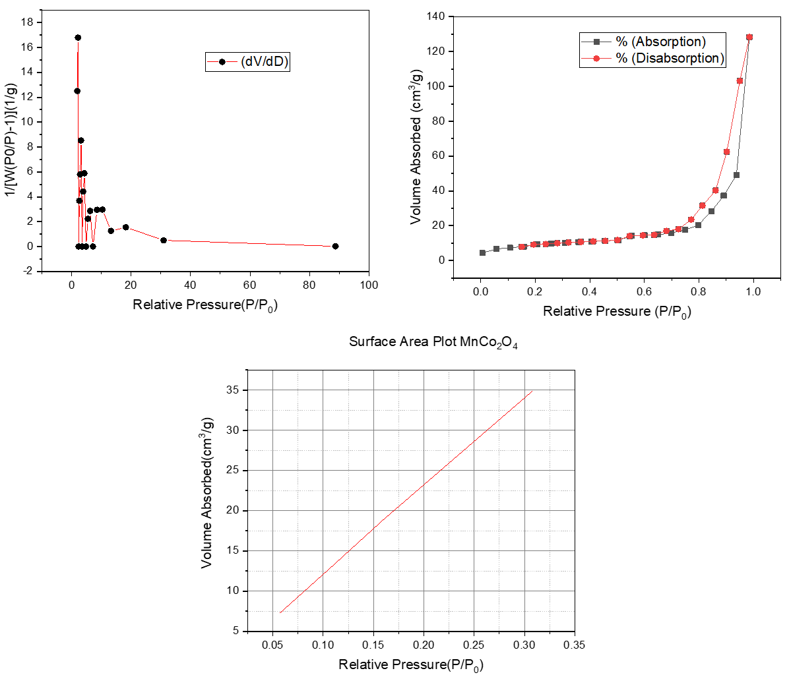
Figure:10 BET analysis of Mn₂Co₄/Cellulose
To evaluate the suitability of MnCo₂O₄/Cellulose for dye removal in wastewater treatment, surface area and porosity analyses were performed using the Brunauer–Emmett–Teller (BET) method [39]. The corresponding pore size distribution and nitrogen adsorption desorption isotherms are presented. Using the Barrett–Joyner–Halenda (BJH) method, the composite material [40] was found to have:
- BET Surface Area: 56.689 m²/g
- Pore Volume: 0.219 cc/g
- Pore Diameter: 2.141 nm
BET Surface Area 56.689 m²/g. This tells us how much surface area is available per gram of the material. A surface area of 56.689 square meters per gram means that just one gram of this composite has enough tiny pores and surfaces to cover nearly 57 square meters if spread flat. A larger surface area provides more active sites for dye molecules to attach to. This improves the material’s adsorption capacity, making it more effective at removing dyes from wastewater. Pore Volume 0.219 cc/g. This value represents the total space inside the pores in one gram of the material. A value of 0.219 cubic centimeters per gram indicates the volume available to hold dye molecules. A higher pore volume means that more dye molecules can fit inside the material. This enhances the material’s ability to trap and hold contaminants, improving overall dye removal efficiency. Pore Diameter 2.141 nm. This is the average width of the pores in the material. A pore diameter of 2.141 nanometers places it in the mesoporous range (2–50 nm). Mesoporous materials are ideal for adsorbing larger molecules, such as dye molecules. The pore size here is just right for the dyes to enter, interact, and get trapped. A mesoporous structure (pore size between 2–50 nm) is highly effective for adsorbing larger molecules like dyes. The combination of high surface area and suitable pore size means that the material can trap more dye molecules and hold them efficiently.
These features enhance the interaction between dye molecules and the adsorbent surface, leading to improved adsorption performance. The mesoporous structure allows for easy diffusion and trapping of dye molecules. The high surface area offers more interaction points. The suitable pore volume supports sufficient adsorption capacity. These values indicate that the MnCo₂O₄-Cellulose possesses a mesoporous structure with a high surface area, an essential feature for effective adsorption. The combination of large surface area and optimal pore size facilitates better dye molecule interaction and entrapment, confirming the material’s strong potential for efficient and sustainable wastewater treatment [41] applications.
4. Application
4.1. Sample Test 1
A 50 ml round-bottom flasks and 10 ml vials with different quantities of the solution were filled with the prepared solution. As shown in Fig.11 these containers for samples had been treated to direct sunshine. After half an hour, every vial was inspected. After the MB and MO dye molecules were adsorbed, the MnCo₂O₄/Cellulose was observed.
Adsorptive Removal of Methylene Blue, Methyl Orange Dye Using Under Sunlight
The already-prepared solution had been distributed into separate vials (5 ml each vial). As a few of these vials holding a solution had been exposed to direct sunlight [42]. At 15-minute intervals, each vial had been removed from sunlight and placed within a light-resistant (dark) box. As illustrated. MnCo₂O₄ in each vial had absorbed methylene blue and methyl orange dyes following the conclusion of the corresponding exposure periods. The amount of adsorption varied among the vials as a result of different sun exposure times. In comparison to the vial exposed to 1.5 hours of sunshine, the vial exposed for 15 minutes had demonstrated less adsorption. Through the adsorption method, the dye molecules of MB, MO have been adsorbed to the surface of the MnCo₂O₄/Cellulose. The adsorption is clearly evident that after the adsorption of the Methylene Blue, Methyl Orange dye by MnCo₂O₄/Cellulose. Stock solutions of Methylene Blue (MB) and Methyl Orange (MO) dyes were prepared to study the adsorptive and catalytic behavior of MnCo₂O₄ and Cellulose.
To prepare the stock solution, 0.159925 g (5 × 10⁻⁴mol) of MB and the same amount of MO dye were accurately weighed and placed in separate beakers. Each dye was then dissolved in 50 mL of distilled water and stirred for 10 minutes to ensure complete dissolution. In parallel, 0.1 g of MnCo₂O₄ /Cellulose was dispersed in 50 mL of distilled water and sonicated for 15 minutes to achieve a uniform suspension. Then, 50 mL of the MB/ MO mixture was added to the 50 ml of MnCo₂O₄/Cellulose dispersion. The resultant solutions were stirred for an additional 30 minutes to ensure uniform mixing. These final mixtures were then ready for adsorption and catalytic studies. The efficiency of MnCo₂O₄/Cellulose while interacting with the dye molecules could be further evaluated using UV-Vis spectroscopy [43].
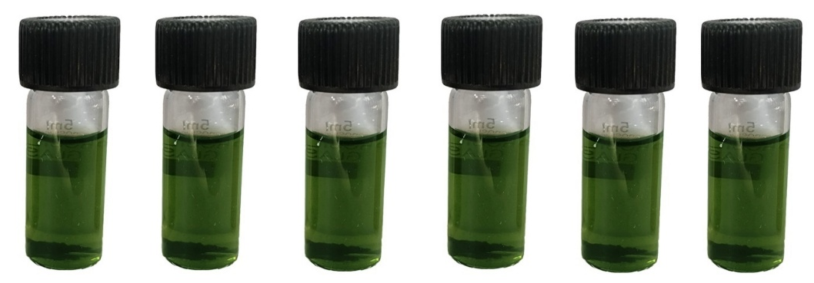
Figure: 11 The batch of vials containing the solution was kept under direct sun
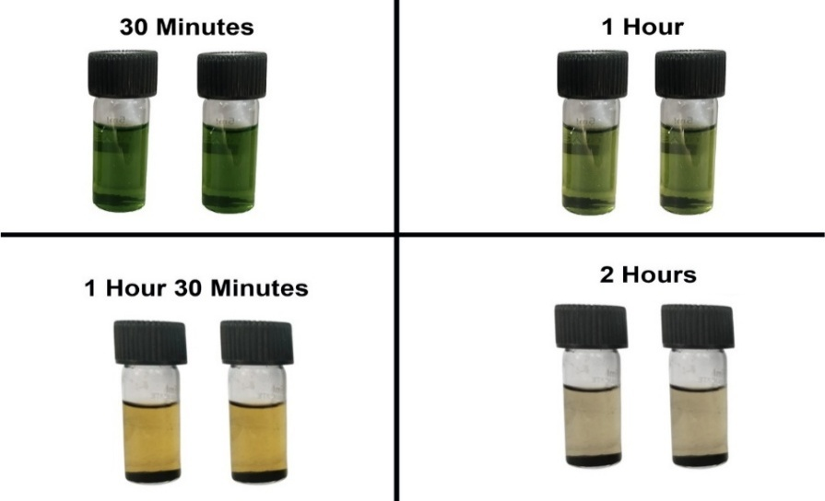
Figure:12 Cellulose – MnCo₂O₄ after the absorption of MB, MO
UV–Vis Analysis of the MnCo₂O₄ and Cellulose that has Adsorbed the Methylene blue and Methyl Orange Dye
With increased exposure time, the level of adsorption had also been elevated. The adsorption process had occurred more rapidly over time. Variations in adsorption among samples had been attributed to differing durations of sunlight exposure [44] , as illustrated in Fig. 12. The sample exposed to sunlight for 15 minutes had shown lower adsorption compared to the one subjected to 2 hours of exposure, after which adsorption had reached completion. UV spectra of the time-dependent samples had revealed adsorption peaks corresponding to MnCo₂O₄/Cellulose activity, with rapid adsorption occurring within the first 15 minutes. A comparison between the UV peak of the control sample and the 15-minute exposed sample had indicated that MnCo₂O₄/Cellulose had effectively adsorbed MB-MO dye under sunlight. The primary UV excitation peak of the MB-MO dye had been recorded at 660 nm, confirming that increased sunlight exposure had enhanced dye adsorption. The corresponding UV excitation peaks had demonstrated efficient adsorption of MB and MO dyes by MnCo₂O₄/Cellulose from wastewater under solar conditions. Thus, the application of solar-assisted adsorption had validated MnCo₂O₄/Cellulose as a highly active adsorbent for wastewater treatment, as shown in Fig. 14.
Figure: 13 UV–Vis plot of MnCo₂O₄/Cellulose that has Adsorbed the methylene blue, Methyl Orange Dye
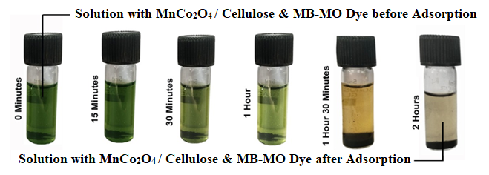
Figure: 14 The batch of vials after the adsorption of MnCo₂O₄ / Cellulose

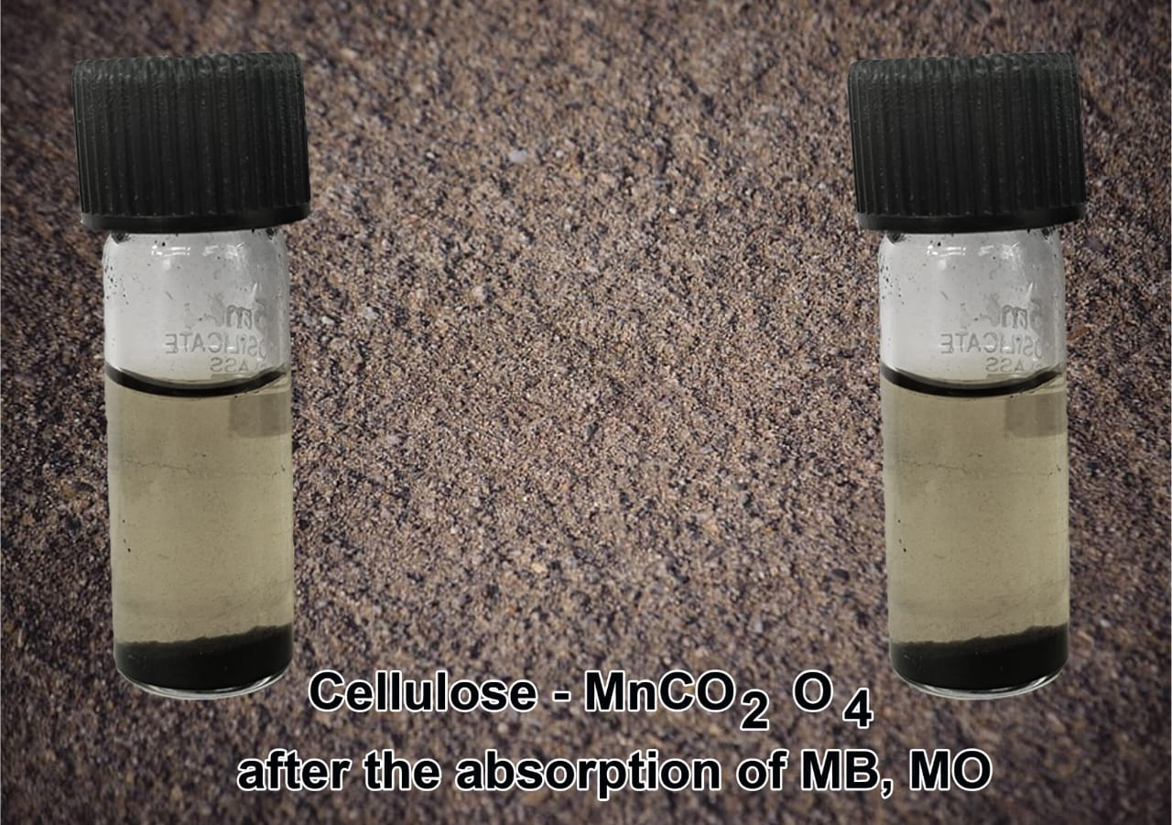
Figure:15 Cellulose – MnCo₂O₄ after the adsorption of MB-MO dye mixture
After the adsorption of the combined Methylene Blue (MB) and methyl orange (MO) dye solution utilizing the Cellulose/MnCo₂O₄ composite, the observed color result is often green or brown in color, attributed to the overlapping spectrum of absorption of the two dyes as shown in figure 15. The final color of the solution is also influenced by pH-dependent changes.
- Under acidic conditions (pH < 3.1), MO turns red and MB remains blue, resulting in a purple or dark blue-red hue.
- In a neutral pH range (4.4–6.0), MO appears orange and MB stays blue, producing a greenish or brownish appearance.
- Under basic conditions (pH > 4.4), MO turns yellow and MB remains blue, leading to a cyan or blue-green solution.
In the presence of reducing agents such as NaBH₄, Zn + HCl, or glucose, both dyes undergo reduction MB transforms into Leuco-Methylene Blue and MO into its reduced, colorless form, resulting in a colorless solution. Complete decolorization of the solution results from the breakdown of MB and MO into carbon dioxide (CO₂), water (H₂O), with tiny organic molecules under the effect of photocatalytic degradation using UV light and catalysts like TiO₂ or ZnO. Thus, the final outcome varies depending on the treatment method and pH, ranging from a persistent colored mixture to complete dye degradation.
Conclusion
The comprehensive study on MnCo₂O₄/Cellulose highlights its immense potential as an innovative and eco-friendly adsorbent for sustainable wastewater treatment, particularly for the removal of persistent organic dyes such as Methylene Blue (MB) and Methyl Orange (MO). Synthesized through a hydrothermal method using extracted cellulose from Kinnow (Citrus reticulata) peels, the composite material combines the high surface area and porosity of cellulose with the catalytic and redox-active properties of MnCo₂O₄, resulting in superior adsorption efficiency. The composite exhibited fast uptake of both MB and MO, with significant adsorption even after 15 minutes of sunlight exposure. Maximum dye removal was observed after 1.5 hours of solar-assisted treatment, suggesting enhanced photothermal interaction. UV–Vis analysis showed a marked reduction in characteristic dye peaks (660 nm for MB and 460–505 nm for MO), confirming strong dye binding. BET surface area was recorded as 56.689 m²/g, with a pore volume of 0.219 cc/g and average pore diameter of 2.141 nm, confirming a mesoporous cubic structure highly favorable for dye adsorption. The material works effectively under ambient and solar conditions, without requiring UV assistance or external energy input. It is cost-effective, uses locally sourced citrus waste, and is reusable over multiple cycles, making it scalable for both industrial and municipal wastewater applications.

References
[1] H. E. Muga and J. R. Mihelcic, “Sustainability of wastewater treatment technologies,” J Environ Manage, vol. 88, no. 3, pp. 437–447, Aug. 2008, doi: 10.1016/J.JENVMAN.2007.03.008.
[2] J. A. Garrido-Cardenas, B. Esteban-García, A. Agüera, J. A. Sánchez-Pérez, and F. Manzano-Agugliaro, “Wastewater Treatment by Advanced Oxidation Process and Their Worldwide Research Trends,” International Journal of Environmental Research and Public Health 2020, Vol. 17, Page 170, vol. 17, no. 1, p. 170, Dec. 2019, doi: 10.3390/IJERPH17010170.
[3] U. Ejairu, A. T. Aderamo, H. Chukwuemeka Olisakwe, A. E. Esiri, U. M. Adanma, and N. O. Solomon, “Eco-friendly wastewater treatment technologies (concept): Conceptualizing advanced, sustainable wastewater treatment designs for industrial and municipal applications,” 2024, doi: 10.57219/crret.2024.2.1.0063.
[4] R. Kishor et al., “Ecotoxicological and health concerns of persistent coloring pollutants of textile industry wastewater and treatment approaches for environmental safety,” J Environ Chem Eng, vol. 9, no. 2, p. 105012, Apr. 2021, doi: 10.1016/J.JECE.2020.105012.
[5] T. Chang et al., “A critical review on plasma-catalytic removal of VOCs: Catalyst development, process parameters and synergetic reaction mechanism,” Science of The Total Environment, vol. 828, p. 154290, Jul. 2022, doi: 10.1016/J.SCITOTENV.2022.154290.
[6] P. O. Oladoye, T. O. Ajiboye, E. O. Omotola, and O. J. Oyewola, “Methylene blue dye: Toxicity and potential elimination technology from wastewater,” Results in Engineering, vol. 16, p. 100678, Dec. 2022, doi: 10.1016/J.RINENG.2022.100678.
[7] A. K. Roy Choudhury, “Environmental Impacts of the Textile Industry and Its Assessment Through Life Cycle Assessment,” pp. 1–39, 2014, doi: 10.1007/978-981-287-110-7_1.
[8] U. Ejairu, A. T. Aderamo, H. Chukwuemeka Olisakwe, A. E. Esiri, U. M. Adanma, and N. O. Solomon, “Eco-friendly wastewater treatment technologies (concept): Conceptualizing advanced, sustainable wastewater treatment designs for industrial and municipal applications,” 2024, doi: 10.57219/crret.2024.2.1.0063.
[9] V. Chugh, A. Basu, A. Kaushik, N. Manshu, S. Bhansali, and A. K. Basu, “Employing nano-enabled artificial intelligence (AI)-based smart technologies for prediction, screening, and detection of cancer,” Nanoscale, vol. 16, no. 11, pp. 5458–5486, Mar. 2024, doi: 10.1039/D3NR05648A.
[10] P. Rajeswaran, P. Kamalarajan, S. Vasanthan, S. Sivagami, D. Venkatesh, and P. S. Karthik, “Structural Elucidation and Environmental Remediation Potential of Novel CoMn2O4@rGO Nanocatalyst,” Journal of Inorganic and Organometallic Polymers and Materials 2025, pp. 1–14, Mar. 2025, doi: 10.1007/S10904-025-03741-4.
[11] B. Thomas et al., “Nanocellulose, a Versatile Green Platform: From Biosources to Materials and Their Applications,” Chem Rev, vol. 118, no. 24, pp. 11575–11625, Dec. 2018, doi: 10.1021/ACS.CHEMREV.7B00627/ASSET/IMAGES/MEDIUM/CR-2017-00627Z_0029.GIF.
[12] N. H. A. Kadir, M. Mohammad, M. Alam, M. Torkashvand, T. G. B. Silvaragi, and S. L. Gururuloo, “Utilization of nanocellulose fibers, nanocrystalline cellulose and bacterial cellulose in biomedical and pharmaceutical applications,” Nanotechnology in Paper and Wood Engineering: Fundamentals, Challenges and Applications, pp. 409–470, Jan. 2022, doi: 10.1016/B978-0-323-85835-9.00025-8.
[13] S. S. Shah, M. N. Shaikh, M. Y. Khan, M. A. Alfasane, M. M. Rahman, and M. A. Aziz, “Present Status and Future Prospects of Jute in Nanotechnology: A Review,” The Chemical Record, vol. 21, no. 7, pp. 1631–1665, Jul. 2021, doi: 10.1002/TCR.202100135.
[14] R. Sahu, T. Patodia, S. Juyal, F. S. Gill, B. Prasad, and A. Jain, “Innovations and fundamentals in visible light-driven photocatalysis for CO2 reduction,” Catal Sci Technol, vol. 15, no. 4, pp. 988–1002, Feb. 2025, doi: 10.1039/D4CY01305K.
[15] D. M. Chen and X. J. Zhang, “A polyoxometalate template metal-organic framework with unusual {Cu8(μ4-OH)6}10+ secondary building unit for photocatalytic dye degradation,” Inorg Chem Commun, vol. 108, p. 107523, Oct. 2019, doi: 10.1016/J.INOCHE.2019.107523.
[16] A. Bafana, S. S. Devi, and T. Chakrabarti, “Azo dyes: past, present and the future,” https://doi.org/10.1139/a11-018, vol. 19, no. 1, pp. 350–370, 2011, doi: 10.1139/A11-018.
[17] Y. Gao, S. Q. Deng, X. Jin, S. L. Cai, S. R. Zheng, and W. G. Zhang, “The construction of amorphous metal-organic cage-based solid for rapid dye adsorption and time-dependent dye separation from water,” Chemical Engineering Journal, vol. 357, pp. 129–139, Feb. 2019, doi: 10.1016/J.CEJ.2018.09.124.
[18] M. D. Khan, A. Singh, M. Z. Khan, S. Tabraiz, and J. Sheikh, “Current perspectives, recent advancements, and efficiencies of various dye-containing wastewater treatment technologies,” Journal of Water Process Engineering, vol. 53, p. 103579, Jul. 2023, doi: 10.1016/J.JWPE.2023.103579.
[19] E. Osaba et al., “A Tutorial On the design, experimentation and application of metaheuristic algorithms to real-World optimization problems,” Swarm Evol Comput, vol. 64, p. 100888, Jul. 2021, doi: 10.1016/J.SWEVO.2021.100888.
[20] P. Rajeswaran, P. Kamalarajan, S. Vasanthan, S. Sivagami, D. Venkatesh, and P. S. Karthik, “Structural Elucidation and Environmental Remediation Potential of Novel CoMn2O4@rGO Nanocatalyst,” Journal of Inorganic and Organometallic Polymers and Materials 2025, pp. 1–14, Mar. 2025, doi: 10.1007/S10904-025-03741-4.
[21] Comprehensive Utilization of Citrus By-Products - Google Books.” Accessed: Mar. 31, 2025. [Online]. Available: https://books.google.co.in/books?
[22] M. Kumari, S. Singh, and A. K. Chauhan, “A Comparative Study of the Extraction of Pectin from Kinnow (Citrus reticulata) Peel Using Different Techniques,” Food Bioproc Tech, vol. 16, no. 10, pp. 2272–2286, Oct. 2023, doi: 10.1007/S11947-023-03059-4/METRICS.
[23] R. Koshani, T. G. M. Van De Ven, and A. Madadlou, “Characterization of Carboxylated Cellulose Nanocrytals Isolated through Catalyst-Assisted H2O2 Oxidation in a One-Step Procedure,” J Agric Food Chem, vol. 66, no. 29, pp. 7692–7700, Jul. 2018, doi: 10.1021/ACS.JAFC.8B00080/ASSET/IMAGES/MEDIUM/JF-2018-00080D_0010.GIF.
[24] E. Thaninayagam et al., “Bioreduction of gold nanocolloids using Quercus infectoria (Oliv): UV-assisted cationic-anionic dye degradation,” Biomass Convers Biorefin, vol. 13, no. 4, pp. 3463–3474, Feb. 2023, doi: 10.1007/S13399-023-03777-X/METRICS.
[25] T. Nypelö, “Magnetic cellulose: does extending cellulose versatility with magnetic functionality facilitate its use in devices?,” J Mater Chem C Mater, vol. 10, no. 3, pp. 805–818, Jan. 2022, doi: 10.1039/D1TC02105B.
[26] A. Dutta, “Fourier Transform Infrared Spectroscopy,” Spectroscopic Methods for Nanomaterials Characterization, vol. 2, pp. 73–93, Jan. 2017, doi: 10.1016/B978-0-323-46140-5.00004-2.
[27] S. M. S. Vagner de Alencar Arnaut de, Toledo ; Maria Claudia Colla Ruvolo-Takasusuki; Oliveira, Arildo José Braz de Chambó, Emerson Dechechi; Lopes, “MACRO TO Edited by Jamal Uddin,” pp. 269–290, 2012.
[28] M. Asemani and A. R. Rabbani, “Detailed FTIR spectroscopy characterization of crude oil extracted asphaltenes: Curve resolve of overlapping bands,” J Pet Sci Eng, vol. 185, p. 106618, Feb. 2020, doi: 10.1016/J.PETROL.2019.106618.
[29] M. Asemani and A. R. Rabbani, “Detailed FTIR spectroscopy characterization of crude oil extracted asphaltenes: Curve resolve of overlapping bands,” J Pet Sci Eng, vol. 185, p. 106618, Feb. 2020, doi: 10.1016/J.PETROL.2019.106618.
[30] P. Pazhamalai, V. Krishnan, M. S. Mohamed Saleem, S. J. Kim, and H. W. Seo, “Investigating composite electrode materials of metal oxides for advanced energy storage applications,” Nano Convergence 2024 11:1, vol. 11, no. 1, pp. 1–32, Jul. 2024, doi: 10.1186/S40580-024-00437-2.
[31] S. Onwubu, M. T. Mazibuko, T. H. Mokhothu, V. Paul, and P. S. Mdluli, “Amine-Functionalized Cellulose-Silica Composites for the Remediation of Hexavalent Chromium (Cr6+) in Contaminated Water,” 2024, doi: 10.2139/SSRN.4933843.
[32] Z. Y. Zhou, N. Tian, J. T. Li, I. Broadwell, and S. G. Sun, “Nanomaterials of high surface energy with exceptional properties in catalysis and energy storage,” Chem Soc Rev, vol. 40, no. 7, pp. 4167–4185, Jun. 2011, doi: 10.1039/C0CS00176G.
[33] V. Valtchev and L. Tosheva, “Porous nanosized particles: Preparation, properties, and applications,” Chem Rev, vol. 113, no. 8, pp. 6734–6760, Aug. 2013, doi: 10.1021/CR300439K/ASSET/CR300439K.FP.PNG_V03.
[34] J. Liu, “Scanning transmission electron microscopy and its application to the study of nanoparticles and nanoparticle systems,” J Electron Microsc (Tokyo), vol. 54, no. 3, pp. 251–278, Jun. 2005, doi: 10.1093/JMICRO/DFI034.
[35] M. A. Wahab, “Importance of d-Spacing in Diffraction of Crystals,” Springer Series in Solid-State Sciences, vol. 200, pp. 105–142, 2024, doi: 10.1007/978-981-99-8361-2_5.
[36] I. Puskas, T. H. Fleisch, J. B. Hall, B. L. Meyers, and R. T. Roginski, “Metal-support interactions in precipitated, magnesium-promoted cobaltsilica catalysts,” J Catal, vol. 134, no. 2, pp. 615–628, Apr. 1992, doi: 10.1016/0021-9517(92)90347-K.
[37] A. Badreldin, A. E. Abusrafa, and A. Abdel-Wahab, “Oxygen-Deficient Cobalt-Based Oxides for Electrocatalytic Water Splitting,” ChemSusChem, vol. 14, no. 1, pp. 10–32, Jan. 2021, doi: 10.1002/CSSC.202002002.
[38] A. Haleem, A. Shafiq, S. Q. Chen, and M. Nazar, “A Comprehensive Review on Adsorption, Photocatalytic and Chemical Degradation of Dyes and Nitro-Compounds over Different Kinds of Porous and Composite Materials,” Molecules 2023, Vol. 28, Page 1081, vol. 28, no. 3, p. 1081, Jan. 2023, doi: 10.3390/MOLECULES28031081.
[39] P. Rajeswaran, P. Kamalarajan, S. Vasanthan, S. Sivagami, D. Venkatesh, and P. S. Karthik, “Structural Elucidation and Environmental Remediation Potential of Novel CoMn2O4@rGO Nanocatalyst,” Journal of Inorganic and Organometallic Polymers and Materials 2025, pp. 1–14, Mar. 2025, doi: 10.1007/S10904-025-03741-4.
[40] V. G. Baldovino-Medrano, V. Niño-Celis, and R. Isaacs Giraldo, “Systematic Analysis of the Nitrogen Adsorption-Desorption Isotherms Recorded for a Series of Materials Based on Microporous-Mesoporous Amorphous Aluminosilicates Using Classical Methods,” J Chem Eng Data, vol. 68, no. 9, pp. 2512–2528, Sep. 2023, doi: 10.1021/ACS.JCED.3C00257/SUPPL_FILE/JE3C00257_SI_001.PDF.
[41] W. Al-Gethami et al., “Emerging environmentally friendly bio-based nanocomposites for the efficient removal of dyes and micropollutants from wastewater by adsorption: a comprehensive review,” RSC Adv, vol. 14, no. 4, pp. 2804–2834, Jan. 2024, doi: 10.1039/D3RA06501D.
[42] V. Snowlin et al., “Solar Assisted Removal of Methylene Blue Dye from Wastewater Using Zinc-Metal Organic Framework (Zn-MOF),” J Inorg Organomet Polym Mater, vol. 34, no. 1, pp. 251–265, Jan. 2024, doi: 10.1007/S10904-023-02823-5/METRICS.
[43] S. Ahmed, P. A. Nelson, K. G. Gallagher, N. Susarla, and D. W. Dees, “Cost and energy demand of producing nickel manganese cobalt cathode material for lithium ion batteries,” J Power Sources, vol. 342, pp. 733–740, Feb. 2017, doi: 10.1016/J.JPOWSOUR.2016.12.069.
[44] B. Sun et al., “Waste-cellulose-derived porous carbon adsorbents for methyl orange removal,” Chemical Engineering Journal, vol. 371, pp. 55–63, Sep. 2019, doi: 10.1016/J.CEJ.2019.04.031.

