PILOT INVESTIGATION ON SHALLOW SUBSURFACE MAPPING USING SEISMIC WAVE REFRACTION IN BATU CAVES AREA

ABSTRACT

Karstic limestone terrains pose significant challenges for engineering development because of their highly variable subsurface conditions, including cavities, dissolution features, fractured zones, and irregular bedrock surfaces. Accurate characterization of these features is essential to reduce geotechnical risks such as differential settlement, foundation instability, and sinkhole formation. This study presents a pilot investigation of shallow subsurface conditions in the Batu Caves limestone formation, Selangor, Malaysia, using seismic refraction as a non-destructive geophysical method for near-surface characterization. A 24-channel ABEM Terraloc seismic system with 1 m geophone spacing was deployed along a 24 m survey line to acquire first-arrival travel-time data. The collected seismic records were processed through travel-time analysis and velocity inversion to generate subsurface velocity models and geological interpretations. To support the geophysical findings, Schmidt rebound hammer testing and X-ray fluorescence (XRF) analysis were conducted to evaluate the mechanical strength and mineralogical composition of the exposed limestone. The rebound hammer results indicated estimated compressive strengths ranging from 42.2 MPa to 46.7 MPa, classifying the rock as moderately strong limestone. XRF analysis showed that the rock mass is dominated by calcium carbonate (59.44%) and magnesium carbonate (30.80%), confirming its carbonate composition. Seismic interpretation revealed three main subsurface layers consisting of topsoil, clay-rich overburden, and underlying limestone bedrock. Several localized low-velocity zones were identified, which may represent weathered materials, fractured limestone, or potential karst-related voids. The results demonstrate that seismic refraction is an effective technique for rapidly delineating shallow subsurface variability in tropical limestone environments. By integrating geophysical, mechanical, and mineralogical data, the study provides valuable preliminary information for geotechnical site investigations, infrastructure planning, and geohazard assessment in the Batu Caves karst terrain. The findings also highlight the potential of seismic refraction as a cost-effective tool for future engineering and environmental studies in complex limestone settings.

Keywords: Pilot study, Seismic refraction method, Shallow subsurface, Batu Caves region, Non-destructive test

INTRODUCTION

Research background

Karst terrains developed within carbonate rock formations are among the most challenging geological environments for civil engineering projects due to their highly heterogeneous subsurface conditions. Dissolution processes acting on limestone bedrock generate irregular pinnacles, cavities, sinkholes, enlarged fractures, and underground drainage systems, resulting in significant uncertainty in foundation design and construction planning. In tropical regions such as Malaysia, prolonged chemical weathering and intense rainfall accelerate karstification processes, increasing the likelihood of ground instability and subsidence-related hazards. Consequently, reliable characterization of shallow subsurface conditions is a fundamental requirement for infrastructure development in limestone areas.

Traditional site investigation methods such as borehole drilling provide direct information on subsurface materials; however, they are costly, time-consuming, spatially limited, and often insufficient for capturing the highly variable nature of karst systems. In contrast, geophysical methods offer rapid, cost-effective, and non-destructive alternatives capable of providing continuous subsurface information between boreholes. Among the available geophysical techniques, seismic refraction has been widely applied for mapping weathered rock profiles, bedrock topography, fracture zones, and subsurface discontinuities through the analysis of seismic wave propagation characteristics.

The Batu Caves area represents one of the most significant limestone formations in Peninsular Malaysia and forms part of the Kuala Lumpur Limestone Formation. The region is characterized by extensive karstification, irregular bedrock surfaces, dissolution cavities, and structurally controlled fractures that pose challenges for urban development and engineering construction. Although numerous geological investigations have been conducted within the Kuala Lumpur limestone belt, the application of seismic refraction methods for shallow subsurface characterization in Batu Caves remains relatively limited. Most previous studies have focused on geological mapping, geotechnical borehole investigations, or electrical resistivity techniques, leaving a knowledge gap regarding the effectiveness of seismic wave refraction in identifying shallow karstic features and subsurface heterogeneity.

Therefore, this study aims to evaluate the applicability of seismic refraction surveying for shallow subsurface mapping within the Batu Caves limestone environment. The specific objectives are to (i) characterize the near-surface geological profile using seismic velocity analysis, (ii) identify potential weathered zones and karst-related anomalies, and (iii) correlate geophysical findings with rock mechanical and mineralogical properties obtained from rebound hammer and XRF testing. The findings contribute towards improving geotechnical site investigation practices and enhancing the understanding of tropical limestone subsurface conditions for sustainable infrastructure development.

LITERATURE REVIEW

Shallow Subsurface Mapping

The shallow subsurface is shaped by processes like weathering, erosion, and deposition. The process of weathering deteriorates rocks and minerals, transforming them into smaller particles and contributing to the formation of soil. It is a fundamental geological process that has played a significant role in the long-term formation of the Earth's landscape. Different physical, chemical, and biological phenomena, either alone or in combination, can cause weathering.

Shallow subsurface mapping refers to the research and mapping of the geological and geophysical characteristics of the uppermost strata of the Earth's crust, typically extending to a few hundred metres below the surface. Geophysical surveys, ground-penetrating radar, electrical resistivity tomography, seismic refraction, and borehole logging were used to collect data and construct maps and models of the subsurface as shown in Figure 1.

Figure 1. Example of 2-D Shallow Subsurface Mapping using Electrical Resistivity (Metwaly & AlFouzan, 2013)

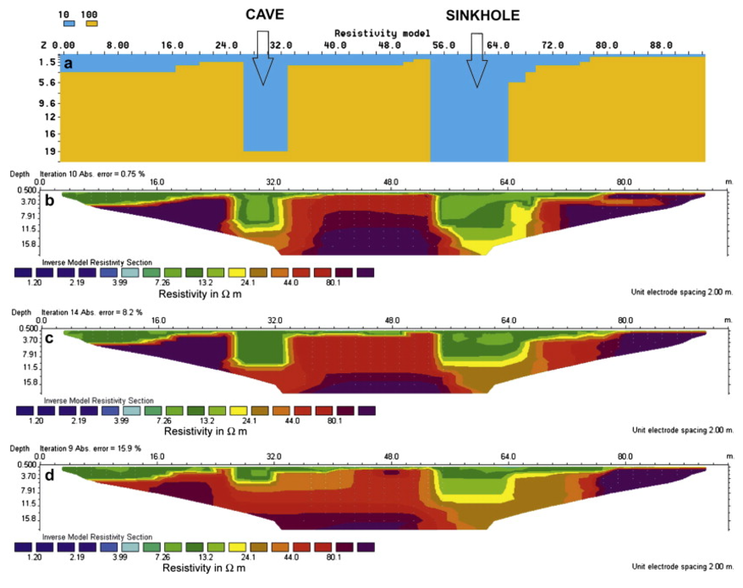

Understanding shallow subsurface features helps engineers analyse soil stability, load bearing capability, and geotechnical hazards in project construction and foundation design. Analysing shallow subsurface geological-engineering conditions to detect weak zones is common for constructing new and restoring existing transportation lines. These zones modify the geological medium, which deforms the route of construction and surface.

Shallow Subsurface of Research Area

The selected research area is located at Batu Caves, as shown in Figure 2 which presents a complex geological structures and different subsurface conditions. It relatively flats with limestone bedrock covered by an alluvial deposit. According to Ibrahim Komoo (1989), a karstic topographic hill formed by the Batu Caves limestone with the highest elevation of about 200m. Normally, it is made of calcitic and dolomitic marble with fine to coarse grain that ranges from white to grey. The process of dissolution in carbonate and evaporitic rocks creates a karst morphology profile in Kuala Lumpur as indicated in Figure 3.

Figure 2. Geological Features of Research Area (Bakhshipouri et al., 2009)

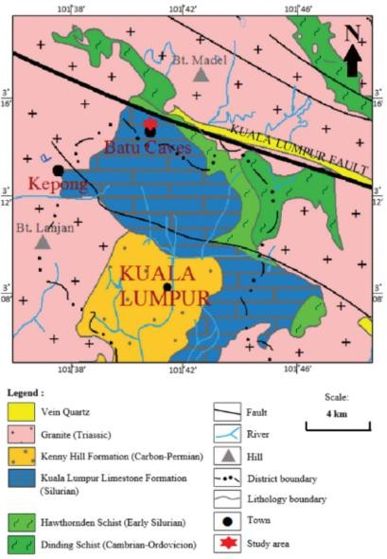

Figure 3. Profile of Karstic Topography in Kuala Lumpur (Yeap, 1986)

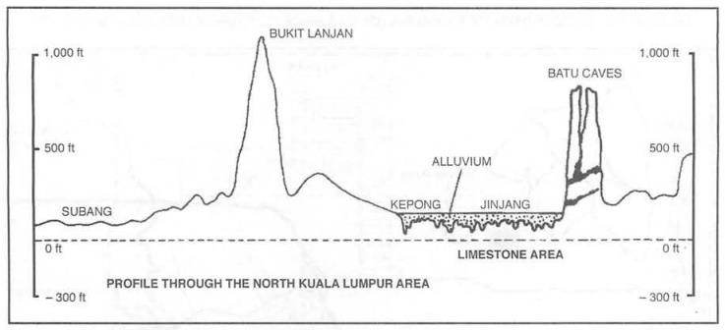

Although geological, hydrogeological, and geomorphological investigations cannot reveal a karst system's fundamental structure, they can estimate its karstification progress. The geometry and structure of various components; karst systems are unclear because of their complexity. Karst voids are frequently a significant engineering hazard in areas where carbonate minerals form the subsurface. Subsurface karstic cavities are associated with several issues, including road and highway subsidence, building foundation failure, and dam leakage. Large void formation in a karst environment can result in sudden and catastrophic pavement failure, while the sluggish migration of fine particles from the sub-base can result in gradual ground subsidence. For engineering structure design, any of the above situations in a karst environment can be expensive.

Limestone Formation and Karstic Regions Properties

Calcite's unique physical and engineering qualities make limestone formations and karstic regions popular research subjects. Research shows limestone's porosity and permeability vary, which affects its hydrological behaviour. Permeability allows things like water to move through porous pore spaces. The limestone type and diagenesis process affect these qualities.

Water slowly dissolves calcite in limestone's porosity and permeability, creating karst landscapes. Chemical weathering generates sinkholes, caves, and disappearing streams. Karstic locations have different topography and drainage systems because water dissolves limestone. Despite limestone's longevity, contaminants and cementation can modify its properties. Subsurface gaps and voids can pose stability risks and cause sinkholes and subsidence; therefore, limestone engineering projects must consider them.

Seismic Wave Refraction Methods

Refraction seismology operates on the principle that seismic waves encounter variations in geological properties during their propagation through the Earth. When a seismic wave reaches an interface between two distinct strata, a portion of the wave energy is refracted through the subsurface layers. Geophones or seismometers strategically placed on the ground capture these refracted waves, and the collected information is utilised to generate a detailed representation of the subsurface. The process of refraction seismology involves generating a controlled seismic wave, typically facilitated by an energy source like a seismic vibrator or an explosive charge. As the wave travels through the Earth, it undergoes refractions upon encountering various rock layers with distinct acoustic properties. Geophones then capture these refracted signals, converting them into digital data for subsequent analysis.

The Common Midpoint (CMP) method remains a pivotal technique for interpreting seismic refraction data. This method encompasses collecting seismic data at different source-receiver offsets, correlating recorded refractions based on their travel times and source-receiver distances, and documenting the outcomes, as illustrated in Figure 4. Through the stacking and processing these refracted signals, geophysicists can generate a comprehensive image of the subsurface, revealing details about the depth, thickness, and geological characteristics of the subsurface layers.

Figure 4. CMP method illustration (a) CMP gathers (b) CDP gathers (Cox et al., 2020)

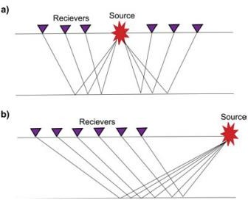

Limitation of Seismic Wave Refraction

Seismic refraction methods, like refraction methods, have limitations. The survey target needs to be large relative to the seismic signal wavelength, which is determined by the velocity-to-frequency ratio. Higher-frequency waves provide better resolution but have limited penetration depth, while lower-frequency waves penetrate deeply but offer coarser resolution. This trade-off affects the ability to capture fine-scale features in seismic refraction images. Additionally, materials near the surface, especially dry, porous sediments, can attenuate high- frequency energy, impacting the transmission of energy into the ground. Factors influencing this include near-surface materials, seismic source characteristics, source-receiver spacing, and ground coupling. Seismic waves may attenuate and absorb as they travel, leading to energy loss and reduced refracted signal amplitudes. Noise from various sources, such as wind, traffic, machinery, or other seismic energy forms, can affect survey results by lowering the signal-to-noise ratio.

Towards the end, accurate determination of refraction event arrival time changes, known as "moveout," requires a wide range of source-receiver offsets. Deeper refractions exhibit smaller moveouts for a fixed array length, reducing velocity estimation accuracy with increasing depth. The depth of seismic wave penetration depends on subsurface frequency and characteristics, with higher-frequency waves attenuating faster and having shallower penetration than lower-frequency waves, which penetrate deeper but may sacrifice resolution.

Research Gap and Knowledge Advancement

Recent studies have demonstrated the effectiveness of seismic refraction techniques for identifying weathered bedrock profiles, fault zones, fracture networks, and karstic features in complex geological environments. Li et al. (2024) reported that advanced travel-time tomography significantly improves the delineation of shallow subsurface heterogeneity within karst terrains. Similarly, Zhu et al. (2023) highlighted the growing application of high-resolution seismic methods for engineering site characterization in challenging geological settings. However, most investigations have been conducted in temperate environments where weathering processes differ considerably from tropical karst systems.

In Malaysia, geophysical investigations of limestone terrains have predominantly focused on electrical resistivity tomography, microgravity surveys, and borehole verification methods. Limited studies have explored the use of seismic refraction techniques for shallow subsurface characterization within tropical karst formations such as Batu Caves. Furthermore, existing studies rarely integrate seismic velocity interpretation with independent rock property assessments such as rebound hammer strength estimation and mineralogical characterization through XRF analysis. This lack of integrated datasets restricts confidence in interpreting seismic velocity anomalies within highly weathered limestone environments.

Accordingly, this study addresses three important knowledge gaps: (i) the limited application of seismic refraction methods within Malaysian tropical karst terrains, (ii) the insufficient correlation between seismic velocity profiles and rock engineering properties, and (iii) the lack of pilot-scale investigations evaluating the feasibility of seismic refraction for future geotechnical site investigations in Batu Caves. The outcomes are expected to provide a foundation for developing integrated geophysical-geotechnical approaches for limestone hazard assessment and infrastructure planning.

RESEARCH METHODOLOGY

Study Area and Geological Setting

The study was conducted at Gua Damai Extreme Park, Batu Caves, Selangor, Malaysia, as shown in Figure 5 which is situated within the Kuala Lumpur Limestone Formation, one of the most prominent karstic limestone formations in Peninsular Malaysia. The area is characterized by highly weathered carbonate bedrock, irregular pinnacled limestone surfaces, dissolution cavities, fractures, and localized karst features resulting from prolonged tropical weathering processes. The limestone formation is predominantly composed of calcitic and dolomitic carbonate rocks that have undergone varying degrees of dissolution and secondary mineralization. The presence of alluvial deposits and residual soils overlying the limestone bedrock further contributes to the heterogeneity of the subsurface conditions. Such geological complexity poses significant challenges for engineering development due to uncertainties associated with foundation support, groundwater flow, subsidence, and sinkhole formation (Komoo, 1989; Bakhshipouri et al., 2009; Stevanović, 2024). Consequently, detailed characterization of the shallow subsurface is essential for understanding the geological variability and assessing potential geotechnical hazards within the study area.

Figure 5. Gua Damai Extreme Park, Batu Caves

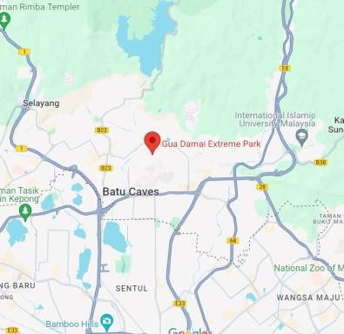

Seismic Refraction Survey Design

A seismic refraction survey was adopted as the primary geophysical technique for shallow subsurface characterization due to its ability to provide rapid, cost-effective, and non-destructive information on subsurface layering and material stiffness. The survey design was developed based on the anticipated geological conditions, expected depth of investigation, site accessibility, and the objective of delineating weathered zones and bedrock interfaces. A 24 m survey line was established across a relatively open area within the park to minimize obstructions and ensure efficient seismic wave propagation. Data acquisition was performed using an ABEM Terraloc Pro 24-channel seismograph equipped with twenty-four vertical geophones having a natural frequency of 28 Hz. The geophones were installed at 1 m intervals as in Figure 6 to provide high spatial resolution suitable for shallow subsurface investigations. A 10 kg sledgehammer striking a steel plate was employed as the seismic energy source due to its effectiveness for near-surface investigations and its ability to generate high-frequency compressional waves suitable for resolving shallow geological features (Foti et al., 2022). Seven shot locations were selected at offsets of -8 m, 0.5 m, 5.5 m, 11.5 m, 17.5 m, 22.5 m, and +8 m relative to the geophone spread to ensure sufficient ray coverage and improve subsurface velocity inversion reliability.

Figure 6. Geophones placed at 1m intervals for 24 meters.

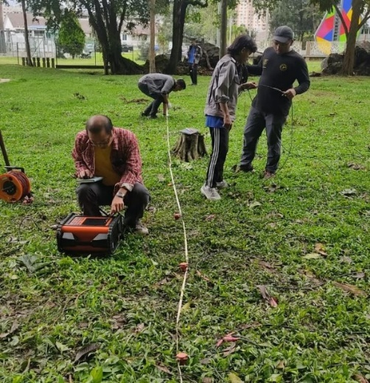

Data Acquisition Procedure

Prior to data acquisition, a reconnaissance survey was conducted to assess ground conditions, identify potential sources of environmental noise, and determine the most suitable survey alignment. Particular attention was given to minimizing interference from recreational activities, pedestrian movement, traffic vibrations, and surface obstacles that could adversely affect seismic signal quality. During data collection, each shot point was repeated several times and stacked automatically within the acquisition system to enhance the signal-to-noise ratio and improve first-arrival detection. Geophone-ground coupling was carefully verified to ensure efficient transmission and reception of seismic energy. The survey geometry, source-receiver spacing, and shot distribution were selected based on standard near-surface seismic investigation practices to provide adequate depth penetration and lateral coverage while maintaining sufficient resolution for detecting weathered zones, fractures, and shallow karstic features (Malehmir et al., 2021). Field notes, environmental conditions, equipment settings, and acquisition parameters were systematically documented to facilitate subsequent data processing and interpretation.

Data Processing and Velocity Inversion

The acquired seismic records were processed using SmartRefract software following a systematic workflow consisting of data quality assessment, first-arrival picking, travel-time analysis, velocity estimation, and subsurface model generation. Initially, all seismic traces were inspected visually to identify poor-quality records, excessive noise contamination, or anomalous signals that could compromise interpretation accuracy. First-arrival times were subsequently identified through a combination of automated and manual picking procedures to ensure reliable detection of refracted wave arrivals. Accurate first-break picking is a critical stage in seismic refraction analysis because small timing errors can significantly influence velocity estimation and depth calculations (Li et al., 2024).

Figure 7. Picking Point Line 1 (Source: SmartRefract)

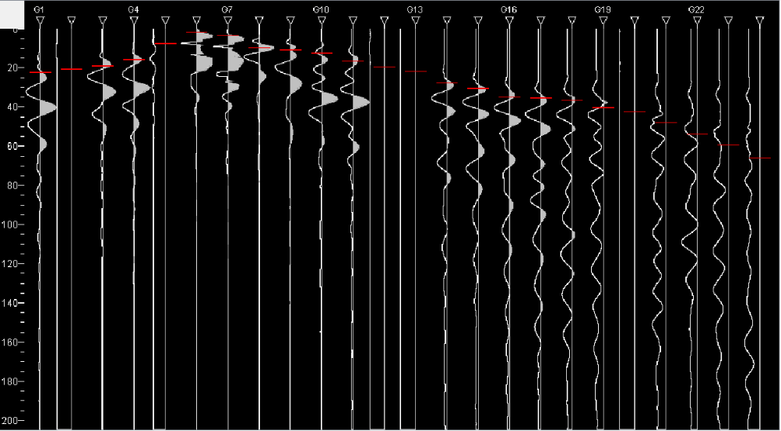

Following first-arrival selection as indicated in Figure 7, travel-time curves were generated for each shot gather and verified through consistency checks to ensure realistic velocity gradients. The processed travel-time data were then subjected to velocity inversion to establish subsurface velocity models and identify geological boundaries. The resulting seismic velocity profiles were interpreted based on established correlations between seismic P-wave velocity and geological materials. Generally, lower velocities were associated with unconsolidated soils and highly weathered materials, while higher velocities indicated denser and more competent limestone bedrock. Velocity anomalies were further evaluated as potential indicators of weathered zones, fractures, solution cavities, or localized karst features. The interpreted profiles were subsequently used to develop a shallow subsurface geological model of the study area.

Schmidt Rebound Hammer Testing

To provide supplementary information regarding the mechanical characteristics of the exposed limestone, Schmidt rebound hammer testing was performed on representative rock outcrops adjacent to the seismic survey line. The testing procedure followed the recommendations outlined by the International Society for Rock Mechanics (ISRM) for estimating rock surface hardness and indirect compressive strength. Prior to testing, weathered debris and loose particles were removed from the rock surface to ensure consistent contact conditions. Multiple rebound readings were obtained from each test location, avoiding discontinuities, joints, edges, and visibly weathered sections. The recorded rebound values were averaged to reduce measurement variability and provide representative estimates of rock strength. Although rebound hammer testing provides only indirect estimates of uniaxial compressive strength, it serves as a rapid and effective field-based assessment technique for evaluating relative variations in rock competence and weathering conditions (Aydin, 2009).

X-ray Fluorescence (XRF) Analysis

X-ray fluorescence (XRF) analysis was conducted to determine the elemental and chemical composition of limestone samples collected from the study area. Representative rock specimens were obtained from exposed limestone outcrops and prepared according to standard laboratory procedures. The samples were crushed, pulverized, and homogenized before analysis to ensure representative elemental characterization. During testing, the prepared specimens were subjected to X-ray irradiation, causing constituent elements to emit characteristic fluorescent radiation. The emitted spectra were subsequently analysed to quantify the concentration of major oxides and carbonate constituents. The resulting chemical composition data were used to confirm the lithological classification of the rock mass and evaluate the mineralogical characteristics that may influence seismic wave propagation, weathering behaviour, and engineering performance. The integration of XRF analysis with seismic and mechanical testing provides a more comprehensive understanding of the geological characteristics of the Batu Caves limestone formation.

Quality Control and Data Validation

Several quality assurance measures were implemented throughout the investigation to enhance data reliability and interpretation confidence. Prior to field deployment, the seismic acquisition system was calibrated according to the manufacturer's recommendations, and geophone functionality was verified through signal response testing. During acquisition, repeated hammer impacts and trace stacking were employed to improve signal quality and minimize random noise effects. The consistency of first-arrival picks was verified through reciprocal travel-time checks and travel-time curve validation. In addition, field observations, geological mapping information, Schmidt rebound hammer results, and XRF data were used as independent sources of evidence to support the interpretation of seismic velocity profiles.
Despite these quality control measures, there are several limitations were recognized. Environmental noise generated by recreational activities within the study area may have influenced signal clarity and arrival-time accuracy. The relatively short survey line length restricted the depth of investigation and limited the detection of deeper karstic features. Furthermore, seismic velocity interpretation in karst terrains is inherently non-unique because similar velocity values may represent different geological conditions, including weathered rock, saturated soils, fractured limestone, or partially filled cavities. Therefore, the interpreted subsurface model should be considered a preliminary representation of site conditions. Future investigations incorporating borehole verification, electrical resistivity tomography (ERT), and multichannel analysis of surface waves (MASW) are recommended to further validate and refine the subsurface interpretation.

RESULTS AND DISCUSSION

Mechanical Characteristics of Limestone Based on Schmidt Rebound Hammer Testing

The Schmidt rebound hammer test was conducted to provide a rapid assessment of the surface hardness and estimated compressive strength of the exposed limestone within the study area. Table 1 shows the overall rebound hammer results on the study rock surface area at point A and B. The recorded rebound-derived compressive strength values ranged from 42 MPa to 54 MPa at Location A and from 36 MPa to 52 MPa at Location B, with average values of 46.7 MPa and 42.2 MPa, respectively. These results indicate moderate variability in rock strength across the investigated outcrops, reflecting differences in weathering intensity, mineralogical composition, microfracture distribution, and localized dissolution processes commonly observed in tropical karst environments.

Table 1. Rebound Hammer Result

Point | Rebound Value (MPa)
Point | A | B
1 | 54 | 36
2 | 47 | 40
3 | 50 | 38
4 | 43 | 52
5 | 49 | 42
6 | 45 | 40
7 | 44 | 37
8 | 46 | 43
9 | 42 | 48
10 | 47 | 46
Average | 46.7 | 42.2

According to the rock strength classification proposed by the International Society for Rock Mechanics (ISRM), the measured values generally correspond to moderately strong limestone. The slightly higher average strength observed at Location A suggests a relatively lower degree of weathering and greater rock mass integrity compared to Location B. Such variations are consistent with previous investigations conducted within the Kuala Lumpur Limestone Formation, where the heterogeneous nature of the carbonate bedrock frequently results in substantial spatial variability in mechanical properties due to differential weathering and karstification processes (Komoo, 1989; Tan et al., 2022).

The observed strength characteristics are important for engineering applications because limestone strength directly influences foundation bearing capacity, excavation stability, and long-term infrastructure performance. Although rebound hammer testing provides only indirect estimates of uniaxial compressive strength, the results indicate that the exposed bedrock possesses sufficient competence to support engineering structures provided that subsurface voids, weathered zones, and discontinuities are properly identified and addressed during design. Nevertheless, localized reductions in rock strength may be associated with dissolution-enhanced fractures and weathered zones that can potentially influence seismic wave propagation and subsurface interpretation.

Mineralogical and Chemical Composition of Batu Caves Limestone

The X-ray fluorescence (XRF) analysis was undertaken to characterize the mineralogical composition of the limestone and provide supporting evidence for interpreting the seismic refraction results as indicated in Table 2. The average chemical composition revealed that calcium carbonate (CaCO₃) constituted approximately 59.44% of the rock mass, while magnesium carbonate (MgCO₃) accounted for approximately 30.80%. Smaller quantities of silica (SiO₂), alumina (Al₂O₃), iron oxide (Fe₂O₃), sulphur trioxide (SO₃), potassium oxide (K₂O), titanium oxide (TiO₂), and manganese oxide (MnO) were also detected.

Table 2. XRF Test Result

Chemical Composition | Percentage (%)
Chemical Composition | 1 | 2 | 3 | Average
MgCO₃ | 35.446 | 23.982 | 32.971 | 30.800
Al₂O₃ | 1.633 | 13.669 | 1.573 | 5.625
CaCO₃ | 58.795 | 60.453 | 59.075 | 59.441
SiO₂ | 3.598 | 0.897 | 5.649 | 3.381
SO₃ | 0.043 | 0.090 | 0.152 | 0.095
Fe₂O₃ | 0.385 | 0.680 | 0.405 | 0.490
TiO₂ | 0.024 | 0.056 | 0.036 | 0.039
K₂O | 0.042 | 0.082 | 0.061 | 0.062
MnO | 0.033 | 0.092 | 0.078 | 0.068
P₂O₅ | < LOD | < LOD | < LOD

The dominance of CaCO₃ confirms that the investigated rock mass is primarily composed of limestone, while the relatively high MgCO₃ content indicates partial dolomitization of the carbonate formation. Dolomitization is a common secondary geological process in carbonate environments and may contribute to localized variations in density, porosity, permeability, and mechanical behaviour. The presence of silica and alumina suggests the incorporation of clay minerals and insoluble weathering residues within the limestone matrix. Such weathering products are commonly associated with tropical carbonate terrains where prolonged chemical weathering facilitates the accumulation of residual soils and clay-rich materials within fractures and dissolution features.

From an engineering perspective, the mineralogical composition provides valuable information regarding the long-term durability and weathering susceptibility of the limestone. Carbonate-rich rocks are particularly vulnerable to dissolution under slightly acidic groundwater conditions, leading to progressive enlargement of fractures and development of karstic voids. The substantial carbonate content identified in this study therefore supports the geological expectation of active karstification within the Batu Caves area and provides a plausible explanation for the occurrence of subsurface anomalies observed in the seismic velocity profiles. Similar mineralogical characteristics have been reported for other sections of the Kuala Lumpur Limestone Formation, where extensive dissolution features and irregular bedrock surfaces pose significant challenges for geotechnical development (Bakhshipouri et al., 2009; Wong et al., 2021).

Seismic Velocity Interpretation and Shallow Subsurface Characterization

The processed seismic refraction data enabled the development of a preliminary subsurface velocity model and geological interpretation of the study area. Three distinct subsurface layers were identified from the seismic velocity distribution and travel-time analysis, consisting of a shallow topsoil layer, an intermediate clay-rich residual soil layer, and an underlying limestone bedrock layer. The interpreted stratigraphy agrees with the expected geological profile of the Batu Caves region, where residual soils and alluvial deposits commonly overlie weathered carbonate bedrock.

The uppermost layer exhibited the lowest seismic velocities and is interpreted as unconsolidated topsoil containing organic materials, loose sediments, and varying moisture contents. The second layer displayed moderate seismic velocities corresponding to clay-rich residual soils formed through the prolonged weathering of carbonate rocks. These materials generally exhibit lower stiffness and greater compressibility than intact limestone, resulting in reduced seismic wave velocities. The deepest layer exhibited comparatively higher velocities and is interpreted as weathered limestone bedrock underlying the soil cover. Table 3 summarizes the interpreted velocity ranges and corresponding geological materials identified within the study area.

Table 3. Interpretation of Seismic Velocity Ranges

Layer | Approximate Velocity Range (m/s) | Geological Interpretation
Layer 1 | < 500 | Topsoil and loose surficial materials
Layer 2 | 500 – 1400 | Clay-rich residual soil and weathered overburden
Layer 3 | > 1400 | Weathered limestone bedrock

Despite the successful identification of subsurface stratification, the interpreted bedrock velocity of approximately 484 m/s was significantly lower than the expected velocity range for weathered limestone, which typically exceeds 1400 m/s and may reach several thousand metres per second depending on rock quality and saturation conditions (Li et al., 2024; Malehmir et al., 2021). This discrepancy suggests the possible presence of highly weathered materials, fractured rock masses, partially saturated zones, or karst-related voids within the investigation area.

Several factors may have contributed to the reduced velocity values observed during the survey. First, intensive weathering and dissolution processes may have increased porosity and fracture density, reducing the effective stiffness of the rock mass. Second, the presence of clay-filled discontinuities and weathered infill materials can significantly attenuate seismic energy and lower apparent velocities. Third, environmental noise generated by recreational activities within Gua Damai Extreme Park may have affected first-arrival picking accuracy and travel-time estimation. Finally, the relatively short survey length limits the depth of investigation and may restrict the detection of more competent limestone layers at greater depths.

The low-velocity anomalies identified within the profile are particularly significant because they may represent localized zones of weakness associated with weathered limestone, fracture corridors, dissolution channels, or partially developed karst cavities. Similar low-velocity features have been reported in other karst investigations where seismic refraction techniques successfully identified subsurface voids and highly weathered carbonate zones (Rai et al., 2022; Li et al., 2024). Therefore, although direct verification was not available, the detected anomalies should be considered areas requiring further investigation through borehole drilling or complementary geophysical techniques.

Engineering Implications and Karst Hazard Assessment

The identification of heterogeneous subsurface conditions has important implications for engineering design and infrastructure development within the Batu Caves limestone terrain. The presence of weathered overburden, fractured limestone, and potential low-velocity zones indicates that the subsurface environment is highly variable and may exhibit significant spatial changes in engineering properties over relatively short distances. Such variability can increase the likelihood of differential settlement, foundation instability, and unexpected ground movements if not adequately characterized during site investigation.

The interpreted low-velocity zones are particularly important because they may indicate areas susceptible to progressive dissolution and subsurface cavity development. In karst environments, these features can evolve into sinkholes or localized subsidence zones that pose serious risks to buildings, roads, retaining structures, and underground utilities. Consequently, seismic refraction surveys can serve as an effective preliminary screening tool for identifying potentially problematic areas before construction commences.

From a geotechnical perspective, the results demonstrate the value of integrating geophysical, geological, and material characterization techniques to improve site assessment reliability. The combination of seismic refraction, rebound hammer testing, and XRF analysis provides complementary information regarding subsurface geometry, rock strength, and mineralogical composition. Such an integrated approach enhances confidence in subsurface interpretation and supports more informed engineering decision-making. However, given the inherent complexity of karst terrains and the limitations associated with a pilot-scale survey, future investigations should incorporate borehole verification, electrical resistivity tomography (ERT), multichannel analysis of surface waves (MASW), and three-dimensional geophysical imaging to improve resolution and reduce interpretation uncertainty. The integration of these methods would enable a more comprehensive assessment of karst hazards and facilitate safer and more sustainable infrastructure development within the Batu Caves region.

CONCLUSION AND RECOMMENDATION

This study evaluated the applicability of seismic refraction surveying as a non-destructive geophysical technique for shallow subsurface characterization within the Batu Caves limestone formation, a tropical karst environment characterized by complex geological and geotechnical conditions. The integration of seismic refraction data, Schmidt rebound hammer testing, and X-ray fluorescence (XRF) analysis provided a comprehensive assessment of the subsurface geological conditions and engineering characteristics of the study area. The rebound hammer results indicated average estimated compressive strengths of 46.7 MPa and 42.2 MPa for the investigated limestone outcrops, suggesting that the exposed bedrock can be classified as moderately strong limestone. Meanwhile, the XRF analysis confirmed the carbonate nature of the rock mass, with calcium carbonate (59.44%) and magnesium carbonate (30.80%) identified as the dominant constituents. The high carbonate content supports the occurrence of active karstification processes that have contributed to the development of weathered zones, fractures, and potential dissolution features within the subsurface.

The seismic refraction survey successfully delineated the shallow subsurface profile and identified three principal geological units comprising topsoil, clay-rich residual soil, and underlying limestone bedrock. Variations in seismic velocity across the profile indicate significant subsurface heterogeneity, which is consistent with the irregular and highly variable nature of tropical karst terrains. The occurrence of localized low-velocity anomalies suggests the possible presence of highly weathered materials, fractured limestone, dissolution channels, or incipient karst cavities that may adversely influence ground stability. Although the pilot survey successfully demonstrated the capability of seismic refraction to identify major subsurface boundaries and potential zones of weakness, the relatively low recorded seismic velocities compared to typical limestone values indicate that the study area may be affected by intensive weathering, structural discontinuities, or site-specific environmental conditions that warrant further investigation.

From an engineering perspective, the findings highlight the importance of detailed subsurface characterization in limestone terrains prior to infrastructure development. The identification of potentially weak or weathered zones is essential for mitigating risks associated with differential settlement, foundation instability, subsidence, and sinkhole formation. The results further demonstrate that seismic refraction surveying can serve as an effective preliminary site investigation tool capable of rapidly providing continuous subsurface information in areas where conventional borehole investigations alone may be insufficient to capture the highly heterogeneous nature of karst systems. The integration of geophysical, geological, and material characterization methods adopted in this study significantly enhances the reliability of subsurface interpretation and supports more informed geotechnical decision-making.
Despite the encouraging findings, several limitations should be acknowledged. The relatively short survey line restricted the depth of investigation and limited the characterization of deeper limestone features. Furthermore, the interpretation of seismic velocity anomalies in karst environments is inherently non-unique, as similar velocity responses may be associated with weathered zones, saturated materials, fractured rock masses, or partially developed cavities. Environmental noise generated by recreational activities within the study area may also have influenced data quality and arrival-time interpretation. Consequently, the subsurface model developed in this study should be considered a preliminary representation of site conditions rather than a definitive geological characterization.

Future research should focus on expanding the survey coverage through multiple seismic profiles and larger investigation areas to improve spatial representation of the subsurface conditions. The integration of complementary geophysical methods such as Electrical Resistivity Tomography (ERT), Multichannel Analysis of Surface Waves (MASW), microgravity surveys, and Ground Penetrating Radar (GPR) is recommended to enhance the detection and verification of karst features. In addition, borehole drilling, Standard Penetration Testing (SPT), and laboratory characterization should be incorporated to provide direct validation of the geophysical interpretations. Advanced three-dimensional geophysical imaging and geostatistical modelling approaches should also be explored to improve the characterization of subsurface heterogeneity and karst-related hazards. The outcomes of such integrated investigations will contribute towards the development of more reliable geotechnical site investigation frameworks and support safer, more sustainable infrastructure development within the Batu Caves limestone region and other tropical karst environments.

This pilot investigation establishes a preliminary framework for integrating seismic refraction, rock strength assessment, and mineralogical characterization in tropical karst terrains. The proposed approach provides a practical basis for future geotechnical site investigations aimed at improving hazard assessment, foundation design, and sustainable land-use planning in limestone regions.

REFERENCES

- Bakhshipouri, Z., Omar, H., Yousof, Z. B., & Ghiasi, V. (2009). An overview of subsurface karst features associated with geological studies in Malaysia. Electronic Journal of Geotechnical Engineering, 14, 1-15.
- Cox, D. R., Newton, A. M. W., & Huuse, M. (2020). Chapter 22 - An introduction to seismic reflection data: acquisition, processing and interpretation. In N. Scarselli, J. Adam, D. Chiarella, D. G. Roberts, & A. W. Bally (Eds.), Regional Geology and Tectonics (Second Edition) (pp. 571-603). Elsevier. https://doi.org/10.1016/B978-0-444-64134-2.00020-1
- Foti, S., Hollender, F., Garofalo, F., Albarello, D., Asten, M., Bard, P.Y., et al. (2022). Guidelines for the good practice of surface wave analysis. Bulletin of Earthquake Engineering.
- Ibrahim Komoo (1989). Engineering Geology of Kuala Lumpur, Malaysia. Proceedings of the international conference on engineering geology in tropical terrains, 262-273.
- Jong, K., Tan, S. B., & Lee, T. W. (2023). Application of geophysical methods in karst terrain for subsurface characterization: A case study. Journal of Geotechnical and Geoenvironmental Engineering, 149(3), 04023002.
https://doi.org/10.1061/(ASCE)GT.1943-5606.0002800
- Li, X., Wang, J., & Zhao, P. (2024). Advances in seismic refraction techniques for subsurface mapping in karst environments. Geophysical Journal International, 238(2), 1012–1025. https://doi.org/10.1093/gji/ggad092
- Kaufmann, O., Deceuster, J. (2023). Integrated geophysical methods for karst investigations. Engineering Geology.
- Malehmir, A., Bastani, M., Krawczyk, C.M. (2021). Near-surface geophysics for engineering and environmental applications. Surveys in Geophysics.
- Metwaly, M., & AlFouzan, F. (2013). Application of 2-D geoelectrical resistivity tomography for subsurface cavity detection in the eastern part of Saudi Arabia. Geoscience Frontiers, 4(4), 469-476. https://doi.org/10.1016/j.gsf.2012.12.007
- Miller, R.D., Pullan, S.E., Waldner, J.S. (2021). Engineering applications of shallow seismic methods. Journal of Applied Geophysics.
- Pánek, T., Margielewski, W. (2022). Karst-related geohazards and engineering implications. Geomorphology.
- Rai, A. N., Kumar, V., & Singh, S. (2022). Seismic refraction surveys for mapping karstic features and faults: Methodology and case applications. Geophysics, 87(4), EN61–EN72. https://doi.org/10.1190/GEO2021-0456.1
- Stevanović, Z. (2024). Karst Hydrogeology and Engineering Applications. Springer.
- Tan, R. J., Ng, L. H., & Koh, K. T. (2022). Physical and engineering properties of karst limestone: Implications for infrastructure design. Engineering Geology, 302, 106609. https://doi.org/10.1016/j.enggeo.2022.106609
- Wong, K. H., Cheong, W. S., & Lim, T. P. (2021). Geological hazards in limestone karst regions: A review of geophysical approaches. Environmental Geotechnics, 8(5), 322–335. https://doi.org/10.1680/jenge.19.00072
- Yeap, E.B., (1986). Irregular Topography of Subsurface Carbonate Bedrock in the Kuala Lumpur Area. Paper in Foundation Problems in Limestone Areas of Peninsular Malaysia, 1-12.
- Zhu, Y., Lin, H., & Chen, W. (2023). Overcoming challenges in seismic imaging for complex geological settings. Journal of Applied Geophysics, 212, 104598. https://doi.org/10.1016/j.jappgeo.2023.104598

