- Declaration

I hereby declare that this report paper on the topic of “Work and Education right for prisoner” prepared for the subject of clinical law, is my own original work and all source of information have been acknowledged properly.

Signature ............ Bhawana Pantha Date:2082-04-02

Acknowledgement

I would like to express my sincere gratitude to all those who helped me in completing this report paper on the topic of “Work and Education right for prisoner” prepared for the subject Clinical law. First and foremost, I am thankful to my subject teacher Magnath khanal for their valuable guidance, support, and encouragement throughout the viva.
I would also like to express my sincere gratitude to police officer who help me while i visit prison of Nawalprasi kharaghar espically for their invaluable support, cooperation, and guidance. I am especially thankful for their willingness to provide information and insight, which significantly contributed to the success of this work. I would also like to express my sincere gratitude to my campus, LBU School of law for providing me with the necessary resources {campus library} and facilities to carry out this research. I would also like to express my appreciation to my classmates, who provided me with thought-provoking discussion and constructive criticism which have been invaluable in helping me shape my ideas and perspectives.
Lastly, I am grateful for the support of my friends who have offered their encouragement and understanding thought-out this process. Their help and encouragement have been a source of strength, and I could not have completed this project without them.

Sincerely Bhawana Pantha

Table of content

- Declaration 1
- Acknowledgement 1
Chapter -1 3
Introduction 4
  - General Background 4
  - Statement of problem 5
  - Objective of study 5
  - Significant of study 5
  - Limitation of Study 6
  - Literature review 6
  - Methodology of study 6
Chapter - 2 6
Conceptual framework 7
  - concept of Prison 7
  - Historical Background 7
  - The Right to Work in Prison 8
  - The Right to Education in Prison 9
  - Challenges of prisoners 10
Prison Overcrowding 11
Addressing Non-Imprisonment Related Grievances 11
Social Exclusion and Stigma 11
Mental Health Needs 11
Restricted Freedom of Speech 11
Limited Voting Rights 11
Concerns about Discrimination 11
Impact of Criminal Justice Reform: 11
Chapter - 3 12
International Provision Related to Prisoner Right 13
  - Universal Declaration of Human Right 13
  - Convention against Torture and Other Cruel, Inhuman or Degrading Treatment or Punishment (CAT), 1984 13
Chapter- 4 13
Nepalese Provision Under Prisoner Right 14
  - Constitution of Nepal 14
  - Prisoner Act 2079 14
  - Criminal Offenses (Sentencing and Execution) Act, 2074 14
  - Children Act, 2075 15
Chapter -5 15
case laws 16
  - Jung Bahadur Singh vs. The Office of the Prime Minister and Council of Minister.
D.N 8631 16
  - Charles Sobhraj v. Superintendent, Central Jail, Tihar, New Delhi (1978) 16
  - Grady v. North Carolina (U.S., 1983) 16
  - State of Gujarat v. Hon’ble High Court of Gujarat (1998) 16
  - Adv. Ajaya shanker Jha vs Nepal Government, D.N 9845, NKP 2074 16
Chapter -6 17
Data presentation and Analysis 18
  - Presentation of Data 18
Related Articles, KATHMANDU, JANUARY 6 18
  - Analysis 19
Chapter -7 21
finding, conclusion, suggestion 21
  - Finding 21
  - Conclusion 24
  - Suggestion 24
Chapter- 8 28
References 28

Chapter -1 Introduction

General Background
A prisoner is a person who is kept in prison as a punishment for a crime that they have committed. The treatment of prisoners serves as a reflection of a society's commitment to justice, human dignity, and the rule of law. In modern legal systems, prisoners are no longer viewed solely as individuals to be punished but as persons capable of reform and reintegration. Central to this rehabilitative approach is the recognition of prisoners' rights especially the rights to work and education. These rights are essential for the development of inmates' potential, reducing recidivism, and enhancing public safety through successful reintegration into society. The right to work and education is not only a matter of human dignity but also a strategic approach to criminal justice reform. Work provides prisoners with routine, responsibility, and the chance to learn marketable skills, while education fosters critical thinking, literacy, and personal development. Denying these rights not only violates international human rights standards but also undermines the prospects of meaningful rehabilitation¹.
International legal instruments, including the Universal Declaration of Human Rights (1948), the International Covenant on Economic, Social and Cultural Rights (1966), and the UN Standard Minimum Rules for the Treatment of Prisoners (the Nelson Mandela Rules, 2015)², affirm the rights of prisoners to access work and education. These frameworks advocate for humane treatment and emphasize the role of correctional institutions in preparing inmates for their return to society.
From a practical perspective, the right to education can involve access to literacy programs, secondary schooling, vocational training, or even higher education. Similarly, the right to work includes the opportunity to engage in productive labor, receive fair compensation, and gain practical skills. These programs not only benefit the prisoner but also contribute to safer prisons, lower incarceration costs, and reduced rates of reoffending³. Despite these recognized benefits, challenges persist across jurisdictions. Many prison systems suffer from underfunding, lack of infrastructure, limited access to qualified educators, and societal stigma against investing in

1 1 United Nations. (1948). Universal Declaration of Human Rights. https://www.un.org/en/about-us/universal-declaration-of-human-rights

² United Nations Office on Drugs and Crime. (2015). The United Nations Standard Minimum Rules for the Treatment of Prisoners (the Nelson Mandela Rules). https://www.unodc.org/unodc/en/justice-and-prison-reform/Nelson-Mandela-Rules.html

3 3 UNESCO Institute for Lifelong Learning. (2020). Education in prison: A lifelong learning perspective. https://uil.unesco.org

prisoners' futures. In some instances, prison labor has been misused for exploitative purposes, which contradicts the principle of decent work⁴.

Statement of problem
Many prisoners do not get the chance to study or work while they are in jail. Most prisons don’t have enough education or job training programs for them. Because of this, prisoners can’t learn new skills or improve their knowledge. This makes it harder for them to find work and live a better life after they are released. Without these opportunities, many end up going back to crime. That’s why it’s important to look at whether prisoners are getting their basic rights to education and work, which are also protected by human rights laws. Some statement questions are given below:
    - Whether the refreshment arrangement is available for prisoners?
    - What kind of education programs are available for prisoners?
    - Whether prisoners have the right to education in prison?

Objective of study
    - To understand the rights of prisoners, especially related to education, work, and living conditions.
    - To learn how prisons are managed and how prisoners' needs are fulfilled.
    - To know how prisoners spend their free time and what activities are provided for their refreshment.

Significant of study
This study is important to understand the basic rights of prisoners, such as the right to education, work, health, and proper living conditions. As a student of law, it helps me learn how these rights are protected under national and international laws. The study also helps to know about the basic needs of prisoners, like food, medical care, space, and mental support. Understanding whether these needs are being fulfilled or not is important for prison reform. Additionally, this study gives knowledge about what types of crimes are increasing nowadays, such as drug abuse, domestic violence, cybercrime, and theft. Knowing this helps in understanding the cause of

⁴ International Labour Organization. (2020). Decent work in prisons. https://www.ilo.org/global/topics/forced-labour/lang--en/index.htm

crimes and how proper treatment and education in prison can reduce repeat crimes. Overall, this study supports the idea that prisoners are also human beings and must be treated with dignity and fairness, which is an important value in the legal system. Some important are given below:
- To learn how prisoners, basic needs are met or not met.
- To gain knowledge about which crimes are increasing these days, such as drug-related crimes, cybercrime, and domestic violence.
- To help find ways to reduce crimes by improving prisoner treatment and education.
- To support the idea that prisoners should be treated with dignity and fairness under the law.
- To increase awareness as a law student about prisoners, rights and current crime trends.

Limitation of Study

The report is concerned with the study of work and education rights of prisoners under normal circumstances. This study is doctrinal and non-doctrinal research focused primarily on specific district of Nepal hence it may not represent situation of other prisons with certainty. This study intends to find out the status of prison and prisoners 'rights in Nepal specifically within Nawalparasi district Bhardhat Sustha Pashim.

Literature review
Every relevant and accessible work of literature was examined for this investigation. Penology and Victimology, a book by S.R. Myneni, discusses crime, criminal psychology, and forensic science in prison administration. Researchers referenced this book to learn more about the definition and history of the term "jail."
.

Methodology of study
This report is drafted based upon doctrinal approach and non-doctrinal approach. The design of this research is in descriptive and analytical manner. The sources of data used are both primary and secondary nature. The primary data collected through field observation including interview and questionnaires from District Prison Office Nawalparasi Nepal. Other secondary sources of data are collected from relevant books newspaper, articles, and internet source.

Chapter - 2

Conceptual framework

concept of Prison
A prison, derived from the Latin term "carcer", is a legal institution where individuals are confined because of judicial proceedings. It represents a form of custodia corporis, meaning the physical custody of a person by the state. The Advance Law Lexicon says“ prison, in its general sense can be said to include the various buildings, whether designated as prisons ,jails, penitentiaries, houses of correction, or otherwise, which are used for the confinement of persons in judicial custody, in civil or criminal proceedings, either as punishment in form of imprisonment or to ensure their production in further proceedings5.
Section 2 (e) of Prison Act 2079 "Prisoner" means a person detained in a prison under sentence by a judgment of any Court. Prison, an institution for the confinement of persons who have been remanded (held) in custody by a judicial authority or who have been deprived of their liberty following conviction for a crime6. The prison system is tried to be made a meeting point between punishment and reformation. Prison system is made to provide justice according to the label of crime committed7.
According to Section 3(1) of the Indian Prisons Act, 1894“Prison means any jail or place used, permanently or temporarily under the general or special orders of a State Government for the detention and reform of prisoners, and include all lands and buildings appurtenant thereto, but does not include:
    - Any place for the confinement of prisoners who are exclusively in the custody of the police;
    - Any place specially appointed by the state government under section 541 of the Code of Criminal Procedure,1882; or
    - Any place which has been declared by the State Government by general or special orders, to be a subsidiary jail.”

5 Namrta Sharma, MEANING, DEFINITION AND CONCEPTUAL ANALYSIS OF THE TERM ‘CRIME’, ‘PRISON’, ‘PRISONER’ AND ‘ADMINISTRATION OF CRIMINAL JUSTICE’ Available at:
https://giirj.com/index.php/giirj/article/view/2593/2500

⁶ COYLE,ANDREWG.PRISON.ENCYCLOPEDIABRITANNICA,(AUG19,2023), HTTPS://WWW.BRITANNICA.COM.

⁷ madhavpd.Acharya&ganeshbdr.bhattrai,criminologypenology73(2012).

Historical Background
Historically, the treatment of prisoners focused predominantly on punishment rather than rehabilitation. In ancient and medieval societies, prisons served primarily as holding facilities before execution or corporal punishment, with little concern for inmates’ welfare, let alone education or work. However, over time, evolving views on human rights and justice began to influence prison systems⁸ . During the 18th and 19th centuries, particularly with the rise of Enlightenment thinking, prison reformers such as John Howard and Elizabeth Fry in England advocated for more humane treatment of prisoners. Their efforts emphasized health, discipline, and moral reformation ⁹. In the United States, the Pennsylvania and Auburn systems introduced the concepts of solitary labor and congregate work, respectively, viewing labor as a means of moral reform and discipline.
By the 20th century, the rehabilitative model of incarceration gained traction globally. Prisons began implementing work programs and basic education as tools to prevent recidivism. International attention to prisoner rights grew significantly after World War II, culminating in the adoption of the Universal Declaration of Human Rights (1948), which recognized education and work as fundamental human rights for all individuals, including those incarcerated ¹⁰.
Despite the progress, the extent and quality of work and education opportunities have varied widely across regions and prison systems. In many developing countries, systemic barriers such as underfunding, political instability, and societal stigma have limited progress. Conversely, nations like Norway and Germany have been recognized for their emphasis on rehabilitative prison models that integrate comprehensive work and education programs⁸.

The Right to Work in Prison
Prisoners are not sentenced to work. Work in prison should therefore be a right rather than a duty. However, it is often made compulsory by prison rules. Those who refuse to work may have benefits withdrawn (such as visits from friends and family, television or gym time, less or no income) and may also be sanctioned with solitary confinement¹¹. A Council of Europe survey that looked at 40 (out of its 47 at the time) Member States found that, in 25 states,

8 5Wacquant, L. (2009). Punishing the Poor: The Neoliberal Government of Social Insecurity. Duke University Press.

⁹. ⁶ Fry, E. (1813). Memoirs of the Life of Elizabeth Fry. London: Charles Gilpin.

¹⁰ United Nations. (1948). Universal Declaration of Human Rights. https://www.un.org/en/about-us/universal-declaration-of-human-right

¹¹ Pandeli, Marinetto and Jenkins (n 4), 604.

prisoners are required to work at least in certain circumstances ¹² . The fact that work is compulsory but not part of one's sentence is concerning not least because it raises issues of proportionality of punishment.
Moreover, studies on the legal rights of working prisoners in European countries show how prison labour becomes an instrument of mortification by excluding working prisoners from other basic entitlements that workers outside prison have. Working prisoners are often excluded from the right to form trade unions and the right to strike, from being covered by collective agreements or a social security system, and from minimum wage laws. A Council of Europe survey explained that in 12 Member States, prisoners are not included in a pension system,¹³ while in other countries the affiliation to a social security system depends on the type of work performed, and particularly whether it is remunerated and whether it is for outside employers. In French law, the employment relations of incarcerated people are not covered by an employment contract. As a result, prisoners do not have a right to form and join trade unions or a right to sick pay. Moreover, prisoners are not entitled to a minimum wage. Similar exclusions are found in Germany, where prison work is compulsory but those working in prison have better coverage in unemployment protection than in France. Importantly, the German Federal Constitutional Court recently ruled that prisoners’ low wages are incompatible with the Constitution¹⁴.
Rules treating working prisoners differently to other workers exist in many legal orders. These rules either explicitly exclude the incarcerated or view them as outside the scope of protective laws because they are not classified as employees. It has therefore been said that working prisoners are used as a ‘source of cheap labour or to undercut the wages of local workers’,¹⁵which also suggests that the exploitation of working prisoners has effects on the wages of all workers.

The Right to Education in Prison
The United Nations Standard Minimum Rules for the Treatment of Prisoners underlined the importance of education and training for all prisoners who can benefit and stated that prison education and training should be integrated with the mainstream educational system. The Rules were adopted by the First National Congress on the Prevention of Crime and the Treatment of Offenders and subsequently approved by resolutions of the United Nations Economic and Social Council (EROSOC). Rule 77 states:

¹² Azerbaijan, the Czech Republic, Estonia, Finland, Georgia, Germany, Hungary, Ireland, Italy, Latvia, Lithuania, Luxembourg, Malta, the Netherlands, Norway, Poland, Montenegro, Russia, Slovakia, Spain, Sweden, Switzerland, Turkey, Ukraine and the United Kingdom. See Stummer v Austria, App No 37452/02, Judgment of 7 July 2011, para 60(a).

13 Stummer v Austria, (n 27), para 60(c).

14 BVerfG of 20.06.2023 (2 BvR 166/16, 2 BvR 1683/17). See Azinovic, in this special issue.

¹⁵ Andrew Coyle, A Human Rights Approach to Prison Management (International Centre for Prison Studies, 2009), 92

- Provision shall be made for the further education of all prisoners capable of profiting thereby, including religious instruction in the countries where this is possible. The education of illiterates and young prisoners shall be compulsory, and special attention shall be paid to it by the administration.
- So far as practicable, the education of prisoners shall be integrated with the educational system of the country so that after their release they may continue their education without difficulty.

Principle 6 of the Basic Principles on the Treatment of Prisoners was adopted by the 1990 UNGA Resolution 45/111, and states: 'All prisoners shall have the right to take part in cultural activities and education aimed at the full development of the human personality. The rights of juveniles in detention are the subject of the Rules for the Protection of Juveniles deprived of their Liberty, adopted by UNGA Resolution 45/113 of 14 December 1990. Rule 38 stipulates: Every juvenile of compulsory school age has the right to education suited to his or her needs and abilities and designed to prepare him or her for return to society. And Rule 39 stipulates that: Juveniles above compulsory school age who wish to continue their education should be permitted and encouraged to do so, and every effort should be made to provide them with access to appropriate educational programmes.
In England and Wales prisoners retain a set of fundamental rights and lose only those civil rights that are taken away either expressly by an Act of Parliament, or by a necessary implication of that Act. The test to be applied is whether the right is fundamental and whether the attempt to remove or curtail the right has any authority in such sources as the Prison Act 1952 and the Prison Rules 1999 Prisoners' rights are limited only if this is considered as necessary for the prevention of crime, prison security, or to protect the safety of preachers or others. Any limitations should be proportionate to the aim that the authorities are sealking to achieve
Prison Service Order 4205 states that 'Every prisoner able to profit from the education facilities provided at a prison shall be encouraged to do so Rule 32 of the Prison Rules 1999 states that educational classes shall be arranged at every prison, and Rule 35, which applies to young offenders (those aged between 15 and 21 in Young Offender Institutions), requires that arrangements shall be made for participation in education or training courses for at least 15 hours a week Prisoners of compulsory school age are to be denied education only as a last resort and, in relation to young offenders of statutory school age, inadequate educational facilities could amount to a breach of Article 2 of the second protocol of the European Convention on Human Rights¹⁶.

¹⁶ ECHR Art 2,

Challenges of prisoners
Prisoners across the world face a range of challenges that hinder their human dignity, well-being, and rehabilitation. One of the most pressing problems is overcrowding, which is especially acute in developing countries such as Nepal. Overcrowded prisons lead to poor hygiene, inadequate sleeping space, and limited access to clean water and healthcare 17 . According to the Office of the High Commissioner for Human Rights (OHCHR, 2009), overcrowding directly contributes to inhumane and degrading conditions, violating international standards such as the Nelson Mandela Rules18. Some challenges are mentioned below:
Prison Overcrowding: Overcrowding in prisons can exacerbate existing problems, leading to inadequate living conditions, limited access to services like healthcare and education, and increased risks of violence.
Addressing Non-Imprisonment Related Grievances: Prisoners may struggle to address grievances related to family relations, social protection, or other issues outside the confines of the prison system¹⁹.
Social Exclusion and Stigma: Prisoners may face challenges reintegrating into society due to social isolation, the stigma of being an ex-prisoner, and difficulties securing employment or housing.
Mental Health Needs: Prisons may not adequately address the mental health needs of prisoners, leading to increased rates of mental illness and suicide.
Restricted Freedom of Speech: While prisoners retain some freedom of speech, their ability to exercise this right is often limited, particularly regarding mail censorship.
Limited Voting Rights: American citizens incarcerated in prison are often denied the right to vote.
Concerns about Discrimination: Prisoners may face discrimination based on race, gender, disability, or other characteristics.
Impact of Criminal Justice Reform: Criminal justice reforms, while aimed at improving the system, can sometimes have unintended consequences for prisoner rights.

17 Penal Reform International. (2021). Global Prison Trends 2021. https://www.penalreform.org/resource/global-prison-trends-2021/
18 OHCHR. (2009). Human Rights and Prisons: A Manual on Human Rights Training for Prison Officials.
United Nations.

19 21 Barendrecht, M. (2012). Five Strategies towards basic justice care for everyone. World Justice Project. https://worldjusticeproject.org/news/five-strategies-towards-basic-justice-care-everyone

Chapter - 3

International Provision Related to Prisoner Right
  - Universal Declaration of Human Right
The Universal Declaration of Human Rights (UDHR), adopted by the United Nations General Assembly on 10 December 1948, is a foundational international document that outlines the basic rights and freedoms to which all human beings are entitled. It applies to all people without discrimination, including prisoners, and has become a global standard for human rights.
Article 7: Equality before the Law: "All are equal before the law and are entitled without any discrimination to equal protection of the law. “This article stresses the principle of equality before the law without discrimination. It is relevant to ensuring that all the detainees and prisoners are treated fairly and without discrimination based on their gender and other grounds.
Article 26 of the UDHR clearly states that education is a universal human right. It emphasizes that education should be accessible to all individuals, without discrimination of any kind including to those deprived of liberty, such as prisoners²⁰.

  - Convention against Torture and Other Cruel, Inhuman or Degrading Treatment or Punishment (CAT), 1984
The Convention against Torture and Other Cruel, Inhuman or Degrading Treatment or Punishment (CAT), adopted by United Nation General Assembly on 10 Dec 1984, sets forth principles and guidelines to prevent torture and other forms of cruel, inhuman, or degrading treatment or punishment. Several articles within CAT are relevant to the treatment of prisoners:
Article 16: It mandates each State Party to prevent acts of cruel, inhuman, or degrading treatment or punishment, even when such acts do not amount to torture. This includes ensuring humane conditions of detention for prisoners²¹.

20 UDHR 1948,
21 CAT 1984,

Chapter- 4

Nepalese Provision Under Prisoner Right

Constitution of Nepal
Articles 16: ‘Right to live with dignity’ ensures the dignified life of every person. Article 17: ‘Right to freedom’: asserts that no person shall be deprived of his or her personal liberty except in accordance with law. Article 18: ‘Right to equality’: assures that all citizens shall be equal before law and no person shall be denied the equal protection of law. Similarly, Article 19: ‘Right to communication’ ,Article 22: ‘Right against torture’, Article 23: ‘Right against preventive detention’, Article 24: ‘Right against untouchability and discrimination’, Article 27: ‘Right to information’, Article 28: ‘Right to privacy’, Article 29: ‘Right against exploitation’ and almost all other fundamental rights are advantageous to the prisoners and their better shake²².

Prisoner Act 2076
The Prison Act of Nepal includes provisions related to the management and treatment of prisoners, including male inmates, within the prison system. Here are some relevant sections from the Prison Act of Nepal:
section (26) - Work and Education (24): This article addresses the provision of work, education, and vocational training programs within prisons. It emphasizes the rehabilitation and reintegration of prisoners, including male inmates, back into society upon release.

Criminal Offenses (Sentencing and Execution) Act, 2074
According to this Act, which came into force on Bhadra 1st2075, the offender may be ordered to perform community service considering the circumstances of the offence, his age, conduct, the circumstances of the offence, and the way he committed the offence. Those who have been sentenced to imprisonment for two years or less may be sent to a correctional home under other circumstances (Section 25) drug or other abusers and physical or mental depending on the situation, a criminal suffering from infirmity can be sent to a rehabilitation centre (sec 26).

22 Constitution Of Nepal 2072,

The prison sentence can be suspended, sent to a correctional facility, can be served in prison only on the last day of the week or at night, can be kept in an open prison, can be subjected to manual labour for imprisonment. It also has made a new legal arrangement that can be released from prison, can be kept on parole, and can be shortened. The Federal Probation and Parole Board is to be formed under the chairmanship of the Attorney General and the Provincial Probation and Parole Board will be formed under the chairmanship of the Chief Justice (Section 38, 39). But most of them are yet to be implemented.

Children Act, 2075
According to this Act- Juvenile Justice Administration that the best interests of children who are imprisoned or imprisoned due to conflict of law should be kept in mind. The Children’s Act seems to have adopted this belief. This Act stipulates that if children are sentenced to imprisonment for committing a crime, they should not be kept with adult prisoners, and children who cannot be nailed or handcuffed should not be kept in solitary confinement. According to the Act, those who have to be imprisoned for the investigation or investigation of the case for the prosecution of any offense or who are sentenced to imprisonment must be kept in a juvenile correctional home.

Chapter -5

case laws

Jung Bahadur Singh vs. The Office of the Prime Minister and Council of Minister. D.N 8631
fact: It does not mean that all the fundamental rights are automatically suspended in the case of imprisonment. Other freedoms cannot be taken away from an imprisoned person, except from their freedom of movement. A criminal may face punishment from the government. The state is not authorized to infringe upon citizens' reproductive rights because the constitution does not place any limitations on those rights. If the husband is in prison, the wife and if the wife is in prison, the husband should be given the facility of family visit for enjoying reproductive rights.

Charles Sobhraj v. Superintendent, Central Jail, Tihar, New Delhi (1978)
Jurisdiction: India
Citation: AIR 1978, SC 1514
Summary: The Supreme Court of India held that a prisoner does not cease to be a human being while in prison. The court emphasized the right to life and dignity under Article 21 of the Constitution. Though not exclusively about education, this case laid the foundation for recognizing prisoners' rights, including access to educational facilities.

Grady v. North Carolina (U.S., 1683)
jurisdiction: United States
Summary: While this case was more focused on prisoner rehabilitation, it influenced the idea that correctional education plays a critical role in reducing recidivism. It supported the notion that denying education to prisoners contradicts the goals of correctional facilities.

State of Gujarat v. Hon’ble High Court of Gujarat (1668)
Citation: AIR 1998 SC 3164
Court: Supreme court of India Key Point: The court emphasized that prisoners can be required to work, but the work must be meaningful, and wages must be paid. It was also held that non-payment or token payment amounts to forced labour, violating Article 23.

Adv. Ajaya shanker Jha vs Nepal Government, D.N 9845, NKP 2074
(Case No. 14)
Except for some rights related to fundamental freedoms that cannot or do not naturally exist due to being imprisoned, all other rights remain with the prisoners. Being imprisoned does not mean that all rights of a person are extinguished. Since it is the duty of the state to ensure that the rights of prisoners and detainees are not violated and that they are respected, protected and promoted, the overall management of the prison should be arranged accordingly.

Chapter -6
Data presentation and Analysis

Presentation of Data
To gather information for this report, I visited Nawalparasi Prison. I collected Primary data to evaluate the current conditions of prisoners and the extent to which their rights are being upheld. The primary source of data was a survey questionnaire designed to gather information about various prisoner rights and prison environment. The questions were straightforward and focused on key aspects of prisoner rights. The collected data is presented in tabular formate. The total capacity of jail is 170.

Related Articles, KATHMANDU, JANUARY 6
Nawalparasi Prison is facing severe management issues due to overcrowding, with the number of inmates far exceeding its capacity. According to Jailor Bikal Shrestha, the prison, designed to accommodate 175 prisoners, currently holds 565 inmates.
The facility has the capacity for 25 women and 150 men, but it now houses 88 women, 458 men, and three children under the age of five. The increasing inmate population has strained resources, creating significant management challenges. Shrestha stated that although the prison administration has requested the transfer of inmates to other facilities, no action has been taken so far. He highlighted that the lack of space in Rupandehi and Kapilvastu prisons has forced female inmates to be transferred to West Nawalparasi, further worsening the overcrowding problem.
    - Total capacity of prison –175,
    - But the condition of prison is overcrowding because now there are 88 women and 458 men and 3 children under the age of five.

i.Prisoner nationality

Following chart show the nationality of prisoners:

Nationality | No.of.prisoners
Nepali | 534

Foreigner (Indian) | 19

Crime | Detainees | Prisoners
Murder | 46 | 104
Drug abuse | 47 | 67
Theft | 18 | 27
Human trafficking | 2 | 10
Rape | 30 | 111
Major nature of crime is tabulating above:

Analysis
It seems that the daily expenses of seven hundred grams of rice and Rs. 80/- are very low. Sufficient in terms of physical conditions and number of sleeping assets in prisons. It is found that there is a shortage of health workers in prisons, and the availability of medicines is not enough. It was not seen that the health of prisoners and detainees was regularly examined. Due to lack of separate rooms for meetings with relatives and lawyer's prisoner and it seems that the prisoner’s privacy cannot be maintained. Prisoners and detainees are kept in the same place in the prison. Underage it was not found that prisoners should be isolated. Custody for differently abled, transgender and senior citizens and there was no special arrangement in the prison.
According to the prison administration, basic needs like food, water, and clothing are provided, but the human rights situation is not fully satisfactory. The overpopulation and limited space for movement and recreation contribute to stress and health issues. Proper mental health support and recreational activities are lacking.
The visit highlights a critical need for reform in prison infrastructure, educational opportunities, and human rights standards. To align with national and international human rights norms, authorities must address overcrowding, enhance educational and vocational programs, and ensure dignified living conditions for all inmates. The total capacity of prison is
175. Murder and drug abuse cases are increasing in the area, reflecting a rise in serious crimes. The prison holds more men than women, and they are kept separately. The higher number of male inmates presents challenges in management and resource allocation. In the prison, 104

prisoners and 46 detainees are involved in murder cases, while 67 prisoners and 47 detainees are related to drug abuse, showing a high rate of serious crimes.

  - Finding

Chapter -7

finding, conclusion, suggestion

During my field visit to Nawalparasi Prison, located in Bardaghat Susta Paschim, I had the opportunity to observe the prison environment firsthand and interact with key personnel, including an insightful interview with Mr. Bikal Shrestha, the head of prison administration. The visit offered me a rare chance to enter the prison compound and assess the living conditions, human rights situation, infrastructure, and rehabilitation measures in place for the incarcerated population.
Mr. Shrestha candidly shared the realities of the prison, noting that the facility is severely overcrowded. Although the prison has a capacity of just 175 inmates, it currently houses 562 prisoners, including 27 foreign men and 4 foreign women. This overcrowding has put immense pressure on the available space and basic services. The physical infrastructure is old and deteriorating. Many inmates are forced to sleep in congested rooms with poor ventilation. Sanitary conditions are below standard, and there is limited access to clean drinking water and proper toilet facilities. The prison lacks enough bedding and personal hygiene materials, particularly for new or economically disadvantaged inmates.
Regarding the human rights situation, Mr. Shrestha acknowledged some improvements in recent years, particularly in administrative transparency and the prevention of custodial violence. However, significant gaps remain. Inmates have limited privacy, and access to legal aid or mental health counselling is insufficient. Female inmates, especially foreign nationals, often suffer isolation and lack gender-sensitive care. The prison has no separate unit for juveniles, although no juvenile prisoners were present during the visit.
In terms of education and rehabilitation, the prison offers basic literacy classes for illiterate inmates and some skill development training, but these efforts are limited due to lack of funding and trained staff. Some prisoners have received training in tailoring, handicrafts, and basic agriculture, but there is no formal certification or linkage to employment opportunities after release. The education program is not continuous and relies heavily on NGO support or short-term government projects. Recreational and refreshment measures are minimal. While prisoners are allowed daily outdoor time, there is a lack of sports equipment, libraries, or cultural activities to support their mental well-being. Television is available in only a few blocks, and radio access is restricted. The lack of psychological counselling or group therapy worsens the mental health conditions of long-term inmates.

Conclusion

Prisoner means a person who did work which is against the society and they kept in prison as a punishment for crime that they have committed. They have right to work and education. Education for improve them and work for to fulfil their family need. While in prison, skill must provide them because which secure employment after they are release. Giving them the chance to study and work while in jail helps them improve their lives and become better people. Education gives them knowledge, and work teaches them skills they can use after they leave prison. These rights are important for their future and help reduce crime in society. So, every prison should make sure that prisoners get proper education and work opportunities to support their rehabilitation. When prisoners learn and work, they are less likely to commit crimes again after they are released. This helps make society safer and also saves government money in the long run. Even though there are some challenges in giving equal and quality education or work to all prisoners, governments should try to improve this system. Prison should not only be for punishment, but also for helping people become better.

Suggestion
Based on the field visit to Nawalparasi Prison in Bardaghat Susta Paschim and the information gathered through observation and interview with the prison administrative head Mr. Bikal Shrestha, the following suggestions are proposed to improve the overall condition of the prison and ensure the protection of prisoners’ rights:
    - AddressOvercrowdingthroughPolicyReform
Overcrowding can be reduced through alternatives to imprisonment for minor and non-violent offenders, such as community service, parole, or bail provisions. Courts and the government should review pending cases and introduce fast-track courts to reduce the number of under-trial detainees.
    - StrengthenEducationalandVocationalPrograms
The prison should implement structured and continuous educational programs. Literacy classes, formal education, and certified vocational training (such as tailoring, carpentry, agriculture, computer skills) should be expanded in collaboration with NGOs, government departments, and educational institutions. This can help inmates become self-reliant after release.
    - EnsureAccesstoHealthandMentalCare
Qualified medical staff, including mental health professionals, should be appointed to regularly monitor the health of prisoners. Periodic health check-ups, emergency care, and psychological counselling must be made accessible to all inmates, especially those serving long-term sentences.
    - EnhanceHumanRightsMonitoringandLegalAid
Independent human rights bodies or legal aid organizations should be allowed to conduct regular visits and provide legal counselling. Legal awareness programs should also be conducted inside the prison to educate prisoners about their rights and the legal process.
    - ImproveRecreationalandRefreshmentMeasures
Inmates should have regular access to recreational facilities such as sports, music, library, and group activities to support their mental and emotional well-being. Such activities also promote discipline and socialization.
    - FocusonForeignandFemalePrisoners’Needs
Special attention should be given to foreign inmates and women, especially in terms of language support, legal interpretation, gender-sensitive hygiene products, and protection from abuse. Separate rehabilitation programs can help address their unique needs.

Annex
- How many prisoners are currently in this prison?
- What is the total capacity of the prison?
- What kinds of work opportunities are available for prisoners?
- Are foreign prisoners treated equally in terms of rights and facilities?
- What types of crimes are most common among the prisoners?
- What kind of skill-based work is provided?

Photo -while visit in prison of Nawalparasi
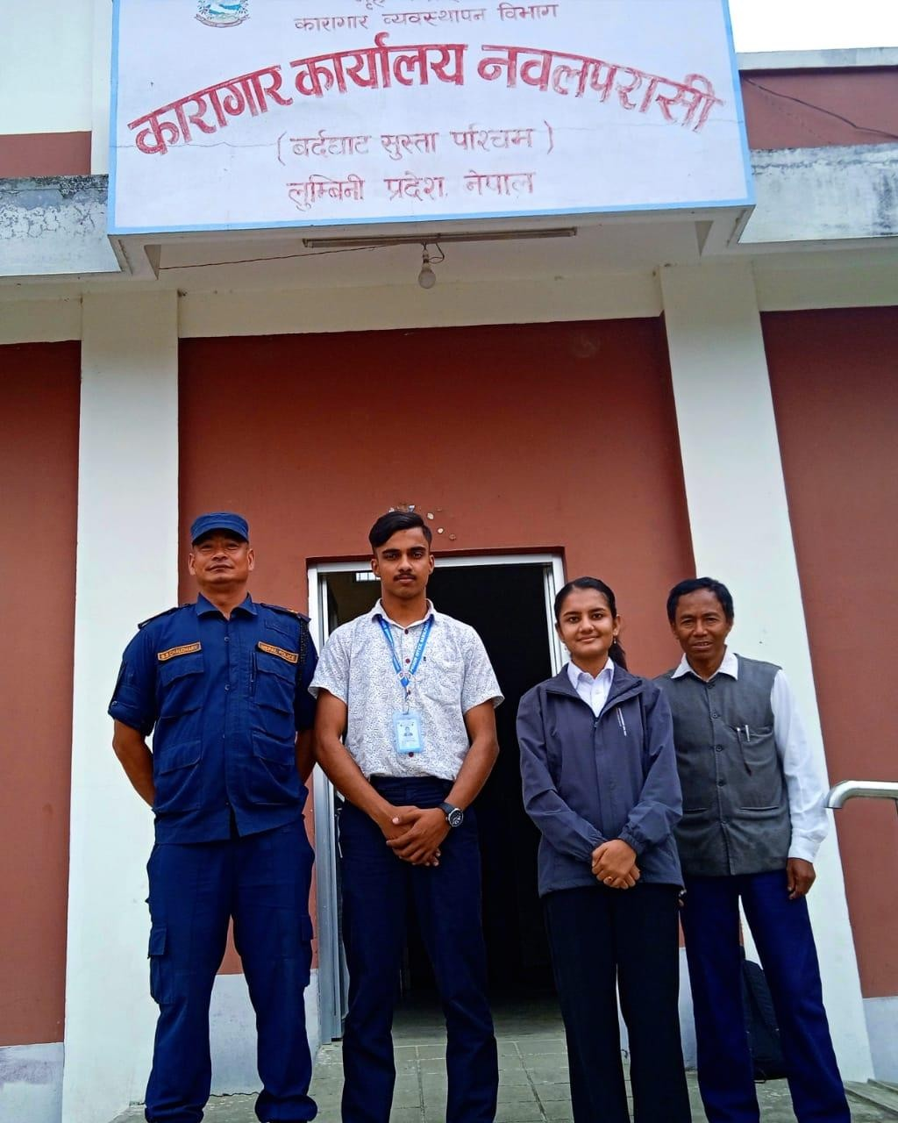

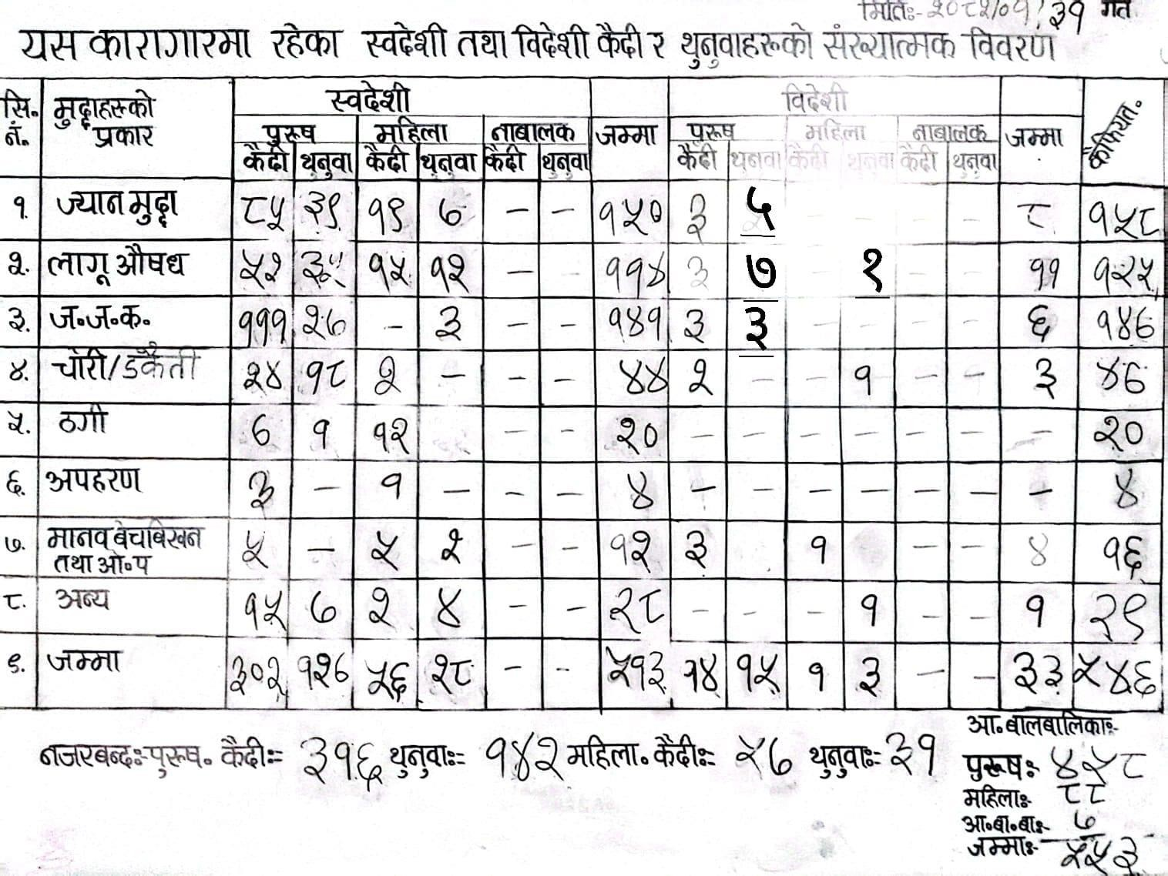
Above table describe about the number of prisoners,

Primary sources: Constitution of Nepal 2072, Prisons Act 2079

Chapter- 8 References

Criminal offences (sentencing and execution Act- 2074)

Online sources:
United Nations. (1948). Universal Declaration of Human Rights. https://www.un.org/en/about-us/universal-declaration-of-human-rights
United Nations Office on Drugs and Crime. (2015). The United Nations Standard Minimum Rules for the Treatment of Prisoners (the Nelson Mandela Rules). https://www.unodc.org/unodc/en/justice-and-prison-reform/Nelson-Mandela-Rules.html
UNESCO Institute for Lifelong Learning. (2020). Education in prison: A lifelong learning perspective. https://uil.unesco.org
International Labour Organization. (2020). Decent work in prisons. https://www.ilo.org/global/topics/forced-labour/lang--en/index.htm
United Nations. (1948). Universal Declaration of Human Rights. https://www.un.org/en/about-us/universal-declaration-of-human-right
Pratt, J. (2008). Scandinavian exceptionalism in an era of penal excess. British Journal of Criminology, 48(2), 119–137.
Inter-American Commission on Human Rights. (2006). Principles and Best Practices on the Protection of Persons Deprived of Liberty in the Americas
Andrew Coyle, A Human Rights Approach to Prison Management (International Centre for Prison Studies, 2009), 92
ECHR Art 2,

Barendrecht, M. (2012). Five Strategies towards basic justice care for everyone. World Justice Project. https://worldjusticeproject.org/news/five-strategies-towards-basic-justice-care-everyone

Cases:
Charles Sobhraj v. Superintendent, Central Jail, Tihar, AIR 1978 SC 1514. International Covenant on Civil and Political Rights (ICCPR), United Nations, 1966. State of Gujarat v. Hon’ble High Court of Gujarat, AIR 1998 SC 3164.
Jung Bahadur Singh vs the office of the prime Minister and council of minister NKP.2068 D.N 8631

Article:

K.C., A. (2020). Prison reforms and rehabilitation in Nepal. Nepal Law Review, 12(1), 33–48.
Bhandari, S. (2076 B.S.). Karagarbhitra siksha ra rojgar: Aadhunik samasya ra sambhavana. Nyayik Darpan, 10(1), 22–30.

