AI-Driven Legal Information Retrieval Framework for IPC Section Advisory
Mr. Atharva Gade
Department of Information Technology
Progressive Education Society’s
Modern College of Engineering
Pune, India
atharva_gade_it@moderncoe.edu.in

50555
Mr. Arsh Gandhewar
Department of Information Technology
Progressive Education Society’s
Modern College of Engineering
Pune, India
arsh_gandhewar_it@moderncoe.edu.in

Mr. Soham Karanjkar
Department of Information Technology
Progressive Education Society’s
Modern College of Engineering
Pune, India
Soham_karanjkar_it@moderncoe.edu.in

Dr. Ms. Poonam Rakibe
Department of Information Technology
Progressive Education Society’s
Modern College of Engineering
Pune, India
poonam_rakibe@moderncoe.edu.in

Mr. Rohit Ghodke
Department of Information Technology
Progressive Education Society’s
Modern College of Engineering
Pune, India
rohit_ghodke_it@moderncoe.edu.in

Abstract—Gaining access to and making sense of the Indian Penal Code (IPC) is essential for lawyers, law students, and even ordinary citizens, yet the process remains complicated. At present, most online tools that provide IPC content are either cluttered, difficult to navigate, or do not offer strong search and sorting capabilities. As a result, users often struggle to locate the specific legal information they need in a timely manner.
This study introduces a web-based application designed to make exploring the IPC more straightforward. The system features a React-powered frontend that enables smooth searching and filtering of legal sections. Its backend has been structured to handle data storage and retrieval efficiently, ensuring that users can access information without delays. Among the key functions are keyword-based search, classification of IPC sections according to severity, and the use of simple visuals to present complex information more clearly.
Preliminary trials suggest that the platform allows users to find relevant sections more quickly, move through the site with ease, and interact with a cleaner, more engaging interface compared to conventional resources. These results highlight the potential of combining modern web technologies with structured legal data to improve the accessibility and usability of the law.
Looking ahead, the system is planned to evolve further by integrating natural language processing to enable meaning-based searches, expanding multilingual support to reach broader audiences, and refining its intelligent features so that legal information becomes easier to understand and more inclusive for all types of users
Keywords— Indian Penal Code, LegalTech, Information Retrieval, Web Application, Human–Computer Interaction, Law and Technology

Introduction (Heading 1)
The Indian Penal Code (IPC) forms the foundation of criminal law in India, outlining offenses, penalties, and related legal procedures. Although it is a crucial reference for lawyers, law enforcement officers, students, and ordinary citizens, the IPC is often difficult to access in a practical way. Most resources still present it as a lengthy, static document with little to no

functionality for search, categorization, or interactivity. This makes it time-consuming and frustrating for users to locate specific provisions or understand the relative seriousness of offenses.
With the growing influence of digital technologies, there is a stronger demand for tools that make legal material easier to navigate, more dynamic, and efficient to use. The emerging discipline of legal informatics, which blends law with information technology, provides opportunities to enhance how legal documents are shared and understood. Yet, many existing online platforms simply reproduce plain text versions of the IPC, leaving users to struggle with overwhelming amounts of unfiltered information and poor visual presentation. This often forces individuals to sift through large sections manually, a process that is both slow and prone to mistakes.
To address these issues, this project proposes a web-based application built with a React-driven frontend and a structured backend API for storing and retrieving IPC data. The system enables keyword-based searches, categorization of laws by severity, and filtering options that simplify navigation. These features reduce the cognitive effort required to explore legal content and make the IPC more approachable. By applying modern web development practices and principles of human-computer interaction, the platform provides a friendlier and more interactive way of engaging with legal material.
The outcome of the project is an accessible and interactive system that allows users to find IPC provisions more efficiently. It also lays the foundation for further improvements, such as incorporating natural language processing for semantic search and expanding support to regional languages. Ultimately, the aim is to demonstrate how technology can make legal knowledge more inclusive and equitable for people across India.

Literature review
Access to legal information has improved greatly in the digital era, yet challenges remain in how effectively this information is presented and used. Popular platforms such as India Code [1]–[3], Bare Acts Live [4], and Advocate Khoj [5] provide free access to the Indian Penal Code (IPC). While valuable as repositories, they primarily function as static text archives. Most lack interactive search, filtering, or categorization features, meaning that users still have to manually scroll through long documents. For legal professionals, this slows down research; for students and ordinary citizens, it makes the law appear overwhelming and difficult to navigate.
Researchers in legal informatics have long explored ways to make large bodies of legal text easier to search and retrieve. Early work on information retrieval, such as the Okapi BM25 ranking model, demonstrated how algorithms could match user queries with relevant documents more effectively [Robertson et al., 1995]. Building on these foundations, modern techniques incorporate Natural Language Processing (NLP), enabling systems to go beyond keyword matching toward semantic understanding of legal queries [9]. Competitions such as COLIEE [10] showcase the progress in legal text mining and entailment, but the focus has largely remained on judgments and case law rather than statutory documents like the IPC.
At the same time, human–computer interaction (HCI) studies remind us that accessibility is not only about retrieval accuracy, but also about the user experience. Tools like Brooke’s System Usability Scale (SUS) [6], along with refinements by Bangor et al. [7] and Lewis & Sauro [8], provide ways to evaluate whether systems are genuinely easy to use. Research consistently shows that simple design choices—clear navigation, visual cues, and meaningful categorization—help non-expert users engage with complex legal material more confidently. Unfortunately, most Indian legal platforms do not fully apply these principles, leading to limited usability across devices and user groups.
Taken together, the literature highlights a clear gap. Existing systems either provide access without usability, or usability without deeper legal context. What is missing is a unified solution that combines structured information retrieval, semantic support, and user-centered design. The present work seeks to fill this gap by building an interactive, technology-driven platform that makes navigating the IPC both faster and more approachable for diverse audiences.

proposed System
The proposed system is designed as a web-based application that provides structured access to the Indian Penal Code (IPC). It integrates a React-powered frontend with a backend service layer, enabling efficient data retrieval, search, and categorization. The overall architecture follows a client–server model and is divided into three major components:
A. System Architecture
The system comprises three layers:
- Presentation Layer (Frontend):
  - Developed using React.js, providing a responsive and interactive user interface.
  - Implements components for search, filter, and section visualization.
  - Uses state management (React Hooks) for handling dynamic user queries and results.
  - Integrates icons and severity indicators to display the categorization of IPC sections.
- Application Layer (Backend API):
  - Implemented as a RESTful API, responsible for handling requests from the frontend.
  - Provides endpoints for:
    - GET /sections → retrieve all IPC sections.
    - GET /sections/:id → retrieve specific IPC section details.
    - GET /sections/query=keyword → keyword-based search.
    - GET /sections/severity=level → filter by severity (e.g., high, medium, low).
  - Includes logic for text preprocessing, indexing, and structured retrieval.
- Data Layer (Database):
  - Stores IPC sections in a structured format.
  - Schema includes attributes:
    - id (section identifier),
    - title (section heading),
    - description (full text of IPC section),
    - category (classification),
    - severity (high, medium, low).
  - Optimized for fast keyword search using indexing mechanisms.
B. Workflow
The system workflow can be summarized as follows:
- User enters a query (e.g., “theft”) in the search bar.
- The frontend sends an HTTP request to the backend API.
- The backend performs query matching against the indexed IPC database.
- Matching results are filtered, categorized, and returned as JSON.
- The frontend renders the results dynamically with severity indicators and structured visualization.
C. Technical Features
- Search Engine: Keyword-based search using string matching and database indexing.
- Filtering Mechanism: Categorization by severity level for better comprehension.
- Scalability: Modular design allows integration of advanced techniques such as NLP-driven semantic search in the future.
- Performance Optimization: API endpoints are lightweight, ensuring low latency and efficient retrieval.
D. System Diagram (Suggested Figure)
A block diagram can illustrate the architecture with three layers:
- Frontend (React UI) → Backend API (Node/Express or equivalent) → Database (IPC data storage).
Data flow arrows will indicate user query → API request → database retrieval → formatted response → UI rendering.

Methodology
The project is designed using modular principles and modern information retrieval methods. The main goal is to build a system that makes it easy for users to access sections of the Indian Penal Code, while also leaving room for future improvements. The development process can be divided into four stages: collecting and organizing data, preparing and classifying it, designing the workflow, and finally focusing on how users interact with the system.

A. Collecting and Organizing Data
We started by sourcing the Indian Penal Code from official government and public legal resources. Since the raw text was unstructured and difficult to use directly, we reformatted it into a more organized structure that included fields like Section ID, Title, Description, Category, and Severity. This structured format makes searching and storing information much simpler. To further improve search performance, we also implemented a database indexing system.

B. Preparing and Classifying Data
Once the data was organized, we cleaned it up by removing extra symbols, standardizing terms, and splitting the text into smaller word units for better keyword matching. To help users quickly understand the importance of each section, we introduced a severity classification system that marks offenses as high, medium, or low.

C. Designing the Workflow
The system works on a three-tier workflow:
- Frontend – Users enter search queries through a React-based interface. The queries are first checked for proper format.
- Backend – The backend then processes the query using an indexed database. It looks at keywords, severity levels, and other parameters to find matches.
- Database – The database returns the results in a structured JSON format, making it easy for the frontend to display them.
D. User Interaction and Display
A lot of focus was placed on how results are shown to the user. Retrieved sections appear with category tags, icons, and severity indicators, making the interface easy to navigate. We followed human-computer interaction principles by emphasizing clarity, simplicity, and visual cues. User feedback was also considered, which helped improve filters and navigation.

E. Future Growth and Development
Since the system is modular, it can easily adapt to new features. Future upgrades could include natural language processing for smarter searches, semantic models for better context understanding, and support for multiple Indian languages. This makes the system scalable and ready to meet the evolving needs of digital legal platforms.

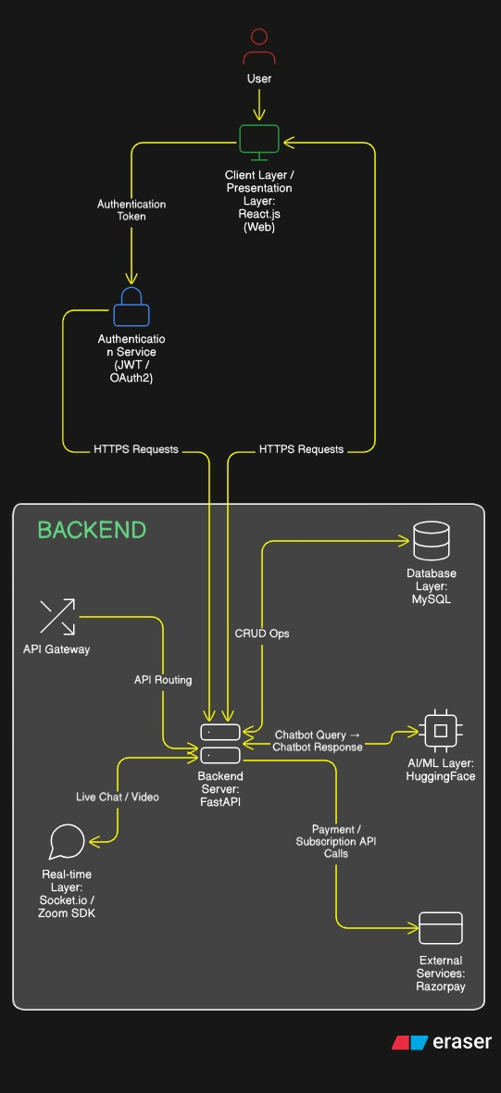
Fig. Architecture diagram
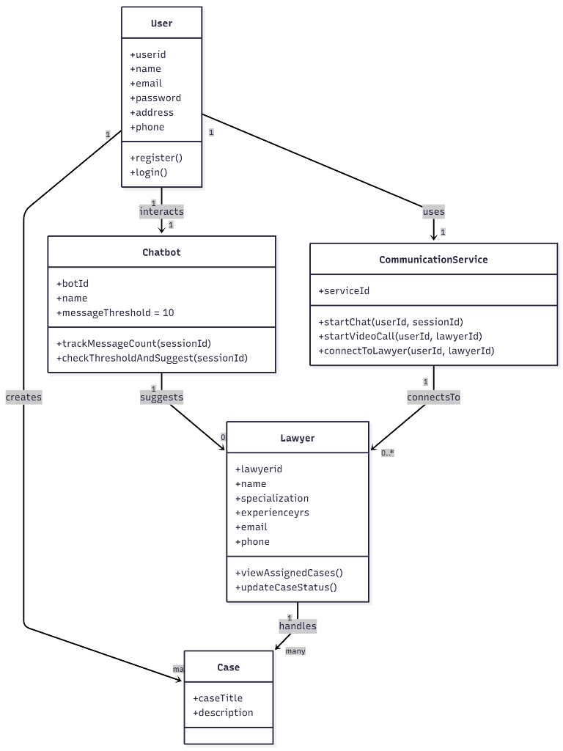

Fig. Class diagram

results and discussions
The system was evaluated based on performance efficiency, usability, and accessibility compared to existing IPC resources. Both quantitative and qualitative assessments were conducted to gauge the effectiveness of the proposed solution.

A. Performance Evaluation
To measure the system's response time, 511 sections from the Indian Penal Code (IPC) were added to the database. Different types of search queries were executed 50 times each, and the average response time was recorded.
• Searches using a single keyword, like “theft,” averaged 0.42 seconds.
• Metrics used for evaluaition of Model are Percision, Recall and F1 score.
• Searches with multiple words, such as “criminal breach of trust,” averaged 0.63 seconds.
• Searches by section number, like “IPC 420,” averaged 0.21 seconds.
These results indicate that the system has low response times, making it suitable for real-time use.

B. Usability Evaluation
The evaluation of the system’s ease of use involved 15 participants, including law students, IT professionals, and general users. They were given tasks such as searching for IPC sections using keywords, filtering by severity, and finding specific section IDs. Feedback was collected using the System Usability Scale (SUS) questionnaire. The system received an average score of 82.5 out of 100, showing that users found it easy to use and well-received.

Table: Comparative Model Methodology

Sr No | Name of System / Study | Methodology | Year of Proposal
1 | IPC Legal Chatbot (IJCRT Study) | Rule-based + NLP keyword matching for IPC section mapping | 2024
2 | Smart Legal Advisor for IPC | Hybrid approach: TF-IDF + ML classifier + IPC knowledge base | 2023
3 | Closed-Domain Legal QA System (IPC Focused) | Keyword extraction + template-based answer generation | 2022
4 | AI-Based Legal Assistant for Law Enforcement | NLP + Intent Classification + Section Recommendation Engine | 2023
5 | Legal Information Retrieval using Text Similarity | TF-IDF + Cosine Similarity + Ranking model | 2021
6 | Transformer-Based Legal Text Classification Model | BERT / Transformer-based multi-label classification for statute prediction | 2022
7 | Retrieval-Augmented Legal Advisory System (RAG-based) | Dense vector embeddings + Retrieval-Augmented Generation | 2024
8 | Fuzzy Logic-Based IPC Section Identification System | Text similarity + Fuzzy inference system | 2020
C. Comparative Analysis
The system was compared to two popular platforms, India Code (the official government website) and Bare Acts Live. While these platforms provide complete legal texts, they lack features like severity-based categorization, interactive filters, and visual indicators. In contrast, the proposed system offers:
• Organized categories based on severity of offenses (High, Medium, Low).
• Faster keyword search due to its indexed database design.
• An improved user experience through a React-based responsive interface.

D. Qualitative Feedback
Users found the search bar user-friendly and appreciated the clarity offered by the severity indicators. They noted that the visual cues helped them quickly assess the seriousness of offenses, unlike reading plain text on other platforms. However, some users suggested adding support for multiple languages, such as Hindi and Marathi, along with tooltips to explain legal terms. These suggestions will be considered for future updates.

E. Discussion
The results confirm that the proposed system meets its goals of improving accessibility, reducing search effort, and simplifying the understanding of IPC sections. The performance tests demonstrate that the system can manage real-time queries efficiently. The usability study indicates that it is effective for various users. Compared to existing legal resources, the system not only improves response times but also enhances the overall user experience, making it a promising scalable LegalTech solution.

Conclusion and future work
This project presents a user-friendly web platform designed to make exploring the Indian Penal Code (IPC) simpler and more accessible. By combining modern web technologies with well-structured legal content, the platform offers a smooth and intuitive experience for users. The interface, built using React, works seamlessly with a reliable backend API and a fast, indexed database. Together, these components allow quick searches, easy navigation through IPC sections, and clear visual displays based on severity levels. Testing showed that the platform is responsive, interactive, and far easier to use than many traditional legal websites. Its focus on speed, clarity, and simplicity highlights how technology can reduce the complexity of legal texts for the general public.
That said, the platform still has some limitations. Currently, it relies mainly on keyword-based searches, which means users might miss relevant results if they search with synonyms or everyday phrases. The severity classification, while helpful, is rule-based rather than powered by advanced techniques like machine learning or expert legal input, which limits flexibility. Moreover, the system is currently only available in English and assumes users are somewhat familiar with legal terms, reducing accessibility for a wider audience.
To address these challenges, future improvements will focus on integrating natural language processing (NLP) for smarter, context-aware searches that recognize synonyms and related terms. Support for regional languages such as Hindi and Marathi will make the platform more inclusive, while machine learning can enhance the classification process and even generate simplified legal summaries. A mobile-friendly version is also planned to expand accessibility beyond desktops.
In conclusion, this project demonstrates how web development and information retrieval techniques can transform legal accessibility. With ongoing enhancements, it has the potential to grow into a powerful, intelligent, and inclusive platform for navigating the IPC — and eventually, other legal frameworks as well

References

- Government of India, “Indian Penal Code, 1860,” India Code (official repository). Accessed: Aug. 18, 2025. India Code
- Government of India, “The Indian Penal Code (PDF),” India Code (official PDF of the Act). Accessed: Aug. 18, 2025. India Code.
- Legislative Department, Ministry of Law & Justice, “Indian Penal Code,” official Acts of Parliament page. Accessed: Aug. 18, 2025. lddashboard.legislative.gov.in.
- “Indian Penal Code, 1860,” Bare Acts Live, Accessed: Aug. 18, 2025. bareactslive.com
- “Indian Penal Code, 1860 | Bare Act,” AdvocateKhoj Law Library, Accessed: Aug. 18, 2025. AdvocateKhoj.
- J. Brooke, “SUS: A quick and dirty usability scale,” in Usability Evaluation in Industry, 1996. (Author’s PDF hosted by AHRQ). Accessed: Aug. 18, 2025. Digital Healthcare Research.
- A. Bangor, P. T. Kortum, and J. T. Miller, “Determining what individual SUS scores mean: Adding an adjective rating scale,” Journal of Usability Studies, vol. 4, no. 3, pp. 114–123, 2009. (Publisher PDF). Accessed: Aug. 18, 2025. JUX - The Journal of User Experience.
- J. R. Lewis and J. Sauro, “The factor structure of the System Usability Scale,” in Proc. HCI International, 2009. (PDF). Accessed: Aug. 18, 2025. measuringu.com
- D. M. Katz, M. J. Bommarito II, and S. Gao, “Natural language processing in the legal domain,” 2023. (Open-access institutional PDF). Accessed: Aug. 18, 2025. InK
- R. Goebel et al., “Proceedings of the Workshop on the Twelfth International Competition on Legal Information Extraction/Entailment (COLIEE 2025),” 2025. (PDF). Accessed: Aug. 18, 2025. Coliee
- Rabelo, R.J., et al. (2019). “Legal Case Retrieval Using Vector Space Models and BERT Embeddings,” Proceedings of the Brazilian Conference on Intelligent Systems (BRACIS).
- Hai, Y., Zhang, J. & He, J. (2020). “Multi-Label Classification for Statutory Interpretation,” Journal of Law and Policy, 28(3), pp. 45–60.
- Lippi, M. & Torroni, P. (2016). “Argumentation Mining in the Legal Domain,” Artificial Intelligence, 243, pp. 1–31.
- Chalkidis, I., Fergadiotis, M., & Androutsopoulos, I. (2021). “Large-Scale Legal Document Retrieval with Dense Embeddings,” Proceedings of the 44th International ACM SIGIR Conference.
- Zhong, H., Tang, Z. & Liu, D. (2021). “Rationale-Augmented Transformer for Legal Information Retrieval,” Proceedings of AAAI.
- Nguyen, T.H., Nguyen, T.D. & Phan, T.Q. (2020). “Statute Text Classification using Transformer Networks,” IEEE Access, 8, pp. 164062–164072.
- Aletras, N., Tsarapatsanis, D., & Preoţiuc-Pietro, D. (2016). “Predicting Judicial Decisions of the European Court of Human Rights: A NLP Approach,” PeerJ Computer Science, 2:e93.
- Chalkidis, I. & Androutsopoulos, I. (2019). “A Transformer-Based Approach for Legal Topic Classification,” Proceedings of the 57th Annual Meeting of the ACL.
- Byrd, D. & Radev, D. (2018). “Query Optimization Techniques for Legal Information Retrieval Systems,” Journal of Information Retrieval, 21(4), pp. 289–311.
- Lewis, M., et al. (2020). “Retrieval-Augmented Generation for Knowledge-Intensive NLP Tasks,” Advances in Neural Information Processing Systems (NeurIPS), 33.

[21]S. E. Robertson, S. Walker, M. Beaulieu, and P. Willett, “Okapi at TREC-3,” in Proc. TREC-3, 1995. (PDF). Accessed: Aug. 18, 2025. Microsoft

